Late Permian palynozones and associated CA-IDTIMS dated tuffs from the Bowen Basin, Australia
Geoscience Australia
RECORD 2013/46
Tegan E. Smith1, Daniel Mantle2
- Geoscience Australia, GPO Box 378, Canberra, ACT, 2601
- Morgan Goodall Palaeo Pty Ltd, PO Box 161, Maitland, SA, 5573
Department of Industry
Minister for Industry: The Hon Ian Macfarlane MP
Parliamentary Secretary: The Hon Bob Baldwin MP
Secretary: Ms Glenys Beauchamp PSM
Geoscience Australia
Chief Executive Officer: Dr Chris Pigram
This paper is published with the permission of the CEO, Geoscience Australia
© Commonwealth of Australia (Geoscience Australia) 2013
With the exception of the Commonwealth Coat of Arms and where otherwise noted, all material in this publication is provided under a Creative Commons Attribution 3.0 Australia Licence. (http://www.creativecommons.org/licenses/by/3.0/au/deed.en)
Geoscience Australia has tried to make the information in this product as accurate as possible. However, it does not guarantee that the information is totally accurate or complete. Therefore, you should not solely rely on this information when making a commercial decision.
Geoscience Australia is committed to providing web accessible content wherever possible. If you are having difficulties with accessing this document please contact clientservices@ga.gov.au.
ISSN 2201-702X (PDF)
ISBN 978-1-922201-84-3 (PDF)
GeoCat 72990
Bibliographic reference: Smith, T. E. & Mantle, D., 2013. Late Permian palynozones and associated CA-IDTIMS dated tuffs from the Bowen Basin, Australia. Record 2013/46. Geoscience Australia: Canberra.
Version 1310

Contents
Abstract 1
Introduction 2
Background 2
Location of Meeleebee 5 4
Analysed Samples 7
Palynology of the Meeleebee 5 samples 10
Sample 2122664 10
Sample 2122665 10
Sample 2122669 11
Sample 2122673 11
Sample 2122700 11
Sample 2122676 12
Sample 2122681 12
Sample 2122682 13
Sample 2122696 13
Sample 2122698 14
Sample 2122706 14
Sample 2122708 14
Sample 2122711 15
Sample 2122714 15
Sample 2122715 16
Sample 2122718 16
Sample 2122723 16
Sample 2122726 17
Discussion 18
Conclusions and Recommendations 22
Acknowledgements 23
References 24
Plates 26
Plate 1 26
Plate 2 26
Appendix A : Full Table of Meeleebee 5 samples 30
Appendix B : List of all identified taxa 33
B.1 Spores 33
B.2 Pollen 34
B.3 Acritarchs 35
Appendix C : Palynological results for selected Meeleebee 5 samples 36
C.1 Key to palynological results tables 36
C.2 Spores 37
C.3 Pollen 38
C.4 Acritarchs 39

Abstract
As part of a continuing program to date Permian plant microfossil zones using CA-IDTIMS dating, 11 tuff and 18 sedimentary core samples were examined from the Bowen Basin succession intersected in APLNG Meeleebee 5, a CSG well spudded in the Surat Basin, Queensland. The Bowen Basin consists of terrestrial and marine sediments interspersed with numerous tuff layers and economic coal seams. Palynological strew-slides were examined using a light microscope to identify taxa. Quantitative analyses, with counts up to 100 specimens, were undertaken. Almost all the plant microfossil assemblages analysed from the Meeleebee 5 core belong to the Price (1997) APP5 spore-pollen zone, and one may belong to the younger APP6 zone. The APP5 index species, Dulhuntyispora parvithola was present throughout the section. The APP5005 index species Microreticulatisporites bitriangularis was also present in many samples and the Micrhystridium evansii acme event was readily identified. Triquitrites proratus, a species usually restricted to APP6, was identified near the top of the succession, although no other species typical of APP6 were found. When compared with CA-IDTIMS tuff ages, the Dulhuntyispora parvithola zone spans around five million years, almost extending to the Permian-Triassic boundary. Additionally, the Microreticulatisporites bitriangularis Subzone and Microstridium evansii event are both younger than previously estimated. By combining the results of the palynology and CA-IDTIMS dating, numeric ages are attached to palynostratigraphic units, aiding regional and global correlations of the palynofloras and economic coal-bearing sequences of the basin.

Introduction
  - Background
Palynology is used as a key tool for correlation within and between sedimentary basins across Australia. The high preservation potential of palynomorphs, combined with their recovery from both marine and non-marine rocks, makes them ideal biostratigraphic markers (Christopher & Goodman 1996). The current study reports on Late Permian palynomorphs recovered from core samples from APLNG Meeleebee 5, an Australia Pacific Liquid Natural Gas well in the Surat Basin, which also intersects the underlying Bowen Basin. The aim is to determine the palynostratigraphy of the upper Permian Bowen Basin succession and to tie the resultant data to chronometric dating of the tuffaceous intervals within the same stratigraphic section. In doing so, numeric ages are attached to biozones and stratigraphic units, thus aiding regional and global correlations of the palynofloras and the economic coal-bearing sequences.
Early work in eastern Australian basins in the 1950s and ‘60s culminated in the Permian and Mesozoic palynostratigraphic units of Evans (1966; 1970) which were later modified by numerous authors (summarised by Price 1997), before an alphanumeric nomenclature was introduced by Price et al. (1985). This nomenclature was updated by Price (1997), creating the scheme used in the current study. Figure 1 outlines Price’s (1997) Permian spore-pollen zonation along with the index forms that define each zone.
The current study forms part of an ARC (Australian Research Council) funded study “International Timescale Calibration of the Late Permian-Early Triassic of Australia: Understanding mass extinctions and deep time climate change.” One of the aims of this project is to enhance biostratigraphic calibration and correlation of the Australian Late Permian–Early Triassic by providing radiometric ages for Australian regional palynofloras. The End-Permian mass extinction was the most catastrophic ecological event in the Earth’s history. Over 80% of marine genera disappeared, yet the impact on terrestrial biota is poorly known (Hochuli et al. 2010). Additionally, the causes and timing of events associated with the extinction remain uncertain despite intensive study (Mundil et al. 2004). The ARC project aims to achieve a better understanding of the causes and consequences of this extinction event and provide new constraints on the position and nature of the Permian-Triassic boundary in Australia. Many Australian basins of this age provide important coal and unconventional hydrocarbon reserves (Geoscience Australia and ABARE 2010) and as such, this research will also provide a temporal framework for exploration and exploitation of these economically important resources. Absolute dating methods are used to link biostratigraphic zones to the international geological timescale, providing critical age controls for oil and gas exploration.
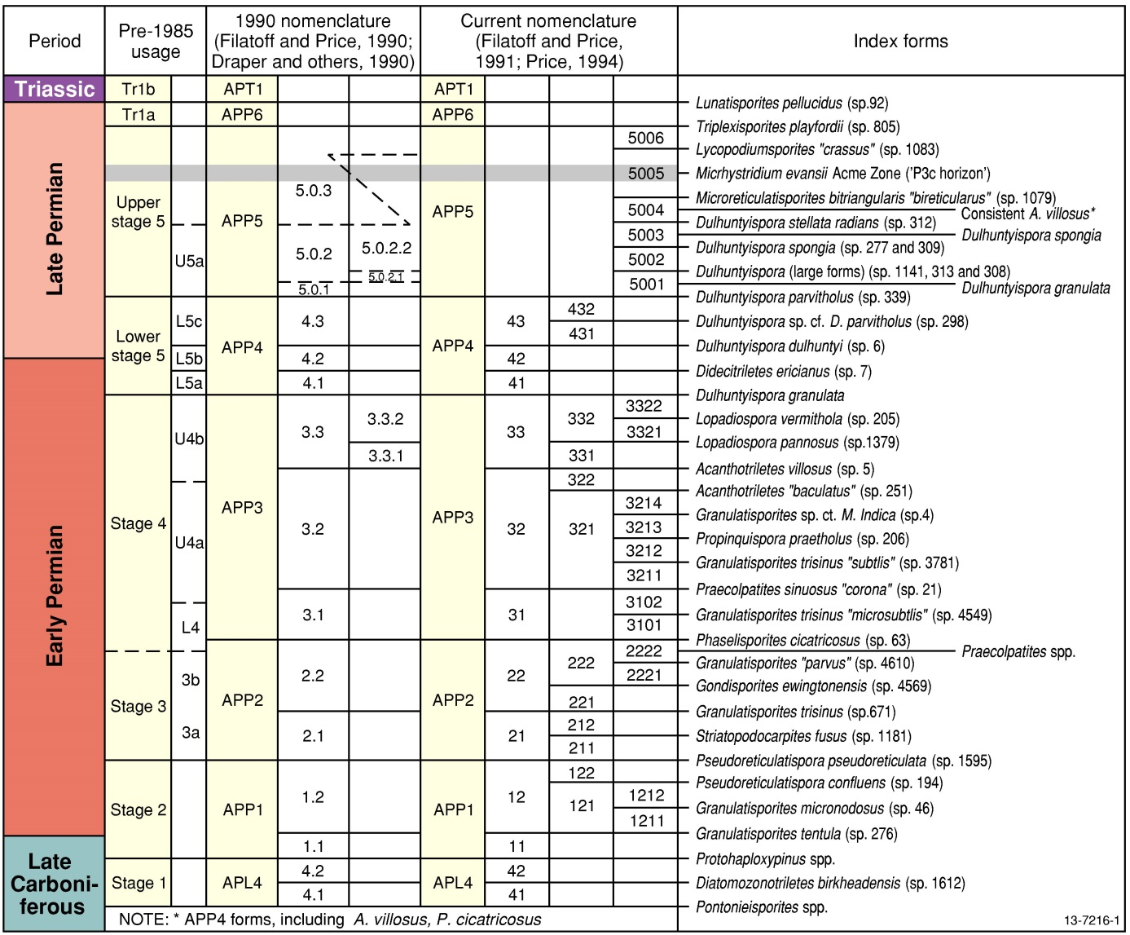
Figure 1: Permian palynostratigraphic zonation of eastern Australia (after Price 1997, Fig. 2).
The Chemical Abrasion–Isotope-Dilution Thermal Ionisation Mass Spectrometry (CA-IDTIMS) method of U-Pb dating of zircons is used to provide high resolution absolute ages for ash-fall tuff layers in the Bowen Basin. As part of this method, zircon grains undergo chemical abrasion to entirely remove domains that have undergone Pb loss which would otherwise result in anomalously young ages. The zircons are first annealed at temperatures in the range of 800-1100°C for 48 h, before being subjected to a series of dissolution steps at progressively higher temperatures. This process removes parts of the zircon crystal lattice with high U and Th concentrations and in grains that lack inheritance, a 206Pb/238U plateau age is defined with a 2σ error of 0.1% or less (Mattinson 2005).
The focus of the current study is Meeleebee 5 — a single continuously cored stratigraphic well that penetrates both the Jurassic-Cretaceous Surat Basin and the Permian-Triassic Bowen Basin. The well contains numerous tuff beds in the upper Permian succession. This project aims to assess the Upper Stage 5/APP5 (see Figure 1) palynofloras from this well, to accompany CA-IDTIMS dating of the tuff layers, thus providing international correlation of this regional palynoflora. Price (1997) divides APP5 into 6 subzones, based on the presence of index taxa shown in Figure 1. Foster (1982) describes the taxa listed below as characteristic of Upper Stage 5 (equivalent to APP5 of Price; 1997) of the Bowen Basin. Those taxa marked with an asterisk (*) on this list, were identified in this study.
- Baculatisporites spp. *
- Bipartitisporis sp. cf. Verrucosisporites trisecatus
- Didecitriletes ericianus*
- Distriatites insolitus
- Dulhuntyispora parvithola*
- Gondisporites bharadwajii
- Indospora clara
- Indotriradites reidii*
- Klausipollenites sp. A
- Lophotriletes spp.*
- Marsupipollenites striatus*
- Microfoveolatispora explicita*
- Protohaploxypinus spp.*
- Scheuringipollenites maximus*
- Scheuringipollenites ovatus*
- Secarisporites bullatus*
- Striatoabieites multistriatus*
- Striatopodocarpites spp.*
- Triradiaspora sp. cf. T. epigona
- Vitreisporites signatus
- Weylandites spp.*
The geochronological analyses accompanying the palynological results of the current study were conducted by the Isotope Geology Laboratory at Boise State University. By analysing the palynofloras of the carbonaceous siltstones and coals bracketing the tuff layers, chronometric ages can be assigned to plant microfossil assemblages. Results suggest that the time-calibrations of some spore pollen zones require revision. For example, the Dulhuntyispora parvithola assemblage has a longer duration than previously suggested, spanning around five million years, almost extending to the Permian-Triassic boundary. Also, the Microreticulatisporites bitriangularis subzone and Micrhystridium evansii event are both younger than previously estimated. These results concur with those of a similar study conducted in the Sydney Basin, where the CA-IDTIMS ages associated with both the Dulhuntyispora parvithola and Praecolpatites sinuosus zones, are younger than previously accepted (Mantle et al. 2011).
  - Location of Meeleebee 5
The Meeleebee 5 well is located where the Surat Basin overlies the Bowen Basin, at the south end of Comet Ridge, one of the major Bowen Basin structural features (Figure 2). The Bowen Basin consists of a succession of Permian and Triassic rocks up to 10 km thick, which were deposited in a near-coast, mainly non-marine setting (Dickins & Malone 1971). The basin contains numerous coal seams, which initially formed around the margins of the basin, expanding to cover the entire basin in the latest Permian (Mallett et al. 1995). The basin is up to 900 km long and 300 km wide, stretching from Collinsvale in the north to south of the Queensland-New South Wales border (Riley 2004). It covers an area of about 120 000 km2 (Geoscience Australia and ABARE 2010), though the southern portion of the basin is overlain by Jurassic-Cretaceous sediments of the Surat Basin (Goscombe and Coxhead 1995). It is one of Australia’s principal black coal producing basins and though it produces some crude oil and condensates, the primary petroleum resource for the basin is coal seam gas (Geoscience Australia and ABARE 2010). The Bowen Basin is structurally complex, incorporating several major NNW-SSE trending troughs and highs (Mallett et al. 1995). A generalised stratigraphy for the major structural sub-divisions of the Bowen Basin against the spore-pollen zones (Price 1997) is shown in Figure 3, while Figure 4 illustrates the stratigraphic units of the Bowen Basin succession in Meeleebee 5 well, along with the locations of the tuff samples and the palynology samples.
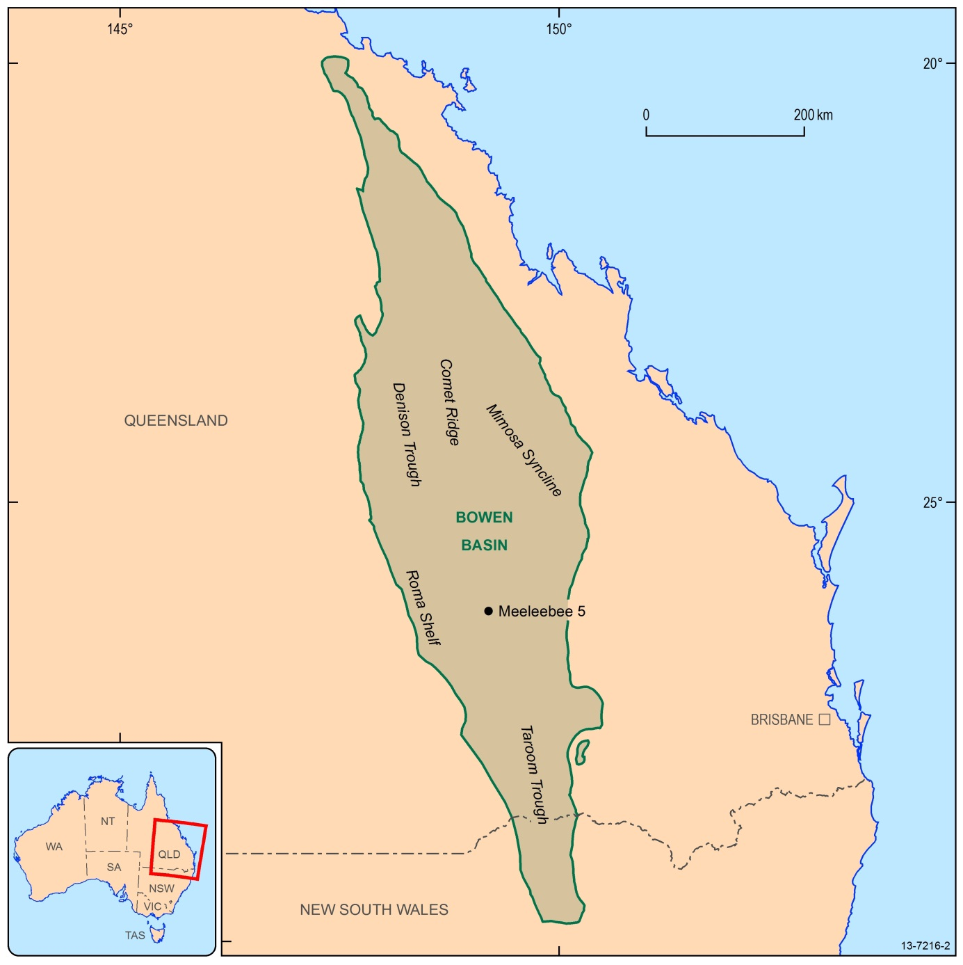
Figure 2: Location of the Meeleebee 5 well, Bowen Basin.
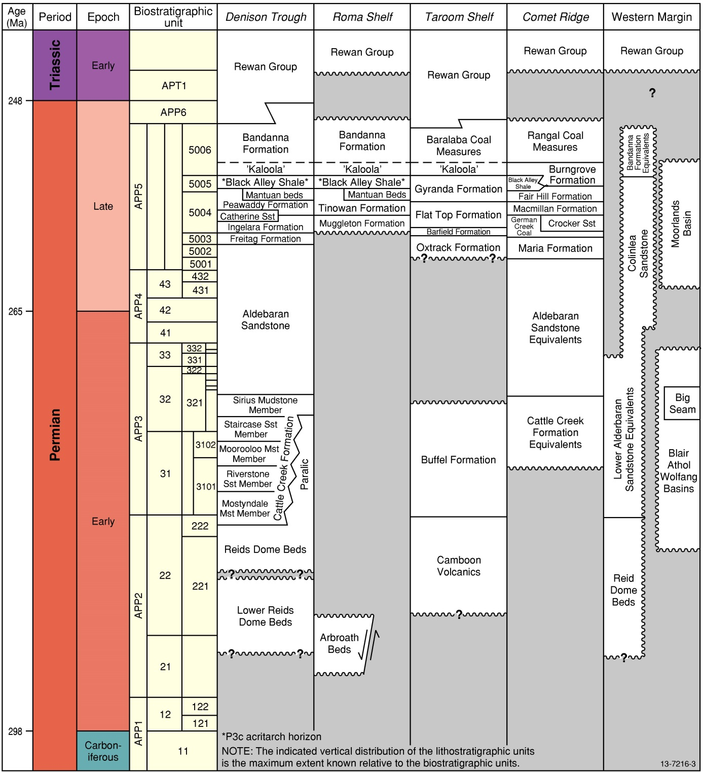
Figure 3: Permian stratigraphy of the Bowen Basin correlated to biostratigraphic units by Price (1997, Fig 3)
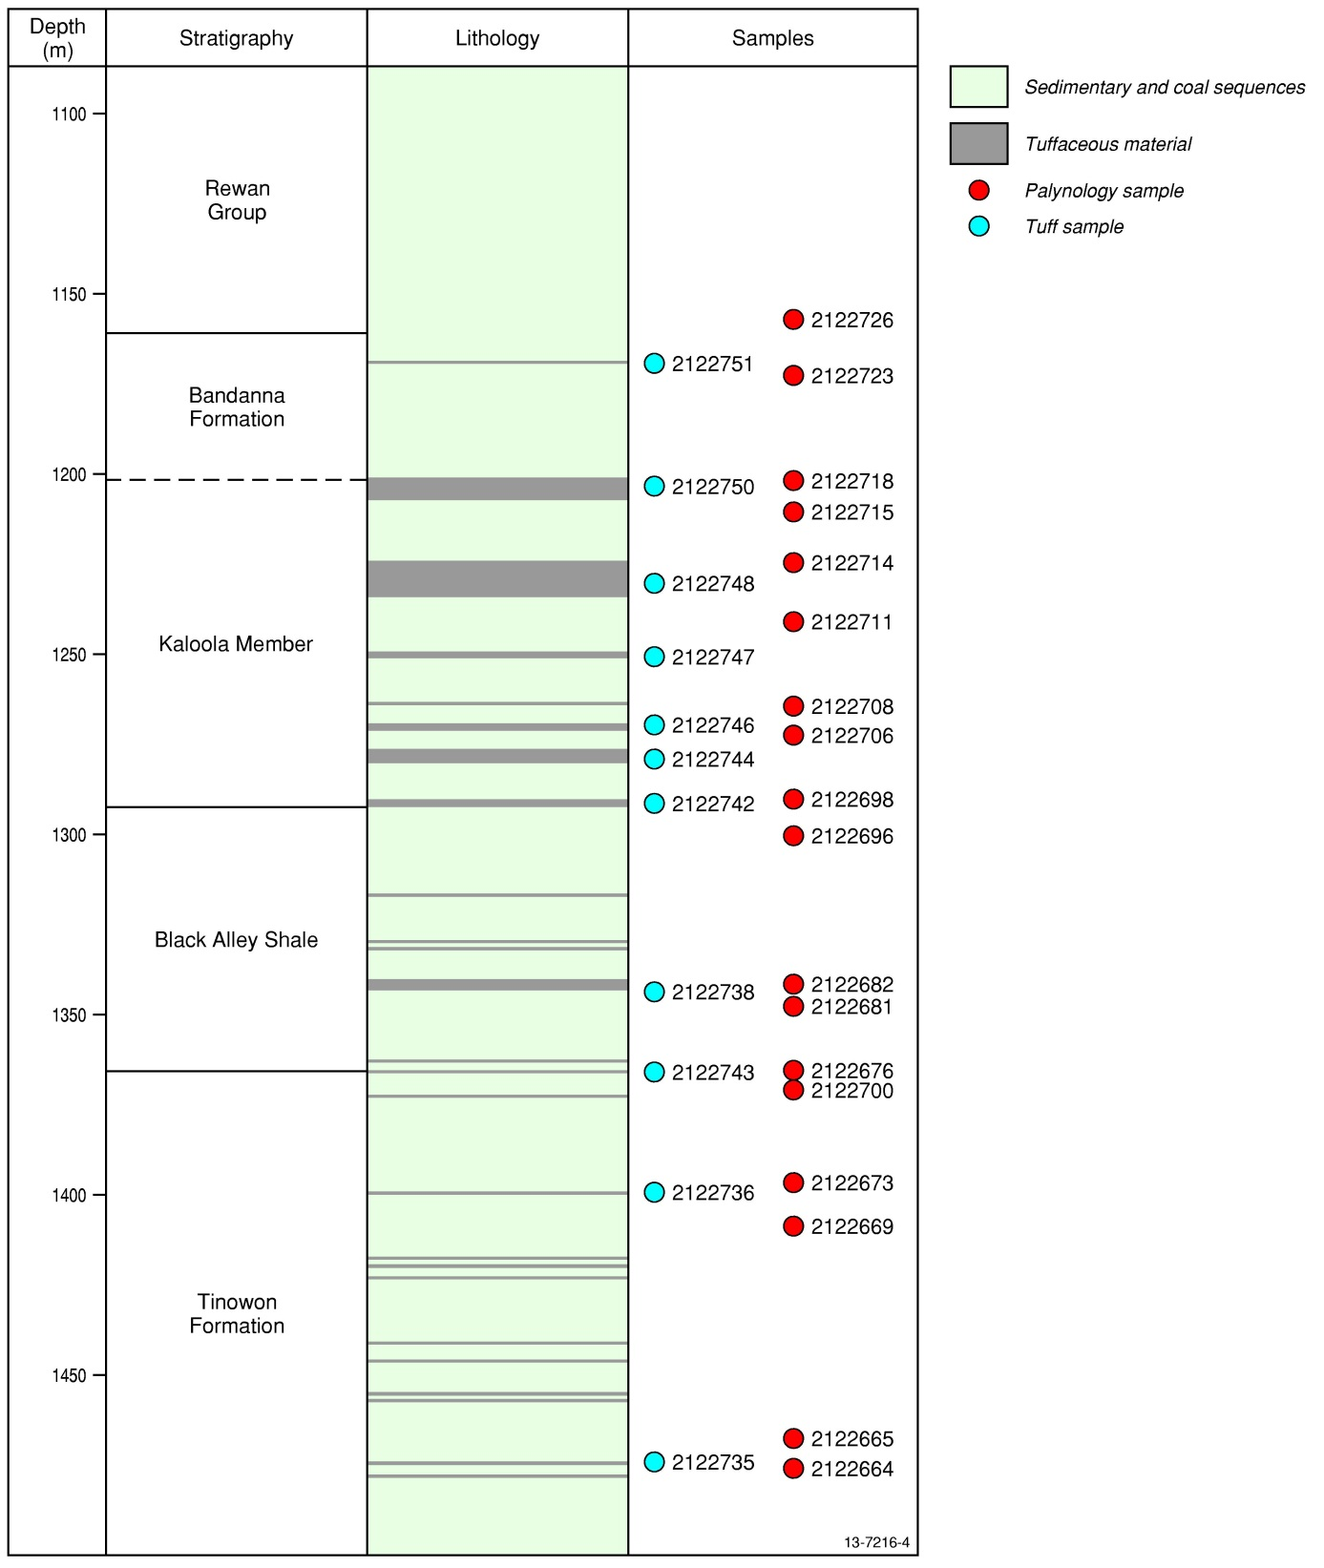
Figure 4: Stratigraphy, lithology and sampling locations of Meeleebee 5
  - Analysed Samples
Seventeen tuff samples and 68 palynology samples were collected from the Meeleebee 5 core (Appendix A). Eleven tuff samples were sent to Boise State University for high precision CA-IDTIMS U-Pb zircon dating. Samples were analysed using laboratory procedures outlined by Mattinson (2005) and results for seven samples are now available (Table 1). All 68 palynology samples were processed by the Geoscience Australia Palaeontology and Sedimentology Laboratory. Standard palynological processing procedures based on those described by Wood et al. (1996) were used to produce strew slides from all 68 samples and of these 18 were selected for inclusion in the current study. These samples were selected primarily to bracket the 11 dated tuff samples (Figure 4 and Table 1) and secondarily for the quality of preservation of the included palynomorphs.
Table 1: Meeleebee 5 samples analysed in this study. See Appendix A for the full list of collected samples.
Sample Type | Sample Number | Top Depth (m) | Base Depth (m) | CA-IDTIMS Age (Ma)*
Palynology | 2122726 | 1157.10 | 1157.13
Tuff | 2122751 | 1168.95 | 1169.36 | Pending
Palynology | 2122723 | 1172.05 | 1172.08
Palynology | 2122718 | 1201.23 | 1201.25
Tuff | 2122750 | 1202.31 | 1203.42 | 252.54 ± 0.04
Palynology | 2122715 | 1209.12 | 1209.13
Palynology | 2122714 | 1225.91 | 1225.94
Tuff | 2122748 | 1233.34 | 1234.56 | 253.32 ± 0.04
Palynology | 2122711 | 1240.75 | 1240.78
Tuff | 2122747 | 1250.61 | 1251.82 | 253.59 ± 0.13
Palynology | 2122708 | 1264.24 | 1264.27
Tuff | 2122746 | 1268.49 | 1269.03 | Pending
Palynology | 2122706 | 1270.80 | 1270.81
Tuff | 2122744 | 1279.50 | 1280.25 | 253.81 ± 0.05
Palynology | 2122698 | 1289.42 | 1289.44
Tuff | 2122742 | 1290.16 | 1291.11 | 254.10 ± 0.09
Palynology | 2122696 | 1299.40 | 1299.43
Palynology | 2122682 | 1342.37 | 1342.40
Tuff | 2122738 | 1342.82 | 1343.00 | 254.34 ± 0.08
Palynology | 2122681 | 1346.78 | 1346.81
Palynology | 2122676 | 1365.40 | 1365.44
Tuff | 2122743 | 1368.35 | 1368.59 | Pending
Palynology | 2122700 | 1370.17 | 1370.19
Palynology | 2122673 | 1396.95 | 1396.98
Tuff | 2122736 | 1398.70 | 1399.42 | 256.01 ± 0.07
Palynology | 2122669 | 1408.00 | 1408.03
Palynology | 2122665 | 1468.96 | 1468.98
Tuff | 2122735 | 1469.00 | 1469.76 | No date
Palynology | 2122664 | 1469.82 | 1469.85
* Tuff samples marked as ‘No date’ did not yield sufficient zircons for CA-IDTIMS dating. Those marked “Pending” are still to undergo analysis.
For each selected palynology sample, one filtered (14 µm) strew slide was systematically scanned using a light microscope and counts of 100 palynomorphs were made. Further scans were completed to document the presence of less abundant taxa outside the count. Forty-seven palynomorph taxa were identified to species level and 28 to genus, while the remainder were assigned to the following groupings:
- Undifferentiated spores.
- Undifferentiated taeniate bisaccate pollen.
- Undifferentiated non-taeniate bisaccate pollen.
- Undifferentiated monosaccate pollen.
- Undifferentiated non-saccate pollen.
- Undifferentiated acritarchs.
All the identified taxa are listed in Appendix B, while Appendix C documents the taxa recorded in each sample. Selected taxa including those used to characterise biozones are illustrated in Plates 1 and 2. Plant microfossil assemblages from each sample are assigned to a palynostratigraphic zone or subzone based on first appearances of index species shown in Figure 1. A high confidence rating indicates that the presence of an index species allows the sample to be assigned to a single subzone. A moderate confidence rating indicates that the samples can only be allocated to a range of subzones. A low confidence rating is applied where no index species for the zone has been identified, yet one or more other species common to the zone assemblage have made a first appearance.

Palynology of the Meeleebee 5 samples
  - Sample 2122664
Depth: 1469.82–1469.84 m
Spore-Pollen Zone (Price 1997): ?APP5005
Confidence Rating: Moderate
Depositional Environment: Probably fluvial or lacustrine environments.
Comments: 34% spores, 64% pollen, 2% acritarchs. The palynomorph assemblage includes 10 of the 20 taxa described as common for Upper Stage 5 by Foster (1982). Biostratigraphically important species include Dulhuntyispora parvithola and a possible Microreticulatisporites bitriangularis. Taeniate bisaccate pollen are abundant, with Protohaploxypinus spp. making up 41% of the count. Common taxa (5%-15%) include Leiotriletes spp. and non-taeniate bisaccate pollen. Although counts for other taxa are mostly low, the assemblage is diverse, with at least 31 taxa present. The undifferentiated spore count is high (19%) due to poor preservation.
Important accessory species: Didecitriletes dentatus, Granulatisporites micronodosus, Granulatisporites trisinus, Horriditriletes tereteangulatus, Interradispora daedala, Microbaculispora tentula, Microfoveolatispora explicita, Phaselisporites cicatricosus, Pseudoreticulatispora pseudoreticulata, Retusotriletes nigritellus, Marsupipollenites striatus, Praecolpatites sinuosus, Scheuringipollenites ovatus and Striatoabieites multistriatus.
  - Sample 2122665
Depth: 1468.96–1468.98 m
Spore-Pollen Zone (Price 1997): ?APP5005
Confidence Rating: Moderate
Depositional Environment: Probably fluvial or lacustrine environments.
Comments: 27% spores, 72% pollen, 1% acritarchs. The palynomorph assemblage includes 14 of the 20 taxa described as common for Upper Stage 5 by Foster (1982). Biostratigraphically important species include Dulhuntyispora parvithola and a possible Microreticulatisporites bitriangularis. Bisaccate pollen are abundant, with Protohaploxypinus spp. making up 43% of the count and non-taeniate taxa 18%. Cyclogranisporites spp. is also common (5%). Although counts for other taxa are mostly low, the assemblage is diverse, with at least 31 taxa present.
Important accessory species: Didecitriletes ericianus, Granulatisporites micronodosus, Granulatisporites trisinus, Horriditriletes tereteangulatus, Indotriradites reidii, Interradispora daedala, Microbaculispora tentula, Microfoveolatispora explicita, Pseudoreticulatispora pseudoreticulata, Secarisporites bullatus, Marsupipollenites striatus, Scheuringipollenites ovatus and Striatoabieites multistriatus.
  - Sample 2122669
Depth: 1408.00–1408.03 m
Spore-Pollen Zone (Price 1997): APP5005
Confidence Rating: High
Depositional Environment: Probably fluvial or lacustrine environments.
Comments: 33% spores, 67% pollen. The palynomorph assemblage includes 12 of the 20 taxa described as common for Upper Stage 5 by Foster (1982). Biostratigraphically important species include Dulhuntyispora parvithola and Microreticulatisporites bitriangularis. Bisaccate pollen are abundant, with Protohaploxypinus spp. making up 32% of the count and non-taeniate taxa 23%. Common taxa (5%-15%) include Horriditriletes tereteangulatus and Leiotriletes spp. In total, at least 23 taxa are present.
Important accessory species: Didecitriletes dentatus, Didecitriletes ericianus, Granulatisporites sp., Granulatisporites trisinus, Indotriradites reidii, Microbaculispora sp. cf. G. micronodosus, Microbaculispora tentula, Microbaculispora villosa, Phaselisporites cicatricosus, Retusotriletes nigritellus, Marsupipollenites striatus, Praecolpatites sinuosus, Scheuringipollenites ovatus and Striatoabieites multistriatus.
  - Sample 2122673
Depth: 1396.95–1396.98 m
Spore-Pollen Zone (Price 1997): APP5005
Confidence Rating: High
Depositional Environment: Probably fluvial or lacustrine environments.
Comments: 30% spores, 69% pollen, 1% acritarchs. The palynomorph assemblage includes 12 of the 20 taxa described as common for Upper Stage 5 by Foster (1982). Biostratigraphically important species include Dulhuntyispora parvithola and a possible Microreticulatisporites bitriangularis. Bisaccate pollen are abundant, with Protohaploxypinus spp. making up 20% of the count and non-taeniate taxa 24%. Common taxa (5%-15%) include Scheuringipollenites ovatus and Striatopodocarpites spp. Although counts for other taxa are mostly low, the assemblage is diverse, with at least 26 taxa present.
Important accessory species: Didecitriletes ericianus, Granulatisporites trisinus, Horriditriletes tereteangulatus, Microbaculispora sp. cf. G. micronodosus, Microbaculispora tentula, Microfoveolatispora explicita, Praecolpatites sinuosus and Striatoabieites multistriatus.
  - Sample 2122700
Depth: 1370.17–1370.19 m
Spore-Pollen Zone (Price 1997): APP5005
Confidence Rating: High
Depositional Environment: Probably fluvial or lacustrine environments, with possible minor brackish-marine influence.
Comments: 53% spores, 44% pollen, 3% acritarchs. The palynomorph assemblage includes 11 of the 20 taxa described as common for Upper Stage 5 by Foster (1982), including Dulhuntyispora parvithola - the key APP5 index species. Non-taeniate bisaccate pollen are abundant, making up 19% of the count. Common taxa (5%-15%) include D. parvithola, Horriditriletes tereteangulatus, Leiotriletes spp. Protohaploxypinus spp. and Scheuringipollenites ovatus. In total, at least 25 taxa are present, including one acritarch genus, Micrhystridium (3%).
Important accessory species: Didecitriletes dentatus, Didecitriletes ericianus, Granulatisporites trisinus, Horriditriletes tereteangulatus, Microbaculispora sp. cf. G. micronodosus, Microbaculispora tentula, Microbaculispora villosa, Retusotriletes nigritellus, Secarisporites bullatus, Bascanisporites undosus, Marsupipollenites striatus, Praecolpatites sinuosus and Striatoabieites multistriatus.
  - Sample 2122676
Depth: 1365.40–1365.44 m
Spore Pollen Zone (Price 1997): APP5005
Confidence Rating: High
Depositional Environment: Marginal/shallow marine
Comments: 18% spores, 35% pollen, 47% acritarchs. The palynomorph assemblage includes 8 of the 20 taxa described as common for Upper Stage 5 by Foster (1982). Acritarchs are abundant, though with low diversity; Micrhystridium evansii makes up 45% of the count, representing an acme zone (Evans 1962; Price 1997) and providing evidence of some degree of salinity. Dulhuntyispora parvithola, the key APP5 index species, also occurs in this assemblage. Additionally, non-taeniate bisaccate pollen are abundant, making up a further 27% of the count, while Protohaploxypinus spp. constitutes only 6%. In total, at least 25 taxa are present, including the unusual, spinose acritarch, Mehlisphaeridium regulare.
Important accessory species: Bipartitisporites sp. A, Didecitriletes dentatus, Didecitriletes ericianus, Granulatisporites micronodosus, Granulatisporites trisinus, Horriditriletes tereteangulatus, Microbaculispora sp. cf. G. micronodosus, Microbaculispora tentula, Retusotriletes nigritellus, Bascanisporites undosus, Praecolpatites sinuosus, Scheuringipollenites ovatus and Striatoabieites multistriatus.
  - Sample 2122681
Depth: 1346.78–1346.81 m
Spore-Pollen Zone (Price 1997): APP5005
Confidence Rating: Moderate
Depositional Environment: Probably fluvial or lacustrine environments.
Comments: 31% spores, 69% pollen. The palynomorph assemblage includes 10 of the 20 taxa described as common for Upper Stage 5 by Foster (1982). Biostratigraphically important species include Dulhuntyispora parvithola and Microreticulatisporites bitriangularis. Bisaccate pollen are abundant, with Protohaploxypinus spp. making up 20% of the count and non-taeniate bisaccate pollen 26%. Common taxa (5%-15%) include Scheuringipollenites ovatus and Striatopodocarpites spp. Although counts for other taxa are mostly low, the assemblage is diverse, with at least 32 taxa present.
Important accessory species: Didecitriletes dentatus, Didecitriletes ericianus, Granulatisporites trisinus, Horriditriletes tereteangulatus, Interradispora daedala, Microbaculispora sp. cf. G. micronodosus, Microbaculispora tentula, Retusotriletes nigritellus, Secarisporites bullatus, Bascanisporites undosus, Marsupipollenites striatus, Praecolpatites sinuosus and Striatoabieites multistriatus.
  - Sample 2122682
Depth: 1342.37–1342.40 m
Spore-Pollen Zone (Price 1997): APP5005
Confidence Rating: Moderate
Depositional Environment: Lacustrine or swampy environments.
Comments: 78% spores, 21% pollen, 1% acritarchs. The palynomorph assemblage includes 8 of the 20 taxa described as common for Upper Stage 5 by Foster (1982), plus the key APP5005 subzone index species, Microreticulatisporites bitriangularis. This sample, like 2122708, is unusual due to the high ratio of spores to pollen in the assemblage. This is due to the abundance of Microbaculispora tentula (25%), which commonly occurs in large clumps throughout the sample. These clumps suggest in situ preservation, as the sporangia and the tetrads would be expected to break up as a consequence of transportation within the sediment load. The dominance of these spore masses accounts for the lower diversity of taxa (21) relative to other samples. The only other common taxa are Leiotriletes spp. (13%) and Protohaploxypinus spp. (8%).
Important accessory species: Didecitriletes dentatus, Didecitriletes ericianus, Granulatisporites trisinus, Horriditriletes tereteangulatus, Interradispora daedala, Microbaculispora sp. cf. G. micronodosus, Microbaculispora tentula, Retusotriletes nigritellus, Secarisporites bullatus, Bascanisporites undosus, Marsupipollenites striatus, Praecolpatites sinuosus and Striatoabieites multistriatus.
  - Sample 2122696
Depth: 1299.40–1299.43 m
Spore-Pollen Zone (Price 1997): APP5005
Confidence Rating: Moderate
Depositional Environment: Probably fluvial or lacustrine environments.
Comments: 47% spores, 53% pollen. The palynomorph assemblage includes 10 of the 20 taxa described as common for Upper Stage 5 by Foster (1982). Dulhuntyispora parvithola, the key APP5 index species, also occurs in this assemblage. A tentative identification of the early-middle Permian spore, Propinquispora praetholus could indicate reworking in this sample. Bisaccate pollen are abundant, with taeniate taxa making up 22% of the count and non-taeniate taxa 20%. Common taxa (5%-15%) include Leiotriletes spp., Microbaculispora sp. cf. G. micronodosus and undifferentiated monosaccate pollen. This is the most diverse sample analysed, with at least 33 taxa present.
Important accessory species: Didecitriletes dentatus, Didecitriletes ericianus, Dulhuntyispora dulhuntyi, Granulatisporites micronodosus, Granulatisporites trisinus, Horriditriletes tereteangulatus, Indotriradites reidii, Interradispora daedala, Microbaculispora tentula, Microfoveolatispora explicita, Phaselisporites cicatricosus, Retusotriletes nigritellus, Bascanisporites undosus, Praecolpatites sinuosus, Scheuringipollenites ovatus and Striatoabieites multistriatus.
  - Sample 2122698
Depth: 1289.42–1289.44 m
Spore-Pollen Zone (Price 1997): APP5005
Confidence Rating: Moderate
Depositional Environment: Probably fluvial or lacustrine environments.
Comments: 50% spores, 50% pollen. The palynomorph assemblage includes 10 of the 20 taxa described as common for Upper Stage 5 by Foster (1982), including Dulhuntyispora parvithola, the key APP5 index species. Bisaccate pollen are abundant, with taeniate taxa making up 17% of the count and non-taeniate taxa 28%. Common taxa (5%-15%) include D. parvithola, Granulatisporites trisinus, Leiotriletes spp. and Microbaculispora sp. cf. G. micronodosus. In total, at least 24 taxa are present.
Important accessory species: Didecitriletes dentatus, Didecitriletes ericianus, Horriditriletes tereteangulatus, Indotriradites reidii, Microbaculispora tentula, Microfoveolatispora explicita, Phaselisporites cicatricosus, Secarisporites bullatus, Bascanisporites undosus, Praecolpatites sinuosus, Scheuringipollenites ovatus and Striatoabieites multistriatus.
  - Sample 2122706
Depth: 1270.80–1270.81 m
Spore-Pollen Zone (Price 1997): APP5005
Confidence Rating: Moderate
Depositional Environment: Probably fluvial or lacustrine environments.
Comments: 34% spores, 66% pollen. The palynomorph assemblage includes 11 of the 20 taxa described as common for Upper Stage 5 by Foster (1982). Dulhuntyispora parvithola, the key APP5 index species, also occurs in this assemblage. Non-taeniate bisaccate pollen are abundant, making up 50% of the count. Common taxa (5%-15%) include Leiotriletes spp. and Protohaploxypinus spp. Although counts for other taxa are mostly low, the assemblage is diverse, with at least 28 taxa present.
Important accessory species: Didecitriletes ericianus, Granulatisporites trisinus, Horriditriletes tereteangulatus, Interradispora daedala, Microbaculispora sp. cf. G. micronodosus, Microbaculispora tentula, Retusotriletes nigritellus, Phaselisporites cicatricosus, Secarisporites bullatus, Bascanisporites undosus, Praecolpatites sinuosus, Scheuringipollenites ovatus and Striatoabieites multistriatus.
  - Sample 2122708
Depth: 1264.24–1264.27 m
Spore-Pollen Zone (Price 1997): APP5005
Confidence Rating: Moderate
Depositional Environment: Probably fluvial or lacustrine environments.
Comments: 77% spores, 23% pollen. The palynomorph assemblage includes only 5 of the 20 taxa described as common for Upper Stage 5 by Foster (1982), although it does include the key APP5 index species, Dulhuntyispora parvithola. This sample, like 2122682, is unusual, due to the high ratio of spores to pollen. Poor preservation may account for this, as well as the lower diversity of taxa (19) and high undifferentiated spore count (28%). Common taxa (5%-15%) include Leiotriletes spp. and Protohaploxypinus spp.
Important accessory species: Didecitriletes ericianus, Granulatisporites micronodosus, Granulatisporites trisinus, Horriditriletes tereteangulatus, Indotriradites reidii, Interradispora daedala, Microbaculispora sp. cf. G. micronodosus and Microbaculispora tentula.
  - Sample 2122711
Depth: 1240.75–1240.78 m
Spore-Pollen Zone (Price 1997): APP5005
Confidence Rating: Moderate
Depositional Environment: Probably fluvial or lacustrine environments.
Comments: 50% spores, 50% pollen. The palynomorph assemblage includes 10 of the 20 taxa described as common for Upper Stage 5 by Foster (1982), including the key APP5 index species, Dulhuntyispora parvithola. Bisaccate pollen are abundant, with taeniate taxa making up 21% of the count and non-taeniate taxa 27%. Common taxa (5%-15%) include Horriditriletes tereteangulatus, Leiotriletes spp. Protohaploxypinus spp. and Striatopodocarpites spp. Although counts for other taxa are mostly low, the assemblage is diverse, with at least 25 taxa present.
Important accessory species: Didecitriletes dentatus, Didecitriletes ericianus, Granulatisporites micronodosus, Granulatisporites trisinus, Microbaculispora sp. cf. G. micronodosus, Microbaculispora tentula, Microfoveolatispora explicita, Retusotriletes nigritellus, Praecolpatites sinuosus, Scheuringipollenites ovatus and Striatoabieites multistriatus.
  - Sample 2122714
Depth: 1225.91–1225.94 m
Spore-Pollen Zone (Price 1997): APP5005
Confidence Rating: Moderate
Depositional Environment: Lacustrine or swampy environments.
Comments: 51% spores, 49% pollen. The palynomorph assemblage includes 7 of the 20 taxa described as common for Upper Stage 5 by Foster (1982). Bisaccate pollen are abundant, with taeniate taxa making up 19% of the count and non-taeniate taxa 28%. Common taxa include Lophotriletes spp. (14%) and Granulatisporites absonus (12%), both of which commonly occur in large clumps throughout the sample. Protohaploxypinus spp. are also common (13%). This sample displays the lowest diversity of any of the studied samples, with 18 taxa.
Important accessory species: Granulatisporites micronodosus, Horriditriletes tereteangulatus, Microbaculispora tentula, Scheuringipollenites ovatus and Striatoabieites multistriatus.
  - Sample 2122715
Depth: 1209.12–1209.13m
Spore-Pollen Zone (Price 1997): APP5005
Confidence Rating: Moderate
Depositional Environment: Probably fluvial or lacustrine environments.
Comments: 41% spores, 58% pollen, 1% acritarchs. The palynomorph assemblage includes 11 of the 20 taxa described as common for Upper Stage 5 by Foster (1982), plus the key APP5005 subzonal index species, Microreticulatisporites bitriangularis. Bisaccate pollen are abundant, with taeniate and non-taeniate taxa each making up 28% of the count. Common taxa (5%-15%) include Leiotriletes spp. Chordasporites spp. Protohaploxypinus spp. and Scheuringipollenites ovatus. Although counts for other taxa are mostly low, the assemblage is diverse, with at least 29 taxa present.
Important accessory species: Didecitriletes dentatus, Didecitriletes ericianus, Granulatisporites micronodosus, Granulatisporites trisinus, Horriditriletes tereteangulatus, Interradispora daedala, Microbaculispora sp. cf. G. micronodosus, Microbaculispora tentula, Microfoveolatispora explicita, Phaselisporites cicatricosus, Secarisporites bullatus, Praecolpatites sinuosus and Striatoabieites multistriatus.
  - Sample 2122718
Depth: 1201.23–1201.25 m
Spore-Pollen Zone (Price 1997): APP5005
Confidence Rating: Moderate
Depositional Environment: Probably fluvial or lacustrine environments.
Comments: 33% spores, 67% pollen. The palynomorph assemblage includes 10 of the 20 taxa described as common for Upper Stage 5 by Foster (1982). Bisaccate pollen are abundant, with taeniate taxa making up 36% of the count and non-taeniate bisaccate pollen 29%. Common taxa (5%-15%) include Leiotriletes spp., Microbaculispora sp. cf. G. micronodosus Protohaploxypinus spp. and Striatoabieites multistriatus. Although counts for other taxa are mostly low, the assemblage is diverse, with at least 32 taxa present.
Important accessory species: Didecitriletes ericianus, Dulhuntyispora dulhuntyi, Granulatisporites trisinus, Horriditriletes tereteangulatus, Interradispora daedala, Microbaculispora tentula, Microfoveolatispora explicita, Phaselisporites cicatricosus, Praecolpatites sinuosus and Scheuringipollenites ovatus.
  - Sample 2122723
Depth: 1172.05–1172.08 m
Spore-Pollen Zone (Price 1997): APP5005
Confidence Rating: Moderate
Depositional Environment: Probably fluvial or lacustrine environments.
Comments: 55% spores, 44% pollen, 1% acritarchs. The palynomorph assemblage includes 7 of the 20 taxa described as common for Upper Stage 5 by Foster (1982). Bisaccate pollen are abundant, with taeniate taxa making up 22% of the count and non-taeniate taxa 17%. Common taxa (5%-15%) include Granulatisporites absonus, Horriditriletes tereteangulatus, Leiotriletes spp. Protohaploxypinus spp. and Scheuringipollenites ovatus. In total, at least 25 taxa are present.
Important accessory species: Didecitriletes dentatus, Didecitriletes ericianus, Dulhuntyispora dulhuntyi, Granulatisporites trisinus, Interradispora daedala, Microbaculispora sp. cf. G. micronodosus, Microbaculispora tentula, Phaselisporites cicatricosus, Praecolpatites sinuosus and Striatoabieites multistriatus.
  - Sample 2122726
Depth: 1157.10–157.13 m
Spore-Pollen Zone (Price 1997): ?APP6–APP5
Confidence Rating: Low
Depositional Environment: Probably fluvial or lacustrine environments.
Comments: 63% spores, 37% pollen. The assemblage from this sample contains the first record of Triquitrites proratus, which occurs in the Playfordiaspora crenulata zone, as defined by Foster (1982). The remaining assemblage is typical of Upper Stage 5, including 7 of the 20 taxa described as common for Upper Stage 5 by Foster (1982). However, no other species diagnostic of the Playfordiaspora crenulata zone occur in this sample. Bisaccate pollen are abundant, with taeniate taxa making up 18% of the count and non-taeniate bisaccate pollen 13%. Other common taxa (5%-15%) include Leiotriletes spp., Protohaploxypinus spp. and undifferentiated monosaccate pollen. In total, 26 taxa are present.
Important accessory species: Dulhuntyispora dulhuntyi, Granulatisporites micronodosus, Horriditriletes tereteangulatus, Interradispora daedala, Microbaculispora sp. cf. G. micronodosus, Microbaculispora tentula, Phaselisporites cicatricosus, Marsupipollenites striatus, Praecolpatites sinuosus, Scheuringipollenites ovatus and Striatoabieites multistriatus.

Discussion
The presence of Dulhuntyispora parvithola in most samples, including the lowest in the sequence (2122664), indicates the entire sequence belongs to the APP5 zone. The presence of many species from the list given by Foster (1982; see above) supports this conclusion. Other species that were commonly identified in this study, which are not listed by Foster (1982), include:
- Granulatisporites trisinus
- Horriditriletes tereteangulatus
- Leiotriletes spp.
- Microbaculispora tentula
- Microbaculispora sp. cf. G. micronodosus
- Praecolpatites sinuosus
Although these are species that make their first appearances in the early to middle Permian, they are also found in Stage 5 assemblages (Backhouse 1991; Foster 1979). Microreticulatisporites bitriangularis is definitely recorded in the third sample (2122669; Figure 4) from the base of the sequence thus placing this sample in APP5005. The two preceding samples may also belong to APP5005, especially as tentative identifications of M. bitriangularis were made. However, an assignment to younger APP5 subzones cannot be ruled out. The Micrhystridium evansii acme is present in sample 2122676, an event known to occur during APP5005, though previously thought to be confined to the Denison Trough and Springsure Shelf (P3c of Evans 1962; Price 1997). All samples from above this level are assigned to APP5005, as Lycopodiumsporites ‘crassus’, the FAD of which defines the base of APP5006, was not found in this study. Price (1997) correlates the upper boundary for APP5005 with the top of the Black Alley Shale (Figure 3), but without the elusive L. ‘crassus’, this could not be confirmed herein. The uppermost sample analysed, 2122726, contained Triquitrites proratus. This species makes its first appearance in the Playfordiaspora crenulata zone of Foster (1982), yet no other species with first appearances in this zone, such as Brevitriletes hennellyi, Playfordiaspora crenulata or Triplexisporites playfordii (the FAD of which defines the base of APP6) occur in this sample. As such, this sample is only tentatively assigned to APP6.
Figure 5 shows the stratigraphic sequence in Meeleebee 5 with the spore-pollen zones determined herein added. The M. evansii acme occurs at the base of the Black Alley Shale and the base of the APP6 zone possibly lies within the uppermost Bandanna Formation, though the assignment to APP6 is very tentative. This zonation is in agreement with the lithostratigraphy and palynostratigraphy of the Bowen Basin reported by Price (1997; Figure 3).
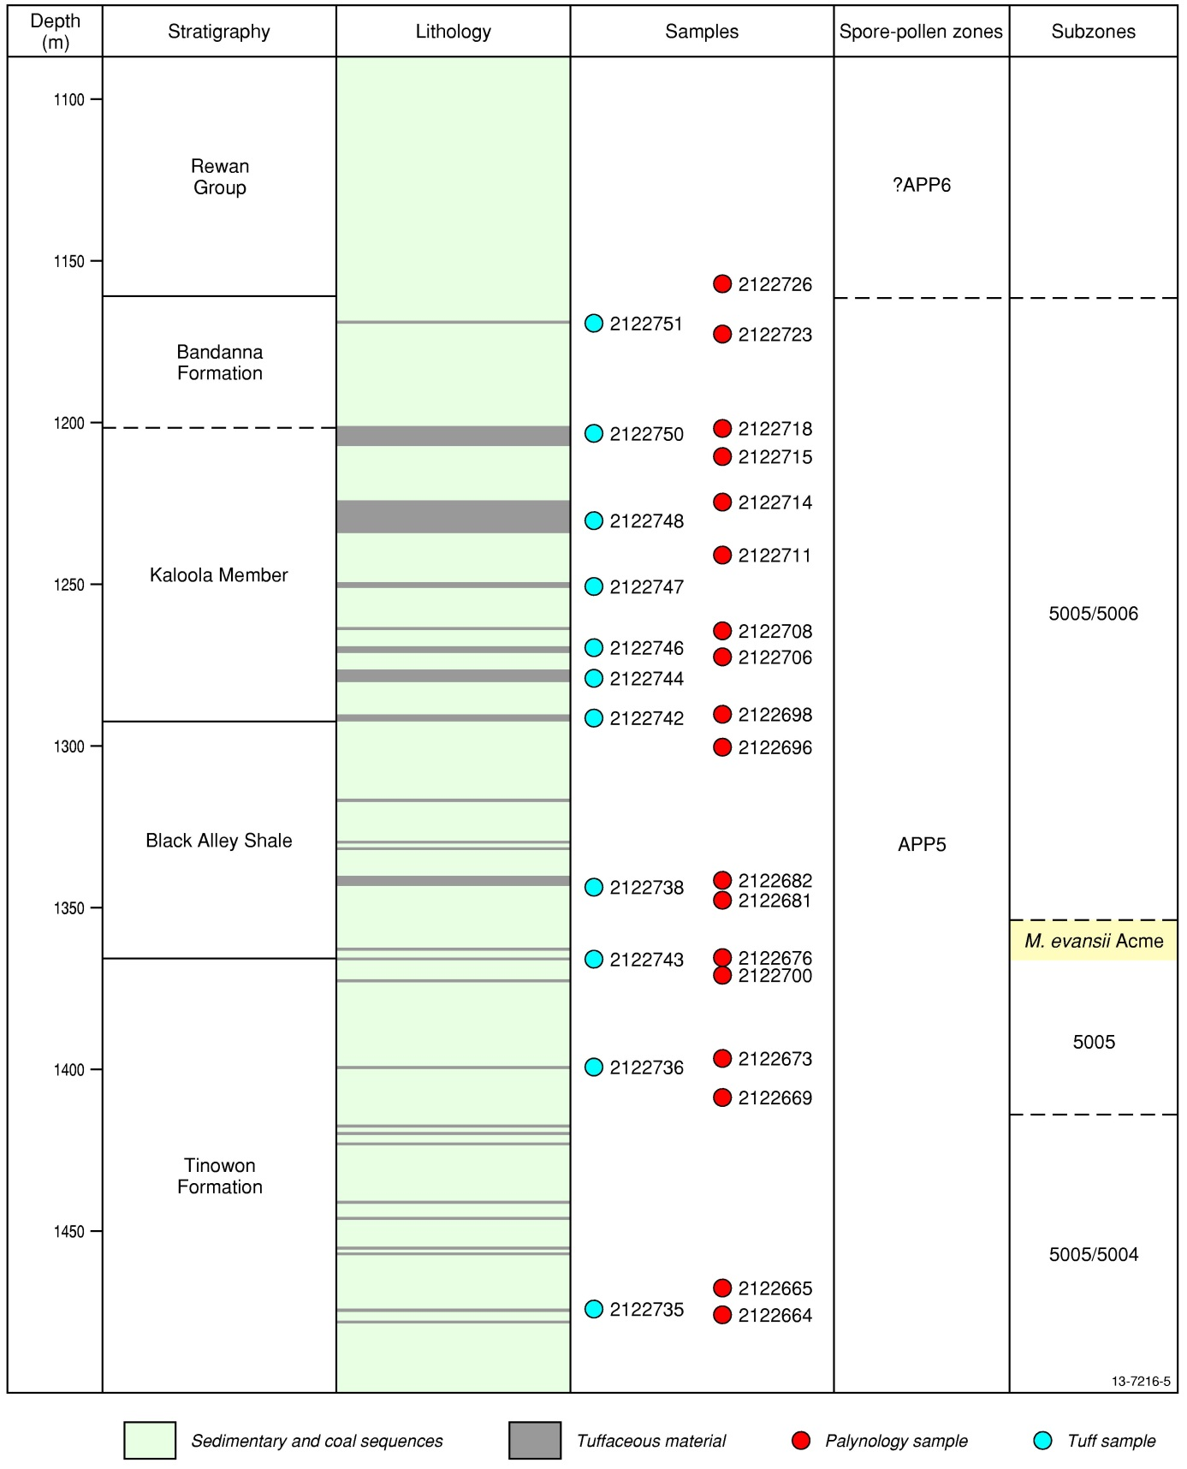
Figure 5: Stratigraphy, lithology, sampling locations and palynostratigraphy of the sampled Meeleebee 5 well
Figure 6 shows the relationship between the numerically dated samples, palynological samples and the international time scale of Gradstein et al. (2012). All dated tuff samples are bracketed by APP5 zone palynomorphs, suggesting that the top of the APP5 zone is younger than previously proposed. It extends up to at least 252.54 ± 0.04 Ma; well in to the Changhsingian and approaching the Permian-Triassic boundary (252.16 Ma). The tentative APP6 sample (2122726) was collected from more than 45 m above this dated tuff. This result calls into question the validity of the late Permian Playfordiaspora crenulata and Protohaploxypinus microcorpus palynozones, which are either squeezed into a period of less than 400 ky, or are forced into the early Triassic. This result is corroborated by the results of Mantle et al. (2011), who analysed palynomorphs in the Sydney Basin, similarly bracketing CA-IDTIMS dated tuffs. They found the APP5 zone to extend up to at least 253.14 ± 0.04 Ma in the Wybong 1 well and likewise found the Praecolpatites sinuosus zone to be younger than expected in the Sandy Creek 32 well, bracketing an age of 271.60 ± 0.11 Ma. They did find, however, that the date of 248.23 ± 0.13 Ma for the Aratrisporites tenuispinosus zone, obtained for an outcrop sample from Bulli Tops lies within the currently accepted age range of this zone, suggesting that not all of the Permian–Triassic palynozones require revision.
Other chronometric tie-points provided by these CA-IDTIMS ages include the M. evansii acme at the base of the Black Alley Shale and the first appearance datum for M. bitriangularis. The M. evansii acme can be constrained to the late Wuchiapingian, somewhere between 256.01 ± 0.04 and 254.34 ± 0.08 Ma. The M. evansii acme sample (2122767) was collected from one metre below an undated tuff (2122737; Appendix A). A brief examination of sample 2122677 indicates that the M. evansii acme is also present above this tuff, suggesting that CA-IDTIMS dating of this sample would provide a precise age for this event. The first appearance datum for M. bitriangularis in Meeleebee 5 occurs in a sample located immediately below the lowest dated tuff, which places it near the top of the APP5005 Subzone of Price (1997), for which this species is the index. There were, however, tentative identifications of M. bitriangularis in samples from up to 62 metres lower in the Meeleebee 5 core, suggesting this sub-zone may actually extend to well below the dated age of 256.01 ± 0.07 Ma.
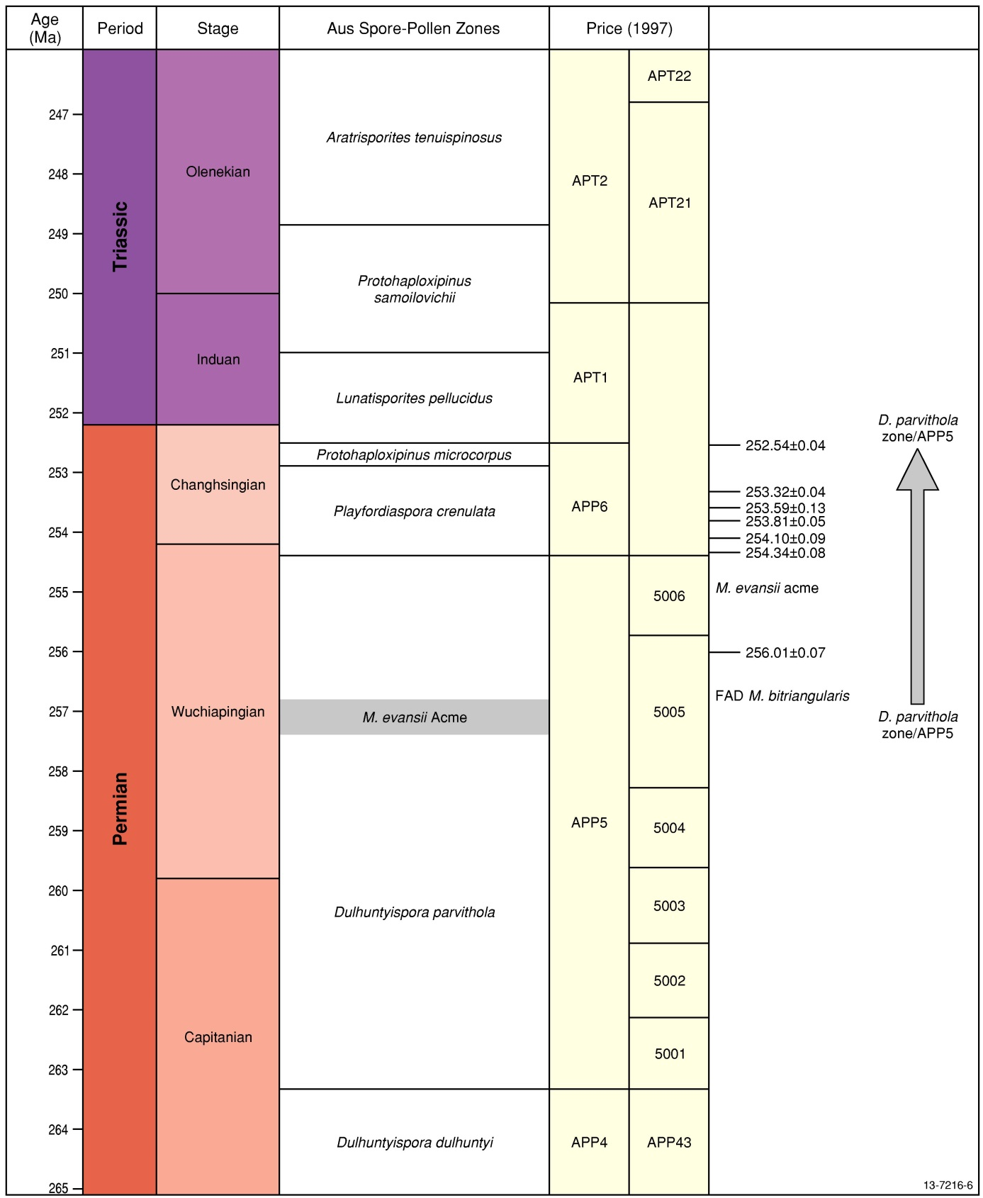
Figure 6: Meeleebee 5 CA-IDTIMS ages and palynological results, compared to the International Timescale (Gradstein et al. 2012) and eastern Australian Spore-Pollen zonations (Foster 1982; Price 1997).

Conclusions and Recommendations
- The analysed interval of the Meeleebee 5 core primarily spans the APP5005 spore-pollen subzone and tentatively includes the base of the APP6 zone. The Micrhystridium evansii acme zone is readily identifiable in the palynological assemblage at the base of the Black Alley Shale, thus demonstrating its occurrence in Comet Ridge and expanding its regional correlative value outside the Denison Trough and Springsure Shelf.
- The CA-IDTIMS ages provide chronometric ties for the palynozones to the international geological timescale, providing numeric ages for occurrences such as the M. evansii acme and at least part of APP5005.
- CA-IDTIMS results suggest significant revision to the age currently assigned to the top of the Dulhuntyispora parvithola zone is required, bringing the top of the zone close to the Permian-Triassic boundary and raising questions regarding the placement of the Playfordiaspora crenulata and Protohaploxypinus microcorpus palynozones of Foster (1982).
- It is recommended that the remaining palynological samples from the studied interval be analysed in order to further characterise and constrain the palynofloras of this well. Additionally, the Meeleebee 5 core continues above the interval sampled for this study. As such, further samples should be collected from above the uppermost samples in this study to clarify the age and location of the APP5/APP6 boundary.
- Sample 2122676, showing the M. evansii acme, is one metre below an undated tuff (2122737). A brief examination of the sample above the tuff, 2122677, indicates that the M. evansii acme is also expressed above the tuff, and as such, dating of this ash layer would provide a precise age for this well known intra-basinal event.

Acknowledgements
The authors thank Origin Energy Limited for providing access to the APLNG Meeleebee 5 well for sampling and J.S Crowley of Boise State University and I. Metcalfe of University of New England for providing CA-IDTIMS ages. J.R. Laurie and C.B Foster are greatly thanked for their perceptive and constructive comments when reviewing the manuscript. TS is particularly grateful to D. Mantle and C.B. Foster for their palynological tutelage and advice, for which they are warmly thanked.

References
Backhouse, J., 1991. Permian Palynostratigraphy of the Collie Basin, Western Australia. Review of Palaeobotany and Palynology, 67, 237-314.
Christopher, R.A. & Goodman, D.K., 1996. Introduction to biostratigraphy and time scales. In Jansonius, J. & McGregor, D.C. eds., Palynology: Principles & Applications. Vol. 2: Applications. American Association of Stratigraphic Palynologists Foundation: Texas, USA, 463-492.
Dickins, J.M. & Malone, E.J., 1971. Geology of the Bowen Basin, Queensland. Bureau of Mineral Resources Record 1971/64, 284pp.
Evans, P.R., 1962. Palynological examination of AAO Westgrove 2 Well, Surat Basin, Queensland. Mines Administration Pty Ltd, Well Completion Report, Q/55-56, P/110.
Evans, P.R., 1966. Mesozoic stratigraphic palynology in Australia. Australasian Oil and Gas Gazette, 12, 58-63.
Evans, P.R., 1970. Upper Carboniferous and Permian Palynological Stages and their Distribution in Eastern Australia. Bureau of Mineral Resources Record 1967/99, 17pp.
Foster, C.B., 1979. Permian Plant Microfossils of the Blair Athol Coal Measures, Baralaba Coal Measures, and Basal Rewan Formation of Queensland. Publication of the Geological Survey of Queensland 372, Palaeontological Paper 45, 244pp
Foster, C.B., 1982. Spore-pollen assemblages of the Bowen Basin, Queensland (Australia): their relationship to the Permian/Triassic boundary. Review of Palaeobotany and Palynology, 36, 165-183.
Geoscience Australia and ABARE, 2010. Australian Energy Resource Assessment, Canberra.
Goscombe, P.W. & Coxhead, B.A., 1995. Clarence-Moreton, Surat, Eromanga, Nambour and Mulgildie Basins. In: Ward, C. R., Harrington, H. J., Mallett, C. W. & Beeston, J. W eds., Geology of Australian Coal Basins. Geological Society of Australia Coal Geology Group Special Publication, 1, 489-511.
Gradstein, F.M., Ogg, J.G. Schmitz, M.D. & Ogg, G.M. eds., 2012. The Geologic Time Scale 2012; Volumes 1 & 2.. Elsevier BV, 1144pp.
Hochuli, P.A., Hermann, E., Vigran, J.O., Bucher, H. & Weissert, H., 2010. Rapid demise and recovery of plant systems across the end-Permian extinction event. Global and Planetary Change, 74, 144-155.
Mallett, C.W., Pattinson, C., McLennan, T., Balfe, P. & Sullivan, D., 1995. Bowen Basin. In Ward, C.R., Harrington, H.J., Mallett, C.W. & Beeston, J.W. eds., Geology of Australian Coal Basins. Geological Society of Australia Coal Geology Group Special Publication, 1, 299-340.
Mantle, D., Foster, C.B., Nicoll, R.S., Metcalfe, I., Crowley, J., Mundil, R., & Kelly, T.E., 2011. Late Permian-Early Triassic palynology of the Bowen and Sydney Basins: results and implications of new CA-IDTIMS isotopic ages. In Hakasson, E. & Trotter, J.A. eds. Record - Geological Survey of Western Australia, 90, Programme and abstracts; the XVII international congress on the Carboniferous and Permian, 2011, 93p.
Mattinson, J.M., 2005. Zircon U-Pb chemical abrasion (“CA-IDTIMS”) method: Combined annealing and multi-step partial dissolution analysis for improved precision and accuracy of zircon ages. Chemical Geology, 220, 47-66.
Mundil, R., Ludwig, K.R., Metcalfe, I. & Renne, P.R., 2004. Age and timing of the Permian mass extinctions: U/Pb dating of closed-systems zircons. Science, 305, 1760-1763.
Price, P.L., 1997. Permian to Jurassic palynostratigraphic nomenclature of the Bowen and Surat Basins. In Green, P. M. ed., The Surat and Bowen Basins, south-east Queensland. Queensland Minerals and Energy Review Series, Queensland Department of Mines and Energy. 137-178.
Price, P.L., Filatoff, J., Williams, A.J., Pickering, S.A. & Wood, G.R. 1985. Late Palaeozoic and Mesozoic palynostratigraphical units. CSR Oil and Gas Division, Palynological Facility Report 274/25. Department of Mines and Energy, Queensland CR 14012.
Riley, J.M., 2004. The rise and rise of coal seam gas in the Bowen Basin. Oil & Gas Gazette, July, 20-23.
Wood, G.D., Gabriel, A.M. & Lawson, J.C., 1996. Palynological techniques – processing and microscopy. In Jansonius, J. & McGregor, D. C. eds., Palynology: Principles & Applications. Vol. 1: Principles. American Association of Stratigraphic Palynologists Foundation: Texas, USA. 29-50.

Plates
  - Plate 1
- Brevitriletes levis (Balme & Hennelly) Bharadwaj & Srivastava 1969. Meeleebee 5, sample 2122665, slide 2, EF S36/3. CPC 41374.
- Microfoveolatispora explicita Foster 1979. Meeleebee 5, sample 2122680, slide 1, EF D30/4. CPC 41375.
- Microreticulatisporites bitriangularis Balme & Hennelly 1956. Meeleebee 5, sample 2122715, slide 1, EF P36/3. CPC 41376
- Interradispora daedala Foster 1979. Meeleebee 5, sample 2122715, slide 1, EF P42/0. CPC 41377
- Bipartitisporis sp. A Foster 1979. Meeleebee 5, sample 2122676, slide 2, EF U24/1. CPC 41378
- Dulhuntyispora parvithola (Balme & Hennelly) Potonié 1960. Meeleebee 5, sample 2122669, slide 1, EF M43/4. CPC 41379
- Triquitrites proratus Potonié & Kremp 1970. Meeleebee 5, sample 2122726, slide 1, EF L40/0. CPC 41380
- Granulatisporites trisinus Balme & Hennelly 1956. Meeleebee 5, sample 2122698, slide 2, EF T20/0. CPC 41381
- Microbaculispora 'arbroathensis' (informal). Meeleebee 5, sample 2122698, slide 3, EF F36/2. CPC 41382
- Microbaculispora villosa (Balme & Hennelly) Bharadwaj 1962. Meeleebee 5, sample 2122669, slide 1, EF X45/1. CPC 41383
- Microbaculispora villosa (Balme & Hennelly) Bharadwaj 1962. Meeleebee 5, sample 2122700, slide 3, EF O26/1. CPC 41384
- Didecitriletes ericianus (Balme & Hennelly) Venkatachala & Kar 1965. Meeleebee 5, sample 2122669, slide 1, EF O40/4. CPC 41385
- Didecitriletes dentatus (Balme & Hennelly) Venkatachala & Kar 1965. Meeleebee 5, sample 2122700, slide 3, EF O44/0. CPC 41386
  - Plate 2
- Striatoabieites multistriatus (Balme & Hennelly) Hart 1964. Meeleebee 5, sample 2122665, slide 2, EF K33/0. CPC 41387
- Phaselisporites cicatricosus (Balme & Hennelly) Price 1983. Meeleebee 5, sample 2122669, slide 1, EF U17/1. CPC 41388
- Micrhystridium sp. A Foster 1979. Meeleebee 5, sample 2122680, slide 1, EF S49/2. CPC 41389
- Micrhystridium evansii Price 1983. Meeleebee 5, sample 2122676, slide 2, EF G35/1. CPC 41390
- Limitisporites rectus Leschik 1956. Meeleebee 5, sample 2122680, slide 1, EF M36/3. CPC 41391
- Indotriradites reidii Foster 1979. Meeleebee 5, sample 2122669, slide 1, EF L21/1. CPC 41392
- Marsupipollenites striatus (Balme & Hennelly) Foster 1975. Meeleebee 5, sample 2122700, slide 3 EF J33/0. CPC 41393
- Taeniate bisaccate pollen (intermediate form showing characteristics of Lunatisporites Leschik emend. Mädler 1964 and Lueckisporites Potonié & Klaus emend. Klaus 1963). Meeleebee 5, sample 2122665, slide 2, EF R18/1. CPC 41394
- Scheuringipollenites ovatus (Balme & Hennelly) Foster 1975. Meeleebee 5, sample 2122680, slide 1, EF O33/0. CPC 41395
- Marsupipollenites triradiatus Balme & Hennelly 1956. Meeleebee 5, sample 2122669, slide 1, EF L17/0. CPC 41396
- Protohaploxypinus spp. Meeleebee 5, sample 2122680, slide 1, EF R50/0. CPC 41397
- Bascanisporites undosus Balme & Hennelly 1956. Meeleebee 5, sample 2122680, slide 1, EF V50/0. CPC 41398
- Praecolpatites sinuosus (Balme & Hennelly) Bharadwaj & Srivastava 1969. Meeleebee 5, sample 2122676, slide 2, EF N15/1. CPC 41399
Plate 1
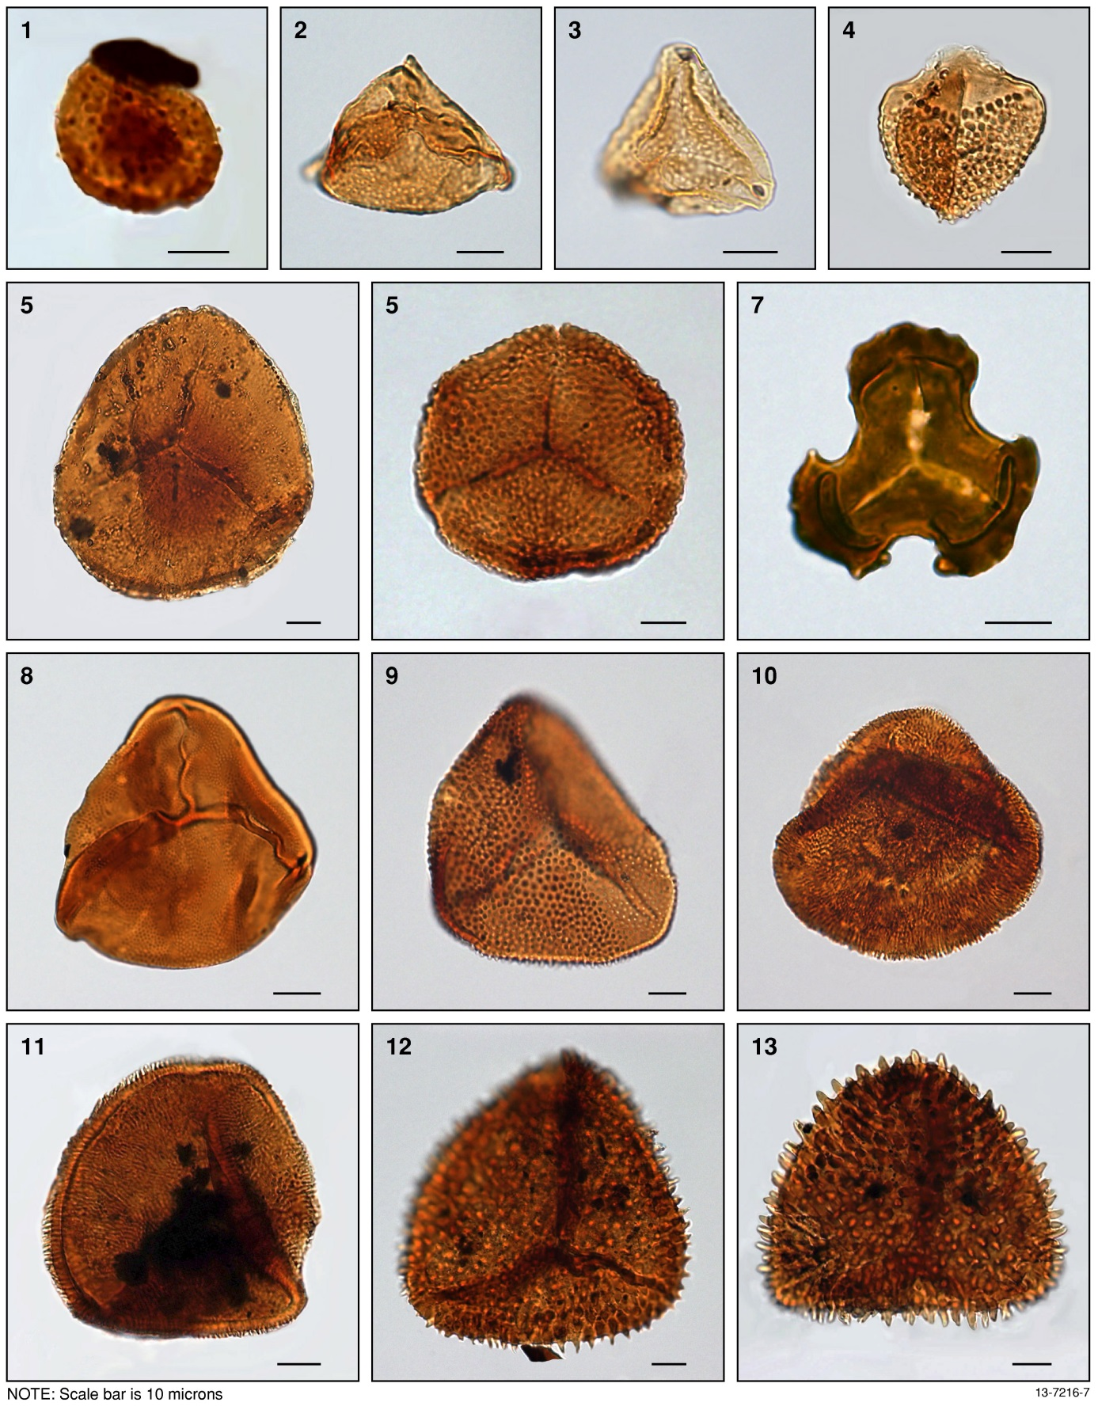

Plate 2
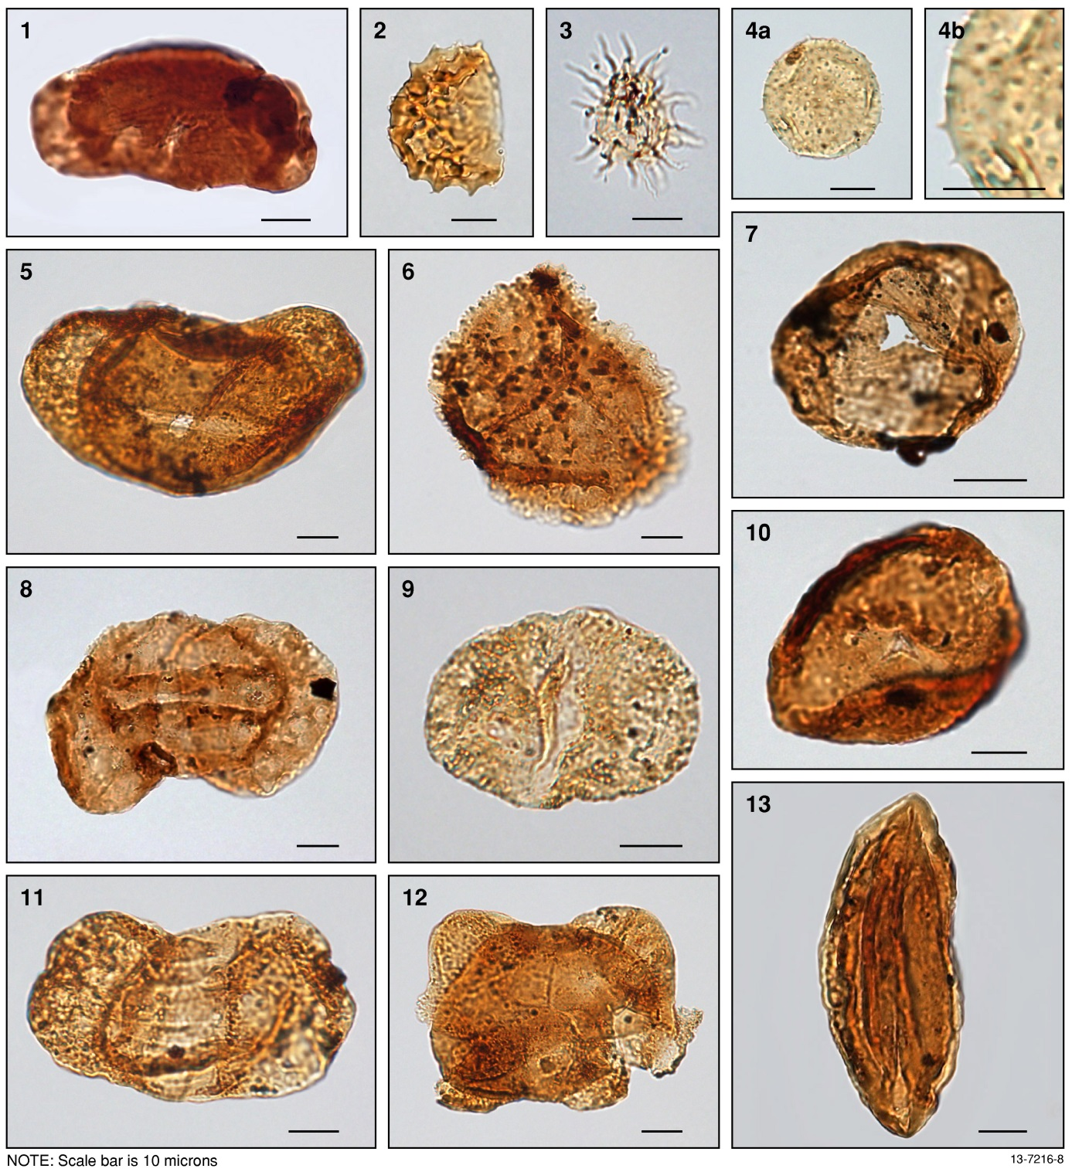

: Full Table of Meeleebee 5 samples
Sample type | Sample number | Top depth (m) | Base depth (m) | Selected for analysis
Palynology | 2122727 | 1155.000 | 1155.050
Palynology | 2122728 | 1156.760 | 1156.800
Palynology | 2122726 | 1157.100 | 1157.130 | √
Palynology | 2122725 | 1167.950 | 1168.000
Palynology | 2122724 | 1169.140 | 1169.190
Tuff | 2122751 | 1168.950 | 1169.360 | √
Palynology | 2122723 | 1172.050 | 1172.080 | √
Palynology | 2122722 | 1176.160 | 1176.180
Palynology | 2122721 | 1187.390 | 1187.410
Palynology | 2122720 | 1199.220 | 1199.250
Palynology | 2122719 | 1200.060 | 1200.080
Palynology | 2122718 | 1201.230 | 1201.250 | √
Tuff | 2122750 | 1202.310 | 1203.420 | √
Palynology | 2122717 | 1205.400 | 1205.420
Tuff | 2122749 | 1206.070 | 1206.570
Palynology | 2122716 | 1209.020 | 1209.050
Palynology | 2122715 | 1209.120 | 1209.130 | √
Palynology | 2122714 | 1225.910 | 1225.940 | √
Tuff | 2122748 | 1233.340 | 1234.560 | √
Palynology | 2122712 | 1234.560 | 1234.600
Palynology | 2122711 | 1240.750 | 1240.780 | √
Palynology | 2122710 | 1248.320 | 1248.340
Tuff | 2122747 | 1250.610 | 1251.820 | √
Palynology | 2122709 | 1253.640 | 1253.650
Palynology | 2122708 | 1264.240 | 1264.270 | √
Palynology | 2122746 | 1268.490 | 1269.030 | √
Palynology | 2122707 | 1269.920 | 1269.950
Tuff | 2122745 | 1270.060 | 1270.370
Palynology | 2122706 | 1270.800 | 1270.810 | √
Palynology | 2122705 | 1271.130 | 1271.140
Palynology | 2122704 | 1276.150 | 1276.170
Palynology | 2122703 | 1276.980 | 1277.000
Tuff | 2122744 | 1279.500 | 1280.250 | √
Palynology | 2122702 | 1281.960 | 1281.980
Palynology | 2122699 | 1288.110 | 1288.130
Palynology | 2122698 | 1289.420 | 1289.440 | √
Tuff | 2122742 | 1290.160 | 1291.110 | √
Palynology | 2122696 | 1299.400 | 1299.430 | √
Palynology | 2122697 | 1292.940 | 1299.960
Palynology | 2122695 | 1303.360 | 1303.380
Palynology | 2122694 | 1315.550 | 1315.560
Palynology | 2122693 | 1316.040 | 1316.045
Tuff | 2122741 | 1316.000 | 1316.320
Palynology | 2122692 | 1317.260 | 1317.265
Palynology | 2122691 | 1321.960 | 1321.990
Palynology | 2122690 | 1326.270 | 1326.290
Palynology | 2122689 | 1328.040 | 1328.050
Palynology | 2122688 | 1330.970 | 1331.000
Palynology | 2122687 | 1331.650 | 1331.750
Tuff | 2122739 | 1331.750 | 1331.970
Palynology | 2122686 | 1331.970 | 1332.000
Palynology | 2122713 | 1231.970 | 1332.000
Palynology | 2122685 | 1333.100 | 1333.130
Palynology | 2122684 | 1334.290 | 1334.330
Palynology | 2122683 | 1340.850 | 1340.870
Palynology | 2122682 | 1342.370 | 1342.400 | √
Tuff | 2122738 | 1342.820 | 1343.000 | √
Palynology | 2122681 | 1346.780 | 1346.810 | √
Palynology | 2122680 | 1347.160 | 1347.180
Palynology | 2122679 | 1361.200 | 1361.220
Palynology | 2122678 | 1362.100 | 1362.140
Palynology | 2122677 | 1363.270 | 1363.290
Tuff | 2122737 | 1364.330 | 1364.420
Palynology | 2122676 | 1365.400 | 1365.440 | √
Palynology | 2122701 | 1366.700 | 1366.710
Tuff | 2122743 | 1368.350 | 1368.595 | √
Palynology | 2122700 | 1370.170 | 1370.190 | √
Palynology | 2122675 | 1372.180 | 1372.200
Palynology | 2122674 | 1394.000 | 1394.020
Palynology | 2122673 | 1396.950 | 1396.980 | √
Palynology | 2122672 | 1398.700 | 1398.740
Tuff | 2122736 | 1398.700 | 1399.420 | √
Palynology | 2122671 | 1399.700 | 1399.740
Palynology | 2122670 | 1403.140 | 1403.180
Palynology | 2122669 | 1408.000 | 1408.030 | √
Palynology | 2122668 | 1437.740 | 1437.780
Palynology | 2122667 | 1455.980 | 1456.000
Palynology | 2122666 | 1465.030 | 1465.040
Palynology | 2122665 | 1468.960 | 1468.980 | √
Tuff | 2122735 | 1469.000 | 1469.760 | √
Palynology | 2122664 | 1469.820 | 1469.850 | √
Palynology | 2122663 | 1471.000 | 1471.030
Palynology | 2122662 | 1474.090 | 1474.120
Palynology | 2122661 | 1478.860 | 1478.890

: List of all identified taxa
  - Spores
- Apiculatisporis spp.
- Baculatisporites spp.
- Bipartitisporis sp. A Foster 1979
- Brevitriletes cornutus (Balme & Hennelly) Backhouse 1991
- Brevitriletes levis (Balme & Hennelly) Bharadwaj & Srivastava 1969
- Brevitriletes spp.
- Calamospora spp.
- Camptotriletes cretus Foster 1979
- Converrucosisporites pustulatus Backhouse 1988
- Cyathidities spp.
- Cyclogranisporites spp.
- Densoisporites spp.
- Dictyophyllidites spp.
- Dictyotriletes aules Rigby 1977
- Didecitriletes dentatus (Balme & Hennelly) Venkatachala & Kar 1965
- Didecitriletes ericianus (Balme & Hennelly) Venkatachala & Kar 1965
- Didecitriletes spp.
- Dulhuntyispora dulhuntyi Potonié 1956
- Dulhuntyispora parvithola (Balme & Hennelly) Potonié 1960
- Granulatisporites absonus Foster 1979
- Granulatisporites micronodosus Balme & Hennelly 1956
- Granulatisporites 'gramerus' (informal)
- Granulatisporites trisinus Balme & Hennelly 1956
- Horriditriletes filiformis (Balme & Hennelly) Backhouse 1991
- Horriditriletes ramosus (Balme & Hennelly) Bharadwaj & Salujha 1964
- Horriditriletes spp.
- Horriditriletes tereteangulatus (Balme & Hennelly) Backhouse 1991
- Indotriradites reidii Foster 1979
- Indotriradites splendens (Balme & Hennelly) Foster 1979
- Indotriradites spp.
- Interradispora daedala Foster 1979
- Jayantisporites spp.
- Leiotriletes spp.
- Lophotriletes spp.
- Microbaculispora 'arbroathensis' (informal)
- Microbaculispora sp. cf. G. micronodosus
- Microbaculispora spp.
- Microbaculispora tentula Tiwari 1965
- Microbaculispora villosa (Balme & Hennelly) Bharadwaj 1962
- Microfoveolatispora explicita Foster 1979
- Microreticulatisporites bitriangularis Balme & Hennelly 1956
- Osmundacidites spp.
- Phaselisporites cicatricosus (Balme & Hennelly) Price 1983
- Propinquispora praetholus Price 1983
- Pseudoreticulatispora pseudoreticulata (Balme & Hennelly) Bharadwaj & Salujha 1969
- Punctatisporites spp.
- Retusotriletes nigritellus (Luber) Foster 1979
- Secarisporites bullatus (Balme & Hennelly) Smith 1971
- Triquitrites proratus Balme 1970
- Verrucosisporites spp.
  - Pollen
- Bascanisporites undosus Balme & Hennelly 1956
- Chordasporites spp.
- Cycadopites spp.
- Limitisporites rectus Leschik 1956
- Lunatisporites noviaulensis (Leschik) Foster 1979
- Marsupipollenites striatus (Balme & Hennelly) Foster 1975
- Marsupipollenites triradiatus Balme & Hennelly 1956
- Platysaccus spp.
- Praecolpatites ovatus (Anderson) Backhouse 1991
- Praecolpatites sinuosus (Balme & Hennelly) Bharadwaj & Srivastava 1969
- Praecolpatites spp.
- Protohaploxypinus spp.
- Scheuringipollenites maximus (Hart) Tiwari 1973
- Scheuringipollenites ovatus (Balme & Hennelly) Foster 1975
- Striatoabieites multistriatus (Balme & Hennelly) Hart 1964
- Striatopodocarpites spp.
- Tiwariaspores simplex (Tiwari) Maheshwari & Kar 1967
- Weylandites spp.
  - Acritarchs
- Circulisporites parvus de Jersey 1962
- Maculatisporites amplus Segroves 1967
- Mehlisphaeridium regulare Anderson 1977
- Micrhystridium evansii Price 1983
- Micrhystridium sp. A Foster 1979
- Rugaletes playfordii Foster 1979

: Palynological results for selected Meeleebee 5 samples
  - Key to palynological results tables
- x = present outside count to 100 palynomorphs
- ? = tentative identification
- R = possibly reworked

  - Spores

 | Sample depth (m) | Spore-Pollen Zones (Price 1997) | Spore-Pollen Sub-zones (Price 1997) | Apiculatisporis spp. | Baculatisporites spp. | Bipartitisporis sp. A Foster 1979 | Brevitriletes cornutus | Brevitriletes levis | Brevitriletes spp. | Calamospora spp. | Camptotriletes cretus | Converrucosisporites sp. cf. pustulatus | Cyathidities spp. | Cyclogranisporites spp. | Densoisporites spp. | Dictyophyllidites spp. | Dictyotriletes aules | Didecitriletes dentatus | Didecitriletes ericianus | Didecitriletes spp. | Dulhuntyispora dulhuntyi | Dulhuntyispora parvithola | Granulatisporites absonus | Granulatisporites micronodosa | Granulatisporites 'gramerus' | Granulatisporites trisina | Granulatisporites sp. - with tall laesurae | Horriditriletes filiformis | Horriditriletes ramosus | Horriditriletes spp. | Horriditriletes tereteangulatus | Indotriradites reidii | Indotriradites splendens | Indotriridites spp. | Interradispora daedala | Jayantisporites spp. | Leiotriletes spp. | Lophotriletes spp. | Microbaculispora 'arbroathensis' | Microbaculispora 'micronodosa' | Microbaculispora spp. | Microbaculispora tentula | Microbaculispora villosa | Microfoveolatispora explicita | Microreticulatisporites bitriangularis | Osmundacidites spp. | Phaselisporites cicatricosus | Phaselisporites sp. cf. cicatricosus | Propinquispora praetholus | Pseudoreticulatispora pseudoreticulata | Punctatisporites spp. | Retusotriletes nigritellus | Secarisporites bullatus | Triquitrites proratus | Verrucosisporites spp. | Aff. Verrucosisporites | Undifferentiated spores | Undifferentiated megaspores | Total Spores
2122726 | 1157.10 - 1157.13 | ?APP6 |  | x | 1 |  | 1 |  |  | 4 |  |  | 4 | 3 |  | 3 |  |  |  |  | 1 |  |  | 3 |  |  |  |  |  |  | x |  |  |  | 3 |  | 5 | 4 |  | 3 |  | x |  |  |  | 4 | 4 | 1 |  |  |  |  |  | 1 | x | 4 | 14 |  | 63
2122723 | 1172.05 - 1172.08 | APP5 | 5005/5006 |  | 3 |  |  |  | 4 | 2 |  |  | 2 |  |  | x |  | x | 2 |  | 1 |  | 10 |  |  | x | 2 |  |  |  | 5 |  | x |  | 1 |  | 6 | 2 |  | x |  | x |  |  |  |  | 3 |  |  |  | 2 |  |  |  | x |  | 11 |  | 56
2122718 | 1201.23 - 1201.25 | APP5 | 5005/5006 |  | 2 |  | 2 |  |  | x |  |  | 2 | 1 | x | x | x |  | 1 |  | x |  |  |  |  | 1 | 1 | x |  |  | 3 |  |  | 1 | 2 |  | 5 | x |  | 5 | 2 | x |  | x |  |  | x |  |  |  | x |  |  |  | x |  | 8 |  | 36
2122715 | 1209.12 - 1209.13 | APP5 | 5005/5006 |  | 2 |  | x |  |  | 3 |  | x | 1 |  |  | x |  | x | 1 |  |  |  |  | x |  | x | 3 | 1 |  |  | 1 |  |  | x | x |  | 8 | 1 |  | 4 |  | 2 |  | 1 | x | 2 | x |  |  |  | x |  |  |  | x |  | 11 |  | 41
2122714 | 1225.91 - 1225.94 | APP5 | 5005/5006 |  | x |  |  |  |  | x |  |  | 1 | 1 | ? |  |  |  |  |  |  |  | 12 | 1 |  | x |  | x |  | 1 | x |  |  |  |  |  | 2 | 14 |  |  |  | x |  |  |  | 3 |  |  |  |  | 1 |  |  |  |  |  | 15 |  | 51
2122711 | 1240.75 - 1240.78 | APP5 | 5005/5006 |  |  |  | x |  |  | 1 |  |  | 1 | x |  |  |  | x | 1 | 1 |  | x |  | 1 |  | 1 | x | 1 |  |  | 6 |  |  |  |  |  | 11 | 1 |  | 2 |  | x |  | x | x | 1 |  | x |  |  |  | x |  |  |  |  | 22 |  | 50
2122708 | 1264.24 - 1264.27 | APP5 | 5005/5006 |  | 3 |  | x |  |  | 4 |  |  |  | 1 |  | x |  |  | 3 |  |  | x |  | 2 |  | 3 |  | 2 | 3 |  | 7 | x |  |  | x |  | 13 | 1 |  | 2 |  | 3 |  |  |  | 1 |  |  |  |  | 2 |  |  |  |  |  | 28 |  | 78
2122706 | 1270.80 - 1270.81 | APP5 | 5005/5006 |  | x |  | x |  |  | 4 |  |  | 1 | x |  | 1 |  |  | 2 |  |  | x |  |  |  | 2 |  | 1 | 1 |  | 1 |  |  |  | x |  | 5 | x |  | 3 |  | 3 |  |  |  | x | x |  |  |  | x |  | x |  | x |  | 10 |  | 34
2122698 | 1289.42 - 1289.44 | APP5 | 5005/5006 |  | x |  |  |  |  | x |  |  |  | 1 |  |  |  | x | 3 |  | x | 6 | 2 |  |  | 7 |  | x | x |  | 4 | 1 |  |  |  |  | 9 |  |  | 8 |  | 1 | ? | x |  | x | 1 |  |  |  | x |  | x |  | x |  | 8 | x | 51
2122696 | 1299.40 - 1299.43 | APP5 | 5005/5006 |  | x |  |  |  |  | 3 |  |  | 4 | 1 |  | x |  | x | 1 |  | x | x |  | 4 |  | 2 |  | x | x |  | x | x |  |  | 2 |  | 7 | 1 |  | 6 |  | 2 |  | x |  | 2 | x |  | ?R |  | x | x |  |  |  |  | 12 |  | 47
2122682 | 1342.37 - 1342.40 | APP5 | 5005/5006 |  |  |  |  |  |  | 1 |  |  |  | 2 |  | 2 |  | 4 | 2 |  |  |  |  |  |  | 2 |  | x | x |  | 3 |  |  |  |  |  | 13 | 1 |  | 1 | x | 25 |  |  | x | 2 |  |  |  |  |  | x |  |  | x |  | 20 |  | 78
2122681 | 1346.78 - 1346.81 | APP5 | 5005/5006 |  |  |  |  |  |  | x |  |  | x | 3 |  | 1 |  | x | 1 |  |  | x |  |  |  | x |  |  | x |  | 2 |  | x |  | 2 |  | 2 | x | x | 3 |  | 3 |  |  | x | 1 |  |  |  |  | 1 | x | x |  | x |  | 12 |  | 31
2122676 | 1365.40 - 1365.44 | APP5 | 5005 |  |  | x |  |  |  | x |  |  | x |  |  | x |  | x | x |  |  | x |  | 1 |  | x |  | x | x |  | x |  |  |  |  |  | x |  |  | x | x | x |  |  |  | x |  |  |  |  |  | x |  |  |  |  | 17 |  | 18
2122700 | 1370.17 - 1370.19 | APP5 | 5005 |  | 2 |  |  |  |  |  |  |  | x | 4 |  |  | x | x | 2 |  |  | 5 |  |  |  | 2 |  |  | x |  | 6 |  |  |  |  | x | 9 |  |  | 3 |  | 1 | x |  |  | 2 |  |  |  |  | 1 | x | x |  |  |  | 16 |  | 53
2122673 | 1396.95 - 1396.98 | APP5 | 5005 |  | x |  | x |  |  | 2 |  |  |  | x |  | 2 |  |  | 2 |  |  | 3 |  |  |  | 1 |  | x |  |  | 2 |  |  |  |  |  | 3 | x |  | 2 | x | 1 |  | x | ? | 1 |  |  |  |  | x |  |  |  |  |  | 11 |  | 30
2122669 | 1408.00 - 1408.03 | APP5 | 5005 |  | 1 |  | x |  |  |  |  |  |  | x |  | 1 | x | x | 3 |  |  | x |  |  | x | 3 |  | x | x |  | 5 | x |  | x |  |  | 6 |  |  | 1 |  | 2 | x |  | x | x | x |  |  |  |  | x |  |  |  |  | 11 |  | 33
2122665 | 1468.96 - 1468.98 | APP5 | 5005/5004 |  | x |  |  | x |  | x |  |  |  | 5 |  | x |  |  | 3 |  |  | 1 |  | 1 |  | 1 |  | x |  |  | 2 | x |  |  | 1 |  | 2 |  |  | x |  | x |  | x | ? | x |  |  |  | x | x |  | 1 |  | x |  | 10 |  | 27
2122664 | 1469.82 - 1469.85 | APP5 | 5005/5004 |  | 2 |  | x |  |  | x | ? |  |  | 2 |  | x | x | x |  |  |  | 1 |  | 1 |  | x |  |  |  |  | 3 |  |  |  | x |  | 6 | x |  | x |  | x |  | x | ? |  | x |  |  | x | x | x |  |  |  |  | 19 |  | 34
  - Pollen
 | Sample depth (m) | Spore-Pollen Zones (Price 1997) | Spore-Pollen Sub-zones (Price 1997) | Bascanisporites undosus | Chordasporites spp. | Cycadopites spp. | Limitisporites rectus | Lunatisporites noviaulensis | Marsupipollenites striatus | Marsupipollenites triradiatus | Platysaccus spp. | Praecolpatites ovatus | Praecolpatites sinuosus | Praecolpatites spp. | Protohaploxypinus spp. | Scheuringipollenites maximus | Scheuringipollenites ovatus | Striatoabieites multistriatus | Striatopodocarpites spp. | Tiwariaspores simplex | Weylandites spp. | Undifferentiated striate bisaccate pollen | Undifferentiated non-striated bisaccate pollen | Undifferentiated monosaccate pollen | Undifferentiated non-saccate pollen | Total Pollen
2122726 | 1157.10 - 1157.13 | ?APP6 |  |  | x |  |  |  | x |  | 1 |  | 1 |  | 8 |  | 1 | 2 | 2 |  |  | 6 | 11 | 5 |  | 37
2122723 | 1172.05 - 1172.08 | APP5 | 5005/5006 |  | 1 |  |  |  |  |  | 1 |  | 2 |  | 11 |  | 5 | 1 | 1 |  |  | 9 | 10 | 3 |  | 44
2122718 | 1201.23 - 1201.25 | APP5 | 5005/5006 |  | 1 | 1 |  |  |  | x | 1 |  | 1 |  | 20 | x | 3 | 5 | 3 |  | x | 10 | 26 | x | 1 | 72
2122715 | 1209.12 - 1209.13 | APP5 | 5005/5006 |  | 5 | x |  |  |  |  |  |  | x |  | 15 | 1 | 10 | 4 | 3 |  | x | 6 | 12 | 2 |  | 58
2122714 | 1225.91 - 1225.94 | APP5 | 5005/5006 |  | 1 |  |  |  |  |  | x |  |  |  | 13 | x | 4 | 1 | x |  |  | 5 | 24 | x | 1 | 49
2122711 | 1240.75 - 1240.78 | APP5 | 5005/5006 |  | 1 |  |  |  |  | 1 | x |  | x |  | 11 | x | 3 | 1 | 5 | x |  | 4 | 23 | x | 1 | 50
2122708 | 1264.24 - 1264.27 | APP5 | 5005/5006 |  |  |  |  |  |  |  | x |  |  |  | 5 |  |  |  |  | 1 |  | 2 | 13 | x | 2 | 23
2122706 | 1270.80 - 1270.81 | APP5 | 5005/5006 | x | 1 |  |  | x |  |  |  |  |  |  | 11 | 1 | x | x | 2 | x | x | 1 | 48 | 1 | 1 | 66
2122698 | 1289.42 - 1289.44 | APP5 | 5005/5006 | 1 |  |  |  |  |  |  | x |  | x |  | 8 |  | 2 | 1 | 2 | x |  | 6 | 28 | x | 2 | 50
2122696 | 1299.40 - 1299.43 | APP5 | 5005/5006 | x | 1 | x | 1 |  |  | x | 1 |  | 1 |  | 14 |  | 3 | 1 | x | 1 | x | 7 | 17 | 5 | 1 | 53
2122682 | 1342.37 - 1342.40 | APP5 | 5005/5006 | x |  |  |  |  |  |  |  |  | x |  | 8 |  | x | 1 | x | 2 |  | 2 | 7 | x | 1 | 21
2122681 | 1346.78 - 1346.81 | APP5 | 5005/5006 | x | x | 1 | x |  | x | x | 1 |  | 1 | x | 22 | 1 | 6 | 3 | 5 | 1 | 1 | 3 | 24 | 1 |  | 70
2122676 | 1365.40 - 1365.44 | APP5 | 5005 | x | x | x | x |  |  | 1 |  |  | x |  | 6 | 1 |  | x | x | x |  | 2 | 25 | x |  | 35
2122700 | 1370.17 - 1370.19 | APP5 | 5005 | 1 | 1 |  |  |  | x | 2 |  |  | 1 |  | 7 | 1 | 7 | 1 | 2 | x |  |  | 19 | 2 |  | 44
2122673 | 1396.95 - 1396.98 | APP5 | 5005 |  | 1 |  |  |  |  | 1 |  |  | x |  | 20 | 2 | 8 | 2 | 5 | x | 3 | 1 | 23 | 1 | 2 | 69
2122669 | 1408.00 - 1408.03 | APP5 | 5005 |  |  |  |  |  | 1 | 2 |  |  | x |  | 32 | 1 | 2 | 1 | 3 | 1 |  |  | 23 | 1 |  | 67
2122665 | 1468.96 - 1468.98 | APP5 | 5005/5004 |  | 3 | 1 | x | ? | x |  |  |  |  |  | 43 | x | 2 | x | 3 | x |  |  | 18 | 2 |  | 72
2122664 | 1469.82 - 1469.85 | APP5 | 5005/5004 |  | 1 | x |  |  | 2 | x |  |  | x |  | 41 | x | 1 | 2 | x | 1 |  |  | 14 | 2 |  | 64

  - Acritarchs
 | Sample depth (m) | Spore-Pollen Zones (Price 1997) | Spore-Pollen Sub-zones (Price 1997) | Circulisporites parvus | Maculatisporites amplus | Mehlisphaeridium regulare | Micrhystridium evansii | Micrhystridium sp. A | Rugaletes playfordii | Undifferentiated acritarchs | Total Acritarchs
2122726 | 1157.10 - 1157.13 | ?APP6 |  |  |  |  |  |  |  |  | 0
2122723 | 1172.05 - 1172.08 | APP5 | 5005/5006 |  |  |  |  |  | 1 |  | 1
2122718 | 1201.23 - 1201.25 | APP5 | 5005/5006 |  | x |  |  |  |  |  | 0
2122715 | 1209.12 - 1209.13 | APP5 | 5005/5006 | x |  |  |  |  |  | 1 | 1
2122714 | 1225.91 - 1225.94 | APP5 | 5005/5006 |  |  |  |  |  |  |  | 0
2122711 | 1240.75 - 1240.78 | APP5 | 5005/5006 |  |  |  |  |  |  |  | 0
2122708 | 1264.24 - 1264.27 | APP5 | 5005/5006 |  |  |  |  |  |  |  | 0
2122706 | 1270.80 - 1270.81 | APP5 | 5005/5006 |  |  |  |  |  |  |  | 0
2122698 | 1289.42 - 1289.44 | APP5 | 5005/5006 |  |  |  |  |  |  |  | 0
2122696 | 1299.40 - 1299.43 | APP5 | 5005/5006 |  |  |  |  |  |  |  | 0
2122682 | 1342.37 - 1342.40 | APP5 | 5005/5006 |  |  |  | 1 |  |  |  | 1
2122681 | 1346.78 - 1346.81 | APP5 | 5005/5006 |  |  |  |  |  |  |  | 0
2122676 | 1365.40 - 1365.44 | APP5 | 5005 |  |  | x | 45 | 1 |  | 1 | 47
2122700 | 1370.17 - 1370.19 | APP5 | 5005 |  |  |  |  | 3 |  |  | 3
2122673 | 1396.95 - 1396.98 | APP5 | 5005 |  |  |  | 1 |  |  |  | 1
2122669 | 1408.00 - 1408.03 | APP5 | 5005 |  |  |  |  |  |  |  | 0
2122665 | 1468.96 - 1468.98 | APP5 | 5005/5004 |  |  |  |  | 1 |  |  | 1
2122664 | 1469.82 - 1469.85 | APP5 | 5005/5004 |  |  |  |  | 2 |  |  | 2

