Hydrogeological Investigation of Deep Groundwater Resources in the Ti-Tree Basin, Northern Territory

Final Technical Report of the Palaeovalley Groundwater Project for the Ti-Tree Demonstration Site

Geoscience Australia

Record 2012/08

by

J.D.H. Wischusen^{1, 2}, E.N. Bastrakov¹, J.W. Magee¹, S.J. Lewis¹,
L.J. Gow¹, P.L. Kilgour¹, J.G. Bell¹, and T. Kelly¹.

- Geoscience Australia, GPO Box 378, Canberra, ACT 2601.
- Present address: Northern Territory Department of Land Resource Management, PO Box 1120, Alice Springs, NT 0871.
Department of Resources, Energy and Tourism
Minister for Resources and Energy: The Hon. Martin Ferguson, AM MP
Secretary: Mr Drew Clarke

Geoscience Australia
Chief Executive Officer: Dr Chris Pigram

This report is published with the permission of the CEO, Geoscience Australia

© Commonwealth of Australia (Geoscience Australia) 2012

With the exception of the Commonwealth Coat of Arms and where otherwise noted, all material in this publication is provided under a Creative Commons Attribution 3.0 Australia Licence (http://www.creativecommons.org/licenses/by/3.0/au/)

Geoscience Australia has tried to make the information in this product as accurate as possible. However, it does not guarantee that the information is totally accurate or complete. Therefore, you should not solely rely on this information when making a commercial decision.

ISSN 1448-2177

ISBN 978-1-921954-80-1 (Print)
ISBN 978-1-921954-78-8 (PDF)

GeoCat 73672

Bibliographic reference: Wischusen, J.D.H., Bastrakov, E.N., Magee, J.W., Lewis, S.J., Gow, L.J., Kilgour, P.L., Bell, J.G., and Kelly, T. 2012. Hydrogeological Investigation of Deep Groundwater Resources in the Ti-Tree Basin, Northern Territory. Final Technical Report of the Palaeovalley Groundwater Project for the Ti-Tree Demonstration Site. Record 2012/08. Geoscience Australia: Canberra.

Acknowledgment:

This project was funded by the Australian Government through the National Water Commission’s Raising National Water Standards Program.

Executive summary
The Ti-Tree Basin is in the central Australian region of the Northern Territory (NT), approximately 150–200 kilometres north of Alice Springs. The intracratonic basin is infilled with up to several hundred metres of Cenozoic alluvial and lacustrine sediments. The basin’s groundwater potential has been the focus of many government investigations and policies since the early 1960s, with most concentrating on the relatively shallow Cenozoic aquifers less than 100 metres below surface. In 2012 these aquifers were licensed to supply about 5 gigalitres (GL) of groundwater for horticulture (e.g., table grape and melon production), and a much smaller volume for community water use. The shallow Ti-Tree aquifer system is estimated to contain ~8,000 GL of groundwater (Knapton 2006a, 2006b).

Despite the reliance on groundwater in the Ti-Tree Basin, relatively little information is known about the deeper aquifers. This is despite information suggesting that the Ti-Tree Basin is (in places) infilled to depths of at least 320 metres with sediments, including hydraulically conductive sand-rich layers. The deeper successions were encountered by initial government drilling programs (Edworthy, 1967) and some early mineral exploration (O’Sullivan, 1973). For example, the cored drillhole CRA TT1 in the central Ti-Tree Basin intersected Proterozoic basement rocks at 305 m below surface. This drillhole also encountered a ~45 m thick zone (below 208 m) of well sorted, free-flowing sands. More recent mineral exploration work by NuPower Resources Ltd. confirmed that a varied sedimentary assemblage infills the southern Ti-Tree basin to depths of about 320 metres. The NuPower drillholes encountered deep stratigraphic sequences containing up to 10-20 m of poorly consolidated sands containing abundant groundwater (Higgins and Rafferty, 2009).

Palynostratigraphic analysis of lignite and carbonaceous sediments from above the deep sand-bearing zones in nearby drillholes (Wyche, 1983) indicated possible Middle Eocene ages (Macphail, 1997). The implication of these dates is that the deeper sand-bearing sequences in the Ti-Tree Basin may be time-equivalents of Eocene sand-rich aquifers known from palaeovalleys in Western Australia, such as the North Royal Formation (formerly Wollubar Sandstone) of the Eastern Yilgarn Goldfields (Commander et al., 1992). Determining the extent and nature of possible stratigraphic correlatives for the major West Australian palaeovalley aquifers was a key recommendation arising from the initial project literature review on Australia’s arid zone palaeovalley systems (Magee, 2009).

Despite several other exploration drillholes encountering deep sands in the Ti-Tree Basin, none were constructed with suitable casing to allow evaluation of groundwater characteristics. Thus, prior to this study, there was no indication of groundwater quality or age for the groundwater resources of the deeper basin aquifer, or its degree of interaction with the shallower groundwater system.

Research program and objectives
Following initial data evaluation, new research in the Ti-Tree Basin for this study focused on better understanding the nature of the deeper aquifer. The key objectives were to:

- Construct new deep drillholes to intersect the entire Ti-Tree Basin stratigraphic profile (down to basement) and to evaluate the distribution and quality of potential aquifers;
- Reinterpret the existing Ti-Tree Basin drillcore (incorporating other prior datasets) to develop a new hydrostratigraphic framework for the basin;
- Collect representative groundwater samples from deep aquifer intervals to determine groundwater ionic and isotopic compositions, and evaluate groundwater residence times (radiocarbon dating); and
- Develop a conceptual hydrogeologic model to explain groundwater distribution and processes in both the shallow and deeper parts of the Ti-Tree Basin.

Field investigation program
The field investigation program focused initially on constructing a deep borehole (RN 18356) adjacent to the original CRATT1 drillhole (for which drillcore was available, thereby providing stratigraphic control on target aquifer thickness and depth). The aim of this new drillhole was to evaluate the aquifer potential and groundwater characteristics of a prospective sand-rich horizon 208-213 m below ground, as well as to better understand Cenozoic basin evolution more broadly in central Australia. Unfortunately, problems with installation of borehole casing after drilling prevented precise emplacement of screens. However, new information was obtained about the deep groundwater composition, from a representative sample collected from a sandy siltstone horizon about 200 m below surface. Although drillhole construction for RN 18356 did not proceed as originally planned, there was sufficient evidence to continue further investigation of the deep sand layers of the Ti-Tree Basin.

Follow-up ground-based gravity and electromagnetic (SIROTEM) surveying along two ~10 km-long traverses (200 m station spacing) was undertaken to determine the location of the thickest sediment sequence (deepest basement) in the area. The ground geophysical work identified a distinct anomaly about 2 km south of the CRA TT1 drillhole (characterised by lower relative gravity measurements). This gravity low was initially interpreted as the location of the thickest section of Ti-Tree Basin sediments, potentially up to 500 m thick. To evaluate the geophysical anomaly and to obtain further deep groundwater samples, a subsequent drillhole was designed from the lessons learned from drilling RN 18356. Drilling of the second deep Ti-Tree investigation hole (RN 18594) showed that the basement intersection occurred at ~340 m below surface, indicating that the gravity low was probably due to density variations in the underlying basement rocks. Nevertheless, drilling at RN 18594 permitted the installation of waterbore screens in the deeper sand-rich section of the Ti-Tree Basin at 265 m below surface, and the collection of further deep groundwater samples for analysis. The very high groundwater yields (greater than the 25 L/s airlift capacity of the drilling rig) obtained from this hole clearly demonstrated the excellent groundwater potential of this previously untested deep Cenozoic sand aquifer. The salinity of the deep groundwater sample was 2,600 mg/L total dissolved solids (TDS). The drilling method used in the construction of RN 18594 proved sound and has already been used in other deep palaeovalley boreholes, e.g., RN 18599 in the Central Mount Wedge Basin (Woodgate et al., 2012).

To provide basin-wide lithostratigraphic context for the new drilling data, Ti-Tree Basin drillcore from 1970s CRA exploration was re-evaluated at the Alice Springs core storage facility (operated by project partners, the Northern Territory Geological Survey, NTGS). Dr. Carmen Krapf from the Geological Survey of Western Australia (GSWA) provided expert guidance to project staff to classify the major sedimentary facies of the Ti-Tree Basin and determine the likely depositional environments. This resulted in the definition of four major hydrostratigraphic facies here termed Ti-Tree Facies 1-4. The availability of drillcore near the main project investigation area offered a rare opportunity to calibrate the new rotary air-blast (RAB) drilling data. This analytical work helped to classify four distinct hydrostratigraphic facies in the Ti-Tree Basin. Several sedimentary horizons rich in organic matter were also sampled for subsequent palynostratigraphic analysis, with results confirming that the deeper sediments in the Ti-Tree Basin were deposited during the Eocene (Macphail, 2010b). These analyses further suggested that several of the overlying (younger) sedimentary facies are of Miocene age, although the high degree of deep in situ weathering and the relative geographic isolation of the central Australian region have restricted palynostratigraphic interpretations (Macphail, 2011). Despite these limitations the data reveal that multiple cycles of Cenozoic deposition have formed the stratigraphic sequences in the Ti-Tree Basin. This finding correlates well with the origin and evolution of palaeovalley infill sediments in parts of Western Australia and South Australia.

Hydrostratigraphy
Existing drillcore data, new drilling results and palynostratigraphic analyses indicate that the infill sediments of the Ti-Tree Basin can effectively be considered a three-layered hydrostratigraphic sequence. From top-to-bottom, this consists of:

- An upper aquifer with mottled sandy clays (Ti-Tree Facies 4);
- A confining layer of relatively low hydraulic conductivity dominated by lacustrine clays and fine grained sediments formed in low-energy depositional environments (Ti-Tree Facies 3 and 2); and
- At the base of the sequence, a deeper aquifer system consisting of silty sands interspersed with zones of well sorted, clean quartz-bearing sands (the basal Eocene sequence designated as Ti-Tree Facies 1).

The characteristics of this sedimentary profile are largely unknown away from the main project study site in the Ti-Tree Basin, as most previous bores have only targeted the upper aquifer system. Cored drillholes through the entire sequence to basement rocks are rare. The distribution of the three hydrostratigraphic layers has been evaluated with access to data recently acquired by NuPower Resources Ltd, including rotary drilling data for several deep holes and a regional airborne electromagnetics (AEM) survey in the southern part of the basin. The preliminary conceptual three-layered aquifer model indicates that the basal Eocene sediments of Ti-Tree Facies 1 are geographically isolated in the Ti-Tree Basin and occur only in several deeper troughs within discrete northern and southern parts of the basin.

Stratigraphic correlation of the Ti-Tree Basin with other palaeovalley systems in central Australia is difficult due to extensive deep chemical weathering, relatively poor preservation of micro-fossils, and the geographic isolation of many sites of Cenozoic deposition. Nevertheless, new palynological data acquired during this study suggest that the lower facies sequences in the Ti-Tree Basin may be tentatively regarded as equivalents of the Hale Formation (Senior et al., 1995), whereas the upper aquifer probably correlates to the Waite Formation.

The new deep drilling program has confirmed the presence of significant sand-rich sediment sequences in deeper-than-expected parts of the Ti-Tree Basin. Preliminary evaluation of the groundwater resources suggests excellent potential for high yielding aquifers containing slightly brackish quality water. Furthermore, mineral exploration drilling in the south indicates that laterally extensive and thicker sand-rich sequences occur at depth parallel to the southern basin margin. This potential major extension to the aquifer sequence has yet to be tested for groundwater yield or quality. Spatially extensive and high yielding deep (~300 m below surface) groundwater resources containing potable to slightly brackish quality water may occur across significant areas of the Ti-Tree Basin (based on their aquifer characteristics yet-to-be-proven similar to those encountered in drillhole RN 18594).

In the northern Ti-Tree Basin trough near RN 18594 the slightly saltier groundwater in the deeper aquifer appears to have greater hydraulic head than the upper aquifer. This means that as the pressure is lowered (by extraction) in the upper aquifer, deeper and saltier groundwater may be drawn upwards to eventually mix with groundwater in the shallower aquifer. The magnitude of this interaction will largely depend on the vertical permeability of the separating aquitard layer. It is possible that even without reduction of head in the upper aquifer some deep groundwater is leaking into the upper aquifer layer. These results suggest that future hydrogeological investigations, necessary if the entire Ti-Tree aquifer sequence is to be exploited and managed responsibly, should focus on groundwater heads and fluxes. In particular, a detailed understanding of the nature of connection between the upper and lower aquifer layers is vital.

Conclusions
The key finding of the Ti-Tree Basin investigation is the increased likelihood of deeper and more extensive groundwater resources (of slightly brackish quality water) in high-yielding aquifers. These findings are of potential benefit to this major horticultural region of central Australia (DIPE, 2002). The development of a new conceptual three-layered aquifer model may also be applicable to other central Australian palaeovalleys (e.g., the Outer Farm Basin near Alice Springs) that contain relatively thick sequences of Cenozoic sediments (>300 m). Future management frameworks for these other sites should now also consider the possibility that deeper aquifer systems, possibly with different quality groundwater, may exist and be directly connected with the shallower groundwater resources.

Other important conclusions drawn from the Ti-Tree Basin study include:

- The extent, depth, thickness and salinity characteristics of the three-layered basin model suggest that at least some of the central Australian palaeovalley systems are, in a hydrogeologic sense, very different from the longer, more narrow and sinuous palaeovalleys typical of WA and SA; and
- The hitherto unappreciated complexity of the Ti-Tree Basin groundwater system discovered during this study acts as a precautionary tale for groundwater exploration and management elsewhere in the arid zone. It is likely many other palaeovalley groundwater systems will also prove similarly complex once assessed in greater detail.

Finally, the value provided by information in the long-forgotten Edworthy (1967) report, coupled with access to new exploration company data (deep drilling and AEM) in the southern Ti-Tree Basin, illustrates the benefit of sourcing a wide variety of datasets for groundwater resource studies. This includes analysing data that are not traditionally considered as part of routine groundwater investigations, and applies even to those aquifers that have been relatively well studied. The demonstrated relevance of mineral exploration data for groundwater assessments (and vice versa) indicates that jurisdictional government water and mineral resource departments should establish more formal working relationships to better inform and advise of relevant work programs and findings of interest to both parties. There are potentially significant outcomes and economic synergies in having clearer and more open communication between these separate government departments. For example, for the relatively minor costs of borehole casing and additional labour the deep NuPower Resources drillholes could have been established as monitoring bores to obtain groundwater quality and ongoing water level data for the southern Ti-Tree Basin. However, as this opportunity was missed, new water bore infrastructure costing hundreds of thousands of dollars is now required to collect groundwater samples from the deep aquifer.
Contents
Executive summary iii
Research program and objectives iii
Field investigation program iv
Hydrostratigraphy v
Conclusions vi
List of figures ix
List of tables xii
Abbreviations and acronyms xiii
Units xv
1. Introduction 1
1.1 The Palaeovalley Groundwater Project 1
1.1.1 Objectives 2
1.1.2 Demonstration sites 3
1.2 Project operations in the Ti-Tree Basin 3
1.2.1 Research program and objectives 4
1.2.2 Structure and focus of this report 4
1.3 Overview of the Ti-Tree Basin 6
1.3.1 Climate 6
1.3.2 Landscape 6
1.3.3 Surface water 10
1.3.4 Population and economy 10
1.3.5 Groundwater extraction 10
2. Geological and geophysical setting 15
2.1 Geology 15
2.2 Regolith 15
2.3 Geophysics 17
2.4 Palynology 18
3. Hydrogeological setting 23
3.1 Introduction 23
3.2 Groundwater flow in the shallow aquifer 25
3.3 Recharge 26
3.4 Groundwater chemistry of the shallow aquifer 27
3.4.1 Spatial distribution of hydrochemistry data 33
3.4.2 Evolution of Ti-Tree Basin groundwater 37
3.5 Potential for groundwater resources in deep aquifers 38
3.6 Summary 40
4. Investigation of deep groundwater systems in the Ti-Tree Basin 42
4.1 Gravity 42
4.2 Drilling 47
4.2.1 Drilling objectives 47
4.2.2 RN 18356 47
4.2.3 RN 18594 48
4.3 Stratigraphic analysis 49
4.4 Palynostratigraphic analysis 54
4.5 Hydrogeologic analysis 56
4.5.1 Head difference 57
4.5.2 Groundwater sampling and chemical analysis 60
5. Revised hydrostratigraphic model of the Ti-Tree Basin 66
5.1 Introduction 66
5.2 Regional cross-sections 66
5.3 Hydrogeology 71
5.4 Stratigraphic correlations and comparisons with other arid zone palaeovalleys 72
5.5 Conclusions 73
6. Conclusions and recommendations 75
7. Acknowledgments 76
8. Glossary 77
9. References 86
Appendix 1: Deep investigative drillhole logs 90
Drilling report log for RN18356 (Ti-Tree Station) 90
Drilling report log for RN18594 93

List of figures
Figure 1.1: Palaeovalley Groundwater Project regional demonstration sites. 2
Figure 1.2: (next page) The Ti-Tree Basin in central Australia showing the main study location for the Palaeovalley Groundwater Project. The extent of Cenozoic sediments in the basin is shown in yellow, surrounded by older basement rocks (orange) such as the Paleoproterozoic Lander Rock Formation (after McDonald, 1990). Cross-section A–B shows the basic structure of the basin and the shallow aquifer. Line E-F is discussed in Chapter 5. 4
Figure 1.3: Annual rainfall for Aileron (NT) with rolling five year average. 6
Figure 1.4: Typical landscape and terrain of the Ti-Tree Basin (photo by John Wischusen, November 2011). 7
Figure 1.5: Multi-resolution Valley Bottom Flatness (MrVBF) index for part of central Australia, showing the relatively low and flat topography of the Ti-Tree Basin compared with the surrounding elevated terrain. 8
Figure 1.6: Digital elevation model of part of central Australia centred on the Ti-Tree Basin, from Alice Springs in the south to Barrow Creek in the north. This image is based on the SRTM dataset and shows major landscape features in the Ti-Tree region such as the Hanson and Woodforde Rivers, the surrounding uplands, and the vegetated sand plain of the central basin. 9
Figure 1.7: MODIS image from central Australia showing that the widespread flat sand plain of the Ti-Tree Basin has a distinct orange-brown signature associated with the local vegetation. Surface drainage systems are also well depicted. 11
Figure 1.8: Night-time thermal infrared (NTIR) image from the NOAA-AVHRR satellite sensor. The darker blue-black tones that coincide with most of the Ti-Tree Basin reflect relatively lower thermal emissions compared with the surrounding bedrock exposures (white). The variation in thermal signature between Ti-Tree Basin and nearby bedrock areas may relate to the shallower watertable that occurs in the sedimentary infill of the basin. 12
Figure 1.9: Extent of Cenozoic sediments and the saturated aquifer system of the Ti-Tree Basin. The four Water Control Zones and main horticulture users of groundwater are also shown (after Knapton, 2007). 13
Figure 1.10: Annual groundwater extraction for the Ti-Tree Basin. 14
Figure 2.1: Surface geology of the Ti-Tree region in central Australia. The boundary of the saturated Cenozoic basin sediments is overlain (after Read and Tickell, 2007). 16
Figure 2.2: Pre-Cenozoic basement geology of the Ti-Tree region (after Ahmad and Scrimgeour, 2006). 17
Figure 2.3: Quaternary regolith in the Ti-Tree region (after Craig, 2006). 19
Figure 2.4: Total magnetic intensity (TMI) image for the Ti-Tree region, derived from the national airborne geophysical archive. 20
Figure 2.5: The 1st vertical derivative of regional TMI data for the Ti-Tree Basin area. This image enhances the major linear structural features of the basement rocks and highlights the north-west orientation in the vicinity of Ti-Tree. 21
Figure 2.6: Gamma-ray spectrometric image of the Ti-Tree region in central Australia. Modern surface drainages enriched in potassium (red) are clearly depicted, as well as distinctive landscape features such as salt lakes (Lake Lewis), upland ranges, and flat sandy plains. This map produced from the national radiometrics dataset of Australia. 22
Figure 3.1: Distribution of major Cenozoic basins (palaeovalleys) in the southern part of the Northern Territory around Alice Springs (after Bell et al., 2012). 23
Figure 3.2: Extent and thickness of the shallow aquifer in the Ti-Tree Basin. The position of cross-section A-B is also shown (modified after Read and Tickell, 2007). 24
Figure 3.3: Standing water level of the shallow aquifer in the Ti-Tree Basin. 25
Figure 3.4: Summary of rainfall and groundwater fluctuations in selected bores from the Ti-Tree Basin (after Read and Tickell, 2007). 27
Figure 3.5: Early groundwater quality map for the Ti-Tree Basin, highlighting the spatial variability of potable and brackish water zones (after McDonald, 1990). 28
Figure 3.6: Groundwater salinity of the shallow aquifer in the Ti-Tree Basin, highlighting the area where detailed field investigations were conducted for this project. This map shows only the main zone of saturated Cenozoic sediments in the Ti-Tree Basin identified by Read and Tickell (2007), rather than the larger basin extent of earlier workers such as McDonald (1990). However, the main groundwater quality zones are similar to those shown for Figure 3.5. 29
Figure 3.7: Groundwater conductivity of the shallow aquifer in the Ti-Tree Basin. The main horticultural areas coincide with low groundwater conductivity (EC <1,000 µS/cm). Data provided by A. Knapton, 2012 (NT Department of Land Resource Management). 30
Figure 3.8: The ratio of (HCO₃⁻ + HSO₄⁻) to (HCO₃⁻ + HSO₄⁻ + Cl⁻) in groundwater samples from the Ti-Tree Basin plotted on basin salinity map (historical groundwater data sourced from NT DLRM). This ratio is here termed the ‘water quality ratio’ and is also used for subsequent maps in this chapter. 31
Figure 3.9: The ratio of (HCO₃⁻ + HSO₄⁻) to (HCO₃⁻ + HSO₄⁻ + Cl⁻) in Ti-Tree Basin groundwater plotted on groundwater flow direction map of the shallow aquifer (historical groundwater data sourced from NT Government database). 32
Figure 3.10: Piper diagram for Ti-Tree Basin groundwater samples, highlighting deep investigation boreholes drilled for this study (RN 18365 and RN 18594). 33
Figure 3.11: The chemical composition of Ti-Tree Basin groundwater expressed as a function of TDS (mg/L) and the relative contributions of HCO₃, Cl, and HSO₄ (mg/L): (a) TDS vs. HCO₃/ Cl⁻; (b) TDS vs ratio of (HCO₃⁻ + HSO₄⁻) to (HCO₃⁻ + HSO₄⁻ + Cl⁻); (c) correlation between the two ratios. 34
Figure 3.12: The chemical composition of Ti-Tree groundwater expressed as a function of TDS and the relative contributions of the main anions, HCO₃⁻, SO₄⁻, and Cl⁻. The values are draped over the MrVBF image with the main basin recharge areas in the flood-out zones of Allungra Creek and the Woodforde River shaded green (Read and Tickell, 2007). 35
Figure 3.13: Distribution of (HCO₃⁻ + HSO₄⁻) to (HCO₃⁻ + HSO₄⁻ + Cl⁻) ratios in Ti-Tree Basin groundwater samples, draped over the MrVBF image. The main basin recharge areas of the Woodforde River and Allungra Creek are shaded green. 36
Figure 3.14: Distribution of (HCO₃⁻ + HSO₄⁻) to (HCO₃⁻ + HSO₄⁻ + Cl⁻) ratios in Ti-Tree Basin groundwater samples, draped over the radiometric image. 37
Figure 3.15: Correlation between groundwater chemistry and age based on corrected ¹⁴C data from Harrington (1999). 38
Figure 3.16: A schematic representation of the geological units and relationships within the Ti-Tree Basin (after Edworthy, 1967). The Upper Cretaceous to Tertiary sediments (mainly sands and silts, shown here in green) correspond to the deeper basin sediments which are the focus of this study. 40
Figure 4.1: Gravity survey lines, new boreholes and existing drilling sites in the main study area of the Ti-Tree Basin, Northern Territory. An interpreted cross-section for Line G–H is shown in Figure 4.13. 43
Figure 4.2: Dr John Wischusen of Geoscience Australia collects a gravity reading along the west to east survey line in the Ti-Tree Basin. 44
Figure 4.3: Levelling gravity survey stations using DGPS to correct for the influence of elevation on the field-based (raw) gravity readings. 44
Figure 4.4: Reduced gravity data for south-west to north-east oriented investigation line in the Ti-Tree Basin (survey location from TT2 to TT3 shown on Figure 4.1). The location of CRA cored drillholes TT1, TT2, and TT3 (circa 1970s) along the survey line is highlighted. 45
Figure 4.5: Reduced gravity data for west to east investigation line in the Ti-Tree Basin (location shown on Figure 4.1). 45
Figure 4.6: Gravity survey stations overlain on TMI image (relatively high magnetic intensity shown red, lower intensity shown blue). 46
Figure 4.7: Coarse-grained and poorly consolidated sands recovered from RAB drilling of borehole RN 18356 (208–214 metres below surface). 47
Figure 4.8: Drilling operations at RN 18356 highlighting the damage caused to the in-line screens due to problems in constructing the borehole. 48
Figure 4.9: Examining Ti-Tree Basin drillcore in September 2010 at the Alice Springs NTGS core shed (left to right: Dr. Carmen Krapf, GSWA, and Dr. Steven Lewis, GA). 50
Figure 4.10: Comparison of gamma-ray logs for deep drillholes in the central Ti-Tree Basin. The log for CRA TT1 was digitised from the paper record (O’Sullivan, 1973); RN 18356 was drilled only 10m from CRA TT1. A schematic of the new Krapf Ti-Tree facies classification scheme is plotted for RN 18594. 52
Figure 4.11: Idealised stratigraphic correlation chart for the Ti-Tree Basin and other selected Cenozoic basins overlying the eastern Arunta Block in central Australia (modified after Senior et al., 1995). 53
Figure 4.12: (A) Core tray from CRA drillhole TT1 CRA cored drillhole, showing dark grey carbonaceous sedimentary interval near the base of the deep sand-bearing zone. (B) Carbonaceous sedimentary rocks recovered from the cored CRA exploration drillhole TT1 in the Ti-Tree Basin. 55
Figure 4.13: (next page): Composite stratigraphic cross-section G to H showing variation in new Cenozoic sedimentary facies defined for this project (see Figure 4.1 for location). This section shows the trough of Cenozoic sediments in the central Ti-Tree Basin. The graphic logs of lithologic data have been compiled from available drillhole information from the mid 1960’s onwards. The cored drillholes TT2, TT3 and TTW1 are projected onto the section line. The salinity (mg/L TDS) of groundwater encountered during drilling or after construction is shown at the approximate depth. As mud drilling is commonly used for deeper intervals, only the screened bores RN 18594 and RN 18356 allow for collection of water samples below 150 m depth. 58
Figure 4.14: Piper diagram showing the chemical compositional of available groundwater samples from bores in Figure 4.13. The blue arrow indicates a possible mixing line between deep brackish groundwater and shallow fresher groundwater. 60
Figure 4.15: Submersible pump reel and generator at bore RN 18594 in September 2010 to collect water samples for ionic and isotopic analysis. 61
Figure 4.16: Piper diagram of groundwater compositions from the central Ti-Tree Basin, including the deep boreholes RN 18356 and RN 18594 (red) drilled for this project. Most groundwater samples from the shallow Ti-Tree aquifer are from Harrington (1999), some have been coloured for presentation purposes: low salinity (blue), high salinity (green), near to the deep boreholes (yellow), and other bores (open). 63
Figure 5.1: Location of regional cross-sections for the Ti-Tree Basin. 67
Figure 5.2: Schematic Ti-Tree Basin cross-section A–B. The location of the cross-section is shown in Figure 5.1. 68
Figure 5.3: Schematic Ti-Tree Basin cross-section E–F. The scale of this section differs to that shown as Figure 5.2. The location of the cross-section is shown in Figure 5.1. 69
Figure 5.4: Schematic Ti-Tree Basin cross-section C–D. The scale of this section differs to that shown as Figure 5.2. The location of the cross-section is shown in Figure 5.1. 69

List of tables
Table 4.1: New facies classification for Cenozoic sedimentary infill of the Ti-Tree Basin. 51
Table 4.2: Ti-Tree Basin palynology data (analytical work by Macphail, 1997; 2010a, b). 56
Table 4.3: Chemical composition of groundwater sampled from approximately 204 m depth in bore RN 18356 and 265 metres depth in bore RN 18594. 62
Table 4.4: Selected groundwater compositions for samples from the deep and shallow groundwater systems in the Ti-Tree Basin. 64
Abbreviations and acronyms
ADWG Australian Drinking Water Guidelines
AEM Airborne Electromagnetics
APY Anangu Pitjantjatjara Yankunytjatjara
CSIRO Commonwealth Scientific and Industrial Research Organisation
Czk Cenozoic calcrete
CRA Con Zinc Rio Tinto
DEM Digital Elevation Model
DLRM Northern Territory Department of Land Resource Management
GA Geoscience Australia
Ga Billions of years ago
GIS Geographic Information System
GL Gigalitre: one billion litres (equivalent to 1000 megalitres, ML)
GMWL Global Meteoric Water Line
kL kilolitre: 1000 litres (cubic litre: m³)
LMWL Local Meteoric Water Line
Ma Millions of years ago
ML Megalitre: one million (1,000,000) litres
MODIS Moderate Resolution Imaging Spectroradiometer
MrVBF Multi-resolution Valley Bottom Flatness Index
NCGRT National Centre for Groundwater Research and Training
NOAA-AVHRR National Oceanic and Atmospheric Administration – Advanced Very High Resolution Radiometer
NT Northern Territory
NTGS Northern Territory Geological Survey
NTIR Night Time Infra-Red
NWC National Water Commission
NWI National Water Initiative 2004
OESP Onshore Energy Security Program
pMC percent Modern Carbon
Qa Quaternary alluvium
RAB Rotary Air Blast
RN Registered Number (in the NT government borehole database)
RNWS Raising National Water Standards
SA South Australia
SIROTEM CSIRO Transient Electromagnetic system
SMOW Standard Mean Ocean Water
SRTM Shuttle Radar Topographic Mission
SWL Standing Water Level
TAG Technical Advisory Group
TDS Total Dissolved Solids
TMI Total Magnetic Intensity
WA Western Australia
WASANT WA – SA – NT

Units
cm centimetres

m metres

km kilometres

L/s litres per second

mg/L milligrams per litre

mS/m milli-Siemens per metre

S/m Siemens per metre

µS/cm micro-Siemens per centimetre

kL kilolitre: 1,000 litres (cubic litre: m³)

ML Megalitre: one million (1,000,000) litres

GL Gigalitre: one billion litres (equivalent to 1,000 megalitres, ML)

mGal milligals (unit of gravity measurement)

Introduction

The Palaeovalley Groundwater Project
This report is the summation of the main activities, findings, achievements and recommendations of the work program conducted in the Ti-Tree region of the Northern Territory for the Raising National Water Standards (RNWS) project: ‘Water for Australia’s arid zone – identifying and assessing Australia’s palaeovalley groundwater resources’. Hereafter referred to as the Palaeovalley Groundwater Project, this four-year investigation, supportive of the Intergovernmental Agreement on a National Water Initiative 2004 (NWI), commenced in June 2008 and was completed in April 2012. Funding of $4.935M from the National Water Commission (NWC) was staged over eleven milestones, with in-kind contributions estimated at $10M provided by the consortium of project partners and industry stakeholders.

The NWI recognises that there are many important issues that require significant action to improve the understanding and management of Australia’s groundwater resources (http://www.nwc.gov.au/reform/nwi). Key outcomes from the Palaeovalley Groundwater Project were designed to provide improved understanding for these widespread and important aquifers that support communities, mining, agricultural and tourist developments as well as various natural ecosystems in arid Australia.

Arid Australia is about 48% of the continent, with a further 31% semi-arid, based on the Köppen-Geiger climate classification. The jurisdictions with the greatest proportion of arid environments, Western Australia (WA), South Australia (SA) and the Northern Territory (NT), were the exclusive focus of activities for the Palaeovalley Groundwater Project (Figure 1.1). Although some parts of Queensland and New South Wales are also arid or semi-arid, this project deliberately concentrated on central and western parts of Australia because of the strong reliance on palaeovalley groundwater resources. Major groundwater resources are more accessible in eastern Australia, including the Great Artesian Basin and the Murray-Darling Basin, and there has generally been substantial hydrogeology work through recent decades and less overall reliance on palaeovalley aquifers. Notwithstanding, many of the key project findings are equally relevant to arid or semi-arid parts of eastern Australia, and some to other arid zones of the world, e.g., parts of Saharan or southern Africa, and South America.

Geoscience Australia (GA) was the lead investigator and manager of the Palaeovalley Groundwater Project, 2008-2012. Significant project support was provided by WA, SA and the NT government water resource departments and geological surveys. Each government agency contributed expert geoscientific and hydrologic staff to the Technical Advisory Group (TAG) and Project Steering Committee (PSC). Additionally, several mining and exploration companies (e.g., Toro Energy, NuPower Resources, Uramet Minerals, Aditya Birla Minerals, Newcrest Mining and Cameco Australia), and various hydrogeological consultants associated with these companies, provided considerable support by allowing the project team to access geologic and hydrogeologic data relevant to palaeovalleys.

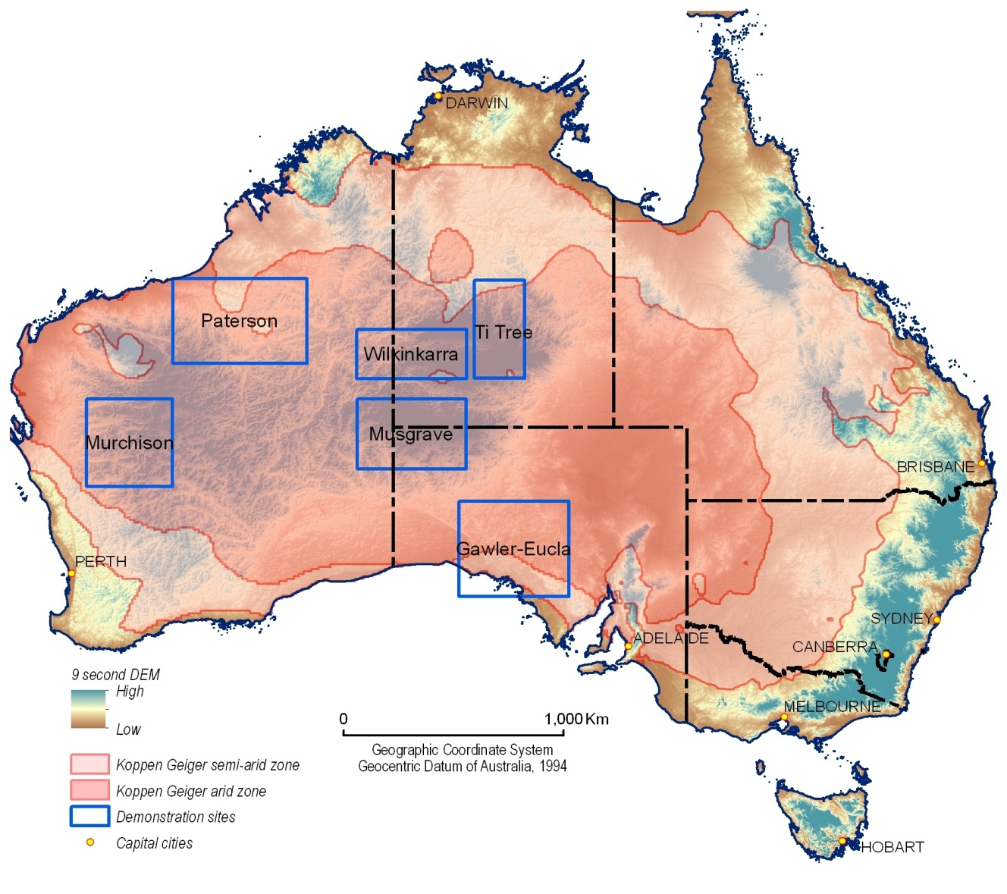
Figure 1.1: Palaeovalley Groundwater Project regional demonstration sites.

Objectives
The aim of the Palaeovalley Groundwater Project was to deliver an innovative and integrated national-scale approach for better understanding the capacity, quality, quantity and dynamics of groundwater systems in palaeovalley aquifers, thereby enabling improved management of these important groundwater resources. To fulfil this goal a number of specific objectives were developed, with the project seeking to:

- Fill very large gaps in the knowledge base of groundwater resources in arid and semi-arid regions;
- Appraise and improve methodologies currently used to assess groundwater resources in palaeovalleys by field and remote sensing studies at priority demonstration areas in WA, SA and the NT;
- Evaluate, in particular, the application of datasets derived from AEM, and ground-based gravity and seismic surveys with more conventional hydrogeologic techniques, hydrochemical analysis and groundwater dating methods;
- Develop a conceptual and spatial framework of key palaeovalley groundwater system ‘types’ within the range of geologic and climatic zones across arid and semi-arid Australia;
- Provide general recommendations and guidelines to assist government departments, communities and mining companies to develop improved management practices for palaeovalley groundwater systems; and
- Produce a range of user-friendly information products (e.g., reports, maps, and digital datasets) to improve the delineation of palaeovalley aquifers and definition of their groundwater resources. One of the most significant outputs is a Palaeovalley Thematic Map of the arid and semi-arid zones of WA, SA and the NT, and an accompanying GIS package of national-scale geologic and interpretative data layers for the 200 major palaeovalleys.

Demonstration sites
Demonstration site locations in WA, SA and the NT (Figure 1.1) were selected following consultation with the project Technical Advisory Group (TAG):

1. Gawler Craton - Eucla Basin, SA;
2. Murchison Province, WA;
3. Paterson Province - Canning Basin, WA;
4. Ti-Tree Basin of central Australia, the NT; and
5. Wilkinkarra (Lake Mackay), with fieldwork around the remote Aboriginal communities of Kintore, Nyirripi and Papunya, the NT.

In addition, analysis of remote sensing data was undertaken for the Musgrave (WA-SA-NT) and Tanami regions (WA-NT). A comprehensive investigation program, comprising integrated office and field-based activities, addressed fundamental gaps in the national understanding of palaeovalley systems to achieve the goals of the Palaeovalley Groundwater Project. Site-based work programs and results for the other four study sites (additional to this Ti-Tree Basin report) are outlined in a series of Geoscience Australia records (http://www.ga.gov.au/cedda/publications/96).

Project operations in the Ti-Tree Basin
Previous groundwater investigations in central Australia have shown that Cenozoic sedimentary aquifers (palaeovalleys) are a significant and reliable source of groundwater, e.g., Jacobson et al., 1989, McDonald, 1990, Wischusen et al., 1998. Many communities in central Australia rely on groundwater sourced from palaeovalley aquifers, including Nyirripi, Docker River, Mount Liebig, Yulara, Mutijulu, Willowra, Papunya, Ti-Tree and Ali Curung. Horticultural and domestic supplies for Ti-Tree and the Alice Springs Farm area have also been sustained for many years by groundwater extracted from shallow Cenozoic sediments. Additionally, many remote outstations, hundreds of stock bores as well as some mines and mineral exploration camps use palaeovalley aquifers.

Detailed site-specific palaeovalley investigations in central Australia have been conducted for parts of the Ti-Tree Basin (McDonald, 1990), in the Western Water Study area (Wischusen, et al., 1998), the Lake Amadeus and Ayers Rock region (Jacobson, et al., 1989) and the Tanami area (Domahidy, 1990). Senior et al. (1995) also documented the geology and stratigraphy of Cenozoic basins (or palaeovalleys) near Alice Springs in the mid-1990s. However, prior to this present investigation, these studies were the only coordinated work programs in central Australia which attempted to characterise the hydrogeology of Cenozoic sedimentary successions. Given that much of this vast and sparsely inhabited region is underlain by Cenozoic aquifers that are widely used to supply water, there is a pressing need for much improved understanding and knowledge of these valuable groundwater systems.
In this context, the key criteria for selecting the Ti-Tree Basin as one of the regional study sites for the Palaeovalley Groundwater Project were:

- The significance of the palaeovalley system as a major groundwater resource for various users, including a significant horticultural industry; and
- The relatively poor understanding of the deeper aquifer system and groundwater resources, including its water quality and the degree of interaction with the shallow aquifer.

Research program and objectives
The shallow aquifer system of the Ti-Tree Basin (less than 100 m deep, Figure 1.2) has been extensively studied because of its important role in supporting major horticultural production (Chapter 3). However, relatively little information is known about aquifer characteristics of the deeper sedimentary successions, which some mineral exploration drilling has shown reaches depths of ~300-320 m below surface. Following initial data evaluation new research in the Ti-Tree Basin for the Palaeovalley Groundwater Project focused on better understanding the distribution, composition and functioning of the deeper aquifer system. The key objectives of this study were to:

- Construct new deep drillholes to intersect the entire Ti-Tree Basin stratigraphic profile down to the underlying Proterozoic basement rocks, and evaluate the distribution and quality of potential aquifers in the deeper sediment successions;
- Reinterpret the existing Ti-Tree Basin drillcore (incorporating previously collected data) to develop a new hydrostratigraphic framework across the basin;
- Collect representative groundwater samples from deep aquifer intervals to determine groundwater ionic and isotopic compositions, and gauge groundwater residence times (radiocarbon dating); and
- Develop an updated conceptual hydrogeologic model to explain groundwater distribution and processes in both the shallow and deeper parts of the Ti-Tree Basin.

Structure and focus of this report
This report is divided into six chapters. The remainder of this introductory chapter provides contextual information on the climate, landscape, population and economy of the Ti-Tree Basin. This is followed by background chapters on the regional geology and geophysics (Chapter 2) and the hydrogeology of the basin, based on synthesis of existing published literature and NT government reports (Chapter 3). Chapter 4 outlines the investigative methods and results for the new research program conducted in the Ti-Tree area. The new data is integrated with existing knowledge in Chapter 5 to present a revised conceptual model of the hydrogeology and stratigraphy of the Ti-Tree Basin. The final chapter (Chapter 6) presents a summary of conclusions and recommendations arising from the project work program.

Figure 1.2: (next page) The Ti-Tree Basin in central Australia showing the main study location for the Palaeovalley Groundwater Project. The extent of Cenozoic sediments in the basin is shown in yellow, surrounded by older basement rocks (orange) such as the Paleoproterozoic Lander Rock Formation (after McDonald, 1990). Cross-section A–B shows the basic structure of the basin and the shallow aquifer. Line E-F is discussed in Chapter 5.
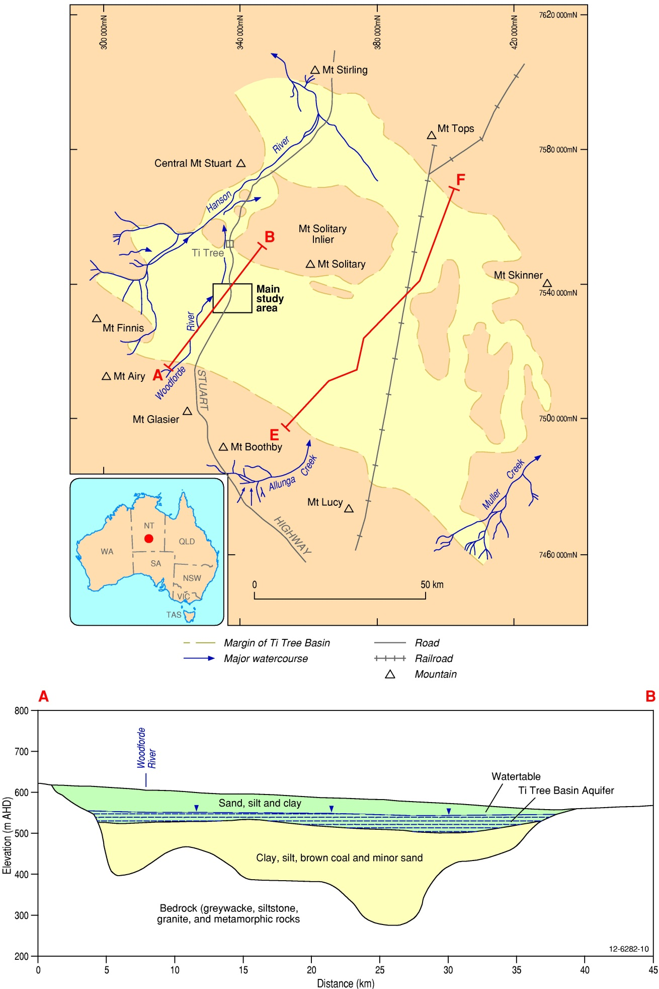

Overview of the Ti-Tree Basin

Climate
The Ti-Tree Basin occurs in arid central Australia. The mean annual rainfall is 250-300 mm (Figure 1.3), and the annual pan evaporation rate is ~3,500 mm (Bureau of Meteorology, 2012). Most rainfall occurs during high-intensity storms which occur from October to March, although rain patterns are spatially and temporally variable. Hot and windy conditions are common in summer, with temperatures commonly exceeding 40°C. Minor frosts may occur during the winter months.

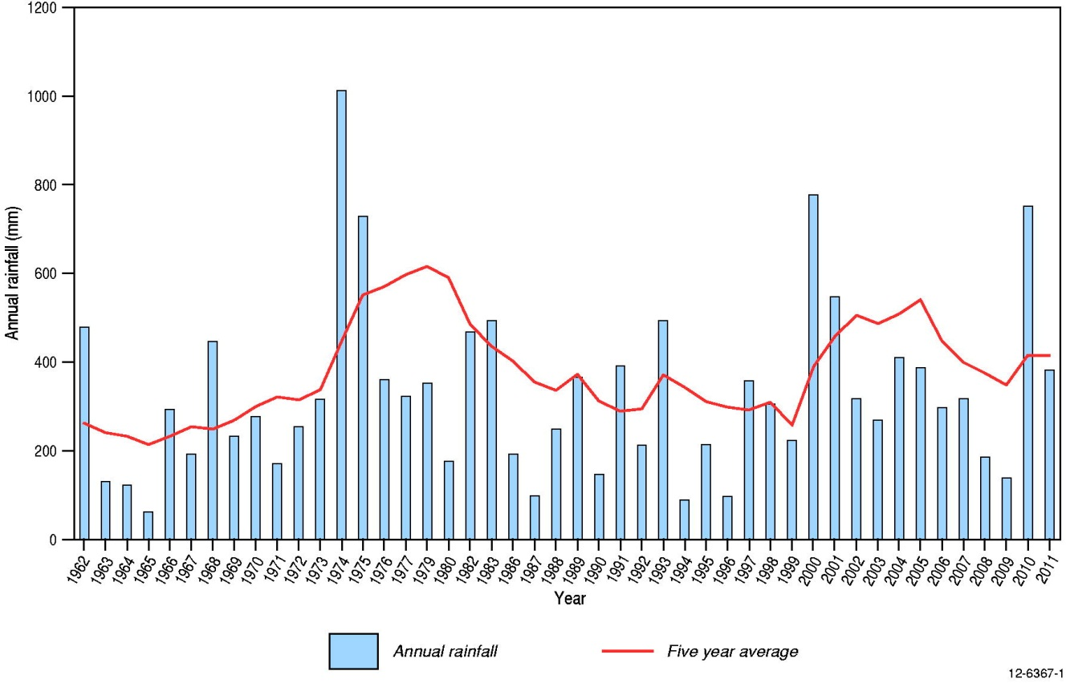
Figure 1.3: Annual rainfall for Aileron (NT) with rolling five year average.

Landscape
The Ti-Tree Basin underlies relatively flat sand plains typified by sparse small trees, mulga scrub and spinifex (Figure 1.4). Red earthy sand is the dominant soil type and is widely developed across most of the region. Longitudinal aeolian sand dunes occur in the central part of the basin with individual dunes up to 5 km long striking mainly towards the north-west (McDonald, 1990). Minor calcrete deposits crop out in the northern part of the basin, where the watertable is shallower.

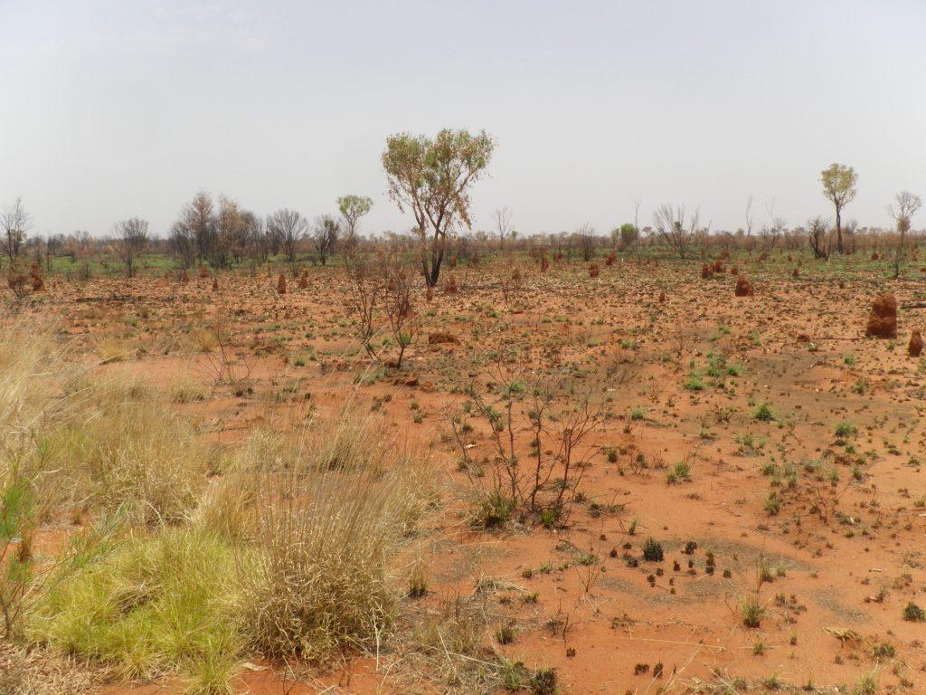
Figure 1.4: Typical landscape and terrain of the Ti-Tree Basin (photo by John Wischusen, November 2011).

The Ti-Tree Basin is discontinuously surrounded by upland areas of exposed Proterozoic basement rocks, such as the Reynolds Range to the south-west. These fringing ranges contain many short and closely spaced creeks that provide the main source of run-off to the basin following intense rainfall. There are a number of discrete topographic highs around the basin margins, including Mt Stirling, Mt Skinner, Mt Boothby and Central Mt Stuart (Figure 1.2).

The flat terrain of the Ti-Tree Basin and the elevated surrounds of basement rocks are highlighted in the Multi-resolution Valley Bottom Flatness (MrVBF) index (Figure 1.5). This image has been derived from the 1-arc second digital elevation model dataset of Australia (obtained from the Shuttle Radar Topographic Mission, SRTM, dataset; Figure 1.6) using the MrVBF algorithm of Gallant and Dowling (2003). The MrVBF index primarily discriminates depositional landforms (valley bottoms) based on their distinctive topographic signature as flat, low-lying areas. Many ancient drainage features coincide with modern topographic lows, although not all areas of low elevation are related to palaeodrainage systems. Consequently, the MrVBF tool can help to better understand the distribution and interaction of various landscape elements, but it does not definitively classify palaeovalleys. Further information on the application of the MrVBF index for identifying palaeovalleys is provided in Geoscience Australia Record 2012/10, the Palaeovalley Methodology Toolbox report (Gow et al., 2012).
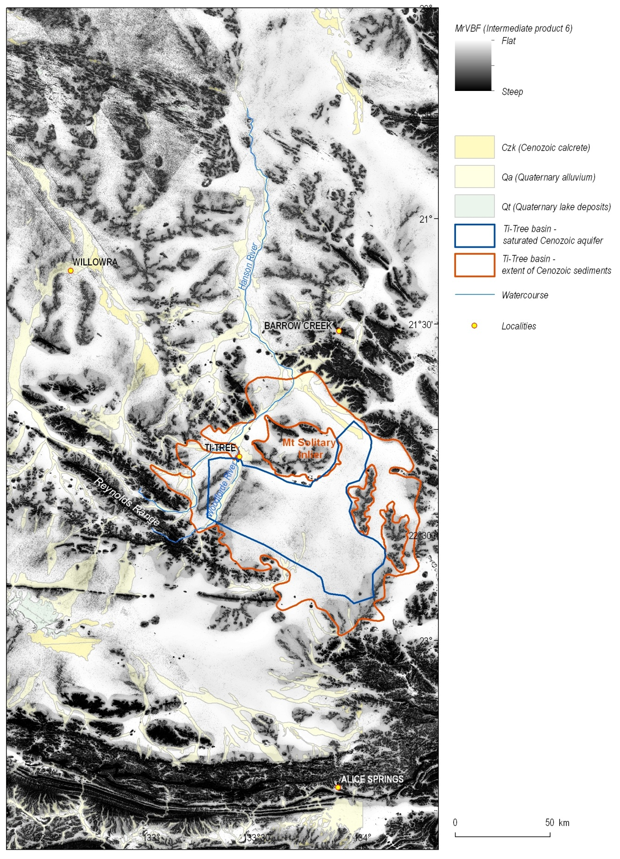
Figure 1.5: Multi-resolution Valley Bottom Flatness (MrVBF) index for part of central Australia, showing the relatively low and flat topography of the Ti-Tree Basin compared with the surrounding elevated terrain.
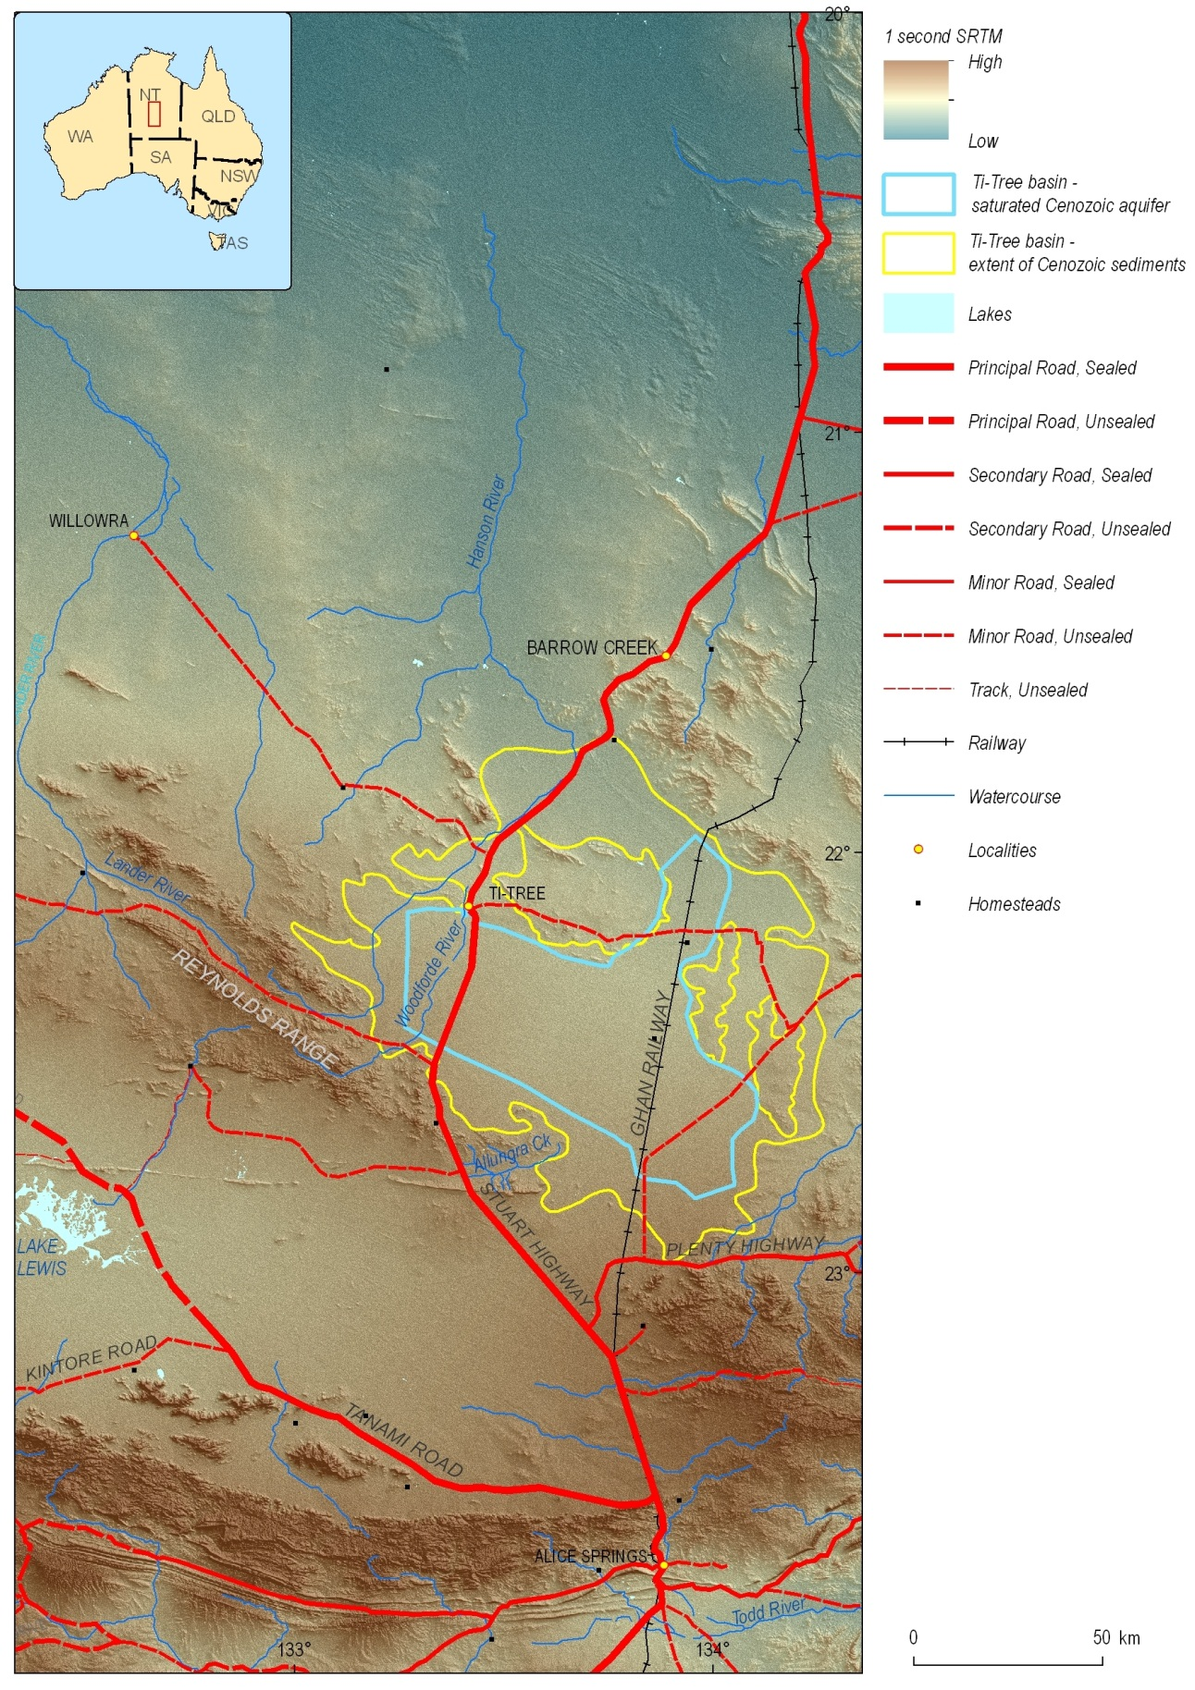
Figure 1.6: Digital elevation model of part of central Australia centred on the Ti-Tree Basin, from Alice Springs in the south to Barrow Creek in the north. This image is based on the SRTM dataset and shows major landscape features in the Ti-Tree region such as the Hanson and Woodforde Rivers, the surrounding uplands, and the vegetated sand plain of the central basin.
Many landscape features in central Australia are well depicted by satellite images, including those acquired from Landsat, MODIS and NOAA-AVHRR platforms. In some cases these remotely sensed images may provide a direct indication of palaeovalley systems, e.g., areas of saturated palaeovalley sediments surrounded by bedrock can be defined by night-time thermal infrared imagery from the NOAA-AVHRR sensor (Hou, 2004). More commonly though, remote sensing imagery helps to better understand the broad-scale distribution of terrain features such as mountains, soil types and surface water drainage systems that may indirectly assist in mapping and characterising palaeovalleys. Remotely sensed imagery of the Ti-Tree Basin, compiled specifically for the Palaeovalley Groundwater Project, is shown as Figure 1.7 and Figure 1.8.

Surface water
The arid climate of the Ti-Tree region means that there are no permanent surface water bodies. The modern drainage lines are only active following significant rainfall events in the nearby upland catchments, such as the Reynolds Range. The main drainage systems flow towards the north-east and include the Hanson River and Woodforde River in the west of the basin, and Allungra Creek in the south (Figure 1.2). During times of surface water flow in the Ti-Tree Basin the main rivers and creeks are interpreted as zones of significant recharge for the local groundwater system.

Population and economy
The Ti-Tree area has a population of fewer than 500 people dispersed in several small communities including Ti-Tree, Nturiya, Pmara Jutunta and Wilora, on irrigation farms in the western and central zones of the Water Control District (Figure 1.9), and at Aileron, Pine Hill, Woodgreen and Stirling pastoral stations. The Stuart Highway, the Alice Springs to Darwin Railway and the pipeline from Mereenie Gas Field cross the district. Alice Springs is 200 km to the south and Darwin is 1,300 km to the north. All water supplies for town and community use, irrigation and pastoral homestead and stock needs are drawn from groundwater, and most rely on aquifers in the Ti-Tree Basin. Relatively shallow aquifers of good quality and yield are accessible across ~1,000 square km in the district (NT DIPE, 2002).

The land overlying the Ti-Tree Basin is generally suitable for irrigated horticulture (NT DIPE, 2002). Extensive areas of sand plain with well-drained soils provide few constraints for pastoral production or crop growth (Figure 1.4). For management purposes the Ti-Tree Basin is divided into four water control zones (Figure 1.9). Irrigation development occurs across some 300 hectares and is mostly focused in the western and central zones. Annual horticultural production is worth around $20M.

Groundwater extraction
There are multiple groundwater production bores at Ti-Tree Farms in the Western Zone of the Water Control District, and in the Central Zone area operated by Table Grape Growers of Australia (Figure 1.9). From peak levels >3 GL in 2005-2006 annual groundwater extractions from Ti-Tree Basin have declined over the past few years (Figure 1.10). These variations reflect changes in the horticultural operations within the basin, as well as problems associated with vine diseases and increased market competition from other areas of Australia (M. Rittner, 2012, pers. comm.).

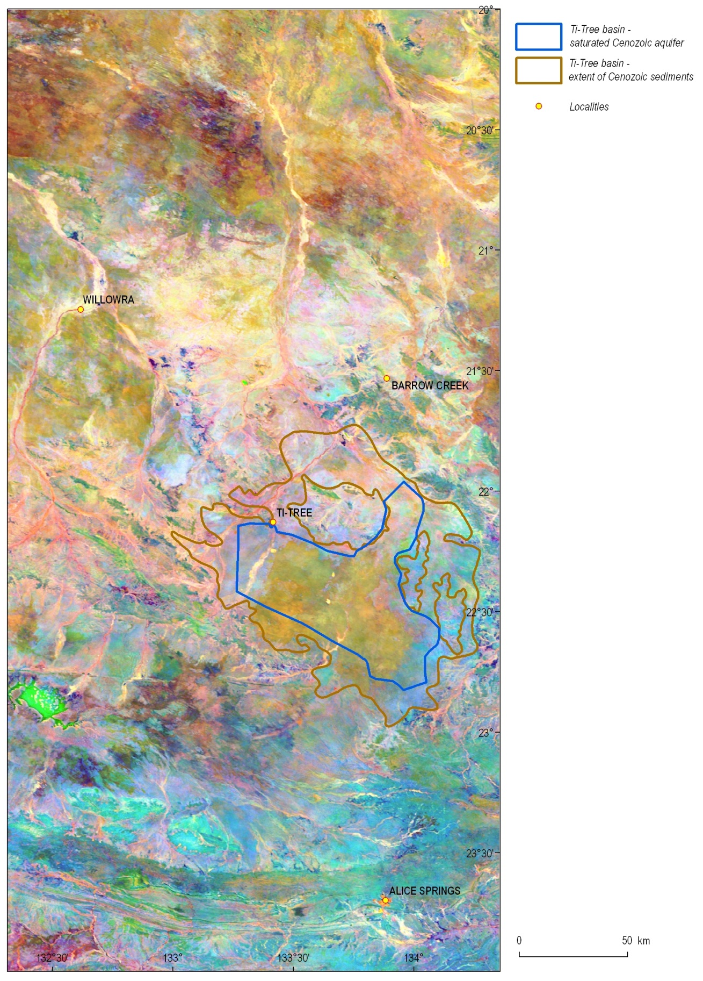
Figure 1.7: MODIS image from central Australia showing that the widespread flat sand plain of the Ti-Tree Basin has a distinct orange-brown signature associated with the local vegetation. Surface drainage systems are also well depicted.
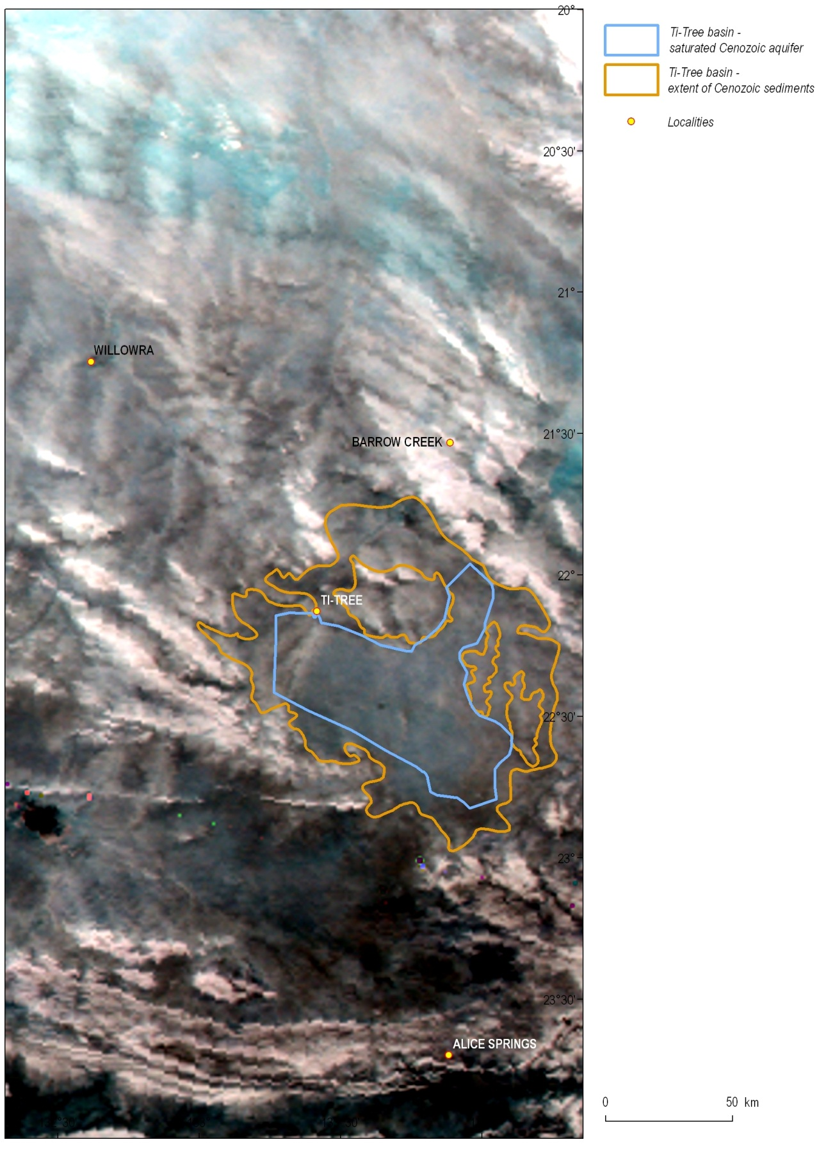
Figure 1.8: Night-time thermal infrared (NTIR) image from the NOAA-AVHRR satellite sensor. The darker blue-black tones that coincide with most of the Ti-Tree Basin reflect relatively lower thermal emissions compared with the surrounding bedrock exposures (white). The variation in thermal signature between Ti-Tree Basin and nearby bedrock areas may relate to the shallower watertable that occurs in the sedimentary infill of the basin.
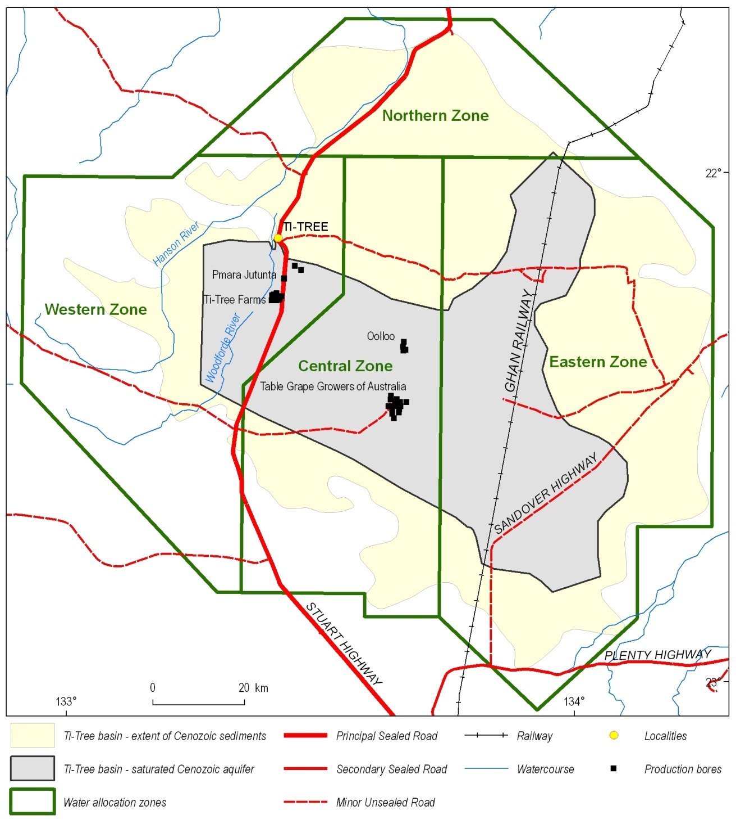
Figure 1.9: Extent of Cenozoic sediments and the saturated aquifer system of the Ti-Tree Basin. The four Water Control Zones and main horticulture users of groundwater are also shown (after Knapton, 2007).

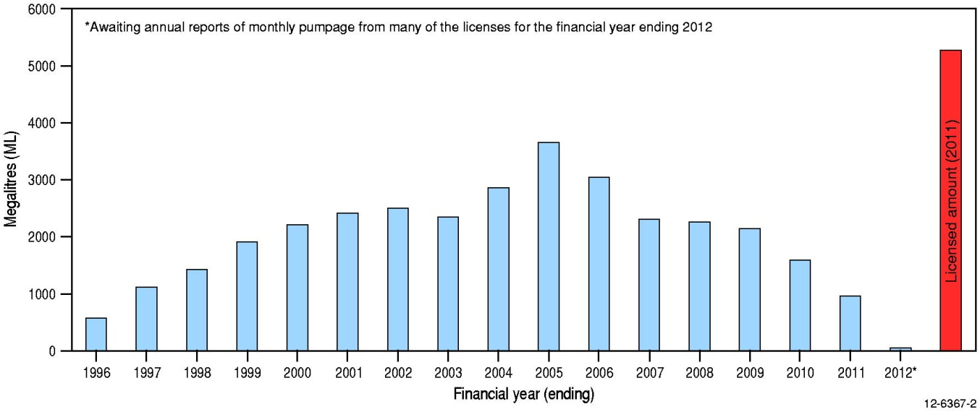
Figure 1.10: Annual groundwater extraction for the Ti-Tree Basin.

Geological and geophysical setting

Geology
The Ti-Tree Basin is an intracratonic Cenozoic basin infilled with up to ~320 m of sediments originally deposited in alluvial and lacustrine environments. The basin is covered at surface by Quaternary sediments such as aeolian sands, alluvium and minor calcrete (Figure 2.1). These surficial deposits are widespread and obscure most of the older Cenozoic sediments (which are Eocene to Miocene age). Paleoproterozoic basement rocks of the Arunta Region, which have a complex metamorphic and tectonic history, underlie much of the Ti-Tree region (McDonald, 1988). The dominant structural trend in the basement rocks is north-westerly with a series of major sub-parallel faults cross-cutting the Proterozoic rocks beneath the Ti-Tree Basin (Figure 2.2).

The Paleoproterozoic Lander Rock Formation, which mainly consists of greywacke, siltstone, shale, schist and gneiss, is the most common basement unit in the Ti-Tree area (Figure 2.2). Paleoproterozoic to Mesoproterozoic granites and gneisses also occur and form discrete intrusive bodies or faulted basement blocks (Ahmad and Scrimgeour, 2006). The northern Ti-Tree Basin is partly underlain by Neoproterozoic rocks of the Yuendumu/Arumbera Sandstone (Figure 2.2). The Proterozoic basement rocks crop out sporadically around the basin margins, forming prominent uplands such as the Reynolds Range to the south-west.

Characteristics of the regional geology which are relevant to the present investigation include:

- The shape of the Ti-Tree Basin is elongated north-westerly, coincident with the orientation of the dominant structural zones in the basement rocks. This suggests that basement faulting and associated tectonic activity probably played an important role in the evolution of the Cenozoic basin and its sedimentary infill sequence.
- The major north-west trending fault that cuts across the central part of the Ti-Tree Basin (Figure 2.2) coincides with the site approximately 15 km south of Ti-Tree where previous drilling has shown that a thickened sequence of Cenozoic sediments occurs. This provides further evidence of the influence of tectonism in the development of the basin.
- The northern outflow part of the basin, termed the Wilora Palaeochannel, overlies Neoproterozoic rocks of the Yuendumu/Arumbera Sandstone. Elsewhere in the Northern Territory these sandstones, limestones and siltstones form a modest aquifer when intersected near-surface in the Amadeus and Ngalia Basins. Thus, there is potential for some degree of hydraulic connection between the Cenozoic sediments of the Ti-Tree Basin and the underlying Neoproterozoic sedimentary rocks. Further detailed investigation would be required to better understand and quantify the degree of groundwater interaction that may occur (although this is not part of the present study).

Regolith
Previous regolith mapping of the Ti-Tree Basin has been undertaken by Reu and Garbin (1999), Craig (2006), and Robertson et al. (2006). Aeolian sands are widely distributed at surface over most of the central Ti-Tree Basin (Figure 2.3). Red earthy soils occur mainly around the margins of the basin in transitional zones from surrounding areas of outcropping basement rocks. Alluvial deposits are associated with the modern surface drainages such as the Woodforde and Hanson Rivers. Figure 2.3 also highlights the intricate network of small creeks that dissect the ranges which flank the Ti-Tree Basin.
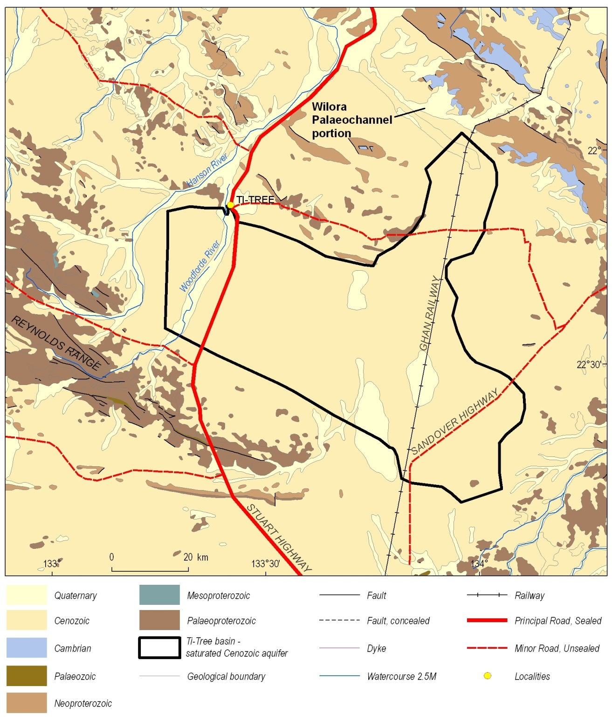
Figure 2.1: Surface geology of the Ti-Tree region in central Australia. The boundary of the saturated Cenozoic basin sediments is overlain (after Read and Tickell, 2007).

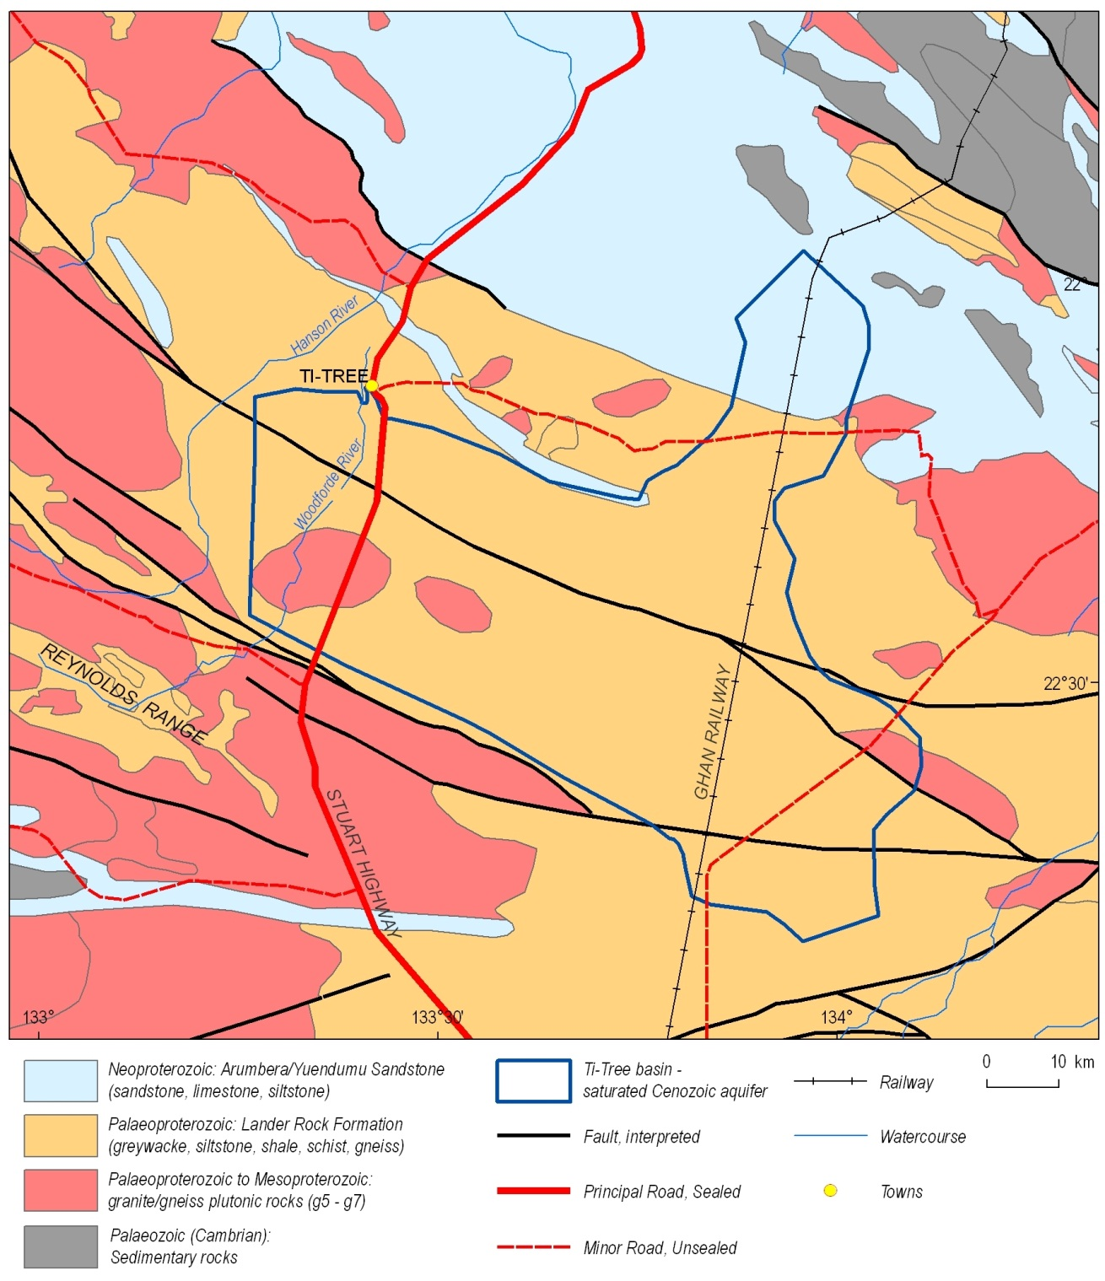
Figure 2.2: Pre-Cenozoic basement geology of the Ti-Tree region (after Ahmad and Scrimgeour, 2006).

Geophysics
Geoscience Australia is the custodian of national-scale geophysical datasets such as magnetics, gravity and radiometrics. These geophysical data, accessible via the Geophysical Archive Data Delivery System (GADDS), were compiled for the Palaeovalley Groundwater Project to assist in better understanding the regional geology of each demonstration study site, including the Ti-Tree Basin (Figure 2.4–2.6). Although the regional geophysical data do not directly assist in delineating the Ti-Tree Basin or understanding the groundwater resources, the analysis of these images aids in the interpretation of basin evolution (magnetics) and modern-day landscape features (radiometrics).
Observations of the regional geophysical datasets for the Ti-Tree area relevant to the present study are:

- The regional magnetics data show that the Ti-Tree Basin occurs in an area of relatively low magnetic intensity, compared with geological domains to the north and south (Figure 2.4);
- Both the TMI and the 1st vertical derivative magnetic data provide further evidence of the dominant north-west structural orientation of the geologic basement. Distinct faults depicted on the regional geology map coincide with specific features in the magnetics data;
- The radiometrics data highlight the north-flowing modern surface drainage systems in the vicinity of the Ti-Tree area. The dominantly red colour of the alluvial sediments in these drainage lines indicates that they are relatively enriched in potassium, reflecting the potassium-bearing basement rocks (e.g., granite and gneiss) that are the ultimate source of these modern sediments; and
- The flat sandy plain of the Ti-Tree Basin is distinctly greenish in the radiometrics image, reflecting the relative abundance of thorium in the aeolian sands that cover much of this area. In contrast, the nearby salt lake to the south-west of the Ti-Tree Basin is purplish-blue, indicating that it is enriched in uranium.

Palynology
Palynology is the study of organic plant microfossils such as algal cysts, spores and pollen, and is used to assist in dating and correlating fine-grained sedimentary rocks (English et al., 2012). Macphail (1997) analysed sediment samples collected from the Ti-Tree Basin to help constrain the age of Cenozoic deposition and interpret basin evolution in central Australia. Samples were obtained from cored drillholes completed by the Northern Territory Geological Survey (NTGS), the location of which coincides with the main study area for the Palaeovalley Groundwater Project (Figure 1.2). Results from the work of Macphail (1997) included:

- Coal recovered at 190-196 m depth from NTGS drillhole 81TT1 was interpreted as being Oligo-Miocene age (which corresponded with palynological evidence presented by O’Sullivan (1973) indicating that a similar interval in nearby drillhole TT6 was Middle Miocene); and
- Coal from 196-199 m depth from NTGS drillhole TTW2 (a few km east of drillhole CRA TT1) was considered to be Middle Eocene (Nothofagidites asperus).
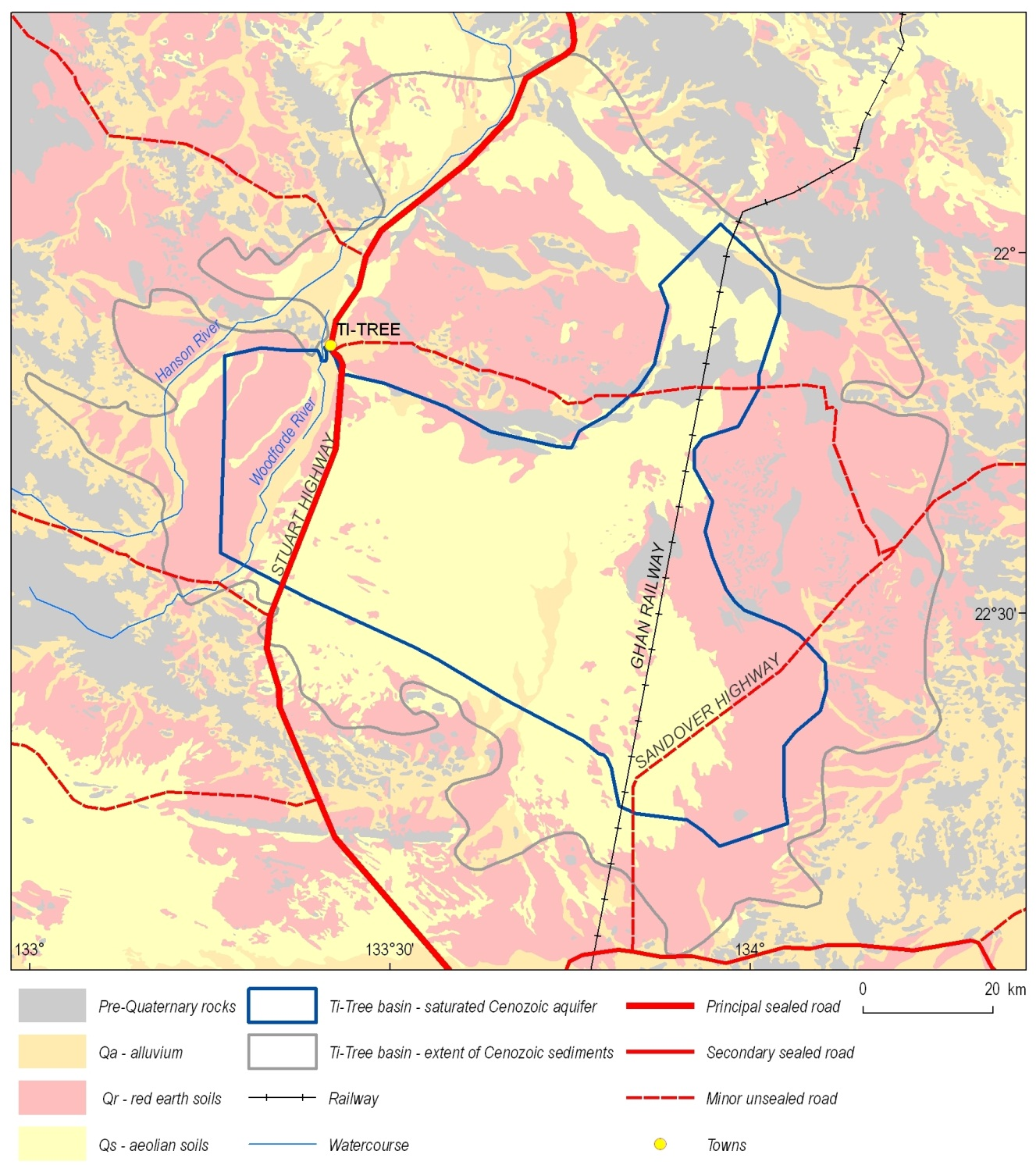
Figure 2.3: Quaternary regolith in the Ti-Tree region (after Craig, 2006).
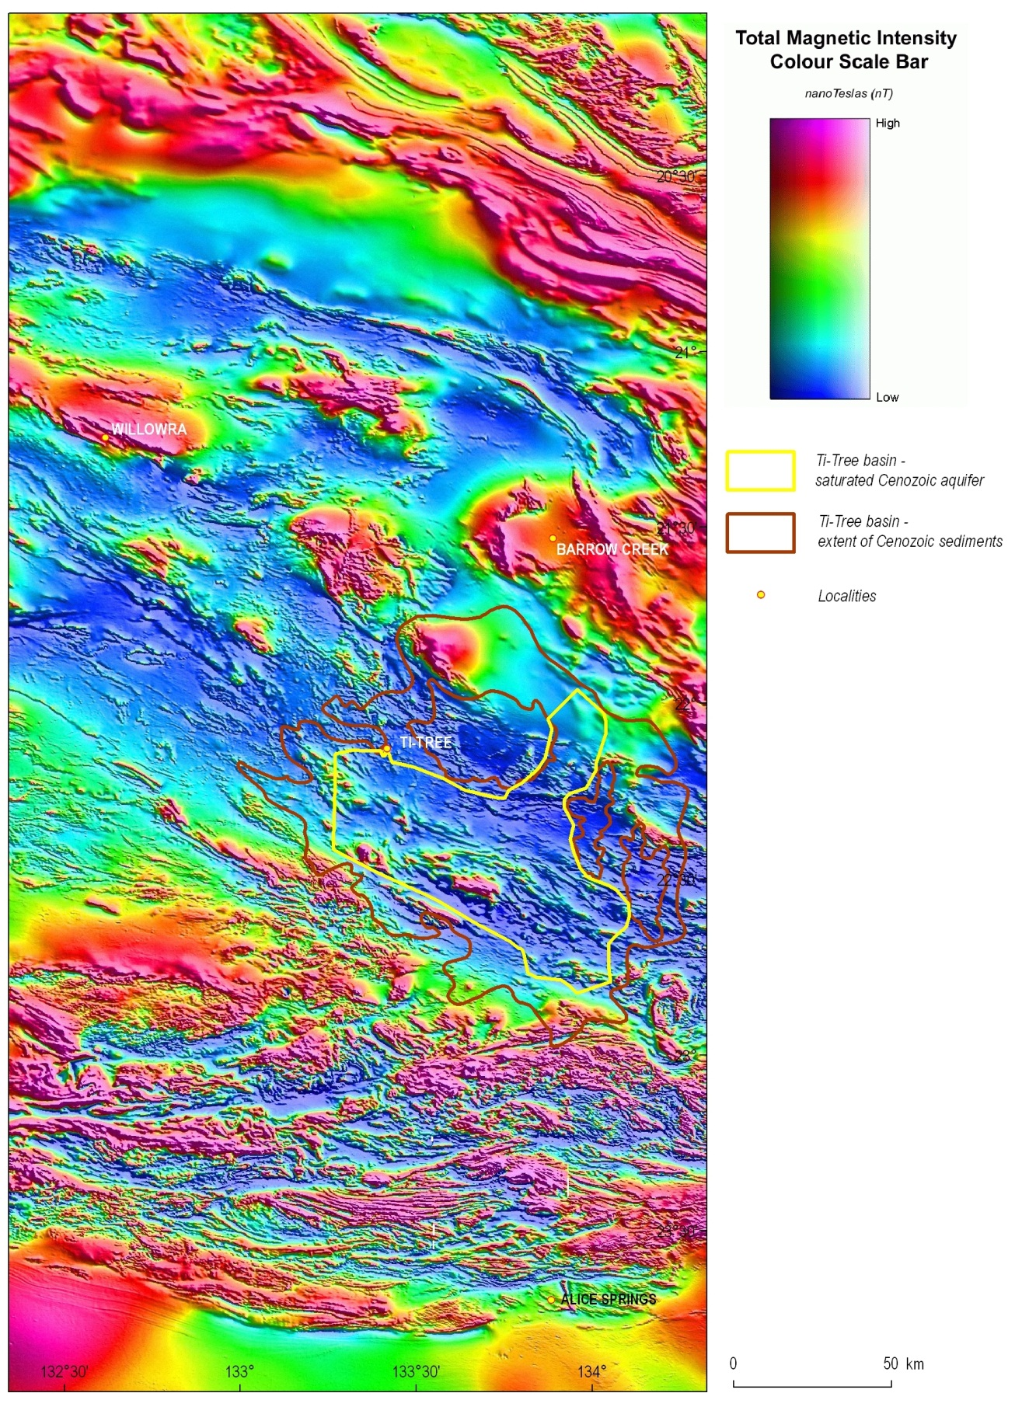
Figure 2.4: Total magnetic intensity (TMI) image for the Ti-Tree region, derived from the national airborne geophysical archive.

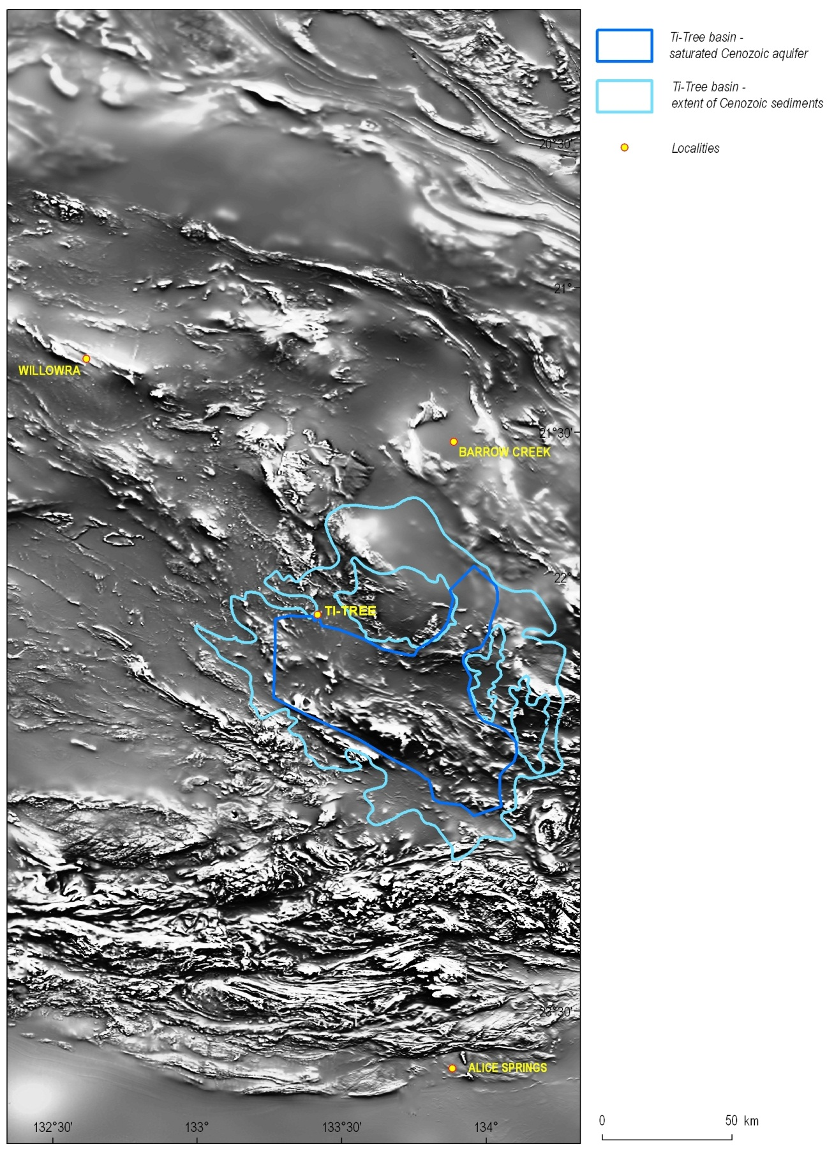
Figure 2.5: The 1st vertical derivative of regional TMI data for the Ti-Tree Basin area. This image enhances the major linear structural features of the basement rocks and highlights the north-west orientation in the vicinity of Ti-Tree.
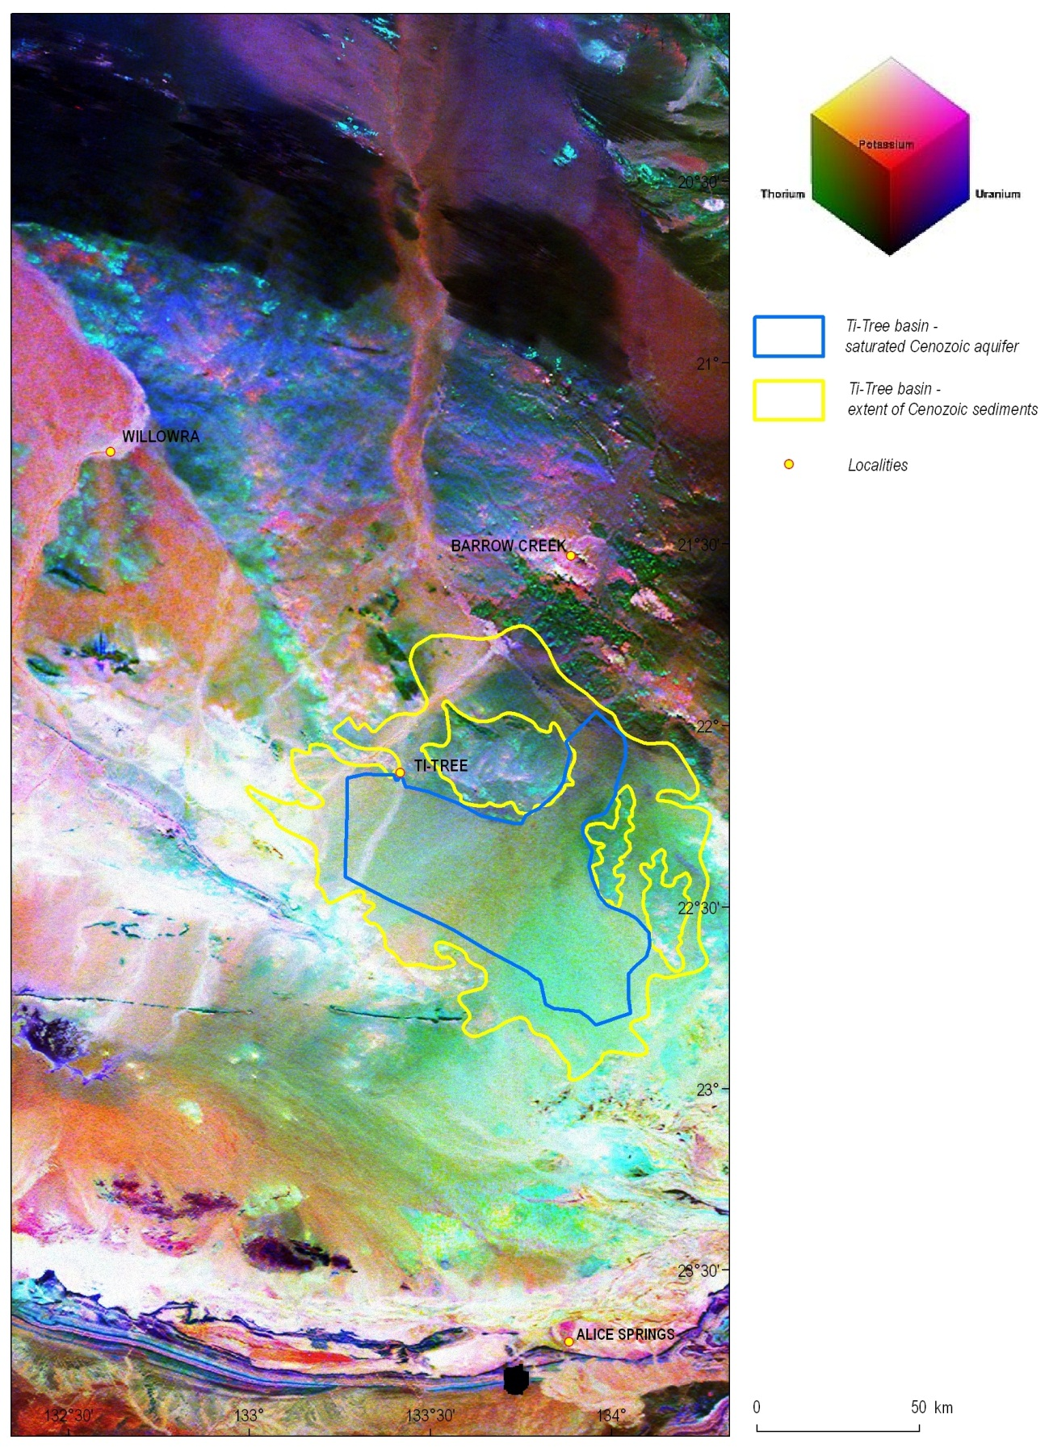
Figure 2.6: Gamma-ray spectrometric image of the Ti-Tree region in central Australia. Modern surface drainages enriched in potassium (red) are clearly depicted, as well as distinctive landscape features such as salt lakes (Lake Lewis), upland ranges, and flat sandy plains. This map produced from the national radiometrics dataset of Australia.

Hydrogeological setting

Introduction
The Ti-Tree Basin is one of many Cenozoic palaeovalley systems in central Australia (Figure 3.1). Many of these palaeovalleys contain up to several hundred metres of saturated sediments which include significantly thick intervals of hydraulically conductive sands, silts and minor gravels. The widespread use of groundwater resources to support horticulture means that the hydrogeology of the Ti-Tree Basin is probably the most well understood of all Cenozoic basins in central Australia, e.g., from the detailed hydrogeological investigations by McDonald (1990), Harrington et al. (1999), Knapton (2005, 2006a,b), and Magee (2009).

Several previous studies have shown that sedimentary infill of the Ti-Tree Basin is over 300 metres thick in some places (Figure 1.2). However, knowledge of groundwater quality and quantity in the Ti-Tree Basin is limited to the relatively shallow aquifers (<100 m deep), with scant information available on the deeper groundwater resources (prior to this project). Consequently, this chapter focuses on the key characteristics of the shallow groundwater system in the Ti-Tree Basin, although it also outlines prior investigations which have provided evidence in support of the potential deeper groundwater resources.

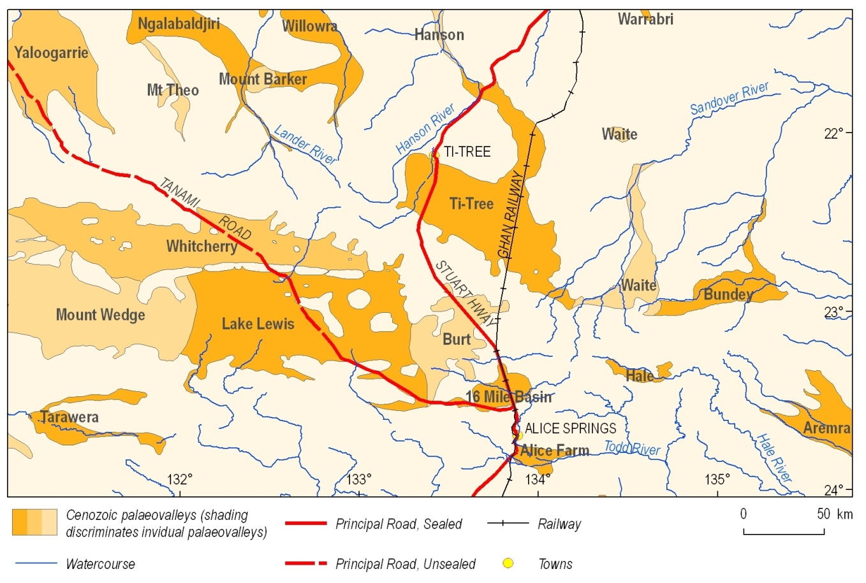
Figure 3.1: Distribution of major Cenozoic basins (palaeovalleys) in the southern part of the Northern Territory around Alice Springs (after Bell et al., 2012).
The shallow aquifer system in the Ti-Tree Basin varies from less than 10 m thick near the basin margins to over 60 m thick in the central part of the basin (Figure 3.2). The maximum saturated sediment thickness of nearly 80 m occurs in an isolated trough near the north-western margin of the basin about 10 km south of Ti-Tree. Read and Tickell (2007) summarised bore yields in the shallow aquifer as:

“The main Ti-Tree Basin aquifer (water bearing formation) is developed in the old river sands. It is located as shallow as 10 metres to over 60 metres below the ground. In places moderately high yields (5-15 L/second) can be extracted from bores. Variations in thickness of the aquifer and in the amount of silt and clay mixed with the sand make for considerable variability in bore yield.”

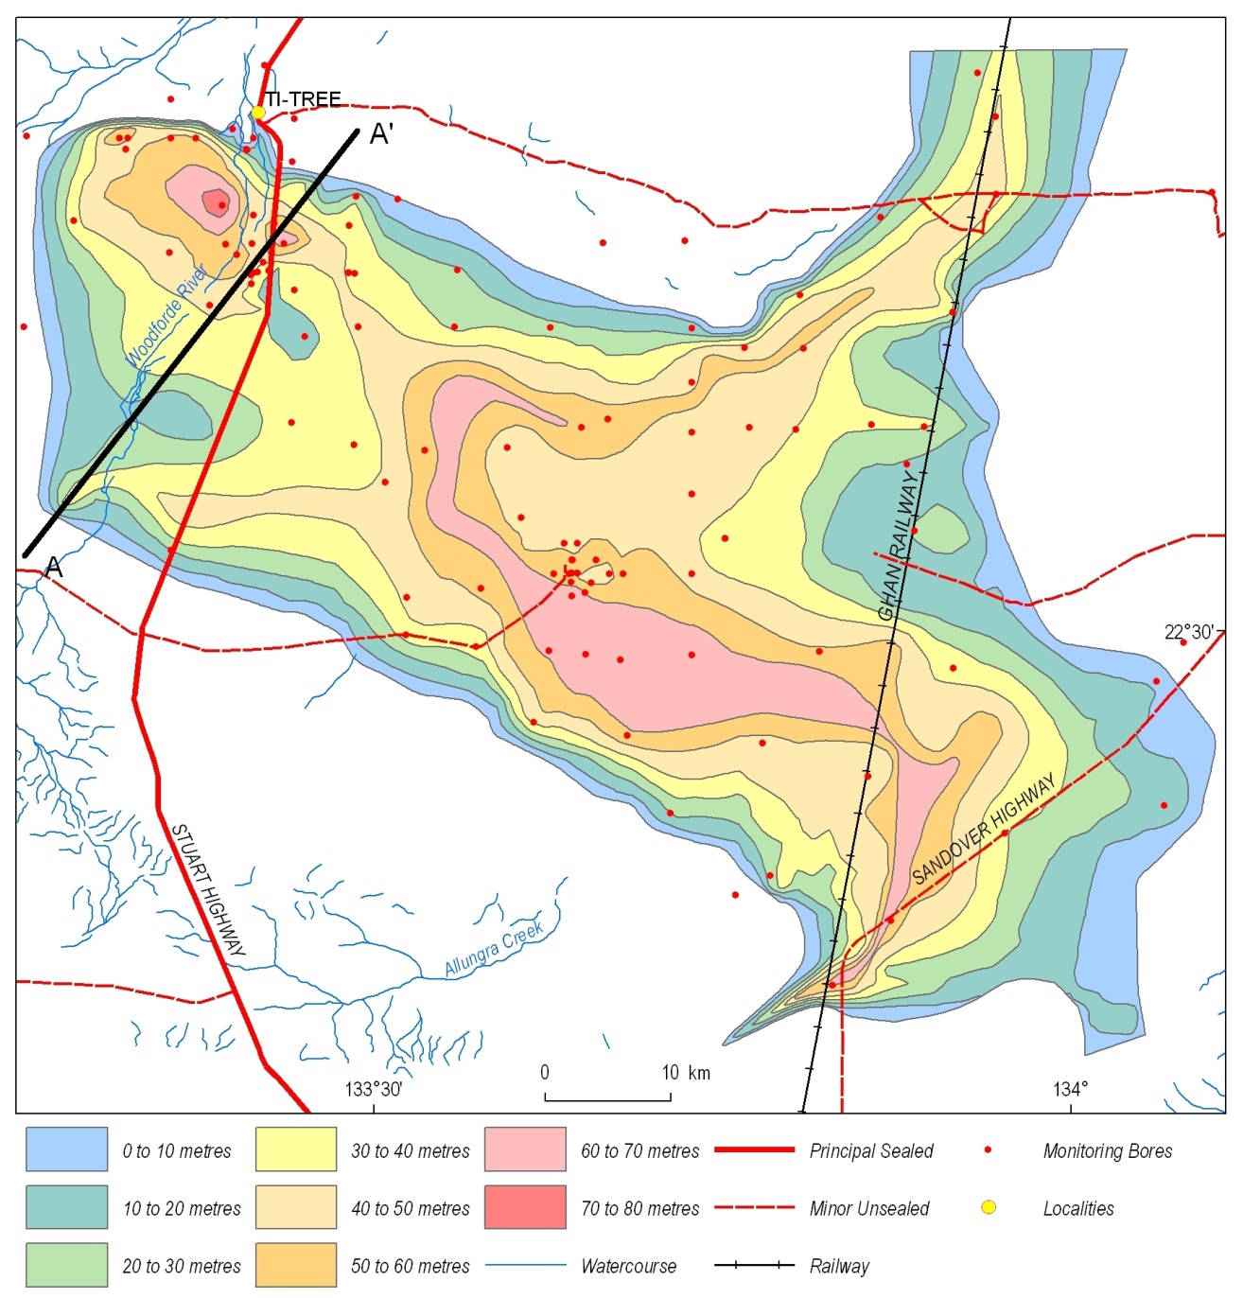
Figure 3.2: Extent and thickness of the shallow aquifer in the Ti-Tree Basin. The position of cross-section A-B is also shown (modified after Read and Tickell, 2007).

Groundwater flow in the shallow aquifer
The direction and rate of groundwater flow has been of interest in previous studies of the Ti-Tree Basin. Several maps of the potentiometric surface have been developed, with the earliest version by Edworthy (1966) and the most recent by Knapton (2006a). Groundwater in the shallow aquifer generally flows from the south and west of the basin towards the north-east (Figure 3.3). Flow patterns are locally complicated by the shape of the basin, with flow diverging around basement inliers (McDonald, 1990).

The overall pattern of groundwater flow, coupled with the lack of any significant thickness of Cenozoic sediments north of Ti-Tree community, suggests that groundwater in the shallow aquifer mostly flows out of the basin and into the Wilora Palaeochannel (Read and Tickell, 2007). The Wilora Palaeochannel was originally included as part of the Ti-Tree Basin in earlier studies (e.g., McDonald, 1990), but more recent work (e.g., Read and Tickell, 2007) has shown that it is not part of the basin. Groundwater from Ti-Tree Basin may eventually flow into sediments underlying the Hanson River, far to the north-west of Ti-Tree. The water balance model for this flow pathway remains speculative. However, the recent work of Howe et al. (2007), Cook et al. (2008), and O’Grady et al. (2009), combined with the increasingly shallow watertable east of the Mount Solitary Inlier, suggests that discharge via evapotranspiration is a major component of the water balance for the shallow aquifer.

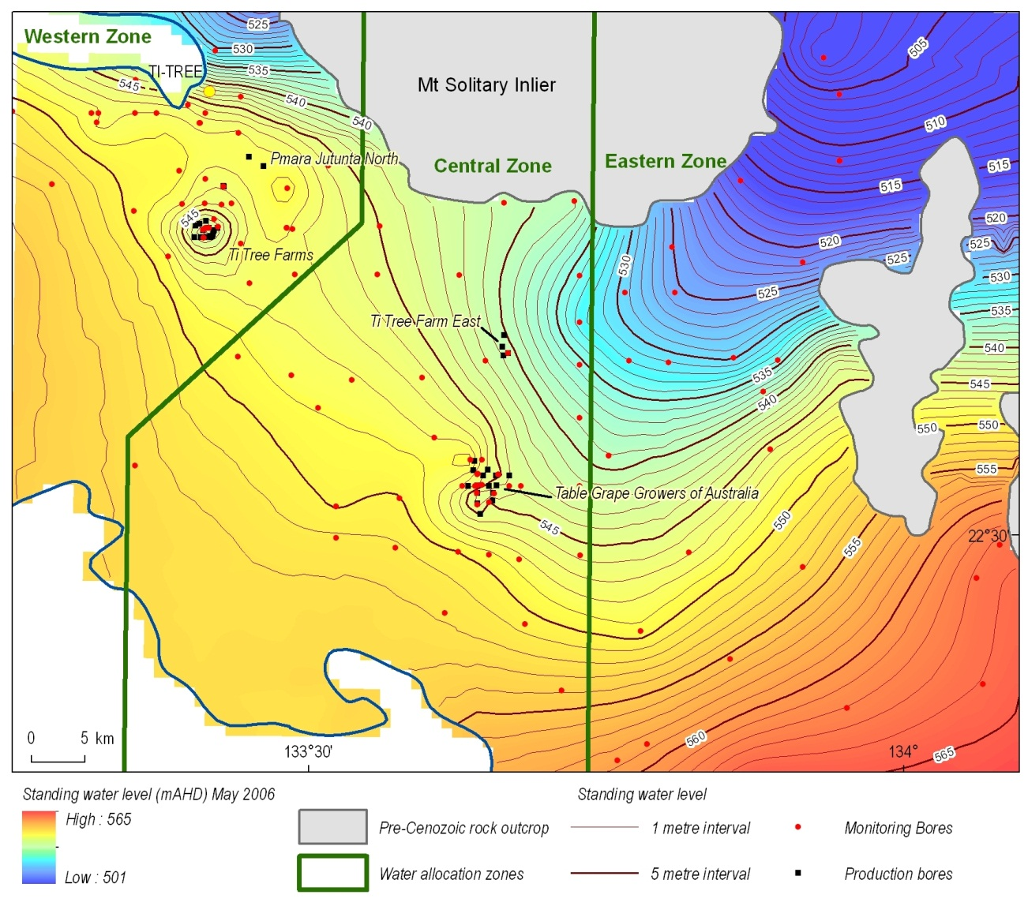
Figure 3.3: Standing water level of the shallow aquifer in the Ti-Tree Basin.

Recharge
Quantifying recharge has been an ongoing focus in the hydrogeological interpretation of the Ti-Tree Basin. Early studies concentrated on quantifying the amount of recharge and the main hydrodynamic processes affecting the groundwater system (e.g., Edworthy, 1967; Ride, 1968). Later investigations were completed by Harrington (1999), Harrington et al. (2002) and Calf et al. (1991). The recharge component of the water balance at Ti-Tree has been controversial as the amount assumed determines predictions of sustainable extraction rates. Magee (2009) summarised some of this debate and the apparent inconsistencies of recharge estimates used by different researchers. The Alice Springs DLRM hydrogeologists working on the Ti-Tree area have recently favoured a more conservative estimate of recharge, more in keeping with the 2 mm-per-year estimation of Harrington et al. (1999) rather than the higher values used in the NT government-commissioned modelling studies (Water Studies, 2001, 2004) and some water policy documents (A. Knapton, 2009, pers. comm.).

Knapton (2007) has developed a new model of the Ti-Tree Basin incorporating:

- Transmissivity data similar to that determined from test pumping by McDonald (1990);
- Storage characteristics similar to those determined by Seidel (1995) and Read (2003); and
- Recharge predominantly focused along the Woodforde and Allungra drainages (McDonald 1990; Harrington, 1999; Water Studies, 2004).

This model assumed diffuse discharge where the watertable is less than 4 m from surface, i.e., mainly in the Wilora Palaeochannel. Calibration of this model confirmed the recharge rate of 2 mm-per-year proposed by Harrington (1999), and also indicated that around 1,000 ML/yr flows north into the Wilora Palaeochannel. Analysis of the modelling indicates that current extraction levels should not affect groundwater dependent ecosystems in the area of the shallow watertable to the north of the Ti-Tree Basin. The modelling work of Knapton (2007) has shown that hydrological characteristics matching observed data, rather than the high recharge rates used by Water Studies (2001, 2004), can best be used to simulate the Ti-Tree aquifer system.

Read and Tickell (2007) presented the following succinct summary of recharge (Figure 3.4):

‘Due to the low average rainfall (318 mm/year) and its sporadic nature, the aquifer does not receive recharge every year. The abrupt rises in groundwater levels record recharge events, typically associated with heavy rainfall. An exceptionally large event occurred in the mid to late 1970’s. Groundwater levels have still not fallen to pre-1970’s levels over much of the basin. The long-term average recharge is estimated at 2 mm/year, a relatively small amount.’

Since the late 1960s the Northern Territory Government has measured groundwater levels in the shallow aquifer, as have some groundwater users more recently. In the recently ‘State of the Basin’ reports (e.g., Knapton, 2005; 2006a) the water levels in over sixty monitoring bores have been assessed. Apart from the routinely monitored bores, new monitoring bores for other projects are also added periodically. For example, in 2007 three nested piezometers and a temporary riverbed monitoring bore were drilled and constructed near Arden Soak, 30 km south of Ti-Tree near the Woodforde River. Another bore was also installed near Tin Fish Well on the Wilora Palaeochannel. This drilling and construction of monitoring bores was part of a collaborative project by the NT Government, the CSIRO and the University of Tasmania to study recharge and discharge characteristics in the basin (Cook et al., 2008).

In 2007 an ad hoc basin-wide monitoring program sampled 113 bores for field parameters such as conductivity and also measured water levels in 85 of the sampled bores (Pye, 2007).

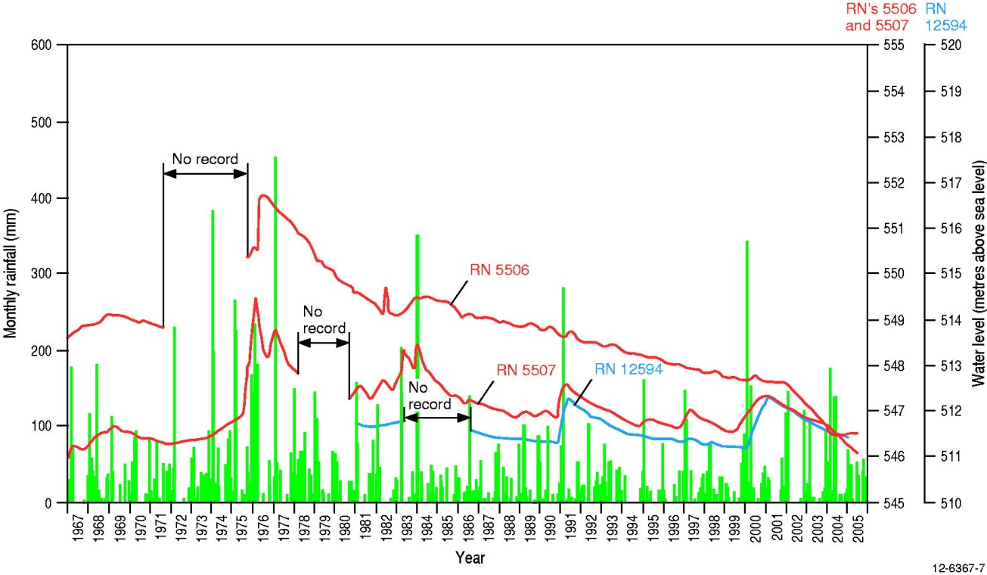
Figure 3.4: Summary of rainfall and groundwater fluctuations in selected bores from the Ti-Tree Basin (after Read and Tickell, 2007).

Groundwater chemistry of the shallow aquifer
A regional overview of the chemical characteristics of groundwater in the shallow Ti-Tree aquifer was provided initially by McDonald (1990). Harrington (1999) conducted a more detailed hydrochemical study and investigated groundwater evolution and processes that have affected the aquifer system. Subsequent hydrochemistry work was undertaken by Harrington and Herczeg (2000, 2003) and Harrington et al. (1999, 2002). The information presented below summarises the key findings of these previous studies.

The high yields of good quality groundwater in the shallow aquifer of the Ti-Tree Basin have been the driver for most previous investigations. Groundwater quality (both salinity and trace element loads) varies both spatially and with depth (Figure 3.5 and Figure 3.6). Magee (2009) noted that total dissolved solids (TDS) range from 420–6,410 mg/L, although compilation of available data for this review suggests wider variation with maximum TDS ~11,000 mg/L. The relationship between groundwater salinity and electrical conductivity is consistent for most of the basin and given by the equation: TDS = EC x 0.64 (Figure 3.7).

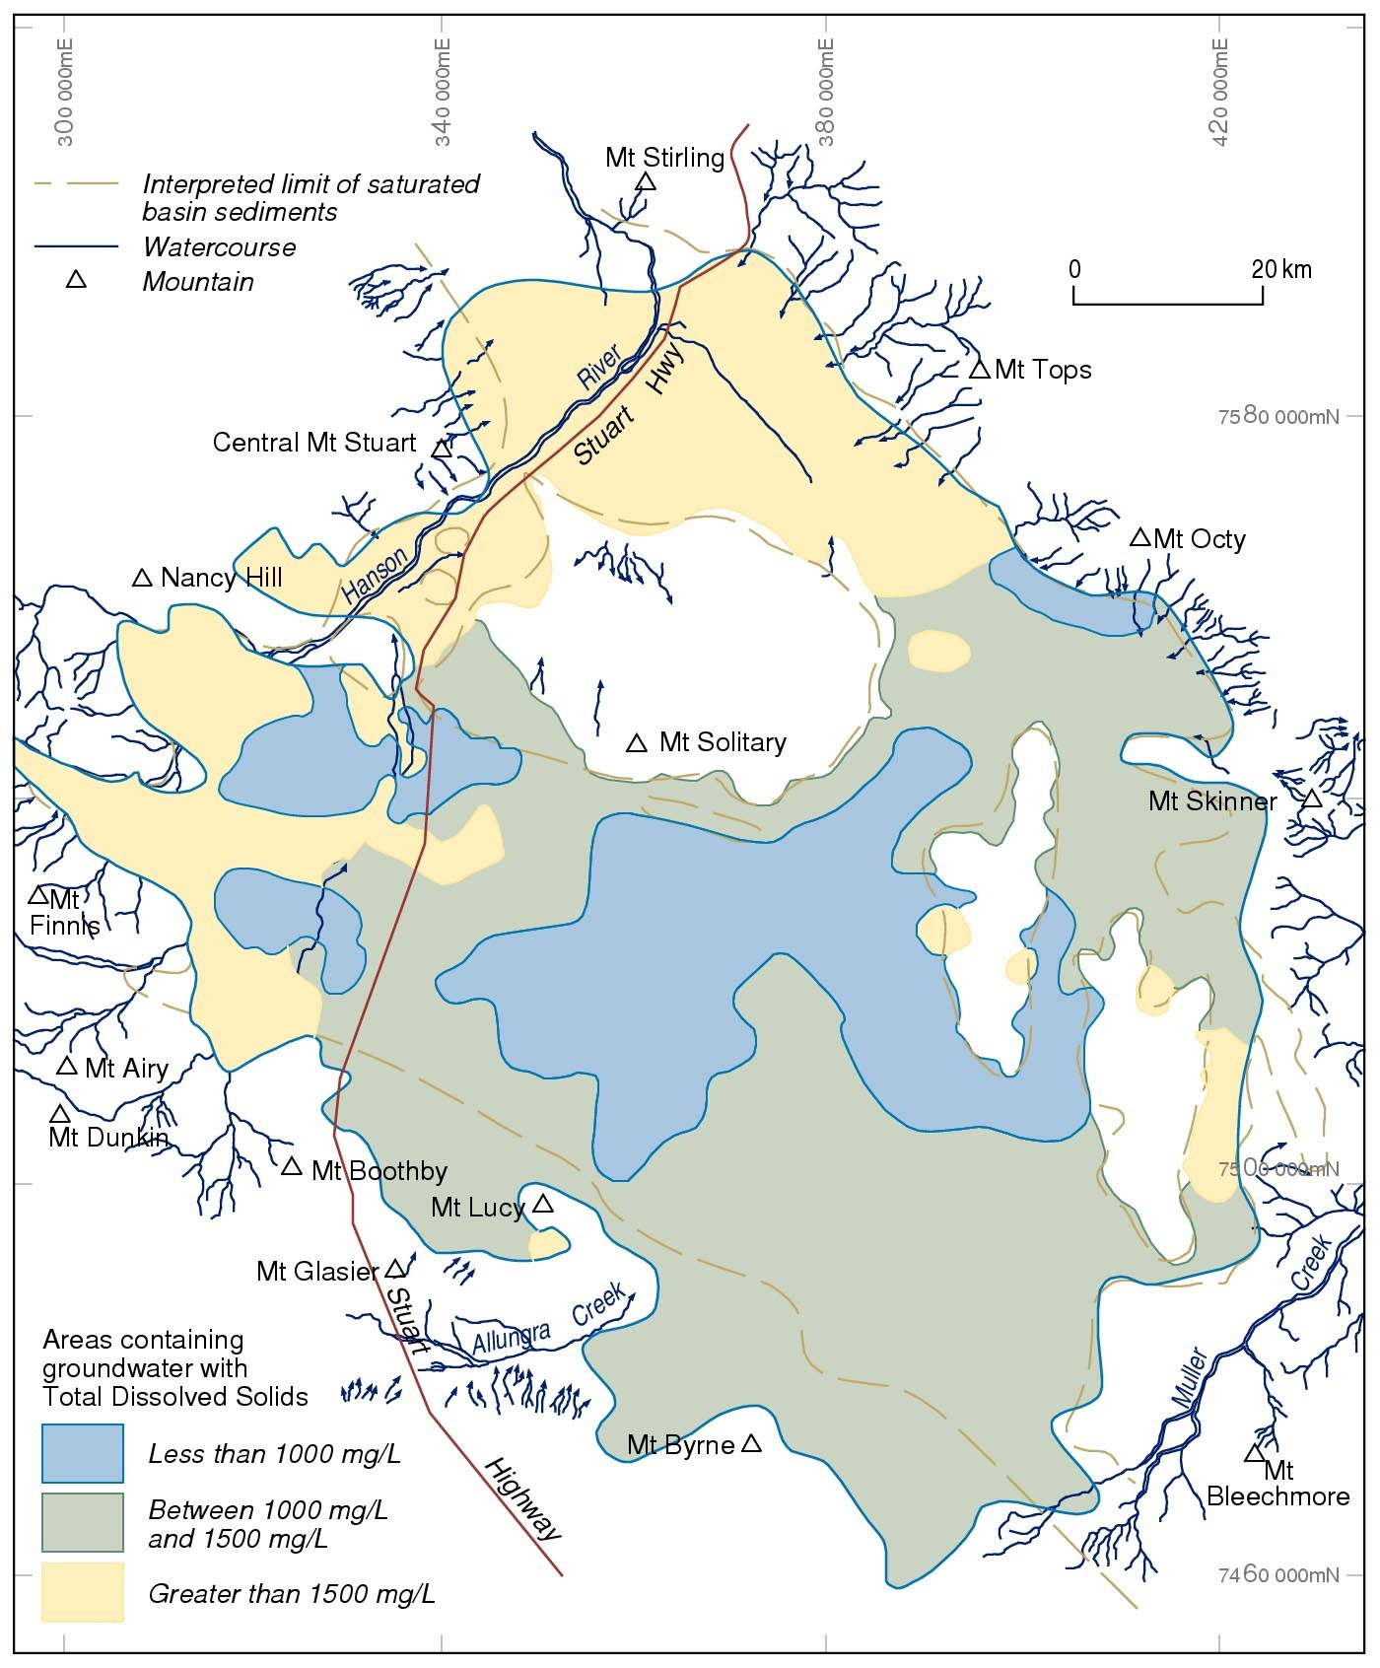
Figure 3.5: Early groundwater quality map for the Ti-Tree Basin, highlighting the spatial variability of potable and brackish water zones (after McDonald, 1990).

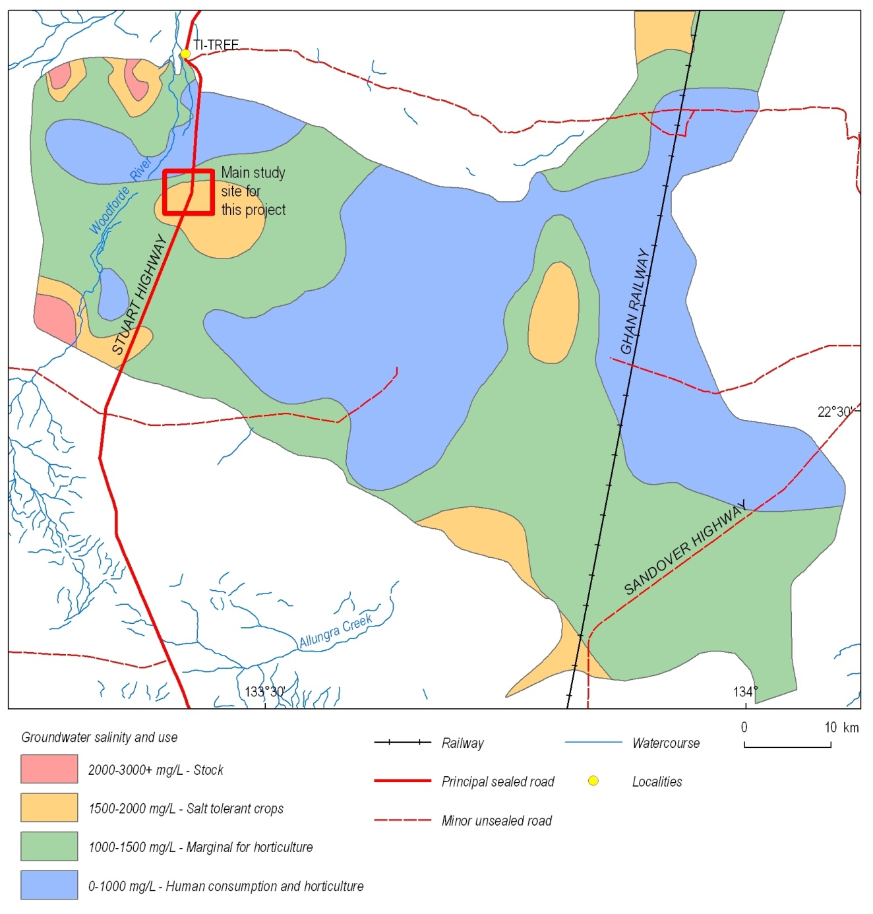
Figure 3.6: Groundwater salinity of the shallow aquifer in the Ti-Tree Basin, highlighting the area where detailed field investigations were conducted for this project. This map shows only the main zone of saturated Cenozoic sediments in the Ti-Tree Basin identified by Read and Tickell (2007), rather than the larger basin extent of earlier workers such as McDonald (1990). However, the main groundwater quality zones are similar to those shown for Figure 3.5.

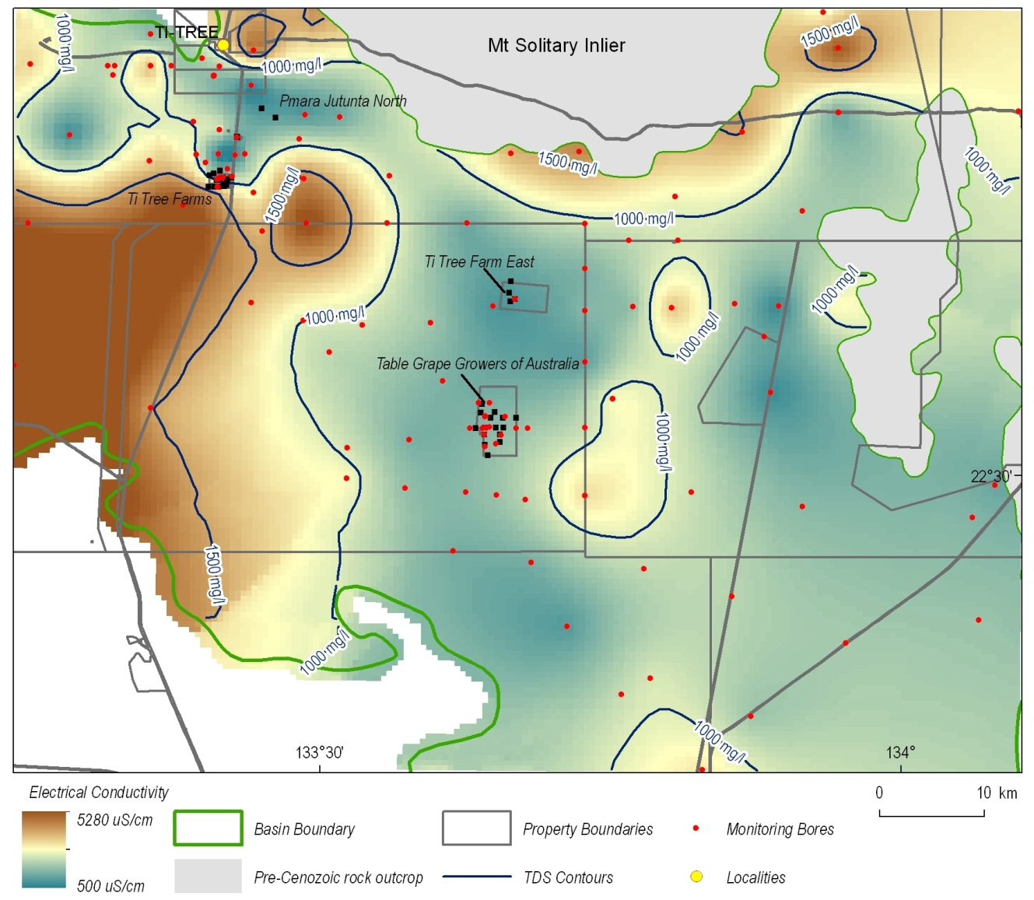
Figure 3.7: Groundwater conductivity of the shallow aquifer in the Ti-Tree Basin. The main horticultural areas coincide with low groundwater conductivity (EC <1,000 µS/cm). Data provided by A. Knapton, 2012 (NT Department of Land Resource Management).

The area of freshest groundwater (TDS <1,000 mg/L) is located in the central part of the Ti-Tree Basin (Figure 3.8). McDonald (1990) attributed this central fresh water zone to recharge from the floodplain of Allungra Creek after major rainfall events. The ratio of bicarbonate to chloride (HCO₃⁻ to Cl⁻) was interpreted by McDonald (1990) as an indicator of groundwater recharge, with values >1 closely correlated with low TDS (Figure 3.8 and Figure 3.9). Nitrate levels generally range from 70-350 mg/L. Potable groundwater supplies (where TDS<1,500 mg/L and nitrate <45 mg/L) only occur in the north-west part of the basin.

Harrington et al. (1999, 2002) suggested that two dominant process groups account for the chemical composition of the shallow Ti-Tree groundwater system:

- Group 1 processes: Dissolution of calcite (CaCO₃) and gypsum (CaSO₄*2H₂O), and silicate weathering (addition of HCO₃ and HSO₄ at initially low Cl concentrations).
- Group 2 processes: Evapotranspiration, precipitation of carbonate minerals, cation exchange of calcium for sodium on clay minerals, and in some instances weathering of silicates.

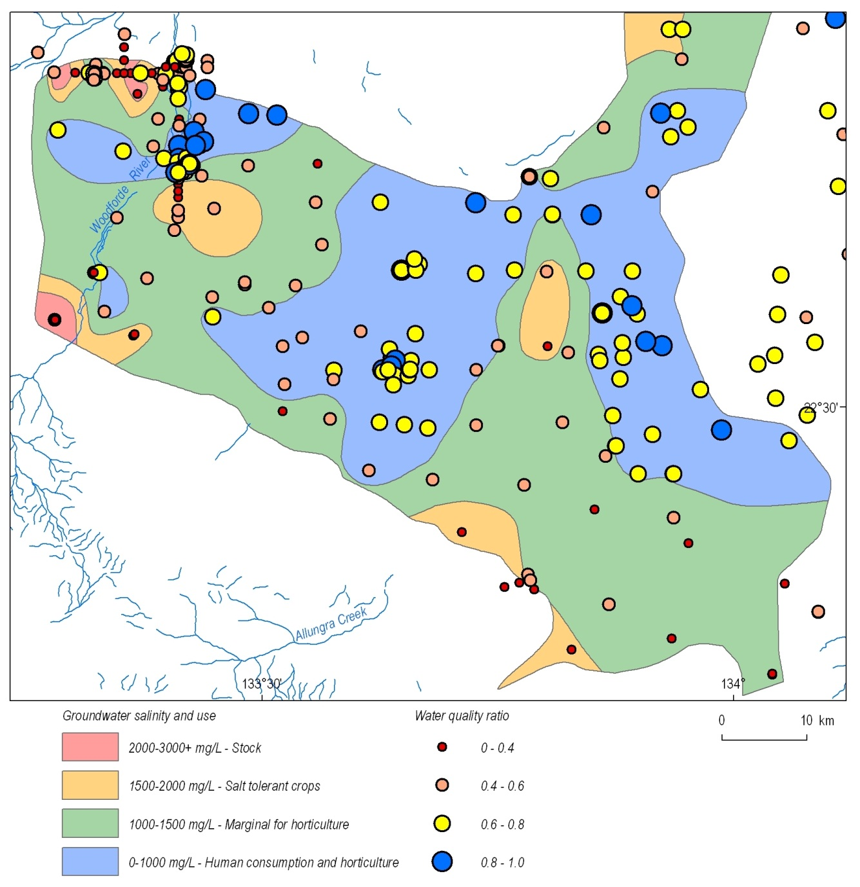
Figure 3.8: The ratio of (HCO₃⁻ + HSO₄⁻) to (HCO₃⁻ + HSO₄⁻ + Cl⁻) in groundwater samples from the Ti-Tree Basin plotted on basin salinity map (historical groundwater data sourced from NT DLRM). This ratio is here termed the ‘water quality ratio’ and is also used for subsequent maps in this chapter.

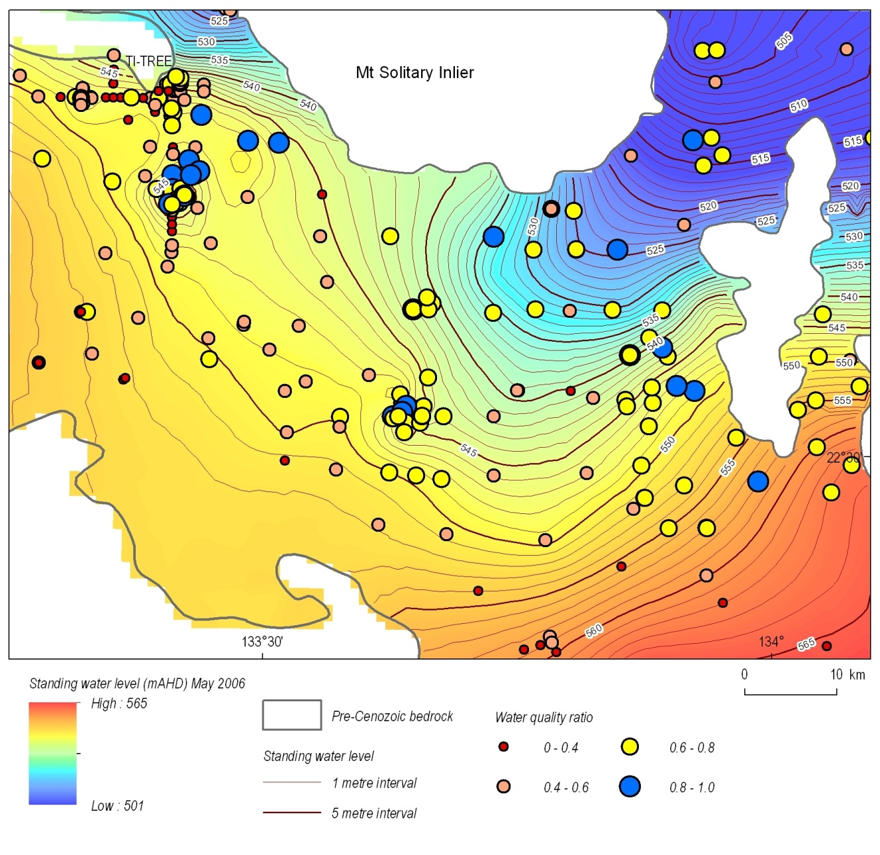
Figure 3.9: The ratio of (HCO₃⁻ + HSO₄⁻) to (HCO₃⁻ + HSO₄⁻ + Cl⁻) in Ti-Tree Basin groundwater plotted on groundwater flow direction map of the shallow aquifer (historical groundwater data sourced from NT Government database).

Samples of Ti-Tree Basin groundwater (all available data) form a relatively tight cation data cluster on the Piper diagram. However, there is a distinct sub-linear trend evident for the anion data, from groundwater dominated by HCO₃⁻ to Cl⁻⁻enriched groundwater (Figure 3.10). The groundwater processes (described above) classed as Group 2 by Harrington et al. (1999, 2002) are mainly responsible for the cation data cluster and also for increased levels of chloride compared with total anions (when plotted against total chloride). Visual examination of the Piper diagram suggests that the HSO₄⁻ to Cl⁻ ratio is similar for most of the Ti-Tree samples. This indicates that removal of bicarbonate and chloride, and accumulation of sulfate, is the major process driving the chemical evolution of the Ti-Tree groundwater system. This justifies the simplified approach of McDonald (1990) for plotting the ratio of HCO₃⁻ to Cl⁻ to indicate areas of groundwater recharge (Figure 3.11). McDonald (1990) also found excellent correlation between the ratio of HCO₃⁻ to Cl⁻ and TDS. However, the ratio of (HCO₃⁻ + HSO₄⁻) to (HCO₃⁻ + HSO₄⁻ + Cl⁻) is more useful as it accounts not only for bicarbonate removal, but also for sulfate removal by precipitation of gypsum (Figure 3.11).
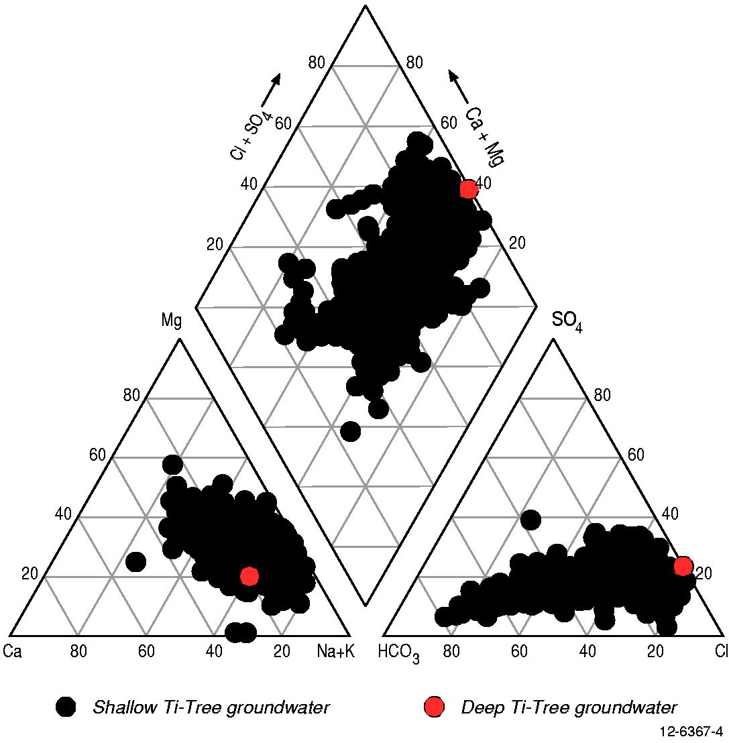
Figure 3.10: Piper diagram for Ti-Tree Basin groundwater samples, highlighting deep investigation boreholes drilled for this study (RN 18365 and RN 18594).

Spatial distribution of hydrochemistry data
Two approaches were used to evaluate spatial trends in the distribution of hydrogeochemical data in the Ti-Tree Basin:

Approach 1 – Plotting pie charts to depict distribution of total anions in groundwater (HCO3, HSO4, and Cl); and

Approach 2 – Plotting the ratio of (HCO₃⁻ + HSO₄⁻) to (HCO₃⁻ + HSO₄⁻ + Cl⁻).

These data were plotted on the MrVBF and radiometrics images of the Ti-Tree Basin to evaluate spatial hydrochemical relationships relative to landscape features (Figure 3.12–3.14).

Figure 3.12 shows pie charts of major anions in groundwater plotted over the MrVBF index. Although these provide the most complete picture of the spatial distribution of the groundwater composition, the maps of the (HCO₃⁻ + HSO₄⁻) to (HCO₃⁻ + HSO₄⁻ + Cl⁻) ratio also relate essentially the same information with greater clarity (Figure 3.13–3.14).

As expected from the XY scatter plots (Figure 3.11) there is a well expressed spatial correlation between the selected HCO₃⁻–HSO₄⁻–Cl⁻ratios and the TDS and Cl content of Ti-Tree groundwater (Figure 3.8). However, there are no obvious correlations with the general direction of groundwater flow (Figure 3.9). This is consistent with the previous conclusions of both McDonald (1990) and Harrington et al. (1999, 2002), whereby groundwater composition and quality in the Ti-Tree Basin is controlled mostly by the distribution of enhanced groundwater recharge zones.

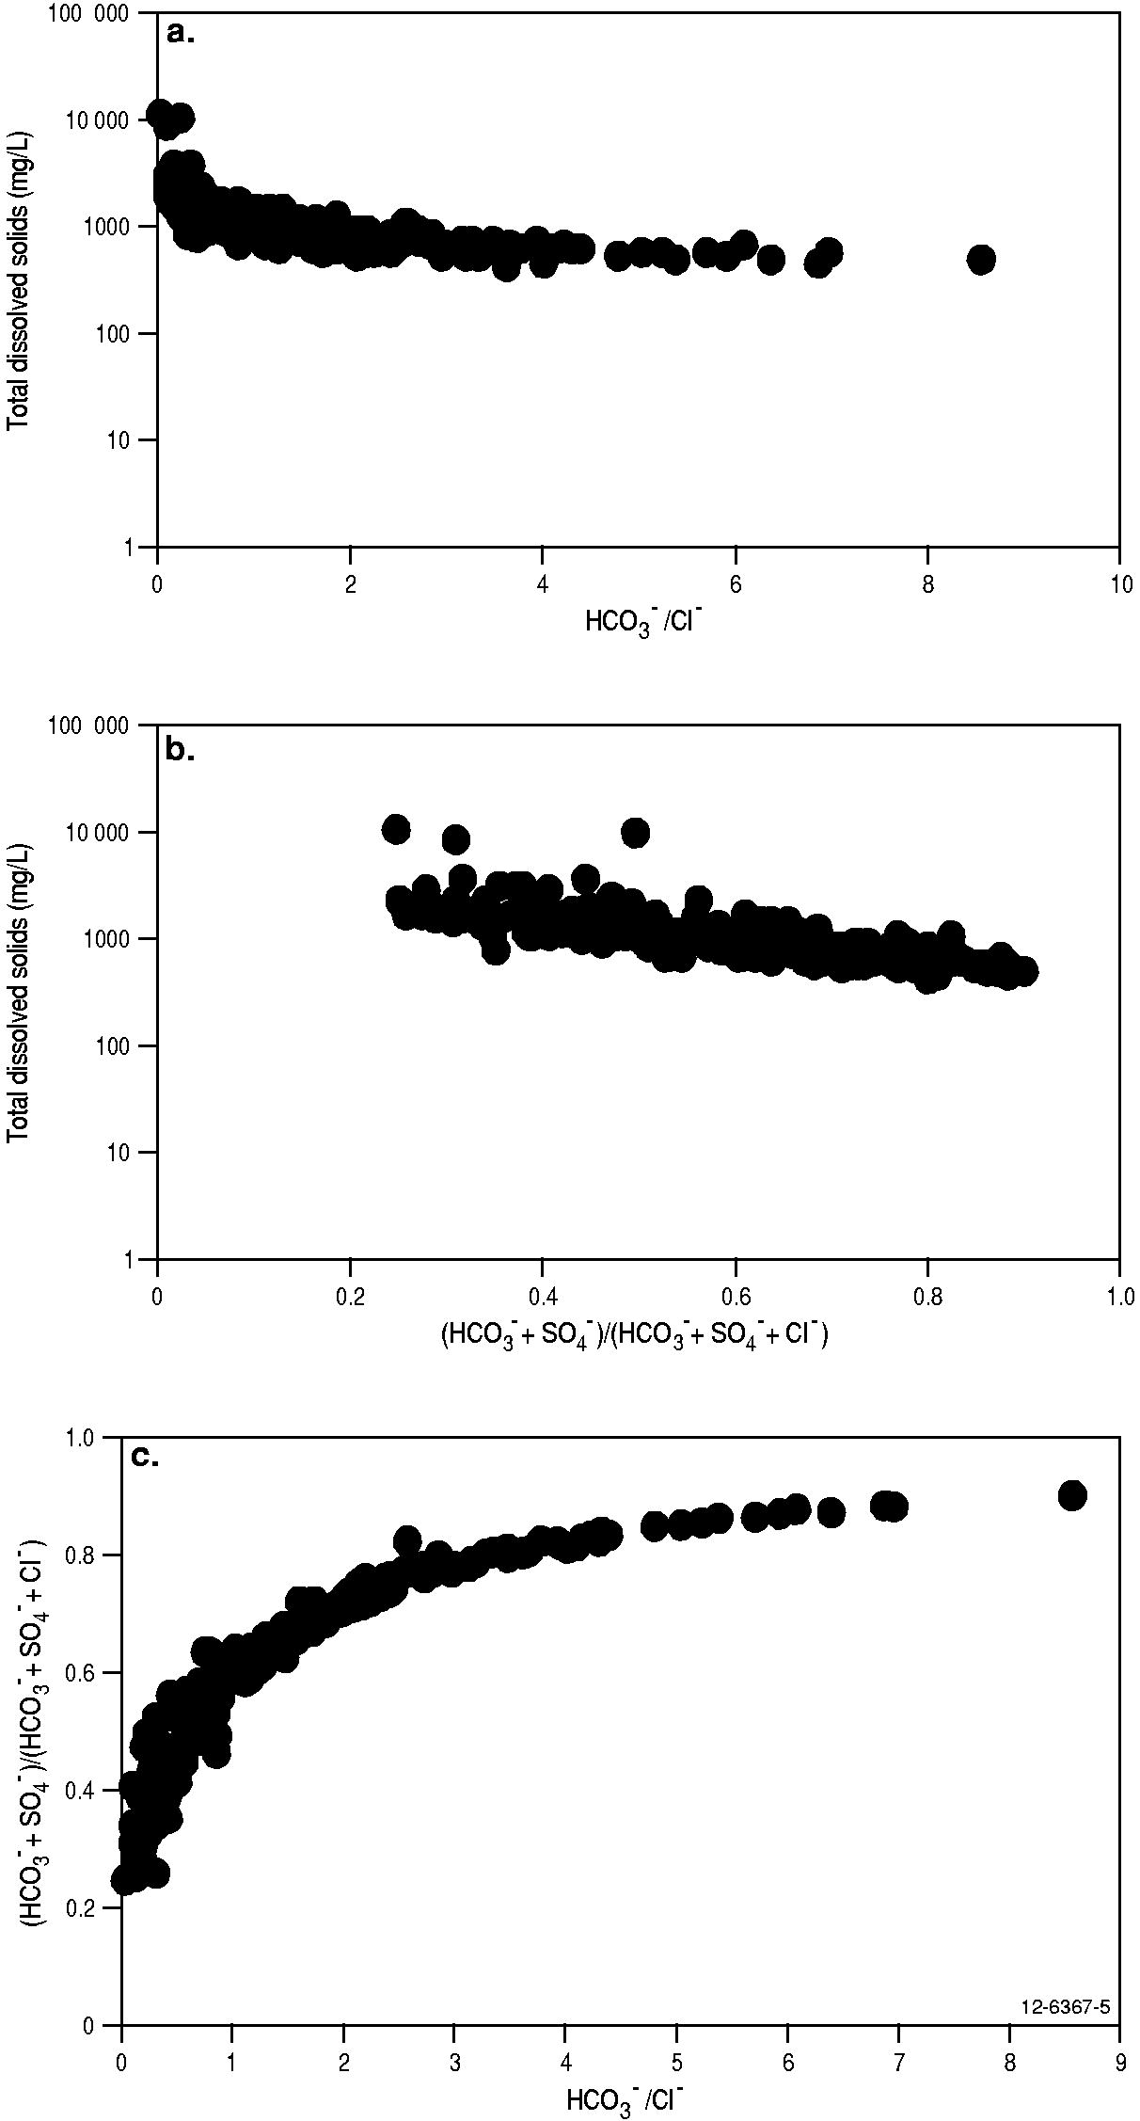
Figure 3.11: The chemical composition of Ti-Tree Basin groundwater expressed as a function of TDS (mg/L) and the relative contributions of HCO₃, Cl, and HSO₄ (mg/L): (a) TDS vs. HCO₃/ Cl⁻; (b) TDS vs ratio of (HCO₃⁻ + HSO₄⁻) to (HCO₃⁻ + HSO₄⁻ + Cl⁻); (c) correlation between the two ratios.
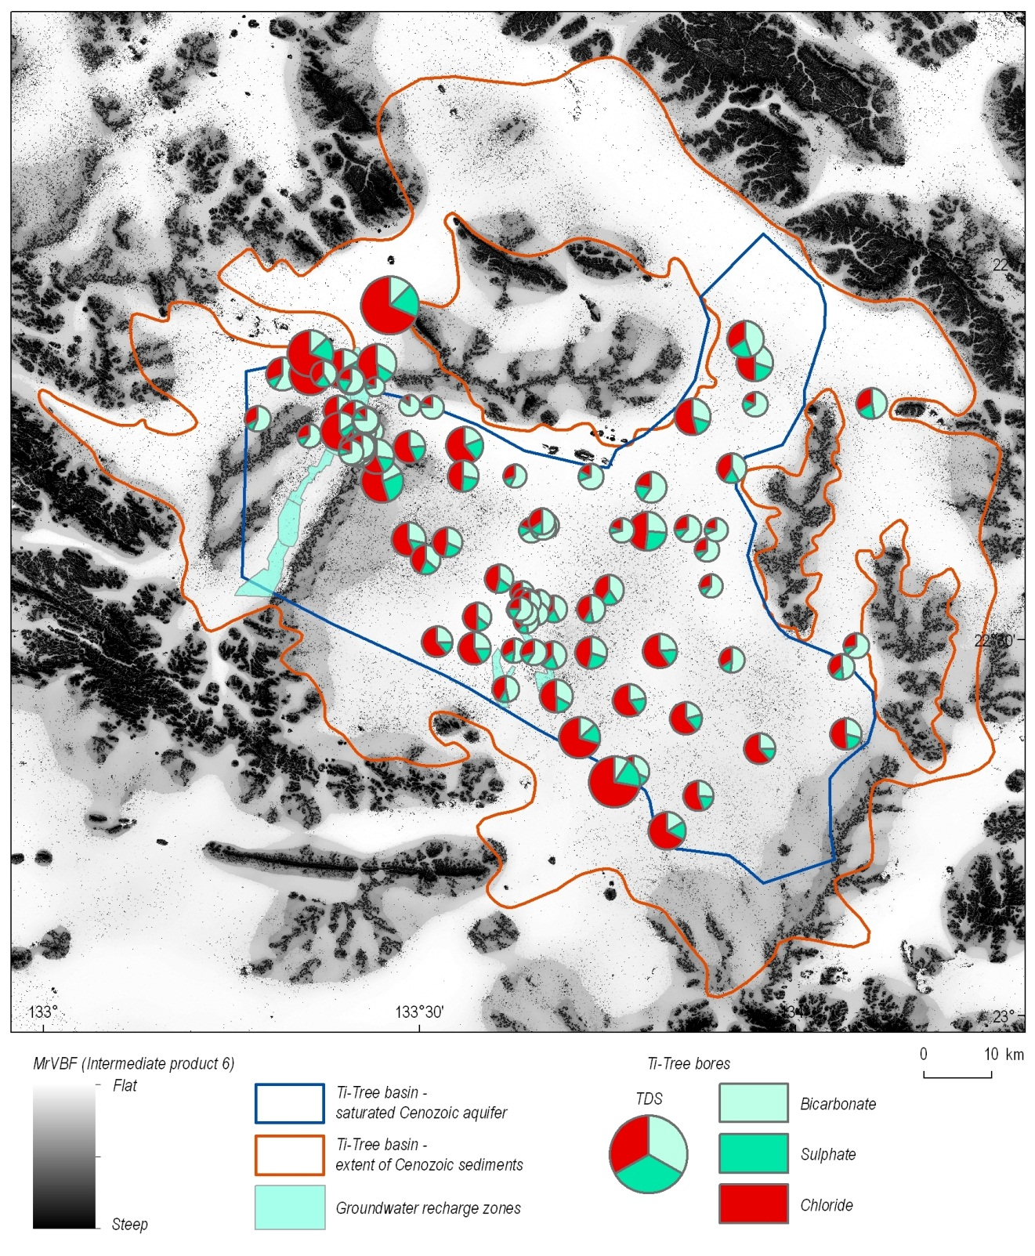
Figure 3.12: The chemical composition of Ti-Tree groundwater expressed as a function of TDS and the relative contributions of the main anions, HCO₃⁻, SO₄⁻, and Cl⁻. The values are draped over the MrVBF image with the main basin recharge areas in the flood-out zones of Allungra Creek and the Woodforde River shaded green (Read and Tickell, 2007).

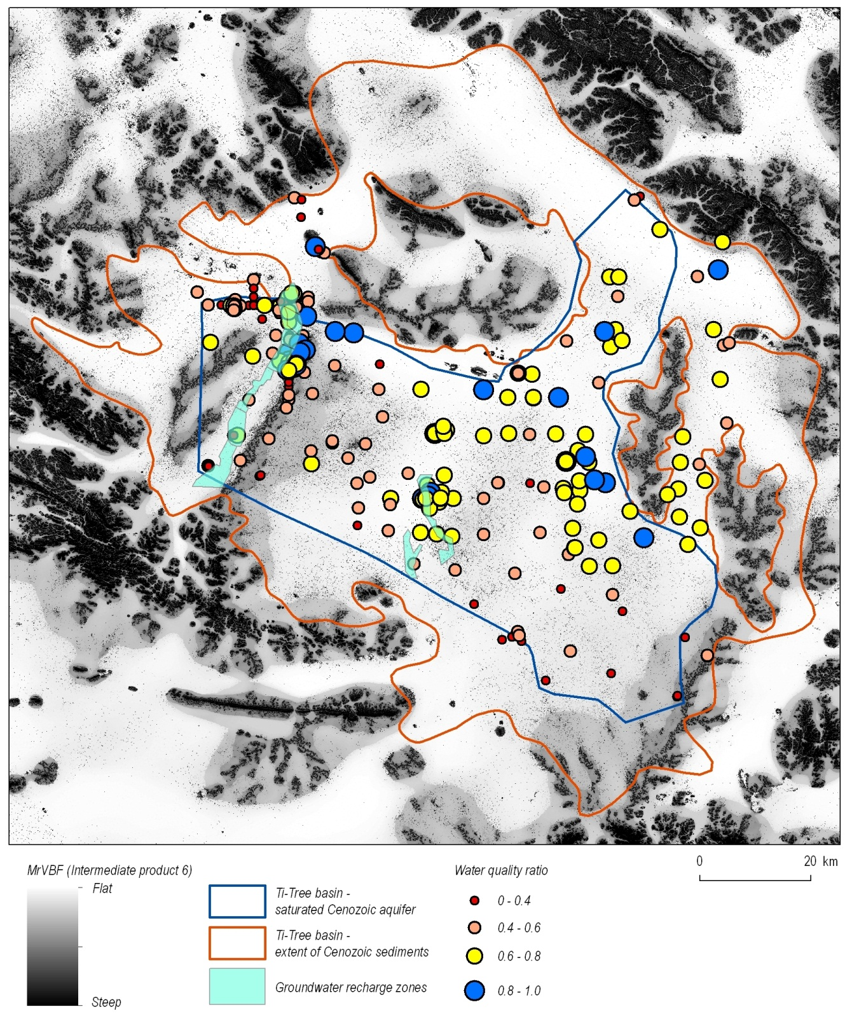
Figure 3.13: Distribution of (HCO₃⁻ + HSO₄⁻) to (HCO₃⁻ + HSO₄⁻ + Cl⁻) ratios in Ti-Tree Basin groundwater samples, draped over the MrVBF image. The main basin recharge areas of the Woodforde River and Allungra Creek are shaded green.
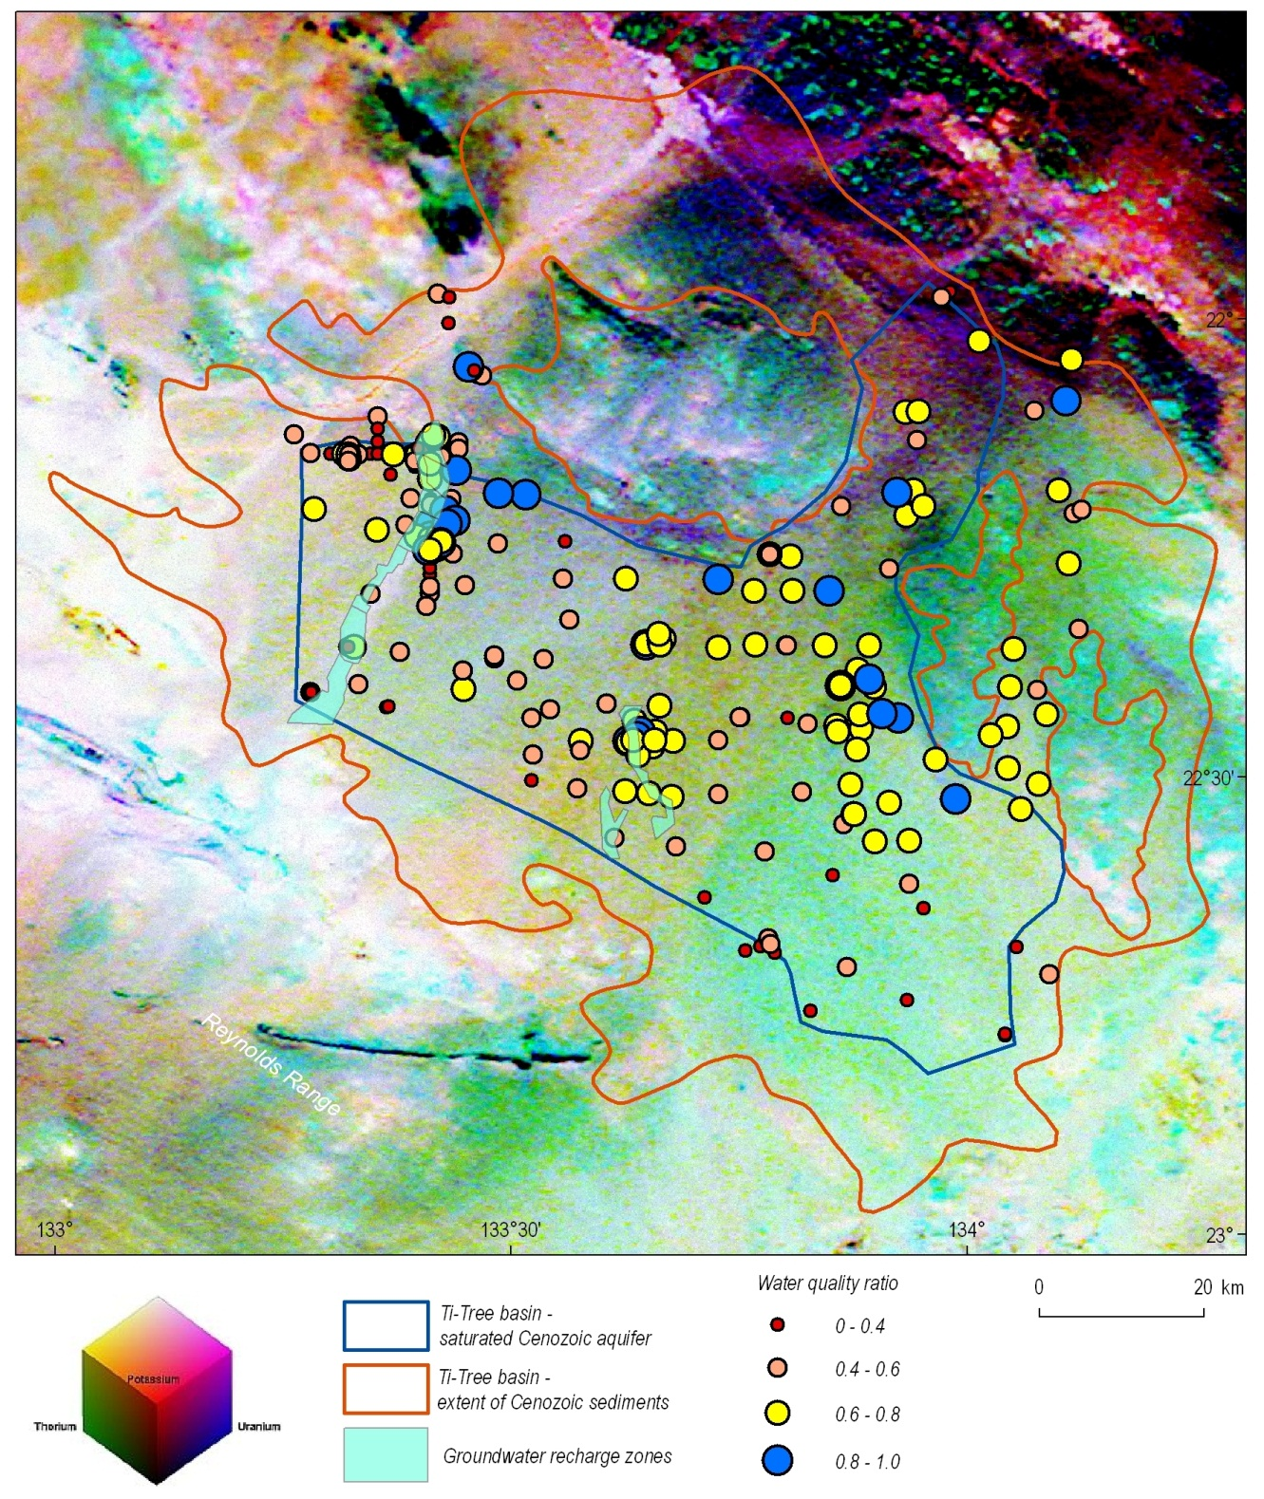
Figure 3.14: Distribution of (HCO₃⁻ + HSO₄⁻) to (HCO₃⁻ + HSO₄⁻ + Cl⁻) ratios in Ti-Tree Basin groundwater samples, draped over the radiometric image.

Evolution of Ti-Tree Basin groundwater
Groundwater compositions in the Ti-Tree Basin are Na–HCO₃-dominated at lower salinity, and NaCl-dominated at TDS levels above ~1,500 mg/L (McDonald, 1990; Harrington et al., 1999, 2002). This trend is shown on the Piper diagram for all available groundwater samples for the basin (Figure 3.10). The data of Harrington (1999) suggest broad correlation between groundwater chemistry and the groundwater residence time (‘age’) based on corrected carbon-14 data (Figure 3.15).
Harrington et al. (1999, 2002) suggested that the composition of the NaCl–type groundwater reflected greater evaporative concentration in the soil zone resulting in precipitation of carbonate minerals, cation exchange of calcium for sodium in clay minerals, and (in some instances) weathering of silicates. Saturation indices of calcite and gypsum calculated with the PHREEQC geochemical code and database (for this present study) supports the interpretation of groundwater evolution in the direction of calcite (and ultimately gypsum) saturation as evaporative concentration of chloride progresses. Calcite saturation occurs at chloride concentrations ~10 milliequivalents-per-litre (meq/L), although gypsum remains unsaturated at the observed concentrations. This latter effect explains why the evolution trend of groundwater is best expressed in terms of HCO₃ to Cl ratios.

The simple evolutionary trend on the Piper diagram can be locally “reversed” for the case of mixing between brackish groundwater (potentially sourced from deeper aquifers in the Ti-Tree Basin) and lower salinity water in the upper aquifer (explained further in Chapter 5). However, despite the potential for such local variations, the major conclusion from this hydrochemistry data review is that the more evolved and mature Ti-Tree groundwater system largely develops in the direction of concentrated NaCl–rich waters.

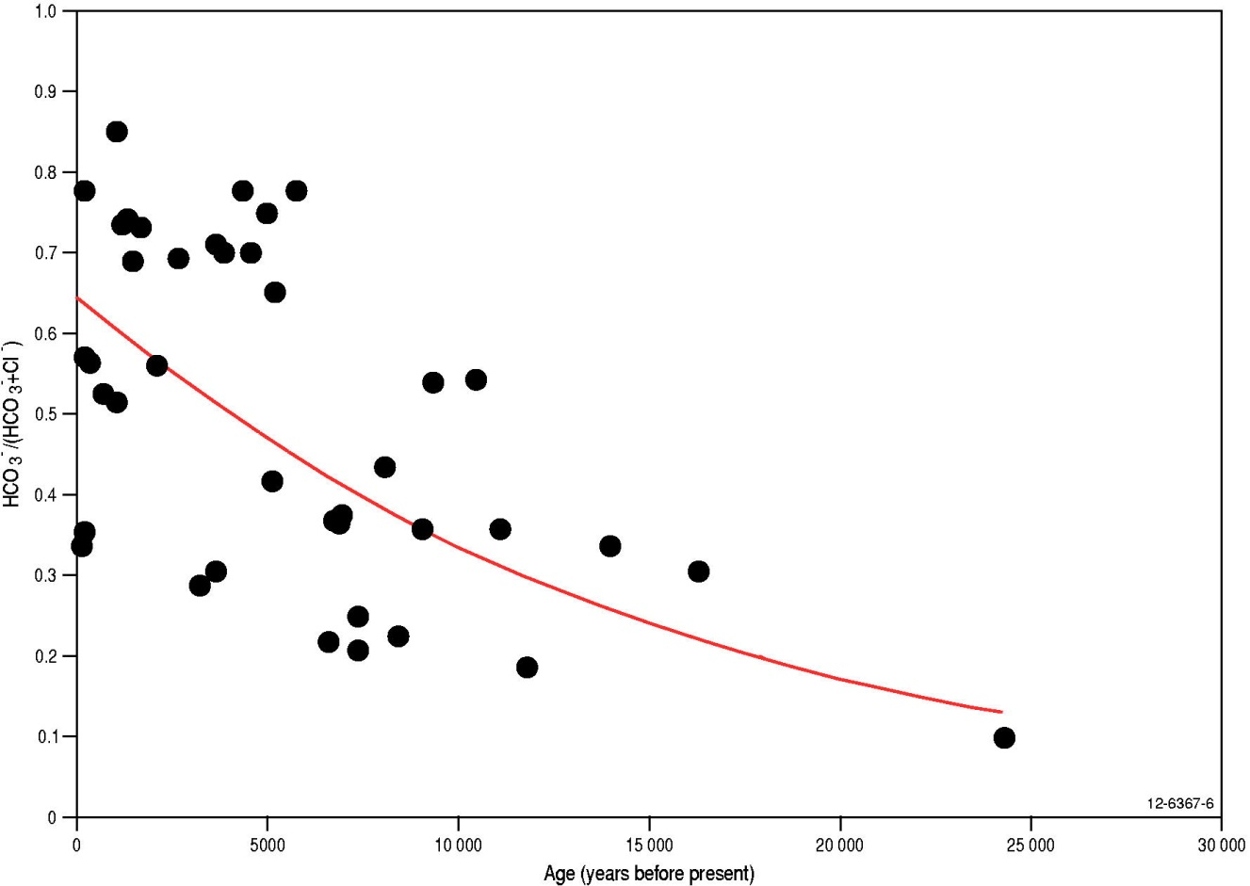
Figure 3.15: Correlation between groundwater chemistry and age based on corrected ¹⁴C data from Harrington (1999).

Potential for groundwater resources in deep aquifers
The potential for the deeper sedimentary successions of the Ti-Tree Basin to contain significant aquifers was sparked by mineral exploration drilling conducted in the Ti-Tree area by NuPower Resources Ltd. in 2009-2010 (Higgins and Rafferty, 2009). The outcomes of this exploration work led to re-examination of older government and exploration company reports from the region, especially those of Edworthy (1966, 1967) and O’Sullivan (1973). Appraisal of this information, conducted as part of the Palaeovalley Groundwater Project, showed that significant sand-rich layers had previously been encountered at depths of over 250 metres below surface in some parts of the Ti-Tree Basin. However, despite the obvious potential of such sediment layers to function as high-quality aquifers, there had been no significant investigation of the deeper groundwater system in the basin.

In 1966 Edworthy conducted an investigative drilling program in response to government interest in the groundwater potential of the Ti-Tree area. This was largely based on earlier assessment by Perry (1962) and Perry et al. (1963). After examining existing data Edworthy drilled along a series of grid lines and completed 83 rotary drillholes. The various sedimentary units were logged in detail and assigned to stratigraphic intervals. Edworthy (1967) also constructed some elegant geological fence diagrams to show the distribution of the sedimentary facies across the basin.

Edworthy’s (1967) deepest drillhole is identified by the grid number 130/52.5. This hole has since had various numbers assigned but is now identified in the NT Government borehole database by the registered number (RN) 5568. As an illustration of the aquifer potential Edworthy described clean and loose sands between 740-810 and 960-1,020 feet (i.e., approximately 226-247 and 293-311 metres, respectively).

Subsequent hydrogeological investigations of the Ti-Tree Basin do not (surprisingly) discuss the geological interpretations of Edworthy (1967) in great detail. For example, only a summary of the lithological descriptions of Edworthy (1966) was mentioned by Ride (1968) in his report on later drilling operations. However, Ride (1968) noted that the deep sands were untested due to the need for drilling with mud. The Edworthy (1967) report was also not cited by O’Sullivan (1973), McDonald (1990) and Harrington (1999). Until staff from NuPower Resources mentioned they had encountered 50+ metres of clean sands below 250 metres in some exploration drillholes, the deep sand-bearing zones of the Ti-Tree Basin seem to have mostly been forgotten.

A schematic of the sedimentary successions defined by Edworthy (1967) has been reproduced as Figure 3.16. The interpretation of the sedimentary units and weathering profiles within the basin was not attempted in subsequent groundwater investigations, although the initial mineral exploration report by CRA Exploration Ltd (Hughes and O’Sullivan, 1973) did use similar units to those of Edworthy. CRA subsequently drilled six diamond core holes to basement in the Ti-Tree area as part of their exploration program (O’Sullivan, 1973). The deepest of these holes, named TT1 by CRA (now RN 17269 in the NT borehole database), is in the southern region of the (former) Ti-Tree Station pastoral lease, just east of the Stuart Highway (Figure 1.2). Palynological analysis completed on a sample of carbonaceous mudstone and lignite from TT6 (RN 17273) was tentatively assigned as Middle Miocene (O’Sullivan, 1973).

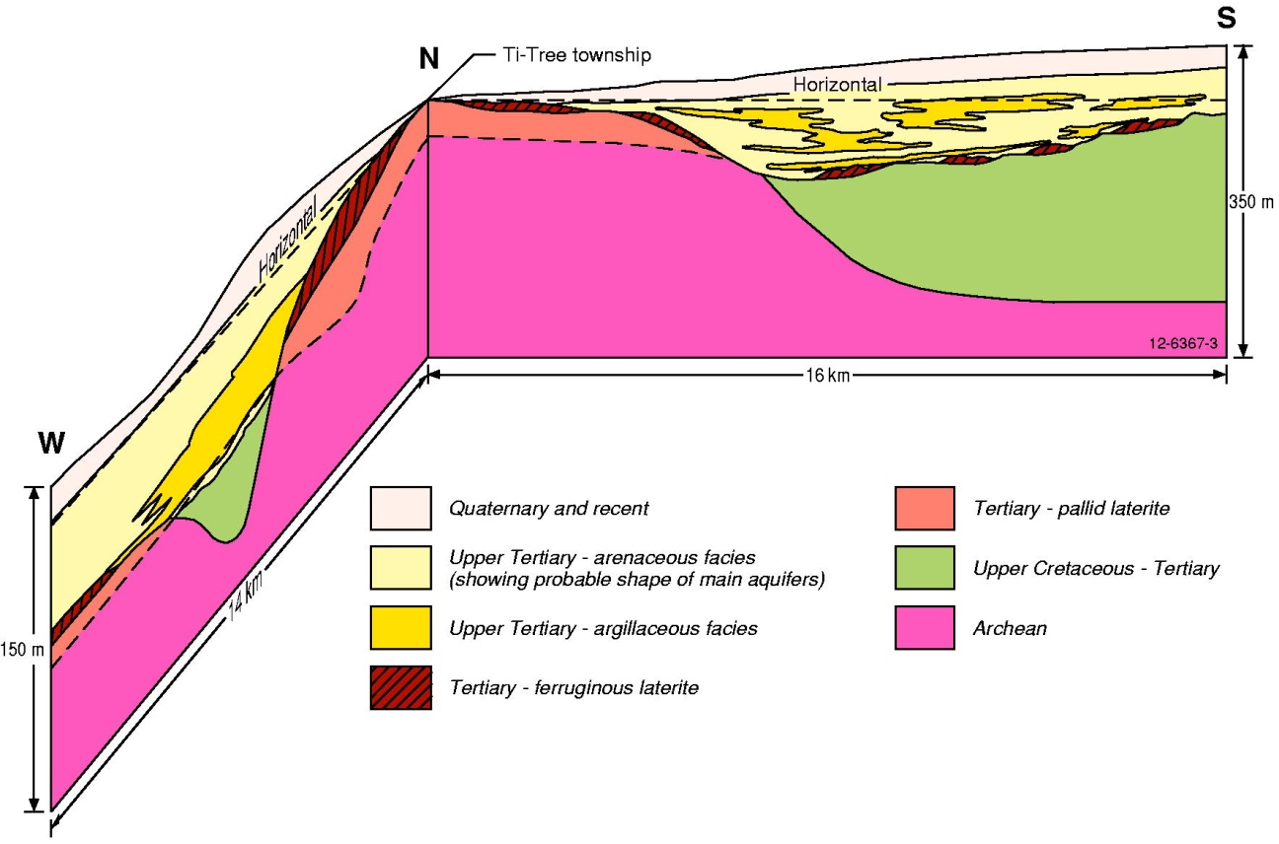
Figure 3.16: A schematic representation of the geological units and relationships within the Ti-Tree Basin (after Edworthy, 1967). The Upper Cretaceous to Tertiary sediments (mainly sands and silts, shown here in green) correspond to the deeper basin sediments which are the focus of this study.

O’Sullivan (1973) defined six sedimentary facies in the Ti-Tree Basin on the basis of interpretations of the six CRA cored drillholes. All but the uppermost group were of variable thickness, depth and lateral extent. The six groups were:

- Oxidised poorly sorted silts, silty sands and sandy silts with minor granule and grit horizons;
- Green and grey variable siltstones, mudstones and sandy siltstones;
- Lignite and carbonaceous clay;
- White kaolinitic silts and clays;
- Soft, unconsolidated, buff and pink coloured sands; and
- Laterite.

O’Sullivan (1973) did not relate these six facies groups to the units previously defined by Edworthy (1967). However, from the core descriptions provided by O’Sullivan (1973) for the deep TT1 drillhole it is apparent that the ~45 m sand-bearing zone below 208 metres depth (described as loose and free flowing sands) are similar to Edworthy’s descriptions of the same depth interval for nearby borehole RN 5568. The position of these two deepest drillholes (RN 5568 and TT1) in the Cenozoic-filled basin coincides with a major north-west fault zone evident in the regional magnetic dataset (Figure 2.4 and Figure 2.5), and also interpreted by Ahmad and Scrimgeour (2006). This suggests that the development of the thickest sedimentary section in the Ti-Tree Basin was strongly influenced by faulting.

Summary
Despite many previous hydrogeological investigations in the Ti-Tree Basin, relatively little information was known about deeper groundwater systems. Although several deep drillholes had penetrated the entire sedimentary sequence in the basin and encountered potential water-bearing zones at depth, these holes were drilled some 40–50 years ago. In the intervening years all hydrogeological studies had concentrated on the shallower groundwater system, providing considerable scope to further investigate aquifers below depths of ~200 metres, and determine some basic characteristics of the deep groundwater system.

Investigation of deep groundwater systems in the Ti-Tree Basin
The work program conducted in the Ti-Tree Basin for the Palaeovalley Groundwater Project focused on evaluating the nature of the deeper groundwater resources. This followed-on from initial discussions about the results of drilling by NuPower Resources Ltd, and the ‘discovery’ of the earlier reports by Edworthy (1967) and O’Sullivan (1973). All of these sources indicated that favourable aquifer intervals (sand-rich sequences) occur in the deeper Cenozoic strata of the basin, at variable depths of approximately 200–320 m below surface.

Investigations into the deep Ti-Tree groundwater system for this project focused on the north-west part of the basin in the vicinity of existing deep drillholes TT1 and RN 5568 (Figure 4.1), and included:

- Ground-based gravity surveying to determine the deepest part of the basin in the area of interest, as a guide to siting new drillholes;
- Drilling two deep rotary drillholes at selected localities to determine the sedimentary strata, identify potential aquifer zones, establish monitoring bores and collect samples of deep groundwater for hydrochemical analysis;
- Re-evaluate the stratigraphy of the Ti-Tree Basin on the basis of existing bore data, and the new drilling results;
- Collect suitable sample material from existing cored drillholes and the new deep drillholes to conduct palynological analysis and improve understanding of the age and environment of sediment deposition; and
- Collect samples of deep groundwater for hydrogeochemical analysis, including major and minor ions, stable isotopes, and radiogenic isotopes.

Gravity
Twenty kilometres of ground-based gravity data were acquired along two survey lines at 200 m station spacing to help define the shape of the basement rock surface beneath the Ti-Tree Basin (Figure 4.2). The area with the lowest gravity readings was expected to coincide with the thickest sequence of Cenozoic sediments in this part of the basin. The structure, stratigraphy and groundwater resources of this area would then be investigated by drilling down through the sediment profile to intersect the underlying basement rocks.

The gravity data were acquired using a LaCoste and Romberg Model G gravity meter (accurate to 0.01 milligals, mGal) provided by Geoscience Australia’s Continental Geophysics team. Base station and repeat station readings were taken at regular intervals (base station every three hours, repeat stations every 10 readings) to ensure data consistency and help minimise errors. Data were systematically collected over several days of surveying in late-2009, although work along the north-east survey line (which linked the six previous CRA cored drillholes) was hampered by thick scrub.

The elevation of each gravity station was surveyed using differential GPS technology (Figure 4.3). The field gravity readings were then processed to correct for the effects of latitude and elevation, thereby allowing the Bouguer gravity anomaly to be calculated for each survey line (Griffiths and King, 1981). The Bouguer gravity data primarily reflect local variations in the density of the rocks and sediments below the surface at each survey station (Figure 4.4 and Figure 4.5). In the case of this survey, the gravity measurements were collected to help define the approximate depth and shape of the interface between Cenozoic sediments of the Ti-Tree Basin and the underlying Proterozoic rocks.

Analysis of the initial north-east survey line (Figure 4.4) indicated that the relative Bouguer gravity low anomaly is about 2 km south-west of drillhole CRA TT1 (the cored hole with the thickest section of Cenozoic sediments). Consequently, the second survey line (west to east) was positioned to intersect this region of anomalously low gravity, expected to represent a thicker sedimentary infill sequence. The Bouguer anomaly for the second survey line (Figure 4.5) indicated that the deepest basement intersection was likely to occur several kilometres south of TT1. Consequently, this site was targeted for drilling RN 18594 (discussed below).

Within the gravity survey area drillhole CRA TT1 is situated on a major north-west trending fault system, recognised in both the regional bedrock geology map and in the regional magnetic data (Figure 4.6). The coincidence of major faults and thick Cenozoic sediment sequences provides evidence that large-scale regional structures have played an important role in the evolution of the Ti-Tree Basin.

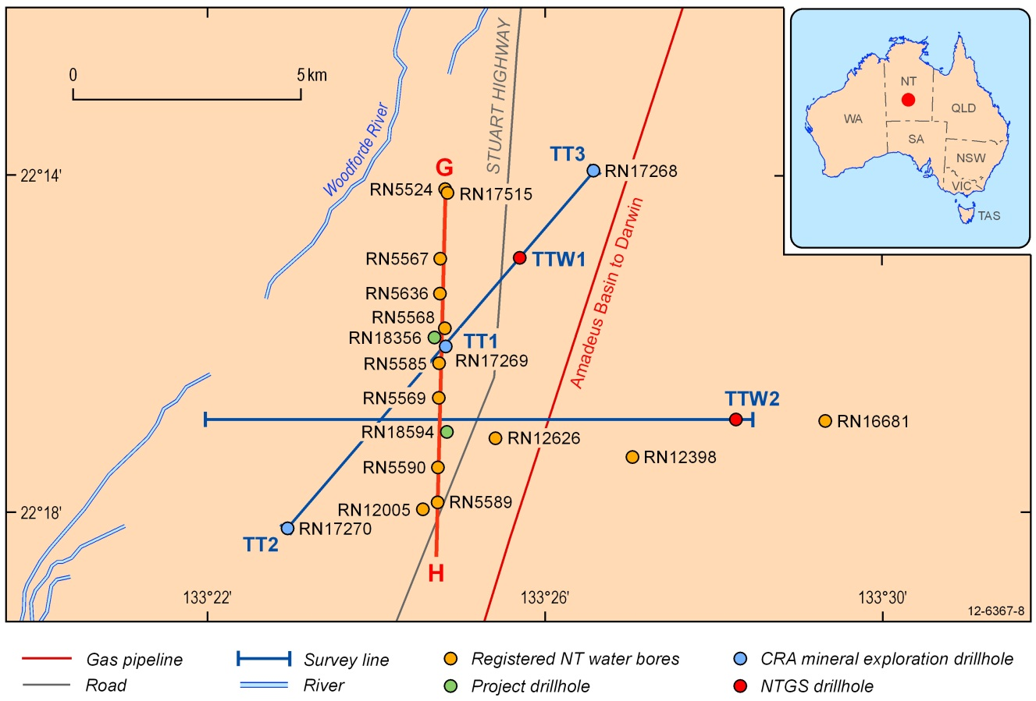
Figure 4.1: Gravity survey lines, new boreholes and existing drilling sites in the main study area of the Ti-Tree Basin, Northern Territory. An interpreted cross-section for Line G–H is shown in Figure 4.13.
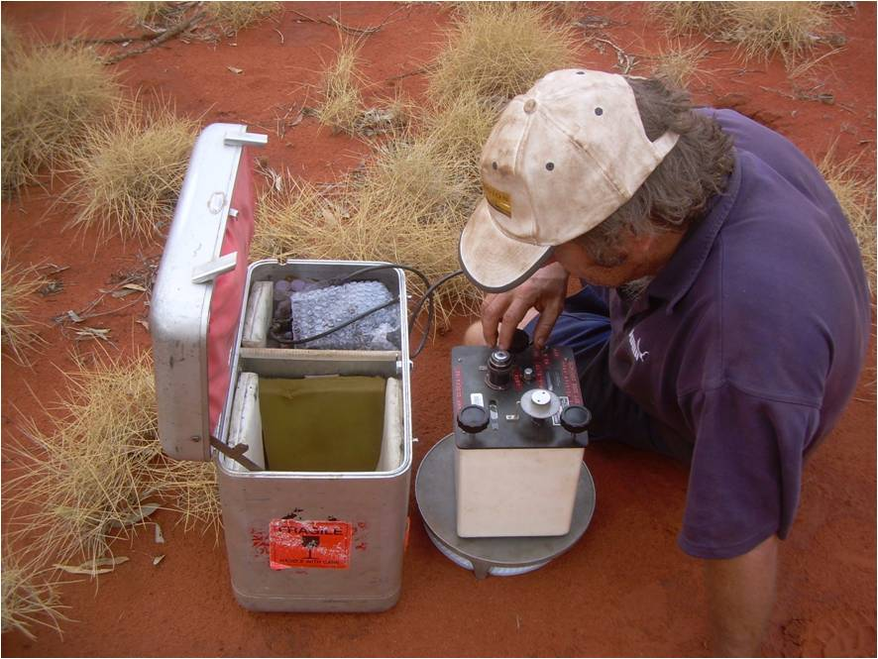
Figure 4.2: Dr John Wischusen of Geoscience Australia collects a gravity reading along the west to east survey line in the Ti-Tree Basin.

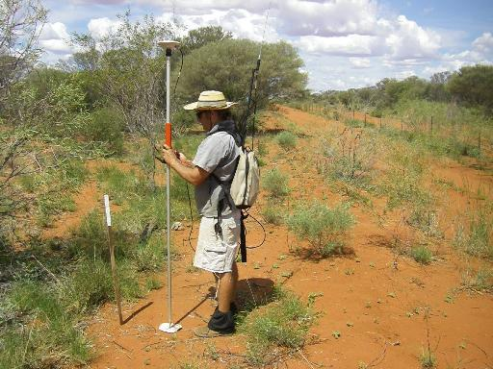
Figure 4.3: Levelling gravity survey stations using DGPS to correct for the influence of elevation on the field-based (raw) gravity readings.
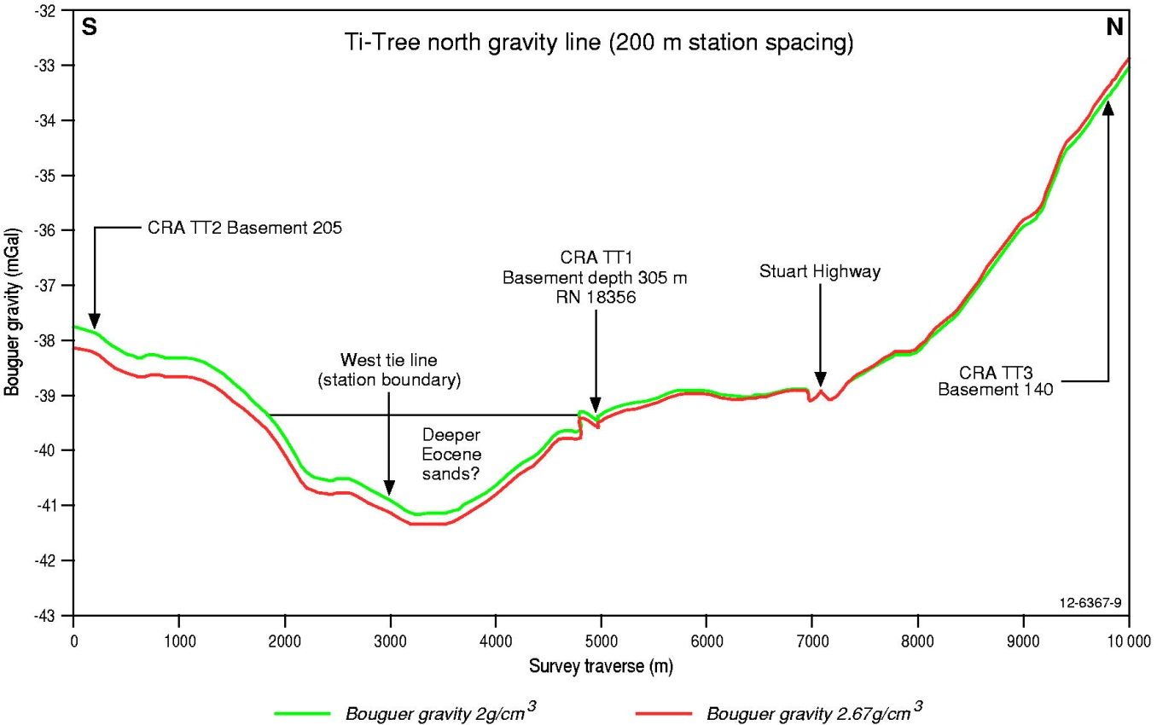
Figure 4.4: Reduced gravity data for south-west to north-east oriented investigation line in the Ti-Tree Basin (survey location from TT2 to TT3 shown on Figure 4.1). The location of CRA cored drillholes TT1, TT2, and TT3 (circa 1970s) along the survey line is highlighted.

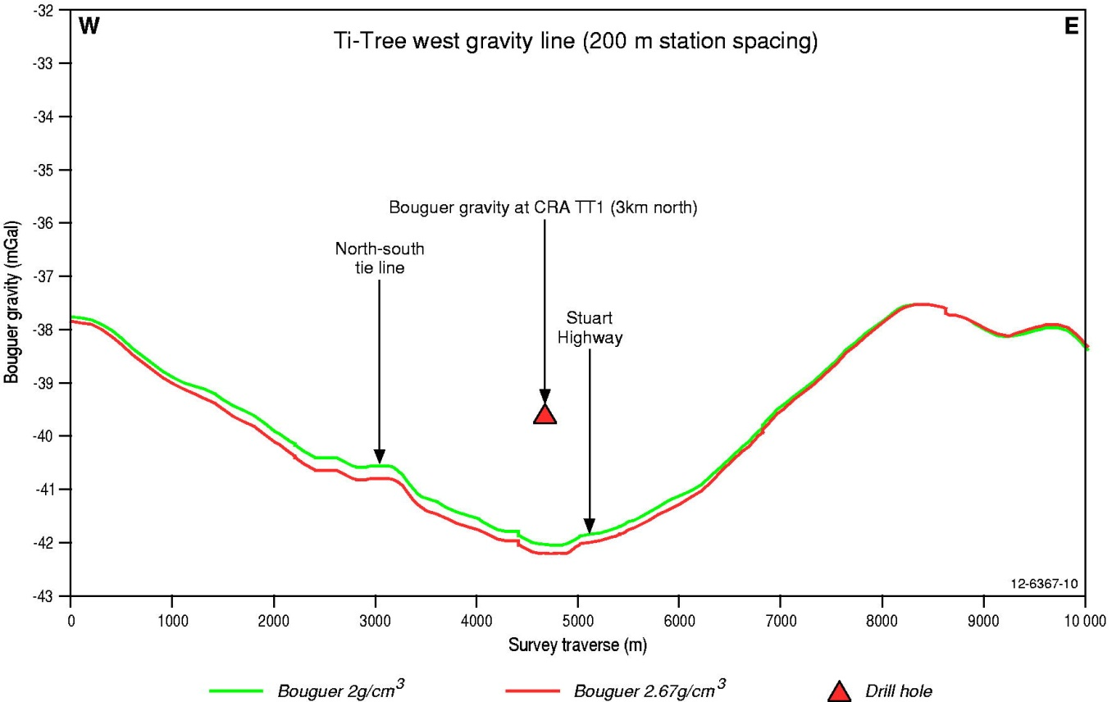
Figure 4.5: Reduced gravity data for west to east investigation line in the Ti-Tree Basin (location shown on Figure 4.1).
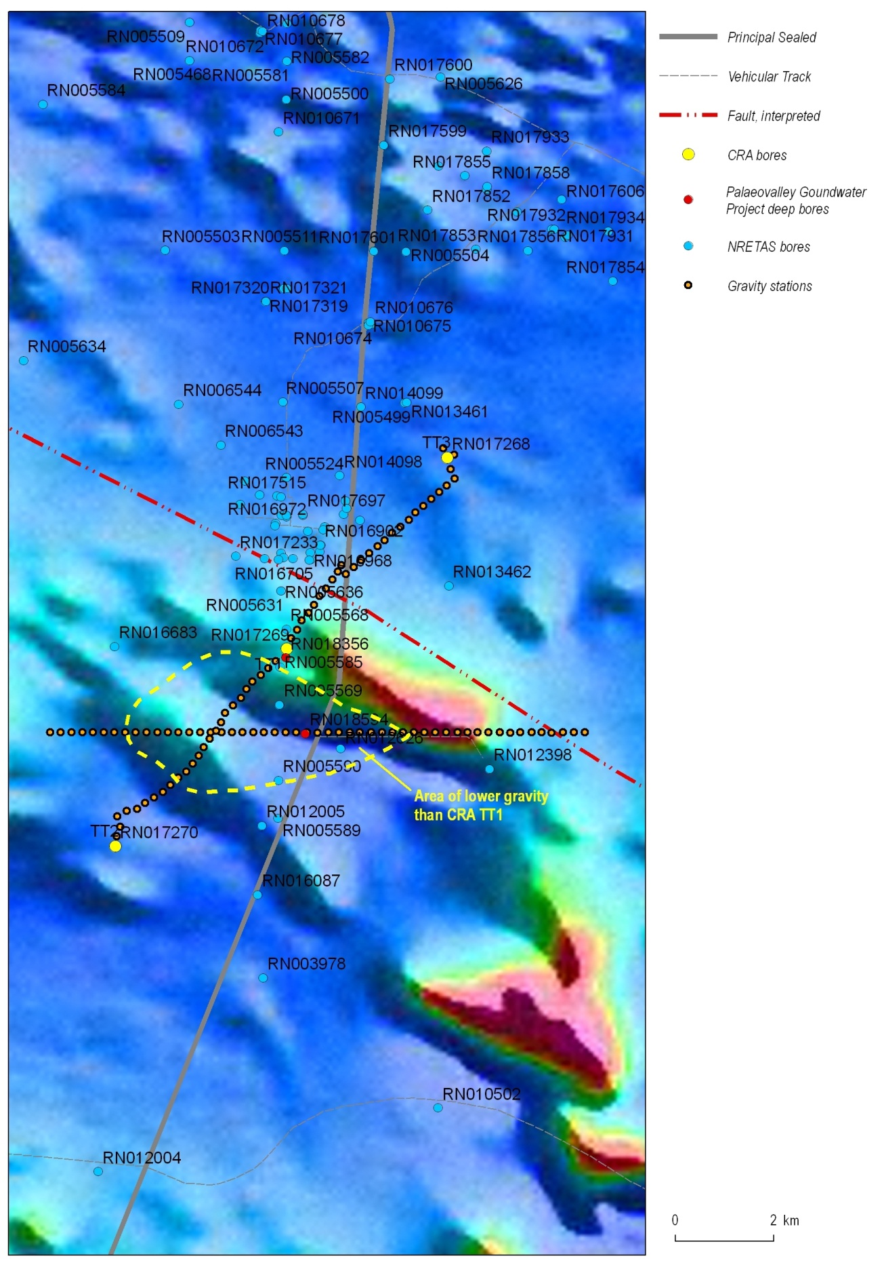
Figure 4.6: Gravity survey stations overlain on TMI image (relatively high magnetic intensity shown red, lower intensity shown blue).

Drilling

Drilling objectives
The drilling program was designed to provide information on the aquifer characteristics and spatial distribution of the deep Ti-Tree Basin sands. Drilling was conducted in two stages:

- The initial deep drillhole (RN 18356) was 10 metres away from the site of the previously cored drillhole CRA TT1. This allowed for stratigraphic correlation with the existing core, stored in the Alice Springs core depot of the Northern Territory Geological Survey.

- The second drillhole (RN 18594) was sited on the gravity low defined from the west to east gravity survey line. This hole was designed to drill through the entire sedimentary succession to reach the underlying deepest basement rocks (expected to be considerably deeper than the basement intersection at RN 18356 because of the lower Bouguer gravity anomaly).

RN 18356
RN 18356 was drilled to obtain information about the sand-bearing intervals known to exist below 200 m depth. The borehole was drilled with the rotary air blast (RAB) rig operated by the NT Government’s Water Resources Branch (WRB). The lithologic log compiled for this hole is included in Appendix 1. A target interval of 208-214 m below ground level was selected to emplace the down-hole screens for later sampling of groundwater. This interval was chosen based on information from the gamma and geological logs that showed it to consist of poorly consolidated sands with good aquifer potential (Figure 4.7). However, due to various problems encountered during drilling the screens had to be set slightly above the original target horizon (200.5-206.5 m).

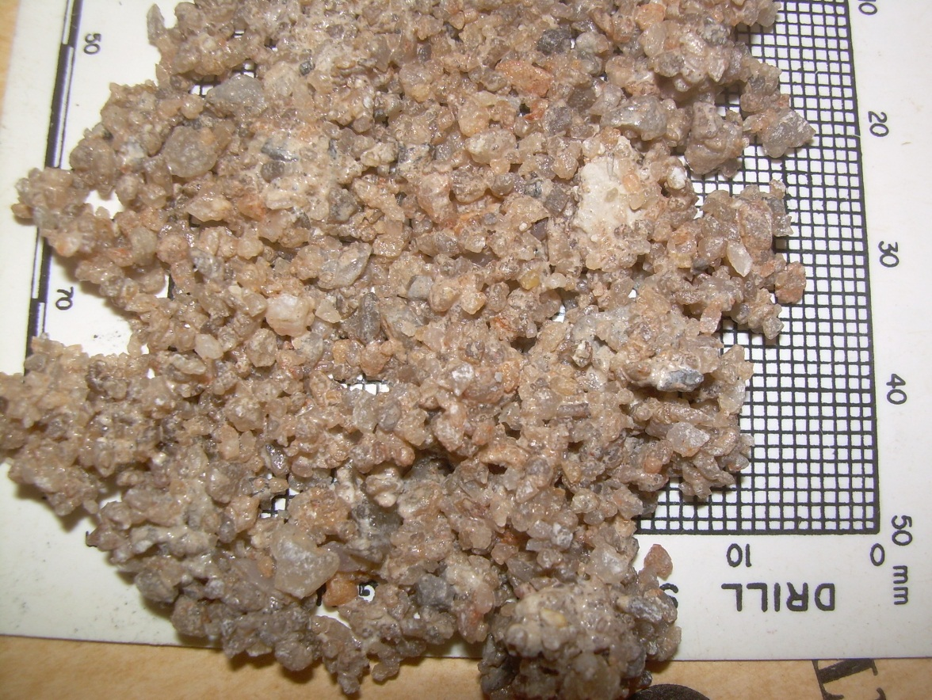
Figure 4.7: Coarse-grained and poorly consolidated sands recovered from RAB drilling of borehole RN 18356 (208–214 metres below surface).

Further problems occurred during bore construction, and the in-line screen method was found to be unsuitable. When the casing was extracted the screens had irreparably concertinaed (Figure 4.8). This was probably caused by bridging in the lower part of the drillhole which prevented the screens from being lowered to the correct interval. Despite these problems, groundwater was airlifted and pumped from the hole for subsequent hydrochemical analysis, albeit sourced from above the originally proposed target zone.

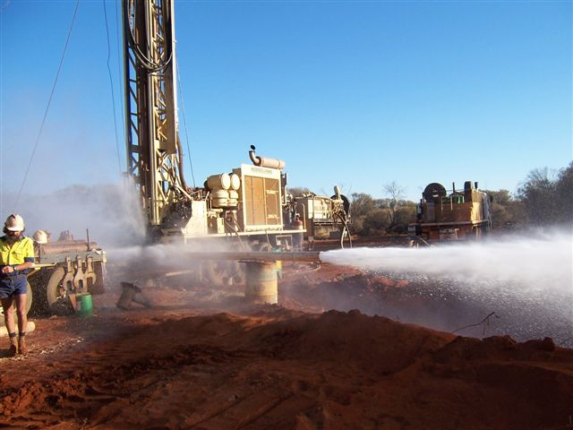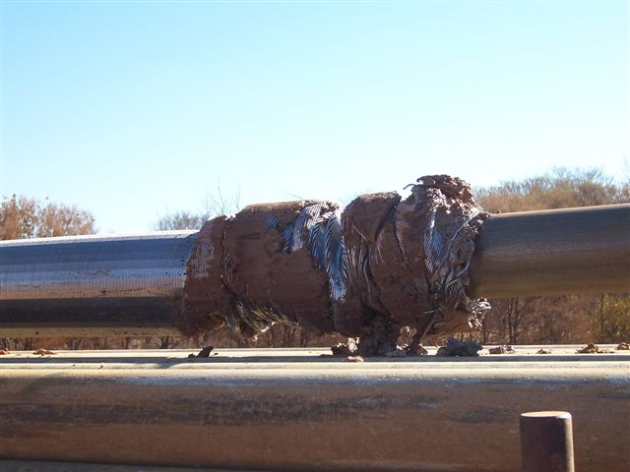
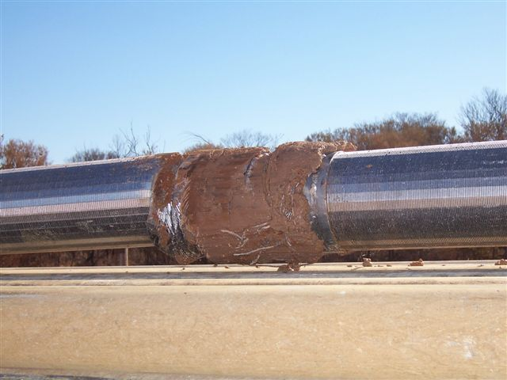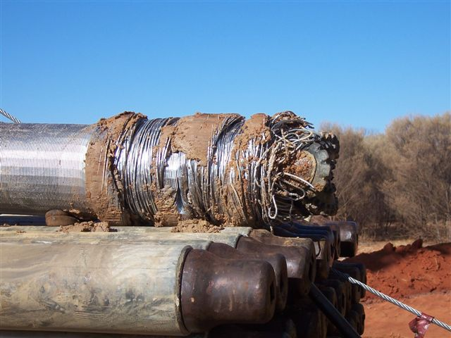
Figure 4.8: Drilling operations at RN 18356 highlighting the damage caused to the in-line screens due to problems in constructing the borehole.

RN 18594
Drilling of RN 18594 was undertaken to investigate the depth and composition of the sedimentary infill over the zone of anomalously low gravity identified from the earlier survey (Figure 4.5). The initial interpretation of the gravity data (compared to the north-east directed survey line) suggested that up to 400 m of sedimentary infill may occur at this site. Additional objectives were to construct a deep monitoring bore and collect samples of groundwater from the basal aquifer for later hydrochemistry analysis. Drilling was undertaken in July 2010 using the NT Government’s RAB rig. The borehole was around 3 km south of the existing CRA TT1 core hole and RN 18356 drilled in 2009 (Figure 4.1).

RN 18594 was constructed with the benefit of the lessons learnt from drilling the first deep hole. RAB drilling proceeded initially to 241 m depth below surface. Steel casing (150 mm) was then run down-hole and cemented in-place. Drilling continued through the sedimentary profile until granitic basement rocks were intersected at about 339 m. The total borehole depth was 345 m (Appendix 1). Geophysical logs (gamma-ray) were then run, prior to the bore being constructed with 103 mm diameter steel tubing suspended from the bottom of the 150 mm casing string. Ten metres of stainless steel screens (1 mm aperture, 103 mm diameter) were included in-line with the tubing and set between 255-265 m below ground. This interval was identified from the lithologic and gamma logs as a zone of well sorted, coarse-grained sands with good aquifer potential. Following construction groundwater was airlifted from the bore in excess of 25 L/s (the maximum airlift capacity of the rig), demonstrating the excellent aquifer characteristics of this sand-rich interval. Following construction the standing water level in the borehole was 30 m below ground level.

The down-hole graphic log in Appendix 1 shows how the bore was constructed to avert the problems previously encountered when drilling RN 18356. The 100 mm diameter steel tubing was initially telescoped through 150 mm steel casing. The open bore was then backfilled with gravel to provide a stable platform for the 100 mm tubing. The screened aquifer interval at 255-265 m consists of poorly consolidated, light grey, predominantly quartz-bearing gravels which range from fine- to coarse-grained. Most sediment particles are sub-rounded to sub-angular. There is a slight discrepancy in the correlation of the drillhole cuttings with the gravel-bearing aquifer zone (a common problem when drilling deep bores due to the lag time in cuttings being returned to surface). However, this potential error was corrected by reference to the downhole gamma log acquired after drilling (before bore construction). Although the gravel-bearing zone is centred ~270 m depth, the gamma logs indicated the most prospective water-bearing zone to be about 265 m deep.

The thickness of the Ti-Tree Basin sediments intersected in RN 18594 was significantly less than originally hypothesised on the basis of the Bouguer gravity anomaly. Drilling showed that the most likely reason for the zone of lower gravity at this site (compared to RN 18356) is the variation in composition of the basement rocks, rather than any significant variation in Cenozoic sediment thickness. The granitic basement intersected in RN 18594 is of lower density than the mica schist bedrock that underlies the basin sediments in RN 18356.

Stratigraphic analysis
Following construction of RN 18356 and RN 18594 drillcore from the six 1970s-era CRA exploration holes (TT1 to TT6) was re-examined to interpret the stratigraphy, sedimentary facies and weathering characteristics of the Ti-Tree Basin. In particular, this work aimed to correlate stratigraphy in the two new deep holes with the nearby CRA drillcore. This work was led by Dr. Carmen Krapf, in association with project staff from GA and NT DLRM, and took place at the NTGS Alice Springs core shed in September 2010 (Figure 4.9). The drillcore was examined to better understand the sedimentary geology intersected by the two new deep boreholes (a rare opportunity in remote area hydrogeological studies). Prospective horizons were also identified and sampled for palynology.

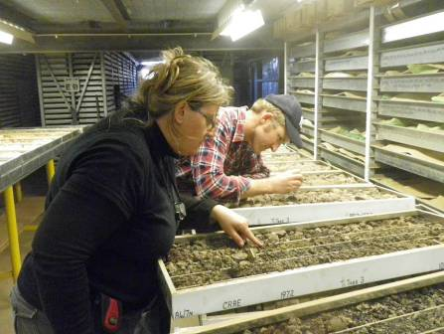
Figure 4.9: Examining Ti-Tree Basin drillcore in September 2010 at the Alice Springs NTGS core shed (left to right: Dr. Carmen Krapf, GSWA, and Dr. Steven Lewis, GA).

Detailed analysis of the available drillcore led to the development of a new 4-stage sedimentary facies scheme for the Ti-Tree Basin (Table 4.1 and Figure 4.10) which can be correlated with the regional stratigraphic observations made by Senior et al. (1995):

‘In the deeper holes, a unit, up to 130 m thick, of white siltstone and claystone rests on basement (Ti-Tree Facies 1) and is overlain by lenticular units of lignite and carbonaceous claystone (Ti-Tree Facies 2). The carbonaceous units, or where they are absent, the 'white beds', are overlain by greenish-grey siltstone and silty sandstone (Ti-Tree Facies 3). These units pass, in turn, upwards into their weathered and oxidised equivalents. The uppermost 60 m or so is commonly dominated by reddish-brown sandy siltstone (Ti-Tree Facies 4b), whereas the lower 60 m or so are, in places, characterised by multi-coloured (pale grey, brownish-grey, white or yellow) siltstone or mudstone, and includes minor coarse sandstone and gritty sandstone layers (Ti-Tree Facies 4a).’
Table 4.1: New facies classification for Cenozoic sedimentary infill of the Ti-Tree Basin.
Krapf facies number | Description of sediments | Interpreted depositional environment | Regional Stratigraphic correlation | Comments
Ti-Tree Facies 1 | Clayey silts to sandy silts with distinct sand-rich layers forming good quality aquifers | Fluvial system – proximal to medial from source, likely low sinuosity to braided streams | Lower Hale Fm (Eocene) | Degree of lithification varies from poor to moderate. Primary structures and compositions are mostly over-printed by deep chemical weathering
Ti-Tree Facies 2 | Dark, carbonaceous clays and lignite; minor silts and sands | Lacustrine to swampy | Middle Hale Fm (Eocene) | This unit does not occur across the entire Ti-Tree Basin
Ti-Tree Facies 3 | Greenish-grey silts and silty sands | Fluvial system – distal floodplain, likely high sinuosity meandering streams with distributary channels | Upper Hale Fm (Eocene)
Ti-Tree Facies 4a | Silty clay with lenses of fine- to medium-grained sand and silt; minor coarse sands and gritty sands | Fluvial | Waite Fm (Miocene) | This facies only distinguishable from drillcore samples
Ti-Tree Facies 4b | Sandy silts and silts with distinct reddish mottling | Fluvial | Waite Fm (Miocene to Early Pliocene) | Mottling caused by chemical weathering

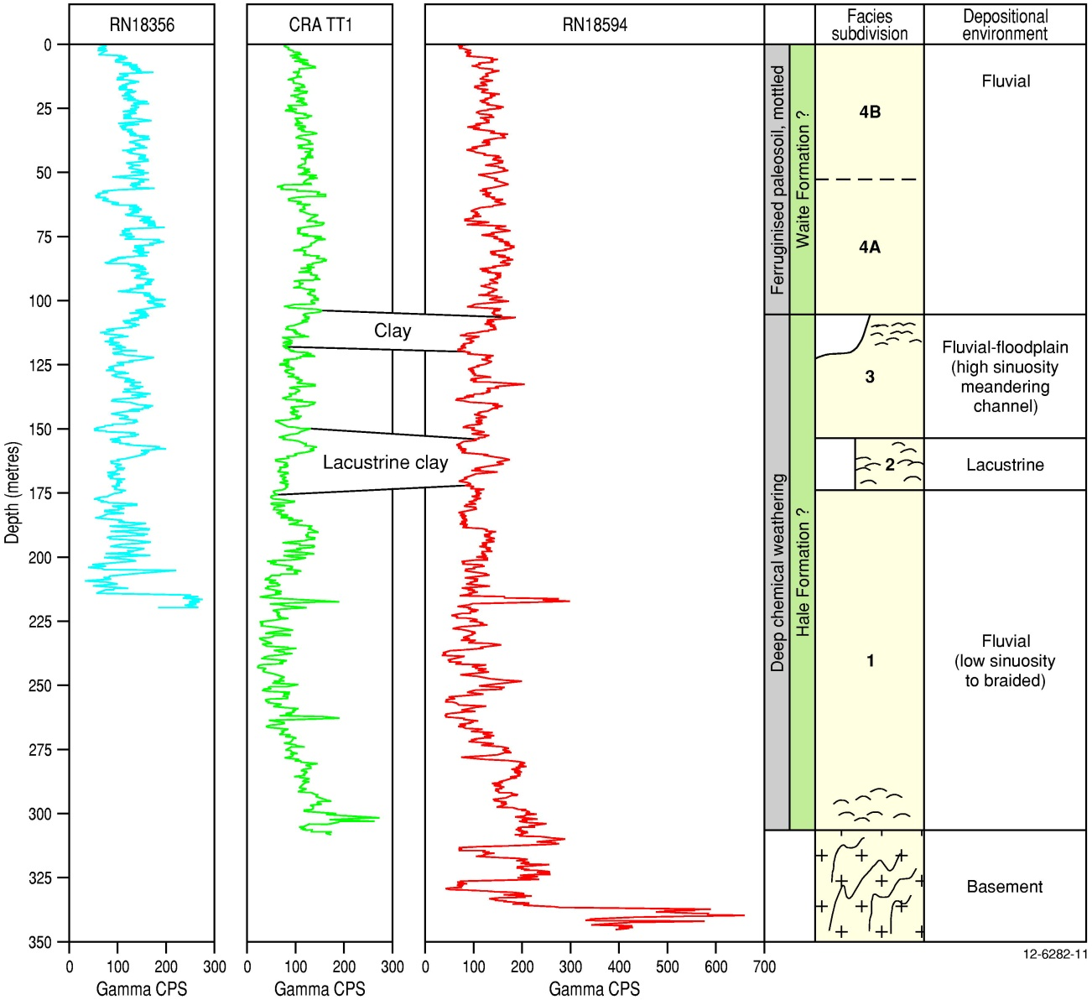
Figure 4.10: Comparison of gamma-ray logs for deep drillholes in the central Ti-Tree Basin. The log for CRA TT1 was digitised from the paper record (O’Sullivan, 1973); RN 18356 was drilled only 10m from CRA TT1. A schematic of the new Krapf Ti-Tree facies classification scheme is plotted for RN 18594.

Senior et al. (1994) equated the infill stratigraphy of various central Australian basins to the previously defined formations of the Waite (Woodburne, 1967) and Hale (Stewart et al., 1980) Basins (Figure 4.11). On this basis the newly defined Ti-Tree Facies 1, 2, and 3 are considered part of the Hale Formation, and Facies 4a and 4b are part of the Waite Formation. The Waite and Hale Formations are separated by a non-depositional hiatus during the Oligocene. Thus, the oxidised red to mottled sequences commonly encountered during drilling in the upper aquifer water bores of the Ti-Tree Basin (Read and Tickell, 2007) are most likely equivalents of the Waite Formation.

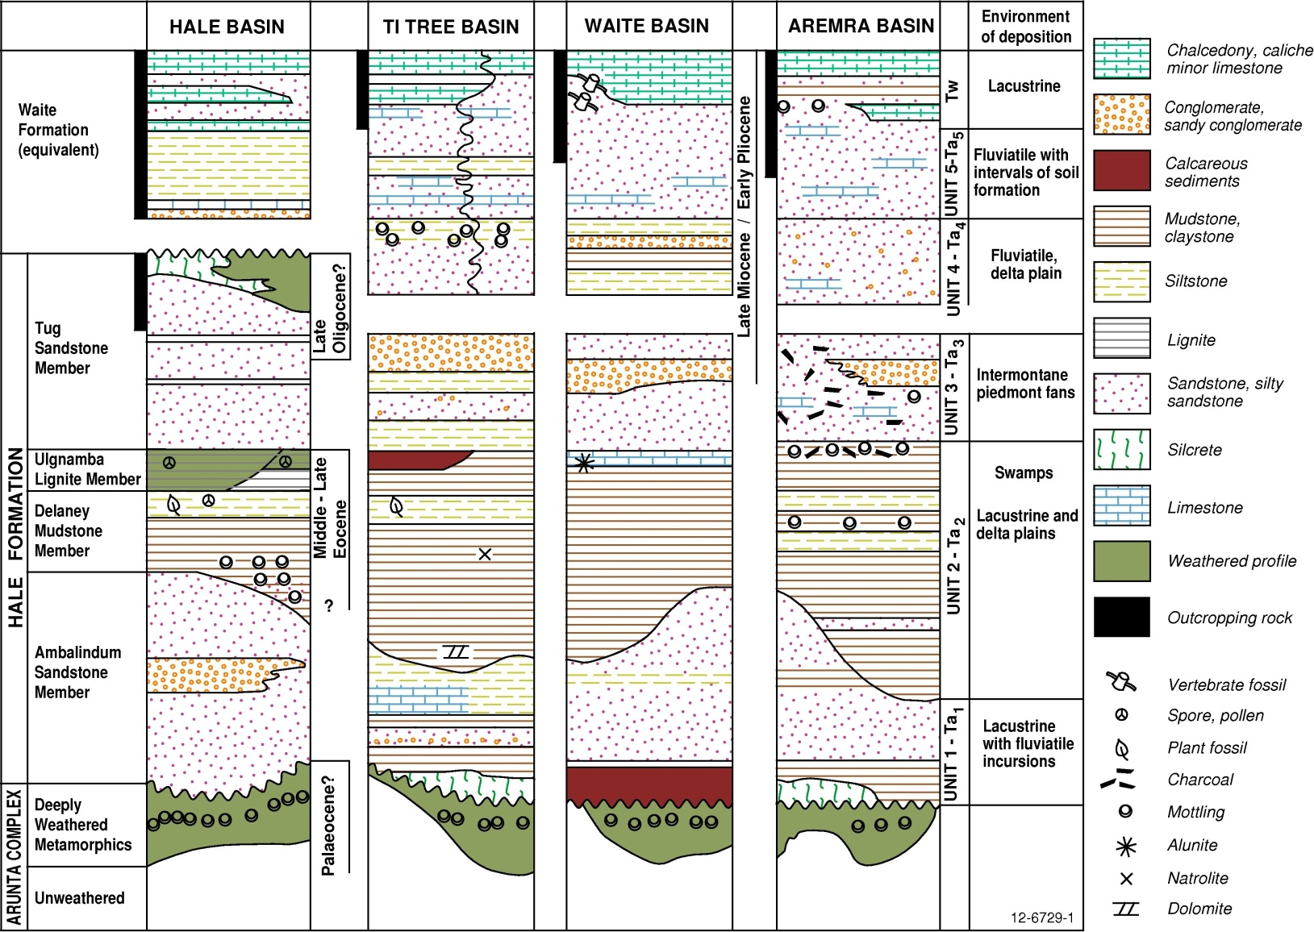
Figure 4.11: Idealised stratigraphic correlation chart for the Ti-Tree Basin and other selected Cenozoic basins overlying the eastern Arunta Block in central Australia (modified after Senior et al., 1995).

The correlation of Cenozoic sediments across the many central Australian basins (Figure 4.11) has long been problematic. For example, English (2001) and Higgins and Rafferty (2009) identified upper Cenozoic sedimentary successions that each considered warranted new formation names (Anmatyerre Clay and Napperby Formation, respectively) rather than form part of the Waite Formation. Similarly Lau et al. (1997) proposed that a thick clay sequence intersected in several drillholes north of Papunya be called the Mount Wedge Clay rather than be correlated with the Hale or Waite Formations. These problems are not surprising given that Senior et al. (1995) qualified their attempted Cenozoic correlations by noting that:

‘Although there is gross lithological similarity between the successions in the basins of the Alice Springs area, detailed correlation has been hampered by the weathering of many lithologies and the lack of fossils.’

This difficulty of correlating sedimentary facies is also apparent for different parts of the Ti-Tree Basin. For example, the deep RAB drilling data (including gamma-ray logs) acquired by NuPower Resources near the southern margin of the Ti-Tree Basin (consisting of several holes drilled to rig capacity of around 320 m depth) cannot readily be matched to the sedimentary sequence of cored CRA TT1 drillhole (Figure 4.10). The line of six TT-series cored drillholes at 5 km intervals across part of the Ti-Tree Basin are also not easily correlated (O’Sullivan, 1973).

Higgins and Rafferty (2009) developed a revised stratigraphic classification from new RAB drilling in the south of the Ti-Tree Basin (completed for uranium exploration). This scheme provisionally matched the stratigraphy of the Hale and Waite Basins (south-east and east of Ti-Tree, respectively) developed by Senior et al. (1995). Higgins and Rafferty (2009) recognised elements of the Hale and Waite Formations in their drilling and invoked an informal unit name (‘Napperby Formation’) to describe an upper oxidised alluvial palaeosol and poorly sorted colluvial unit. This unit is described variously as silty sands, clayey sands and sandy clays with minor sandy channels. It is mostly a red ferruginised unit with paleosols partially developed. As defined this unit is similar to the description of the upper aquifer in the Ti-Tree Basin and also corresponds with the new Ti-Tree Facies 4 (above).

Higgins and Rafferty (2009) drew upon experience in drilling the southern Whitcherry Basin (south-west of Ti-Tree) to develop their revised stratigraphic framework. They also made some comparisons with Cenozoic stratigraphic units in the South Australian Frome Embayment. However, Higgins and Rafferty (2009) emphasised that their stratigraphy was based on individual rotary drillholes and did not involve rigorous inter- or intra-basinal correlations. Consequently, a reliable and robust palynological or fossil framework (currently unavailable) would be a very useful tool to improve the nomenclature and correlation of Cenozoic stratigraphic units in the central Australian region (including the Ti-Tree Basin).

Palynostratigraphic analysis
Previous palynological studies in the Ti-Tree Basin showed that sediments were deposited during either the Eocene or the Oligo-Miocene (O’Sullivan, 1973; Macphail, 1997). Analyses were mainly undertaken on cored samples from various drillholes within the western part of the basin (Figure 4.1). Specific evidence of Eocene depositional ages includes:

- Drillcore from the NTGS drillhole TTW2 (Wyche, 1983) yielded Middle Eocene palynomorphs from a carbonaceous clay unit intersected at ~118 metres depth below surface (Macphail, 1997); and
- Palynomorphs in grey clays recovered at ~290 metres depth in drillhole CRA TT1 for this project (Figure 4.12) were also interpreted as Middle Eocene (Macphail, 2010a).

Senior et al. (1995) noted that a Middle Eocene age was preferred for deeper sediments in the Ti-Tree Basin, based on likely correlations with palynological data from similar units in the nearby Whitcherry and Hale basins. Attempts to acquire further evidence for the distribution of Eocene sediments in the Ti-Tree Basin for this project were hampered by the lack of suitable sedimentary intervals from the available CRA TT1 and TT3 drillcore, such as carbonaceous clay horizons (Macphail, 2010b). Thus, it was not possible to extend the range of Eocene dating in the central Ti-Tree Basin region.

Further south in the basin (around Tinarkie Bore) Macphail (1997) reported that the NTGS drillhole 81TT1 (Wyche, 1983) contains Oligocene to Miocene palynomorphs from the interval 190-196 m below surface. This contrasts with the Middle to Late Eocene age determined for black clays below 196 metres in the same drillhole. Macphail (1997) considered that the deeper clays correlate with the Middle to Late Eocene Ulgnamba Lignite of the Hale Basin (~150 km south-east of Ti-Tree). The Eocene age for the basal lignite in this region suggests that these sediments on-lap the basement rocks. Thus, the free-flowing sands reported below 300 m depth by NuPower Resources exploratory drilling along the southern margin of the Ti-Tree Basin (Higgins and Rafferty, 2009) may, assuming fairly flat lying strata, also be considered of likely Eocene age.

Less than a kilometre to the east of drillhole 81TT1 the CRA TT6 cored drillhole yielded Middle Miocene aged sediments between 184–193 metres deep (O’Sullivan, 1973). This interpretation of a thicker Miocene sequence was confirmed by Macphail (1997) in his subsequent assessment of 81TT1. Further analysis of samples from CRA TT6 for this project determined that sediments at 190 metres depth are Middle to Late Eocene, whereas sediments at 187 m are Early Miocene (Macphail, 2010b). This result confirmed the previously reported unconformity horizon at about 190 metres depth in drillhole 81TT1 (Macphail, 1997). These two drillholes are in the deeper southern trough of the Ti-Tree Basin (discussed further in Section 5.2).

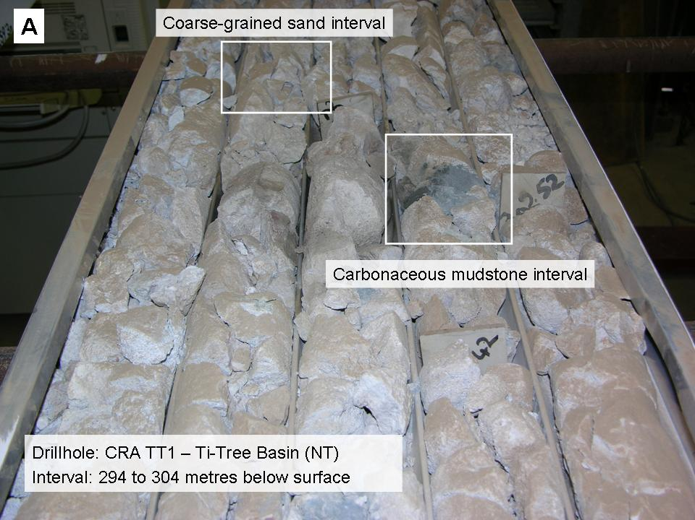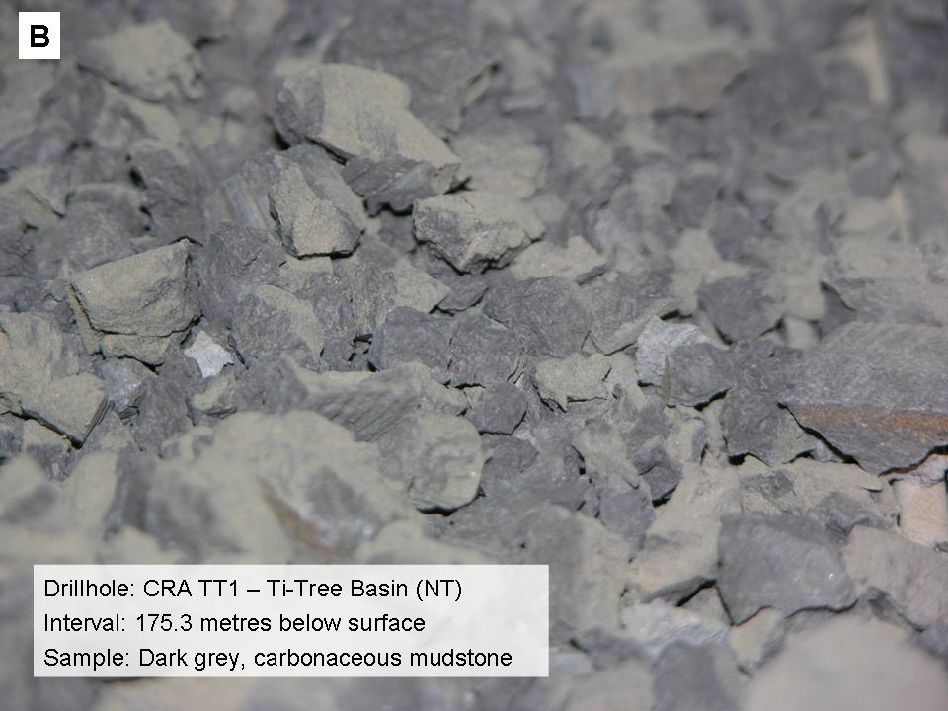
Figure 4.12: (A) Core tray from CRA drillhole TT1 CRA cored drillhole, showing dark grey carbonaceous sedimentary interval near the base of the deep sand-bearing zone. (B) Carbonaceous sedimentary rocks recovered from the cored CRA exploration drillhole TT1 in the Ti-Tree Basin.

The 15 out of 17 barren samples collected for palynology analysis in this project in September 2010 highlight the difficulties of dating the central Australian Cenozoic palaeovalley basins (Table 4.2). Senior et al. (1995) stated:

‘Dating within the basins is hampered by the poor recovery of palynomorphs from the largely weathered sediments, with only a few sites yielding spores and pollen.’
The reasons for such poor palynological return from samples are discussed in more detail by Macphail (2007, 2010b). Nevertheless, recent analyses for this project (cored drillholes CRA TT1 and NTGS TTW2) have provided some further palynological dating of sediments in the Ti-Tree Basin. These results have largely confirmed the Eocene age for basal sand aquifers in the central Ti-Tree Basin (Lewis et al., 2009; 2010). Thus, these sediments are likely time-equivalents of palaeovalley aquifers in the Goldfields region of Western Australia such as the North Royal Formation (previously known as the Wollubar Sandstone; Commander et al., 1992).

Further palynological data (if possible) are required to improve correlation of the Cenozoic successions between the many basins in central Australia, as well as within individual basins such as Ti-Tree.

Table 4.2: Ti-Tree Basin palynology data (analytical work by Macphail, 1997; 2010a, b).
Drillhole | Depth (metres below surface) | Interpreted Age | Zone
TT1 | 109.60 m | no evidence | modern contaminants only
 | 154.75 m | no evidence | modern contaminants only
 | 164.50 m | no evidence | modern contaminants only
 | 168.00 m | no evidence | modern contaminants only
 | 173.35 m | no evidence | modern contaminants only
 | 175.00 m | no evidence | modern contaminants only
 | 290.20 m | Middle Eocene | Trace Nothofagidites emarcidus
TT3 | 106.50 m | no evidence | modern contaminants only
 | 110.20 m | no evidence | modern contaminants only
 | 119.20 m | no evidence | modern contaminants only
 | 127.60 m | no evidence | modern contaminants only
 | 138.60 m | no evidence | modern contaminants only
TT6 | 186.75 m | Early Miocene | Canthiumidites bellus Equiv.
 | 190.25 m | Middle to Late Eocene | Middle N. asperus Equiv.
RN 18594 | 159 to 162 m | no evidence | modern contaminants only
 | 162 to 165 m | no evidence | modern contaminants only
 | 165 to 168 m | no evidence | modern contaminants only
 | 168 to 171 m | no evidence | modern contaminants only
 | 279 to 282 m | no evidence | modern contaminants only
TTW2 | 119.00 m | Early Eocene | Malvacipollis diversus Zone Equiv.
81TT1 | 190 to 196 m | Early Miocene | Canthiumidites bellus Equiv.
 | 196 to 199 m | Early Eocene | Malvacipollis diversus Zone Equiv.

Hydrogeologic analysis
The re-analysis and interpretation of existing drilling data from the Ti-Tree Basin, combined with results of new deep drillholes for this project, has helped develop a revised north-south stratigraphic cross-section of the central Ti-Tree Basin (Figure 4.13). Some hydrogeologically significant observations of the Ti-Tree Basin based on this section include:

- There is a major trough evident in the central part of the Cenozoic sedimentary basin, measuring about 4 km wide and 320 metres deep;
- This trough is infilled with basal sedimentary facies (Ti-Tree Facies 1) which contains well-sorted sand-rich horizons which have good aquifer potential, i.e., the deep Ti-Tree sands aquifer;
- The variation in the composition of the underlying basement rocks between CRA TT1 (micaceous schist) and RN 18594 (granite), combined with observations of the regional geological structure (Ahmad and Scrimgeour, 2006), suggests that the origin and evolution of the Ti-Tree Basin trough has been strongly controlled by basement faults; and
- There is an overall trend of increasing groundwater salinity with depth in the basin.

Head difference
Potentiometric data from some of the deeper Ti-Tree Basin drillholes suggest that hydraulic head increases with depth. For example, RN 18368 had a standing water level (SWL) of 28.5 m below ground level when screens were emplaced at 204 m depth. However, after the hole was cemented-off at 109 m below surface the SWL fell to 32 m below ground level. Similarly, Edworthy (1967) suspected that groundwater head was higher in the deeper bore RN 5885 compared to other nearby shallow bores during the initial drilling program in the basin.

These head variations imply that groundwater from the deeper basin ‘trough’ may leak to the upper (shallow) aquifer in the central Ti-Tree Basin. Groundwater samples from the central Ti-Tree Basin (in the vicinity of drillholes shown on cross-section A-B, Figure 4.13) plotted on a Piper diagram indicated the potential for most of these waters to lie upon a compositional mixing line (Figure 4.14). This would explain the tendency for more saline groundwater to occur at slightly shallower depths in this vicinity, as opposed to other areas of the basin (Figure 3.6). The potential for groundwater to ‘leak’ from some deeper parts of the basin to the shallow aquifer may contribute (at least in part) to the overall distribution of brackish water in the shallow Ti-Tree Basin aquifer (Figure 3.6–3.7). Further investigation of similar mixing mechanisms is warranted for other sites of brackish water in the basin.
Figure 4.13: (next page): Composite stratigraphic cross-section G to H showing variation in new Cenozoic sedimentary facies defined for this project (see Figure 4.1 for location). This section shows the trough of Cenozoic sediments in the central Ti-Tree Basin. The graphic logs of lithologic data have been compiled from available drillhole information from the mid 1960’s onwards. The cored drillholes TT2, TT3 and TTW1 are projected onto the section line. The salinity (mg/L TDS) of groundwater encountered during drilling or after construction is shown at the approximate depth. As mud drilling is commonly used for deeper intervals, only the screened bores RN 18594 and RN 18356 allow for collection of water samples below 150 m depth.

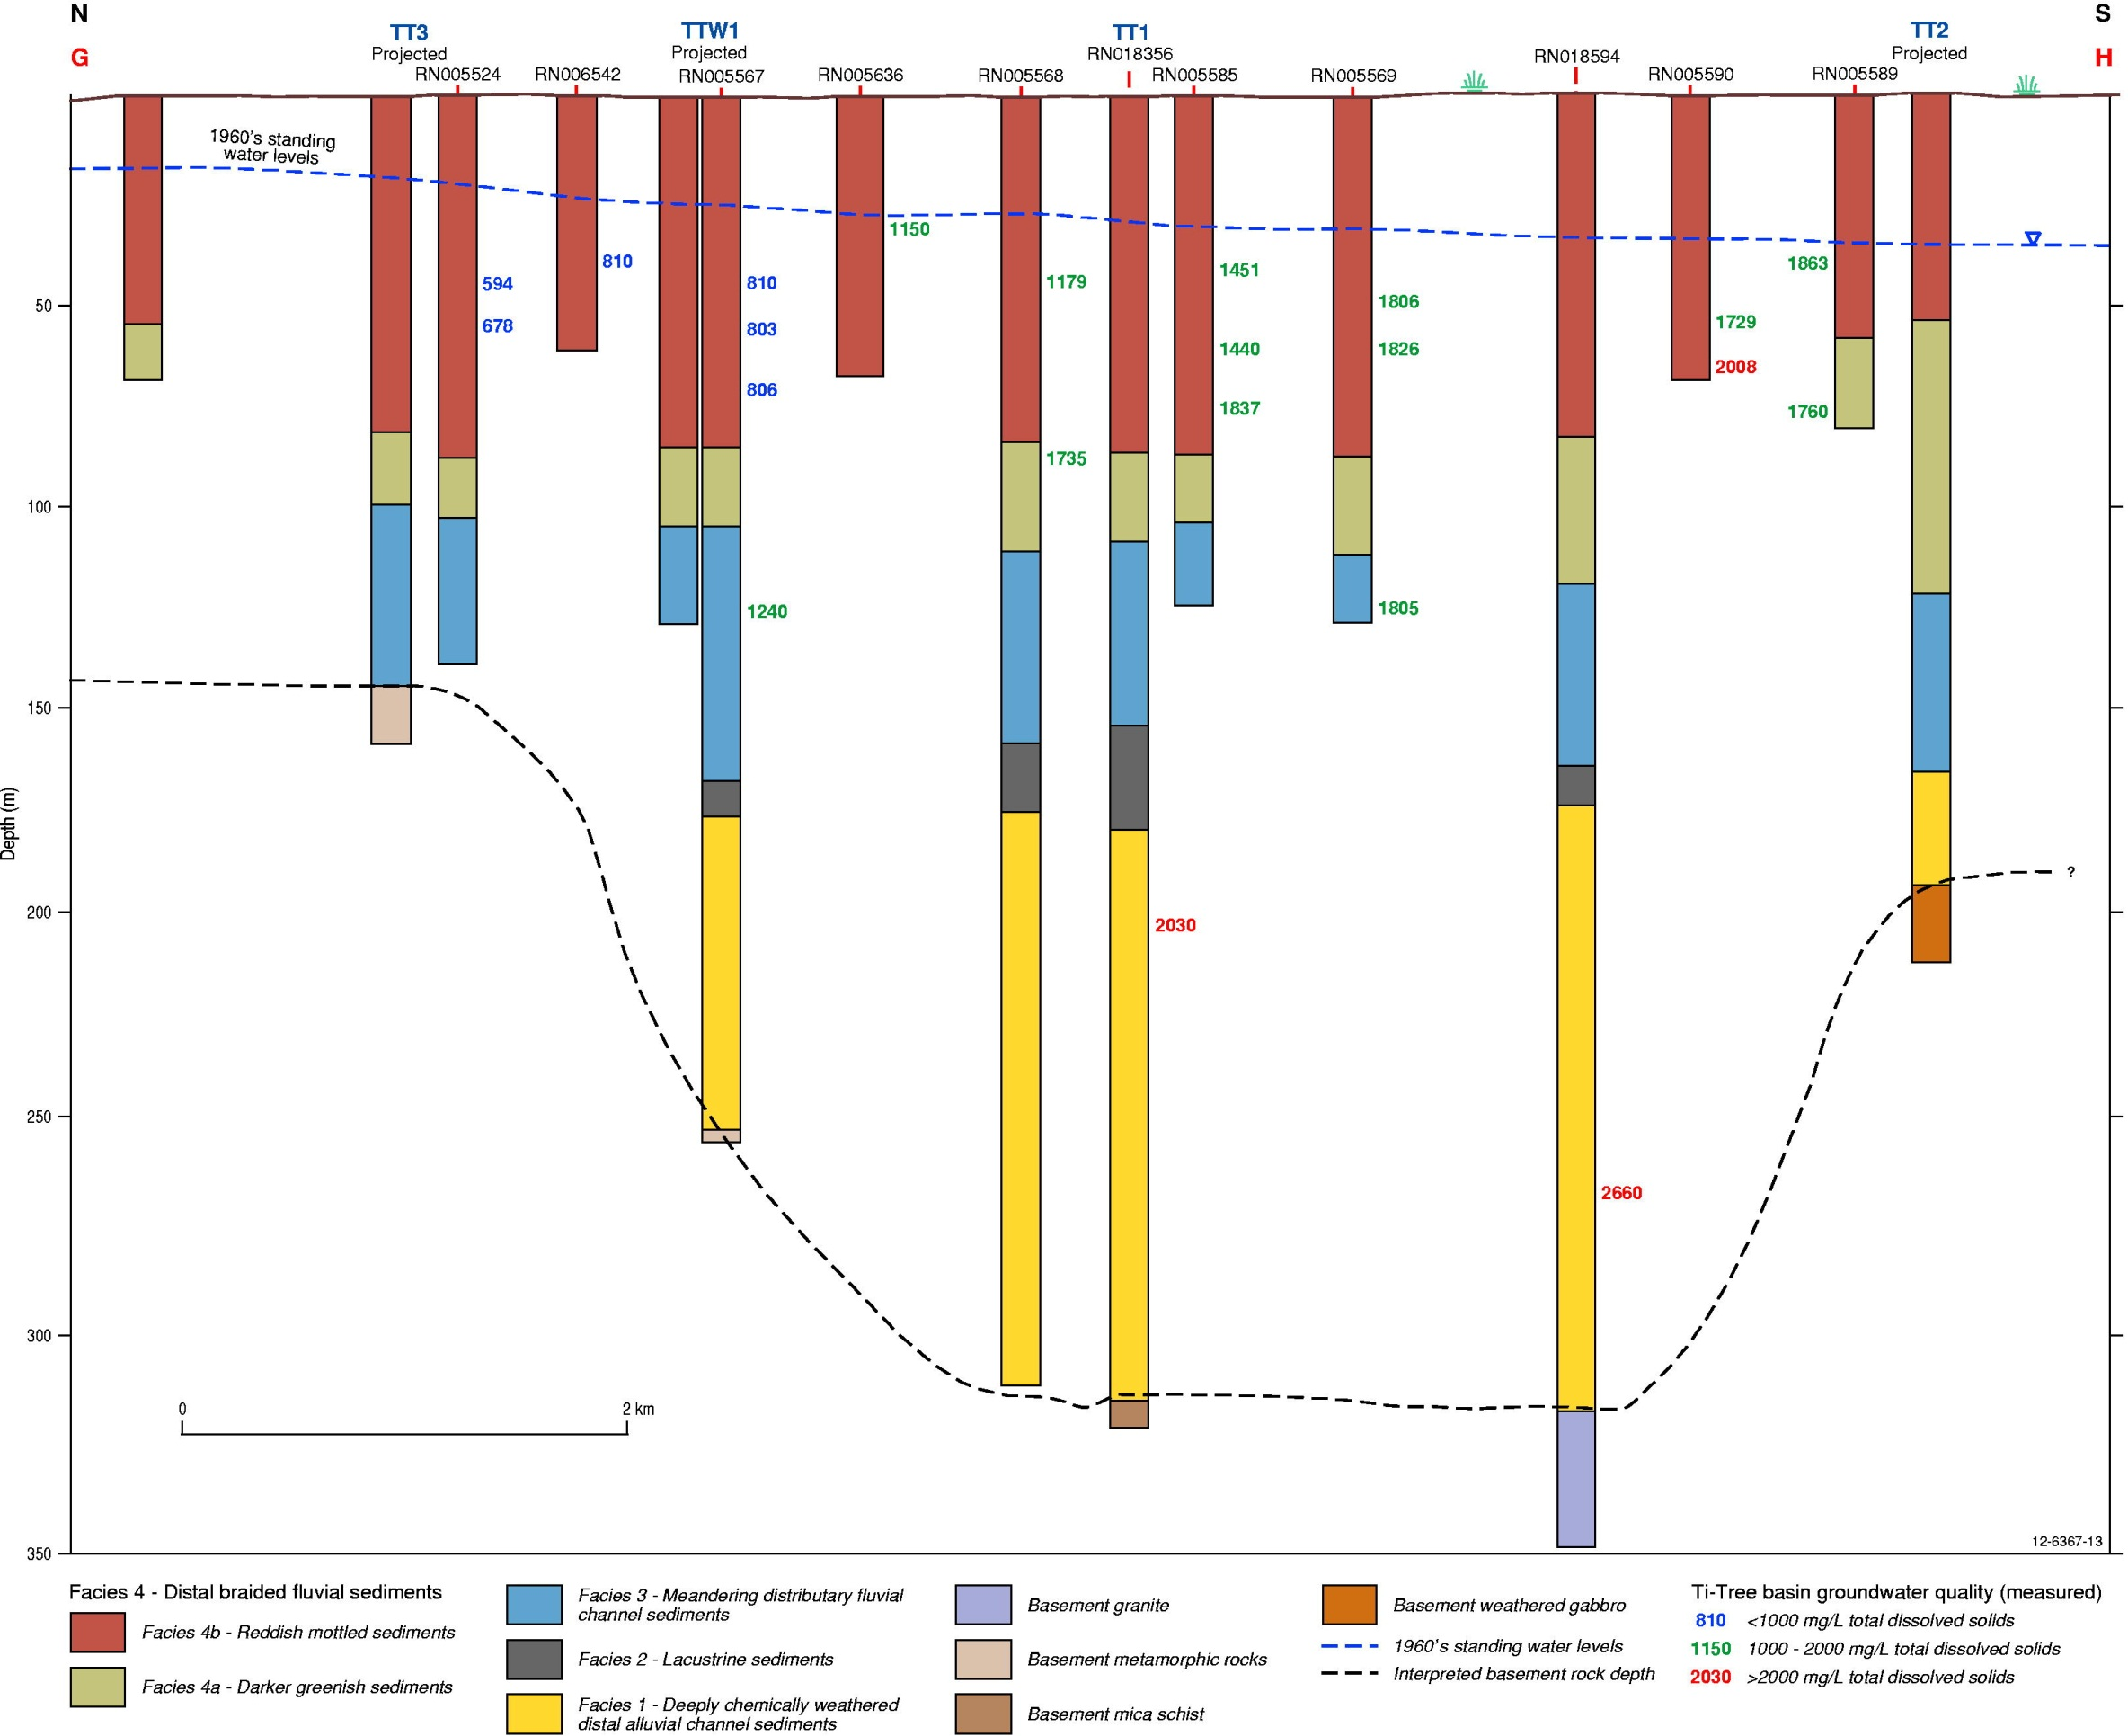

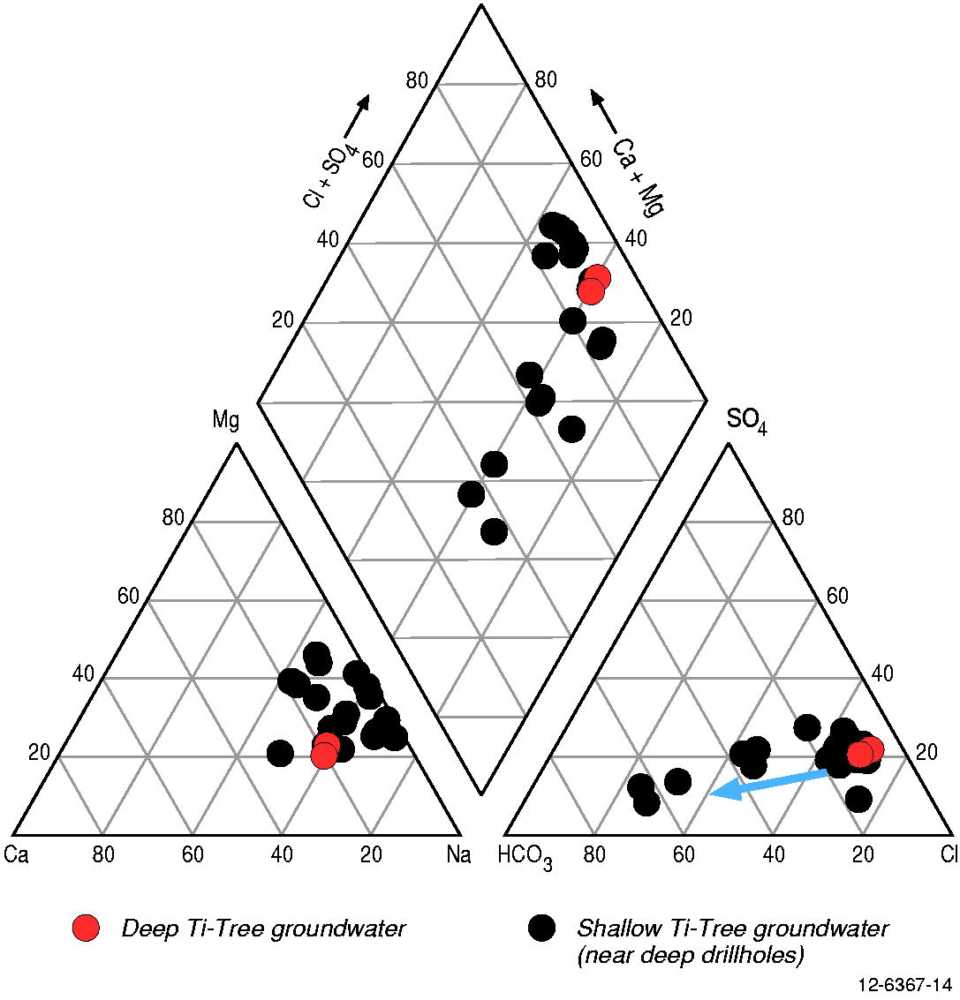
Figure 4.14: Piper diagram showing the chemical compositional of available groundwater samples from bores in Figure 4.13. The blue arrow indicates a possible mixing line between deep brackish groundwater and shallow fresher groundwater.

Groundwater sampling and chemical analysis
In August 2009 bore RN 18356 was pumped for several hours before the casing and concertinaed screens were retrieved. This allowed for collection of a groundwater sample from approximately 204 m below ground level. This sample was taken for subsequent laboratory analysis of major and minor ions, radiocarbon and stable isotopes (Table 4.3).

In October 2010 bore RN 18594 was pumped to obtain a representative groundwater sample from the deep sand aquifer. This sample was also collected for similar compositional analysis as groundwater from RN 18356. An electric submersible pump and generator equipment owned by NT DLRM was used for this task (Figure 4.15). Table 4.3 compares chemistry data of an unfiltered groundwater sample from initial drill-rig airlift of this hole (soon after completion) with a filtered groundwater sample obtained during later pumping.

Analysis of various groundwater samples from the deep and shallow Ti-Tree aquifers shows that the ionic and isotopic signature of the deeper groundwaters is within the range of compositions previously recorded for the shallower system (Figure 4.16 and Table 4.3). Although the deep groundwater system is currently only represented by two samples, the overall similarity of chemical compositions between the shallow and deep Ti-Tree aquifers may indicate that these systems are hydraulically connected, or have evolved from similar hydrogeochemical processes. Further sampling and analytical work of the deeper groundwater system is required to improve the level of confidence in this preliminary interpretation.

The stable isotope data for groundwater from the deep boreholes (Figure 4.17) plots slightly closer to the local meteoric water line (LMWL) than most shallow groundwater samples (Harrington, 1999). Although robust conclusions are limited by the paucity of data, the preliminary indication is that the deeper water may have a slightly different origin from groundwater in the upper Ti-Tree Basin aquifer.

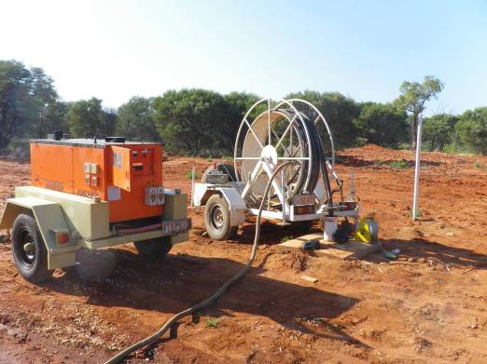
Figure 4.15: Submersible pump reel and generator at bore RN 18594 in September 2010 to collect water samples for ionic and isotopic analysis.

Table 4.3: Chemical composition of groundwater sampled from approximately 204 m depth in bore RN 18356 and 265 metres depth in bore RN 18594.
 | RN 18356 | RN 18594 (NTEL) | RN 18594 (GAHL) | Units
pH | 7.9 | 8.1 | 7.78
Electrical Conductivity | 3,640 | 4,070 | 3,560 | µS/cm
Alkalinity | 240 | 221 | 220 | mg/L
CO₃ | <1 | <1 |  | mg/L
HCO₃ | 240 | 221 |  | mg/L
OH | <1 | <1 |  | mg/L
Total Suspended Solids | 10 | 20 |  | mg/L
Total Dissolved Solids | 2,030 | 2,660 | 2,412 | mg/L
NO₃ |  | 17.7 | 13.6 | mg/L
Cl | 876 | 1,130 | 977 | mg/L
F | 1.2 | 1.2 | 1.47 | mg/L
Ca | 139 | 160 | 148 | mg/L
K | 27.7 | 28.8 | 27.2 | mg/L
Mg | 82.1 | 114 | 105 | mg/L
Na | 475 | 594 | 561 | mg/L
SiO₂ | 28.4 | 14.6 | 7.5 | mg/L
SO₄ | 339 | 457 | 452 | mg/L
S |  |  | 149 | mg/L
Ag | <10 | <10 |  | µg/l
Al | 100 | 480 | 80 | µg/l
As | 1 | 1 |  | µg/l
B | 380 | 360 | 330 | µg/l
Ba | <50 | <50 | 32 | µg/l
Be | <1 | <1 |  | µg/l
Br | 5,230 | 6,620 | 4,820 | µg/l
Cd | <0.2 | <0.2 |  | µg/l
Cr | <5 | <5 |  | µg/l
Cu | 10 | <10 | <50 | µg/l
Fe | 4,160 | 840 | 2,600 | µg/l
Hg | <0.1 | <0.1 |  | µg/l
I | 220 | 380 |  | µg/l
Li |  |  | 130 | µg/l
Mn | 155 | 15 | 40 | µg/l
Mo | <5 | <5 |  | µg/l
Ni | 4 | <2 |  | µg/l
Pb | <1 | <1 |  | µg/l
S |  |  |  | µg/l
Sb | <0.2 | <0.2 |  | µg/l
Se | 4 | 9 |  | µg/l
Sn | <10 | <10 |  | µg/l
Sr |  |  | 1480 | µg/l
U | 44.5 | 47.5 |  | µg/l
Zn | 20 | <10 | <40 | µg/l
Note: Data for RN18594 are for: 1. an unfiltered 1 litre sample from rig airlift soon after construction (analysis by Northern Territory Environment Laboratories, NTEL); and 2. a filtered sample collected after pumping the bore in Oct 2010 (analysis by Geoscience Australia Hydrogeochemistry Laboratory, GAHL).
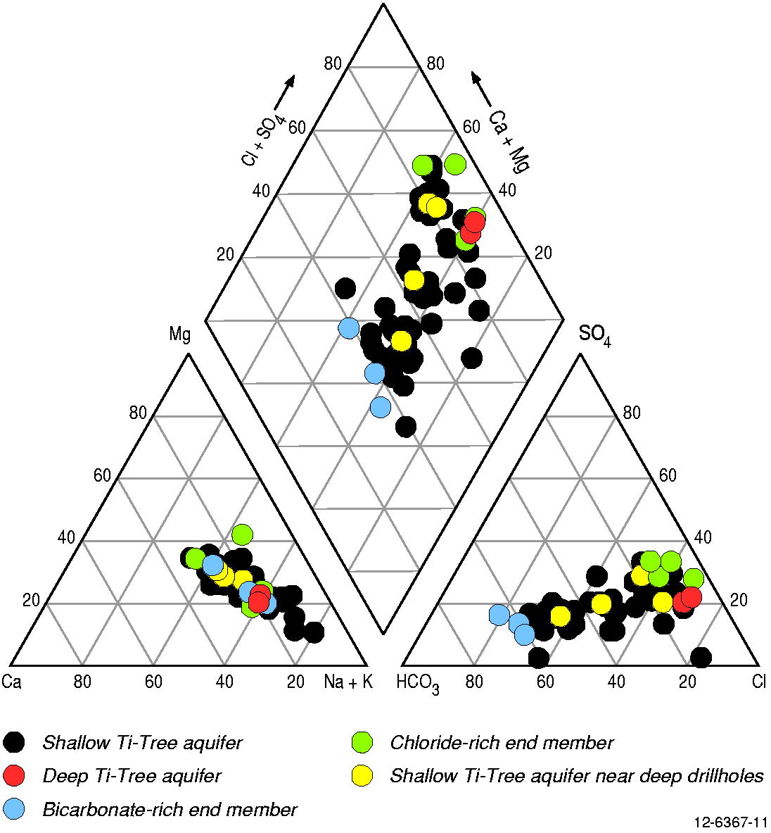
Figure 4.16: Piper diagram of groundwater compositions from the central Ti-Tree Basin, including the deep boreholes RN 18356 and RN 18594 (red) drilled for this project. Most groundwater samples from the shallow Ti-Tree aquifer are from Harrington (1999), some have been coloured for presentation purposes: low salinity (blue), high salinity (green), near to the deep boreholes (yellow), and other bores (open).

The radiocarbon activity (presented as percent Modern Carbon or pMC) of the deep groundwater system is low (5–14 pMC). However, it also falls within the overall range of results determined by Harrington (1999) for the Ti-Tree Basin upper aquifer (Table 4.4). These pMC values equate to uncorrected conventional radiocarbon ages of between 16,000 and 23,000 years before present (using the Libby half life of 5,568 years and following the conventions of Stuiver and Polach, 1977). These estimates represent maximum sample ages and assume that there has been no water–rock interaction (considered unlikely). Due to inherent uncertainty about the geochemical characteristics and composition of the basin sediments, and the nature and extent of reaction between groundwater and sediments, no attempt was made to age-correct these sample results as part of this study.

The presence of some radiocarbon activity in groundwater from 265 m depth below surface (5.6 pMC in RN 18594), as well as the very low activity at shallow depths (e.g., 6.7 pMC in RN 13747 from screen interval 30–35 m) in some parts of the basin may indicate that the upper and lower aquifer layers are (at least partially) interconnected. However, this interpretation might be complicated because RN 13747 (and RN 15745) is situated in the Wilora Palaeochannel, where the presence of a deep aquifer system has yet to be established. This highlights the need for further detailed work across the basin to assess the relationship between the deep and shallow aquifers in the Ti-Tree Basin.
Table 4.4: Selected groundwater compositions for samples from the deep and shallow groundwater systems in the Ti-Tree Basin.
Borehole | Group | screen depth | pMC | EC (µS/cm) | Cl⁻ | δ¹⁸O  (‰) | δ²H  (‰)
RN 18356 | Deep aquifer groundwater | 204 m | 13.6 | 3,640 | 876 | -7.89 | -56.50
RN 18594 | Deep aquifer groundwater | 265 m | 5.6 | 4,070 | 1,130 | -7.56 | -54.00
RN 10676 | Shallow aquifer – fresh groundwater | 57.3 m | 70 | 1,029 | 71 | -7.85 | -60.50
RN 13933 | Shallow aquifer – fresh groundwater | 7.9 m | 77.5 | 1,055 | 89 | -7.20 | -54.10
RN 15028 | Shallow aquifer – fresh groundwater | 14 m | 36.8 | 974 | 86 | -7.10 | -51.10
RN 13747 | Shallow aquifer – brackish groundwater | 50 m | 6.7 | 3,320 | 696 | -7.14 | -54.00
RN 13748 | Shallow aquifer – brackish groundwater | 50 m | 4.2 | 4,800 | 1,240 | -7.21 | -53.10
RN 16686 | Shallow aquifer – brackish groundwater | 51 m | 42.2 | 5,580 | 1,270 | -7.14 | -54.20
RN 17522 | Shallow aquifer – brackish groundwater | 21.5 m | 18.6 | 4,550 | 1,020 | -7.20 | -55.70
RN 14881 | Shallow aquifer – near to deep drillholes | 32 m | 53.8 | 1,759 | 283 | -7.31 | -58.90
RN 15682 | Shallow aquifer – near deep holes | 18 m | 59.2 | 1,326 | 172 | -7.64 | -62.00
RN 15683 | Shallow aquifer – near deep holes | 37 m | 45.4 | 5,580 | 1,274 | -7.40 | -59.20
RN 12626 | Shallow aquifer – near deep holes | 22.4 m | 29.3 | 2,680 | 549 | no data | -57.10

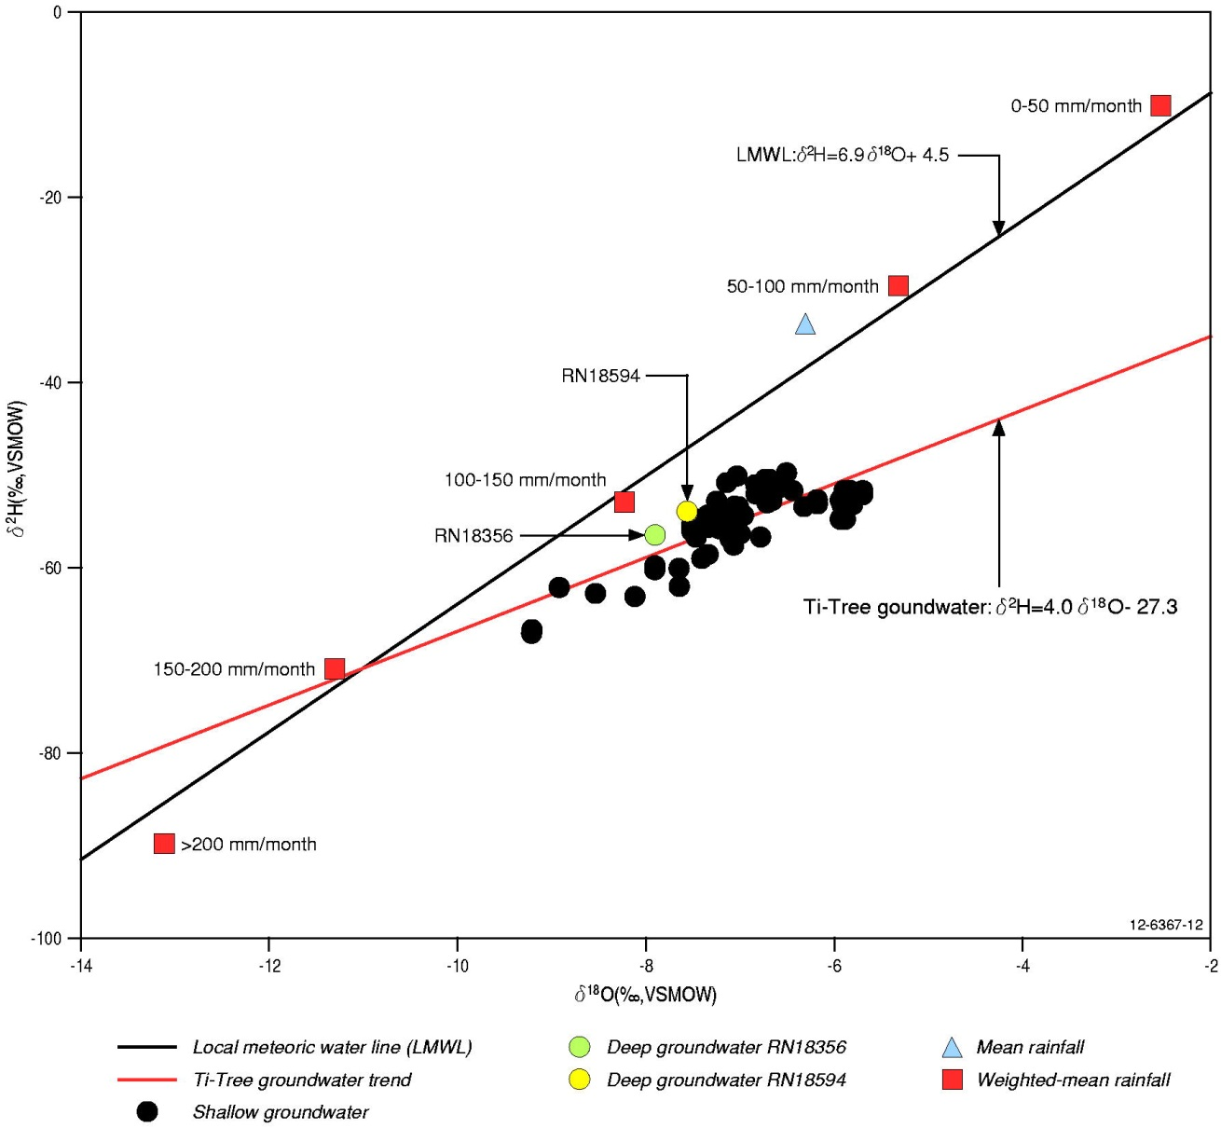
Figure 4.17: Results of stable isotope analyses from bore RN 18356 plotted on diagram of stable isotope results from the upper aquifer of the Ti-Tree Basin. This diagram is similar to that of Harrington et al. (1999), although modified by addition of stable isotope compositions of the deep groundwater system. Mean rainfall composition determined from analysis of precipitation from nearby Alice Springs.

Revised hydrostratigraphic model of the
Ti-Tree Basin

Introduction
The drilling and hydrogeological data assessed for this project shows that the Ti-Tree Basin can effectively be considered as a three-layered hydrostratigraphic system, which from top to bottom consists of the:

- Upper aquifer layer (Ti-Tree Facies 4);
- Aquitard layer, a thick sequence of lacustrine clays and fine grained sediments deposited in relatively low-energy environments (Ti-Tree Facies 3 and 2); and
- Lower aquifer layer, consisting of the deep level Eocene sands and silts (Ti-Tree Facies 1).

This revised conceptual understanding has largely been developed from re-examination of previous work combined with new operations conducted for this study (Figure 4.1). This model has benefited from the deep bores (RN 18356 and RN 18594), as well as analysis of several cored exploration drillholes. Away form the main study area the hydrogeological characteristics of the sedimentary succession are largely unknown, as most previous drilling has targeted the upper aquifer only. However, with the recent drilling of several deep exploration holes by NuPower Resources, and regional AEM surveying over part of the southern basin, preliminary assessment of the distribution of the three-layered aquifer system is now possible.

Regional cross-sections
Three regional cross-sections have been constructed for the Ti-Tree Basin to highlight the variation in the depth of Cenozoic sedimentary infill and the distribution of the newly defined hydrostratigraphic layers (Figure 5.1). This represents the first attempt to map and understand the distribution of the deeper aquifer system across the basin. The cross-sections have been derived by integrating data from three deep NuPower Resources drillholes (rotary air blast, RAB, drillholes) with other drilling data. Additionally, preliminary evaluation of confidential NuPower AEM data over the southern Ti-Tree Basin was also used to help define the depth to the base of the Cenozoic sediments.

Developing the new cross-sections was hampered by the difficulties inherent with correlating sedimentary units between individual drillholes (as discussed in Section 4.3) and by the paucity of drilling data over100 m deep across most of the Ti-Tree Basin. The depth to basement in areas without deep drilling has been approximated from the NuPower Resources AEM data. Despite these limitations, the initial attempt at defining the geometry of the three-layered groundwater system across the basin is a significant step towards improving knowledge of the entire Ti-Tree groundwater system.

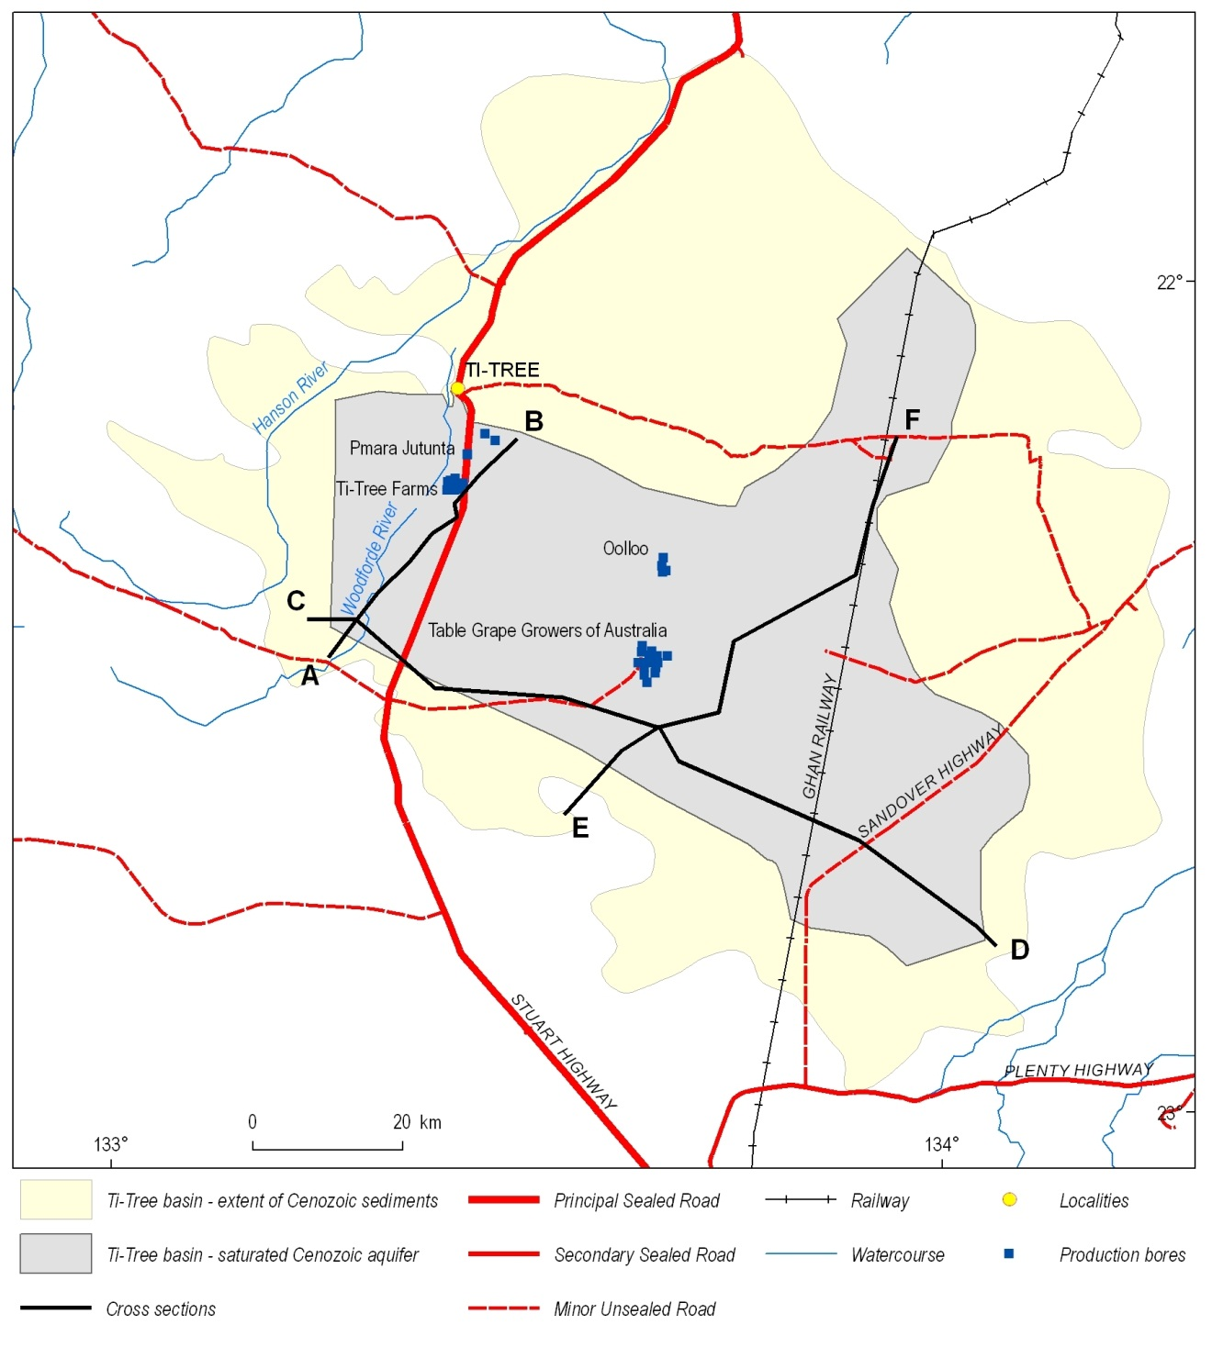
Figure 5.1: Location of regional cross-sections for the Ti-Tree Basin.

The Ti-Tree Basin cross-sections (Figure 5.2–5.4) have been referenced to the Australian Height Datum (AHD). Most of the cored drillholes and the NT Government bores have accurate height survey data. The elevation of other bores has been estimated from available surface elevation data. The greater stratigraphic detail available for the CRA cored drillholes has allowed Ti-Tree Facies 4 to be subdivided into an upper unit (4B) and a lower unit (4A). However, as there are no cored holes available for the other cross-sections (only RAB drill cuttings) there was no attempt to further subdivide Ti-Tree Facies 4 along these lines. The reliance on RAB chip samples over much of the basin means that the groundwater system mapping shown on the cross-sections is tentative. Additional cored drillhole data down to basement would significantly improve the existing level of detail in these interpretations.
The carbonaceous to lignitic lacustrine unit (Ti-Tree Facies 2) does not form a continuous horizon in the cross-sections. The lack of continuity suggests lateral variation in the development of this sedimentary facies, typical of many lower energy fluvial environments. A possible scenario is that the carbonaceous lacustrine clays of Ti-Tree Facies 2 may have coarser grained lateral equivalents, formed closer to the eroded source rocks. If so, the areas where Facies 2 is absent can be interpreted as lateral facies variations which have effectively ‘pinched-out’ this finer-grained unit along-strike (alternatively, it may have been eroded prior to deposition of younger sediments).

The southern basin margin, extending eastwards from drillhole CRA TT6 along the cross-section line C–D, forms a relatively deep and broad trough up to 50 km wide (Figure 5.4). The basal parts of this sequence are infilled with up to 100 metres of sediments associated with Ti-Tree Facies 1. However, in the eastern part of this cross-section the interpretation of the regional AEM data suggests that the Cenozoic sedimentary infill is thinner, i.e., shallower basement.

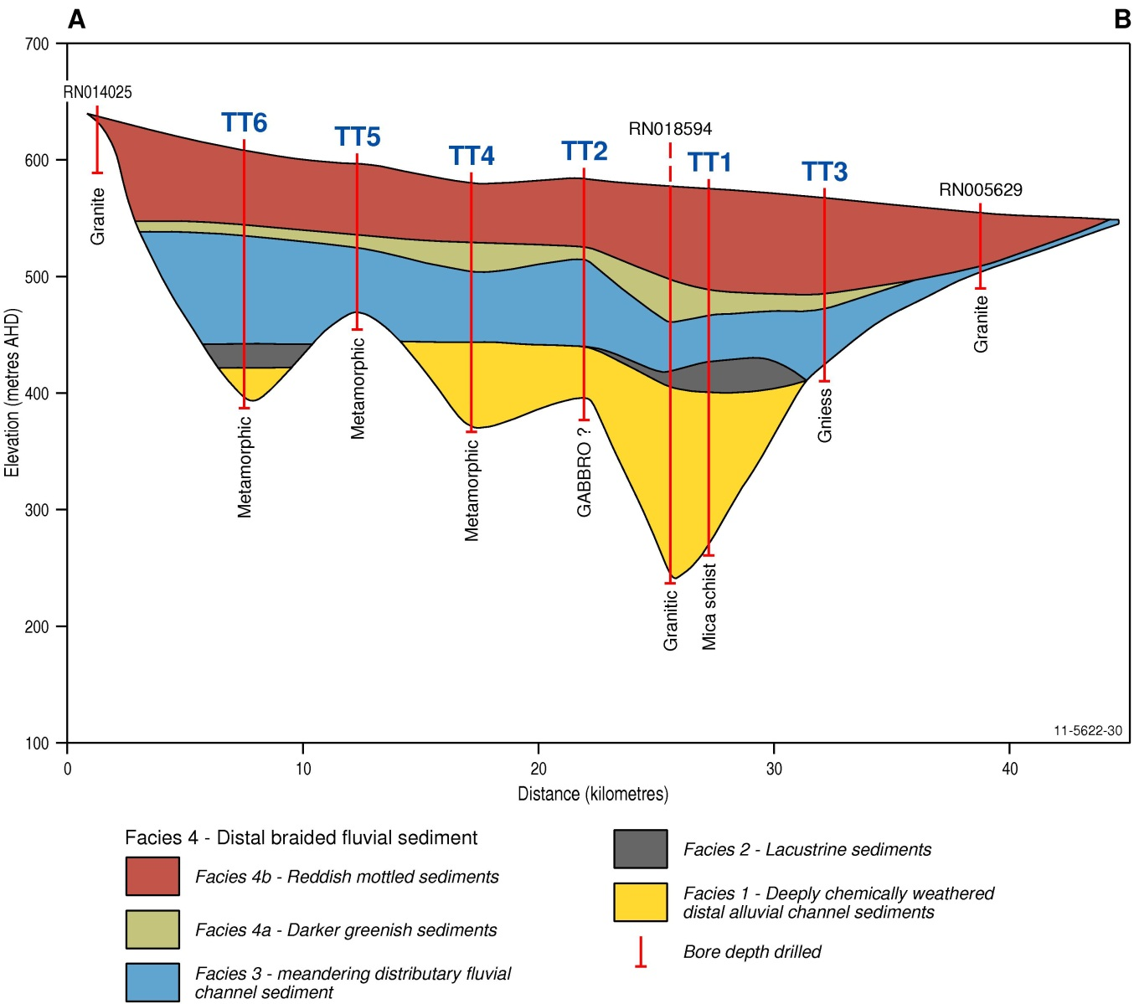
Figure 5.2: Schematic Ti-Tree Basin cross-section A–B. The location of the cross-section is shown in Figure 5.1.

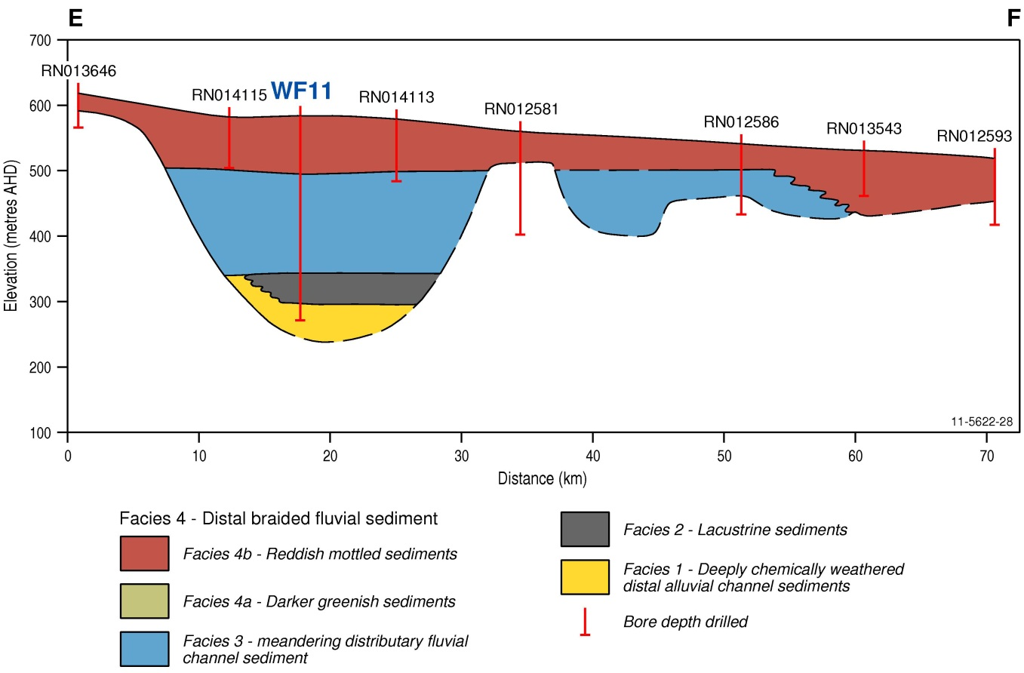
Figure 5.3: Schematic Ti-Tree Basin cross-section E–F. The scale of this section differs to that shown as Figure 5.2. The location of the cross-section is shown in Figure 5.1.

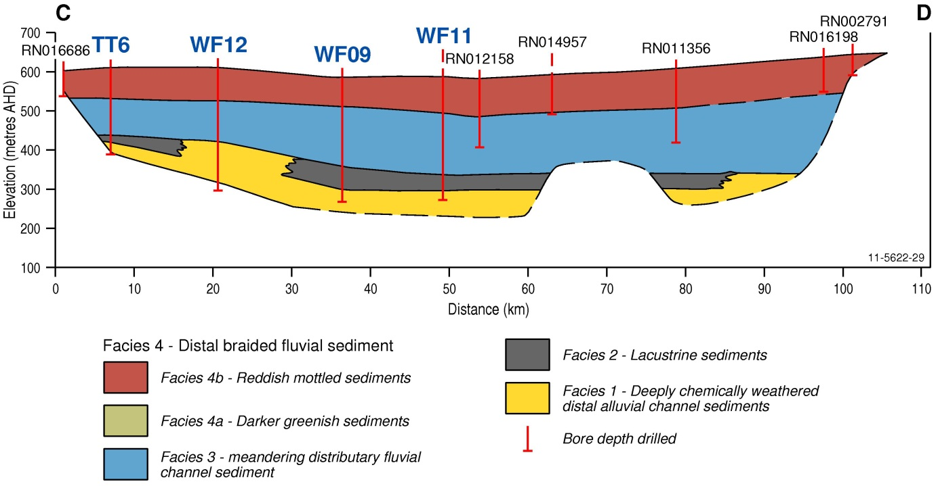
Figure 5.4: Schematic Ti-Tree Basin cross-section C–D. The scale of this section differs to that shown as Figure 5.2. The location of the cross-section is shown in Figure 5.1.

Evidence from the deep RAB drilling data provided by NuPower Resources indicates that Ti-Tree Facies 1 contains significant intervals of highly permeable sands which likely host a major deep groundwater resource. A significant volume of groundwater is likely to be stored in the southern basin trough. Based on the approximate dimensions of the Ti-Tree Facies 1 zone (shown in the cross-sections), a sand aquifer at least 40 m thick may occur within an elongated trough 40 km long and 10 km wide. Assuming a specific yield for this facies of 10%, the first-order estimate of the volume of groundwater in storage for Ti-Tree Facies 1 in the southern trough is ~1,600 GL. For comparison, Alice Springs urban water usage is currently around 10 GL per annum. Although it is unlikely that this entire volume of groundwater could be extracted, the estimated volume illustrates that significant groundwater is stored in the deep Ti-Tree Basin aquifer (although water quality has also yet to be determined for the lower aquifer of the southern trough).

In contrast to the southern trough the nature and extent of the eastern part of the deeper trough in the northern basin (centred on drillhole CRA TT1) remains largely unknown (Figure 4.13, Figure 5.2). This is because no deep drilling or regional AEM data are available in this region. The cross-section E–F (Figure 5.3) shows basement to be relatively shallow in the northern part of the basin to the east of TT1. This cross-section is orientated along the line of deepest drillholes available in this area, and is also mostly covered by the regional AEM survey (Figure 5.1). Consequently, further deep drilling data combined with more regionally extensive AEM data are required between cross-sections C–D and E–F before the full extent of the deep aquifer can be more confidently determined. Due to the absence of these datasets it is not currently possible to derive valid groundwater storage calculations for the northern trough in the Ti-Tree Basin.

Despite the difficulty of correlating stratigraphic units within and between Cenozoic basins in central Australia (Senior et al., 1995), the development of regional Ti-Tree Basin cross-sections has helped define the distribution of a new three-layered groundwater system. The lower aquifer (Ti-Tree Facies 1) occurs in discrete deeper troughs in the southern and northern parts of the basin, with Cenozoic sediments extending to over 300 metres deep in some places. The development of these deeper sedimentary infill sequences has probably been influenced by major geological structures that underlie the basin. The deepest hydrostratigraphic facies of the Ti-Tree Basin is interpreted to contain a major groundwater resource, although there is currently insufficient data to determine the nature and location of the connection between discrete troughs.

Langford et al. (1995) speculated that during the Middle to Late Eocene the region containing the Ti-Tree Basin formed part of a major fluvial system that drained north towards the Indian Ocean via the Victoria River. However, during the Late Oligocene to Miocene, the same authors proposed that the Ti-Tree Basin was part of a system that drained southwards to Lake Eyre via the Plenty River (essentially the opposite direction to the previous flow direction). Such major reversal of drainage direction implies that Cenozoic tectonism significantly affected this part of central Australia after the deposition of the Eocene basal sand unit (the lower aquifer). Extensive block faulting and subsequent erosion may have separated the northern and southern basin troughs, such that there may now be no direct connection between the basal sands in each trough.

Tectonic activity may have also disrupted the internal structure of the Cenozoic stratigraphy considerably more than is presently interpreted on the regional cross-sections. Given that the deep Ti-Tree bores are relatively widely spaced (~5 km apart), it is possible that the flat lying stratigraphic layers depicted in the cross-sections may actually occur within a series of fault-bounded horst and graben structures (or some other structurally complex arrangement). Therefore, as stated earlier, the regional cross-sections and relatively simple three-layered hydrostratigraphic model developed here should be regarded as a preliminary concept. As further data is acquired from future investigations these cross-sections will likely be modified to better reflect the basin structure and stratigraphy.

Hydrogeology
Many fundamental hydrogeologic parameters of the three-layered Ti-Tree Basin groundwater system remain poorly understood, in particular:

- The effectiveness of the aquitard layer (Ti-Tree Facies 2 and 3) as a seal between the upper and lower aquifers is an important consideration that requires further research. If this seal is leaky then the influence of the lower aquifer must be considered in future resource assessments of the upper aquifer. However, if the aquitard unit forms an effective seal then the upper and lower aquifers can be treated as discrete groundwater systems. Determining the degree and nature of connection between the two aquifers is likely to be a complex task. For example, the deep drilling data in the northern trough (Section 4.5) indicated that head difference may exist between the two layers, thereby providing evidence that the aquitard is an effective seal. However, the increase in groundwater salinity in the upper aquifer above the trough (where the SWL is around 30 m below ground) suggests that upwards leakage of saline water from the lower aquifer may occur. Consequently, if the groundwater head was significantly lowered in the upper aquifer above the trough, groundwater salinity may increase in this aquifer.

- Recharge and discharge fluxes from the deep aquifer system are unknown. The considerable depth, coupled with the overlying aquitard layer, suggests that recharge to the lower aquifer is likely to occur over long timeframes and be a very slow process. Along the southern boundary of the Ti-Tree Basin (north of the Reynolds Range) mountain-front recharge (Lerner et al., 1990) is probably an important input mechanism for the upper aquifer. Mounding of groundwater recharge in this region may create sufficient head differential to force water into the lower aquifer. The lack of lacustrine Ti-Tree Facies 2 along this basin edge (Figure 5.3–5.4) may also assist groundwater recharge into the basal aquifer system. Other potential sources of groundwater influx to the lower aquifer are downward leakage from the aquitard, or discharge from underlying fractured basement rocks. If the basement troughs are influenced by faulting then these may act as relatively permeable conduits for basement groundwater to discharge into the lower aquifer. Alternatively, groundwater from the lower aquifer may discharge into the basement rocks surrounding the basin in some places.

- There are many potential water flux mechanisms that may control the movement of groundwater into and out of the lower aquifer system. However, the considerable depth of the lower aquifer (at least in terms of groundwater investigations), and the cost of drilling to these depths, will continue to restrict further investigation. Perhaps the simplest parameter to evaluate would be the effectiveness of the middle layer as a seal between the upper and lower aquifers. For example, test pumping of bore RN 18594 (over a prolonged timeframe), with several monitoring bores constructed into the aquitard and upper aquifer units, could be used to effectively determine the hydraulic characteristics of the aquitard. However, the cost of drilling and constructing monitoring holes and the fact that results would only apply in the local vicinity of the tested bore, suggest that even this type of simple hydraulic analysis unlikely to occur (at least without some further economic imperative). As a minimum measure the nature of the hydraulic gradient should be determined to properly assess the flux and origin of groundwater in the lower aquifer.

Sparse hydrogeologic information is currently available for the three-layered Ti-Tree Basin conceptual model. Given that further evidence to improve the model characteristics is unlikely over the short to medium-term, an interim precautionary approach to the management of the entire groundwater system of the Ti-Tree Basin is recommended. This approach should consider that all three layers have some level of inter-connection, as suggested by the similarity of groundwater chemistry in the upper and lower aquifer systems (Section 4.5).

Stratigraphic correlations and comparisons with other arid zone palaeovalleys
Several major episodes of Cenozoic tectonism have occurred in central Australia (Senior et al. 1995). Uplift and subsidence was of sufficient magnitude to allow for the deposition of over 400 m of sediments in some parts of this region. Significant sedimentary deposits, including deep sandy intervals with good aquifer potential, have been noted from many central Australian basins (Figure 3.1), such as the Warrabri Basin (>300 m sediments; Warrick Rafferty, 2009, pers. comm.), Central Mount Wedge Basin (>400 m sediments in borehole RN 18599; Woodgate et al., 2012), and the Alice Springs Outer Farm Basin (>300 m sediments in RN 3641). Palynological data (Section 4.4) imply that the lower aquifer sands in the Ti-Tree Basin were deposited in the Eocene (e.g., CRA TT1 drillhole, Macphail 2010a), with the overlying lignite-rich layers (Ti-Tree Facies 2) also of Eocene age (e.g., CRA TT6 drillhole and NTGS drillhole 81TT1; Macphail 2010b). Comparison with data provided by Senior et al. (1995) suggests that the lower aquifer system in the Ti-Tree Basin correlates to the Hale Formation (Figure 4.13). The most likely stratigraphic equivalents are: 1. Ti-Tree Facies 1: the Ambalindum Sandstone member, and 2. Ti-Tree Facies 2: the Ulgnamba lignite member. Although these units are possible age equivalents Senior et al. (1995) indicated that direct correlation of the lower units of the Hale and Ti-Tree Basins is difficult. This is further hampered by significant variations in the thickness of sediments within each basin, i.e., >320 m in the Ti-Tree Basin compared with ~155 m in the Hale Basin.

Palynological data from the Ti-Tree Basin indicates the potential for continental-scale stratigraphic correlation between the central Australian palaeovalleys and some of the better documented palaeovalley systems of Western Australia. In particular, the Eocene sands of the lower Ti-Tree Basin aquifer are likely time equivalents of the North Royal Formation (formerly known as the Wollubar Sandstone) which forms a major palaeovalley aquifer in the Goldfields region of WA (Commander et al., 1992). Likewise, the Ti-Tree Basin aquitard layer (Facies 2 and 3) may correlate to the Perkolilli Shale, a thick mottled clay unit that overlies the North Royal Formation in the Kalgoorlie region (Kern and Commander, 1993; de Broekert and Sandiford, 2005). However, there is considerable variation in the thickness of these formations between the two regions, with the WA palaeovalley deposits significantly thinner than those from central Australia. The Perkolilli Shale has a maximum thickness of 39 m and the North Royal Formation is commonly around 20 m thick (de Broekert and Sandiford, 2005).

The common absence of a thick upper aquifer sequence (as occurs in the Ti-Tree Basin) is another important difference between the palaeovalleys of the WA Yilgarn and those of central Australia. Most published stratigraphic successions for palaeovalleys in the Yilgarn (e.g. de Broekert and Sandiford, 2005) lack a significant aquifer unit above the Perkolilli Shale. There are several exceptions though, with the Raeside and Carey palaeochannels north of Kalgoorlie containing up to 60 m of alluvial and colluvial sedimentary infill over the Perkolili Shale (Commander et al., 1992)

The significantly thicker palaeovalley successions in central Australia indicate that the evolution of palaeovalleys across the now arid and semi-arid zones of the continent, especially the development of their sedimentary infill sequences, has resulted from the variable interplay of several major processes. Fluvial activity was a consistent influence, although depositional environments likely spanned a range of high and low-energy systems ranging from alluvial fans, to meandering streams, lakes and swamps. The significantly thicker sedimentary successions developed in deeper and wider basin-like palaeovalleys of central Australia suggest that multiple stages of tectonic activity (probably both during deposition and at later times) has played an important role in their origin and development. Likewise, the proximity of the central Australian basins to nearby upland ranges with much greater topographic relief (compared with palaeovalleys in areas such as the Yilgarn and Gawler cratons) suggest that this has also influenced their evolution. Whatever the range of factors responsible for their origin, it is clear that the accumulation and preservation of a major sedimentary aquifer sequence at relatively shallow depths is a characteristic that is not common to all of Australia’s arid zone palaeovalleys.
Groundwater quality (salinity) is not well correlated between the central Australian palaeovalleys and their counterparts in WA and SA. Palaeovalleys in central Australia mostly contain groundwater with TDS in the range of <1,000 to 5,000 mg/L. In comparison, palaeovalley aquifers in WA and SA are commonly saline or hypersaline (e.g., Magee, 2009; Lewis et al., 2012). A significant source of saline groundwater is derived from the re-circulation of playa-derived salts, along with evaporative concentration of very shallow groundwater near playas. Thus, groundwater salinity generally increases along the flow direction of the palaeovalley aquifer, being fresher near the recharge zone and saltier near the discharge zone.

An important factor explaining the common salinity difference between the WA palaeovalleys and most of the central Australian basin-like systems is the depth to the watertable. In the main part of the Ti-Tree Basin there are no playas and the watertable commonly sits tens of metres deep (below surface) within the upper aquifer. Thus, the existence of the widespread upper aquifer may be a key reason to explain the generally better water quality of the central Australian palaeovalleys. The greater topographic relief of nearby ranges in central Australia probably also contributes to greater runoff and more abundant fresh water recharge into the basin aquifers.

The geometry of the central Australian basin-like palaeovalleys also differs from most of those in WA and SA. Many central Australian palaeovalleys are broad and wide basin-like features (Figure 5.2–5.4) whereas those in WA and SA are much narrower and sinuous landscape elements incised into the surrounding bedrock (Commander et al., 1992; Hou, 2004; Magee, 2009). These geometric variations may also account for some of the observed differences in groundwater salinity. The shallow aquifers in central Australian palaeovalleys are broad groundwater systems that occur at relatively elevated levels in the basin infill sequence. Consequently, these aquifers intercept and store most of the recharge that enters the basin, thereby limiting the amount of water that can percolate downwards towards the underlying basement rocks. The basal alluvial aquifer, at least in the Ti-Tree Basin, is also significantly thicker and wider than the main palaeovalley aquifers in WA. For example, the North Royal Formation (Wollubar Sandstone) has a maximum aquifer extent of ~1.5 km wide by 20 m thick (de Broekert and Sandiford, 2005), which is much less than the aquifer thickness of the Ti-Tree Basin (and most others in central Australia). Again the greater dilution of basement groundwater influx afforded by the larger storage volume in the Ti-Tree Basin sequence may help to further explain its lower salinity groundwater (~2,600 mg/L TDS in RN 18594). The hydrostatic head of the several hundred meters of saturated sediments in parts of the Ti-Tree Basin can also be expected to limit leakage from basement aquifers. It is even possible (though speculative) that major hydraulic head differences in some parts of the Ti-Tree Basin actually drive palaeovalley groundwater out of the basal sedimentary aquifer and into the surrounding fractured basement rocks.

The above discussion shows that the central Australian basin-like palaeovalleys differ in many ways from the palaeovalley aquifers of WA and SA. Despite the chronostratigraphic similarity of the sediment infill sequences (e.g., basal Eocene deposits) many of the fundamental hydrogeological characteristics are region-specific. Thus, the assessment and management of groundwater resources in arid zone palaeovalleys cannot be nationally prescriptive, but must account for these critical local variations.

Conclusions
This study of the Ti-Tree Basin palaeovalley system has developed a three-layered groundwater conceptual model. This conceptual model indicates that hitherto unrecognised yet significant groundwater resources occur at depth in the Ti-Tree Basin. Similar deep groundwater stores likely exist in other central Australian palaeovalley basins such as the Waite, Warrabri and Central Mount Wedge basins. However this interpretation can only be regarded as a preliminary finding as few deep drillholes (>150 m) currently exist, and only one monitoring bore has thus far been constructed to tap the lower aquifer in the Ti-Tree Basin. As a consequence relatively little information is known about the hydrogeological characteristics of the deep aquifer system. The one existing borehole indicates that high yields of brackish quality groundwater occur in the northern trough of the Ti-Tree Basin. However, the hydrostratigraphy and groundwater systems of the larger southern trough remain untested. The extent, depth, thickness and salinity characteristics of the three-layered basin model imply that the central Australian palaeovalley systems are, at least hydrogeologically, very different from most of the longer and narrower (sinuous) palaeovalleys in WA and SA.

Conclusions and recommendations
The existence of a significant deep aquifer in the Ti-Tree Basin has been proven by drilling and construction of two >200 metre deep boreholes (RN 18356 and RN 18594). The drilling method used to construct RN 18594 proved sound and has already been used in other deep palaeovalley investigative drillholes in central Australia, e.g., RN 18599 in the Central Mount Wedge Basin (Woodgate et al., 2012). Mineral exploration drilling in 2008-2009 (NuPower Resources) in the south of the Ti-Tree Basin indicated more extensive and thicker sand-rich sedimentary successions within a deeper trough parallel to the southern margin of the basin. These sands have not yet been tested for groundwater yield or quality. However, if results are similar to RN 18594 (considered a reasonable assumption) then further extensive groundwater resources are likely to occur across the basin.

Based on analysis of the new deep drilling data a simple three-layered aquifer system has been developed as a conceptual model of the Ti-Tree Basin. In the northern trough near RN 18594 the existing data suggests that the slightly saltier groundwater system in the deeper aquifer has greater hydraulic head than the upper aquifer. Consequently, the flux relationship and degree of connectivity between the upper and lower aquifers need to be considered in future management initiatives for the main Ti-Tree Basin (upper) aquifer. Salinisation of the shallow aquifer resource is an example of a potential problem that could be caused by the connectivity of the shallow and deep groundwater system. Depending on the vertical permeability of the separating aquitard layer, as the head is lowered (by extraction) in the upper aquifer the deeper (saltier) groundwater may potentially be drawn upwards, thereby increasing the salinity of the shallow Ti-Tree aquifer and threatening the viability of the exiting horticultural activities and other users.

Current palynological evidence suggests that the lower aquifer layer (Ti-Tree Facies 1) and the aquitard layer (Facies 2 and 3) consists of Eocene sediments, and the overlying layer (Ti-Tree Facies 4) is of Miocene age. Although these sediment ages correlate with palaeovalley infill sequences in parts of WA (such as the Goldfields), the degree of weathering and geographic isolation from known marker species has significantly hampered palynological interpretation. Stratigraphic correlation with other central Australian basins is also difficult for similar reasons, although the lower two layers are tentatively regarded as equivalents of the Hale Formation (after Senior et al., 1995), and the upper aquifer is a likely analogue of the Waite Formation.

Unearthing the long-neglected data contained in the early Ti-Tree Basin drilling report (Edworthy, 1967) highlighted that useful information for hydrogeologic investigations can be obtained from unexpected sources. This was further emphasised through the chance meeting with exploration geologists from NuPower Resources Ltd. that provided considerable insight into the deep stratigraphy of the southern Ti-Tree Basin, including recognition of favourable aquifer horizons at depth in this part of the basin. The demonstrated relevance of mineral exploration data to assist in groundwater assessments (and vice versa) indicates the value of collaborative investigations in areas of mutual interest. For example, such communication has the potential to provide significant time and cost benefits.

Future hydrogeological studies in the Ti-Tree Basin, necessary if the deep aquifer resources are to be fully understood and sustainably exploited (managed) should specifically focus on groundwater fluxes. In particular, a detailed understanding of the nature of connection between the upper and lower aquifer layers is essential to provide better technical data which will underpin improved resource management.

Acknowledgments
This work has benefited significantly from the help and enthusiasm of many people, including staff from the NT government: Maria Woodgate, Tessa Gough, Jon Sumner, Rodney Metcalf, Patrick Gray, Roland Maddocks, Paul Montefiores, Max Rittner, Des Yinfoo, Anthony Knapton, Steve Tickell, Dave Miller, Ian Macmasters, Peter Pardon and the drilling section of the Water Resources Branch of NT DLRM. Carmen Krapf from the Geological Survey of South Australia (formerly of the GSWA) helped with core interpretation, Bob Read helped on the gravity survey. Mike Macphail completed palynology analyses. Gill Bowman of Pine Hill Station allowed access to his station; the Central Land Council did sacred site clearances. The Technical Advisory Group assembled for the Palaeovalley Groundwater Project provided excellent guidance and encouragement. Ray Tracey of the Continental Geophysics Section at Geoscience Australia is thanked for his help in providing access to a gravity meter, as well as instruction on best-practice operation of the equipment. Pauline English, Ross S Brodie and Jane Coram of Geoscience Australia are also thanked for their input and support.

Glossary
ADWG: Australian Drinking Water Guidelines, developed by the National Health and Medical Research Council (NHMRC) and the Natural Resource Management Ministerial Council (NRMMC) to provide an authoritative reference to the Australian community and the water supply industry on what defines safe, good quality water, how it can be achieved and how it can be assured.
Aeolian: Pertains to wind; especially said of dune sand and finer sediments such as dust transported (blown) and laid down by the wind.
Aeromagnetic: Applying to airborne surveys that measure the total magnetic intensity of rock below a flown grid, interpreted in terms of changes in the properties of rocks and magnetic patterns.
Airborne Electromagnetic (AEM) survey: A geophysical survey method that maps the subsurface conductivity structure of the survey area using a loop mounted on a fixed-wing aircraft or carried beneath a helicopter. Many such systems exist with different performances, allowing the survey to be tailored to the needs of the end users. Sometimes referred to as Airborne EM.
Alluvial/alluvium: Sediments deposited by the action of rivers in low-lying areas and flood plains.
Anastomosing: Refers to an interlacing network of branching and reuniting channels.
Aquifer: A geological horizon that holds and conducts water, the water is contained within the porosity of the aquifer. Aquifers may be unconfined, meaning they are open to the atmosphere, or confined, meaning they are capped by a relatively impermeable unit, or aquitard.
Aquiclude: A rock or sediment whose very low hydraulic conductivity makes it almost impermeable to groundwater flow (even though it may be saturated with groundwater). It limits an aquifer, and may form confining strata.
Aquitard: A relatively impermeable geological layer that caps a confined aquifer. Its low hydraulic conductivity allows some movement of water through it, but at a slower rate than that of the adjacent aquifer.
Archean: Rocks older than 2.5 billion years (2500 Million years); spelled Archaean in older literature.
Architecture: The relationship of different geological units to each other in space. For example, regolith architecture, sedimentary architecture etc.
Basement: The crust below the rocks of interest; in hydrogeology it means non-prospective rocks below accessible groundwater. Commonly refers to igneous and metamorphic rocks which are unconformably overlain by sedimentary beds or cover material, and sometimes used to indicate ‘bedrock’, i.e., underlying or encasing palaeovalley sediments.
Basin: Subsided part of the Earth’s crust in which sediments accumulates from surrounding higher areas.
Bed/bedding: Layers/layering of sediments or sedimentary rocks that reflect differences in grainsize, composition or colour of constituent grains.
Bedrock: Loose term given to any geological material that underlies the stratum of interest. Bedrock commonly consists of crystalline rocks such as granite or metasedimentary rocks.
Braid Plain (braided river, braided channel): A river course that consists of a number of small channels separated by bars of sediment. A braid plain may be laterally broad, have no confining banks, or lack stabilizing vegetation.
Brine: A concentrated solution of salts formed by the partial evaporation of saline water. A ‘brine pool’ typically underlies salt lakes, infusing pore spaces in palaeovalley or palaeolacustrine sediments.
Calcrete: Calcium carbonate (CaCO₃) formed in soil or sediments in a semi-arid region under conditions of sparse rainfall and warm temperatures, normally by precipitation of calcium. Calcrete is common in low-lying areas in arid to semi-arid regions, particularly palaeovalleys (‘valley calcrete’), and may form aureoles around salt lakes. It is commonly a significant near-surface aquifer in the arid zone.
Capillary fringe: Zone above the saturated zone – neither saturated nor unsaturated but between the two.
Carbonate: Carried in solution in surface water or groundwater. The two main types are: pedogenic (or vadose) calcretes that form in the soil profile and groundwater (non-pedogenic or phreatic) calcretes which tends to precipitate at the watertable in the overlying capillary fringe.
Catchment: The area of land from which rainwater drains into a river, stream or lake. Catchments are separated from each other by divides or water sheds.
Cenozoic: Geologic era for the last 65.5 Ma (Million years) that encompasses three periods: Paleogene, Neogene and Quaternary. It is also sob-divided into the epochs: Paleocene, Eocene, Oligocene, Miocene, Pliocene, Pleistocene and Holocene (the latter two making up the Quaternary, see below). The Cenozoic was formerly referred to as the Tertiary and until recently the term Cainozoic was used.
Chalcedony: variety of very fine grained quartz (SiO₂); sometimes occurs in silicified calcrete that may be a significant near-surface aquifer.
Clay: Refers to either grainsize or mineralogy: (a) an earthy sediment composed of rock or mineral fragments or detrital particles smaller than a very fine silt grain; (b) clay minerals are hydrous aluminium silicates derived largely from feldspars, micas and carbonate by weathering.
Colluvium: Rock debris that has moved down a hillslope either by gravity or surface wash.
Confined aquifer: An aquifer that is sealed above and below by impermeable material.
Conglomerate: A sedimentary deposit formed by cementing gravels and cobbles together with minerals precipitated from groundwater.
Consolidated: See cemented.
Craton: Part of the Earth’s crust which is no longer affected by tectonic activity and has been stable for about a billion years (1,000 Million years)
Deflation: Removal of material from a land surface by aeolian processes. It is most effective where extensive unconsolidated sediments are exposed, as on dry lake or river beds.
Diagenesis: The changes that occur to sediments after they are deposited, including cementation and weathering.
DEM: See Digital Elevation Models.
Depocentre: A site of maximum deposition, where the thickest accumulation of sediment is found, within a sedimentary basin or valley.
Desiccation: Drying out.
Detrital: Material derived from the mechanical breakdown of rock by the processes of weathering and erosion.
Digital Elevation Models (DEM): Digital representations of the topography of the earth that are important components of geographic information systems (GIS). DEM are obtained by many systems, including ground surveying, airborne radar and laser surveys, or from satellite radar.
Discharge: The flow of groundwater to surface water, bores, from one aquifer to the other or the sea. Also includes evapotranspiration from shallow aquifers.
Discharge zone: An area in which subsurface water is discharged to the land surface; in the arid zone it is where evaporite minerals (salts) precipitate as the water evaporates to the atmosphere.
Dissected: A term applied to landscapes which have been extensively eroded by valleys and gullies.
Down-hole logging: A method of measuring the geophysical properties of the rocks, soils, or sediments penetrated by a drillhole. A tool that measures properties such as conductivity and natural gamma radioactivity is lowered down the borehole; data is recorded during both descent and ascent of the tool. Down-hole logging is a vital technique to calibrate conductivity and surveys and interpret geological logs.
Drawdown: The lowering of the watertable or potentiometric surface, normally as a result of the deliberate (or excessive) extraction of groundwater.
Duricrust: A hardened layer formed in the regolith by cementation of soil or sediment, generally by minerals rich in iron, sulfate, silica, or carbonate.
EC: Electrical Conductivity, a measure of conductivity and a proxy for salinity, typically measured in micro Siemens per cm (µS/cm). Fresh drinking water is, ideally, less than 100 µS/cm while seawater has a conductivity of 54,000 µS/cm.
Eocene: Geologic epoch extending from 56 to 33.9 million years ago. Part of the Cenozoic era.
Erosion: Part of the process of denudation that includes the physical breaking down, chemical solution, and transportation of material. Movement of soil or rock material is by the agents of running water, wind and gravity. Differential erosion pertains to adjacent or subjacent materials that have eroded differentially; the more reactive material is rapidly weathered and more easily transported, and tends to leave more recessive landforms relative to more resistant material which forms upstanding landforms.
Evaporative concentration: Concentration of solutes in groundwater owing to evaporation down-gradient in the flow path or at near-surface levels. The concentration of chemical constituents may remain fairly constant although the volume of water in which they are dissolved decreases owing to evaporation.
Evapotranspiration: Combined term for water lost as vapour from a soil or open water surface (evaporation) and from the surface of a plant (transpiration).
Fault: Fracture in a rock body along which displacement (movement) has occurred.
Feldspar: A common rock-forming mineral consisting of aluminium, silicon, oxygen and varying amounts of calcium, sodium, and potassium.
Ferricrete: A hardened iron-rich duricrust/weathering profile. Many Australian duricrusts formed during the Late Cretaceous and early Cenozoic when the climate was warm and humid. The term ‘ferricrete’ is preferred over the more obsolete term ‘laterite’ which has ambiguous definitions.
Fluvial: Pertaining to a river, Fluvial processes relate to water flow (within and beyond a stream channel) bringing about erosion, transfer and deposition of sediment. ‘Fluviatile’ relates to sediments of fluvial origin.
Fracture: Cracks in indurated rocks formed by stress and strain. Fractures along which significant movement has occurred are called faults.
Gamma ray logging: Down-hole geophysical logging technique that maps the gamma radiation released by naturally occurring uranium, thorium and radioactive potassium within rocks and regolith.
Geomorphology: The study of landforms.
Geophysics: The study of the physical properties of the earth, in particular magnetic, conductivity, and radiometric properties, or variations in the earth’s gravity. Geophysical techniques are widely used in mineral exploration and can help to understand the subsurface structure of the earth, locate groundwater, and map salinity (as well as many other applications).
Geographical Information Systems (GIS): GIS are computer-based systems for creating, storing, analysing and managing multiple layers of spatial data. These datasets include maps of geology, topography, infrastructure, soils, vegetation, and land use. GIS allow users to create interactive queries to analyse trends and patterns in spatial information.
Gigalitre (GL): one billion litres (equivalent to 1000 megalitres, ML).
Gneiss: Coarse-grained banded crystalline rocks that formed from regional metamorphism; the banding reflects the separation of constituent mafic (iron and magnesium-rich) and felsic (feldspar and silica/quartz-rich) minerals.
GOCAD: 3D modelling software for building subsurface geologic models.
Goethite: A yellowish-brown iron hydroxide mineral that is common in soils and regolith.
Granite: A light-coloured, coarse-grained crystalline igneous rock consisting mainly of quartz and feldspar, plus mica and accessory minerals.
Granules: Gravel-sized sediment between 2-4 mm in diameter.
Gravel: All loose, coarse-grained sediments with grains greater than 2 mm diameter.
Gypsum: Calcium sulphate (CaSO₄.2H₂O). ‘Gypcrete’ refers to indurated secondary precipitates of gypsum deposits which are common around salt lakes. ‘Gypsiferous’ refers to gypsum-rich material. Gypsiferous dunes, which commonly make islands and skirt the margins of salt lakes, have formed from gypsum crusts deflated from the lakebed and redeposited by aeolian action.
Haematite: A reddish-brown iron oxide mineral that is common in soils and regolith.
Hydraulic conductivity (permeability): The ability of a rock, unconsolidated sediment or soil to permit water flow through its pores.
Hydraulic gradient: A measure of the change in groundwater head over a given distance. Maximum flow will normally be in the direction of the maximum fall in the head.
Hydrogeology: The study of geological properties of rocks, soils, and sediments as they relate to groundwater movement and storage.
Hypersaline: More saline than seawater, which has TDS of approximately 35,000 ppm (mg/L).
Igneous: Applied to one of three main groups of rock types (igneous, metamorphic and sedimentary), to describe those rocks that have crystallized from magma.
Incised channel: A river channel that has cut down below its original flood plain. This commonly occurs in response to changes in river flow conditions or geological uplift.
Indurated: The process of hardening, such as occurs when sediments are turned into rock by various cementing agents, or surface hardening of some exposed rock surfaces that can occur during weathering.
Kilolitre (kL): 1000 litres (cubic litre: m³)
Lacustrine: Pertaining to, produced by, or formed in a lake.
LANDSAT: A polar-orbit satellite launched by NASA to collect multispectral images of the Earth surface. Seven satellites have been launched in the series. Commonly written as “Landsat”.
Lignite: Peat or brown coal. Carbon-rich material formed from the remains of fossil plants that were deposited in lakes or swamps and subsequently buried, dehydrated and compressed.
Limestone: Sedimentary rock composed of calcium carbonate (CaCO₃) of organic, chemical or detrital origin.
Lithic: A term applied to sand or gravel where the particles are made up of rock fragments.
Mafic: Describes dark-coloured igneous rocks with a high proportion of iron- and magnesium-rich minerals.
Magnetic survey: A geophysical survey method that maps the distribution of magnetic materials in the earth. Magnetic surveys can be carried out on the ground or from aircraft, the latter terms ‘aeromagnetic surveys’.
Megalitre (ML): one million (1,000,000) litres
Metadata: Information about the source and accuracy of information used in a GIS.
Metamorphics: General term for rocks that have been recrystallised as a result of heat and pressure.
Milligal (mGal): A unit of acceleration used in the gravitational method of geophysical prospecting. It is about one millionth of the average value of the acceleration due to gravity at the Earth's surface; i.e., 1 milligal = 1 cm/s².
Mineralogy: Mineral composition of a rock or sediment.
Miocene: Geologic epoch extending from 23.03 to 5.333 million years ago. Part of the Cenozoic era.
Multispectral imagery: Images acquired by satellites or aircraft that capture more than the three colour bands visible to the human eye. Multispectral images can be manipulated and combined in a GIS to emphasise subtle features such as variations in soil composition or vegetation.
Oligocene: Geologic epoch extending from 33.9 to 23.03 million years ago. Part of the Cenozoic era.
Palaeochannel: Refers to the main channel of ancient rivers, sometimes called the ‘thalweg’, the lowest point of incision along the river bed where coarser sediments are commonly deposited. Former river channels that are recognised in the surface (from aerial or satellite images) or subsurface (typically in AEM surveys or drilling).
Palaeogeography: The reconstruction of physical geography of past geologic ages in an attempt to restore areas to their depositional condition.
Palaeovalley: Ancient valleys infilled with sediments that were incised by past river systems. Palaeovalley sediments include (but are not restricted to) those of palaeochannels. Typically palaeovalley sediments are not associated with currently active river (fluvial) processes, although they are commonly significant aquifers.
Paleozoic: Geologic Era spanning approximately 542 Ma (million years ago) to 251 Ma. Australia was part of the Gondwana supercontinent during this time.
Palynology: The study of microscopic particles of organic composition, such as pollen and spores, found in sediments, than enables stratigraphic dating (palynostratigraphy) and interpretation of depositional environments of the sediments in which they are found.
Palynomorphs: A palynomorph is a particle between 5 and 500 microns in sedimentary rock, composed of organic material such as chitin, pseudochitin and sporopollenin. Typically, palynomorphs are dinoflagellate cysts, acritarchs, spores, pollen, fungi, worms, arthropod organs, chitinozoans and microforams.
Pediment: A gently-sloping apron of exposed or shallowly buried bedrock surrounding hills and rises.
Pedogenic: Processes or features pertaining to soil formation.
Peneplain: An area of low relief mantled by continuous regolith and by wide shallow river valleys, a peneplain – the end-product of a cycle of erosion – is produced by denudation over a long period of time.
Permeability: See Hydraulic conductivity.
Phreatic: Refers to the zone of saturation, the soil or rock below the level of the watertable where all voids are saturated.
Porosity: Open spaces in rocks and sediments that can hold water. Primary porosity formed when the sediments were laid down; these spaces may be variably infilled by cement, leaving remnant primary porosity. Secondary porosity forms through modification of rocks, such as by dissolution of soluble grains, formation of fractures, or solution-forming karst.
Potable: Described fresh water that is safe to drink and palatable for human consumption – water in which the concentration of salts and other constituents are low or have been lowered sufficiently by treatment, for consumption.
Potentiometry/potentiometric: Representation of the level to which groundwater in a confined aquifer rises in boreholes. The potentiometric surface is mapped by interpolation between borehole measurements. The slope of the potentiometric surface defines the direction of groundwater flow.
Progradation: The seaward movement of the coastal zone caused by infilling of coastal environments by sediments derived from the land after a transgression.
Proterozoic: A geological era that encompasses the time between 2,500 and 545 million years ago. The Proterozoic is formally divided into the Paleoproterozoic (2,500 and 1,600 million years), Mesoproterozoic (1,600-1,000 million years), and Neoproterozoic (1,000-545 million years).
Provenance: The source or origin of detrital sediments.
Quartz: A very common mineral consisting of silicon dioxide that commonly occurs in river sands and as the main mineral in sandstones.
Quartzite: Sandstone consisting largely of quartz that has been recrystallised (metamorphosed) by exposure to geological heat and pressure.
Quaternary: Geological Period spanning approximately the most recent 2.5 Ma (Million years). The Quaternary is sub-divided into two epochs, the Pleistocene (2.5 Ma to approximately 11,000 years ago) and the Holocene (11,000 years to the present). The Quaternary is characterised by extreme climate fluctuations, alternating glacial and interglacial periods, with aridification of the Australian inland being a legacy of the last glacial.
Radiometric: Also known as (airborne) gamma-ray spectrometry (AGS) or gamma-radiometic measurement. A spectrometer measures gamma-radiation from isotopes of potassium, thorium and uranium emitted from rocks and sediment to record the distribution of these elements in the landscape.
Recharge: The process by which water is added to an aquifer; the downward movement of water from the soil to the watertable. Also, the total volume of water added to the total amount of groundwater in storage within a given period of time. A ‘recharge area’ acts as a catchment for a particular aquifer.
Regolith: The earth materials that occur between fresh rock and fresh air, including weathered rocks, soils, shallow groundwater and sediments.
Relict: A term applied to landscape features that are no longer being actively formed. For example, the floodplain of the Ord River is regarded as relict because, prior to dam construction, it was not being inundated during seasonal floods.
Rotary mud drilling: A relatively cheap drilling method that uses a rotating cutting bit to drill a hole. Samples are brought to the surface as cuttings supported by a circulated drilling fluid containing mud, and this also keeps the hole open. Samples are contaminated by the drilling fluid, and these are averaged over the sample interval (typically 1-5 m). Material from shallower depths can also contaminate samples drilled further down-hole. Also known as mud drilling, mud rotary or rotary drilling.
Salinity: Areas where salt is being deposited in the near-surface environment. Salinity is a natural phenomenon but can be increased through land use practices involving inappropriate types of soil management, vegetation clearing, cropping, and irrigation. Within the arid zone, salinity is largely ‘Primary’ or ‘Natural’ salinity, brought about steadily through aridification during the Quaternary. In disturbed agricultural lands, salinisation is commonly regarded as ‘Secondary’ or ‘Anthropogenic’ salinity.
Salinity ranges: For the purpose of the Palaeovalley Groundwater Project the following ranges have been used when discussing groundwater salinity: <1,000 mg/L TDS = fresh water, 1,001 to 10,000 mg/L = brackish water, 10,001 to 35,000 mg/L = saline water, >35,000 mg/L = hypersaline water.
Sandstone: A sedimentary rock composed of sand-sized particles.
Saprock: Compact, slightly weathered rock with low porosity; defined as having less than 20% of weatherable minerals altered but generally requiring a hammer blow to break. It may still contain rock structure.
Saprolite: Saprolite is weathered rock in which more than 20% of the weatherable minerals in the original rock have been altered in situ, with interstitial grain relationships being undisturbed. Saprolite is altered from the original rock by mainly chemical alteration and loss without any change in volume. This is sometimes referred to as constant volume alteration. Saprolite can be highly porous and permeable and may be an important aquifer.
Saprolith: Saprolith is all those parts of a weathering profile that have been formed strictly in situ, with interstitial grain relationships being undisturbed. This contrasts with residual material or pedolith, which has been disturbed. Saprolith is altered from the original rock by mainly chemical alteration and loss without any change in volume. It is subdivided into saprock and saprolite.
Schist: A regional metamorphic rock composed of mica, quartz, and mafic minerals that have a preferred orientation.
Sedimentary: Pertaining to deposition of sediments and sedimentary process, for example, a sedimentary rock is a rock once composed of sediments such as sand, gravel, silt, etc.
Shale: A sedimentary rock composed of clay particles.
Sheetwash: A geomorphological process by which a thin layer of water flow over the surface of a hillslope and may transport surface regolith material downslope. It is important process in semi-arid regions, especially in mulga country.
Silica: Term applied to fine-grained quartz (SiO₂) cement in sediments and soils. ‘Silcrete’ is silica rich duricrust that functions as a cement.
Silicification: Process by which silica is deposited.
Siltstone: A sedimentary rock composed of silt-sized particles.
Succession: Term applied to a series of sedimentary or volcanic deposits.
Stratigraphy: The study of how different layers of sediments can be related to each other.
SRTM: Digital Elevation Model data collected during the 2000 STS-99 Shuttle Radar Topography Mission by the Space Shuttle Endeavour. SRTM data is widely available at 3-arc second (~90 m) horizontal resolution and on a restricted basis at 1-arc second (~30 m) horizontal resolution.
Terrane: Used in geology to distinguish a fragment of crustal material of a particular rock type from an adjacent rock type (abbreviated from ‘tectonstratigraphic terrane’).
TDS: Total Dissolved Solids, measured in parts per million (ppm), equivalent to milligrams per litre (mg/L). Drinking water has a TDS of 100 to 1,000 ppm (mg/L); seawater has a TDS of approximately 35,000 ppm (mg/L).
Thalweg: The deepest continuous channel within a river valley, typically marking the course of the most active and fastest part of the main river channel. In palaeovalleys the thalweg usually contains the most coarse-grained and well sorted sediments, making it the most conductive aquifer zone in the buried valley sedimentary sequence, and a common borehole target.
Transgression: A long-term rise in relative sea-level causing flooding of the coastal zone, for example, after the end of the last ice age, or in the Cenozoic when palaeovalleys in the southern part of Australia because inundated by seawater and accumulated marine sediments, as in the Eucla Basin/Nullarbor Plain.
Transgressive: Pertaining to processes or sediments resulting from a (marine) Transgression.
Transmissivity: A measure of the ability of groundwater to pass through soil, sediment or rock making up an aquifer. The rate at which groundwater, under the hydraulic gradient, is transmitted.
Transpiration: Water given off by plants via pores in the surface tissues.
Unconfined: See aquifer.
Unconformity: A bounding surface where the rocks below rest at a different angle to those above, for example, where alluvial gravels rest on bedrock.
Unconsolidated: See uncemented.
Unsaturated zone: Occurs above the watertable and above the capillary fringe.
Vadose zone: Soil-water, unsaturated, aeration zone. The zone between the ground surface and the watertable.
Watertable: The surface below which an unconfined aquifer is saturated with water. See also potentiometric surface.
Weathered/weathering: The physical and chemical changes that a rock undergoes when it is exposed to the atmosphere and shallow groundwater.
Wetlands: Low-lying areas subject to partial or continuous inundation. Also called swamps.
XRD: X-ray diffraction. An analytical method used to determine the mineral composition of soil, sediment, and rock samples.

References
Ahmad, M. and Scrimgeour I.R., 2006. Geological map of the Northern Territory, 1:2,500,000 scale. Northern Territory Geological Survey, Darwin.
Bell, J.G., Kilgour, P.L., English, P.M., Woodgate, M.F., Lewis, S.J. and Wischusen, J.D.H., 2012, WASANT Palaeovalley Map – Distribution of Palaeovalleys in Arid and Semi-arid WA-SA-NT (1st ed.). 1:4,500,000 Geoscience Australia Thematic Map.
Bureau of Meteorology, 2012, website address when accessed on 9/7/2012: http://www.bom.gov.au/jsp/ncc/climate_averages/evaporation/index.jsp
Calf, G.E., McDonald, P.S. and Jacobson, G., 1991. Recharge mechanism and groundwater age in the Ti-Tree Basin, Northern Territory. Australian Journal of Earth Sciences, 38, 299-306.
Commander, D.P., Kern, A.M. and Smith, R.A., 1992. Hydrogeology of the Tertiary palaeochannels in the Kalgoorlie region (Roe palaeodrainage). Western Australia Geological Survey, Record 1991/10, 56pp.
Cook, P.G., O’Grady, A.P., Wischusen, J.D.H., Duguid, A., Fass, T. and Eamus, D., 2008. Ecohydrology of sand plain woodlands of central Australia. Report to National Heritage Trust 2005/147, 52pp.
Craig, M.A., 2006. Regolith map of the Northern Territory, 1:2,500,000 scale. Northern Territory Geological Survey, Darwin.
de Broekert, P. and Sandiford, M., 2005. Buried inset-valleys in the Eastern Yilgarn Craton, Western Australia: geomorphology, age, and allogenic control. The Journal of Geology, 113, 471-493.
Domahidy, G., 1990. Hydrogeology of the Granites-Tanami mining region: explanatory notes for 1:250,000 scale map. Northern Territory Power and Water Authority Report, 74/1990, 23p.
Edworthy, K.J., 1966. Preliminary appraisal of the Tea-Tree groundwater basin. Report of the Resident Geologists Office, Mines Branch, Northern Territory Administration, Alice Springs. NT Water Resources Branch report, 04/1966A.
Edworthy, K.J., 1967. Geology and hydrogeology of the Tea-Tree groundwater basin report of the Resident Geologists Office, Mines Branch, Northern Territory Administration, Alice Springs, NT Water Resources Branch report, 1967/17.
English, P.M., 2002. Cainozoic evolution and hydrogeology of the Lake Lewis Basin, Central Australia. PhD thesis (unpubl.), Australian National University, Canberra.
English, P.M., Lewis, S.J., Bell, J.G., Wischusen, J.D.H., Woodgate, M.F., Bastrakov, E.N., Macphail, M.K. and Kilgour, P.L., 2012. Water for Australia’s arid zone – identifying and assessing Australia’s palaeovalley groundwater resources: project summation. National Water Commission Waterlines Report, 86, August 2012.
Gallant J.C. and Dowling T.I., 2003. A multi-resolution index of valley bottom flatness for mapping depositional areas. Water Resources Research, 39 (12), 401-413.
Gow, L.J., Hostetler, S., English, P.E., Woodgate, M.W., Wischusen, J.D.H., Kilgour, P.L., Lewis, S.J., Bell, J.G. and Hanna, A.L., 2012, The Palaeovalley Investigative Toolbox – Exploring and Assessing Palaeovalley Groundwater Resources in Arid Australia, Geoscience Australia Record 2012/10, Canberra.
Griffiths, D.H. and King, R.F., 1981. Applied geophysics for geologists and engineers – the elements of geophysical prospecting (2nd ed.). Permagon, London, 230pp.
Harrington, G.A., 1999. Recharge mechanisms and chemical evolution in an arid groundwater system, Central Australia. PhD thesis (unpubl.), Flinders University, Adelaide, 293p.
Harrington, G.A., and Herczeg, A.L., 2000. Estimating groundwater ¹⁴C ages in the arid Ti-Tree Basin, Central Australia: use of ⁸⁷Sr/⁸⁶Sr to constrain sources of inorganic carbon. Proceedings International Symposium on Isotope Techniques in Water Resources Management and Development, International Atomic Energy Agency, Vienna, 272-273.
Harrington, G.A. and Herczeg, A.L., 2003. The importance of silicate weathering of a sedimentary aquifer in arid central Australia indicated by very high ⁸⁷Sr/⁸⁶Sr ratios. Chemical Geology, 199, 281-292.
Harrington, G.A., Cook, P.G. and Herczeg, A.L., 2002. Spatial and temporal variability of groundwater recharge in central Australia: a tracer approach. Ground Water, 40 (4), 518-528.
Harrington, G.A., Herczeg, A.L. and Cook, P.G., 1999, Groundwater sustainability and water quality in the Ti-Tree Basin, Central Australia. CSIRO Land and Water Technical Report, 53/99.
Higgins, J. and Rafferty, W., 2009. Aileron Project, EL 24741 Woodforde. Annual Report for period ending 20th April 2009. 174p.
Hou, B., 2004. Kingoonya palaeochannel project: architecture and evolution of the Kingoonya Palaeochannel system, South Australia. Department of Primary Industries and Resources Report Book, 2004/1.
Howe, P., O'Grady, A.P., Cook, P.G., Knapton, A., Duguid, A. and Fass, T., 2007. A framework for assessing the environmental water requirements of groundwater dependent ecosystems, Report 2 field studies. Chapter 2, Ti-Tree Basin. Land and Water Australia, Adelaide.
Hughes, F.E. and O'Sullivan, K.N., 1973. Authority to prospect no. 3360. Mt Lucy NT, Final Report. NTGS report CR1973-0026.
Jacobson, G., Lau, G.J., Macdonald, P.S. and Jankowski, J., 1989. Hydrogeology of the Lake Amadeus-Ayers Rock region, Northern Territory. Bureau of Mineral Resources Bulletin, 230, 77pp.
Kern, A.M. and Commander, D.P., 1993, Cainozoic stratigraphy in the Roe Palaeodrainage of the Kalgoorlie region, Western Australia. Geological Survey of Western Australia, Report, 34, 85-95
Knapton. A., 2005. Ti-Tree Basin - health of the basin report. NRETAS Water Resources Branch report, 19/2005A.
Knapton. A., 2006a. Ti-Tree Basin - health of the basin report. NRETAS Water Resources Branch report, 27/2006A.
Knapton, A., 2006b. Review of the Ti-Tree Basin groundwater monitoring network. NRETAS Water Resources Branch report, 28/2006A.
Knapton, A., 2007. Development of a groundwater model for the Ti-Tree Basin. NRETAS Water Resources Branch report, 18/2007A.
Langford, R.P., Wilford, G.E., Truswell, E.M. and Isern, A.R., 1995. Palaeogeographic atlas of Australia - Volume 10: Cainozoic. Australian Geological Survey Organisation, Canberra.
Lau, J.E., Bierwirth, P.N., Jacobson, G., Wischusen, J.D.H., Woodcock, L.G. and Jamieson, M.C., 1997. Cainozoic geology of the Papunya–Yuendumu–Kintore region, Northern Territory, Western Water Study (Wiluraratja Kapi), 1:500,000 scale map. Australian Geological Survey Organisation, Canberra.
Lerner, D.N., Issar, A.S. and Simmers, I., 1990. Groundwater recharge, a guide to understanding and estimating natural recharge. International Association of Hydrogeologists-International Contributions to Hydrogeology, Vol. 8, Heise, Hannover, 345pp.
Lewis, S.J. (ed.) 2011. Palaeovalley Groundwater Project: Progress Report and Operational Update on Demonstration Study Sites. Milestone 7 Progress Report for the National Water Commission (unpublished), March 2011, 220pp.
Lewis, S.J., English, P.M., Wischusen, J.D.H., Woodgate, M.F., Gow, L.J., Hanna, A.L. and Kilgour, P.L., 2010. The Palaeovalley Groundwater Project: Operational Update on Demonstration Study Sites July 2009 to April 2010. Milestone 5 Report by Geoscience Australia for the National Water Commission (unpublished), April 2010, 302pp.
Lewis, S.J., English, P.M., Wischusen, J.D.H., Woodgate, M.F., Gow, L.J., Kilgour, P.L. and Hanna, A.L., 2009, Palaeovalley Groundwater Project: Detailed Demonstration Study Site Work Plans – Palaeovalley Groundwater Project Milestone 4. Report by Geoscience Australia for the National Water Commission (unpublished), August 2009, 266pp.
Macphail, M.K., 1997. Palynostratigraphy of Late Cretaceous to Tertiary basins in the Alice Springs district, Northern Territory. Australian Geological Survey Organisation, Record, 1997/31, 27pp.
Macphail, M.K., 2007. Australian Palaeoclimates: Cretaceous to Tertiary. A review of palaeobotanical and related evidence to the year 2000. CRC-LEME Open File Report, 151, 279pp.
Macphail, M.K., 2010a. Palynostratigraphic analysis of probable Tertiary Samples, Palaeontological report prepared for Geoscience Australia (unpublished), Canberra, 21 April 2010.
Macphail, M.K., 2010b. Palynostratigraphic dates from the Ti-Tree Basin, central Australia. Palynostratigraphic report prepared for the Palaeovalley Groundwater Project, Geoscience Australia, Canberra (unpublished), 20pp.
Magee, J.M., 2009. Palaeovalley groundwater resources in arid and semi-arid Australia. Geoscience Australia Record, 2009/03, Canberra, 224pp.
McDonald, P.S., 1990. Groundwater studies, Ti-Tree Basin, 1984-1988. Northern Territory Government, Power and Water Authority Report, 1/90.
NT Department of Infrastructure, Planning and Environment (NT DIPE), 2002. Ti-Tree region water resource strategy 2002. NT Water Resources Branch.
O'Grady, A.P., Cook P.G., Eamus, D., Duguid A, Wischusen, J.D.H., Fass T. and Worldedge, D., 2009. Convergence of tree water use within an arid-zone woodland. Oecoligia, 160 (4), 643-65.
O’Sullivan, K.N., 1973. Final report and results of stratigraphic drilling, EL No.752, Tea Tree area, N.T. NTGS report CR1973-0183.
Perry, R.A. (editor/compiler), 1962. General report on lands of the Alice Springs area, Northern Territory, 1956-57. CSIRO Australia. Land Resources Series, 6.
Perry, R.A., Quinlan, T., Jones, N.O. and Basinski, J.J., 1963. Preliminary assessment of groundwater suitable for irrigation in the Alice Springs area and its agricultural significance. CSIRO Land Research and Regional Survey, Technical Paper, 21.
Pye, A., 2007. Ti-Tree Farms and Ti-Tree Basin water sampling and bore monitoring program, March 2007. NRETAS Water Resources Branch report 19/2007A.
Read, R.E., 2003. Ti-Tree groundwater basin recharge/discharge assessment 1999-2003. NT Water Resources Branch report, 41/2003.
Read, R.E. and Tickell, S.J, 2007. The Ti-Tree Basin aquifer.1:250,000 scale map. Department of Natural Resources, Environment, Art and Sport. Darwin.
Reu, S.D. and Garbin, V.T., 1999. The land resources of Pine Hill Station. Northern Territory Department of Lands Planning and Environment, Technical Memorandum TM 99/3.
Ride, G., 1968. Ti-Tree groundwater basin geohydrology. Books 1 and 2. Water Resources Branch, Northern Territory Administration, Report, 06/1968A.
Robertson, I.D.M., Craig, M.A. and Anand, R.R., 2006. Atlas of regolith materials of the Northern Territory, CRC-LEME Open File Report, 196.
Seidel, G., 1995. Ti-Tree Basin water resource re-assessment. Power and Water Authority, Water Resources Branch Report, 15/1994A.
Senior, B.R., Truswell, E.M., Idnurm, M., Shaw, R.D. and Warren, R.G., 1995. Cainozoic sedimentary basins in the Alice Springs region: records of drilling and reconnaissance geology. Australian Geological Survey Organisation, Record 1994/66, 85pp.
Stewart, A.J., Shaw, R.D., Offe, L.A., Langworthy, A.P., Warren, R.G., Allen, A.R., Clarke, D.B., 1980, Stratigraphic definitions of named units in the Arunta Block, Northern Territory. Bureau of Mineral Resources Report, 216.
Water Studies Pty Ltd, 2001. Development of a groundwater model for the Ti-Tree Farms area – summary report. NT Department of Infrastructure, Planning and Environment, DIPE Report, 628.
Water Studies Pty Ltd, 2004. Ti-Tree Basin groundwater model recalibration and evaluation of development options. NT Department of Infrastructure, Planning and Environment, DIPE Report, A1261.
Wischusen, J.D.H., 1998. Hydrogeology of the Yuendumu–Papunya–Kintore region, Northern Territory. Australian Geological Survey Organisation Record, 1998/31, 44pp.
Woodburne, M.O., 1967, The Alcoota fauna, central Australia. An integrated palaeontological and geological study, Bureau of Mineral Resources Bulletin, 87.
Woodgate, M.F., Holzschuh, J., Wischusen, J.D.H., Gow, L.J., and Kilgour, P.L., 2012. Hydrogeological investigations of palaeovalleys in the Wilkinkarra region, Northern Territory. Geoscience Australia Record, 2012/09, Canberra.
Wyche, S., 1983. Coal and lignite occurrences in the southern part of the Northern Territory. NT Department of Mines and Energy, Technical Report GS83/14, Darwin.

Appendix 1: Deep investigative drillhole logs

Drilling report log for RN18356 (Ti-Tree Station)
Driller: Ian McMasters

Hydrogeologist: Maria Woodgate

Date of drilling: 12/8/09-18/8/09

Location:
Borehole sited on Ti-Tree Station between Stuart Highway and Woodforde River, to the south of Ti-Tree Farms and north of Pine Hill Station. Approximately 2.5 m east of CRA cored borehole TT1 (RN017269 drilled in 1972).

Objective:
To investigate the water resources associated with deep sand aquifers identified via previous exploration drilling nearby. In particular, the work aimed to obtain yield and water quality information for the deep sand aquifer of the Ti-Tree Basin.

Drilling method:
Mud rotary drilling with 203 mm diameter hole to total depth of 221.5 metres depth. Developed by airlifting and V-notch yield (comment: mud was inadequate -degraded too fast, too light a grade- to maintain a stable hole, hole had to be cleaned out a few times before casing was run. It was not possible to get a downhole conductivity log due to instability of hole. Future deep holes in this area should be drilled with a heavier duty mud at a higher pH).

Bore construction details:
6 inch (152 mm) steel casing used to construct hole. 0.5 mm aperture stainless steel screen set at 210 – 216 mbgl, 6 m sump below screen. 8 inch collar.

Geological summary:
Cenozoic fluvio-lacustrine sediments intersected throughout hole. The section from 0 to 208 m dominated by clayey silts with lesser sand beds (comparison of the logs suggest that sand beds largely obscured by mud drilling). At 208 to 201.5 metres below ground level (mbgl), coarse-grained, angular to subrounded, moderately sorted quartz sands occur with minor whitish silt matrix. White clay was intersected at the base of the borehole approximately 221.5 metres below ground.

Table A1.1: Bore log summary for RN 18356.
Depth from  (m below surface) | Depth to  (m below surface) | sediment type | Colour | Description
0 | 3 | clayey silt | moderate red brown (10R4/6) | bulldust from surface cover with minor quartz-rich gravel
3 | 6 | gravelly silt | greyish orange (10YR7/4) | slightly mottled
6 | 9 | ilt | greyish orange (10YR7/4) | semi-consolidated, stiff, slightly pisolitic, small haematitic patches
9 | 12 | gravelly silt | light brown (5YR6/4) | semi-consolidated, quartz gravel sub-rounded to 6 mm, minor sub-rounded quartz sand, poorly sorted
12 | 15 | sandy clay | moderate yellow brown (10YR5/4) | micaceous, fine sand in soft, cohesive clay matrix, with trace sub-angular qtz gravel <3 mm
15 | 18 | sandy clay | mottled red grey yellow | 15% coarse angular sand, ~5% sub rounded qtz gravel up to 15mm, poorly sorted, bimodal
18 | 21 | clayey silt | very pale orange (10YR8/12) | haematitic patches, some mottling with ~5% sub-rounded qtz gravel
21 | 24 | clayey silt | very pale orange (10YR8/12) | haematitic patches, some mottling with ~5% sub-rounded qtz gravel
24 | 27 | clayey silt | mottled yellow brown, olive (10YR5/4, 5YR5/2) | trace sub-angular qtz gravel, with minor pisolites
27 | 30 | sandy silt | moderate red brown (10R4/6) | fine sand ~40% with angular qtz clasts up to 10mm
30 | 33 | clayey silt | moderate reddish brown (10R4/6) | similar to red clay brick, ~20% coarse sand and gravel with sub-angular quartz
33 | 36 | clayey silt | greyish orange pink (5YR7/2) | as above but micaceous
36 | 39 | clayey silt | greyish orange pink (5YR7/2) | as above but micaceous
39 | 42 | silt | mottled red brown, pale grey | slightly micaceous, ~5% sub-rounded qtz gravel
42 | 45 | silt | mottled red brown, pale grey | slightly micaceous, ~5% sub-rounded qtz gravel
45 | 48 | silt | mottled red brown, pale grey | slightly micaceous, ~5% sub-rounded qtz gravel
48 | 51 | clayey silt | pale red (10R6/2) | ~10% sub-rounded quartz gravel to 4mm, some oxidized surfaces
51 | 57 | clayey silt | pale red (10R6/2) | ~10% sub-rounded quartz gravel to 4mm, some oxidized surfaces
57 | 60 | silt | very pale orange (10YR8/2) | minor angular quartz-rich gravel
60 | 63 | silty sand | light brownish grey (5YR6/1) | fine to coarse sand, sub-rounded, and poorly sorted, minor qtz clasts ~8mm and oxidised surfaces
63 | 81 | silt | light brown (5YR6/4) | angular to sub-rounded qtz gravel up to 4mm
81 | 84 | silty sand | greyish orange pink (5YR7/2) | silt and gravel in equal parts, sub-angular to sub-rounded gravel up to ~12 mm, poorly sorted, oxidized
84 | 102 | silt | greyish orange pink (5YR7/2) | ~10% qtz gravel to 3mm
102 | 117 | silt | brownish grey dark red mottled (5YR4/1, 10R5/8) | trace amount of quartz gravel
117 | 120 | siltstone | light brownish grey (5YR6/1) | brittle and slightly carbonaceous with trace qtz gravel, oxidized
120 | 132 | silt | very pale orange (10YR8/2) | trace qtz gravel with minor orange mottling
132 | 150 | silty clay | very pale orange (10YR8/2) | soft, pliable clay with minor qtz sand fine-grained and well sorted
150 | 156 | silty sandstone | pinkish grey (5YR8/1) | fine- to coarse-grained, subrounded poorly sorted, silty matrix ~ 50%
156 | 165 | mudstone | brownish grey (5YR4/1) | minor patches of white, and carbonaceous
165 | 177 | silty mudstone | medium dark grey (4N4) | minor limonite staining
177 | 180 | sandy silt | light brownish grey (5YR6/1) | fine-grained sand
180 | 183 | sand | light brownish grey (5YR6/1) | fine- to medium-grained, poorly sorted and subrounded
183 | 186 | silt with fine sand | light brownish grey (5YR6/1) | sand ~40%, bimodal
186 | 206 | silt with clay | light brownish grey (5YR6/1) | trace sub-angular quartz sand and gravel to 3mm, limonite staining
206 | 207 | clayey silt | greyish orange pink (5YR7/2) | trace qtz grains sub-rounded
207 | 209 | clayey silt and fine sand | greyish orange pink (5YR7/2) | as above but with fine sand and less clay, minor limonite
209 | 210 | sand | greyish orange pink (5YR7/2) | poorly sorted, sub-angular to sub-rounded medium- to coarse-grained quartz with minor limonite staining, silty matrix ~10%
210 | 220 | sand | pale yellowish brown (10YR6/2) | medium- to coarse-grained moderately sorted sand, angular to sub-rounded grains with minor patches of limonite (slight coarsening downwards to gravelly component up to~ 12mm size), whitish silt matrix <10%
220 | 221.5 (EOH) | clay | white | soft

Drilling report log for RN18594

The summary drilling log compiled for RN 18594 by NT government geologist Tessa Gough is presented on the following page.

Table A1.2: Bore log summary for RN 18594.
Depth from  (m below surface) | Depth to  (m below surface) | sediment type | Colour | Description
0 | 3 | Sand | Red | Iron stained quartz with small sandstone fragments
3 | 6 | Clayey Sand | Pink | Clay with poorly sorted quartz, feldspar and fragments of rock chips
6 | 18 | Sand | Pink/ brown | Mostly very fine-grained iron stained sandstone with some larger quartz
18 | 24 | Clayey Sand | Yellow/ brown | As above with clay
24 | 27 | Sand | Pink/ brown | Mostly very fine grain iron stained sandstone with some larger white quartz
27 | 30 | Sand | light brown | High quartz content
30 | 33 | Sand | Pink/ brown | High quartz content with red stained grains
33 | 45 | Clayey Sand | Pink/ brown | High quartz content with red stained grains, clay washes out easily
45 | 51 | Clayey Sand | Pink/ brown | High quartz content with red stained grains, clay washes out easily
51 | 60 | Clayey Sand | Yellow/ brown | Rock fragments, quartz and clay all mixed together
60 | 63 | Clayey Sand | Pink/ brown | Mostly very fine grain iron stained sandstone with occ. larger quartz all mixed with clay
63 | 69 | Silty sand | Pink/ brown | Iron stained quartz with small sandstone fragments
69 | 72 | Sand | Pink/ brown | Iron stained quartz with small sandstone fragments
72 | 78 | Clayey Sand | Pink/ brown | Quartz with fragments of fine grained sandstone and clay
78 | 84 | Silty sand | Pink/ brown | As above but more coarse grains and fewer rock fragments
84 | 87 | Clayey Sand | Light grey | As above with more clay
87 | 96 | Sandy Clay | Light grey | Mostly silty clay with occ. Larger grains
96 | 102 | Clayey Sand | Light grey | Silty clay with increasing no. of coarse grains
102 | 108 | Silty sand | Light grey | Mostly quartz
108 | 117 | Silty sand | Grey | Fragments of red/purple well consolidated rock - poss. Ferricrete
117 | 120 | Mudstone | Grey | Mudstone with minor coarse quartz
120 | 126 | Sand | Grey | Chips of grey and red fine grain sandstone, quartz stained pink and yellow and clear, feldspar crystals
126 | 129 | Clayey Sand | Light grey | As above approx. 10% in clay
129 | 132 | Sandy Clay | Light grey | Mainly silty clay with <2% sands
132 | 141 | Clayey Sand | Light grey | Grey and red fine grain sandstone, quartz stained pink and yellow and clear, and feldspar crystals in clay
141 | 147 | Sandy clay | Light grey | Very sandy with clay texture
147 | 153 | Sandy Clay | Light grey | As above with about 25% clear quartz gravel in clay
153 | 156 | Clayey Sand | Light grey | Chips of grey and red fine grain sandstone, quartz stained pink and yellow and clear,and feldspar crystals in clay
156 | 159 | Silty Clay | Light grey
159 | 162 | Clay | Grey
162 | 168 | Clay | Dark grey
168 | 171 | Clayey Sand | Dark grey | 10% clay with well sorted sands and gravels, minor gravel sized quartz
171 | 180 | Clayey Sand | Grey | 10% clay with well sorted sands and gravels, minor gravel sized quartz
180 | 186 | Sandy Clay | Grey | Clay with fine grained sands and minor coarse grains
186 | 189 | Mudstone and sandy clay | Grey | Silty clay with some coarser grains and dark grey flakes of poorly consolidated mudstone
189 | 192 | Sandy Clay | Grey | Silty clay with some coarser grains
192 | 198 | Silty Clay | Grey
198 | 201 | Sandy Clay | Light grey | Mostly clay and silt with minor coarse grains
201 | 216 | Sandy Clay | Light grey | Weathered, quartz in clay
216 | 222 | Clayey Sand | Light grey | Less weathered, feldspar remaining with quartz dominating
222 | 240 | Clayey Sand | Light Grey | Weathered, only quartz remaining in clay
240 | 243 | Silty Sand | Light grey | Quartz with silt
243 | 255 | Clayey Sand | Light grey | Weathered, only quartz in clay
255 | 261 | Silty Sand | Light grey | Quartz with silt
261 | 264 | Clayey Sand | Light grey | Quartz in clay
264 | 273 | Sand | Light grey | Predominantly coarse quartz gravel
273 | 282 | Clayey Sand | Light grey | Quartz in clay
282 | 288 | Sandy Clay | Light grey | Increasing clay content
288 | 294 | Clay | Light grey
294 | 300 | Clay | Light grey | Clay blocking bit, hard drilling
300 | 306 | Clay | White
306 | 327 | Clay | White
327 | 330 | Clay with rock chips | White/green | Angular rock chips in clay
330 | 333 | Clay with rock chips | White/green | Angular rock chips in clay, as above but less clay
333 | 339 | Clay with rock chips | White/green | Angular rock chips in clay, as above but more clay
339 | 345 (EOH) | Basement rock | Green/white | fragments of biotite and muscovite mica, quartz

Details of the Köppen-Geiger classification at: http://www.bom.gov.au/climate/environ/other/koppen_explain.shtml
Central Australia is here used to refer to that part of the NT south of latitude 20°.
The MrVBF algorithm of Gallant and Dowling (2003) partitions the landscape between areas of relatively high and steep terrain and areas of low and flat terrain. This has proven an extremely useful analytical tool to identify palaeovalleys and related landforms in their modern environmental settings.
MODIS is the acronym for the Moderate Resolution Imaging Spectroradiometer, and NOAA-AVHRR is the acronym for the Advanced Very High Resolution Radiometer space-borne sensor on the National Oceanic and Atmospheric Administration polar orbiting satellite.
Based on the premise that the Cenozoic sediments (sands, silts, clays, and gravels) infilling the Ti-Tree Basin are less dense than the Proterozoic metamorphic and igneous rocks that form the underlying basement.
At the time of this work Dr Krapf worked with the Geological Survey of Western Australia (GSWA), but she now works for the Geological Survey of South Australian (GSSA). Dr. Krapf was a member of the TAG for the Palaeovalley Groundwater Project.
The southern Ti-Tree Basin AEM data was provided to Geoscience Australia by NuPower Resources Ltd for the sole purpose of evaluating the distribution of various stratigraphic layers and interpreting the depth to base of the Cenozoic sequences. The data remains confidential and has not been reproduced or included within this report.

