CO2 storage prospectivity of the offshore Vlaming Sub-basin—evaluating containment risk
  - I. Borissova, G. Bernardel, C. Southby, M. Lech, S. Johnston, N. Rollet, and C. Lewis
  - Introduction
- The Vlaming Sub-basin is a Mesozoic depocentre in the offshore southern Perth Basin. It contains up to 15 km sediments with good quality reservoir/seal pairs.
- The basin lies close to major CO2 emission sources: Kwinana industrial area - 8.4 Mt CO2/yr; Collie area power stations - 4.8 Mt CO2/yr.
- The Early Cretaceous Gage Sandstone was previously studied for potential CO2 storage. It has an areal extent of about 1890 km2, porosity 18-25% and permeability 100-1300 mD.
- The Gage Sandstone is overlain by the South Perth Shale, previously described as a good regional seal.
- Carbon Storage Taskforce assessment (2009) concluded that about 1Gt of CO2 can be stored in the Gage Sandstone.
  - New Study
As part of the National CO2 Infrastructure Plan, Geoscience Australia is undertaking a three year project to provide a detailed assessment of the prospectivity of the Vlaming Sub-basin for geological storage of CO2. An important part of this assessment is an evaluation of the seal quality and integrity, including analysis of fault reactivation, signs of seepage and lithological variability within the seal. Over a large area the Gage reservoir is underlain by the Charlotte reservoir (Figure 1). Based on well data, the two reservoirs are at least partially connected. Due to limited data, the Charlotte reservoir was not considered by the previous studies for additional storage capacity. Even if the Charlotte Sandstone is not considered for storage, it presents a base seal issue for CO2 storage in the Gage reservoir that needs to be addressed. The current study mapped the Charlotte reservoir and analysed its potential impact on the containment of CO2. Initial results of this study are outlined below.
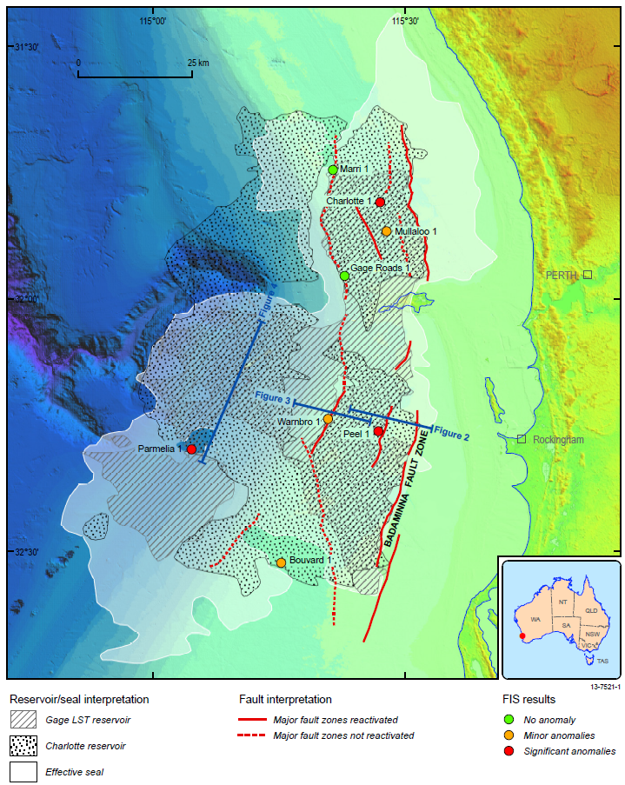
Figure 1 Spatial extent of the effective seal, Gage reservoir and the underlying Charlotte reservoir. Also shown reactivated fault zones.
  - Fault Reactivation
- Reactivated fault zones (Figure 1) are mapped from the seismic (Figure 2), newly acquired swath bathymetry and sub-bottom profiler data.
- Seismic anomalies, potentially indicating recent seepage activity, are identified in the central and northern parts of the basin (Figure 3).
- Fluid Inclusion Stratigraphy (FIS) results show shallow hydrocarbon anomalies at a number of wells (Figure 1). Location of these wells broadly correlates with areas of absent seal and reactivated fault zones.
  - Seal
- The South Perth Shale (SPS) is a thick prograding deltaic unit (up to 800 m) containing a large proportion of sandy and silty lithologies.
- The basal part of the SPS comprises shaly pro-delta facies or deep-water pelagic sediments, which are interpreted to be the effective seal.
- Thick effective seal is confined to the depositional lows, while over the palaeotopographic highs it is thin or absent.
- In some areas the combined Gage-Charlotte reservoir is fully covered by the effective seal, while in other areas, it extends far beyond the seal. When a reservoir not covered by the seal lies topographically higher than adjacent areas covered by the seal (Figure 4), injection close to the seal boundary may result in CO2 migration into the unsealed areas and eventually to leakage.
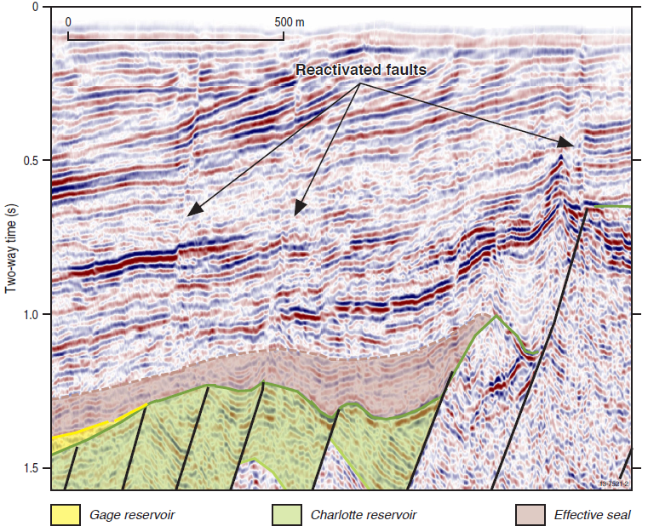
Figure 2 Seismic example showing fault reactivation in the Badaminna Fault Zone. Location of the line is shown in Figure 1
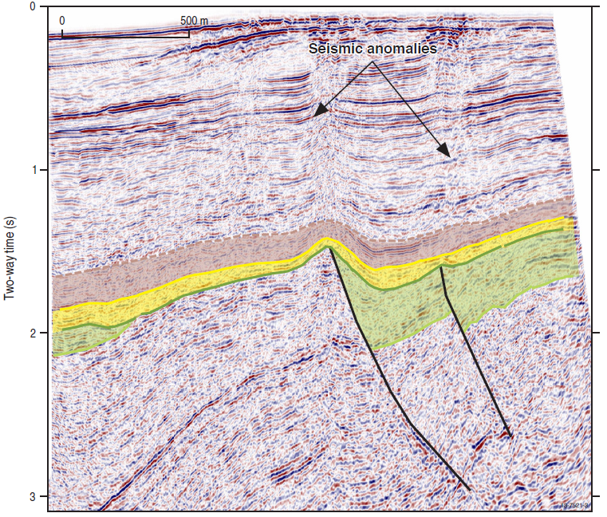
Figure 3 Seismic example showing seismic anomalies potentially indicative of fluid seepage. Location of the line is shown in Figure 1.
  - Containment Evaluation
- For identifying suitable storage sites in the Vlaming Sub-basin the following factors are being considered:
  - Proximity to reactivated faults, especially to those associated with the seepage signs;
  - Base of the seal topography and predicted direction of CO2 migration;
  - The presence of the effective top seal, and
  - Proximity to the effective seal boundary, particularly where the reservoir continues past the seal
- Preliminary results of this analysis indicate that large areas in the west and south-west, as well as a number of smaller areas throughout the basin may be suitable for CO2 storage (Figure 5).
- Provided Charlotte and Gage reservoirs are connected at the site considered for sequestration, the storage capacity could be significantly increased by injecting into the Charlotte reservoir.
- High-resolution seismic data and further detailed analysis are required for successful selection of the storage sites in the Vlaming Sub-basin.
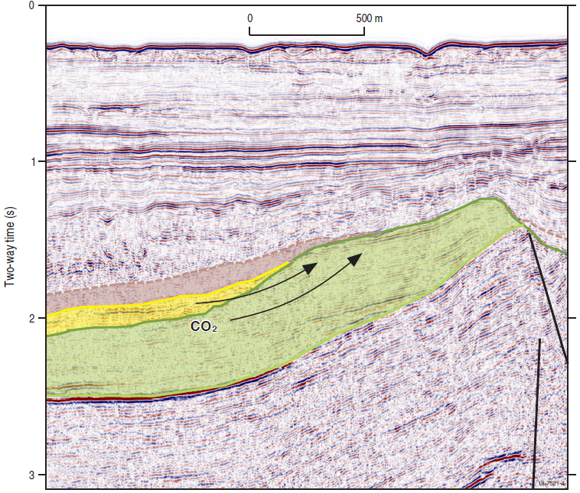
Figure 4 Seismic example illustrating base seal issue. Location of the line is shown in Figure 1.
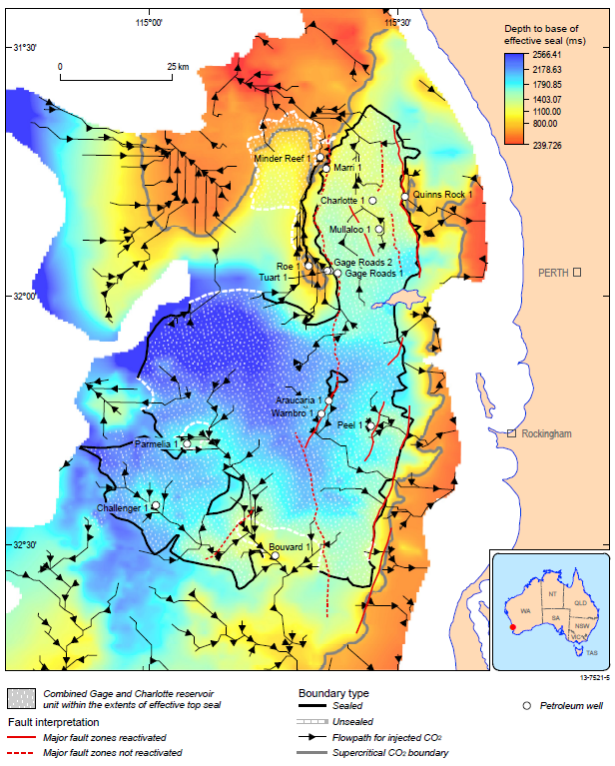
Figure 5 Topography of the base of the SPS with flow lines indicating direction of CO2 migration after the injection. Outline of the combined Gage-Charlotte reservoir is clipped to the extent of the effective seal and subdivided into sealed (the seal fully covers the reservoir) and unsealed segments (reservoir extends past the seal boundary).

