A national-scale vulnerability assessment of seawater intrusion

Seawater intrusion vulnerability indexing – quantitative
Geoscience Australia
Record 2013/20
Leanne K. Morgan1, Adrian D. Werner1, Hashim Carey2
- National Centre for Groundwater Research and Training, Flinders University, Adelaide, South Australia
- Geoscience Australia, Canberra, ACT
Department of Resources, Energy and Tourism
Minister for Resources and Energy: The Hon Gary Gray AO MP
Secretary: Mr Blair Comley, PSM
Geoscience Australia
Chief Executive Officer: Dr Chris Pigram
This paper is published with the permission of the CEO, Geoscience Australia
© Commonwealth of Australia (Geoscience Australia) 2013
With the exception of the Commonwealth Coat of Arms and where otherwise noted, all material in this publication is provided under a Creative Commons Attribution 3.0 Australia Licence. (http://www.creativecommons.org/licenses/by/3.0/au/deed.en)
Geoscience Australia has tried to make the information in this product as accurate as possible. However, it does not guarantee that the information is totally accurate or complete. Therefore, you should not solely rely on this information when making a commercial decision.
Geoscience Australia is committed to providing web accessible content wherever possible. If you are having difficulties with accessing this document please contact clientservices@ga.gov.au.
ISSN 2201-702X (PDF)
ISBN 978-1-922201-50-8 (PDF)
GeoCat 74958
Bibliographic reference: Morgan, L. K., Werner, A. D., Carey, H., 2013. A national-scale vulnerability assessment of seawater intrusion: Seawater intrusion vulnerability indexing - quantitative. Record 2013/20. Geoscience Australia, Canberra, and National Centre for Groundwater Research and Training, Adelaide.
Current as at May 2013

Contents
Acknowledgements vi
Executive Summary 1
1. Introduction 2
1.1. Background to a National Scale Vulnerability Assessment of Seawater Intrusion 2
1.2. Vulnerability Concept Clarification 3
1.3. Project Aim and Objectives 4
1.4. Project Methodology 4
1.5. Quantitative Indexing Aims and Objectives 5
2. Method 7
2.1. Unconfined Aquifers 8
2.2. Confined Aquifers 9
2.3. Freshwater Lens Systems 10
3. Limitations 11
4. Results 12
4.1. Uley South, Eyre Peninsula, South Australia 13
4.1.1. Bridgewater Formation - Unconfined aquifer 13
4.1.2. Wanilla Sands - Confined aquifer 14
4.2. Willunga, South Australia 15
4.2.1. Quarternary - Unconfined aquifer 15
4.2.2. Port Willunga Formation - Confined aquifer 16
4.2.3. Maslin Sands - Confined aquifer 17
4.3. Port Macdonnell 18
4.3.1. Tertiary Limestone - Unconfined aquifer 18
4.3.2. Tertiary Sands - Confined aquifer 19
4.4. Le Fevre 20
4.4.1. Semaphore Sands - Unconfined aquifer 20
4.4.2. T1 - Confined aquifer 21
4.4.3. T2 - Confined aquifer 22
4.5. Adelaide Metropolitan, South Australia 23
4.5.1. T1 - Confined aquifer 23
4.5.2. T2 - Confined aquifer 24
4.6. Werribee, Victoria 25
4.6.1. Alluvium/Fractured rock - Unconfined aquifer 25
4.7. Point Nepean, Victoria 26
4.7.1. Freshwater lens system 26
4.8. Bowen, Queensland 27
4.8.1. Unconfined aquifer 27
4.9. North Stradbroke Island (East & West), Queensland 28
4.9.1. Unconfined aquifer 28
4.10. Pioneer Valley 29
4.10.1. Unconfined aquifer 29
4.11. Burdekin, Queensland 30
4.11.1. Unconfined aquifer 30
4.12. Burnett (Moore Park) Queensland 31
4.12.1. Unconfined aquifer 31
4.13. Burnett (Bargara) Queensland 32
4.13.1. Unconfined aquifer 32
4.14. Perth (Whitfords) Western Australia 33
4.14.1. Superficial - Unconfined aquifer 33
4.14.2. Leederville - Confined aquifer 34
4.14.3. Yarragadee - Confined aquifer 35
4.15. Perth (Cottesloe), Western Australia 36
4.15.1. Freshwater lens system 36
4.16. Rottnest Island, Western Australia 37
4.16.1. Freshwater lens system 37
4.16.2. Esperance, Western Australia 38
4.16.3. Superficial/Pallinup – Unconfined aquifer 38
4.16.4. Werillup - Confined aquifer 39
4.17. Albany (Ocean Side), Western Australia 40
4.17.1. Werillup Formation Sand – Unconfined aquifer 40
4.18. Albany (Harbour Side), Western Australia 41
4.18.1. Superficial – Unconfined aquifer 41
4.18.2. Pallinup/Werillup - Confined aquifer 42
4.19. Busselton, Western Australia 43
4.19.1. Superficial – Unconfined aquifer 43
4.19.2. Leederville - Confined aquifer 44
4.20. Bunbury, Western Australia 45
4.20.1. Superficial – Unconfined aquifer 45
4.20.2. Yarragadee - Confined aquifer 46
4.21. Carnarvon, Western Australia 47
4.21.1. River bed sand – Unconfined aquifer 47
4.21.2. Alluvium - Confined aquifer 48
4.22. Exmouth (Cape Range), Western Australia 49
4.22.1. Cape Range Group – Unconfined aquifer 49
4.22.2. Cape Range Group – Freshwater Lens 50
4.23. Broome (Coconut Wells & Cable Beach), Western Australia 51
4.23.1. Broome Sandstone - Unconfined aquifer 51
4.24. Derby, Western Australia 52
4.24.1. Wallal/Erskine Sandstone - Unconfined aquifer 52
4.25. Botany Sands, New South Wales 53
4.25.1. Botany Sand Beds - Unconfined aquifer 53
4.26. Stuarts Point, New South Wales 54
4.26.1. Coastal Sands - Unconfined aquifer 54
4.27. Hat Head, New South Wales 55
4.27.1. Coastal Sands - Unconfined aquifer 55
4.28. Stockton, New South Wales 56
4.28.1. Stockton Sand Beds - Unconfined aquifer 56
4.29. Howard Springs, Northern Territory 57
4.29.1. Koolpinyah/Coomalie dolomite - Confined aquifer 57
5. Results summary 58
6. References 61
Appendix A. Case study area location maps 63
Appendix B. Math analysis results used for the indexing 77

Acknowledgements
The authors gratefully acknowledge the Geosciences Australia team, including Baskaran Sundaram, Narsimha Garlapati, Rebecca Norman, Sarah Marshall, Luke Wallace, Scott Cook and Karen Ivkovic (Naiades Geohydrology) for GIS support, data provision and helpful discussions on conceptual elements associated with seawater intrusion. Thanks also to Peta Jacobsen for assistance with formatting and editing. We acknowledge the helpful reviews by Prof. Ray Volker, Wendy Welsh and Jay Punthakey. The authors also wish to thank individuals from the various Federal, State and Territory stakeholder agencies for their support and input into the project. The study is funded by the National Water Commission.

Executive Summary
Fresh groundwater stored in Australian coastal aquifers constitutes an important resource for humans and the natural environment. However, many Australian coastal aquifers are vulnerable to seawater intrusion (SWI) – the landward encroachment of seawater into coastal aquifers. SWI can significantly degrade water quality and reduce freshwater availability. The increasing demands for freshwater in coastal areas and the anticipated impacts of climate change (such as sea-level rise and variations in rainfall recharge) may result in increases in the incidence and severity of SWI. Despite these threats, comprehensive investigations of SWI are relatively uncommon and the extent of monitoring and investigations specific to SWI are highly variable across the nation (Werner 2010).
In response to the threat posed by SWI, Geoscience Australia (GA) and the National Centre for Groundwater Research and Training (NCGRT), in collaboration with state and territory water agencies, have undertaken a national scale assessment of the vulnerability of coastal aquifers to SWI. This assessment aims to identify the coastal groundwater resources that are most vulnerable to SWI, including future consequences of over-extraction, sea-level rise, and recharge–discharge variations associated with climate change. The current study focuses on assessing the vulnerability of coastal aquifers, rather than that of surface waterbodies, to the landward migration of the freshwater–saltwater interface. Project funding was provided through the Raising National Water Standards program, which is administered by the National Water Commission.
In order to achieve the project aims, the study comprised five technical assessments to analyse factors contributing to the vulnerability of coastal aquifers: (i) vulnerability factor analysis (VFA); (ii) coastal aquifer typology; (iii) mathematical analysis; (iv) SWI quantitative and qualitative vulnerability indexing; and, (v) future land surface inundation and population growth analysis.
This report describes the SWI quantitative vulnerability indexing component of the project and should be considered as a complement to the report by Norman et al. (2012), which describes the qualitative indexing.

Introduction
The current project entitled “A national scale vulnerability assessment of seawater intrusion” has been completed by Geoscience Australia (GA) and the National Centre for Groundwater Research and Training (NCGRT) in collaboration with State and Territory agencies. The aim of this project is to identify Australian coastal groundwater resources currently vulnerable to seawater intrusion (SWI), and potentially at risk in the future as a consequence of over-extraction, sea-level rise and/or recharge-discharge variations associated with climate change.
The introduction to this report provides background information on SWI and provides a motivating context for the development of the project. In this chapter the concept of vulnerability is introduced; the aims and objectives of the project are listed; the quantitative vulnerability indexing methodology and application to 28 case study areas (CSAs) is also described.
The project has included five technical assessments in order to analyse factors contributing to the vulnerability of coastal aquifers: (i) vulnerability factor analysis (VFA); (ii) coastal aquifer typology; (iii) mathematical analysis; (iv) SWI quantitative and qualitative vulnerability indexing; and, (v) future land surface inundation and population growth analysis. This report addresses the quantitative vulnerability indexing component of the project. A summary of this report can be found in Chapter 4.5 of the project summary report (Ivkovic et al., 2012c).

Background to a National Scale Vulnerability Assessment of Seawater Intrusion
Fresh groundwater stored in Australian coastal aquifers is an important resource for the natural environment, as well as for urban, agricultural, rural residential and industrial activities. These aquifers may be vulnerable to seawater intrusion (SWI), which is the landward encroachment of seawater into fresh coastal aquifers. SWI can be caused by hydrologic changes, such as groundwater extraction, groundwater recharge variations, sea-level rise, or modifications to coastal surface water features. SWI poses a threat to the groundwater resources in all of Australia’s states and the Northern Territory. Yet despite this existing threat, comprehensive investigations of SWI are relatively uncommon and the extent of monitoring and investigations specific to SWI is highly variable across the nation (Werner, 2010). SWI investigation is a problematic and resource intensive business and the current scientific challenges of coastal aquifer management in Australia are as complex and diverse as the systems themselves.
The vulnerability of Australia’s coastal aquifers to SWI is not only an area of current concern but also an area of increasing future concern. The increasing demands for freshwater in coastal areas and the anticipated impacts of climate change, such as sea-level rise and variations in rainfall recharge, may result in increases in the incidence and severity of SWI. An assessment is needed to address the paucity of knowledge of SWI vulnerability at the national scale that considers the extensive and diverse aquifer systems of Australia’s coastal fringe (Werner, 2010). An improved awareness and understanding of the key drivers for SWI, the current and emerging SWI vulnerable areas and possible future trends in SWI, will benefit decision makers and groundwater stakeholders across local, state and national levels. Development of a consistent approach for the assessment of SWI vulnerability will assist national, state and regional planning and management strategies.
The national vulnerability assessment of SWI was developed to address the issues highlighted above. The broader project includes a number of technical reports focussing on various factors contributing to SWI vulnerability. The increased stresses being placed upon Australia’s freshwater coastal aquifer systems and the reported threats of SWI within the states and the Northern Territory were strong motivating factors for development of the current project. It was funded by the National Water Commission under the Groundwater Action Plan, and implemented by Geoscience Australia and the National Centre for Groundwater Research and Training (NCGRT) in partnership with state and territory agencies. The project commenced in November 2009 and finished in May 2012.

Vulnerability Concept Clarification
The principal focus of this project is assessing the vulnerability of Australian coastal aquifers to SWI, and accordingly a discussion of the concept of vulnerability and its meaning are provided. Vulnerability has numerous definitions, conceptualisations and assessment methods in the literature found both across and within disciplines (Füssel, 2007). This project has utilised several vulnerability definitions that are appropriate for the multiple components of this national vulnerability assessment of SWI.
Füssel (2007) reviewed vulnerability definitions and found that four dimensions were fundamental to describe any vulnerable situation. These four dimensions included:
- The System undergoing analysis;
- The Valued Attribute(s) of the vulnerable (susceptible) system that is threatened by its exposure to a hazard;
- Hazard: A potentially damaging influence on the system of analysis; and
- Temporal Reference: The point in time or period of interest (current, future, number of years into future etc.).
Using these terms, this project can be described as an assessment of the vulnerability of Australian freshwater coastal aquifers (system and attribute of concern) to SWI as a consequence of over-extraction and sea-level rise and/or recharge-discharge variations associated with climate change (hazards) in the present, and future (temporal reference). This is consistent with the fact that SWI vulnerability is a function of the intrinsic characteristics of the aquifer and the management of the water balance in that aquifer.
The Intergovernmental Panel on Climate Change (IPCC) has defined vulnerability in the specific context of climate change as “the degree to which a system is susceptible to, or unable to cope with, adverse effects of climate change” (IPCC, 2007). Barnett et al. (2007), notes that “While there is no consensus on the best approach to vulnerability assessment, in general they entail considering one or more of: exposure to climate risks, susceptibility to damage, and capacity to recover”. The essence of these definitions is captured by (Voice et al., 2006) who states “vulnerability is a function of exposure, sensitivity and adaptive capacity”.
By combining the above vulnerability definitions for the purposes of the current study, this report assesses the system of aquifer SWI vulnerability as a function of:
- Exposure to hazards (SWI as a result of groundwater extraction and climate change);
- Sensitivity of the system (coastal aquifers) for attribute of concern (position of the freshwater-seawater interface);
- Time (current and future vulnerability); and,
- Adaptive capacity (monitoring and management specific to SWI).

Project Aim and Objectives
The aim of ‘A national scale vulnerability assessment of seawater intrusion’ is to undertake a national assessment of coastal groundwater resources currently vulnerable to SWI, and potentially vulnerable in the future, as a consequence of over-extraction, sea-level rise and recharge-discharge variations associated with climate change.
The project has three principal objectives:
Objective 1: Provide a baseline assessment of the current status and knowledge of SWI around Australia
Objective 2: Provide conceptualisations and assessments of a range of factors contributing to the SWI vulnerability of Australian coastal aquifers, including the influences of over-extraction, sea-level rise and recharge-discharge variations associated with climate change
Objective 3: Provide an integrated assessment of the vulnerability of coastal aquifers in Australia to SWI.
The methodologies employed to meet the above objectives are outlined below.

Project Methodology
In order meet the project objectives and to achieve a national scale assessment of aquifer vulnerability to SWI for current and future scenarios, the project adopted a methodology comprising four work phases. These are:
Phase 1: Literature and data reviews to provide a baseline assessment of the state of SWI investigations in Australia and informed the development of the project methodology (Ivkovic et al., 2012a).
Phase 2: Five technical assessment components to analyse key factors contributing to the overall vulnerability of coastal aquifers to SWI. The five technical assessments included:
Vulnerability Factor Analysis (Cook et al., 2012)
Coastal Aquifer Typology (Ivkovic et al., 2012b)
Mathematical Analysis (Morgan et al., 2012b)
Quantitative and Qualitative Indexing (Morgan and Werner (2012) and Norman et al. (2012) respectively)
Future land surface inundation and population growth analysis (contained within the Ivkovic et al. (2012c) project summary report)
Phase 3: The five technical components in phase 2 are integrated to provide an overall SWI vulnerability assessment (Marshall et al., 2012)
Phase 4: A national summary of SWI vulnerability (Ivkovic et al., 2012c) provides an overview of the project findings.
The following general approaches to analysis were adopted throughout this project:
- SWI vulnerability analysis was restricted to areas within 15 kilometres of the coast, including a limited selection of off-shore islands; areas further than 15 kilometres inland were not considered likely to be vulnerable to SWI.
- The areas of interest for detailed analysis within the CSAs are those where the groundwater management units or equivalent groundwater management areas intersect the 15 kilometre buffer zone and are connected to the coast.
- The project focus is on SWI of coastal aquifer systems and there is limited emphasis on investigating the impacts of inundation to coastal environments and communities (human, ecological, infrastructure etc.).
- Surface water processes are not specifically considered in any detail.
- The project has been restricted to the synthesis, analysis and interpretation of existing data and there has not been any new field data collection, local mapping or drilling.

Quantitative Indexing Aims and Objectives
The Vulnerability Indexing methodology involves vulnerability ratings and weightings to combine both theoretical and subjective elements associated with SWI. As such, the indexing methodology is made up of two components: 1. Quantitative Indexing, which uses results from the Mathematical Analysis of case study areas, and 2. Qualitative Indexing, which uses results from the Coastal Aquifer Typology and Vulnerability Factor Analysis. This document describes the Quantitative Indexing methodology, as well as its application to 28 case study areas. The Qualitative Indexing methodology has been described in Norman et al. (2012), and includes application to the same case study areas. The indexing approach developed as part of the NSWI project improves on existing methods through the use of theoretically robust quantitative factors as well as a range of qualitative factors, which are able to capture various SWI vulnerability complexities, not captured by the Mathematical Analysis.
Existing indexing methods used to characterise SWI vulnerability, such as GALDIT (Lobo-Ferreira et al. 2007) and CVI (Ozyurt, 2007), apply a range of SWI vulnerability indicators that are presumed to control SWI. The GALDIT approach, for example, considers aquifer type, distance from the coast, hydraulic conductivity, groundwater level, previous occurrence of SWI and aquifer thickness. While the simplicity of these methods makes them useful for large-scale SWI vulnerability assessments, they lack a theoretical basis because only subjective elements associated with SWI are considered. Also, aquifer fluxes are not accounted for, and SWI vulnerability arising from changes in sea-level, recharge or extraction is not captured directly, if at all.
The Mathematical Analysis methodology is based on the commonly applied approach to the rapid assessment of SWI in coastal aquifers. That approach involves a steady state, sharp-interface approximation to the freshwater-saltwater transition zone, combined with the Ghyben-Herzberg relation. While the Mathematical Analysis methodology relies heavily on the theory developed by Strack (1976), there are mathematical extensions to Strack’s (1976) analytical solutions that have been devised specifically for the purposes of the current project. A detailed description of the method can be found in Werner et al. (2012) as well as this project’s Milestone 5 Report (Morgan et al., 2012). Mathematical analyses of 28 case study areas have been completed as part of the NSWI project, with unconfined, confined and freshwater lens systems considered. Results from these analyses are reported in Morgan et al. (2012) and are used for the quantitative SWI vulnerability indexing described in this document.

Method
The Quantitative SWI Vulnerability Indexing employs a matrix-style approach to systematically categorise the SWI vulnerability of selected case study areas. The mathematical analysis considered unconfined aquifers, confined aquifers and freshwater lens systems. Separate indexing matrices were developed for each of these aquifer systems. The range of potential indexing scores is consistent across the different indexing matrices, allowing for comparison between the different systems.
The factors used for each of the unconfined, confined and freshwater lens system indexing matrices are taken directly from results of the Mathematical Analysis. The Mathematical Analysis results that were used included: a) the calculated theoretical steady-state extent of SWI under current conditions (i.e., scaled wedge toe (unconfined aquifers), wedge toe (confined aquifers), and maximum freshwater thickness (freshwater lenses)), b) the location of the wedge toe relative to extraction bores (for unconfined and confined aquifers), and c) the propensity for change in SWI extent under future stresses (sea-level rise, recharge change and changes in flows at the inland boundary, as might occur under increased extraction). Morgan et al. (2012) provide further details of the Mathematical Analysis results and the key tables of results are provided in Appendix B of this document.
Ratings for each factor were characterised by subdividing possible values (determined using results for all case studies considered in the Mathematical Analysis) into classes. The different classes are given a rating score. The rating is used to determine the relative significance of the factor on SWI at each site.
Weightings assigned to each factor are a fixed value, which represent the (subjectively determined) relative importance of the factor in terms of SWI vulnerability. Here, the selection of weightings was also guided by the need to have consistent minimum and maximum indexing scores across the different indexing matrices. The minimum indexing score is 5 and the maximum indexing score is 50. An indexing score is obtained by summing the product of the rating and weighting for each factor. A large indexing score is presumed to indicate high vulnerability.

Unconfined Aquifers
The indexing matrix developed for unconfined aquifers is shown in Table 1.
Table 1. Indexing matrix for unconfined aquifers
 | Scaled wedge toe, xT' | Wedge toe relative to extraction bores [1] | Propensity for change in SWI extent due to sea-level rise [2] | Propensity for change in SWI extent due to recharge change [2] | Propensity for change in SWI extent due to change in flows at the inland boundary [2]
Weighting → Rating ↓ | 1 | 1 | 1 | 1 | 1
1 | xT' < 0.05 | 0 | In lowest quarter of ranked results | In lowest quarter of ranked results | In lowest quarter of ranked results
2
3 |  | 0 to 0.25
4 | 0.05 ≤ xT' ≤ 0.1 |  | In lower-mid quarter of ranked results | In lower-mid quarter of ranked results | In lower-mid quarter of ranked results
5
6 |  | 0.25 to 0.5
7 | 0.1 < xT' < 1 |  | In upper-mid quarter of ranked results | In upper-mid quarter of ranked results | In upper-mid quarter of ranked results
8 |  | 0.5 to 0.75
9
10 | xT' = 1 | ≥0.75 | In highest quarter of ranked results | In highest quarter of ranked results | In highest quarter of ranked results
Score = weighting × rating
[1] This is the ratio of toe location to distance of extraction bores from the coast.
[2] Derivatives for all unconfined aquifers that were assessed as part of the Math Analysis component of the NSWI project were ranked by magnitude. The ranking is used to determine the rating in the above indexing table.

Confined Aquifers
The indexing matrix developed for confined aquifers is shown in Table 2.
Table 2. Indexing matrix for confined aquifers
 | Inland extent of wedge toe, xT | Wedge toe relative to extraction bores [1] | Propensity for change in SWI extent due to sea-level rise [2] | Propensity for change in SWI extent due to change in flows at the inland boundary [2]
Weighting → Rating ↓ | 2 | 1 | 1 | 1
1 | xT < 2 km | 0 | In lowest quarter of ranked results | In lowest quarter of ranked results
2
3 |  | 0 to 0.25
4 | 2 km ≤ xT ≤ 10 km |  | In lower-mid quarter of ranked results | In lower-mid quarter of ranked results
5
6 |  | 0.25 to 0.5
7 | xT > 10 km |  | In upper-mid quarter of ranked results | In upper-mid quarter of ranked results
8 |  | 0.5 to 0.75
9
10 | Unstable | ≥0.75 | In highest quarter of ranked results | In highest quarter of ranked results
Score = weighting × rating
[1] This is the ratio of toe location to distance of extraction bores from the coast
[2] Derivatives for all confined aquifers that were assessed as part of the Math Analysis component of the NSWI project were ranked by magnitude. The ranking is used to determine the rating in the above indexing table.

Freshwater Lens Systems
The indexing matrix developed for freshwater lenses is shown in Table 3.
Table 3. Indexing matrix for freshwater lenses
 | Maximum freshwater thickness, hmax (m) | Propensity for change in SWI extent due to recharge change [1]
Weighting → Rating ↓ | 3 | 2
1 | hmax > 100 m | In lowest quarter of ranked results
2
3
4 | 100 m ≥ hmax ≥ 50 m | In lower-mid quarter of ranked results
5
6
7 | 50 m > hmax > 20 m | In upper-mid quarter of ranked results
8
9
10 | hmax ≤ 20 m | In highest quarter of ranked results
Score = weighting × rating
[1] Derivatives for all lens systems that were assessed as part of the Math Analysis component of the NSWI project were ranked by magnitude. The ranking is used to determine the rating in the above indexing table.

Limitations
The Quantitative Indexing used outputs from the Mathematical Analysis and, as such, is subject to the limitations of the Mathematical Analysis, as reported by Morgan et al. (2012). These limitations arise from the simplification of the conceptual system and the assumptions inherent in the analytical models. These include assumptions of steady-state conditions, a sharp interface, homogeneous aquifer properties and uniform hydrologic stresses. It has also been assumed that all aquifers discharge at the coast. Further, wells are not directly simulated and tidal impacts are not accounted for.
It is also important to consider that the effectiveness of the Mathematical Analysis is heavily reliant on the conceptualisation of the coastal system as well as the availability of data for parameterisation. In this regard, a challenge for the project was the development of conceptual models for a large number of case study areas, in such a way that the key parameters for SWI vulnerability are discernible. That is, the Mathematical Approach was heavily dependent on parameters obtained from aquifer characterisation assessments.
In light of the limitations listed above, it is important to appreciate that the Quantitative Indexing is complemented by the Qualitative Indexing, as described by Norman et al. (2012). The Qualitative Indexing considers subjective elements associated with SWI vulnerability, not accounted for by the Mathematical Analysis. Ranking of aquifers and case study areas using both the Quantitative and Qualitative Indexing will be used to inform the final assessment of vulnerability, which will consider all project components.
Additional limitations arise from the need to develop separate indexing matrices for unconfined, confined and freshwater lens systems, because the Mathematical Analysis produced different outputs for these systems. The ability of the indexing matrices to effectively compare the potential vulnerability of the different systems requires further detailed assessment.

Results
The Quantitative Indexing was applied to 28 case study areas, shown in Figure 1. The resulting indexing matrices are provided in this section and a summary of the indexing results is provided at the end of this section. Maps showing the location of case study areas, as well as extraction bore locations are provided in Appendix A. Please refer to the Milestone 5 Math Analysis report (Morgan et al., 2012) for values used to determine the ratings for the different factors for each aquifer.
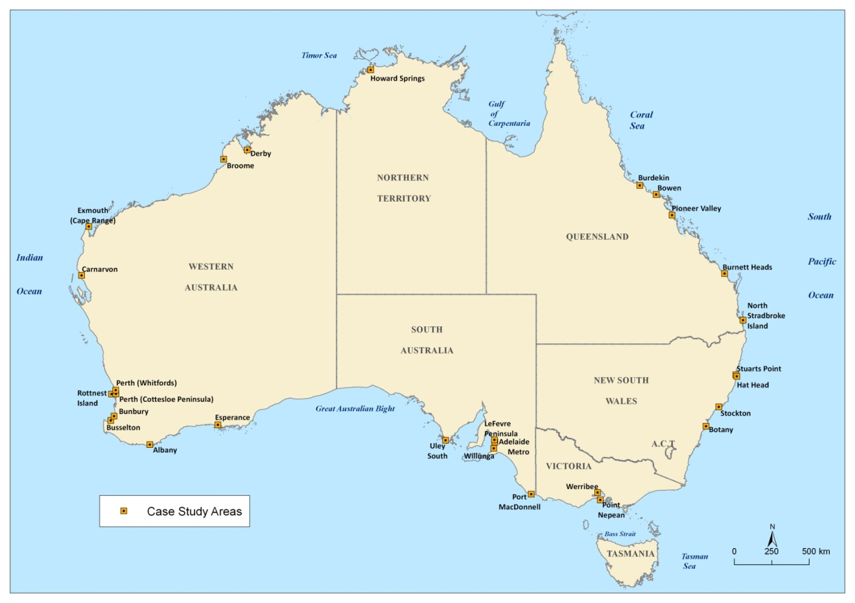
Figure 1. Indexed case study areas

Uley South, Eyre Peninsula, South Australia

Bridgewater Formation - Unconfined aquifer
 | Scaled wedge toe, xT' | Wedge toe relative to extraction bores [1] | Propensity for change in SWI extent due to sea-level rise [2] | Propensity for change in SWI extent due to recharge change [2] | Propensity for change in SWI extent due to change in flows at the inland boundary [2]
Weighting → Rating ↓ | 1 | 1 | 1 | 1 | 1
1 | xT' < 0.05 | 0 | In lowest quarter of ranked results | In lowest quarter of ranked results | In lowest quarter of ranked results
2
3 |  | 0 to 0.25
4 | 0.05 ≤ xT' ≤ 0.1 |  | In lower-mid quarter of ranked results | In lower-mid quarter of ranked results | In lower-mid quarter of ranked results
5
6 |  | 0.25 to 0.5
7 | 0.1 < xT' < 1 |  | In upper-mid quarter of ranked results | In upper-mid quarter of ranked results | In upper-mid quarter of ranked results
8 |  | 0.5 to 0.75
9
10 | xT' = 1 | ≥0.75 | In highest quarter of ranked results | In highest quarter of ranked results | In highest quarter of ranked results
Score = 25
[1] This is the ratio of toe location to distance of extraction bores from the coast.
[2] Derivatives for all unconfined aquifers that were assessed as part of the Math Analysis component of the NSWI project were ranked by magnitude. The ranking is used to determine the rating in the above indexing table.

Wanilla Sands - Confined aquifer
 | Inland extent of wedge toe, xT | Wedge toe relative to extraction bores [1] | Propensity for change in SWI extent due to sea-level rise [2] | Propensity for change in SWI extent due to change in flows at the inland boundary [2]
Weighting → Rating ↓ | 2 | 1 | 1 | 1
1 | xT < 2 km | 0 | In lowest quarter of ranked results | In lowest quarter of ranked results
2
3 |  | 0 to 0.25
4 | 2 km ≤ xT ≤ 10 km |  | In lower-mid quarter of ranked results | In lower-mid quarter of ranked results
5
6 |  | 0.25 to 0.5
7 | xT > 10 km |  | In upper-mid quarter of ranked results | In upper-mid quarter of ranked results
8 |  | 0.5 to 0.75
9
10 | Unstable | ≥0.75 | In highest quarter of ranked results | In highest quarter of ranked results
Score = 10
[1] This is the ratio of toe location to distance of extraction bores from the coast.
[2] Derivatives for all confined aquifers that were assessed as part of the Math Analysis component of the NSWI project were ranked by magnitude. The ranking is used to determine the rating in the above indexing table.

Willunga, South Australia

Quarternary - Unconfined aquifer
 | Scaled wedge toe, xT' | Wedge toe relative to extraction bores [1] | Propensity for change in SWI extent due to sea-level rise [2] | Propensity for change in SWI extent due to recharge change [2] | Propensity for change in SWI extent due to change in flows at the inland boundary [2]
Weighting → Rating ↓ | 1 | 1 | 1 | 1 | 1
1 | xT' < 0.05 | 0 | In lowest quarter of ranked results | In lowest quarter of ranked results | In lowest quarter of ranked results
2
3 |  | 0 to 0.25
4 | 0.05 ≤ xT' ≤ 0.1 |  | In lower-mid quarter of ranked results | In lower-mid quarter of ranked results | In lower-mid quarter of ranked results
5
6 |  | 0.25 to 0.5
7 | 0.1 < xT' < 1 |  | In upper-mid quarter of ranked results | In upper-mid quarter of ranked results | In upper-mid quarter of ranked results
8 |  | 0.5 to 0.75
9
10 | xT' = 1 | ≥0.75 | In highest quarter of ranked results | In highest quarter of ranked results | In highest quarter of ranked results
Score = 25
[1] This is the ratio of toe location to distance of extraction bores from the coast.
[2] Derivatives for all unconfined aquifers that were assessed as part of the Math Analysis component of the NSWI project were ranked by magnitude. The ranking is used to determine the rating in the above indexing table.

Port Willunga Formation - Confined aquifer
 | Inland extent of wedge toe, xT | Wedge toe relative to extraction bores [1] | Propensity for change in SWI extent due to sea-level rise [2] | Propensity for change in SWI extent due to change in flows at the inland boundary [2]
Weighting → Rating ↓ | 2 | 1 | 1 | 1
1 | xT < 2 km | 0 | In lowest quarter of ranked results | In lowest quarter of ranked results
2
3 |  | 0 to 0.25
4 | 2 km ≤ xT ≤ 10 km |  | In lower-mid quarter of ranked results | In lower-mid quarter of ranked results
5
6 |  | 0.25 to 0.5
7 | xT > 10 km |  | In upper-mid quarter of ranked results | In upper-mid quarter of ranked results
8 |  | 0.5 to 0.75
9
10 | Unstable | ≥0.75 | In highest quarter of ranked results | In highest quarter of ranked results
Score = 35
[1] This is the ratio of toe location to distance of extraction bores from the coast.
[2] Derivatives for all confined aquifers that were assessed as part of the Math Analysis component of the NSWI project were ranked by magnitude. The ranking is used to determine the rating in the above indexing table.

Maslin Sands - Confined aquifer
 | Inland extent of wedge toe, xT | Wedge toe relative to extraction bores [1] | Propensity for change in SWI extent due to sea-level rise [2] | Propensity for change in SWI extent due to change in flows at the inland boundary [2]
Weighting → Rating ↓ | 2 | 1 | 1 | 1
1 | xT < 2 km | 0 | In lowest quarter of ranked results | In lowest quarter of ranked results
2
3 |  | 0 to 0.25
4 | 2 km ≤ xT ≤ 10 km |  | In lower-mid quarter of ranked results | In lower-mid quarter of ranked results
5
6 |  | 0.25 to 0.5
7 | xT > 10 km |  | In upper-mid quarter of ranked results | In upper-mid quarter of ranked results
8 |  | 0.5 to 0.75
9
10 | Unstable | ≥0.75 | In highest quarter of ranked results | In highest quarter of ranked results
Score = 50
[1] This is the ratio of toe location to distance of extraction bores from the coast.
[2] Derivatives for all confined aquifers that were assessed as part of the Math Analysis component of the NSWI project were ranked by magnitude. The ranking is used to determine the rating in the above indexing table.

Port Macdonnell

Tertiary Limestone - Unconfined aquifer
 | Scaled wedge toe, xT' | Wedge toe relative to extraction bores [1] | Propensity for change in SWI extent due to sea-level rise [2] | Propensity for change in SWI extent due to recharge change [2] | Propensity for change in SWI extent due to change in flows at the inland boundary [2]
Weighting → Rating ↓ | 1 | 1 | 1 | 1 | 1
1 | xT' < 0.05 | 0 | In lowest quarter of ranked results | In lowest quarter of ranked results | In lowest quarter of ranked results
2
3 |  | 0 to 0.25
4 | 0.05 ≤ xT' ≤ 0.1 |  | In lower-mid quarter of ranked results | In lower-mid quarter of ranked results | In lower-mid quarter of ranked results
5
6 |  | 0.25 to 0.5
7 | 0.1 < xT' < 1 |  | In upper-mid quarter of ranked results | In upper-mid quarter of ranked results | In upper-mid quarter of ranked results
8 |  | 0.5 to 0.75
9
10 | xT' = 1 | ≥0.75 | In highest quarter of ranked results | In highest quarter of ranked results | In highest quarter of ranked results
Score = 47
[1] This is the ratio of toe location to distance of extraction bores from the coast.
[2] Derivatives for all unconfined aquifers that were assessed as part of the Math Analysis component of the NSWI project were ranked by magnitude. The ranking is used to determine the rating in the above indexing table.

Tertiary Sands - Confined aquifer
 | Inland extent of wedge toe, xT | Wedge toe relative to extraction bores [1] | Propensity for change in SWI extent due to sea-level rise [2] | Propensity for change in SWI extent due to change in flows at the inland boundary [2]
Weighting → Rating ↓ | 2 | 1 | 1 | 1
1 | xT < 2 km | 0 | In lowest quarter of ranked results | In lowest quarter of ranked results
2
3 |  | 0 to 0.25
4 | 2 km ≤ xT ≤ 10 km |  | In lower-mid quarter of ranked results | In lower-mid quarter of ranked results
5
6 |  | 0.25 to 0.5
7 | xT > 10 km |  | In upper-mid quarter of ranked results | In upper-mid quarter of ranked results
8 |  | 0.5 to 0.75
9
10 | Unstable | ≥0.75 | In highest quarter of ranked results | In highest quarter of ranked results
Score = 20
[1] This is the ratio of toe location to distance of extraction bores from the coast.
[2] Derivatives for all confined aquifers that were assessed as part of the Math Analysis component of the NSWI project were ranked by magnitude. The ranking is used to determine the rating in the above indexing table.

Le Fevre

Semaphore Sands - Unconfined aquifer
 | Scaled wedge toe, xT' | Wedge toe relative to extraction bores [1] | Propensity for change in SWI extent due to sea-level rise [2] | Propensity for change in SWI extent due to recharge change [2] | Propensity for change in SWI extent due to change in flows at the inland boundary [2]
Weighting → Rating ↓ | 1 | 1 | 1 | 1 | 1
1 | xT' < 0.05 | 0 | In lowest quarter of ranked results | In lowest quarter of ranked results | In lowest quarter of ranked results
2
3 |  | 0 to 0.25
4 | 0.05 ≤ xT' ≤ 0.1 |  | In lower-mid quarter of ranked results | In lower-mid quarter of ranked results | In lower-mid quarter of ranked results
5
6 |  | 0.25 to 0.5
7 | 0.1 < xT' < 1 |  | In upper-mid quarter of ranked results | In upper-mid quarter of ranked results | In upper-mid quarter of ranked results
8 |  | 0.5 to 0.75
9
10 | xT' = 1 | ≥0.75 | In highest quarter of ranked results | In highest quarter of ranked results | In highest quarter of ranked results
Score = 16
[1] This is the ratio of toe location to distance of extraction bores from the coast.
[2] Derivatives for all unconfined aquifers that were assessed as part of the Math Analysis component of the NSWI project were ranked by magnitude. The ranking is used to determine the rating in the above indexing table.

T1 - Confined aquifer
 | Inland extent of wedge toe, xT | Wedge toe relative to extraction bores [1] | Propensity for change in SWI extent due to sea-level rise [2] | Propensity for change in SWI extent due to change in flows at the inland boundary [2]
Weighting → Rating ↓ | 2 | 1 | 1 | 1
1 | xT < 2 km | 0 | In lowest quarter of ranked results | In lowest quarter of ranked results
2
3 |  | 0 to 0.25
4 | 2 km ≤ xT ≤ 10 km |  | In lower-mid quarter of ranked results | In lower-mid quarter of ranked results
5
6 |  | 0.25 to 0.5
7 | xT > 10 km |  | In upper-mid quarter of ranked results | In upper-mid quarter of ranked results
8 |  | 0.5 to 0.75
9
10 | Unstable | ≥0.75 | In highest quarter of ranked results | In highest quarter of ranked results
Score = 50
[1] This is the ratio of toe location to distance of extraction bores from the coast.
[2] Derivatives for all confined aquifers that were assessed as part of the Math Analysis component of the NSWI project were ranked by magnitude. The ranking is used to determine the rating in the above indexing table.

T2 - Confined aquifer
 | Inland extent of wedge toe, xT | Wedge toe relative to extraction bores [1] | Propensity for change in SWI extent due to sea-level rise [2] | Propensity for change in SWI extent due to change in flows at the inland boundary [2]
Weighting → Rating ↓ | 2 | 1 | 1 | 1
1 | xT < 2 km | 0 | In lowest quarter of ranked results | In lowest quarter of ranked results
2
3 |  | 0 to 0.25
4 | 2 km ≤ xT ≤ 10 km |  | In lower-mid quarter of ranked results | In lower-mid quarter of ranked results
5
6 |  | 0.25 to 0.5
7 | xT > 10 km |  | In upper-mid quarter of ranked results | In upper-mid quarter of ranked results
8 |  | 0.5 to 0.75
9
10 | Unstable | ≥0.75 | In highest quarter of ranked results | In highest quarter of ranked results
Score = 50
[1] This is the ratio of toe location to distance of extraction bores from the coast.
[2] Derivatives for all confined aquifers that were assessed as part of the Math Analysis component of the NSWI project were ranked by magnitude. The ranking is used to determine the rating in the above indexing table.

Adelaide Metropolitan, South Australia

T1 - Confined aquifer
 | Inland extent of wedge toe, xT | Wedge toe relative to extraction bores [1] | Propensity for change in SWI extent due to sea-level rise [2] | Propensity for change in SWI extent due to change in flows at the inland boundary [2]
Weighting → Rating ↓ | 2 | 1 | 1 | 1
1 | xT < 2 km | 0 | In lowest quarter of ranked results | In lowest quarter of ranked results
2
3 |  | 0 to 0.25
4 | 2 km ≤ xT ≤ 10 km |  | In lower-mid quarter of ranked results | In lower-mid quarter of ranked results
5
6 |  | 0.25 to 0.5
7 | xT > 10 km |  | In upper-mid quarter of ranked results | In upper-mid quarter of ranked results
8 |  | 0.5 to 0.75
9
10 | Unstable | ≥0.75 | In highest quarter of ranked results | In highest quarter of ranked results
Score = 50
[1] This is the ratio of toe location to distance of extraction bores from the coast.
[2] Derivatives for all confined aquifers that were assessed as part of the Math Analysis component of the NSWI project were ranked by magnitude. The ranking is used to determine the rating in the above indexing table.

T2 - Confined aquifer
 | Inland extent of wedge toe, xT | Wedge toe relative to extraction bores [1] | Propensity for change in SWI extent due to sea-level rise [2] | Propensity for change in SWI extent due to change in flows at the inland boundary [2]
Weighting → Rating ↓ | 2 | 1 | 1 | 1
1 | xT < 2 km | 0 | In lowest quarter of ranked results | In lowest quarter of ranked results
2
3 |  | 0 to 0.25
4 | 2 km ≤ xT ≤ 10 km |  | In lower-mid quarter of ranked results | In lower-mid quarter of ranked results
5
6 |  | 0.25 to 0.5
7 | xT > 10 km |  | In upper-mid quarter of ranked results | In upper-mid quarter of ranked results
8 |  | 0.5 to 0.75
9
10 | Unstable | ≥0.75 | In highest quarter of ranked results | In highest quarter of ranked results
Score = 50
[1] This is the ratio of toe location to distance of extraction bores from the coast.
[2] Derivatives for all confined aquifers that were assessed as part of the Math Analysis component of the NSWI project were ranked by magnitude. The ranking is used to determine the rating in the above indexing table.

Werribee, Victoria

Alluvium/Fractured rock - Unconfined aquifer
 | Scaled wedge toe, xT' | Wedge toe relative to extraction bores [1] | Propensity for change in SWI extent due to sea-level rise [2] | Propensity for change in SWI extent due to recharge change [2] | Propensity for change in SWI extent due to change in flows at the inland boundary [2]
Weighting → Rating ↓ | 1 | 1 | 1 | 1 | 1
1 | xT' < 0.05 | 0 | In lowest quarter of ranked results | In lowest quarter of ranked results | In lowest quarter of ranked results
2
3 |  | 0 to 0.25
4 | 0.05 ≤ xT' ≤ 0.1 |  | In lower-mid quarter of ranked results | In lower-mid quarter of ranked results | In lower-mid quarter of ranked results
5
6 |  | 0.25 to 0.5
7 | 0.1 < xT' < 1 |  | In upper-mid quarter of ranked results | In upper-mid quarter of ranked results | In upper-mid quarter of ranked results
8 |  | 0.5 to 0.75
9
10 | xT' = 1 | ≥0.75 | In highest quarter of ranked results | In highest quarter of ranked results | In highest quarter of ranked results
Score = 20
[1] This is the ratio of toe location to distance of extraction bores from the coast.
[2] Derivatives for all unconfined aquifers that were assessed as part of the Math Analysis component of the NSWI project were ranked by magnitude. The ranking is used to determine the rating in the above indexing table.

Point Nepean, Victoria

Freshwater lens system
 | Maximum freshwater thickness, hmax (m) | Propensity for change in SWI extent due to recharge change [1]
Weighting → Rating ↓ | 3 | 2
1 | hmax > 100 m | In lowest quarter of ranked results
2
3
4 | 100 m ≥ hmax ≥ 50 m | In lower-mid quarter of ranked results
5
6
7 | 50 m > hmax > 20 m | In upper-mid quarter of ranked results
8
9
10 | hmax ≤ 20 m | In highest quarter of ranked results
Score = 26
[1] Derivatives for all lens systems that were assessed as part of the Math Analysis component of the NSWI project were ranked by magnitude. The ranking is used to determine the rating.

Bowen, Queensland

Unconfined aquifer
 | Scaled wedge toe, xT' | Wedge toe relative to extraction bores [1] | Propensity for change in SWI extent due to sea-level rise [2] | Propensity for change in SWI extent due to recharge change [2] | Propensity for change in SWI extent due to change in flows at the inland boundary [2]
Weighting → Rating ↓ | 1 | 1 | 1 | 1 | 1
1 | xT' < 0.05 | 0 | In lowest quarter of ranked results | In lowest quarter of ranked results | In lowest quarter of ranked results
2
3 |  | 0 to 0.25
4 | 0.05 ≤ xT' ≤ 0.1 |  | In lower-mid quarter of ranked results | In lower-mid quarter of ranked results | In lower-mid quarter of ranked results
5
6 |  | 0.25 to 0.5
7 | 0.1 < xT' < 1 |  | In upper-mid quarter of ranked results | In upper-mid quarter of ranked results | In upper-mid quarter of ranked results
8 |  | 0.5 to 0.75
9
10 | xT' = 1 | ≥0.75 | In highest quarter of ranked results | In highest quarter of ranked results | In highest quarter of ranked results
Score = 30
[1] This is the ratio of toe location to distance of extraction bores from the coast.
[2] Derivatives for all unconfined aquifers that were assessed as part of the Math Analysis component of the NSWI project were ranked by magnitude. The ranking is used to determine the rating in the above indexing table.

North Stradbroke Island (East & West), Queensland

Unconfined aquifer
 | Scaled wedge toe, xT' | Wedge toe relative to extraction bores [1] | Propensity for change in SWI extent due to sea-level rise [2] | Propensity for change in SWI extent due to recharge change [2] | Propensity for change in SWI extent due to change in flows at the inland boundary [2]
Weighting → Rating ↓ | 1 | 1 | 1 | 1 | 1
1 | xT' < 0.05 | 0 | In lowest quarter of ranked results | In lowest quarter of ranked results | In lowest quarter of ranked results
2
3 |  | 0 to 0.25
4 | 0.05 ≤ xT' ≤ 0.1 |  | In lower-mid quarter of ranked results | In lower-mid quarter of ranked results | In lower-mid quarter of ranked results
5
6 |  | 0.25 to 0.5
7 | 0.1 < xT' < 1 |  | In upper-mid quarter of ranked results | In upper-mid quarter of ranked results | In upper-mid quarter of ranked results
8 |  | 0.5 to 0.75
9
10 | xT' = 1 | ≥0.75 | In highest quarter of ranked results | In highest quarter of ranked results | In highest quarter of ranked results
Score = 10
[1] This is the ratio of toe location to distance of extraction bores from the coast. Extraction bore locations not available for this site however and therefore average rating applied.
[2] Derivatives for all unconfined aquifers that were assessed as part of the Math Analysis component of the NSWI project were ranked by magnitude. The ranking is used to determine the rating in the above indexing table.

Pioneer Valley

Unconfined aquifer
 | Scaled wedge toe, xT' | Wedge toe relative to extraction bores [1] | Propensity for change in SWI extent due to sea-level rise [2] | Propensity for change in SWI extent due to recharge change [2] | Propensity for change in SWI extent due to change in flows at the inland boundary [2]
Weighting → Rating ↓ | 1 | 1 | 1 | 1 | 1
1 | xT' < 0.05 | 0 | In lowest quarter of ranked results | In lowest quarter of ranked results | In lowest quarter of ranked results
2
3 |  | 0 to 0.25
4 | 0.05 ≤ xT' ≤ 0.1 |  | In lower-mid quarter of ranked results | In lower-mid quarter of ranked results | In lower-mid quarter of ranked results
5
6 |  | 0.25 to 0.5
7 | 0.1 < xT' < 1 |  | In upper-mid quarter of ranked results | In upper-mid quarter of ranked results | In upper-mid quarter of ranked results
8 |  | 0.5 to 0.75
9
10 | xT' = 1 | ≥0.75 | In highest quarter of ranked results | In highest quarter of ranked results | In highest quarter of ranked results
Score = 16
[1] This is the ratio of toe location to distance of extraction bores from the coast.
[2] Derivatives for all unconfined aquifers that were assessed as part of the Math Analysis component of the NSWI project were ranked by magnitude. The ranking is used to determine the rating in the above indexing table.

Burdekin, Queensland

Unconfined aquifer
 | Scaled wedge toe, xT' | Wedge toe relative to extraction bores [1] | Propensity for change in SWI extent due to sea-level rise [2] | Propensity for change in SWI extent due to recharge change [2] | Propensity for change in SWI extent due to change in flows at the inland boundary [2]
Weighting → Rating ↓ | 1 | 1 | 1 | 1 | 1
1 | xT' < 0.05 | 0 | In lowest quarter of ranked results | In lowest quarter of ranked results | In lowest quarter of ranked results
2
3 |  | 0 to 0.25
4 | 0.05 ≤ xT' ≤ 0.1 |  | In lower-mid quarter of ranked results | In lower-mid quarter of ranked results | In lower-mid quarter of ranked results
5
6 |  | 0.25 to 0.5
7 | 0.1 < xT' < 1 |  | In upper-mid quarter of ranked results | In upper-mid quarter of ranked results | In upper-mid quarter of ranked results
8 |  | 0.5 to 0.75
9
10 | xT' = 1 | ≥0.75 | In highest quarter of ranked results | In highest quarter of ranked results | In highest quarter of ranked results
Score = 50
[1] This is the ratio of toe location to distance of extraction bores from the coast.
[2] Derivatives for all unconfined aquifers that were assessed as part of the Math Analysis component of the NSWI project were ranked by magnitude. The ranking is used to determine the rating in the above indexing table.

Burnett (Moore Park) Queensland

Unconfined aquifer
 | Scaled wedge toe, xT' | Wedge toe relative to extraction bores [1] | Propensity for change in SWI extent due to sea-level rise [2] | Propensity for change in SWI extent due to recharge change [2] | Propensity for change in SWI extent due to change in flows at the inland boundary [2]
Weighting → Rating ↓ | 1 | 1 | 1 | 1 | 1
1 | xT' < 0.05 | 0 | In lowest quarter of ranked results | In lowest quarter of ranked results | In lowest quarter of ranked results
2
3 |  | 0 to 0.25
4 | 0.05 ≤ xT' ≤ 0.1 |  | In lower-mid quarter of ranked results | In lower-mid quarter of ranked results | In lower-mid quarter of ranked results
5
6 |  | 0.25 to 0.5
7 | 0.1 < xT' < 1 |  | In upper-mid quarter of ranked results | In upper-mid quarter of ranked results | In upper-mid quarter of ranked results
8 |  | 0.5 to 0.75
9
10 | xT' = 1 | ≥0.75 | In highest quarter of ranked results | In highest quarter of ranked results | In highest quarter of ranked results
Score = 36
[1] This is the ratio of toe location to distance of extraction bores from the coast.
[2] Derivatives for all unconfined aquifers that were assessed as part of the Math Analysis component of the NSWI project were ranked by magnitude. The ranking is used to determine the rating in the above indexing table.

Burnett (Bargara) Queensland

Unconfined aquifer
 | Scaled wedge toe, xT' | Wedge toe relative to extraction bores [1] | Propensity for change in SWI extent due to sea-level rise [2] | Propensity for change in SWI extent due to recharge change [2] | Propensity for change in SWI extent due to change in flows at the inland boundary [2]
Weighting → Rating ↓ | 1 | 1 | 1 | 1 | 1
1 | xT' < 0.05 | 0 | In lowest quarter of ranked results | In lowest quarter of ranked results | In lowest quarter of ranked results
2
3 |  | 0 to 0.25
4 | 0.05 ≤ xT' ≤ 0.1 |  | In lower-mid quarter of ranked results | In lower-mid quarter of ranked results | In lower-mid quarter of ranked results
5
6 |  | 0.25 to 0.5
7 | 0.1 < xT' < 1 |  | In upper-mid quarter of ranked results | In upper-mid quarter of ranked results | In upper-mid quarter of ranked results
8 |  | 0.5 to 0.75
9
10 | xT' = 1 | ≥0.75 | In highest quarter of ranked results | In highest quarter of ranked results | In highest quarter of ranked results
Score = 16
[1] This is the ratio of toe location to distance of extraction bores from the coast.
[2] Derivatives for all unconfined aquifers that were assessed as part of the Math Analysis component of the NSWI project were ranked by magnitude. The ranking is used to determine the rating in the above indexing table.

Perth (Whitfords) Western Australia

Superficial - Unconfined aquifer
 | Scaled wedge toe, xT' | Wedge toe relative to extraction bores [1] | Propensity for change in SWI extent due to sea-level rise [2] | Propensity for change in SWI extent due to recharge change [2] | Propensity for change in SWI extent due to change in flows at the inland boundary [2]
Weighting → Rating ↓ | 1 | 1 | 1 | 1 | 1
1 | xT' < 0.05 | 0 | In lowest quarter of ranked results | In lowest quarter of ranked results | In lowest quarter of ranked results
2
3 |  | 0 to 0.25
4 | 0.05 ≤ xT' ≤ 0.1 |  | In lower-mid quarter of ranked results | In lower-mid quarter of ranked results | In lower-mid quarter of ranked results
5
6 |  | 0.25 to 0.5
7 | 0.1 < xT' < 1 |  | In upper-mid quarter of ranked results | In upper-mid quarter of ranked results | In upper-mid quarter of ranked results
8 |  | 0.5 to 0.75
9
10 | xT' = 1 | ≥0.75 | In highest quarter of ranked results | In highest quarter of ranked results | In highest quarter of ranked results
Score = 31
[1] This is the ratio of toe location to distance of extraction bores from the coast.
[2] Derivatives for all unconfined aquifers that were assessed as part of the Math Analysis component of the NSWI project were ranked by magnitude. The ranking is used to determine the rating in the above indexing table.

Leederville - Confined aquifer
 | Inland extent of wedge toe, xT | Wedge toe relative to extraction bores [1] | Propensity for change in SWI extent due to sea-level rise [2] | Propensity for change in SWI extent due to change in flows at the inland boundary [2]
Weighting → Rating ↓ | 2 | 1 | 1 | 1
1 | xT < 2 km | 0 | In lowest quarter of ranked results | In lowest quarter of ranked results
2
3 |  | 0 to 0.25
4 | 2 km ≤ xT ≤ 10 km |  | In lower-mid quarter of ranked results | In lower-mid quarter of ranked results
5
6 |  | 0.25 to 0.5
7 | xT > 10 km |  | In upper-mid quarter of ranked results | In upper-mid quarter of ranked results
8 |  | 0.5 to 0.75
9
10 | Unstable | ≥0.75 | In highest quarter of ranked results | In highest quarter of ranked results
Score = 32
[1] This is the ratio of toe location to distance of extraction bores from the coast.
[2] Derivatives for all confined aquifers that were assessed as part of the Math Analysis component of the NSWI project were ranked by magnitude. The ranking is used to determine the rating in the above indexing table.

Yarragadee - Confined aquifer
 | Inland extent of wedge toe, xT | Wedge toe relative to extraction bores [1] | Propensity for change in SWI extent due to sea-level rise [2] | Propensity for change in SWI extent due to change in flows at the inland boundary [2]
Weighting → Rating ↓ | 2 | 1 | 1 | 1
1 | xT < 2 km | 0 | In lowest quarter of ranked results | In lowest quarter of ranked results
2
3 |  | 0 to 0.25
4 | 2 km ≤ xT ≤ 10 km |  | In lower-mid quarter of ranked results | In lower-mid quarter of ranked results
5
6 |  | 0.25 to 0.5
7 | xT > 10 km |  | In upper-mid quarter of ranked results | In upper-mid quarter of ranked results
8 |  | 0.5 to 0.75
9
10 | Unstable | ≥0.75 | In highest quarter of ranked results | In highest quarter of ranked results
Score = 32
[1] This is the ratio of toe location to distance of extraction bores from the coast.
[2] Derivatives for all confined aquifers that were assessed as part of the Math Analysis component of the NSWI project were ranked by magnitude. The ranking is used to determine the rating in the above indexing table.

Perth (Cottesloe), Western Australia

Freshwater lens system
 | Maximum freshwater thickness, hmax (m) | Propensity for change in SWI extent due to recharge change [1]
Weighting → Rating ↓ | 3 | 2
1 | hmax > 100 m | In lowest quarter of ranked results
2
3
4 | 100 m ≥ hmax ≥ 50 m | In lower-mid quarter of ranked results
5
6
7 | 50 m > hmax > 20 m | In upper-mid quarter of ranked results
8
9
10 | hmax ≤ 20 m | In highest quarter of ranked results
Score = 38
[1] Derivatives for all lens systems that were assessed as part of the Math Analysis component of the NSWI project were ranked by magnitude. The ranking is used to determine the rating.

Rottnest Island, Western Australia

Freshwater lens system
 | Maximum freshwater thickness, hmax (m) | Propensity for change in SWI extent due to recharge change [1]
Weighting → Rating ↓ | 3 | 2
1 | hmax > 100 m | In lowest quarter of ranked results
2
3
4 | 100 m ≥ hmax ≥ 50 m | In lower-mid quarter of ranked results
5
6
7 | 50 m > hmax > 20 m | In upper-mid quarter of ranked results
8
9
10 | hmax ≤ 20 m | In highest quarter of ranked results
Score = 38
[1] Derivatives for all lens systems that were assessed as part of the Math Analysis component of the NSWI project were ranked by magnitude. The ranking is used to determine the rating.

Esperance, Western Australia

Superficial/Pallinup – Unconfined aquifer
 | Scaled wedge toe, xT' | Wedge toe relative to extraction bores [1] | Propensity for change in SWI extent due to sea-level rise [2] | Propensity for change in SWI extent due to recharge change [2] | Propensity for change in SWI extent due to change in flows at the inland boundary [2]
Weighting → Rating ↓ | 1 | 1 | 1 | 1 | 1
1 | xT' < 0.05 | 0 | In lowest quarter of ranked results | In lowest quarter of ranked results | In lowest quarter of ranked results
2
3 |  | 0 to 0.25
4 | 0.05 ≤ xT' ≤ 0.1 |  | In lower-mid quarter of ranked results | In lower-mid quarter of ranked results | In lower-mid quarter of ranked results
5
6 |  | 0.25 to 0.5
7 | 0.1 < xT' < 1 |  | In upper-mid quarter of ranked results | In upper-mid quarter of ranked results | In upper-mid quarter of ranked results
8 |  | 0.5 to 0.75
9
10 | xT' = 1 | ≥0.75 | In highest quarter of ranked results | In highest quarter of ranked results | In highest quarter of ranked results
Score = 43
[1] This is the ratio of toe location to distance of extraction bores from the coast.
[2] Derivatives for all unconfined aquifers that were assessed as part of the Math Analysis component of the NSWI project were ranked by magnitude. The ranking is used to determine the rating in the above indexing table.

Werillup - Confined aquifer
 | Inland extent of wedge toe, xT | Wedge toe relative to extraction bores [1] | Propensity for change in SWI extent due to sea-level rise [2] | Propensity for change in SWI extent due to change in flows at the inland boundary [2]
Weighting → Rating ↓ | 2 | 1 | 1 | 1
1 | xT < 2 km | 0 | In lowest quarter of ranked results | In lowest quarter of ranked results
2
3 |  | 0 to 0.25
4 | 2 km ≤ xT ≤ 10 km |  | In lower-mid quarter of ranked results | In lower-mid quarter of ranked results
5
6 |  | 0.25 to 0.5
7 | xT > 10 km |  | In upper-mid quarter of ranked results | In upper-mid quarter of ranked results
8 |  | 0.5 to 0.75
9
10 | Unstable | ≥0.75 | In highest quarter of ranked results | In highest quarter of ranked results
Score = 50
[1] This is the ratio of toe location to distance of extraction bores from the coast.
[2] Derivatives for all confined aquifers that were assessed as part of the Math Analysis component of the NSWI project were ranked by magnitude. The ranking is used to determine the rating in the above indexing table.

Albany (Ocean Side), Western Australia

Werillup Formation Sand – Unconfined aquifer
 | Scaled wedge toe, xT' | Wedge toe relative to extraction bores [1] | Propensity for change in SWI extent due to sea-level rise [2] | Propensity for change in SWI extent due to recharge change [2] | Propensity for change in SWI extent due to change in flows at the inland boundary [2]
Weighting → Rating ↓ | 1 | 1 | 1 | 1 | 1
1 | xT' < 0.05 | 0 | In lowest quarter of ranked results | In lowest quarter of ranked results | In lowest quarter of ranked results
2
3 |  | 0 to 0.25
4 | 0.05 ≤ xT' ≤ 0.1 |  | In lower-mid quarter of ranked results | In lower-mid quarter of ranked results | In lower-mid quarter of ranked results
5
6 |  | 0.25 to 0.5
7 | 0.1 < xT' < 1 |  | In upper-mid quarter of ranked results | In upper-mid quarter of ranked results | In upper-mid quarter of ranked results
8 |  | 0.5 to 0.75
9
10 | xT' = 1 | ≥0.75 | In highest quarter of ranked results | In highest quarter of ranked results | In highest quarter of ranked results
Score = 7
[1] This is the ratio of toe location to distance of extraction bores from the coast.
[2] Derivatives for all unconfined aquifers that were assessed as part of the Math Analysis component of the NSWI project were ranked by magnitude. The ranking is used to determine the rating in the above indexing table.

Albany (Harbour Side), Western Australia

Superficial – Unconfined aquifer
 | Scaled wedge toe, xT' | Wedge toe relative to extraction bores [1] | Propensity for change in SWI extent due to sea-level rise [2] | Propensity for change in SWI extent due to recharge change [2] | Propensity for change in SWI extent due to change in flows at the inland boundary [2]
Weighting → Rating ↓ | 1 | 1 | 1 | 1 | 1
1 | xT' < 0.05 | 0 | In lowest quarter of ranked results | In lowest quarter of ranked results | In lowest quarter of ranked results
2
3 |  | 0 to 0.25
4 | 0.05 ≤ xT' ≤ 0.1 |  | In lower-mid quarter of ranked results | In lower-mid quarter of ranked results | In lower-mid quarter of ranked results
5
6 |  | 0.25 to 0.5
7 | 0.1 < xT' < 1 |  | In upper-mid quarter of ranked results | In upper-mid quarter of ranked results | In upper-mid quarter of ranked results
8 |  | 0.5 to 0.75
9
10 | xT' = 1 | ≥0.75 | In highest quarter of ranked results | In highest quarter of ranked results | In highest quarter of ranked results
Score = 7
[1] This is the ratio of toe location to distance of extraction bores from the coast.
[2] Derivatives for all unconfined aquifers that were assessed as part of the Math Analysis component of the NSWI project were ranked by magnitude. The ranking is used to determine the rating in the above indexing table.

Pallinup/Werillup - Confined aquifer
 | Inland extent of wedge toe, xT | Wedge toe relative to extraction bores [1] | Propensity for change in SWI extent due to sea-level rise [2] | Propensity for change in SWI extent due to change in flows at the inland boundary [2]
Weighting → Rating ↓ | 2 | 1 | 1 | 1
1 | xT < 2 km | 0 | In lowest quarter of ranked results | In lowest quarter of ranked results
2
3 |  | 0 to 0.25
4 | 2 km ≤ xT ≤ 10 km |  | In lower-mid quarter of ranked results | In lower-mid quarter of ranked results
5
6 |  | 0.25 to 0.5
7 | xT > 10 km |  | In upper-mid quarter of ranked results | In upper-mid quarter of ranked results
8 |  | 0.5 to 0.75
9
10 | Unstable | ≥0.75 | In highest quarter of ranked results | In highest quarter of ranked results
Score = 7
[1] This is the ratio of toe location to distance of extraction bores from the coast.
[2] Derivatives for all confined aquifers that were assessed as part of the Math Analysis component of the NSWI project were ranked by magnitude. The ranking is used to determine the rating in the above indexing table.

Busselton, Western Australia

Superficial – Unconfined aquifer
 | Scaled wedge toe, xT' | Wedge toe relative to extraction bores [1] | Propensity for change in SWI extent due to sea-level rise [2] | Propensity for change in SWI extent due to recharge change [2] | Propensity for change in SWI extent due to change in flows at the inland boundary [2]
Weighting → Rating ↓ | 1 | 1 | 1 | 1 | 1
1 | xT' < 0.05 | 0 | In lowest quarter of ranked results | In lowest quarter of ranked results | In lowest quarter of ranked results
2
3 |  | 0 to 0.25
4 | 0.05 ≤ xT' ≤ 0.1 |  | In lower-mid quarter of ranked results | In lower-mid quarter of ranked results | In lower-mid quarter of ranked results
5
6 |  | 0.25 to 0.5
7 | 0.1 < xT' < 1 |  | In upper-mid quarter of ranked results | In upper-mid quarter of ranked results | In upper-mid quarter of ranked results
8 |  | 0.5 to 0.75
9
10 | xT' = 1 | ≥0.75 | In highest quarter of ranked results | In highest quarter of ranked results | In highest quarter of ranked results
Score = 13
[1] This is the ratio of toe location to distance of extraction bores from the coast.
[2] Derivatives for all unconfined aquifers that were assessed as part of the Math Analysis component of the NSWI project were ranked by magnitude. The ranking is used to determine the rating in the above indexing table.

Leederville - Confined aquifer
 | Inland extent of wedge toe, xT | Wedge toe relative to extraction bores [1] | Propensity for change in SWI extent due to sea-level rise [2] | Propensity for change in SWI extent due to change in flows at the inland boundary [2]
Weighting → Rating ↓ | 2 | 1 | 1 | 1
1 | xT < 2 km | 0 | In lowest quarter of ranked results | In lowest quarter of ranked results
2
3 |  | 0 to 0.25
4 | 2 km ≤ xT ≤ 10 km |  | In lower-mid quarter of ranked results | In lower-mid quarter of ranked results
5
6 |  | 0.25 to 0.5
7 | xT > 10 km |  | In upper-mid quarter of ranked results | In upper-mid quarter of ranked results
8 |  | 0.5 to 0.75
9
10 | Unstable | ≥0.75 | In highest quarter of ranked results | In highest quarter of ranked results
Score = 10
[1] This is the ratio of toe location to distance of extraction bores from the coast.
[2] Derivatives for all confined aquifers that were assessed as part of the Math Analysis component of the NSWI project were ranked by magnitude. The ranking is used to determine the rating in the above indexing table.

Bunbury, Western Australia

Superficial – Unconfined aquifer
 | Scaled wedge toe, xT' | Wedge toe relative to extraction bores [1] | Propensity for change in SWI extent due to sea-level rise [2] | Propensity for change in SWI extent due to recharge change [2] | Propensity for change in SWI extent due to change in flows at the inland boundary [2]
Weighting → Rating ↓ | 1 | 1 | 1 | 1 | 1
1 | xT' < 0.05 | 0 | In lowest quarter of ranked results | In lowest quarter of ranked results | In lowest quarter of ranked results
2
3 |  | 0 to 0.25
4 | 0.05 ≤ xT' ≤ 0.1 |  | In lower-mid quarter of ranked results | In lower-mid quarter of ranked results | In lower-mid quarter of ranked results
5
6 |  | 0.25 to 0.5
7 | 0.1 < xT' < 1 |  | In upper-mid quarter of ranked results | In upper-mid quarter of ranked results | In upper-mid quarter of ranked results
8 |  | 0.5 to 0.75
9
10 | xT' = 1 | ≥0.75 | In highest quarter of ranked results | In highest quarter of ranked results | In highest quarter of ranked results
Score = 16
[1] This is the ratio of toe location to distance of extraction bores from the coast.
[2] Derivatives for all unconfined aquifers that were assessed as part of the Math Analysis component of the NSWI project were ranked by magnitude. The ranking is used to determine the rating in the above indexing table.

Yarragadee - Confined aquifer
 | Inland extent of wedge toe, xT | Wedge toe relative to extraction bores [1] | Propensity for change in SWI extent due to sea-level rise [2] | Propensity for change in SWI extent due to change in flows at the inland boundary [2]
Weighting → Rating ↓ | 2 | 1 | 1 | 1
1 | xT < 2 km | 0 | In lowest quarter of ranked results | In lowest quarter of ranked results
2
3 |  | 0 to 0.25
4 | 2 km ≤ xT ≤ 10 km |  | In lower-mid quarter of ranked results | In lower-mid quarter of ranked results
5
6 |  | 0.25 to 0.5
7 | xT > 10 km |  | In upper-mid quarter of ranked results | In upper-mid quarter of ranked results
8 |  | 0.5 to 0.75
9
10 | Unstable | ≥0.75 | In highest quarter of ranked results | In highest quarter of ranked results
Score = 38
[1] This is the ratio of toe location to distance of extraction bores from the coast.
[2] Derivatives for all confined aquifers that were assessed as part of the Math Analysis component of the NSWI project were ranked by magnitude. The ranking is used to determine the rating in the above indexing table.

Carnarvon, Western Australia

River bed sand – Unconfined aquifer
 | Scaled wedge toe, xT' | Wedge toe relative to extraction bores [1] | Propensity for change in SWI extent due to sea-level rise [2] | Propensity for change in SWI extent due to recharge change [2] | Propensity for change in SWI extent due to change in flows at the inland boundary [2]
Weighting → Rating ↓ | 1 | 1 | 1 | 1 | 1
1 | xT' < 0.05 | 0 | In lowest quarter of ranked results | In lowest quarter of ranked results | In lowest quarter of ranked results
2
3 |  | 0 to 0.25
4 | 0.05 ≤ xT' ≤ 0.1 |  | In lower-mid quarter of ranked results | In lower-mid quarter of ranked results | In lower-mid quarter of ranked results
5
6 |  | 0.25 to 0.5
7 | 0.1 < xT' < 1 |  | In upper-mid quarter of ranked results | In upper-mid quarter of ranked results | In upper-mid quarter of ranked results
8 |  | 0.5 to 0.75
9
10 | xT' = 1 | ≥0.75 | In highest quarter of ranked results | In highest quarter of ranked results | In highest quarter of ranked results
Score = 25
[1] This is the ratio of toe location to distance of extraction bores from the coast.
[2] Derivatives for all unconfined aquifers that were assessed as part of the Math Analysis component of the NSWI project were ranked by magnitude. The ranking is used to determine the rating in the above indexing table.

Alluvium - Confined aquifer
 | Inland extent of wedge toe, xT | Wedge toe relative to extraction bores [1] | Propensity for change in SWI extent due to sea-level rise [2] | Propensity for change in SWI extent due to change in flows at the inland boundary [2]
Weighting → Rating ↓ | 2 | 1 | 1 | 1
1 | xT < 2 km | 0 | In lowest quarter of ranked results | In lowest quarter of ranked results
2
3 |  | 0 to 0.25
4 | 2 km ≤ xT ≤ 10 km |  | In lower-mid quarter of ranked results | In lower-mid quarter of ranked results
5
6 |  | 0.25 to 0.5
7 | xT > 10 km |  | In upper-mid quarter of ranked results | In upper-mid quarter of ranked results
8 |  | 0.5 to 0.75
9
10 | Unstable | ≥0.75 | In highest quarter of ranked results | In highest quarter of ranked results
Score = 29
[1] This is the ratio of toe location to distance of extraction bores from the coast.
[2] Derivatives for all confined aquifers that were assessed as part of the Math Analysis component of the NSWI project were ranked by magnitude. The ranking is used to determine the rating in the above indexing table.

Exmouth (Cape Range), Western Australia

Cape Range Group – Unconfined aquifer
 | Scaled wedge toe, xT' | Wedge toe relative to extraction bores [1] | Propensity for change in SWI extent due to sea-level rise [2] | Propensity for change in SWI extent due to recharge change [2] | Propensity for change in SWI extent due to change in flows at the inland boundary [2]
Weighting → Rating ↓ | 1 | 1 | 1 | 1 | 1
1 | xT' < 0.05 | 0 | In lowest quarter of ranked results | In lowest quarter of ranked results | In lowest quarter of ranked results
2
3 |  | 0 to 0.25
4 | 0.05 ≤ xT' ≤ 0.1 |  | In lower-mid quarter of ranked results | In lower-mid quarter of ranked results | In lower-mid quarter of ranked results
5
6 |  | 0.25 to 0.5
7 | 0.1 < xT' < 1 |  | In upper-mid quarter of ranked results | In upper-mid quarter of ranked results | In upper-mid quarter of ranked results
8 |  | 0.5 to 0.75
9
10 | xT' = 1 | ≥0.75 | In highest quarter of ranked results | In highest quarter of ranked results | In highest quarter of ranked results
Score = 50
[1] This is the ratio of toe location to distance of extraction bores from the coast.
[2] Derivatives for all unconfined aquifers that were assessed as part of the Math Analysis component of the NSWI project were ranked by magnitude. The ranking is used to determine the rating in the above indexing table.

Cape Range Group – Freshwater Lens
 | Maximum freshwater thickness, hmax (m) | Propensity for change in SWI extent due to recharge change [1]
Weighting → Rating ↓ | 3 | 2
1 | hmax > 100 m | In lowest quarter of ranked results
2
3
4 | 100 m ≥ hmax ≥ 50 m | In lower-mid quarter of ranked results
5
6
7 | 50 m > hmax > 20 m | In upper-mid quarter of ranked results
8
9
10 | hmax ≤ 20 m | In highest quarter of ranked results
Score = 41
[1] Derivatives for all lens systems that were assessed as part of the Math Analysis component of the NSWI project were ranked by magnitude. The ranking is used to determine the rating.

Broome (Coconut Wells & Cable Beach), Western Australia

Broome Sandstone - Unconfined aquifer
 | Scaled wedge toe, xT' | Wedge toe relative to extraction bores [1] | Propensity for change in SWI extent due to sea-level rise [2] | Propensity for change in SWI extent due to recharge change [2] | Propensity for change in SWI extent due to change in flows at the inland boundary [2]
Weighting → Rating ↓ | 1 | 1 | 1 | 1 | 1
1 | xT' < 0.05 | 0 | In lowest quarter of ranked results | In lowest quarter of ranked results | In lowest quarter of ranked results
2
3 |  | 0 to 0.25
4 | 0.05 ≤ xT' ≤ 0.1 |  | In lower-mid quarter of ranked results | In lower-mid quarter of ranked results | In lower-mid quarter of ranked results
5
6 |  | 0.25 to 0.5
7 | 0.1 < xT' < 1 |  | In upper-mid quarter of ranked results | In upper-mid quarter of ranked results | In upper-mid quarter of ranked results
8 |  | 0.5 to 0.75
9
10 | xT' = 1 | ≥0.75 | In highest quarter of ranked results | In highest quarter of ranked results | In highest quarter of ranked results
Score = 47
[1] This is the ratio of toe location to distance of extraction bores from the coast.
[2] Derivatives for all unconfined aquifers that were assessed as part of the Math Analysis component of the NSWI project were ranked by magnitude. The ranking is used to determine the rating in the above indexing table.

Derby, Western Australia

Wallal/Erskine Sandstone - Unconfined aquifer
 | Scaled wedge toe, xT' | Wedge toe relative to extraction bores [1] | Propensity for change in SWI extent due to sea-level rise [2] | Propensity for change in SWI extent due to recharge change [2] | Propensity for change in SWI extent due to change in flows at the inland boundary [2]
Weighting → Rating ↓ | 1 | 1 | 1 | 1 | 1
1 | xT' < 0.05 | 0 | In lowest quarter of ranked results | In lowest quarter of ranked results | In lowest quarter of ranked results
2
3 |  | 0 to 0.25
4 | 0.05 ≤ xT' ≤ 0.1 |  | In lower-mid quarter of ranked results | In lower-mid quarter of ranked results | In lower-mid quarter of ranked results
5
6 |  | 0.25 to 0.5
7 | 0.1 < xT' < 1 |  | In upper-mid quarter of ranked results | In upper-mid quarter of ranked results | In upper-mid quarter of ranked results
8 |  | 0.5 to 0.75
9
10 | xT' = 1 | ≥0.75 | In highest quarter of ranked results | In highest quarter of ranked results | In highest quarter of ranked results
Score = 50
[1] This is the ratio of toe location to distance of extraction bores from the coast.
[2] Derivatives for all unconfined aquifers that were assessed as part of the Math Analysis component of the NSWI project were ranked by magnitude. The ranking is used to determine the rating in the above indexing table.

Botany Sands, New South Wales

Botany Sand Beds - Unconfined aquifer
 | Scaled wedge toe, xT' | Wedge toe relative to extraction bores [1] | Propensity for change in SWI extent due to sea-level rise [2] | Propensity for change in SWI extent due to recharge change [2] | Propensity for change in SWI extent due to change in flows at the inland boundary [2]
Weighting → Rating ↓ | 1 | 1 | 1 | 1 | 1
1 | xT' < 0.05 | 0 | In lowest quarter of ranked results | In lowest quarter of ranked results | In lowest quarter of ranked results
2
3 |  | 0 to 0.25
4 | 0.05 ≤ xT' ≤ 0.1 |  | In lower-mid quarter of ranked results | In lower-mid quarter of ranked results | In lower-mid quarter of ranked results
5
6 |  | 0.25 to 0.5
7 | 0.1 < xT' < 1 |  | In upper-mid quarter of ranked results | In upper-mid quarter of ranked results | In upper-mid quarter of ranked results
8 |  | 0.5 to 0.75
9
10 | xT' = 1 | ≥0.75 | In highest quarter of ranked results | In highest quarter of ranked results | In highest quarter of ranked results
Score = 28
[1] This is the ratio of toe location to distance of extraction bores from the coast.
[2] Derivatives for all unconfined aquifers that were assessed as part of the Math Analysis component of the NSWI project were ranked by magnitude. The ranking is used to determine the rating in the above indexing table.

Stuarts Point, New South Wales

Coastal Sands - Unconfined aquifer
 | Scaled wedge toe, xT' | Wedge toe relative to extraction bores [1] | Propensity for change in SWI extent due to sea-level rise [2] | Propensity for change in SWI extent due to recharge change [2] | Propensity for change in SWI extent due to change in flows at the inland boundary [2]
Weighting → Rating ↓ | 1 | 1 | 1 | 1 | 1
1 | xT' < 0.05 | 0 | In lowest quarter of ranked results | In lowest quarter of ranked results | In lowest quarter of ranked results
2
3 |  | 0 to 0.25
4 | 0.05 ≤ xT' ≤ 0.1 |  | In lower-mid quarter of ranked results | In lower-mid quarter of ranked results | In lower-mid quarter of ranked results
5
6 |  | 0.25 to 0.5
7 | 0.1 < xT' < 1 |  | In upper-mid quarter of ranked results | In upper-mid quarter of ranked results | In upper-mid quarter of ranked results
8 |  | 0.5 to 0.75
9
10 | xT' = 1 | ≥0.75 | In highest quarter of ranked results | In highest quarter of ranked results | In highest quarter of ranked results
Score = 10
[1] This is the ratio of toe location to distance of extraction bores from the coast.
[2] Derivatives for all unconfined aquifers that were assessed as part of the Math Analysis component of the NSWI project were ranked by magnitude. The ranking is used to determine the rating in the above indexing table.

Hat Head, New South Wales

Coastal Sands - Unconfined aquifer
 | Scaled wedge toe, xT' | Wedge toe relative to extraction bores [1] | Propensity for change in SWI extent due to sea-level rise [2] | Propensity for change in SWI extent due to recharge change [2] | Propensity for change in SWI extent due to change in flows at the inland boundary [2]
Weighting → Rating ↓ | 1 | 1 | 1 | 1 | 1
1 | xT' < 0.05 | 0 | In lowest quarter of ranked results | In lowest quarter of ranked results | In lowest quarter of ranked results
2
3 |  | 0 to 0.25
4 | 0.05 ≤ xT' ≤ 0.1 |  | In lower-mid quarter of ranked results | In lower-mid quarter of ranked results | In lower-mid quarter of ranked results
5
6 |  | 0.25 to 0.5
7 | 0.1 < xT' < 1 |  | In upper-mid quarter of ranked results | In upper-mid quarter of ranked results | In upper-mid quarter of ranked results
8 |  | 0.5 to 0.75
9
10 | xT' = 1 | ≥0.75 | In highest quarter of ranked results | In highest quarter of ranked results | In highest quarter of ranked results
Score = 13
[1] This is the ratio of toe location to distance of extraction bores from the coast.
[2] Derivatives for all unconfined aquifers that were assessed as part of the Math Analysis component of the NSWI project were ranked by magnitude. The ranking is used to determine the rating in the above indexing table.

Stockton, New South Wales

Stockton Sand Beds - Unconfined aquifer
 | Scaled wedge toe, xT' | Wedge toe relative to extraction bores [1] | Propensity for change in SWI extent due to sea-level rise [2] | Propensity for change in SWI extent due to recharge change [2] | Propensity for change in SWI extent due to change in flows at the inland boundary [2]
Weighting → Rating ↓ | 1 | 1 | 1 | 1 | 1
1 | xT' < 0.05 | 0 | In lowest quarter of ranked results | In lowest quarter of ranked results | In lowest quarter of ranked results
2
3 |  | 0 to 0.25
4 | 0.05 ≤ xT' ≤ 0.1 |  | In lower-mid quarter of ranked results | In lower-mid quarter of ranked results | In lower-mid quarter of ranked results
5
6 |  | 0.25 to 0.5
7 | 0.1 < xT' < 1 |  | In upper-mid quarter of ranked results | In upper-mid quarter of ranked results | In upper-mid quarter of ranked results
8 |  | 0.5 to 0.75
9
10 | xT' = 1 | ≥0.75 | In highest quarter of ranked results | In highest quarter of ranked results | In highest quarter of ranked results
Score = 16
[1] This is the ratio of toe location to distance of extraction bores from the coast.
[2] Derivatives for all unconfined aquifers that were assessed as part of the Math Analysis component of the NSWI project were ranked by magnitude. The ranking is used to determine the rating in the above indexing table.

Howard Springs, Northern Territory

Koolpinyah/Coomalie dolomite - Confined aquifer
 | Inland extent of wedge toe, xT | Wedge toe relative to extraction bores [1] | Propensity for change in SWI extent due to sea-level rise [2] | Propensity for change in SWI extent due to change in flows at the inland boundary [2]
Weighting → Rating ↓ | 2 | 1 | 1 | 1
1 | xT < 2 km | 0 | In lowest quarter of ranked results | In lowest quarter of ranked results
2
3 |  | 0 to 0.25
4 | 2 km ≤ xT ≤ 10 km |  | In lower-mid quarter of ranked results | In lower-mid quarter of ranked results
5
6 |  | 0.25 to 0.5
7 | xT > 10 km |  | In upper-mid quarter of ranked results | In upper-mid quarter of ranked results
8 |  | 0.5 to 0.75
9
10 | Unstable | ≥0.75 | In highest quarter of ranked results | In highest quarter of ranked results
Score = 14
[1] This is the ratio of toe location to distance of extraction bores from the coast.
[2] Derivatives for all confined aquifers that were assessed as part of the Math Analysis component of the NSWI project were ranked by magnitude. The ranking is used to determine the rating in the above indexing table.

Results summary
The Quantitative Indexing in Section 4.0 was used to rank aquifers in the 28 case study areas. Results are shown in Table 1. The method outlined in this report was presented to stakeholders at a workshop on 26 March 2012 and comments and suggestions were considered and incorporated, where applicable. The 28 case study areas indexed within this report were also indexed using the Qualitative Indexing methods. The rankings were used to inform the final assessment of SWI vulnerability, which considered all project components, as outlined in the final project summary report (Ivkovic et al., 2012c).
Table 4. Ranking of aquifers based on quantitative indexing results
Case study area | Aquifer | Indexing score
Le Fevre, SA | T1 - Confined | 50
Le Fevre, SA | T2 - Confined | 50
Adelaide Metropolitan, SA | T1 - Confined | 50
Adelaide Metropolitan, SA | T2 - Confined | 50
Willunga, SA | Maslin Sands - Confined | 50
Burdekin, QLD | Unconfined | 50
Esperance, WA | Werillup - Confined | 50
Exmouth, WA | Cape Range Group - Unconfined | 50
Derby, WA | Wallal/ Erskine Sandstone - Unconfined | 50
Broome (Coconut Wells and Cable Beach), WA | Broome Sandstone -Unconfined | 47
Port MacDonnell, SA | Tertiary Limestone - Unconfined | 47
Esperance, WA | Superficial/ Pallinup - Unconfined | 43
Exmouth, WA | Cape Range Group – Freshwater lens | 41
Perth (Cottesloe), WA | Freshwater lens | 38
Rottnest Island, WA | Freshwater lens | 38
Bunbury, WA | Yarragadee - Confined | 38
Burnett (Moore Park), QLD | Unconfined | 36
Willunga, SA | Port Willunga Formation - Confined | 35
Perth (Whitford), WA | Yarragadee - Confined | 32
Perth (Whitford), WA | Leederville - Confined | 32
Perth (Whitford), WA | Superficial - Unconfined | 31
Bowen, QLD | Unconfined | 30
Carnarvon, WA | Alluvium - Confined | 29
Botany Sands, NSW | Botany Sand Beds - Unconfined | 28
Point Nepean, VIC | Freshwater lens | 26
Carnarvon, WA | Riverbed Sand - Unconfined | 25
Uley South, SA | Bridgewater Formation | 25
Willunga, SA | Quarternary - Unconfined | 25
Port MacDonnell, SA | Tertiary Sands - Confined | 20
Werribee, VIC | Unconfined | 20
Pioneer Valley, QLD | Unconfined | 16
Le Fevre, SA | Semaphore Sands - Unconfined | 16
Burnett (Bargara), QLD | Unconfined | 16
Bunbury, WA | Superficial - Unconfined | 16
Stockton, NSW | Stockton Sand Beds - Unconfined | 16
Howard Springs, NT | Koolpinyah/ Coomalie - Confined | 14
Busselton, WA | Superficial - Unconfined | 13
Hat Head, NSW | Coastal Sands - Unconfined | 13
Busselton, WA | Leederville - Confined | 10
Stuarts Point, NSW | Coastal Sands - Unconfined | 10
North Stradbroke Island, QLD | Unconfined | 10
Uley South, SA | Wanilla Sands | 10
Albany (Ocean side), WA | Werillup Formation Sand - Unconfined | 7
Albany (Harbour Side), WA | Superficial - Unconfined | 7
Albany (Harbour Side), WA | Pallinup/ Werillup - Confined | 7

References
Barnett J, Dessai S, Jones RN 2007, Vulnerability to Climate Variability and Change in East Timor. AMBIO: A Journal of the Human Environment, 36(5): 372-378.
Cook S, Dixon-Jain P, Hocking M, Sundaram B, Morgan LK, Ivkovic KM, Werner AD, Norman R, Caruana L and Garlapati N 2012, ‘Vulnerability Factor Analysis, National scale Vulnerability Assessment of Seawater Intrusion Project’, Unpublished Report, Geoscience Australia and National Centre for Groundwater Research and Training.
Intergovernmental Panel on Climate Change (IPCC) 2007, Climate Change 2007: Working group I: The physical science basis. Projections of future changes in climate, http://ipcc.ch/publications_and_data/ar4/wg1/en/spmsspm-projections-of.html. Accessed 29 April 2011.
Ivkovic KM, Dixon-Jain P, Marshall SK, Sundaram B, Clarke JDA, Wallace L and Werner AD 2012a, Seawater Intrusion in Australian Coastal Aquifers – Literature Review & Project Methodology, National Scale Vulnerability Assessment of Seawater Intrusion Project, Milestone 2 Report, Geoscience Australia and National Centre for Groundwater Research and Training.
Ivkovic KM, Marshall SK, Carey H, Morgan LK, Sundaram B and Werner AD 2012b, Coastal aquifer typology, national scale vulnerability assessment of seawater intrusion project, Geoscience Australia and National Centre for Groundwater Research and Training, Canberra, Unpublished technical report.
Ivkovic KM, Marshall SK, Morgan LK, Werner AD, Carey H, Cook S, Sundaram B., Norman R, Wallace L, Caruana L, Dixon-Jain P, Simon D 2012c, A national scale vulnerability assessment of seawater intrusion: summary report, Waterlines report, National Water Commission, Canberra
Lobo-Ferreira JP, Chachadi AG, Diamantino C, Henriques MJ 2007, Assessing aquifer vulnerability to seawater intrusion using the GALDIT method: part 1 - application to the Portuguese Monte Gordo aquifer, In proceedings (ed. J.P. Lobo Ferreira, J.M.P. Viera) Water in Celtic Countries: Quantity, Quality and Climate Variability, IAHS Publication 310, International Association of Hydrological Sciences, Wallingford, pp. 161-171.
Marshall SK, Norman R, Ivkovic K, Wallace L, Werner A, Sundaram B, Morgan L, Caruana L, Carey H, Cook S and Simon D 2012, National Seawater Intrusion Project Reference Guide: Integration of Key Results, Geoscience Australia and National Centre for Groundwater Research and Training, Canberra, Unpublished technical report.
Morgan LK, Werner AD, Ivkovic KM, Carey H and Sundaram B 2012, First order assessment of seawater intrusion for Australian case study sites, National scale vulnerability assessment of seawater intrusion project, National Centre for Groundwater Research and Training and Geoscience Australia, Unpublished technical report.
Norman R, Marshall SK, Carey H, Garlapati N, Sundaram B, Ivkovic KM, Morgan LK, Wilson A and Werner AD 2012, Seawater intrusion vulnerability indexing – qualitative, national scale vulnerability assessment of seawater intrusion project, Geoscience Australia and National Centre for Groundwater Research and Training, Unpublished technical report.
Ozyurt G 2007, Vulnerability of coastal areas to sea level rise: A case study on Goksu Delta, Masters Thesis, Department of Civil Engineering, Middle East Technical University, Ankara, University.
Strack ODL 1976, Single-potential solution for regional interface problems in coastal aquifers, Water Resources Research 12, 1165-1174.
Voice M, Harvey N and Walsh K (eds.) 2006, Vulnerability to Climate Change of Australia’s Coastal Zone: Analysis of Gaps in Methods, Data and System Thresholds, Canberra, Australia. June 2006: Report to the Australian Greenhouse Office.
Werner AD, Ward JD, Morgan LK, Simmons CT, Robinson N, Teubner MD 2012, Vulnerability indicators of seawater intrusion. Ground Water 50(1), 48-58.

Appendix A. Case study area location maps
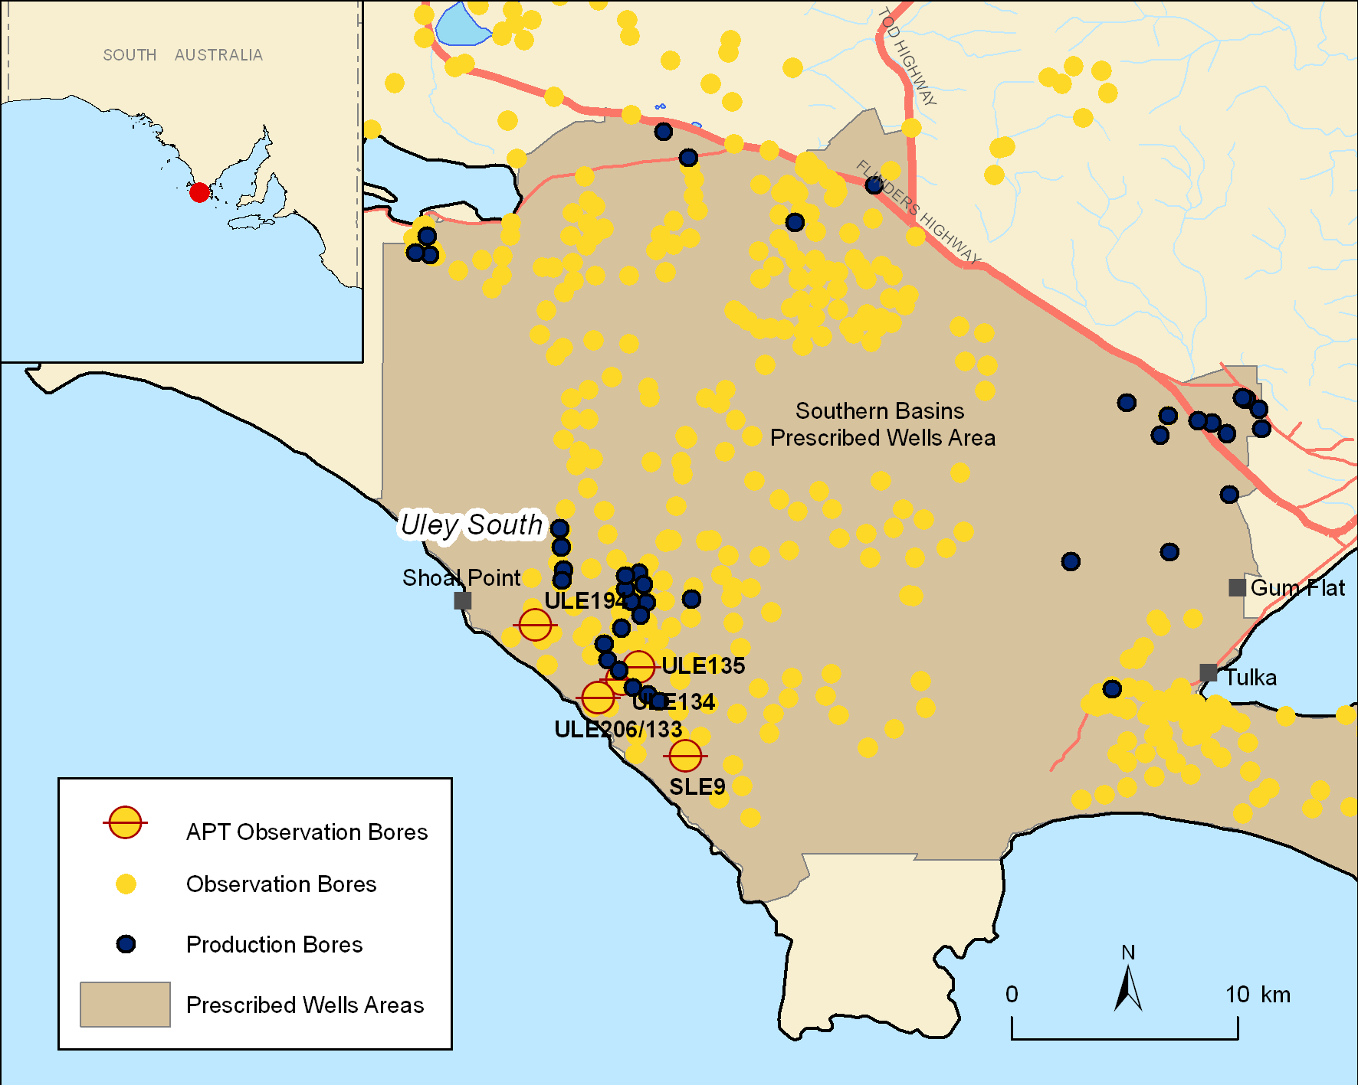
Figure 2. Location map and associated features of the Uley South, SA case study area

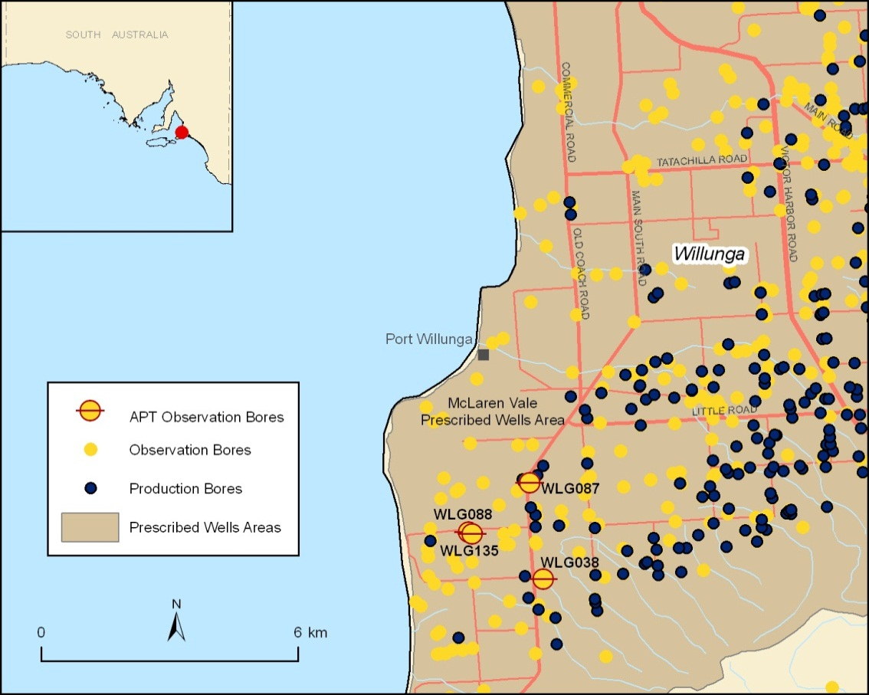
Figure 3. Location map and associated features of the Willunga, SA case study area
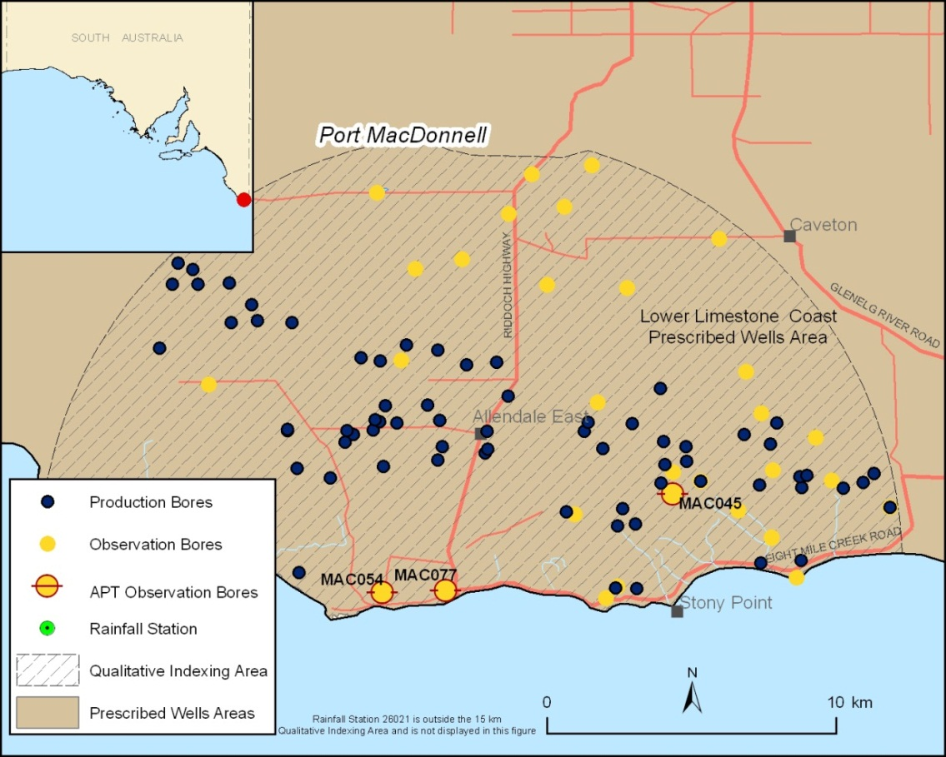
Figure 4. Location map and associated features of the Port MacDonnell, SA case study area
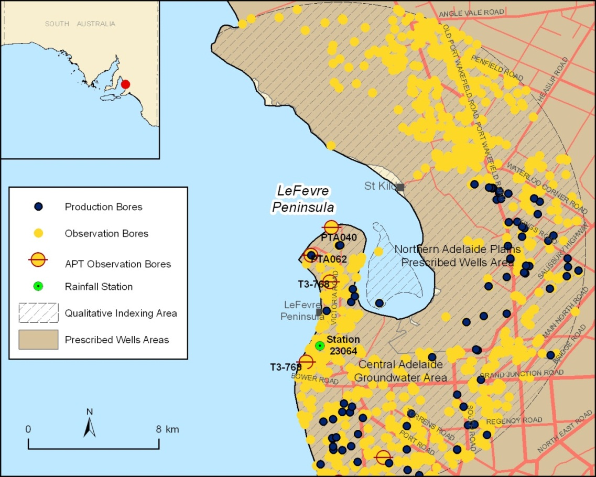
Figure 5. Location map and associated features of the LeFevre, SA case study area
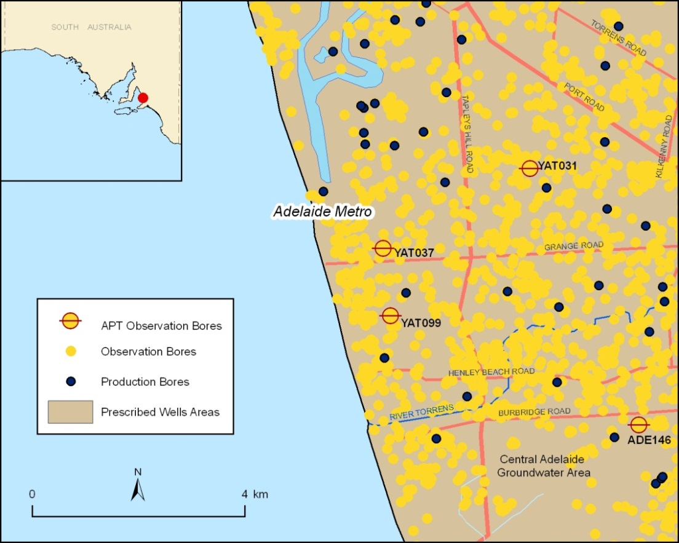
Figure 6. Location map and associated features of the Adelaide Metropolitan, SA case study area
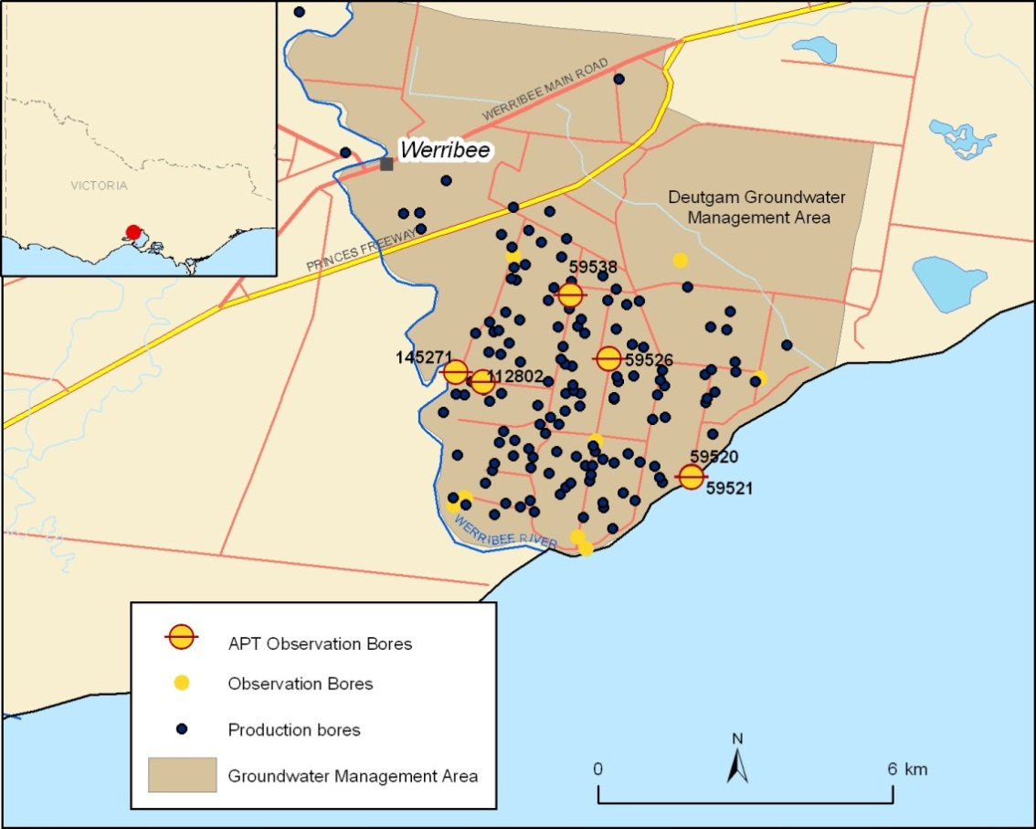
Figure 7. Location map and associated features of the Werribee, VIC case study area
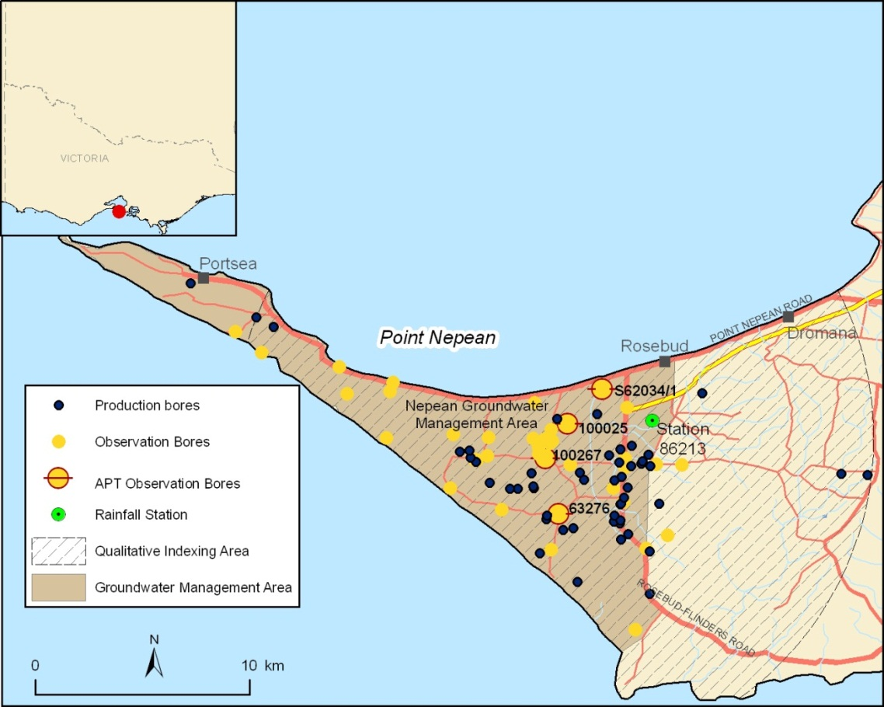
Figure 8. Location map and associated features of the Point Nepean, VIC case study area
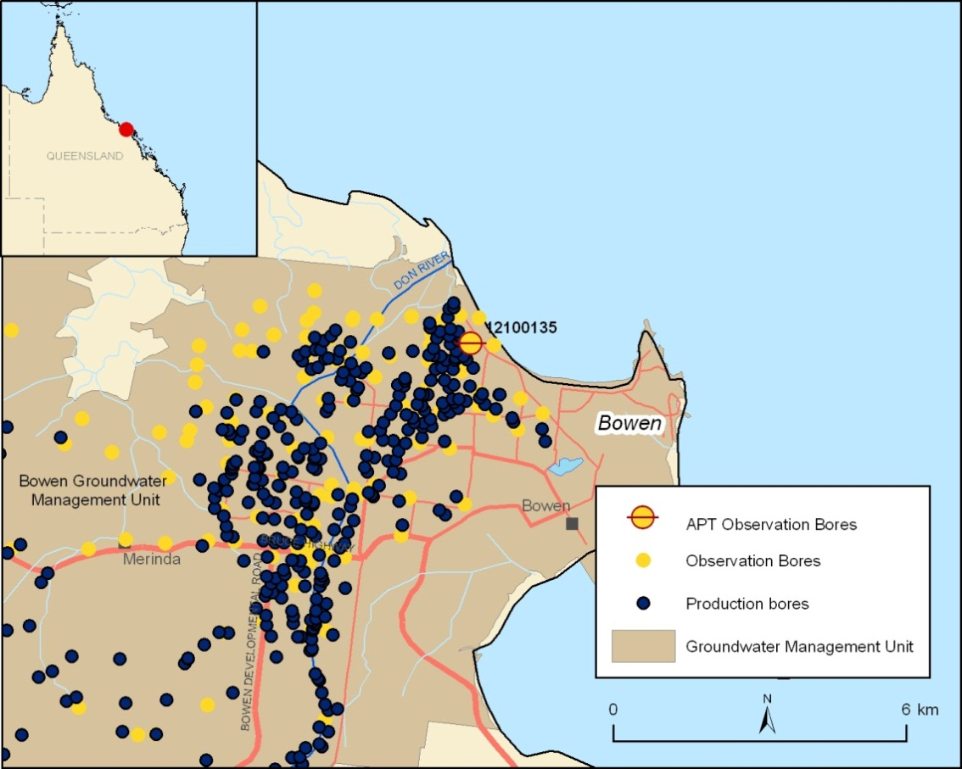
Figure 9. Location map and associated features of the Bowen, QLD case study area
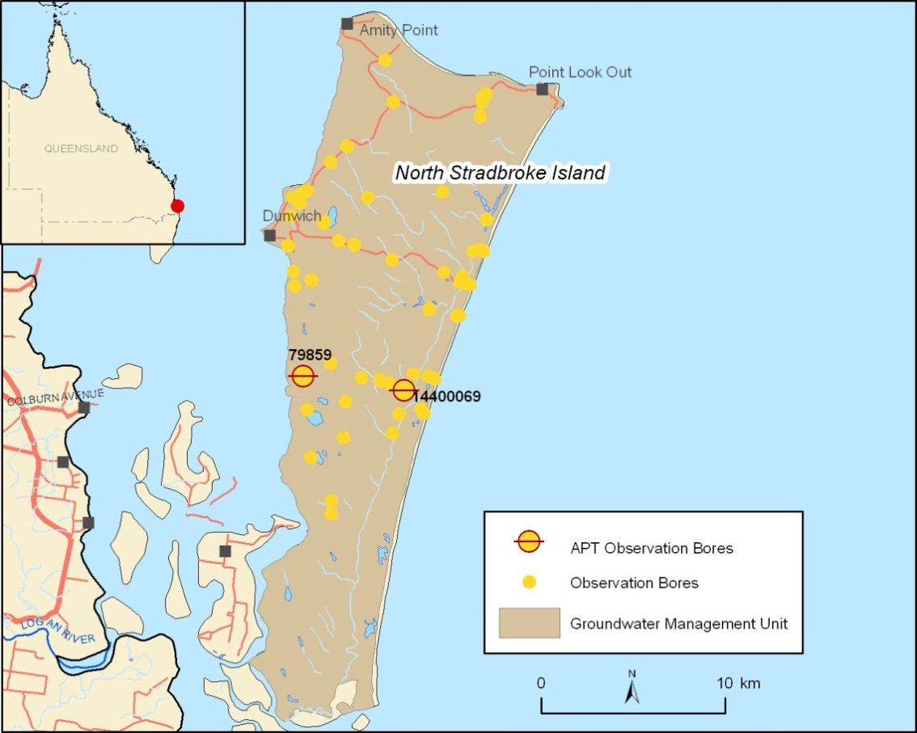
Figure 10. Location map and associated features of the North Stradbroke Island, QLD case study area
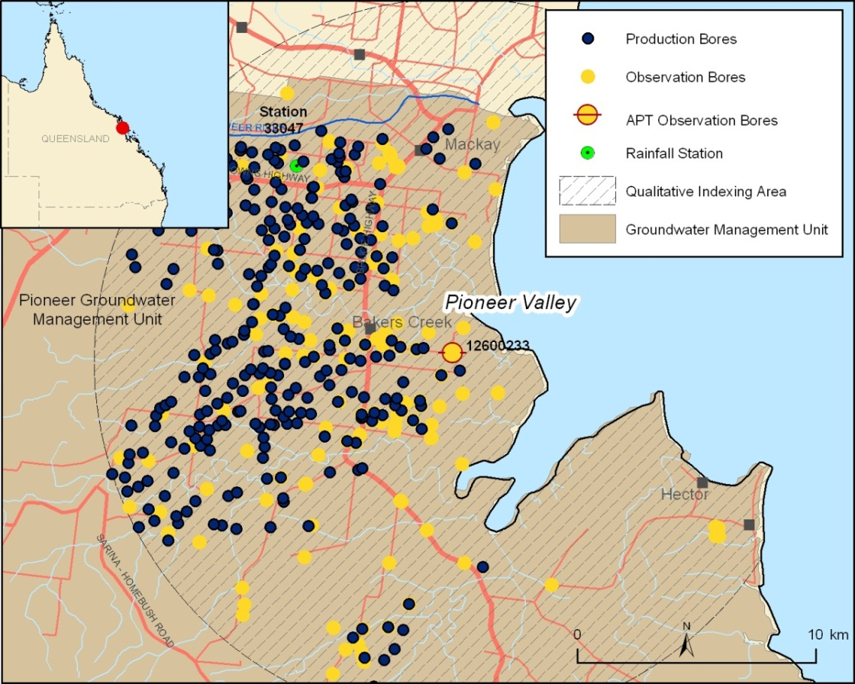
Figure 11. Location map and associated features of the Pioneer Valley, QLD case study area
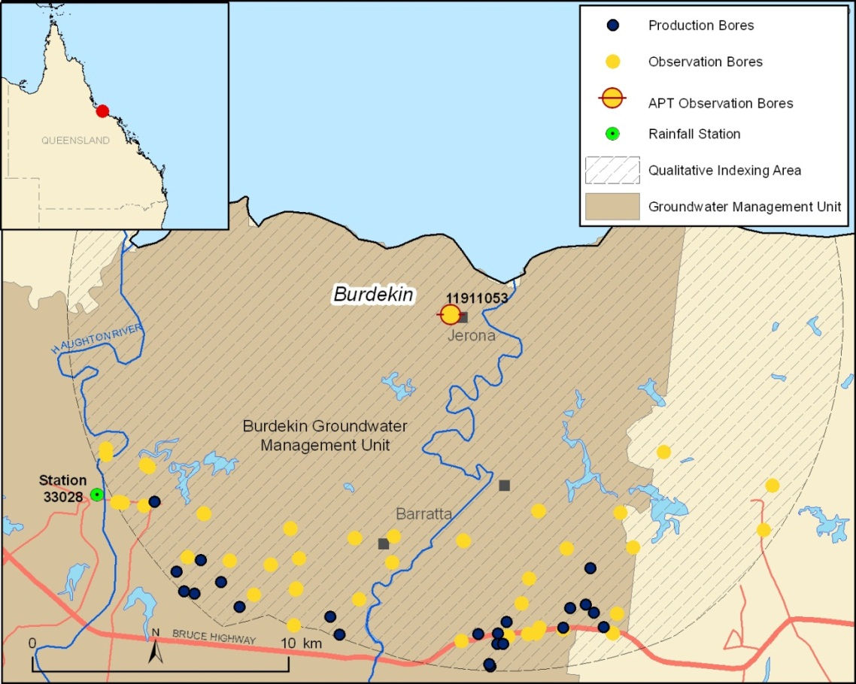
Figure 12. Location map and associated features of the Burdekin, QLD case study area
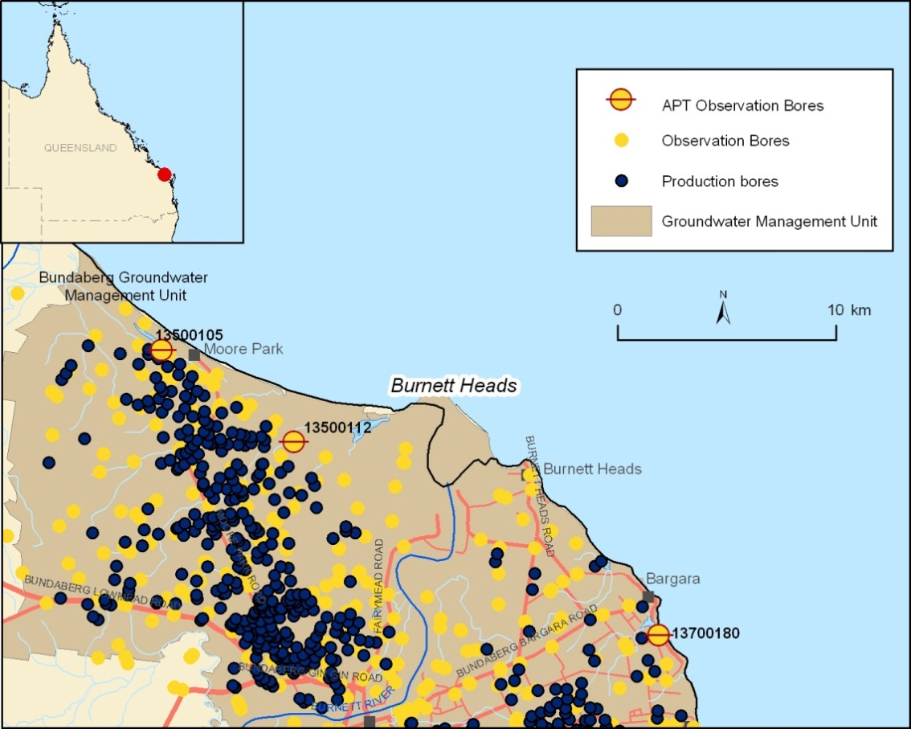
Figure 13. Location map and associated features of the Burnett, QLD case study areas
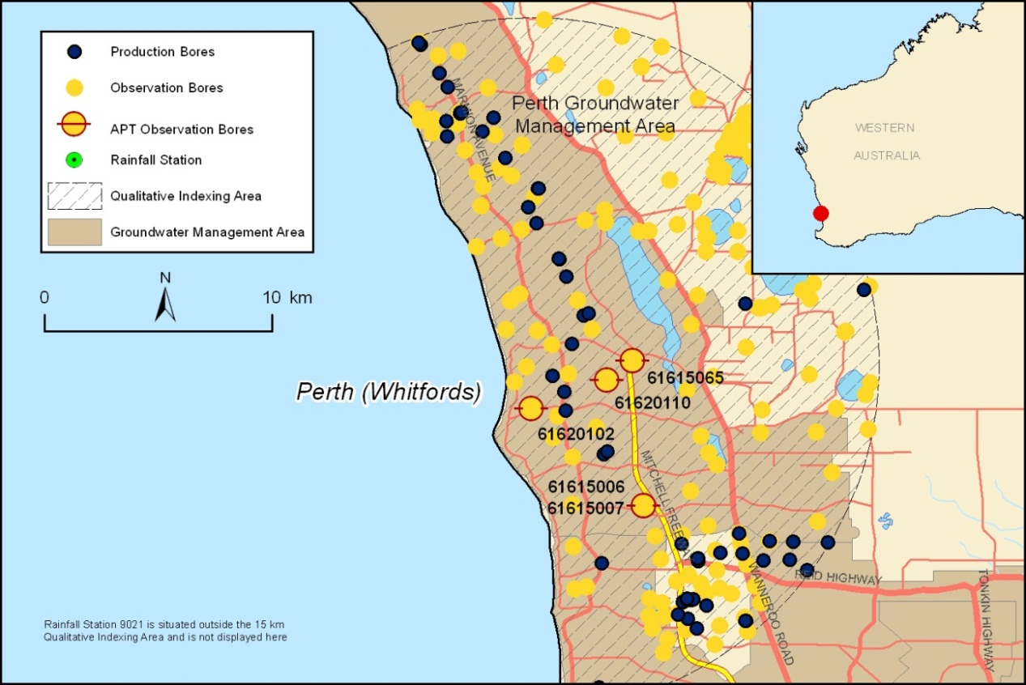
Figure 14. Location map and associated features of the Perth (Whitfords), WA case study area
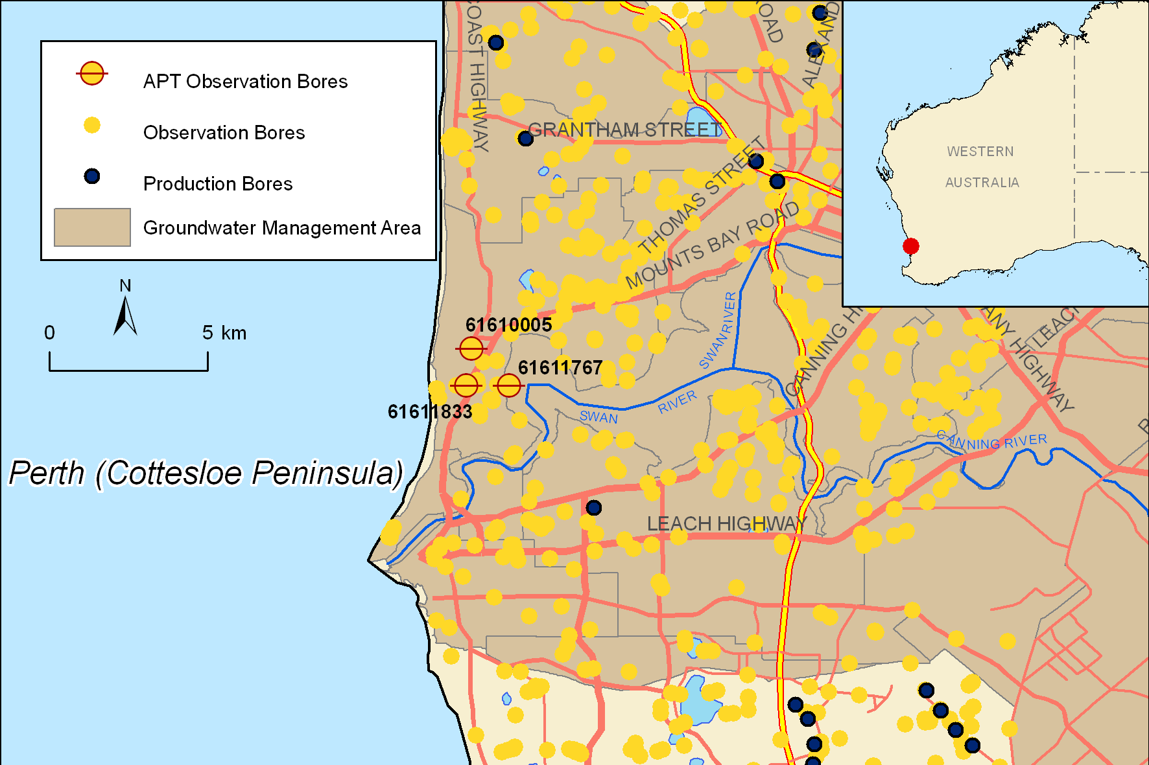
Figure 15. Location map and associated features of the Perth (Cottesloe), WA case study area
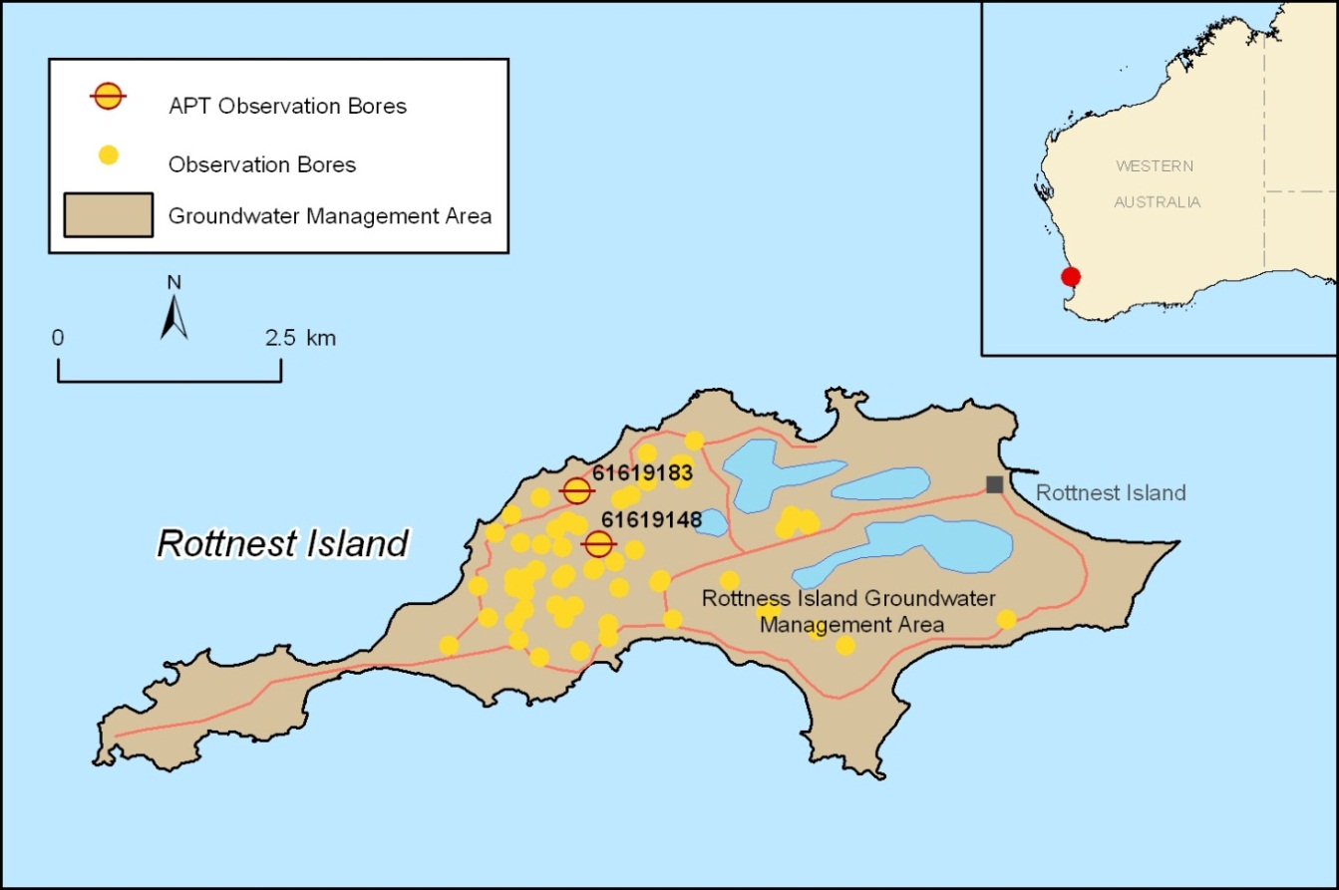
Figure 16. Location map and associated features of the Rottnest Island, WA case study area
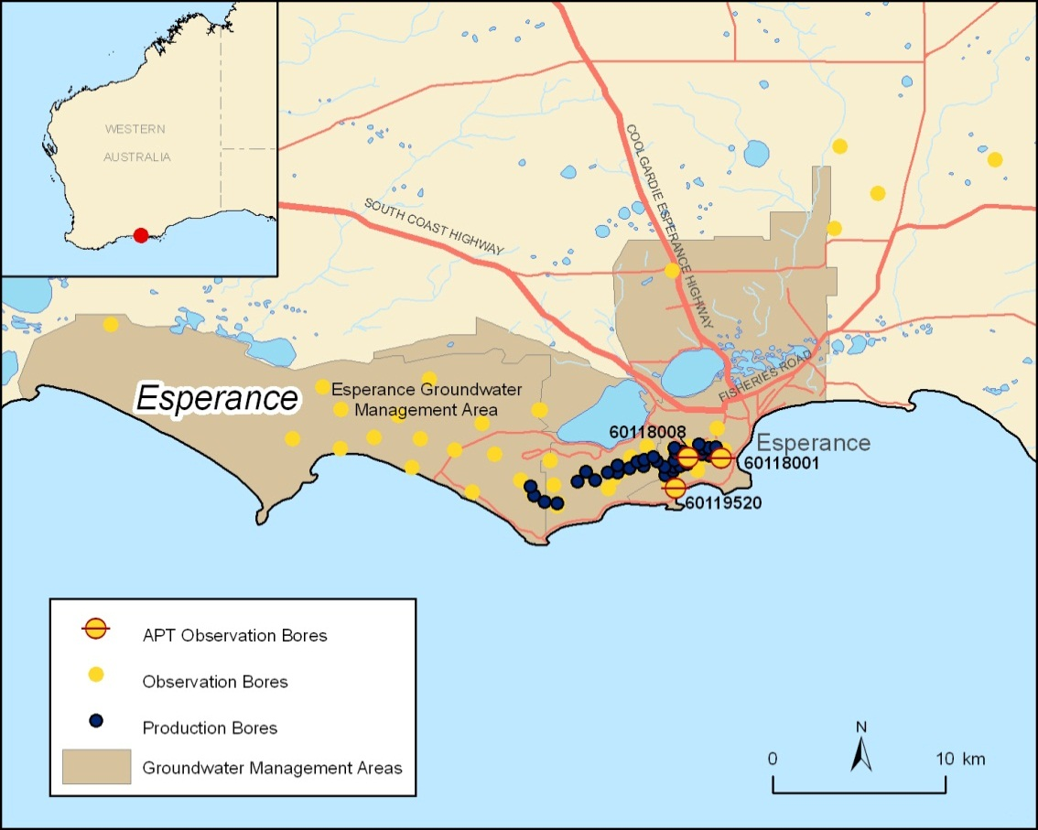
Figure 17. Location map and associated features of the Esperance, WA case study
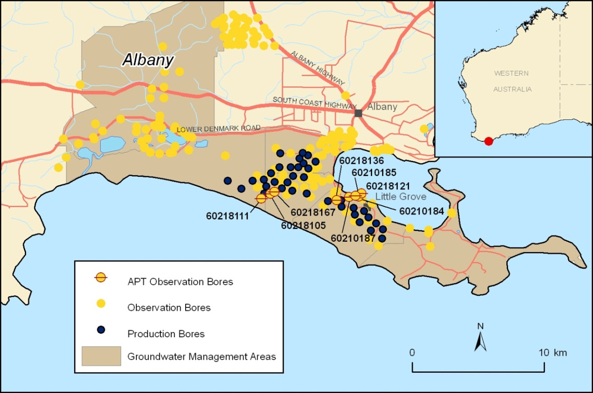
Figure 18. Location map and associated features of the Albany, WA case study area
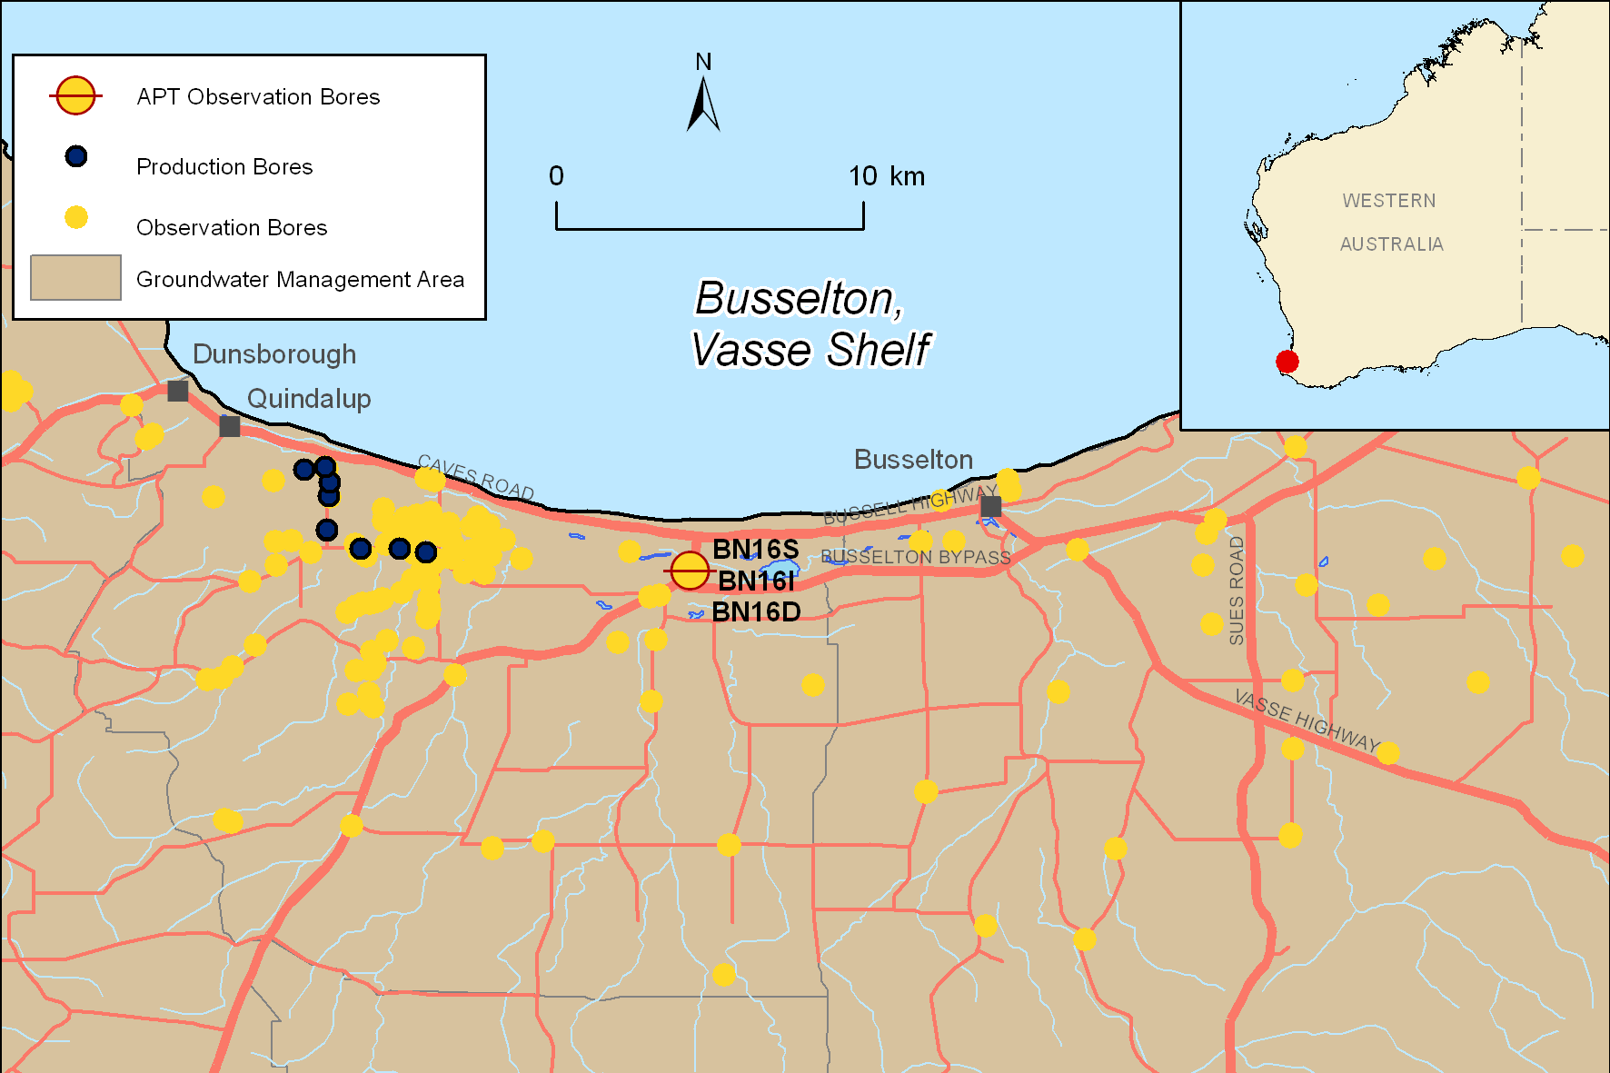
Figure 19. Location map and associated features of the Busselton, WA case study area
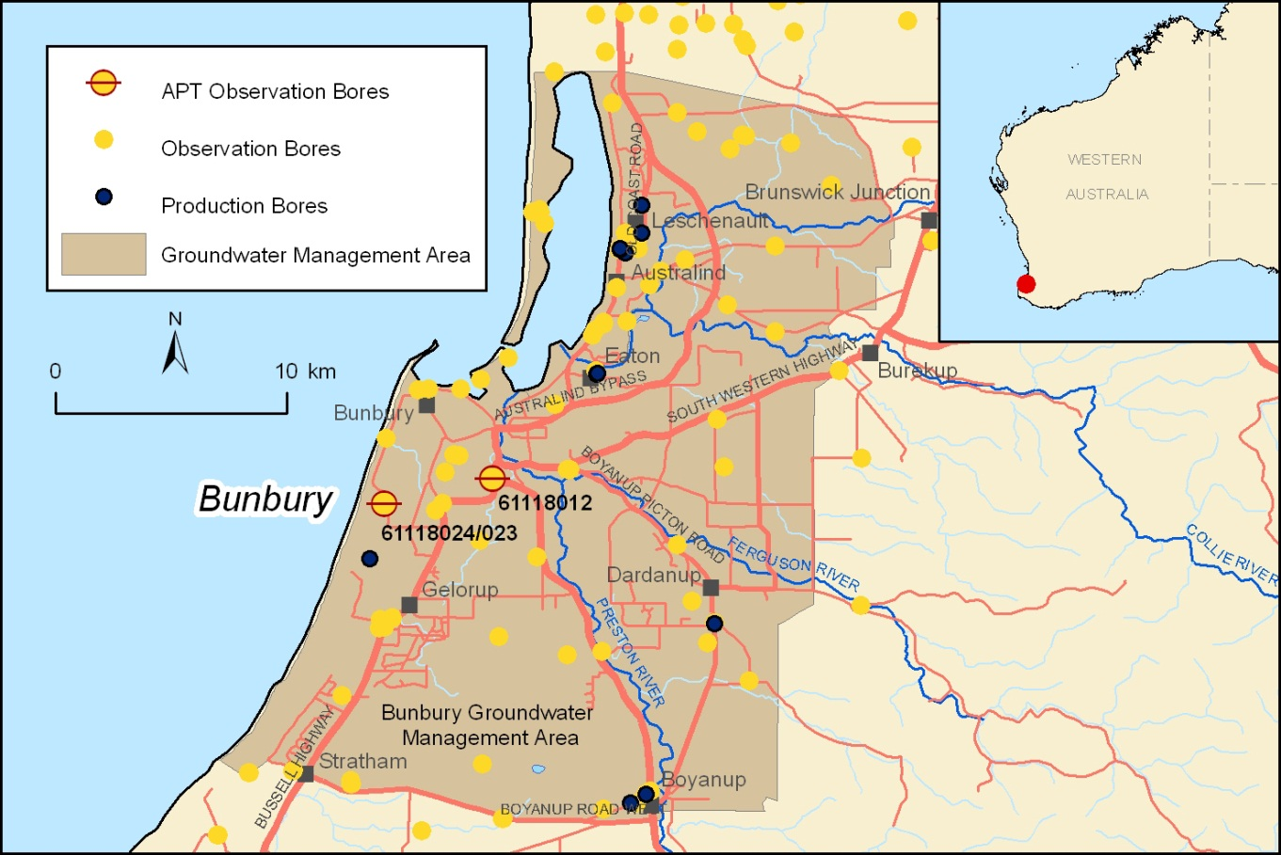
Figure 20. Location map and associated features of the Bunbury, WA case study area
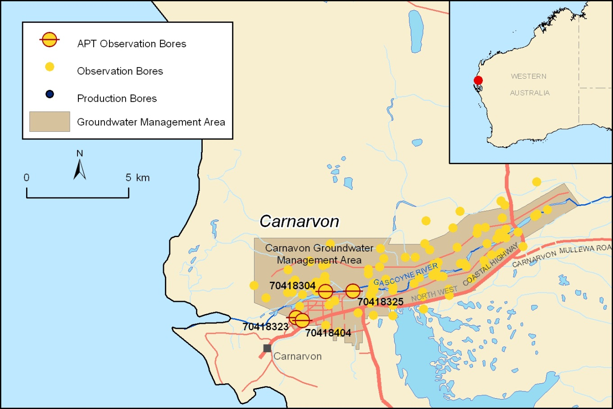
Figure 21. Location map and associated features of the Carnarvon, WA case study area
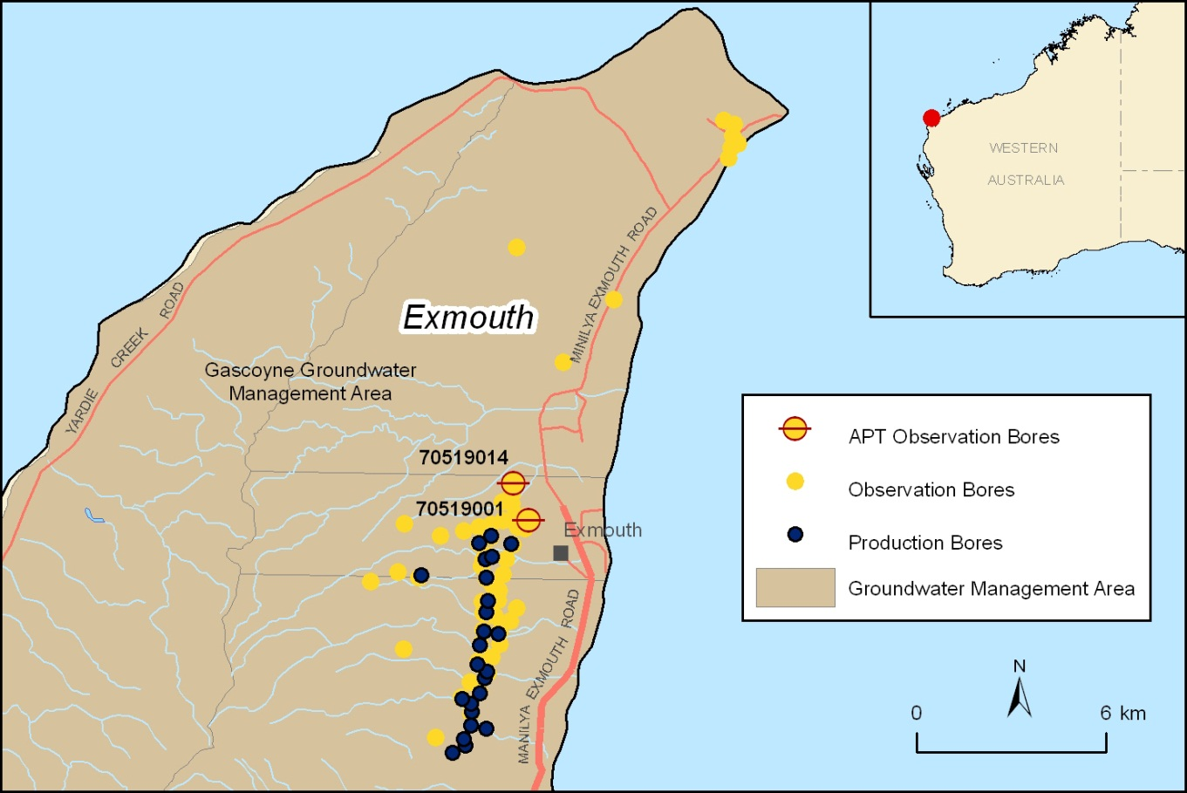
Figure 22. Location map and associated features of the Exmouth, WA case study area
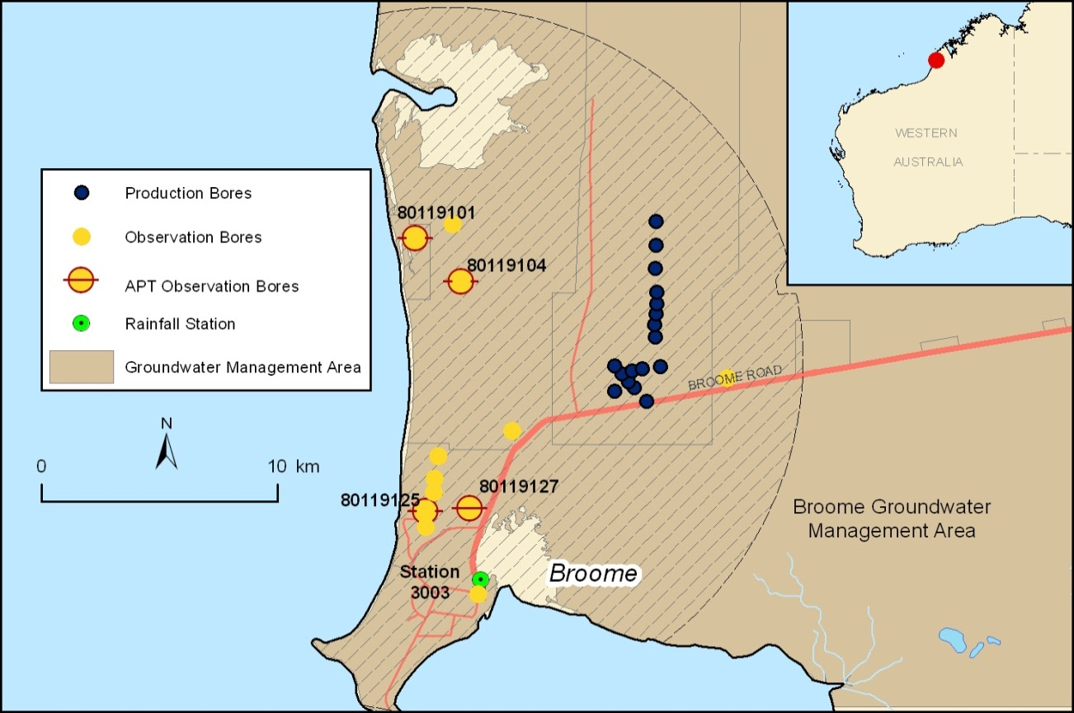
Figure 23. Location map and associated features of the Broome, WA case study area
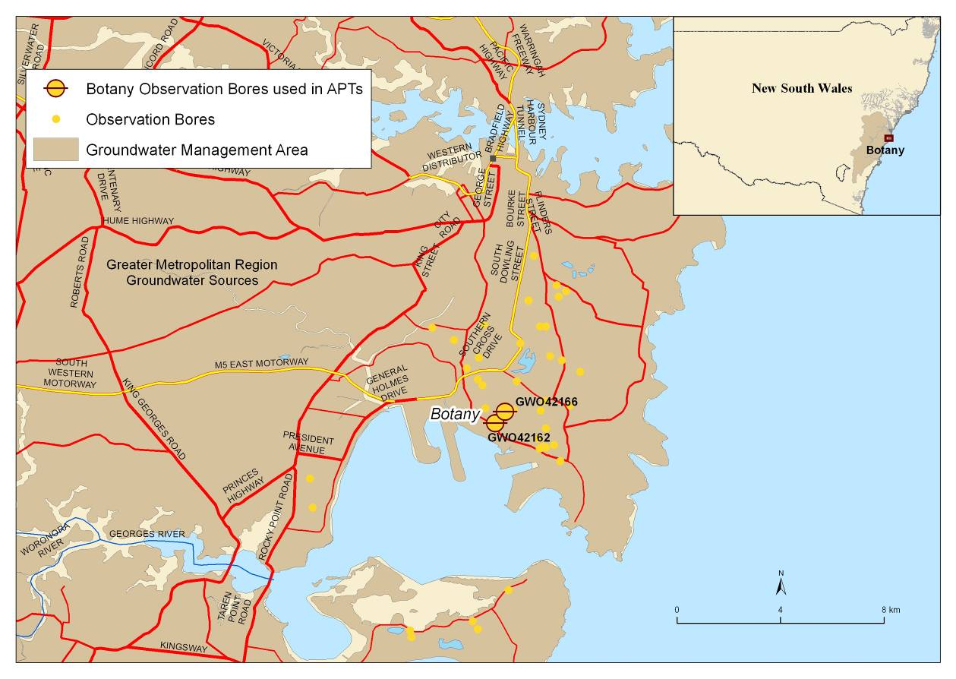
Figure 24. Location map and associated features of the Botany, NSW case study area
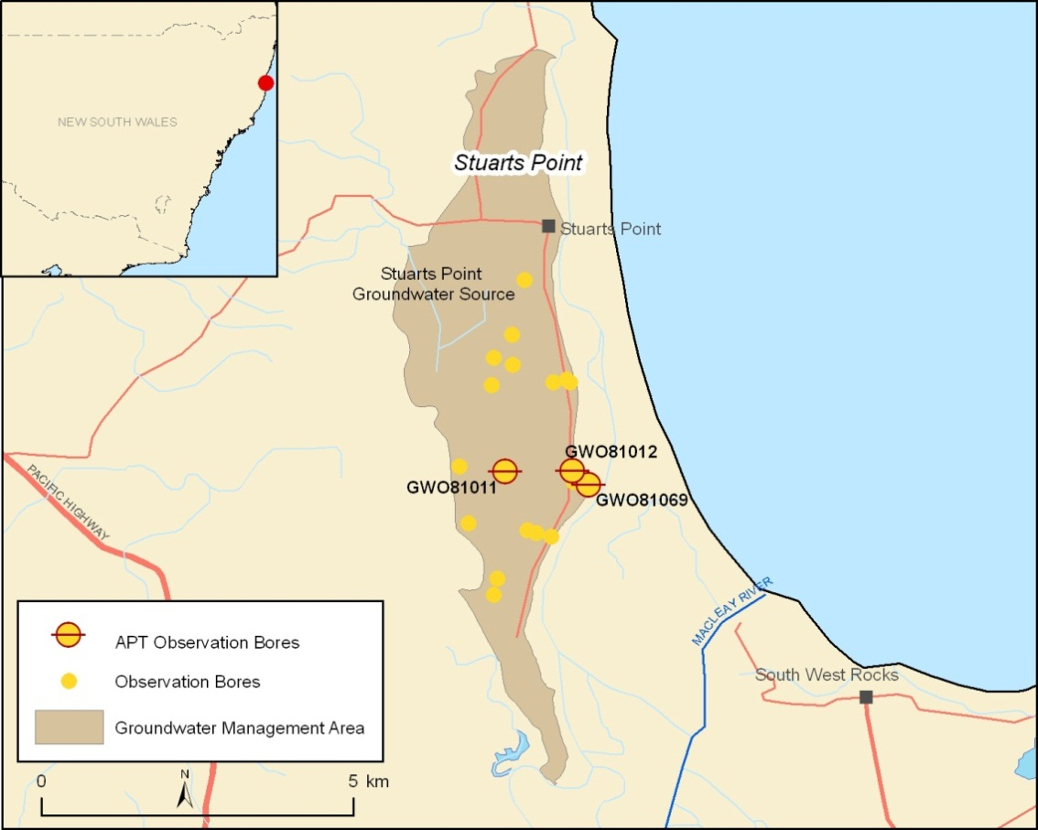
Figure 25. Location map and associated features of the Stuarts Point, NSW case study area
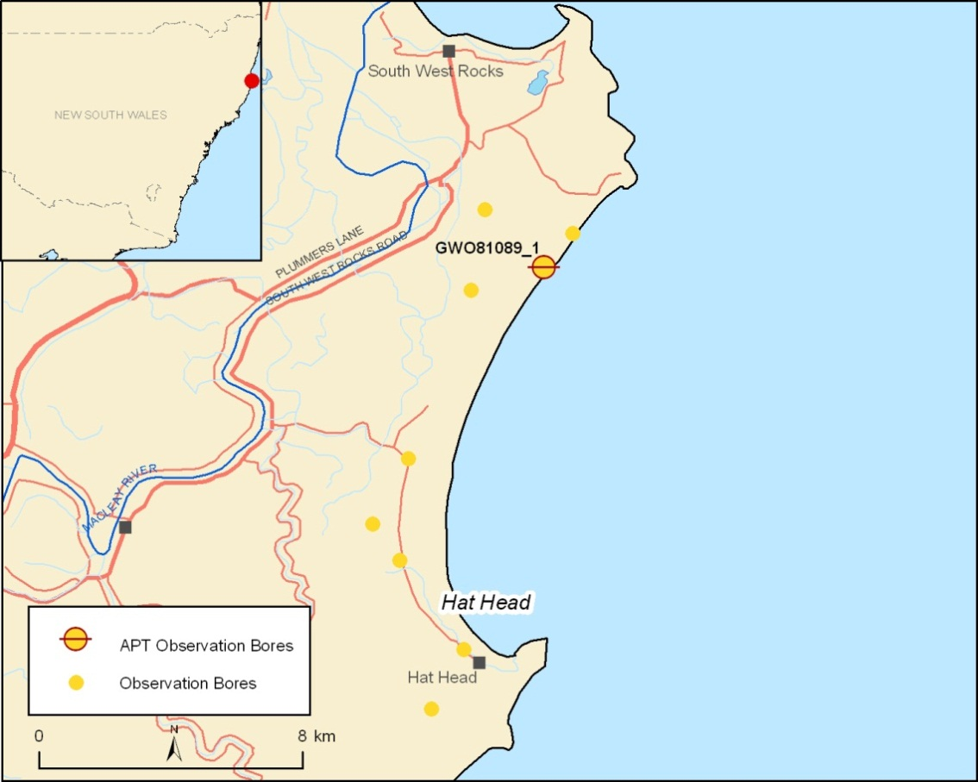
Figure 26. Location map and associated features of the Hat Head, NSW case study area
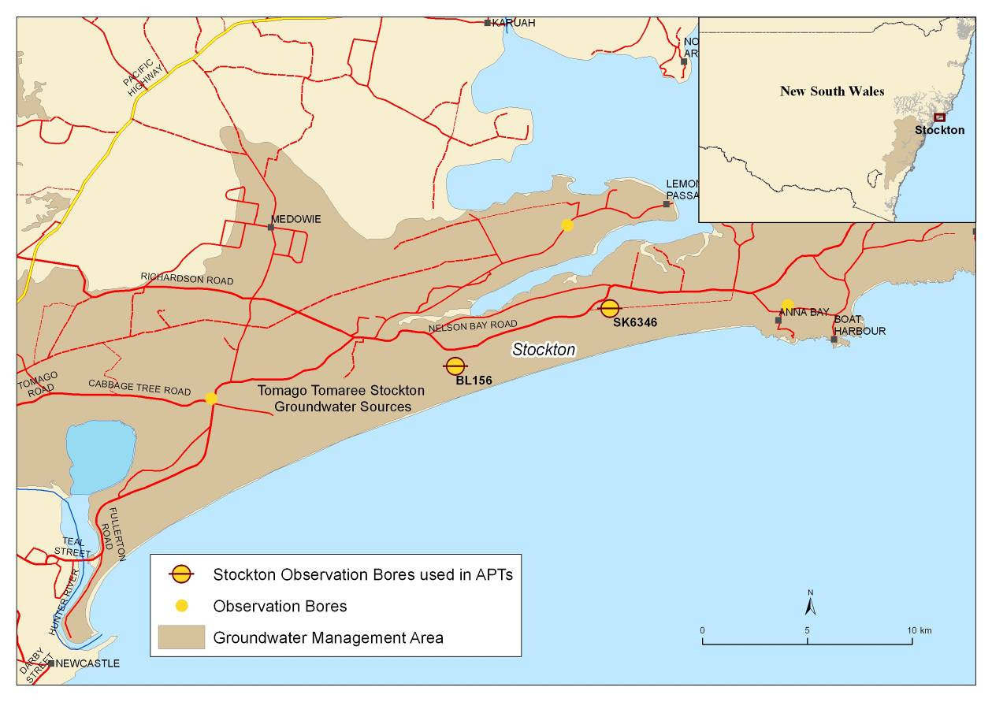
Figure 27. Location map and associated features of the Stockton, NSW case study area
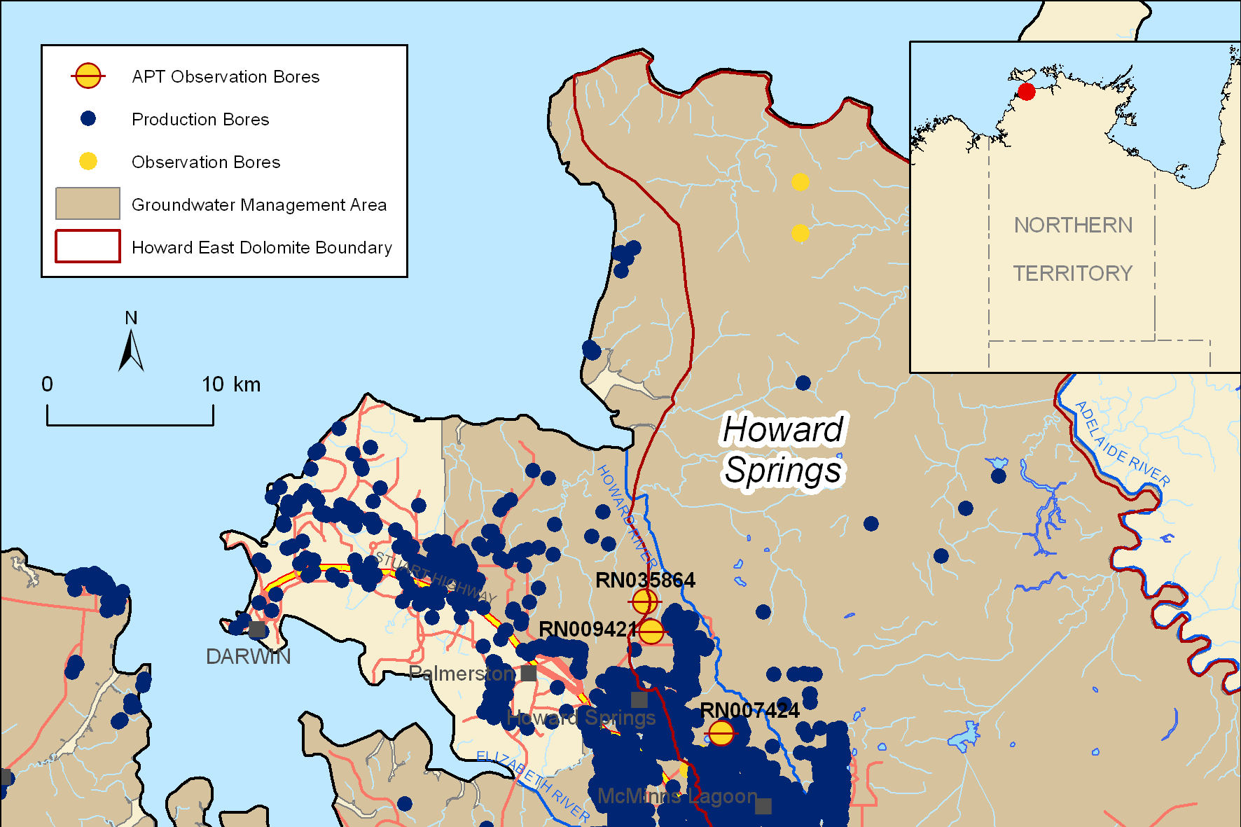
Figure 28. Location map and associated features of the Howard Springs, NT case study area

Appendix B. Math analysis results used for the indexing
Table 5. Wedge toe and scaled wedge toe values for unconfined aquifers
Case study | Aquifer | xT  (m) | xT'  (-)
Derby (WA) | Wallal/Erskine Sandstone | Unstable | 1.00
Exmouth (WA) | Cape Range Group | Unstable | 1.00
Burdekin (QLD) | Unconfined | Unstable | 1.00
Broome, Cable Beach (WA) | Broome Sandstone | 7676 | 0.42
Port MacDonnell (SA) | Tertiary Limestone | 14679 | 0.30
Broome, Coconut Wells (WA) | Broome Sandstone | 5471 | 0.24
Burnett Heads, Moore Park (QLD) | Elliott Formation | 392 | 0.23
Botany Sands (NSW) | Botany Sand Beds | 208 | 0.19
Esperance (WA) | Superficial/ Pallinup | 635 | 0.15
Perth, Whitfords (WA) | Superficial | 1138 | 0.10
Uley South (SA) | Bridgewater Formation/Wanilla Sands | 1044 | 0.07
Bowen (QLD) | Unconfined | 441 | 0.04
Le Fevre (SA) | Semaphore Sands | 42 | 0.04
Willunga (SA) | Quarternary | 197 | 0.04
Stockton (NSW) | Stockton Sand Beds | 55 | 0.04
Hat Head (NSW) | Coastal Sands | 122 | 0.03
Uley South (SA) | Bridgewater Formation | 224 | 0.03
Stuarts Point (NSW) | Coastal Sands | 112 | 0.03
Nth Stradbroke, East (QLD) | Unconfined | 37 | 0.02
Albany, Ocean side (WA) | Werrillup Formation Sand | 34 | 0.02
Werribee (VIC) | Alluvium/ Fractured Rock | 42 | 0.02
Burnett Heads, Bargara (QLD) | Elliott Formation | 90 | 0.01
Carnarvon (WA) | Riverbed Sand | 89 | 0.01
Bunbury (WA) | Superficial | 59 | 0.01
Albany, Harbour side (WA) | Superficial | 6 | 0.01
Busselton (WA) | Superficial | 16 | 0.01
Pioneer Valley (QLD) | Unconfined | 201 | 0.01
Nth Stradbroke, West (QLD) | Unconfined | 9 | 0.00
Table 6. Unconfined aquifers ranked using propensity for change in SWI extent for sea-level rise
Case study | Aquifer | Flux-controlled  xT/z0  (-) | Head-controlled  xT/z0  (-)
Derby, WA | Wallal/Erskine Sandstone | Unstable | Unstable
Burdekin, QLD | Unconfined | Unstable | Unstable
Exmouth, WA | Cape Range Group | Unstable | Unstable
Port MacDonnell, SA | Tertiary Limestone | 123 | 1598
Broome (Cable Beach), WA | Broome Sandstone | 104 | 1834
Esperance, WA | Superficial/ Pallinup | 69 | 483
Broome (Coconut Wells), WA | Broome Sandstone | 63 | 657
Burnett Heads (Moore Park), QLD | Elliott Formation | 60 | 620
Uley South, SA | Bridgewater Formation/Wanilla Sands | 48 | 191
Bowen, QLD | Unconfined | 45 | 118
Carnarvon, WA | Riverbed Sand | 36 | 52
Perth (Whitfords), WA | Superficial | 32 | 156
Uley South, SA | Bridgewater Formation | 30 | 69
Willunga, SA | Quarternary | 20 | 53
Botany Sands, NSW | Botany Sand Beds | 19 | 160
Pioneer Valley, QLD | Unconfined | 13 | 17
Burnett Heads (Bargara), QLD | Elliott Formation | 12 | 19
Le Fevre, SA | Semaphore Sands | 8 | 22
Bunbury, WA | Superficial | 8 | 11
Stockton, NSW | Stockton Sand Beds | 7 | 19
Hat Head, NSW | Coastal Sands | 7 | 17
Stuarts Point, NSW | Coastal Sands | 6 | 14
Werribee, VIC | Alluvium/ Fractured Rock | 4 | 7
Albany (Ocean side), WA | Werrillup Formation Sand | 3 | 6
Busselton, WA | Superficial | 3 | 4
Albany (Harbour side), WA | Superficial | 2 | 3
Nth Stradbroke (East), QLD | Unconfined | 2 | 3
Nth Stradbroke (West), QLD | Unconfined | 0 | 0

Table 7. Unconfined aquifers ranked using propensity for change in SWI extent for recharge change
Case study | Aquifer | Flux-controlled  xT/Wnet  (d) | Head-controlled  xT/Wnet  (d)
Derby, WA | Wallal/Erskine Sandstone | Unstable | Unstable
Burdekin, QLD | Unconfined | Unstable | Unstable
Exmouth, WA | Cape Range Group | Unstable | Unstable
Port MacDonnell, SA | Tertiary Limestone | -2.2.E+08 | -9.2.E+07
Broome (Cable Beach), WA | Broome Sandstone | -1.5.E+08 | -5.6.E+07
Broome (Coconut Wells), WA | Broome Sandstone | -9.2.E+07 | -4.0.E+07
Esperance, WA | Superficial/ Pallinup | -1.7.E+07 | -7.7.E+06
Perth (Whitfords), WA | Superficial | -1.4.E+07 | -6.7.E+06
Bowen, QLD | Unconfined | -4.1.E+06 | -2.0.E+06
Uley South, SA | Bridgewater Formation/Wanilla Sands | -4.0.E+06 | -1.9.E+06
Willunga, SA | Quarternary | -3.7.E+06 | -1.8.E+06
Burnett Heads (Moore Park), QLD | Elliott Formation | -1.8.E+06 | -8.0.E+05
Carnarvon, WA | Riverbed Sand | -1.3.E+06 | -6.5.E+05
Uley South, SA | Bridgewater Formation | -8.3.E+05 | -4.1.E+05
Bunbury, WA | Superficial | -7.3.E+05 | -3.6.E+05
Pioneer Valley, QLD | Unconfined | -6.7.E+05 | -3.3.E+05
Burnett Heads (Bargara), QLD | Elliott Formation | -3.7.E+05 | -1.8.E+05
Botany Sands, NSW | Botany Sand Beds | -2.0.E+05 | -8.8.E+04
Busselton, WA | Superficial | -1.9.E+05 | -9.6.E+04
Werribee, VIC | Alluvium/ Fractured Rock | -1.8.E+05 | -9.1.E+04
Le Fevre, SA | Semaphore Sands | -1.7.E+05 | -8.4.E+04
Hat Head, NSW | Coastal Sands | -1.7.E+05 | -8.3.E+04
Stuarts Point, NSW | Coastal Sands | -1.5.E+05 | -7.6.E+04
Albany (Ocean side), WA | Werrillup Formation Sand | -7.7.E+04 | -3.8.E+04
Stockton, NSW | Stockton Sand Beds | -7.3.E+04 | -3.6.E+04
Nth Stradbroke (East), QLD | Unconfined | -4.1.E+04 | -2.0.E+04
Albany (Harbour side), WA | Superficial | -1.3.E+04 | -6.5.E+03
Nth Stradbroke (West), QLD | Unconfined | -1.0.E+04 | -5.0.E+03

Table 8. Unconfined aquifers ranked using propensity for change in SWI extent for change in flows at the inland boundary
Case study | Aquifer | xT/qi  (d/m)
Derby, WA | Wallal/Erskine Sandstone | Unstable
Burdekin, QLD | Unconfined | Unstable
Exmouth, WA | Cape Range Group | Unstable
Broome (Cable Beach), WA | Broome Sandstone | -10389
Port MacDonnell, SA | Tertiary Limestone | -5396
Broome (Coconut Wells), WA | Broome Sandstone | -4493
Esperance, WA | Superficial/ Pallinup | -4286
Perth (Whitfords), WA | Superficial | -1262
Burnett Heads (Moore Park), QLD | Elliott Formation | -1229
Willunga, SA | Quarternary | -772
Bowen, QLD | Unconfined | -387
Uley South, SA | Bridgewater Formation/Wanilla Sands | -291
Botany Sands, NSW | Botany Sand Beds | -201
Le Fevre, SA | Semaphore Sands | -173
Carnarvon, WA | Riverbed Sand | -166
Bunbury, WA | Superficial | -123
Uley South, SA | Bridgewater Formation | -118
Busselton, WA | Superficial | -96
Werribee, VIC | Alluvium/ Fractured Rock | -71
Burnett Heads (Bargara), QLD | Elliott Formation | -56
Stockton, NSW | Stockton Sand Beds | -53
Hat Head, NSW | Coastal Sands | -48
Albany (Ocean side), WA | Werrillup Formation Sand | -44
Stuarts Point, NSW | Coastal Sands | -41
Nth Stradbroke (East), QLD | Unconfined | -23
Pioneer Valley, QLD | Unconfined | -22
Albany (Harbour side), WA | Superficial | -20
Nth Stradbroke (West), QLD | Unconfined | 0

Table 9. Wedge toe values for confined aquifers
Case study | Aquifer | xT  (m)
Le Fevre (SA) | T1 | Unstable
Le Fevre (SA) | T2 | Unstable
Adelaide Metro (SA) | T1 | Unstable
Adelaide Metro (SA) | T2 | Unstable
Willunga (SA) | Maslin Sands | Unstable
Burnett Heads, Bargara (QLD) | Fairymead Beds | Unstable
Esperance (WA) | Werillup | Unstable
Bunbury (WA) | Yarragadee | 675000
Perth, Whitfords (WA) | Yarragadee | 54759
Willunga (SA) | Port Willunga Formation | 31500
Perth, Whitfords (WA) | Leederville | 23181
Carnarvon (WA) | Older Alluvium | 9450
Port MacDonnell (SA) | Tertiary Sands | 4167
Busselton (WA) | Leederville | 601
Uley South (SA) | Wanilla Sands | 600
Albany, Harbour side (WA) | Pallinup/ Werrilup | 140
Howard Springs (NT) | Koolpinyah/Coomalie dolomite | 80

Table 10. Confined aquifers ranked using propensity for change in SWI extent for sea-level rise
Case study | Aquifer | Flux-controlled  xT/z0  (-) | Head-controlled  xT/z0  (-)
Le Fevre (SA) | T1 | 0 | Unstable
Le Fevre (SA) | T2 | 0 | Unstable
Adelaide Metro (SA) | T1 | 0 | Unstable
Adelaide Metro (SA) | T2 | 0 | Unstable
Willunga (SA) | Maslin Sands | 0 | Unstable
Burnett Heads, Bargara (QLD) | Fairymead Beds | 0 | Unstable
Esperance (WA) | Werillup | 0 | Unstable
Bunbury (WA) | Yarragadee | 0 | 41512500
Willunga (SA) | Port Willunga Formation | 0 | 258300
Perth, Whitfords (WA) | Leederville | 0 | 71938
Carnarvon (WA) | Older Alluvium | 0 | 38745
Perth, Whitfords (WA) | Yarragadee | 0 | 36427
Port MacDonnell (SA) | Tertiary Sands | 0 | 712
Uley South (SA) | Wanilla Sands | 0 | 351
Busselton (WA) | Leederville | 0 | 106
Albany, Harbour side (WA) | Pallinup/ Werrilup | 0 | 101
Howard Springs (NT) | Koolpinyah/Coomalie | 0 | 10

Table 11. Confined aquifers ranked using propensity for change in SWI extent for change in inflows at the inland boundary
Case study | Aquifer | xT/qi  (d/m)
Le Fevre, SA | T1 | Unstable
Le Fevre, SA | T2 | Unstable
Adelaide Metro, SA | T1 | Unstable
Adelaide Metro, SA | T2 | Unstable
Willunga, SA | Maslin Sands | Unstable
Burnett Heads (Bargara), QLD | Fairymead Beds | Unstable
Esperance, WA | Werillup | Unstable
Bunbury, WA | Yarragadee | -20250000
Carnarvon, WA | Older Alluvium | -3528000
Perth (Whitfords), WA | Leederville | -1403675
Willunga, SA | Port Willunga Formation | -980000
Perth (Whitfords), WA | Yarragadee | -53308
Busselton, WA | Leederville | -6841
Port MacDonnell, SA | Tertiary Sands | -868
Albany (Harbour side), WA | Pallinup/ Werrilup | -788
Uley South, SA | Wanilla Sands | -356
Howard Springs, NT | Koolpinyah/Coomalie dolomite | -20

Table 12. Maximum freshwater thickness for freshwater lenses
Case study | Aquifer | hmax  (m)
Perth, Cottesloe (WA) | Tamala Limestone | 5
Rottnest (WA) | Tamala Limestone | 17
Exmouth (WA) | Cape Range Group | 43
Point Nepean (Vic) | Quaternary | 67
Table 13. Freshwater lenses ranked using propensity for change in SWI extent for recharge change
Case study | Aquifer | Flux-controlled  hmax/Wnet  (d) | Head-controlled  hmax/Wnet  (d)
Exmouth, WA | Cape Range Group | 3.16E+05 | 0.00E+00
Point Nepean, Vic | Quaternary | 3.08E+05 | 0.00E+00
Perth (Cottesloe), WA | Tamala Limestone | 2.67E+04 | 0.00E+00
Rottnest, WA | Tamala Limestone | 2.65E+05 | 0.00E+00

