Benthic Biota of Northern Australia:

SS2012t07 Post-survey Report

Geoscience Australia
Record 2013/07
Rachel Przeslawski1, Belinda Alvarez de Glasby2, Neil Smit3, Libby Evans-Illidge4, Kiki Dethmers5
- Coastal Marine and Climate Changes Group, Geoscience Australia, GPO Box 378, Canberra ACT 2601
- Museum and Art Gallery of the Northern Territory, 19 Conacher Street, Fannie Bay NT 0820
- Flora and Fauna Division, Department of Land Resource Management, Northern Territory Government, PO Box 496, Palmerston NT 0831
- Australian Institute of Marine Science, PMB 3, Townsville QLD 4810
- Charles Darwin University, Ellengowan Drive Casuarina NT 0810
Department of Resources, Energy and Tourism
Minister for Resources and Energy: The Hon. Martin Ferguson, AM MP
Secretary: Mr Blair Comley, PSM
Geoscience Australia
Chief Executive Officer: Dr Chris Pigram
This paper is published with the permission of the CEO, Geoscience Australia
© Commonwealth of Australia (Geoscience Australia) 2013
With the exception of the Commonwealth Coat of Arms and where otherwise noted, all material in this publication is provided under a Creative Commons Attribution 3.0 Australia Licence. (http://www.creativecommons.org/licenses/by/3.0/au/)
Geoscience Australia has tried to make the information in this product as accurate as possible. However, it does not guarantee that the information is totally accurate or complete. Therefore, you should not solely rely on this information when making a commercial decision.
Geoscience Australia is committed to providing web accessible content wherever possible. If you are having difficulties with accessing this document please contact feedback@ga.gov.au.
ISSN 2201-702X (PDF)
ISBN 978-1-922201-26-3 (PDF)
GeoCat 74986
Bibliographic reference: Przeslawski, R., Alvarez de Glasby, B., Smit, N., Evans-Illidge, L., Dethmers, K. 2013. Benthic Biota of Northern Australia: SS2012t07 Post-survey Report. Record 2013/07. Geoscience Australia: Canberra.
Current as at March 8, 2013

Contents
Executive Summary 1
1. Introduction 2
1.1. Biodiversity and Epibenthos of Northern Australia 2
1.2. Biodiscovery and Marine Bioactive Compounds 4
1.3. Study Area & Previous Work 4
1.4. Aims & Significance 6
2. Methods 7
2.1. Remote Operated Vehicle (ROV) 7
2.2. Benthic Sled 7
2.3. Ocean Drifter 8
3. Preliminary Results 9
3.1. ROV 9
3.2. Benthic Sled 12
3.3. Habitat and Community Characterisation 15
3.3.1. Area I 16
3.3.2. Area II 16
3.3.3. Sponges and Octocorals as Habitat 16
4. Conclusions 18
Acknowledgements 19
References 20
Appendix A: Notes from ROV Camera Live Feed and GA-276 Video 22
Appendix B: Daily Survey Log 24
Appendix C: Scientific Crew 28
Appendix D: Ship Crew 29
Appendix E: List of Abbreviations 30
Appendix F: Molluscan Species Identifications 31

Executive Summary
The North Marine Region of Australia includes all Commonwealth waters from the Northern Territory-Western Australia border in the Joseph Bonaparte Gulf and Timor Sea to the western side of Cape York and has been identified as an area in which comparatively little is known about marine biodiversity. A network of Commonwealth Marine Reserves (CMRs) has been finalised in the North Marine Region to protect representative physical and biological features. Biological data are sparse in parts of the region but are required in order to effectively manage and monitor the CMRs. Baseline information about broad community and habitat types, as well as species inventories, will be valuable to inform current and future management plans, to detect change as part of a monitoring program, and to identify significant species (e.g. threatened or listed species). In addition, such species inventories can contribute to natural products research, as many marine invertebrates have been identified as a source of bioactive compounds which can be used for a range of pharmaceutical, cosmetic, and industrial applications.
The Museum and Art Gallery of the Northern Territory (MAGNT), in collaboration with Geoscience Australia, the NT government, and the Australian Institute of Marine Science (AIMS) undertook a biological data acquisition program as part of the transit of the R.V. Southern Surveyor between Darwin and Cairns, 15-24 October 2012. The overarching aim of this program was to use an ROV and benthic sled to collect benthic marine information and specimens for biodiversity and biodiscovery research in areas previously mapped by Geoscience Australia in 2005 during survey GA-276, including a bank (Area I) and terrace/hole feature within the Wessel Islands CMR (Area II). This study focuses on sessile invertebrates such as sponges and octocorals due to their ecological importance as habitat providers and their chemical importance as sources of marine natural products and medicines.
In less than 24 hours of sampling effort, 261 voucher specimens were collected to be used for biodiversity and natural products research. A total of 49 samples is to be lodged at the Australian Bioresources Library, and samples with weights larger than 300 g will be sent to the National Cancer Institute for screening of active compounds against cancer and HIV. Sponges were the most abundant group collected, based on both biomass (~ 139 kg) and number of voucher specimens (93), followed by cnidarians (30 kg, 73 vouchers), particularly hard corals (23 kg, 11 vouchers). The top of the bank in Area I has a seemingly diverse and abundant sessile invertebrate community, with consistent patchy occurrence of sponges, octocorals, and hard corals. The terrace in Area II supports moderate densities of sponges and octocorals, while the adjacent deep hole at ~ 100 m is covered with muddy gravel and supports scattered mobile and sedentary invertebrates, of which crinoids dominate, as well as skates and numerous small demersal fish.
Habitat characterisations and species identifications from this survey will be archived at Geoscience Australia and used to support ongoing biodiversity research in northern Australia, as well as to inform the marine management plan and marine monitoring for this region.
- Introduction
  - Biodiversity and Epibenthos of Northern Australia
The North Marine Region of Australia includes all Commonwealth waters from the Northern Territory-Western Australia border in the Joseph Bonaparte Gulf and Timor Sea to the western side of Cape York and covers approximately 715,000 km2 of marine environment. It is an area of high species richness but low endemism (Commonwealth of Australia, 2008), meaning that although the north region supports many species, these species are not unique to the region. Compared to other parts of the world, the North Marine Region has been recognised as one of the last remaining shallow-water tropical areas that is still almost pristine (Hill, 1994; Veron, 2004). Detailed studies have been conducted on seabed habitats and biological communities of the northern region, including Big Bank Shoals (Heyward et al., 1997), Sahul Shelf (Hooper, 1994; Wienberg et al., 2010), Joseph Bonaparte Gulf (Przeslawski et al., 2011), the Gulf of Carpentaria (Long and Poiner, 1994; Post, 2008), and the Arafura Sea (Wilson, 2010). For other northern marine regions such as the tract between Darwin and the Wessel Islands (off the coast of Arnehm Land), almost no biological data are available (Hooper and Ekins, 2004).
As a whole, the northern marine region of Australia has been identified as an area in which comparatively little is known about marine biodiversity (Commonwealth of Australia, 2008). For example, a growing catalogue of sponge species and associated biodiversity patterns exists for northwestern Australia (Heyward et al., 2010; Schönberg and Fromont, 2011) and the Great Barrier Reef (Wilkinson and Cheshire, 1989; Fromont, 1994; Sutcliffe et al., 2010), but there is a large knowledge gap about sponge communities in northern Australia. Only 12% of selected publications on Australian sponge biodiversity represent northern Australia (Schönberg and Fromont, 2011). This is surprising considering that the area between the eastern Joseph Bonaparte Gulf and the Wessel Islands has been identified as a sponge biodiversity hotspot (Hooper and Ekins, 2004), and the Wessel Islands are known for high endemism and a distinct biogeographical boundary for sponge taxa (Commonwealth of Australia, 2008). To help address such biological knowledge gaps, the Australian north marine region has been selected as an area of focus for the NERP Marine Biodiversity Hub (www.nerpmarine.edu.au).
In November 2012, the Department of Sustainability Environment, Water, Populations and Communities (SEWPaC) finalised the Commonwealth Marine Reserve (CMR) network which includes reserves throughout the northern bioregion (Fig. 1.1). In the absence of comprehensive biological data, most of these reserves were designed to include key ecological features (KEFs) (Falkner et al 2009), defined as elements considered to be of regional importance in terms of biodiversity or ecosystem function and integrity (Commonwealth of Australia, 2008). However, species-level biological data will be crucial for their management and monitoring. Baseline information about broad community and habitat types, as well as species inventories, will be valuable to detect change as part of a monitoring program, as well as identify significant species (e.g. threatened or listed species). Opportunistic sampling, as occurred on this survey, remains a key source of information about community assemblages in a given area.

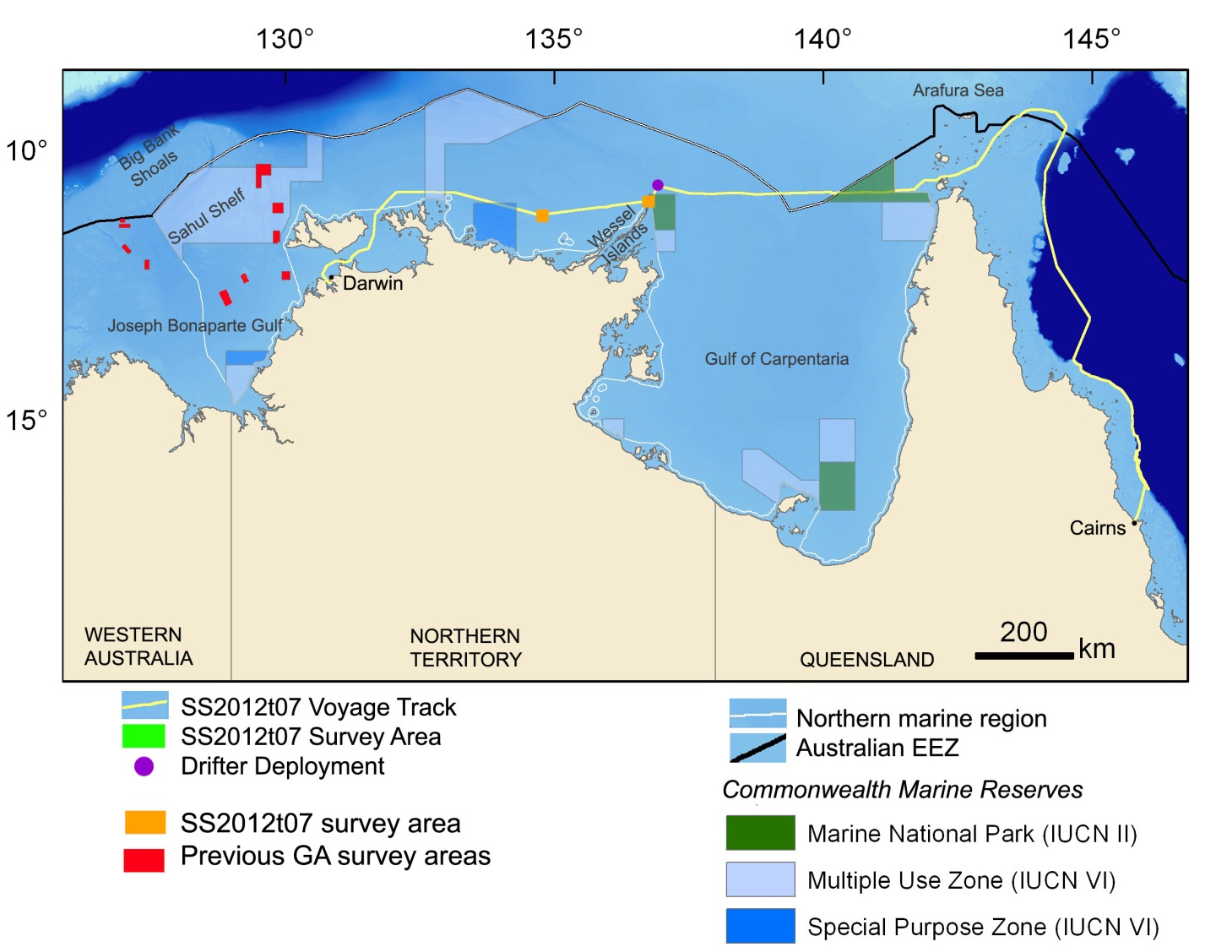
Figure 1.1: Map of northern Australia showing voyage track, survey areas, and drifter release location. Commonwealth Marine Reserves and previous GA surveys in the area are also marked.

Large sessile invertebrates such as sponges, corals, ascidians, and bryozoans play an important role in the ecosystem of these northern waters and are therefore targeted in the current survey. In particular, sponges and octocorals play key ecological roles including those related to substrate modification, nutrient cycling, habitat provision, and microbial associations (Bell, 2008). Since sponges represent one of the major habitat-forming taxa on the seafloor, their distribution can be an indicator of overall biodiversity (Przeslawski et al., 2011).
  - Biodiscovery and Marine Bioactive Compounds
Marine organisms are a rich source of bioactive compounds which can be used for a range of pharmaceutical, cosmetic, and industrial applications (Sipkema et al., 2005; Benkendorff, 2011; Stowe et al., 2011). In particular, sessile invertebrates seem to be one of the main sources of such compounds, particularly sponges, ascidians, and octocorals (Laport et al., 2009), perhaps due to the need for chemical defense and communication in the absence of behavioural or mechanical mechanisms. Within Australia, there are several groups engaged in biodiscovery research. University research teams often focus on the complex ecology and chemistry of a few promising species (Westley et al., 2010), while national and international programs tend to engage in isolating and screening compounds from a broad range of species. As one of the latter, the Australian Institute of Marine Science (AIMS) holds the Australian Bioresources Library (ABL) of over 20,000 marine organisms collected since 1987 from more than 1600 sites within Australia’s marine jurisdiction. The ABL is thus a nationally significant resource for biodiscovery and is facilitated with legally compliant access for that purpose.
In order to catalogue, test and synthesise potentially useful compounds for pharmaceutical use, the associated marine organisms must be collected and identified first. Since 2002, the Museum and Art Gallery of the Territory (MAGNT) has been engaged in a cooperative biodiscovery program with the U.S.-based Coral Reef Research Foundation and the National Cancer Institute. As part of this program, Dr Belinda Alvarez de Glasby at the MAGNT collects, identifies and provides samples of marine organisms for screening of anti-cancer compounds. With the collaboration of the ABL, samples collected from Commonwealth waters have been included in this collection program. Some of the samples collected in the current survey will be exported to the NCI under existing agreements and permits through the ABL, which will allow biodiscovery research and commercialisation while protecting the resource provider interests in the collections. These will add to a total of 926 samples which have already been sent to NCI for screening.
  - Study Area & Previous Work
The survey includes two study areas: Area I located ~ 200 km to the west of the Wessel Island CMR and Area II located within the reserve which is zoned as a Marine National Park (IUCN II) (Fig. 1.1). Sampling locations were chosen based on previous high-resolution mapping completed during survey GA-276 in 2005 using multibeam sonar (Harris et al 2007). Area I includes a submerged reef rising from 50 m to 14 m depth (Fig. 1.2a). Two towed underwater video transects acquired during the 2005 survey show that the top of the bank supports sponges and gorgonians in moderate density, but nothing else was known about the biological communities. Area II includes a deep hole (114 m depth) bordered on the northeast by a vertical wall rising to a 60 m terrace (Fig. 1.2b). A single video transect acquired from the bottom of the hole reveal scattered sessile invertebrates with some fish, but again, nothing else was known about the biology within or around this feature.

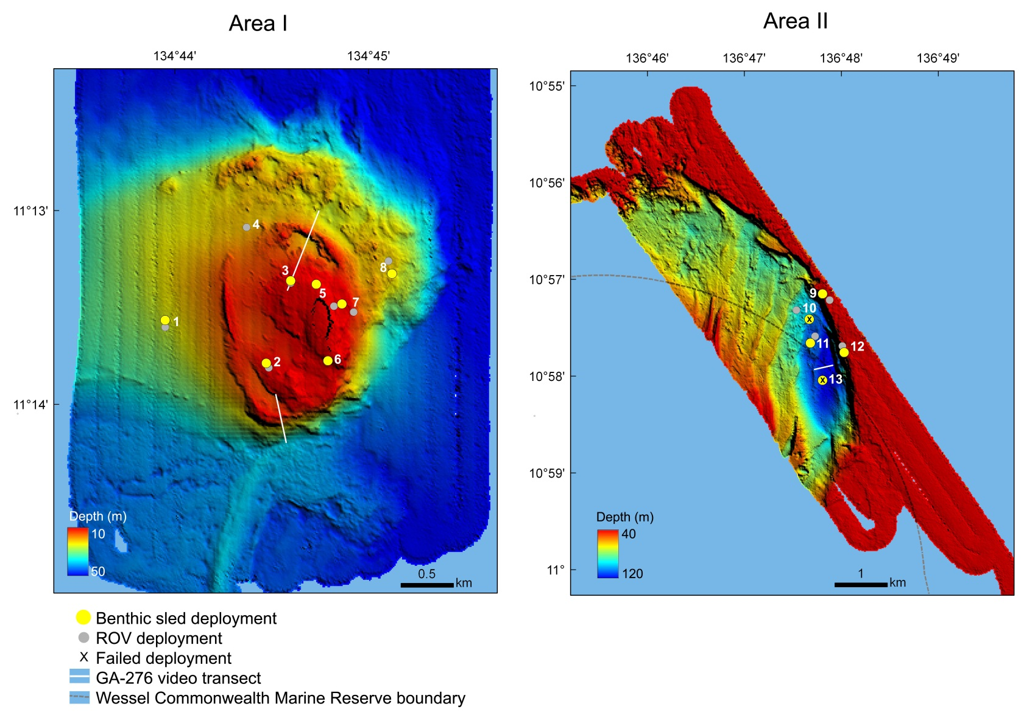
Figure 1.2: Study areas as shown by bathymetry acquired from GA-276 survey in 2005: a) Area I includes a submerged reef and b) Area II includes a deep hole and terrace. Stations for the current survey are overlain on the map and indicate the starting position of each sled transect and ROV deployment, along with towed video transects previously acquired during survey GA-276.

  - Aims & Significance
As a collaborative effort between agencies with different interests, the overarching aim of this survey was to efficiently collect and process samples for both biodiversity and biodiscovery purposes. This study focuses on sessile invertebrates such as sponges and octocorals due to their ecological importance as habitat providers and their chemical importance as sources of marine natural products and medicines.
Specific tasks of the survey were:
- To broadly characterise the seafloor and inform sled deployment using a remotely operated underwater video camera (ROV);
- To collect epibenthic fauna using a benthic sled;
- To sort, photograph, document and prepare taxonomic vouchers of the samples collected with the benthic sled;
- To deposit taxonomic vouchers of all samples at appropriate museums for curation, registration and distribution to the appropriate taxonomic experts;
- To prepare and freeze suitable samples for screening of bioactive compounds for the Australian Bioresources Library for biodiscovery research and for export to the US National Cancer Institute (NCI) laboratories (> 250 g sample weight) for screening of anti-cancer compounds;
- To correlate biodiversity measure obtained from the survey with available physical datasets from GA (e.g. geomorphology, sediment grain-size).
Data from this study will be valuable to the NERP Marine Biodiversity Hub and SEWPaC for several reasons:
- Biological data will be combined with that from previous surveys to the Joseph Bonaparte Gulf and Oceanic Shoals CMR (GA-322, GA-325, GA-339) to provide a regional assessment and comparison of biodiversity, particularly among geomorphic features such as banks and deep valleys/holes.
- The collection of images from key geomorphic features will support the analysis of transitions in physical and biological factors which will help researchers investigate possible causes of major biodiversity patterns such as the occurrence of sponge gardens or Halimeda.
- The collection of baseline data from these currently unknown biological communities will fill a knowledge gap in this part of northern Australia, as well as provide valuable information for future monitoring of the Wessel Commonwealth Marine Reserve and contribution to the Marine Bioregional Plan of the Northern Marine Region.
In addition, material collected for biodiscovery will expand Australia’s bioresource library and facilitate future projects on marine chemistry and bioprospecting research. Material sent to the NCI will also contribute to pharmaceutical and medical research on a range of diseases.
- Methods
  - Remote Operated Vehicle (ROV)
At each station a small ROV camera (Seabotix LBV1502 (530 x 245 x 245 mm, 11 kg) was deployed to assess the substratum and epibenthic communities. The ROV is propelled by four thrusters which allow the equipment to operate in currents up to 2 knots. It is equipped with two colour video cameras (520 lines), a 700 Lumen LED array for lighting and a transponder for positioning (Tritech MicroNav System). The unit is controlled from the surface via a 250m umbilical, through which video, ROV depth, and heading are relayed to the surface and displayed on screen. VirtualDub was used to record the video.
The ROV was lowered by hand mid-ship to minimise the risk of the umbilical being cut by the ship’s propellers. Further, to minimise the drag of the umbilical caused by currents lead weights were attached to the umbilical. In shallow water (30 m) a single dive weight was attached to the umbilical at 10 m from the ROV; in deeper waters, five dive weights were attached at 30 m from the ROV.
Initially, it was planned to navigate the camera along a transect distance determined by the maximum tether length, depth, and currents. However, the ROV thrusters were insufficient to counteract the strong currents and tides in the area, as sampling days coincided with one of the largest spring tides of the year: tidal range of 7m (Darwin) and 5m (NW Crocodile Islands). In addition, the vessel needed to travel 0.5 knots into the current to keep the vessel in control whilst deploying the ROV. As a result, the ROV was working well outside the 2 knot maximum current for which the thrusters were designed and had to be deployed as a drop down camera with little control of the speed and position of the ROV. Consequently the video allowed only brief glimpses of the seafloor over a smaller spatial extent than planned. Nevertheless, images were sufficient to broadly assess the presence of conspicuous benthic communities and determine whether the sled should be deployed.
  - Benthic Sled
At stations where video observations indicated sufficient epibenthos present, a benthic sled with a 125x120x160 cm frame and a 6 m long net with a 45mm stretch diamond mesh was deployed and towed for approximately 100 m at an average speed of 1 knot. Material captured with the sled was released on deck, photographed, sorted in groups, and taken to the ship’s laboratory for further processing. In the laboratory, samples were sorted by morpho-species. Each sample was assigned a field number, photographed with the field number, weighed and documented in the field register. A voucher of each sample was prepared using the appropriate methods for each group of organisms. Most organisms were immediately fixed and preserved in 95% ethanol, but several groups were relaxed first in methanol crystals (e.g. ascidians, polychaetes) and fixed in 10% formalin (e.g. ascidians). Selected samples (generally with weights greater than 50 g) were also prepared for biodiscovery research, and stored in plastic bags at -20 degrees. If processing at the fish lab was not completed before the next capture, samples from subsequent stations were provisionally stored in a temperature-controlled room (12 degrees) until the scientific team was finished processing samples from the previous station.
  - Ocean Drifter
In addition to the planned ROV and sled deployments, an opportunity arose immediately prior to the survey departure to release an ocean surface drifter. The SVP mini drifter was one of ten drifters initially deployed on GA-339 during the Oceanic Shoals CMR survey in September 2012, but the drifter and drogue were subsequently retrieved from the Joseph Bonaparte Gulf soon after deployment. The drogue was reattached to the buoy and the tether shortened to 2 meters. Redeployment occurred at 12:00 CST on October 18th at 10°49.9575S, 136°54.7950E, approximately 20 nm north of Cape Wessel (Area II). This area was chosen as it represents a convergence area of major currents in the Arafura Sea.
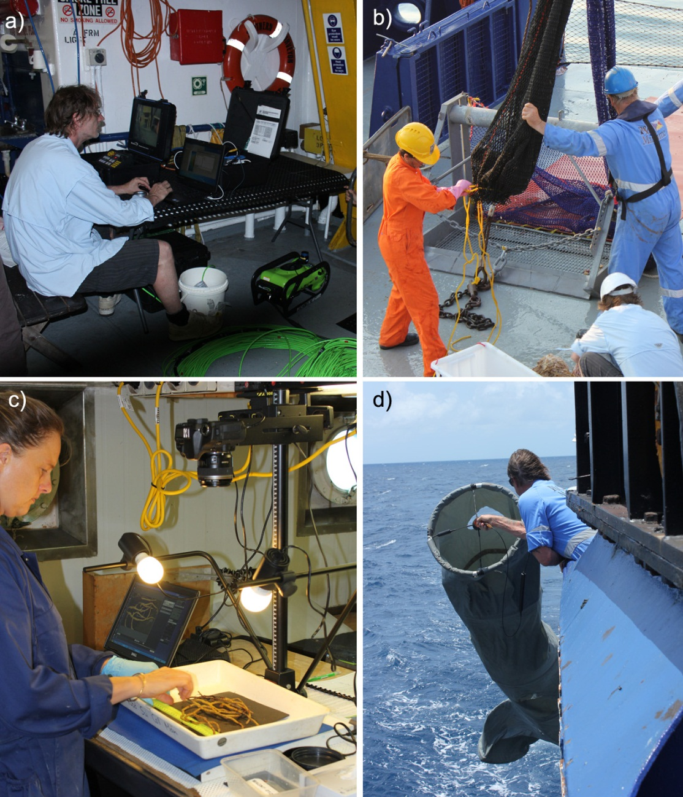
Figure 2.1: Equipment and methods used to collect specimens and data. a) Seabotix ROV (bright green and black) with live video feed to surface, b) Australian Institute of Marine Science benthic sled, c) Processing sled specimens in the laboratory, d) NOAA ocean drifter.
- Preliminary Results
  - ROV
A total of 11 ROV deployments successfully obtained images of the seafloor (Table 3.1). One deployment was unsuccessful (Station 6) because the ROV was unable to reach the bottom despite several attempts due to strong currents.

Table 3.1: Locations at which ROV obtained images of the seafloor
Utc Date | Area | Station | Start Lat | Start Long | Start Depth | End Lat | End Long | End Depth | Comments1
16/10/2012 | I | 1ROV1 | -11.22665 | 134.7325 | 30.9 | -11.22695 | 134.732667 | 30.8 | no recording made, live view only, soft substrata with sparse biota
16/10/2012 | I | 2ROV2 | -11.23015 | 134.7413817 | 22.9 | -11.230633 | 134.7420 | 22.7 | no recording made, live view only, weight stuck and umbilical wrapped around sponge, took ~ 30 minutes of ship manuevering to release, decision made to remobe weights for station 3, hard substrata with sessile invertebrates and hard corals
16/10/2012 | I | 3ROV3 | -11.222883 | 134.7433333 | 20.7 | -11.223033 | 134.744 | 19.6 | ROV recording in midwater for ~2 minutes, overexposed, hard substrata with sessile invertebrates and hard corals
16/10/2012 | I | 4ROV4 | -11.218083 | 134.7395 | 29.2 | -11.217633 | 134.740167 | 29.5 | Overexposed, mixed substrata with sparse biota
16/10/2012 | I | 5ROV5 | -11.224917 | 134.747 | 21.4 | -11.223917 | 134.746167 | 18.5 | Overexposed, hard substrata with patches of sessile invertebrates and hard corals
17/10/2012 | I | 7ROV06 | -11.22535 | 134.7486667 | 28.7 | -11.225372 | 134.748775 | 28.5 | overexposed, 2 attempts, only a few seconds of video on seafloor before the currents took it, decided waste of time to continue trying, unknown substrata with sparse biota
17/10/2012 | I | 8ROV07 | -11.22095 | 134.7516667 | 27.2 | -11.21895 | 134.748833 | 27.2 | overexposed, short deployment due to strong currents, hard substrata with sessile invertebrates
17/10/2012 | II | 9ROV08 | -10.953583 | 136.798 | 59.5 | -10.953367 | 136.797833 | 60.1 | Overexposed, unknown substrata with sessile invertebrates
17/10/2012 | II | 10ROV09 | -10.955333 | 136.7923333 | 94.4 | -10.954867 | 136.791667 | 88.5 | currents too strong to view bottom properly, unknown substrata with sparse biota
17/10/2012 | II | 11ROV10 | -10.959817 | 136.7955 |  | -10.9595 | 136.795167 | 105.3 | difficult to see due to speed and mud, mixed substrata with sparse biota
17/10/2012 | II | 12ROV11 | -10.961483 | 136.8001667 | 66.58 | -10.9615 | 136.833167 | 69.2 | Overexposed, unknown substrata with sessile invertebrates
1 See Appendix A for full description of the seabed

The station with the highest observed abundance and biomass of epifauna based on the ROV were Stations 2 and 3 on the top of the bank in Area I, in which localised high densities of large habitat-forming sponges, octocorals, and hard corals were noted. These observations were supported by two video transects from survey GA-276 in which plate corals (likely including Trubinaria spp.), barrel sponges Xestospongia spp.), and sea fans were common.
In Area II, Stations 9 (~ 60 m depth) and 12 (~ 67 m depth) on the terraces showed sand veneer over hard substrate with high diversity of sponges and octocorals in the limited ROV footage, although the biomass was not as high as on the bank feature in Area I.
Overall, the images acquired from the ROV were of poor quality due to the inability to maneuver the ROV in strong currents, particularly in Area II. Another problem was that no recording was made at Stations 1 and 2 due to issues between the computer and ROV monitor connection, and only notes associated with the live view are available for these stations. Imagery obtained from the ROV was sufficient to ground-truth for sled deployment and determine broad epifaunal community type, particularly in conjunction with the three video transects available from GA-376 (Figure 1.2).
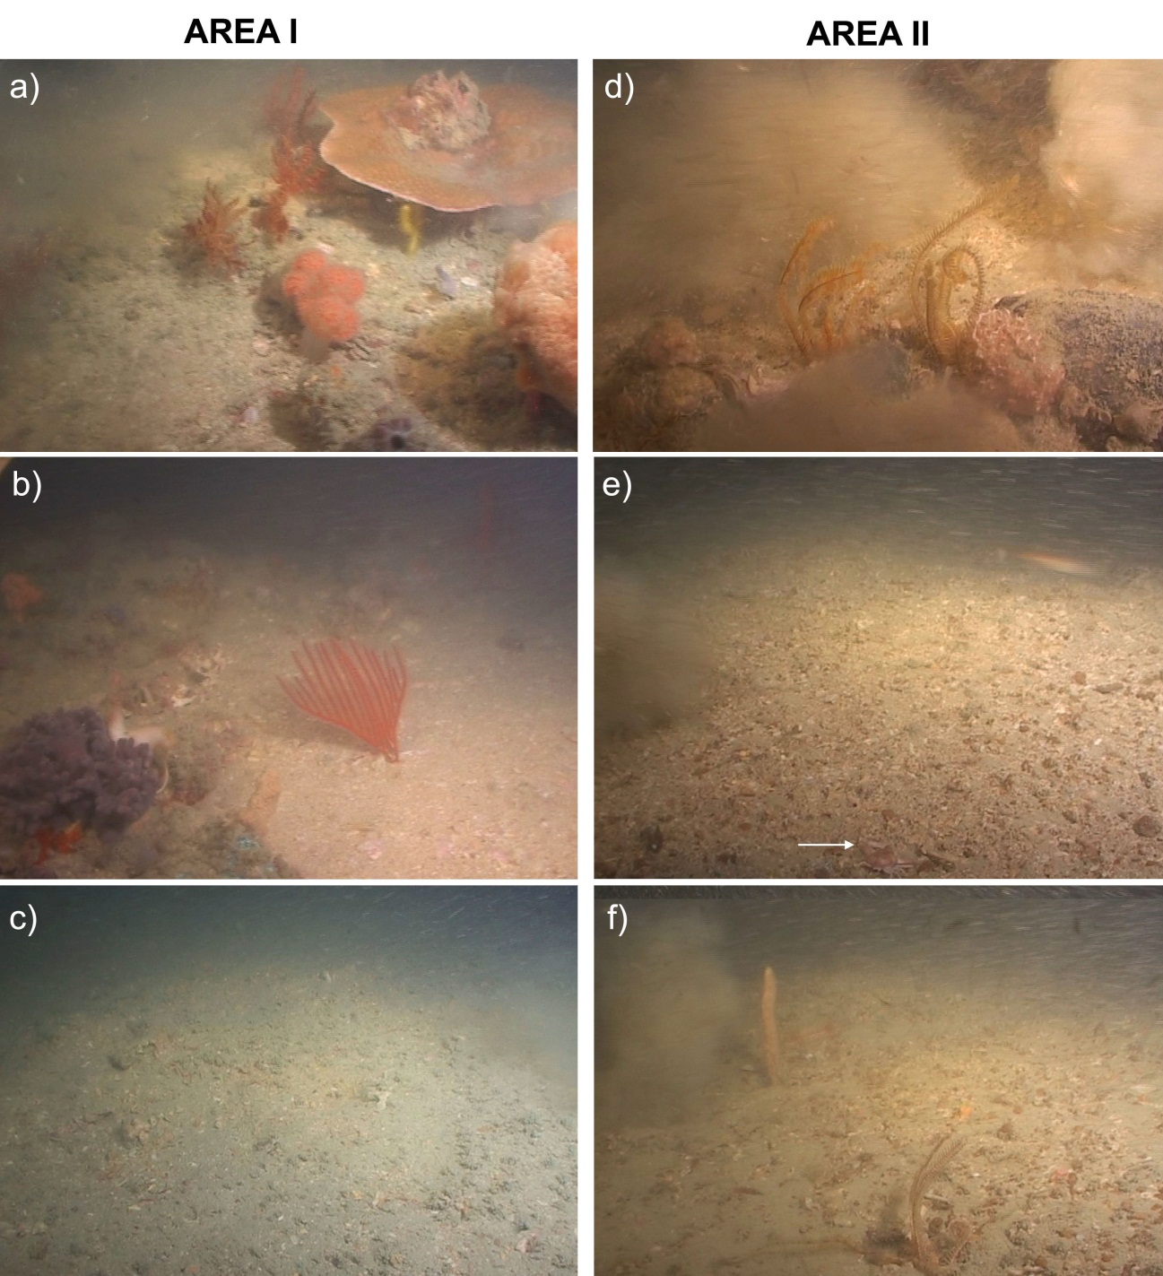
Figure 3.1: Representative images from the towed underwater video collected during survey GA-276 (Harris et al. 2007) showing the bank feature in Area I with a) patches of sponges, octocorals, and hard coral (likely Turbinaria spp.) at 22 m depth, b) scattered sessile epibenthos at ~25 m depth, and c) barren sandy gravel between rocky outcrop at ~ 30 m depths; and the hole in Area II all at ~ 100 m depth with d) crinoids near small rock with sediment plumes from camera disturbance, e) muddy gravel with small crab in foreground indicated by arrow, and f) sparse epibenthos including octocoral, crinoid, and brittlestar. Images were taken from Station 72 and 69 respectively (see Figure 1.2 and Appendix A).
  - Benthic Sled
A total of 11 benthic sled deployments returned specimens (Table 3.2). Based on the lack of epibenthos seen in the video from Station 4, it was decided not to deploy a sled at this location.

Table 3.2: Locations at which the benthic sled was deployed
Date | Area | Station | Start Lat | Start Long | Start Depth | End Lat | End Long | End Depth | Comments
16/10/2012 | I | 1BS1 | -11.226117 | 134.7325 | 30.8 | -11.225833 | 134.732333 | 30.8
16/10/2012 | I | 2BS2 | -11.229783 | 134.7411667 | 23.3 | -11.229783 | 134.740833 | 23.3
16/10/2012 | I | 3BS3 | -11.222667 | 134.7433333 | 21.3 | -11.222517 | 134.742167 | 23.5
17/10/2012 | I | 5BS4 | -11.223017 | 134.7455 | 19.1 | -11.223717 | 134.746667 | 21.1
17/10/2012 | I | 6BS5 | -11.229617 | 134.7465 | 19.2 | -11.2307 | 134.747167 | 22.3
17/10/2012 | I | 7BS6 | -11.2247 | 134.7476667 | 20.3 | -11.225267 | 134.749 | 24.1
17/10/2012 | I | 8BS7 | -11.222067 | 134.752 | 27.7 | -11.222967 | 134.752 | 27.9
17/10/2012 | II | 9BS8 | -10.95245 | 136.7968333 | 60.1 | -10.953783 | 136.798333 | 59.7
17/10/2012 | II | 10BS9 | -10.95685 | 136.7945 | 100.6 | -10.958683 | 136.796167 | 101.9 | Sled seemed to get caught, no specimens collected
17/10/2012 | II | 11BS10 | -10.961017 | 136.7946667 | 108.8 | -10.96225 | 136.799167 | 92.8
17/10/2012 | II | 12BS11 | -10.962617 | 136.8005 | 62.8 | -10.963217 | 136.802333 | 60.6 | Sled net was ripped completely in half, some specimens still collected
17/10/2012 | II | 13BS12 | -10.96735 | 136.7968333 | 108.2 | -10.9706 | 136.797667 | 107.3 | Sled net lost, no specimens collected

A total of 261 vouchers was obtained for taxonomic identification and analysis. Most samples are represented by distinct morpho-species however in some cases (especially for the echinoderms and crustacean) samples contain multiple species A total of 52 samples was prepared for lodging at the ABL for biodiscovery research and for screening at the NCI. Sponges were the most abundant group collected based on both biomass (~ 139 kg) and number of samples (93), followed by cnidarians (30 kg, 73 samples) of which hard corals dominated (23 kg, 11 samples). Approximately 8.5 kg of echinoderms were collected representing 47 samples, with crinoids and ophiuroids the dominant classes. The other phyla (annelids, arthropods, bryozoans, chordates, molluscs) each accounted for less than 1 kg biomass and < 15 samples. At the time of writing this report, only the molluscs had been identified to species level (Appendix F).
The heaviest biomass was collected from Station 8 on top of the bank in Area I, although this was due to over 60 kg of a single species (barrel sponge Xestospongia testudinaria). Station 9 on the terrace of Area II had the next heaviest biomass as well as the highest number of samples (Figure 3.2). Scleractinian (reef-forming) corals were only collected from the top (Stations 3, 5, 7) and eastern flank (Station 8) of the bank in Area I.
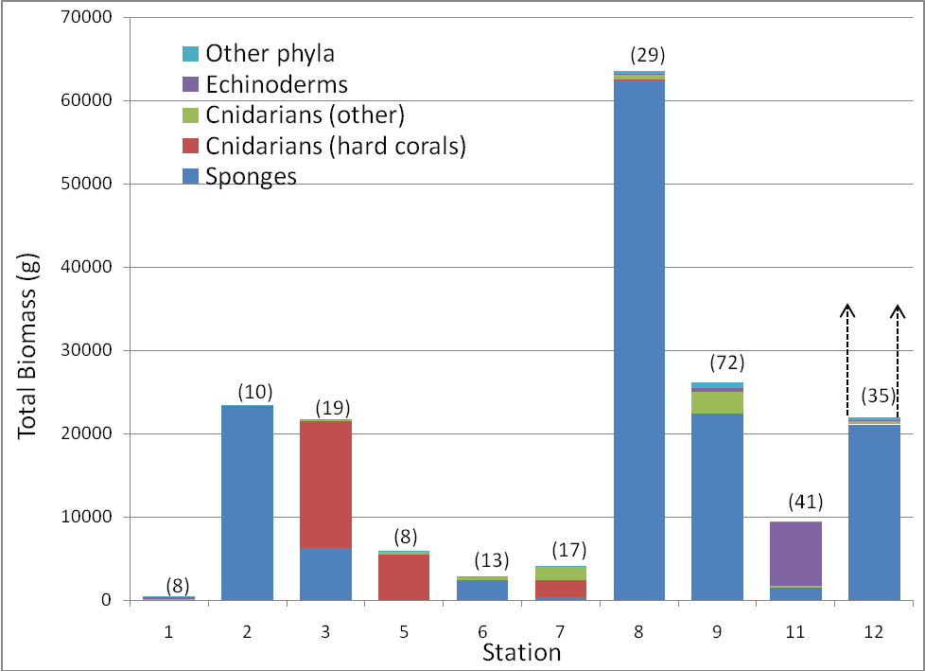
Figure 3.2: Biomass collected from benthic sled at each station. Parentheses show the number of voucher specimens collected at each station. Dashed arrows indicate a probable larger haul if the sled net hadn’t torn in half during the tow at Station 12.
  - Habitat and Community Characterisation
The seafloor was also broadly characterised in relation to epifauna by using the biological collections from the sled and images from the ROV and previous survey GA-276, (Figure 3.3). However, due to the lack of high-resolution imagery and the limited number of stations examined in each study area, the characterisations of communities in this report can only be made in the broadest context and must be considered only as preliminary observations. Classifications included the following:
- Barren. There was little or no evidence of epifaunal activity;
- Scattered epifauna. Seafloor has low epifaunal cover, with very few if any large habitat-forming taxa;
- Mobile epibenthos. Seafloor supports patches of mobile or sedentary epibenthos (echinoderms, crustaceans, fish) but few large habitat-forming taxa;
- Mixed patches. Occasional rocky outcrops support locally abundant patches of octocorals and sponges with no reef-forming corals.
- Mixed patches with hard corals. Occasional rocky outcrops support locally abundant patches of octocorals, sponges, and reef-forming corals;
- Mixed gardens. The seafloor supports moderately dense coverage of sponges and octocorals with high abundances of other taxa; and
- Mixed gardens with hard corals. The seafloor supports moderately dense coverage of sponges, octocorals, and reef-forming corals with high abundances of other taxa.
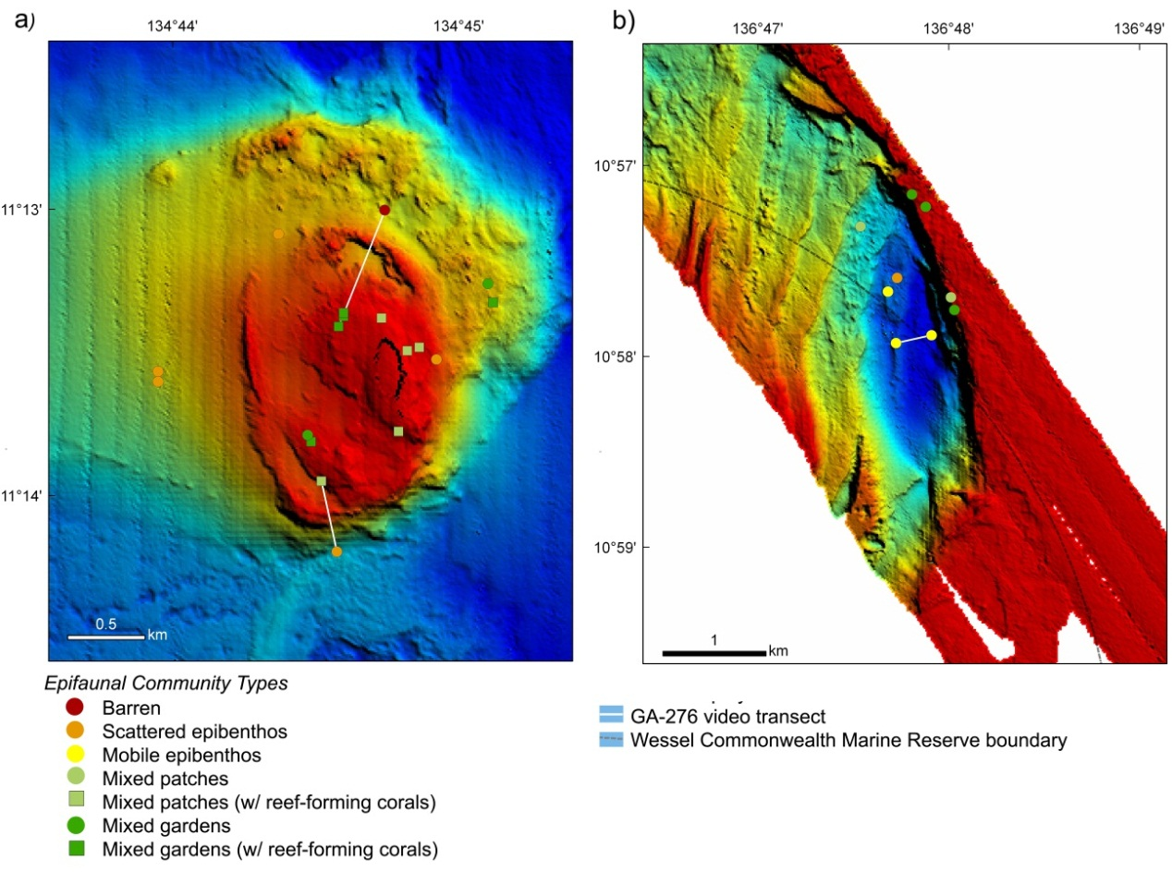
Figure 3.3: Broad epifaunal community classifications of each station based on ROV and benthic sled deployments from SS2012t07, as well as video acquired during GA-276. Stations are overlaid on bathymetry acquired during GA-276.
    - Area I
The top of the bank had a seemingly diverse and abundant sessile invertebrate community, with consistent patchy occurrence of sponges, octocorals, and hard corals. However, based on the limited video acquired, density of organisms may be lower than that observed on banks elsewhere in the northern bioregion (e.g. along the Van Diemen Rise in Przeslawski et al. 2011 (GA-322, GA-325) and western Oceanic Shoals Commonwealth Marine Reserve (GA-339)). Hard corals were generally limited to robust plate or table morphologies on the top of the bank, likely due to the strong currents over the bank. The western (Station 1) and northern (Station 4) flank stations were dominated by soft sediment communities, although the northern station showed more signs of bioturbation than the western. The eastern flank (Station 8) had denser epifaunal communities than the other flank stations, including localised patches of sponges and octocorals as well as at least some scleractinian corals.
    - Area II
The terrace at 60 m depth supported moderate densities of sponges and octocorals. The obvious differences between these communities and those seen on the banks are the absence of hard corals (insufficient light levels) and the lower density but more even distribution of the sessile invertebrates here compared to patches of high-density sponges/corals in Area I.
The deep hole at ~ 100 m was covered with muddy gravel and scattered sessile and sedentary invertebrates, of which crinoids dominate. The hole also supports skates and numerous small demersal fish, the latter of which included schools. The sled at Station 11 returned many small rocks and cobbles, along with dozens of empty vermetid mollusc tubes, a large number of crinoids, brittlestars, and smaller mobile invertebrates (decapods, worms). The ROVs and video transect from the 2005 survey confirmed patches of sessile and sedentary epibenthos, particularly crinoids, in the hole feature but very little sessile epifauna elsewhere. Compared to the terrace, there was a notable absence of large sponges and octocorals in the hole, although several smaller specimens were collected. The lack of larger sessile invertebrates may be due to the predominately unconsolidated sediment combined with high disturbance limiting settlement on all but the larges rocks. Our limited sampling (including lost net and scratched sled) also indicates that the deep hole contains small jagged rocks, although these were not seen on the GA-276 video transect from 2005.
    - Sponges and Octocorals as Habitat
Sponges and octocorals provided a habitat to a range of other taxa on the bank, including crinoids and bivalves that grew on the surface of larger sessile invertebrates (Figure 3.4a). In addition, mobile taxa such as carids, brittlestars, and polychaetes were seen crawling inside many of the larger sponge species. At one station, four barrel sponges (Xestospongia testudinaria) were cut open and visible endofauna removed (Figure 3.4b). These included an estimated 12 species of polychaetes, seven species of crustacean, five species of ophiuroids, two species of molluscs, and a single ascidian and sponge (Figure 3.4c,d).
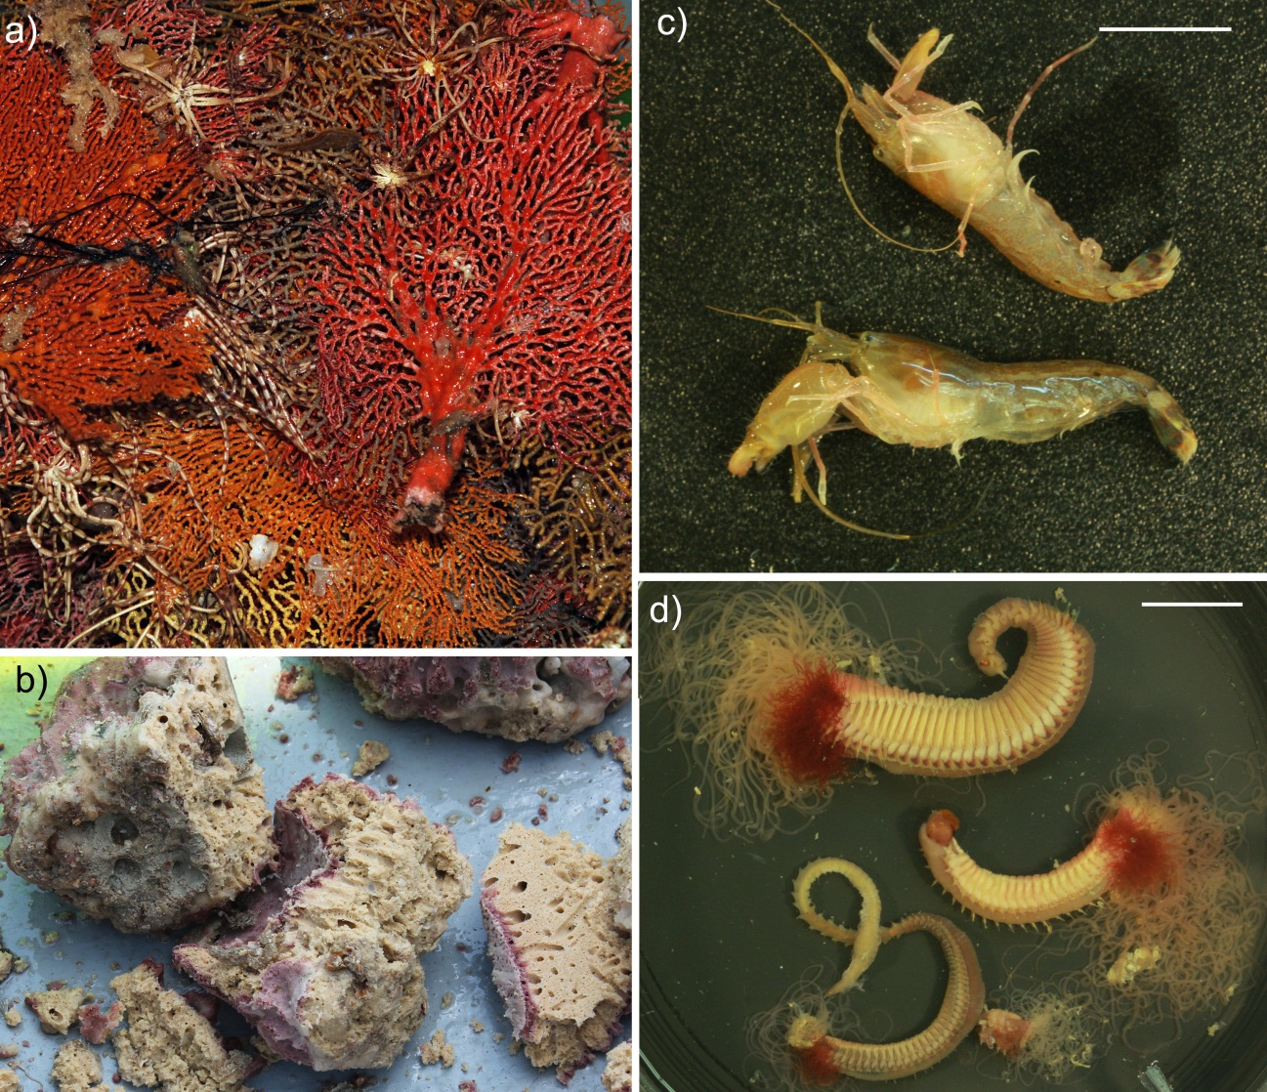
Figure 3.4: Large sessile invertebrates provide habitat to other organisms: a) Gorgonians are often collected with many crinoids attached to their branches (Station 9BS8, 60 m depth). b) Barrel sponges such as Xetospongia testudinaria (Station 8BS7, 28 m depth) support smaller mobile endofauna such as c) shrimp and d) terebellid polychaetes. Scale bars represent 1 cm.
- Conclusions
In less than 24 hours of sampling effort, survey SS2012/t07 collected 263 samples that will be used for biodiversity and biodiscovery research. A total of 49 samples is to be lodged at the ABL, and samples with weights larger than 250 g will be sent to the NCI for screening of active compounds against cancer and HIV.
As taxonomic identifications are completed, sponges and perhaps other groups will be related to communities in other regions of northern Australia to determine if communities on banks are similar throughout this region. If they are not, physical aspects of the banks and surrounding water column can be investigated as potential drivers of such differences. Future studies in this area could deploy more appropriate imaging equipment such as an Automated Underwater Vehicle (AUV) to investigate community changes over spatial gradients related to geomorphic features (e.g. from terrace to deep hole in Area II).

Acknowledgements
We are extremely grateful to the crew of the R.V. Southern Surveyor who were integral to our sampling program. Lisa Woodward and Brett Muir (CSIRO) assisted with operations and technical support regardless of the time of day or night. Chris Davis (AIMS) provided training on the deployment of the sled and prepared the sled for operation. Jonathan Windsor, Ed Butler, Marcus Stower (all of AIMS), Gavin Dally, and Chris Glasby (both of MAGNT) assisted with logistics and mobilisation. Peter Harris (GA) suggested suitable study areas during survey planning, and Johnathan Kool and Scott Nichol provided helpful reviews of this report. We would also like to thank the cruise leader of this transit trip Martina Doblin (University of Technology Sydney) and her scientific team for their support during the survey, as well as the Marine National Facility (CSIRO) for allowing us the opportunity to participate in a transit voyage. We are also grateful to Richard Willan (MAGNT) for promptly identifying molluscs.
This project is funded by the US National Cancer Institute program (Collection and Taxonomy of Marine Organisms’ Contract N02CO-2009-00012 to MAGNT through Coral Reef Research Foundation, Palau) and the Australian Institute of Marine Science (AIMS). R Przeslawski’s participation was supported by the Marine Biodiversity Hub through the Australian Government’s National Environmental Research Program (NERP). NERP Marine Biodiversity Hub partners include the Institute for Marine and Antarctic Studies, University of Tasmania; CSIRO, Geoscience Australia, Australian Institute of Marine Science, Museum Victoria, Charles Darwin University and the University of Western Australia. This report is published with permission of the Chief Executive Officer of Geoscience Australia.

References
Bell, J. J., 2008. The functional roles of marine sponges. Estuarine Coastal and Shelf Science, 79, 341-353.
Benkendorff, K., 2011. Molluscan biological and chemical diversity: Secondary metabolites and medicinal resources produced by marine molluscs. Biological Reviews, 84, 757-775.
Commonwealth of Australia, 2008. North Marine Bioregional Plan Bioregional Profile - A Description of the Ecosystems, Conservation Values and Uses of the North Marine Region. Canberra, Department of the Environment, Water, Heritage and the Arts.
Fromont, J., 1994. Reproductive development and timing of tropical sponges (order Haplosclerida) from the Great Barrier Reef, Australia Coral Reefs, 13, (2), 127-133.
Harris, P.T., Heap, A., Marshall, J., Hemer, M., Daniell, J., Hancock, A., Buchanan, C., Sbaffi, L., Brewer D., Heales, D., 2007. Submerged coral reefs and benthic habitats of the southern Gulf of Carpentaria: post-survey report GA survey 276, Southern Surveyor. GA Record 2007/02. Geoscience Australia, Canberra.
Heyward, A., Fromont, J., Schönberg, C. H. L., Colquhoun, J., Radford, B. and Gomez, O., 2010. The sponge gardens of Ningaloo Reef, Western Australia. The Open Marine Biology Journal, 4, 3-11.
Heyward, A., Pinceratto, E. and Smith, L., 1997. Big Bank Shoals of the Timor Sea: An Environmental Resource Atlas. Melbourne, BHP Petroleum.
Hill, B. J., 1994. Ecology of the Gulf of Carpentaria. Australian Journal of Marine and Freshwater Research, 45, 454.
Hooper, J. N. A., 1994. Coral reef sponges of the Sahul Shelf - a case for habitat preservation. Memoirs of the Queensland Museum, 36, 93-106.
Hooper, J. N. A. and Ekins, M., 2004. Collation and Validation of Museum Collection Databases Related to the Distribution of Marine Sponges in Northern Australia. Hobart, National Oceans Office, Department of Environment and Heritage.
Laport, M. S., Santos, O. C. and Muricy, G., 2009. Marine sponge: potential sources of new antimicrobial drugs. Current Pharmaceutical Biotechnology, 10, 86-105.
Long, B. G. and Poiner, I. R., 1994. Infaunal benthic community structure and function in the Gulf of Carpentaria, northern Australia. Australian Journal of Marine and Freshwater Research, 45, (3), 293-316.
Post, A. L., 2008. The application of physical surrogates to predict the distribution of marine benthic organisms. Ocean & Coastal Management, 51, (2), 161-179.
Przeslawski, R., Daniell, J., Anderson, T., Barrie, J. V., Heap, A., Hughes, M. G., Li, J., Potter, A., Radke, L., Siwabessy, J., Tran, M., Whiteway, T. and Nichol, S., 2011. Seabed Habitats and Hazards of the Joseph Bonaparte Gulf and Timor Sea, Northern Australia. GA Record 2011/40. Canberra, Geoscience Australia.
Schönberg, C. H. L. and Fromont, J., 2011. Sponge gardens of Ningaloo Reef (Carnarvon Shelf, Western Australia) are biodiversity hotspots. Hydrobiologia, 687, 143-161.
Sipkema, D., Granssen, M. C., Osinga, R., Tramper, J. and Wijffels, R. H., 2005. Marine sponges as pharmacy. Marine Biotechnology, 7, 142-62.
Stowe, S. D., Richards, J. J., Tucker, A. T., Thompson, R., Melander, C. and Cavanagh, J., 2011. Anti-Biofilm Compounds Derived from Marine Sponges. Marine Drugs, 9, (10), 2010-2035.
Sutcliffe, P. R., Hooper, J. N. A. and Pitcher, C. R., 2010. The most common sponges on the Great Barrier Reef seabed, Australia, include species new to science (Phylum Porifera). Zootaxa, 2616, 1-30.
Veron, J. E. N., 2004. Coral Survey at Selected Sites in Arnhem Land. Townsville, Australian Institute of Marine Science.
Westley, C. B., Lewis, M. and Benkendorff, K., 2010. Enhanced acute apoptotic response to azoxymethane-induced DNA damage in rodent colonic epithelium by Tyrian purple precursors: A potential colorectal cancer chemopreventative. Cancer Biology and Therapy, (9), 371-379.
Wienberg, C., Westphal, H., Kwoll, E. and Hebbeln, D., 2010. An isolated knoll in the Timor Sea (Sahul Shelf, NW Australia): facies zonation and sediment composition. Facies, 56, 179-193.
Wilkinson, C. R. and Cheshire, A. C., 1989. Patterns in the distribution of sponge populations across the central Great Barrier Reef. Coral Reefs, 8, 127-134.
Wilson, G. D. F., 2010. Arafura Sea Biological Survey: Taxonomic Results. Sydney, Australian Museum. p.

Appendix A: Notes from ROV Camera Live Feed and GA-276 Video
Survey SS2012t07
Area | Station | Number | Description Of Seabed | Comments On Video Acquisition
I | 1 | ROV1 | strong currents (ROV ~ 50 m off vessel), sandy bottom, scatttered small sessile epibenthos, large crinoids, hydroids, some sponges, sparse biota | no recording made, live view only
I | 2 | ROV2 | hard ground, octocorals, scattered plate corals, whips, sea fans, xestospongias and other sponges, fish | no recording made, live view only, weight stuck and umbilical wrapped around sponge, took ~ 30 minutes of ship manuevering to release, decision made to remove weights for station 3
I | 3 | ROV3 | hard ground (more so than Station 2), scattered tabletop corals (may be sponges - hard to see), xestospongia, whips, cup sponges, encrusting sponges and other encrusting organisms, table sponges, seems to be high sponge diversity | ROV recording in midwater for ~2 minutes, overexposed
I | 4 | ROV4 | beginning of video seems to be sediment veneer over hard substrata followed by soft sediment, scattered epifauna, crinoids, mounds/burrows, very sparse biota so decided not to deploy sled | overexposed
I | 5 | ROV5 | rocky outcrops/boulders, no visible hard corals at beginning. Later, plate corals, branching corals, xestos, whips, not as dense as Stations 2 and 3, patchy outcrops with moderate density of hard corals and sponges | overexposed
I | 7 | ROV06 | strong currents , scattered epibenthos, whips | overexposed, 2 attempts, only a few seconds of video on seafloor before the currents took it,, decided waste of time to continue trying
I | 8 | ROV07 | hard ground with sand veneer in patches, scattered epibenthos, whips, sponges, hard outcrops with denser patches of sessiles, moderate sponge/octocoral gardens | overexposed, short deployment due to strong currents
II | 9 | ROV08 | gorgonians (incl mopsella?), sponges (incl ianthella), evenly dispersed epibenthos with (light-mod density), very turbid | overexposed
II | 10 | ROV09 | muddy, turbid, very hard to see but some signs of sessile epibenthos (e.g. sponges or octocorals) | currents too strong to view bottom properly
II | 11 | ROV10 | muddy, flat, small conglomerates with scattered sessiles, crinoids, turbid, no large boulders or rocky outcrops | difficult to see due to speed and mud
II | 12 | ROV11 | very turbid, strong currents, sponges, gorgonians, light-mod even dispersal of sessiles like station 9
Survey GA-276
Area | Station | Number | Description Of Seabed | Comments On Video Acquisition
I | 69 | CAM65 | Turbid, strong currents, muddy gravel with shell grit and small rocks/pebbles, scattered epibenthos, small local patches of denser coverage on small rocks and boulders prevalent on eastern side of transect, dominated by crinoids (biomass), very few sponges, schools of small fish, at 5:20 start seeing scattered seafans such as Mopsella, at 07:00-13:15 very barren of epibenthos, only a few epibenthic patches seen after barren part, skate observed at 09:04, small plume ejected from sediment at 15:28 | Total video length ~20:00. Camera is towed from east to west.
I | 71 | CAM66 | Sand veneer or rocky outcrops, whips, moderate hard coral/sponge/octocoral cover (hard coral cover much denser than station 72), scattered fish, slow tow/currents. At 4:00 moves from gardens into patches with plate and other hard corals since it’s interspersed with unconsolidated sediments, sea fans and fan-shaped sponges all oriented in the same direction,after 22:00 almost all barren seafloor (except from 25:30 – 27:45 and 35:00 – 38:30 and 42:00- 44:00 which have gardens with no hard corals),more fish after ~30 minutes (including trevally(?) schools at 45-46:30 minutes) | Total video length ~46:30, tape only (digital copy is not able to be played – corrupt?). Camera is towed from southwest (bank surface) to northeast (bank flank).
II | 72 | CAM67 | Starts out flat with sandy gravel and only scattered epibenthos, currents do not seem that strong, at 2:30 moves into hard ground with scattered sponges, octocorals, plate coral, and fish including some hiding in barrel sponges,at ~5:00 sponges and octocorals are more dense and uniform (gardens with hard corals) – coincides with faster tow/currents, at ~07:00 back to sandy gravel with scattered epibenthos and patches. At ~ 10:00 gardens again along with lots of rocky outcrops. At 12:15 patches/scattered epibenthos again. At 14:28, shark and large ray seen over ‘barren’ habitat. Large fallen seafan at 15:26. | Total video length ~20:00. Camera is towed from north (bank surface) to south (seafloor adjacent to bank).

Appendix B: Daily Survey Log
15th October 2012
Scientific and ship’s crew mobilised equipment for unscheduled early departure from the wharf at 10:00 due to low tides. Not all gear was able to be loaded so the ship remained in Darwin Harbour during which time scientific crew had an induction with the Chief Officer at 13:00, a muster and abandon ship drill at 14:30, and a scientific induction at 15:00. During the latter meeting, the two scientific teams were introduced: CI Martina Doblin’s team of 6 from UTS (planktonic microbial biology) and CI Belinda Glasby’s team of 4 from NTG, NAMRA, MAGNT, and GA (benthic biodiversity and biodiscovery).
The ship returned to the wharf at 16:00 and departed for the transit voyage at 18:30, 2.5 hours after scheduled departure time. The remainder of the evening was spent unpacking, setting up the wet lab in which specimen sorting and vouchering will take place, and discussing the upcoming ambitious sampling activities. Seas were fine so hopefully the associated vessel speed during this early part of the transit will make up for the lost time due to delayed departure.
16th October 2012
In the morning, Belinda relayed an activity and station schedule to the bridge while Rachel confirmed waypoints. Rick Smith (CSIRO) liaised with the bridge to transfer GA’s previously acquired bathymetric grids to them for navigation assistance, as there was some concern about the shallow bank feature of Area I. Unfortunately, the bridge was unable to access the bathymetric grids so they remained useful as printouts only.
Kiki was trained on GA’s macrophotography equipment and protocol, and we had a toolbox meeting for the ROV and benthic sled at 11:00.
17th October 2012
We arrived in Area I at 4:30am and began with an ROV drop immediately followed by a sled. The station was quite biologically depauperate and was a good one to start with while we fine-tuned equipment and procedures. Each team member was responsible for specific tasks: Belinda – sleds and laboratory, Neil – ROV, Rachel – operations and meta-data, Kiki – sleds and laboratory assistance. In addition, Brett Muir helped with the ROV and operations and Lisa Woodward helped with meta-data and operations throughout the day.
ROV
The ROV got stuck at Station 2 at multiple points: once with its weights jammed in an unknown object and again when the umbilical wrapped around a barrel sponge. Many were thinking the ROV might have to be cut away and lost, but thanks to some excellent maneuvring by the 1st mate and good communication between the deck and bridge, the ROV was recovered. We decided to remove all weights near the bottom.
The ROV continued to be problematic, with increasing current speed over the bank making it almost impossible to maneuver or even get to the bottom. At several stations, the ROV umbilical wrapped around the ship’s hull. At some stations, we were only able to get a few seconds’ glimpse of the bottom but it was enough to ground-truth for sled deployment and determine broad habitat/community type.
Another problem was associated with the electronics and software related to the ROV. At the first 2 stations, no recording was made due to issues between the computer and ROV monitor connection. As such, only notes associated with the live view are available for these stations. In addition, most ROV digital file that was acquired was overexposed and unusable in many areas.
Neil and the rest of the scientific team have determined that the ROV is unsuitable for open ocean conditions with strong currents and tides. In such conditions the towed video is optimal for marine imagery. However, Neil has several promising ideas for tomorrow’s deployment, including putting weights on the umbilical ~30 m in front of the ROV or putting weights on the ROV itself so that it faces downwards. Concerns for tomorrow’s ROV deployment are due to the depth (60 – 100 m) and the tides/currents.
Sled
To our knowledge, this was the first time the AIMS sled has been deployed off the Southern Surveyor. Despite promising images from the ROV on top of the banks, the sled never returned a large haul of biological specimens. This may be due to the hard and relatively flat bottom causing the sled to skip along the seabed, the strong currents interfering with the sled reaching or staying at the bottom, or a number of other factors. Far fewer samples than expected were collected for bioprospecting, although we had a good number of specimens collected for biodiversity/taxonomic research.
Stations
As expected the top of the bank had a seemingly diverse and abundant sessile invertebrate community, with sponges, octocorals, and hard corals obvious. Hard corals were generally limited to robust plate or table morphologies, likely due to the strong currents over the bank. The western and northern flank of the bank seemed dominated by soft sediment communities, with the eastern flank having denser epifaunal communities including localised patches of moderate sponge and octocorals.
18th October 2012
We arrived at Area II at 02:15 and began ROV and sled operations. There was some concern that the deeper waters in this area would exacerbate the issues we had with the ROV and sled yesterday. Luckily the currents seemed less severe in this area, although they were still a challenge regarding ROV deployment. The team had several high points today in Area II (better sled hauls, deployment of drifter) but also several set-backs (continued issues with ROV, torn sled net, lost sled net).
ROV
With Neil’s new weight location on the umbilical, the ROV was able to reach bottom at 60 m (2 stations) and 100 m (1 station), but we were unable to obtain any but the most cursory images of the seafloor at all but one station (9). The thrusters on the ROV were insufficient against the strong currents, and the ROV ended up being used as a drop-cam. However, the currents were too fast to allow usable image and the depths hindered keeping the camera at a suitable distance above the seafloor.
Sled
The first few sled hauls were much more promising than the previous days, with a moderately large haul rich in sponges and octocorals. Importantly, more material was collected that was suitable for bioprospecting (> 250 g wet weight).
The sled failed to return a catch at Stations 10 and 13, and the cause was unknown. At Station 12, the sled was brought on deck after deployment with the net completely ripped in half. Nevertheless, we collected several sponges and other species. The back-up net was installed on the sled and we deployed it at Station 13. Unfortunately, the knot on the first attempt was not secured and no sample was collected. After the second try at this station, we were forced to end our sampling program because the sled came up with the replacement net completely gone. We believe this may be due to the jagged small rocks that likely occur on the bottom of the deep hole; such rocks were previously collected in a different sled from the hole (Station 11), and the plastic mat on the bottom of the sled was extremely scratched and gouged after deployment at Station 13.
Belinda spent the rest of the day processing the bioprospecting samples.
Drifter
Because we were on schedule for our scheduled arrival in Cairns, we were able to steam 20 nm north of the Wessel Islands to deploy the NOAA drifter. This drifter was previously deployed on GA-AIMS survey SOL5650, but it was picked up by a fishing vessel and delivered to AIMS-Darwin. Kiki released it on the current survey to inform her research on the effects of ghost nets. Data returned from the drifter is publicly accessible and will likely feed into multiple projects including those of the NERP Marine Hub.
Stations
The terrace at 60 m depth supports moderate densities of sponges and octocorals. The obvious differences between these communities and those seen on the banks are the absence of hard corals (insufficient light levels) and the lower density but more even distribution of the sessile invertebrates here compared to patches of high-density sponges/corals in Area I. The deep hole at ~ 100 m seems to be dominated by sandy mud and scattered sessile invertebrates. The sled returned many small rocks and cobbles, along with a large number of crinoids, brittlestars, and smaller mobile invertebrates (decapods, worms), particularly compared to the other stations in Area I and II.
Compared to the terrace, there was a notable absence of large sponges and octocorals, although several smaller specimens were collected. Our limited sampling indicates that the deep hole is muddy sand with small jagged rocks, possibly related to rockfalls associated with the nearby 40 m wall.
19 October 2012
The second science program led by Martina commenced today (microbial and plankton ecology), with several CTD and optical casts. Our team digitally collated data, began cleaning the lab, and finished processing specimens.
We briefly passed into Indonesian waters on transit across the Gulf of Carpentaria and arrived into Queensland waters around midday so our clocks were set forward ½ hour.
Seas are fine, and all is on schedule for arrival in Cairns Wednesday morning.
20 October 2012
All scientific sampling was put on hold today while we passed through Torres Strait during daylight hours. Our science team spent the day QC-ing data (Belinda, Rachel), watching for ghost nets (Kiki), writing the post-survey report (Rachel), and working on other MAGNT- or NTG-related tasks (Neil, Belinda).
Seas were calm through the Torres Strait, but the swell picked up once we rounded the east coast.
21 October 2012
Our scientific team spent the day engaged in their own pursuits. Work-related tasks included finalising a draft of the post-survey report for team members’ comments - figures will need to be completed back at GA due to the need for access to Arc GIS to create the maps.
Seas have picked up with a swell causing us to be grateful that our sampling activities are finished. Martina’s group continues to deploy optical casts and CTDs 3 times a day.
22 October 2012
We packed voucher specimens according to freight guidelines and rang Toll Ipec and TNT to arrange necessary pick-ups for Wednesday morning. The GA photography equipment will be sent back with Rachel as excess baggage on her flight. We are on schedule for an early arrival in Cairns sometime Tuesday night.
24th October 2012
The pilot met us at 06 30 for escort to Cairns port. Since our arrival was several hours earlier than anticipated, we waited for freight and shipping transport to arrive before demobilisation during late morning. Frozen samples were taken to the airport and air-freighted to MAGNT, Darwin in special polystyrene boxes and packed with dry ice. Other vouchers were freighted by road to MAGNT, MOV (echinoderms and crustacea) and MTQ (bryozoans and hard coral). The benthic sled was returned by road-freight to AIMS, Townsville. Other gear and equipment was road/air freighted to MAGNT,
Both scientific programs were deemed a success, and scientific and ships crew seemed satisfied with operations and outcomes.
Written by R. Przeslawski

Appendix C: Scientific Crew
Name | Role
Belinda Glasby | Chief Scientist, MAGNT (benthic biodiversity)
Martina Doblin | Chief Scientist, UTS (microbial ecology)
Rachel Przeslawski | Scientist, co-PI (GA)
Neil Smit | Scientist, co-PI (NTG)
Kiki Dethmers | Scientist (AIMS, CDU)
Justin Seymour | Scientist
Mark Brown | Scientist
Martin Ostrowski | Scientist
Lauren Messer | Scientist
Charlotte Robinson | Scientist
Lindsay Pender | Computing (MNF)
Peter Hughes | Hydrochemistry (MNF)
Brett Muir | Electronics (MNF)
Rick Smith | Swath Mapping (MNF)
Lisa Woodward | Voyage Manager (MNF)

Appendix D: Ship Crew
Name | Role
John Barr | Master
Mick Tuck | Chief Mate
Fred Rostron | Chief Engineer
Paul Iddon | Second Mate
Rob Cave | First Engineer
Graeme Perkins | Second Engineer
Charmayne Aylett | Chief Steward
Aaron Buckleton | Chief Cook
Oliver Herlihy | Second Cook
Tony Hearne | CIR
Rod Langham | IR
Matt Streat | IR
Peter Taylor | IR
Ron Johnson | IR

Appendix E: List of Abbreviations
ABL: Australian Bioresources Library, managed by the AIMS
AIMS: Australian Institute of Marine Science
CMR: Commonwealth Marine Reserve, declared November 2012
KEF: Key Ecological Feature
NERP Marine Hub: National Environmental Research Program - Marine Biodiversity Hub
MAGNT: Museum and Art Gallery of the Northern Territory
NCI: National Cancer Institute, based in the United States
ROV: Remotely operated vehicle
SEWPaC: The Commonwealth Department of Sustainability, Environmental, Waters, Populations and Communities

Appendix F: Molluscan Species Identifications
Species-level identifications completed by Richard Willan; specimens are lodged at the MAGNT.
Station | Sample No | Family | Species | Common Name | Comments1
1 | 109 | Pectinidae | Annachlamys flabellata | Scallop | 1; adult
1 | 109 | Pinnidae | Atrina pectinata | Pen shell | 1; adult
5 | 146 | Cardiidae | Fulvia australis | Cockle | 1; adult
8 | 177 | Limidae | Lima vulgaris | File clam | 1; juvenile. The other bivalves in this sample were not alive. from Xestospongia
8 | 189 | Cardiidae | Nemocardium becheii | Cockle | 1; adult
8 | 190 | Phyllidiidae | Phyllidiella pustulosa | Nudibranch | 1; adult
8 | 196 | Pteriidae | Pteria chinensis | Wing oyster | 3 live-taken specimens; all juvenile, attached with byssal thread to several species of gorgonian
8 | 196 | Pteriidae | Pteria lata | Wing oyster | 1 live-taken specimen; juvenile
8 | 205 | Ovulidae | Pellasimnia rosea | Spindle cowrie | 1; live-taken specimen; adult, attached with byssal thread to several species of gorgonian
9 | 220 | Chamidae | Chama lazarus | Lazarus' Jewel-box Clam | 1; adult
12 | 269 | Siliquariidae | Tenagodus cumingi | Corkscrew shell | many adult shells; all dead;
11 | 285 | Pinnidae | Pinna bicolor | Pen shell | 1; adult
11 | 286 | Bursidae | Bufoniaria rana | Frog snail | 1; subadult
11 | 286 | Muricidae | Chicoreus cervicornis | Murex | 1; adult
1 Comments based on onboard collection notes (R Przeslawski, B Glasby) and museum identifications (R Willan, MAGNT)

