Weathering, erosion, landforms and regolith

Teacher notes and student activities
Geoscience Australia
Record 2013/16
2nd Edition
Megan E. Lech and Cindy L. Trewin
Department of Resources, Energy and Tourism
Minister for Resources and Energy: The Hon Gary Gray AO MP
Secretary: Mr Blair Comley, PSM
Geoscience Australia
Chief Executive Officer: Dr Chris Pigram
This paper is published with the permission of the CEO, Geoscience Australia
© Commonwealth of Australia (Geoscience Australia) 2013
With the exception of the Commonwealth Coat of Arms and where otherwise noted, all material in this publication is provided under a Creative Commons Attribution 3.0 Australia Licence. (http://www.creativecommons.org/licenses/by/3.0/au/deed.en)
Geoscience Australia has tried to make the information in this product as accurate as possible. However, it does not guarantee that the information is totally accurate or complete. Therefore, you should not solely rely on this information when making a commercial decision.
Geoscience Australia is committed to providing web accessible content wherever possible. If you are having difficulties with accessing this document please contact clientservices@ga.gov.au.
ISSN 2201-702X (PDF)
ISBN 978-1-922201-41-6 (PDF)
GeoCat 75055
Second Edition 2013
First published 2002
About the booklet
This booklet is intended to provide information for both science and geography teachers to support their work with pupils in both upper primary and secondary settings. Teachers should evaluate the student activities to ensure they are of appropriate difficulty for their cohort of students. If you have any further comments or feedback please email: education@ga.gov.au
For information about this publication or other education resources please visit Geoscience Australia’s Education website at www.ga.gov.au/education, or contact the Education Centre.
Acknowledgements
Original concept and content compiled by Megan E. Lech and Cindy L. Trewin
Second edition edited by Lara Davis, Shona Blewett, Ian Roach and Katy Tomkins
Scientific advice and editing by Brendan Brooke, Colin Pain, Phil McFadden, Cindy L. Trewin, Cindy Hann, Greg McNamara
Classroom exercises by Cindy L. Trewin
Educational advice and editing by Lara Davis and Shona Blewett
Graphics, design and production by Products and Promotion, Geoscience Australia
Cover images: Jim Mason and Bruce Wilson
Education Centre
Geoscience Australia
GPO Box 378, CANBERRA ACT 2601.
Phone: +61 2 6249 9673
Fax: +61 2 6249 9926 Email: education@ga.gov.au
Bibliographic reference: Lech, M. E and Trewin, C. L. 2013. Weathering, Erosion and Landforms: Teacher Notes and Student Activities, 2nd edn. Record 2013/16. Geoscience Australia: Canberra.

Contents
Weathering and erosion 1
Introduction 1
What is weathering? 2
Environmental factors affecting rates of weathering 2
Mechanisms of weathering 3
Physical weathering 4
1. Thermal weathering 4
2. Unloading 5
3. Frost wedging 5
4. Dust wedging 5
5. Salt crystallisation 5
6. Abrasive action of wind-blown sand 6
7. Biological action 6
Chemical weathering 6
1. Hydrolysis 6
2. Hydration 7
3. Leaching 7
4. Oxidation and reduction 7
5. Carbonation 7
6. Ferrolysis 7
Erosion, transportation & deposition 9
Processes of erosion 9
Flowing water - Erosion and transport 9
Coastal erosion and transport by waves 12
Transport by gravity (mass wasting) 15
Wind in action 18
Erosion and transportation by ice (glaciers) 20
Weathering and erosion – some examples 22
Sedimentary landforms 22
The Twelve Apostles, Victoria 22
Little Sahara, Kangaroo Island, South Australia 24
Purnululu (The Bungle Bungle Ranges), Western Australia 24
Weathered volcanic rocks 27
Granite weathering 30
Karlwekarlwe (The Devil’s Marbles), Northern Territory 30
Remarkable Rocks, Kangaroo Island, South Australia 32
Glacial landscapes 33
Pleistocene glaciation in Australia 33
Hallett Cove, South Australia 33
Franz Josef Glacier, New Zealand 34
Desert landforms 34
Uluru (Ayers Rock), Northern Territory 35
Karst topography 39
Jenolan Caves, New South Wales 40
The Nullarbor Plain, South Australia and Western Australia 42
Regolith 43
A regolith profile 43
Regolith, soil and sediments – what is the difference? 44
Regolith mapping 45
The value of understanding regolith 47
Regolith and land management 47
Regolith and houses 51
Resources within the regolith 51
From regolith to riches - Using regolith for mineral exploration 55
Importance of regolith to the Indigenous Australians 58
Regolith and medicine (geomedicine, geohealth or medical geology) 58
Biogeochemistry 61
Resource list 62
Books and journal articles 62
Websites for further information 64
Glossary 66
Overview of Student Activities 74
Teacher Notes 74
Icebreaker (teacher demonstration) 74
Tour’osion (written activity) 74
How Would You Like To Be Remembered? - The effects of acid rain on buildings (practical activity) 74
You drip! Part 1 75
You drip! Part 2: 77
Icebreaker 79
Agent erosion 81
Factors affecting physical and chemical weathering 82
Rates of weathering 84
Tour’osion 86
How would you like to be remembered? 91
Erosion in action 94
You drip! Part 2: 98
Icebreaker 99
Factors affecting physical and chemical weathering 100
Rates of weathering 101
Tour’osion 102
How would you like to be remembered? 103
Erosion in Action 104

Weathering and erosion

Introduction
Weathering, erosion and deposition are all around us. Without these natural processes we would not have river valleys, beautiful sandy beaches or even the soil in which we grow our food!
Continents that lack recent tectonic or volcanic activity have had more of an opportunity for weathering, erosion and deposition to shape the landscape. Most of Australia, Africa, Eurasia and parts of North and South America fall into this category. Places like the Himalayas, Hawaii and New Zealand have not had as much time to develop deep weathering because they are so tectonically active, and weathered products are quickly removed by erosion. In Australia, great natural icons such as Uluru (Ayers Rock), the Twelve Apostles and Karlwekarlwe (The Devil’s Marbles), as well as the Grand Canyon in the USA, glacial landscapes in Europe and the huge dune fields of the Sahara Desert in Africa are all examples of weathering and erosion in action.
The term regolith (Greek: “blanket rock”) may be new for many teachers reading this resource. However, you will find that you already know a lot, without realising, because it incorporates everything between fresh rock and fresh air, including rotten rocks, soil, plants, animals, groundwater and soil gasses.
This booklet outlines the processes of weathering, erosion and deposition for the information of teachers and students. It highlights the different types of weathering, erosion and transport and provides examples of famous landscapes to enhance the understanding of these processes. The guide has reproducible student activities that will give the students a fun and easy way to learn about the processes that shape our Earth and form the regolith.

What is weathering?
Weathering is the process in which the texture and composition of rocks and minerals change after being exposed at the Earth’s surface to weathering agents such as water, oxygen, organic and inorganic acids and large temperature fluctuations. These changes usually occur in place (in situ) but also continue during and after transportation. The process of weathering can be chemical or physical (mechanical).

Environmental factors affecting rates of weathering
The following factors can affect the rate and the amount of weathering that takes place:
1) Rock type (what is present to be weathered): Different types of materials weather in different ways, thus the rate at which rocks and minerals weather depends on their composition. A rock with high amounts of stable minerals like quartz-rich sandstone will be more resistant to weathering than a rock with high amounts of olivine such as basalt (Figure 1).

Figure 1: Simplified Goldich weathering series, showing the weatherability of common rock-forming minerals.
2) Climate: The amount of rainfall and the temperature have a significant effect on the amount and depth of weathering that takes place. The amount of rainfall helps to determine the amount of water present for weathering. The temperature governs the rate at which the weathering takes place. Areas that are cold and dry, such as Antarctica, have slow rates of chemical weathering (weathering here is mostly physical), whereas warm, moist tropical areas tend to favour chemical weathering over physical weathering, leading to greater depths of weathering.
3) Time: It takes a long time, relatively speaking, to develop regolith, hence the more time that has passed the more weathering that will have occurred. In areas such as the Pilbara and Yilgarn in Western Australia there are very old and stable areas called shields or cratons. Some rocks in these areas have been dated to an age of 3 800 million years and, until recently, were regarded as being the oldest in the world! Zircon crystals from the Jack Hills in the Yilgarn Craton are now known to be the oldest minerals on Earth, dated at over 4 400 million years. Here, regolith has had more than 1 000 million years to develop into weathering profiles that are hundreds of metres thick. In parts of the world such as New Zealand, glaciers still cover some of the landscape. They have scraped the ground back to bare rock and when they melt, development of the weathering profile will have to begin from scratch (this has also happened in North America and northern Europe). Throughout geological time glacial events have “reset” the weathering clock in many parts of the world including Australia during the Permian Period.

Mechanisms of weathering
Weathering is normally a combination of both physical and chemical weathering and often occurs together with erosion and transportation. In the process, rocks and minerals are broken down to make them more easily weathered, eroded, transported and deposited.
Activities: Factors affecting physical and chemical weathering and rates of weathering
Fine-grained rocks generally weather faster than more coarse-grained rocks because they have a larger accessible surface area. As shown in Figure 2, a cube with sides of one metre does not have as much accessible surface area as eight cubes that add up to the same volume . This is because the internal surfaces of the eight cubes are accessible to water, oxygen and the other weathering agents discussed above. Likewise, rocks with increased numbers of joints and fractures weather more quickly than a solid mass of rock with the same dimensions. These gaps provide pathways for weathering agents to enter a rock mass and speed up the weathering process. The cubes shown in Figure 2, and real rocks in nature, will eventually weather away to form spheroids. The corners of the cubes weather more quickly than the cube faces because weathering agents can attack the cube corners from two sides, whereas the cube faces can only be attacked from one side.
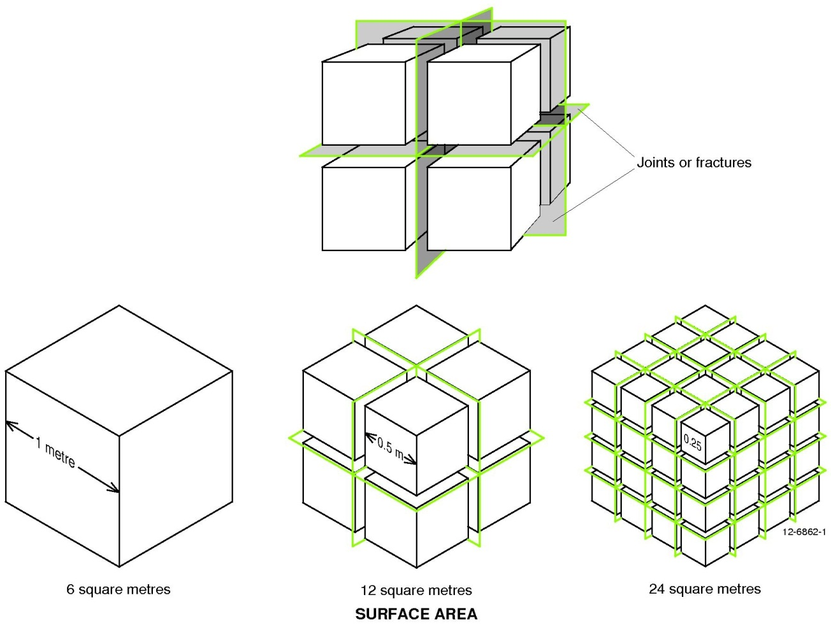
Figure 2: Diagrammatic representation of a rock weathering. An increase in the surface area of rock will increase the rate at which it is weathered.

Physical weathering
Physical weathering involves the disintegration of rocks and minerals by mechanical processes. Such processes break down the materials into smaller portions without altering their chemical make-up.

1. Thermal weathering
Changes in temperature can cause rocks to expand and contract. In areas like deserts, temperatures on dark rock surfaces can vary by more than 40°C in the course of a day. This constant change in temperature causes expansion and contraction of the rocks, with the outsides expanding and contracting more than the insides. This can cause cracks to develop in the rock mass. These cracks provide pathways for rainwater to enter, which speeds up the breakdown of the rock (see frost wedging below). Fire can cause extreme changes in temperature. As rocks are not good conductors of heat, the outer surfaces of rocks are heated while the middle remains relatively cool. Repeated heating and cooling can cause the outer surface of the rock to flake away from the main rock. This is called exfoliation and is commonly seen on granite boulders (tors).

2. Unloading
Igneous rocks are formed deep within the Earth. If conditions are right, uplift plus weathering and erosion can remove the overlying materials until the igneous rock is close to the surface. The rock that was once compressed by the weight of all the rocks above it now expands with the decrease in pressure. This can cause joints and fractures to form into which water can penetrate to allow physical and chemical weathering processes to occur. The Karlwekarlwe (The Devil’s Marbles) is a good example of unloading, but these features can also been seen in rocky outcrops in the Great Dividing Range and along the coast. This process also occurs in sedimentary and metamorphic rocks that were once deeply-buried.

3. Frost wedging
When water freezes it increases in volume – by nine per cent in fact! If water that is trapped in small fractures or voids in the rock freezes it expands, causing the rock to be forced apart. This often occurs in regions where the temperatures hover around freezing or below for part of the year, such as many parts of northern Europe and North America. However, some of the rock debris found high on the slopes of mountains with peaks above the snow line such as Mount Kosciuszko in the Australian Alps, Mount Wellington in Tasmania and Mt Wilhelm in Papua New Guinea is the result of frost wedging.
Activity: Icebreaker

4. Dust wedging
This process is particularly important in arid areas like central Australia. The process of dust-wedging is similar to that of frost wedging. When the rock expands due to the temperature, dust is able to settle in the cracks. When the rock cools and contracts the dust wedged in the cracks prevents them from closing. With subsequent heating and cooling, more dust is able to get in the cracks, forcing the rock to split further apart. Some dust in the desert is also composed of expansive minerals like halite, gypsum and smectite (swelling clay), further exacerbating the wedging during rainfall.

5. Salt crystallisation
This process is similar to that of frost wedging. When the groundwater in pore spaces or cracks in rocks evaporates, ions present in the water can precipitate out to form salts. As the salt crystals grow, pressures they exert on the rock may be large enough to cause the rock to disintegrate. The effects of salt crystallisation can be seen in coastal areas, in desert landscapes near salt lakes and in areas that are prone to salinity problems. The salts halite (NaCl), thenardite (Na2S04) and mirabilite (Na2SO4.10H2O) can exert a pressure of crystallization of up to 120 megaPascals (MPa); the tensile strength (the force require to pull it apart) of a typical granite is only 4 MPa.

6. Abrasive action of wind-blown sand
Have you ever been outside on a windy day and felt the sandblasting effect of sand grains being transported in the wind? This is called ‘aeolian abrasion’. In severe sand storms cars have even had their paint removed! In desert areas abrasion of stones and rock surfaces creates ‘ventifacts’. Ventifacts form when a pebble is flattened on the exposed surface by the constant attack of wind-blown sand (Figure 3). Ventifacts are common in desert areas but also occur in Antarctica due to windblown ice crystals, which act the same as sand.
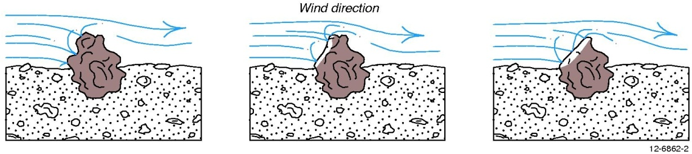
Figure 3: The stages of formation of a ventifact.

7. Biological action
Fungi, bacteria, plant roots, worms, ants and other animals help rocks to weather, both chemically and physically. As plant roots grow they act like crowbars and physically wedge apart the bedrock. In much the same way, plants break apart footpaths and pavements. Ants and termites bring small pieces of rock and minerals up to the surface of the Earth where the pieces are then in contact with air and water. Burrowing vertebrates like wombats and rabbits churn the upper regolith, bringing fresher rock to the surface when it can be weathered more quickly, and falling trees will often bring fresh rocks up from the soil-bedrock interface within their root balls. In north Queensland, the action of termites and ants (bioturbation) can churn over a 2 m thick soil profile in between 40 000 and 70 000 years – this is a geological eyeblink!

Chemical weathering
Chemical weathering involves the breakdown of rocks and minerals through changes in the chemical composition of the material. These changes are predominantly the result of interactions with air and water and chemical compounds contained within them.
Activity: You drip

1. Hydrolysis
The amount of hydrogen ions, H+, present within a solution such as water is an important control on many reactions. The more H+ ions present in water, the more acidic the water is. The more hydroxide ions, OH-, in a solution the more alkaline the water becomes. Plants, fungi and bacteria are a good source of H+ as they exchange H+ for nutrients. In doing so, they create organic acids such as tannic, humic and carbonic acid, which acidify the environment around them and chemically weather nearby minerals in the regolith to release essential trace element nutrients.

2. Hydration
Put simply, hydration involves the addition of water to the rock or mineral. Invariably this causes an increase in volume (just like when you have a dry kitchen sponge and put it in water). This is accompanied by a transfer of ions from the rock or mineral into solution. Hydration is an important process in the formation of clays from feldspars (the most common crustal minerals) and in the formation of hydrated iron oxides and iron hydroxides (such as goethite and limonite).

3. Leaching
During leaching, soluble components within the regolith are removed when they interact with water, either on the Earth’s surface or underground. The soluble ions that are removed from rocks during weathering are transferred into the water and are carried away. The unpleasant taste of some groundwater can occur when components leached out of rocks become too concentrated in the water e.g. sulphate may give water the smell of rotten egg gas, and too much calcium, sodium, potassium or magnesium will cause water to become “hard”, making it difficult to build up a good soapy lather in the shower! In general, the major rock-forming elements will leach in the following order (from most leachable to least leachable): Na > K > Ca> Mg > Si> Al > Fe > Ti. The last four are generally regarded as being “immobile” and will tend to stay put during weathering, but there are always exceptions.

4. Oxidation and reduction
In weathering, oxidation simply means the addition of oxygen to a reaction. Reduction is the removal of oxygen from a reaction. Adding oxygen forms oxides. If oxygen and water are added to minerals they form hydroxides. Minerals that contain iron are particularly susceptible and regolith may appear red or yellow accordingly because iron oxides (such as rust) are reddish and iron hydroxides yellowish. Where reduction occurs, regolith can take on a grey, green or even bluish colour.

5. Carbonation
This involves the reaction between minerals and carbonate or bicarbonate ions. For example, increased carbon dioxide in the air can create acid rain that contains carbonic acid. In some urban environments, these small amounts of acid in the rain are slowly dissolving buildings made of limestone and concrete. A similar process occurs where acid in water moves through the soil. The carbonic acid creates H+ ions which can be substituted for other ions within minerals, thus altering their composition and eventually causing them to break down. Acid rain is a devastating problem for those countries which depend on high sulphur coal for electricity, resulting in sulphuric acid rain!

6. Ferrolysis
This involves the creation of hydrogen ions (H+) by the repeated reduction (by soil-based organisms) and re-oxidation of iron. These H+ ions acidify water and are capable of dissolving clays within the regolith, releasing aluminium and other metals into groundwater toxic levels. This reaction commonly occurs in acid sulphate soil (ASS) environments in conjunction with oxidation and reduction reactions.
Activity: How would you like to be remembered: The effects of acid rain on buildings
Some common chemical weathering reactions:
1. Carbonation: Carbonic acid produced from CO2 in the atmosphere.
CO2 | + | H2O | ⇔ | H2CO3 | ⇔ | H+ | + | HCO3-
carbon dioxide |  | water |  | carbonic acid |  | hydrogen ion |  | bicarbonate ion
2. Oxidation: Oxidation of pyrite in soil to form sulphuric acid.
FeS2 | + | 8O2 | ⇔ | 4H+ | ⇔ | 2H2SO4+ | ⇔ | Fe2+-
pyrite |  | oxygen |  | hydrogen ions |  | sulphuric acid |  | reduced (ferrous) iron
3. Ferrolysis: Formation of iron hydroxide and acid through Fe oxidation.
Fe2+ | + | 3H2O | ⇔ | Fe(OH)2 | + | 3H+ | + | e-
reduced (ferrous) iron |  | water |  | iron hydroxide |  | hydrogen ions |  | electron
4. Hydration: Formation of goethite in the regolith from haematite.
Fe2O3 | + | H2O | ⇔ | 2FeO.OH
haematite |  | water |  | goethite

Erosion, transportation & deposition
The removal of weathered materials from where they were formed is called erosion. The products of erosion can be transported by gravity, water, wind or glaciers. Finally the material is then deposited in a new environment. These processes are all part of the ‘rock cycle’ and may lead to the formation of new sedimentary rocks.

Processes of erosion
Erosion is a natural process that has been occurring throughout geological time to create landforms such as rivers, valleys, caves and coastal platforms. The rates of erosion can, however, be accelerated by human interference. Activities like inappropriate cropping, grazing, and the building of roads and houses have sometimes resulted in large-scale soil erosion, landslides and even desertification.
Activity: Agent erosion

Flowing water - Erosion and transport
Erosion by running water occurs before the water even enters a stream. Erosion can occur by the impact of raindrops on the ground and by overland flow where the rainwater travels across the ground after it falls.

Soil erosion
Soil erosion occurs when sediment is carried over the landscape as an overland flow – as a layer of water running over the landscape. Erosion by overland flow occurs far less if there is a protective layer of vegetation above the soil. Tree canopies, shrubs, grasses and mulch cushion the effect of the falling raindrops, and roots hold the soil together.
Soil erosion occurs in different ways and is most obvious when the soil is bare:
- Splash erosion: This occurs from the impact of raindrops on the soil surface. The loose sediment may later be removed and transported by overland flow.
- Sheet erosion: Water flowing over the surface of the land can strip away thin, uniform sheets of soil and underlying regolith. Visually the land surface has the same shape as it had before it was eroded, but it will be slightly lower elevation.
- Rill erosion: As water running over a surface becomes more turbulent, it tries to take the easiest route. This results in the concentration of water into small channels or rills. Rills are normally several centimetres in depth and often occur after cultivation.
- Gully erosion: This occurs as rills deepen and rainwater accumulates in narrow channels. Over a short period of time the water removes the soil and underlying regolith in a narrow area to considerable depths, often down to saprolite or fresh bedrock. Gullies can range in size from less than one metre deep to tens or even one hundred metres deep, and be many tens of metres across.

Streams and their deposits
Rivers can take many forms: a single channel, sinuous channels, meandering channels and braided channels. The material transported in rivers and streams is called its load. The solid portion transported by streams is either bed load or suspended load. The bed load is the solid material carried along a river bed. It consists of the heavier portion of the sediment and is generally between 5 and 50 percent of the total load. As the sand and rocks are transported they will gradually become smaller and increasingly rounded from the constant banging against other sediment in the river (Figure 4a). Suspended load is the fine material transported by moving water in the zone of turbulent flow. The size of the bed and suspended load depends on the speed of the river. The faster the river flows the bigger and heavier the rocks that are transported. As the river slows down again the particles will be deposited (Figure 4b).
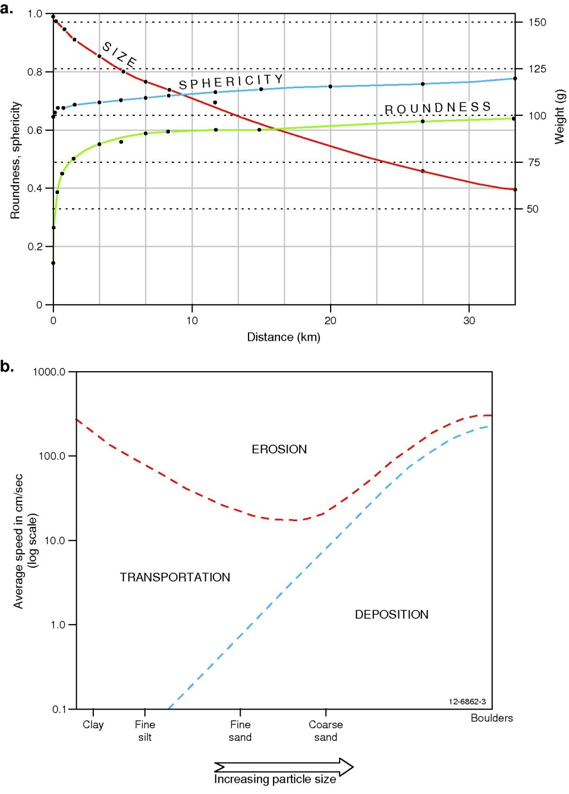
Figure 4: a) The change in size, sphericity and roundness of pieces of limestone as they are transported down a river. b) This graph shows the behaviour of sediments in a river. The upper curve shows the energy needed to pick up and move a particle. The lower zone shows the speed below which sediment is deposited.
The suspended load consists of fine sand, silts and clays that often give the water a muddy/cloudy look. Even crystal-clear streams contain dissolved chemical substances in their suspended load. The seven most common ions in rivers are bicarbonate (HCO3-), calcium (Ca2+), sulfate (SO42-), chloride (Cl-), sodium (Na+), magnesium (Mg2+) and potassium (K+).
Activity: Erosion in action

As a stream loses speed it deposits some of its solid load. Distinctive deposits include the following:
- Floodplains & levees: After a flood event fine silts, clays and sands may be deposited beyond the banks of the stream. These are known as floodplain or overbank deposits and are rich in organics that are excellent for market gardens. Natural levees form at the boundary between the floodplain and the stream bank and consist of a broad, low ridge of coarser-grained alluvial material.
- Sand bars: These form as the stream temporarily loses some of its load. Bars consist of coarse sediment and are commonly seen as islands at river bends or between channels. Placer deposits, rich in mineral sands and gold, sometimes collect upstream from rocks and sediment bars where the winnowing effect of rushing water removes lighter, less dense sediment and leaves the heavier minerals behind. If the speed of the stream flow is just right the heavier minerals are deposited and concentrated in a bed load, while the lighter minerals such as quartz and feldspar are washed away.
- Alluvial fans: If a river flowing through a narrow valley suddenly emerges onto a flat alluvial plain it can no longer keep its load in suspension and the heavier components are dropped because the water suddenly loses velocity and loses the ability to keep particles moving in its bed load or suspended load. The result is a bit like a river delta, except here the load is deposited on land rather than in the ocean. Over time the river shifts course to as it searches for lower ground, producing numerous sediment lobes. With continued deposition an alluvial fan forms; this is a fan-shaped formation composed of alluvium and typically forms where the gradient suddenly changes when rivers leave steep mountain valleys. As you will discover later, the formation of Uluru began as an alluvial fan.
- Terraces: Most rivers have terraces that are remnants of abandoned floodplains. They occur as steps in the landscape beside rivers and form when the river erodes down and floods can no longer reach the former floodplain, often because of tectonic uplift. Terraces provide excellent records of the erosion and depositional history of a stream.

Post-settlement alluvium
This is an example of erosion and deposition, unfortunately caused by human interference. In countries like Australia and the United States of America, pre-settlement vegetation dominated the landscape. After European settlement in Australia in 1788, vast areas of native bushland were destroyed to provide space for the cultivation of crops, the establishment of colonies and by the introduction of hard-hooved animals (sheep, cattle) and feral species like rabbits. Once the native vegetation was removed, rapid erosion ensued and much of the topsoil was washed into creek and river systems. Topsoil was deposited downstream as sediment, known today as ‘post settlement alluvium’, which buried the pre-existing soil that was present before clearing began. It is very common to find European artefacts like glass, wire and sheet metal buried in the post-settlement alluvium. Post-settlement alluvium can be several metres think in the floodplains of upland streams.

Coastal erosion and transport by waves
Ocean waves are created by the wind. The stronger the winds the more powerful the waves and the more eroding they will do. When a wave breaks on the shore it becomes more turbulent. This turbulent water is called the ‘surf’. Beach faces are generally eroded by the surf in winter from high energy waves. In summer usually waves are not so energetic and beach faces get built up from the deposition of sand and sediment. There is constant erosion and deposition and as one coastal area is being eroded another is being built. The mechanisms outlined below help to change the face of our coastline.

Wave erosion on the coast
Most erosion on coasts is due to the action of waves. Erosion occurs not only in the surf zone, but also below and above average sea level. During storms waves pound the shore well above high tide level - this is why we must all be careful when fishing on rock platforms because sudden waves can knock an unsuspecting fisherperson right off their feet. Tsunamis can be extremely large waves that cause tremendous erosion and transport house-size boulders up onto the land. Most tsunamis are caused by earthquakes, where enormous masses of water (measured in the hundreds or thousands of cubic kilometres) are suddenly displaced. Away from this extreme, the constant pounding of the waves on cliffs and beaches can loosen rocks. Underneath the surface the erosive action of the waves can be felt to a depth related to the height of the wave; the higher the wave, the deeper the erosive action of the wave is felt. Consequently seaweed has adapted by having strong root-like holdfasts that act like anchors to hold the plant in place. Likewise sea creatures such as crabs and molluscs have developed hard exoskeletons and shells to protect them from the powerful waves, as well as from predators. Waves are excellent at transporting sand and small rock fragments. These, in turn, are very good at rubbing and grinding surfaces below and just above water level in a process known as abrasion.

Sediment transport and deposition by waves and currents
Sediment produced by the erosive action of waves or sediment transported by river systems is moved by ocean waves and currents to form beaches, or is moved offshore onto the continental shelf. Most waves reach the shore at an angle of about 10° but this can change depending on the wind direction. Each successive wave moves sand at an angle along the beach face. Consequently currents within the surf zone flow along the shore as longshore drift (Figure 5). This causes sediment to move along the beach in a zigzag pattern.
- 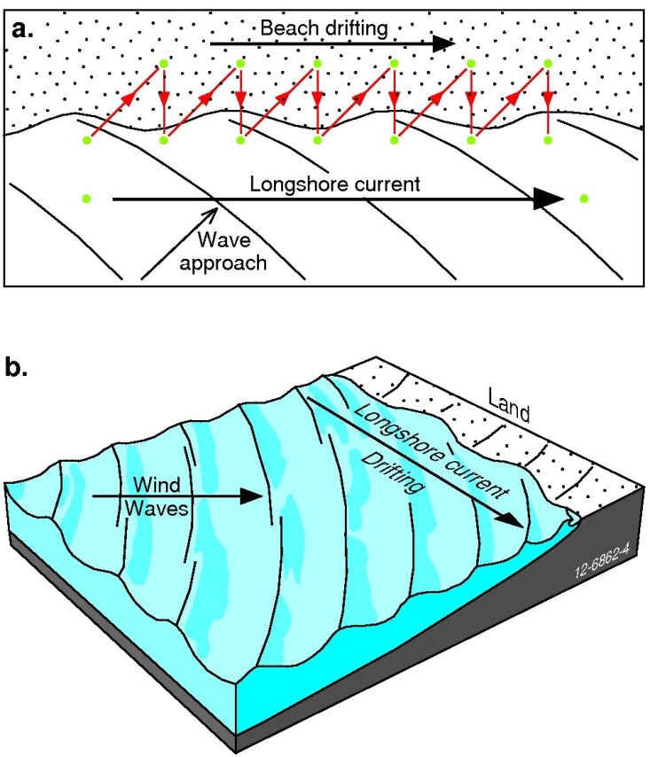
Figure 5: The action of longshore drift
As wind directions change through the year, the angle of approach of the waves changes and so can the direction of longshore drift. Some landforms are made from the build-up of sediment transported by longshore drift and these include spits, barrier spits, tombolos, barrier islands, islands and bayhead beaches (Figure 6).
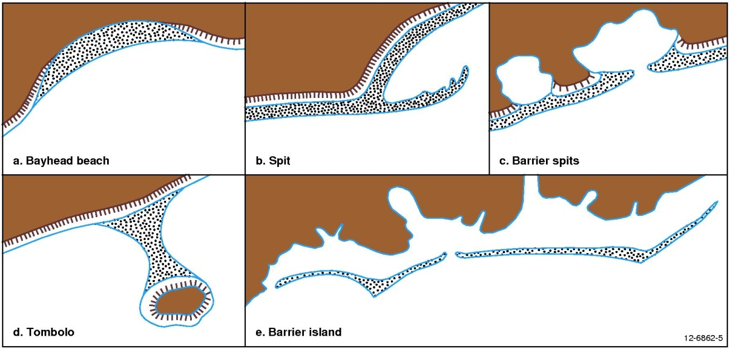
Figure 6: Coastal features created by longshore drift.

Beach placers
Beaches, like rivers, are perfect places for the concentration of gold, diamonds and other heavy minerals like zircon, rutile, ilmenite and cassiterite. They are deposited in the beach sands by the action of the surf and longshore drift. These are more comprehensively outlined in the ‘Resources Within the Regolith’ section.

Marine deltas
If the coastline builds out (or progrades) faster than it can be eroded by the surf a marine delta can form. The size of the delta depends on the sediment load that comes from rivers and also on the erosive action of the waves. Most deltas have a long history of sedimentation that spans many thousands of years. Some notable deltas are the Mississippi River Delta in the USA, the Nile Delta in Egypt and the Amazon Delta in Brazil. Australia also possesses some impressive river deltas including the Burdekin River Delta, the Ord River Delta and the MacArthur River Delta.

Transport by gravity (mass wasting)
Although a slope might appear to be stable and unchanging, if viewed with a time-lapse video we would see that the slope is constantly changing. This is the result of mass wasting or mass movement. Triggers for mass wasting include shocks from earthquakes, excessive rain, submarine slope failure, volcanic eruptions and slope modification e.g. for roads.
Mudslides, rock falls, mass flows and other examples of mass movement can be devastating to human lives and infrastructure. As part of its day-to-day work, Geoscience Australia studies the likelihood of these hazards happening. These studies can help emergency managers to plan measures that will mitigate the risk to people and property from such hazards.
Any perceived movement of regolith and bedrock is often mistakenly referred to as a landslide. This term is commonly overused and oversimplified and the following classifications provide a better understanding of the processes that involve transport by gravity.

Soil creep
Soil creep, as the name suggests, involves the slow movement of soil down a slope under the influence of gravity (Figure 8). It can be recognised by a number of features including terracettes (small terraces running contour-like around a hillside), curved tree trunks, curved fence lines and long cracks in road surfaces parallel to the hillside.
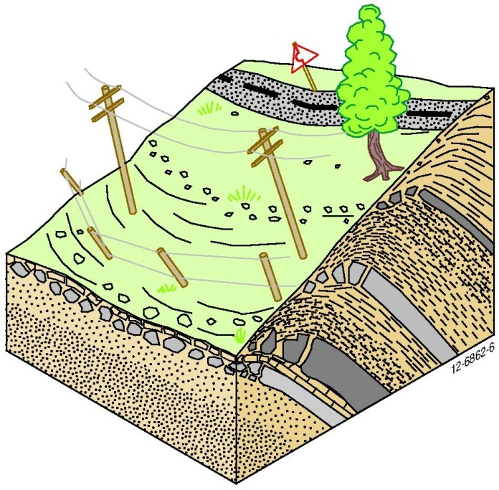
Figure 7: Soil creep causes the gradual movement of regolith downslope. It can subtly change the landscape and bend structures like fences and roads.

Slope failure
The constant stress of gravity can make all hills and mountains susceptible to failure. When this does occur, the rocks and debris settle downslope into a more stable position. The following are examples (Figure 9) of types of slope failure:
Slump – These involve a downward rotational movement with characteristic concave-up slip surfaces. Slumps are a common type of mass movement as they often occur as a result of humans modifying the landscape. Slumps are more likely to occur after heavy rains or from sudden shocks like earthquakes. These are very common on cleared hillsides in eastern Australia and are best seen when the sun is very low in the sky at dawn or dusk.
Rock/debris falls and slides – Rock falls and slides occur when unattached rocks and boulders fall from a cliff or down a steep slope. They often occur in rainy mountainous areas. Debris falls differ in that when a mountain slope collapses not only the rock but all the overlying regolith and vegetation is generally involved.
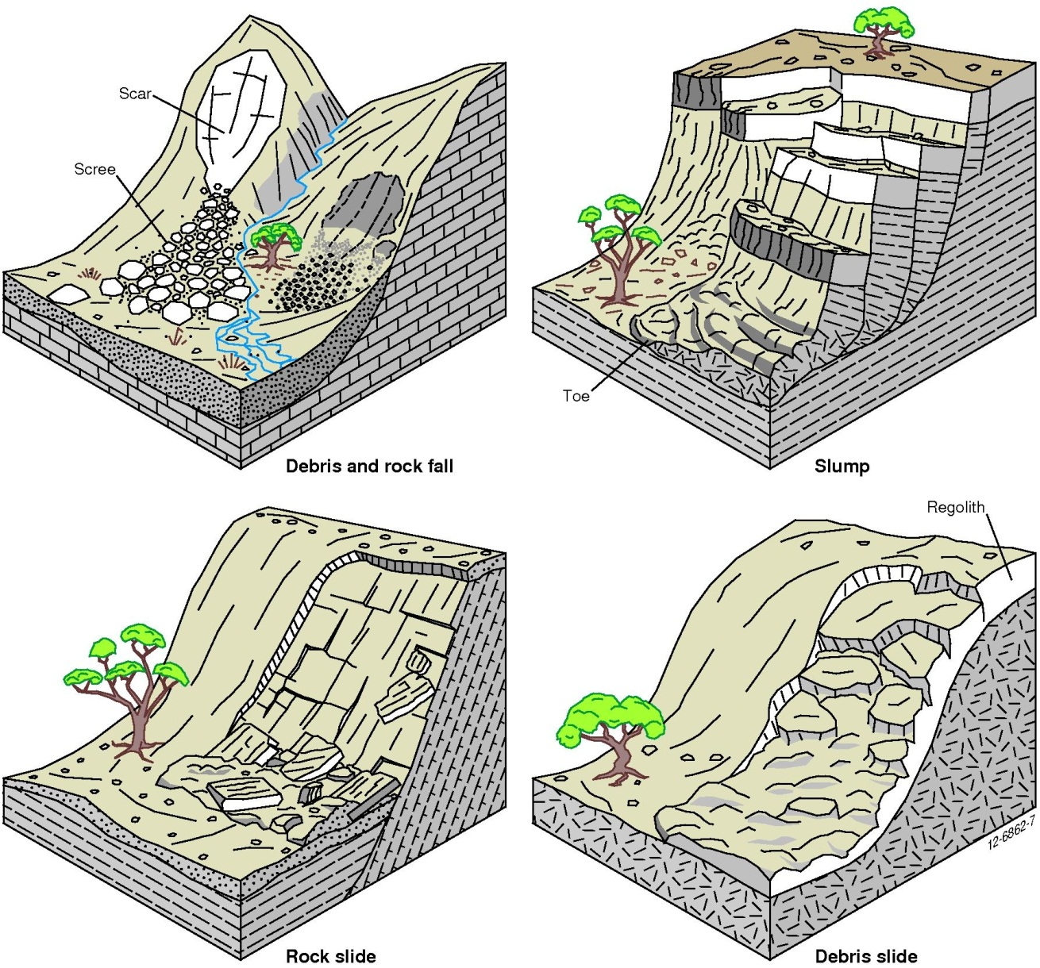
Figure 8: Examples of slope failure resulting in slumps as well as rock and debris falls and slides.

Sediment flows
Sediment flows have more water in the equation and are therefore more fluid than slope failures.
Earthflow – The shape of an earth flow is similar to a slump but happens faster and does not retain the internal cohesion that is a feature of slumps.
Mudflows – These normally flow further and faster than earthflows because there is more water present. They are synonymous with debris flows but have enough water to make them highly fluid. These are very common after heavy rain and frequently occur during cyclones or hurricanes.
Lahars – These are volcanically-derived mudflows. A good example is the mudflow related to the eruption of Mt. St. Helens in the USA, where the volcanic eruption melted the snowcap of the mountain, which then created a lahar. Lahars can travel at up to 100 kilometres per hour and many tens of kilometres. The 1953 Tangiwai railway disaster in New Zealand was caused by a lahar from Mt Ruapehu; it eroded the supports of a rail bridge on the Wellington to Auckland rail line minutes before the train arrived. The disaster killed 151 when the train plunged into the Whangaehu River valley. Lahars are also common in the Andes mountain range of South America and are equally if not very much more deadly than those in other parts of the world.
Debris flow – These are similar to mudflows but have larger and less well-sorted rock materials present. When flowing, a typical debris flow moves along a stream channel and can spread across an alluvial fan to form a poorly sorted deposit.
Debris avalanche – These are rare events and consequently are poorly understood. When moving, they travel at speeds of tens to hundreds of kilometres per hour and can be highly destructive. They can result from large rock falls or as collapses on the flanks of steep stratovolcanoes.

Wind in action
If you have ever seen a whirlwind (“willy-willy”) or a dust storm, you have seen wind erosion and transport in action. Even more powerful are the effects of cyclones, hurricanes and tornadoes as they rip trees out of the ground and pull houses to pieces. Wind is an important agent of erosion, transport and deposition, but is largely forgotten, except in desert regions where it is more obvious.

Erosion
The wind erodes in two ways:
1) Deflation - the picking up and transport of dust, sand and loose rock fragments by the wind.
2) Abrasion - sediments wear away rocks by impact.

Transport
Sand, silt and clay particles can be transported by suspension, saltation or by creep, depending on the size, shape and density of the particle (Figure 9). Suspension carries the lightest wind-blown particles and is a common transportation method for dust, which is composed of clay and silt-sized particles (see Wentworth size classes in the Glossary). Dust can be carried at very high altitudes over long distances, hence the common occurrence of dust present in New Zealand after being transported from Australia and likewise with dust from Saharan Africa deposited in the USA.
Saltation accounts for at least three-quarters of sand transport in areas where sand dunes are present. When wind blows across sand the sand grains will begin to move if the speed of the wind rises above a certain threshold. Increasing wind speed causes grains to creep, rolling along the ground. If wind speed increases further, saltation occurs when a sand grain collides with a second grain, knocking it into the air. When the second grain falls to the ground it can hit another one, so the process keeps going. These saltating sand grains rarely rise far from the ground. The process of saltation is also active in fluvial environments such as rivers. You would have experienced saltation as sand grains stinging your legs if you’ve been to the beach on a windy day.
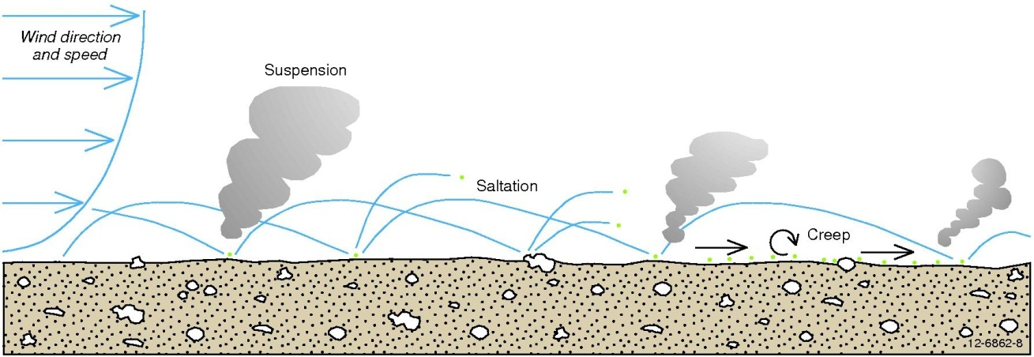
Figure 9: Modes of sediment transport in both wind and water: suspension, saltation and creep.

Deposition
Wind-blown dust can be transported over very long distances. Dust from a February 1983 dust storm wreaked havoc in Melbourne but was also seen depositing in New Zealand! Dust is also present on and in polar ice-sheets and can be correlated with drier world conditions from millions of years ago, particularly during ice ages.
Loess is wind-blown dust that can form thick sheets of silt, fine sand and clay. Parna is the name given to a particular type of loess that is common in Australia which is composed of silt and fine sand-sized clay aggregates, often bound together by salt (halite) or carbonate minerals. Loess can be an important resource in countries where it is thick and widespread. Loess produces rich agricultural soils and is present in areas like the Mississippi Valley, USA, and the Qinghai-Tibet Plateau and Loess Plateau in China.
Dunes are probably the most well-known deposit from wind transport. Dunes are hills or ridges that are formed by deposited sand and are found in a variety of landscapes, including deserts and beaches. Dunes can come in all shapes and sizes such as crescent-shaped barchan dunes, transverse dunes that are perpendicular to the strongest wind direction, star dunes with sinuous radiating arms and parabolic dunes that are shaped like a V or U and are common on the coast. Sand ripples are a smaller version of dunes and are made up of well-sorted but unstable sheets of sand.
Volcanic ash from volcanic eruptions is transported globally by the wind. Although most of the large particles fall out quickly, the fine ash may circle the Earth many times before settling. The plume from the Mt. Pinatubo eruptions in June 1991 sent plumes of ash high into the stratosphere and created spectacular sunsets worldwide for several years. Volcanic ash, because it is composed primarily of volcanic glass, is a particular geohazard to aircraft flying through ash clouds. In 1982, a British Airways 747 was flying from Kuala Lumpur, Malaysia, to Perth, Western Australia, when it entered an ash cloud that had erupted from the Mount Galunggung volcano in Indonesia. The aircraft lost power to all four engines but managed (after much effort by the pilots) to restart all four engines (one failed again a little later) and land safely in Jakarta. It was later discovered that the volcanic ash had melted into glass on the insides of the engines and had sand-blasted all the paint from the aircraft’s nose and wings. The ash had also sand-blasted most of the front windows, making it near-impossible for the pilots to see out!

Erosion and transportation by ice (glaciers)
Glaciers can form in any place where snow fall exceeds snow melt. As more and more snow accumulates it becomes more dense and is fused into ice. After accumulating for many years the thick layers of snow and ice begin to move downhill under the force of gravity and a glacier is then born.
Glaciers can be classified by their shape and size as cirque, valley, fjord and piedmont glaciers (Figure 10). An ice sheet is the largest type of glacier in the world. Ice sheets currently cover Greenland and Antarctica and contain 95% of all the ice existing in glaciers. If these ice sheets were to melt they would raise sea levels by almost 66 metres.
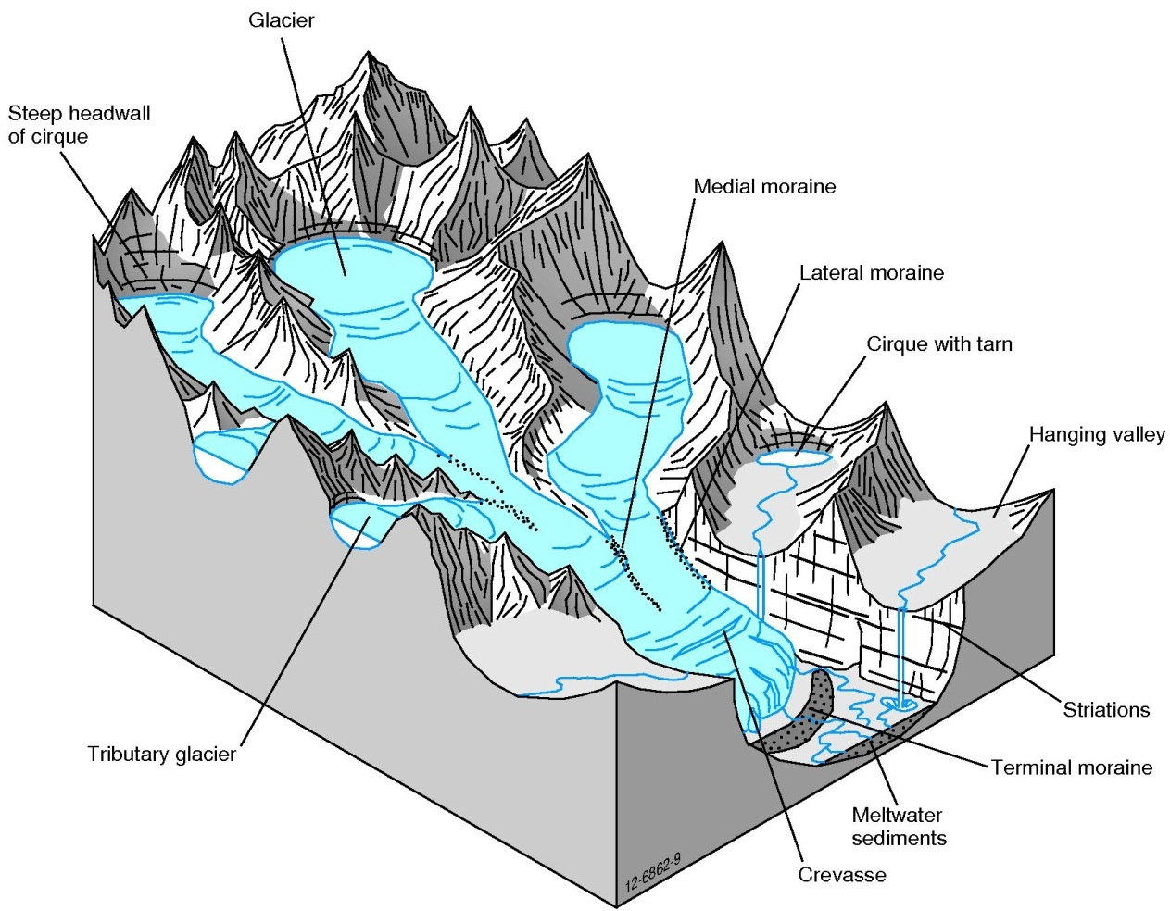
Figure 10: Typical features of a glacier.
As glaciers move they carry boulders and debris that has fallen onto the surface of the glacier from the valley walls and move them for kilometres until they reach the face or terminus of the glacier. This may take many years, but if the position of the boulder is carefully measured, the boulder may be seen to move some several metres per year down the glacier.
Due to the sheer weight of the compacted ice and the debris present at the base of the glacier, as it moves down a valley the glacier scrapes up the materials beneath and beside it, sometimes eroding the Earth back to bare rock. A glacier can pluck out blocks of bedrock and plough the debris into piles at the face of the glacier.
Glacial striations are formed as rocks and debris underneath and sides of the glacier scrape and scratch the bedrock in a nearly parallel pattern. As larger rocks are dragged along by the glacier, glacial grooves form and are aligned to the direction of the glacial flow. Geologists are able to use these grooves and striations to determine which way former glaciers flowed.
Glaciers are renowned for the U-shaped valley they leave behind. This differs from the V-shaped valley that rivers create in their early life. A glacier is like a river of ice, but the main difference is that instead of transporting sediments, a glacier can actually cut deep into the unweathered bedrock. The transported material, including the gouged-out rock, is locked into the ice. Unlike transportation by wind and streams, glaciers are able to transport large boulders and small rocks without any degree of sorting according to size or density. As a result, sediments deposited directly by a glacier are not sorted or stratified. Underneath the glacier, fine sands and silts accumulate. These are very angular and were made from the crushing and grinding of rocks beneath the ice. As a glacier moves, the rocks and debris that accumulate can be deposited if the ice thickness decreases. Some of the debris from the base of the glacier is deposited directly as till. Some of the debris ends up being released into the meltwater. Any debris that is deposited by the glacier but bears no relation to the underlying bedrock is called a moraine.
The term ‘glacial retreat’ is not an entirely accurate description because a glacier always advances downhill. The term refers to the fact that the ice at the lower end of the glacier melts faster than the glacier advances, thus giving the appearance that it is retreating back up the mountain. Many glaciers today are retreating. This is one piece of evidence pointing to global warming as a real phenomenon.
Glaciers are currently retreating from the continents of North and South America, Europe, Asia and New Zealand. There has not been enough time to erase the effects of these glaciers, hence features such as striations, grooves and glacial tills are still relatively fresh. In these countries the landscape does not remain devoid of plants and animals for long and the plant community progressively establishes to its climax stage. This process is called ecological succession. The landscape is initially colonised by pioneer species that modify the environment enough for the next variety of species to replace the pioneers. This continues until a climax community is eventually founded. Establishing plant communities can modify the environment by increasing organic carbon and nitrogen concentrations and changing the soil pH.
In areas of recent glaciation the plant communities that develop on glacial moraines are used to determine the age of the glacial retreat. An example of glacial moraine succession in operation comes from Glacier Bay in southeastern Alaska. Since around 1750 the glaciers in this region have retreated about 100 kilometres. The pattern of glacial succession on the exposed glacial till in the region is described below:
1. Mosses, fireweed, Dryas (a hardy relative of oleander), willows (as low ground cover) and cottonwood are the first to colonise. The willows develop into communities of small shrubs, which are quickly invaded by alder (Alnus). The alder grows into dense thickets that reach up to nine metres tall. This requires about 50 years.
2. In the next 120 years the alder thicket is overrun by Sitka spruce that forms a dense forest.
3. Western hemlock and mountain hemlock invade the spruce forests. After approximately 120 years a climax community is established.
4. If the land has poor drainage, however, Sphagnum mosses grow on the forest floor. The moss acidifies the soil and the hemlock is unable to survive. The trees die from increased acidity, the waterlogging of the soil and the lack of oxygen around their roots. The climax vegetation in poorly drained areas is Sphagnum bog or muskeg.

Weathering and erosion – some examples

Sedimentary landforms
Activity: Tour’osion

The Twelve Apostles, Victoria
The Twelve Apostles are stacks and are a great example of weathering in action (although there are not actually ‘12’ of them). They are an example of a retreating limestone coastline that is under attack by waves (Figure 11). Ten to twelve million years ago tiny skeletons of marine animals like molluscs, bryozoans and brachiopods were deposited on the sea floor. Thick layers of skeletons were cemented together to form limestone rock. By the end of the Miocene (5 million years ago) much of the limestone that was once covered by water was exposed to air and weathering and erosion began. Waves pounded against the shore. Gradually the constant attack of the waves wore the soft limestone away along vertical fractures and horizontal bedding planes and the limestone was sculpted into vertical cliffs. Varying hardness of the limestone has caused its jagged appearance as softer parts of the limestone are eroded faster than the harder parts. This feature is not limited to the Port Campbell area and is a common feature along the Victorian and South Australian coastline.
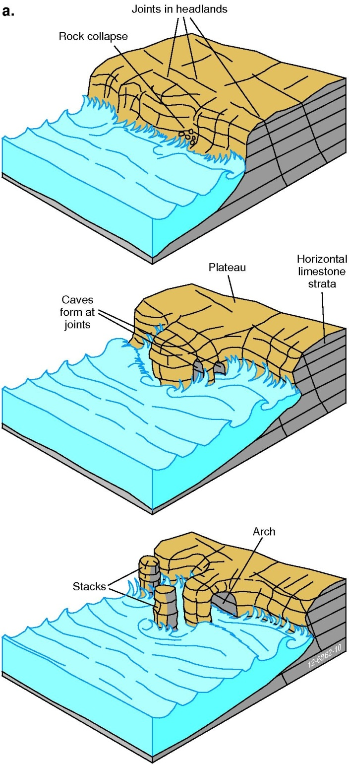 b 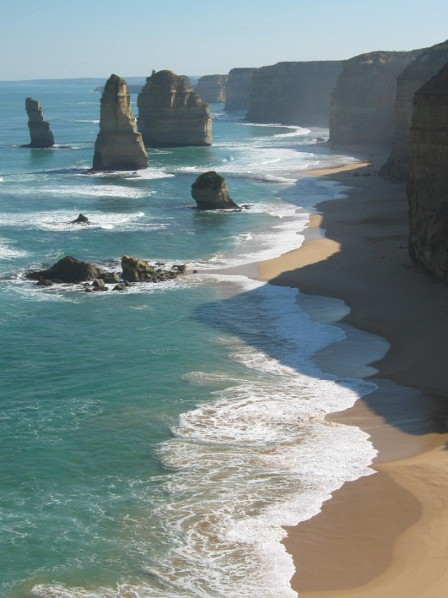
Figure 11: a) Stages in the formation of the Twelve Apostles b) Twelve Apostles. Photo credit: Kathryn Owen.
The cliffs are under attack from the sea, sea spray and rain as well as wind and water carrying abrasive sand and gravel. The cliffs are undercut by the waves pounding the cliffs and caves are formed. As time progresses, the caves widen into arches. Later the tops of the arches collapse and the stacks are the only remnant of the cliff to remain. The next step, of course, is for the stack to be undercut and fall into the ocean to form a reef.
‘London Bridge’, as it was once called, is a good example of rapid coastal change due to weathering and erosion. It was once two arches attached to a headland in the Port Campbell area. In 1990 the arch closest to the land collapsed forming a stack. Several tourists were trapped on the stack and had to be rescued by helicopter.

Little Sahara, Kangaroo Island, South Australia
The “Little Sahara” is a dune field on the south coast of Kangaroo Island. With an area of approximately 400 hectares, it extends about three kilometres inland and is composed of four main east-west trending longitudinal dunes. The dunes rise up to 50 m high and have sharp, well-defined crests. They are currently advancing north along the coastline and provide a living example of coastal dune stabilisation and vegetative succession. The dunes are initially colonised by hardy grasses and scattered shrubs, mainly coastal wattle. This plant is eventually succeeded by mallee (Eucalyptus sp.), which is the climax community.

Purnululu (The Bungle Bungle Ranges), Western Australia
Purnululu is located in the Kimberley region of north-western Australia in the Purnululu National Park. The park is famous for its beehive-shaped sandstone towers and gorges (Figure 12). These sandstone beehives make up less than 20 percent of the actual area of the National Park, and can be found in the south-western and north-eastern parts of the range. Sandstone beehives similar to the ones in the Kimberleys can be found in the Sahara Desert in northern Africa, in northern Australia near Kununurra and south of Halls Creek in the Canning Desert.
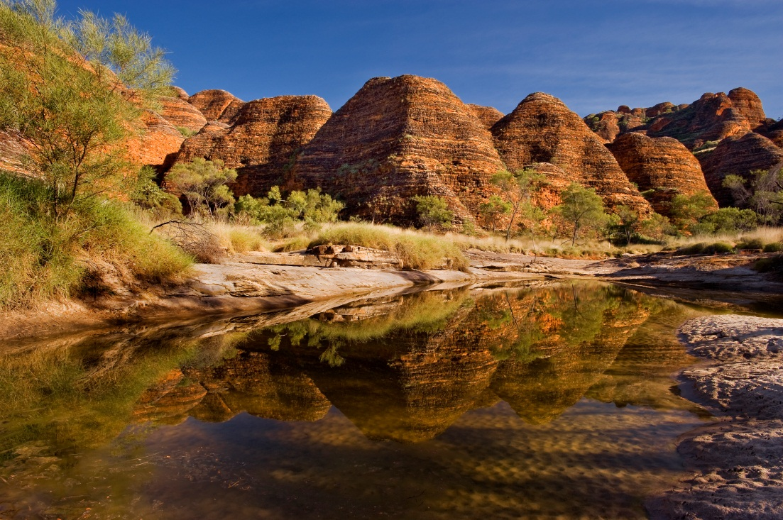
Figure 12: Bungle Bungle Ranges, WA. Credit: Jim Mason

How did they form?
The sandstone that makes up the beehives was formed when braided rivers deposited layers of sand and gravel in a large shallow depression. These sediments were the end product of 250 million years of erosion of an ancient mountain range. Over millions of years the layers of sand and gravel were loosely cemented into rock. From about 20 million years ago the landscape began to erode again after a drop in sea level (or a rise in the land surface) of about 300 metres. The sandstone began eroding along joints in the rock. There are two main sets; one trending north-west and the other trending north-east. Creeks and rivers have cut down along these weaknesses to form gorges and carved out the beehives (Figure 13).
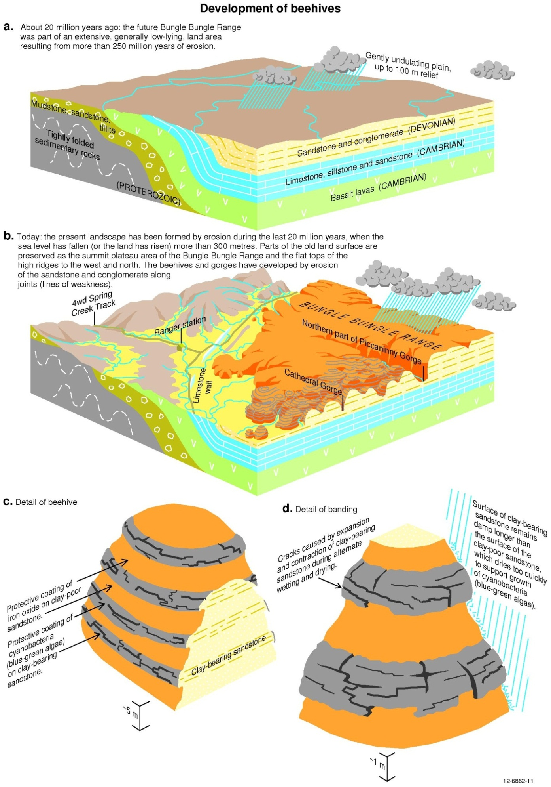Figure 13: The development of sandstone beehives, Purnululu.
The shape of the beehives is similar to that formed in karst topography (see page 33). The landforms are not the result of chemical weathering, but have formed principally from mechanical weathering and the physical removal of grains of sandstone, predominantly by running water and also by wind, rain, plants and animals. Because there is hardly any cementing agent (like clay and silica) between the sand grains the unweathered sandstone easily rubs away – even with your fingers! This is why climbing on the beehives is prohibited. If these sandstones are so erodible, why have they not all eroded away? This is because the individual sand grains lock tightly together to form the vertical cliffs. They also have a protective coating which is explained below.

So why are they called the Beehives?
Layers of parallel sandstone and clay-bearing sandstone cause the alternating orange and dark grey beehive pattern on the sandstone pillars (Figure 13). Each band is a few metres thick and has internal layering within. The dark-grey layers have a protective coating of cyanobacteria (formerly known as ‘blue-green’ algae). Why the cyanobacteria are only present on the darker beds could be attributed to slight changes in the physical characteristics such as clay content and porosity. The orange sandstone layers may dry out too quickly for the cyanobacteria to survive - they are coated with an iron-oxide. Although these coatings are only a few millimetres thick, they hinder the weathering and erosion of the delicate white and pale grey sandstone beneath.

Weathered volcanic rocks
Seventeen million years ago volcanic activity commenced in the area that is now known as the Warrumbungles, near Coonabarabran in New South Wales. It was part of the ‘hot spot’ volcanism that occurred from north to south along the east coast of Australia as the continent has drifted slowly northwards, much like the way the Hawaiian Island chain is forming today. By around 13 million years ago a large shield volcano had formed that was 50 km across (Figure 14). Over time, erosion has carved away at the weathered volcano to reveal a series of spectacular landforms.
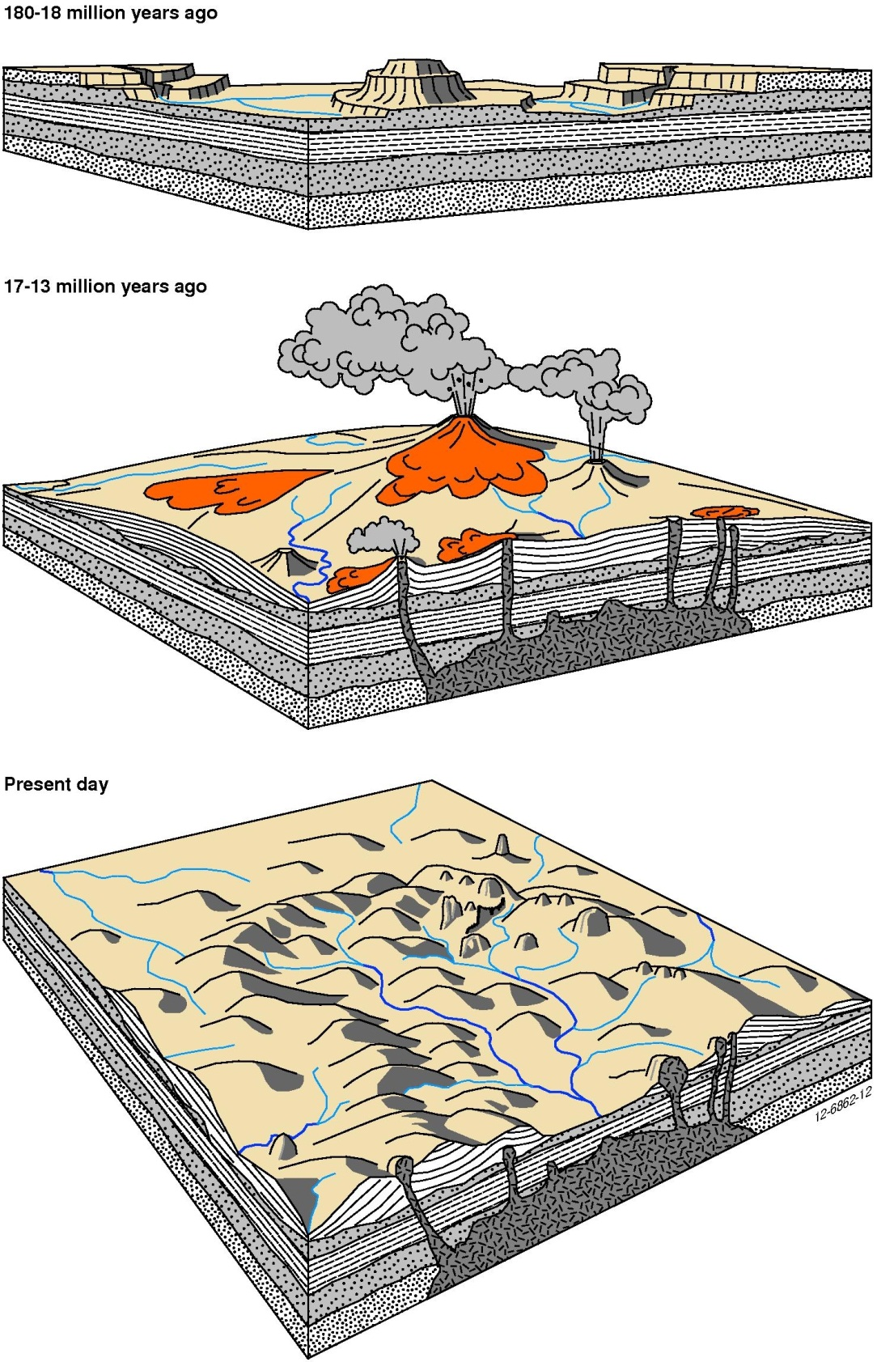
Figure 14: Diagrammatic representation of the evolution of the Warrumbungles.
The more easily weathered rocks like tuffs and breccias have all but gone, leaving only the most resistant parts – the plugs, dykes and domes (the veins and arteries of the volcano). What we see today is the remnant of what once was (Figure 15). Famous features like the Breadknife (Figure 16) and Bluff Mountain are all that is left of the once massive shield volcano. These weathered remnants show joints caused by shrinkage of the cooling magma. The hexagonal pattern is known as columnar jointing.
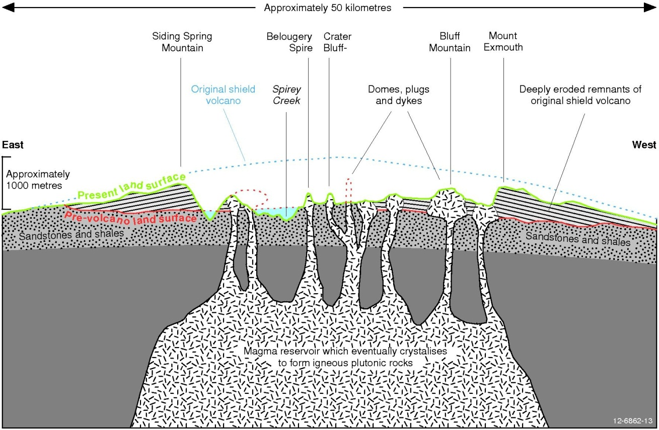
Figure 15: A diagrammatic cross section of what remains of the Warrumbungles.
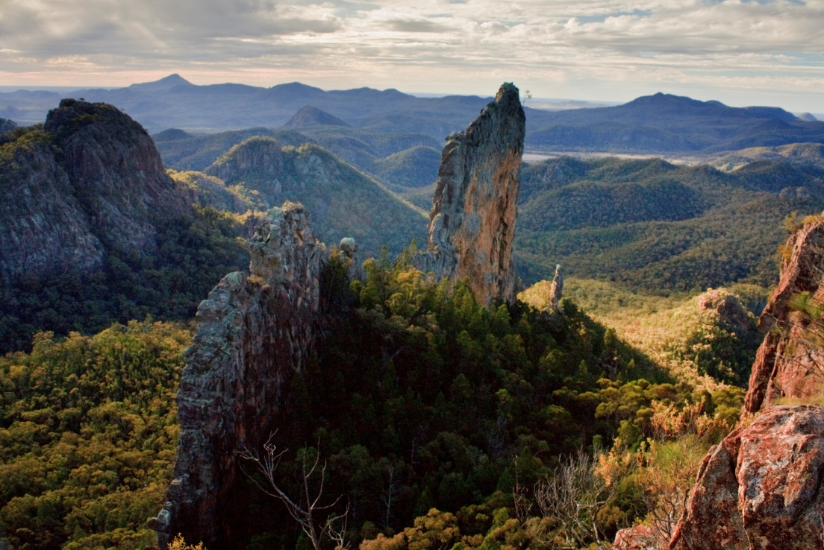
Figure 16: Weathering and erosion of volcanic plugs resulting in features like the Breadknife, Warrumbungles, NSW. Source: Wikipedia Commons.

Granite weathering

Karlwekarlwe (The Devil’s Marbles), Northern Territory
The famous granite boulders known as the ‘Devil’s Marbles’ got their name from their likeness to a bunch of giant marbles that have been scattered in heaps in a valley (Figure 17). Kundjarra or the ‘Devil’s Pebbles’ are a similar formation located in the same region near Tennant Creek.
The Devil’s Marbles originally formed part of a large mass of granite that succumbed to the processes of weathering and erosion over the past 1700 million years (Figure 18).
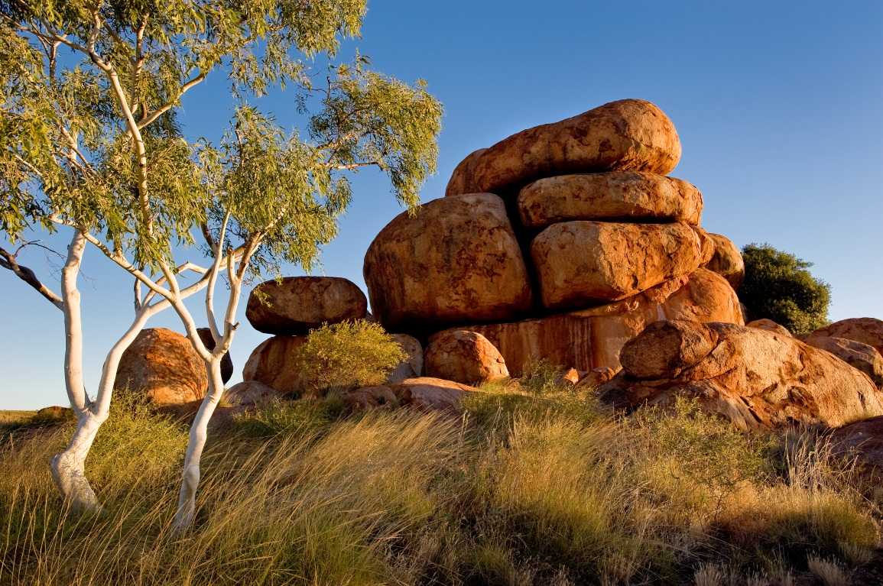
Figure 17: Devil’s Marbles. Credit: Jim Mason
The pluton had three main sets of joint planes which opened as a result of unloading. Water was able to penetrate along the planes to begin the weathering process. As the granite body weathered, it was split into rectangular blocks that were three to seven metres square. Further weathering in the joints and exfoliation rounded the corners of the boulders. The surface soil was eroded away to reveal the rounded boulders that we see today. See “Mechanisms of Weathering” on page 3.
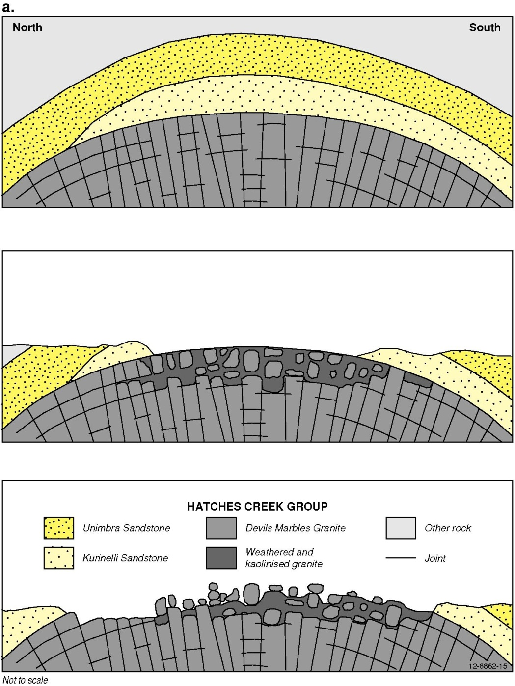
Figure 18: The progression of weathering that formed the Devil’s Marbles. As the overlying rock and regolith are removed rounded boulders of granite develop.

Remarkable Rocks, Kangaroo Island, South Australia
The curious house-sized boulders of granite that make up the Remarkable Rocks can be found perched on the cliffs on the Kangaroo Island coastline (Figure 19). The granite was formed between 470 and 500 million years ago in the Late Cambrian to Early Ordovician. As time progressed, the surface material was stripped on the seaward (southern) side to uncover a large granite dome. There are very few persistent vertical joints present, hence the domal appearance of the rock because joints here are mostly parallel to the land surface because of unloading. The seaward side of the rocks are particularly weathered into tafoni, or caverns; sea-spray is an obvious contributor to the cavernous appearance. All of the granite boulders have pits and excavated hollows (tafoni) formed on their underside. These have most likely formed from salt crystallising in the rock surface, as well as from spheroidal weathering (see “Physical Weathering” on page 4).
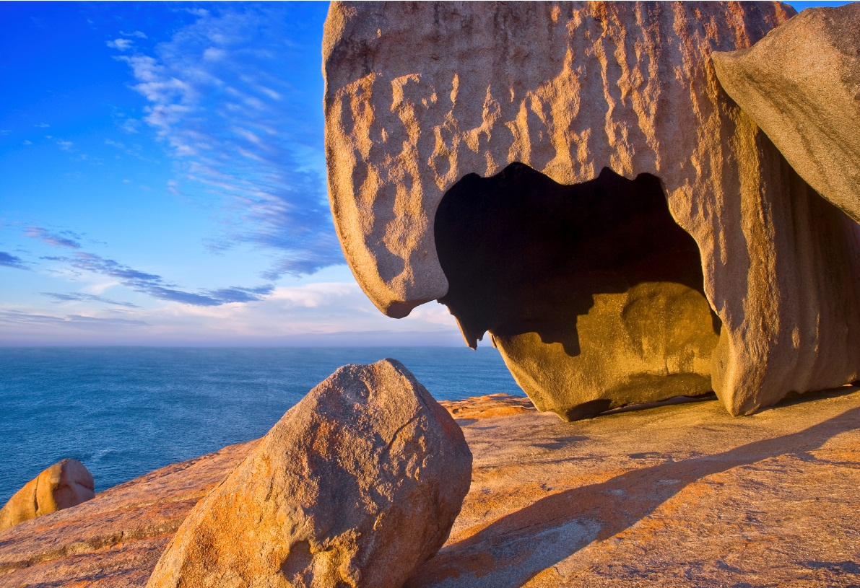
Figure 19: Remarkable Rocks, Kangaroo Island, an example of tafoni. Credit: Jim Mason.

Glacial landscapes

Pleistocene glaciation in Australia
During the Pleistocene Epoch parts of Australia were affected by active glaciation including the Australia Alps and Tasmania.
In the Australian Alps, the highest part of the Kosciuszko National Park in New South Wales contains remnant glacial landscapes. A number of glacial landforms survive include cirques (circular depressions where glaciers nucleated, like the Blue Lake cirque) which hold tarns (a steep-sided mountain lake, often formed by glaciers, like Blue Lake), glacial striations, lateral moraines and terminal moraines. Similar landforms also occur throughout the elevated parts of Tasmania (the Central Highlands and Central Plateau), which was much more extensively glaciated in the Pleistocene than the Kosciuszko area. Isotopic dating of moraine deposits in the Kosciuszko National Park indicate that there were at least three cycles of glaciation at about 59 000 years, 32 000 years and between 19 000 and 17 000 years ago

Hallett Cove, South Australia
Hallett Cove is located in Adelaide’s southern suburbs and is famous for the excellent preservation of evidence from the Permian glaciation that affected much of Australia when it was still part of Gondwana. Evidence of the Permian glaciation can be found in throughout Australia as the physical marks that glaciers leave behind including at Hallet Cove and in the Paterson region of Western Australia, as well as in sediments exposed in river and road cuttings and in drill holes wherever Permian rocks occur throughout Australia.
The oldest rocks at Hallett Cove were formed around 600 million years ago on tidal flats in the Neoproterozoic Era. These sedimentary siltstones and sandstones were uplifted to form mountains around 500 million years ago. They were then weathered away for the next 220 million years.
From 270-298 million years ago (during the Permian), much of southern Australia was covered by a huge ice sheet, much like Antarctica is today. Australia was still part of the supercontinent of Gondwana, along with Antarctica, South America and India.
As the ice over Hallett Cove moved in a north-westerly direction, it scratched and polished the exposed rock surfaces like a giant piece of sandpaper. At the same time, rock fragments dragged underneath the ice sheet made large, straight scratches called striations. These glacial pavements can be clearly seen along the cliff tops in the area. As the ice began to melt, large boulders (glacial erratics) were left behind in the area and glacial sediments were deposited in a lake dammed by a wall of ice. Eventually, the Earth warmed and the glaciers melted and retreated, leaving the moraines and other signs of their progress behind. Modern erosion has formed the present-day cliffs, wave-cut platforms and beaches.

Franz Josef Glacier, New Zealand
The Franz Josef Glacier is one of two glaciers located in the Westland National Park of New Zealand’s Southern Alps. The Glacier descends 2 500 metres over a very short distance. The rate at which this very steep glacier is moving is amazing - an aeroplane that crashed 3½ kilometres from Franz Josef’s terminal face in 1943 ended up at the bottom 6½ years later. When the speed is calculated, the Glacier must have been moving at a rate of 1½ metres per day for this to happen!
As it is moving so quickly, Franz Josef Glacier responds quickly to changes in world climatic conditions. This is not characteristic of most glaciers. Its advance and retreat is directly proportional to the amount of snow that falls in the Southern Alps and how fast the terminal face melts.
Huge chunks of rock can be seen strewn on the valley floor below the glacier and in moraine heaps after being eroded and transported from the valley walls and base of Franz Josef. Braided rivers formed from melt water at the terminus of the glacier transport these fragments, which become progressively more rounded as a result. Terraces are also present on the valley walls that tell the story of previous advances and retreats of the glacier.

Desert landforms
Desert regions are quite distinct from other environments, in that they experience very low rainfall and can have dramatic day-night temperature variations. Physical weathering tends to dominate through wind erosion and thermal weathering at the surface. As a result unique landforms characteristic of arid regions develop. These include:
- Inselbergs: German for ‘island mountain’ are isolated rocky hills found surrounded by a flat plain. Inselbergs can be found in southern and central Africa, north western Brazil and central Australia. Inselbergs, like Uluru or Mt Connor, form from a relatively homogenous hard rock like granite and gneiss but can also form from sedimentary rocks like sandstone. Over a long period of time, differential weathering leaves the more resistant island of rock standing out from the surrounding eroded plain. Deserts are not, however, the only environment in which the inselbergs occur and they can be found from coastal to interior and arid to humid environments.
- Buttes and mesas: These are isolated steep-sided hills or pillars with flat tops that are erosional remnants of past land surfaces. These landscapes were made famous in the Road Runner cartoons (beep beep!). Buttes and mesas are common in the Great Australian Basin (Queensland, New South Wales and South Australia) and the Pilbara region of Western Australia where they are often the remnants of earlier drainage systems left high and dry by relief inversion. Generally speaking, buttes are smaller than mesas. The main characteristic of a mesa is that it looks like an elevated piece of land with a flat top, rather than looking like a hill.
- Desert lakes and playas: Runoff in deserts is rarely enough to sustain permanent lakes. Desert basins often have a dry lake bed, known as a playa. Salt crusts are often present on their surface as a result of the concentration of salts from the water by evaporation. These can form layers with thicknesses of tens of metres and are a source of industrial chemicals like gypsum. Lake Eyre – Australia’s most famous salt lake or playa – shrinks and swells with the seasons and can be brim-full one year and bone dry the next.
- Desert pavements: When sand and dust are removed by processes of wind erosion and sheet erosion, those stones that are too big to be removed are concentrated at the surface. These stones cap the underlying finer sediments and so prevent further erosion and look a little like a cobblestone pavement, hence the name. The Gibber Desert in Australia is a classic example. The stones are commonly polished and shaped by wind blown sand and are known as ventifacts.

Uluru (Ayers Rock), Northern Territory
What we see of Uluru today is like the tip of an iceberg (as is Kata Tjuta – The Olgas – or should that be “the tip on an inselberg?” shown in (Figure 21). Uluru towers 348 metres above the surrounding sand plains. Much of the huge rock mass that makes up Uluru is buried beneath the site (probably for several kilometres) and evolved through a complex history of deposition, uplift and erosion.
The sediments that formed Uluru began their life 550 million years ago as alluvial fans deposited at the base of some ancient mountains that have now eroded away (Figure 20).
The fan-shaped deposits of sediment were eroded from the mountains and consisted mainly of sand and small pebbles of quartz and feldspar. When the loose sediments were gradually cemented into rock, they formed a type of sandstone called arkose. After the development of the alluvial fans ceased, a shallow inland sea then inundated the region. Deposits of sand, mud and limestone gradually covered up the alluvial fan. About 400 million years ago there was another period of folding, faulting and uplift that moved the Uluru Arkose (the sedimentary rock that makes up Uluru) to its current position. Erosion has preferentially worn away the surrounding softer limestone and sedimentary rocks to leave the more resistant layers that form Uluru standing proud of the plain.
a) 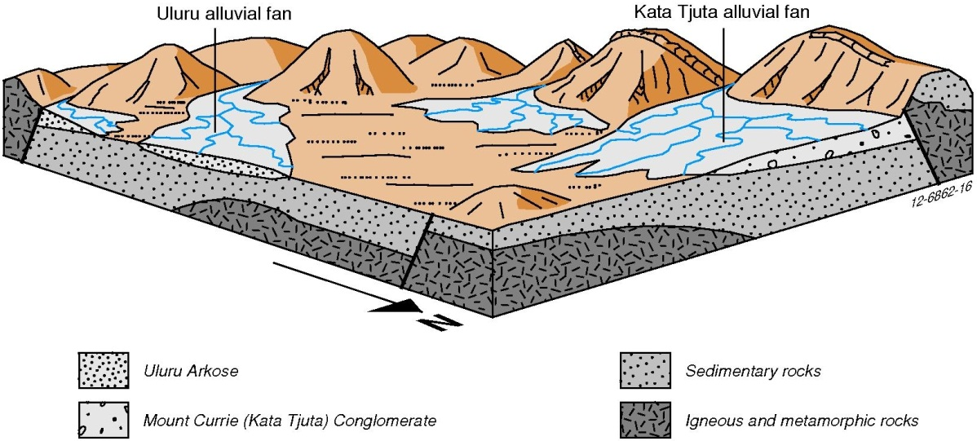
b) 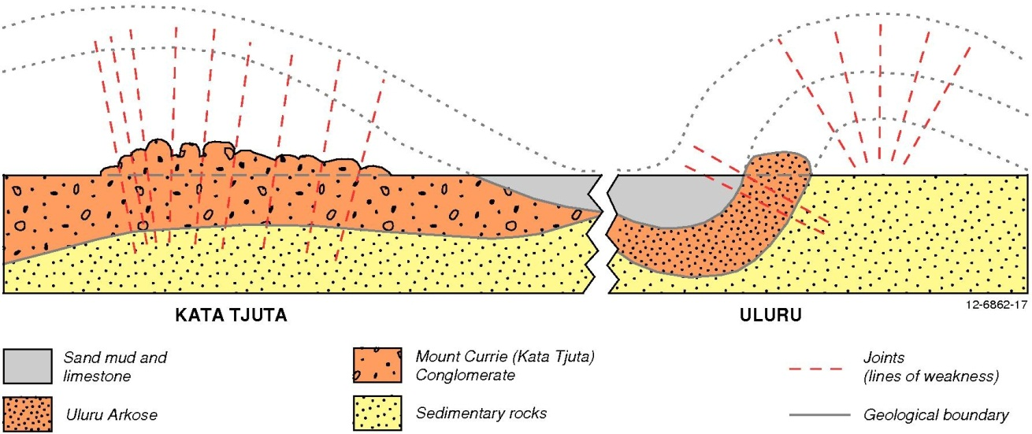
Figure 20: a) The formation of Uluru and Kata Tjuta began as a series of alluvial fans eroding from a big mountain range. b) Diagrammatic representation of the development of Uluru and Kata Tjuta.
Many great examples of weathering and erosion features can be seen at Uluru – some of these processes have actually preserved the rock. Although Uluru appears to have a flat top, there are ridges present on the surface and down the flanks. This is the result of slight differences in the hardness of the rock layers. Small hollows also collect rain and prolong the weathering around these hollows. This favours the dissolution of iron-rich minerals from the rock and these minerals build a tough crust where they precipitate on the lower faces of the rock. They can be seen as ribbon-like deposits of “Desert Varnish” forming stripes down the sides of the rock, protecting part of the rock from further weathering.
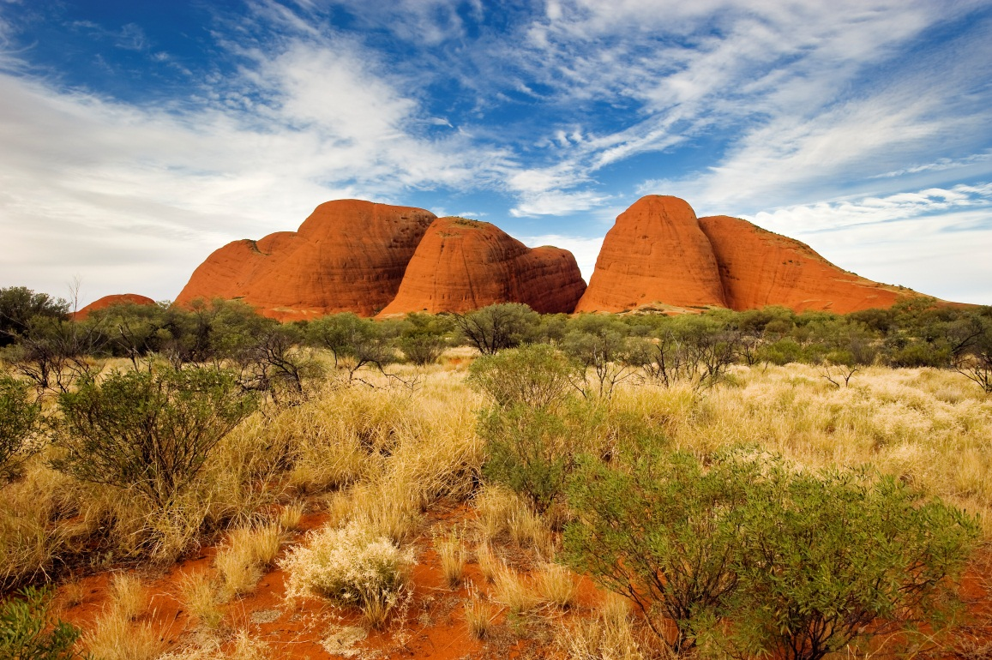
Figure 21: Kata Tjuta. Credit: Jim Mason.
Where the protective crust has been broken, pitted honeycomb features like “The Brain” are present (Figure 22). The constant heating and cooling of the rock in the desert environment may have led to cracks forming in the surface of the rock. Rainwater would have then been able to penetrate the rock surface, preferentially weathering the rock to form “The Brain”. The soft, loose pieces of rock would then be washed away by rain or blown away by the wind.
The “Kangaroo Tail”, or “the Digging Stick” (Figure 22) is likely to have formed from small localised joints that formed when the pressure of the rock above and beside was removed. As the rock expanded outwards, the joints were separated from the main body of rock.
A very unusual erosion feature is caused by lightning, and is most common around the breaks in the chain where tourists climb the rock. The chain appears to act as a conductor that directs the lightning. It forms an exposed zone where the lightning has travelled along the wet surface of the rock and stripped it back, probably by creating small explosions of steam.
a)
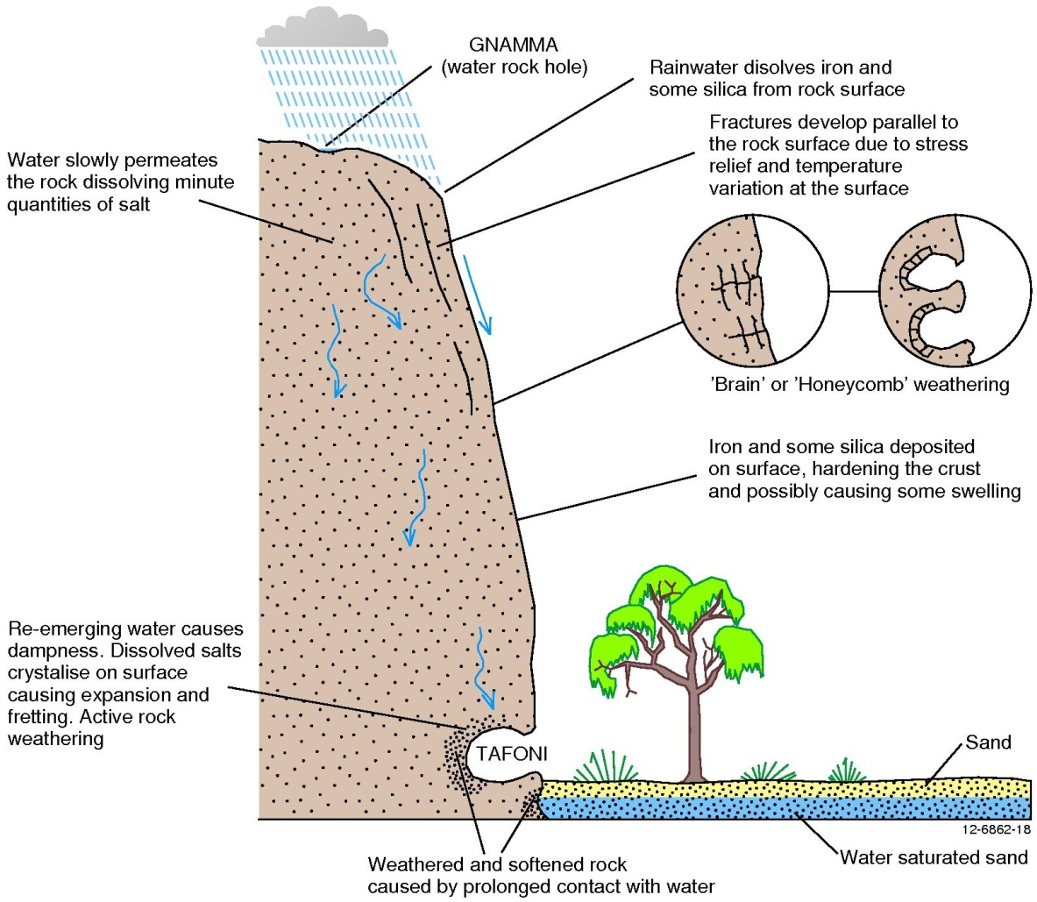
b)
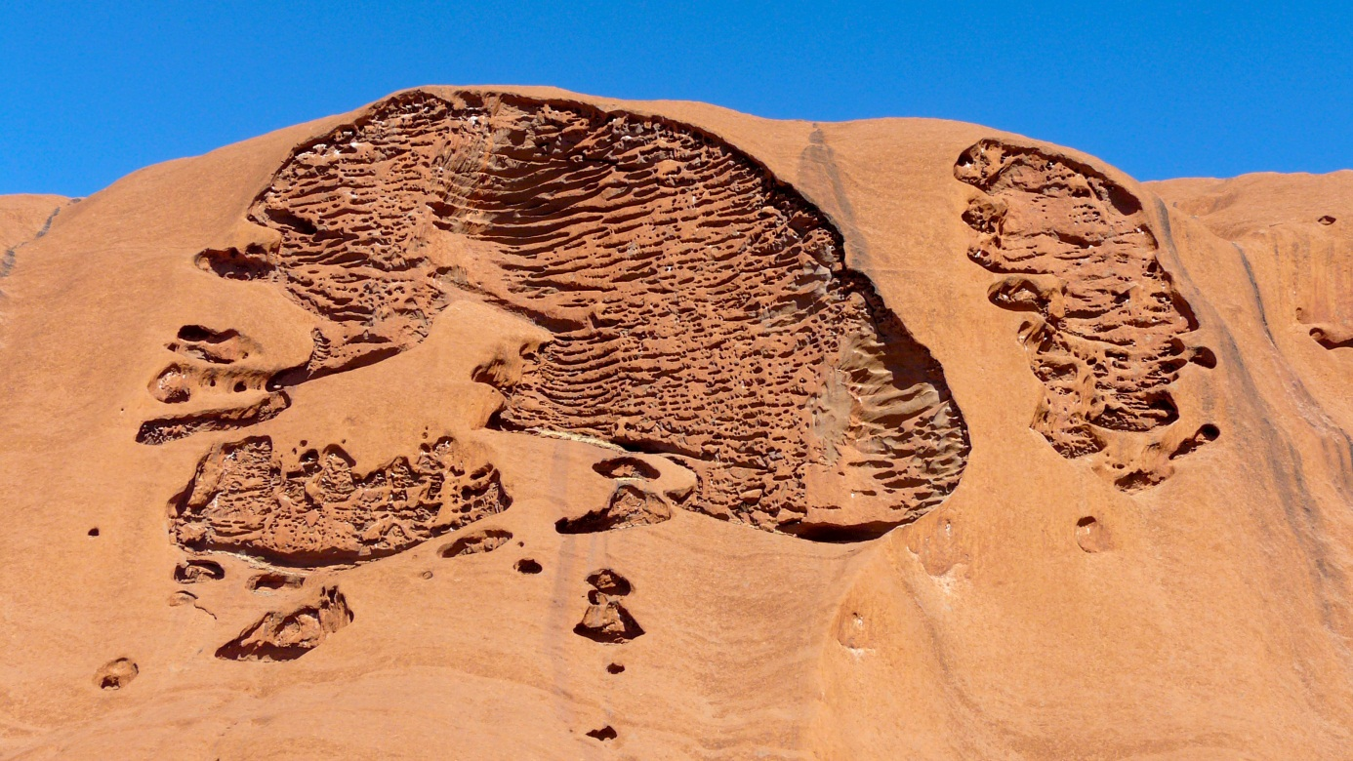
c)
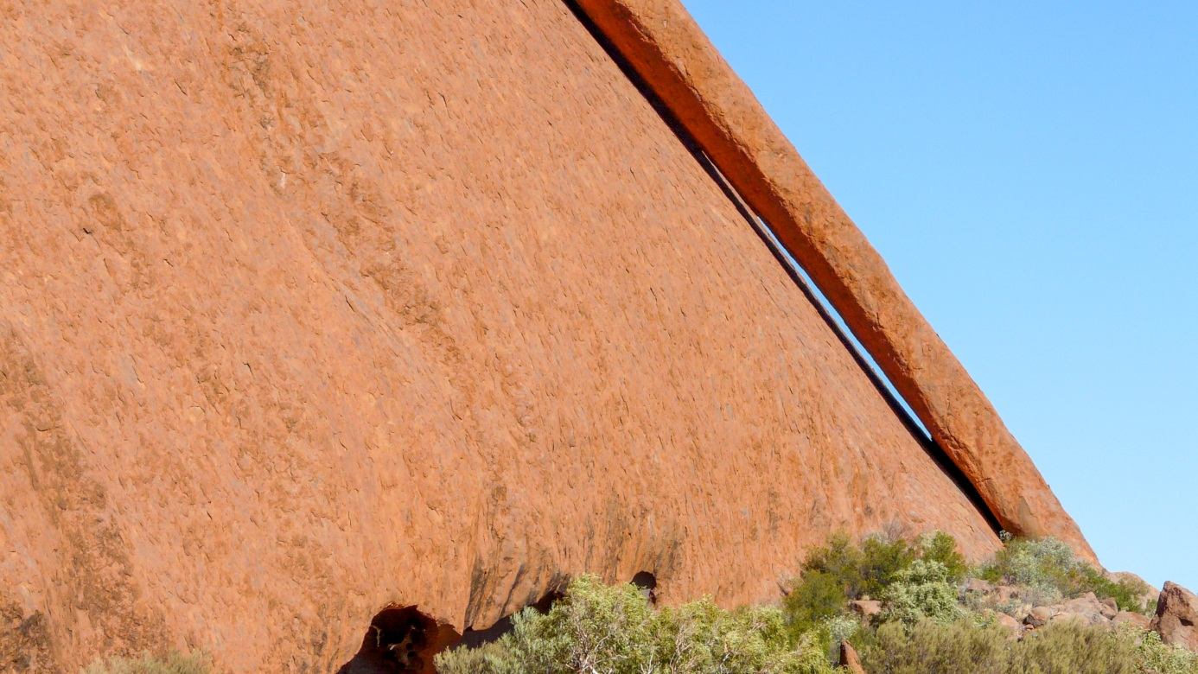
Figure 22: a) A schematic diagram that illustrates the different processes of weathering and preservation at Uluru, b) erosion feature “The Brain”, c) erosion feature “Kangaroo Tail”. Images courtesy of Bruce Wilson.

Karst topography
You may have heard stories of the Earth suddenly opening up underneath roads, and houses being swallowed in large holes. This is the nature of sink holes in karst topography. The rainwater reacts with carbon dioxide in the air and forms weak carbonic acid (see Reaction table, page 1) or organic acids. As the acidic rainwater dissolves the limestone, it collects calcium carbonate. With prolonged contact with the limestone, the percolating rainwater can redeposit the calcium carbonate on cave walls to produce awesome cave structures like stalagmites and stalactites and flowstone.
The constant chemical weathering and erosion of the limestone bedrock by acids in groundwater can carve out caves just beneath the surface. After a while, the cave roofs can collapse to form a sink holes (Figure 23).
Sinkholes are a common geohazard in every continent and can occur naturally through the activity of groundwater, but can also be man-made, occurring because of burst underground pipes. Natural sinkholes are a major threat to infrastructure in places like Florida and Texas in the United States, but in 2010 a 100 metre deep sinkhole opened under a road in Guatemala City, Guatemala, caused by a broken sewer pipe. Sinkholes can occur anywhere the subsurface is removed by water or human activity, including old mine sites - some Australian towns are affected like Parkes in New South Wales and Kalgoorlie in Western Australia.
Southern China, northern Vietnam and southern Thailand are famous for their tower karst landscapes consisting of pinnacles of weathered limestone rock. As a result the tower karst topography is often featured in Chinese traditional paintings.
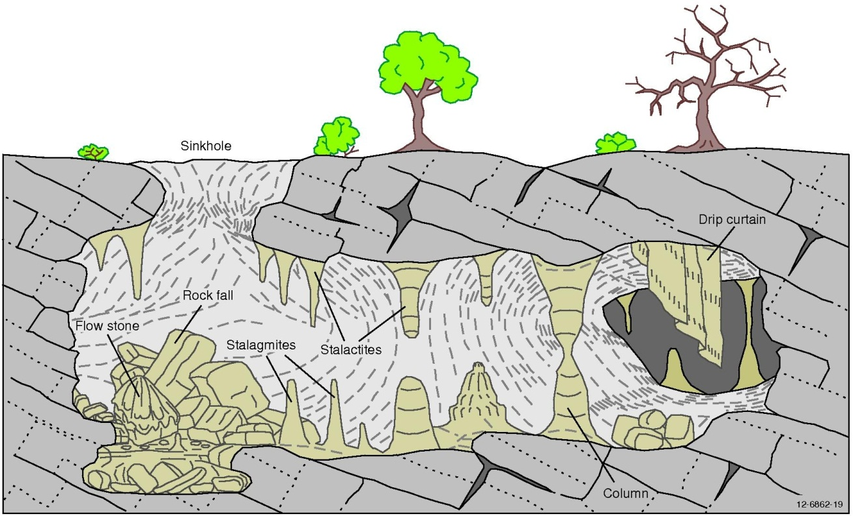
Figure 23: Sinkhole formation and limestone cave deposits including stalagmites and stalactites.

Jenolan Caves, New South Wales
Jenolan Caves beyond the Blue Mountains, near Oberon in NSW, are typical of the caves formed in eastern Australia and are much older than those found on the west coast. The limestone in which the caves occur was formed in the ocean when skeletons of marine invertebrates and sediments containing calcium carbonate were buried under volcanic rocks. The burial took place over a period of millions of years in the Silurian and Devonian periods, between 359 and 443 million years ago. During burial, the heat and weight from the overlying volcanic rocks eventually compressed the calcium carbonate into limestone. Caves began to form and the rocks were uplifted. During this process the rocks were folded and deformed so the beds of limestone no longer lay flat but dipped at various angles and are sometimes even upside down. As rivers ran across the landscape the softer shales, slates and volcanics were eroded away preferentially. When the slightly acid water penetrated cracks in the limestone, the cracks widened into caves. The level of the valley lowered as the surrounding softer rocks were eroded away and the river changed its course to find an easier path lower down the valley (Figure 24). Isotopic dating of clays in the Jenolan Caves suggests that these caves have been open, active caves since the Carboniferous, about 340 million years ago, very soon after the original limey sediments were deposited.
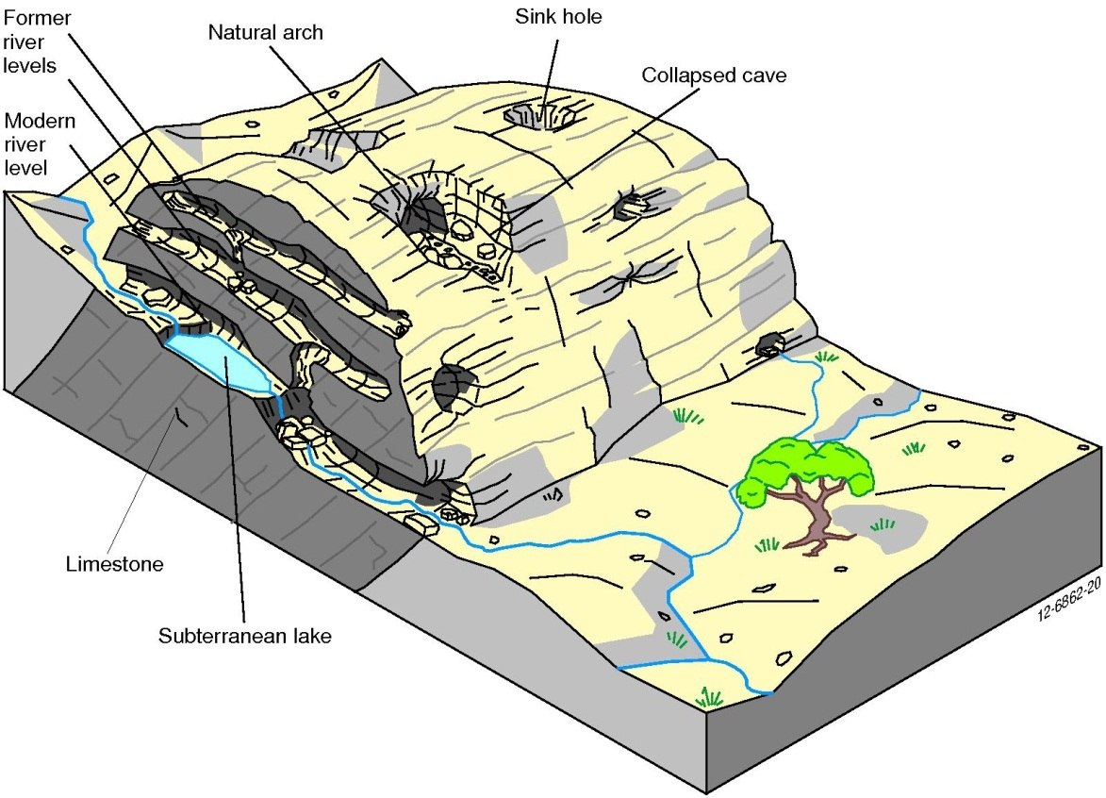
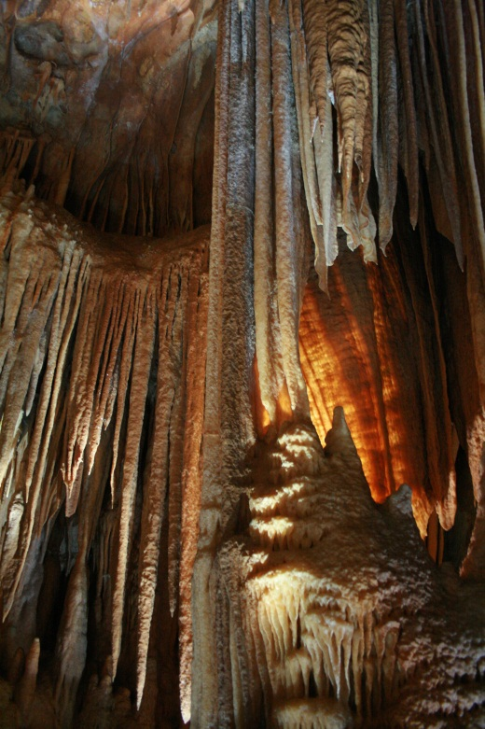
Figure 24: a) The formation of caves in eastern Australia from steeply dipping limestone, b) Jenolan Cave formations. Photo credit: Toby Hudson.

The Nullarbor Plain, South Australia and Western Australia
The Nullarbor Plain, located north of the Great Australian Bight hosts Australia’s largest known region of karst topography, covering about 200 000 km2. The limestone these caves are formed in was deposited in a shallow marine environment between 43 and 14 million years ago when sea levels were higher than today.
Now that sea levels are lower the limestones have been revealed and form a vast plain between 75 and 150 metres thick (Figure 25). The plain has no surface drainage channels due to the well-developed fractures in the limestone through which rainwater flows. All the channels have gradually found their way underground, dissolving more rock along the way; eventually they emerge as springs or from the mouth of caves at sea level.
The cave walls feature a honeycomb effect and, unlike most limestone caves, rarely display stalagmites and stalactites. Even though there are joints in the rock, the lack of water (both past and present) means that there is little dripping water, which is essential for the formation of cave ornaments or “speleothems”.
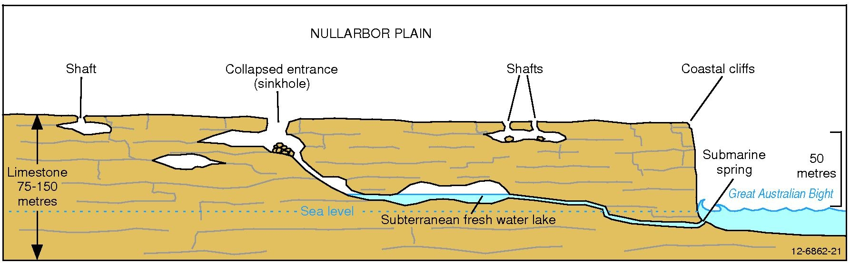
Figure 25: A diagrammatic section of the limestone caves formed on the Nullabor Plain.

Regolith
Regolith can be described as anything in between fresh rock and fresh air. The term regolith comes from Greek words rhegos which means ‘blanket’ and lithos which means ‘stone’.
In more complex terms:
Regolith (reg’-o-lith) – All of the loose or secondarily re-cemented cover that overlays solid bedrock. It can be formed from weathering, transport and/or deposition of older material. The regolith includes cracked and weathered basement rocks, saprolite, soils, build ups of organic matter, volcanic material, deposits from glaciers, colluvium, alluvium, wind-blown (aeolian) deposits, groundwater and sediments formed from evaporation (like salt andgypsum).
Regolith geoscientists study the regolith and its implications for a raft of disciplines including mineralogy, sedimentology, mineral exploration, geomorphology, landscape evolution, agriculture, botany, ecology, biodiversity, hydrogeology, archaeology, palaeontology, engineering, environmental geology, geohealth, defence and climate science. Today it is seen that the regolith has important implications for engineering, water quality, salinity, groundwater contaminant studies and many other environmental issues.

A regolith profile
A cross-section through the regolith can be called a regolith profile. A simple regolith profile will contain unweathered bedrock at its base, weathered bedrock (saprolith) and a soil covering (pedolith). Countless combinations and permutations of these features can be seen in nature, but a generic regolith profile is shown in Figure 26 below; profiles like the one shown are very common around Kalgoorlie in Western Australia and Cobar in New South Wales. Note that the soil occupies the very top part of the regolith. We depend on this thin skin of soil for our existence on the Earth.
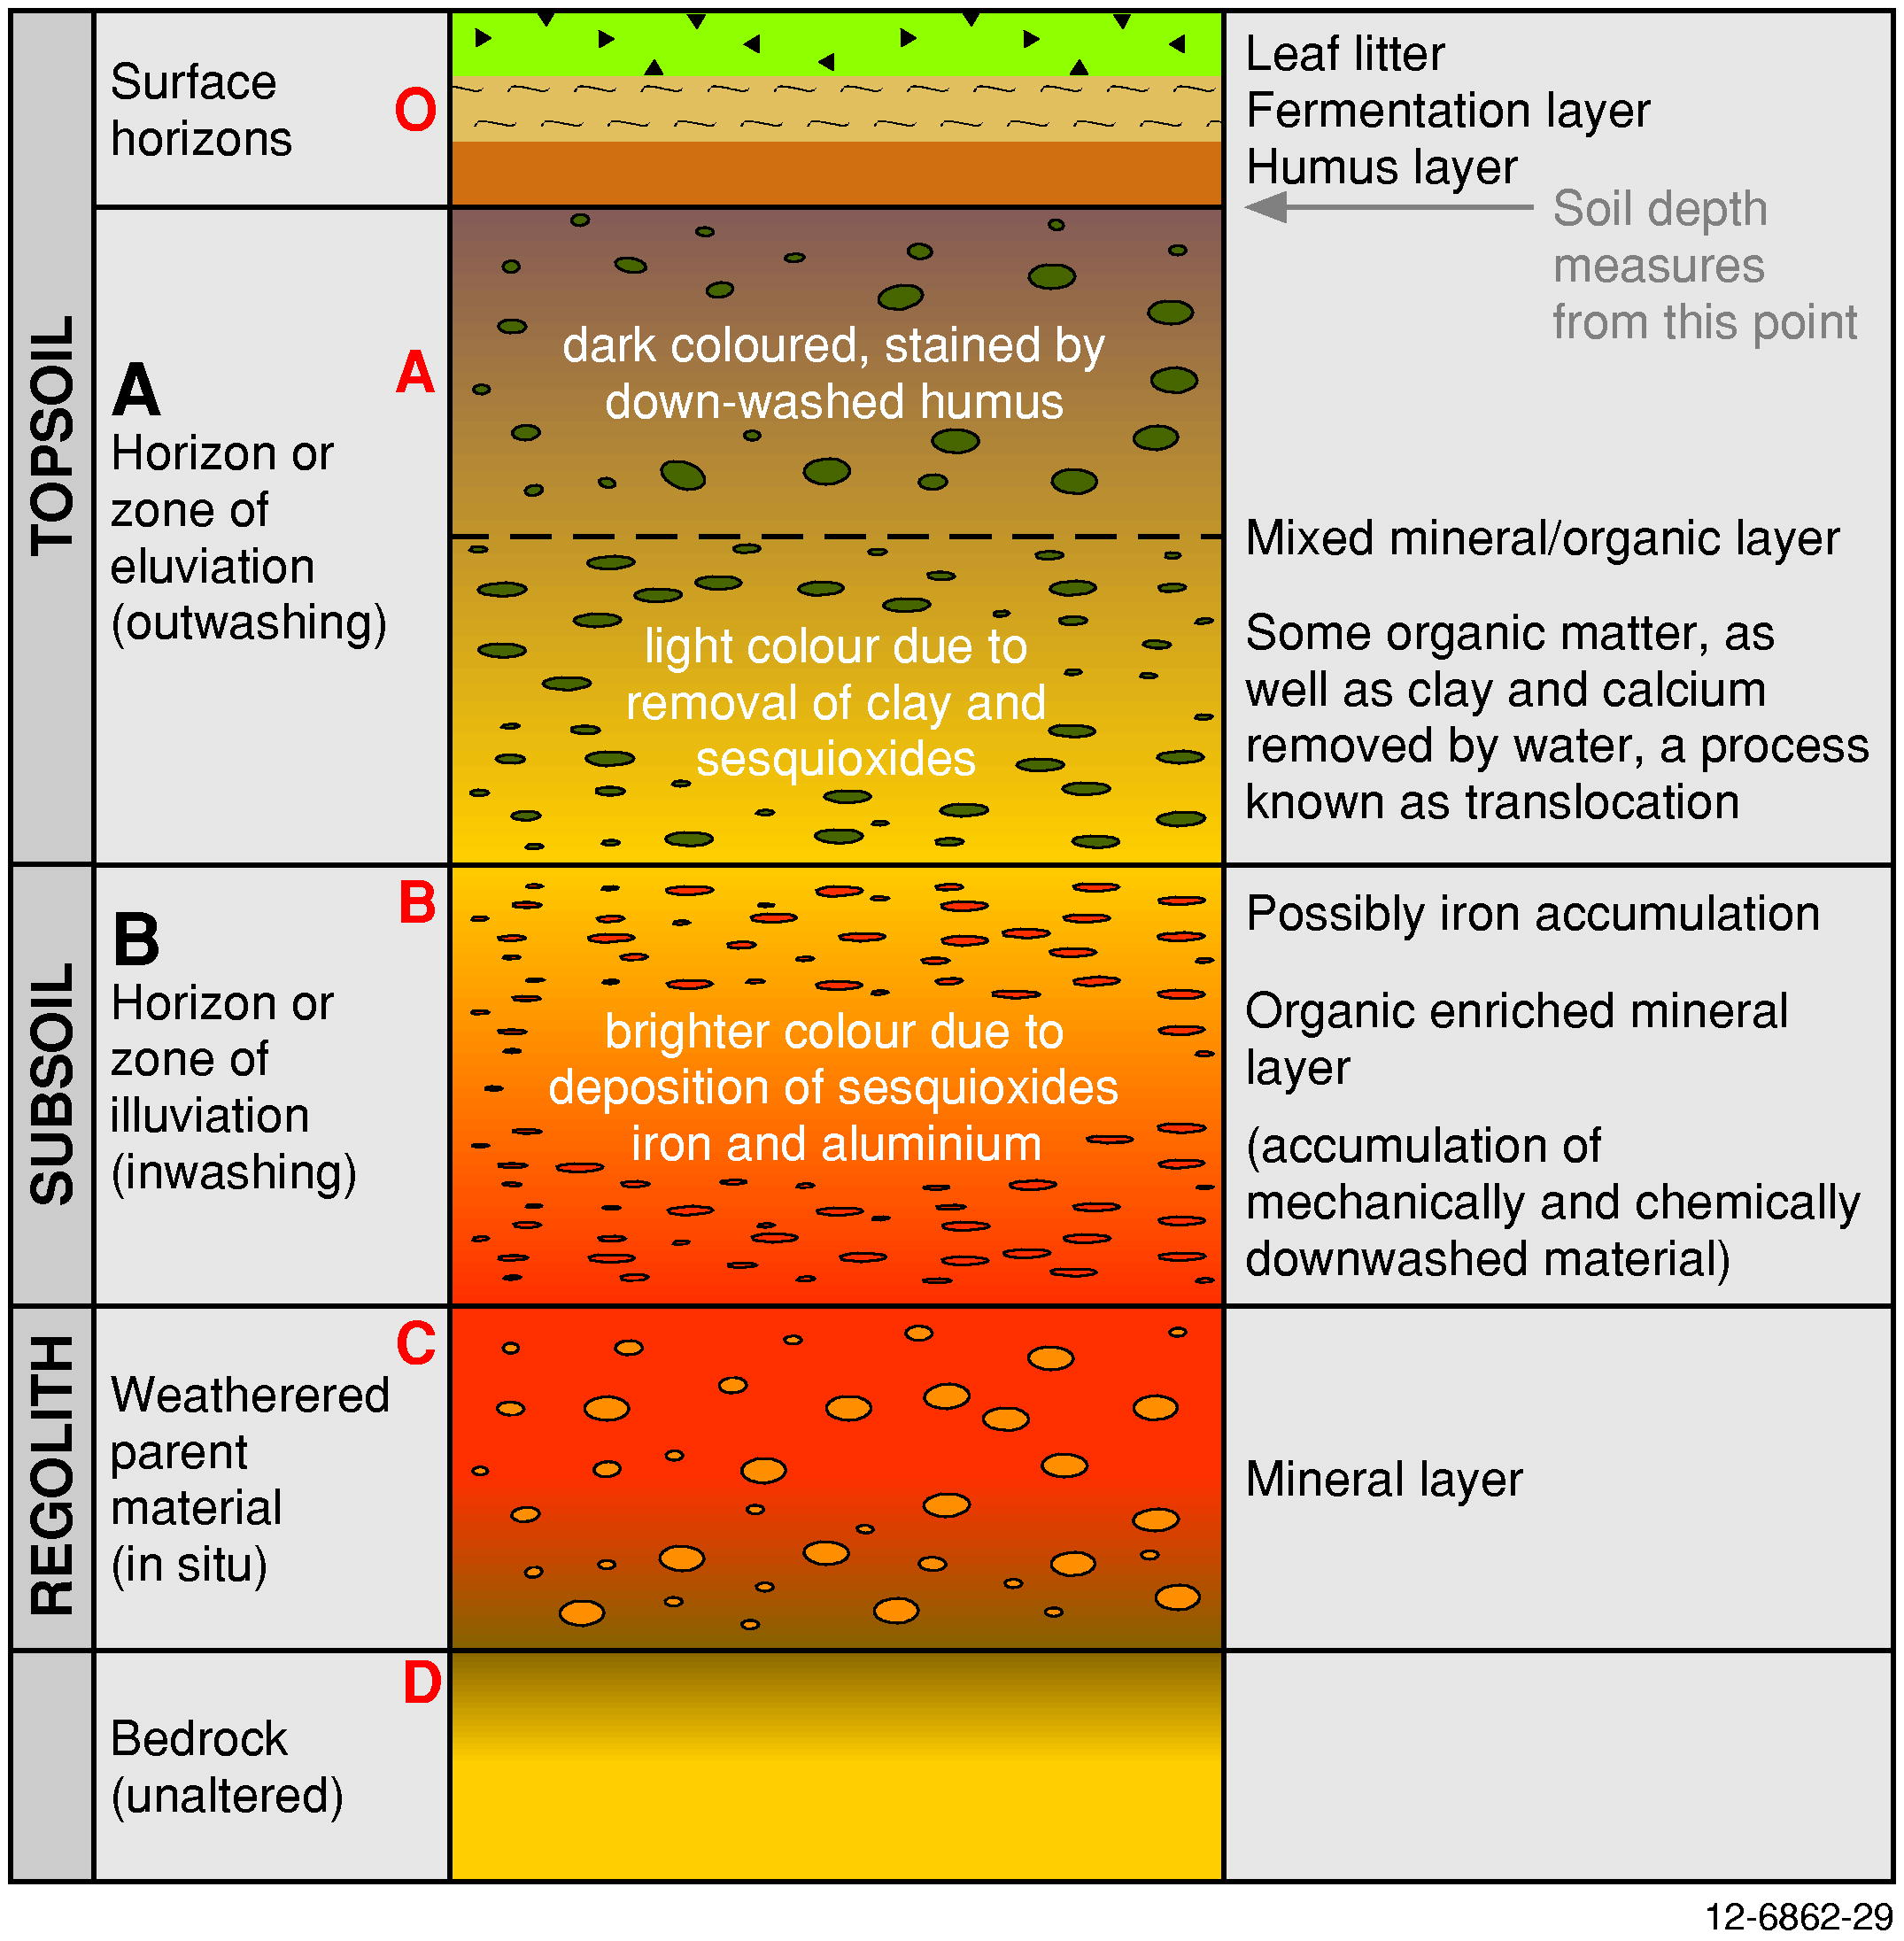
Figure 26: A generic regolith profile with labels describing the composite parts.

Regolith, soil and sediments – what is the difference?
The difference between regolith and soils has confused people for many years. Simply, a soil forms in the upper-most part of the regolith (Figure 27). The concept of regolith was introduced by Merrill in 1897 to describe the mass of material covering the underlying rocks. Many soil scientists class the regolith as the rocks and minerals that are present under the solum (A and B horizons of a soil profile). The main difference between regolith and soil is that regolith must be formed in situ (in place), however soil can be formed or transported on in situ materials. We prefer to include soil as the upper part of the regolith.
There is also a grey area between ‘sediments’ and regolith. Generally, if the sediments are only a few metres thick then they are considered regolith. However, when do sediments stop being regolith and start being rock? There is no hard-and-fast boundary defined, however, it is generally agreed that once sediments become lithified (once they are turned into rock through diagenesis) then they are bedrock, not regolith. That is, up until the time they become uplifted, weathered and eroded all over again. For instance, the Mesozoic sediments of the Great Australian Basin might be considered regolith by some, because they are only partially consolidated in some places, but are considered bedrock by others.
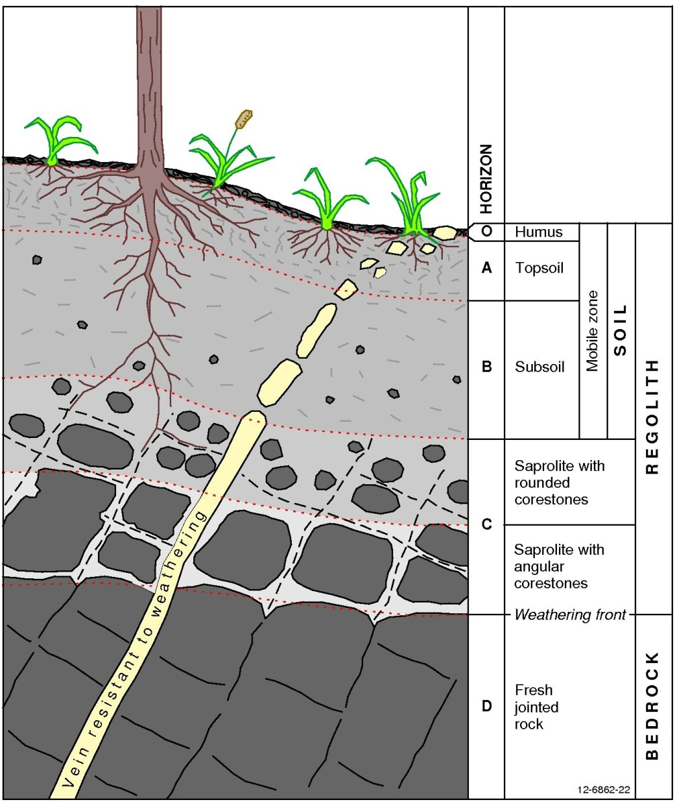
Figure 27: The features of regolith and its upper part, soil. Many regolith geoscientists consider the subaerial parts of plants as regolith materials.

Regolith mapping
By creating regolith landform maps, a better understanding can be gained of a region by mapping the sources and sinks of regolith materials and their relationships with the landscapes in the mapping area. Although the concept of geological mapping has been around for two centuries (the first ever authoritative geological map was of Britain, and was published by William Smith in 1815), the concept of mapping regolith is still relatively new.
The main uses of a regolith landform map are:
- To record information on the nature and distribution of regolith materials and the landforms in which they occur.
- Specific applications such as mineral exploration, engineering geology, soil mapping and land management. Other relevant information may include depth to water table, depth of weathering and areas affected by salinity.
- As an aid in understanding regolith geochemical, biogeochemical and geobotanical data. Relationships between different regolith types may become more apparent once mapped, for example the relationship between ferricrete and ancient drainage channels near Kalgoorlie, WA. This can help to identify possible alluvial gold deposits as well as define the preferential pathways of salt that can cause salinity. The relationships between regolith landforms and specific plants and animals may also be recognised more easily.
- As the basis for most studies of the regolith. Most regolith research at present involves some degree of regolith mapping.
Regolith landform mapping differs from geological mapping because the characteristics of regolith vary over comparatively short distances. Also, it is useful to build up a 3-dimensional picture of the regolith by obtaining a full regolith profile, however, these occur only rarely (although there are opportunities to see profiles in quarries, road cuttings and by drilling holes). To get around this dilemma, regolith landform maps use surrogates including topography, landforms, geology, soil, biota, geophysical and remote-sensed imagery and regolith mineralogical information; where the regolith is undisturbed; these surrogates are closely related to the regolith beneath.
Before going into the field to start regolith mapping, preliminary work is done to familiarise the mapper with the area. Information including remote sensing data (satellite images) and airborne geophysical data (magnetics and radiometrics) is used to gain an understanding of the physical and chemical characteristics of the area to be mapped. A draft map is sketched onto a transparency over aerial photographs (these are used because they can be viewed in stereo, allowing the user to see the ups and downs of the landscape). This preliminary map will be checked, modified and added to in the field to create the final regolith landform map (Figure 28). This map is then digitised and loaded into a Geographic Information System (GIS). This file or a paper version is then ready to be used by industry, government and landholders alike.
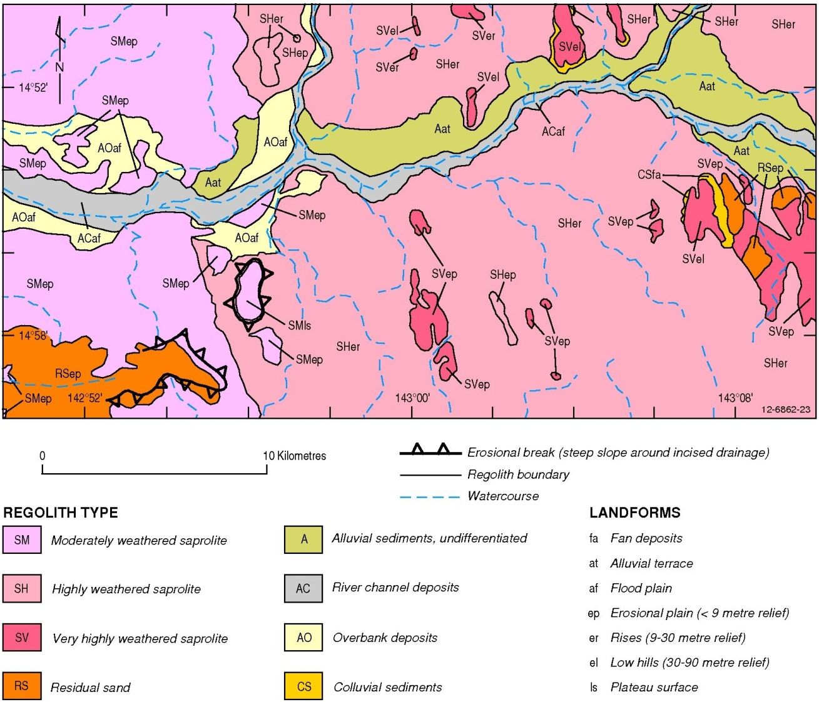
Figure 28: An example of a regolith map, in this case a section of the Ebagoola Regolith Landform.

The value of understanding regolith
Some geologists have described regolith as the ‘scum on the top of the Earth that hides mineral deposits’. However times have changed and more people now realise that regolith knowledge is a useful tool for mineral exploration. Equally, having an understanding of the regolith can help people to manage the effects of salinity and also help farmers develop new land management practices.

Regolith and land management
Many problems face our land managers today, some of which are described below. All are examples of how regolith relates to land management practices. It is important to identify the pressures affecting the land and manage them accordingly.

Sodic soils
Some soils are ‘sodic’, meaning that they have an excess of sodium bonded to clays within regolith. The characteristics of these soils are they are dispersive and hard-setting. When exposed by drought or cultivation, these soils are highly susceptible to erosion due to their dispersive nature; the clumps of soil break apart in water and the fine particles become suspended throughout the water. This is because the sodium ions attached to the clays when dry become dissolved into the water, leaving individual clay particles loosely bonded to water molecules, allowing them to disperse easily. Eroded gullies tens of metres in width are common in areas affected by sodic soils, as well and sheet and rill erosion. When the sodic soils dry out, they set hard like concrete to form hard cappings in which it is next to impossible for new vegetation to establish. It is difficult for water to penetrate these highly dispersive, hard-setting soils. The best treatment for these soils is to spread large amounts of gypsum (calcium sulphate) onto the land. The calcium in the gypsum replaces the sodium bonded to the clays and forces the clays to flocculate, forming flocs which are sand-sized aggregates of clay. This has the effect of increasing water penetration and thus productivity. Unfortunately, this process needs to be repeated frequently.

Gilgai
Regolith with shrink-swell characteristics may form soil landscape features called gilgai. Gilgai are small-scale undulations on the Earth’s surface. They can have a relative relief of up to two metres but are more commonly around 50 centimetres, and may be several metres in diameter. They are very common on alluvial soil plains surrounding Australia’s large inland river systems. Some clays, namely smectite (a generic name incorporating the clay minerals beidellite, montmorillonite, saponite and nontronite), in the regolith have unique characteristics in that are able to incorporate water into their crystal structure. When they absorb water they swell. When the clays dry out, they release the water, shrink and form cracks; repeat this process over and over, and you’re left with gilgai. Generally the tops of the gilgai hummocks contain more cracking clays than the depressions, so after rain the clays expand to form the hummocky topography. The process also heaves rocks out of the soil, often leaving a rocky mantle on the rims of the gilgai depressions. These features are difficult to build on - buildings constructed on gilgai need to have deep foundations that can accommodate high shrink-swell characteristics, and roads need to have very deep, stabilised road bases, otherwise they will quickly break up.

Salinity
Salinity is a national land management priority in Australia, as more and more of Australia’s agricultural lands are no longer productive due to the effects of salinity. Salinity can be a natural process but is accelerated by human intervention. It comes in a number of forms:

Dryland salinity
This occurs when deep-rooted native vegetation is removed and replaced with shallow-rooted crops and pastures. These crop plants allow the groundwater level (water table) to rise, bringing salts stored in the regolith to the land surface. As the groundwater rises, these salts enter the root zone and damage the plants, eventually killing all but the most hardy halophytes (salt-loving plants commonly found near the sea shore and in salty swamps). Water-logging of soils can also occur in areas where there is not much salt in the groundwater, but where native species have been removed. In some areas affected by salinity, like the Liverpool Plains of NSW, rising water tables are not the cause of the salinity problem. In this instance removal of vegetation has caused erosion that exposes natural salt stores lying below the surface of the ground.

Irrigation salinity
The main cause of this style of salinity is the application of huge amounts of water to irrigate crops and orchards in excess of what the plants actually use. Water volumes as much as four times the natural amount of rainfall is applied, which causes the groundwater level to rise. Irrigation salinity does not take as long as other types of salinity to arise and often occurs soon after the irrigation system is put in place. This can be rectified by new technology to monitor soil moisture contents and a change in irrigation practice like using drip irrigation rather than overhead sprinklers or flood irrigation.

Urban salinity
This is a combination of dryland and irrigation salinity. Native vegetation is cleared for housing and additional water comes from watering gardens and parks, leaking pipes and changes to the natural drainage paths. This results in a rise in the water table. As well as poisoning garden plants, the salt dissolved in the groundwater physically weathers infrastructure including roads and buildings through salt crystal growth. Many cities in Australia suffer from this in low-lying areas.

River salinity
A rise in the amount of dissolved salt in rivers can result from the combined discharge from dryland, irrigation, urban and industrial salinity entering our rivers. With time, the river’s water quality decreases. For people living in Adelaide, river salinity is a major concern. They are the end-users of water that has had increasing salt loads added from upstream in the Murray-Darling Basin river system.

Industrial salinity
Salinity has an impact on, and is impacted by, industry. Effluent from urban areas, agriculture and industry may contain high levels of salt. Some industries, like the coal industry, use water for cooling in their processing plants and wash vast amounts of coal to reduce contaminants, which can concentrate salts.
The effects of salinity include die back of vegetation, soil erosion, , salt scalds in vegetated areas and the disintegration of infrastructure including roads and buildings. As these issues become more pressing, it is important to understand where the salinity is coming from and how we can combat it.
So where does the salt come from? There is more than one source of the salt and they include:
- salt from the sea - over millions of years, salt is carried from the oceans as an aerosol which becomes incorporated into rain which increases the amount of salt in the regolith;
- salt formed from the weathering of rocks and minerals accumulated in the regolith; and
- inland seas – much of Australia’s interior was once an inland sea when sea levels were higher than at present. When the seas retreated much of the sea salt was left behind in the sediments that were formed in the bottom of the inland seas.
The Australian Government funds environment management of our natural resources through a program called “Caring for our Country”. It works by supporting communities, farmers and other land managers to protect Australia's natural environment and sustainability. Funding from this program supports regional natural resource management groups, local, state and territory governments, Indigenous groups, industry bodies, land managers, farmers, Landcare groups and communities.
What can we do? Changing our land management practices today may not have an immediate impact on reducing salinity but will help in the long term. Actions we can take include: protect and manage our native vegetation, plant more trees, modify the crops and pastures we plant and change the way they are managed and also use water more efficiently and effectively.

Coastal acid sulfate soils
The problem of Coastal Acid Sulfate Soils (CASS) is not as well known as the various forms of salinity, yet it has the potential to be a big problem in Australia.
Coastal acid sulfate soils occur in the mouths of rivers and estuaries. During the last ice age, when global sea levels were about 100 metres lower than today, these rivers were scoured of sediment. When sea levels rose, the rivers became clogged with sediment and organic material from the swamps that formed in these backwaters, often creating large peat deposits. The high levels of carbon in the swamps scavenge free oxygen, resulting in the proliferation of anaerobic bacteria (bacteria that can survive without free oxygen); these actually use sulfur as part of their life cycle. The bacteria fix sulfur and iron in the swamps to create large amounts of metal sulfides, usually the mineral pyrite (iron sulfide – FeS2). If left undisturbed, these swampy deposits present no danger, but if drained the pyrite in the sediments can become exposed to oxygen and rapidly becomes oxidised to form sulfuric acid. Potential acid sulfate soils (PASS - soils with pyrite that has not yet been oxidised) are located along the coast where the elevation is less than five metres above mean sea level. Actual Acid Sulfate Soils (AASS), where the pyrite has been allowed to oxidise, occur in many of the rivers and estuaries around Australia. PASS and AASS also occur in swampy ground in inland Australia.
Every day activities such as dredging, construction of roads, farming, flood mitigation drains, sand mining and aquaculture can expose the pyrite in these soils, which oxidises rapidly to release the stores of acid within these soils, causing major environmental damage. Times of drought lead to depressed water tables and increased acid sulphate soil problems. Dent and Pons researched the problem and said the following about acid sulfate soils in 1993:
“Acid sulfate soils are the nastiest soils in the world and they don’t keep their troubles to themselves. They generate sulfuric acid that leaks into drainage and floodwaters. The acid brings the pH as low as 2 which corrodes steel and concrete. It also dissolves aluminium that kills vegetation and aquatic life or, in sub-lethal doses, stunts growth and renders species susceptible to disease. Generations of people depending on those soils have been impoverished and, probably, poisoned by their drinking water.”
Every state and territory in Australia has the potential to be affected by CASS since these soils occur in around 40 000 square kilometres of our coastal zone. Countries like China, Malaysia and Indonesia are already suffering from the consequences of disturbing acid sulfate soils and the resultant toxic metals release (one of which is arsenic). Bangladesh has high arsenic contents in their groundwater from the oxidation of pyrite and arsenopyrite that occurs naturally in clay and peat interbeds within the aquifers. There are reported higher incidences of cancer and skin lesions as a result of drinking the groundwater. This can become a problem in areas affected by acid sulfate soils if metals leached from the acid sulfate soils enter groundwater.
There are ways to help combat the effects of CASS. The best of these is, of course, avoidance. If the iron sulfide layer is not disturbed then expensive remediation is not needed. All Australian states have developed maps so that the extent of the CASS is known (search for “acid sulfate soils” on the Internet). If acid sulfate soils are disturbed the following techniques can be used to help reduce the damage to the environment:
- Liming: By adding agricultural lime (an alkali) to the soil and drains, the effects of the acid can be neutralised. Liming is usually too costly for it to be used for large areas of affected land.
- Re-flooding: Re-flooding with fresh or seawater can halt further acidification. Seawater can also neutralise the effects of the acid from the soils.
- Forestry: This involves planting trees that are tolerant to acid sulfate soils.
- Shallow drains: Deep drains are more likely to expose any pyrite layer to oxygen, therefore increasing the risk of creating acid sulfate soils. Modifying the drains so that they are shallower reduces the risk of exposing the pyrite and frees-up valuable farm land.
The National Strategy for the Management of Coastal Acid Sulfate Soils was developed in 1999 with the cooperation of the Federal, State and Territory Governments. By creating the strategy, attempts are being made to help ensure that the recognition and management of acid sulfate soils are administered responsibly. The strategy also helps in educating about these soils and their management and remediation. This has been updated in 2011 as a document describing the National guidance for the management of acid sulfate soils in inland aquatic ecosystems.

Regolith and houses
Since ancient times people have been living within the regolith or using it to build their homes. Before the art of building homes was perfected, people often used to dwell in caves. In areas where temperatures get very high, like Coober Pedy in South Australia, people have made homes from opal mine caves excavated into the regolith. The regolith is an excellent insulator and keeps the house cool in summer and warm in winter. If we look at our current homes, many are made with bricks, of which weathered regolith (rock and clays) is a component. Another important building material is cement –a mixture composed predominantly of lime, quartz and clay. The clay and quartz is usually from weathered rock or transported regolith deposits. In Kerala in India, ‘laterite’ (actually mottled saprolite) is cut and used directly as bricks to make houses.

Resources within the regolith
The regolith holds a wealth of resources within it. These include:

Bauxite
Bauxite is a rock composed of almost pure aluminium hydroxide (primarily the mineral gibbsite, but also boehmite or diaspore). It is the primary source of the lightweight metal aluminium that is used for everything from soft drink cans, window frames, car bodies and even jumbo jets.
Bauxite is found on most continents of the world. It mainly forms in tropical or semitropical climates but has been known to form in cooler climates. Bauxites generally form in situ but there is some debate about whether the world class deposits at Weipa in Queensland are actually secondary concentrations of bauxite pisolites (pea-shaped grains) that have been transported from the surrounding hills. Soluble components such as silica, calcium, magnesium and potassium are removed from the bedrock or regolith by percolating water and this concentrates the insoluble aluminium rich mineral.
Most of the world’s bauxite is ‘lateritic’. It has features characteristic of a lateritic weathering profile including an upper pisolitic layer or a massive zone with a white kaolinitic horizon and then bedrock below.
Australia has just over one fifth of the world’s economic bauxite resources. As such, Australia is the world’s second largest producer of bauxite, constituting one third of the world’s production.. Brazil, Jamaica, Guinea and India are also major producers (Geoscience Australia. 2012. Australia’s Identified Mineral Resources 2011. Geoscience Australia. Canberra).

Commercial clays
Clays are a product of weathering. Different parent rocks and different weathering processes form different clays. The clay mineral kaolinite has a vast range of uses, from ceramics and paint through to pharmaceuticals. The rock kaolin is composed largely of the mineral kaolinite.
The first recorded use of kaolin was in Kauling, Jianxi Province, China, where the locals washed the impurities out of granitic saprolite to leave only the clay minerals. This clay was then used to make fine porcelain or chinaware. Bentonite is a type of smectite clay that is known for its properties of swelling and expanding once wet. Because of these properties it is used as an absorbent, as liners to seal small earthen farm dam walls, as well as drillers’ mud. Attapulgite is a large constituent of palygorskite and/or sepiolite clays. These rare clays are fibrous and have a porosity and high surface area which makes them ideal for adsorption. They are used as oil and grease adsorbent, drilling mud, as animal feed, pet litter and in pesticides.

Iron ore
Iron (Fe) is one of the most abundant elements and constitutes 5% of the Earth’s crust. Second only to Russia, Australia has 16% of the world’s known global reserves of iron ore. Iron ore is the raw material from which iron metal is smelted. Most iron ores consist of haematite Fe2O3 (70% Fe), goethite Fe2O3.H2O (63% Fe), limonite (a mixture of hydrated iron ores up to 60% Fe) and magnetite Fe3O4 (72% Fe). Australia’s biggest iron ore deposits are located in the Hamersley Basin in the Pilbara region of Western Australia.
Sedimentary rocks known as Banded Iron Formations (BIFs) are the major source of iron ore in the world. These are almost all Precambrian in age (i.e. more than 600 million years old). In the Hamersley, three different types of deposits are present: those formed in ancient river channels (palaeochannels), those formed from the erosion and deposition of colluvium and alluvium from existing orebodies (detrital iron ore bodies); and those iron oxides that are enriched within the BIF after prolonged weathering has removed the excess silica to leave behind the concentrated iron. New sources of iron ore are being developed in Australia in vast Neoproterozoic (1000-540 Ma) shale deposits in South Australia and New South Wales. These rocks contain up to 50% magnetite by volume.

Nickel laterite deposits
Most of the world’s nickel resources come from hard rock sulfide deposits associated with ancient volcanism and lava flows. Nickel laterite deposits, however, have formed in response to intense weathering of nickel-bearing rocks where there has been little to no erosion. In regions like New Caledonia and parts of Australia trace amounts of nickel have become concentrated as oxide or silica ores. The nickel is temporarily dissolved into solution and is then re-precipitated in concentrations 10-30 times more than the fresh parent rock. These deposits occur on ultramafic rocks that are relatively rich in nickel. In these rocks the nickel is present in the olivine or serpentine minerals.

Opals
Australia is the world’s main producer of top quality opal. There are two types of opal - common and gem. Gem quality opals are rare. The common opal or ‘potch’ has no spectacular display of colours and is of no value apart from curiosity. One of the most famous locations in Australia for mining opals is Lightning Ridge in northern New South Wales (Figure 29).
Lightning Ridge is recognised for its extremely rare ‘black’ opals, which have glistening red colourings on a dark background. Most of the opal found in Australia is found at the edges of the Great Artesian Basin in sediments that are of Cretaceous age, i.e., deposited about 100 million years ago.
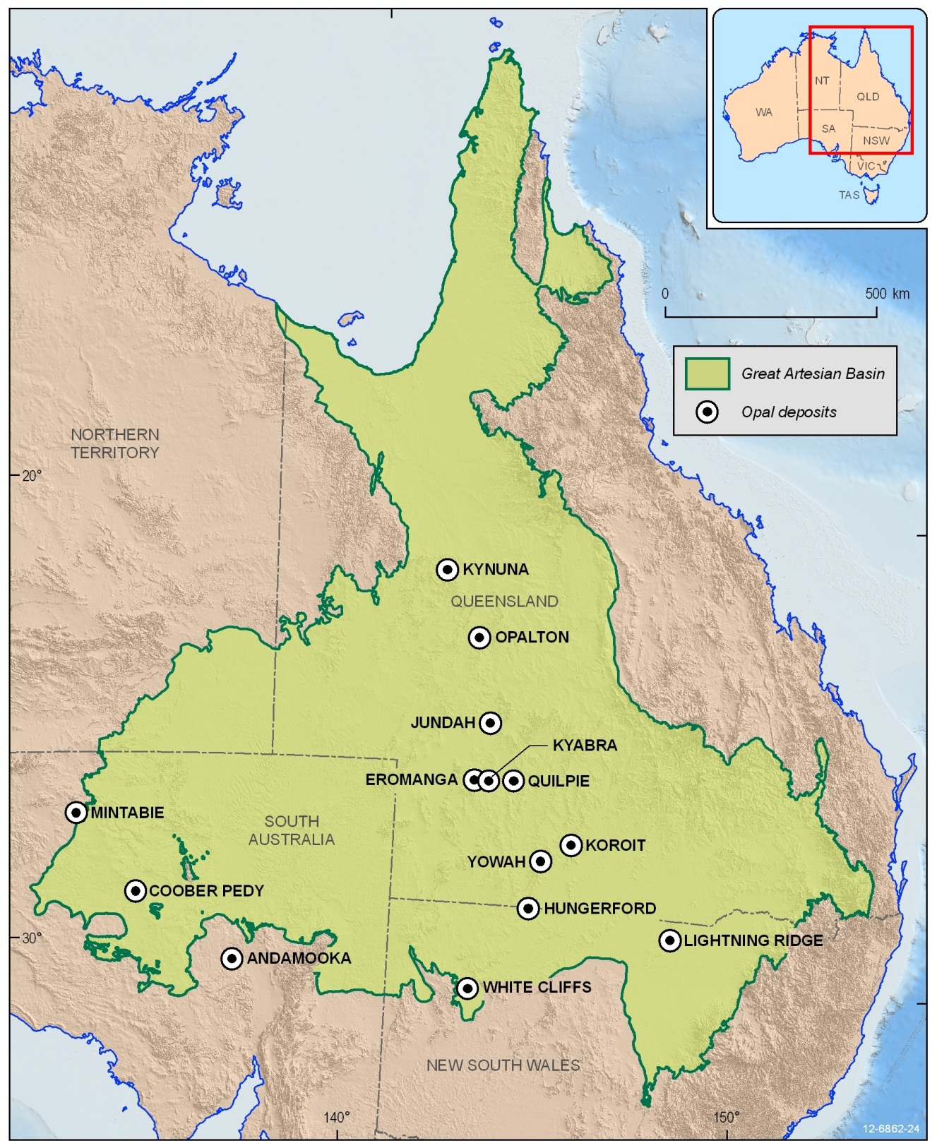
Figure 29: Location of opal mining areas in Australia
Unlike most other minerals, opals are amorphous; in other words they have no crystal structure. Opal is a form of silica that contains water in its internal structure. Although the water content can range from 1-21%, gem quality opals have between 6 and 10% water.
Opal normally forms when water that contains dissolved silica is evaporated slowly. The silica that is left behind contains less water and forms a gel, which then forms spheres of amorphous hydrated silica. Opal commonly occurs in two different environments. The first, and most important, environment for opals in Australia is in deeply weathered sedimentary rocks in arid areas.
Opals can be found in cracks and hollows in the regolith or may be replace regolith materials like shells and other fossils. In Australia opalised fossils can be found, including shellfish or even reptiles – Eric the Pliosaur is a good example of an opalised skeleton. The other environment for opal formation is in active volcanic areas where excess silica in the groundwater can become trapped in gas bubbles within the volcanic rock. This water partially evaporates to form opal.

Phosphates and guano
Bird droppings have high concentrations of phosphate. When bird colonies living on islands deposit large amounts of droppings the deposits are known as guano. Large colonies of birds living in one place for a long time deposit large amounts of guano! Much of this type of phosphorous deposit has been mined out (search for reports about Nauru and Christmas Island on the Internet). Another type of deposit forms when the guano interacts with the underlying rock to form rock phosphate. Bats also form guano deposits in caves but the volume of these deposits pales in comparison with the bird-derived guano.

Placer deposits – Diamonds and gold, mineral sands
Placer (or alluvial) deposits are a valuable source of gold, diamonds, titanium, tin, zinc, some rare earth elements, and gems like sapphire and ruby. Minerals found in placers are highly resistant to physical and chemical weathering hence they are able to be transported with little change in their shape or composition. The deposits are normally formed by water transport, like in stream and beach environments, but can be formed by aeolian processes.
Mineral sands are the major source of heavy minerals such as rutile (TiO2), ilmenite (FeTiO3) and zircon (ZrSiO4). Coastal regolith is a good source of these minerals. However, many mineral sand deposits are in national parks and therefore cannot be mined. Not all minerals sands occur on the modern coastline; large amounts of mineral sand occur in old beach deposits in the Murray-Darling Basin and the Eucla Basin. Australia is a leader in the production of mineral sands, along with South Africa, Florida in the United States, Sierra Leone and India.
Diamond placers can be found in Sierra Leone and Swaziland and parts of the Central African Republic. In the Central African Republic diamond placers are present in recent (less than 10 000 years) to modern river terraces and channels. The continental shelf of north Western Australia also has diamond placers but these tend to be in deep unreachable channels on the sea floor. Some rivers leading away from the Argyle Diamond Mine in Western Australia contain diamond placer deposits.

From regolith to riches - Using regolith for mineral exploration
In Australia long periods of weathering, without vigorous tectonic activity, have resulted in a thick cover of regolith over bedrock throughout much of the continent. In some parts of Australia, like Western Australia, regolith cover can be hundreds of metres thick.
Ore deposits contain high concentrations of useful elements such as iron, gold and copper. In the early years of mineral exploration, finding ore deposits was easy. Many were found outcropping at the surface. As these types of deposits have become scarce it is increasingly important to search for deposits under the regolith where hidden ore deposits might be located (Figure 30). Using the regolith as a sampling medium, a large area can be sampled with minimal effort. This is one option to help find these hidden ore deposits.
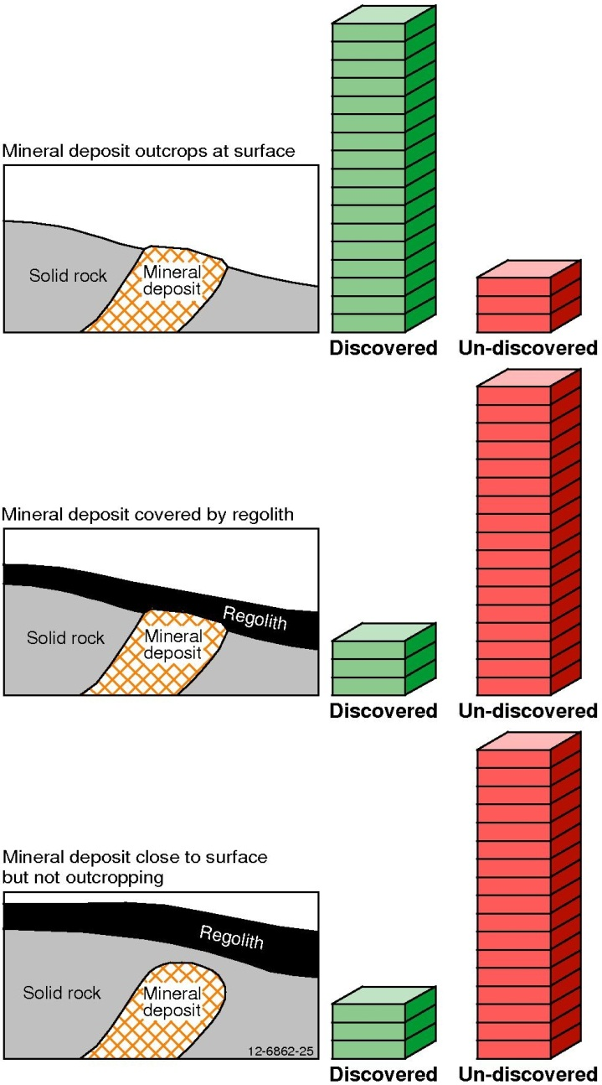
Figure 30: Diagram illustrating mineral location within the Earth’s crust and their subsequent discovery potential.
Some ore deposits have characteristic elements dispersed within the surrounding regolith – a ‘dispersion halo’. Once understood, the dispersion halo might be detected using remote sensing, geophysical and geochemical techniques and can lead an explorer to the ore deposit.
By utilising the materials that are present on the surface of the Earth, a picture of what may lie beneath can be ascertained. Some surface indicators for the presence of a possible mineral deposit include:
- Gossan – a strong sign of an orebody occurring beneath. A gossan is the weathered surface expression of an orebody. Gossans normally consist of iron oxy-hydroxide minerals on sulfide deposits (although not all gossans indicate an ore body). These are often more resistant to weathering than the surrounding material, hence they often form hills or ridges as the surrounding rocks are weathered and eroded. Gossans can also contain oxides, carbonates or halides of ore elements.
- Duricrusts – This is a hardened layer at the top of, or within, a regolith profile. The layer forms when solutions carrying dissolved minerals are transported and precipitated in soil or sediments. Common forms of duricrust include: ferricrete (rich in iron whether it be goethite or haematite); calcrete (rich in calcium carbonate); silcrete (rich in SiO2 as opal, chalcedony etc); bauxite/alcrete (rich in Al2O3 as gibbsite, boehemite etc); gypcrete (rich in CaSO4.2H2O as gypsum); and manganocrete (rich in Mn-oxyhydroxides). Duricrusts can contain elevated amounts of ore elements.
- Ferruginous materials – Also known as ‘ironstones’, these are composed of loose material that has been weathered and eroded from ferricretes or hard iron-rich mottles within a laterite profile (Figure 31). They are good sampling media for finding potential ore deposits because, like gossans, they are excellent scavengers of metals. This is because metals like gold, copper, nickel and zinc that are dissolved in the groundwater are attracted to the mineral goethite (and to a lesser extent hematite), that forms the bulk of the ferruginous material. The metals are then adsorbed onto the surfaces of the goethite and hematite in concentrations that are higher than the surrounding regolith. However, it is important to understand the regolith processes that have formed and then weathered and eroded ironstones so as to not be misled - the redistributed materials may give an indication of an ore body, but one is not necessarily underneath the ferruginous materials sampled.
- Saprolite – It’s good to gain experience on how the local rocks weather, and what they look like when weathered. Saprolite (weathered bedrock) can be used as an exploration tool because it will very often carry elevated metal contents from any local orebodies.
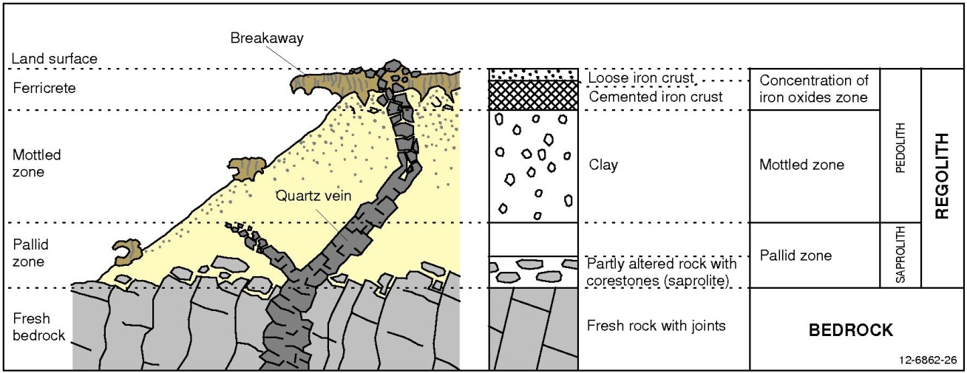
Figure 31: A typical laterite profile showing iron cemented crust, a mottled zone and a light coloured pallid zone on bedrock.

Importance of regolith to the Indigenous Australians
Indigenous Australians used regolith materials in their day–to-day life for body decoration, tools and even for weapons.
Some tools needed to be extremely hard to withstand everyday wear and tear. Indigenous Australians used silcrete to make tools like axes and cutting instruments, as it is an extremely hard and durable regolith material. In areas where silcrete was unavailable, axes could be made from hard river stone like basalt and quartzite. The streams rounded these stones into shapes that were ideal to work further by chipping or grinding into a cutting edge. Millstones were fashioned out of a quarried slab of sandstone. Women used the millstone for grinding seeds into a type of flour, whereas men used it for sharpening axes and chisels. Grindstones (or mortars) were made from slightly weathered sandstones and the grinders (or pestles) were made from rocks that were harder than the grindstones. The grinders were commonly made from rounded river pebbles and silcrete.
The Aborigines used ochre to paint their bodies, to decorate woodcarvings and also for their rock art. Red ochres are from hematite-rich regolith materials whereas yellow and orange ochres are mostly from goethite-rich regolith. White pigments were from kaolin and black was made from a manganese oxide called pyrolusite.
Aboriginal tools and weapons are often found hundreds of kilometres away from the source of the rocks and regolith from which they were made. These materials were highly valued and Indigenous Australians traded them across extensive networks throughout Australia, often for thousands of kilometres.

Regolith and medicine (geomedicine, geohealth or medical geology)
Geomedicine studies the effect of the geoenvironment on human, plant and animal health. It studies the relationship between health problems and their geographical distribution. Our health depends on our intake of essential nutrients that are found in the food we eat. These nutrients were absorbed into the plants we eat. Originally these nutrients were released during weathering, regolith and soil development and also as soluble ions in water. If we do not get enough of a nutrient, or we get too much, it can be harmful to our health.
The idea of a relationship between where people live and their health has been around for as long as medical science has existed. Over 2 000 years ago, the Greeks observed relationships between geography and specific animal diseases. The Chinese also recorded similar observations in medical texts as early as the third century BCE.
Geology can have an impact on human, plant and animal health by obvious physical threats such as volcanoes and earthquakes. Less obvious are the naturally occurring phenomena like radiation from the radioactive breakdown of potassium, thorium and uranium in igneous rocks like granite; dental and skeletal deformities resulting from too much fluorine in water and skin lesions and Bowen’s disease resulting from burning coal with a high arsenic content in South West China. Being able to understand the role of rocks, soil and regolith and groundwater on human health involves the cooperation of geoscientists and medical researchers.

Case study 1: Sickness country in Australia
For thousands of years the Indigenous Australians have recognised a particular region in Kakadu National Park as “sickness country” (Figure 32). If people spent too much time in this region it would have a negative impact on their health.
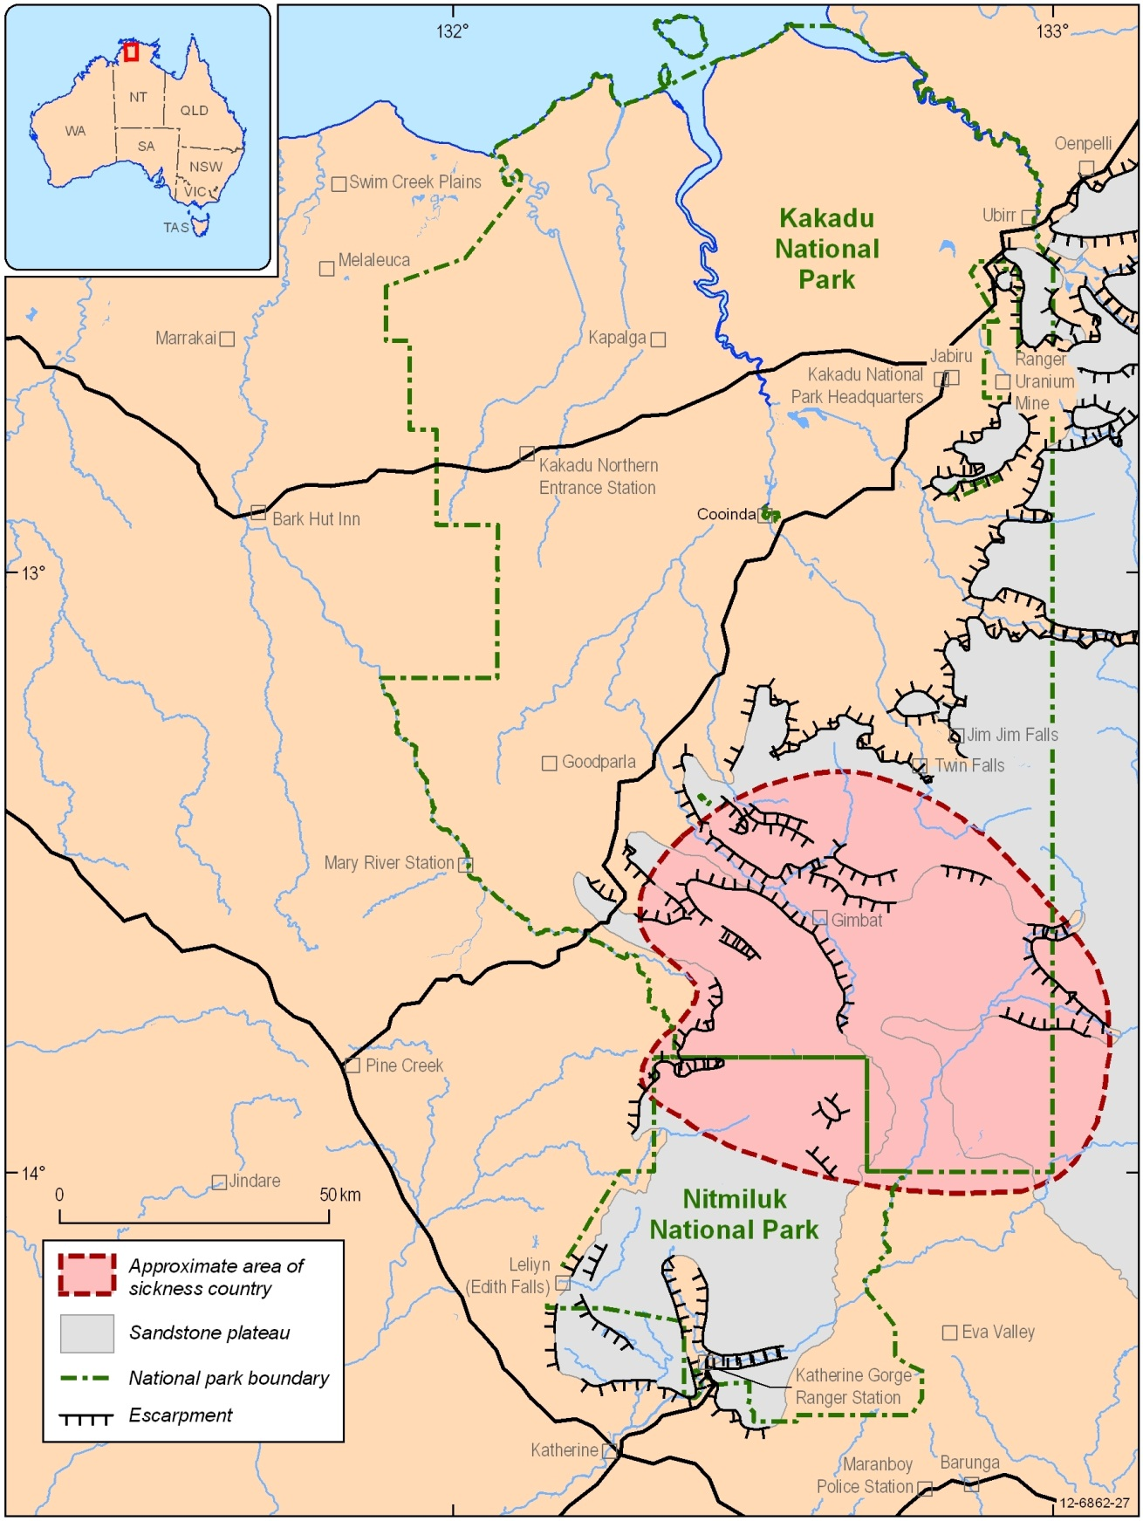
Figure 32: The approximate location and extent of sickness country in Kakadu National Park.
This area covers 2 000 km2 and was taboo for Aboriginal people to enter, except for special ceremonies. Geochemists were perplexed by the area and research has since found that the “sickness country” coincides with naturally high concentrations of thorium, uranium, arsenic, mercury, fluorine and radon in groundwater and drinking water. It was found that the high concentrations of the metals come from the granite and volcanic rocks underlying the area.

Case study 2: Arsenic exposure from eating chilli peppers in China
Scientists were baffled as to why there were suddenly high incidences of arsenic poisoning in people from the Guizhou Province in China. It was found that the arsenic poisoning in the locals was from eating chilli peppers which had a high arsenic content. Due to the cool, damp autumn weather experienced in the area, farmers often strung their chilli peppers and corn within the houses to dry. Hundreds of years ago the villagers burnt wood to dry their harvest but, due to deforestation, coal is now used but it has a high arsenic content. The villagers began drying their food over unvented coal fires, the chilli peppers became enriched in arsenic and the villagers ate the chilli peppers. As a result many people developed symptoms ranging from hyperpigmentation (changes in the colour of the skin), hyperkeratosis (scaly lesions on the skin, predominantly the hands and feet) and Bowen’s disease (dark, horny pre-cancerous lesions on the skin).

Biogeochemistry
As the name suggests, biogeochemistry studies the relationship between BIOlogy, GEOlogy and CHEMISTRY.
Plants can be useful indicators of what lies beneath in the regolith. Some plants are excellent accumulators of rare elements in the regolith, thus indicating a possible ore deposit beneath. If a particular plant occurs over a wide area, their leaves, bark or twigs can be sampled to determine how much of a particular element is in the regolith beneath.
The pearl salt bush (Maureana sedifolia) occurs on a wide scale and it typically grows where there is a high calcium content in the upper section of the regolith. Determining the distribution of the calcium carbonate-rich regolith (and possible ore minerals related to this) is made much easier by looking for this type of vegetation growing on the surface. In Western Australia, the nickel bush occurs where there are elevated concentrations of nickel in the regolith (hence the name). There are many other good examples of plants that are metal accumulators or hyperaccumulators, plants that are geobotanical indictors, or plants that are geobotanical avoiders.

Resource list

Books and journal articles
Blewett, R.S. ed. 2012. Shaping a Nation: A Geology of Australia. Commonwealth of Australia (Geoscience Australia) and ANU E Press, Canberra, Australia.
Boggs, S. Jr. (1987). Principles of Sedimentology and Stratigraphy, Merrill Publishing Company, Columbus, Ohio, USA, 784 pp.
British Geological Survey (2001) Earthwise – Geology and Health, Issue 17, 34 pp.
Clark, I.F. & Cook, B.J. (1983) Perspectives of the Earth, Australian Academy of Science, 651 pp.
Colhoun, E.A. and Barrows, T.T., (2011). The Glaciation of Australia. In: Developments in Quaternary Science Vol. 15, p 1037-1045. Elsevier.
Dent, D.L. & Pons, L. (1993) Acid and Muddy Thoughts, In: Proc. Nat. Conf. Acid Sulfate Soils, p 1-18., CSIRO.
Drew , G (Jan, 1997) Hallet Cove Geological Trail In: MESA Journal, p 23-33.
Duggan, M.B. and Knutson, J. (1993) The Warrumbungle Volcano: A Geological Guide to the Warrumbungle National Park, Australian Geological Survey Organisation, Canberra, 51 pp.
Eggleton, R.A. (Ed) (2001) The Regolith Glossary – Surficial Geology, Soils and Landscapes, Cooperative Research Centre for Landscape Evolution and Mineral Exploration, Canberra, 145 pp.
Evans, A.M. (1993) An Introduction to Ore Geology and Industrial Minerals (3rd Edition), Blackwell Sciences Ltd, 389 pp.
Hoatson, D and others (1997) Bungle Bungle Range: Purnululu National Park, East Kimberley, Western Australia: A Guide to the Rocks, Landforms, Plants, Animals, and Human Impact, Australian Geological Survey Organisation, Canberra, 82 pp.
Kearey, P (1996) Dictionary of Geology, Penguin Group, London, 366 pp.
Krebs, C.J. (1994) Glacial Moraine Succession in Southeastern Alaska, In: Ecology: The Experimental Analysis of Distribution and Abundance (4th Edition), HarperCollins College Publishers, New York, p 491-492.
Laseron, C.F. (1972) Australian Caves, In: The Face of Australia (3rd Edition), Angus and Robertson Pty Ltd, p 184-195.
McBriar, E.M. and Giles, C.W. (eds) (1984) Geological Monuments in South Australia, Part 5., Geological Society of Australia S.A. Branch, p 108-9, p 111.
McTainsh, G.H. and Boughton, W.C. (1993) Land Degradation Processes in Australia, Longman Cheshire Pty Limited, Melbourne, 389 pp.
Ollier, C.L. (1984) Weathering (2nd Edition), Longman Group Limited, p 22.
Ollier, C. & Pain, C. (1995) Regolith, Soils and Landforms, John Wiley & Sons Ltd, 316 pp.
Osborne, R.A.L., Zwingmann, H, Pogson, R.E. and Colchester D.M.,( 2006). Carboniferous cave deposits from the Jenolan Caves, NSW, Australia: Implications for timing and speleogenesis and regional geology. Australian Journal of Earth Sciences volume 53, p 377-405.
Scott, K.M. and Pain, C.F. eds (2008). Regolith Science. CSIRO Publishing, Melbourne, 461 pp.
Skinner, B.J. & Porter, S.C. (1992) The Dynamic Earth; An Introduction to Physical Geology (2nd Edition), John Wiley & Sons Ltd, 570 pp.
Sweet, I.P. & Crick, I.H. (1994) Uluru and Kata Tjuta – A Geological History, Australian Geological Survey Organisation, Australian Government Printing Service, 27 pp.
Sutherland, L. (1995). The Volcanic Earth, University of New South Wales Press, 248 p.
Taylor, G. & Eggleton, R.A. (2001) Regolith Geology and Geomorphology, John Wiley & Sons Ltd, 375 pp.
Thompson, R.B. (1991) A Guide to the Geology and Landforms of Central Australia, Northern Territory Geological Survey.
Twidale, C.R. & Campbell, E.M. (1993) Australian Landforms: Structure, Process and Time, Gleneagles Publishing, 560 pp.
Turner, P. (Ed) (1998) New Zealand Lonely Planet, Lonely Planet Publications, p 521-523.
Sammut, J. (2000) An Introduction to Acid Sulfate Soils (2nd Edition), Environment Australia & Dept. Agriculture Fisheries, Forestry Australia, 26 pp.

Websites for further information
Regolith studies:
http://crcleme.org.au (includes a variety of educational materials for tertiary students)
Australian landforms
http://www.ga.gov.au/education/geoscience-basics/landforms.html
Geomorphology and geology:
Geology of South Australia
http://outernode.pir.sa.gov.au/minerals/geological_survey_of_sa/geology
Geology of Victoria
http://parkweb.vic.gov.au/explore/parks/twelve-apostles-marine-national-park/environment
Glaciers:
Columbia Glacier, Alaska
http://earthobservatory.nasa.gov/Features/WorldOfChange/columbia_glacier.php
Coastal acid sulfate soils:
Comprehensive information pages from the Department of Sustainability, Environment, Water, population and Communities
http://www.environment.gov.au/water/topics/acid-sulfate-soils/index.html
Acid sulphate soils information from the Murray Darling Basin Authority
http://www.mdba.gov.au/programs/acid-sulfate-soils-risk-assessment
Video on coastal acid sulphate soil development http://vro.dpi.vic.gov.au/dpi/vro/vrosite.nsf/pages/soil_acid_sulfate_soils
A few pages on marine pollution
http://www.environment.gov.au/archive/coasts/cass/index.html
http://www.environment.gov.au/coasts/pollution/
http://www.environment.nsw.gov.au/acidsulfatesoil/effects.htm
Atlas of Australian acid sulfate soils
http://www.clw.csiro.au/acidsulfatesoils/atlas.html
Salinity:
NSW Department of Primary Industries on soil health and fertility
http://www.dpi.nsw.gov.au/agriculture/resources/soils/salinity
Department of Agriculture, Fisheries and Forestry
http://www.daff.gov.au/natural-resources/salinity
Western Australian Department of Agriculture and Food
http://www.agric.wa.gov.au/PC_92359.html
PDF about “Urban salinity causes and impacts”
http://www.dpi.nsw.gov.au/__data/assets/pdf_file/0004/309316/Urban-salinity-causes-and-impacts.pdf
Fact sheet on salinity and water quality
http://www.environment.gov.au/water/publications/quality/salinity-and-water-quality-fs.html
Acid sulfate soils
An introduction to Acid sulphate soils from NSW Department of Primary Industries
http://www.dpi.nsw.gov.au/agriculture/resources/soils/ass/general/introduction
Queensland government introduction to acid sulphate soils
http://www.derm.qld.gov.au/land/ass/what_are_ass.html
Fact sheet on inland acid sulphate soil and water quality
http://www.environment.gov.au/water/publications/quality/inland-acid-sulfate-soil-and-water-quality-fs.html
Downloadable MS Word file on national guidance for the management of acid sulphate soils in inland aquatic ecosystems
http://www.environment.gov.au/water/publications/quality/pubs/guidance-for-management-of-acid-sulfate-soils.doc
Medical geology:
US Geological Survey page on human health and medical geology
http://energy.usgs.gov/HealthEnvironment/EcosystemsHumanHealth/MedicalGeology.aspx
Karst topography:
Information on the geology of limestone caves and how they form
http://www.jenolancaves.org.au/about/geology-of-limestone-caves/
A PDF on limestone cave ecosystems and their management
http://www.reec.nsw.edu.au/2002/teachers/texttch/pdf/cavenote.pdf
Geological glossaries:
Glossary of geological terms from the Illinois State Geological Survey’s Prairie Research Institute
http://www.isgs.uiuc.edu/glossary.shtml
Other resources:
Earth Learning Idea – practical activities for teachers including supporting information
http://www.earthlearningidea.com/English/Earth_Energy.html
A simulation map of changing sea levels going back in time from Monash University
http://sahultime.monash.edu.au/explore.html - sea levels simulation
Australian mines atlas mineral fact sheets
http://www.australianminesatlas.gov.au/education/fact_sheets/index.html

Glossary
Abrasion This is the physical break down of rocks or minerals either by rubbing against other rocks, or from the impact between pieces of rock or minerals. Abrasion commonly occurs in streams and in deserts and helps to round or flatten stones and helps to make large rocks or minerals smaller.
Acid sulfate soil Acid Sulphate Soil (ASS) commonly has a low pH of <3.5. Potential Acid Sulfate Soils (PASS) have pyrite present in their profile and could become acid sulfate soils if the pyrite is oxidised by disturbing the soil (e.g. by trenching) or by lowering the ground water table (e.g. by pumping).
Adsorption Process of adhesion of material to a surface. Not to be confused with absorption.
Aeolian Relating to the wind, particularly erosion and deposition caused by the wind. This particularly applies to rocks, soils and deposits which have been blown and deposited by the wind such as sand dunes and wind-blown ripple marks in sand.
Alluvium Sediment deposited from creeks, streams, rivers etc. Adjective: alluvial.
Bentonite A rock that is mainly composed of smectite clay and is formed in place from the chemical weathering of volcanic tuff or ash.
Bioturbation The action of plants and animals in turning over regolith to enhance weathering by bringing fresher regolith to the Earth’s surface where it will weather more quickly.
Breccia A rock made up of mainly broken angular fragments – often the result of explosive volcanic activity.
Colluvium An assortment of material of any particle size that is mainly made up of soil and/or rock fragments. Colluvium gathers on the lower parts of slopes and hills and is transported by the effects of gravity, soil creep, sheet flow, rainwash or mudflows.
Craton A piece of the Earth’s crust that has been stable has hardly deformed for a prolonged period.
Crustal Relating to the crust of the Earth.
Deposition The setting down of any material by any means including wind (aeolian), water (fluvial), ice (glacial) or by other natural processes.
Desertification Process where dry land becomes more arid, losing bodies of water, wildlife and vegetation.
Diagenesis The process of physical and chemical change in a sediment during its conversion to a rock.
Dispersive Dispersion is the distribution of a particular constituent in a rock or in soil.
Duricrust A regolith material that has been hardened and cemented during the weathering process. It occurs at or near the Earth’s surface and the cement is commonly composed of silica (silcrete), iron oxyhyrdoxides (ferricrete or lateritic duricrust), calcium carbonate (calcrete), manganese oxyhydroxides (manganocrete), dolomite (dolocrete), aluminium (alcrete) or a combination of these.
Dyke Dykes can be thought of as the veins of a volcano. A dyke is a sheet-like body of magma that cuts through the local rock and then solidifies.
Erosion The basic process that loosens and moves rocks and earth materials (like soil) from one place to another.
Exfoliation The peeling off of the outer layers of a rock face or boulder.
Ferricrete Refers to any material that has an iron cement containing iron oxides and oxyhydroxides
Flocculate A process creating flocs, which are sand-sized aggregates of clay, in water.
Fracture A rock crack that has noticeable movement. Large fractures are called faults.
Geohazard A geological feature or process that may threaten life and or property in the natural or built environment. Geohazards include earthquakes, volcanic eruptions, tsunamis, landslides, debris flows, gas accumulations and naturally-occurring radiation. Geohazards are a sub group of natural hazards.
Geomedicine The study of the spatial association between geology and medicine/health. Also known as Medical Geology and Geohealth.
Goethite (FeO.OH) Goethite is an iron hydroxide that occurs in environments where water is freely available (like in a valley). It often gives a yellow or yellow-orange colour to soils and regolith.
Groundwater Water that flows or seeps downward, saturating soil or rocks and remaining within pore spaces or fractures within rocks. Groundwater is the source of water in springs and wells.
Hematite An iron oxide (Fe2O3) that gives a red colour to soils, regolith etc. It often occurs in drier environments such as hill tops.
Inorganic acids Inorganic acids are those that do not contain carbon. They can be strong acids, but are normally very dilute in the environment. They can form in rain water or surface water from dissolved gasses like chlorine, fluorine, sulphur and nitrogen which create hydrochloric, hydrofluoric, sulphuric and nitric acid. Concentrations of these acids can be quite strong around active volcanoes, which exhale these compounds.
Joint A rock crack that has had no noticeable movement. It may be apparent as a hairline in a rock and forms by contraction during cooling or expansion by unloading overhead rocks.
Kaolinite This is a clay mineral with a chemical formula of Al2Si2O5(OH)4. It is a major component of weathering profiles, and forms as a weathering product of aluminosilicates, minerals that contain aluminium and silica in their crystal structure, e.g: feldspar and mica. The rock kaolin is composed of more than 80% kaolinite.
Karst A terrain with distinct characteristics of drainage and topography arising primarily through the higher solubility of bedrocks than elsewhere. Karst is most common in limestone terrain, but may occur anywhere erosion occurs by solution and collapse including in clastic sedimentary rocks like sandstone and igneous rocks including granite and syenite.
- Laterite A residual deposit of iron and aluminium hydroxides. It forms part of a weathering profile that normally occurs in wet, tropical regions. Bauxite is an example of a laterite.
Laterite profile A laterite profile has the following layers or horizons from the bottom up: ‘bed’ rock, saprock, saprolite, pallid (light coloured) zone, mottled zone or iron-rich saprolite, soil and iron crust.
Magnetics Airborne magnetics uses a magnetometer mounted on a fixed-wing aircraft, helicopter or even an airship or remote-controlled vehicle to measure the Earth’s natural magnetic field.
- Moraine An accumulation of boulders and rock fragments that have been transported and deposited by a glacier or ice sheet.
Organic acids An organic compound with acidic properties. To be organic the compound must contain carbon atoms. Generally organic acids are weak acids formed by the reaction in the regolith of organic molecules from plant or animal matter (e.g. humus) with water to create weak acids like carbonic acid.
Palygorskite A fibrous mineral that has a chemical formula of (Mg,Al)5Si8O20(OH)2.4H2O. It is largely found in arid environments where evaporation rates are high.
Parna Wind blown, silt and sand-sized aggregates of silts and clays. They often occur as dune-like deposits or as sheets that drape over the landscape.
pH A measure of how acidic or basic/alkaline a substance is. A pH of 0-6 is acidic, pH 7 is neutral and 8-14 is alkaline.
Pisolite A sedimentary rock made of pisoids, which are spherical grains of minerals of more than 2 mm in diameter. These grains have concentric layers. Examples include bauxite, limonite and siderite.
Placer An accumulation of high density minerals of due to gravity separation, e.g. in the bend of a river or the base of an escarpment.
Pluton Intrusive igneous rock that is crystallised from magma cooling below the surface. Typically several kilometres in size.
Pyrite (FeS2) This is the most common iron sulfide mineral.
Pyrolusite (MnO2) A grey mineral that is the most important ore mineral of manganese.
Radiometrics Airborne radiometrics measure the naturally occurring radioelements potassium (K), thorium (Th) and uranium (U) in the surface of the Earth. These are recorded using a gamma-ray spectrometer mounted on a fixed-wing aircraft, helicopter or even an airship or remote-controlled vehicle.
Regolith Anything in between fresh rock and fresh air! Regolith comprises all of the loose or secondarily re-cemented cover that overlays solid ‘bed’ rocks. It can be formed from weathering, transport and/or deposition of older material. The regolith includes cracked and weathered basement rocks, saprolite, soil, build-ups of organic matter, volcanic material, deposits from glaciers, colluvium, alluvium, wind blown (aeolian) deposits, groundwater and sediments formed from evaporation (like salt, gypsum etc).
Relief inversion The process of turning a landscape ‘upside down’. Over long periods of time, valley bottoms can become indurated, becoming more resistant to weathering and erosion than the surrounding materials. Further weathering and erosion will remove the softer materials, leaving the old valley bottoms at the top of the landscape, thus inverting the original relief. This is also common in areas where lava flows have run down river valleys, and the surrounding material has been eroded, leaving the lava flow at the top of the landscape.
Rill A narrow, shallow trench in the topsoil due to flowing water.
Roundness The degree of smoothing on sedimentary particles as a result of abrasion. The scale of roundness ranges from very angular to well-rounded.
Saltation Occurs when loose material, such as sand or snow, is lifted by a fluid (e.g. water or wind), transported a distance and then dropped back to the surface.
Saprock Saprock is the first stage in the weathering process of rock. It contains both weathered and unweathered minerals and all the fabric of the rock is maintained. Saprock still needs a hammer to break it.
Saprolite Weathered rock that retains the internal structure of the rock from which it is weathered. It is more weathered than saprock and will normally break apart will a light blow from a hammer. Soil scientists commonly call it the C-horizon of a soil.
Sepiolite A fibrous material with a composition of Mg8Si12O30(OH)4.4H2O. Also see palygorskite.
Shields A large area of exposed rocks in a craton, often with a convex surface.
Shield volcano A large volcano, several kilometres to several tens of kilometres diameter, that builds up to be a dome shape. It has a broad, low shape with surface slopes of only a few degrees and resembles a shield laid on the ground.
Smectite A clay that takes water into, or loses water from, its crystal structure to give the clay shrink-swell and cracking characteristics. Varieties include bentonite, beidellite, montmorillonite, attapulgite, nontronite and saponite.
Soil This is the uppermost part of the regolith. It must be formed in situ and can be characterised into the following horizons;
A1 - Organic or mineral horizon that is at the land’s surface and has an accumulation of organic matter.
A2 – Is generally paler and has less organic matter than the A1 or the B horizons.
B1 – A transition zone between the A and B horizons has characteristics more like B2 than A.
B2 – This is the zone of accumulation. It is more concentrated in clay, iron and humus. Soil structures are most developed in this horizon and it is the richest in colour.
B3 - The transition between the B and C-horizon but has more characteristics of the B2-horizon.
C – The horizon beneath the solum (A & B-horizons). It is partially weathered and known as saprolite in regolith terms. It is least affected by soil forming processes.
D – A buried horizon. It is unlike the soil layers above.
R – Bedrock.
Solum The solum comprises of A1-B3 horizons of a soil (ie: an AB profile).
Sorting The sorting of a sediment refers to the distribution of grain sizes in a sample of sediments or in a sedimentary rock. The degree of sorting (well sorted through to very poorly sorted) gives an indication of the energy, rate, duration and transport process involved.
Speleothems Secondary mineral deposits in caves. Stalactites and stalagmites are examples of speleothems.
Stack A landform near the sea consisting of steep, often vertical, columns of rock created by erosional processes.
Tafoni Pits and cavities found in rocks formed by crystallisation of salts in the rock surface and by physical fretting due to wind-blown sand. This is especially common for granites weathering in desert or sea-shore environments. Tafoni is the plural name, tafoni the singular name, of these spectacular landforms.
Till Poorly sorted angular debris that has been deposited directly from glacial ice, usually by glacial melting.
Tor A rounded boulder of rock occurring at the Earth’s surface, most commonly occurring on granitic or silica-rich volcanic rocks.
Tuff A rock that has formed from the accumulation and compaction of volcanic ash and small fragments of other volcanic material. These materials are the result of the explosive break-up of viscous magma or volcanic rocks.
Ultramafic A rock that contains more than 90% ferromagnesian minerals like olivine, augite and hornblende (ie: have iron and magnesium in their crystal structure).
Ventifact A stone that has been flattened on one or more sides due to erosion by the wind, mainly by sand abrasion.
Weathering This is the process in which the texture and composition of rocks, sediments and regolith change after being exposed at or near the Earth’s surface to weathering agents such as water, oxygen, organic acids and large temperature fluctuations. Weathering can be chemical or physical (mechanical) and includes changes by the effects of gravity, the atmosphere, the hydrosphere and/or the biosphere at normal temperatures and pressures.
Weathering profile A weathering profile is the vertical assemblage of zones with differing degrees of weathering. A typical in situ weathering profile consists of the following zones (from the bottom up); 1) fresh rock, 2) a weathering front which is the division between fresh rock and weathered rock, 3) saprock, 4) saprolite, and 5) soil.
Wentworth size classes The Wentworth grain size class system allows geologists to define particle sizes according to a standard scale based on the diameter of particles. In this scale, particles can be divided into four major size categories (clay, silt, sand and gravel) with clays < 0.0039 mm (1/256 mm) diameter, silt > 0.0039 and < 0.0625 mm (1/16 mm) diameter, sand > 0.0629 mm and < 2 mm diameter and gravel > 2 mm diameter.

Student Activities

Overview of Student Activities

Teacher Notes

Icebreaker (teacher demonstration)
Notes: See notes page 5. THIS IS NOT A STUDENT ACTIVITY - IT IS A TEACHER DEMONSTRATION DUE TO POTENTIAL DANGER FROM BROKEN GLASS. Fill a glass jar of water to the brim and seal tightly with a lid. Place it in 1 or 2 strong resealable plastic bags then place in the freezer overnight. Carefully remove from freezer to show class that the glass has shattered.

Tour’osion (written activity)
Notes: See notes page 23. You may need to go through one example of longitude and latitude to remind the students. The starting point for the activity is Townsville, from which the answers are calculated, however you could use your own town but you will need to determine the new answers.

How Would You Like To Be Remembered? - The effects of acid rain on buildings (practical activity)
Notes: See notes page 8. A follow-up excursion for this activity could be a visit to a cemetery. Even if you don’t live in a big city, with lots of air pollution, as long as you have access to an old cemetery you can look at the effect of weathering on tombstones. Although acid rain isn’t a large problem here in Australia, if you live in Sydney or Melbourne you may be able to observe some of these effects on the older tombstones and use the dates on the tombstones to give an idea about the speed of weathering.

You drip! Part 1
TEACHER INSTRUCTIONS: Buy a salt block/brick from a pet store. Set up a constant drip system in the classroom. Use a retort stand if you have one or otherwise find a way to suspend a small container of water to drip onto the salt block (this will simulate erosion in your classroom).
1. What is erosion? (Write your or your class’s definition here)

2. Draw and fully label the salt block and apparatus your teacher has set up.

3. Predict what you think will happen to the salt block.

4. Each day, for six days you are to observe what has happened to the salt block and record your observations in the table below.
Date | Observation

You drip! Part 2:
1. Collect 25 ml of the water that is being dripped onto the salt block and collect 25 ml of the run off liquid from around the salt block. Place in petrie dishes (or shallow plastic containers) and allow to evaporate.
2. Predict what you think will happen in the dishes.
Water dish:

Run-off dish:

3. Make observations of the dishes after evaporation and record them in the table below.
Observation
Water

Run-off

4. Finish the following sentence:
If water drips against a salt block for a long period of time

5. Describe examples of where water acts in a similar way in the natural world.

Icebreaker
(Teacher demonstration)
Aim:
To determine if freezing water causes weathering or erosion.
Materials:
- 1 glass jar
- water
- small towel
- zip lock plastic bag large enough to fit over the jar
Method:
1. Fill the jar completely with water and seal it with the lid.
2. Wrap the jar in a resealable plastic bag with a towel around it and place it in a freezer overnight.
Predict what you think will happen to the jar.

3. Unwrap the jar carefully and observe what has happened.
Results:
What happened to the jar after the water inside it had been frozen?

Conclusion:
1. When water freezes it expands OR contracts (circle correct answer).
How do you know this?

2. When water freezes in cracks in rocks, the expansion may cause the rock to

3. In which parts of Australia do you think this type of ‘freeze-thaw process’ may take place?

Agent erosion
Notes: See notes page 9. This is an assignment to be done in groups of four.
Your name:
Agent:
Group members:

Instructions
Your group will be assigned one ‘agent of erosion’ from the following list: running water, waves, glaciers and wind. Each group is a top secret government department and your task is to compile a dossier on your ‘secret agent’. This file should contain the following information:
Statistics on agent - size of particles, speed of process, where found in the world, etc.
Modus operandi of the agent - how the secret agent actually causes erosion.
Thwart potential - an imaginative way that an agent may be stopped (or can they be stopped?). Discuss ways in which this type of erosion agent interferes with human’s plans and ways to prevent its interference.
Scene of the crime - drawings and pictures of the scene of the erosion agent, where it operates and areas it causes problems.
It is recommended that each person in the group should research ONE of the above four topics.
Assessment
Your group will have to decide how to divide up the work equally.
The following will be assessed:
- A written report no longer than 500 words. Include only the most important information.
- A presentation to the class - include one or two pictures that really demonstrate your type of erosion and the most important information/facts from your written report. Your presentation should include any props or demonstrations that help you to explain information to the rest of the class. This should not be longer than 5 – 7 minutes.
Due date:

Factors affecting physical and chemical weathering
Aim:
To describe and give examples of factors which affect the rate of physical and chemical weathering.
Materials:
- Water
- 3 sugar cubes
- 3 small jars with lids
- Eye dropper
Method:
1. Place one sugar cube in each of the jars
2. Put 5 drops of water onto the sugar cube in the first jar. Observe what happens and write your observations in the table.
3. Cover the second jar tightly with the lid. Shake the sugar cube vigorously for 10 seconds. Observe what happens and write your observations in the table. (DO NOT place any water in this jar.)
4. Place 5 drops of water on the sugar cube in the third jar. Cover the jar tightly with the lid. Shake the jar vigorously for 10 seconds. Observe what happens and write your observations in the table.
Results:
Experiment | Observation
a) Sugar cube and water

b) Sugar cube and shake

c) Sugar cube, water and shake

Conclusion:
1. Which method resulted in the most weathering of the sugar cube?

Explain why this method was the most destructive.

2. What types of weathering (physical, chemical) are illustrated by the experiment in each jar?
Jar 1)
Jar 2)
Jar 3)
3. Where might you find examples of the same types of weathering as this experiment demonstrates?

Rates of weathering
Aim:
To identify factors which affect the rate of weathering.
Hypothesis:

Materials:
- 2 beakers or jars, water
- 2 Alka Seltzer tablets
- Stop watch
Method:
- Break one tablet into small pieces and put the pieces in a beaker.
- Leave the other tablet whole and put in the other beaker.
- Add 15 ml of water to each beaker at exactly the same time.
- Observe what happens and record the time it takes for each tablet to completely dissolve.

Sample | Time taken (seconds) | Observations
Broken tablet

Whole tablet

Conclusion:
1. Which tablet had the largest area of surface touching the water – the broken or the whole tablet?

2. What is the relationship between surface area and the speed it takes for the tablet to dissolve?

3. How does this relationship apply to weathering in nature?

Tour’osion
Ella and Kai are planning to tour Australia and visit a variety of geological features, all of which have been affected by weathering and erosion. They have been given a map reference and a description of the places they are to visit. They need to mark these places on the map provided to enable them to plan their trip.
a) Mark in and label your home town on the map.
b) Read the description about each site and use latitude and longitude to mark where they are located on the map of Australia.
ULURU (Ayers Rock)  Lat: 25.20 S Long: 131.02 E  The sediments that formed Uluru began their life 550 million years ago as alluvial fans deposited sediments from ancient mountains that have now eroded away. Erosion has worn away the surrounding softer limestone and sedimentary rocks to leave the more resistant Uluru. | TWELVE APOSTLES  Lat: 38.5 S Long: 143 E  The ‘Apostles’ are under attack from the sea, sea spray and rain as well as wind and water carrying sand and gravel that act as abrasives. They are undercut by the waves pounding the cliffs and caves are formed. As time progresses the caves widen into arches that can collapse to form each ‘Apostle’. | KARLWEKARLWE  Lat: 21.5 S Long: 134 E  These ‘marbles’ weathered as water penetrated the rock, splitting it into rectangular blocks of 3-7 metres square. Further weathering in the cracks and the peeling of the outside of each rock rounded the corners of the boulders. The surface soil was eroded away to reveal the rounded boulders that we see today.
REMARKABLE ROCKS  Lat: 36 S Long: 137.5 E  The seaward side of these dome-shaped granite boulders are particularly weathered. Sea-spray is a contributor to its cavernous appearance. All the boulders have pits and hollows formed on their underside. These have most likely formed from salt crystallising on the rock surface. | FRASER ISLAND  Lat: 25 S Long: 153 E  Fraser Island is 125km long and over 160 000 hectares in area. It was formed during the last Ice Age when the prevailing winds transported vast quantities of sand from New South Wales and deposited it along the coast of Queensland, forming Fraser Island. It is the largest coastal dune system and largest sand island in the world. | CRADLE MOUNTAIN  Lat: 41.5 S Long: 146 E  The area where Cradle Mountain is located was glaciated during the last Ice Age (about 10 000 years ago) when a 6 km wide ice cap formed and glaciers flowed from its edges, carving the landscape into dramatic shapes. It is characterised by a range of glacial formations - tarns, glacial lakes, moraine deposits, U-shaped valleys and waterfalls.
PURNULULU (Bungle Bungles)  Lat: 17.25 S Long: 128.3 E  The ‘Beehive’ landforms have formed from mechanical weathering and the physical removal of grains of sandstone, mainly by running water but also by wind, rain, plants and animals. | WAVE ROCK  Lat: 32 S Long: 120 E  Wave Rock is a granite cliff, 14 m high and 110 m long. Its overhanging curve was caused by weathering and water erosion. The vertical streaks have been caused by rain washing down its face and leaving behind chemical deposits. | WARRUMBUNGLES  Lat: 31.5 S Long: 149 E  Over time, the forces of weathering and erosion have carved away at this volcano that formed 13 million years ago. The more easily weathered rocks have all but gone, leaving only the most resistant parts – the plugs, dykes and domes (the “veins and arteries” of the volcano).

‘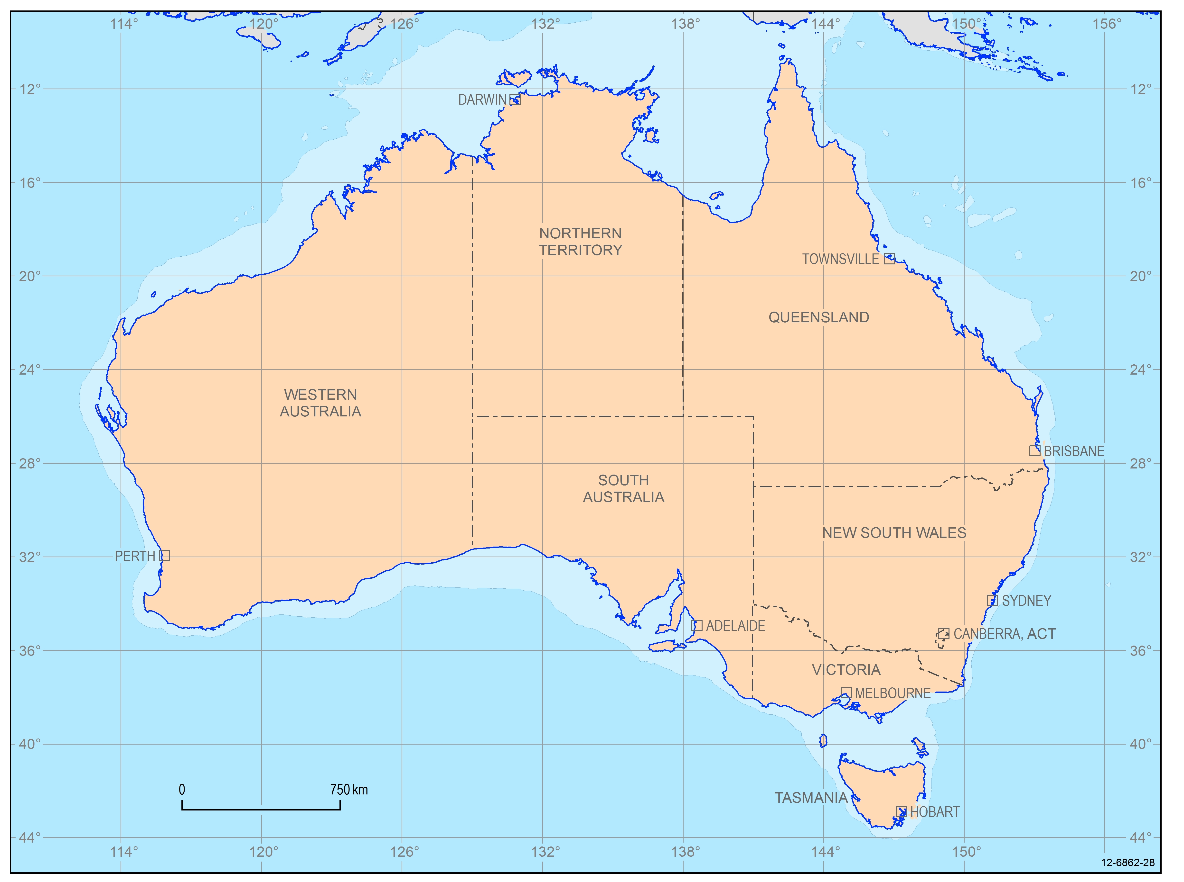
Your task
Ella and Kai will travel in an anticlockwise direction around the country starting in their home town of Townsville in far north Queensland. You need to plan their tour of the erosion features using the shortest possible route. They will be travelling in a plane.
Once you have marked all the places on the map you need to measure the distance between each place to enable you to plan the shortest possible route. You will need a ruler to measure in centimetres then use the scale on the map to convert to kilometres. Alternatively use the edge of a piece of paper to mark the distance then use the scale bar to convert to kilometres.
Fill in your details on the table below:
From | To | Distance (km)
Townsville
 | Total

Conclusion
(You will need to read the description of each site to answer these questions.)
1. Is there one main agent of erosion for all the sites?

2. Which of the sites were affected by chemical erosion?

3. List all the types of weathering and erosion mentioned.

4. Research the aboriginal story of the formation of one of the sites and compare this with the scientific view on its formation by weathering and erosion.
Extension: Discuss the view that without weathering and erosion overseas tourists would have little reason to come to see the natural environment in Australia.

How would you like to be remembered?
Aim:
To determine what tombstone/gravestone rock type would be most affected by acid rain in a cemetery.
Hypothesis:
Acid rain coming into contact with some tombstones will...

Materials (per group):
- Small pieces of limestone, marble, granite, sandstone
- 8 small glass jars with lids
- Dilute HCl or vinegar
- Tap water
- Marker pen or masking tape
- Safety goggles
Method:
1. Put a piece of each of the four types of stone into a separate jar.
2. Half fill these jars with dilute HCl.
3. Label the jars with the name of the tombstone material and the liquid that they are in. For example limestone and HCl.
4. Place the remaining stones into separate jars then half fill them with water and label each jar.
5. Observe the initial effects of acid and tap water on the building materials in each jar. Record these observations in the table.
6. Record observations again after 20 minutes.
7. Let the jars sit overnight or until the next lesson then record your last observation.
Results:
 |  | HCl | Tap water
Limestone | Initial
 | 20 min
 | Next day
Marble | Initial
 | 20 min
 | Next day
Granite | Initial
 | 20 min
 | Next day
Sandstone | Initial
 | 20 min
 | Next day
Conclusions:
1. Which rock was most affected by the acid?

2. Were any rocks substantially affected by the water?

3. What evidence is there that a chemical change has taken place in some of the jars?

4. Rain naturally contains chemicals that make it acidic. What can you conclude about the effect of acid rain on rock types?

5. Which rock type would you choose to build you tombstone out of? Give your reasons.

Erosion in action
Aim:
To develop an appreciation of the factors which contribute to rates of erosion.
Materials:
- Five shoe boxes or trays or possibly large plastic drink bottles - trimmed to five centimetres deep, v-notched at one end, and lined with plastic if needed (plastic should extend several centimetres beyond notched end). These should all be the same size.
- Water
- Sprinkling cans or containers
- Measuring device or graduated cylinders
- Filter paper or paper towel
- Funnel
- Electronic scales or balance
- ‘Grass sod’ (indoor/outdoor carpet, discarded carpet, terry towelling cloth)
- Soil (enough for the five trays to be filled with the same soil)
Method:
- Fill one erosion tray or box with moist soil about 3 cm deep and pack down tightly.
- Fill one erosion tray or box with moist soil about 2 cm deep and then place a layer of sod, carpet, or cloth over the top of the soil and pack down tightly.
- Fill one erosion tray or box with moist soil about 3 cm deep and, using your finger, make shallow trenches across the slope (contouring), i.e., across the tray.
- Fill one erosion tray or box with moist soil about 3 cm deep and, using your finger, make shallow trenches up and down the slope, i.e., the long direction of the tray.
- Fill one erosion tray or box with moist soil about 3 cm deep and using a ruler, make steps across the slope (terracing), i.e. across the short direction of the tray.
- Line up the boxes on an incline with the v-notch at the lower end; place catch cans, measuring cups, or some type of drip pan under the v-notch; place the cup or can close enough to the v-notch to prevent splashing.
- Have one student from each group simultaneously sprinkle a measured amount of water (300ml) on each soil tray from a height of about thirty centimetres above each box. The same amount of water should be sprinkled on each tray; pour steadily.
- Have one student from each group record the length of time from the beginning of the sprinkling until water first starts running out of the v-notch; similarly, record the total length of time water continues to flow out of the v-notch of each tray.
- Let the water in the measuring cups or catch cans settle and measure the sediment in each cup. Filter the outflow from each box through a filter. Dry the filter paper and measure the mass the amount of sediment that was washed from each box. You can also measure the amount of water that ran off, compared to the amount of water applied.
Hypothesis:
Predict which tray will have the most and least amount of erosion
Most _____________________________ Least _____________________________
Results table:
Treatment | Tray 1  none | Tray 2  sod/carpet | Tray 3  contour | Tray 4  long trench | Tray 5  terrace
Time for water to begin running

Total time for water to run out of tray

Volume of water that was applied

Volume of water (mL) that "ran off"

Dry mass (g) of solid that "eroded"

Conclusions:
1. Which soil surface had the greatest amount of runoff? _____________________________
2. Which soil surface lost the least soil? ___________________________________________
3. In which soil surface did the runoff/erosion appear first? In which soil condition did the runoff last the longest?

4. Farmers can affect the amount of soil erosion on their farms. Which land management methods were most effective in controlling erosion in this experiment? Explain why.

5. Why should you pour the same amount of water for the same amount of time on each of the soil conditions?

Answer sheets

You drip! Part 2:
1. Collect 25 ml of the water that is being dripped onto the salt block and collect 25 ml of the run off liquid from around the salt block. Place in petrie dishes (or shallow plastic containers) and allow to evaporate.
 | Observation
Water
Run-off | Salt crystals are left behind.
4. Finish the following sentence:
If water drips against an object for a long period of time it will erode the surface it is dripping on.
5. Describe examples of where water acts in a similar way in the natural world.
Caves, rivers, creeks, coastal areas.

Icebreaker
(Teacher demonstration)
Results:
What happened to the jar after the water inside it had been frozen?
The glass cracked.
Conclusion:
Circle the correct answer and answer the rest of the question
1. When water freezes it expands OR contracts (circle correct answer).
How do you know this?
The frozen water cracked the glass because it took up more space than the liquid water.
2. When water freezes in cracks in rocks, the expansion may cause the rock to crack even further.
3. In which parts of Australia do you think this type of ‘freeze-thaw process’ may take place?
Snowy Mountains, Antarctica.

Factors affecting physical and chemical weathering
Results:
Experiment | Observation
a) Sugar cube and water
b) Sugar cube and shake
c) Sugar cube, water and shake
Conclusion:
1. Which method resulted in the most weathering of the sugar cube?
(c) sugar cube, water and shake
Explain why this method was the most destructive.
The combination of both chemical and physical weathering.
2. What types of weathering (physical, chemical) are illustrated by the experiment in each jar?
Jar 1) ______chemical_________________________________
Jar 2) ______physical__________________________________
Jar 3) ______chemical and physical_______________________
3. Where might you find examples of the same types of weathering as this experiment demonstrates?
Rivers, oceans where rocks are in water (chemical weathering) and being tumbled
about (physical weathering).

Rates of weathering
Conclusion:
1. Which tablet had the largest area of surface touching the water – the broken or the whole tablet?
Broken
2. What is the relationship between surface area and the speed it takes for the tablet to dissolve?
The larger the surface area the faster the reaction can take place.
3. How does this relationship apply to weathering in nature?
Small stones, rocks, etc, weather much faster than large rocks. Also, pitted and cracked
rock faces, with large surface area, will weather faster than smooth rock faces with
smaller surface areas.

Tour’osion
From | To | Distance (km)  (Given answers have been rounded to nearest half cm measurement)  2.7 cm = 750km
Townsville | Karlwekarlwe | 5 cm = 1389km
Karlwekarlwe | Purnululu | 3.5 cm = 972 km
Purnululu | Uluru | 3.5 cm = 972 km
Uluru | Wave Rock | 5.5 cm = 1528 km
Wave Rock | Remarkable Rocks | 7.5 cm = 2083 km
Remarkable Rocks | Twelve Apostles | 3 cm = 833 km
Twelve Apostles | Cradle Mountain | 1 cm = 278 km
Cradle Mountain | Warrumbungles | 4 cm = 1111 km
Warrumbungles | Fraser Island | 3 cm= 833 km
Fraser Island | Townsville | 3.5cm = 972 km
 | TOTAL | 39.5 cm = 10 972 km  $$\frac{39.5}{2.7}×750=10 972$$
Conclusion
1. Is there one main agent of erosion for all the sites?
Yes, water.
2. Which of the sites visited were affected by chemical erosion?
Wave rock
3. List all the types of weathering and erosion mentioned.
Physical weathering, chemical weathering, soil erosion, wave erosion, wind erosion,
glacial erosion.

How would you like to be remembered?
Conclusions:
1. Which rock was most affected by the acid?
Marble and limestone were both affected by the acid.
2. Were any rocks substantially affected by the water?
No real noticeable effect.
3. What evidence is there that a chemical change has taken place in some of the jars?
Bubbles are given off the rocks that are dissolving.
4. Rain naturally contains chemicals that make it acidic. What can you conclude about the effect of acid rain on rock types?
The effect of the acid will depend on the type of rock. Different rocks are composed of
different minerals, all of which have different solubilities in the acid. Some dissolve
easily, some are more resistant to the acid.

Erosion in Action
Conclusions:
1. Which soil surface had the greatest amount of runoff? Tray 1
2. Which soil surface lost the least soil? Sod/carpet (Tray 2)
4. Farmers can affect the amount of soil erosion on their farms. Which land management methods were most effective in controlling erosion in this experiment? Explain why.
Sod/carpet as the sod covered the soil and meant water was moving slower through it.
Contours are also an effective method in controlling erosion. The contours slowed the
process of runoff through the soil cover.
5. Why should you pour the same amount of water for the same amount of time on each of the soil conditions?
To ensure consistency and allowing for comparisons to be drawn between each
experiment.

