A compilation of grainsize, biogenic silica and carbonate data from East Antarctic surface sediments

Geoscience Australia  
Record 2013/05

Alexandra L. Post



Department of Resources, Energy and Tourism

Minister for Resources and Energy: The Hon. Martin Ferguson, AM MP  
Secretary: Mr Blair Comley, PSM

Geoscience Australia

Chief Executive Officer: Dr Chris Pigram  
This paper is published with the permission of the CEO, Geoscience Australia



© Commonwealth of Australia (Geoscience Australia) 2013

With the exception of the Commonwealth Coat of Arms and where otherwise noted, all material in this publication is provided under a Creative Commons Attribution 3.0 Australia Licence. (<http://www.creativecommons.org/licenses/by/3.0/au/>)

Geoscience Australia has tried to make the information in this product as accurate as possible. However, it does not guarantee that the information is totally accurate or complete. Therefore, you should not solely rely on this information when making a commercial decision.

Geoscience Australia is committed to providing web accessible content wherever possible. If you are having difficulties with accessing this document please contact [feedback@ga.gov.au](mailto:feedback@ga.gov.au).

Cover images used with permission from the Australian Antarctic Division

ISSN 1448-2177 (Print)  
ISSN 2201-702X (PDF)

ISBN 978-1-922201-23-2 (Print)  
ISBN 978-1-922201-24-9 (PDF)

GeoCat 75087

Bibliographic reference: Post, A.L., 2013. A compilation of grainsize, biogenic silica and carbonate data from East Antarctica surface sediments. Record 2013/05. Geoscience Australia: Canberra.

Current as at March 12, 2013

Contents

Executive summary 1

Introduction 2

Methods 3

Data compilation 3

Quantitative data 3

Qualitative data 6

Sample Analysis 7

Sediment distribution patterns 8

Proposed D’Urville Sea - Mertz MPA 8

Proposed Prydz MPA 11

Proposed Mac.Robertson MPA 13

Proposed Gunnerus MPA 14

Surface calcium carbonate 16

Surface biogenic silica 19

Conclusions 22

Acknowledgements 23

References 24

Appendix I 27

# Executive summary

Sediment grainsize and compositional data is presented for the East Antarctic region (30-150ºE) south of 60ºS to provide insight into the nature of habitats available for benthic communities. This compilation of sedimentary properties incorporates data collected and analysed from the 1950s to 2012. Sediment grainsize data is presented from quantitative analyses (469 samples) and Folk classifications (an additional 192 samples), and composition data is presented for calcium carbonate (255 samples) and biogenic silica (304 samples).

Sedimentary properties are a key environmental layer for understanding the nature and diversity of benthic habitats. In this report, sediment grainsize and composition data are overlain on maps of bathymetry and geomorphic features, to further illustrate key variations in seabed habitats. The Antarctic shelf is typically dissected by deep troughs and channels, and these form sediment depocenters for fine grained biosiliceous material. Shelf banks, by contrast, are typically composed of coarser sands and gravels due to their exposure to stronger currents and frequent iceberg scouring. The continental slope is heavily eroded into rugged canyons which also contain coarser sediments due to reworking by down slope processes. In several regions, high carbonate content occurs at the shelf break, associated with areas of known hydrocoral occurrence. These variations in physical properties across the Antarctic shelf and slope create distinct habitats for seabed communities. Maps of sediment type, together with broader-scale maps of geomorphic features, can therefore guide understanding of the nature and distribution of seabed habitats in East Antarctica, and particularly within the seven proposed Marine Protected Areas (MPAs) within this region. Sedimentary and geomorphic properties are shown to be highly variable within these MPAs, indicating that these areas likely support a wide variety of benthic communities.

# Introduction

This report presents surface sediment grainsize and carbonate and biogenic silica composition for the east Antarctic margin (30º-160ºE; south of 60ºS). Sediment data has been compiled from a range of published and unpublished sources, with some new data analyses included from material sourced from core repositories. The data is presented here to make it more readily available for further interpretation, and to guide understanding of the nature and distribution of seabed habitats. The data is discussed and presented with maps of geomorphic features (O’Brien et al., 2009) to highlight the broader-scale variations in seafloor properties.

The composition of marine surface sediments has been shown to have important implications for the distribution of marine benthic communities in many settings, and including on the Antarctic shelf (e.g. Gambi and Bussotti, 1999; Cattaneo-Vietti et al., 2000; Beaman and Harris, 2005; Koubbi et al., 2010; Post et al., 2011). Soft sediments are often associated with deposit and detritus feeder dominated macrobenthic communities, while sandy to gravelly substrates have high abundances of suspension feeders (Beaman and Harris, 2005; Post et al., 2011). Demersal fish communities also appear to be delineated by sediment grainsize properties (Koubbi et al., 2010). The carbonate composition of the sediments indicates production and preservation of carbonate producing organisms, thereby reflecting both biological and oceanographic processes (see Hauck et al., 2012). Biogenic silica values represent the preservation and deposition of siliceous organisms, mostly diatoms, again reflecting biological production and the oceanographic processes that influence preservation and deposition. Diatom flux has significant implications for the benthic organisms that rely on surface production for food (Grebmeier and Barry, 1991). Determining the composition and texture of seabed sediments is therefore an important component for understanding the potential distribution of benthic communities.

On the East Antarctic margin, seven broad areas have been identified as potential marine protected areas (MPAs, Fig. 1) based on the characteristics of the regions in terms of biodiversity patterns, ecosystem processes, physical environmental features and human activities. At the time that the MPA network was designed, sediment data had not been compiled for the region so was therefore not incorporated in the selection process. The sediment compilation presented in this report provides an additional dataset to better understand the potential benthic habitats within these proposed MPAs.

# Methods

## Data compilation

### Quantitative data

Surface sediment data have been compiled from various published sources for the area south of 60ºS and between 30º and 160ºE (Fig. 1). A few samples from just north of 60ºS were also included where they were close to an MPA boundary or adjacent to other samples within the 60ºS limit. An additional 44 samples were sourced for analysis from the Antarctic Research Facility, Florida State University, the Lamont-Doherty Earth Observatory and the Geoscience Australia core repository. These samples were analysed at Geoscience Australia for grainsize, carbonate and biogenic silica content. Published data was sourced from journal articles and several public databases: the Geoscience Australia Marine Sediments Database (MARS: <http://www.ga.gov.au/oracle/mars/>); the National Geological Data Centre Index to Marine and Lacustrine Geological Samples (NGDC: <http://www.ngdc.noaa.gov/geosamples/index.jsp>); and PANGAEA Data Publisher for Earth and Environmental Science (<http://www.pangaea.de/>). Some unpublished data was also acquired from theses and colleagues. Data for 664 samples were compiled for grainsize parameters (per cent mud, sand, gravel and qualitative classifications), 255 samples for per cent calcium carbonate content and 304 samples for per cent biogenic silica content. All previously unpublished data have been recorded in MARS and the full dataset can be found in Appendix I and via direct download. All of the surveys and available datasets are listed in Table 1.

Table 1: Summary of East Antarctic quantitative sediment data

| Survey | vessel | Sample types | datasets | Reference |
| --- | --- | --- | --- | --- |
| DAVIS_09-1 | AAD dive program | push core | grainsize, CaCO3 | J. Stark pers. comm. |
| CEAMARC | Aurora Australis | box core, grab | grainsize, CaCO3, biogenic silica | Post et al., 2011 |
| GA149-BANGSS | Aurora Australis | gravity core | grainsize, CaCO3, biogenic silica | O'Brien et al., 1995 |
| GA186-BRAD | Aurora Australis | grab, gravity core | grainsize, CaCO3, biogenic silica | Harris et al., 1997 |
| GA901-KROCK | Aurora Australis | grab, gravity core | grainsize, CaCO3, biogenic silica | O'Brien et al., 1993 |
| au0207-LOSS | Aurora Australis | grab | grainsize | Hemer, 2003 |
| ELT 27 | Eltanin | piston core | CaCO3, biogenic silica | Bradtmiller et al., 2009 |
| ELT 34 | Eltanin | trigger core | grainsize, CaCO3, biogenic silica | MARS |
| ELT 36 | Eltanin | trigger core | grainsize, CaCO3, biogenic silica | MARS; Archer, 1999; Bradtmiller et al., 2009 |
| ELT 37 | Eltanin | trigger core, piston core | grainsize, CaCO3, biogenic silica | MARS |
| ELT 38 | Eltanin | trigger core | grainsize, CaCO3, biogenic silica | MARS |
| ELT 47 | Eltanin | trigger core, grab | grainsize, CaCO3, biogenic silica | MARS |
| ELT 50 | Eltanin | gravity core, trigger core, piston core | grainsize, CaCO3, biogenic silica | MARS; Archer, 1999 |
| DF 79 | Glacier | grab, trigger core, piston core | grainsize, CaCO3, biogenic silica | Domack, 1980; MARS |
| DFI | Glacier | piston core, grab | grainsize | US Navy Hydro. Office, 1956 |
| DFII | Glacier | gravity core, grab | grainsize | US Navy Hydro. Office, 1957 |
| Challenger | HMS Challenger | unknown | CaCO3, biogenic silica | Franklin, 1997 |
| MD88 | Marion Dufresne | box core | CaCO3, biogenic silica | Pichon et al., 1992; Archer, 1999 |
| NBP01-01 | Nathaniel B. Palmer | trigger core, box core, piston core | grainsize, CaCO3, biogenic silica | Leventer et al., 2001; MARS |
| PD86-VIII | Polar Duke | grab | grainsize, CaCO3, biogenic silica | MARS |
| ANT-VIII/6 | Polarstern | gravity core | grainsize, CaCO3, biogenic silica | Schmiedl, 1990b; 1990a; Maus and Fütterer, 1997; Hillenbrand and Ehrmann, 2005; Petschick, et al., 1996; Bonn, et al., 1998 |
| ANT-XI/4 | Polarstern | gravity core | grainsize | Petschick, et al., 1996 |
| ANT-XXIII/9 | Polarstern | gravity core | biogenic silica | Berg et al., 2010c; 2010b; 2010a |
| RC08 | Robert Conrad | piston core | CaCO3, biogenic silica | Archer, 1999 |
| RC17 | Robert Conrad | piston core | grainsize, CaCO3, biogenic silica | MARS |
| WEGA | RV Tangaroa | gravity core, piston core, grab | grainsize, biogenic silica | Brancolini et al., 2000 |
| L184AN | Samuel P. Lee | gravity core | grainsize | Hampton et al., 1987; Barnes et al., 1990 |
| Dennis Franklin | Southern Comfort | grab | grainsize, CaCO3, biogenic silica | Franklin, 1997 |
| Russian Antarctic Expeditions | unknown | unknown | grainsize, CaCO3, biogenic silica | Harris et al., 1998; MARS |

Samples were collected using a variety of methods. These include piston cores, gravity cores, grab samples, box cores, push cores and trigger cores (Table 1). Data from piston cores was only used if other core types were unavailable since piston coring is not ideal for collecting undisturbed surface sediments. Most samples were taken from the top 2 cm of the cores, but a few samples were from depths of up to 10 cm where no other material was available.

### Qualitative data

Qualitative data were also compiled from external databases and publications, resulting in an additional 134 grainsize samples (Table 2). These data provide descriptive grainsize composition and are used in addition to the quantitative data by converting to a modified Folk grainsize classification (Figure 1, Long, 2006). This modified classification was developed specifically for use in habitat mapping, showing a level of detail more appropriate for distinguishing between different habitat types. The combined qualitative data provide a much broader coverage of grainsize data, particularly at lower latitudes of up to 57ºS.

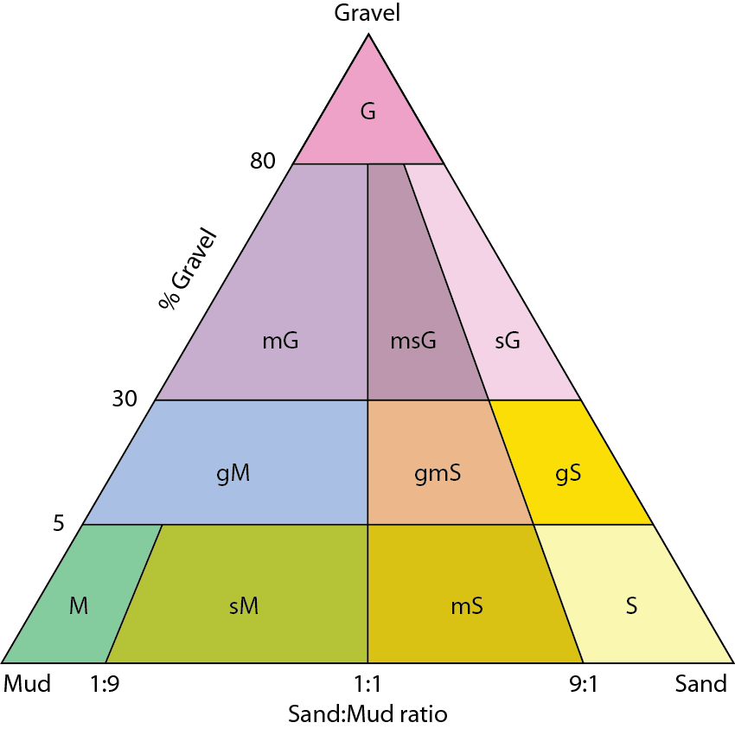

Figure 1: Simplified Folk sediment classification used for this analysis (Long, 2006).

Table 2: Summary of East Antarctic qualitative sediment data

| Survey | vessel | Sample types | datasets | Reference |
| --- | --- | --- | --- | --- |
| DF 79 | Glacier | grab, piston core | folk grainsize | Anderson et al., 1981 |
| ELT 27 | Eltanin | trigger core, piston core | folk grainsize | NGDC |
| ELT 34 | Eltanin | trigger core, gravity core | folk grainsize | USNS, 1973 |
| ELT 35 | Eltanin | trigger core | folk grainsize | USNS, 1973 |
| ELT 36 | Eltanin | trigger core, piston core | folk grainsize | USNS, 1973; NGDC |
| ELT 37 | Eltanin | trigger core, piston core | folk grainsize | USNS, 1973; NGDC |
| ELT 38 | Eltanin | trigger core | folk grainsize | USNS, 1973; NGDC |
| ELT 39 | Eltanin | trigger core | folk grainsize | USNS, 1973 |
| ELT 44 | Eltanin | trigger core | folk grainsize | USNS, 1973 |
| ELT 45 | Eltanin | trigger core, piston core | folk grainsize | USNS, 1973; NGDC |
| ELT 47 | Eltanin | trigger core, grab, gravity core, piston core | folk grainsize | USNS, 1973; NGDC |
| ELT 49 | Eltanin | trigger core, piston core | folk grainsize | USNS, 1973 |
| ELT 50 | Eltanin | gravity core, trigger core, piston core | folk grainsize | USNS, 1973; NGDC |
| ELT 53 | Eltanin | piston core | folk grainsize | NGDC |
| RC08 | Robert Conrad | piston core | folk grainsize | NGDC |
| NBP01-01 | Nathaniel B. Palmer | box core | folk grainsize | Leventer et al., 2001 |
| L184AN | Samuel P. Lee | gravity core | folk grainsize | Hampton et al., 1987 |
| DSDP_028 | Glomar Challenger | drill core | folk grainsize | NGDC |

## Sample Analysis

Surface sediment samples were analysed to determine the gravel, sand and mud content by washing through 2 mm and 63 μm sieves. Percentages for each fraction were then determined based on the weight of the dried sample. Carbonate content was determined for each sample using the carbonate bomb method of Müller and Gastner (1971). The sample was reacted with acid, and the pressure of CO2 released used to calculate the per cent carbonate present in the sample. The biogenic silica content of the bulk sediment was measured based on the method of Mortlock and Froelich (1989). Samples were treated with hydrogen peroxide to remove organic material, and then with a dilute solution of hydrochloric acid to remove carbonates. Silicon was then extracted from the sample with a concentrated sodium carbonate solution. The per cent opal was calculated from this based on an average water content of 10 per cent for diatomaceous silica (Mortlock and Froelich, 1989).

# Sediment distribution patterns

Qualitative and quantitative grainsize distributions are shown in Figure 2. The spatial distribution of the sample locations is highly variable, with high densities within the southern part of the proposed D’Urville Sea - Mertz and Prydz MPAs, but much lower density within the other proposed MPAs. There are no samples within the proposed Enderby MPA, only two quantitative samples within the proposed Drygalski MPA and one within the proposed Wilkes MPA.

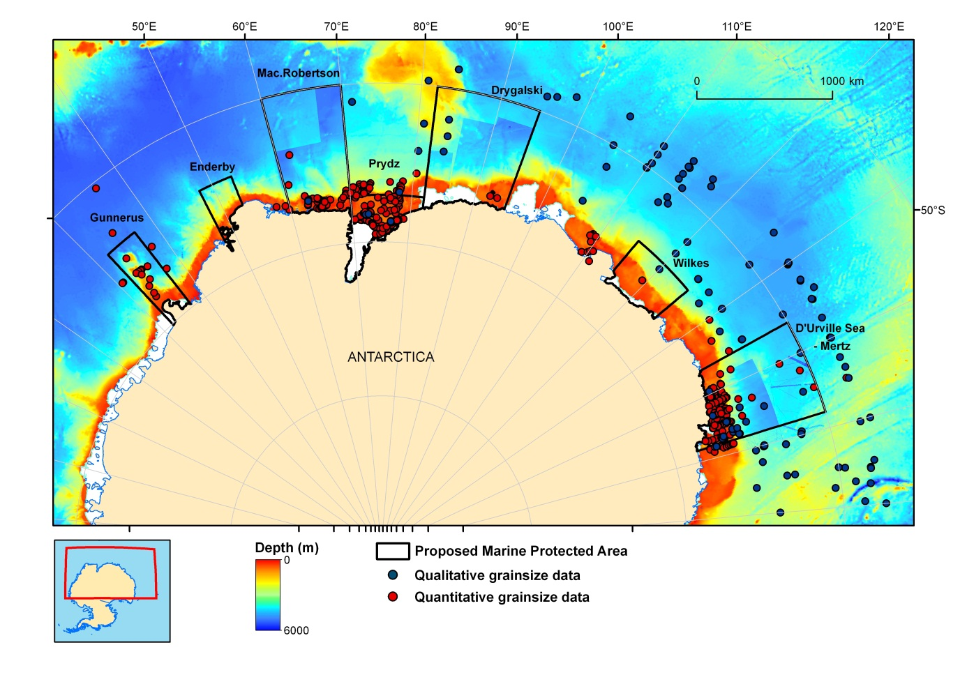

Figure 2: Distribution of samples with qualitative and quantitative grainsize. Data are overlain on ETOPO2 bathymetry data, and higher resolution grids within several of the proposed MPAs which are based on single and multibeam data (Beaman et al., 2010; Wilson, submitted).

## Proposed D’Urville Sea - Mertz MPA

The proposed D’Urville Sea - Mertz MPA consists of a broad continental shelf, a continental slope heavily dissected by canyons and deep regions of more uniform morphology on the continental rise and abyssal plain (Figure 3). The shelf morphology is typical of the Antarctic margin. The glacially eroded George V Basin, reaching depths of 1300 m adjacent to the Mertz Glacier Tongue, intersects the Adélie and Mertz Banks which have mean depths of approximately 200 m to 250 m (Beaman et al., 2010). The inner shelf is cut by a complex series of deep (up to ~1200 m) depressions and small glacial basins. Large submarine canyons cut the continental slope, with the Jussieu Canyon reaching the shelf break.

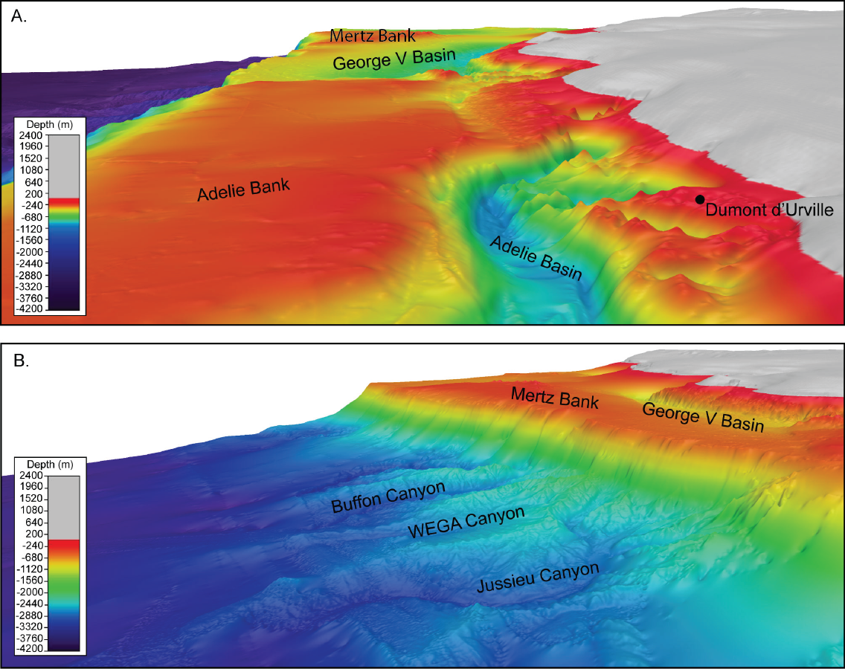

Figure 3: 3D views along the continental shelf (A) and slope (B) within the proposed D’Urville Sea – Mertz MPA (15x vertical exaggeration).

The shelf sediments within the proposed D’Urville Sea - Mertz MPA are characterised by sandy muds within the shelf deeps, while the shelf banks consist of muddy sands and gravelly muddy sands (Figure 4). Video transects across the George V shelf indicate that the sediment properties are closely tied to the benthic biota in this region (Post et al., 2011). Suspension feeders have much higher abundance on the sandy banks while deposit and detrital feeders dominate in the muddy basins. Sediment properties on the upper continental slope have high sand content, and are classified as muddy sands and sandy muds. Some gravelly sediments also occur in this environment reflecting the high energy of the continental slope where down slope processes and current flow maintain rugged submarine canyons. While there are fewer samples distributed on the lower continental slope and abyssal plain, the sediment properties are typically less variable in these environments. Surface sediments on the lower slope and abyssal plain are dominated by muds, with >75 per cent mud content in all samples (Figure 4). Most samples on the slope and abyssal plain are therefore classified as muds or sandy muds, though a few samples with higher gravel content are classified as muds and gravelly muds.

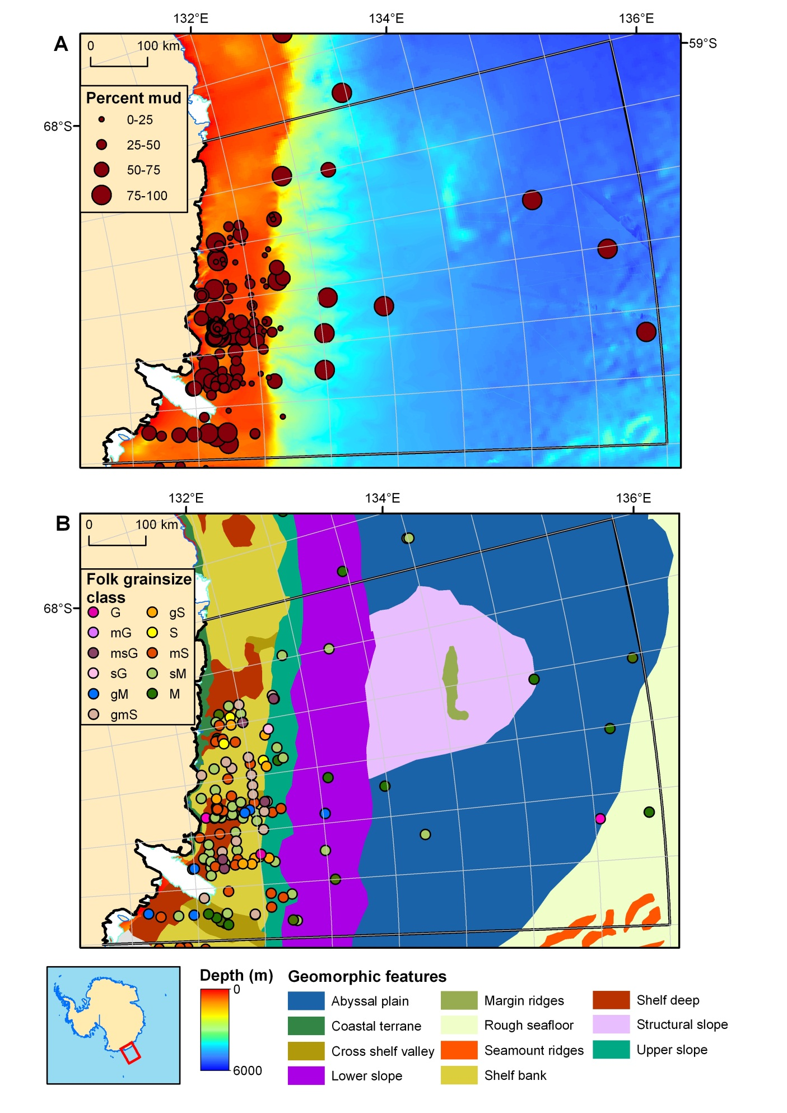

Figure 4: (A) Percent mud overlain on ETOPO2 bathymetry data, and a 100m resolution grid compiled from single and multibeam data (Beaman et al., 2010) within the proposed D’Urville Sea - Mertz MPA. (B) Modified folk classification of surface sediments overlain on geomorphic features (from O’Brien et al., 2009).

## Proposed Prydz MPA

The proposed Prydz MPA consists of an extremely broad continental shelf, the ice free part of which extends over 300 km north to south. The outer shelf of Prydz Bay comprises relatively shallow banks with depths ranging from 100 to 400 m, and these are separated by Prydz Channel which is a major trough 150 km wide and over 600 m deep (Figure 5, O'Brien et al., 1999). The Four Ladies Bank on the eastern outer shelf shoals to 100–200 m depth and is separated from the Ingrid Christensen Coast by a series of connected troughs and saddles, forming Svenner Channel (O'Brien et al., 2007). The inner part of Prydz Bay is occupied by shelf depressions, with the Amery Depression occurring on the eastern side and reaching depths of 600 to 800 m, and the Lambert Deep occupying the western side with depths of 1100 m adjacent to the Amery Ice Shelf front.

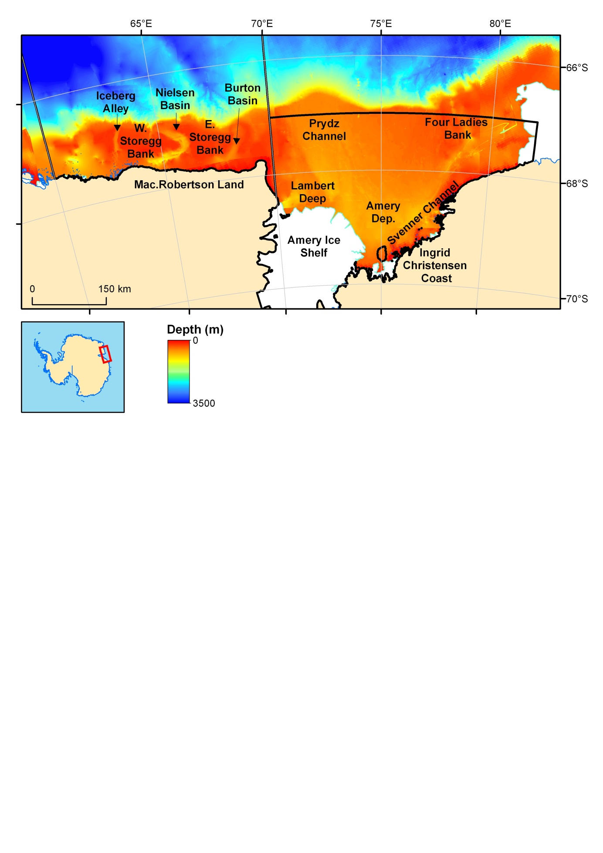

Figure 5: Locations on the Prydz Bay and MacRobertson shelves as mentioned in the text. Bathymetry is shown using the ETOPO2 bathymetry data, and an interpolated grid compiled from single and multibeam data (Wilson, submitted).

Surface sediments on the Prydz Bay shelf typically have high mud content associated with the shelf deeps in the southern and western parts of the basin (Figure 6). These sediments are classified as muds and sandy muds. The outer shelf banks have lower mud content, with predominantly muddy sands over these shallow and heavily iceberg scoured regions. Inner shelf areas also tend to have a higher sand content, particularly close to outlet glaciers and along the western side of the Amery Ice Shelf. Coarse sediments, sandy gravels and muddy sandy gravels, also occur along the shelf break and the upper continental slope reflecting the stronger currents which winnow any finer grained material from these sediments. Muds become dominant towards the lower slope with a content of >75 per cent (Figure 6).

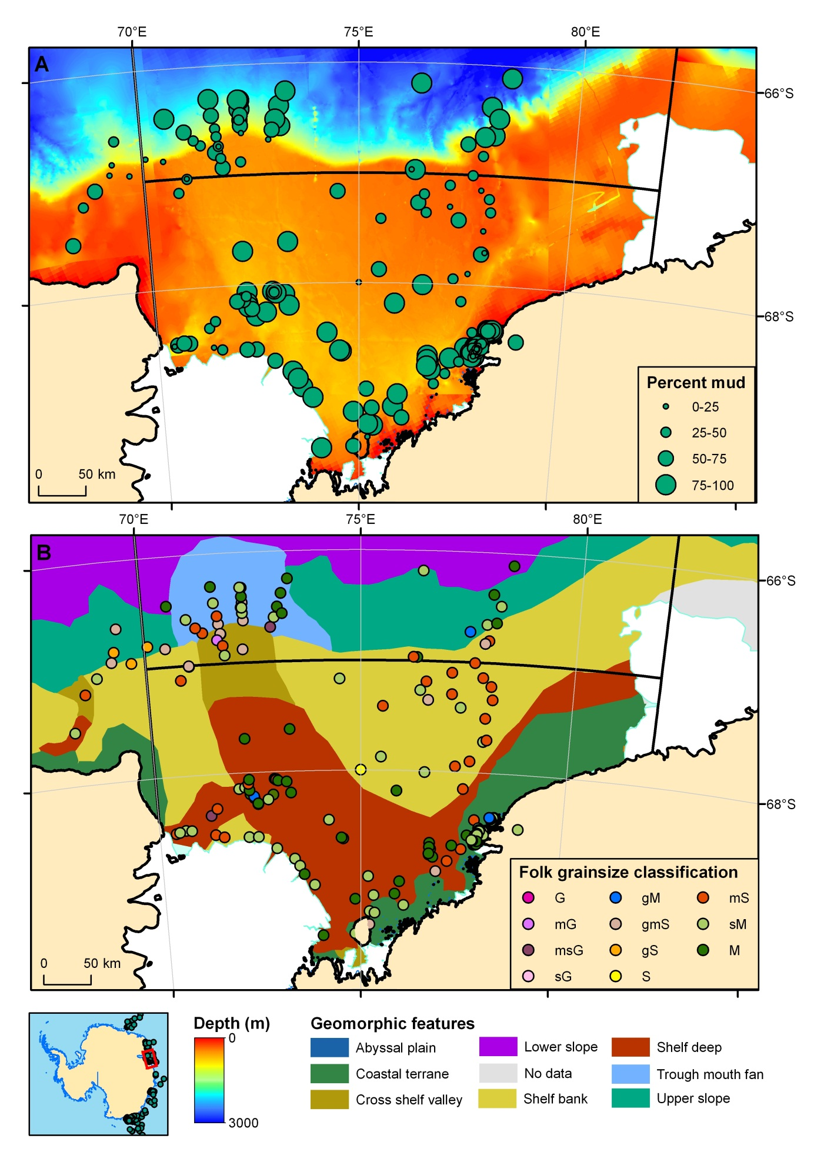

Figure 6: (A) Percent mud overlain on ETOPO2 bathymetry data, and an interpolated grid compiled from single and multibeam data (Wilson, submitted) within the proposed Prydz MPA. (B) Modified folk classification of surface sediments overlain on geomorphic features (from O’Brien et al., 2009).

## Proposed Mac.Robertson MPA

The Mac.Robertson Shelf is intersected by three shelf deeps, from east to west these are the Burton Basin (>500 m), the Nielsen Basin (500-1000 m) and Iceberg Alley (500-600 m) (Figure 4, Harris and O'Brien, 1996). These shelf deeps are typical of erosive processes caused by the repeated expansion of ice streams across the shelf during past glaciations. The east and west Storegg Banks are cut by these troughs. These shelf banks are delimited by the 200 m isobath and shoal to depths of 110 m. The continental slope is steep (up to 6º) and is cut by submarine canyons.

The sediment samples within the proposed Mac.Robertson MPA are clustered within the shelf deeps, and consist predominantly of muddy and sandy mud sediments (Figure 7). The shelf banks consist of muddy sands, with a mud content of 0-25 per cent. On the upper slope, coarser grained surface sediments occur, including gravelly muds, sand, gravelly sand and gravel. The coarse grainsize of these slope sediments is consistent with the occurrence of strong, contour currents that flow intermittently along the upper slope in this region (Hodgkinson et al., 1988). Samples on the lower slope also have relatively low mud content (25-50 per cent).

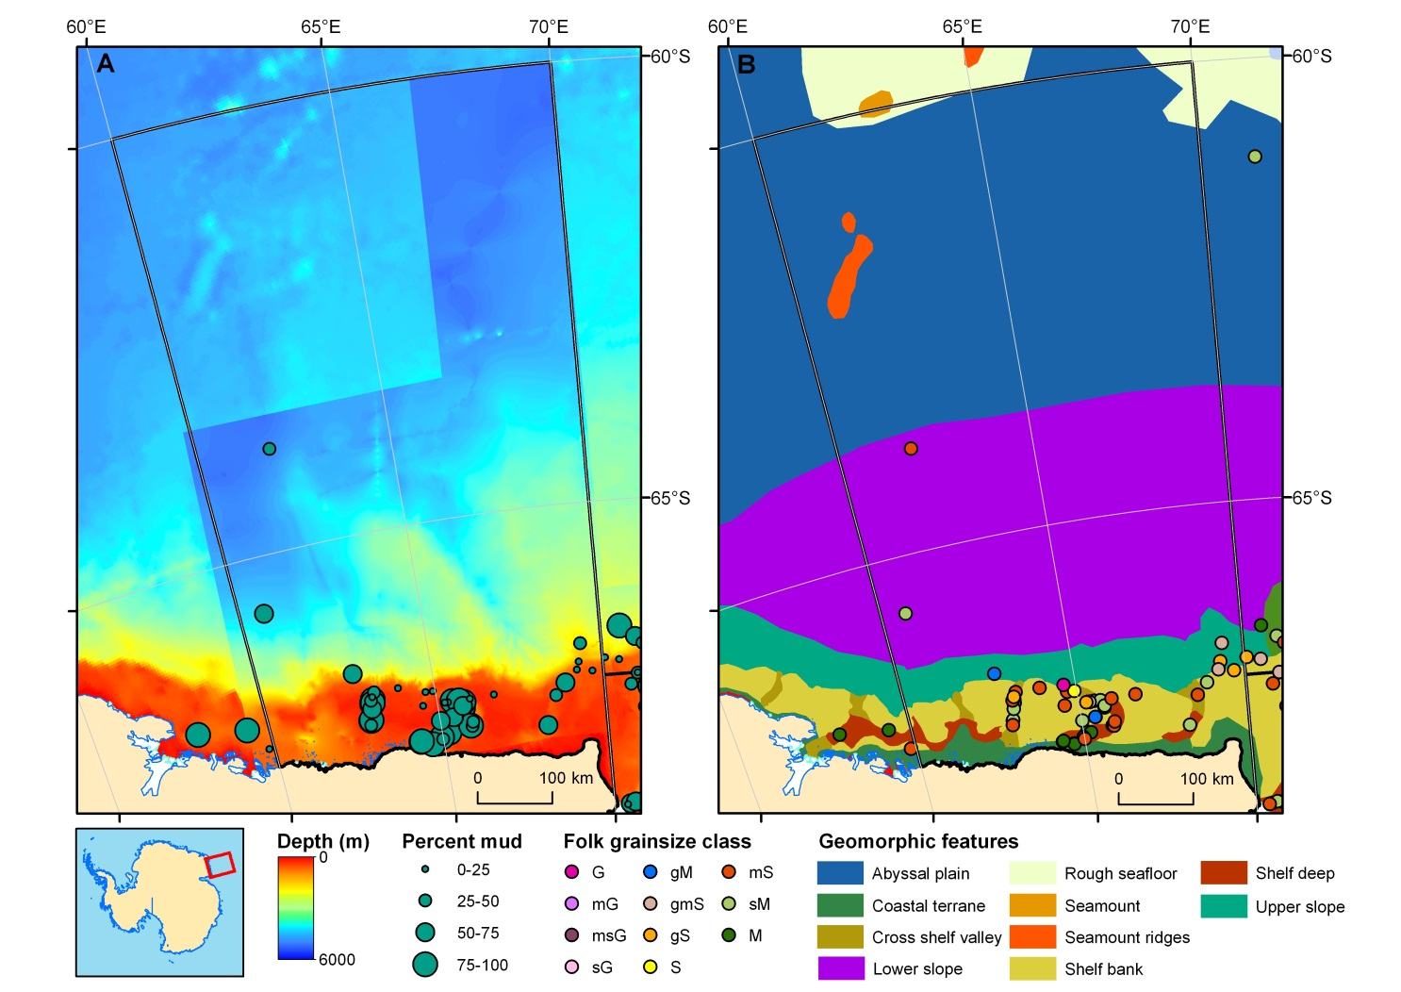

Figure 7: (A) Percent mud overlain on ETOPO2 bathymetry data, and an interpolated grid compiled from single and multibeam data (Wilson, submitted) within the proposed Mac.Robertson MPA. (B) Modified folk classification of surface sediments overlain on geomorphic features (from O’Brien et al., 2009).

## Proposed Gunnerus MPA

The proposed Gunnerus MPA comprises the submarine Gunnerus Ridge which extends 450 km from the edge of the continent. The ridge lies in water depths of 900-1200 m, with the surrounding seafloor rapidly dropping to depths of over 5000 m. Surface sediments within the proposed Gunnerus MPA are located mostly along the ridge. These sediments have low mud content (<50 per cent) and are classified as muddy sands, sands and gravelly sediments (Figure 8). Mud-dominated sediments occur in deeper waters of the abyssal plain and lower slope adjacent to the ridge, with a much more homogeneous sample composition in these deep water environments.

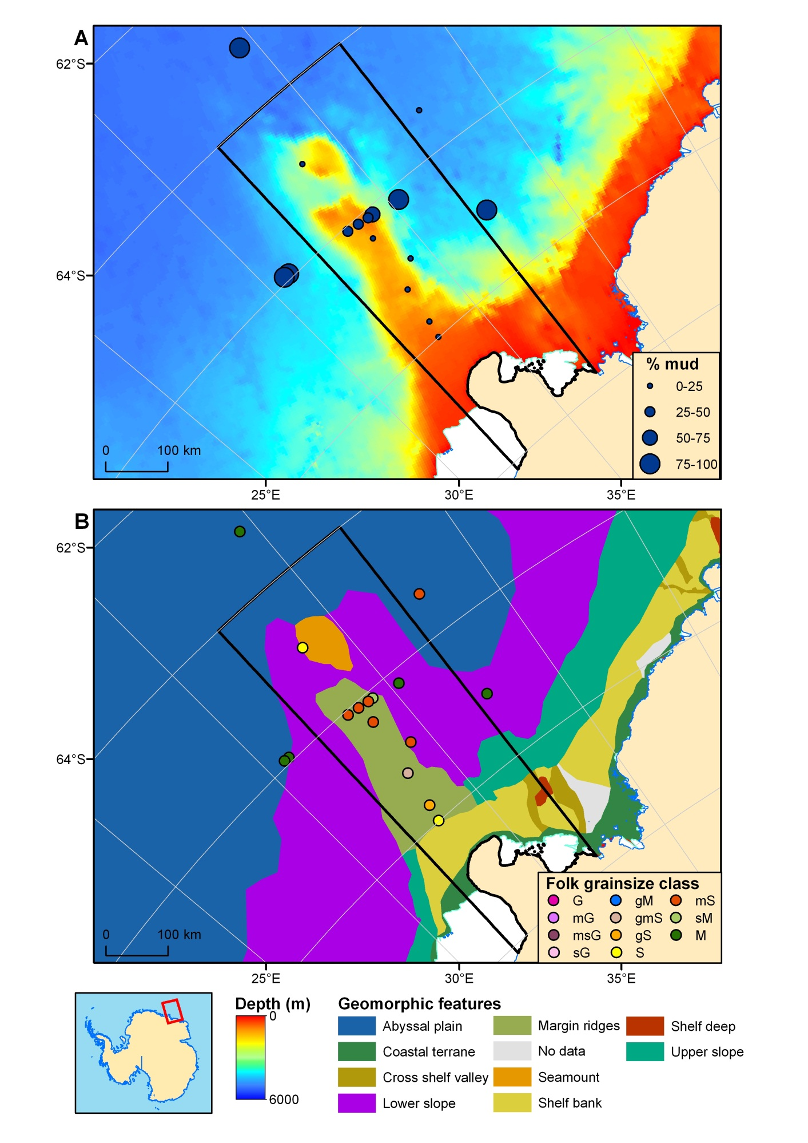

Figure 8: (A) Percent mud overlain on ETOPO2 bathymetry data, and an interpolated grid compiled from single and multibeam data (Wilson, submitted) within the proposed Gunnerus MPA. (B) Modified folk classification of surface sediments overlain on geomorphic features (from O’Brien et al., 2009).

# Surface calcium carbonate

The calcium carbonate composition of the sediments represents the proportion of calcifying organisms preserved in the sediments. Carbonate production on the shelf is generally dominated by bryozoans, foraminifera, bivalves, brachiopods, echinoderms, polychaetes and soft corals, all of which are abundant on parts of the Mertz (Post et al., 2010) and Prydz Bay shelves (Harris and O'Brien, 1996). Carbonate preservation is typically low on the Antarctic shelf, controlled by factors such as the flux of organic matter to the seafloor and the associated rates of respiration/remineralisation in the sediments, current transport and the calcium carbonate saturation state of the water mass (Hauck et al., 2012). Many of the samples shown for the proposed Mac.Robertson and Prydz MPAs contain no detectable CaCO3, and most of the other samples are <10 per cent (Figures 9 and 10). Hauck et al. (2012), in their study of Antarctic margin carbonates, observed peaks in carbonate content at depths of 150-200 m and 600 – 900 m. They suggest that carbonates are preserved in-situ at depths <200 m, with possibly some current focussing, while carbonate accumulation on the outer shelf and shelf break represents winnowing of clay and silt by the strong currents associated with the shelf edge environment. In the current study of East Antarctic sediments, the highest carbonate preservation occurs on the Mertz and Mac.Robertson continental shelf and upper slope, with a carbonate composition of 10-40 per cent (Figure 10). On the Mertz slope high carbonate values are associated with dense communities of hydrocorals, which form carbonate skeletons (Post et al., 2010). Current winnowing may have also helped to the concentrate the carbonate in these sediments, given the generally low mud content of the outer shelf sediments (see Figure 4). Across the whole dataset, highest average values for calcium carbonate composition occur on the upper slope and at abyssal depths (Figure 10C).

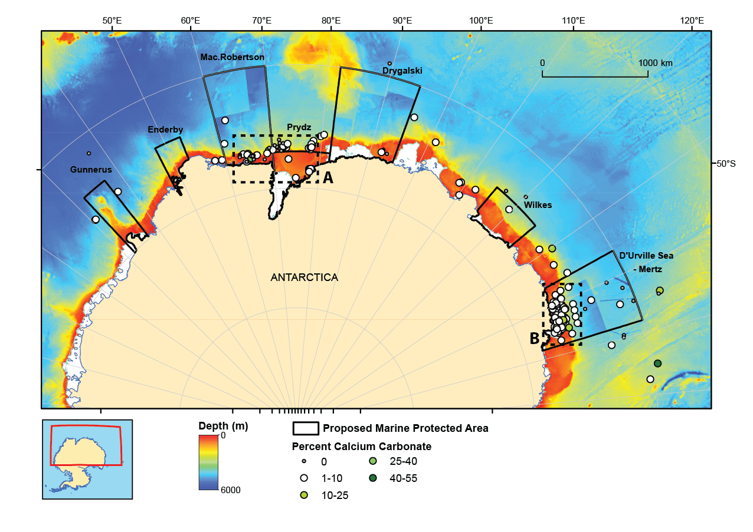

Figure 9: The calcium carbonate content of surface sediments. Data are overlain on ETOPO2 bathymetry data, and higher resolution grids within several of the proposed MPAs which are based on single and multibeam data (Beaman et al., 2010; Wilson, submitted). Locations of figures 10A and B are indicated by the dotted lines.

Distribution patterns are discussed in the text. Average calcium carbonate values have been calculated within geomorphic units for the whole dataset and are shown in a bar chart as follows:
Shelf deep: percent calcium carbonate is 0.9%
Shelf bank: percent calcium carbonate is 3%
Upper slope: percent calcium carbonate is 4.7%
Lower slope: percent calcium carbonate is 2.5%
Abyssal depths: percent calcium carbonate is 5.4%

Figure 10: The calcium carbonate composition of surface sediments overlain on geomorphic features (from O’Brien et al., 2009) for the Prydz Bay and Mac.Robertson shelf regions (A) and the D’Urville Sea - Mertz region (B, for locations see Figure 9). Figure C shows the average percent calcium carbonate value from all of the east Antarctic samples within 5 key geomorphic features.

# Surface biogenic silica

Biogenic silica represents the preservation of siliceous organisms, primarily diatoms, with lesser abundances of radiolaria, silicoflagellates and sponge spicules. The values for biogenic silica, are therefore tied most strongly to surface water production. However, much of the silica produced by surface organisms dissolves before reaching the seafloor, with a global average sediment burial rate of just ~3% of production (Tréguer et al., 1995). In the Southern Ocean, however, preservation is as high as 24% due to increased preservation in regions of high production. Dissolution is controlled by sinking speed (given that the ocean is everywhere undersaturated with respect to biogenic silica), temperature (with preservation enhanced at lower temperatures), trace element composition, and biological factors (see Nelson et al., 1995 and references therein). Preservation is enhanced in areas of diatom blooms, likely due to the greater sinking speeds of particle aggregates (e.g. Smetacek, 1985) as well as more rapid burial at the seafloor (Nelson et al., 1995). Intense phytoplankton blooms can therefore supply large quantities of food to benthic organisms (Grebmeier and Barry, 1991).

There is a relatively high density of biogenic silica data on the Mertz, Prydz and Mac.Robertson shelves (Figure 11). The biogenic silica content of these surface sediments is highly variable, with values ranging from 0 to 80 per cent. Biogenic silica is closely coupled to mud content on the Antarctic margin due to the high diatom abundance in this size fraction. Highest values for biogenic silica are associated with shelf deeps, which form sediment depocentres, and parts of the deep sea (Figure 12). Lowest values are associated with shelf banks and the continental slope where finer grained diatom-bearing sediments commonly become winnowed.

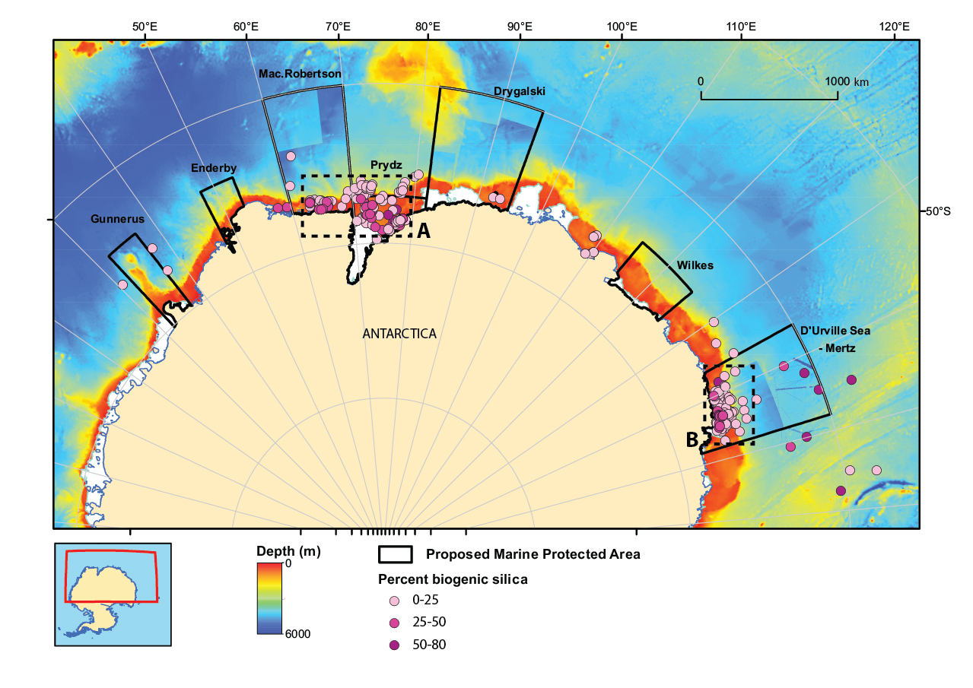

Figure 11: The biogenic silica content of surface sediments. Data are overlain on ETOPO2 bathymetry data, and higher resolution grids within several of the proposed MPAs which are based on single and multibeam data (Beaman et al., 2010; Wilson, submitted). Locations of figures 12A and B are indicated by the dotted lines.

Distribution patterns are discussed in the text. Average biogenic silica values have been calculated within geomorphic units for the whole dataset and are shown in a bar chart as follows:
Shelf deep: percent calcium carbonate is 25.5%
Shelf bank: percent calcium carbonate is 9.7%
Upper slope: percent calcium carbonate is 6.7%
Lower slope: percent calcium carbonate is 9.8%
Abyssal depths: percent calcium carbonate is 35.9%

Figure 12: The biogenic silica composition of surface sediments overlain on geomorphic features (from O’Brien et al., 2009) for the Prydz Bay and Mac.Robertson shelf regions (A) and the D’Urville Sea - Mertz region (B, for locations see Figure 11). Figure C shows the average percent biogenic silica value from all of the east Antarctic samples within 5 key geomorphic features.

# Conclusions

This study presents sediment grainsize and compositional data for seabed samples in the region south of 60ºS and between 30 and 160ºE. Quantitative and qualitative grainsize data is presented for 469 and 661 samples respectively, with highest concentrations on the D’Urville Sea – Mertz, Prydz and Mac.Robertson continental shelves. Calcium carbonate data is presented for 255 samples, though poor preservation on the Antarctic margin means that many values are <10 per cent. Relatively high values occur on the continental shelf break, and are associated with known hydrocoral communities (Post et al., 2010). Biogenic silica values are presented for 304 samples, with highest values associated with shelf deeps and abyssal depths.

Within this East Antarctic region seven broad areas have been identified and proposed as marine protected areas. The sediment data presented here provides an additional layer which can be used to better understand the types of physical seafloor habitats within these regions. Grainsize properties and composition are also shown to be strongly associated with geomorphic features, so the broad-scale mapping of these features can be used to expand our understanding of the nature of the seabed environments across the East Antarctic region. The physical seabed properties of sediment type, composition and morphology have been shown to be closely associated with the distribution of distinct benthic macrofauna and fish communities on the Antarctic shelf (e.g. Gambi and Bussotti, 1999; Cattaneo-Vietti et al., 2000; Beaman and Harris, 2005; Koubbi et al., 2010; Post et al., 2011). The diversity of sediment types and geomorphic features within the proposed MPAs indicates that these regions include a wide range of benthic habitats, and therefore most likely encompass a diversity of benthic organisms.

# Acknowledgements

Many thanks to Charlotte Sjunneskog at the Antarctic Research Facility, Florida State University and Nichole Anest, Lamont-Doherty Earth Observatory who provided many additional samples from their repositories that were analysed as part of this project. Thanks to Jonny Stark (Australian Antarctic Division) for use of unpublished data. Thanks also to Christian Thun, Tony Watson, Billie Poignant and Janice Trafford (Geoscience Australia) for completion of laboratory analyses. Reviews by Lynda Radke and Anna Potter were much appreciated in improving the manuscript. This record is published with permission of the CEO, Geoscience Australia.

# References

Anderson, J.B., Davis, S.B., Domack, E.W., Kurtz, D.D., Balshaw, K.M. and Wright, R., 1981. Marine sediment core descriptions IWSOE 68, 69, 70; Deep Freeze 79, Rice University, Deptarment Of Geology, Houston, Texas.

Archer, D.E., 1999. Opal, quartz and calcium carbonate content in surface sediments of the ocean floor. doi:10.1594/PANGAEA.56017. In: D.E. Archer, 1996. An atlas of the distribution of calcium carbonate in sediments of the deep sea. Global Biogeochemical Cycles, 10, 159-174.

Barnes, P.W., Edwards, B.D. and Karl, H.A., 1990. Morphologic, stratigraphic, and sedimentologic studies of surficial sediments off Wilkes Land and in the western Ross Sea. A.K. Cooper and P.N. Webb (Editors), International Workshop on Antarctic Offshore Seismic Stratigraphy (ANTOSTRAT): Overview and Extended Abstracts. U.S. Geological Survey Open-File Report 90-309, p. 42-43pp.

Beaman, R.J. and Harris, P.T., 2005. Bioregionalization of the George V Shelf, East Antarctica. Continental Shelf Research, 25, 1657-1691.

Beaman, R.J., O'Brien, P.E., Post, A.L. and De Santis, L., 2010. A new high-resolution bathymetry model for the Terre Adélie and George V continental margin, East Antarctica. Antarctic Science, 23(01), 95-103. doi:10.1017/S095410201000074X.

Berg, S., et al., 2010a. Geochemistry on sediment profile Co1011. doi:10.1594/PANGAEA.744539. In: S. Berg, B. Wagner, H. Cremer, M.J. Leng and M. Melles, 2010. Late Quaternary environmental and climate history of Rauer Group, East Antarctica. Palaeogeography, Palaeoclimatology, Palaeoecology, 297, 201-213.

Berg, S., et al., 2010b. Geochemistry on sediment profile Co1010. doi:10.1594/PANGAEA.744550. In: S. Berg, B. Wagner, H. Cremer, M.J. Leng and M. Melles, 2010. Late Quaternary environmental and climate history of Rauer Group, East Antarctica. Palaeogeography, Palaeoclimatology, Palaeoecology, 297, 201-213.

Berg, S., et al., 2010c. Geochemistry on sediment profile Co1014. doi:10.1594/PANGAEA.744536. In: S. Berg, B. Wagner, D.A. White and M. Melles, 2010. No significant ice-sheet expansion beyond present ice margins during the past 4500 yr at Rauer Group, East Antarctica. Quaternary Research, 74, 23-25.

Bonn, W.J., et al., 1998. Accumulation and flux data calculated for sediment core PS1821-6. doi:10.1594/PANGAEA.351211. In: W.J. Bonn, F. Gingele, H. Grobe, A. Mackensen and D.K. Fütterer, 1998. Palaeoproductivity at the Antarctic continental margin: opal and barium records for the last 400 ka. Palaeogeography, Palaeoclimatology, Palaeoecology, 139, 195-211.

Bradtmiller, L.I., Anderson, R.F., Fleisher, M.Q. and Burckle, L.H., 2009. Comparing glacial and Holocene opal fluxes in the Pacific sector of the Southern Ocean. Paleoceanography, 24(2), PA2214.

Brancolini, G., Harris, P.T. and Shipboard Party, 2000. Post-Cruise Report: Joint Italian/Australian Marine Geoscience Expedition Aboard the R.V. Tangaroa to the George Vth Land Region of East Antarctica during February-March 2000. Australian Geological Survey Organisation, Record, 2000/19, 181pp.

Cattaneo-Vietti, R., Chiantore, M., Schiaparelli, S. and Albertelli, G., 2000. Shallow- and deep-water mollusc distribution at Terra Nova Bay (Ross Sea, Antarctica). Polar Biology, 23, 173-182.

Domack, E.W., 1980. Glacial marine geology of the George V-Adélie continental shelf, East Antarctica. Masters Thesis, Rice University, Houston, Texas, 142 pp.

Franklin, D., 1997. Sedimentology of Holocene Prydz Bay: Sedimentary Patterns and Processes. PhD Thesis Thesis, University of Tasmania, Hobart, Australia.

Gambi, M.C. and Bussotti, S., 1999. Composition, abundance and stratification of soft-bottom macrobenthos from selected areas of the Ross Sea shelf (Antarctica). Polar Biology, 21, 347-354.

Grebmeier, J.M. and Barry, J.P., 1991. The influence of oceanographic processes on pelagic-benthic coupling in polar regions: A benthic perspective. Journal of Marine Systems, 2(3-4), 495-518.

Hampton, M.A., Kravitz, J.H. and Luepke, G., 1987. Geology of Sediment Cores from the George V Continental Margin, Antarctica. In: S.L. Eittreim and M.A. Hampton (eds), The Antarctic Continental Margin: Geology and Geophysics of Offshore Wilkes Land, Circum-Pacific Council for Energy and Mineral Resources, 151-174p.

Harris, P.T. and O'Brien, P.E., 1996. Geomorphology and sedimentology of the continental shelf adjacent to Mac. Robertson Land, East Antarctica: a scalped shelf. Geo-Marine Letters, 16, 287‑296.

Harris, P.T., O'Brien, P.E., Quilty, P.G., Taylor, F., Domack, E., De Santis, L. and Raker, B., 1997. Antarctic CRC marine geoscience, Vincennes Bay, Prydz Bay and Mac.Robertson Shelf : post-cruise report : AGSO cruise 186, ANARE voyage 5, 1996/97 (BRAD) Australian Geological Survey Organisation, Record, 1997/51, 75pp.

Harris, P.T., Taylor, F., Pushina, Z., Leitchenkov, G., O'Brien, P.E. and Smirnov, V., 1998. Lithofacies distribution in relation to the geomorphic province of Prydz Bay, East Antarctica. Antarctic Science, 10, 227-235.

Hauck, J., Gerdes, D., Hillenbrand, C.-D., Hoppema, M., Kuhn, G., Nehrke, G., Völker, C. and Wolf-Gladrow, D., 2012. Distribution and mineralogy of carbonate sediments on Antarctic shelves. Journal of Marine Systems, 90, 77-87. 10.1016/j.jmarsys.2011.09.005

Hemer, M.A., 2003. The oceanographic influence of sedimentation on the continental shelf: a numerical comparison between tropical and Antarctic environments. PhD Thesis, University of Tasmania, 355 pp.

Hillenbrand, C.-D. and Ehrmann, W.U., 2005. Biogenic opal content of sediment core PS1824-1. doi:10.1594/PANGAEA.218268. In: C.-D. Hillenbrand and W.U. Ehrmann, 2005. Late Neogene to Quaternary environmental changes in the Antarctic Peninsula region: evidence from drift sediments. Global and Planetary Change, 45, 165-191.

Hodgkinson, R.P., Coman, R.S., Kerry, D.R. and Robb, M., 1988. Water currents in Prydz Bay, Antarctic during 1985. ANARE Research Notes, No 59, 127 pp.

Koubbi, P., Ozouf-Costaz, C., Goarant, A., Moteki, M., Hulley, P.-A., Causse, R., Dettai, A., Duhamel, G., Pruvost, P., Tavernier, E., Post, A.L., Beaman, R.J., Rintoul, S.R., Hirawake, T., Hirano, D., Ishimaru, T., Riddle, M. and Hosie, G., 2010. Estimating the biodiversity of the East Antarctic shelf and oceanic zone for ecoregionalisation: Example of the ichthyofauna of the CEAMARC (Collaborative East Antarctic Marine Census) CAML surveys. Polar Science, 4(2), 115-133.

Leventer, A., Domack, E., Dunbar, G., McClennen, C., Brachfeld, S., Manley, P. and Pilskin, C., 2001. Sediment description for R/V Nathaniel B. Palmer Cruise 1, 2001. Antarctic Marine Geology Research Facility, Florida State University, 313pp.

Long, D., 2006. BGS detailed explanation of seabed sediment modified folk classification. Accessible online at: [http://www.searchmesh.net/PDF/GMHM3_Detailed_explanation_of_seabed_sediment_classification.pdf](http://www.searchmesh.net/PDF/GMHM3_Detailed_explanation_of_seabed_sediment_classification.pdf" \o "Download link for reference PDF).

Maus, B. and Fütterer, D.K., 1997. Sedimentology of cores PS1824-1 and -2. doi:10.1594/PANGAEA.52108. Maus, B., 1993. Plio-Pleistozäne Sedimentation im Randbereich des Ritscher-Canyons, westlich des Gunnerus-Rückens (Ostantarktis). Diploma Thesis, Alfred Wegener Institute for Polar and Marine Research, Bremerhaven & Universität Freiburg, 123pp.

Mortlock, R.A. and Froelich, P.N., 1989. A simple method for the rapid determination of biogenic opal in pelagic marine sediments. Deep Sea Research, 36, 1415-1426.

Müller, G. and Gastner, M., 1971. The "Karbonat-Bombe," a simple device for the determination of the carbonate content in sediments, soils and other materials. Neues Jahrbuch für Mineralogie, Monatshefte, 10, 466-469.

Nelson, D.M., Tréguer, P., Brzezinski, M.A., Leynaert, A. and Quéguiner, B., 1995. Production and dissolution of biogenic silica in the ocean: Revised global estimates, comparison with regional data and relationship to biogenic sedimentation.

O'Brien, P.E., Franklin, D. and O'Loughlin, M., 1993. Post cruise report - Prydz Bay and Mac. Robertson Shelf, Antarctica, January-March, 1993. Australian Geological Survey Organisation, Record, 1993/78, 39pp.

O'Brien, P.E., Harris, P.T., Quilty, P.G., Taylor, F. and Wells, P., 1995. Post-cruise report, Antarctic CRC marine geoscience, Prydz Bay, Mac. Robertson Shelf and Kerguelen Plateau. Australian Geological Survey Organisation, Record, 1995/29, 123pp.

O'Brien, P.E., De Santis, L., Harris, P.T., Domack, E. and Quilty, P.G., 1999. Ice shelf grounding zone features of western Prydz Bay, Antarctica: sedimentary processes from seismic and sidescan images. Antarctic Science, 11, 78-91.

O'Brien, P.E., Goodwin, I., Forsberg, C.F., Cooper, A.K. and Whitehead, J., 2007. Late Neogene ice drainage changes in Prydz Bay, East Antarctica and the interaction of the Antarctic ice sheet evolution and climate. Palaeogeography, Palaeoclimatology, Palaeoecology, 245, 390-410.

O’Brien, P.E., Post, A.L. and Romeyn, R., 2009. Antarctic-wide geomorphology as an aid to habitat mapping and locating Vulnerable Marine Ecosystems. Commission for the Conservation of Antarctic Marine Living Resources Vulnerable Marine Ecosystems Workshop, Paper WS-VME-09/10. CCAMLR, La Jolla, California, USA.

Petschick, R., et al., 1996. Grain size distribution of surface sediments of the South Atlantic. doi:10.1594/PANGAEA.51464. In: R. Petschick, G. Kuhn and F. Gingele, 1996. Clay mineral distribution in surface sediments of the South Atlantic: sources, transport, and relation to oceanography. Marine Geology, 130, 203-229.

Pichon, J.J., Bareille, G.F., Labracherie, M., Labeyrie, L.D., Baudrimont, A. and Turon, J.-L., 1992. Quantification of the biogenic silica dissolution in Southern Ocean sediments. Quaternary Research. Quaternary Research, 37, 361-378.

Post, A.L., O'Brien, P.E., Beaman, R.J., Riddle, M.J. and De Santis, L., 2010. Physical controls on deep-water coral communities on the George V Land slope, East Antarctica. Antarctic Science, 22, 371-378, doi:10.1017/S0954102010000180.

Post, A.L., Beaman, R.J., O'Brien, P.E., Eléaume, M. and Riddle, M.J., 2011. Community structure and benthic habitats across the George V Shelf, East Antarctica: trends through space and time. Deep Sea Research II, 58, 105-118. doi:10.1016/j.dsr2.2010.05.020.

Schmiedl, G., 1990a. Sedimentology of core PS1823-6. doi:10.1594/PANGAEA.51741. In: G. Schimiedl, 1990. Quartäre Sedimentationsprozesse in der Tiefsee des Riiser-Larsenmeeres westlich des Gunnerus-Rückens, Ost-Antarktis. Diploma Thesis, Alfred Wegener Institute for Polar and Marine Research, Bremerhaven, 113pp.

Schmiedl, G., 1990b. Sedimentology of core PS1823-1. doi:10.1594/PANGAEA.51740. In: G. Schimiedl, 1990. Quartäre Sedimentationsprozesse in der Tiefsee des Riiser-Larsenmeeres westlich des Gunnerus-Rückens, Ost-Antarktis. Diploma Thesis, Alfred Wegener Institute for Polar and Marine Research, Bremerhaven, 113pp.

Smetacek, V.S., 1985. Role of sinking in diatom life-history cycles: Ecological, evolutionary, and geological significance. Marine Biology, 84, 239-251.

Tréguer, P., Nelson, D.M., van Bennekom, A.J., DeMaster, D.J., Leynaert, A. and Quéguiner, B., 1995. The silica balance in the world ocean: A re-estimate. Science, 268, 375-379.

US Navy Hydro. Office, 1956. Technical report, U.S. Navy Hydrographic Office report on Operation Deep Freeze I, October 1956. U.S. Navy Hydrographic Office, Washington, D.C.

US Navy Hydro. Office, 1957. Technical report, Operation Deep Freeze II 1956-1957. Oceanographic Survey Results, October 1957. U.S. Navy Hydrographic Office. Washington, D.C.

USNS, 1973. USNS Eltanin Sediment descriptions Cruises 4-54, Sedimentology Research Laboratory, July 1973, Contribution No. 37.

Wilson, O.A., submitted. Bathymetry Compilation for Proposed Marine Protected Areas in East Antarctica: Technical Report. Geoscience Australia Record.

# Appendix I

Surface sediment data sourced for this study.

| Ship | Survey | Sample | Sample type | Latitude | Longitude | Water depth | %  Mud | %  Sand | %  Gravel | Folk | %  CaCO3 | %  Biogenic silica | Source |
| --- | --- | --- | --- | --- | --- | --- | --- | --- | --- | --- | --- | --- | --- |
| AAD dive program | DAVIS_09-1 | STP 11A | push core | -68.599120 | 77.921000 | 0 | 9.10 | 84.20 | 6.70 | gS | 1.82 |  | J. Stark pers comm. |
| AAD dive program | DAVIS_09-1 | STP 11B | push core | -68.595650 | 77.933200 | 0 | 13.40 | 79.40 | 7.20 | gmS | 0.41 |  | J. Stark pers comm. |
| AAD dive program | DAVIS_09-1 | STP 13B | push core | -68.648133 | 77.858833 | 0 | 2.10 | 90.80 | 7.00 | gS | 0.43 |  | J. Stark pers comm. |
| AAD dive program | DAVIS_09-1 | STP0 | push core | -68.578312 | 77.961329 | 3 | 10.10 | 86.10 | 3.80 | mS | 0.87 |  | J. Stark pers comm. |
| AAD dive program | DAVIS_09-1 | STP1 | push core | -68.578240 | 77.958820 | 0 | 11.50 | 87.20 | 1.20 | mS | 0.43 |  | J. Stark pers comm. |
| AAD dive program | DAVIS_09-1 | STP10A | push core | -68.584390 | 77.944050 | 5 | 32.50 | 65.90 | 1.60 | mS | 0.43 |  | J. Stark pers comm. |
| AAD dive program | DAVIS_09-1 | STP10B | push core | -68.584290 | 77.948680 | 7 | 25.40 | 73.80 | 0.80 | mS | 0.38 |  | J. Stark pers comm. |
| AAD dive program | DAVIS_09-1 | STP10C | push core | -68.586050 | 77.935420 | 13 | 63.60 | 34.20 | 2.20 | sM | 0.56 |  | J. Stark pers comm. |
| AAD dive program | DAVIS_09-1 | STP10D | push core | -68.584990 | 77.957380 | 20 | 8.70 | 90.10 | 1.20 | S | 0.52 |  | J. Stark pers comm. |
| AAD dive program | DAVIS_09-1 | STP12A | push core | -68.617970 | 77.891810 | 3 | 28.10 | 71.40 | 0.50 | mS | 0.64 |  | J. Stark pers comm. |
| AAD dive program | DAVIS_09-1 | STP12B | push core | -68.618130 | 77.875950 | 1 | 16.70 | 83.20 | 0.10 | mS | 0.54 |  | J. Stark pers comm. |
| AAD dive program | DAVIS_09-1 | STP13A | push core | -68.655070 | 77.863620 | 7 | 34.50 | 64.80 | 0.70 | mS | 0.49 |  | J. Stark pers comm. |
| AAD dive program | DAVIS_09-1 | STP14 | push core | -68.543590 | 78.010360 | 0 | 38.20 | 59.20 | 2.60 | mS | 0.49 |  | J. Stark pers comm. |
| AAD dive program | DAVIS_09-1 | STP14A | push core | -68.540130 | 78.003110 | 4 | 70.90 | 28.60 | 0.50 | sM | 0.93 |  | J. Stark pers comm. |
| AAD dive program | DAVIS_09-1 | STP14B | push core | -68.547040 | 77.984020 | 1 | 5.20 | 90.40 | 4.40 | S | 0.87 |  | J. Stark pers comm. |
| AAD dive program | DAVIS_09-1 | STP15A | push core | -68.523000 | 78.073350 | 4 | 69.30 | 30.00 | 0.70 | sM | 0.64 |  | J. Stark pers comm. |
| AAD dive program | DAVIS_09-1 | STP15B | push core | -68.528730 | 78.060770 | 2 | 28.50 | 69.30 | 2.30 | mS | 0.29 |  | J. Stark pers comm. |
| AAD dive program | DAVIS_09-1 | STP15C | push core | -68.531030 | 78.039380 | 2 | 64.30 | 32.60 | 3.10 | sM | 0.64 |  | J. Stark pers comm. |
| AAD dive program | DAVIS_09-1 | STP16 | push core | -68.568010 | 77.963870 | 5 | 5.20 | 89.60 | 5.10 | gS | 0.91 |  | J. Stark pers comm. |
| AAD dive program | DAVIS_09-1 | STP17 | push core | -68.589370 | 77.920600 | 0 | 69.30 | 30.00 | 0.70 | sM | 0.61 |  | J. Stark pers comm. |
| AAD dive program | DAVIS_09-1 | STP2 | push core | -68.578680 | 77.953210 | 2 | 6.60 | 93.20 | 0.20 | S | 0.41 |  | J. Stark pers comm. |
| AAD dive program | DAVIS_09-1 | STP3 | push core | -68.576320 | 77.959080 | 4 | 18.50 | 80.00 | 1.50 | mS | 0.41 |  | J. Stark pers comm. |
| AAD dive program | DAVIS_09-1 | STP4 | push core | -68.576470 | 77.949310 | 2 | 17.80 | 73.30 | 8.80 | gmS | 0.41 |  | J. Stark pers comm. |
| AAD dive program | DAVIS_09-1 | STP5 | push core | -68.573610 | 77.952150 | 1 | 14.90 | 81.70 | 3.40 | mS | 0.43 |  | J. Stark pers comm. |
| AAD dive program | DAVIS_09-1 | STP6 | push core | -68.580620 | 77.942760 | 1 | 3.90 | 93.70 | 2.40 | S | 0.81 |  | J. Stark pers comm. |
| AAD dive program | DAVIS_09-1 | STP7 | push core | -68.576700 | 77.945030 | 3 | 47.20 | 51.90 | 0.90 | mS | 0.98 |  | J. Stark pers comm. |
| AAD dive program | DAVIS_09-1 | STP9 | push core | -68.582830 | 77.919150 | 2 | 75.30 | 24.00 | 0.70 | sM | 0.93 |  | J. Stark pers comm. |
| Aurora Australis | au0207-LOSS | au0207/GR01 | grab | -68.495000 | 70.656667 | 874 | 53.30 | 46.69 | 0.00 | sM |  |  | Hemer, 2003 |
| Aurora Australis | au0207-LOSS | au0207/GR02 | grab | -68.501667 | 70.801667 | 760 | 65.96 | 34.04 | 0.00 | sM |  |  | Hemer, 2003 |
| Aurora Australis | au0207-LOSS | au0207/GR03 | grab | -68.553333 | 71.386667 | 508 | 23.91 | 76.09 | 0.00 | mS |  |  | Hemer, 2003 |
| Aurora Australis | au0207-LOSS | au0207/GR04 | grab | -68.576667 | 71.600000 | 486 | 45.85 | 54.15 | 0.00 | mS |  |  | Hemer, 2003 |
| Aurora Australis | au0207-LOSS | au0207/GR05 | grab | -68.588333 | 72.220000 | 494 | 53.01 | 46.98 | 0.00 | sM |  |  | Hemer, 2003 |
| Aurora Australis | au0207-LOSS | au0207/GR06 | grab | -68.588333 | 72.450000 | 498 | 53.12 | 46.87 | 0.00 | sM |  |  | Hemer, 2003 |
| Aurora Australis | au0207-LOSS | au0207/GR07 | grab | -68.700000 | 72.903333 | 705 | 74.91 | 25.09 | 0.00 | sM |  |  | Hemer, 2003 |
| Aurora Australis | au0207-LOSS | au0207/GR08 | grab | -68.800000 | 73.338333 | 784 | 89.90 | 10.10 | 0.00 | sM |  |  | Hemer, 2003 |
| Aurora Australis | au0207-LOSS | au0207/GR09 | grab | -68.865000 | 73.468333 | 771 | 89.81 | 10.19 | 0.00 | sM |  |  | Hemer, 2003 |
| Aurora Australis | au0207-LOSS | au0207/GR10 | grab | -69.041667 | 73.828333 | 697 | 76.34 | 23.66 | 0.00 | sM |  |  | Hemer, 2003 |
| Aurora Australis | au0207-LOSS | au0207/GR11 | grab | -69.286667 | 75.228333 | 744 | 78.80 | 21.20 | 0.00 | sM |  |  | Hemer, 2003 |
| Aurora Australis | au0207-LOSS | au0207/GR12 | grab | -69.300000 | 75.355000 | 608 | 82.81 | 17.19 | 0.00 | sM |  |  | Hemer, 2003 |
| Aurora Australis | CEAMARC | 01BC01Bulk | box core | -65.996566 | 142.335883 | 233 | 43.31 | 51.79 | 4.90 | mS | 7.55 | 9.82 | Post et al., 2011 |
| Aurora Australis | CEAMARC | 01BC03Bulk | box core | -65.992750 | 142.333466 | 235 | 16.18 | 78.17 | 5.65 | gmS | 6.86 | 7.90 | Post et al., 2011 |
| Aurora Australis | CEAMARC | 02BC01Bulk | box core | -65.998433 | 141.288333 | 232 | 13.86 | 75.69 | 10.45 | gmS | 2.60 | 5.71 | Post et al., 2011 |
| Aurora Australis | CEAMARC | 03GRSM02Bulk | grab | -65.990666 | 141.951800 | 245 | 18.63 | 57.39 | 23.98 | gmS | 6.34 | 10.13 | Post et al., 2011 |
| Aurora Australis | CEAMARC | 04BC01B/0-1 | box core | -66.347550 | 141.972250 | 263 | 32.13 | 67.02 | 0.85 | mS | 1.39 | 5.73 | Post et al., 2011 |
| Aurora Australis | CEAMARC | 06BC01B | box core | -66.330283 | 142.627966 | 380 | 10.39 | 87.70 | 1.91 | mS | 1.04 | 3.38 | Post et al., 2011 |
| Aurora Australis | CEAMARC | 07BC01B/0-1 | box core | -66.560000 | 142.664100 | 368 | 4.51 | 80.07 | 15.42 | gS | 1.48 | 2.33 | Post et al., 2011 |
| Aurora Australis | CEAMARC | 08BC01/0.3-1.3 | box core | -66.559050 | 142.323283 | 370 | 79.82 | 20.18 | 0.00 | sM | 5.21 | 28.54 | Post et al., 2011 |
| Aurora Australis | CEAMARC | 10BC01Bulk | box core | -66.340916 | 141.335566 | 252 | 21.76 | 65.50 | 12.74 | gmS | 3.39 | 13.75 | Post et al., 2011 |
| Aurora Australis | CEAMARC | 13ABC02Bulk | box core | -66.153500 | 140.656833 | 224 | 15.32 | 84.42 | 0.27 | mS | 0.87 | 6.07 | Post et al., 2011 |
| Aurora Australis | CEAMARC | 14BC01Bulk | box core | -66.328833 | 140.655083 | 168 | 7.28 | 92.67 | 0.04 | S | 5.30 | 2.74 | Post et al., 2011 |
| Aurora Australis | CEAMARC | 15BBC01Bulk | box core | -66.389266 | 139.809783 | 1132 | 84.29 | 15.71 | 0.00 | sM | 0.61 | 33.70 | Post et al., 2011 |
| Aurora Australis | CEAMARC | 16ABC01Bulk | box core | -66.350500 | 139.945633 | 673 | 48.93 | 50.48 | 0.58 | mS | 1.04 | 15.89 | Post et al., 2011 |
| Aurora Australis | CEAMARC | 17BC02Bulk | box core | -66.174550 | 140.010616 | 153 | 7.77 | 81.23 | 11.00 | gS | 2.08 | 5.47 | Post et al., 2011 |
| Aurora Australis | CEAMARC | 18BC02Bulk | box core | -66.171066 | 139.724783 | 408 | 9.53 | 90.47 | 0.00 | S | 0.69 | 3.50 | Post et al., 2011 |
| Aurora Australis | CEAMARC | 19BC01Bulk | box core | -66.158216 | 139.302983 | 780 | 48.60 | 47.19 | 4.21 | sM | 0.69 | 24.62 | Post et al., 2011 |
| Aurora Australis | CEAMARC | 20BC02Bulk | box core | -65.996516 | 139.993800 | 193 | 4.29 | 32.02 | 63.68 | msG | 1.13 | 4.15 | Post et al., 2011 |
| Aurora Australis | CEAMARC | 20GRVV03Bulk | grab | -65.993233 | 139.991133 | 194 | 22.63 | 70.27 | 7.10 | gmS | 3.13 | 6.50 | Post et al., 2011 |
| Aurora Australis | CEAMARC | 21BC01Bulk | box core | -66.003483 | 139.665150 | 216 | 57.03 | 42.70 | 0.27 | sM | 4.17 | 14.47 | Post et al., 2011 |
| Aurora Australis | CEAMARC | 22BC01Bulk | box core | -66.004133 | 139.326650 | 472 | 34.51 | 37.29 | 28.21 | gmS | 1.13 | 16.18 | Post et al., 2011 |
| Aurora Australis | CEAMARC | 27BC02A/Bulk | box core | -66.006250 | 142.671233 | 430 | 21.58 | 56.65 | 21.76 | gmS | 0.87 | 4.74 | Post et al., 2011 |
| Aurora Australis | CEAMARC | 28BC02B/0-1 | box core | -66.002816 | 142.973233 | 463 | 42.45 | 52.89 | 4.67 | mS | 1.04 | 4.40 | Post et al., 2011 |
| Aurora Australis | CEAMARC | 29BC01B/0-1 | box core | -65.999216 | 143.367016 | 466 | 79.07 | 17.79 | 3.14 | sM | 10.42 | 14.63 | Post et al., 2011 |
| Aurora Australis | CEAMARC | 30BC03B/0-1 | box core | -65.993500 | 143.649283 | 430 | 56.49 | 40.90 | 2.60 | sM | 0.95 | 2.24 | Post et al., 2011 |
| Aurora Australis | CEAMARC | 31BC01Bulk | box core | -66.564283 | 144.950333 | 500 | 27.28 | 31.79 | 40.92 | msG | 0.87 | 3.96 | Post et al., 2011 |
| Aurora Australis | CEAMARC | 34BC02Bulk | box core | -66.334500 | 144.318866 | 461 | 42.14 | 51.75 | 6.11 | gmS | 0.87 | 6.96 | Post et al., 2011 |
| Aurora Australis | CEAMARC | 35BC01Bulk | box core | -66.331183 | 143.979550 | 520 | 50.53 | 47.07 | 2.40 | sM | 0.95 | 11.42 | Post et al., 2011 |
| Aurora Australis | CEAMARC | 35BC02Bulk | box core | -66.330850 | 143.979800 | 521 | 52.18 | 43.66 | 4.16 | sM | 1.04 | 9.62 | Post et al., 2011 |
| Aurora Australis | CEAMARC | 37BC02B/0.3-1.3 | box core | -66.560483 | 143.328433 | 952 | 82.03 | 17.97 | 0.00 | sM | 1.04 | 32.66 | Post et al., 2011 |
| Aurora Australis | CEAMARC | 38GRVV02B/0-1 | grab | -66.344400 | 143.312950 | 708 | 96.52 | 3.48 | 0.00 | M | 0.52 | 41.12 | Post et al., 2011 |
| Aurora Australis | CEAMARC | 39BC01B/0-1 | box core | -66.553116 | 142.985000 | 865 | 39.69 | 60.31 | 0.00 | mS | 1.91 | 16.20 | Post et al., 2011 |
| Aurora Australis | CEAMARC | 46BC01B/0-1 | box core | -66.875783 | 144.051233 | 663 | 18.87 | 81.13 | 0.00 | mS | 4.17 | 7.21 | Post et al., 2011 |
| Aurora Australis | CEAMARC | 49ABC01B/0-1 | box core | -67.024516 | 145.231866 | 1350 | 69.50 | 30.50 | 0.00 | sM | 1.22 | 15.76 | Post et al., 2011 |
| Aurora Australis | CEAMARC | 50ABC01B/0-1 | box core | -66.754016 | 145.217333 | 604 | 55.22 | 43.91 | 0.88 | sM | 1.22 | 12.74 | Post et al., 2011 |
| Aurora Australis | CEAMARC | 51ABC02B/0-1 | box core | -66.754683 | 145.531316 | 534 | 49.79 | 45.47 | 4.74 | sM | 0.52 | 8.00 | Post et al., 2011 |
| Aurora Australis | CEAMARC | 52BC03Bulk | box core | -66.549900 | 145.296850 | 449 | 32.83 | 34.86 | 32.31 | msG | 0.95 | 3.10 | Post et al., 2011 |
| Aurora Australis | CEAMARC | 53BC01Bulk | box core | -66.332916 | 144.659083 | 424 | 70.88 | 29.12 | 0.00 | sM | 1.04 | 10.78 | Post et al., 2011 |
| Aurora Australis | CEAMARC | 54BC02Bulk | box core | -65.908233 | 143.993566 | 408 | 25.31 | 64.45 | 10.23 | gmS | 5.30 | 3.65 | Post et al., 2011 |
| Aurora Australis | CEAMARC | 55BC01Bulk | box core | -66.337183 | 145.000333 | 395 | 42.81 | 52.99 | 4.20 | mS | 1.22 | 5.28 | Post et al., 2011 |
| Aurora Australis | CEAMARC | 56BC01Bulk | box core | -66.561383 | 144.663983 | 587 | 36.11 | 38.50 | 25.39 | gmS | 1.74 | 8.62 | Post et al., 2011 |
| Aurora Australis | CEAMARC | 57BC01B/0-1 | box core | -66.742683 | 144.995033 | 723 | 54.40 | 45.60 | 0.00 | sM | 1.30 | 17.44 | Post et al., 2011 |
| Aurora Australis | CEAMARC | 58BC01B/0-2 | box core | -66.755900 | 144.668483 | 845 | 88.34 | 11.65 | 0.00 | sM | 0.78 | 30.07 | Post et al., 2011 |
| Aurora Australis | CEAMARC | 59BC01Bulk | box core | -66.751583 | 144.345150 | 915 | 84.12 | 15.83 | 0.06 | sM | 1.13 | 30.17 | Post et al., 2011 |
| Aurora Australis | CEAMARC | 60BC02Bulk | box core | -66.570450 | 143.991150 | 920 | 41.16 | 57.66 | 1.19 | mS | 1.65 | 16.80 | Post et al., 2011 |
| Aurora Australis | CEAMARC | 61BC03B/0-1 | box core | -66.335216 | 143.012000 | 673 | 61.57 | 38.43 | 0.00 | sM | 0.87 | 24.05 | Post et al., 2011 |
| Aurora Australis | CEAMARC | 62BC01B/0-1 | box core | -66.160266 | 143.305850 | 590 | 47.97 | 24.38 | 27.65 | gM | 0.61 | 12.05 | Post et al., 2011 |
| Aurora Australis | CEAMARC | 63BC01Bulk | box core | -65.845633 | 142.984366 | 429 | 13.51 | 55.73 | 30.76 | msG | 5.30 | 2.86 | Post et al., 2011 |
| Aurora Australis | CEAMARC | 65BC01B/0-1 | box core | -65.809166 | 142.988183 | 1025 | 28.56 | 42.25 | 29.19 | gmS | 45.31 | 3.58 | Post et al., 2011 |
| Aurora Australis | CEAMARC | 70BC01Bulk | box core | -66.441116 | 140.520183 | 1053 | 21.93 | 77.10 | 0.98 | mS | 1.74 | 9.72 | Post et al., 2011 |
| Aurora Australis | CEAMARC | 72BC02Bulk | box core | -66.335316 | 140.481933 | 397 | 17.07 | 78.90 | 4.03 | mS | 1.56 | 5.42 | Post et al., 2011 |
| Aurora Australis | CEAMARC | 73BC01Bulk | box core | -65.486833 | 139.219000 | 560 | 24.69 | 62.05 | 13.26 | gmS | 0.52 | 6.94 | Post et al., 2011 |
| Aurora Australis | CEAMARC | 79BC02Bulk | box core | -65.698783 | 140.581583 | 470 | 5.48 | 79.07 | 15.44 | gS | 2.17 | 4.06 | Post et al., 2011 |
| Aurora australis | CEAMARC | 80BC02Bulk | box core | -65.682050 | 140.510683 | 920 |  |  |  |  |  | 3.98 | Post et al., 2011 |
| Aurora Australis | CEAMARC | 84BC02Bulk | box core | -65.466733 | 139.347350 | 920 | 63.53 | 36.47 | 0.00 | sM | 1.39 | 24.22 | Post et al., 2011 |
| Aurora Australis | CEAMARC | 86EBC01Bulk | box core | -65.475733 | 139.343933 | 686 | 8.46 | 43.75 | 47.79 | msG | 0.69 | 3.62 | Post et al., 2011 |
| Aurora Australis | CEAMARC | 88BC02Bulk | box core | -65.634495 | 140.387308 | 1428 | 2.55 | 58.03 | 39.41 | sG | 0.40 | 2.11 | Post et al., 2011 |
| Aurora australis | GA149_BANGSS | 149/01GB01 | grab | -67.478333 | 64.350000 | 1100 |  |  |  |  | 1.00 |  | Harris et al., 1998 |
| Aurora australis | GA149_BANGSS | 149/01GC01 | gravity core | -67.478333 | 64.350000 | 1100 | 92.00 | 8.00 | 0.00 | M | 0.00 | 44.49 | O'Brien et al., 1995; Harris et al., 1998 |
| Aurora australis | GA149_BANGSS | 149/01GC02 | gravity core | -67.484000 | 64.329167 | 850 | 93.00 | 7.00 | 0.00 | M | 0.00 | 37.02 | O'Brien et al., 1995; Harris et al., 1998 |
| Aurora australis | GA149_BANGSS | 149/02GC03 | gravity core | -67.497833 | 64.996667 | 1200 | 42.00 | 57.00 | 1.00 | mS | 0.00 | 24.08 | O'Brien et al., 1995; Harris et al., 1998 |
| Aurora australis | GA149_BANGSS | 149/03GC04 | gravity core | -67.396667 | 65.892833 | 855 | 77.00 | 23.00 | 0.00 | sM | 0.00 | 28.99 | O'Brien et al., 1995; Harris et al., 1998 |
| Aurora australis | GA149_BANGSS | 149/04GC05 | gravity core | -67.403500 | 65.930333 | 870 | 46.00 | 54.00 | 0.00 | mS | 0.00 | 23.13 | O'Brien et al., 1995; Harris et al., 1998 |
| Aurora australis | GA149_BANGSS | 149/05GB02 | grab | -67.283333 | 65.023333 | 805 |  |  |  |  | 0.00 |  | Harris et al., 1998 |
| Aurora australis | GA149_BANGSS | 149/05GC06 | gravity core | -67.283333 | 65.023333 | 805 | 69.00 | 31.00 | 0.00 | sM | 0.00 | 24.62 | O'Brien et al., 1995; Harris et al., 1998 |
| Aurora australis | GA149_BANGSS | 149/06GB03 | grab | -66.931167 | 64.937167 | 376 |  |  |  |  | 1.00 |  | Harris et al., 1998 |
| Aurora australis | GA149_BANGSS | 149/06GC07 | gravity core | -66.931167 | 64.937500 | 376 | 7.00 | 92.00 | 1.00 | S | 0.00 | 1.70 | O'Brien et al., 1995; Harris et al., 1998 |
| Aurora australis | GA149_BANGSS | 149/07GB04 | grab | -66.845333 | 64.919167 | 643 |  |  |  |  | 36.00 |  | Harris et al., 1998 |
| Aurora australis | GA149_BANGSS | 149/08GB05 | grab | -67.085000 | 65.226667 | 130 |  |  |  |  | 1.00 |  | Harris et al., 1998 |
| Aurora australis | GA149_BANGSS | 149/08GC08 | gravity core | -67.085000 | 65.226667 | 130 | 7.00 | 71.00 | 22.00 | gS | 1.00 | 3.36 | O'Brien et al., 1995; Harris et al., 1998 |
| Aurora australis | GA149_BANGSS | 149/09GC09 | gravity core | -67.085833 | 65.321667 | 388 | 15.00 | 63.00 | 22.00 | gmS | 1.00 | 8.88 | O'Brien et al., 1995; Harris et al., 1998 |
| Aurora australis | GA149_BANGSS | 149/10GB06 | grab | -67.083500 | 65.464500 | 627 |  |  |  |  | 0.00 |  | Harris et al., 1998 |
| Aurora australis | GA149_BANGSS | 149/10GC10 | gravity core | -67.083500 | 65.464500 | 627 | 84.00 | 16.00 | 0.00 | sM | 0.00 | 24.09 | O'Brien et al., 1995; Harris et al., 1998 |
| Aurora australis | GA149_BANGSS | 149/11GC11 | gravity core | -67.086167 | 65.647833 | 587 | 81.00 | 19.00 | 0.00 | sM | 0.00 | 32.96 | O'Brien et al., 1995; Harris et al., 1998 |
| Aurora australis | GA149_BANGSS | 149/12GB07 | grab | -67.111667 | 65.778667 | 626 |  |  |  |  | 0.00 |  | Harris et al., 1998 |
| Aurora australis | GA149_BANGSS | 149/12GC12 | gravity core | -67.111667 | 65.778667 | 626 | 85.00 | 15.00 | 0.00 | sM | 0.00 | 37.92 | O'Brien et al., 1995; Harris et al., 1998 |
| Aurora australis | GA149_BANGSS | 149/13GB08 | grab | -67.088333 | 65.982500 | 413 |  |  |  |  | 0.00 |  | Harris et al., 1998 |
| Aurora australis | GA149_BANGSS | 149/13GC13 | gravity core | -67.088333 | 65.982500 | 413 | 13.00 | 85.00 | 1.00 | mS | 0.00 | 3.21 | O'Brien et al., 1995; Harris et al., 1998 |
| Aurora australis | GA149_BANGSS | 149/14GC14 | gravity core | -66.640833 | 71.733333 | 849 | 39.00 | 51.00 | 10.00 | gmS | 0.00 | 9.94 | O'Brien et al., 1995; Harris et al., 1998 |
| Aurora australis | GA149_BANGSS | 149/15GC15 | gravity core | -66.252667 | 73.340333 | 2250 | 97.00 | 3.00 | 0.00 | M | 0.00 | 16.99 | O'Brien et al., 1995; Harris et al., 1998 |
| Aurora australis | GA149_BANGSS | 149/16GB09 | grab | -66.381667 | 73.183333 | 1960 |  |  |  |  | 0.00 |  | Harris et al., 1998 |
| Aurora australis | GA149_BANGSS | 149/16GC16 | gravity core | -66.381667 | 73.183333 | 1960 | 98.00 | 2.00 | 0.00 | M | 1.00 | 18.05 | O'Brien et al., 1995; Harris et al., 1998 |
| Aurora australis | GA149_BANGSS | 149/17GC17 | gravity core | -66.504000 | 73.091667 | 1540 | 97.00 | 3.00 | 0.00 | M | 0.00 | 14.55 | O'Brien et al., 1995; Harris et al., 1998 |
| Aurora australis | GA149_BANGSS | 149/18GC18 | gravity core | -66.599167 | 73.009000 | 1170 | 73.00 | 27.00 | 0.00 | sM | 0.00 | 4.34 | O'Brien et al., 1995; Harris et al., 1998 |
| Aurora australis | GA149_BANGSS | 149/19GC19 | gravity core | -66.685833 | 72.924833 | 765 | 16.00 | 24.00 | 60.00 | msG | 4.00 | 1.94 | O'Brien et al., 1995; Harris et al., 1998 |
| Aurora australis | GA149_BANGSS | 149/20GC20 | gravity core | -66.618000 | 72.304500 | 697 | 20.00 | 65.00 | 16.00 | gmS | 3.00 |  | O'Brien et al., 1995; Harris et al., 1998 |
| Aurora australis | GA149_BANGSS | 149/21GC21 | gravity core | -66.551500 | 72.293333 | 1060 | 55.00 | 41.00 | 4.00 | sM | 4.00 | 2.88 | O'Brien et al., 1995; Harris et al., 1998 |
| Aurora australis | GA149_BANGSS | 149/22GC22 | gravity core | -66.456167 | 72.297333 | 1450 | 55.00 | 19.00 | 25.00 | gmS | 0.00 | 11.91 | O'Brien et al., 1995; Harris et al., 1998 |
| Aurora australis | GA149_BANGSS | 149/23GC23 | gravity core | -66.320333 | 72.293500 | 1884 | 91.00 | 9.00 | 0.00 | M | 0.00 | 15.94 | O'Brien et al., 1995; Harris et al., 1998 |
| Aurora australis | GA149_BANGSS | 149/24GC24 | gravity core | -66.011000 | 71.534333 | 2535 |  |  |  |  | 0.00 | 11.56 | Harris et al., 1998 |
| Aurora australis | GA149_BANGSS | 149/25GC25 | gravity core | -66.298833 | 71.602000 | 2010 | 92.00 | 8.00 | 0.00 | M | 0.00 | 13.49 | O'Brien et al., 1995; Harris et al., 1998 |
| Aurora australis | GA149_BANGSS | 149/26GC26 | gravity core | -66.448833 | 71.645833 | 1623 | 51.00 | 46.00 | 3.00 | sM | 0.00 |  | O'Brien et al., 1995; Harris et al., 1998 |
| Aurora australis | GA149_BANGSS | 149/27GC27 | gravity core | -66.567667 | 71.714000 | 1200 | 43.00 | 54.00 | 3.00 | mS | 0.00 | 4.30 | O'Brien et al., 1995; Harris et al., 1998 |
| Aurora australis | GA149_BANGSS | 149/28GC28 | gravity core | -66.730167 | 71.778167 | 527 | 14.00 | 77.00 | 9.00 | gmS | 0.00 | 4.66 | O'Brien et al., 1995; Harris et al., 1998 |
| Aurora australis | GA149_BANGSS | 149/29GC29 | gravity core | -66.728167 | 71.774500 | 527 | 35.00 | 60.00 | 5.00 | gmS | 0.00 |  | O'Brien et al., 1995; Harris et al., 1998 |
| Aurora australis | GA149_BANGSS | 149/30GC29 | gravity core | -66.783833 | 71.691333 | 515 |  |  |  |  | 0.00 | 4.10 | Harris et al., 1998 |
| Aurora australis | GA149_BANGSS | 149/30GC30 | gravity core | -66.783833 | 71.691333 | 515 | 53.00 | 14.00 | 33.00 | mG | 0.00 | 10.66 | O'Brien et al., 1995; Harris et al., 1998 |
| Aurora australis | GA149_BANGSS | 149/31GC31 | gravity core | -66.838333 | 71.817000 | 512 | 36.00 | 64.00 | 0.00 | mS | 0.00 | 11.40 | O'Brien et al., 1995; Harris et al., 1998 |
| Aurora australis | GA149_BANGSS | 149/32GC32 | gravity core | -66.927167 | 71.846000 | 502 | 54.00 | 44.00 | 1.00 | sM | 0.00 | 14.09 | O'Brien et al., 1995; Harris et al., 1998 |
| Aurora australis | GA149_BANGSS | 149/33GC33 | gravity core | -66.714500 | 71.365333 | 834 | 47.00 | 49.00 | 4.00 | mS | 0.00 | 10.34 | O'Brien et al., 1995; Harris et al., 1998 |
| Aurora australis | GA149_BANGSS | 149/34GC34 | gravity core | -66.665167 | 71.206333 | 1215 | 43.00 | 57.00 | 1.00 | mS | 0.00 | 7.70 | O'Brien et al., 1995; Harris et al., 1998 |
| Aurora australis | GA149_BANGSS | 149/35GC35 | gravity core | -66.583333 | 71.000000 | 1566 | 55.00 | 45.00 | 0.00 | sM | 0.00 | 7.80 | O'Brien et al., 1995; Harris et al., 1998 |
| Aurora australis | GA149_BANGSS | 149/36GC36 | gravity core | -66.450333 | 70.575000 | 2105 | 91.00 | 9.00 | 0.00 | M | 0.00 | 13.44 | O'Brien et al., 1995; Harris et al., 1998 |
| Aurora australis | GA149_BANGSS | 149/37GC37 | gravity core | -67.079667 | 66.701000 | 168 | 11.00 | 88.00 | 0.00 | mS | 1.00 | 2.17 | O'Brien et al., 1995; Harris et al., 1998 |
| Aurora australis | GA149_BANGSS | 149/39GC38 | gravity core | -67.156000 | 65.750833 | 722 | 75.00 | 25.00 | 0.00 | sM | 0.00 | 14.98 | O'Brien et al., 1995; Harris et al., 1998 |
| Aurora australis | GA149_BANGSS | 149/39GC39 | gravity core | -67.156000 | 65.750833 | 650 |  |  |  |  | 0.00 |  | Harris et al., 1998 |
| Aurora australis | GA149_BANGSS | 149/39GC40 | gravity core | -67.155333 | 65.749330 | 620 | 63.00 | 37.00 | 0.00 | sM | 0.00 | 17.76 | O'Brien et al., 1995; Harris et al., 1998 |
| Aurora australis | GA149_BANGSS | 149/40GC42 | gravity core | -67.078000 | 64.584667 | 349 | 12.00 | 88.00 | 0.00 | mS | 0.00 | 3.31 | O'Brien et al., 1995; Harris et al., 1998 |
| Aurora australis | GA149_BANGSS | 149/41GC43 | gravity core | -66.926000 | 64.721333 | 824 | 22.00 | 77.00 | 0.00 | mS | 8.00 | 1.03 | O'Brien et al., 1995; Harris et al., 1998 |
| Aurora australis | GA149_BANGSS | 149/42GC44 | gravity core | -66.823667 | 63.946667 | 364 | 10.00 | 87.00 | 3.00 | mS | 1.00 | 2.15 | O'Brien et al., 1995; Harris et al., 1998 |
| Aurora australis | GA149_BANGSS | 149/43GC45 | gravity core | -67.000000 | 63.083833 | 354 | 67.00 | 33.00 | 0.00 | sM | 0.00 | 18.05 | O'Brien et al., 1995; Harris et al., 1998 |
| Aurora australis | GA149_BANGSS | 149/44GC46 | gravity core | -66.904167 | 63.099333 | 440 | 40.00 | 60.00 | 0.00 | mS | 0.00 |  | O'Brien et al., 1995; Harris et al., 1998 |
| Aurora australis | GA149_BANGSS | 149/45GC47 | gravity core | -66.816333 | 63.233500 | 354 | 35.00 | 65.00 | 0.00 | mS | 0.00 | 4.54 | O'Brien et al., 1995; Harris et al., 1998 |
| Aurora australis | GA186_BRAD | 186/01GB01 | grab | -65.434500 | 109.056667 | 475 | 42.35 | 52.88 | 4.77 | mS | 3.34 | 5.14 | Harris et al., 1997 |
| Aurora australis | GA186_BRAD | 186/01GC01 | gravity core | -65.380000 | 109.070000 | 475 | 79.79 | 19.54 | 0.67 | sM |  | 1.12 | Harris et al., 1997 |
| Aurora australis | GA186_BRAD | 186/02GB02 | grab | -65.483167 | 108.933167 | 512 | 72.35 | 27.42 | 0.23 | sM |  | 8.73 | Harris et al., 1997 |
| Aurora australis | GA186_BRAD | 186/02GC02 | gravity core | -65.478333 | 108.943333 | 512 | 55.64 | 43.81 | 0.55 | sM |  | 8.48 | Harris et al., 1997 |
| Aurora australis | GA186_BRAD | 186/03GB03 | grab | -65.543167 | 108.800867 | 592 | 66.56 | 25.20 | 8.23 | gM | 3.42 | 8.99 | Harris et al., 1997 |
| Aurora australis | GA186_BRAD | 186/03GC03 | gravity core | -65.548333 | 108.780333 | 599 | 82.44 | 15.83 | 1.73 | sM |  | 13.74 | Harris et al., 1997 |
| Aurora australis | GA186_BRAD | 186/04GC04 | gravity core | -66.715000 | 109.146667 | 2180 | 98.75 | 1.25 | 0.00 | M |  | 6.94 | Harris et al., 1997 |
| Aurora Australis | GA186_BRAD | 186/04GC05 | gravity core | -66.719500 | 109.131833 | 2100 | 96.28 | 3.72 | 0.00 | M |  |  | Harris et al., 1997 |
| Aurora australis | GA186_BRAD | 186/05GB04 | grab | -66.507000 | 109.943167 | 1200 | 91.35 | 8.65 | 0.00 | M |  | 4.99 | Harris et al., 1997 |
| Aurora australis | GA186_BRAD | 186/05GC06 | gravity core | -66.505333 | 109.951000 | 1200 | 93.73 | 6.27 | 0.00 | M |  | 4.41 | Harris et al., 1997 |
| Aurora Australis | GA186_BRAD | 186/05GC07 | gravity core | -66.506333 | 109.950333 | 1200 | 91.00 | 8.92 | 0.08 | M |  |  | Harris et al., 1997 |
| Aurora australis | GA186_BRAD | 186/06GB05 | grab | -66.365500 | 110.188833 | 1740 | 95.02 | 4.98 | 0.00 | M |  | 9.55 | Harris et al., 1997 |
| Aurora australis | GA186_BRAD | 186/06GC08 | gravity core | -66.366333 | 110.172500 | 1740 | 94.62 | 5.38 | 0.00 | M | 3.46 | 9.73 | Harris et al., 1997 |
| Aurora Australis | GA186_BRAD | 186/07GC09 | gravity core | -68.066833 | 72.900167 | 698 | 98.80 | 1.20 | 0.00 | M |  |  | Harris et al., 1997 |
| Aurora australis | GA186_BRAD | 186/08GC10 | gravity core | -68.069500 | 72.932500 | 655 | 59.59 | 37.98 | 2.43 | sM |  | 1.27 | Harris et al., 1997 |
| Aurora australis | GA186_BRAD | 186/08GC11 | gravity core | -68.070833 | 72.929167 | 655 | 47.10 | 45.59 | 7.30 | gM |  | 23.93 | Harris et al., 1997 |
| Aurora australis | GA186_BRAD | 186/09GC12 | gravity core | -68.075000 | 72.933667 | 660 | 41.18 | 58.41 | 0.41 | mS |  | 14.94 | Harris et al., 1997 |
| Aurora australis | GA186_BRAD | 186/10GC13 | gravity core | -68.197833 | 72.294333 | 678 | 92.36 | 5.94 | 1.70 | M |  | 44.08 | Harris et al., 1997 |
| Aurora australis | GA186_BRAD | 186/11GC14 | gravity core | -68.220333 | 72.383167 | 690 | 72.14 | 12.52 | 15.34 | gM |  | 40.40 | Harris et al., 1997 |
| Aurora Australis | GA186_BRAD | 186/12GB06 | grab | -68.197000 | 73.289333 | 710 | 98.76 | 1.24 | 0.00 | M |  |  | Harris et al., 1997 |
| Aurora australis | GA186_BRAD | 186/13GC15 | gravity core | -68.517500 | 70.407500 | 1050 | 18.64 | 78.52 | 2.84 | mS |  | 6.45 | Harris et al., 1997 |
| Aurora australis | GA186_BRAD | 186/14GC16 | gravity core | -68.374667 | 71.307000 | 726 | 33.61 | 33.88 | 32.51 | msG |  | 0.72 | Harris et al., 1997 |
| Aurora australis | GA186_BRAD | 186/15GC17 | gravity core | -68.315833 | 71.464667 | 716 | 32.86 | 66.82 | 0.32 | mS |  | 9.42 | Harris et al., 1997 |
| Aurora australis | GA186_BRAD | 186/16GC18 | gravity core | -68.145167 | 72.020167 | 608 | 50.28 | 48.24 | 1.48 | sM |  | 5.26 | Harris et al., 1997 |
| Aurora australis | GA186_BRAD | 186/17GC19 | gravity core | -68.134500 | 72.167000 | 775 | 66.50 | 33.50 | 0.00 | sM |  | 24.08 | Harris et al., 1997 |
| Aurora australis | GA186_BRAD | 186/18GC20 | gravity core | -68.161667 | 72.274333 | 780 | 94.22 | 5.78 | 0.00 | M |  | 35.98 | Harris et al., 1997 |
| Aurora australis | GA186_BRAD | 186/19GB07 | grab | -67.618333 | 73.300000 | 570 | 92.95 | 7.05 | 0.00 | M | 6.12 |  | Harris et al., 1997 |
| Aurora australis | GA186_BRAD | 186/19GC21 | gravity core | -67.617500 | 73.300000 | 570 | 91.31 | 8.69 | 0.00 | M |  | 47.71 | Harris et al., 1997 |
| Aurora australis | GA186_BRAD | 186/20GC22 | gravity core | -67.691167 | 72.217333 | 660 | 90.66 | 9.34 | 0.00 | M |  | 36.50 | Harris et al., 1997 |
| Aurora australis | GA186_BRAD | 186/23GB09 | grab | -67.528167 | 64.663333 | 1240 | 94.88 | 5.12 | 0.00 | M |  | 33.53 | Harris et al., 1997 |
| Aurora australis | GA186_BRAD | 186/23GC23 | gravity core | -67.533667 | 64.663000 | 1240 | 92.16 | 7.84 | 0.00 | M |  | 30.63 | Harris et al., 1997 |
| Aurora australis | GA186_BRAD | 186/25GC25 | gravity core | -67.357500 | 65.971667 | 785 | 29.94 | 70.06 | 0.00 | mS |  | 9.52 | Harris et al., 1997 |
| Aurora australis | GA186_BRAD | 186/26GC26 | gravity core | -67.131167 | 70.794833 | 390 | 27.96 | 71.39 | 0.65 | mS |  | 6.41 | Harris et al., 1997 |
| Aurora australis | GA186_BRAD | 186/27GC27 | gravity core | -67.168667 | 74.503667 | 436 | 59.96 | 40.04 | 0.00 | sM |  | 12.46 | Harris et al., 1997 |
| Aurora australis | GA186_BRAD | 186/28GC28 | gravity core | -67.267500 | 76.398667 | 338 | 65.53 | 33.69 | 0.77 | sM |  | 8.88 | Harris et al., 1997 |
| Aurora australis | GA186_BRAD | 186/29GC29 | gravity core | -66.500333 | 72.272000 | 1230 | 44.35 | 47.17 | 8.48 | gmS |  | 5.39 | Harris et al., 1997 |
| Aurora australis | GA186_BRAD | 186/29GC30 | gravity core | -66.501667 | 72.289333 | 1230 | 58.32 | 39.39 | 2.29 | sM |  | 5.64 | Harris et al., 1997 |
| Aurora australis | GA186_BRAD | 186/30GC31 | gravity core | -66.401833 | 72.285167 | 1625 | 92.43 | 7.17 | 0.40 | M |  | 15.24 | Harris et al., 1997 |
| Aurora australis | GA186_BRAD | 186/31GC32 | gravity core | -66.318500 | 72.258500 | 1830 | 85.06 | 14.94 | 0.00 | sM |  | 12.95 | Harris et al., 1997 |
| Aurora australis | GA186_BRAD | 186/33GC34 | gravity core | -66.942500 | 63.115500 | 470 | 92.09 | 7.91 | 0.00 | M |  | 29.76 | Harris et al., 1997 |
| Aurora australis | GA186_BRAD | 186/34GC35 | gravity core | -67.181833 | 62.962167 | 600 | 46.84 | 52.07 | 1.10 | mS |  | 14.35 | Harris et al., 1997 |
| Aurora australis | GA901_KROCK | 901/06GR01 | grab | -66.724167 | 77.519667 | 803 | 50.11 | 41.44 | 8.46 | gM | 1.97 | 8.83 | O'Brien et al., 1993; Franklin, 1997; Harris et al., 1998 |
| Aurora australis | GA901_KROCK | 901/06GR02A | grab | -68.431167 | 77.806333 | 179 | 48.60 | 51.40 | 0.00 | mS | 8.16 | 14.53 | O'Brien et al., 1993; Franklin, 1997; Harris et al., 1998 |
| Aurora Australis | GA901_KROCK | 901/105GR34 | grab | -66.559667 | 62.740000 | 1882 | 54.00 | 34.00 | 12.00 | gM |  |  | O'Brien et al., 1993 |
| Aurora Australis | GA901_KROCK | 901/106GR35 | grab | -66.867167 | 63.160000 | 434 | 9.00 | 81.00 | 10.00 | gS |  |  | O'Brien et al., 1993 |
| Aurora australis | GA901_KROCK | 901/11GR03 | grab | -68.573333 | 77.640000 | 388 | 100.00 | 0.00 | 0.00 | M |  | 16.55 | O'Brien et al., 1993; Harris et al., 1998 |
| Aurora australis | GA901_KROCK | 901/11GR03B | grab | -68.573333 | 77.640000 | 388 |  |  |  |  |  | 2.04 | Harris pers comm.; Harris et al., 1998 |
| Aurora australis | GA901_KROCK | 901/125GC01 | gravity core | -66.899167 | 63.154333 | 478 | 82.90 | 17.10 | 0.00 | sM |  | 38.56 | O'Brien et al., 1993; Harris et al., 1998 |
| Aurora australis | GA901_KROCK | 901/128GC02 | gravity core | -67.474333 | 64.972667 | 1091 | 92.31 | 7.69 | 0.00 | M |  | 37.24 | O'Brien et al., 1993; Harris et al., 1998 |
| Aurora Australis | GA901_KROCK | 901/129GC03 | gravity core | -67.269667 | 65.417833 | 134 | 74.94 | 15.64 | 9.42 | gM |  |  | O'Brien et al., 1993 |
| Aurora australis | GA901_KROCK | 901/12GR04 | grab | -68.703333 | 77.511667 | 707 | 40.06 | 59.94 | 0.00 | mS |  | 11.35 | O'Brien et al., 1993; Harris et al., 1998 |
| Aurora Australis | GA901_KROCK | 901/136GC08 | gravity core | -66.939667 | 69.682333 | 433 | 5.00 | 71.00 | 24.00 | gS |  |  | O'Brien et al., 1993 |
| Aurora australis | GA901_KROCK | 901/13GR05 | grab | -68.672333 | 77.271833 | 538 | 92.90 | 7.10 | 0.00 | M |  | 6.24 | O'Brien et al., 1993; Harris et al., 1998 |
| Aurora Australis | GA901_KROCK | 901/143GC14 | gravity core | -66.835500 | 70.484000 | 430 | 14.00 | 71.00 | 15.00 | gmS |  |  | O'Brien et al., 1993 |
| Aurora Australis | GA901_KROCK | 901/144GC15 | gravity core | -67.008333 | 71.004000 | 480 | 31.00 | 64.00 | 5.00 | gmS |  |  | O'Brien et al., 1993 |
| Aurora Australis | GA901_KROCK | 901/144GC16 | gravity core | -67.003833 | 71.000500 | 480 | 24.00 | 66.00 | 10.00 | gmS |  |  | O'Brien et al., 1993 |
| Aurora australis | GA901_KROCK | 901/14GR06 | grab | -68.816667 | 77.166667 | 760 | 42.15 | 57.85 | 0.00 | mS |  | 14.09 | O'Brien et al., 1993; Harris et al., 1998 |
| Aurora Australis | GA901_KROCK | 901/151GC22 | gravity core | -68.065000 | 72.276000 | 766 | 96.87 | 3.13 | 0.00 | M |  |  | O'Brien et al., 1993 |
| Aurora Australis | GA901_KROCK | 901/152GC23 | gravity core | -68.081833 | 72.984000 | 661 | 97.75 | 2.25 | 0.00 | M |  |  | O'Brien et al., 1993 |
| Aurora Australis | GA901_KROCK | 901/153GC24[*](http://www.pangaea.de/search?q=@ref33807) | gravity core | -68.093833 | 73.189333 | 705 | 99.23 | 0.77 | 0.00 | M |  |  | O'Brien et al., 1993 |
| Aurora Australis | GA901_KROCK | 901/156GC26 | gravity core | -68.623833 | 74.564167 | 676 | 99.72 | 0.28 | 0.00 | M |  |  | O'Brien et al., 1993 |
| Aurora australis | GA901_KROCK | 901/159GC29 | gravity core | -68.663000 | 76.695500 | 789 |  |  |  |  |  | 49.76 | Harris pers comm.; Harris et al., 1998 |
| Aurora Australis | GA901_KROCK | 901/15GR07 | grab | -68.912000 | 76.893500 | 700 | 25.28 | 45.83 | 28.89 | gmS |  |  | O'Brien et al., 1993 |
| Aurora Australis | GA901_KROCK | 901/162GC32 | gravity core | -67.171333 | 59.847833 | 279 | 15.00 | 85.00 | 0.00 | mS |  |  | O'Brien et al., 1993 |
| Aurora Australis | GA901_KROCK | 901/163GC33 | gravity core | -67.181333 | 68.538333 | 376 | 31.00 | 69.00 | 0.00 | mS |  |  | O'Brien et al., 1993 |
| Aurora Australis | GA901_KROCK | 901/17GR08 | grab | -68.782000 | 76.804167 | 798 | 100.00 | 0.00 | 0.00 | M |  |  | O'Brien et al., 1993 |
| Aurora Australis | GA901_KROCK | 901/18GR09 | grab | -68.710167 | 76.744333 | 820 | 100.00 | 0.00 | 0.00 | M |  |  | O'Brien et al., 1993 |
| Aurora Australis | GA901_KROCK | 901/19GR10 | grab | -68.655333 | 76.716667 | 775 | 100.00 | 0.00 | 0.00 | M |  |  | O'Brien et al., 1993 |
| Aurora Australis | GA901_KROCK | 901/21GR11 | grab | -68.012333 | 76.547167 | 460 | 77.34 | 22.66 | 0.00 | sM |  |  | O'Brien et al., 1993 |
| Aurora Australis | GA901_KROCK | 901/23GR12 | grab | -67.354500 | 76.588000 | 318 | 38.65 | 47.50 | 13.85 | gmS |  |  | O'Brien et al., 1993 |
| Aurora Australis | GA901_KROCK | 901/24GR13 | grab | -66.969333 | 76.310500 | 330 | 100.00 | 0.00 | 0.00 | M |  |  | O'Brien et al., 1993 |
| Aurora Australis | GA901_KROCK | 901/37GR14 | grab | -68.966667 | 75.185000 | 740 | 68.56 | 31.44 | 0.00 | sM |  |  | O'Brien et al., 1993 |
| Aurora Australis | GA901_KROCK | 901/38GR15 | grab | -68.614500 | 74.521500 | 667 | 95.28 | 4.72 | 0.00 | M |  |  | O'Brien et al., 1993 |
| Aurora Australis | GA901_KROCK | 901/39GR16 | grab | -68.451667 | 74.208667 | 665 | 87.35 | 12.17 | 0.48 | sM |  |  | O'Brien et al., 1993 |
| Aurora australis | GA901_KROCK | 901/41GR17 | grab | -68.944333 | 73.573833 | 792 | 100.00 | 0.00 | 0.00 | M |  | 31.59 | O'Brien et al., 1993; Harris et al., 1998 |
| Aurora australis | GA901_KROCK | 901/42GR18 | grab | -68.184667 | 75.875500 | 695 | 100.00 | 0.00 | 0.00 | M |  | 72.71 | O'Brien et al., 1993; Harris et al., 1998 |
| Aurora australis | GA901_KROCK | 901/43GR19 | grab | -69.228000 | 76.099667 | 548 | 71.71 | 25.02 | 3.26 | sM |  | 69.33 | O'Brien et al., 1993; Harris et al., 1998 |
| Aurora australis | GA901_KROCK | 901/60GR23 | grab | -68.102667 | 72.250500 | 788 | 40.73 | 57.95 | 1.32 | mS |  | 53.74 | O'Brien et al., 1993; Harris et al., 1998 |
| Aurora australis | GA901_KROCK | 901/62GR24 | grab | -68.509667 | 70.499333 | 1060 | 69.75 | 27.31 | 2.94 | sM |  | 8.53 | O'Brien et al., 1993; Harris et al., 1998 |
| Aurora australis | GA901_KROCK | 901/63GR25 | grab | -66.879833 | 72.268667 | 532 | 27.77 | 62.95 | 9.28 | gmS |  | 20.97 | O'Brien et al., 1993; Harris et al., 1998 |
| Aurora australis | GA901_KROCK | 901/73GR26 | grab | -66.614167 | 69.396667 | 1435 | 27.76 | 53.93 | 18.31 | gmS | 0.00 | 3.14 | O'Brien et al., 1993; Franklin, 1997; Harris et al., 1998 |
| Aurora australis | GA901_KROCK | 901/74GR27 | grab | -66.823667 | 69.296167 | 907 | 3.03 | 91.92 | 5.05 | gS | 17.80 | 1.33 | O'Brien et al., 1993; Franklin, 1997; Harris et al., 1998 |
| Aurora australis | GA901_KROCK | 901/75GR28 | grab | -66.914833 | 69.220500 | 512 | 19.56 | 68.17 | 12.27 | gmS | 0.00 | 6.53 | O'Brien et al., 1993; Franklin, 1997; Harris et al., 1998 |
| Aurora australis | GA901_KROCK | 901/76GR29 | grab | -67.046500 | 68.847000 | 200 | 63.45 | 35.70 | 0.86 | sM | 3.59 | 0.29 | O'Brien et al., 1993; Franklin, 1997; Harris et al., 1998 |
| Aurora australis | GA901_KROCK | 901/77GR30 | grab | -67.515167 | 68.195667 | 460 | 63.00 | 36.00 | 1.00 | sM | 0.00 | 18.26 | O'Brien et al., 1993; Franklin, 1997; Harris et al., 1998 |
| Aurora australis | GA901_KROCK | 901/92GR31 | grab | -67.269500 | 65.423000 | 110 | 75.00 | 16.00 | 9.00 | gM | 28.81 | 14.95 | O'Brien et al., 1993; Franklin, 1997; Harris et al., 1998 |
| Aurora Australis | GA901_KROCK | 901/93GR32 | grab | -67.419667 | 65.102333 | 1057 | 100.00 | 0.00 | 0.00 | M |  |  | O'Brien et al., 1993 |
| Aurora Australis | GA901_KROCK | 901/95GR33 | grab | -66.840500 | 64.660500 | 1520 | 0.00 | 10.00 | 90.00 | G |  |  | O'Brien et al., 1993 |
| Aurora Australis | GA901_KROCK | 901/GC10 | gravity core | -66.802500 | 70.082667 | 1257 | 4.28 | 89.01 | 6.71 | gS | 7.90 | 0.62 | O'Brien et al., 1993; MARS |
| Eltanin | ELT 16 | 005-TC | trigger core | -56.083000 | 159.083000 | 3899 |  |  |  | M |  |  | NGDC |
| Eltanin | ELT 27 | 017-TC | trigger core | -59.618000 | 155.238000 | 3208 |  |  |  | M |  |  | NGDC |
| Eltanin | ELT 27 | 018-TC | trigger core | -59.087000 | 157.048000 | 3123 |  |  |  | M |  |  | NGDC |
| Eltanin | ELT 27 | 024-PC | piston core | -59.087000 | 157.048000 | 3123 |  |  |  | M |  |  | NGDC |
| Eltanin | ELT 27 | 025-PC | piston core | -57.932000 | 143.722000 | 3528 |  |  |  | S |  |  | NGDC |
| Eltanin | ELT 27 | 023-PC | piston core | -59.618000 | 155.238000 | 3208 |  |  |  | M | 54.46 | 16.87 | Bradtmiller et al., 2009; NGDC |
| Eltanin | ELT 34 | 002-PH | gravity core | -57.950000 | 135.067000 | 4595 |  |  |  | M |  |  | USNS, 1973 |
| Eltanin | ELT 34 | 002-TC | trigger core | -56.998000 | 169.835000 | 5190 |  |  |  | S |  |  | USNS, 1973 |
| Eltanin | ELT 34 | 005-TC | trigger core | -57.388000 | 159.993000 | 3842 |  |  |  | M |  |  | USNS, 1973 |
| Eltanin | ELT 34 | 016-TC | trigger core | -58.117000 | 144.938000 | 3586 | 85.40 | 14.60 | 0.00 | sM | 0.00 | 68.39 | MARS |
| Eltanin | ELT 34 | 017-TC | trigger core | -60.195000 | 144.667000 | 3903 | 97.92 | 2.08 | 0.00 | M | 0.00 | 66.88 | MARS |
| Eltanin | ELT 34 | 018-TC | trigger core | -60.000000 | 134.870000 | 4580 |  |  |  | M |  |  | USNS, 1973 |
| Eltanin | ELT 34 | 019-TC | trigger core | -56.667000 | 135.218000 | 4071 |  |  |  | M |  |  | USNS, 1973 |
| Eltanin | ELT 35 | 004-TC | trigger core | -56.868000 | 129.635000 | 4672 |  |  |  | M |  |  | USNS, 1973 |
| Eltanin | ELT 35 | 005-TC | trigger core | -56.050000 | 128.180000 | 4562 |  |  |  | M |  |  | USNS, 1973 |
| Eltanin | ELT 35 | 017-TC | trigger core | -58.083000 | 117.017000 | 4543 |  |  |  | M |  |  | USNS, 1973 |
| Eltanin | ELT 35 | 018-TC | trigger core | -58.492000 | 117.425000 | 4610 |  |  |  | sM |  |  | USNS, 1973 |
| Eltanin | ELT 36 | 007-TC | trigger core | -55.992000 | 140.033000 | 3453 |  |  |  | M |  |  | USNS, 1973 |
| Eltanin | ELT 36 | 008-TC | trigger core | -58.092000 | 139.910000 | 4438 |  |  |  | M |  |  | USNS, 1973 |
| Eltanin | ELT 36 | 009-TC | trigger core | -60.138000 | 140.110000 | 4417 |  |  |  | M |  |  | USNS, 1973 |
| Eltanin | ELT 36 | 010-TC | trigger core | -61.615000 | 140.243000 | 4267 | 92.50 | 7.50 | 0.00 | M | 0.00 | 40.48 | MARS |
| Eltanin | ELT 36 | 011-TC | trigger core | -60.623000 | 142.078000 | 4327 | 98.20 | 1.80 | 0.00 | M | 0.00 | 63.73 | MARS |
| Eltanin | ELT 36 | 012-PC | piston core | -61.752000 | 149.552000 | 4209 |  |  |  | M | 0.00 |  | USNS, 1973; Archer, 1999 |
| Eltanin | ELT 36 | 014-TC | trigger core | -58.093000 | 150.240000 | 3077 |  |  |  | sM |  |  | USNS, 1973 |
| Eltanin | ELT 36 | 015-PC | piston core | -56.583000 | 150.278000 | 3553 |  |  |  | M |  |  | NGDC |
| Eltanin | ELT 36 | 016-PC | piston core | -55.137000 | 149.992000 | 3871 |  |  |  | M |  |  | NGDC |
| Eltanin | ELT 36 | 031-TC | trigger core | -55.000000 | 155.000000 | 4333 |  |  |  | sM |  |  | USNS, 1973 |
| Eltanin | ELT 36 | 032-TC | trigger core | -56.883000 | 155.000000 | 3681 |  |  |  | sM |  |  | NGDC |
| Eltanin | ELT 36 | 033-TC | trigger core | -57.772000 | 154.917000 | 3466 |  |  |  | sM |  |  | USNS, 1973 |
| Eltanin | ELT 36 | 034-TC | trigger core | -60.000000 | 155.042000 | 2812 |  |  |  | sM |  |  | USNS, 1973 |
| Eltanin | ELT 36 | 035-TC | trigger core | -62.752000 | 154.982000 | 3528 |  |  |  | sM |  |  | USNS, 1973 |
| Eltanin | ELT 36 | 036-TC | trigger core | -60.388000 | 157.533000 | 2816 |  |  |  | M |  |  | USNS, 1973 |
| Eltanin | ELT 36 | 036-PC | piston core | -60.388000 | 157.533000 | 2816 |  |  |  |  | 7.07 | 79.78 | Bradtmiller et al., 2009 |
| Eltanin | ELT 36 | 037-PC | piston core | -58.667000 | 159.517000 | 3738 |  |  |  | S |  |  | NGDC |
| Eltanin | ELT 36 | 038-TC | trigger core | -56.467000 | 161.757000 | 4187 |  |  |  | sM |  |  | USNS, 1973 |
| Eltanin | ELT 37 | 001-TC | trigger core | -58.200000 | 157.500000 | 5794 |  |  |  | M |  |  | USNS, 1973 |
| Eltanin | ELT 37 | 002-TC | trigger core | -65.258000 | 155.967000 | 3217 |  |  |  | M |  |  | USNS, 1973 |
| Eltanin | ELT 37 | 003-TC | trigger core | -64.583000 | 152.383000 | 3336 |  |  |  | sM |  |  | USNS, 1973 |
| Eltanin | ELT 37 | 004-PC | piston core | -64.828000 | 150.487000 | 3302 |  |  |  | M |  |  | NGDC |
| Eltanin | ELT 37 | 005-PC | piston core | -65.508000 | 147.383000 | 3013 |  |  |  | sM |  |  | NGDC |
| Eltanin | ELT 37 | 006-PC | piston core | -66.082000 | 145.018000 | 200 |  |  |  | gS |  |  | NGDC |
| Eltanin | ELT 37 | 007-TC | trigger core | -65.018000 | 144.953000 | 3180 | 85.77 | 13.24 | 0.99 | sM | 1.13 | 8.42 | MARS |
| Eltanin | ELT 37 | 008-PC | piston core | -64.858000 | 142.417000 | 3059 | 93.50 | 6.50 | 0.00 | M | 0.87 | 8.37 | MARS |
| Eltanin | ELT 37 | 009-PC | piston core | -65.552000 | 141.095000 | 1306 | 51.97 | 48.03 | 0.00 | sM | 1.04 | 5.60 | MARS |
| Eltanin | ELT 37 | 010-TC | trigger core | -65.223000 | 137.880000 | 2259 | 87.53 | 12.47 | 0.00 | sM | 0.87 | 15.06 | MARS |
| Eltanin | ELT 37 | 011-TC | trigger core | -64.520000 | 138.000000 | 3142 | 74.80 | 23.37 | 1.83 | sM | 3.65 | 5.48 | MARS |
| Eltanin | ELT 37 | 012-TC | trigger core | -64.058000 | 135.527000 | 3491 | 96.52 | 3.40 | 0.09 | M | 1.13 | 14.98 | MARS |
| Eltanin | ELT 37 | 013-TC | trigger core | -64.672000 | 132.977000 | 1332 | 91.11 | 8.89 | 0.00 | M | 0.78 | 21.66 | MARS |
| Eltanin | ELT 37 | 014-TC | trigger core | -63.918000 | 132.458000 | 3317 |  |  |  | S |  |  | USNS, 1973 |
| Eltanin | ELT 37 | 015-TC | trigger core | -64.048000 | 130.253000 | 3302 | 64.52 | 35.48 | 0.00 | sM | 16.49 | 4.09 | MARS |
| Eltanin | ELT 37 | 016-TC | trigger core | -63.970000 | 127.447000 | 3890 |  |  |  | sM |  |  | USNS, 1973 |
| Eltanin | ELT 37 | 017-TC | trigger core | -63.060000 | 127.100000 | 4358 |  |  |  | M |  |  | USNS, 1973 |
| Eltanin | ELT 37 | 018-PC | piston core | -60.012000 | 127.458000 | 4537 |  |  |  | M |  |  | USNS, 1973 |
| Eltanin | ELT 37 | 019-TC | trigger core | -56.093000 | 124.888000 | 4649 |  |  |  | M |  |  | USNS, 1973 |
| Eltanin | ELT 38 | 003-TC | trigger core | -64.242000 | 150.022000 | 4339 |  |  |  | M |  |  | USNS, 1973 |
| Eltanin | ELT 38 | 004-TC | trigger core | -64.232000 | 150.063000 | 3519 |  |  |  | M |  |  | USNS, 1973 |
| Eltanin | ELT 38 | 005-TC | trigger core | -64.233000 | 150.150000 | 3491 |  |  |  | M |  |  | USNS, 1973 |
| Eltanin | ELT 38 | 006-TC | trigger core | -64.292000 | 150.183000 | 3491 |  |  |  | sM |  |  | NGDC |
| Eltanin | ELT 38 | 007-TC | trigger core | -61.822000 | 149.883000 | 3700 |  |  |  | M |  |  | USNS, 1973 |
| Eltanin | ELT 38 | 008-TC | trigger core | -61.810000 | 149.903000 | 3321 | 96.37 | 3.63 | 0.00 | M | 0.00 | 66.33 | MARS |
| Eltanin | ELT 38 | 009-TC | trigger core | -57.462000 | 150.105000 | 3199 |  |  |  | M |  |  | USNS, 1973 |
| Eltanin | ELT 39 | 029A-TC | trigger core | -55.098000 | 126.073000 | 4696 |  |  |  | M |  |  | USNS, 1973 |
| Eltanin | ELT 39 | 031B-TC | trigger core | -57.617000 | 126.250000 | 4664 |  |  |  | M |  |  | USNS, 1973 |
| Eltanin | ELT 39 | 035A-TC | trigger core | -57.512000 | 133.975000 | 4601 |  |  |  | M |  |  | USNS, 1973 |
| Eltanin | ELT 39 | 037B-TC | trigger core | -55.052000 | 133.970000 | 4289 |  |  |  | M |  |  | USNS, 1973 |
| Eltanin | ELT 44 | 011A-TC | trigger core | -56.060000 | 160.752000 | 4476 |  |  |  | sM |  |  | USNS, 1973 |
| Eltanin | ELT 44 | 011B-TC | trigger core | -56.060000 | 160.752000 | 4476 |  |  |  | sM |  |  | USNS, 1973 |
| Eltanin | ELT 44 | 012A-TC | trigger core | -57.985000 | 145.052000 | 3430 |  |  |  | M |  |  | USNS, 1973 |
| Eltanin | ELT 44 | 012B-TC | trigger core | -57.985000 | 145.052000 | 3430 |  |  |  | M |  |  | USNS, 1973 |
| Eltanin | ELT 44 | 013A-TC | trigger core | -58.018000 | 142.450000 | 3840 |  |  |  | M |  |  | USNS, 1973 |
| Eltanin | ELT 44 | 013B-TC | trigger core | -58.018000 | 142.450000 | 3840 |  |  |  | M |  |  | USNS, 1973 |
| Eltanin | ELT 44 | 014A-TC | trigger core | -58.037000 | 139.973000 | 3506 |  |  |  | M |  |  | USNS, 1973 |
| Eltanin | ELT 44 | 014B-TC | trigger core | -58.037000 | 139.973000 | 3506 |  |  |  | M |  |  | USNS, 1973 |
| Eltanin | ELT 44 | 015A-TC | trigger core | -57.993000 | 137.443000 | 4383 |  |  |  | M |  |  | USNS, 1973 |
| Eltanin | ELT 44 | 015B-TC | trigger core | -57.993000 | 137.443000 | 4383 |  |  |  | M |  |  | USNS, 1973 |
| Eltanin | ELT 44 | 016-TC | trigger core | -57.987000 | 134.970000 | 4493 |  |  |  | M |  |  | USNS, 1973 |
| Eltanin | ELT 44 | 017A-TC | trigger core | -58.002000 | 132.537000 | 4635 |  |  |  | M |  |  | USNS, 1973 |
| Eltanin | ELT 44 | 017B-TC | trigger core | -58.002000 | 132.537000 | 4635 |  |  |  | M |  |  | USNS, 1973 |
| Eltanin | ELT 44 | 018-TC | trigger core | -57.965000 | 132.420000 | 4624 |  |  |  | M |  |  | USNS, 1973 |
| Eltanin | ELT 44 | 019A-TC | trigger core | -57.993000 | 130.005000 | 4672 |  |  |  | M |  |  | USNS, 1973 |
| Eltanin | ELT 44 | 020A-TC | trigger core | -58.008000 | 130.063000 | 4672 |  |  |  | M |  |  | USNS, 1973 |
| Eltanin | ELT 44 | 020B-TC | trigger core | -58.008000 | 130.063000 | 4672 |  |  |  | M |  |  | USNS, 1973 |
| Eltanin | ELT 44 | 021A-TC | trigger core | -58.060000 | 130.108000 | 4672 |  |  |  | M |  |  | USNS, 1973 |
| Eltanin | ELT 44 | 021B-TC | trigger core | -58.060000 | 130.108000 | 4672 |  |  |  | M |  |  | USNS, 1973 |
| Eltanin | ELT 44 | 022A-TC | trigger core | -58.088000 | 130.137000 | 4672 |  |  |  | M |  |  | USNS, 1973 |
| Eltanin | ELT 44 | 022B-TC | trigger core | -58.088000 | 130.137000 | 4672 |  |  |  | M |  |  | USNS, 1973 |
| Eltanin | ELT 44 | 023A-TC | trigger core | -58.103000 | 130.183000 | 4675 |  |  |  | M |  |  | USNS, 1973 |
| Eltanin | ELT 44 | 023B-TC | trigger core | -58.103000 | 130.183000 | 4675 |  |  |  | M |  |  | USNS, 1973 |
| Eltanin | ELT 44 | 024A-TC | trigger core | -56.040000 | 119.900000 | 4466 |  |  |  | M |  |  | USNS, 1973 |
| Eltanin | ELT 44 | 024-TC | trigger core | -56.040000 | 119.900000 | 4466 |  |  |  | M |  |  | USNS, 1973 |
| Eltanin | ELT 45 | 039-TC | trigger core | -56.007000 | 112.715000 | 4438 |  |  |  | M |  |  | USNS, 1973 |
| Eltanin | ELT 45 | 040-TC | trigger core | -56.013000 | 112.735000 | 4392 |  |  |  | M |  |  | USNS, 1973 |
| Eltanin | ELT 45 | 041-TC | trigger core | -57.232000 | 113.342000 | 4449 |  |  |  | M |  |  | USNS, 1973 |
| Eltanin | ELT 45 | 042-TC | trigger core | -57.212000 | 113.337000 | 4396 |  |  |  | M |  |  | USNS, 1973 |
| Eltanin | ELT 45 | 043-TC | trigger core | -58.493000 | 114.102000 | 4512 |  |  |  | sM |  |  | USNS, 1973 |
| Eltanin | ELT 45 | 044-TC | trigger core | -58.475000 | 114.122000 | 4511 |  |  |  | M |  |  | USNS, 1973 |
| Eltanin | ELT 45 | 045-TC | trigger core | -59.733000 | 114.945000 | 4484 |  |  |  | sM |  |  | NGDC |
| Eltanin | ELT 45 | 046-TC | trigger core | -59.743000 | 114.947000 | 4482 |  |  |  | sM |  |  | USNS, 1973 |
| Eltanin | ELT 45 | 047-TC | trigger core | -60.755000 | 114.240000 | 4354 |  |  |  | sM |  |  | USNS, 1973 |
| Eltanin | ELT 45 | 048-TC | trigger core | -60.743000 | 114.217000 | 4354 |  |  |  | M |  |  | USNS, 1973 |
| Eltanin | ELT 45 | 049-TC | trigger core | -61.350000 | 113.748000 | 4295 |  |  |  | M |  |  | USNS, 1973 |
| Eltanin | ELT 45 | 050-PC | piston core | -59.420000 | 113.900000 | 4474 |  |  |  | M |  |  | USNS, 1973 |
| Eltanin | ELT 45 | 051-TC | trigger core | -59.425000 | 113.915000 | 4474 |  |  |  | sM |  |  | USNS, 1973 |
| Eltanin | ELT 45 | 052-TC | trigger core | -59.023000 | 113.928000 | 4501 |  |  |  | sM |  |  | USNS, 1973 |
| Eltanin | ELT 45 | 053-TC | trigger core | -58.480000 | 113.920000 | 4511 |  |  |  | M |  |  | USNS, 1973 |
| Eltanin | ELT 45 | 054-TC | trigger core | -58.463000 | 113.898000 | 4509 |  |  |  | M |  |  | USNS, 1973 |
| Eltanin | ELT 45 | 055-TC | trigger core | -57.995000 | 113.955000 | 4526 |  |  |  | M |  |  | USNS, 1973 |
| Eltanin | ELT 45 | 056-TC | trigger core | -57.043000 | 114.018000 | 4526 |  |  |  | M |  |  | NGDC |
| Eltanin | ELT 45 | 057A-TC | trigger core | -57.063000 | 114.058000 | 4526 |  |  |  | M |  |  | USNS, 1973 |
| Eltanin | ELT 45 | 058-TC | trigger core | -56.583000 | 114.115000 | 4488 |  |  |  | M |  |  | USNS, 1973 |
| Eltanin | ELT 45 | 059-PC | piston core | -56.543000 | 114.100000 | 3048 |  |  |  | M |  |  | NGDC |
| Eltanin | ELT 45 | 060-TC | trigger core | -55.062000 | 114.152000 | 4165 |  |  |  | M |  |  | USNS, 1973 |
| Eltanin | ELT 45 | 062-TC | trigger core | -55.080000 | 114.118000 | 4267 |  |  |  | sM |  |  | USNS, 1973 |
| Eltanin | ELT 47 | 002-PC | piston core | -59.697000 | 80.817000 | 1799 |  |  |  | sM |  |  | USNS, 1973 |
| Eltanin | ELT 47 | 003B-TC | trigger core | -62.385000 | 80.788000 | 2797 |  |  |  | M |  |  | USNS, 1973 |
| Eltanin | ELT 47 | 003-PC | piston core | -62.385000 | 80.788000 | 2797 |  |  |  | M |  |  | USNS, 1973 |
| Eltanin | ELT 47 | 004A-TC | trigger core | -64.118000 | 80.398000 | 3637 |  |  |  | mS |  |  | USNS, 1973 |
| Eltanin | ELT 47 | 005A-TC | trigger core | -65.543000 | 80.425000 | 2948 | 71.20 | 28.80 | 0.00 | sM | 0.87 | 8.69 | MARS |
| Eltanin | ELT 47 | 006A-TC | trigger core | -66.112000 | 78.435000 | 2957 | 95.90 | 4.10 | 0.00 | M | 0.69 | 10.65 | MARS |
| Eltanin | ELT 47 | 007A-TC | trigger core | -66.655000 | 77.900000 | 1426 | 83.42 | 12.00 | 4.58 | sM | 1.13 | 13.54 | MARS |
| Eltanin | ELT 47 | 008A-TC | trigger core | -66.827000 | 77.875000 | 292 | 37.26 | 49.75 | 12.98 | gmS | 0.87 | 3.30 | MARS |
| Eltanin | ELT 47 | 009A-TC | trigger core | -66.380000 | 78.020000 | 2443 | 96.58 | 3.42 | 0.00 | M | 1.30 | 11.69 | MARS |
| Eltanin | ELT 47 | 009-CG | grab | -66.483000 | 78.200000 | 1084 | 87.27 | 12.73 | 0.00 | sM | 0.69 | 13.03 | MARS |
| Eltanin | ELT 47 | 010-CG | grab | -66.637000 | 78.118000 | 1591 | 97.69 | 1.73 | 0.58 | M | 0.52 | 17.52 | MARS |
| Eltanin | ELT 47 | 010-PC | piston core | -63.958000 | 83.992000 | 3646 |  |  |  | sM |  |  | NGDC |
| Eltanin | ELT 47 | 011-CG | box core | -66.802000 | 77.962000 | 328 |  |  |  | mS |  |  | NGDC |
| Eltanin | ELT 47 | 011-PC | piston core | -62.980000 | 84.193000 | 2607 |  |  |  | M |  |  | USNS, 1973 |
| Eltanin | ELT 47 | 012A-TC | trigger core | -61.945000 | 84.042000 | 2782 |  |  |  | sM |  |  | USNS, 1973 |
| Eltanin | ELT 47 | 012-PC | piston core | -61.945000 | 84.042000 | 2782 |  |  |  | sM |  |  | USNS, 1973 |
| Eltanin | ELT 47 | 013-PC | piston core | -58.783000 | 84.233000 | 2910 |  |  |  | M |  |  | USNS, 1973 |
| Eltanin | ELT 47 | 014A-TC | trigger core | -61.118000 | 71.273000 | 4229 |  |  |  | sM |  |  | USNS, 1973 |
| Eltanin | ELT 47 | 032A-PH | gravity core | -58.783000 | 84.247000 | 2335 |  |  |  | sM |  |  | USNS, 1973 |
| Eltanin | ELT 49 | 008-PC | piston core | -55.070000 | 110.018000 | 3728 |  |  |  | M |  |  | USNS, 1973 |
| Eltanin | ELT 49 | 009A-TC | trigger core | -56.972000 | 110.088000 | 4392 |  |  |  | M |  |  | USNS, 1973 |
| Eltanin | ELT 49 | 010A-TC | trigger core | -59.013000 | 110.133000 | 4438 |  |  |  | M |  |  | USNS, 1973 |
| Eltanin | ELT 49 | 010-PH | gravity core | -57.102000 | 94.952000 | 4299 |  |  |  | M |  |  | USNS, 1973 |
| Eltanin | ELT 49 | 011A-TC | trigger core | -59.650000 | 110.157000 | 4364 |  |  |  | M |  |  | USNS, 1973 |
| Eltanin | ELT 49 | 012-PC | piston core | -58.368000 | 110.157000 | 4560 |  |  |  | S |  |  | USNS, 1973 |
| Eltanin | ELT 49 | 013-PC | piston core | -56.837000 | 89.740000 | 4171 |  |  |  | M |  |  | USNS, 1973 |
| Eltanin | ELT 49 | 028-PC | piston core | -55.182000 | 94.853000 | 4612 |  |  |  | M |  |  | USNS, 1973 |
| Eltanin | ELT 49 | 029-PC | piston core | -57.095000 | 94.955000 | 4299 |  |  |  | M |  |  | USNS, 1973 |
| Eltanin | ELT 49 | 030A-TC | trigger core | -59.005000 | 95.230000 | 4341 |  |  |  | M |  |  | USNS, 1973 |
| Eltanin | ELT 49 | 031A-TC | trigger core | -58.810000 | 96.347000 | 4512 |  |  |  | sM |  |  | USNS, 1973 |
| Eltanin | ELT 49 | 032A-TC | trigger core | -58.368000 | 98.468000 | 4199 |  |  |  | M |  |  | USNS, 1973 |
| Eltanin | ELT 49 | 033A-TC | trigger core | -57.763000 | 100.042000 | 4095 |  |  |  | M |  |  | USNS, 1973 |
| Eltanin | ELT 49 | 034A-TC | trigger core | -56.555000 | 100.068000 | 3442 |  |  |  | M |  |  | USNS, 1973 |
| Eltanin | ELT 50 | 007A-PH | gravity core | -55.927000 | 105.010000 | 4018 |  |  |  | M |  |  | USNS, 1973 |
| Eltanin | ELT 50 | 008A-PH | gravity core | -57.940000 | 105.023000 | 4463 |  |  |  | M |  |  | USNS, 1973 |
| Eltanin | ELT 50 | 009A-PH | gravity core | -60.037000 | 109.935000 | 4421 |  |  |  | M |  |  | USNS, 1973 |
| Eltanin | ELT 50 | 010A-PH | gravity core | -61.992000 | 120.055000 | 4195 |  |  |  | M |  |  | USNS, 1973 |
| Eltanin | ELT 50 | 011A-PH | gravity core | -63.057000 | 124.772000 | 4137 |  |  |  | sM |  |  | NGDC |
| Eltanin | ELT 50 | 011A-TC | trigger core | -55.945000 | 104.945000 | 3975 |  |  |  | M |  |  | USNS, 1973 |
| Eltanin | ELT 50 | 012A-PH | gravity core | -63.007000 | 129.988000 | 4286 |  |  |  | M |  |  | USNS, 1973 |
| Eltanin | ELT 50 | 012A-TC | trigger core | -57.953000 | 105.017000 | 4470 |  |  |  | M |  |  | USNS, 1973 |
| Eltanin | ELT 50 | 013A-PH | gravity core | -62.978000 | 135.010000 | 4146 |  |  |  | sM |  |  | USNS, 1973 |
| Eltanin | ELT 50 | 013A-TC | trigger core | -59.997000 | 105.000000 | 4270 |  |  |  | M |  |  | USNS, 1973 |
| Eltanin | ELT 50 | 014A-TC | trigger core | -61.373000 | 105.632000 | 4157 |  |  |  | M |  |  | USNS, 1973 |
| Eltanin | ELT 50 | 014A-PH | gravity core | -62.902000 | 150.653000 | 3641 | 87.09 | 12.91 | 0.00 | sM | 0.95 | 35.52 | MARS |
| Eltanin | ELT 50 | 015A-PH | gravity core | -63.977000 | 159.977000 | 2773 |  |  |  | sM |  |  | USNS, 1973 |
| Eltanin | ELT 50 | 015A-TC | trigger core | -60.070000 | 109.983000 | 4142 |  |  |  | M |  |  | USNS, 1973 |
| Eltanin | ELT 50 | 016A-TC | trigger core | -61.043000 | 114.813000 | 4180 |  |  |  | M |  |  | USNS, 1973 |
| Eltanin | ELT 50 | 017-PC | piston core | -63.002000 | 120.050000 | 4236 |  |  |  |  | 0.00 |  | Archer, 1999 |
| Eltanin | ELT 50 | 017A-TC | trigger core | -63.002000 | 120.050000 | 4138 |  |  |  | M |  |  | USNS, 1973 |
| Eltanin | ELT 50 | 018A-TC | trigger core | -64.425000 | 119.977000 | 3146 |  |  |  | sM |  |  | USNS, 1973 |
| Eltanin | ELT 50 | 019-PC | piston core | -63.050000 | 124.728000 | 4118 |  |  |  | mS |  |  | USNS, 1973 |
| Eltanin | ELT 50 | 020A-TC | trigger core | -63.015000 | 129.995000 | 4286 |  |  |  | sM |  |  | USNS, 1973 |
| Eltanin | ELT 50 | 021A-TC | trigger core | -63.005000 | 135.002000 | 4123 |  |  |  | sM |  |  | USNS, 1973 |
| Eltanin | ELT 50 | 023A-TC | trigger core | -64.033000 | 142.958000 | 3728 | 98.02 | 1.98 | 0.00 | M | 0.00 | 24.75 | MARS |
| Eltanin | ELT 50 | 024A-TC | trigger core | -64.967000 | 143.650000 | 3150 |  |  |  | sM |  |  | USNS, 1973 |
| Eltanin | ELT 50 | 026-PC | piston core | -64.968000 | 143.655000 | 3253 | 81.47 | 9.61 | 8.92 | gM | 2.00 | 8.23 | MARS |
| Eltanin | ELT 50 | 027A-TC | trigger core | -63.515000 | 144.723000 | 3854 |  |  |  | sM |  |  | USNS, 1973 |
| Eltanin | ELT 50 | 028A-TC | trigger core | -62.903000 | 150.687000 | 3525 |  |  |  | M |  |  | USNS, 1973 |
| Eltanin | ELT 50 | 029A-TC | trigger core | -63.240000 | 154.930000 | 2992 |  |  |  | sM |  |  | USNS, 1973 |
| Eltanin | ELT 53 | 012-PC | piston core | -60.918000 | 144.733000 | 4229 |  |  |  | G |  |  | NGDC |
| Eltanin | ELT 54 | 002-PH | gravity core | -56.200000 | 82.628000 | 4668 |  |  |  | sM |  |  | USNS, 1973 |
| Eltanin | ELT 54 | 003-PC | piston core | -57.428000 | 77.830000 | 1924 |  |  |  | M |  |  | USNS, 1973 |
| Eltanin | ELT 54 | 003-PH | gravity core | -57.483000 | 82.418000 | 4003 |  |  |  | sM |  |  | USNS, 1973 |
| Eltanin | ELT 54 | 004-PC | piston core | -57.442000 | 77.880000 | 1860 |  |  |  | M |  |  | USNS, 1973 |
| Eltanin | ELT 54 | 005-PC | piston core | -56.877000 | 74.555000 | 2959 |  |  |  | M |  |  | USNS, 1973 |
| Eltanin | ELT 54 | 006-TC | trigger core | -55.468000 | 76.017000 | 2163 |  |  |  | M |  |  | USNS, 1973 |
| Eltanin | ELT 54 | 007-TC | trigger core | -55.880000 | 81.118000 | 4142 |  |  |  | sM |  |  | USNS, 1973 |
| Eltanin | ELT 54 | 008-TC | trigger core | -56.875000 | 81.187000 | 4286 |  |  |  | sM |  |  | USNS, 1973 |
| Eltanin | ELT 54 | 009-TC | trigger core | -57.738000 | 80.275000 | 1661 |  |  |  | M |  |  | USNS, 1973 |
| Eltanin | ELT 54 | 010-TC | trigger core | -57.757000 | 80.662000 | 1735 |  |  |  | M |  |  | USNS, 1973 |
| Eltanin | ELT 54 | 011-TC | trigger core | -57.782000 | 81.015000 | 1831 |  |  |  | M |  |  | USNS, 1973 |
| Eltanin | ELT 54 | 012-TC | trigger core | -57.488000 | 82.360000 | 3491 |  |  |  | M |  |  | USNS, 1973 |
| Glacier | DF 79 | 001-TC | trigger core | -65.483000 | 141.500000 | 2022 | 62.89 | 34.36 | 2.75 | sM | 1.22 | 4.42 | MARS |
| Glacier | DF 79 | 002-PC | piston core | -65.567000 | 141.567000 | 1098 | 93.15 | 6.37 | 0.48 | M | 1.04 | 3.36 | MARS |
| Glacier | DF 79 | 003-GB | grab | -65.750000 | 141.717000 | 737 | 1.64 | 80.36 | 18.00 | gS |  |  | Domack, 1980 |
| Glacier | DF 79 | 004-GB | grab | -65.783000 | 141.483000 | 472 | 5.00 | 95.00 | 0.00 | S |  |  | Domack, 1980 |
| Glacier | DF 79 | 005-GB | grab | -65.983000 | 141.533000 | 233 | 39.36 | 56.64 | 4.00 | mS |  |  | Domack, 1980 |
| Glacier | DF 79 | 006-GB | grab | -66.267000 | 141.600000 | 279 | 28.83 | 64.17 | 7.00 | gmS |  |  | Domack, 1980 |
| Glacier | DF 79 | 007-GB | grab | -66.533000 | 141.533000 | 228 | 78.00 | 22.00 | 0.00 | sM |  |  | Domack, 1980 |
| Glacier | DF 79 | 008-GB | grab | -66.733000 | 141.700000 | 124 | 53.01 | 39.99 | 7.00 | gM |  |  | Domack, 1980 |
| Glacier | DF 79 | 009-GB | grab | -66.733000 | 141.700000 | 180 | 40.05 | 48.95 | 11.00 | gmS |  |  | Domack, 1980 |
| Glacier | DF 79 | 010-GB | grab | -66.783000 | 142.567000 | 619 | 65.00 | 35.00 | 0.00 | sM |  |  | Domack, 1980 |
| Glacier | DF 79 | 011-GB | grab | -66.750000 | 143.333000 | 493 |  |  |  | G |  |  | Anderson et al., 1981 |
| Glacier | DF 79 | 012-GB | grab | -66.567000 | 143.350000 | 807 | 83.00 | 17.00 | 0.00 | sM |  |  | Domack, 1980 |
| Glacier | DF 79 | 013-GB | grab | -66.317000 | 143.317000 | 682 | 95.00 | 5.00 | 0.00 | M |  |  | Domack, 1980 |
| Glacier | DF 79 | 014-GB | grab | -66.083000 | 143.217000 | 503 | 69.75 | 23.25 | 7.00 | gM |  |  | Domack, 1980 |
| Glacier | DF 79 | 015-GB | grab | -65.867000 | 143.333000 | 412 | 15.96 | 60.04 | 24.00 | gmS |  |  | Domack, 1980 |
| Glacier | DF 79 | 017-PC | piston core | -65.750000 | 143.400000 | 1872 | 30.89 | 69.11 | 0.00 | mS | 1.56 | 0.89 | MARS |
| Glacier | DF 79 | 018-GB | grab | -65.617000 | 143.300000 | 2311 | 13.31 | 86.69 | 0.00 | mS | 0.00 | 2.37 | MARS |
| Glacier | DF 79 | 019-GB | grab | -65.783000 | 145.200000 | 2598 | 52.43 | 47.24 | 0.32 | sM | 16.23 | 3.86 | MARS |
| Glacier | DF 79 | 020-GB | grab | -65.867000 | 145.050000 | 2038 | 0.28 | 77.16 | 22.56 | gS | 2.60 | 0.48 | MARS |
| Glacier | DF 79 | 022-GB | grab | -65.983000 | 144.883000 | 919 | 2.09 | 16.91 | 81.00 | G |  |  | Domack, 1980 |
| Glacier | DF 79 | 023-PC | piston core | -66.000000 | 144.967000 | 311 |  |  |  | S |  |  | Anderson et al., 1981 |
| Glacier | DF 79 | 024-GB | grab | -66.133000 | 145.217000 | 200 | 2.70 | 87.30 | 10.00 | gS |  |  | Domack, 1980 |
| Glacier | DF 79 | 025-GB | grab | -66.267000 | 145.183000 | 420 | 3.36 | 80.64 | 16.00 | gS |  |  | Domack, 1980 |
| Glacier | DF 79 | 026-GB | grab | -66.383000 | 145.200000 | 714 | 39.77 | 57.23 | 3.00 | mS |  |  | Domack, 1980 |
| Glacier | DF 79 | 027-GB | grab | -66.533000 | 145.117000 | 391 | 76.00 | 24.00 | 0.00 | sM |  |  | Domack, 1980 |
| Glacier | DF 79 | 028-GB | grab | -66.633000 | 145.100000 | 442 | 54.32 | 42.68 | 3.00 | sM |  |  | Domack, 1980 |
| Glacier | DF 79 | 029-TC | trigger core | -66.683000 | 145.200000 | 558 | 46.00 | 54.00 | 0.00 | mS |  |  | Domack, 1980 |
| Glacier | DF 79 | 030-GB | grab | -67.000000 | 145.217000 | 1079 | 57.85 | 31.15 | 11.00 | gM |  |  | Domack, 1980 |
| Glacier | DF 79 | 031-GB | grab | -66.883000 | 146.367000 | 398 | 43.71 | 49.29 | 7.00 | gmS |  |  | Domack, 1980 |
| Glacier | DF 79 | 032-GB | grab | -66.550000 | 147.000000 | 534 | 76.00 | 24.00 | 0.00 | sM |  |  | Domack, 1980 |
| Glacier | DF 79 | 034-TC | trigger core | -66.833000 | 146.983000 | 595 | 95.00 | 5.00 | 0.00 | M |  |  | Domack, 1980 |
| Glacier | DF 79 | 035-GB | grab | -67.050000 | 147.000000 | 540 | 57.80 | 27.20 | 15.00 | gM |  |  | Domack, 1980 |
| Glacier | DF 79 | 036-TC | trigger core | -67.283000 | 147.000000 | 503 | 65.66 | 32.34 | 2.00 | sM |  |  | Domack, 1980 |
| Glacier | DF 79 | 037-GB | grab | -67.550000 | 147.000000 | 582 | 34.65 | 64.35 | 1.00 | mS |  |  | Domack, 1980 |
| Glacier | DF 79 | 038-GB | grab | -67.733000 | 146.850000 | 1407 | 65.36 | 20.64 | 14.00 | gM |  |  | Domack, 1980 |
| Glacier | DF 79 | 039-GB | grab | -67.600000 | 148.250000 | 502 | 30.00 | 70.00 | 0.00 | mS |  |  | Domack, 1980 |
| Glacier | DF 79 | 040-GB | grab | -67.600000 | 148.433000 | 242 | 19.00 | 81.00 | 0.00 | mS |  |  | Domack, 1980 |
| Glacier | DF 79 | 041-GB | grab | -67.383000 | 149.017000 | 594 | 26.88 | 69.12 | 4.00 | mS |  |  | Domack, 1980 |
| Glacier | DF 79 | 042-GB | grab | -67.283000 | 148.233000 | 404 | 36.26 | 61.74 | 2.00 | mS |  |  | Domack, 1980 |
| Glacier | DF 79 | 043-GB | grab | -67.167000 | 148.233000 | 431 |  |  |  | mS |  |  | Anderson et al., 1981 |
| Glacier | DF 79 | 045-GB | grab | -66.900000 | 148.317000 | 542 | 23.00 | 77.00 | 0.00 | mS |  |  | Domack, 1980 |
| Glacier | DF 79 | 046-GB | grab | -66.817000 | 148.517000 | 369 | 35.60 | 53.40 | 11.00 | gmS |  |  | Domack, 1980 |
| Glacier | DF 79 | 047-GB | grab | -66.750000 | 148.733000 | 476 | 37.44 | 58.56 | 4.00 | mS |  |  | Domack, 1980 |
| Glacier | DF 79 | 048-GB | grab | -66.550000 | 148.700000 | 455 | 91.00 | 9.00 | 0.00 | M |  |  | Domack, 1980 |
| Glacier | DF 79 | 049-GB | grab | -66.400000 | 148.617000 | 357 | 27.90 | 62.10 | 10.00 | gmS |  |  | Domack, 1980 |
| Glacier | DF 79 | 050-GB | grab | -66.283000 | 148.583000 | 350 | 40.00 | 60.00 | 0.00 | mS |  |  | Domack, 1980 |
| Glacier | DF 79 | 051-GB | grab | -66.150000 | 148.583000 | 342 | 25.74 | 73.26 | 1.00 | mS |  |  | Domack, 1980 |
| Glacier | DF 79 | 052-GB | grab | -66.067000 | 148.567000 | 384 | 19.32 | 72.68 | 8.00 | gmS |  |  | Domack, 1980 |
| Glacier | DF 79 | 053-GB | grab | -66.133000 | 147.100000 | 442 | 47.00 | 53.00 | 0.00 | mS |  |  | Domack, 1980 |
| Glacier | DF 79 | 054-GB | grab | -65.883000 | 146.850000 | 710 |  |  |  | mS |  |  | Anderson et al., 1981 |
| Glacier | DF 79 | 055-PC | piston core | -65.700000 | 146.517000 | 1235 |  |  |  | S |  |  | Anderson et al., 1981 |
| Glacier | DF 79 | 056-PC | piston core | -65.700000 | 146.517000 | 2361 | 11.16 | 88.84 | 0.00 | mS | 9.64 | 1.11 | MARS |
| Glacier | DFI | 19 | piston core | -65.683333 | 119.350000 | 585 | 86.00 | 12.00 | 2.00 | sM |  |  | US Navy Hydro. Office, 1956 |
| Glacier | DFI | 20 | grab | -66.925000 | 110.975000 | 91 | 42.00 | 28.00 | 30.00 | mG |  |  | US Navy Hydro. Office, 1956 |
| Glacier | DFII | 15 | grab | -66.266667 | 110.571667 | 73 | 63.00 | 46.00 | 1.00 | sM |  |  | US Navy Hydro. Office, 1957 |
| Glacier | DFII | 17 | gravity core | -66.266670 | 110.575000 | 73 | 87.00 | 13.00 | 0.00 | sM |  |  | US Navy Hydro. Office, 1957 |
| Glacier | DFII | 19 | grab | -66.259500 | 110.539167 | 64 | 3.00 | 37.00 | 60.00 | sG |  |  | US Navy Hydro. Office, 1957 |
| Glacier | DFII | 22 | gravity core | -66.268330 | 110.553056 | 66 | 67.00 | 33.00 | 0.00 | sM |  |  | US Navy Hydro. Office, 1957 |
| Glacier | DFII | 24 | gravity core | -65.405000 | 109.633333 | 497 | 19.00 | 60.00 | 21.00 | gmS |  |  | US Navy Hydro. Office, 1957 |
| Glacier | DFII | 25 | gravity core | -65.859000 | 109.421667 | 356 | 25.00 | 68.00 | 7.00 | gmS |  |  | US Navy Hydro. Office, 1957 |
| Glomar Challenger | DSDP_028 | [266](http://www.ngdc.noaa.gov/geosamples/showsample.jsp?fac=DSDP&cru=LEG%20028&smp=266&dev=drill&inst=) | drill core | -56.402000 | 110.112000 | 4167 |  |  |  | mS |  |  | NGDC |
| Glomar Challenger | DSDP_028 | [268](http://www.ngdc.noaa.gov/geosamples/showsample.jsp?fac=DSDP&cru=LEG%20028&smp=268&dev=drill&inst=) | drill core | -63.950000 | 105.155000 | 3529 |  |  |  | mS |  |  | NGDC |
| HMS Challenger | Challenger | Challenger | unknown | -65.700000 | 79.800000 | 3050 |  |  |  |  | 3.50 | 15.00 | Franklin, 1997 |
| Marion Dufresne | MD88 | KR 8818 | box core | -65.749670 | 138.200833 | 615 |  |  |  |  | 1.00 | 55.00 | Pichon et al., 1992; Archer, 1999 |
| Marion Dufresne | MD88 | KR8813 | box core | -57.947666 | 144.583833 | 3740 |  |  |  |  | 15.00 |  | Archer, 1999 |
| Marion Dufresne | MD88 | KR8814 | box core | -61.279833 | 144.441500 | 4200 |  |  |  |  | 9.00 |  | Archer, 1999 |
| Marion Dufresne | MD88 | KR8815 | box core | -63.304667 | 141.924667 | 3880 |  |  |  |  | 1.00 |  | Archer, 1999 |
| Marion Dufresne | MD88 | KR8816 | box core | -64.769333 | 141.223000 | 3320 |  |  |  |  | 1.00 |  | Archer, 1999 |
| Marion Dufresne | MD88 | KR8817 | box core | -66.200000 | 140.500000 | 180 |  |  |  |  | 1.00 |  | Archer, 1999 |
| Marion Dufresne | MD88 | KR8818 | box core | -65.749666 | 138.200833 | 615 |  |  |  |  | 1.00 |  | Archer, 1999 |
| Marion Dufresne | MD88 | KR8820 | box core | -64.935333 | 129.005833 | 1670 |  |  |  |  | 2.00 |  | Archer, 1999 |
| Marion Dufresne | MD88 | KR8822 | box core | -64.668500 | 119.503667 | 3140 |  |  |  |  | 3.00 |  | Archer, 1999 |
| Marion Dufresne | MD88 | KR8824 | box core | -63.747667 | 116.747667 | 2600 |  |  |  |  | 0.00 |  | Archer, 1999 |
| Marion Dufresne | MD88 | KR8826 | box core | -65.237500 | 112.160333 | 1735 |  |  |  |  | 4.00 |  | Archer, 1999 |
| Marion Dufresne | MD88 | KR8827 | box core | -63.652333 | 101.148833 | 1240 |  |  |  |  | 3.00 |  | Archer, 1999 |
| Marion Dufresne | MD88 | KR8829 | box core | -62.492333 | 95.885333 | 3790 |  |  |  |  | 1.00 |  | Archer, 1999 |
| Marion Dufresne | MD88 | KR8831 | box core | -59.000000 | 89.405500 | 4595 |  |  |  |  | 0.00 |  | Archer, 1999 |
| Marion Dufresne | MD88 | MD88787 | piston core | -56.383330 | 145.300000 | 3020 |  |  |  |  | 9.00 |  | Archer, 1999 |
| Nathaniel B. Palmer | NBO01-01 | KC-50 | box core | -66.788000 | 57.945000 | 1563 | 99.31 | 0.69 | 0.00 | M | 0.87 | 33.27 | MARS |
| Nathaniel B. Palmer | NBP01-01 | JPC-35 | jumbo piston core | -68.285000 | 72.474000 | 854 | 95.00 | 5.00 | 0.00 | M |  |  | Leventer et al., 2001 |
| Nathaniel B. Palmer | NBP01-01 | JTC-1 | trigger core | -66.539000 | 147.419000 | 649 | 99.50 | 0.50 | 0.00 | M |  |  | Leventer et al., 2001 |
| Nathaniel B. Palmer | NBP01-01 | JTC-10 | trigger core | -66.572000 | 143.086000 | 850 | 60.00 | 40.00 | 0.00 | sM |  |  | Leventer et al., 2001 |
| Nathaniel B. Palmer | NBP01-01 | JTC-11 | trigger core | -66.563000 | 143.052000 | 870 | 25.00 | 75.00 | 0.00 | mS |  |  | Leventer et al., 2001 |
| Nathaniel B. Palmer | NBP01-01 | JTC-16 | trigger core | -66.415000 | 140.498000 | 969 | 90.00 | 10.00 | 0.00 | sM |  |  | Leventer et al., 2001 |
| Nathaniel B. Palmer | NBP01-01 | JTC-17B | trigger core | -66.414000 | 140.419000 | 1048 | 95.00 | 5.00 | 0.00 | M |  |  | Leventer et al., 2001 |
| Nathaniel B. Palmer | NBP01-01 | JTC-24 | trigger core | -68.694000 | 76.709000 | 816 | 99.50 | 0.50 | 0.00 | M |  |  | Leventer et al., 2001 |
| Nathaniel B. Palmer | NBP01-01 | JTC-25 | trigger core | -68.752000 | 76.703000 | 848 | 95.00 | 5.00 | 0.00 | M |  |  | Leventer et al., 2001 |
| Nathaniel B. Palmer | NBP01-01 | JTC-34 | trigger core | -68.251000 | 72.730000 | 754 | 80.00 | 20.00 | 0.00 | sM |  |  | Leventer et al., 2001 |
| Nathaniel B. Palmer | NBP01-01 | JTC-36 | trigger core | -68.066000 | 72.273000 | 752 | 99.50 | 0.50 | 0.00 | M |  |  | Leventer et al., 2001 |
| Nathaniel B. Palmer | NBP01-01 | JTC-39 | trigger core | -67.433000 | 65.216000 | 987 | 100.00 | 0.00 | 0.00 | M |  |  | Leventer et al., 2001 |
| Nathaniel B. Palmer | NBP01-01 | JTC-40 | trigger core | -67.176000 | 65.737000 | 750 | 95.00 | 5.00 | 0.00 | M |  |  | Leventer et al., 2001 |
| Nathaniel B. Palmer | NBP01-01 | JTC-41 | trigger core | -67.130000 | 62.990000 | 573 | 95.00 | 5.00 | 0.00 | M |  |  | Leventer et al., 2001 |
| Nathaniel B. Palmer | NBP01-01 | JTC-42 | trigger core | -67.125000 | 63.003000 | 850 | 85.00 | 15.00 | 0.00 | sM |  |  | Leventer et al., 2001 |
| Nathaniel B. Palmer | NBP01-01 | JTC-43A | trigger core | -66.933000 | 63.122000 | 483 | 95.00 | 5.00 | 0.00 | M |  |  | Leventer et al., 2001 |
| Nathaniel B. Palmer | NBP01-01 | JTC-44 | trigger core | -66.936000 | 63.135000 | 475 | 80.00 | 30.00 | 0.00 | sM |  |  | Leventer et al., 2001 |
| Nathaniel B. Palmer | NBP01-01 | KC-2 | box core | -66.552000 | 147.004000 | 544 |  |  |  | M |  |  | Leventer et al., 2001 |
| Nathaniel B. Palmer | NBP01-01 | KC-9 | box core | -66.328000 | 139.555000 | 823 |  |  |  | M |  |  | Leventer et al., 2001 |
| Nathaniel B. Palmer | NBP01-01 | KC-12 | box core | -66.655000 | 147.286000 | 610 |  |  |  | M |  |  | Leventer et al., 2001 |
| Nathaniel B. Palmer | NBP01-01 | KC-13 | box core | -66.713000 | 147.142000 | 645 | 98.93 | 1.07 | 0.00 | M | 0.95 | 23.81 | MARS |
| Nathaniel B. Palmer | NBP01-01 | KC-18 | box core | -66.017000 | 93.389000 | 1103 | 97.65 | 2.35 | 0.00 | M | 0.00 | 19.39 | MARS |
| Nathaniel B. Palmer | NBP01-01 | KC-22 | box core | -66.026000 | 92.248000 | 1000 | 88.98 | 11.02 | 0.00 | sM | 1.04 | 20.43 | MARS |
| Nathaniel B. Palmer | NBP01-01 | KC-26 | box core | -68.763000 | 76.710000 | 844 |  |  |  | M |  |  | Leventer et al., 2001 |
| Nathaniel B. Palmer | NBP01-01 | KC-27B | box core | -68.694000 | 76.711000 | 811 |  |  |  | M |  |  | Leventer et al., 2001 |
| Nathaniel B. Palmer | NBP01-01 | KC-28 | box core | -69.175000 | 74.863000 | 809 | 94.02 | 5.98 | 0.00 | M | 0.87 | 42.93 | MARS |
| Nathaniel B. Palmer | NBP01-01 | KC-29B | box core | -68.251000 | 72.731000 | 783 |  |  |  | M |  |  | Leventer et al., 2001 |
| Nathaniel B. Palmer | NBP01-01 | KC-30 | box core | -68.208000 | 72.855000 | 739 |  |  |  | M |  |  | Leventer et al., 2001 |
| Nathaniel B. Palmer | NBP01-01 | KC-31 | box core | -68.235000 | 72.392000 | 780 |  |  |  | M |  |  | Leventer et al., 2001 |
| Nathaniel B. Palmer | NBP01-01 | KC-32 | box core | -68.291000 | 72.474000 | 821 |  |  |  | M |  |  | Leventer et al., 2001 |
| Nathaniel B. Palmer | NBP01-01 | KC-45 | box core | -66.934000 | 63.127000 | 475 |  |  |  | M |  |  | Leventer et al., 2001 |
| Nathaniel B. Palmer | NBP01-01 | KC-46 | box core | -66.937000 | 63.147000 | 475 |  |  |  | M |  |  | Leventer et al., 2001 |
| Nathaniel B. Palmer | NBP01-01 | KC-49 | box core | -66.895000 | 59.364000 | 1173 | 97.47 | 2.53 | 0.00 | M | 1.22 | 26.93 | MARS |
| Polar Duke | PD86-VIII | 001-GB | grab | -63.830000 | 61.872000 | 210 | 45.35 | 52.15 | 2.51 | mS | 1.13 | 7.19 | MARS |
| Polarstern | ANT_VIII/6 | PS1805-5 | gravity core | -66.189600 | 35.308500 | 4149 | 95.80 | 4.20 | 0.00 | M |  |  | Petschick, et al., 1996 |
| Polarstern | ANT_VIII/6 | PS1806-5 | gravity core | -66.112100 | 34.294200 | 2953 | 67.90 | 32.10 | 0.00 | sM |  |  | Petschick, et al., 1996 |
| Polarstern | ANT_VIII/6 | PS1807-1 | gravity core | -66.107500 | 34.110800 | 1866 | 36.90 | 63.10 | 0.00 | mS |  |  | Petschick, et al., 1996 |
| Polarstern | ANT_VIII/6 | PS1811-7 | gravity core | -66.086500 | 33.712700 | 1146 | 39.60 | 60.30 | 0.00 | mS |  |  | Petschick, et al., 1996 |
| Polarstern | ANT_VIII/6 | PS1812-5 | gravity core | -66.063400 | 33.282200 | 1360 | 30.60 | 69.40 | 0.00 | mS |  |  | Petschick, et al., 1996 |
| Polarstern | ANT_VIII/6 | PS1813-5 | gravity core | -64.952800 | 33.634700 | 2224 | 7.30 | 92.80 | 0.00 | S |  |  | Petschick, et al., 1996 |
| Polarstern | ANT_VIII/6 | PS1817-5 | gravity core | -67.992400 | 33.190500 | 580 | 0.60 | 99.40 | 0.00 | S |  |  | Petschick, et al., 1996 |
| Polarstern | ANT_VIII/6 | PS1818-1 | gravity core | -67.749700 | 33.312700 | 790 | 7.00 | 82.30 | 10.60 | gS |  |  | Petschick, et al., 1996 |
| Polarstern | ANT_VIII/6 | PS1819-5 | gravity core | -67.216700 | 33.498300 | 1192 | 13.30 | 80.40 | 6.30 | gmS |  |  | Petschick, et al., 1996 |
| Polarstern | ANT_VIII/6 | PS1820-5 | gravity core | -66.364700 | 33.768400 | 1181 | 17.80 | 81.50 | 0.70 | mS |  |  | Petschick, et al., 1996 |
| Polarstern | ANT_VIII/6 | PS1821-5 | gravity core | -67.064800 | 37.479500 | 4028 | 94.50 | 5.00 | 0.40 | M |  |  | Petschick, et al., 1996 |
| Polarstern | ANT_VIII/6 | PS1822-1 | gravity core | -66.917500 | 34.300300 | 3918 | 22.40 | 73.50 | 4.10 | mS |  |  | Petschick, et al., 1996 |
| Polarstern | ANT_VIII/6 | PS1823-1 | gravity core | -65.935400 | 30.827500 | 4441 | 98.40 | 1.60 | 0.00 | M |  |  | Schmiedl, 1990b; Petschick, et al., 1996 |
| Polarstern | ANT_VIII/6 | PS1823-6 | gravity core | -65.936000 | 30.828833 | 4441 | 98.96 | 1.04 | 0.00 | M | 0.11 |  | Schmiedl, 1990a; Maus and Fütterer, 1997 |
| Polarstern | ANT_VIII/6 | PS1824-1 | gravity core | -65.927333 | 30.642333 | 4483 | 98.70 | 1.29 | 0.00 | M | 0.10 | 7.50 | Maus and Fütterer, 1997; Hillenbrand and Ehrmann, 2005 |
| Polarstern | ANT_VIII/6 | PS1824-2 | gravity core | -65.927500 | 30.641400 | 4483 | 96.90 | 3.00 | 0.00 | M | 0.65 | 12.60 | Maus and Fütterer, 1997; Hillenbrand and Ehrmann, 2005; Petschick, et al., 1996 |
| Polarstern | ANTVIII-6 | PS1821-6 | gravity core | -67.065333 | 37.480500 | 4027 |  |  |  |  |  | 15.83 | Bonn, et al., 1998 |
| Polarstern | ANT-XI/4 | PS2600-2 | gravity core | -63.183300 | 34.526700 | 5056 | 98.20 | 1.90 | 0.00 | M |  |  | Petschick, et al., 1996 |
| Polarstern | ANT-XI/4 | PS2602-3 | gravity core | -60.375000 | 36.581700 | 5293 | 96.10 | 3.80 | 0.00 | M |  |  | Petschick, et al., 1996 |
| Polarstern | ANT-XXIII/9 | Co1010 | gravity core | -68.802360 | 77.889250 | 38 |  |  |  |  |  | 28.15 | Berg, et al., 2010b |
| Polarstern | ANT-XXIII/9 | Co1011 | gravity core | -68.826050 | 77.771550 | 8 |  |  |  |  |  | 22.11 | Berg, et al., 2010a |
| Polarstern | ANT-XXIII/9 | Co1014 | gravity core | -68.833067 | 77.926233 | 6 |  |  |  |  |  | 27.20 | Berg, et al., 2010c |
| Robert Conrad | RC08 | 70 | piston core | -58.050000 | 155.783000 | 3301 |  |  |  | M |  |  | NGDC |
| Robert Conrad | RC08 | 71 | piston core | -58.050000 | 155.733000 | 3224 |  |  |  |  |  | 14.04 | Archer, 1999 |
| Robert Conrad | RC08 | 72 | piston core | -58.050000 | 155.650000 | 3232 |  |  |  | M |  |  | NGDC |
| Robert Conrad | RC11 | 93 | piston core | -56.300000 | 51.967000 | 5373 |  |  |  | M |  |  | NGDC |
| Robert Conrad | RC17 | 51 | piston core | -65.650000 | 60.682000 | 3676 | 69.08 | 30.86 | 0.06 | sM | 1.13 | 6.21 | MARS |
| Robert Conrad | RC17 | 52 | piston core | -56.363000 | 51.972000 | 5379 |  |  |  | M |  |  | NGDC |
| Robert Conrad | RC17 | 56 | piston core | -65.398000 | 37.715000 | 4794 | 13.06 | 86.94 | 0.00 | mS | 1.04 | 1.81 | MARS |
| Robert Conrad | RC17 | 57 | piston core | -61.518000 | 37.715000 | 5253 |  |  |  | M | 0.00 |  | Archer, 1999; NGDC |
| RV Tangaroa | GA217_WEGA | 11GC02 | gravity core | -66.520000 | 143.384000 | 792 | 82.00 | 18.00 | 0.00 | sM |  | 39.07 | Brancolini et al., 2000 |
| RV Tangaroa | GA217_WEGA | 11GC03 | gravity core | -66.519833 | 143.384500 | 791 | 83.00 | 17.00 | 0.00 | sM |  | 38.22 | Brancolini et al., 2000 |
| RV Tangaroa | GA217_WEGA | 12GC04 | gravity core | -66.542000 | 143.210833 | 837 | 77.00 | 23.00 | 0.00 | sM |  | 32.05 | Brancolini et al., 2000 |
| RV Tangaroa | GA217_WEGA | 13GB02 | grab | -66.556167 | 143.069167 | 864 | 68.00 | 32.00 | 0.00 | sM |  | 25.48 | Brancolini et al., 2000 |
| RV Tangaroa | GA217_WEGA | 13GC06 | gravity core | -66.558333 | 143.069667 | 878 | 77.00 | 23.00 | 0.00 | sM |  | 32.26 | Brancolini et al., 2000 |
| RV Tangaroa | GA217_WEGA | 14GB03 | grab | -66.567833 | 143.017833 | 866 | 61.00 | 39.00 | 0.00 | sM |  | 24.06 | Brancolini et al., 2000 |
| RV Tangaroa | GA217_WEGA | 14GC07 | gravity core | -66.567167 | 143.019833 | 866 | 56.00 | 44.00 | 0.00 | sM |  | 20.85 | Brancolini et al., 2000 |
| RV Tangaroa | GA217_WEGA | 15GC08 | gravity core | -66.566333 | 143.004833 | 880 | 86.00 | 14.00 | 0.00 | sM |  | 55.74 | Brancolini et al., 2000 |
| RV Tangaroa | GA217_WEGA | 15GC09 | gravity core | -66.566333 | 143.004667 | 880 | 70.00 | 30.00 | 0.00 | sM |  | 33.16 | Brancolini et al., 2000 |
| RV Tangaroa | GA217_WEGA | 16GB04 | grab | -66.574333 | 142.963500 | 861 | 65.00 | 35.00 | 0.00 | sM |  | 21.23 | Brancolini et al., 2000 |
| RV Tangaroa | GA217_WEGA | 16PC01 | piston core | -66.574333 | 142.963500 | 861 | 82.00 | 18.00 | 0.00 | sM |  | 33.36 | Brancolini et al., 2000 |
| RV Tangaroa | GA217_WEGA | 17GB05 | grab | -66.549167 | 143.244167 | 825 | 86.00 | 14.00 | 0.00 | sM |  | 40.27 | Brancolini et al., 2000 |
| RV Tangaroa | GA217_WEGA | 17PC02 | piston core | -66.549167 | 143.244167 | 825 | 79.00 | 21.00 | 0.00 | sM |  | 33.43 | Brancolini et al., 2000 |
| RV Tangaroa | GA217_WEGA | 18GB06 | grab | -66.603000 | 143.333833 | 815 | 77.00 | 23.00 | 0.00 | sM |  | 31.15 | Brancolini et al., 2000 |
| RV Tangaroa | GA217_WEGA | 18PC03 | piston core | -66.603000 | 143.333833 | 815 | 77.00 | 23.00 | 0.00 | sM |  | 29.82 | Brancolini et al., 2000 |
| RV Tangaroa | GA217_WEGA | 19GB07 | grab | -66.613500 | 143.352000 | 808 | 68.00 | 32.00 | 0.00 | sM |  | 25.29 | Brancolini et al., 2000 |
| RV Tangaroa | GA217_WEGA | 19PC04 | piston core | -66.613500 | 143.352000 | 808 | 78.00 | 22.00 | 0.00 | sM |  | 32.72 | Brancolini et al., 2000 |
| RV Tangaroa | GA217_WEGA | 20GB08 | grab | -66.627167 | 143.377833 | 800 | 71.00 | 29.00 | 0.00 | sM |  | 28.26 | Brancolini et al., 2000 |
| RV Tangaroa | GA217_WEGA | 20PC05 | piston core | -66.627167 | 143.377833 | 800 | 75.00 | 25.00 | 0.00 | sM |  | 28.86 | Brancolini et al., 2000 |
| RV Tangaroa | GA217_WEGA | 21PC06 | piston core | -66.837500 | 144.893833 | 942 | 79.00 | 21.00 | 0.00 | sM |  | 27.69 | Brancolini et al., 2000 |
| RV Tangaroa | GA217_WEGA | 22GB09 | grab | -66.846167 | 144.852000 | 934 | 85.00 | 15.00 | 0.00 | sM |  | 30.53 | Brancolini et al., 2000 |
| RV Tangaroa | GA217_WEGA | 22PC07 | piston core | -66.846167 | 144.852000 | 934 | 79.00 | 21.00 | 0.00 | sM |  | 27.64 | Brancolini et al., 2000 |
| RV Tangaroa | GA217_WEGA | 23GB10 | grab | -66.499500 | 143.172000 | 827 | 72.00 | 28.00 | 0.00 | sM |  | 30.44 | Brancolini et al., 2000 |
| RV Tangaroa | GA217_WEGA | 23GB11 | grab | -66.499500 | 143.147667 | 840 | 69.00 | 31.00 | 0.00 | sM |  | 26.87 | Brancolini et al., 2000 |
| RV Tangaroa | GA217_WEGA | 23PC09 | piston core | -66.503000 | 143.147667 | 840 | 72.00 | 28.00 | 0.00 | sM |  | 28.79 | Brancolini et al., 2000 |
| RV Tangaroa | GA217_WEGA | 24GB12 | grab | -66.481500 | 143.136333 | 815 | 40.00 | 60.00 | 0.00 | mS |  | 10.38 | Brancolini et al., 2000 |
| RV Tangaroa | GA217_WEGA | 24PC10 | piston core | -66.481500 | 143.136333 | 815 | 49.00 | 51.00 | 0.00 | mS |  | 13.51 | Brancolini et al., 2000 |
| RV Tangaroa | GA217_WEGA | 25GB13 | grab | -66.566333 | 143.005333 | 879 | 58.00 | 42.00 | 0.00 | sM |  | 30.72 | Brancolini et al., 2000 |
| RV Tangaroa | GA217_WEGA | 25GC13 | gravity core | -66.566333 | 143.005500 | 843 |  |  |  |  |  | 27.10 | Brancolini et al., 2000 |
| RV Tangaroa | GA217_WEGA | 25PC11 | piston core | -66.566333 | 143.005500 | 843 | 82.00 | 18.00 | 0.00 | sM |  | 40.36 | Brancolini et al., 2000 |
| RV Tangaroa | GA217_WEGA | 26GB14 | grab | -66.565333 | 143.014667 | 872 | 51.00 | 49.00 | 0.00 | sM |  | 18.67 | Brancolini et al., 2000 |
| RV Tangaroa | GA217_WEGA | 26PC12 | piston core | -66.565333 | 143.014667 | 872 | 70.00 | 30.00 | 0.00 | sM |  |  | Brancolini et al., 2000 |
| RV Tangaroa | GA217_WEGA | 27GB15 | grab | -66.520333 | 143.382333 | 793 | 83.00 | 17.00 | 0.00 | sM |  | 35.90 | Brancolini et al., 2000 |
| RV Tangaroa | GA217_WEGA | 27PC13 | piston core | -66.520333 | 143.382333 | 793 | 81.00 | 19.00 | 0.00 | sM |  | 37.51 | Brancolini et al., 2000 |
| RV Tangaroa | GA217_WEGA | 28GB16 | grab | -66.390333 | 143.321833 | 739 | 90.00 | 10.00 | 0.00 | sM |  | 37.23 | Brancolini et al., 2000 |
| RV Tangaroa | GA217_WEGA | 28GB17 | grab | -66.392833 | 143.319167 | 735 | 85.00 | 15.00 | 0.00 | sM |  | 36.93 | Brancolini et al., 2000 |
| RV Tangaroa | GA217_WEGA | 28PC15 | piston core | -66.392833 | 143.319167 | 735 | 88.00 | 12.00 | 0.00 | sM |  | 38.04 | Brancolini et al., 2000 |
| RV Tangaroa | GA217_WEGA | 29GB18 | grab | -66.349500 | 143.307667 | 709 | 84.00 | 16.00 | 0.00 | sM |  | 37.77 | Brancolini et al., 2000 |
| RV Tangaroa | GA217_WEGA | 29PC16 | piston core | -66.349500 | 143.307667 | 709 | 89.00 | 11.00 | 0.00 | sM |  | 38.17 | Brancolini et al., 2000 |
| RV Tangaroa | GA217_WEGA | 30PC17 | piston core | -66.203333 | 142.901000 | 554 | 60.00 | 41.00 | 0.00 | sM |  | 14.06 | Brancolini et al., 2000 |
| RV Tangaroa | GA217_WEGA | 32GC11 | gravity core | -66.199500 | 143.484500 | 560 | 70.00 | 30.00 | 0.00 | sM |  | 16.55 | Brancolini et al., 2000 |
| RV Tangaroa | GA217_WEGA | 36PC21 | piston core | -66.898950 | 143.879667 | 3034 |  |  |  |  |  | 9.51 | Brancolini et al., 2000 |
| RV Tangaroa | GA217_WEGA | 36TC04 | trigger core | -66.898950 | 143.879667 | 3034 |  |  |  |  |  | 9.11 | Brancolini et al., 2000 |
| Samuel P. Lee | L184AN | 1-A1G1 | gravity core | -66.587370 | 147.361950 | 611 |  |  |  | M |  |  | Hampton et al., 1987 |
| Samuel P. Lee | L184AN | 2-A2GC2 | gravity core | -66.133333 | 147.083333 | 458 | 41.00 | 59.00 | 10.90 | gmS |  |  | Hampton et al., 1987 |
| Samuel P. Lee | L184AN | 3-A3G1 | gravity core | -66.513540 | 146.172790 | 253 | 23.00 | 77.00 | 0.00 | mS |  |  | Barnes et al., 1990 |
| Samuel P. Lee | L184AN | 6-A6G1 | gravity core | -65.876130 | 146.345630 | 994 |  |  |  | mS |  |  | Hampton et al., 1987 |
| Samuel P. Lee | L184AN | 8-A8G1 | gravity core | -65.563540 | 146.418940 | 2635 |  |  |  | sM |  |  | Hampton et al., 1987 |
| Samuel P. Lee | L184AN | 9-A9G1 | gravity core | -65.567280 | 147.357970 | 3037 |  |  |  | M |  |  | Hampton et al., 1987 |
| Samuel P. Lee | L184AN | 10-10G1 | gravity core | -64.904490 | 145.996210 | 3379 |  |  |  | M |  |  | Hampton et al., 1987 |
| Southern Comfort | 357975-Dfranklin | 93006 | grab | -68.412517 | 78.334317 | 97 | 87.43 | 12.39 | 0.18 | sM | 0.00 | 32.33 | Franklin, 1997 |
| Southern Comfort | 357975-Dfranklin | 93007 | grab | -68.410033 | 78.320483 | 103 | 90.66 | 9.34 | 0.00 | M |  | 34.60 | Franklin, 1997 |
| Southern Comfort | 357975-Dfranklin | 93008 | grab | -68.425317 | 78.315667 | 45 |  |  |  |  | 10.01 | 38.92 | Franklin, 1997 |
| Southern Comfort | 357975-Dfranklin | 93011 | grab | -68.405083 | 78.303417 | 107 | 80.07 | 19.73 | 0.20 | sM | 0.00 | 26.47 | Franklin, 1997 |
| Southern Comfort | 357975-Dfranklin | 93012 | grab | -68.402850 | 78.298950 | 100 | 92.09 | 7.04 | 0.86 | M | 2.01 | 45.40 | Franklin, 1997 |
| Southern Comfort | 357975-Dfranklin | 93013 | grab | -68.402883 | 78.295000 | 102 | 84.48 | 15.52 | 0.00 | sM | 0.00 | 22.21 | Franklin, 1997 |
| Southern Comfort | 357975-Dfranklin | 93019 | grab | -68.403917 | 78.277167 | 123 | 88.25 | 11.75 | 0.00 | sM |  | 47.44 | Franklin, 1997 |
| Southern Comfort | 357975-Dfranklin | 93027 | grab | -68.431950 | 78.234383 | 27 | 64.74 | 34.28 | 0.97 | sM |  | 20.02 | Franklin, 1997 |
| Southern Comfort | 357975-Dfranklin | 93031 | grab | -68.417967 | 78.214317 | 101 | 83.06 | 10.57 | 6.37 | gM | 0.00 | 17.37 | Franklin, 1997 |
| Southern Comfort | 357975-Dfranklin | 93032 | grab | -68.417100 | 78.210100 | 124 | 81.91 | 17.75 | 0.34 | sM | 0.00 | 19.16 | Franklin, 1997 |
| Southern Comfort | 357975-Dfranklin | 93033 | grab | -68.415933 | 78.207250 | 121 | 89.24 | 7.84 | 2.91 | M | 0.00 | 34.49 | Franklin, 1997 |
| Southern Comfort | 357975-Dfranklin | 93034 | grab | -68.414083 | 78.204183 | 86 | 86.19 | 13.10 | 0.71 | sM | 0.00 |  | Franklin, 1997 |
| Southern Comfort | 357975-Dfranklin | 93035 | grab | -68.412383 | 78.201300 | 88 | 62.88 | 36.79 | 0.32 | sM |  |  | Franklin, 1997 |
| Southern Comfort | 357975-Dfranklin | 93036 | grab | -68.410200 | 78.200717 | 69 | 60.37 | 38.42 | 1.21 | sM | 0.00 |  | Franklin, 1997 |
| Southern Comfort | 357975-Dfranklin | 93037 | grab | -68.408383 | 78.193983 | 95 | 83.79 | 7.29 | 8.92 | gM |  | 28.97 | Franklin, 1997 |
| Southern Comfort | 357975-Dfranklin | 93038 | grab | -68.406817 | 78.188450 | 110 | 90.61 | 4.41 | 4.98 | M | 6.93 |  | Franklin, 1997 |
| Southern Comfort | 357975-Dfranklin | 93039 | grab | -68.405917 | 78.186483 | 110 | 94.72 | 0.86 | 4.43 | M | 4.39 |  | Franklin, 1997 |
| Southern Comfort | 357975-Dfranklin | 93040 | grab | -68.404700 | 78.181933 | 85 | 87.25 | 6.64 | 6.10 | gM | 14.80 | 25.39 | Franklin, 1997 |
| Southern Comfort | 357975-Dfranklin | 93043 | grab | -68.489750 | 78.893533 | 50 |  |  |  |  | 0.00 | 1.51 | Franklin, 1997 |
| Southern Comfort | 357975-Dfranklin | 93046 | grab | -68.495250 | 78.900367 | 75 |  |  |  |  |  | 1.57 | Franklin, 1997 |
| Southern Comfort | 357975-Dfranklin | 93047 | grab | -68.497833 | 78.905817 | 104 | 68.06 | 31.94 | 0.00 | sM |  | 12.44 | Franklin, 1997 |
| Southern Comfort | 357975-Dfranklin | 93048 | grab | -68.498950 | 78.909150 | 105 | 60.80 | 39.20 | 0.00 | sM | 0.00 | 13.31 | Franklin, 1997 |
| Southern Comfort | 357975-Dfranklin | 93050 | grab | -68.504783 | 77.921583 | 105 | 68.33 | 31.67 | 0.00 | sM | 0.97 | 6.39 | Franklin, 1997 |
| Southern Comfort | 357975-Dfranklin | 93054 | grab | -68.519433 | 77.943033 | 43 | 58.88 | 41.12 | 0.00 | sM | 0.00 | 4.97 | Franklin, 1997 |
| Southern Comfort | 357975-Dfranklin | 93055 | grab | -68.522933 | 77.950600 | 35 | 66.29 | 33.71 | 0.00 | sM |  | 9.89 | Franklin, 1997 |
| Southern Comfort | 357975-Dfranklin | 93057 | grab | -68.529167 | 77.968333 | 27 | 85.25 | 14.75 | 0.00 | sM |  | 18.72 | Franklin, 1997 |
| Southern Comfort | 357975-Dfranklin | 93058 | grab | -68.531050 | 77.975950 | 38 | 96.49 | 1.65 | 1.86 | M | 0.00 | 28.92 | Franklin, 1997 |
| Southern Comfort | 357975-Dfranklin | 93059 | grab | -68.533950 | 77.984717 | 42 | 100.00 | 0.00 | 0.00 | M |  | 16.62 | Franklin, 1997 |
| Southern Comfort | 357975-Dfranklin | 93060 | grab | -68.536700 | 77.990300 | 22 | 84.53 | 15.47 | 0.00 | sM | 0.00 | 25.52 | Franklin, 1997 |
| Southern Comfort | 357975-Dfranklin | 93061 | grab | -68.541267 | 77.997367 | 13 | 42.24 | 57.35 | 0.41 | mS |  | 2.15 | Franklin, 1997 |
| Southern Comfort | 357975-Dfranklin | 93063 | grab | -68.573617 | 77.838450 | 59 | 29.40 | 70.60 | 0.00 | mS | 0.00 | 0.99 | Franklin, 1997 |
| Southern Comfort | 357975-Dfranklin | 93069 | grab | -68.485000 | 78.308333 | 42 |  |  |  |  | 0.00 | 31.15 | Franklin, 1997 |
| Southern Comfort | 357975-Dfranklin | 93070 | grab | -68.458333 | 78.320000 | 45 |  |  |  |  |  | 6.22 | Franklin, 1997 |
| Southern Comfort | 357975-Dfranklin | 93071 | grab | -68.460000 | 78.346667 | 43 |  |  |  |  | 0.00 | 56.18 | Franklin, 1997 |
| Southern Comfort | 357975-Dfranklin | 93099 | grab | -68.551933 | 77.897850 | 26 |  |  |  |  | 0.00 |  | Franklin, 1997 |
| Southern Comfort | 357975-Dfranklin | 93101 | grab | -68.529833 | 77.947533 | 20 | 62.69 | 35.53 | 1.79 | sM | 0.00 | 12.44 | Franklin, 1997 |
| Southern Comfort | 357975-Dfranklin | 93102 | grab | -68.529833 | 77.947500 | 21 | 55.08 | 44.54 | 0.38 | sM |  |  | Franklin, 1997 |
| Southern Comfort | 357975-Dfranklin | 93103 | grab | -68.554167 | 77.898167 | 21 | 60.47 | 39.53 | 0.00 | sM | 0.00 | 14.70 | Franklin, 1997 |
| Southern Comfort | 357975-Dfranklin | 93104 | grab | -68.556167 | 77.894667 | 33 | 58.06 | 38.81 | 3.13 | sM | 0.00 |  | Franklin, 1997 |
| Southern Comfort | 357975-Dfranklin | 93107 | grab | -68.565833 | 77.899667 | 31 | 84.19 | 15.81 | 0.00 | sM |  | 20.58 | Franklin, 1997 |
| Southern Comfort | 357975-Dfranklin | 93108 | grab | -68.564500 | 77.893833 | 30 | 91.75 | 5.64 | 2.61 | M | 0.00 |  | Franklin, 1997 |
| Southern Comfort | 357975-Dfranklin | 93109 | grab | -68.566000 | 77.886167 | 29 | 74.91 | 25.09 | 0.00 | sM |  | 27.48 | Franklin, 1997 |
| Southern Comfort | 357975-Dfranklin | 93110 | grab | -68.569167 | 77.894000 | 16 |  |  |  |  |  | 12.39 | Franklin, 1997 |
| Southern Comfort | 357975-Dfranklin | 93111 | grab | -68.571667 | 77.881667 | 28 | 69.56 | 30.44 | 0.00 | sM |  | 13.82 | Franklin, 1997 |
| Southern Comfort | 357975-Dfranklin | 93111 | grab | -68.571667 | 77.881667 | 28 |  |  |  |  | 0.00 |  | Franklin, 1997 |
| Southern Comfort | 357975-Dfranklin | 93112 | grab | -68.573333 | 77.893333 | 0 | 78.35 | 21.65 | 0.00 | sM |  |  | Franklin, 1997 |
| Southern Comfort | 357975-Dfranklin | 93113 | grab | -68.566667 | 77.906333 | 28 | 64.16 | 35.84 | 0.00 | sM | 0.00 |  | Franklin, 1997 |
| Southern Comfort | 357975-Dfranklin | 93114 | grab | -68.570167 | 77.905833 | 29 | 73.51 | 26.49 | 0.00 | sM |  | 8.00 | Franklin, 1997 |
| Southern Comfort | 357975-Dfranklin | 93115 | grab | -68.576167 | 77.891667 | 29 | 84.25 | 15.75 | 0.00 | sM | 0.00 | 14.38 | Franklin, 1997 |
| Southern Comfort | 357975-Dfranklin | 93116 | grab | -68.565667 | 77.913333 | 30 | 87.60 | 12.40 | 0.00 | sM | 0.00 | 16.35 | Franklin, 1997 |
| Southern Comfort | 357975-Dfranklin | 93117 | grab | -68.561500 | 77.891833 | 30 | 77.55 | 22.45 | 0.00 | sM |  | 6.19 | Franklin, 1997 |
| Southern Comfort | 357975-Dfranklin | 93118 | grab | -68.560667 | 77.896500 | 30 | 92.86 | 6.68 | 0.46 | M |  | 14.91 | Franklin, 1997 |
| Southern Comfort | 357975-Dfranklin | 93119 | grab | -68.559667 | 77.899500 | 29 | 50.02 | 49.98 | 0.00 | sM |  | 7.10 | Franklin, 1997 |
| Southern Comfort | 357975-Dfranklin | 93120 | grab | -68.564500 | 77.913333 | 27 | 77.10 | 22.90 | 0.00 | sM |  | 12.45 | Franklin, 1997 |
| Southern Comfort | 357975-Dfranklin | 93121 | grab | -68.565167 | 77.902167 | 29 | 83.41 | 16.59 | 0.00 | sM | 0.00 | 16.63 | Franklin, 1997 |
| Southern Comfort | 357975-Dfranklin | 93131.1 | grab | -68.617450 | 77.789833 | 50 | 96.68 | 3.32 | 0.00 | M |  | 27.87 | Franklin, 1997 |
| Southern Comfort | 357975-Dfranklin | 93132 | grab | -68.657617 | 77.821750 | 76 | 84.65 | 15.35 | 0.00 | sM | 0.00 |  | Franklin, 1997 |
| Southern Comfort | 357975-Dfranklin | 93134 | grab | -68.649683 | 77.845933 | 56 | 99.16 | 0.84 | 0.00 | M | 0.49 | 32.32 | Franklin, 1997 |
| Southern Comfort | 357975-Dfranklin | 93136 | grab | -68.647083 | 77.881367 | 14 | 95.37 | 4.63 | 0.00 | M | 0.00 | 19.61 | Franklin, 1997 |
| Southern Comfort | 357975-Dfranklin | 93137 | grab | -68.650667 | 77.887150 | 37 | 98.42 | 1.58 | 0.00 | M | 0.00 | 35.38 | Franklin, 1997 |
| Southern Comfort | 357975-Dfranklin | 93142 | grab | -68.623667 | 77.894400 | 9 | 95.90 | 4.10 | 0.00 | M | 0.00 | 22.83 | Franklin, 1997 |
| Southern Comfort | 357975-Dfranklin | 93146 | grab | -68.619700 | 77.789433 | 57 | 60.76 | 39.24 | 0.00 | sM | 0.00 |  | Franklin, 1997 |
| Southern Comfort | 357975-Dfranklin | 93150 | grab | -68.615500 | 77.763333 | 60 | 64.21 | 35.79 | 0.00 | sM | 0.00 |  | Franklin, 1997 |
| Various Russian | RAE_1985-95 | 3203 | grab | -69.505000 | 74.025000 | ? | 96.74 | 3.26 | 0.00 | M |  |  | Harris pers comm.; Harris et al., 1998 |
| Various Russian | RAE_1985-95 | 3205 | grab | -69.490333 | 74.857333 | 400 | 58.12 | 40.64 | 1.24 | sM |  |  | Harris pers comm.; Harris et al., 1998 |
| Various Russian | RAE_1985-95 | 3207 | grab | -69.405833 | 75.224667 | 786 | 12.87 | 78.31 | 8.81 | gmS |  |  | Harris pers comm.; Harris et al., 1998 |
| Various Russian | RAE_1985-95 | 3215 | piston core | -69.124667 | 75.863000 | 664 | 98.3 | 1.7 | 0 | M |  | 11.28 | Harris pers comm.; Harris et al., 1998 |
| Various Russian | RAE_1985-95 | 3219 | grab | -67.415667 | 75.521333 | 409 | 48.84 | 51.16 | 0.00 | mS |  |  | Harris pers comm.; Harris et al., 1998 |
| Various Russian | RAE_1985-95 | 3222 | grab | -66.965667 | 76.223667 | 336 | 18.8 | 81.2 | 0 | mS |  |  | Harris pers comm.; Harris et al., 1998 |
| Various Russian | RAE_1985-95 | 3227 | grab | -67.878167 | 75.489167 | 455 | 58 | 42 | 0 | sM |  |  | Harris pers comm.; Harris et al., 1998 |
| Various Russian | RAE_1985-95 | 3304 | piston core | -69.141000 | 75.326500 | 740 | 61.7 | 38.3 | 0 | sM |  |  | Harris pers comm.; Harris et al., 1998 |
| Various Russian | RAE_1985-95 | 3305 | piston core | -69.012833 | 75.978500 | 805 | 91.9 | 8.1 | 0 | M |  | 38.21 | Harris pers comm.; Harris et al., 1998 |
| Various Russian | RAE_1985-95 | 3312 | piston core | -68.154333 | 77.498667 | 495 | 40 | 60 | 0 | mS |  |  | Harris pers comm.; Harris et al., 1998 |
| Various Russian | RAE_1985-95 | 3314 | grab | -67.718167 | 77.936500 | 240 | 58 | 42 | 0 | sM |  |  | Harris pers comm.; Harris et al., 1998 |
| Various Russian | RAE_1985-95 | 3315 | grab | -67.701667 | 78.015000 | 220 | 15 | 85 | 0 | mS |  |  | Harris pers comm.; Harris et al., 1998 |
| Various Russian | RAE_1985-95 | 3316 | grab | -67.507000 | 77.959833 | 134 | 20.8 | 79.2 | 0 | mS |  |  | Harris pers comm.; Harris et al., 1998 |
| Various Russian | RAE_1985-95 | 3317 | grab | -67.336333 | 78.108333 | 260 | 36.1 | 63.9 | 0 | mS |  |  | Harris pers comm.; Harris et al., 1998 |
| Various Russian | RAE_1985-95 | 3318 | grab | -67.214500 | 78.062167 | 267 | 38.3 | 61.7 | 0 | mS |  |  | Harris pers comm.; Harris et al., 1998 |
| Various Russian | RAE_1985-95 | 3319 | grab | -67.138500 | 77.866667 | ? | 13.4 | 86.6 | 0 | mS |  |  | Harris pers comm.; Harris et al., 1998 |
| Various Russian | RAE_1985-95 | 3320 | grab | -67.005833 | 77.655500 | 195 | 42 | 58 | 0 | mS |  |  | Harris pers comm.; Harris et al., 1998 |
| Various Russian | RAE_1985-95 | 3321 | grab | -67.900000 | 77.628833 | 235 | 24 | 76 | 0 | mS |  |  | Harris pers comm.; Harris et al., 1998 |
| Various Russian | RAE_1985-95 | 3323 | piston core | -67.101333 | 77.135500 | 295 | 39 | 61 | 0 | mS |  |  | Harris pers comm.; Harris et al., 1998 |
| Various Russian | RAE_1985-95 | 3324 | grab | -67.101333 | 77.135500 | 292 | 34 | 66 | 0 | mS |  |  | Harris pers comm.; Harris et al., 1998 |
| Various Russian | RAE_1985-95 | 3326 | grab | -67.296667 | 77.150000 | 280 | 21 | 79 | 0 | mS |  |  | Harris pers comm.; Harris et al., 1998 |
| Various Russian | RAE_1985-95 | 3328 | grab | -67.416000 | 77.361667 | 322 | 69.9 | 30.1 | 0 | sM |  |  | Harris pers comm.; Harris et al., 1998 |
| Various Russian | RAE_1985-95 | 3335 | grab | -67.950167 | 77.283333 | 435 | 48.64 | 51.36 | 0.00 | mS |  |  | Harris pers comm.; Harris et al., 1998 |
| Various Russian | RAE_1985-95 | 3338 | piston core | -67.187667 | 76.540500 | 325 | 45 | 55 | 0 | mS |  |  | Harris pers comm.; Harris et al., 1998 |
| Various Russian | RAE_1985-95 | 3346 | grab | -66.183333 | 76.412000 | 417 | 81.1 | 18.9 | 0 | sM |  |  | Harris pers comm.; Harris et al., 1998 |
| Various Russian | RAE_1985-95 | 3606 | piston core | -67.997667 | 75.000500 | 395 | 9 | 91 | 0 | S |  | 1.488 | Harris pers comm.; Harris et al., 1998 |
| Various Russian | RAE_1985-95 | 3607 | piston core | -67.357700 | 74.922800 | 433 |  |  |  |  |  | 23.27 | Harris pers comm.; Harris et al., 1998 |
| Various Russian | RAE_1985-95 | 3610 | piston core | -66.564500 | 73.199667 | 612 | 98.4 | 1.6 | 0 | M |  | 42.888 | Harris pers comm.; Harris et al., 1998 |
| Various Russian | RAE_1985-95 | 3615 | piston core | -68.280200 | 71.891300 | 587 |  |  |  |  |  | 26.28 | Harris pers comm.; Harris et al., 1998 |
| Various Russian | RAE_1985-95 | 3616 | piston core | -68.435500 | 71.869000 | 430 |  |  |  |  |  | 4.08 | Harris pers comm.; Harris et al., 1998 |
| Vema | VM16 | 116 | piston core | -55.100000 | 147.483000 | 3296 |  |  |  | M |  |  | NGDC |
| Vema | VM33 | 003TW | trigger core | -56.125000 | 134.263000 | 4196 |  |  |  | sM |  |  | NGDC |
| Vema | VM33 | 004TW | trigger core | -56.215000 | 134.158000 | 4130 |  |  |  | mS |  |  | NGDC |
| Vema | VM33 | 005TW | trigger core | -56.092000 | 131.917000 | 4402 |  |  |  | sM |  |  | NGDC |