Summary of results for the Joint
GSNSW–GA geochronology project

New England Orogen 2009–2010
Geoscience Australia
RECORD 2013/27
GEOLOGICAL SURVEY OF NEW SOUTH WALES
REPORT GS2013/0426
Andrew Cross1 and Phillip Blevin2
- Minerals and Natural Hazards Division, Geoscience Australia, GPO Box 378, Canberra, ACT 2601, Australia
- Minerals and Land Use Assessment Program, Geological Survey of New South Wales, PO Box 344, Hunter Regional Mail Centre, NSW, 2310, Australia
Department of Industry
Minister for Industry: The Hon Ian Macfarlane MP
Parliamentary Secretary: The Hon Bob Baldwin MP
Secretary: Ms Glenys Beauchamp PSM
Geoscience Australia
Chief Executive Officer: Dr Chris Pigram
NSW Trade and Investment
Minister for Resources and Energy: The Hon. Chris Hartcher, MP
Executive Director, Mineral Resources Branch: Mr Brad Mullard
This paper is published with the permission of the CEO, Geoscience Australia, and the Executive Director, Mineral Resources, NSW Trade and Investment
© Commonwealth of Australia (Geoscience Australia) and State of New South Wales (NSW Department of Trade and Investment, Regional Infrastructure and Services) 2013
With the exception of the Commonwealth Coat of Arms and where otherwise noted, all material in this publication is provided under a Creative Commons Attribution 3.0 Australia Licence. (http://www.creativecommons.org/licenses/by/3.0/au/deed.en)
Geoscience Australia has tried to make the information in this product as accurate as possible. However, it does not guarantee that the information is totally accurate or complete. Therefore, you should not solely rely on this information when making a commercial decision.
Geoscience Australia is committed to providing web accessible content wherever possible. If you are having difficulties with accessing this document please contact clientservices@ga.gov.au.
ISSN 2201-702X (PDF)
ISBN 978-1-922201-59-1 (PDF)
GeoCat 75096
Bibliographic reference: Cross, A.J. and Blevin, P.L. 2013. Summary of results for the joint GSNSW–GA geochronology project: New England Orogen 2009–2010. Record 2013/27, Geological Survey of New South Wales Report GS2013/0426. Geoscience Australia: Canberra.
Version: 1308

Contents
1 Introduction 1
1.1 Summary of Results 1
1.2 Analytical Procedures 3
2 Samples Analysed 7
2.1 Middle Brother Monzodiorite PB-NE-08-24/1980500 7
2.1.1 Sample information 7
2.1.2 Petrography 8
2.1.3 Zircons 9
2.1.4 U–Pb isotopic results 9
2.2 Glen Esk Adamellite PB-NE-08-26/1980501 12
2.2.1 Sample information 12
2.2.2 Petrography 12
2.2.3 Zircons 14
2.2.4 U–Pb isotopic results 14
2.3 Smokey Cape Adamellite PB-NE-08-28/1980502 17
2.3.1 Sample Information 17
2.3.2 Petrography 17
2.3.3 Zircons 18
2.3.4 U–Pb isotopic results 19
2.4 Yarrahapinni Adamellite PB-NE-08-29/1980503 22
2.4.1 Sample Information 22
2.4.2 Petrography 23
2.4.3 Zircons 24
2.4.4 U–Pb isotopic results 24
2.5 Valla Adamellite PB-NE-08-30/1980504 27
2.5.1 Sample Information 27
2.5.2 Petrography 27
2.5.3 Zircons 28
2.5.4 U–Pb isotopic results 29
2.6 Round Mountain Leucoadamellite PB-NE-08-31/1980505 32
2.6.1 Sample Information 32
2.6.2 Petrography 32
2.6.3 Zircons 34
2.6.4 U–Pb isotopic results 34
2.7 Oban River Leucoadamellite PB-NE-08-32/1980506 37
2.7.1 Sample Information 37
2.7.2 Petrography 37
2.7.3 Zircons 38
2.7.4 U–Pb isotopic results 39
2.8 Red Range Leucoadamellite PB-NE-08-34/1980508 42
2.8.1 Sample Information 42
2.8.2 Petrography 42
2.8.3 Zircons 43
2.8.4 U–Pb isotopic results 44
2.9 Mount Duval Monzogranite MD-1/2002565 47
2.9.1 Sample Information 47
2.9.2 Petrography (c/- Paul Ashley) 47
2.9.3 Zircons 48
2.9.4 U–Pb isotopic results 48
2.10 Newholme Monzogranite N-1/2002566 51
2.10.1 Sample Information 51
2.10.2 Petrography 51
2.10.3 Zircons 52
2.10.4 U–Pb isotopic results 52
2.11 Pringles Monzogranite PB-09-NE-GD1/2002567 55
2.11.1 Sample Information 55
2.11.2 Petrography 55
2.11.3 Zircons 56
2.11.4 U–Pb isotopic results 57
2.12 Highlands Complex Monzogranite PBNE-10-HC-01/2105109 60
2.12.1 Sample Information 60
2.12.2 Petrography 60
2.12.3 Zircons 61
2.12.4 U–Pb isotopic results 61
2.13 Emmaville Volcanics Volcaniclastic PBNE-09-NEV-02/2105111 64
2.13.1 Sample Information 64
2.13.2 Petrography 64
2.13.3 Zircons 65
2.13.4 U–Pb isotopic results 65
2.14 Elsmore Granite PBNE-10-TIGI-47/2105112 68
2.14.1 Sample Information 68
2.14.2 Petrography 68
2.14.3 Zircons 69
2.14.4 U–Pb isotopic results 69
2.15 Culaden Granodiorite PBNE-09-NEV-04/2105113 72
2.15.1 Sample Information 72
2.15.2 Petrography 72
2.15.3 Zircons 73
2.15.4 U–Pb isotopic results 73
Acknowledgements 76
References 77
Appendix A Additional Session Metadata 79
A.1 Mount GA6089 (session 90042) 79
A.2 Mount GA6118 (session 100031) 79
A.3 Mount GA6139 (session 100128) 79

Introduction
This report presents new SHRIMP U–Pb zircon results for fifteen samples from the New England region of New South Wales (Figure 1.1 and Table 1.1a–c). The work was carried out under the auspices of the National Geoscience Agreement (NGA) between Geoscience Australia and the Geological Survey of New South Wales. It is part of a larger collaborative effort between Geoscience Australia, the Geological Survey of New South Wales and the Geological Survey of Queensland to better understand the geological evolution of the northern New England region through a targeted geochronology program (Cross et al. 2009; 2010; 2012, Chisholm et al. in prep–a; in prep–b). The data and age interpretations contained in this report are available in Geoscience Australia’s Geochron Delivery database (http://www.ga.gov.au/geochron-sapub-web/geochronology/shrimp/search.htm).

Summary of Results
The “coastal granitoids” occurring to the east of the main geographically continuous axis of granites in the central portion of the batholith range in age from ~238 Ma for the Round Mountain Leucoadamellite; ~230 Ma for the Yarrahapinni Adamellite and Valla Adamellite; ~220 Ma for Glen Esk Adamellite and Smokey Cape Adamellite; to ~212 Ma for the Middle Brother Monzodiorite. Granitoid magmatism in this region did not occur in a single early Triassic flourish, but episodically, and with a general younging eastwards to the coast.
Leucoadamellites previously considered to be “Triassic” (i.e. younger than the main stage of the batholith), have been shown to be older. These units — the Oban River Leucoadamellite (~252 Ma) and Red Range Leucoadamellite (~253 Ma) — are the same age as the major units of the Moonbi and Uralla supersuites.
The Mount Duval Monzogranite and Newholme Monzogranite are indistinguishable in age. The Newholme Monzogranite was recognised as a discrete unit in the Mount Duval pluton on the basis of geophysics, petrography and geochemistry.
The Highlands Complex, though petrographically and geochemically distinct from most other magmatism in the New England Batholith, is the same age as the main magmatic stages of the Moonbi and Uralla supersuites.
The Emmaville Volcanics in the Yarraford area, near the Glen Eden porphyry tin deposit is the same age as other members of the Wandsworth Volcanic Group and the main magmatic stage (~252 Ma) of the batholith. The mineralisation at Glen Eden, which is partially hosted by the volcanics, is Triassic in age, although anomalously old Re–Os ages have been determined from molybdenite within the deposits.
The ~250 Ma Elsmore Granite is of similar age but slightly younger than that of the adjacent tin mineralised Gilgai Granite. The Elsmore Granite is a distinct satellite intrusion to the Gilgai Granite.
The Culaden Granodiorite is one of a number of small porphyritic granodiorite stocks and dykes in the Emmaville-Tent-Hill-Ottery area. The ~252 Ma age indicates they are not contemporaneous with the Mole Granite and predate tin mineralisation in the area. They are essentially the same age as the Wandsworth Volcanic Group.
The tin mineralised Pringles Monzogranite in the Watson Creek area near Bendemeer is shown to be ~289 Ma, indistinguishable in age from the host Bundarra Supersuite, indicating that the intrusion and its attendant tin mineralisation is not related to younger magmatism elsewhere within the batholith.
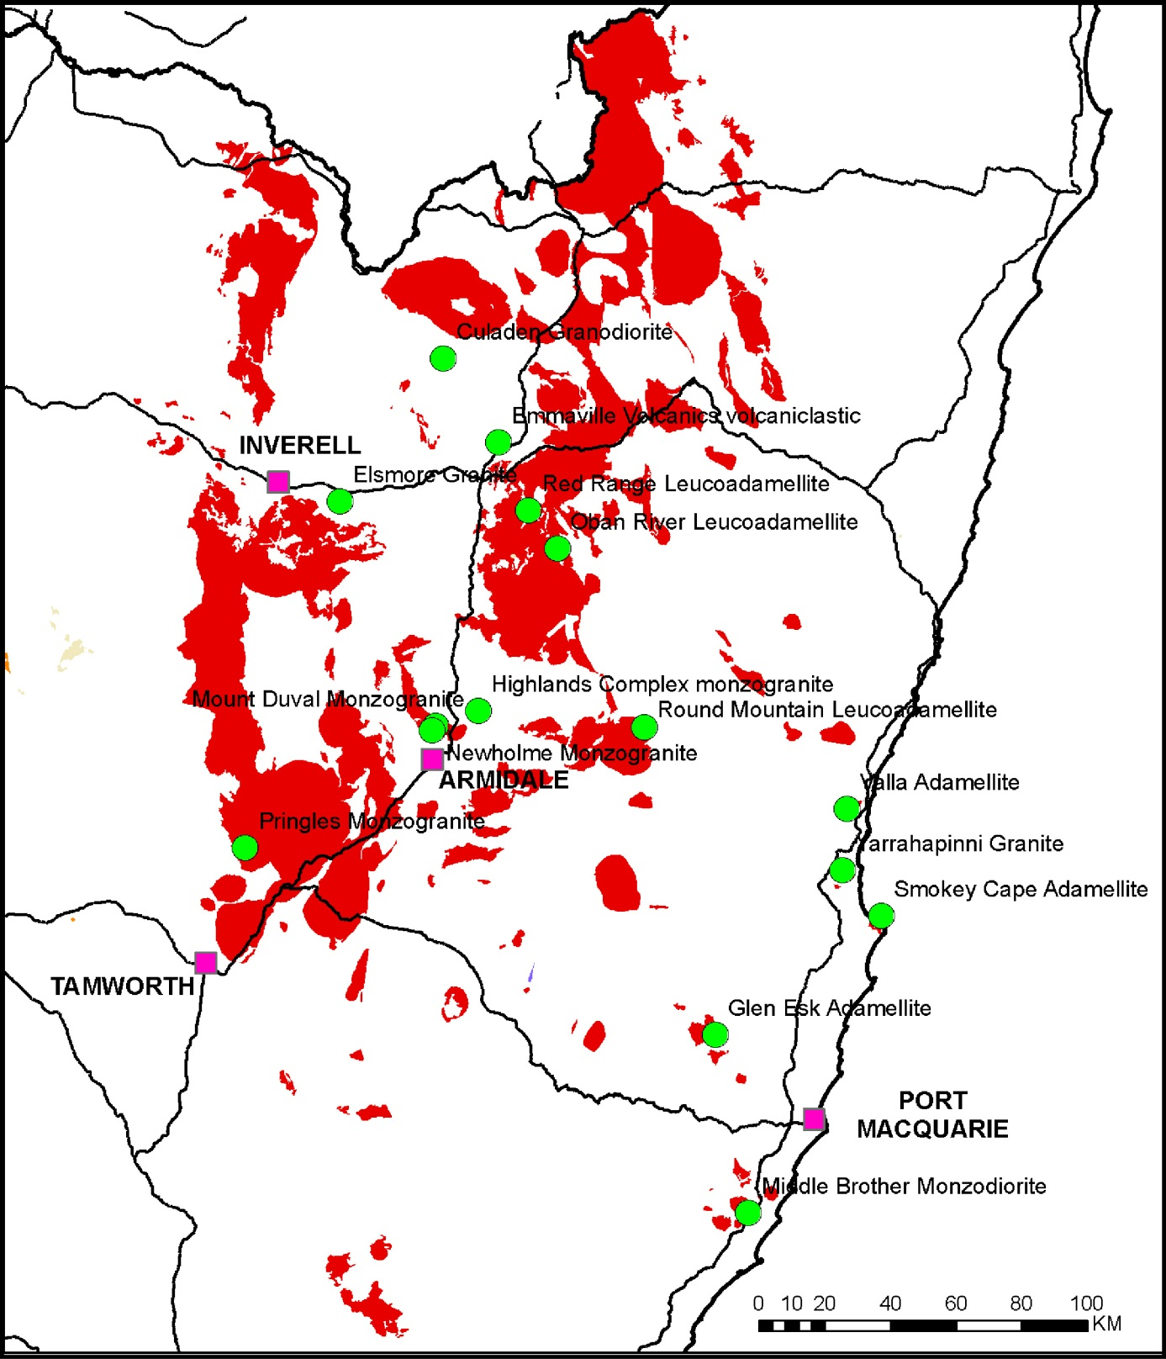
Figure 1.1 Map showing locations for the new SHRIMP U–Pb geochronology presented in this report. The red polygons represent outcropping granites, while the green circles represent the locations of samples mentioned in this report.

Analytical Procedures
Zircon separates were obtained using magnetic and density techniques from crushed samples. The zircons were then mounted in epoxy resin, together with the 206Pb/238U standard zircon TEMORA 2 (416.8 Ma; Black et al. 2004) and 207Pb/206Pb standard zircon OG1 (3465 Ma; Stern et al. 2009). The epoxy mount was polished to reveal zircon interiors, and photomicrographs were taken in transmitted and reflected light. Cathodoluminescence (CL) images were taken of the zircons to reveal their internal zoning. These images were obtained with a JEOL JSM-6490LV scanning electron microscope located at Geoscience Australia, operating at 15 kV with a working distance of 16 mm.
All isotopic analyses reported in this report were carried out using a SHRIMP IIe, located at Geoscience Australia. Analytical procedures followed the methodology described by Compston et al. (1984), Williams and Claesson (1987) and Claoué–Long et al. (1995). The primary O2- beam had an intensity of between ~2.0–2.8 nA, which resulted in a spot diameter of ~25–35 µm. The ionised particles were extracted into the mass spectrometer with a 10kV potential and counted with a single electron multiplier. Ions were focussed into the collector by a cyclic stepping of the magnet and each analysis represents the average of six scans through the different mass stations (Table 1.2). All analyses were carried out with a mass resolution of approximately 5000.
The 206Pb/238U calibration standard was analysed every fourth analysis and the 207Pb/206Pb standard every eighth. Calibration of the 206Pb/238U ratios was by comparison to the zircon standard TEMORA 2 and the power law relationship of 206Pb+/238U+ and 238UO+/238U+ (Claoué–Long et al. 1995). Three separate analytical sessions were used to calibrate the 206Pb/238U ratios of the unknowns analysed. The calibration parameters for each session is shown in Table 1.3 and displayed in Figure 1.2. Additionally, information for each of the calibration sessions is also listed in Appendix A.
Uranium abundances were calculated with reference to SL13 (238 ppm; Claoué–Long et al. 1995), CZ3 (551 ppm; Pigeon et al. 1994) and M257 (840 ppm; Nasdala et al. 2008) and are subject to an uncertainty of at least ± 20%. Th/U ratios were calculated using the linear relationship 232Th/238U = 232ThO+/238UO+*[0.03446(UO+/U+)+0.868]. Data reduction was carried out using Squid2.50_r21, and Isoplot_r5 Microsoft Excel-based macros of Ludwig (2008; 2009) downloaded from the Sourceforge website (http://sourceforge.net/projects/squid2) and (http://sourceforge.net/projects/isoplot). Individual analyses in this report have uncertainties listed in the tables and plotted on Concordia and 206Pb/238U temporal trend diagrams as shaded ellipses or error bars at the 1σ level. The ages for the zircon populations were calculated from a weighted average of the 204Pb corrected 206Pb/238U ages using ISOPLOT 3 (Ludwig 2008) and the final ages are given at the 95% confidence interval.

Table 1.1a Summary of results for samples on SHRIMP mount GA6089, analytical session 90042.
UNIT | GSNSW ID | GA Sample no. | GDA94 Latitude | GDA94 Longitude | 1:250,000 sheet | Age (Ma) | Comments
1. Middle Brother Monzodiorite | PB-NE-08-24 | 1980500 | 152.702782 | -31.712955 | Hastings | 212.5 ± 1.6 | Magmatic crystallisation
2. Glen Esk Adamellite | PB-NE-08-26 | 1980501 | 152.566208 | -31.229592 | Hastings | 221.2 ± 1.5 | Magmatic crystallisation
3. Smokey Cape Adamellite | PB-NE-08-28 | 1980502 | 153.073451 | -30.877867 | Coffs Harbour | 218.4 ± 1.6 | Magmatic crystallisation
4. Yarrahapinni Adamellite | PB-NE-08-29 | 1980503 | 152.940557 | -30.758413 | Dorrigo | 228.4 ± 1.7 | Magmatic crystallisation
5. Valla Adamellite | PB-NE-08-30 | 1980504 | 152.945313 | -30.589925 | Dorrigo | 230.7 ± 1.6 | Magmatic crystallisation
6. Round Mountain Leucoadamellite | PB-NE-08-31 | 1980505 | 152.288359 | -30.397187 | Dorrigo | 238.0 ± 1.7 | Magmatic crystallisation
Table 1.1b Summary of results for samples on SHRIMP mount GA6118, analytical session 100031.
UNIT | GSNSW ID | GA Sample no. | GDA94 Latitude | GDA94 Longitude | 1:250,000 sheet | Age (Ma) | Comments
7. Oban River Leucoadamellite | PB-NE-08-32 | 1980506 | 151.987790 | -29.917038 | Grafton | 252.1 ± 1.4 | Magmatic crystallisation
8. Red Range Leucoadamellite | PB-NE-08-34 | 1980508 | 151.891131 | -29.816031 | Grafton | 253.2 ± 1.5 | Magmatic crystallisation
9. Mount Duval Monzogranite | MD-1 | 2002565 | 151.629452 | -30.418660 | Dorrigo | 253.7 ± 1.4 | Magmatic crystallisation
10. Newholme Monzogranite | N-1 | 2002566 | 151.618053 | -30.431858 | Dorrigo | 252.8 ± 1.5 | Magmatic crystallisation
11. Pringles Monzogranite | PB-09-NE-GD1 | 2002567 | 151.040333 | -30.776055 | Manilla | 288.7 ± 1.6 | Magmatic crystallisation
Table 1.1c Summary of results for samples on SHRIMP mount GA6139, analytical session 100128.
UNIT | GSNSW ID | GA Sample no. | GDA94 Latitude | GDA94 Longitude | 1:250,000 sheet | Age (Ma) | Comments
12. Highlands Complex Monzogranite | PBNE-10-HC-01 | 2105109 | 151.762152 | -30.373093 | Dorrigo | 251.5 ± 1.9 | Magmatic crystallisation
13. Emmaville Volcanics Volcaniclastic | PBNE-09-NEV-02 | 2105111 | 151.787400 | -29.633820 | Grafton | 252.3 ± 2.0 | Magmatic crystallisation
14. Elsmore Granite | PBNE-10-TIGI-47 | 2105112 | 151.296210 | -29.814914 | Inverell | 250.3 ± 1.8 | Magmatic crystallisation
15. Culaden Granodiorite | PBNE-09-NEV-04 | 2105113 | 151.601517 | -29.412421 | Grafton | 252.2 ± 1.9 | Magmatic crystallisation

Table 1.2 Mass stations and count times for the SHRIMP U–Pb zircon analyses carried out in this report.
Mass station | Isotope/species | Mass (amu) | Count time (s) | Delay for magnetic settling (s)
1 | 196Zr2O | 195.804 | 2 | 7
2 | 204Pb | 203.973 | 20 | 2
3 | Background | 204.1 | 20 | 1
4 | 206Pb | 205.974 | 10 | 2
5 | 207Pb | 206.976 | 40 | 1
6 | 208Pb | 207.977 | 10 | 1
7 | 238U | 238.051 | 5 | 2
8 | 248ThO | 248.033 | 2 | 3
9 | 254UO | 254.046 | 2 | 3
10 | 270UO2 | 270.041 | 2 | 3
Table 1.3 SHRIMP 206Pb/238U standard information for the samples reported. Standard used: TEMORA 2; 416.8 Ma (Black et al. 2004).
Mount No. | LIMS session  No. | Analysis date | Standard analyses  (n) | Rejections | Exponent used | Reproducibility  (1σ) | Standard  Error (1σ)
GA6089 | 90042 | 04-May to  08-May 2009 | 38 | 0 | 2 | 0.91 | 0.23
GA6118 | 100031 | 22-Feb to  25-Feb 2010 | 35 | 0 | 2 | 0.70 | 0.19
GA6139 | 100128 | 28-Sep to  01-Oct 2010 | 31 | 0 | 2 | 1.10 | 0.26
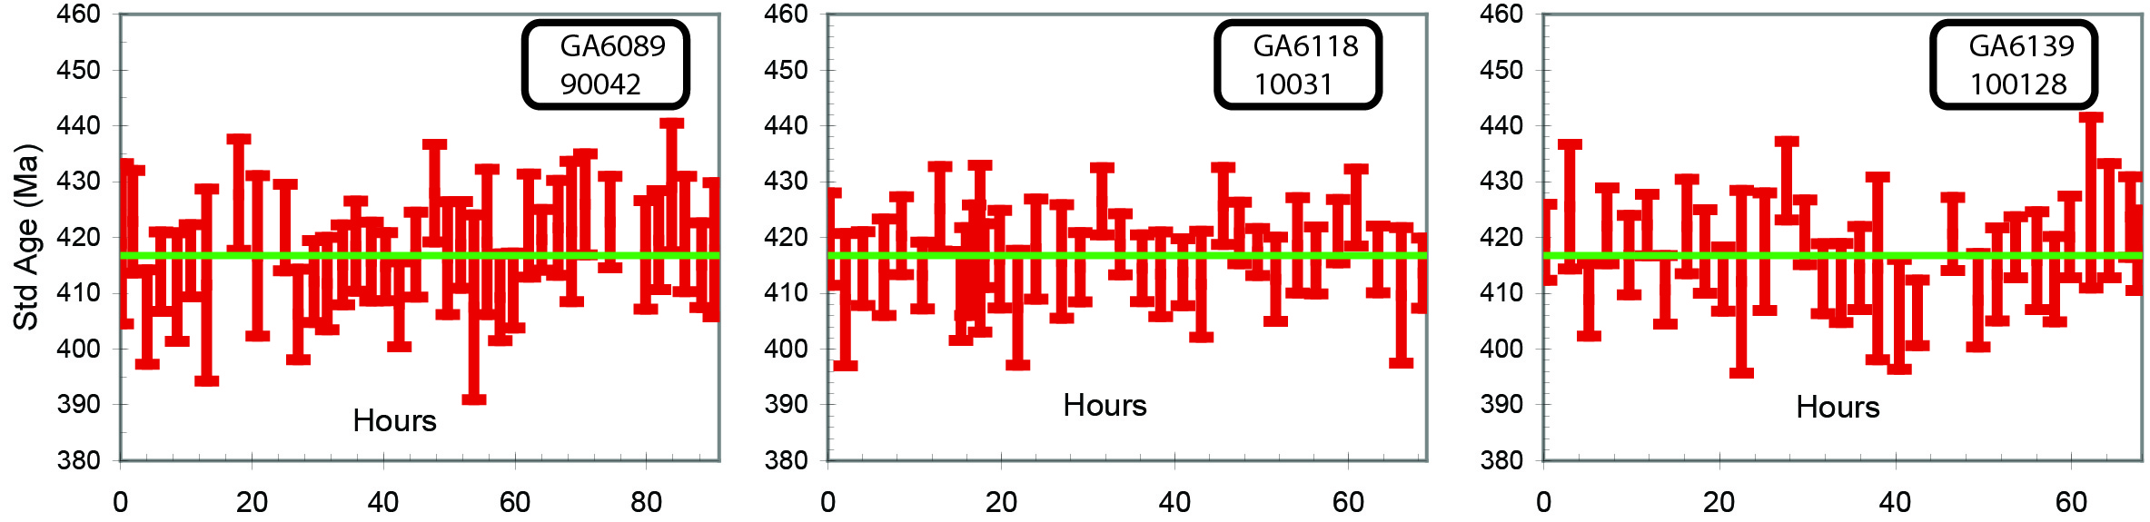
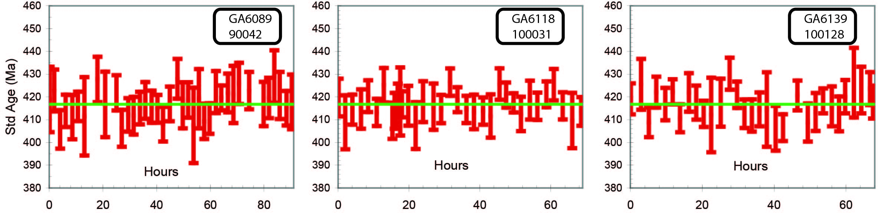
Figure 1.2 Temporal trend of the 206Pb/238U ages for the TEMORA 2 zircon standard for the analytical sessions used in this study (error bars are 2σ). See Table 1.3 and Appendix A for further session details.

Samples Analysed

Middle Brother Monzodiorite PB-NE-08-24/1980500
Table 2.1 Summary of results: Middle Brother Monzodiorite (PB-NE-08-24/1980500).
GA SampleID | 200801611
GA SampleNO | 1980500
GSNSW SITEID | PB-NE-08-24
Formal Name | The Brothers Granitoids
Informal Name | Middle Brother monzodiorite
Lithology | fine grained monzodiorite
1:250 000 Sheet | HASTINGS (SH5614)
1:100 000 Sheet | CAMDEN HAVEN (9434)
Region | New England Region
Location (GDA94) | 152.702782°E, -31.712955°S
Location (MGA 94 Zone 56) | 471839 mE, 6491342 mN
Geochronologist | Andrew Cross
Mount ID | GA6089
Analytical Session | 90042
Interpreted Age | 212.5 ± 1.6 Ma (95% confidence, 24 analyses on 24 zircons)
Geological Attribution | Magmatic crystallisation
Isotopic Ratio Used | 206Pb/238U

Sample information
This sample comprises a fine–grained monzodiorite phase of the Middle Brother intrusion collected from oversize material on the floor at the rear of the Johns River Quarry (Boral) (Figure 2.1). The Brothers Granitoids comprise high level/subvolcanic laccoliths, plugs, sills and dykes of fine– to medium–grained diorite, pyroxene-bearing granodiorite, microgranite and leucocratic graphic granite and granophyre. They are alkali rich and A–type in compositional character. They intrude indurated and deformed interbedded sediments and volcanics of the Lorne Basin which contain Upper Triassic faunal assemblages. K–Ar dating by McDougall and Wellman (1976) on two hornblendes from a microgranodiorite from the Middle Brother intrusion gave a combined result of 205 ± 3 Ma (~210 Ma using modern constants).
This sample was analysed to obtain a magmatic crystallisation age of the main intrusive unit of The Brothers Granitoids and to constrain a minimum age for the formation and deformation of the Lorne Basin and to ascertain the relationship between The Brothers Granitoids and the Coastal I- and A-type Supersuites of eastern New England.

Petrography
The sample is a two pyroxene I-type medium–grained monzodiorite. The Middle Brother intrusion at John’s River Quarry ranges in composition from diorite to monzodiorite and monzogranite. Microsyenite veins and segregations are present and compositional variability at the local scale manifests as wispy and gradational changes in texture and colour index. Cognate, quenched dioritic enclaves are locally abundant. The dating sample is a fine–grained mildly to sparsely porphyritic grey-white coloured rock in hand specimen. Plagioclase dominates with around 5 percent ferromagnesians. Occasional small (< 5 mm) quench textured igneous dioritic enclaves are present.
In thin section the rock is mildly porphyritic (plagioclase >> alkali feldspar) with a blocky textured feldspar–dominated groundmass and minor interstitial (< 2 modal percent) quartz. Groundmass crystals average 0.3 mm while the larger phenocrysts are ~3 mm. Plagioclase (~60 modal percent) is present both as phenocrysts and groundmass with individual blocky to tabular crystals and aggregates of smaller crystals ranging to 2.5 mm. Crystals are reasonably fresh and show simple and polysynthetic twinning. Compositional zoning is sometimes well developed. Alkali feldspar (≤ 1.5 mm; ~35 modal percent) is rather featureless, commonly heavily flecked and occurs as generally less well formed subhedral crystals than do the plagioclases. Rare simple twins are present but microcline twinning and perthite formation is absent.
Ferromagnesian minerals (~5 modal percent; clinopyroxene > orthopyroxene, biotite?) occur as individual crystals and clot–like masses of fibrous birefringent amphibole replacing pyroxene. Opaques (~1 modal percent; magnetite in part) are commonly associated with these clots. Clinopyroxene forms equant to elongate subhedral to euhedral crystals as cores and relicts extensively replaced by amphibole and chlorite. Orthopyroxene is present as rare aggregates to 0.7 mm. Narrow alteration selvedges are present around fringes and cracks. Some of the chlorite/amphibole aggregates may be after biotite, with secondary titanite occurring as strings presumably after forming along biotite cleavages. Quartz (< 2 modal percent) is relegated to the groundmass as late interstitial, anhedral infill. Rare graphic intergrowths of groundmass quartz with alkali feldspar are present. Apatite occurs in elongate to acicular forms, while larger stumpy masses are also present (Figure 2.2).
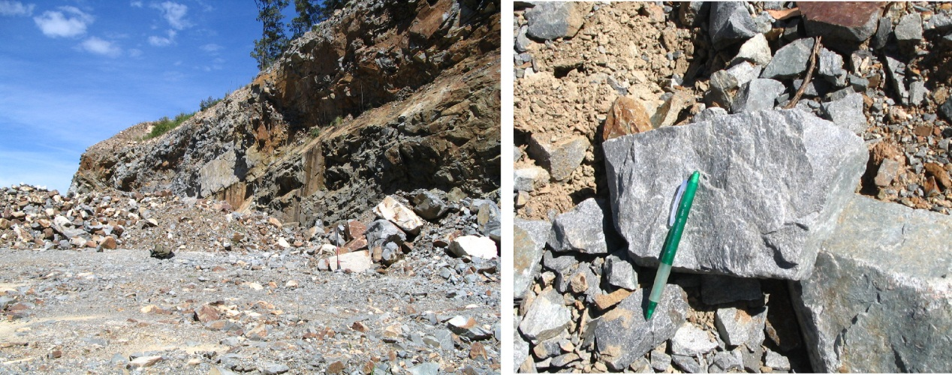
Figure 2.1 Johns River Quarry and hand sample of Middle Brother monzodiorite (PB-NE-08-24/1980500).
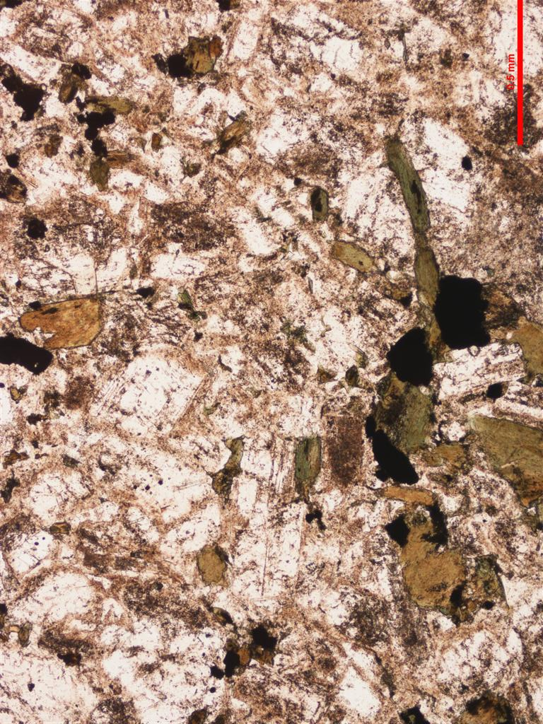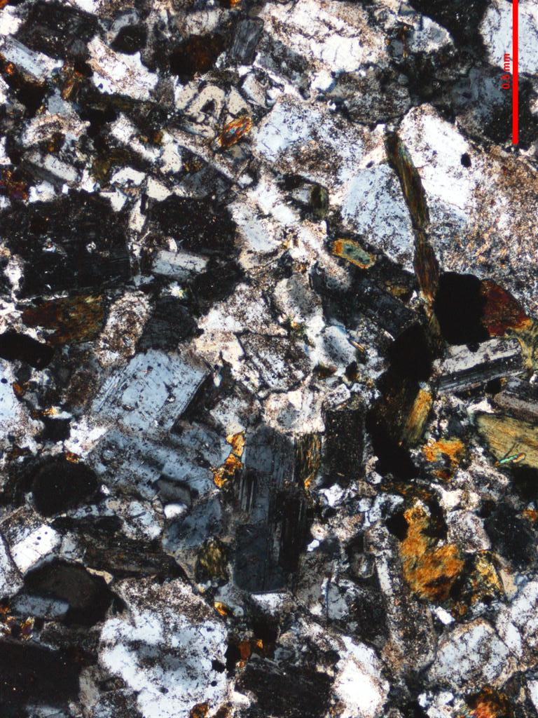
Figure 2.2 Thin section microphotographs of Middle Brother monzodiorite (informal). Scale as indicated (0.5 mm); PPL left, CPL right. Note quartz-poor nature, presence of amphiboles and acicular apatite (PB-NE-08-24/1980500).

Zircons
Zircons recovered from PB-NE-08-24/1980500 consist of a uniform population of clear, colourless, euhedral grains that are between 100–150 µm in diameter. They range from those with equant forms to others with aspect ratios of between 2 to 3. In CL they are moderately luminescent with faint concentric growth zones (Figure 2.3).

U–Pb isotopic results
Twenty-five SHRIMP U–Pb analyses were made on 25 zircons from this sample (Figure 2.4, Table 2.2). Uranium concentrations are typically low to moderate (33–829 ppm, median = 178 ppm) and Th/U ratios uniform, with an average value of 0.65. Common 206Pb concentrations are variable and extend from 0.14 to 5.63 (% 206Pbc). The youngest grain (611.Z.14.1.1) also has the highest common 206Pb and has been removed from further consideration. The remaining analyses have the same radiogenic 206Pb/238U within their analytical uncertainties (MSWD = 0.75, probability = 0.79) and give a weighted mean age of 212.5 ± 1.6 Ma. This is interpreted as the crystallisation age of these zircons and is the preferred age for the Middle Brother monzodiorite and, by inference, The Brothers Granitoids.
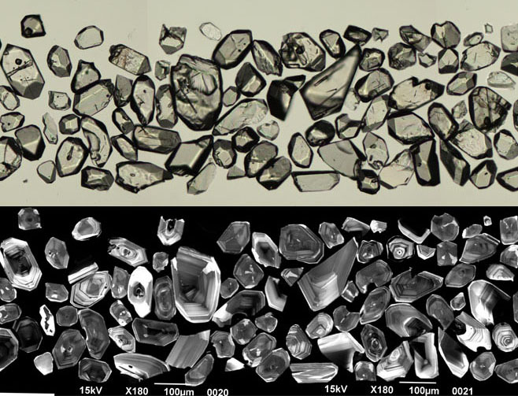
Figure 2.3 Selected transmitted light (top) and cathodoluminescence (bottom) images of zircon grains from the Middle Brother monzodiorite (PB-NE-08-24/1980500).
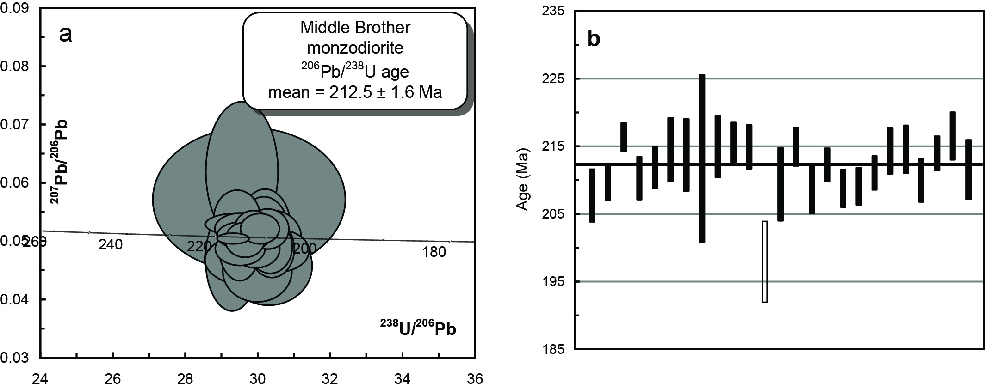
Figure 2.4 (a) Tera-Wasserberg concordia plot and (b) temporal trend of the 206Pb/238U ages from the Middle Brother monzodiorite (PB-NE-08-24/1980500). Analysis 611.Z.14.1.1 has a high common 206Pb content and very imprecise 207Pb/206Pb age and is not plotted in (a) and is represented by the unfilled bar in (b).
Table 2.2 SHRIMP U–Pb zircon data from Middle Brother Monzodiorite (PB-NE-08-24/1980500).
Grain.area | 206Pbc (%) | U (ppm) | Th (ppm) | 232Th/  238U | 238U/  206Pb | ± 1σ (%) | 207Pb/  206Pb | ± 1σ (%) | 206Pb/238U Age (Ma) | ± 1σ (Ma)
Magmatic zircons
611.Z.1.1.1 | 0.98 | 173 | 114 | 0.68 | 30.5331 | 1.9 | 0.0481 | 5.0 | 207.7 | 3.9
611.Z.2.1.1 | 0.67 | 154 | 73 | 0.49 | 30.2575 | 1.3 | 0.0518 | 4.4 | 209.6 | 2.6
611.Z.3.1.1 | 0.14 | 829 | 1393 | 1.74 | 29.2943 | 1.0 | 0.0502 | 1.2 | 216.4 | 2.1
611.Z.4.1.1 | 1.39 | 89 | 38 | 0.44 | 30.1547 | 1.5 | 0.0511 | 8.2 | 210.3 | 3.2
611.Z.5.1.1 | 0.98 | 226 | 153 | 0.70 | 29.9225 | 1.5 | 0.0484 | 4.5 | 211.9 | 3.1
611.Z.6.1.1 | 2.00 | 33 | 20 | 0.62 | 29.5493 | 2.2 | 0.0618 | 12.8 | 214.5 | 4.7
611.Z.7.1.1 | 1.17 | 157 | 79 | 0.52 | 29.6629 | 2.5 | 0.0465 | 6.1 | 213.7 | 5.4
611.Z.8.1.1 | 1.50 | 67 | 32 | 0.49 | 29.7406 | 5.9 | 0.0569 | 14.4 | 213.2 | 12.5
611.Z.9.1.1 | 0.17 | 234 | 171 | 0.75 | 29.4875 | 2.1 | 0.0526 | 2.4 | 215.0 | 4.5
611.Z.10.1.1 | 0.95 | 102 | 64 | 0.65 | 29.4147 | 1.5 | 0.0535 | 6.2 | 215.5 | 3.1
611.Z.13.1.1 | 0.70 | 237 | 182 | 0.79 | 29.4939 | 1.5 | 0.0484 | 4.0 | 214.9 | 3.3
611.Z.15.1.1 | 2.44 | 213 | 136 | 0.66 | 30.2878 | 2.6 | 0.0454 | 9.9 | 209.4 | 5.4
611.Z.16.1.1 | 2.61 | 201 | 116 | 0.60 | 29.4908 | 1.3 | 0.0492 | 8.5 | 215.0 | 2.8
611.Z.17.1.1 | 1.57 | 301 | 238 | 0.82 | 30.3844 | 1.8 | 0.0503 | 6.2 | 208.7 | 3.6
611.Z.18.1.1 | 1.19 | 303 | 254 | 0.87 | 29.8671 | 1.2 | 0.0516 | 4.3 | 212.3 | 2.4
611.Z.19.1.1 | 1.20 | 166 | 132 | 0.82 | 30.3316 | 1.3 | 0.0487 | 6.2 | 209.1 | 2.7
611.Z.20.1.1 | 1.31 | 158 | 91 | 0.60 | 30.3777 | 1.4 | 0.0484 | 6.8 | 208.8 | 2.8
611.Z.21.1.1 | 0.45 | 239 | 177 | 0.76 | 30.0434 | 1.2 | 0.0519 | 3.3 | 211.1 | 2.5
611.Z.22.1.1 | 0.39 | 264 | 197 | 0.77 | 29.5740 | 1.6 | 0.0507 | 3.1 | 214.4 | 3.4
611.Z.23.1.1 | 0.57 | 269 | 205 | 0.79 | 29.5440 | 1.7 | 0.0519 | 3.4 | 214.6 | 3.5
611.Z.24.1.1 | 1.74 | 109 | 84 | 0.80 | 30.1954 | 1.6 | 0.0520 | 8.6 | 210.0 | 3.2
611.Z.25.1.1 | 0.65 | 234 | 104 | 0.46 | 29.6282 | 1.2 | 0.0500 | 4.0 | 214.0 | 2.6
611.Z.26.1.1 | 2.01 | 90 | 47 | 0.54 | 29.2691 | 1.7 | 0.0467 | 12.7 | 216.6 | 3.5
611.Z.27.1.1 | 1.78 | 178 | 108 | 0.62 | 29.9718 | 2.1 | 0.0446 | 7.9 | 211.6 | 4.4
High common Pb
611.Z.14.1.1 | 5.63 | 51 | 18 | 0.37 | 32.0774 | 3.1 | 0.0213 | 53.4 | 197.9 | 6.0
- %206Pbc indicates the proportion of common 206Pb in the total measured 206Pb.
- Pb isotopic ratios corrected for common Pb by reference to the measured 204Pb.
- All errors quoted as 1σ.

Glen Esk Adamellite PB-NE-08-26/1980501
Table 2.3 Summary of results: Glen Esk Adamellite (PB-NE-08-26/1980501).
GA SampleID | 200801613
GA SampleNO | 1980501
GSNSW SITEID | PB-NE-08-26
Formal Name | Glen Esk Adamellite
Informal Name | Gundle Tin Granitoids
Lithology | monzogranite
1:250 000 Sheet | HASTINGS (SH5614)
1:100 000 Sheet | KEMPSEY (9435)
Region | New England Region
Location (GDA94) | 152.566208 °E, -31.229592 °S
Location (MGA 94 Zone 56) | 458687 mE, 6544872 mN
Geochronologist | Andrew Cross
Mount ID | GA6089
Analytical Session | 90042
Interpreted Age | 221.2 ± 1.5 Ma (95% confidence, 25 analyses on 25 zircons)
Geological Attribution | Magmatic crystallisation
Isotopic Ratio Used | 206Pb/238U

Sample information
This sample was collected from boulders excavated during road work operations 20 m down a steep slope on the west side of an access road in the Kippara State Forest (Figure 2.5) The sample comprises coarse grained monzogranite. Others variants observed along the access track include coarse grained porphyritic monzogranite, and granodiorite with microgranular enclaves with quenched and scalloped margins. Granites are poorly exposed and usually deeply weathered and intrude units of unnamed Carboniferous siliclastic sediments. There has been no previous direct dating undertaken on the Gundle tin granitoids, however Rb–Sr whole rock dating on the wider “Gundle Granitoid Belt” has yielded ages of 232–235 Ma (Hensel et al. 1982). A Middle Triassic age has been assumed on the basis of relationships to other granites in the region and their felsic and mineralised character. This sample was analysed to determine a magmatic crystallisation age of the main intrusive unit of the tin mineralised granites at Gundle (Glen Esk, Gundle, Cairncross and Banda Banda), establish an age for Sn mineralisation in the region and confirm the relationship between the “Gundle tin granites” and other members of the Coastal I-type Supersuite.

Petrography
The sample is a medium– to coarse–grained, strongly seriate felsic I-type monzogranite. In hand sample it shows prominent phenocrysts of pale pink alkali feldspar and pale green to white plagioclase both to 1.5 cm and comprising 30 percent of the rock, with scattered crystals and aggregates of biotite to 2 mm set in a medium fine–grained pale–pink quartz-feldspar groundmass.
In thin section quartz (≤ 1 cm; ~35 modal percent) comprises subhedral to rounded phenocrysts showing only minor strain recrystallisation or subgrain formation. Some grain boundaries extend into groundmass. Septa and “resorption” textures within the quartz represent groundmass trapped during rapid crystal growth. Alkali feldspars (≤ 1.5 cm; ~35 modal percent) are reasonably fresh with minor alteration and turbidisation associated with zones of minor microcline twinning and perthite development. Large single twins (Carlsbad) are characteristic of the phenocrysts and growth zoning is weakly apparent in some cases. The plagioclases (≤1 cm; ~30 modal percent) are quite fresh and exhibit simple and polysynthetic twins. Like the alkali feldspars, plagioclase phenocrysts may comprise single crystals or aggregates.
Biotite (~2 modal percent; biotite >> amphibole) is generally very fresh, is subhedral to anhedral in shape and commonly forms ragged aggregates. Amphibole (apple green → straw-yellow green) is rare. One ragged mass (2 mm) is surrounded by biotite and spatially associated with opaques, apatite and zircon. It is locally replaced by blue birefringent (clino)zoisite, or epidote. A shred of strongly blue-green (to green) amphibole is also present. Other amphibole occurrences comprise oriented aggregates (apple green) to 0.7 mm armoured by biotite. An unaltered single brownish mass of amphibole with prominent cleavage is also present. The groundmass comprises 0.1 mm aplitic textured aggregate of blocky quartz and alkali feldspar > plagioclase and biotite. Graphic intergrowths (quartz, alkali feldspar) are only rarely developed. Accessory opaques, zircon, apatite, ?xenotime and fluorite are present and minor secondary chlorite and titanite replace biotite (Figure 2.6).
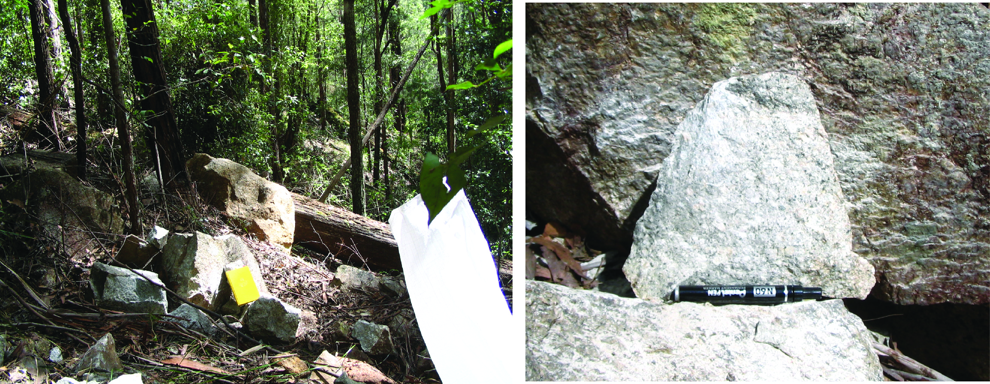
Figure 2.5 Roadside sample site and hand sample of PB-NE-08-26/1980501, Glen Esk Adamellite.
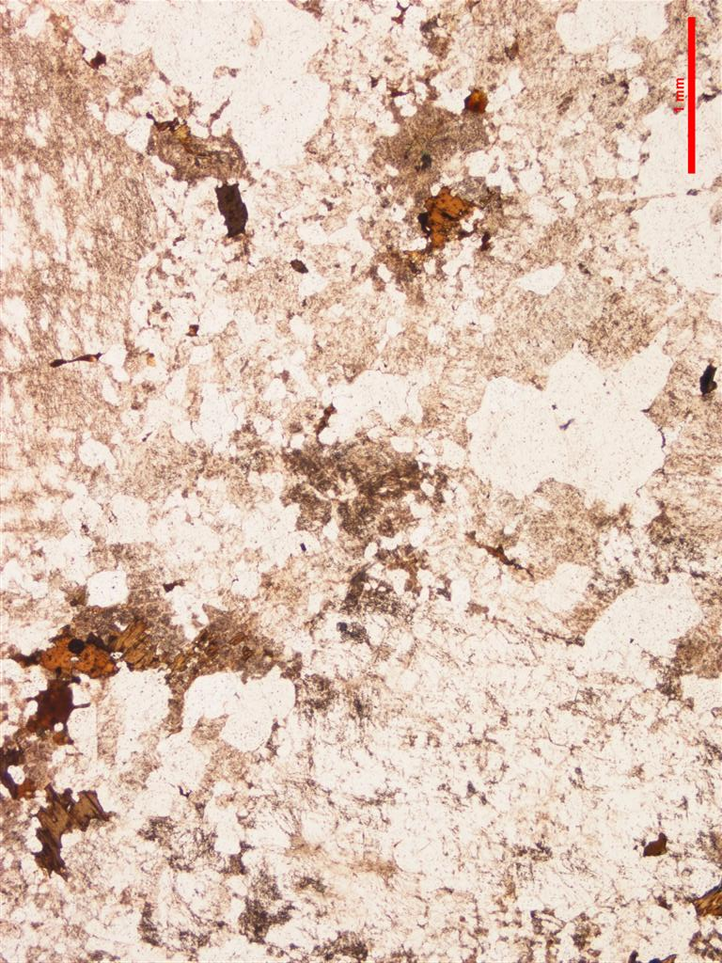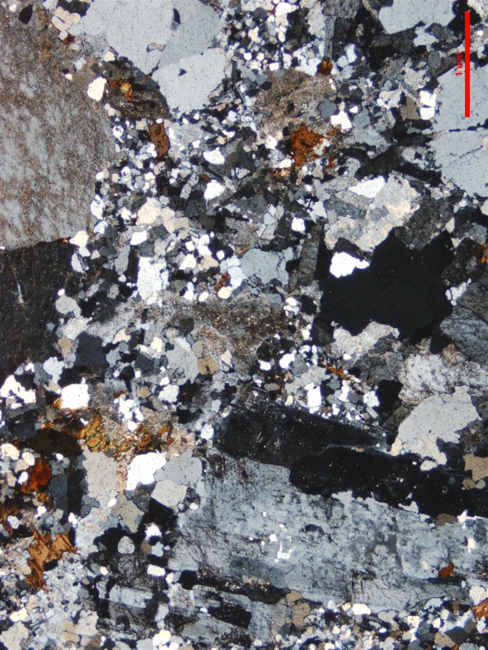
Figure 2.6 Thin section microphotographs of Glen Esk Adamellite. Scale as indicated (1 mm); PPL left, CPL right. Note felsic character and strongly seriate texture (PB-NE-08-26/1980501).

Zircons
Zircons recovered from PB-NE-08-26/1980501 are yellowish, moderately turbid and many have what appears to be an irregular iron oxide staining. The majority of grains are broken fragments while intact grains are euhedral with aspect ratios of between 2 to 3 and range between ~40–150 µm in diameter. Many grains also have inclusions that are typically elongated, randomly orientated and have a strong CL response. The grains have a moderate to weak CL response and are concentrically zoned (Figure 2.7).

U–Pb isotopic results
Twenty-five SHRIMP U–Pb analyses were carried out on 25 grains from this sample (Figure 2.8 and Table 2.4). There is a wide range in U concentration (58–1376 ppm, median = 620 ppm) however, the majority have moderate levels of between ~200–900 ppm. The zircons are uniform in Th/U (mean = ~0.44) and common 206Pb concentrations range from ~0.05 to 2.52 (206Pbc). All 25 SHRIMP analyses have the same 206Pb/238U within their analytical uncertainties and contribute to a weighted mean age of 221.2 ± 1.5 Ma (MSWD = 0.49, probability = 0.98) which is interpreted as the magmatic crystallisation age of the Glen Esk Adamellite.
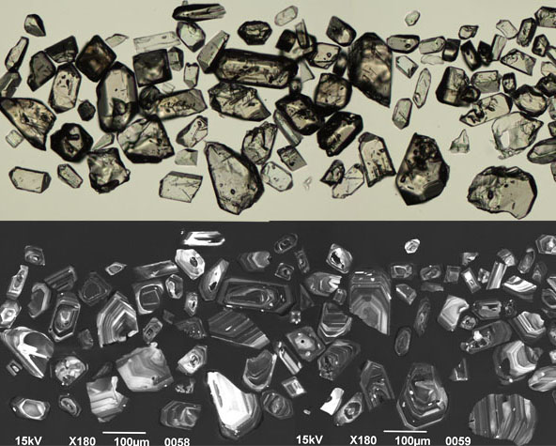
Figure 2.7 Selected transmitted light (top) and cathodoluminescence (bottom) images of zircon grains from the Glen Esk Adamellite (PB-NE-08-26/1980501).
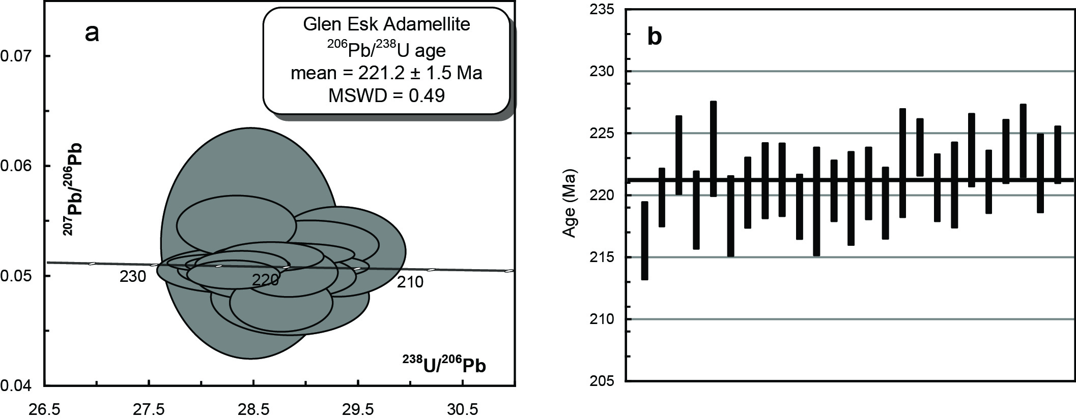
Figure 2.8 (a) Tera-Wasserberg concordia plot and (b) temporal trend of the 206Pb/238U ages from the Glen Esk Adamellite (PB-NE-08-26/1980501).
Table 2.4 SHRIMP U–Pb zircon data from Glen Esk Adamellite (PB-NE-08-26/1980501).
Grain.area | 206Pbc (%) | U (ppm) | Th (ppm) | 232Th/  238U | 238U/  206Pb | ± 1σ (%) | 207Pb/  206Pb | ± 1σ (%) | 206Pb/238U Age (Ma) | ± 1σ (Ma)
Magmatic zircons
613.Z.1.1.1 | 2.52 | 547 | 157 | 0.30 | 29.3018 | 1.5 | 0.0520 | 5.2 | 216.3 | 3.1
613.Z.2.1.1 | 0.34 | 463 | 320 | 0.71 | 28.8265 | 1.1 | 0.0501 | 3.0 | 219.8 | 2.3
613.Z.3.1.1 | 0.42 | 577 | 215 | 0.39 | 28.3766 | 1.4 | 0.0503 | 2.1 | 223.3 | 3.2
613.Z.4.1.1 | 0.25 | 944 | 369 | 0.40 | 28.9603 | 1.5 | 0.0506 | 1.5 | 218.8 | 3.1
613.Z.5.1.1 | 0.42 | 395 | 192 | 0.50 | 28.3107 | 1.7 | 0.0503 | 2.7 | 223.8 | 3.8
613.Z.6.1.1 | 0.40 | 292 | 148 | 0.52 | 29.0291 | 1.5 | 0.0526 | 2.8 | 218.3 | 3.3
613.Z.7.1.1 | 0.08 | 920 | 444 | 0.50 | 28.7757 | 1.3 | 0.0519 | 1.2 | 220.2 | 2.9
613.Z.8.1.1 | 0.15 | 771 | 276 | 0.37 | 28.6465 | 1.4 | 0.0509 | 1.5 | 221.2 | 3.1
613.Z.9.1.1 | 0.27 | 835 | 342 | 0.42 | 28.6363 | 1.4 | 0.0503 | 1.6 | 221.3 | 2.9
613.Z.10.1.1 | 0.06 | 857 | 285 | 0.34 | 28.9284 | 1.2 | 0.0517 | 1.3 | 219.1 | 2.6
613.Z.11.1.1 | 0.67 | 211 | 109 | 0.53 | 28.8690 | 2.0 | 0.0504 | 4.3 | 219.5 | 4.4
613.Z.12.1.1 | 0.80 | 358 | 180 | 0.52 | 28.7564 | 1.1 | 0.0473 | 3.7 | 220.4 | 2.5
613.Z.13.1.1 | 0.87 | 326 | 86 | 0.27 | 28.8373 | 1.7 | 0.0478 | 4.9 | 219.8 | 3.8
613.Z.14.1.1 | 0.15 | 733 | 206 | 0.29 | 28.6755 | 1.3 | 0.0515 | 1.4 | 221.0 | 2.9
613.Z.15.1.1 | 0.41 | 403 | 184 | 0.47 | 28.8886 | 1.3 | 0.0497 | 2.6 | 219.4 | 2.9
613.Z.17.1.1 | 2.38 | 58 | 18 | 0.32 | 28.4587 | 2.0 | 0.0527 | 13.3 | 222.6 | 4.4
613.Z.18.1.1 | 0.24 | 661 | 259 | 0.40 | 28.2935 | 1.0 | 0.0499 | 1.7 | 223.9 | 2.3
613.Z.19.1.1 | 0.12 | 1140 | 444 | 0.40 | 28.7219 | 1.3 | 0.0501 | 1.2 | 220.6 | 2.7
613.Z.20.1.1 | 0.28 | 605 | 250 | 0.43 | 28.6913 | 1.6 | 0.0508 | 1.9 | 220.9 | 3.4
613.Z.21.1.1 | 0.91 | 629 | 246 | 0.40 | 28.3244 | 1.3 | 0.0544 | 3.4 | 223.7 | 3.0
613.Z.22.1.1 | 0.38 | 850 | 405 | 0.49 | 28.6570 | 1.2 | 0.0515 | 1.7 | 221.1 | 2.5
613.Z.23.1.1 | 0.17 | 1376 | 1709 | 1.28 | 28.3357 | 1.2 | 0.0508 | 1.1 | 223.6 | 2.6
613.Z.24.1.1 | 0.05 | 914 | 389 | 0.44 | 28.2269 | 1.3 | 0.0509 | 1.1 | 224.4 | 2.9
613.Z.25.1.1 | 0.62 | 478 | 208 | 0.45 | 28.5662 | 1.5 | 0.0496 | 2.8 | 221.8 | 3.2
613.Z.26.1.1 | 0.20 | 620 | 235 | 0.39 | 28.3712 | 1.0 | 0.0507 | 1.7 | 223.3 | 2.3
- %206Pbc indicates the proportion of common 206Pb in the total measured 206Pb.
- Pb isotopic ratios corrected for common Pb by reference to the measured 204Pb.
- All errors quoted as 1σ.

Smokey Cape Adamellite PB-NE-08-28/1980502
Table 2.5 Summary of results: Smokey Cape Adamellite (PB-NE-08-28/1980502).
GA SampleID | 200801614
GA SampleNO | 1980502
GSNSW SITEID | PB-NE-08-28
Formal Name | Smokey Cape Adamellite
Informal Name | -
Lithology | monzonite
1:250 000 Sheet | COFFS HARBOUR (SH5611)
1:100 000 Sheet | NAMBUCCA (9536)
Region | New England Region
Location (GDA94) | 153.073451 °E, -30.877867 °S
Location (MGA 94 Zone 56) | 507021 mE, 6583931 mN
Geochronologist | Andrew Cross
Mount ID | GA6089
Analytical Session | 90042
Interpreted Age | 218.4 ± 1.6 Ma (95% confidence, 24 analyses on 24 zircons)
Geological Attribution | Magmatic crystallisation
Isotopic Ratio Used | 206Pb/238U

Sample Information
Smokey Cape has been classified as a member of the Coastal A-type Supersuite on the grounds of its geochemistry and petrography. This supersuite includes parts of the Chaelundi Complex (to the NW of Smokey Cape) which has been previously dated at 233–235 Ma by Rb–Sr biotite-whole rock methods (S. E. Shaw, unpublished data, 1989, quoted in Landenberger and Collins, 1996). The Smokey Cape Adamellite has not been previously dated. It intrudes and metmorphoses the Permo-Carboniferous Kempsey beds. The dating sample was collected off the seawall from material quarried immediately adjacent (south of) to the jail ruins. The quoted grid reference is for the centre of the quarry.

Petrography
The sample is a medium to coarse grained monzonite comprising in hand specimen, subequal proportions of mildly porphyritic subhedral medium pink alkali feldspar, pale green-white plagioclase and smaller rounded to skeletal quartz and minor biotite (< 5%).
In thin section quartz (~30 modal percent) is relatively late compared to the feldspars and is characterised by prominent skeletal forms and the nascent development of arrow head textures. Skeletal forms merge with septa within individual crystals to produce angular and blocky habits. Strain crystallisation is very minor.
Alkali feldspars (~40 modal percent) comprise the best formed crystals and range from water clear in the cores of some crystals to strongly turbid and perthitic with exsolved albite distributed evenly through most crystals and locally coalescing into vein and patch forms. Prominent rim replacements are not present. Plagioclase phenocrysts (to 4 mm, ~30 modal percent) show well developed polysynthetic and simple twinning and are usually flecked and often sport clear albite rims.
Biotite (≤0.7 mm; biotite >> amphibole) is usually variably replaced by chlorite. Angular interstices formed against the euhedral feldspar faces are a common site for fibrous and/or radiating chlorite (subsolidus, and after biotite). Amphibole (pale straw yellow → sea green; sometimes brown) is present as subhedral crystals (≤0.6 mm) and as aggregates up to < 1 mm. Late infilling radiating to blocky carbonate shows weak to variable resorption. These patches may also have zircon, apatite and titanite infilling between other crystals. Rare, strongly pleochroic secondary or late epidote is present as may be allanite(?) (Figure 2.9).
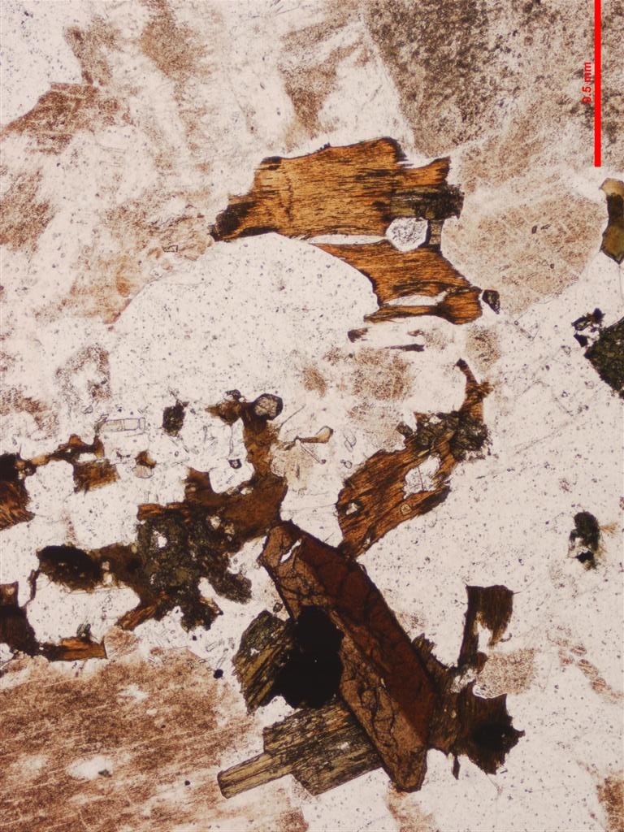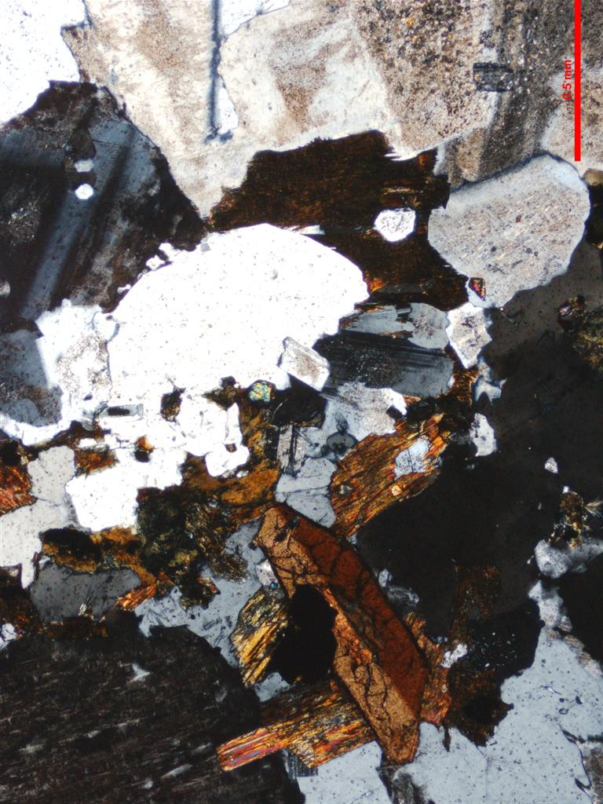
Figure 2.9 Thin section microphotograph of Smokey Cape Adamellite. Scale as indicated (0.5 mm); PPL left, CPL right. Note prominent twinned titanite, variably turbid K-feldspars and accessory phases (zircon, apatite and ?xenotime – near centre of image) (PB-NE-08-28/1980502).

Zircons
The zircons recovered from PB-NE-08-28/1980502 are a uniform population of clear colourless euhedral prisms that typically range between ~50–100 µm in diameter. Most grains are broken fragments while the intact grains have aspect ratios of between 2 to 4. In CL the zircons have a moderate to strong luminescence with fine concentric growth zones (Figure 2.10).

U–Pb isotopic results
Twenty-four SHRIMP U–Pb analyses were carried out on 24 zircons from this sample (Figure 2.11, Table 2.6). The zircons have a low to moderate U concentration (~109–658 ppm, median = 246 ppm) and are uniform in Th/U (~0.55). Common 206Pb concentrations are mostly low while four grains have moderate common 206Pb concentrations of between ~1.13 to 2.33 (% 206Pbc). All 24 analyses have the same radiogenic 206Pb/238U within their assigned analytical uncertainties and contribute to a weighted mean age of 218.4 ± 1.6 Ma (MSWD = 0.82, probability = 0.71). This is interpreted as the magmatic crystallisation age of this rock.
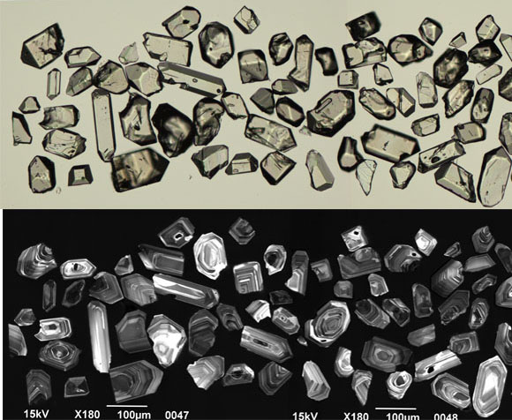
Figure 2.10 Selected transmitted light (top) and cathodoluminescence (bottom) images of zircon grains from the Smokey Cape Adamellite (PB-NE-08-28/1980502).
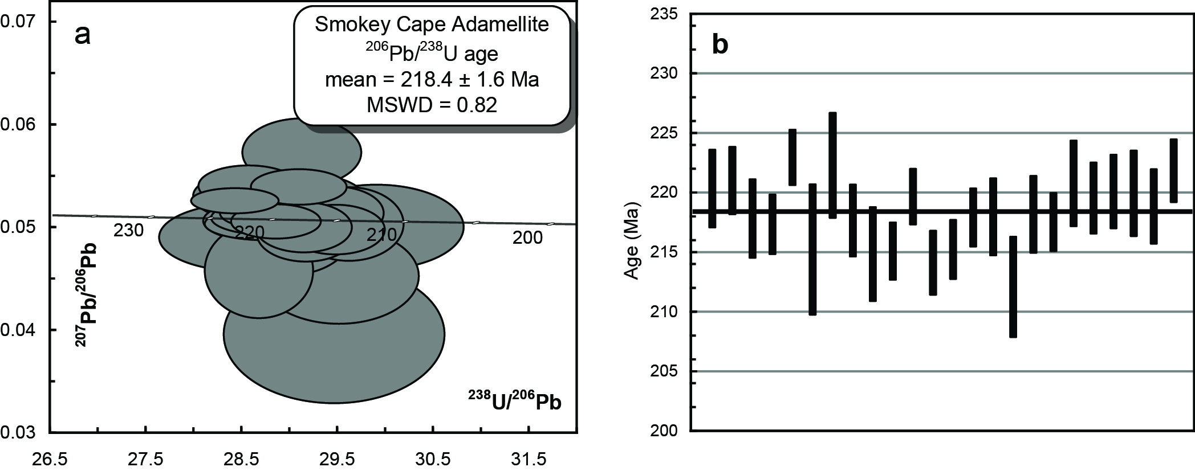
Figure 2.11 (a) Tera-Wasserberg concordia plot and (b) temporal trend of the 206Pb/238U ages from the Smokey Cape Adamellite (PB-NE-08-28/1980502).
Table 2.6 SHRIMP U–Pb zircon data from Smokey Cape Adamellite (PB-NE-08-28/1980502).
Grain.area | 206Pbc (%) | U (ppm) | Th (ppm) | 232Th/  238U | 238U/  206Pb | ± 1σ (%) | 207Pb/  206Pb | ± 1σ (%) | 206Pb/238U Age (Ma) | ± 1σ (Ma)
Magmatic zircons
614.Z.1.1.1 | 0.45 | 658 | 304 | 0.48 | 28.7573 | 1.5 | 0.0501 | 2.1 | 220.4 | 3.3
614.Z.2.1.1 | 1.50 | 205 | 65 | 0.33 | 28.6640 | 1.3 | 0.0455 | 6.8 | 221.1 | 2.8
614.Z.3.1.1 | 0.45 | 318 | 169 | 0.55 | 29.0951 | 1.5 | 0.0526 | 3.1 | 217.8 | 3.3
614.Z.4.1.1 | 0.70 | 303 | 95 | 0.32 | 29.1604 | 1.2 | 0.0491 | 3.6 | 217.4 | 2.5
614.Z.5.1.1 | 0.11 | 534 | 578 | 1.12 | 28.4126 | 1.1 | 0.0524 | 1.6 | 223.0 | 2.3
614.Z.6.1.1 | 2.33 | 147 | 88 | 0.62 | 29.4533 | 2.6 | 0.0392 | 11.4 | 215.2 | 5.5
614.Z.7.1.1 | 0.81 | 220 | 116 | 0.54 | 28.4963 | 2.0 | 0.0488 | 4.5 | 222.3 | 4.4
614.Z.8.1.1 | 0.35 | 121 | 56 | 0.47 | 29.1183 | 1.4 | 0.0572 | 3.9 | 217.7 | 3.0
614.Z.9.1.1 | 1.55 | 205 | 93 | 0.47 | 29.5075 | 1.9 | 0.0450 | 6.9 | 214.8 | 4.0
614.Z.10.1.1 | 0.53 | 297 | 143 | 0.50 | 29.4732 | 1.1 | 0.0495 | 3.2 | 215.1 | 2.4
614.Z.11.1.1 | 0.30 | 455 | 190 | 0.43 | 28.8457 | 1.1 | 0.0504 | 2.2 | 219.7 | 2.3
614.Z.12.1.1 | 0.84 | 189 | 112 | 0.62 | 29.6117 | 1.3 | 0.0501 | 4.8 | 214.1 | 2.7
614.Z.13.1.1 | 0.52 | 308 | 188 | 0.63 | 29.4548 | 1.2 | 0.0512 | 3.4 | 215.2 | 2.5
614.Z.14.1.1 | 0.60 | 262 | 90 | 0.36 | 29.0753 | 1.5 | 0.0509 | 3.6 | 218.0 | 3.2
614.Z.15.1.1 | 0.94 | 171 | 82 | 0.50 | 29.8995 | 2.0 | 0.0498 | 5.5 | 212.1 | 4.2
614.Z.16.1.1 | 1.13 | 112 | 64 | 0.59 | 29.0479 | 1.5 | 0.0507 | 7.2 | 218.2 | 3.2
614.Z.18.1.1 | 0.55 | 274 | 91 | 0.34 | 29.1359 | 1.1 | 0.0498 | 3.3 | 217.5 | 2.5
614.Z.19.1.1 | 0.15 | 327 | 165 | 0.52 | 29.0835 | 1.1 | 0.0538 | 2.1 | 217.9 | 2.4
614.Z.20.1.1 | 0.35 | 191 | 139 | 0.75 | 28.6985 | 1.7 | 0.0528 | 3.2 | 220.8 | 3.6
614.Z.21.1.1 | 0.23 | 382 | 180 | 0.49 | 28.8634 | 1.4 | 0.0512 | 2.1 | 219.6 | 3.0
614.Z.22.1.1 | 0.33 | 414 | 342 | 0.85 | 28.7896 | 1.4 | 0.0507 | 2.2 | 220.1 | 3.1
614.Z.23.1.1 | 0.24 | 229 | 100 | 0.45 | 28.8098 | 1.7 | 0.0504 | 2.8 | 220.0 | 3.6
614.Z.24.1.1 | 0.91 | 109 | 41 | 0.38 | 28.9564 | 1.5 | 0.0512 | 6.3 | 218.9 | 3.1
614.Z.25.1.1 | 0.13 | 198 | 86 | 0.45 | 28.5558 | 1.2 | 0.0538 | 2.5 | 221.9 | 2.7
- %206Pbc indicates the proportion of common 206Pb in the total measured 206Pb.
- Pb isotopic ratios corrected for common Pb by reference to the measured 204Pb.
- All errors quoted as 1σ.

Yarrahapinni Adamellite PB-NE-08-29/1980503
Table 2.7 Summary of results: Yarrahapinni Adamellite (PB-NE-08-29/1980503).
GA SampleID | 200801615
GA SampleNO | 1980503
GSNSW SITEID | PB-NE-08-29
Formal Name | Yarrahapinni Adamellite
Informal Name | -
Lithology | monzogranite
1:250 000 Sheet | DORRIGO (SH5610)
1:100 000 Sheet | MACKSVILLE (9436)
Region | New England Region
Location (GDA94) | 152.940557 °E, -30.758413 °S
Location (MGA 94 Zone 56) | 494311 mE, 6597170 mN
Geochronologist | Andrew Cross
Mount ID | GA6089
Analytical Session | 90042
Interpreted Age | 228.4 ± 1.7 Ma (95% confidence, 25 analyses on 25 zircons)
Geological Attribution | Magmatic crystallisation
Isotopic Ratio Used | 206Pb/238U

Sample Information
The Yarrahapinni Adamellite comprises a leucocratic biotite (± hornblende) monzogranite and alaskite. It intrudes the Late Carboniferous to Early Permian Pee Dee (Nambucca) beds. This sample comprises a fresh, medium to coarse-grained equigranular pink monzogranite. The sample site was from large partially buried bulldozed blocks ~3 metres off the roadside on the steep downside of the track (Figure 2.12). Fresh insitu granite occurs in the base of the gutter along the hill side of the track immediately adjacent the sample site. The granite has not been previously dated but is assumed to be Triassic on the grounds of its similarity with other leucocratic granites in eastern New England. It is inferred to be a member of the Coastal I-type Supersuite which includes Valla Adamellite (PB-NE-08-30/1980504) and Round Mountain Leucoadamellite (PB-NE-08-31/1980505), this report. This supersuite includes parts of the I- and A- type bearing Chaelundi Complex (to the NW of Smokey Cape) which has been previously dated at 233-235 Ma by Rb–Sr biotite-whole rock methods (S. E. Shaw, unpublished data, 1989, quoted in Landenberger and Collins 1996).
This rock was submitted for SHRIMP U–Pb zircon analysis to determine its crystallisation age and thereby also the age of its associated molybdenite mineralisation and its relationship to the Coastal I-type Supersuite (the “Gundle tin granites”, Round Mountain, Yarrahapinni Adamellite, Valla Adamellite).

Petrography
The sample is a medium–grained seriate monzogranite. In hand specimen the sample comprises salmon pink perthitic alkali feldspar (~40 modal percent), bone white plagioclase (~30 modal percent), and subhedral crystals and aggregates of quartz (~30 modal percent), with scattered biotite (~5 modal percent).
In thin section quartz is subhedral (0.5 mm to 6 mm) and shows some strain with minor subgrain development and internal sutured boundaries. Alkali feldspars (0.5 mm to 6 mm) may be relatively fresh, with well formed vein perthites. Some swapped rims and grain boundary decorations are present. Microcline twinning is minor. The plagioclases (0.5 mm to 6 mm) are sodic, flecked with sericite, simply and polysynthetically twinned, and commonly zoned towards the rims. Some cores are apparent, but are not strongly calcic.
Biotites (≤1 mm; chocolate brown → straw-yellow brown) are mostly very fresh, occasionally altering to chlorite + titanite. Amphiboles (≤1 mm; apple green → straw yellow) occur as twinned euhedral inclusions in quartz and alkali feldspar (≤ 0.5 mm) and as larger (≤ 1.5 mm) anhedral crystals in interstitial spaces between quartz and the feldspars. Biotite dominates over amphibole by 3:1. Accessory apatite, opaques, zircon and secondary titanite are present (Figure 2.13).
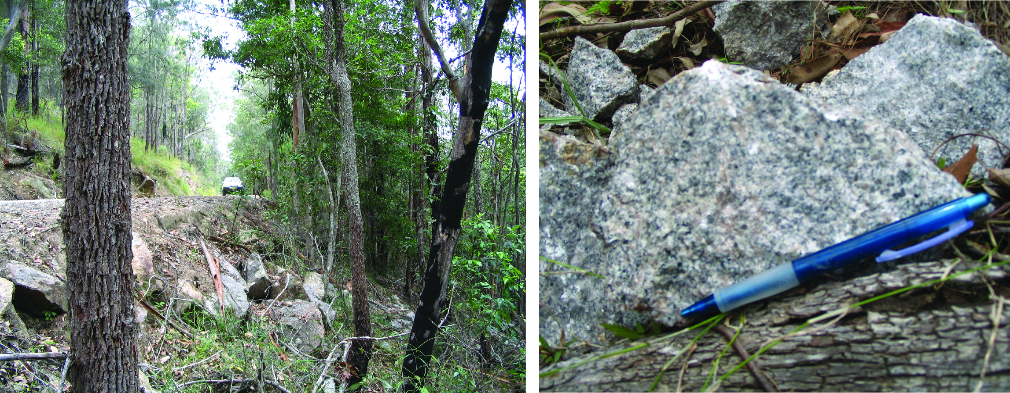
Figure 2.12 Roadside sample site and hand sample of Yarrahapinni Adamellite (PB-NE-08-29/1980503).
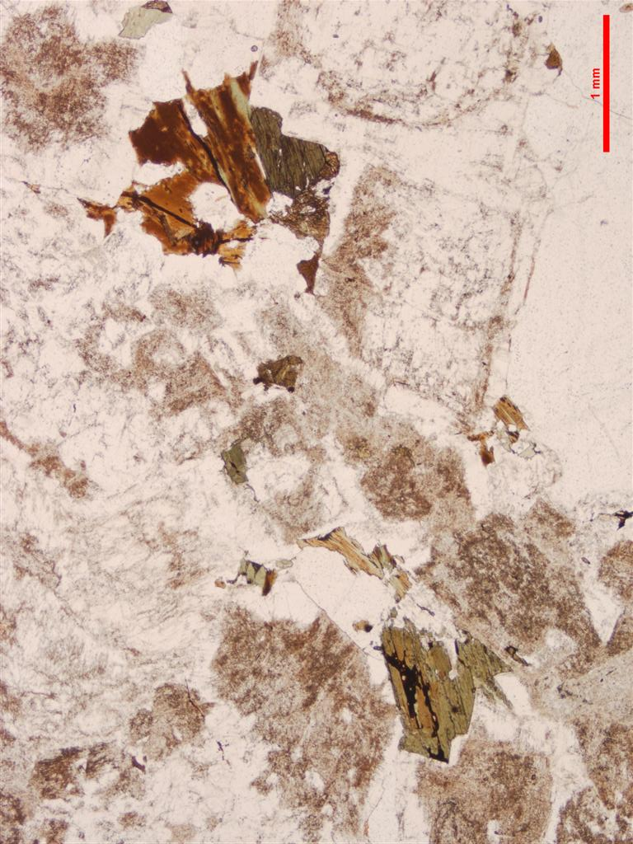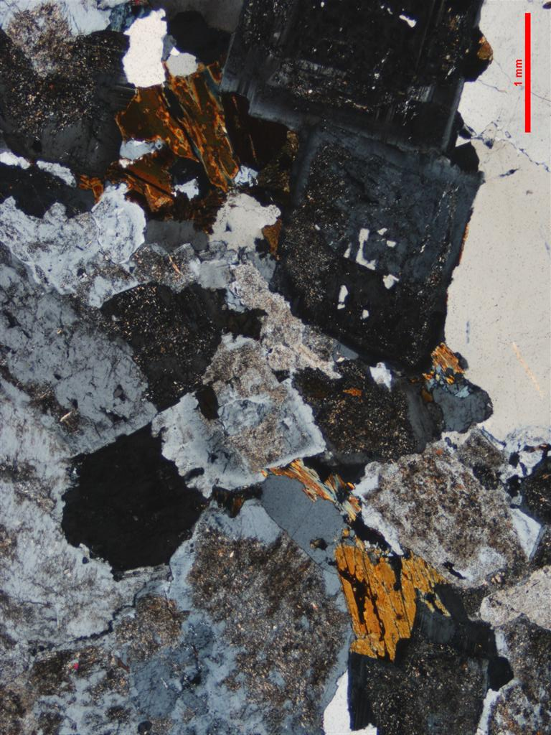
Figure 2.13 Thin section microphotographs of Yarrahapinni Adamellite. Scale as indicated (1 mm); PPL left, CPL right. Note zoned plagioclases (upper right of images) and late crystallising subhedral amphibole (lower right of images) in addition to biotite, despite overall felsic composition (PB-NE-08-29/1980503).

Zircons
Zircons recovered from PB-NE-08-29/1980503 are a homogeneous population of clear, colourless euhedral grains. Most are intact with aspect ratios of between 2 to 3 but the full range extends up to 6. In CL the grains have a moderate to strong luminescence with concentric, oscillatory growth zoning (Figure 2.14).

U–Pb isotopic results
Twenty-five SHRIMP U–Pb analyses were conducted on 25 zircons from this sample (Figure 2.15 and Table 2.8). Uranium concentrations are low to moderate ranging from ~63–906 ppm (median = 211 ppm) and Th/U ratios are uniform with an average value of 0.57. The majority of zircons have low to moderate common 206Pb concentrations (0 to 3% 206Pbc) however two analyses (615.Z.18.1.1 & 615.Z.17.1.1) have low U concentrations (~70 ppm) and also high common 206Pb contents of ~6 % (206Pbc). There is no correlation between the age of these grains and common 206Pb and it is for this reason that they have been retained. All 25 SHRIMP U–Pb analyses have the same radiogenic 206Pb/238U within their analytical uncertainties and contribute to a weighted mean age of 228.4 ± 1.7 Ma (MSWD = 1.24, probability = 0.20). This is interpreted as the magmatic crystallisation age of this rock.
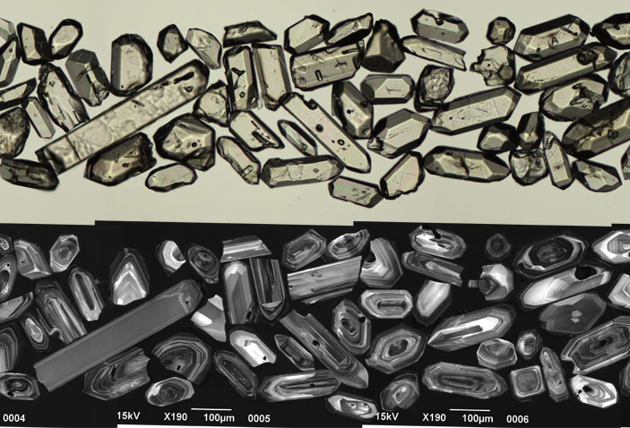
Figure 2.14 Selected transmitted light (top) and cathodoluminescence (bottom) images of zircon grains from the Yarrahapinni Adamellite (PB-NE-08-29/1980503).
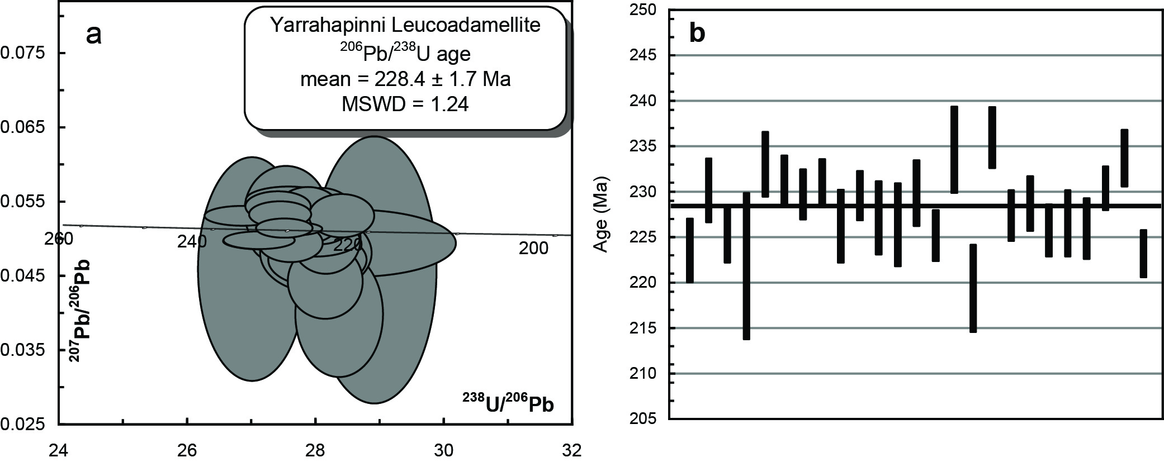
Figure 2.15 (a) Tera-Wasserberg concordia plot and (b) temporal trend of the 206Pb/238U ages from the Yarrahapinni Adamellite (PB-NE-08-29/1980503).
Table 2.8 SHRIMP U–Pb zircon data from Yarrahapinni Adamellite (PB-NE-08-29/1980503).
Grain.area | 206Pbc (%) | U (ppm) | Th (ppm) | 232Th/  238U | 238U/  206Pb | ± 1σ (%) | 207Pb/  206Pb | ± 1σ (%) | 206Pb/238U Age (Ma) | ± 1σ (Ma)
Magmatic zircons
615.Z.1.1.1 | 3.00 | 87 | 45 | 0.54 | 28.3379 | 1.6 | 0.0394 | 14.3 | 223.6 | 3.5
615.Z.2.1.1 | 1.44 | 81 | 48 | 0.61 | 27.5057 | 1.6 | 0.0534 | 7.7 | 230.2 | 3.5
615.Z.3.1.1 | 1.51 | 130 | 83 | 0.66 | 28.1211 | 1.4 | 0.0439 | 7.7 | 225.3 | 3.1
615.Z.4.1.1 | 1.02 | 126 | 77 | 0.63 | 28.5669 | 3.7 | 0.0491 | 6.1 | 221.8 | 8.1
615.Z.5.1.1 | 0.30 | 829 | 685 | 0.85 | 27.1620 | 1.6 | 0.0494 | 1.5 | 233.1 | 3.6
615.Z.6.1.1 | 0.23 | 206 | 83 | 0.42 | 27.3794 | 1.2 | 0.0541 | 2.5 | 231.2 | 2.8
615.Z.7.1.1 | 0.17 | 906 | 901 | 1.03 | 27.5611 | 1.2 | 0.0510 | 1.2 | 229.8 | 2.8
615.Z.8.1.1 | 0.11 | 211 | 113 | 0.55 | 27.4111 | 1.2 | 0.0530 | 2.2 | 231.0 | 2.7
615.Z.9.1.1 | 1.05 | 190 | 105 | 0.57 | 27.9983 | 1.8 | 0.0468 | 5.1 | 226.2 | 4.0
615.Z.10.1.1 | 0.69 | 244 | 107 | 0.46 | 27.5781 | 1.2 | 0.0491 | 3.5 | 229.6 | 2.7
615.Z.13.1.1 | 0.81 | 223 | 127 | 0.59 | 27.8836 | 1.8 | 0.0496 | 4.1 | 227.1 | 4.1
615.Z.14.1.1 | 1.36 | 108 | 42 | 0.40 | 27.9792 | 2.1 | 0.0477 | 7.4 | 226.4 | 4.6
615.Z.15.1.1 | -0.12 | 237 | 90 | 0.39 | 27.5455 | 1.6 | 0.0549 | 2.2 | 229.9 | 3.6
615.Z.16.1.1 | 1.88 | 214 | 71 | 0.34 | 28.1293 | 1.3 | 0.0497 | 6.3 | 225.2 | 2.8
615.Z.17.1.1 | 6.28 | 69 | 24 | 0.36 | 26.9726 | 2.1 | 0.0456 | 22.0 | 234.7 | 4.8
615.Z.18.1.1 | 6.28 | 63 | 22 | 0.36 | 28.8904 | 2.2 | 0.0455 | 26.4 | 219.4 | 4.8
615.Z.19.1.1 | 0.07 | 323 | 188 | 0.60 | 26.8173 | 1.5 | 0.0528 | 1.7 | 236.0 | 3.4
615.Z.20.1.1 | 1.06 | 204 | 99 | 0.50 | 27.8509 | 1.3 | 0.0529 | 4.8 | 227.4 | 2.8
615.Z.21.1.1 | 0.76 | 146 | 57 | 0.40 | 27.6849 | 1.3 | 0.0519 | 5.0 | 228.7 | 3.0
615.Z.22.1.1 | 0.48 | 160 | 47 | 0.30 | 28.0572 | 1.3 | 0.0528 | 4.8 | 225.8 | 2.9
615.Z.23.1.1 | 0.58 | 329 | 184 | 0.58 | 27.9563 | 1.7 | 0.0496 | 3.2 | 226.6 | 3.7
615.Z.24.1.1 | 0.24 | 609 | 417 | 0.71 | 28.0332 | 1.5 | 0.0520 | 1.6 | 225.9 | 3.4
615.Z.25.1.1 | 0.16 | 470 | 184 | 0.40 | 27.4795 | 1.1 | 0.0511 | 1.7 | 230.4 | 2.4
615.Z.26.1.1 | 0.29 | 790 | 689 | 0.90 | 27.0833 | 1.4 | 0.0495 | 1.6 | 233.7 | 3.1
615.Z.27.1.1 | 0.72 | 241 | 139 | 0.60 | 28.3839 | 1.2 | 0.0528 | 3.7 | 223.2 | 2.6
- %206Pbc indicates the proportion of common 206Pb in the total measured 206Pb.
- Pb isotopic ratios corrected for common Pb by reference to the measured 204Pb.
- All errors quoted as 1σ.

Valla Adamellite PB-NE-08-30/1980504
Table 2.9 Summary of results: Valla Adamellite (PB-NE-08-30/1980504).
GA SampleID | 200801616
GA SampleNO | 1980504
GSNSW SITEID | PB-NE-08-30
Formal Name | Valla Adamellite
Informal Name | -
Lithology | leucomonzogranite
1:250 000 Sheet | DORRIGO (SH5610)
1:100 000 Sheet | MACKSVILLE (9436)
Region | New England Region
Location (GDA94) | 152.945313 °E, -30.589925 °S
Location (MGA 94 Zone 56) | 494757 mE, 6615842 mN
Geochronologist | Andrew Cross
Mount ID | GA6089
Analytical Session | 90042
Interpreted Age | 230.7 ± 1.6 Ma (95% confidence, 24 analyses on 24 zircons)
Geological Attribution | Magmatic crystallisation
Isotopic Ratio Used | 206Pb/238U

Sample Information
The Valla Adamellite comprises a leucocratic biotite syenogranite and porphyritic microgranite dykes. It intrudes the Late Carboniferous to Early Permian Nambucca beds. This sample is a medium–grained equigranular leucomonzogranite. Some hydrothermal alteration (greisenisation) and minor molybdenite > pyrite and arsenopyrite is present. The sample was obtained from oversized dump material adjacent the weighbridge at Marriots Quarry. The grid reference is for the centre of the main working floor of the quarry as determined from GIS and SPOT images. The granite has not been previously dated but is assumed to be Lower Triassic on the grounds of its similarity with other leucocratic granites in eastern New England.
The aim of this SHRIMP U–Pb experiment is to determine the magmatic age for the Valla Adamellite, the age of its associated molybdenite mineralisation and its relationship to the Coastal I-type Supersuite (e.g. the “Gundle tin granites”, Round Mountain, Yarrahapinni Adamellite, Valla Adamellite).

Petrography
This sample comprises a very felsic (“minimum melt”) medium-fine grained aplitic textured leucomonzogranite to leucosyenogranite with minor ferromagnesians. The rock in hand sample is medium-fine grained and leucocratic with a bone white colour which, in some feldspar dominated patches, has a pale yellowish tinge possibly consistent with sericitic alteration. Aplitic to angular blocky textured quartz and feldspar is evident under the hand lens with sparse biotite spots. Elsewhere in outcrop there is more intense sericitic to greisen alteration (coarser muscovite-quartz), and molybdenite and other sulfides (e.g., arsenopyrite) occur in veins and along fractures.
In thin section quartz (~35 modal percent) shows some strain recrystallisation and internal suturing. Fluid inclusions trails are evident in places. Alkali feldspars (≤ 2.5 mm; 40 modal percent) can be very fresh with Carlsbad–type twins. Microcline twinning is associated with coarse vein and patch perthite development. Some swapped rim development is locally present along alkali feldspar grain boundaries. Plagioclase (≤ 1.5 mm; 25 modal percent) is sodic and tends to be very fresh. There is little evidence of any cores and the crystals are subhedral and polysynthetically twinned. Minor sericite (and a clay mineral) is also present flecking some plagioclases. Biotite (0.7 mm; ~2 modal percent; mid reddy brown → pale straw yellow) ranges from fresh to complete replacement by chlorite and titanite. There is no amphibole. Accessories include titanite (secondary), opaques, apatite and zircon (Figure 2.16).
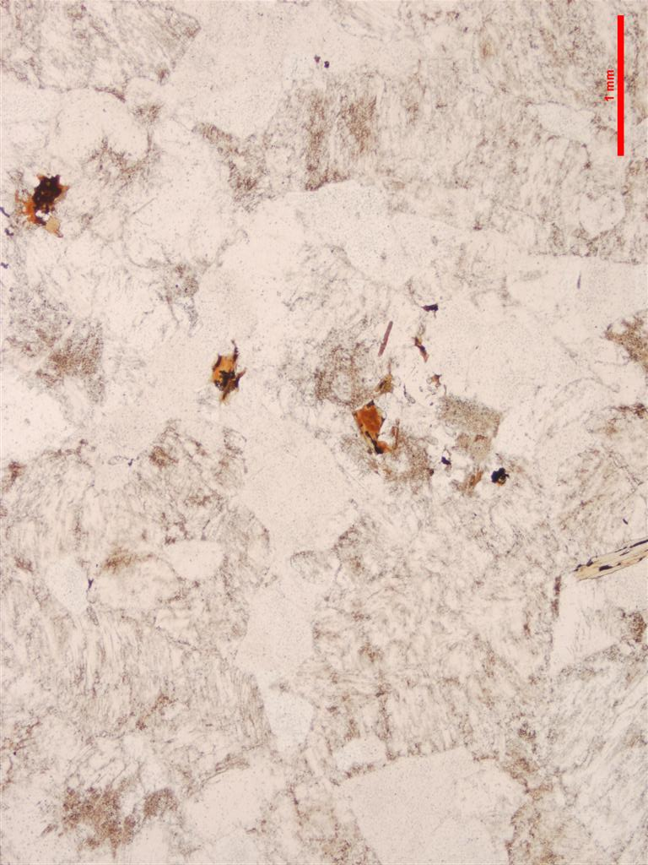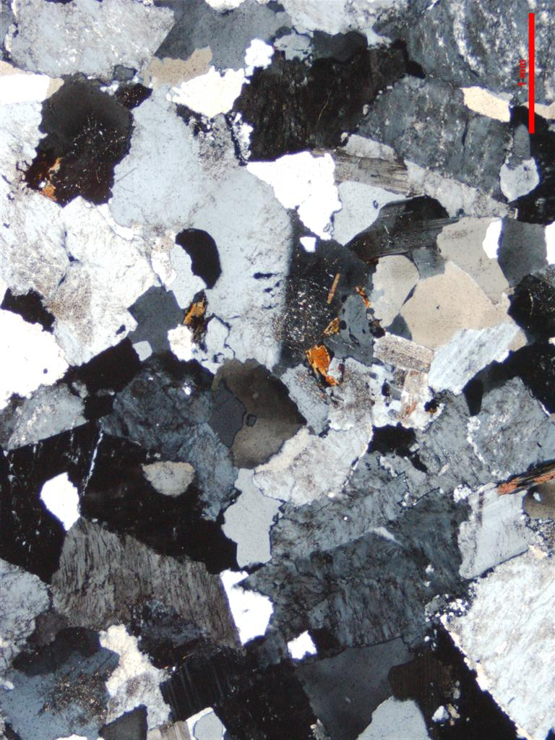
Figure 2.16 Thin section microphotographs of Valla Adamellite. Scale as indicated (1.0 mm); PPL left, CPL right. Medium grained, mildly seriate (leuco)syenogranite with sparse late biotite (PB-NE-08-30/1980504).

Zircons
Zircons recovered from sample PB-NE-08-30/1980504 are clear to moderately turbid and colourless. The majority of grains are euhedral with aspect ratios of between 3 to 4, however all of the zircons extend from grains with equant forms to others with aspect ratios of up to 6. They have a moderate to weak luminescence and are oscillatory zoned (Figure 2.17).

U–Pb isotopic results
Twenty-five SHRIMP U–Pb analyses were undertaken on 25 zircons from this sample (Figure 2.18, Table 2.10). Uranium concentrations are low to moderate ranging from 115–167 ppm (median = 320 ppm) and there is a wide range in Th/U ratio that extends from ~0.43 to 2. The majority of grains have low common 206Pb (< 1% 206Pbc) although one grain has a slightly higher proportion of 1.30% (616.Z.3.1.1). The 25 SHRIMP analyses range in 206Pb/238U slightly above that expected from their analytical uncertainties (MSWD = 1.7). The grain which has the lowest 206Pb/238U also has the highest common 206Pb (616.Z.3.1.1) indicating that this zircon may have lost a minor amount of radiogenic 206Pb and gained common 206Pb. The removal of this grain from the pooled age calculation removes the excess scatter (MSWD = 1.31, probability = 0.14) and gives a weighted mean age of 230.7 ± 1.6 Ma which is interpreted as the crystallisation age of the Valla Adamellite.
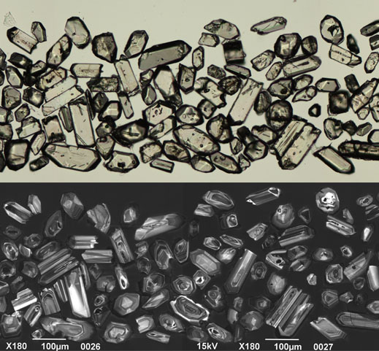
Figure 2.17 Selected transmitted light (top) and cathodoluminescence (bottom) images of zircon grains from the Valla Adamellite (PB-NE-08-30/1980504).
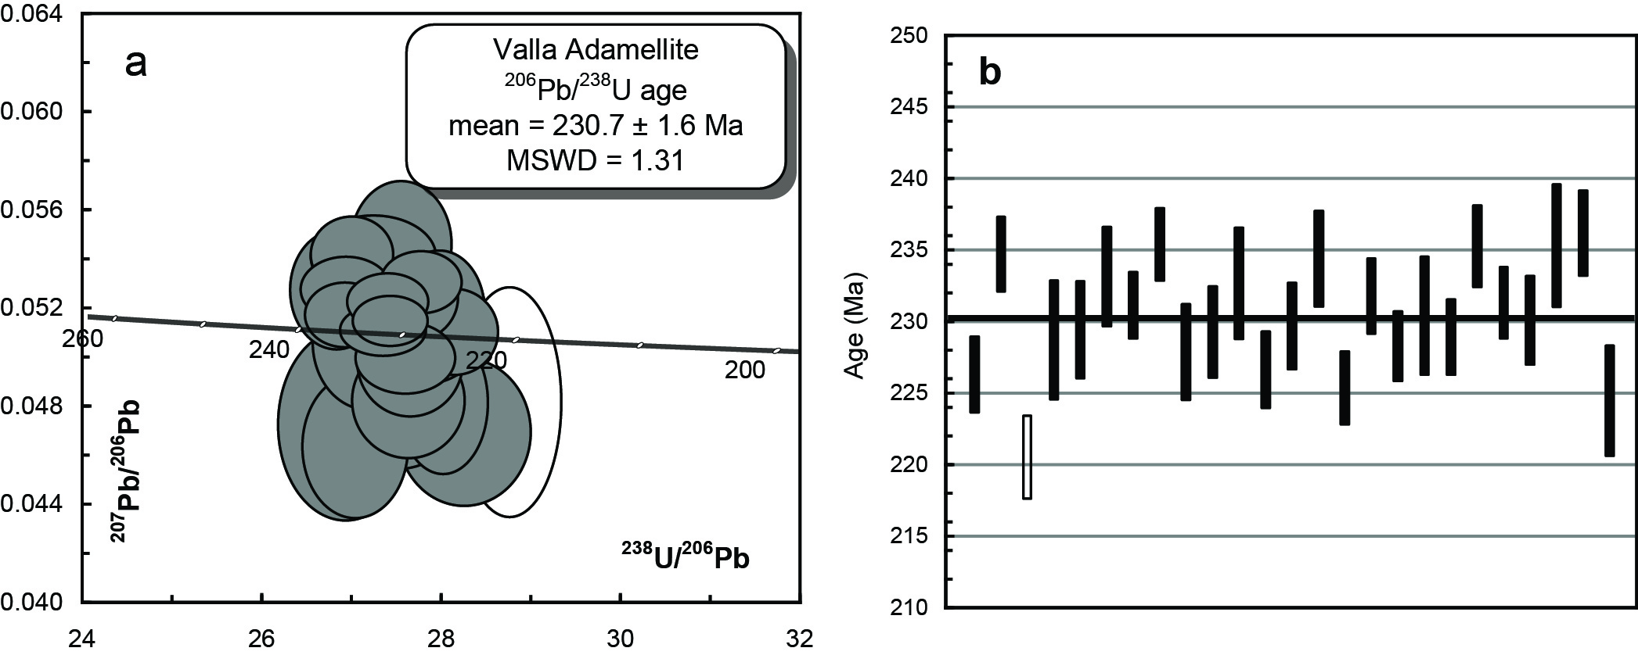
Figure 2.18 (a) Tera-Wasserberg concordia plot and (b) temporal trend of the 206Pb/238U ages from the Valla Adamellite (PB-NE-08-30/1980504). The unfilled ellipse in (a) and bar in (b) were not included in the pooled age calculation.
Table 2.10 SHRIMP U–Pb zircon data from Valla Adamellite (PB-NE-08-30/1980504).
Grain.area | 206Pbc (%) | U (ppm) | Th (ppm) | 232Th/  238U | 238U/  206Pb | ± 1σ (%) | 207Pb/  206Pb | ± 1σ (%) | 206Pb/238U Age (Ma) | ± 1σ (Ma)
Magmatic zircons
616.Z.1.1.1 | 0.85 | 272 | 277 | 1.05 | 27.9893 | 1.2 | 0.0480 | 4.0 | 226.3 | 2.7
616.Z.2.1.1 | 0.13 | 354 | 193 | 0.56 | 26.9614 | 1.1 | 0.0541 | 1.9 | 234.8 | 2.6
616.Z.4.1.1 | 0.47 | 255 | 294 | 1.19 | 27.6868 | 1.8 | 0.0518 | 3.2 | 228.7 | 4.2
616.Z.5.1.1 | 0.70 | 395 | 472 | 1.23 | 27.5975 | 1.5 | 0.0481 | 3.3 | 229.5 | 3.4
616.Z.6.1.1 | 0.37 | 304 | 338 | 1.15 | 27.1475 | 1.5 | 0.0504 | 3.6 | 233.2 | 3.5
616.Z.7.1.1 | 0.14 | 850 | 1647 | 2.00 | 27.3899 | 1.0 | 0.0514 | 1.3 | 231.2 | 2.3
616.Z.8.1.1 | 0.07 | 412 | 576 | 1.44 | 26.8824 | 1.1 | 0.0516 | 1.7 | 235.4 | 2.5
616.Z.9.1.1 | 0.42 | 352 | 328 | 0.96 | 27.7896 | 1.5 | 0.0508 | 2.7 | 227.9 | 3.4
616.Z.10.1.1 | 0.87 | 528 | 375 | 0.73 | 27.6171 | 1.4 | 0.0497 | 3.0 | 229.3 | 3.2
616.Z.11.1.1 | 0.14 | 320 | 151 | 0.49 | 27.2028 | 1.7 | 0.0540 | 2.1 | 232.7 | 3.9
616.Z.12.1.1 | 0.45 | 268 | 139 | 0.54 | 27.9444 | 1.2 | 0.0518 | 3.1 | 226.7 | 2.7
616.Z.13.1.1 | 0.38 | 644 | 761 | 1.22 | 27.5674 | 1.3 | 0.0498 | 2.0 | 229.7 | 3.0
616.Z.14.1.1 | 0.96 | 316 | 185 | 0.60 | 27.0013 | 1.5 | 0.0461 | 4.2 | 234.4 | 3.4
616.Z.15.1.1 | 0.27 | 356 | 283 | 0.82 | 28.1078 | 1.2 | 0.0509 | 2.3 | 225.4 | 2.6
616.Z.17.1.1 | 0.23 | 850 | 669 | 0.81 | 27.3111 | 1.2 | 0.0510 | 1.4 | 231.8 | 2.7
616.Z.18.1.1 | 0.04 | 428 | 205 | 0.49 | 27.7399 | 1.1 | 0.0529 | 1.6 | 228.3 | 2.4
616.Z.19.1.1 | 0.81 | 277 | 288 | 1.07 | 27.4782 | 1.8 | 0.0481 | 3.9 | 230.4 | 4.2
616.Z.20.1.1 | 0.15 | 270 | 254 | 0.97 | 27.6620 | 1.2 | 0.0523 | 2.2 | 228.9 | 2.6
616.Z.21.1.1 | 0.43 | 1115 | 858 | 0.79 | 26.8963 | 1.2 | 0.0526 | 1.7 | 235.3 | 2.9
616.Z.16.2.1 | 0.03 | 449 | 224 | 0.52 | 27.3661 | 1.1 | 0.0521 | 1.5 | 231.4 | 2.5
616.Z.22.1.1 | 0.25 | 168 | 130 | 0.80 | 27.5179 | 1.4 | 0.0545 | 3.1 | 230.1 | 3.1
616.Z.23.1.1 | 0.93 | 167 | 70 | 0.43 | 26.8935 | 1.9 | 0.0471 | 5.5 | 235.4 | 4.3
616.Z.25.1.1 | 0.33 | 190 | 135 | 0.74 | 26.7909 | 1.3 | 0.0526 | 3.1 | 236.2 | 3.0
616.Z.26.1.1 | 0.74 | 229 | 201 | 0.91 | 28.2228 | 1.7 | 0.0468 | 4.3 | 224.5 | 3.9
Pb loss
616.Z.3.1.1 | 1.30 | 192 | 154 | 0.83 | 28.7380 | 1.3 | 0.0480 | 6.5 | 220.5 | 2.9
- %206Pbc indicates the proportion of common 206Pb in the total measured 206Pb.
- Pb isotopic ratios corrected for common Pb by reference to the measured 204Pb.
- All errors quoted as 1σ.

Round Mountain Leucoadamellite PB-NE-08-31/1980505
Table 2.11 Summary of results: Round Mountain Leucoadamellite (PB-NE-08-31/1980505).
GA SampleID | 200801617
GA SampleNO | 1980505
GSNSW SITEID | PB-NE-08-31
Formal Name | Round Mountain Leucoadamellite
Informal Name | -
Lithology | coarse grained leucomonzogranite
1:250 000 Sheet | DORRIGO (SH5610)
1:100 000 Sheet | EBOR (9337)
Region | New England Region
Location (GDA94) | 152.288359 °E, -30.397187 °S
Location (MGA 94 Zone 56) | 431638 mE, 6636987 mN
Geochronologist | Andrew Cross
Mount ID | GA6089
Analytical Session | 90042
Interpreted Age | 238.0 ± 1.7 Ma (95% confidence, 24 analyses on 24 zircons)
Geological Attribution | Magmatic crystallisation
Isotopic Ratio Used | 206Pb/238U

Sample Information
The Round Mountain Leucoadamellite comprises biotite leucogranite, minor hornblende-biotite leucogranite and miarolitic albite leucogranite dykes. While it has not been dated, K–Ar dating of amphiboles from members of the associated supersuite (Carrai Granodiorite and Botumburra Range Adamellite) have yielded ~228–231 Ma ages (Leitch and McDougall 1979). The Round Mountain Leucoadamellite intrudes the Permian Abroi Granodiorite (Hillgrove Supersuite) and is overlain by Cenozoic basalts. The sample was collected from large fresh boulders from an extensive rock dump related to recent road works adjacent the Ebor-Guyra road (Figure 2.19). Equigranular, pegmatitic and porphyritic fine grained variants, aplites and microgranite dykes were also present.
This sample was submitted for SHRIMP U–Pb isotopic analysis to establish a magmatic crystallisation age for the Round Mountain Leucoadamellite and its relationship to the Coastal I-type Supersuite (e.g. the “Gundle tin granites”, Yarrahapinni Adamellite, Valla Adamellite). Alternatively, the Round Mountain pluton may also be associated with the “Oban River Granitoid Belt” which extends to the north–northwest and comprises the Oban River, Red Range, Kingsgate and Yellow Gap plutons.

Petrography
Sample comprises a mildly seriate, medium– to coarse–grained leucomonzogranite, representing a highly fractionated felsic I-type. In hand specimen the sample is equigranular to mildly seriate, medium to coarse grained with prominent pink alkali feldspars to 1.5 cm, dark quartz crystals to < 1 cm, greenish translucent plagioclase to 0.5 cm and < 5 modal percent biotite. The quartz grains often form necklaces and can also surround the slightly large alkali feldspar crystals. The dark quartz suggests elevated Th contents, and the pink feldspar suggests it is relatively oxidised. In thin section quartz (~35 modal percent) shows strain recrystallisation and internal sutured boundaries. Secondary fluid inclusion trails are locally conspicuous. Alkali feldspars (~40 modal percent) are characterised by prominent vein and patch perthite development. Grain boundary decorations such as swapped rims, incipient Manhattan texture, and rarer myrmekite are common. Zoning and Carlsbad twins (perhaps more complex forms as well) are also common. Other than localised turbidisation, the feldspars are relatively fresh. Plagioclase crystals (~25 modal percent) are strongly twinned and zoned out to albitic rims. Smaller tabular plagioclases occur as inclusions in the alkali feldspars. Biotite (~3 modal percent; dark chocolate brown → yellow brown) occurs as subhedral to somewhat ragged crystals and aggregates. Amphibole (1.5 mm; green → brown) comprises a single mass of euhedral cross section outline heavily replaced by chlorite (also after biotite), carbonate and titanite. Late to early subsolidus titanite infills late cracks in feldspars and in interstices with carbonate. Accessories include zircon, apatite, titanite and opaques (Figure 2.20).
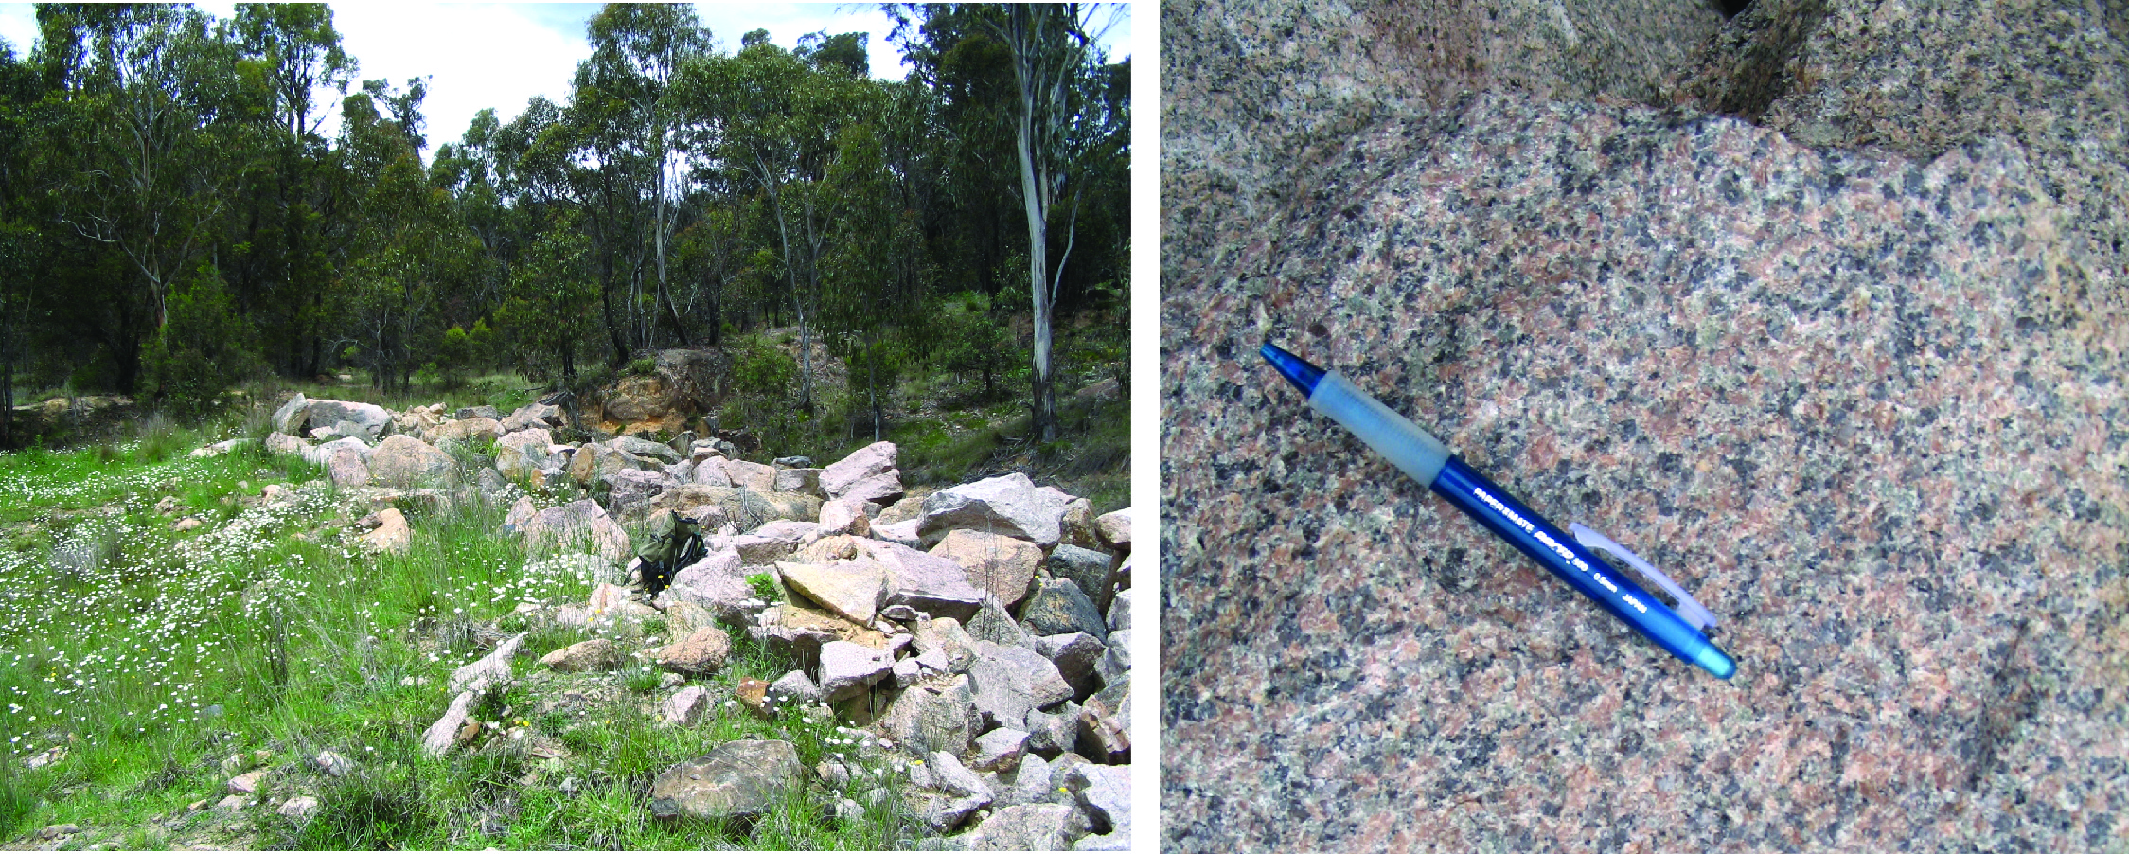
Figure 2.19 Road side ‘dump’ sample site and Round Mountain Leucoadamellite (PB-NE-08-31/1980505; Ebor-Guyra road) sample.
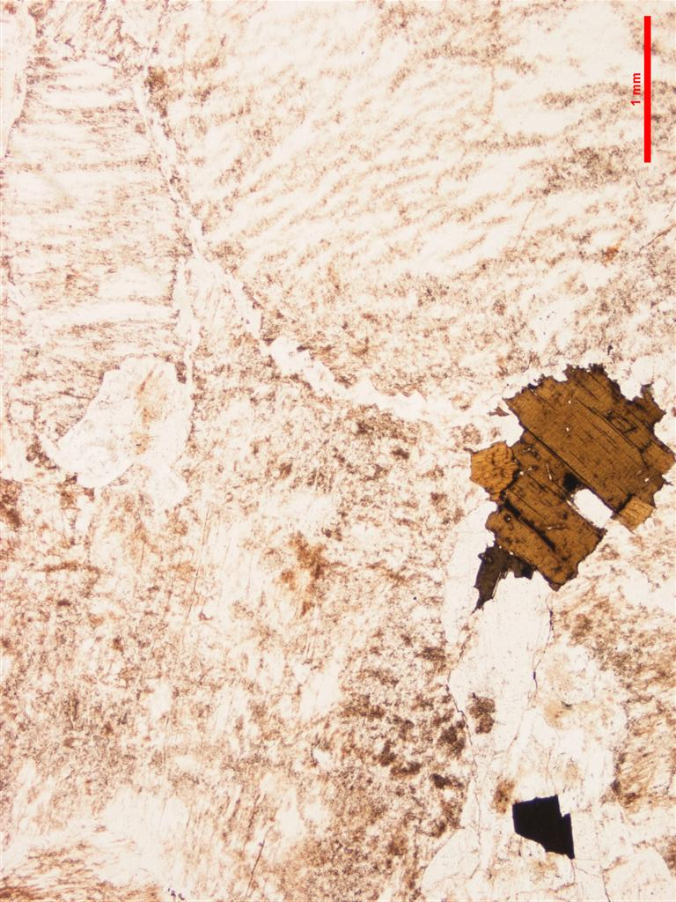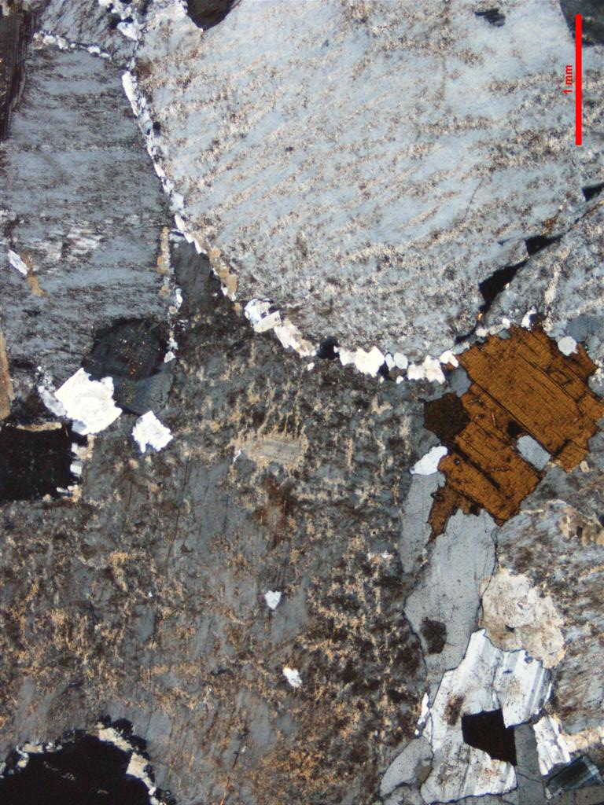
Figure 2.20 Thin section microphotographs of Round Mountain Leucoadamellite. Scale as indicated (1.0 mm); PPL left, CPL right. Note very coarse grained texture, strongly perthitic K-feldspars with grain boundary decorations (PB-NE-08-31/1980505).

Zircons
Zircons recovered from PB-NE-08-31/1980505 consist of a homogeneous population of euhedral, clear and colourless to light yellow grains. They are typically between 100–200 µm in diameter and have aspect ratios of between 1 to 2 and more rarely aspect ratios of 4. The majority of grains also have randomly orientated acicular inclusions. In CL the zircons are moderate to bright with prominent oscillatory growth zones (Figure 2.21).

U–Pb isotopic results
Twenty-five SHRIMP U–Pb analyses were conducted on zircons from this sample (Figure 2.22, Table 2.12). Uranium concentrations are low to moderate (~75–698 ppm, median = 232 ppm) and Th/U ratios moderate (~0.35 to 1). There is a wide range in the proportion of common 206Pb in the analysed zircons ranging from ~0.21 to 4.24% (206Pbc). All 25 zircons have the same radiogenic 206Pb/238U within their analytical uncertainties and contribute to a weighted mean age of 238.0 ± 1.7 Ma (MSWD = 1.07, probability = 0.37). This is interpreted as the magmatic crystallisation age of the Round Mountain Leucoadamellite.
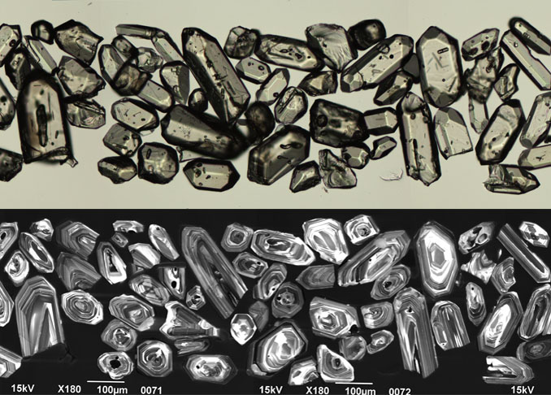
Figure 2.21 Selected transmitted light (top) and cathodoluminescence (bottom) images of zircon grains from the Round Mountain Leucoadamellite (PB-NE-08-31/1980505).
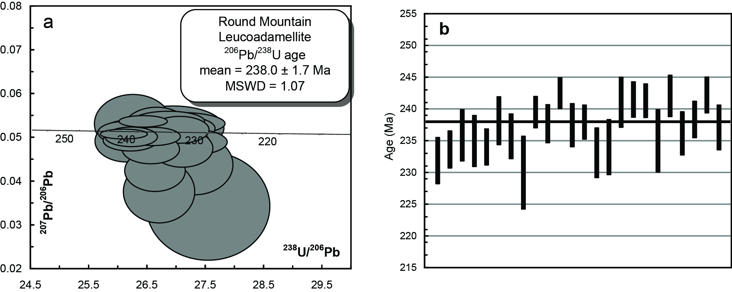
Figure 2.22 (a) Tera-Wasserberg concordia plot and (b) temporal trend of the 206Pb/238U ages from the Round Mountain Leucoadamellite (PB-NE-08-31/1980505).
Table 2.12 SHRIMP U–Pb zircon data from Round Mountain Leucoadamellite (PB-NE-08-31/1980505).
Grain.area | 206Pbc (%) | U (ppm) | Th (ppm) | 232Th/  238U | 238U/  206Pb | ± 1σ (%) | 207Pb/  206Pb | ± 1σ (%) | 206Pb/238U Age (Ma) | ± 1σ (Ma)
Magmatic zircons
617.Z.1.1.1 | 1.79 | 94 | 59 | 0.65 | 27.3034 | 1.6 | 0.0434 | 10.6 | 231.9 | 3.7
617.Z.2.1.1 | 1.35 | 198 | 86 | 0.45 | 27.0930 | 1.3 | 0.0471 | 6.1 | 233.7 | 2.9
617.Z.3.1.1 | 0.81 | 261 | 114 | 0.45 | 26.8345 | 1.8 | 0.0491 | 4.0 | 235.9 | 4.1
617.Z.4.1.1 | 0.69 | 235 | 181 | 0.79 | 26.9368 | 1.8 | 0.0518 | 3.9 | 235.0 | 4.1
617.Z.5.1.1 | 0.71 | 226 | 146 | 0.67 | 27.0471 | 1.2 | 0.0514 | 4.0 | 234.0 | 2.8
617.Z.6.1.1 | 0.48 | 332 | 223 | 0.69 | 26.5675 | 1.6 | 0.0501 | 3.7 | 238.2 | 3.8
617.Z.7.1.1 | 0.35 | 228 | 181 | 0.82 | 26.8527 | 1.5 | 0.0534 | 2.9 | 235.7 | 3.5
617.Z.8.1.1 | 4.24 | 75 | 32 | 0.44 | 27.5358 | 2.6 | 0.0339 | 24.3 | 230.0 | 5.8
617.Z.9.1.1 | 0.21 | 583 | 299 | 0.53 | 26.4143 | 1.0 | 0.0534 | 1.6 | 239.5 | 2.5
617.Z.10.1.1 | 1.84 | 200 | 160 | 0.82 | 26.6194 | 1.3 | 0.0420 | 7.5 | 237.7 | 3.0
617.Z.11.1.1 | 0.23 | 698 | 326 | 0.48 | 26.0807 | 1.0 | 0.0505 | 1.5 | 242.6 | 2.4
617.Z.12.1.1 | 0.90 | 122 | 82 | 0.69 | 26.6466 | 1.5 | 0.0513 | 6.9 | 237.5 | 3.4
617.Z.13.1.1 | 0.37 | 319 | 330 | 1.07 | 26.5933 | 1.2 | 0.0499 | 2.8 | 238.0 | 2.7
617.Z.14.1.1 | 0.86 | 241 | 202 | 0.87 | 27.1570 | 1.7 | 0.0486 | 4.3 | 233.1 | 3.9
617.Z.15.1.1 | 0.35 | 200 | 94 | 0.48 | 27.0499 | 1.9 | 0.0529 | 3.2 | 234.0 | 4.4
617.Z.16.1.1 | 1.49 | 85 | 36 | 0.43 | 26.2391 | 1.7 | 0.0528 | 8.4 | 241.1 | 4.0
617.Z.17.1.1 | 0.61 | 291 | 315 | 1.12 | 26.1910 | 1.2 | 0.0490 | 3.2 | 241.5 | 2.8
617.Z.18.1.1 | 0.59 | 360 | 233 | 0.67 | 26.2115 | 1.1 | 0.0498 | 3.0 | 241.4 | 2.7
617.Z.20.1.1 | 1.29 | 134 | 45 | 0.35 | 26.9370 | 2.1 | 0.0518 | 6.5 | 235.0 | 5.0
617.Z.21.1.1 | 1.36 | 159 | 85 | 0.55 | 26.1301 | 1.4 | 0.0488 | 6.5 | 242.1 | 3.3
617.Z.22.1.1 | 0.55 | 291 | 127 | 0.45 | 26.7953 | 1.5 | 0.0508 | 3.2 | 236.2 | 3.4
617.Z.23.1.1 | 1.00 | 241 | 147 | 0.63 | 26.5466 | 1.2 | 0.0470 | 4.8 | 238.4 | 2.9
617.Z.24.1.1 | 0.57 | 255 | 159 | 0.65 | 26.1117 | 1.2 | 0.0508 | 3.3 | 242.3 | 2.9
617.Z.25.1.1 | 2.58 | 118 | 83 | 0.73 | 26.6902 | 1.5 | 0.0372 | 12.8 | 237.1 | 3.6
- %206Pbc indicates the proportion of common 206Pb in the total measured 206Pb.
- Pb isotopic ratios corrected for common Pb by reference to the measured 204Pb.
- All errors quoted as 1σ.

Oban River Leucoadamellite PB-NE-08-32/1980506
Table 2.13 Summary of results: Oban River Leucoadamellite (PB-NE-08-32/1980506).
GA SampleID | 200801618
GA SampleNO | 1980506
GSNSW SITEID | PB-NE-08-32
FORMAL NAME | Oban River Leucoadamellite
Informal Name | -
Lithology | leucoadamellite
1:250 000 Sheet | GRAFTON (SH5606)
1:100 000 Sheet | GLEN INNES (9238)
Region | New England Region
Location (GDA94) | 151.987790 °E, -29.917038 °S
Location (MGA 94 Zone 56) | 402291 mE, 6689977 mN
Geochronologist | Andrew Cross
Mount ID | GA6118
Analytical Session | 100031
Interpreted Age | 252.1 ± 1.4 Ma (95% confidence, 20 analyses on 20 zircons)
Geological Attribution | Magmatic crystallisation
Isotopic Ratio Used | 206Pb/238U

Sample Information
Collected from bouldery material left from older road construction works on the southern side of Pinkett Road immediately east of the road crest (Figure 2.23). Coarse to very coarse grained homogeneous porphyritic pink K-feldspar “leucoadamellite” with ~< 5% mafics. Magnetic susceptibility of 3.2 x10-3 (320 x10-5) SI units is relatively high for a very felsic rock.

Petrography
In thin section quartz > K-feldspar ≥ plagioclase. Quartz comprises large sutured, but relatively unstrained quartz grains to 1 cm. K-feldspar (to ~1 cm) comprise subhedral to euhedral large tabular crystals usually with prominent simple twins. Microcline twinning has nucleated along thick (0.1 mm) vein perthites which are well developed. Swapped rims are well developed against plagioclase and other K-feldspars. Plagioclases are polysynthetically twinned, and strongly zoned to albitic rims. Tabular, more calcic, relic cores are present. Ferromagnesians (< 5 % of the sample) comprise individual subhedral to scrappy aggregates (≤2 mm) of chocolate brown biotites. These are typically fresh with only minor chloritisation. No remnant amphibole is evident in thin section. Accessory phases include opaques, zircon and very minor apatite (Figure 2.24).
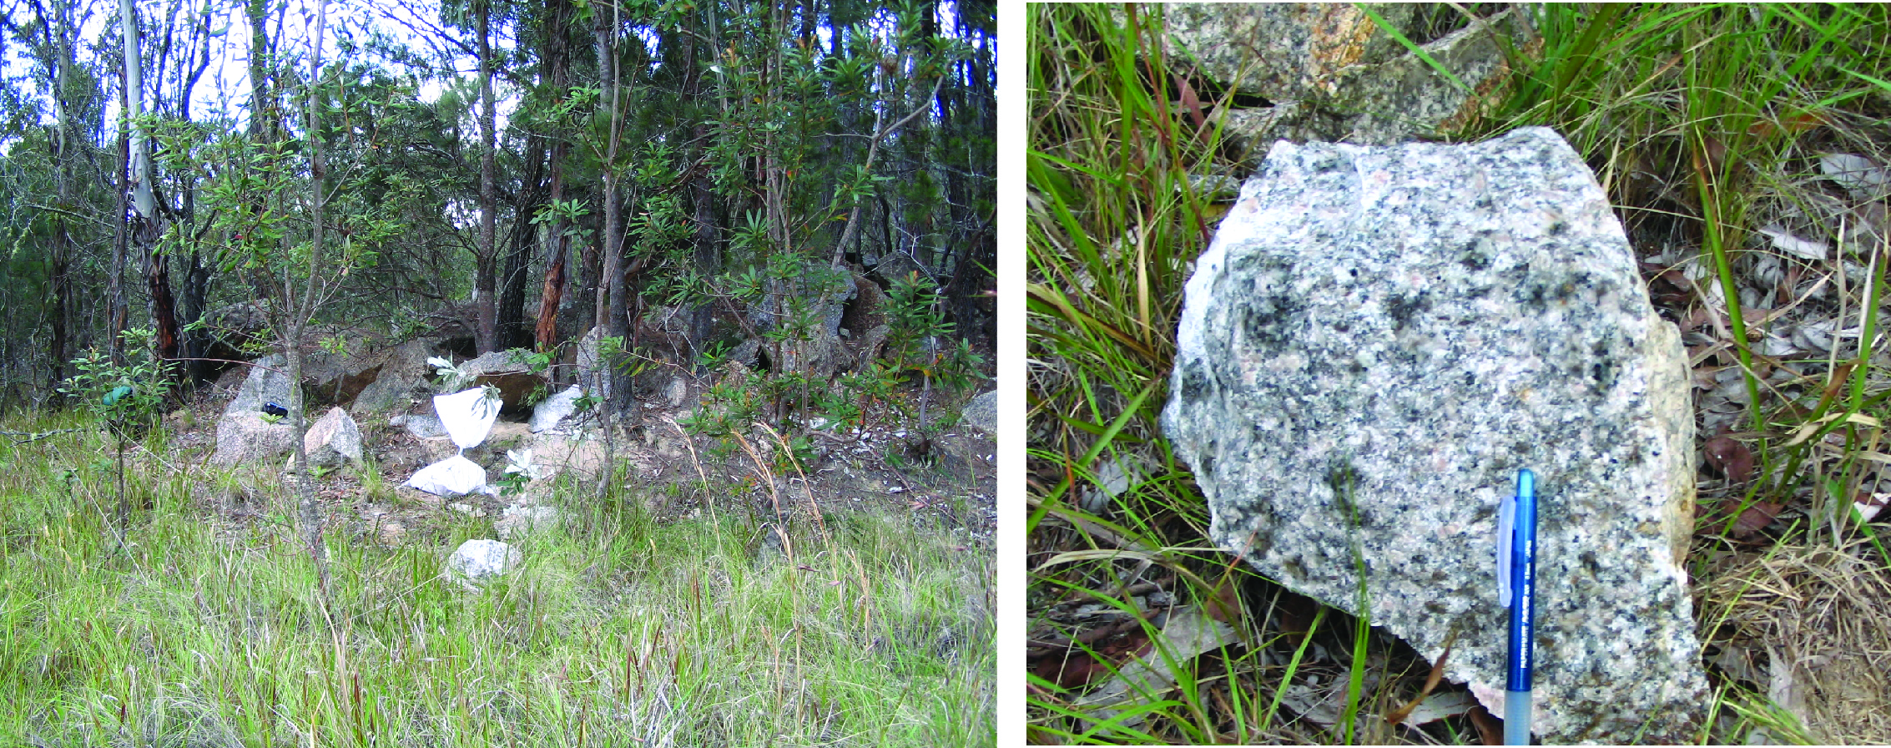
Figure 2.23 Sample site photograph and hand sample of Oban River Leucoadamellite (PB-NE-08-32/1980506).
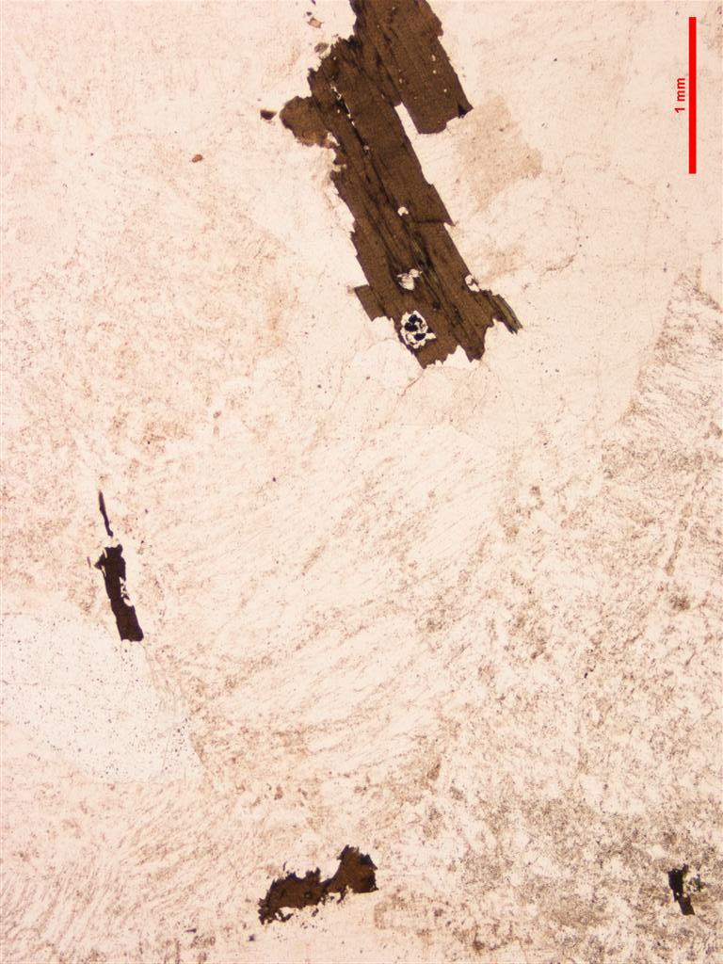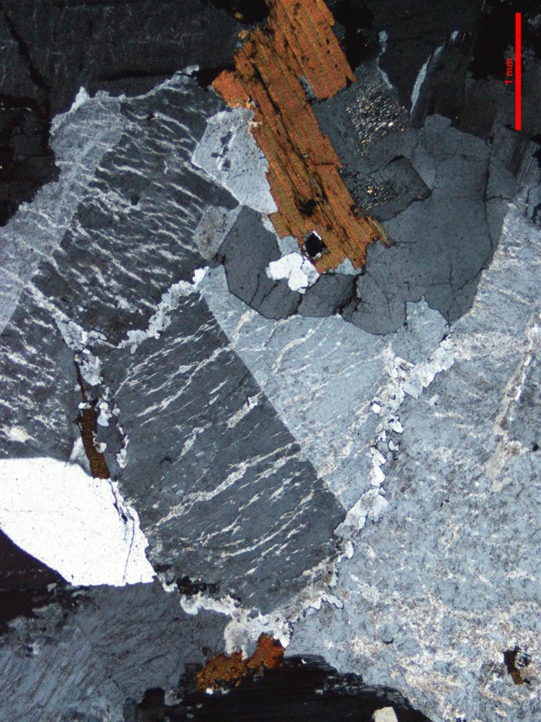
Figure 2.24 Thin section microphotographs of Oban River Leucoadamellite. Scale as indicated (1 mm); PPL left, CPL right. Note strongly perthitic K-feldspar with well developed swapped rims, and fresh biotite (PB-NE-08-32/1980506).

Zircons
Zircons recovered from PB-NE-08-32/1980506 are euhedral, clear prisms that are colourless to light yellow. Many have concentric growth zones that are visible in transmitted light images. The zircons are dominated by grains with aspect ratios of between 2 to 3 and are mostly ~60–100 μm in diameter. They have a weak to moderate CL response and oscillatory growth zoning predominates (Figure 2.25).

U–Pb isotopic results
Twenty-two SHRIMP U–Pb isotopic analyses were carried out on 22 zircons from this sample (Figure 2.26, Table 2.14). Uranium concentrations are low to moderate (86–1015 ppm, median = 670 ppm) and Th/U uniform with an average ratio of ~0.6. Common 206Pb contents are low to moderate ranging up to ~2% (206Pbc). The oldest analysis (~355 Ma, 618.Z.2.1.1) is of a concentrically zoned core and is interpreted as inherited. The remaining 21 zircons are scattered in 206Pb/238U slightly above that expected from their analytical uncertainties (MSWD = 1.56, probability = 0.05). This scatter can be removed by omitting the youngest zircon (618.Z.4.1.1) which also has a moderate to high common 206Pb content (1.70% 206Pbc), indicating a possible exchange of radiogenic 206Pb with common 206Pb. The remaining 20 analyses have the same radiogenic 206Pb/238U within their analytical uncertainties (MSWD = 1.20, probability = 0.26) and combine to give an age of 252.1 ± 1.4 Ma, which is interpreted to be the magmatic crystallisation age of this rock.
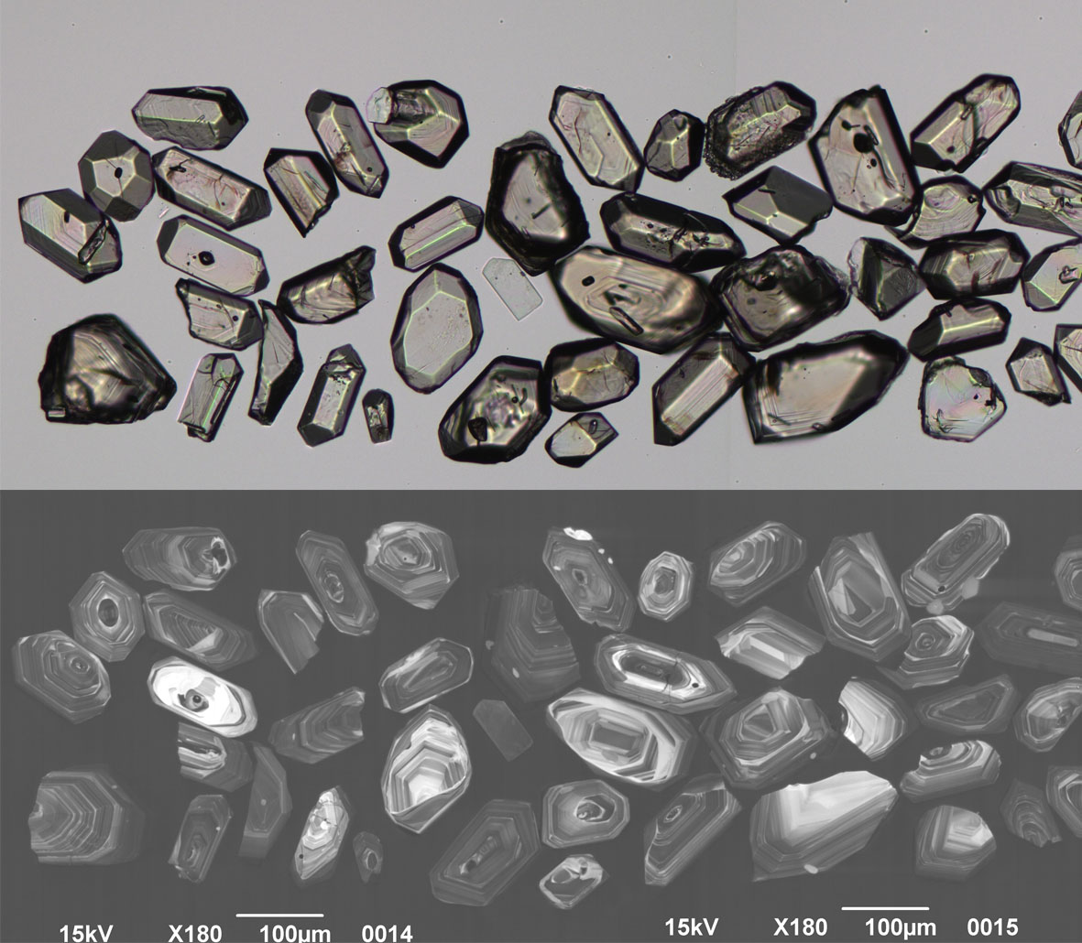
Figure 2.25 Selected transmitted light (top) and cathodoluminescence (bottom) images of zircon grains from the Oban River Leucoadamellite (PB-NE-08-32/1980506).
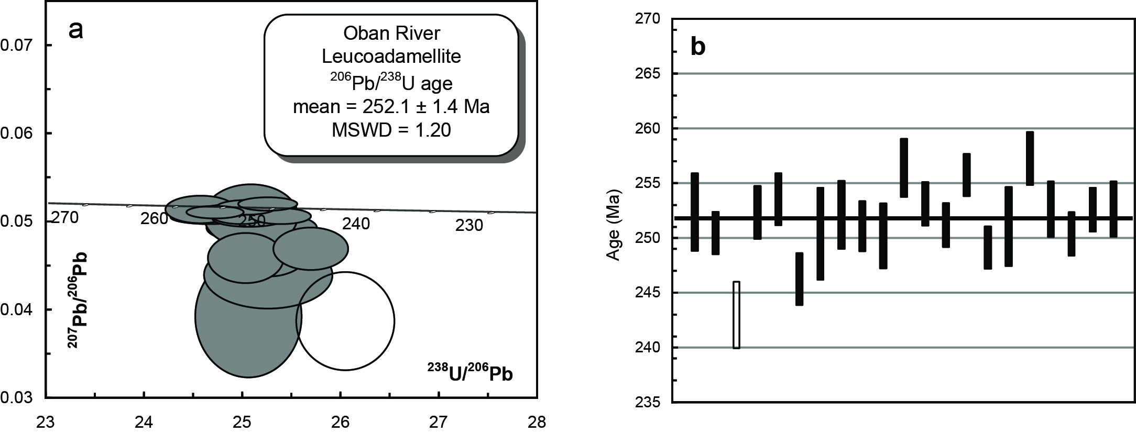
Figure 2.26 (a) Tera-Wasserberg concordia plot and (b) temporal trend of the 206Pb/238U ages from the Oban River Leucoadamellite (PB-NE-08-32/1980506). The unfilled ellipse in (a) and bar in (b) was removed from the pooled age calculation (506.Z.4.1.1). Analysis 506.Z.2.1.1 is an inherited core and is not plotted.
Table 2.14 SHRIMP U–Pb zircon data from Oban River Leucoadamellite (PB-NE-08-32/1980506).
Grain.area | 206Pbc (%) | U (ppm) | Th (ppm) | 232Th/  238U | 238U/  206Pb | ± 1σ (%) | 207Pb/  206Pb | ± 1σ (%) | 206Pb/238U Age (Ma) | ± 1σ (Ma)
Magmatic zircons
506.Z.1.1.1 | 1.94 | 94 | 39 | 0.43 | 25.0462 | 1.4 | 0.0389 | 11.9 | 252.4 | 3.6
506.Z.3.1.1 | 0.05 | 919 | 565 | 0.63 | 25.2425 | 0.8 | 0.0518 | 1.0 | 250.5 | 1.9
506.Z.5.1.1 | 0.20 | 777 | 496 | 0.66 | 25.0485 | 1.0 | 0.0501 | 1.3 | 252.4 | 2.4
506.Z.6.1.1 | 0.03 | 676 | 419 | 0.64 | 24.9271 | 1.0 | 0.0510 | 1.0 | 253.6 | 2.4
506.Z.7.1.1 | 0.72 | 257 | 92 | 0.37 | 25.6830 | 1.0 | 0.0466 | 3.4 | 246.2 | 2.4
506.Z.8.1.1 | 1.08 | 136 | 62 | 0.47 | 25.2474 | 1.7 | 0.0436 | 5.8 | 250.4 | 4.2
506.Z.9.1.1 | 0.46 | 86 | 53 | 0.64 | 25.0728 | 1.3 | 0.0504 | 4.8 | 252.1 | 3.1
506.Z.10.1.1 | 0.09 | 731 | 460 | 0.65 | 25.1768 | 0.9 | 0.0514 | 1.1 | 251.1 | 2.3
506.Z.11.1.1 | 0.96 | 105 | 40 | 0.39 | 25.2679 | 1.2 | 0.0477 | 5.9 | 250.2 | 3.0
506.Z.12.1.1 | 0.10 | 882 | 451 | 0.53 | 24.6422 | 1.1 | 0.0503 | 1.0 | 256.4 | 2.7
506.Z.13.1.1 | 0.21 | 665 | 384 | 0.60 | 24.9680 | 0.8 | 0.0505 | 1.4 | 253.2 | 2.0
506.Z.14.1.1 | 0.07 | 597 | 306 | 0.53 | 25.1659 | 0.8 | 0.0511 | 1.2 | 251.2 | 2.0
506.Z.15.1.1 | 0.06 | 963 | 635 | 0.68 | 24.7052 | 0.8 | 0.0508 | 0.9 | 255.8 | 2.0
506.Z.16.1.1 | 0.13 | 801 | 441 | 0.57 | 25.3784 | 0.8 | 0.0504 | 1.2 | 249.1 | 1.9
506.Z.17.1.1 | 0.41 | 382 | 125 | 0.34 | 25.1807 | 1.5 | 0.0490 | 2.4 | 251.1 | 3.6
506.Z.18.1.1 | 0.10 | 240 | 115 | 0.49 | 24.5571 | 1.0 | 0.0511 | 2.1 | 257.3 | 2.4
506.Z.19.1.1 | 0.06 | 1015 | 614 | 0.62 | 25.0175 | 1.0 | 0.0511 | 0.9 | 252.7 | 2.5
506.Z.20.1.1 | 0.20 | 715 | 456 | 0.66 | 25.2517 | 0.8 | 0.0507 | 1.4 | 250.4 | 2.0
506.Z.21.1.1 | -0.02 | 709 | 403 | 0.59 | 25.0234 | 0.8 | 0.0514 | 1.1 | 252.6 | 2.0
506.Z.22.1.1 | 0.72 | 219 | 114 | 0.54 | 25.0167 | 1.0 | 0.0456 | 4.1 | 252.7 | 2.5
Inherited zircons
506.Z.2.1.1 | 0.83 | 215 | 182 | 0.88 | 17.7518 | 1.0 | 0.0484 | 3.5 | 353.3 | 3.5
Pb loss
506.Z.4.1.1 | 1.67 | 110 | 41 | 0.39 | 26.0376 | 1.3 | 0.0383 | 9.7 | 242.9 | 3.0
- %206Pbc indicates the proportion of common 206Pb in the total measured 206Pb.
- Pb isotopic ratios corrected for common Pb by reference to the measured 204Pb.
- All errors quoted as 1σ.

Red Range Leucoadamellite PB-NE-08-34/1980508
Table 2.15 Summary of results: Red Range Leucoadamellite (PB-NE-08-34/1980508).
GA SampleID | 200801620
GA SampleNO | 1980508
GSNSW SITEID | PB-NE-08-34
Formal Name | Red Range Leucoadamellite
Informal Name | -
Lithology | Leucoadamellite
1:250 000 Sheet | GRAFTON (SH5606)
1:100 000 Sheet | GLEN INNES (9238)
Region | New England Region
Location (GDA94) | 151.891131 °E, -29.816031 °S
Location (MGA 94 Zone 56) | 392852 mE, 6701084 mN
Geochronologist | Andrew Cross
Mount ID | GA6118
Analytical Session | 100031
Interpreted Age | 253.2 ± 1.5 Ma (95% confidence, 21 analyses on 21 zircons)
Geological Attribution | Magmatic crystallisation
Isotopic Ratio Used | 206Pb/238U

Sample Information
This sample was collected from medium–sized boulders left from road construction on the eastern side of Pinkett Road, 100 m south of the Pinkett Road intersection with Hottes Road (to Red Range). The boulders are generally fresh with very thin weathering rinds. In outcrop the rock comprises homogeneous medium fine grained, bone white coloured, equigranular microgranite with < 5% mafics. Magnetic susceptibility is 0.1 x 10-3 SI (Figure 2.27).

Petrography
In thin section the sample comprises a microgranite characterised by saccharoidal texture of seriate textured rounded to blocky quartz up to 1 mm; cloudy, modestly perthitic K-feldspar showing some microcline twinning; and tabular to blocky sodic plagioclases to 1 mm, with rare rounded calcic cores. Quartz and K-feldspar may be up to 3 mm to 4 mm in length. Biotite is generally fresh, occurring as individual crystals or less commonly groups ranging from larger subhedral to finer interstitial (0.1 to 0.5 mm), though occasionally to 1 mm. Occasional radiation haloes are developed. Zircon is present with very minor apatite and opaques (Figure 2.28).
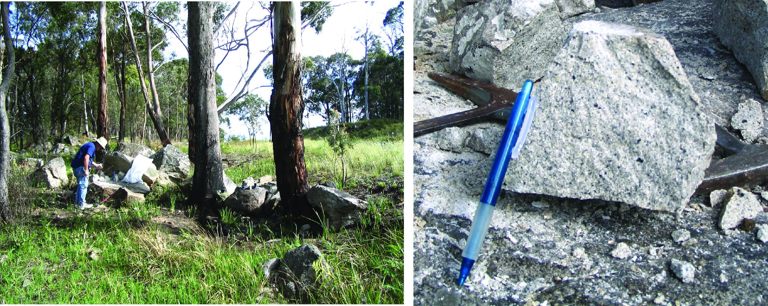
Figure 2.27 Roadside sample photograph and hand sample of sample PB-NE-08-34/1980508, Red Range Leucoadamellite.
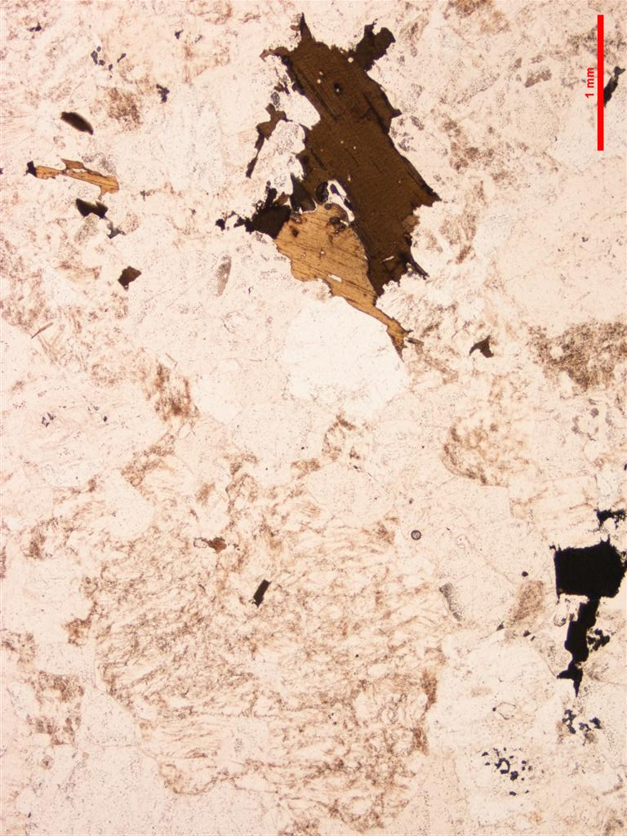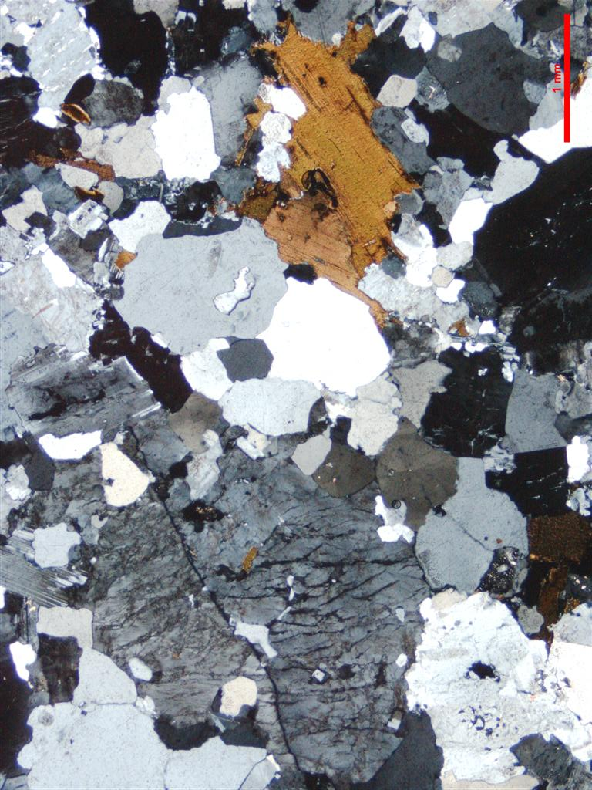
Figure 2.28 Thin section microphotographs of Red Range Leucoadamellite. Scale as indicated (1 mm); PPL left, CPL right. Medium fine grained, seriate to saccharoidal textured leucosyenogranite with fresh biotite (PB-NE-08-34/1980508).

Zircons
Zircons recovered from PB-NE-08-34/1980508 consist of euhedral prisms that are clear and colourless to pale yellow and usually contain fine acicular inclusions. They typically range from ~60–100 μm in diameter with aspect ratios typically between 1 to 2 but the full range extends to ~5. They have a moderate luminescence with fine oscillatory growth zones (Figure 2.29).

U–Pb isotopic results
Twenty-one SHRIMP U–Pb isotopic analyses were carried out on 21 zircons from this sample (Figure 2.30, Table 2.16). The results are generally uniform with U concentrations ranging from 85–816 ppm (median = 310 ppm) and average Th/U = ~0.6. Common 206Pb contents are mostly low, however, two grains (620.Z. 3.1.1, 620.Z.18.1.1) contain ~4.5% 206Pbc. All 21 zircons have the same radiogenic 206Pb/238U within their analytical uncertainties (MSWD = 0.77, probability = 0.75) and combine to give a weighted mean age of 253.2 ± 1.5 Ma which is interpreted to be the crystallisation age of this rock.
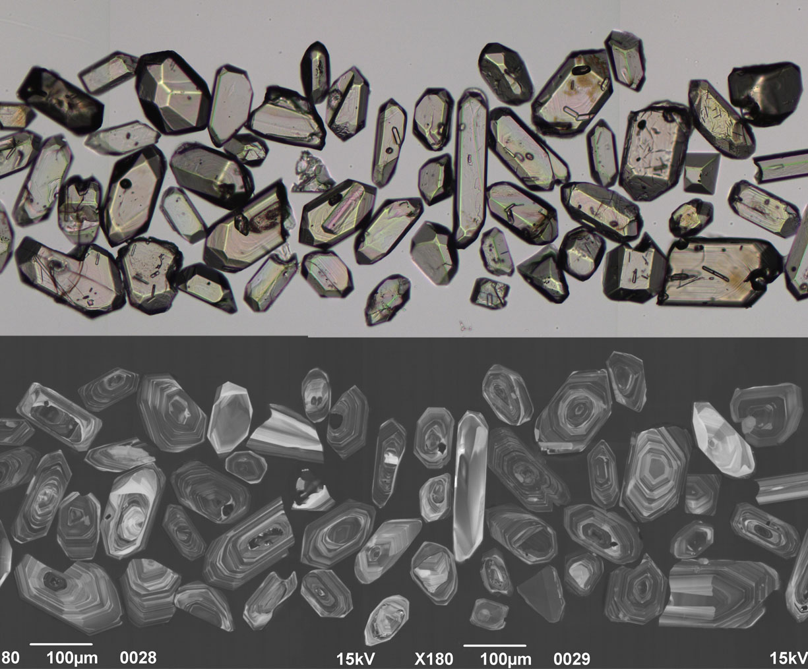
Figure 2.29 Selected transmitted light (top) and cathodoluminescence (bottom) images of zircon grains from the Red Range Leucoadamellite (PB-NE-08-34/1980508).
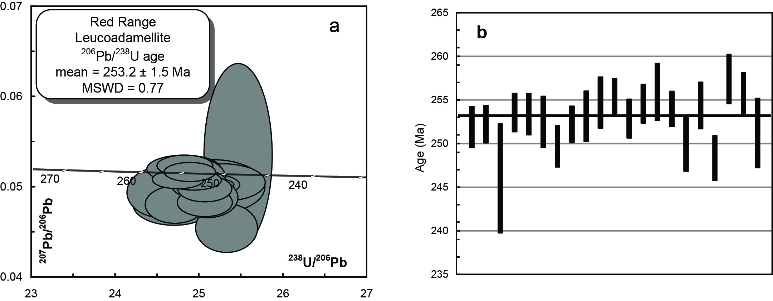
Figure 2.30 (a) Tera-Wasserberg concordia plot and (b) temporal trend of the 206Pb/238U ages from the Red Range Leucoadamellite (PB-NE-08-34/1980508).
Table 2.16 SHRIMP U–Pb zircon data from Red Range Leucoadamellite (PB-NE-08-34/1980508).
Grain.area | 206Pbc (%) | U (ppm) | Th (ppm) | 232Th/  238U | 238U/  206Pb | ± 1σ (%) | 207Pb/  206Pb | ± 1σ (%) | 206Pb/238U Age (Ma) | ± 1σ (Ma)
Magmatic zircons
508.Z.1.1.1 | 0.51 | 303 | 130 | 0.44 | 25.0900 | 1.0 | 0.0486 | 3.0 | 251.9 | 2.4
508.Z.2.1.1 | 0.38 | 495 | 441 | 0.92 | 25.0579 | 0.9 | 0.0480 | 2.2 | 252.3 | 2.2
508.Z.3.1.1 | 4.46 | 85 | 48 | 0.58 | 25.7063 | 2.6 | 0.0212 | 36.9 | 246.0 | 6.3
508.Z.4.1.1 | 0.03 | 394 | 159 | 0.42 | 24.9226 | 0.9 | 0.0505 | 1.5 | 253.6 | 2.2
508.Z.5.1.1 | 0.47 | 263 | 156 | 0.61 | 24.9401 | 1.0 | 0.0508 | 2.8 | 253.4 | 2.4
508.Z.6.1.1 | 0.27 | 538 | 254 | 0.49 | 25.0300 | 1.2 | 0.0500 | 1.7 | 252.5 | 2.9
508.Z.7.1.1 | 0.82 | 224 | 164 | 0.76 | 25.3196 | 1.0 | 0.0452 | 4.0 | 249.7 | 2.4
508.Z.8.1.1 | 0.36 | 424 | 192 | 0.47 | 25.0603 | 0.8 | 0.0496 | 2.0 | 252.2 | 2.1
508.Z.9.1.1 | 0.09 | 569 | 324 | 0.59 | 24.9661 | 1.2 | 0.0500 | 1.3 | 253.2 | 2.9
508.Z.10.1.1 | 0.18 | 273 | 151 | 0.57 | 24.8087 | 1.2 | 0.0518 | 2.0 | 254.7 | 2.9
508.Z.11.1.1 | 0.12 | 500 | 348 | 0.72 | 24.7389 | 0.8 | 0.0506 | 1.4 | 255.4 | 2.1
508.Z.12.1.1 | 0.27 | 310 | 135 | 0.45 | 24.9923 | 0.9 | 0.0501 | 2.2 | 252.9 | 2.2
508.Z.13.1.1 | -0.03 | 314 | 143 | 0.47 | 24.8207 | 0.9 | 0.0522 | 1.5 | 254.6 | 2.2
508.Z.14.1.1 | 0.51 | 239 | 178 | 0.77 | 24.6874 | 1.3 | 0.0478 | 3.2 | 256.0 | 3.3
508.Z.15.1.1 | 0.18 | 621 | 271 | 0.45 | 24.8807 | 0.8 | 0.0515 | 1.4 | 254.0 | 2.0
508.Z.16.1.1 | 0.30 | 235 | 186 | 0.82 | 25.2838 | 1.3 | 0.0503 | 2.7 | 250.0 | 3.2
508.Z.17.1.1 | 0.06 | 816 | 429 | 0.54 | 24.8414 | 1.1 | 0.0508 | 1.1 | 254.4 | 2.7
508.Z.18.1.1 | 4.52 | 563 | 88 | 0.16 | 25.4585 | 1.1 | 0.0533 | 12.7 | 248.4 | 2.6
508.Z.19.1.1 | 0.40 | 142 | 80 | 0.58 | 24.5411 | 1.1 | 0.0492 | 3.8 | 257.5 | 2.8
508.Z.20.1.1 | 0.45 | 274 | 106 | 0.40 | 24.7008 | 0.9 | 0.0478 | 2.9 | 255.8 | 2.4
508.Z.21.1.1 | 0.49 | 145 | 52 | 0.37 | 25.1617 | 1.6 | 0.0498 | 4.0 | 251.2 | 4.0
- %206Pbc indicates the proportion of common 206Pb in the total measured 206Pb.
- Pb isotopic ratios corrected for common Pb by reference to the measured 204Pb.
- All errors quoted as 1σ.

Mount Duval Monzogranite MD-1/2002565
Table 2.17 Summary of results: Mount Duval Monzogranite (MD-1/2002565).
GA SampleID | 200901601
GA SampleNO | 2002565
GSNSW SITEID | MD-1
Formal Name | Mount Duval Monzogranite
Informal Name | -
Lithology | medium grained monzogranite
1:250 000 Sheet | DORRIGO (SH5610)
1:100 000 Sheet | GUYRA (9237)
Region | New England Region
Location (GDA94) | 151.629452 °E, -30.418660 °S
Location (MGA 94 Zone 56) | 368366 mE, 6634025 mN
Geochronologist | Andrew Cross
Mount ID | GA6118
Analytical Session | 100031
Interpreted Age | 253.7 ± 1.4 Ma (95% confidence, 21 analyses on 21 zircons)
Geological Attribution | Magmatic crystallisation
Isotopic Ratio Used | 206Pb/238U

Sample Information
Collected by Nancy Vickery and Paul Ashley from low bouldery outcrop at GA Seismic Station, Newholme property.

Petrography (c/- Paul Ashley)
The sample is medium to coarse grained and sparsely porphyritic. It contains a few large (up to 1 cm) simply twinned anhedral K-feldspar phenocrysts in a mass of medium– to coarse–grained plagioclase, interstitial anhedral quartz and K-feldspar, with less abundant biotite and minor pale green (-brown) hornblende. There are rare small inclusions of colourless pyroxene (?orthopyroxene) in plagioclase, and in K-feldspar, there are a few inclusions of biotite and hornblende. Quartz hosts rare inclusions of apatite, biotite (and rarely, hornblende) and a few small zircon grains.
Only weak alteration has occurred. Apart from the possible pseudomorphs of amphibole and biotite after possible former pyroxene, other manifestations of (lower temperature) alteration include local chloritisation of biotite, sericitisation of plagioclase and slight clouding of K-feldspar by turbid clay (Figure 2.31).
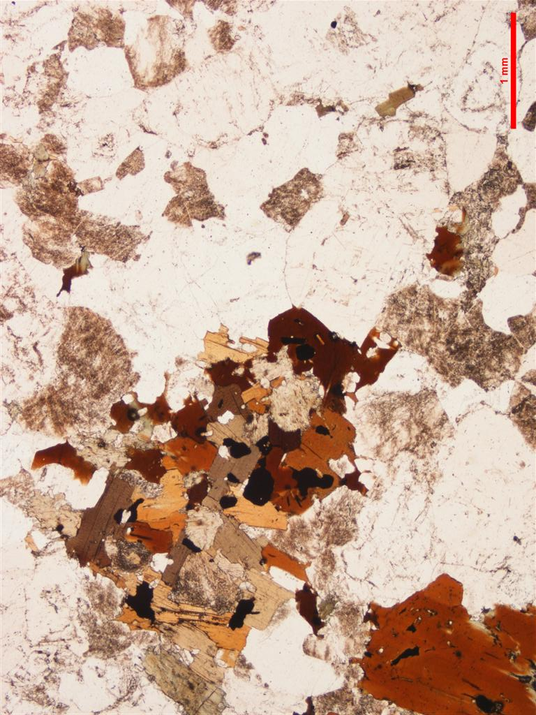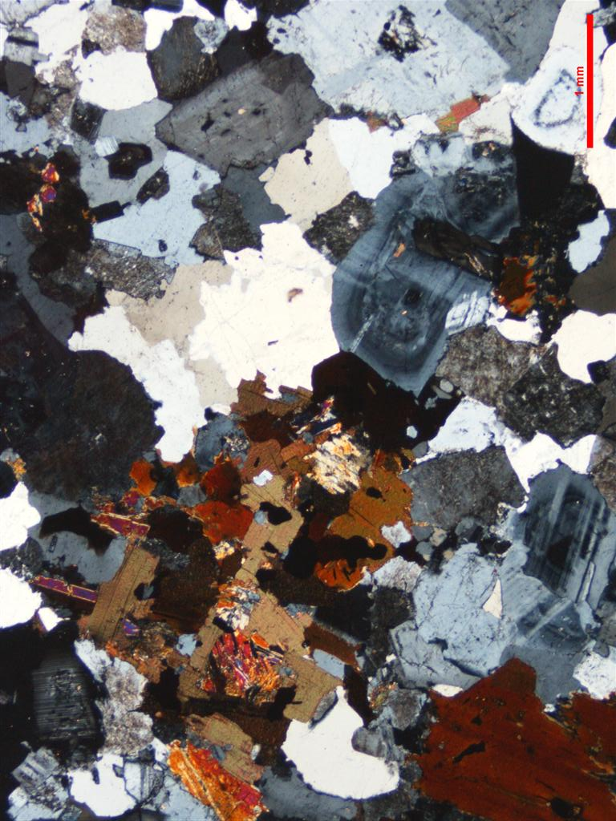
Figure 2.31 Thin section microphotographs of Mount Duval Monzogranite. Scale as indicated (1 mm); PPL left, CPL right. Aggregates of amphibole, biotite and opaques, often with relict primary pyroxene (not present in this view) are typical of Uralla Supersuite granitoids (MD-1/2002565).

Zircons
Zircons recovered from MD-1/2002565 are a uniform population of clear to weakly turbid, yellowish, euhedral grains, many with randomly orientated acicular inclusions. They range between ~70–110 μm in diameter and have aspect ratios of about 2. The zircons have a moderate luminescence and are oscillatory zoned (Figure 2.32).

U–Pb isotopic results
Twenty-one SHRIMP U–Pb isotopic analyses were carried out on 21 zircons from this sample (Figure 2.33, Table 2.18). Th/U ratios are uniform with an average value of ~0.50, U concentrations range from ~219–1000 ppm (median = 466 ppm) and common 206Pb is below 1% (206Pbc). All 21 analyses have the same radiogenic 206Pb/238U within their analytical uncertainties (MSWD = 1.06, probability = 0.39) and combine to give a pooled age of 253.7 ± 1.4 Ma, which is interpreted as the crystallisation age of this rock.
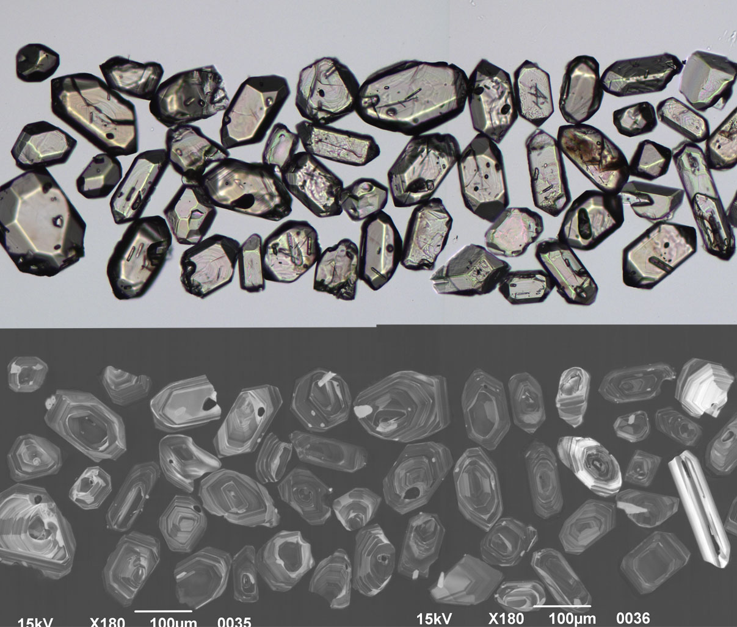
Figure 2.32 Selected transmitted light (top) and cathodoluminescence (bottom) images of zircon grains from the Mount Duval Monzogranite (MD-1/2002565).
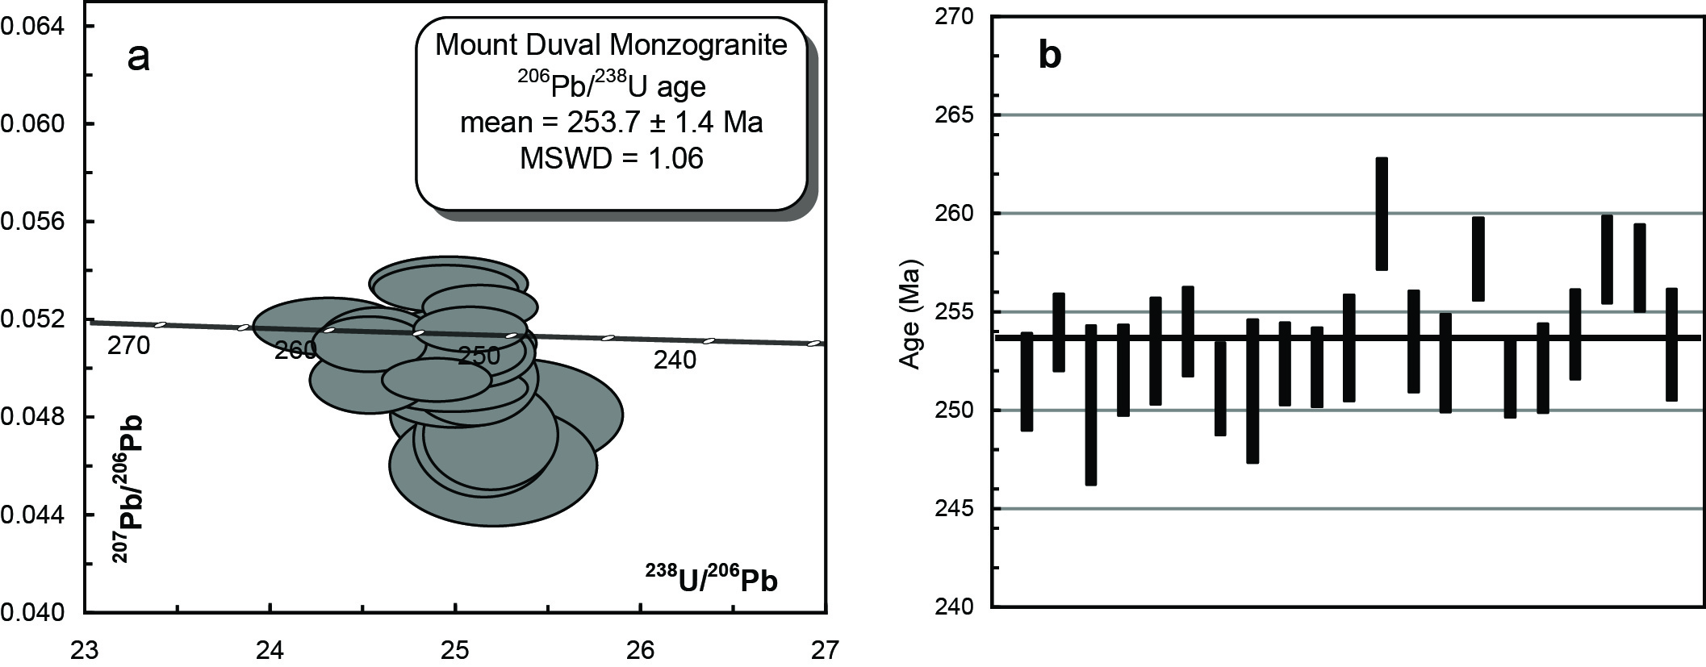
Figure 2.33 (a) Tera-Wasserberg concordia plot and (b) temporal trend of the 206Pb/238U ages from the Mount Duval Monzogranite (MD-1/2002565).
Table 2.18 SHRIMP U–Pb zircon data from Mount Duval Monzogranite (MD-1/2002565).
Grain.area | 206Pbc (%) | U (ppm) | Th (ppm) | 232Th/  238U | 238U/  206Pb | ± 1σ (%) | 207Pb/  206Pb | ± 1σ (%) | 206Pb/238U Age (Ma) | ± 1σ (Ma)
Magmatic zircons
565.Z.1.1.1 | 0.44 | 253 | 96 | 0.39 | 25.1394 | 1.0 | 0.0499 | 2.0 | 251.5 | 2.5
565.Z.2.1.1 | 0.19 | 1000 | 452 | 0.47 | 24.8852 | 0.8 | 0.0504 | 1.1 | 254.0 | 2.0
565.Z.3.1.1 | 0.64 | 303 | 129 | 0.44 | 25.2625 | 1.7 | 0.0516 | 2.2 | 250.3 | 4.1
565.Z.4.1.1 | 0.44 | 313 | 119 | 0.39 | 25.0803 | 0.9 | 0.0523 | 1.9 | 252.0 | 2.3
565.Z.5.1.1 | 0.34 | 487 | 213 | 0.45 | 24.9827 | 1.1 | 0.0521 | 1.4 | 253.0 | 2.7
565.Z.6.1.1 | 0.05 | 873 | 757 | 0.90 | 24.8818 | 0.9 | 0.0489 | 9.3 | 254.0 | 2.3
565.Z.7.1.1 | 0.55 | 219 | 90 | 0.42 | 25.1765 | 1.0 | 0.0511 | 2.3 | 251.1 | 2.4
565.Z.8.1.1 | 0.75 | 232 | 103 | 0.46 | 25.1888 | 1.5 | 0.0492 | 2.1 | 251.0 | 3.6
565.Z.9.1.1 | 0.19 | 512 | 275 | 0.55 | 25.0461 | 0.8 | 0.0525 | 1.3 | 252.4 | 2.1
565.Z.10.1.1 | 0.07 | 580 | 228 | 0.40 | 25.0651 | 0.8 | 0.0513 | 1.2 | 252.2 | 2.0
565.Z.11.1.1 | 0.28 | 834 | 478 | 0.59 | 24.9665 | 1.1 | 0.0510 | 1.6 | 253.2 | 2.7
565.Z.12.1.1 | -0.11 | 366 | 152 | 0.43 | 24.2953 | 1.1 | 0.0522 | 1.9 | 260.0 | 2.8
565.Z.13.1.1 | -0.09 | 544 | 282 | 0.54 | 24.9316 | 1.0 | 0.0518 | 1.4 | 253.5 | 2.6
565.Z.14.1.1 | 0.15 | 491 | 220 | 0.46 | 25.0452 | 1.0 | 0.0503 | 1.5 | 252.4 | 2.5
565.Z.15.1.1 | 0.16 | 534 | 244 | 0.47 | 24.5159 | 0.8 | 0.0534 | 1.3 | 257.7 | 2.1
565.Z.16.1.1 | -0.05 | 601 | 329 | 0.57 | 25.1180 | 0.8 | 0.0506 | 1.4 | 251.7 | 2.0
565.Z.17.1.1 | 0.11 | 324 | 119 | 0.38 | 25.0695 | 0.9 | 0.0501 | 1.7 | 252.1 | 2.3
565.Z.18.1.1 | 0.32 | 320 | 143 | 0.46 | 24.8966 | 0.9 | 0.0485 | 2.0 | 253.9 | 2.3
565.Z.19.1.1 | 0.18 | 418 | 154 | 0.38 | 24.5204 | 0.9 | 0.0511 | 1.5 | 257.7 | 2.2
565.Z.20.1.1 | 0.27 | 398 | 158 | 0.41 | 24.5616 | 0.9 | 0.0528 | 1.5 | 257.3 | 2.2
565.Z.21.1.1 | -0.08 | 466 | 232 | 0.51 | 24.9486 | 1.1 | 0.0511 | 1.8 | 253.3 | 2.8
- %206Pbc indicates the proportion of common 206Pb in the total measured 206Pb.
- Pb isotopic ratios corrected for common Pb by reference to the measured 204Pb.
- All errors quoted as 1σ.

Newholme Monzogranite N-1/2002566
Table 2.19 Summary of results: Newholme Monzogranite (N-1/2002566).
GA SampleID | 200901602
GA SampleNO | 2002566
GSNSW SITEID | N-1
Formal Name | -
Informal Name | Newholme monzogranite
Lithology | medium to coarse grained monzonite
1:250 000 Sheet | DORRIGO (SH5610)
1:100 000 Sheet | GUYRA (9237)
Region | New England region
Location (GDA94) | 151.618053 °E, -30.431858 °S
Location (MGA 94 Zone 56) | 367289 mE, 6632549 mN
Geochronologist | Andrew Cross
Mount ID | GA6118
Analytical Session | 100031
Interpreted Age | 252.8 ± 1.5 Ma (95% confidence, 21 analyses on 21 zircons)
Geological Attribution | Magmatic crystallisation
Isotopic Ratio Used | 206Pb/238U

Sample Information
This sample was collected from an area of low bouldery outcrop from a paddock on the north side of the farm access track extending from “Weirs Road” (off Boorolong Road, north of Armidale), about 2 km east of Dumaresq Dam.

Petrography
This sample is medium– to coarse–grained and sparsely porphyritic. It contains a few simply twinned anhedral K-feldspar phenocrysts (orthoclase; in places poikilitic with a few inclusions of plagioclase, quartz, biotite) up to 6 mm across. The phenocrysts are enclosed in an inequigranular aggregate of plagioclase, quartz, K-feldspar and biotite, with grains generally < 2.5 mm across. Plagioclase tends to be subhedral, with grains showing weak normal zoning and a composition of An20-40. Quartz and K-feldspar form interstitial anhedral grains. Biotite occurs as scattered flakes up to 2 mm across along with forming aggregates up to several millimetres across. Quartz hosts rare inclusions of apatite, with biotite commonly hosting inclusions of ilmenite (up to 0.5 mm across) and zircon (up to 0.15 mm long). The rock also contains traces of fine grained sulphides, mostly associated with biotite. Since the original sulphides (pyrrhotite, chalcopyrite, arsenopyrite) are hosted in fresh, magmatically crystallised silicates (e.g., biotite), it is possible that they represent products deposited under late magmatic to magmatic hydrothermal conditions. Only weak alteration has occurred. Apart from the possible pseudomorphs of amphibole ± biotite ± quartz after possible former pyroxene, other manifestations of (lower temperature) alteration include local chloritisation of biotite, sericitisation of plagioclase and slight clouding of K-feldspar by turbid clay (Figure 2.34).
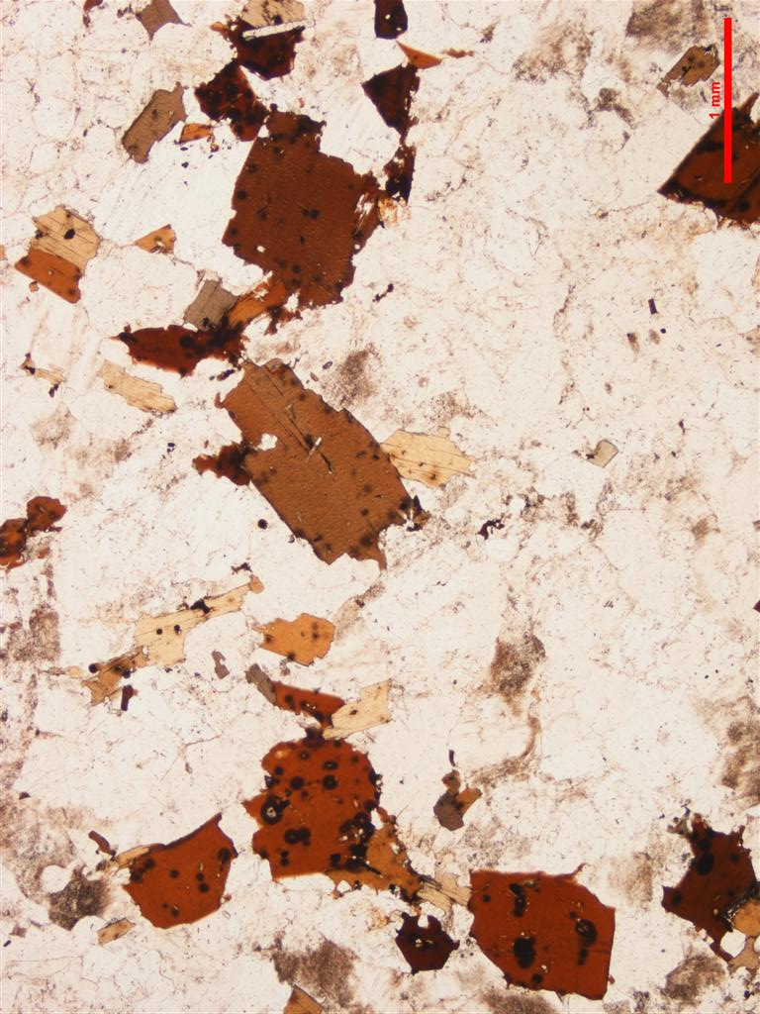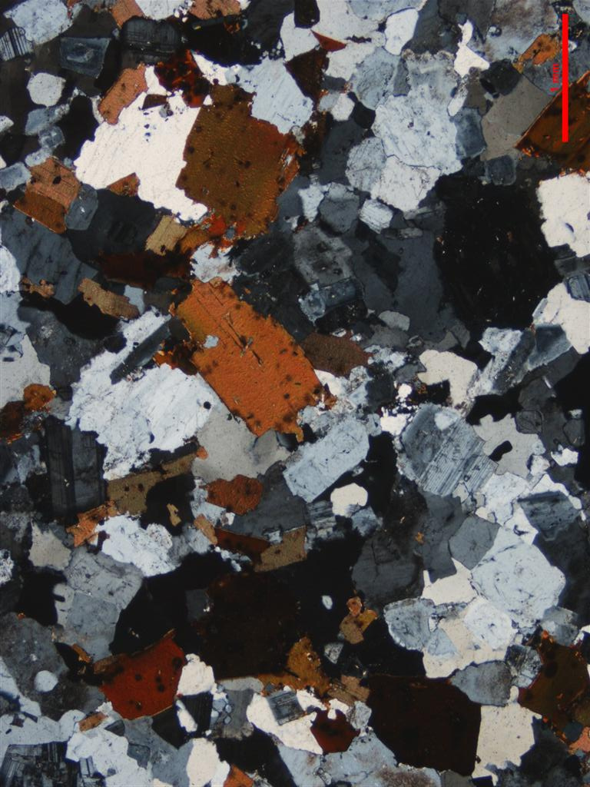
Figure 2.34 Thin section microphotographs of Newholme Monzogranite. Scale as indicated (1 mm); PPL left, CPL right. In contrast to the Mount Duval Monzogranite the Newholme Monzogranite is characterised by biotite >> amphibole; paucity of amphibole + biotite clots after pyroxene; and the presence of radiation haloes in the biotites – all evidence for its more compositionally evolved character (N-1/2002566).

Zircons
Zircons recovered from N-1/2002566 are dominated by clear and colourless euhedral prisms, many containing acicular inclusions. They are mostly between ~40–80 μm in diameter but there are also some larger (100–130 μm) broken fragments. The majority of the grains have aspect ratios between 1 to 3 but the full range extends to ~7. They have a moderate to weak CL response and most are concentrically zoned. About 5–10% of the grains appear to have cores that are only visible in the CL images (Figure 2.35).

U–Pb isotopic results
Twenty-five SHRIMP U–Pb analyses were carried out on 24 zircons from this sample (Figure 2.36 and Table 2.20). Four analyses have analysed zircon cores which have 206Pb/238U ages of ~555 Ma, ~350 Ma, ~340 Ma and ~280 Ma. The remaining 21 zircons mostly have low common 206Pb, with three grains low to moderate contents of about ~1% (206Pbc). Uranium concentrations range between 107–885 ppm (median = 266 ppm) and Th/U ratios are consistent with an average of ~0.56. All 21 zircons have the same radiogenic 206Pb/238U within their analytical uncertainties (MSWD = 0.87, probability = 0.63) and combine to give a weighted mean age of 252.8 ± 1.5 Ma which is interpreted as the crystallisation age of these zircons.
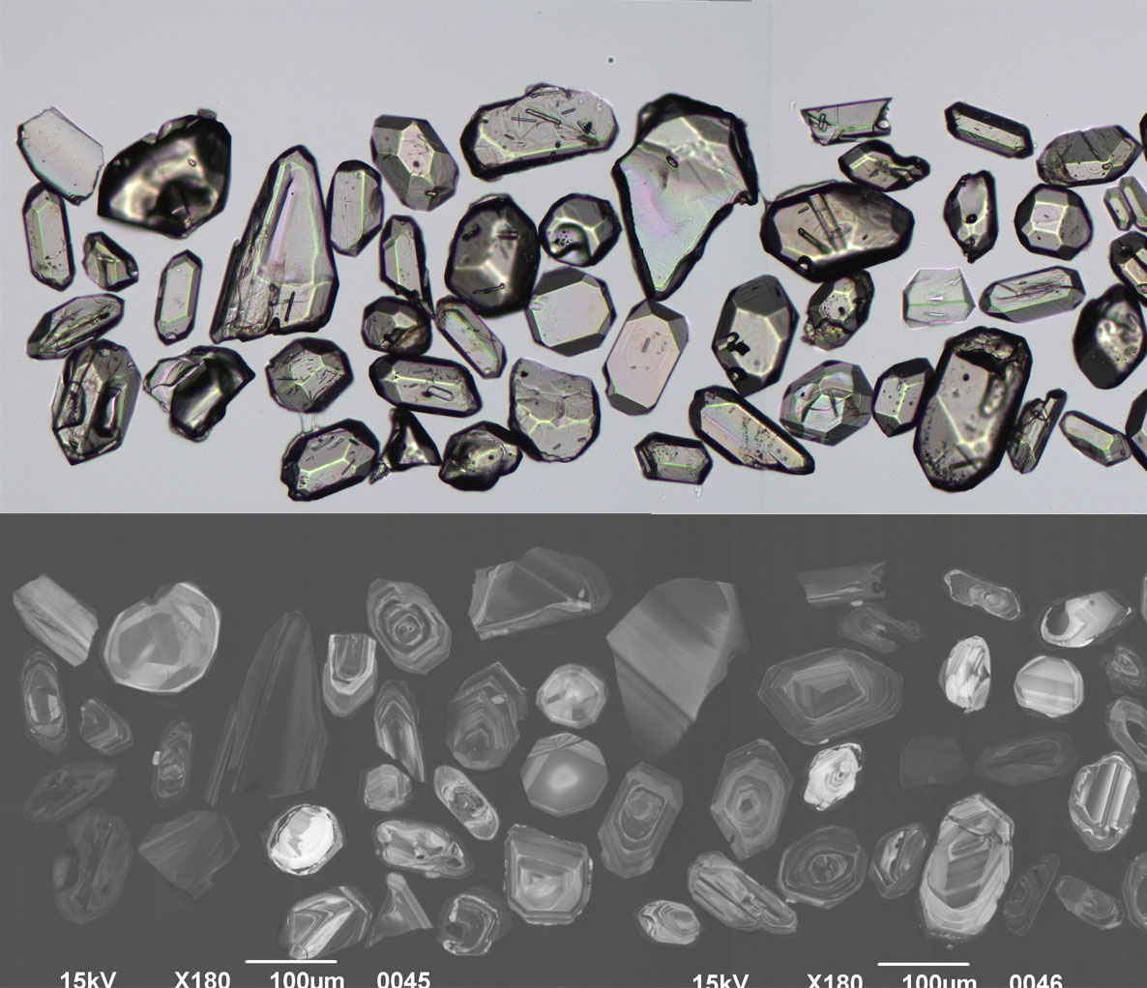
Figure 2.35 Selected transmitted light (top) and cathodoluminescence (bottom) images of zircon grains from the Newholme Monzogranite (N-1/2002566).
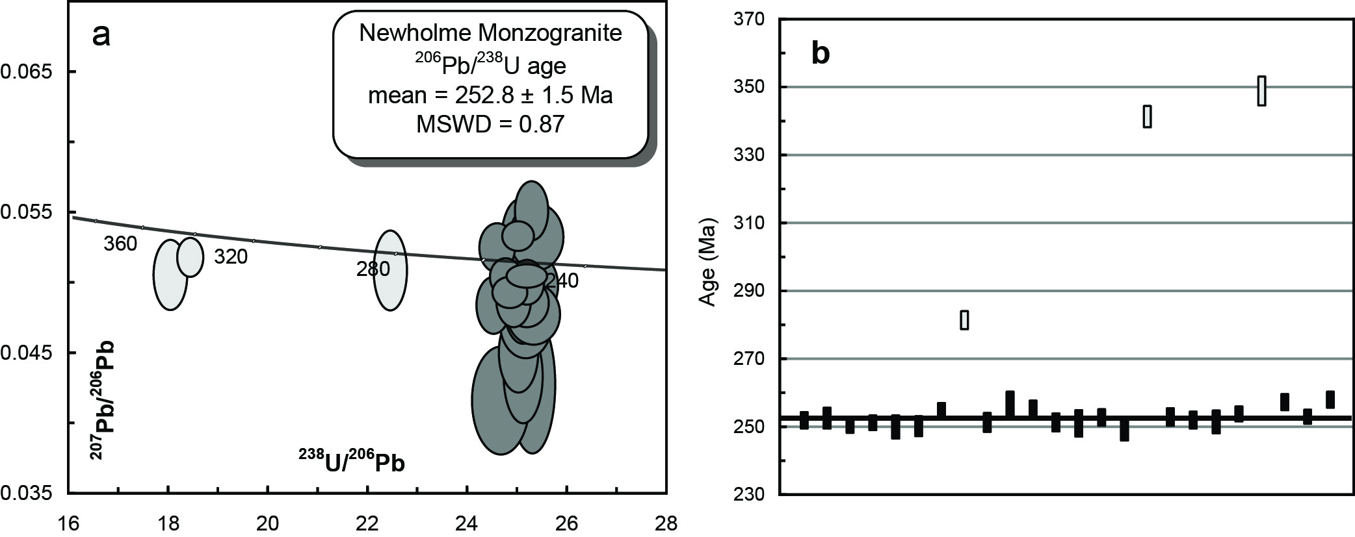
Figure 2.36 (a) Tera-Wasserberg concordia plot and (b) temporal trend of the 206Pb/238U ages from the Newholme Monzogranite (N-1/2002566). The lighter shaded ellipses in (a) and bars in (b) represent inherited grains.
Table 2.20 SHRIMP U–Pb zircon data from Newholme Monzogranite (N-1/2002566).
Grain.area | 206Pbc (%) | U (ppm) | Th (ppm) | 232Th/  238U | 238U/  206Pb | ± 1σ (%) | 207Pb/  206Pb | ± 1σ (%) | 206Pb/238U Age (Ma) | ± 1σ (Ma)
Magmatic zircons
566.Z.1.1.1 | 0.59 | 249 | 97 | 0.40 | 25.0640 | 1.1 | 0.0480 | 3.6 | 251.8 | 2.5
566.Z.2.1.1 | 0.70 | 147 | 78 | 0.55 | 24.9399 | 1.4 | 0.0499 | 4.9 | 252.4 | 3.1
566.Z.3.1.1 | -0.29 | 440 | 188 | 0.44 | 25.3941 | 0.9 | 0.0550 | 2.6 | 250.2 | 2.2
566.Z.4.1.1 | 0.31 | 402 | 389 | 1.00 | 25.1946 | 1.1 | 0.0498 | 2.1 | 251.0 | 2.2
566.Z.5.1.1 | 0.64 | 331 | 137 | 0.43 | 25.1337 | 1.5 | 0.0475 | 3.0 | 249.8 | 3.4
566.Z.7.1.1 | 1.42 | 107 | 45 | 0.43 | 24.9895 | 1.3 | 0.0425 | 7.7 | 250.0 | 3.0
566.Z.9.1.1 | 0.32 | 666 | 633 | 0.98 | 24.8532 | 1.1 | 0.0491 | 1.5 | 254.5 | 2.3
566.Z.10.1.1 | 0.41 | 332 | 180 | 0.56 | 25.0945 | 1.3 | 0.0483 | 2.4 | 251.1 | 2.8
566.Z.11.1.1 | 0.97 | 125 | 48 | 0.39 | 24.4571 | 1.6 | 0.0413 | 6.2 | 256.3 | 3.9
566.Z.12.1.1 | 0.27 | 448 | 209 | 0.48 | 24.7082 | 0.9 | 0.0502 | 1.8 | 255.4 | 2.1
566.Z.13.1.1 | 0.16 | 885 | 757 | 0.88 | 25.0926 | 1.3 | 0.0503 | 1.1 | 251.1 | 2.6
566.Z.14.1.1 | 0.40 | 159 | 79 | 0.51 | 25.1378 | 1.7 | 0.0496 | 3.4 | 250.8 | 3.9
566.Z.15.1.1 | 0.16 | 210 | 133 | 0.65 | 24.9986 | 1.1 | 0.0527 | 3.9 | 252.5 | 2.4
566.Z.16.1.1 | 0.28 | 176 | 56 | 0.33 | 25.3848 | 1.5 | 0.0531 | 3.0 | 249.2 | 3.5
566.Z.18.1.1 | 0.65 | 199 | 55 | 0.29 | 24.8969 | 1.2 | 0.0448 | 4.2 | 252.8 | 2.6
566.Z.19.1.1 | 1.07 | 203 | 90 | 0.46 | 24.9042 | 1.1 | 0.0431 | 5.2 | 251.8 | 2.6
566.Z.20.1.1 | 0.61 | 253 | 225 | 0.92 | 25.0739 | 1.6 | 0.0468 | 3.5 | 251.3 | 3.4
566.Z.22.1.1 | 0.40 | 340 | 137 | 0.42 | 24.8363 | 1.0 | 0.0485 | 2.6 | 253.7 | 2.3
566.Z.22.2.1 | 0.18 | 283 | 116 | 0.42 | 24.5207 | 1.0 | 0.0523 | 2.2 | 257.2 | 2.4
566.Z.23.1.1 | -0.05 | 514 | 303 | 0.61 | 25.0618 | 0.9 | 0.0531 | 1.3 | 252.8 | 2.1
566.Z.24.1.1 | 0.46 | 338 | 172 | 0.53 | 24.3940 | 1.0 | 0.0481 | 2.8 | 257.9 | 2.4
Inherited
566.Z.6.1.1 | 0.14 | 325 | 20 | 0.06 | 11.0912 | 0.9 | 0.0580 | 1.2 | 556.0 | 4.9
566.Z.8.1.1 | 0.42 | 203 | 39 | 0.20 | 22.5546 | 1.0 | 0.0507 | 3.7 | 281.4 | 2.7
566.Z.17.1.1 | 0.16 | 266 | 146 | 0.57 | 18.3821 | 1.0 | 0.0516 | 1.8 | 341.6 | 3.1
566.Z.21.1.1 | 0.35 | 124 | 59 | 0.49 | 17.9395 | 1.4 | 0.0503 | 3.3 | 349.2 | 4.3
- %206Pbc indicates the proportion of common 206Pb in the total measured 206Pb.
- Pb isotopic ratios corrected for common Pb by reference to the measured 204Pb.
- All errors quoted as 1σ.

Pringles Monzogranite PB-09-NE-GD1/2002567
Table 2.21 Summary of results: Pringles Monzogranite (PB-09-NE-GD1/2002567).
GA SampleID | 200901603
GA SampleNO | 2002567
GSNSW SITEID | PB-09-NE-GD1
Formal Name | Pringles Monzogranite
Informal Name | -
Lithology | porphyritic monzogranite
1:250 000 Sheet | MANILLA (SH5609)
1:100 000 Sheet | BENDEMEER (9136)
Region | New England Region
Location (GDA94) | 151.040333 °E, -30.776055 °S
Location (MGA 94 Zone 56) | 312465 mE, 6593575 mN
Geochronologist | Andrew Cross
Mount ID | GA6118
Analytical Session | 100031
Interpreted Age | 288.7 ± 1.6 Ma (95% confidence, 21 analyses on 21 zircons)
Geological Attribution | Magmatic crystallisation
Isotopic Ratio Used | 206Pb/238U

Sample Information
This sample comprises porphyritic biotite-bearing microgranite occurring as a distinctly mappable phase within the S-type Bundarra Supersuite. It was collected on the roadside along the track to the old Giants Dens tin workings, south of Watson’s Creek. The unit is shown on the 1:250K Manilla-Narrabri Metallogenic map and 1:1M scale digital geology as the Pringles Monzonite. The mapped relationships of all the units within the Bundarra Supersuite are unresolved in detail. The microgranite is intimately spatially associated with phyllic to greisenous alteration, tourmalinisation, and veining associated with hard rock tin mineralisation at the Giants Den and related placers and stream occurrences extending to Watsons Creek. The adjacent Banalasta Adamellite has a SHRIMP U–Pb age of 286.2 ± 2.2 Ma (Black 2007). There are no other SHRIMP dates in the Bundarra Supersuite.
This sample was submitted for SHRIMP U–Pb analysis to help establish whether mineralisation at Giants Den/Watson’s Creek is in a differentiated phase of the S-type Bundarra Supersuite or is related to a younger intrusive/mineralisation event.

Petrography
The sample is a seriate to porphyritic textured monzogranite with phenocrysts of quartz (to 7 mm), K-feldspar (to 1 cm) and biotite to 3 mm. K-feldspars are strongly perthitic with large simple twins and well developed microcline twinning. Plagioclases are cloudy and heavily flecked with sericite. Fluid inclusion in quartz, though small, are prominent, particularly the proportion of vapour-rich inclusions. The groundmass comprises incipiently to relatively well–developed graphic textures (quartz-feldspar, and quartz-tourmaline-feldspar) with rare myrmekites. Groundmass feldspar tends to be cloudy. Muscovite appears as late primary crystals as well as replacing K-feldspar (incipient greisenisation) and flecking plagioclase as finer sericite. Tourmaline (mustard yellow → blue) is prominent replacing(?) groundmass feldspars in amongst groundmass quartz to produce graphic-style intergrowths to 1 cm (“tourmaline sun” style). Biotites (foxy red → straw yellow) range from very fresh to completely chloritised with fine sugary secondaries and ?rutile needles. They appear best developed in areas of the thin section away from the tourmaline growths (competition for Fe and Mg during later stages of magmatic crystallisation?). Radiation haloes are often present in the biotites. Accessory phases are not prominent but include opaques (associated with biotite) and zircon. Apatite is not prominent, which is unusual for an S-type granite (Figure 2.37).
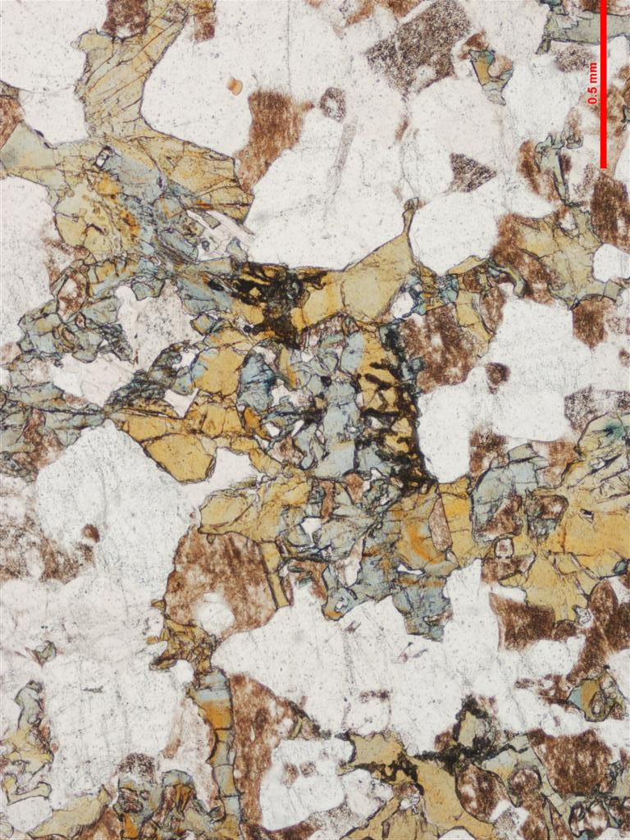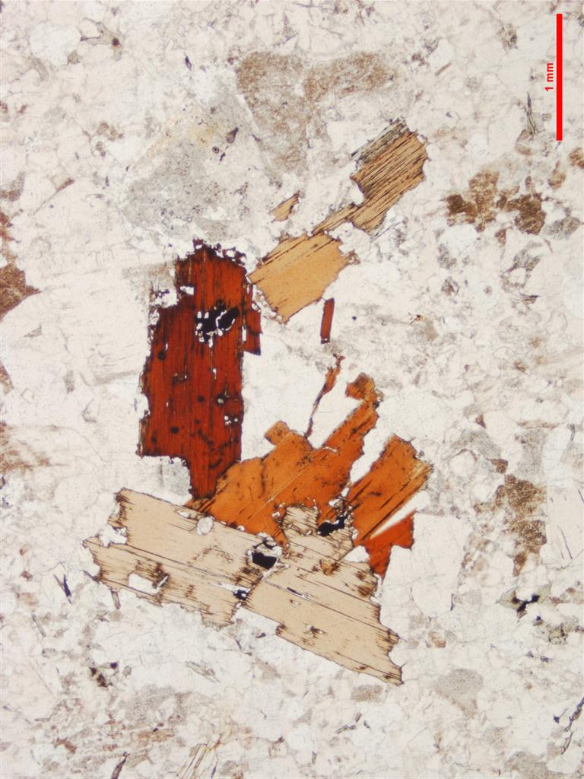
Figure 2.37 Thin section microphotographs of two views of the Pringles Monzogranite. Scale as indicated (left: 0.5 mm; right: 1 mm); both in PPL. Left: late tourmaline intergrown with quartz and feldspar. Right: fresh biotite showing foxy red colouration typical of reduced S-type granites (PB-09-NE-GD1/2002567).

Zircons
Zircons recovered from PB-09-NE-GD1/2002567 are clear colourless euhedral prisms. About 30% of the grains are broken fragments while intact grains have aspect ratios typically between 2 to 3. Most grains are also relatively small and range in diameter from ~30–60 μm. Almost all grains have a moderate to bright CL response and diffuse oscillatory growth zoning predominates. The CL images also show that about 5% of the zircons have inherited cores (Figure 2.38).

U–Pb isotopic results
Twenty-three SHRIMP U–Pb analyses were carried out on 23 zircons from this sample (Figure 2.39, Table 2.22). Two analyses are of inherited zircon cores that have ages of ~360 Ma and ~335 Ma. The remaining 21 analyses constitute a uniform population with moderate U concentrations (~67–576 ppm, median = 312 ppm), low to moderate Th/U (~0.27) and common 206Pb concentrations of < 0.70% (206Pbc). All of these grains have the same radiogenic 206Pb/238U (MSWD = 1.38, probability = 0.12) and combine to give an age of 288.7 ± 1.6 Ma. This age is interpreted to represent the crystallisation age of the Pringles Monzogranite and is within analytical uncertainty of the adjacent Banalasta Adamellite (MSWD = 1.38, probability = 0.12).
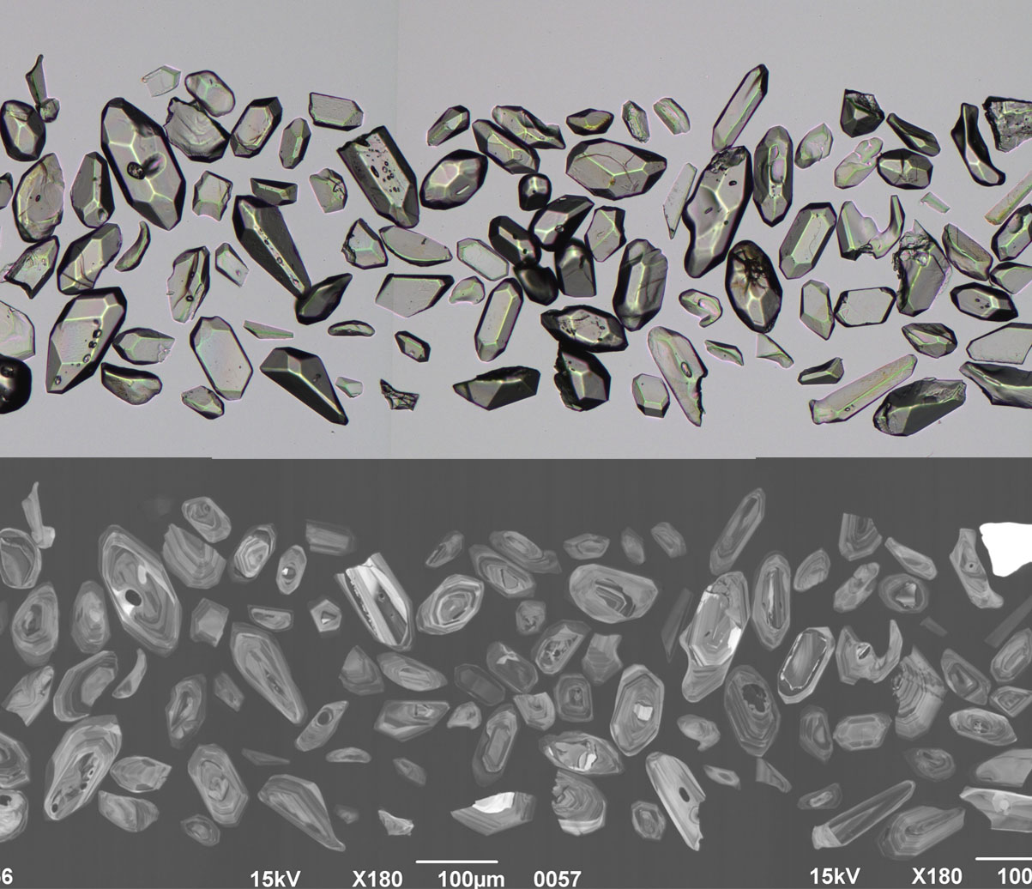
Figure 2.38 Selected transmitted light (top) and cathodoluminescence (bottom) images of zircon grains from the Pringles Monzogranite (PB-09-NE-GD1/2002567).
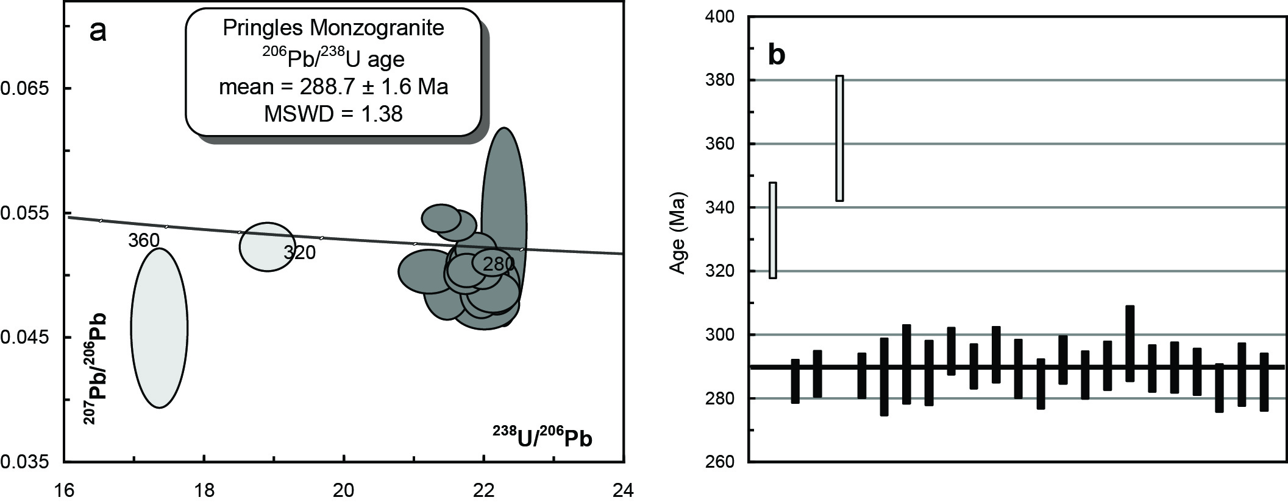
Figure 2.39 (a) Tera-Wasserberg concordia plot and (b) temporal trend of the 206Pb/238U ages from the Pringles Monzogranite (PB-09-NE-GD1/2002567). The lighter shaded ellipses in (a) and bars in (b) represent inherited grains.
Table 2.22 SHRIMP U–Pb zircon data from Pringles Monzogranite (PB-09-NE-GD1/2002567).
Grain.area | 206Pbc (%) | U (ppm) | Th (ppm) | 232Th/  238U | 238U/  206Pb | ± 1σ (%) | 207Pb/  206Pb | ± 1σ (%) | 206Pb/238U Age (Ma) | ± 1σ (Ma)
Magmatic zircons
567.Z.2.1.1 | 0.19 | 576 | 81 | 0.15 | 22.1017 | 0.8 | 0.0508 | 1.5 | 285.3 | 2.4
567.Z.3.1.1 | 0.22 | 401 | 85 | 0.22 | 21.9156 | 0.9 | 0.0511 | 1.8 | 287.6 | 2.5
567.Z.5.1.1 | 0.47 | 435 | 63 | 0.15 | 21.9606 | 0.9 | 0.0503 | 2.1 | 287.1 | 2.4
567.Z.6.1.1 | 0.66 | 276 | 100 | 0.37 | 21.9913 | 1.5 | 0.0475 | 2.9 | 286.7 | 4.2
567.Z.7.1.1 | 0.49 | 290 | 107 | 0.38 | 21.6892 | 1.5 | 0.0496 | 2.5 | 290.6 | 4.3
567.Z.8.1.1 | 0.28 | 289 | 95 | 0.34 | 21.8938 | 1.2 | 0.0501 | 3.4 | 287.9 | 3.5
567.Z.9.1.1 | -0.11 | 375 | 111 | 0.31 | 21.3708 | 0.9 | 0.0544 | 1.4 | 294.8 | 2.5
567.Z.10.1.1 | 0.31 | 420 | 50 | 0.12 | 21.7377 | 0.9 | 0.0502 | 1.8 | 289.9 | 2.4
567.Z.11.1.1 | 0.58 | 173 | 74 | 0.44 | 21.4539 | 1.0 | 0.0488 | 3.5 | 293.7 | 3.0
567.Z.12.1.1 | 0.41 | 312 | 63 | 0.21 | 21.7911 | 1.1 | 0.0501 | 2.3 | 289.2 | 3.2
567.Z.13.1.1 | 0.54 | 216 | 42 | 0.20 | 22.1691 | 1.0 | 0.0489 | 3.2 | 284.4 | 2.7
567.Z.14.1.1 | -0.17 | 390 | 83 | 0.22 | 21.5813 | 0.9 | 0.0538 | 1.5 | 292.0 | 2.6
567.Z.15.1.1 | 0.69 | 312 | 88 | 0.29 | 21.9459 | 0.9 | 0.0484 | 2.9 | 287.2 | 2.6
567.Z.16.1.1 | 0.21 | 288 | 94 | 0.34 | 21.7185 | 0.9 | 0.0499 | 2.1 | 290.2 | 2.7
567.Z.17.1.1 | 0.34 | 284 | 126 | 0.46 | 21.1947 | 1.4 | 0.0501 | 2.3 | 297.2 | 4.0
567.Z.18.1.1 | 0.26 | 352 | 77 | 0.23 | 21.7856 | 0.9 | 0.0509 | 2.0 | 289.3 | 2.6
567.Z.19.1.1 | 0.21 | 265 | 51 | 0.20 | 21.7661 | 1.0 | 0.0508 | 2.2 | 289.6 | 2.7
567.Z.20.1.1 | 0.19 | 393 | 50 | 0.13 | 21.8670 | 0.9 | 0.0518 | 1.8 | 288.3 | 2.5
567.Z.21.1.1 | 0.51 | 347 | 88 | 0.26 | 22.2709 | 1.0 | 0.0537 | 9.9 | 283.1 | 2.7
567.Z.22.1.1 | 0.38 | 339 | 125 | 0.38 | 21.9341 | 1.2 | 0.0498 | 2.3 | 287.4 | 3.4
567.Z.23.1.1 | 0.41 | 426 | 78 | 0.19 | 22.1192 | 1.1 | 0.0484 | 2.3 | 285.0 | 3.2
Inherited zircons
567.Z.1.1.1 | 0.36 | 237 | 205 | 0.89 | 18.8680 | 1.4 | 0.0521 | 2.5 | 332.9 | 4.5
567.Z.4.1.1 | 1.78 | 67 | 25 | 0.38 | 17.3119 | 1.6 | 0.0455 | 9.4 | 362.0 | 5.5
- %206Pbc indicates the proportion of common 206Pb in the total measured 206Pb.
- Pb isotopic ratios corrected for common Pb by reference to the measured 204Pb.
- All errors quoted as 1σ.

Highlands Complex Monzogranite PBNE-10-HC-01/2105109
Table 2.23 Summary of results: Highlands Complex Monzogranite (PBNE-10-HC-01/2105109).
GA SampleID | 2010016001
GA SampleNO | 2105109
GSNSW SITEID | PBNE-10-HC-01
Formal Name | Highlands Complex
Informal Name | Highlands Complex monzogranite
Lithology | monzogranite
1:250 000 Sheet | DORRIGO (SH5610)
1:100 000 Sheet | GUYRA (9237)
Region | New England region
Location (GDA94) | 151.762152 °E, -30.373093 °S
Location (MGA 94 Zone 56) | 381057 mE, 6639222 mN
Geochronologist | Andrew Cross
Mount ID | GA6139
Analytical Session | 100128
Interpreted Age | 251.5 ± 1.9 Ma (95% confidence, 26 analyses on 26 zircons)
Geological Attribution | Magmatic crystallisation
Isotopic Ratio Used | 206Pb/238U

Sample Information
This sample was collected insitu from a prominent 3 m tall road cutting, recently refreshed by bulldozing, on the south side of Puddledock Road 130 m east from a farm gate exiting the road to the south. The sample comprises fresh pink medium grained alkali feldspar-rich biotite-amphibole monzogranite. Magnetic susceptibility is low despite pink colour. The complex intrudes the late–Devonian to early–Carboniferous Sandon beds of the Central Complex and the Permian Fauna IV-bearing Dummy Creek Conglomerate which comprises the base to the Wandsworth Volcanic Group in the Armidale region. It is overlain by Cenozoic basalts. A composite Rb-Sr isochron age for the Highlands Complex and a similar mass at Woodlands yielded an age of 260.5 ± 8.2 Ma (Hensel 1980). The complex is geochemically unique, and a poor fit to the Moonbi Supersuite, to which it is sometimes assigned.

Petrography
Medium–grained monzogranite comprising quartz (15 modal percent; blocky to anhedral; < 1 mm), K-feldspar (30–40 percent; cloudy, simple twinned, occasionally zoned, modestly perthitic), and plagioclase (20 percent; stubby to elongate, < 2 mm). Ferromagnesians (20 percent) comprise biotite and amphibole. Biotite (dark → light chocolate brown; < 1 mm) is typically fresh and occurs as isolated laths and associated with amphibole-biotites aggregates. Amphibole (pale straw → medium green; < 1 mm; well–developed cleavage) also occurs as individual crystals and as part of prominent aggregates of subhedral amphiboles. These clusters can be up to 3 mm in diameter and can show pseudohexagonal and prismatic outlines suggesting they are recrystallised after primary amphibole or pyroxene. No relict pyroxenes were present in thin sections, although are common as relict cores in similar cluster aggregates in members of the Uralla Supersuite. Accessory phases include titanite, zircon and apatite (Figure 2.40).
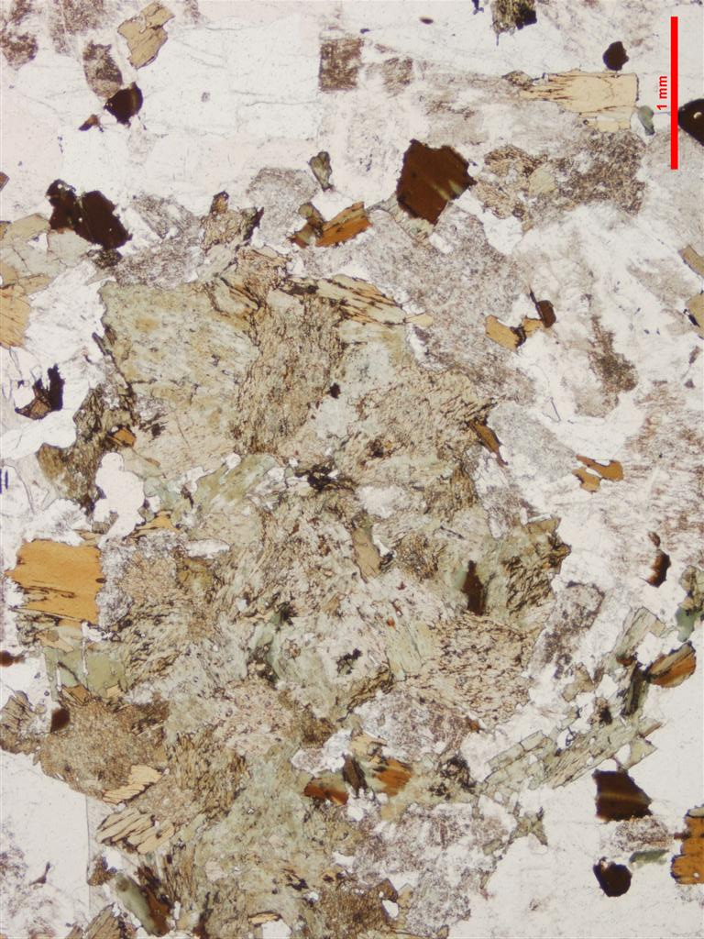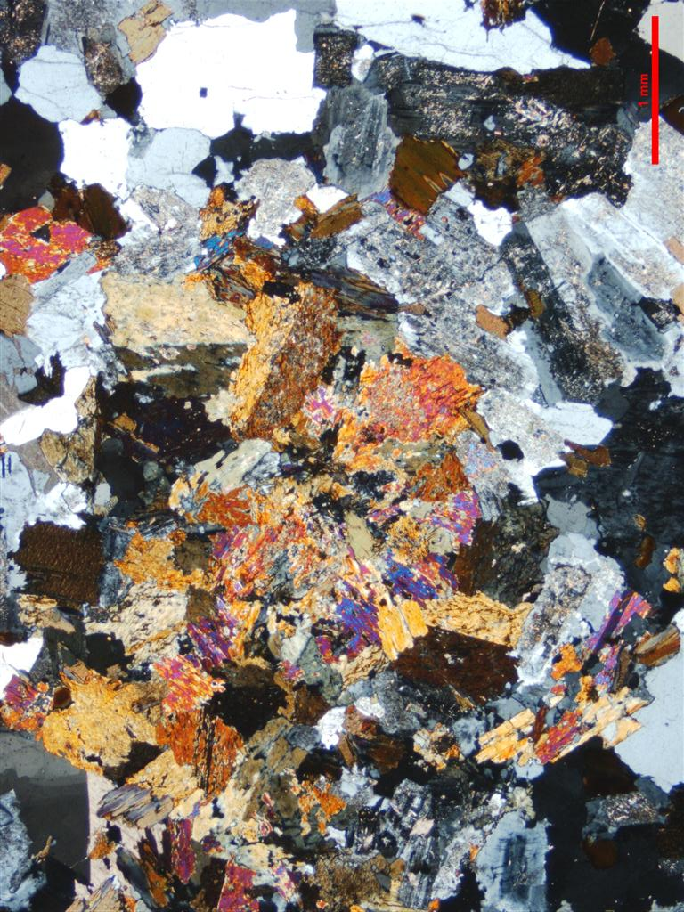
Figure 2.40 Thin section microphotographs of monzogranite from the Highlands Complex. Scale as indicated (1 mm); PPL left, CPL right. Prominent clot of amphibole and biotite after pyroxene (PBNE-10-HC-01/2105109).

Zircons
Zircons separated from this sample comprise a homogeneous population of euhedral, clear and colourless to hyacinth grains, many with randomly orientated inclusions. They range in diameter from ~60–100 µm and typically have a stubby shape with aspect ratios between 1 to 2 however, the full range extends up to grains with aspect ratios of 4. They have a moderate luminescence and are dominated by oscillatory and sector growth zoning (Figure 2.41).

U–Pb isotopic results
Twenty-six SHRIMP U–Pb isotopic analyses were carried out on this sample (Figure 2.42 and Table 2.24). Uranium concentrations are low to moderate (87–569 ppm, median = 205 ppm) and Th/U ratios range from 0.26 to 1.15. Common 206Pb proportions are all below 1% (206Pbc). All 26 grains analysed have the same radiogenic 206Pb/238U within their analytical uncertainties (MSWD = 0.88, probability = 0.64) and contribute to a weighted mean age of 251.5 ± 1.9 Ma, which is interpreted as the magmatic crystallisation age of this rock.
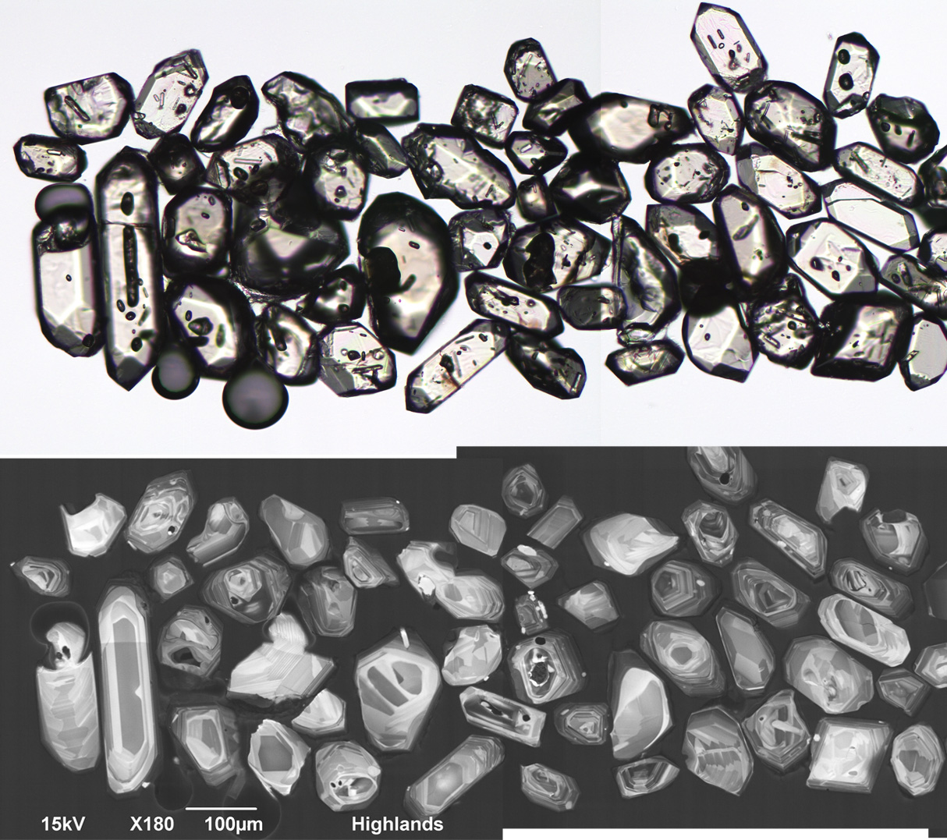
Figure 2.41 Selected transmitted light (top) and cathodoluminescence (bottom) images of zircon grains from the Highlands Complex monzogranite (PBNE-10-HC-01/2105109).
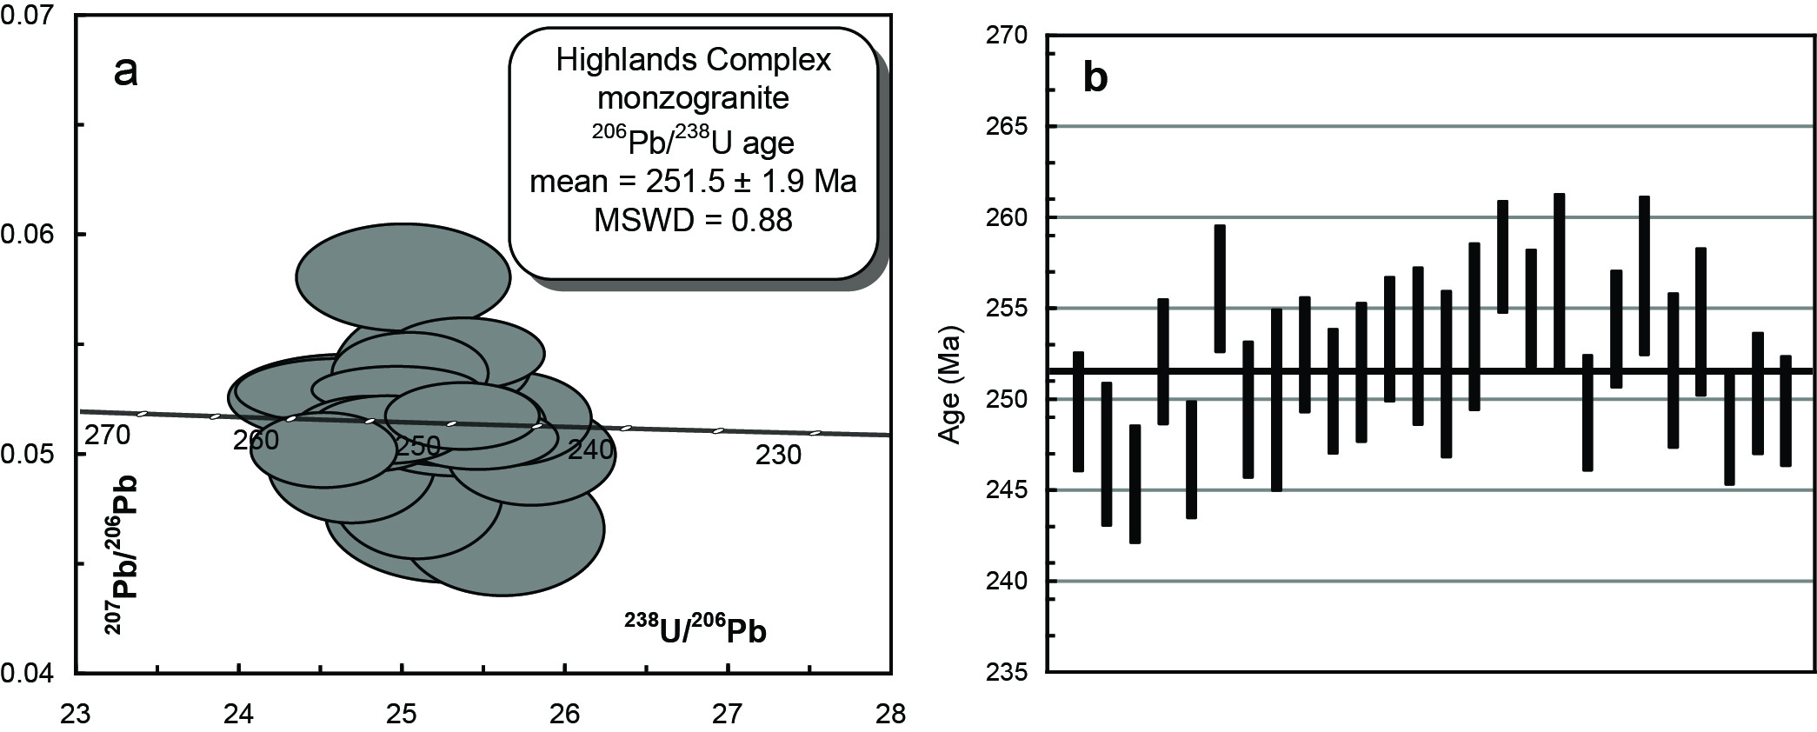
Figure 2.42 (a) Tera-Wasserberg concordia plot and (b) temporal trend of the 206Pb/238U ages from the Highlands Complex monzogranite (PBNE-10-HC-01/2105109).
Table 2.24 SHRIMP U–Pb zircon data from Highlands Complex monzogranite (PBNE-10-HC-01/2105109).
Grain.area | 206Pbc (%) | U (ppm) | Th (ppm) | 232Th/  238U | 238U/  206Pb | ± 1σ (%) | 207Pb/  206Pb | ± 1σ (%) | 206Pb/238U Age (Ma) | ± 1σ (Ma)
Magmatic zircons
109.Z.1.1.1 | -0.18 | 197 | 139 | 0.73 | 25.3596 | 1.3 | 0.0512 | 2.5 | 249.3 | 3.3
109.Z.2.1.1 | 0.73 | 344 | 87 | 0.26 | 25.6039 | 1.6 | 0.0464 | 4.3 | 247.0 | 3.9
109.Z.3.1.1 | 0.31 | 187 | 129 | 0.71 | 25.7801 | 1.3 | 0.0498 | 3.1 | 245.3 | 3.2
109.Z.4.1.1 | 0.53 | 164 | 118 | 0.74 | 25.0754 | 1.4 | 0.0480 | 4.1 | 252.1 | 3.4
109.Z.5.1.1 | 0.20 | 212 | 119 | 0.58 | 25.6370 | 1.3 | 0.0514 | 2.8 | 246.7 | 3.2
109.Z.7.1.1 | 0.42 | 160 | 126 | 0.81 | 24.6714 | 1.4 | 0.0493 | 3.6 | 256.1 | 3.5
109.Z.6.1.1 | 0.24 | 458 | 270 | 0.61 | 25.3450 | 1.5 | 0.0503 | 2.0 | 249.5 | 3.7
109.Z.8.1.1 | 0.80 | 192 | 165 | 0.89 | 25.2917 | 2.0 | 0.0471 | 4.4 | 250.0 | 5.0
109.Z.9.1.1 | -0.27 | 287 | 203 | 0.73 | 25.0348 | 1.3 | 0.0535 | 2.3 | 252.5 | 3.1
109.Z.10.1.1 | 0.08 | 155 | 100 | 0.67 | 25.2416 | 1.4 | 0.0513 | 2.6 | 250.5 | 3.4
109.Z.11.1.1 | 0.37 | 87 | 62 | 0.74 | 25.1340 | 1.5 | 0.0532 | 4.3 | 251.5 | 3.8
109.Z.12.1.1 | -0.11 | 569 | 581 | 1.06 | 24.9497 | 1.4 | 0.0528 | 1.4 | 253.3 | 3.4
109.Z.13.1.1 | -0.56 | 229 | 228 | 1.03 | 24.9894 | 1.7 | 0.0579 | 2.8 | 252.9 | 4.3
109.Z.14.1.1 | 0.00 | 184 | 205 | 1.15 | 25.1448 | 1.9 | 0.0498 | 2.3 | 251.4 | 4.6
109.Z.15.1.1 | 0.53 | 146 | 144 | 1.01 | 24.8819 | 1.8 | 0.0494 | 4.0 | 254.0 | 4.6
109.Z.16.1.1 | 0.15 | 447 | 238 | 0.55 | 24.5003 | 1.2 | 0.0500 | 2.3 | 257.9 | 3.1
109.Z.17.1.1 | 0.18 | 248 | 187 | 0.78 | 24.7802 | 1.3 | 0.0507 | 2.2 | 255.0 | 3.2
109.Z.18.1.1 | -0.08 | 150 | 104 | 0.72 | 24.6402 | 2.0 | 0.0524 | 2.5 | 256.5 | 4.9
109.Z.19.1.1 | -0.10 | 236 | 182 | 0.80 | 25.3625 | 1.3 | 0.0544 | 2.0 | 249.3 | 3.2
109.Z.20.1.1 | -0.16 | 304 | 204 | 0.69 | 24.8945 | 1.3 | 0.0509 | 2.0 | 253.9 | 3.2
109.Z.21.1.1 | 0.00 | 184 | 168 | 0.94 | 24.6016 | 1.7 | 0.0527 | 1.9 | 256.8 | 4.4
109.Z.22.1.1 | 0.06 | 183 | 147 | 0.83 | 25.1259 | 1.7 | 0.0515 | 2.2 | 251.6 | 4.2
109.Z.23.1.1 | 0.16 | 364 | 378 | 1.07 | 24.8550 | 1.6 | 0.0505 | 1.9 | 254.3 | 4.1
109.Z.24.1.1 | 0.11 | 302 | 295 | 1.01 | 25.4491 | 1.3 | 0.0505 | 1.9 | 248.5 | 3.1
109.Z.25.1.1 | -0.13 | 175 | 181 | 1.07 | 25.2546 | 1.4 | 0.0538 | 2.4 | 250.3 | 3.3
109.Z.26.1.1 | 0.20 | 362 | 223 | 0.64 | 25.3552 | 1.2 | 0.0516 | 2.0 | 249.4 | 3.0
- %206Pbc indicates the proportion of common 206Pb in the total measured 206Pb.
- Pb isotopic ratios corrected for common Pb by reference to the measured 204Pb.
- All errors quoted as 1σ.

Emmaville Volcanics Volcaniclastic PBNE-09-NEV-02/2105111
Table 2.25 Summary of results: Emmaville Volcanics Volcaniclastic (PBNE-09-NEV-02/2105111).
GA SampleID | 2010016003
GA SampleNO | 2105111
GSNSW SITEID | PBNE-09-NEV-02
Formal Name | Emmaville Volcanics
Informal Name | -
Lithology | crystal lithic volcaniclastic
1:250 000 Sheet | GRAFTON (SH5606)
1:100 000 Sheet | GLEN INNES (9238)
Region | New England Region
Location (GDA94) | 151.787400 °E, -29.633820 °S
Location (MGA 94 Zone 56) | 382616 mE, 6721175 mN
Geochronologist | Andrew Cross
Mount ID | GA6139
Analytical Session | 100128
Interpreted Age | 252.3 ± 2.0 Ma (95% confidence, 27 analyses on 27 zircons)
Geological Attribution | Magmatic crystallisation
Isotopic Ratio Used | 206Pb/238U

Sample Information
This sample was collected from subdued boulders ~15 m off the south side of Yarraford Road, bulldozed from a small cutting. Here the volcanics are relatively massive, comprising a crystal-lithic unit, uniformly grey in colour with minor veining and joints. Grey coloured phenocrysts of feldspars to 3 mm are well developed. The top of the Emmaville Volcanics (Wandsworth Volcanic Group; WVG) is well constrained by the overlying Dundee Rhyodacite (254.1 ± 2.2 Ma; Brownlow and Cross 2010). The age of the base of the sequence is unknown. A Re-Os age of 267.5 ± 2.5 Ma (Norman et al. 2004) was determined on molybdenite from cross–cutting veins within the WVG at the Glen Eden prospect 9 kms to the northeast of the Yarraford site.

Petrography
Phenocrysts comprise < 50 modal percent of the sample. Plagioclases (< 2 mm) can be remarkably fresh, typically subhedral to euhedral, and strongly zoned. The K-feldspars (plagioclase > K-feldspar) are cloudy, up to 2 mm, and can be euhedral. Quartz as a phenocryst phase is absent. Masses of felted blue-green amphibole may represent former ferromagnesian crystals such as amphibole. Some contain stumpy apatites as inclusions typical of some amphibole crystals in granites. Elongate narrow and curved fragments may be relicts after biotites. Lithic fragments are relatively rare and in one instance comprises a fine grained rhyolitic example with an elongate lithophysa infilled with quartz. Groundmass comprises a mosaical collation of feldspars and presumably quartz, vaguely myrmekitic in places. Stretched out shards are present. Flow layering of phenocrysts and groundmass is evident. Phenocrysts are generally well shaped rather than broken or fragmented (Figure 2.43).
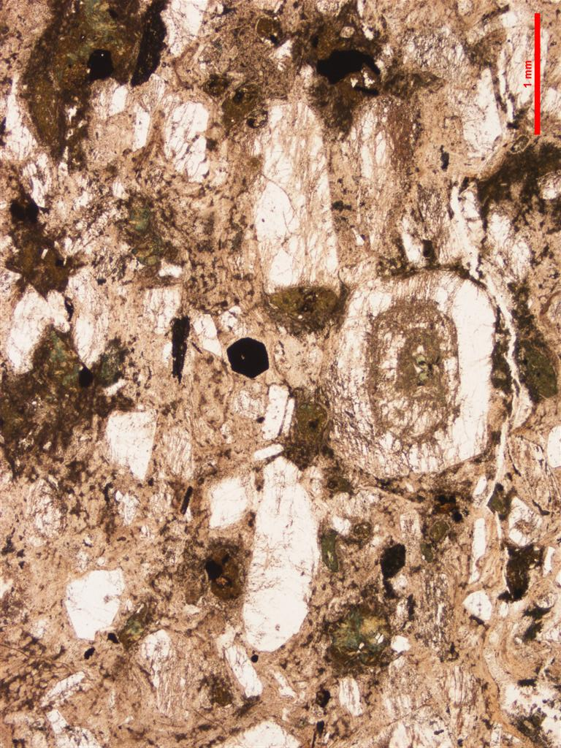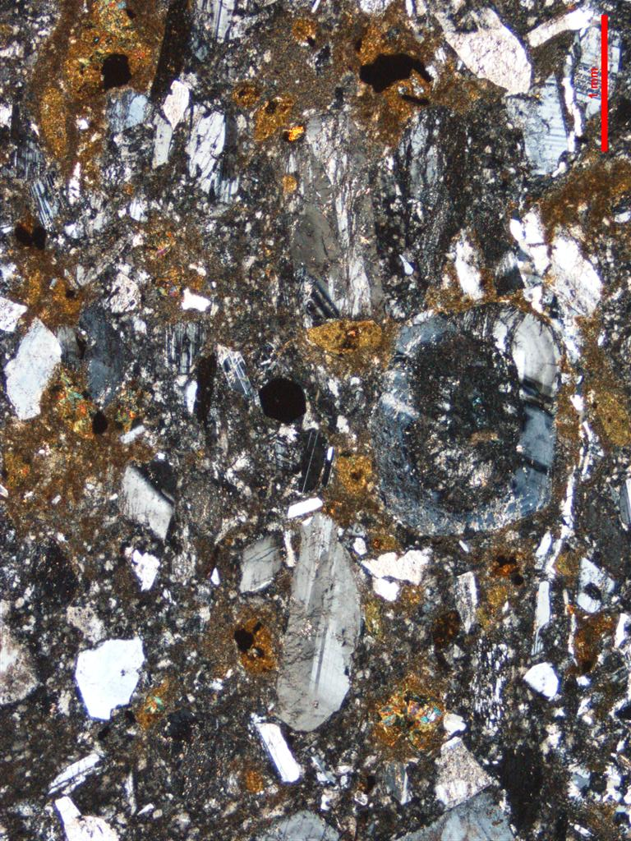
Figure 2.43 Thin section microphotographs of Emmaville Volcanoclastic. Scale as indicated (1 mm); PPL left, CPL right. Note crystal rich character, alignment of phenocrysts and presence of distinct cores in some feldspars (PBNE-09-NEV-02/2105111).

Zircons
Zircons separated from this sample comprise a homogeneous population of euhedral, clear and colourless to hyacinth grains, many with randomly orientated inclusions. They range in diameter from ~60–100 µm and typically have a stubby shape with aspect ratios between 1 to 2 however, the full range extends up to grains with aspect ratios of 4. They have a moderate luminescence and are dominated by oscillatory and sector growth zoning (Figure 2.44).

U–Pb isotopic results
Twenty-six SHRIMP U–Pb isotopic analyses were carried out on this sample (Figure 2.45 and Table 2.26). Uranium concentrations are low to moderate (87–569 ppm, median = 205 ppm) and Th/U ratios range from 0.26 to 1.15. Common 206Pb proportions are all below 1% (206Pbc). All 26 grains analysed have the same radiogenic 206Pb/238U within their analytical uncertainties (MSWD = 0.88, probability = 0.64) and contribute to a weighted mean age of 251.5 ± 1.9 Ma, which is interpreted as the magmatic crystallisation age of this rock.
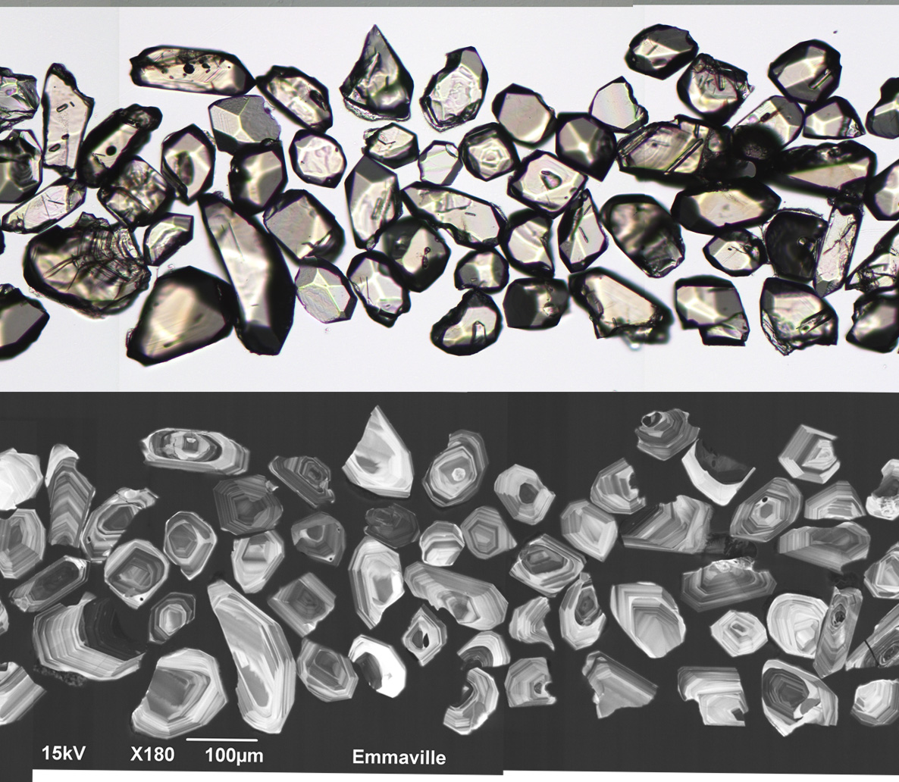
Figure 2.44 Selected transmitted light (top) and cathodoluminescence (bottom) images of zircon grains from the Emmaville Volcanics volcaniclastic (PBNE-09-NEV-02/2105111).
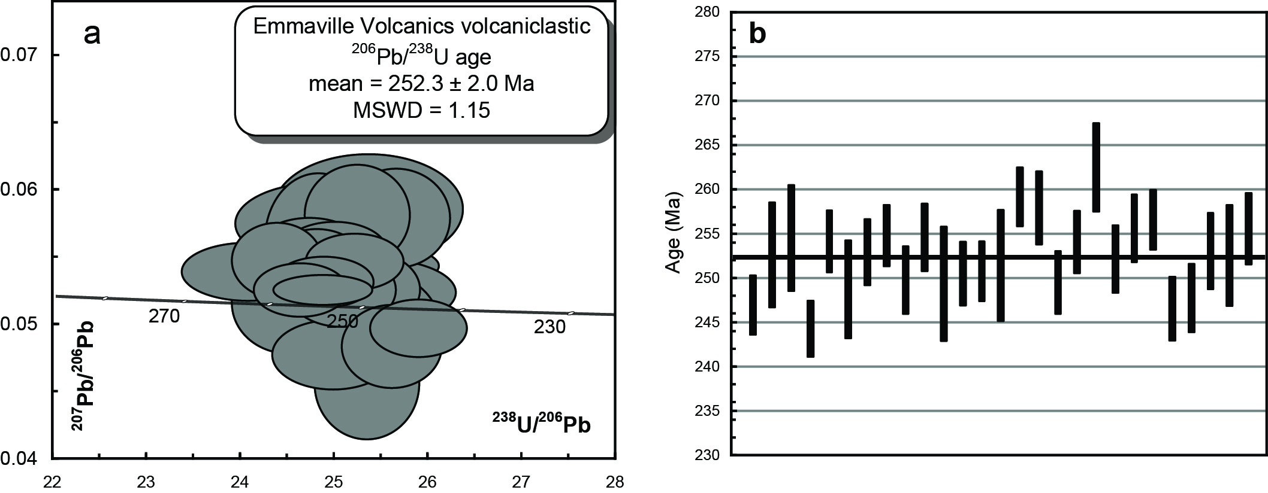
Figure 2.45 (a) Tera-Wasserberg concordia plot and (b) temporal trend of the 206Pb/238U ages from the Emmaville Volcanics volcaniclastic (PBNE-09-NEV-02/2105111).
Table 2.26 SHRIMP U–Pb zircon data from Emmaville Volcanics volcaniclastic (PBNE-09-NEV-02/2105111).
Grain.area | 206Pbc (%) | U (ppm) | Th (ppm) | 232Th/  238U | 238U/  206Pb | ± 1σ (%) | 207Pb/  206Pb | ± 1σ (%) | 206Pb/238U Age (Ma) | ± 1σ (Ma)
Magmatic zircons
111.Z.1.1.1 | 0.64 | 156 | 67 | 0.44 | 25.6082 | 1.4 | 0.0483 | 4.2 | 246.9 | 3.4
111.Z.2.1.1 | 0.28 | 86 | 40 | 0.48 | 25.0206 | 2.4 | 0.0522 | 4.3 | 252.6 | 5.9
111.Z.3.1.1 | -0.31 | 108 | 70 | 0.67 | 24.8286 | 2.4 | 0.0575 | 3.5 | 254.5 | 6.0
111.Z.4.1.1 | 0.20 | 234 | 118 | 0.52 | 25.8928 | 1.3 | 0.0496 | 2.9 | 244.3 | 3.2
111.Z.5.1.1 | -0.11 | 550 | 308 | 0.58 | 24.8673 | 1.4 | 0.0525 | 1.4 | 254.2 | 3.5
111.Z.6.1.1 | 0.11 | 107 | 47 | 0.45 | 25.4215 | 2.3 | 0.0523 | 3.2 | 248.7 | 5.6
111.Z.7.1.1 | 0.00 | 102 | 50 | 0.51 | 24.9925 | 1.5 | 0.0554 | 2.7 | 252.9 | 3.7
111.Z.8.1.1 | -0.37 | 167 | 88 | 0.55 | 24.8024 | 1.4 | 0.0544 | 3.2 | 254.8 | 3.5
111.Z.9.1.1 | 0.14 | 90 | 42 | 0.49 | 25.3113 | 1.6 | 0.0525 | 3.6 | 249.8 | 3.8
111.Z.10.1.1 | -0.53 | 115 | 55 | 0.49 | 24.8220 | 1.5 | 0.0562 | 5.8 | 254.6 | 3.8
111.Z.11.1.1 | -0.85 | 125 | 54 | 0.44 | 25.3566 | 2.6 | 0.0585 | 4.6 | 249.3 | 6.5
111.Z.12.1.1 | -0.76 | 122 | 77 | 0.65 | 25.2369 | 1.5 | 0.0581 | 4.3 | 250.5 | 3.6
111.Z.13.1.1 | -0.15 | 153 | 68 | 0.46 | 25.2118 | 1.4 | 0.0546 | 2.5 | 250.7 | 3.4
111.Z.14.1.1 | -0.12 | 177 | 78 | 0.46 | 25.1438 | 2.6 | 0.0543 | 2.2 | 251.4 | 6.3
111.Z.15.1.1 | -0.36 | 204 | 117 | 0.59 | 24.3748 | 1.3 | 0.0547 | 3.4 | 259.2 | 3.3
111.Z.16.1.1 | 0.30 | 76 | 34 | 0.46 | 24.4963 | 1.6 | 0.0515 | 4.8 | 257.9 | 4.1
111.Z.17.1.1 | 0.94 | 131 | 61 | 0.48 | 25.3420 | 1.5 | 0.0455 | 6.1 | 249.5 | 3.6
111.Z.18.1.1 | 0.00 | 132 | 56 | 0.44 | 24.8754 | 1.4 | 0.0531 | 2.4 | 254.1 | 3.5
111.Z.19.1.1 | -0.09 | 120 | 47 | 0.40 | 24.0606 | 2.0 | 0.0538 | 2.7 | 262.5 | 5.0
111.Z.20.1.1 | 0.13 | 93 | 44 | 0.49 | 25.0694 | 1.5 | 0.0525 | 3.5 | 252.1 | 3.8
111.Z.21.1.1 | 0.00 | 89 | 50 | 0.58 | 24.7216 | 1.5 | 0.0556 | 2.7 | 255.6 | 3.8
111.Z.22.1.1 | -0.18 | 174 | 84 | 0.50 | 24.6276 | 1.3 | 0.0525 | 2.5 | 256.6 | 3.4
111.Z.23.1.1 | -0.57 | 116 | 46 | 0.41 | 25.6514 | 1.5 | 0.0579 | 4.2 | 246.5 | 3.6
111.Z.24.1.1 | 0.66 | 85 | 37 | 0.45 | 25.5257 | 1.6 | 0.0494 | 5.8 | 247.7 | 3.9
111.Z.25.1.1 | 0.36 | 161 | 61 | 0.39 | 24.9799 | 1.7 | 0.0477 | 3.6 | 253.0 | 4.3
111.Z.26.1.1 | -0.25 | 190 | 78 | 0.43 | 25.0302 | 2.3 | 0.0556 | 2.6 | 252.5 | 5.7
111.Z.27.1.1 | -0.23 | 260 | 165 | 0.65 | 24.7264 | 1.6 | 0.0531 | 2.2 | 255.6 | 4.0
- %206Pbc indicates the proportion of common 206Pb in the total measured 206Pb.
- Pb isotopic ratios corrected for common Pb by reference to the measured 204Pb.
- All errors quoted as 1σ.

Elsmore Granite PBNE-10-TIGI-47/2105112
Table 2.27 Summary of results: Elsmore Granite (PBNE-10-TIGI-47/2105112).
GA SampleID | 2010016004
GA SampleNO | 2105112
GSNSW SITEID | PBNE-10-TIGI-47
Formal Name | Elsmore Granite
Informal Name | -
Lithology | granite
1:250 000 Sheet | INVERELL (SH5605)
1:100 000 Sheet | INVERELL (9138)
Region | New England Region
Location (GDA94) | 151.296210 °E, -29.814914 °S
Location (MGA 94 Zone 56) | 335357 mE, 6700506 mN
Geochronologist | Andrew Cross
Mount ID | GA6139
Analytical Session | 100128
Interpreted Age | 250.3 ± 1.8 Ma (95% confidence, 26 analyses on 26 zircons)
Geological Attribution | Magmatic crystallisation
Isotopic Ratio Used | 206Pb/238U

Sample Information
This sample was collected from drill core at the base (180 m) of Malachite Resources diamond drill hole no. SHDD51 at the Sheep Station Hill prospect. The Elsmore Granite is characterised by a significant greisen- and vein-hosted Sn mineral deposit. This granite has previously been regarded as an outlier of the Gilgai Granite, although it has a nonmagnetic response (perhaps due to the presence of incipient background greisenisation). The granite is a medium– to coarse–grained, white syenogranite of highly fractionated I-type character. The granite intrudes the Devonian to Carboniferous sediments of the Central Complex. Recent U–Pb cassiterite age determination from alluvial workings nearby indicates a Triassic age (242.2 ± 1.8 Ma; M. Norman, pers. comm. 2010). There is no other age dating available.

Petrography
The sample comprises an incipiently greisenised porphyritic medium grained granite with quartz ≈ K-feldspar > plagioclase. Quartz grains (< 2 mm) are anhedral to blocky with little strain. K-feldspar can occur as phenocrysts to 2 cm and show strong vein and patch perthite development. Plagioclases (to 2 mm) tend to be elongate and strongly perthiticially twinned, cloudy patches and sericite flecking are well developed. Rare, pronounced and highly altered cores are present. Biotite (dark foxy red → straw yellow; ~3-5 modal percent) is relatively fresh to completely altered to chlorite and occurs as isolated grains or less commonly, as small groups. Radiation haloes are prominent. Muscovite (< 1%) is secondary and replaces the feldspar as sericite, flecks and larger grains (Figure 2.46).
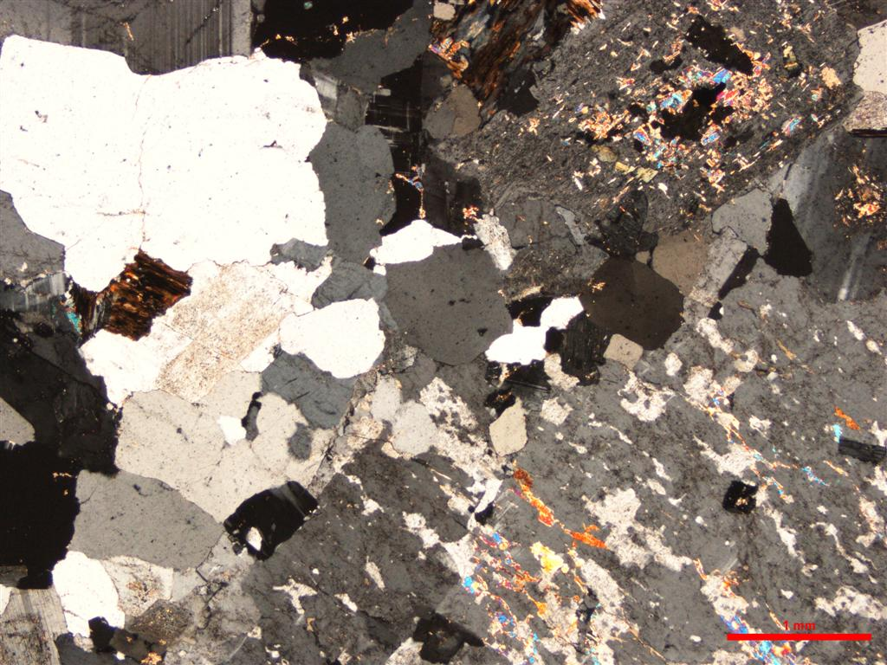
Figure 2.46 Photomicrograph of Elsmore Granite. Scale as indicated (1 mm), CPL. Note porphyritic, felsic character, development of vein and patch perthites, and incipient greisenisation (quartz and muscovite) along seams within the K-feldspar (lower right of image). Sericite flecks also present in the plagioclase. Biotite in this view is strongly altered to chlorite and related secondaries (PBNE-10-TIGI-47/2105112).

Zircons
Zircons separated from this sample are euhedral, turbid, light brown, large grains with diameters between ~80–140 µm and aspect ratios typically between 3 to 5. Concentric zoning patterns are clearly visible in transmitted light images and the majority have numerous inclusions. They have a moderate to weak luminescence and about 5% are strongly luminescent. The majority are oscillatory zoned with many containing strongly luminescent small spots of ?apatite (Figure 2.47).

U–Pb isotopic results
Twenty-eight SHRIMP U–Pb isotopic analyses were carried out on 23 zircons from this sample (Figure 2.48 and Table 2.28). Uranium concentrations range from low to high (58–1254 ppm, median = 406 ppm) and Th/U ratios range from 0.18 to 0.71. Common 206Pb proportions are all below 1% (206Pbc). Two analyses (112.Z.12.1.1 and 112.Z.15.1.1) have distinctly low 206Pb/238U ratios in comparison to the other results from this sample (Figure 2.48). This was noted during the analytical session and follow-up analyses adjacent to these low results were undertaken (112.Z.12.2.1 and 112.Z.15.2.1) which proved to be identical within error to the other 24 analyses undertaken on this sample. Therefore, the two low analyses (112.Z.12.1.1 and 112.Z.15.1.1) are interpreted to represent regions on these two zircons where Pb-loss has occurred. The remaining 26 analyses have the same radiogenic 206Pb/238U within their analytical uncertainties (MSWD = 1.48, probability = 0.06) and combine to give a weighted mean age of 250.3 ± 1.8 Ma, which is interpreted to be the magmatic crystallisation age of this rock.
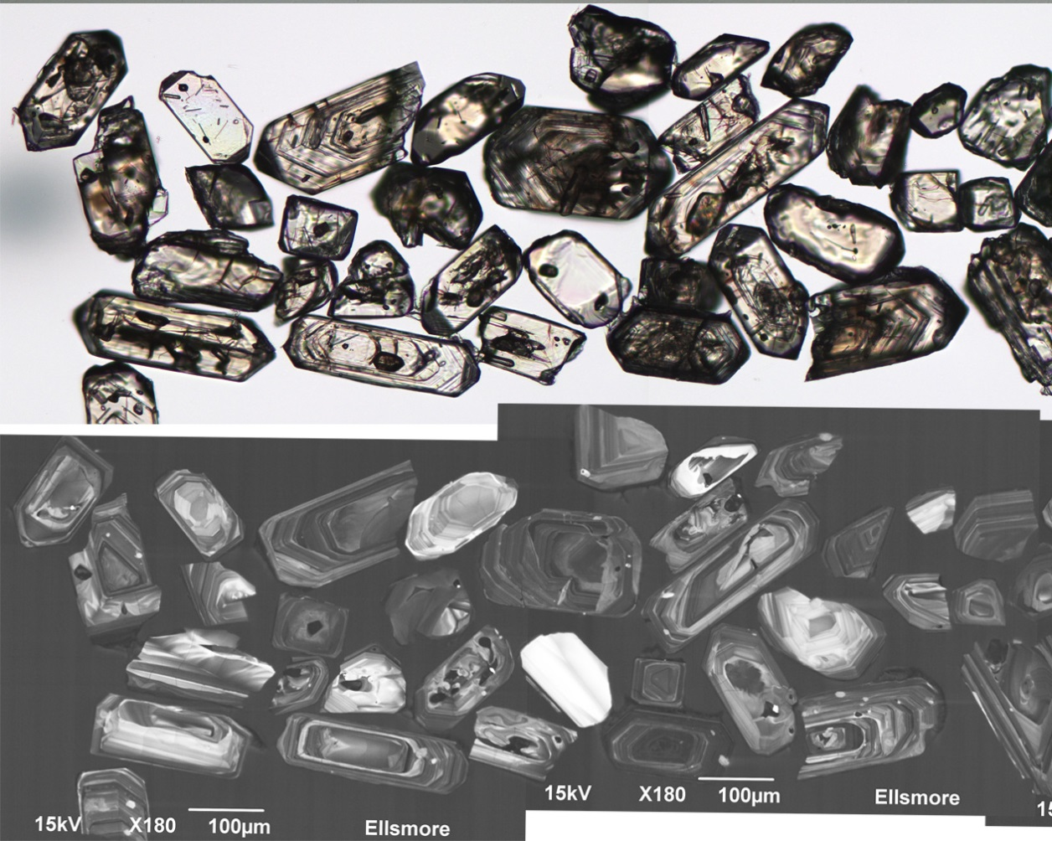
Figure 2.47 Selected transmitted light (top) and cathodoluminescence (bottom) images of zircon grains from the Elsmore Granite (PBNE-10-TIGI-47/2105112).
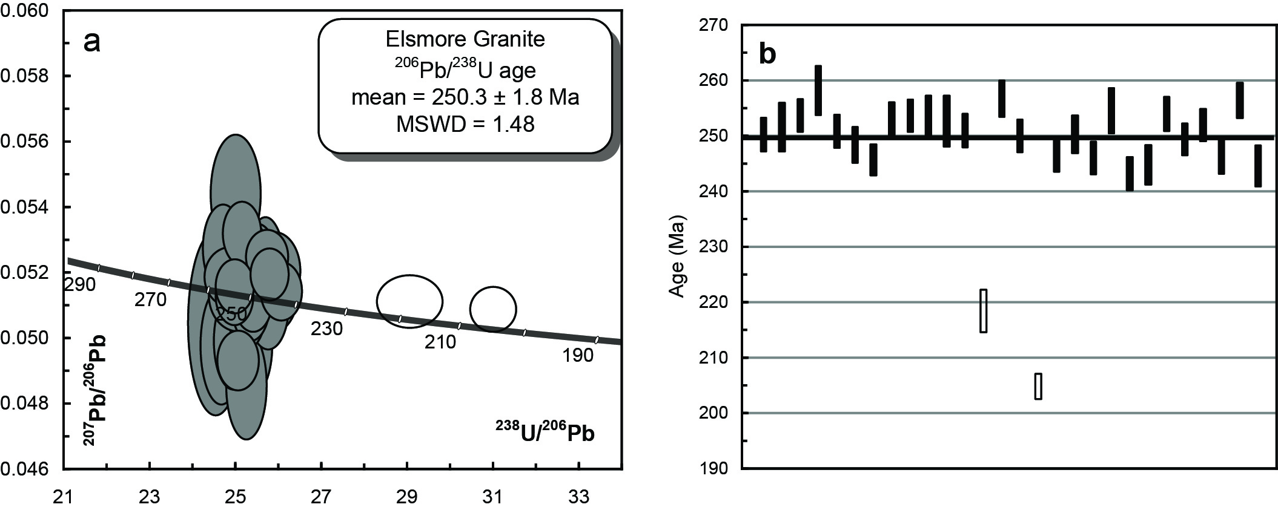
Figure 2.48 (a) Tera-Wasserberg concordia plot and (b) temporal trend of the 206Pb/238U ages from the Elsmore Granite (PBNE-10-TIGI-47/2105112). The unfilled ellipses in (a) and bars in (b) represent zircon regions where Pb-loss has occurred.
Table 2.28 SHRIMP U–Pb zircon data from Elsmore Granite (PBNE-10-TIGI-47/2105112).
Grain.area | 206Pbc (%) | U (ppm) | Th (ppm) | 232Th/  238U | 238U/  206Pb | ± 1σ (%) | 207Pb/  206Pb | ± 1σ (%) | 206Pb/238U Age (Ma) | ± 1σ (Ma)
Magmatic zircons
112.Z.1.1.1 | -0.09 | 420 | 215 | 0.53 | 25.2625 | 1.2 | 0.0524 | 1.5 | 250.3 | 3.0
112.Z.2.1.1 | 0.19 | 260 | 123 | 0.49 | 25.1241 | 1.8 | 0.0497 | 2.3 | 251.6 | 4.4
112.Z.3.1.1 | -0.02 | 574 | 225 | 0.40 | 24.9150 | 1.2 | 0.0513 | 1.2 | 253.7 | 2.9
112.Z.4.1.1 | 0.00 | 58 | 27 | 0.49 | 24.4708 | 1.7 | 0.0504 | 3.7 | 258.2 | 4.4
112.Z.5.1.1 | 0.15 | 365 | 126 | 0.36 | 25.2067 | 1.2 | 0.0509 | 1.7 | 250.8 | 3.0
112.Z.5.2.1 | 0.00 | 186 | 82 | 0.45 | 25.4597 | 1.3 | 0.0519 | 2.0 | 248.4 | 3.3
112.Z.6.1.1 | 0.12 | 1071 | 524 | 0.50 | 25.7466 | 1.1 | 0.0519 | 1.0 | 245.6 | 2.8
112.Z.7.1.1 | 0.17 | 930 | 435 | 0.48 | 25.0011 | 1.3 | 0.0493 | 1.2 | 252.8 | 3.2
112.Z.8.1.1 | 0.05 | 777 | 313 | 0.42 | 24.9214 | 1.2 | 0.0515 | 1.1 | 253.6 | 2.9
112.Z.9.1.1 | -0.20 | 259 | 108 | 0.43 | 24.9401 | 1.5 | 0.0544 | 2.2 | 253.4 | 3.8
112.Z.10.1.1 | -0.03 | 357 | 133 | 0.39 | 25.0162 | 1.8 | 0.0513 | 1.4 | 252.7 | 4.6
112.Z.11.1.1 | 0.33 | 346 | 147 | 0.44 | 25.1948 | 1.2 | 0.0485 | 2.3 | 250.9 | 3.0
112.Z.13.1.1 | 0.16 | 212 | 110 | 0.54 | 24.6143 | 1.3 | 0.0497 | 2.4 | 256.7 | 3.3
112.Z.14.1.1 | 0.12 | 494 | 231 | 0.48 | 25.2903 | 1.2 | 0.0510 | 1.5 | 250.0 | 2.9
112.Z.16.1.1 | 0.31 | 259 | 142 | 0.57 | 25.6468 | 1.3 | 0.0517 | 2.5 | 246.6 | 3.1
112.Z.17.1.1 | 0.15 | 144 | 85 | 0.61 | 25.2594 | 1.4 | 0.0506 | 2.7 | 250.3 | 3.4
112.Z.17.2.1 | 0.10 | 349 | 62 | 0.18 | 25.7091 | 1.2 | 0.0509 | 1.7 | 246.0 | 3.0
112.Z.18.1.1 | -0.04 | 596 | 166 | 0.29 | 24.8303 | 1.6 | 0.0518 | 1.2 | 254.5 | 4.1
112.Z.15.2.1 | 0.08 | 824 | 353 | 0.44 | 26.0181 | 1.3 | 0.0514 | 1.2 | 243.1 | 3.0
112.Z.12.2.1 | 0.09 | 873 | 297 | 0.35 | 25.8435 | 1.5 | 0.0515 | 1.7 | 244.7 | 3.5
112.Z.9.2.1 | 0.24 | 392 | 267 | 0.71 | 24.8894 | 1.2 | 0.0499 | 2.0 | 253.9 | 3.0
112.Z.19.1.1 | 0.09 | 647 | 349 | 0.56 | 25.3546 | 1.2 | 0.0511 | 1.2 | 249.4 | 2.9
112.Z.20.1.1 | -0.10 | 657 | 204 | 0.32 | 25.0918 | 1.2 | 0.0532 | 1.2 | 251.9 | 2.9
112.Z.22.1.1 | -0.02 | 722 | 417 | 0.60 | 25.6888 | 1.3 | 0.0524 | 1.0 | 246.2 | 3.1
112.Z.23.1.1 | 0.00 | 253 | 152 | 0.62 | 24.6477 | 1.3 | 0.0527 | 1.7 | 256.4 | 3.2
112.Z.24.1.1 | 0.00 | 389 | 214 | 0.57 | 25.8653 | 1.5 | 0.0520 | 1.5 | 244.5 | 3.7
Pb loss
112.Z.12.1.1 | 0.19 | 1254 | 578 | 0.48 | 29.0368 | 1.8 | 0.0511 | 1.0 | 218.3 | 3.8
112.Z.15.1.1 | 0.00 | 1100 | 422 | 0.40 | 31.0040 | 1.1 | 0.0508 | 0.9 | 204.6 | 2.3
- %206Pbc indicates the proportion of common 206Pb in the total measured 206Pb.
- Pb isotopic ratios corrected for common Pb by reference to the measured 204Pb.
- All errors quoted as 1σ.

Culaden Granodiorite PBNE-09-NEV-04/2105113
Table 2.29 Summary of results: Culaden Granodiorite (PBNE-09-NEV-04/2105113).
GA SampleID | 2010016005
GA SampleNO | 2105113
GSNSW SITEID | PBNE-09-NEV-04
Formal Name | Culaden Granodiorite
Informal Name | -
Lithology | granodiorite
1:250 000 Sheet | GRAFTON (SH5606)
1:100 000 Sheet | CLIVE (9239)
Region | New England Region
Location (GDA94) | 151.601517 °E, -29.412421 °S
Location (MGA 94 Zone 56) | 364325 mE, 6745507 mN
Geochronologist | Andrew Cross
Mount ID | GA6139
Analytical Session | 100128
Interpreted Age | 252.2 ± 1.9 Ma (95% confidence, 26 analyses on 26 zircons)
Geological Attribution | Magmatic crystallisation
Isotopic Ratio Used | 206Pb/238U

Sample Information
This sample was collected on the western side of Gulf Road from low, fresh rubbly outcrop where a dyke crosses the road northwest of Emmaville adjacent to the Golf Club. The sample is a grey medium– to coarse–grained porphyritic quartz, feldspar biotite amphibole granodiorite outcropping as a prominent dyke (>14 km long) extending from the contact with Mole Granite to northwest of Emmaville. The Culaden Granodiorite is one of a number of similar bodies around Emmaville with several informal names (e.g., Hospital Hill, Ottery, Says etc; see Wood 1982). Geochemically, it is similar to the Uralla Supersuite and is cut by the Mole Granite. Its relationship to the Emmaville Volcanics is unclear. These units contain cassiterite, arsenopyrite and pyrite mineralisation presumably imposed by Mole Granite. The dyke is hosted by unnamed Permian siliciclastic sediments.

Petrography
The sample is a strongly porphyritic granodioritic porphyry with phenocrysts (size range from 0.1 mm to 5 mm; comprising 50 modal percent of rock) of plagioclase, amphibole, biotite, K-feldspar and quartz set in a very fine grained granular groundmass. Plagioclases are very fresh, strongly zoned and twinned and euhedral to subhedral. Amphiboles (brown → olive green) comprise individual and small groups of euhedral rhombs. K-feldspars are less well formed and drab. Biotite (medium chocolate brown → straw yellow brown) are subhedral to euhedral and very fresh. The quartz are blocky in shape and partially skeletal around the margins suggesting rapid growth during undercooling. Some glomeroporphyritic aggregates of (dominantly) feldspar are also present (Figure 2.49).
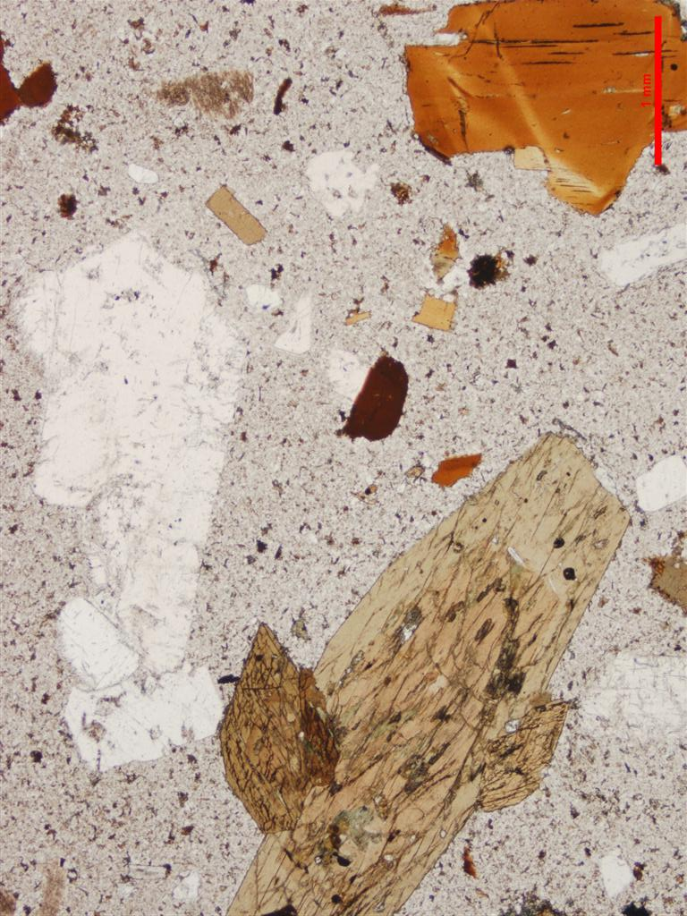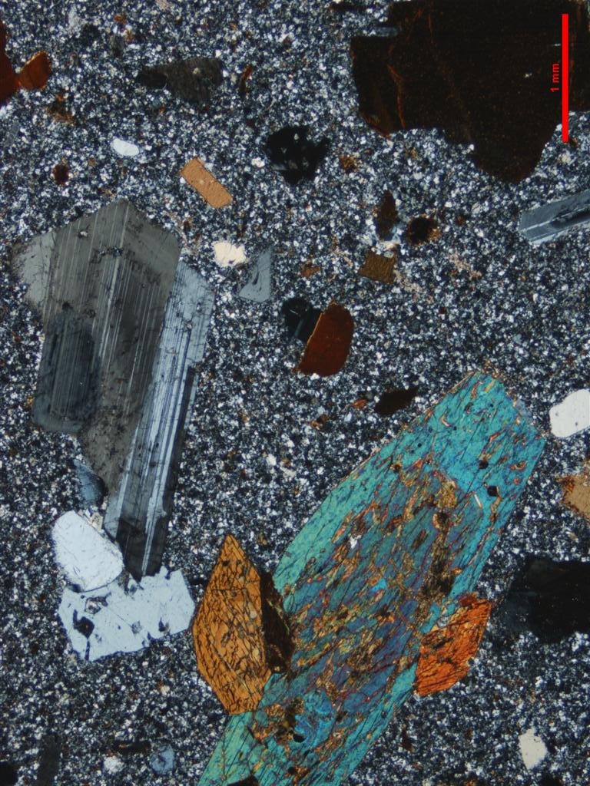
Figure 2.49 Photomicrograph of Culaden Granodiorite (inf). Scale as indicated (1 mm); left: PPL, right: CPL. Strongly porphyritic texture showing prominent amphibole, biotite, plagioclase and minor quartz phenocrysts (PBNE-09-NEV-04/2105113).

Zircons
Zircons separated from this sample are a homogeneous population of euhedral, clear and colourless to light brown grains. They range from ~70–100 µm in diameter and have aspect ratios of about 2. They generally have a moderate luminescence with well–defined oscillatory growth zones (Figure 2.50).

U–Pb isotopic results
Twenty-six SHRIMP U–Pb isotopic analyses were carried out on 26 zircons from this sample (Figure 2.51 and Table 2.30). Uranium concentrations are moderate (92–710 ppm, median = 185 ppm) and Th/U ratios range between 0.30 to 0.92. Common 206Pb proportions are low and generally below 1% (206Pbc). All 26 zircons have the same radiogenic 206Pb/238U within their analytical uncertainties (MSWD = 0.84, probability = 0.69) and contribute to a weighted mean age of 252.2 ± 1.9 Ma, which is interpreted as the magmatic crystallisation age of the Culaden Granodiorite.
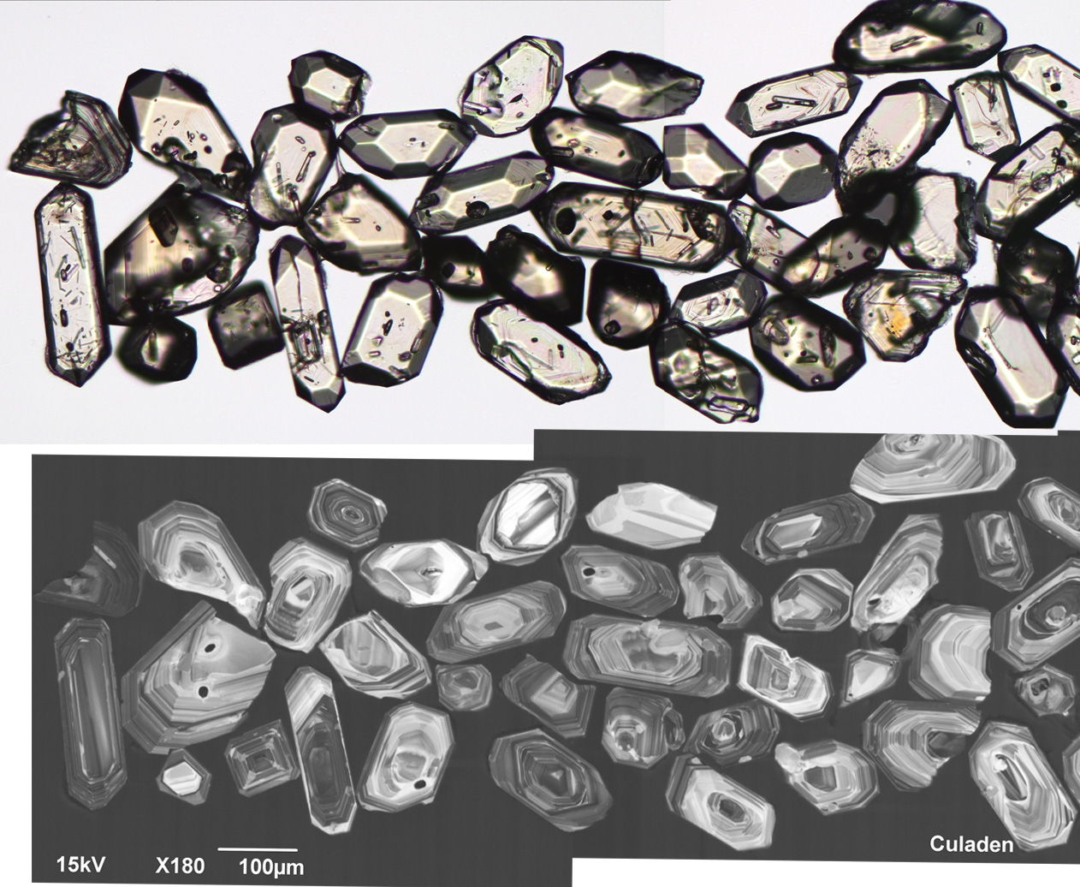
Figure 2.50 Selected transmitted light (top) and cathodoluminescence (bottom) images of zircon grains from the Culaden Granodiorite (PBNE-09-NEV-04/2105113).
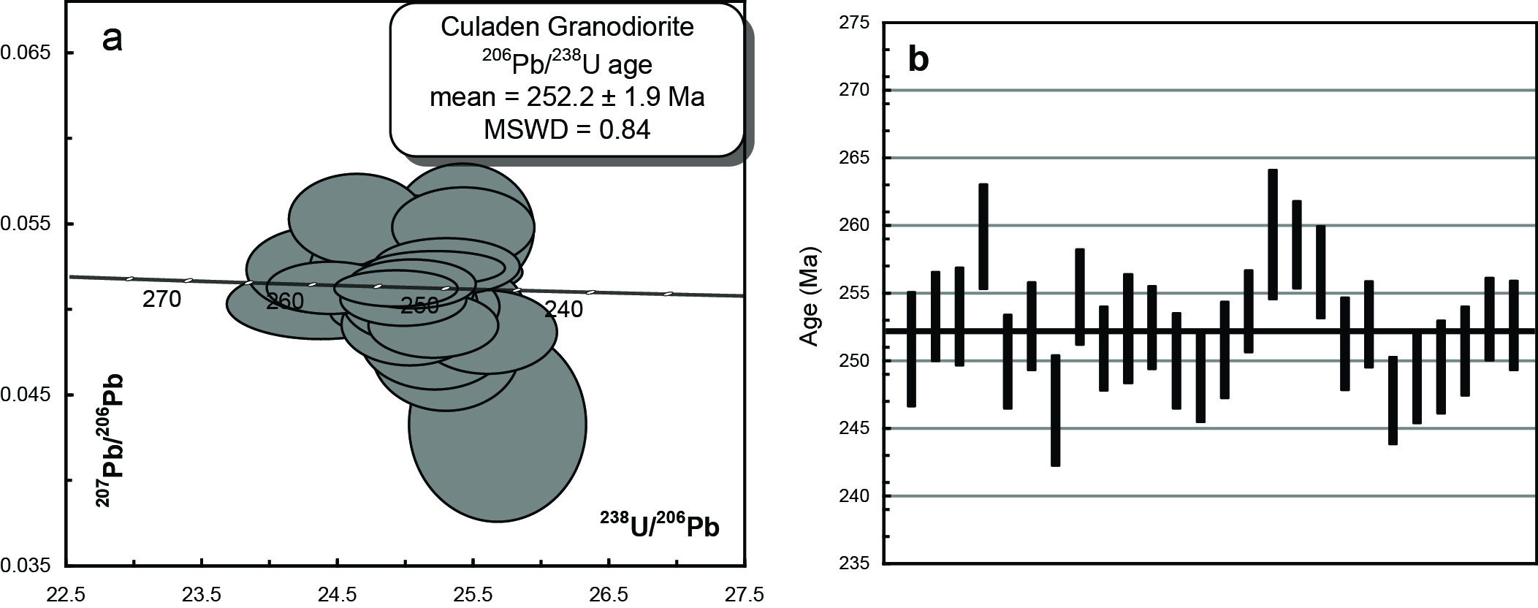
Figure 2.51 (a) Tera-Wasserberg concordia plot and (b) temporal trend of the 206Pb/238U ages from the Culaden Granodiorite (PBNE-09-NEV-04/2105113).
Table 2.30 SHRIMP U–Pb zircon data from Culaden Granodiorite (PBNE-09-NEV-04/2105113).
Grain.area | 206Pbc (%) | U (ppm) | Th (ppm) | 232Th/  238U | 238U/  206Pb | ± 1σ (%) | 207Pb/  206Pb | ± 1σ (%) | 206Pb/238U Age (Ma) | ± 1σ (Ma)
Magmatic zircons
113.Z.1.1.1 | -0.09 | 265 | 125 | 0.49 | 25.2002 | 1.7 | 0.0522 | 1.9 | 250.9 | 4.2
113.Z.2.1.1 | 0.11 | 197 | 57 | 0.30 | 24.9541 | 1.3 | 0.0511 | 2.3 | 253.3 | 3.3
113.Z.3.1.1 | 0.18 | 130 | 72 | 0.57 | 24.9559 | 1.5 | 0.0541 | 3.1 | 253.3 | 3.6
113.Z.4.1.1 | -0.12 | 99 | 49 | 0.52 | 24.3745 | 1.5 | 0.0523 | 3.2 | 259.2 | 3.9
113.Z.5.1.1 | 0.00 | 170 | 70 | 0.42 | 25.2964 | 1.4 | 0.0525 | 2.1 | 249.9 | 3.5
113.Z.6.1.1 | 0.41 | 223 | 129 | 0.60 | 25.0268 | 1.3 | 0.0503 | 3.0 | 252.6 | 3.2
113.Z.7.1.1 | 1.33 | 92 | 46 | 0.52 | 25.6732 | 1.7 | 0.0432 | 8.7 | 246.3 | 4.1
113.Z.8.1.1 | -0.41 | 147 | 76 | 0.53 | 24.8104 | 1.4 | 0.0524 | 3.5 | 254.7 | 3.5
113.Z.9.1.1 | 0.38 | 301 | 157 | 0.54 | 25.1964 | 1.3 | 0.0490 | 2.6 | 250.9 | 3.1
113.Z.10.1.1 | 0.22 | 346 | 201 | 0.60 | 25.0474 | 1.6 | 0.0498 | 2.1 | 252.4 | 4.0
113.Z.11.1.1 | -0.14 | 331 | 204 | 0.64 | 25.0385 | 1.2 | 0.0515 | 1.8 | 252.5 | 3.1
113.Z.12.1.1 | 0.64 | 136 | 81 | 0.61 | 25.2897 | 1.4 | 0.0475 | 4.9 | 250.0 | 3.5
113.Z.13.1.1 | -0.35 | 168 | 91 | 0.56 | 25.4146 | 1.4 | 0.0547 | 4.6 | 248.8 | 3.3
113.Z.14.1.1 | 0.38 | 131 | 65 | 0.52 | 25.2066 | 1.4 | 0.0482 | 4.1 | 250.8 | 3.6
113.Z.15.1.1 | -0.03 | 430 | 384 | 0.92 | 24.9166 | 1.2 | 0.0512 | 1.4 | 253.7 | 3.0
113.Z.16.1.1 | 0.08 | 131 | 64 | 0.50 | 24.3615 | 1.9 | 0.0503 | 2.7 | 259.3 | 4.8
113.Z.17.1.1 | -0.02 | 710 | 280 | 0.41 | 24.4328 | 1.3 | 0.0512 | 2.0 | 258.6 | 3.2
113.Z.18.1.1 | -0.51 | 181 | 102 | 0.58 | 24.6293 | 1.3 | 0.0553 | 3.2 | 256.6 | 3.4
113.Z.19.1.1 | 0.21 | 149 | 68 | 0.47 | 25.1587 | 1.4 | 0.0501 | 3.0 | 251.3 | 3.4
113.Z.20.1.1 | 0.37 | 258 | 139 | 0.56 | 25.0126 | 1.3 | 0.0511 | 2.7 | 252.7 | 3.2
113.Z.21.1.1 | 0.42 | 189 | 100 | 0.55 | 25.5980 | 1.3 | 0.0486 | 3.3 | 247.0 | 3.2
113.Z.21.2.1 | -0.28 | 158 | 82 | 0.54 | 25.4203 | 1.4 | 0.0548 | 2.8 | 248.7 | 3.3
113.Z.22.1.1 | 0.40 | 156 | 79 | 0.52 | 25.3374 | 1.4 | 0.0499 | 3.8 | 249.5 | 3.4
113.Z.23.1.1 | -0.02 | 488 | 371 | 0.79 | 25.2163 | 1.3 | 0.0524 | 1.3 | 250.7 | 3.3
113.Z.24.1.1 | 0.25 | 383 | 182 | 0.49 | 24.9749 | 1.2 | 0.0506 | 2.0 | 253.1 | 3.1
113.Z.25.1.1 | 0.41 | 195 | 102 | 0.54 | 25.0224 | 1.3 | 0.0491 | 3.2 | 252.6 | 3.3
- %206Pbc indicates the proportion of common 206Pb in the total measured 206Pb.
- Pb isotopic ratios corrected for common Pb by reference to the measured 204Pb.
- All errors quoted as 1σ.

Acknowledgements
We would like to acknowledge the meticulous care and professionalism taken with the crushing of samples, SHRIMP mount preparation, photography and SEM imaging of zircons undertaken by members of the Geoscience Australia Geochronology Laboratory: Chris Foudoulis, Steve Ridgeway, Emma Chisholm and David DiBugnara. Patrick Burke ensured the SHRIMP was optimally tuned during all analytical sessions and Les Sullivan’s readiness to assist with any computer related or data storage issues is much appreciated. Thoughtful and careful reviews by Emma Chisholm and Natalie Kositcin of this record are greatly appreciated.

References
Black, L.P., Kamo, S.L., Allen, C.M., Davis, D.W., Aleinikoff, J.N., Valley, J.W., Mundil, R., Campbell, I.H., Korsch, R.J., Williams, I.S. and Foudoulis, C. 2004. Improved 206Pb/238U microprobe geochronology by the monitoring of a trace-element-related matrix effect; SHRIMP, ID–TIMS, ELA–ICP–MS and oxygen isotope documentation for a series of zircon standards. Chemical Geology, 205, 115–140.
Black, L.P. 2007. SHRIMP U–Pb zircon ages obtained during 2006/07 for NSW Geological Survey projects. Geological Survey Report, GS2007/298.
Brownlow, J. and Cross, A. 2010. TIMS U–Pb and SHRIMP U–Pb zircon dating of the Dundee Rhyodacite, northern New England, NSW. New England Orogen 2010 (NEO 2010), 16–19 November 2010, University of New England, NSW.
Claoué-Long, J.C., Compston, W., Roberts, J. and Fanning, M.M. 1995. Two Carboniferous ages: a comparison of SHRIMP zircon dating with conventional zircon ages and 40Ar/39Ar analysis. Geochronology Time Scales and Global Stratigraphic Correlation, SEPM Special Publication No. 54.
Compston, W., Williams, I.S. and Meyer, C. 1984. U–Pb geochronology of zircons from lunar breccia 73217 using a sensitive high resolution ion microprobe. Journal of Geophysical Research Supplement 89, B525–B534.
Cross, A.J., Purdy, D.J., Bultitude, R.J., Dhnaram, C. and von Gnielinski, F.E., 2009. Summary of results, Joint GSQ-GA geochronology project; New England Orogen and Drummond Basin. 2009/03, Geological Survey of Queensland, Brisbane.
Cross, A and Blevin, P. 2010. Summary of results for the joint GSNSW—GA geochronology project: New England Orogen and Sydney—Gunnedah Basin April—July 2008. Geological Survey Report, GS2010/778.
Cross, A.J., Bultitude, R.J., and Purdy, D.J., 2012. Summary of results – Joint GSQ–GA Geochronology project: Ayr, Bowen, Eulo, Mount Coolon; Proserpine and Warwick 1:250 000 Sheet areas. Queensland Geological Record 2012/19.
Chisholm, E.I., Blevin, P.L., Simpson, C.J., In prep–a. New SHRIMP U–Pb zircon ages from the New England Orogen, NSW: July 2010–June 2012. Geoscience Australia: Record. In prep.
Chisholm, E. I., Blevin, P. L., Simpson, C. J., In prep–b. New SHRIMP U–Pb zircon ages from the New England Orogen, NSW: July 2012–June 2013. Geoscience Australia Record. In prep.
Hensel, H.D., Chappell, B.W., Compston, W., and McCulloch, M.T. 1982. A neodymium and strontium isotopic investigation of granitoids and possible source rocks from New England, eastern Australia. In: Flood, P.G., and Runnegar, B. (eds). New England Geology. Voisey Symposium. Department of Geology, University of New England and AHV Club. Armidale. pp. 193–200.
Hensel., H.D. 1980. The Mineralogy, Petrology and Geochronology of Granitoids and Associated Intrusives from the Southern Portion of the New England Batholith. PhD (unpublished), University of New England, Armidale.
Landenberger, B. and Collins, W.J. 1996. Derivation of A-type granites from a dehydrated charnockitic lower crust: evidence from the Chaelundi Complex, eastern Australia. Journal of Petrology, 37, 145–170.
Leitch, E.C., and McDougall, I. 1979. The age of orogenesis in the Nambucca Slate Belt: a K/Ar study of low-grade regional metamorphic rocks. Journal of the Geological Society of Australia, 26, 111–119.
Ludwig, K.R. 2008. Isoplot 3.6: A Geochronological toolkit for Microsoft Excel. Berkley Geochronology Center Special Publication No. 4. http://sourceforge.net/projects/isoplot
Ludwig, K.R. 2009. SQUID 2.50: a users manual. Berkley Geochronology Center. http://sourceforge.net/projects/squid2
McDougall, I. and Wellman, P. 1976. Potassium-argon ages for some Australian Mesozoic igneous rocks. Journal of the Geological Society of Australia, 23, 1–9.
Nasdala, L., Hofmeister, W., Norberg, N., Mattinson, J.M., Corfu, F., Dörr, W., Kamo, S.L., Kennedy, A.K., Kronz, A., Reiners, P.W., Frei, D., Kosler, J., Wan Y., Götze, J., Häger, T., Kröner, A. and Valley, J.W. 2008. Zircon M257 – a homogeneous natural reference material for the ion microprobe U–Pb analysis of zircon: Geostandards and Geoanalytical Research 32, 247–265.
Norman, M., Bennett, V., Blevin, P. and McCulloch, M. 2004. New Re-Os ages of molybdenite from granite-related deposits of Eastern Australia using an improved multi-collector ICP-MS technique. Tectonics to Mineral Discovery - Deconstructing the Lachlan Orogen, Geological Society of Australia Abstracts 74, 129–132.
Pidgeon, R.T., Furfaro, D., Kennedy, A.K., Nemchin, A.A. and van Bronswjk, W. 1994. Calibration of zircon standards for the Curtin SHRIMP: in ‘8th International Conference on Geochronology, Cosmochronology and Isotope Geology’. United States Geological Survey Circular 1107, 251.
Stern, R.A., Bodorkos, S., Kamo, S.L., Hickman, A.H. and Corfu, F. 2009. Measurement of SIMS instrumental mass fractionation of Pb-isotopes during zircon dating. Geostandards and Geoanalytical Research, 33 (2), 145–168.
Williams, I.S. and Claesson, S. 1987. Isotopic evidence for the Precambrian provenance and Caledonian metamorphism of high-grade paragneisses from the Seve Nappes. Scandinavian Caledonides II. Ion microprobe zircon U-Th-Pb. Contributions to Mineralogy and Petrology, 97, 205–217.
Wood, B.L. 1982. The geology and mineralisation of the Emmaville tin field, N.S.W. In: Flood, P. G., and Runnegar, B., New England Geology: The Voisey Symposium. University of New England. pp. 335–344.

Additional Session Metadata
  - Mount GA6089 (session 90042)
PB-NE-08-24 (1980500) Middle Brother monzodiorite
PB-NE-08-26 (1980501) Glen Esk Adamellite
PB-NE-08-28 (1980502) Smokey Cape Adamellite
PB-NE-08-29 (1980503) Yarrahapinni Adamellite
PB-NE-08-30 (1980504) Valla Adamellite
PB-NE-08-31 (1980505) Round Mountain Leucoadamellite
The zircons on this mount were analysed during a five-day session from the 4th to the 8th of May 2009. Uranium abundance was calculated with reference to SL13 (238 ppm; Claoué–Long et al. 1995). Early in the session while the SHRIMP was operating in autorun mode, the magnet inadvertently centred on a REEOx peak, down-mass from the subordinate 206Pb peak. This affected six analyses, which have been removed from the data set. Thirty-eight analyses of the TEMORA 2 zircon standard have a 1σ 206Pb/238U reproducibility of 0.91% and a 2σ standard error of 0.23% (Figure 1.2).
  - Mount GA6118 (session 100031)
PB-NE-08-32 (1980506) Oban River Leucoadamellite
PB-NE-08-34 (1980508) Red Range leucoadamellite
MD-1 (2002565) Mount Duval Monzogranite
N-1 (2002566) Newholme monzogranite
PB-09-NE-GD1 (2002567) Pringles Monzogranite
The zircons on this mount were analysed during a continuous, unbroken analytical session from the 22nd to the 25th of February 2010. Uranium abundance was calculated with reference to CZ3 (551 ppm; Pigeon et al. 1994). Thirty-five analyses of the TEMORA 2 zircon standard have a 1σ 206Pb/238U reproducibility of 0.70% and a 1σ standard error of 0.19% (Figure 1.2).
  - Mount GA6139 (session 100128)
PBNE-10-HC-01 (2105109) Highlands Complex monzogranite
PBNE-09-NEV-02 (2105111) Emmaville Volcanics volcaniclastic
PBNE-10-TIGI-47 (2105112) Elsmore Granite
PBNE-09-NEV-04 (2105113) Culaden Granodiorite
The zircons on this mount were analysed during a continuous, unbroken analytical session from the 28th of September to the 1st of October. Uranium abundance was calculated with reference to M257 (840 ppm; Nasdala et al. 2008). Thirty-one analyses of the TEMORA 2 zircon standard have a 1σ 206Pb/238U reproducibility of 1.10% and a 1σ standard error of 0.26% (Figure 1.2).

