Earthquake Ground Shaking Susceptibility of the Botany Area, New South Wales
Geoscience Australia
RECORD 2013/26
Andrew McPherson1 (editor), Trevor Dhu1, Trevor Jones1 and Michael Neville2

- Geoscience Australia, GPO Box 378, Canberra ACT 2601
- NSW Public Works, 2-24 Rawson Place, Sydney NSW 2000
Department of Industry
Minister for Industry: The Hon Ian Macfarlane MP
Parliamentary Secretary: The Hon Bob Baldwin MP
Secretary: Ms Glenys Beauchamp PSM
Geoscience Australia
Chief Executive Officer: Dr Chris Pigram
This paper is published with the permission of the CEO, Geoscience Australia

© Commonwealth of Australia (Geoscience Australia) 2013
With the exception of the Commonwealth Coat of Arms and where otherwise noted, all material in this publication is provided under a Creative Commons Attribution 3.0 Australia Licence. (http://www.creativecommons.org/licenses/by/3.0/au/deed.en)
Geoscience Australia has tried to make the information in this product as accurate as possible. However, it does not guarantee that the information is totally accurate or complete. Therefore, you should not solely rely on this information when making a commercial decision.
Geoscience Australia is committed to providing web accessible content wherever possible. If you are having difficulties with accessing this document please contact clientservices@ga.gov.au.
ISSN 2201-702X (PDF)
ISBN 978-1-922201-58-4 (PDF)
GeoCat 75265
Bibliographic reference: McPherson, A. (ed.), Dhu, T., Jones, T. and Neville, M. 2013. Earthquake ground shaking susceptibility of the Botany area, New South Wales. Record 2013/26. Geoscience Australia: Canberra.
Version: 1309

Table of Contents
Executive Summary 1
Introduction 3
Authors’ Note 3
Importance of assessing earthquake risk in the Botany area 3
Previous Earthquake Risk Assessments in the Botany Area 4
Engineering Geology and Regolith Classification 7
Regional Geology 7
Description of the Botany Basin Regolith 7
Regolith Site Classes 10
Amplification of Earthquake Ground Shaking 15
Earthquake Shaking Susceptibility 19
Implications for Earthquake Risk 21
Conclusions 27
Acknowledgements 28
References 29

Executive Summary
An earthquake of magnitude 6.0-6.5 in the Sydney region of Australia is viewed by the global insurance community as one of the top 40 risks it faces worldwide from natural disasters. The high ranking of this perceived risk is due to the high population density, standards of construction and the level of insurance exposure in Sydney. Consequently, earthquake hazard and risk in Sydney is an important issue, and one that requires a focused and detailed study in order for the implications of such an earthquake to be fully understood.
The presence of regolith (soils, sediments and weathered rock) can dramatically affect the level of ground shaking experienced during an earthquake. The relatively soft materials that constitute most regolith tend to have low seismic velocities that amplify ground shaking during an earthquake, increasing the potential for damage to buildings and other infrastructure in the affected area. Therefore, models of the response of regolith to an earthquake (referred to as site response) form an integral part of any earthquake risk assessment.
This report documents a preliminary study of potential ground motion amplification due to the regolith in the Botany area of Sydney, Australia. Botany was chosen due to the presence of a significant thickness of regolith and a high value and concentration of critical infrastructure. This report is intended to highlight the potential for significant levels of amplification within the study area, and draw attention to the need for more work on assessing the actual earthquake risk faced by the Sydney region.
In order to determine the amount of ground motion amplification that could be seen in the Botany area, the regolith was classified into a series of four site classes. These regolith site classes are differentiated in terms of geotechnical properties that control ground shaking potential. This classification was based upon published and unpublished geotechnical data as well as seismic velocities obtained by Geoscience Australia. Once geotechnical models were defined for each regolith site class, amplification factors were calculated using a vertically propagating shear wave model. This model accounts for the softening and critical damping of the regolith column during large earthquakes. The results demonstrate that there is significant potential for amplification of ground shaking within the study area. For example, the site class that covers the vast majority of the study area has a maximum amplification factor greater than 3.0 at a fundamental site period of approximately 0.5 s. This period of motion would be expected to strongly affect the structures in the study area.
The modelled amplification factors suggest that, should an earthquake impact the area, the potential for high levels of ground shaking would be dramatically increased due to the properties of the local regolith. An earthquake similar to the local magnitude (ML) 5.6 event experienced in Newcastle in 1989 was simulated, in order to demonstrate the potential amplification effect of the regolith during an earthquake. While this simulation is in no way a full probabilistic risk analysis of the area, it does demonstrate that the amplification of ground shaking could cause response spectral accelerations in excess of 1.0 g, at periods of vibration that would be expected to cause damage to structures in the area.
It is important to emphasise that this work is intended to provide a point of focus to initiate discussion rather than be a definitive seismic hazard assessment product. The results have been derived with limited geotechnical data, and without a detailed analysis of the uncertainties present within either the data or the modelling process. Nevertheless, this work does provide a starting point for recognising and addressing the potential risk that earthquakes pose to the study area.

Introduction
  - Authors’ Note
This study was conducted largely during the period 2000–2002 but was not published at that time because the authors had moved to other competing priorities. There has been continued demand for the information arising from the study, driven particularly from stakeholders in the New South Wales Government and industry who are charged with managing the risk from potential earthquakes in the Sydney region. In light of this demand, renewed efforts have been made to publish the study. This report presents the data captured, methods used and interpretations of the results from that earlier time. No new data or research have been added, with the exception of the seismicity map of the Sydney region, which has been updated to include earthquakes up until January 2013. As such, the report presents the reader with the contemporary knowledge of earthquake susceptibility in the Botany area at that time.
  - Importance of assessing earthquake risk in the Botany area
The 28 December 1989 ML 5.6 Newcastle earthquake demonstrated that the moderate-sized earthquakes that regularly occur within Australia could be responsible for catastrophic damage and loss of life. Table 1 documents some of the significant earthquakes that have occurred within the Sydney region, and suggests that there is significant seismicity within this region. Historically, most of this seismic activity has occurred some distance from metropolitan Sydney (Figure 1). However, the recording of earthquakes in Australia has been carried out for a relatively short period of time, and there is no known reason why an earthquake could not occur close to, or beneath, the Sydney metropolitan area.
A significant concern regarding earthquake hazard in urban areas is the potential for the amplification of seismic ground shaking in the soft soils, sediments and weathered rock, often referred to as regolith. Regolith materials are documented to have caused amplification and extended the duration of ground shaking (Borcherdt and Gibbs, 1976, Murphy et al., 1971; Meremonte et al., 1996) in numerous disastrous earthquakes around the world, including the 1995 Kobe (Japan) and the 1988 Spitak (Armenia), earthquakes. This phenomenon may also have influenced the distribution of damage in the Hunter River delta area during the 1989 Newcastle earthquake (Dhu and Jones, 2002).
The Botany study area lies within the northern Botany Basin, which comprises a sequence of Quaternary sediments from a variety of geological environments, including beach deposits, sand dunes, tidal deltas, mud flats and swamps. In addition, man-made fills have been placed over portions of the study area. These unconsolidated deposits constitute the regolith in the area and are typically in the order of 30–35 m thick, but may be up to 70–80 m thick. The area also has one of the largest concentrations of major lifeline elements in Sydney, a high population density, and major chemical and petrochemical industries. This density of lifelines and population, combined with the relatively thick regolith, suggests that a moderate-sized earthquake located near the Botany area could have a severe impact. Consequently, it is imperative that the risk posed by such potential earthquakes be clearly understood.
  - Previous Earthquake Risk Assessments in the Botany Area
Blong (1993) carried out an earthquake probable maximum loss (PML) study on household buildings in the Sydney region. This was a broad-brush study based on postcode areas; however, the Botany area was rated as a high hazard zone, characterised by moderate to high estimated losses (Blong, 1993). A revised earthquake PML study on household buildings in the Sydney region classified the Botany area as having moderate to high ground shaking hazard (Blong, 1997). This classification was due in part to the highly variable regolith in the Botany area. Burg (1996) undertook a seismic risk assessment in the Botany Basin by collecting and analysing available geological data to generate an initial estimate of earthquake hazard to be made, along preliminary assessments of lifeline vulnerability.
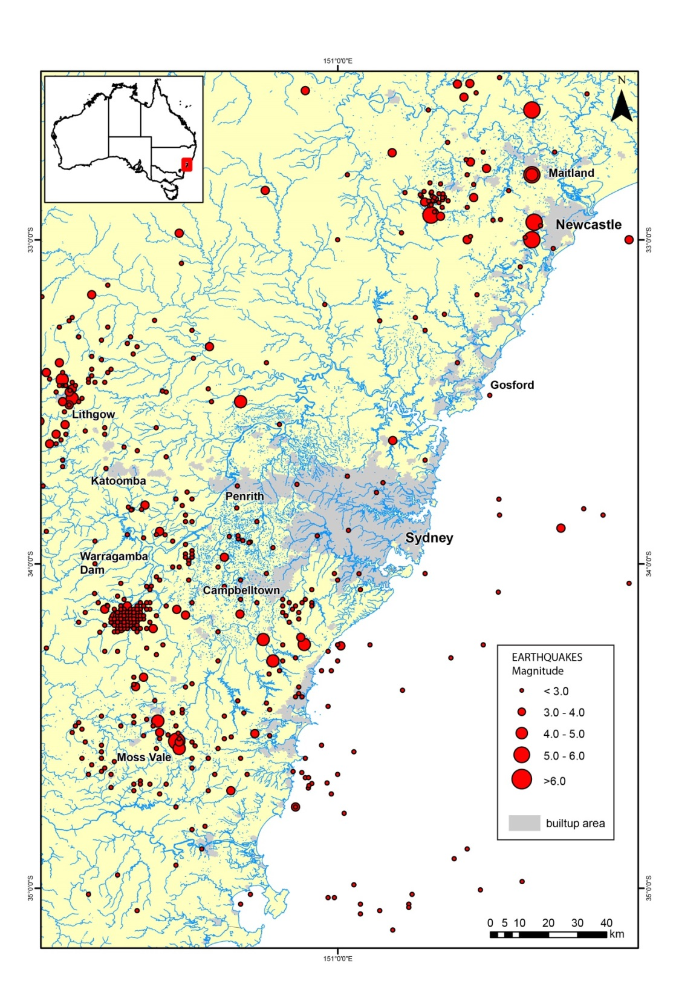
Figure 1. Distribution of seismicity recorded around the greater Sydney region from 1837 to January 2013.
Table 1. Historical earthquakes in New South Wales known to have been felt in the Botany area.
Date | Time (UTC2) | Lat (°S) | Long (°E) | Location | ML3 | MMmax4 | Comments | Reference
02/07/1837 | 12:20 | (33.0) | (152.0) | Near Newcastle | (5.0) | VI | Felt in Newcastle; MM V – VI | Hunter (1991)
27/01/1841 | 21:55 | 32.8 | 151.6 | Near Newcastle | 4.9 | VI | Felt in Sydney; MM III | Hunter (1991)
27/10/1842 | 19:30 | 32.6 | 151.6 | Near Paterson | 5.3 | V | Felt in Sydney; Local damage reported; MM III – IV | Hunter (1991)
18/06/1868 | 14:00 | 32.8 | 151.6 | Near Maitland | 5.3 | VI | Felt in Sydney; MM IV | Rynn et al. (1987)
18/10/1872 | 18:50 | 33.7 | 149.8 | Jenolan Caves | 5.3 | VI | Felt in Sydney; MM III – IV | Hunter (1991)
10/06/1916 | 00:17 | 32.25 | 152.5 | Near Seal Rocks | 4.5 | VI | Felt in Sydney; MM III – IV | Hunter (1991)
15/08/1919 | 10:21 | 33.5 | 150.7 | Near Kurrajong | 4.6 | VI  (VIII) | Felt in Sydney; MM III | Everingham  et al. (1982)
18/12/1925 | 10:47 | (33) | 151.6 | Near Boolaroo | 5.3 | VII | Felt in Sydney; Local damage reported; MM III –IV | Rynn et al. (1987)
21/05/1961 | 21:40 | 34.55 | 150.503 | Near Robertson | 5.6 | VII | Felt in Sydney; Damage in epicentral area; MM III | Everingham  et al. (1982)
09/03/1973 | 19:09 | 34.17 | 150.32 | Near Picton | 5.5 | VII | Felt in Sydney; Damage in epicentral area; MM IV – V | Everingham  et al. (1982)
15/11/1981 | 16:58 | 34.25 | 150.9 | Near Appin | 4.6 | V | Felt in Sydney; MM IV | Everingham  et al. (1982)
13/02/1985 | 08:01 | 33.49 | 150.18 | Near Lithgow | 4.3 | VI | Felt in Sydney; Damage in Lithgow; MM II – III | McCue and Gregson (1996)
20/02/1986 | 21:43 | 33.33 | 150.604 | Upper Colo | 4.0 | IV | Felt in Sydney; MM II – III | McCue and Gregson (1996)
24/06/1987 | 15:04 | 33.43 | 150.149 | Lithgow | 4.3 | VI | Felt in Sydney; Damage in Lithgow; MM III – IV | McCue and Gregson (1996)
27/12/1989 | 23:26 | 32.95 | 151.607 | Newcastle | 5.6 | VIII | Damage in Sydney;  Severe damage in Newcastle; MM IV – V | McCue et al. (1990); McCue (1995); McCue and Gregson (1996)
2. UTC = Universal Coordinated Time = Australian Eastern Standard Time minus 10 hours
3. ML = Richter (or local) magnitude
4. MMmax = maximum seismic intensity measured on the Modified Mercalli Scale

Engineering Geology and Regolith Classification
  - Regional Geology
The Botany study area (Figure 2) sits in the north-eastern portion of a sequence of unconsolidated Quaternary sediments known as the Botany Basin (Griffin, 1963). The Botany Basin is a structural depression within the Permo-Triassic Sydney Basin. The basement rocks that underlie the Botany Basin’s sediments were eroded during a period of much lower sea level. During and since the Pleistocene, a rising sea level has resulted in the infilling of the former valleys with a sequence of terrestrial, estuarine, aeolian and marine sediments (Albani and Rickwood, 1998).
Griffin (1963) interpreted the basin shape and the stratigraphic sequence within the Botany Basin from borehole data. This work has formed the basis for many other studies of the basin’s sedimentary sequence. Other researchers that have made significant contributions to the understanding of the geology within the study area include Roy (1983) and Beck and Jankowski (1998). Beck and Jankowski (1998) present the most updated bedrock topography for the basin, but concentrate on areas to the south of the study area.
The bedrock underlying the Botany Basin is dominated by the Triassic Hawkesbury Sandstone, a medium- to coarse-grained quartzose sandstone with occasional siltstone and conglomerate beds (Conaghan, 1980). Around the western margin of the study area, the overlying Ashfield Shale (Herbert, 1979), which is composed dominantly of laminated shales, forms the bedrock. Valleys within the sandstone are generally steep-sided, while valleys within the shale generally have a gentler-sloping cross-sectional profile.
The Quaternary sediments of the basin are Pleistocene and Holocene in age (e.g. Jeffrey, 1985). They form a continuous depositional sequence that ranges up from terrestrial through estuarine to terrestrial swamp and aeolian deposits. The Holocene sediments are re-worked Pleistocene sediments. Overlying the sediments there are areas of man-made fill. Filling has been undertaken for more than a century, to reclaim land for building. The majority of the fill comprises dune sand and dredged sand, but boiler ash, building materials and domestic garbage have also been used. The most extensive area of fill within the study area is around Port Botany, and the adjacent Sydney airport is an extensive area of fill.
  - Description of the Botany Basin Regolith
The regolith of the Botany Basin generally thickens towards the south and southeast. Generally, the regolith is approximately 30 m thick. However, a number of palaeovalleys which have incised into the bedrock are recognised (Griffin, 1963), and these may contain up to 80 m of sediment (Albani, 1981; Albani and Rickwood, 1998). The longest and deepest of the incised valleys, the Lakes palaeovalley, extends essentially south from Centennial Park and enters Botany Bay at Banksmeadow, while the Shea’s Creek palaeovalley runs approximately south-east from Waterloo and enters Botany Bay beneath the airport near the mouth of the Cooks River (Figure 2).
McNally and Branagan (1998) present a summary of geotechnical properties of the Botany area’s regolith. Thorne (1985) presented results of investigations into the properties of marine clays in the deeper portions of the sequence. Jeffrey (1985) reviewed the nature, variability and engineering properties of the regolith using drilling data from geotechnical investigations, and Burg (1996) presented borehole data with Standard Penetration Test (SPT) results and interpreted SPT N-values. Roy (1983) recognised four units within the Botany Basin regolith, with each of the units being separated by an erosional discontinuity. Descriptions of these units and their interpreted geotechnical properties follow.
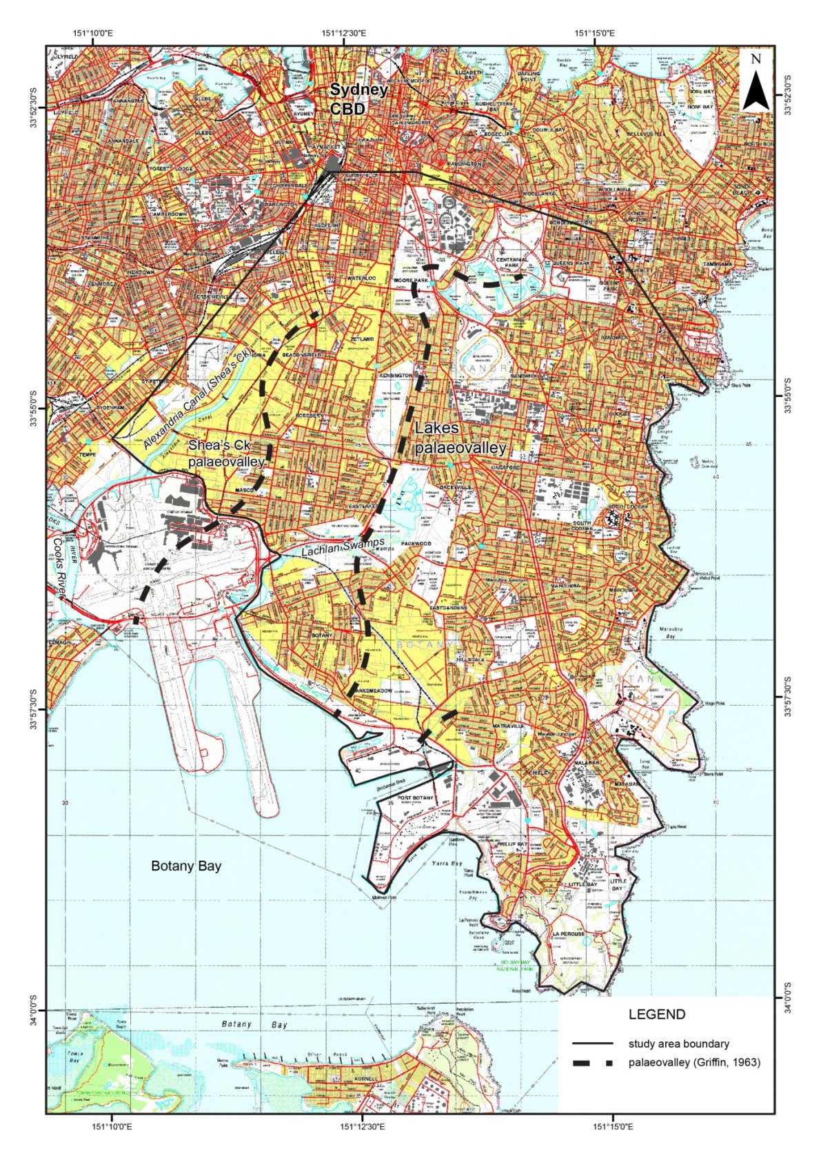
Figure 2. Topographic map (1:25 000 scale) showing the Botany study area (medium black solid line) and the approximate locations of the major palaeovalleys (heavy dashed black line) defined by Griffin (1963).
UNIT 1: Pleistocene sediments comprising fluvial sand with minor gravel in the bedrock channels, and grading up to interbedded sand and mud with estuarine shells. This is the lower-most unit in the sequence, and is only found in deep valleys in the bedrock topography. It is generally found below 40 m of younger sediments. The unit may be up to 30 m thick. The top surface is erosional and may have a relief of up to 15 m. The sands are generally of medium grainsize and are dense, corresponding to SPT N-values in the range of 30-50.
UNIT 2: Pleistocene sediments similar to those in Unit 1, but with a higher proportion of mud and peat (organic mud). This unit is 5-15 m thick, and has an erosional upper surface. Clays are stiff to very stiff, and are often fissured in the upper 3-4 m. This corresponds to SPT N-values in the range of 9-40. The fissuring in the clay is interpreted to have been caused by desiccation. The wet density of the clay is inferred to be 1.80 g/cm3. In the western portion of the basin the alluvial clays overlie residual clay soils of the Ashfield Shale that are interpreted to be very stiff to hard. Sands are interpreted to be dense. Peat is often consolidated to lignite.
UNIT 3: Pleistocene sediments predominantly comprising medium-grained sand with discontinuous peat and mud lenses, especially in the upper part. The sands may be in the order of 30 m thick, and are distributed over the entire basin. The sand is generally medium dense to very dense, and this unit may be distinguished from the overlying Holocene sands as the former generally have SPT N-values of 20 or greater. In situ dry densities are interpreted to be in the range 1.59-1.86 g/cm3. A cemented sand horizon, known as ‘Waterloo Rock’ may be present near the top of this unit; however, its properties and distribution are irregular. Peat may sometimes be consolidated to lignite.
UNIT 4: Upper-most unit of Holocene age comprising loose sand, soft mud, peat and organic clay. The peat generally occurs in sinusoidal channels, and has a moisture content of 100%-400%. The Cooks River and Shea’s Creek estuaries contain 4-5 m of tidal flat mud, and swamp deposits formed later in these estuaries. The loose sand deposits generally have SPT N-values of less than 10. The sediments of this unit are generally re-worked sediments of Unit 3. They are irregularly distributed, and may vary from only several metres to 10 m in thickness.
The area is also irregularly overlain by fill material. These fill materials predominantly comprise sand that was excavated from dunes to fill inter-dune swamps, or was dredged from Botany Bay. Apart from some larger and more recent sites, the fill has not received compaction, and sand fill layers would typically have SPT N-values less than 6. Otherwise, the sand fill would be similar to Holocene dune sand.

  - Regolith Site Classes
The modelling of amplification factors requires that a representative geotechnical model be designed for each of the regolith site classes considered. As described in the previous section, the Botany area consists of a relatively consistent layer of Unit 3 sediments, which in some locations overlies quite thick deposits of Unit 1 and 2 sediments. In order to characterise the spatial variability of the regolith in the study area, the properties described previously were interpolated using the sediment thickness data of Griffin (1963). This facilitated the definition of four regolith site classes, which are summarised in Table 2. Figure 3 presents the mapped distribution of these sites classes in the Botany study area.
A variety of geotechnical parameters must be estimated in order to calculate the amplification factors for each site class. Specifically, shear wave velocity, density and strain properties of the materials must be estimated. The parameters that were used for each model are presented in Figure 4. The densities used in the models have come directly from previously described geological and geotechnical information. The high strain geotechnical parameters used were taken from typical curves provided in the ProShake software that was used for modelling (EduPro Civil Systems Inc., 1999). The specific curves used are listed in Table 3.
Table 2. Description of the regolith site classes defined for the Botany study area.
Site Class | Description
C | Approximately 20 m of weathered rock overlying unweathered bedrock.
D | Approximately 25 m of Unit 3 sands overlying 40 m of Units 1 and 2. This sediment package in turn overlies the weathered rock of Class C.
E | Thinner than Class D, with 25 m of Unit 3 sands overlying 10 m of Units 1 and 2. This sediment package in turn overlies the weathered rock of Class C.
F | Approximately 5 m of Unit 4 sediments overlying 20 m of Unit 3 sands. This sediment package in turn overlies the weathered rock of Class C.
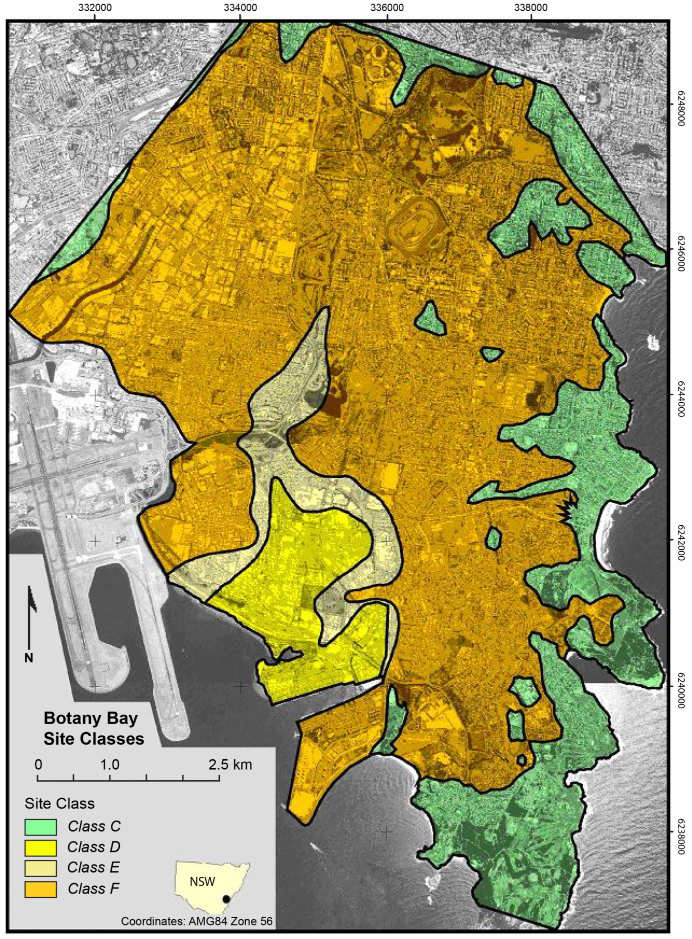
Figure 3. Mapped distribution of site classes in the Botany area as interpreted in this study from the data of Griffin (1963).
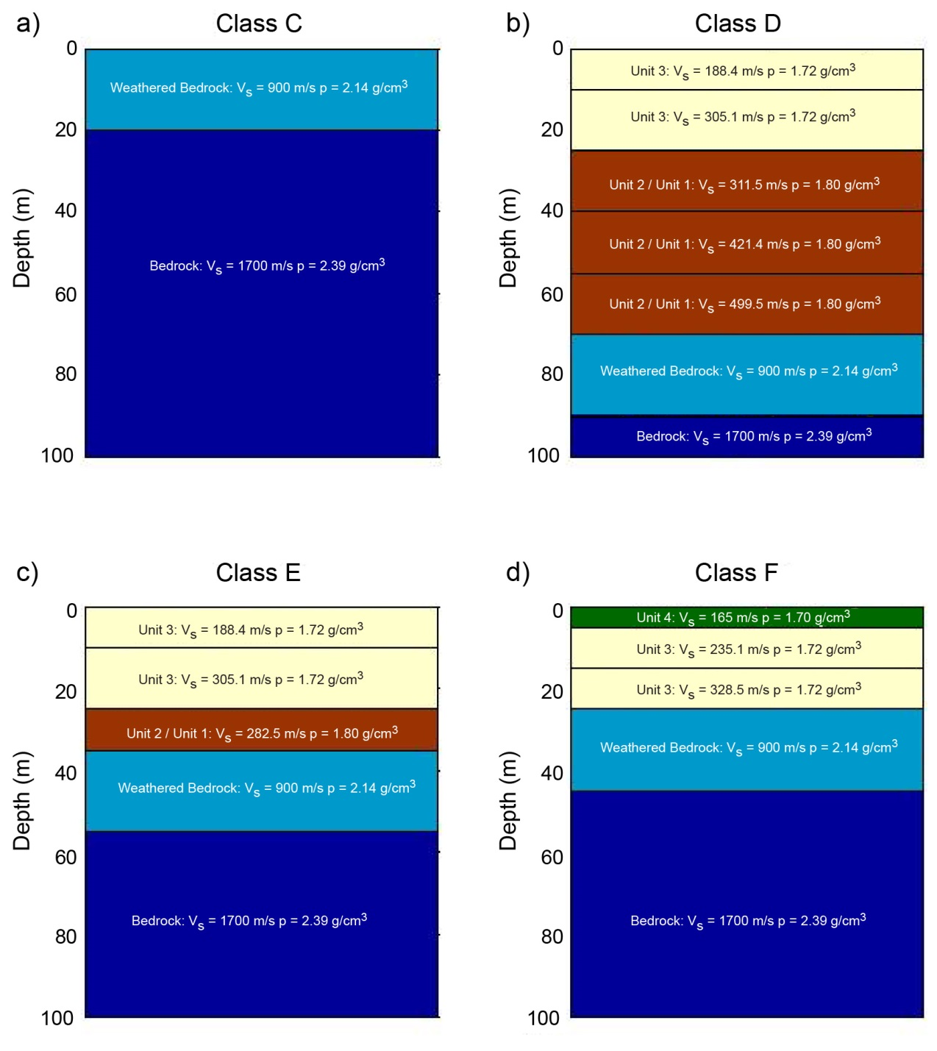
Figure 4. Diagrammatic representation of the site class models applied in the Botany area. Vs = shear-wave velocity (m/s); ρ = density (g/cm3). Depth is expressed in metres. Brown layers are Unit 2 over Unit 1.
Table 3. Summary of shear modulus and damping curves used for the geological units in the Botany site classes. All the curves were provided by the ProShake software package (EduPro Civil Systems Inc., 1999).
Unit(s) | Shear Modulus Curve | Damping Curve | Reference
Unit 4 | Sand – Average | Sand – Average | Seed and Idriss (1970)
Unit 3 | Clay – PI 20-40 | Clay – Lower Bound | Sun et al. (1988)
Unit 1 & Unit 2 | Sand – Upper Bound | Sand – Lower Bound | Seed and Idriss (1970)
Weathered & Unweathered Rock | Rock | Rock | Idriss (1991)

A significant body of work was undertaken in order to estimate the shear wave velocities in the study area. In May and June of 2000, a microtremor survey of approximately 400 measurements was carried out in the study area, as shown in Figure 5. The natural period of the sediments in the Botany region was then calculated from the microtremor data via the horizontal to vertical (H/V) spectral ratio (Nakamura, 1989). In addition to this, NSW Public Works compiled a database of 366 published and unpublished geotechnical boreholes in the area (Figure 5). This database documented the geotechnical properties of the sediments in each borehole, as well as providing a measure of total sediment thickness at each site.
Assuming that the sediments between the surface and bedrock act essentially as a homogenous unit allows the calculation of average shear wave velocity (Vs) from the thickness of sediment (H) and the natural period (T) using the equation Vs = 4H/T (Reiter, 1991). Approximately 137 of the natural period measurements were located near geotechnical boreholes where H was known (Figure 5). These measurements were used to obtain the velocities used in the Botany site class models. The requirement that the sediments act as a single homogenous unit meant that it was not possible to distinguish between Units 3 and 4 in areas of shallower sediment, or between Units 1 and 2 in areas dominated by deeper sediment. Consequently, each of these sets of units has been modelled with a single depth-dependent velocity model.
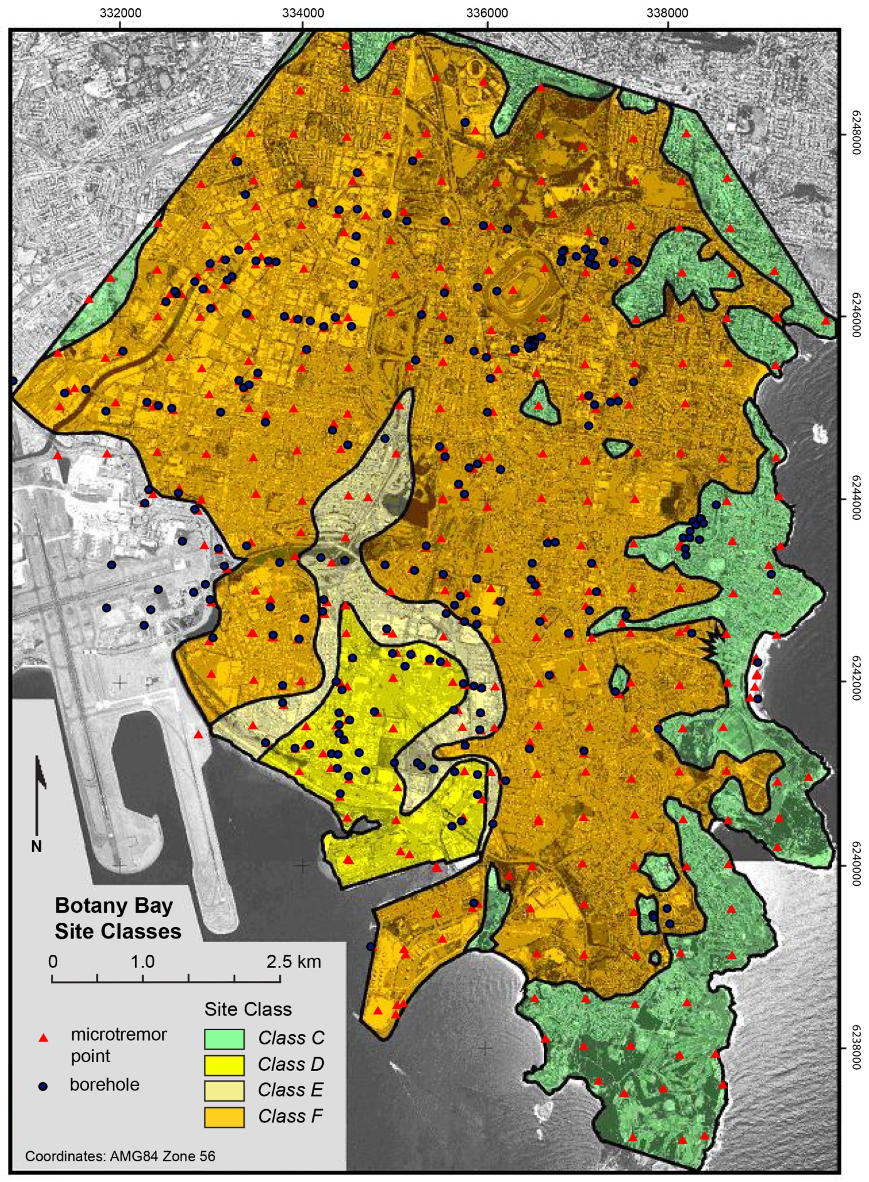
Figure 5. Site class map for the Botany study area showing locations of microtremor (natural period) measurement sites and associated geotechnical boreholes. Data from these points were used to estimate shear-wave velocity for the local regolith materials.

Amplification of Earthquake Ground Shaking
The amount of ground shaking experienced during an earthquake can vary dramatically across a region due to changes in local regolith. The presence of regolith can cause earthquake ground motion to be strongly amplified, hence increasing the earthquake hazard. ProShake software (EduPro Civil Systems Inc., 1999) was used to model the effect of the regolith on ground shaking. ProShake models the regolith profiles by a series of horizontal layers with no lateral variations. Additionally, ProShake uses an equivalent-linear approach to account for softening and damping associated with large strains. This approach approximates the non-linear relationship between strain and modulus/damping by a linear relationship that is appropriate over the range of strains experienced during a specific earthquake of interest. This package takes the geotechnical models described in the regolith site classes and simulates vertically propagating shear waves passing through them. The software then calculates the response spectral acceleration of the original bedrock motion, and the calculated motion at the surface of the model. Period-dependent amplification factors are then determined by finding the ratio of these two response spectra.
Amplification of ground shaking is a function of both the characteristics of the local regolith and the amplitude of the ground shaking that is applied. At lower amplitudes, the regolith behaves linearly, i.e., there is a linear relationship between the applied stress and the consequent soil strains. However, as levels of stress increase, the regolith may degrade and consequently have higher damping and lower shear modulus. This degradation causes the increase in stress to have a smaller associated increase in strain. The net effect of the associated change in linearity is that amplification associated with high amplitude ground motions may actually be less than the amplification associated with lower ground amplitude motions. However, whilst the amount of amplification may be less for large amplitude motions, the regolith itself may fail through liquefaction and loss of bearing capacity.
The amount of amplification will also depend, to a lesser degree, on the frequency content of the motion applied. Consequently, this modelling has used fourteen different earthquake records (Table 4) that were scaled to a peak ground velocity (PGV) of 100 mm/s to represent small levels of ground shaking, and 200 mm/s to represent larger levels of ground shaking. It should be noted that 200 mm/s is a very high level of ground shaking that would have a low probability of occurrence within Australia. However, this level has been chosen to emphasise the impact of ground shaking amplitude on amplification factors.

Table 4. Description of earthquake acceleration records used for determining amplification factors for the Botany area site classes. Records in italics were also used in the creation of the Australian response spectra (Somerville et al., 1998).
Earthquake | Date | Magnitude | Station Name | Distance (km) | Components
Coalinga | 09/05/1983 | MS = 4.7 | SGT (Temp) | 14 | 80, 350
Nahanni | 23/12/1985 | Mb = 5.4 | Iverson | 7 | 10, 280
Northridge | 17/01/1994 | MS = 6.6 | CIT Seismic Station | 41 | 90, 360
Northridge | 17/01/1994 | MS = 6.6 | Mt. Wilson | 45 | 90, 360
Northridge | 17/01/1994 | MS = 6.6 | Pacoima Dam (downstream) | 19 | 175, 265
San Fernando | 09/02/1971 | MS = 6.6 | Santa Anita Dam | 27 | 3, 273
Whittier | 01/10/1987 | M = 6.0 | CIT Seismic Station | 18 | 90, 360

The resultant amplification factors are summarised in Table 5 and plotted in Figure 6. In order to use these amplification factors realistically, it must be emphasised that not all of the uncertainties within the modelling process have been measured. The variability presented in the results is due solely to uncertainties caused by using 14 different input motions. The results include no measure of the uncertainties caused by inaccuracies of geotechnical properties in each site class, or the inherent variability of the regolith within a single site class. An example demonstrating the potential influence of variability associated with uncertainty in the geotechnical models is presented by Robinson et al. (2006).
In general, the results demonstrate that there will be a significant increase in the intensity of ground shaking felt within the Botany area, as compared to what would be experienced on strong rock. While the weathered rock class (Class C) only shows significant amplification for periods less than approximately 0.4 s, all of the other site classes show significant amplification for most periods.
The three classes containing soft sediments have amplification peaks that are closely related to their total sediment thickness. With increasing sediment thickness the period at which peak amplification will occur also increases. Site class D is characterised by a thicker sediment sequence than the other classes, and tends to amplify ground shaking and produce longer period vibration, presenting more of a hazard to taller buildings. In contrast, site class F tends to amplify ground shaking and produce shorter period vibration that will generally be more hazardous to lower storey constructions.
Increasing the intensity of the ground shaking applied has a small but significant effect on the amplification factors (Figure 6). The increased intensity of ground shaking tends to reduce the amplification factors for most of the periods considered. However, this increased intensity of ground shaking tends to move the amplification peak to a slightly higher period for all of the classes containing soft sediments. Consequently, some of the amplification factors at higher periods have increased with increased intensity of ground shaking.
Table 5. Summary of amplification factors for Botany site classes. Factors are shown for each site class for low levels of ground shaking (i.e. motions scaled to a PGV of 100 mm/s) and high levels of ground shaking (i.e. motions scaled to a PGV of 200 mm/s), as indicated in the header row. The range of period values (in seconds) considered, including the mean, is indicated in the left-most column. Maximum values for each class are shown in bold.
 | Site Class C (low) | Site Class C (high) | Site Class D (low) | Site Class D (high) | Site Class E (low) | Site Class E (high) | Site Class F (low) | Site Class F (high)
0.1 s | 1.74 | 1.75 | 1.38 | 0.93 | 1.49 | 1.00 | 1.82 | 1.45
0.2 s | 1.23 | 1.24 | 1.80 | 1.32 | 1.58 | 1.10 | 2.43 | 1.97
0.3 s | 1.14 | 1.14 | 2.37 | 1.91 | 1.58 | 1.26 | 2.60 | 2.41
0.4 s | 1.08 | 1.08 | 2.18 | 1.96 | 1.82 | 1.27 | 3.41 | 2.97
0.5 s | 1.06 | 1.07 | 1.98 | 1.64 | 2.46 | 1.53 | 3.12 | 3.22
0.6 s | 1.04 | 1.05 | 2.30 | 1.72 | 3.19 | 2.09 | 2.36 | 2.69
0.7 s | 1.03 | 1.04 | 2.79 | 1.98 | 3.17 | 2.70 | 1.97 | 2.24
0.8 s | 1.03 | 1.03 | 3.56 | 2.44 | 2.75 | 3.02 | 1.78 | 2.01
0.9 s | 1.03 | 1.03 | 3.75 | 2.93 | 2.28 | 2.76 | 1.58 | 1.72
1.0 s | 1.02 | 1.02 | 3.57 | 3.28 | 2.06 | 2.48 | 1.58 | 1.68
2.0 s | 1.02 | 1.02 | 1.81 | 1.95 | 1.41 | 1.55 | 1.24 | 1.28
3.0 s | 1.02 | 1.02 | 1.58 | 1.61 | 1.32 | 1.39 | 1.22 | 1.26
Mean | 1.12 | 1.12 | 2.42 | 1.97 | 2.09 | 1.85 | 2.09 | 2.08
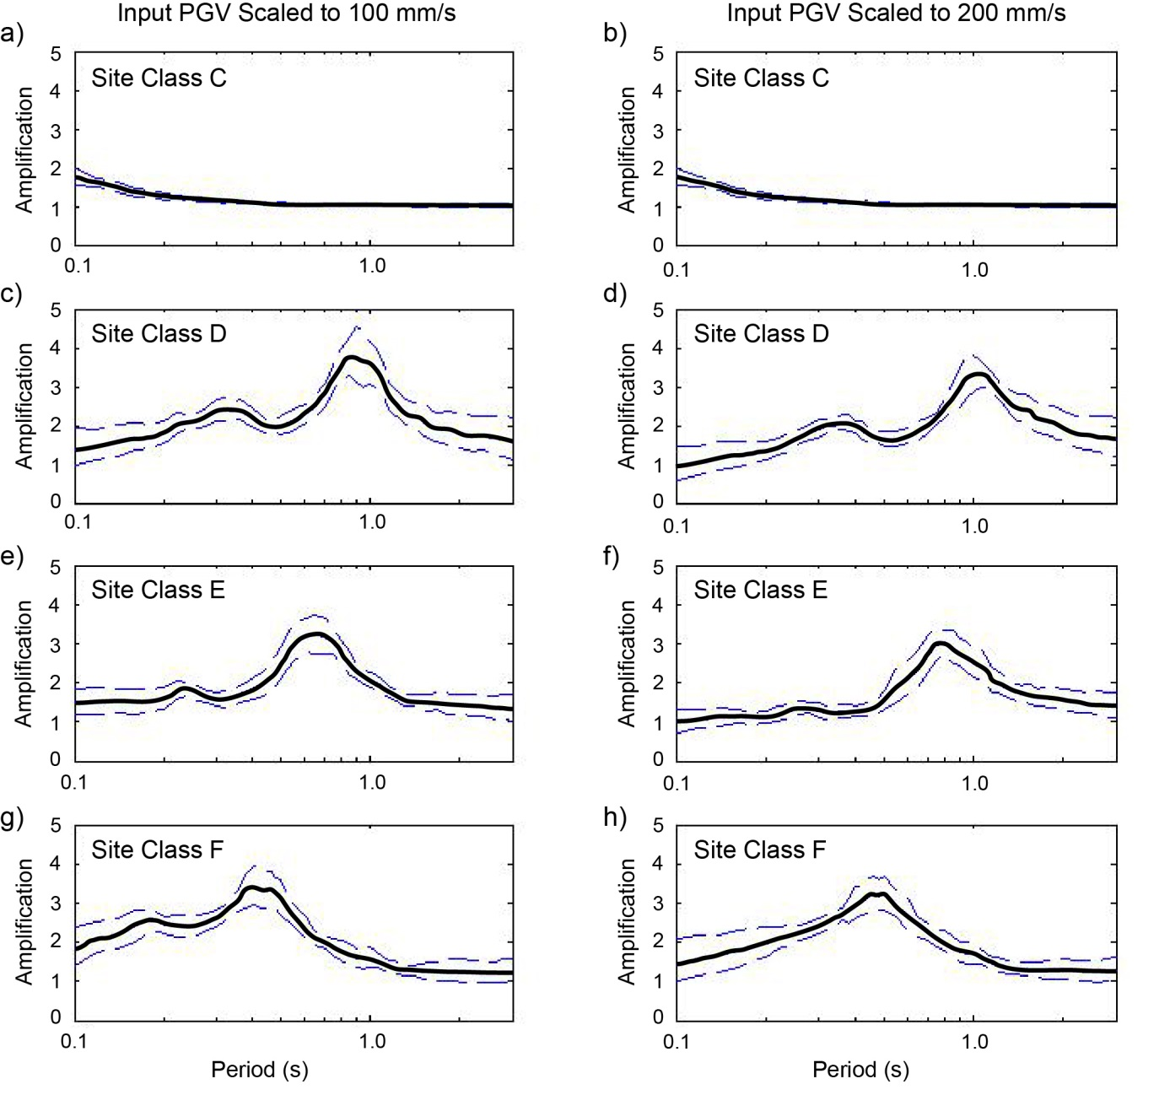
Figure 6. Amplification factors for Botany site classes (see Table 2 and Figure 4). Plots show the median amplification factor (solid line) and the 16th and 84th percentile values (broad dashed lines). Plots (a), (c), (e) and (g) represent input PGV scaled to 100 mm/s, while plots (b), (d), (f) and (h) represent input PGV scaled to 200 mm/s.

Earthquake Shaking Susceptibility
The regolith site classes (Figure 3) and the amplification factors (Table 5) can be used to provide a measure of earthquake susceptibility for the Botany area. In combination this information assists in identifying which parts of the Botany area are likely to experience relatively higher or lower levels of ground shaking in the event of an earthquake, and in a very approximate sense gives an indication of which areas will have relatively higher or lower earthquake hazard.
Defined hazard zones should not be considered accurate at a site-specific level, and should not be used to replace site investigations where required by building codes or local regulations. To use the site class map (Figure 3) reliably, it is imperative that the uncertainties and limitations of the results are clearly understood. Perhaps the largest limitation of the site class map is inherent variability in localised geology within a single site class. For example, the majority of the Botany study area has been classed as site class F. Amplification factors associated with this class were calculated for a single geological model. It would be unrealistic to assume that the chosen model could precisely model the geology at every single point within that site class. Not only would the thickness of sediment within the class vary to some degree, but the detailed succession and geotechnical parameters of the sediments are likely to vary spatially. This issue is compounded for Site Class F due to the presence of the spatially variable Holocene clay and mud (Unit 4).
The amplification factors for Site Class F were recalculated for two additional models in order to understand the potential effects of small variation in geology. The models consisted of two extreme cases, specifically:
- 10 m of Unit 4 overlying 15 m of Unit 3; and
- 30 m thickness of Unit 3 with no Unit 4 present.
The amplification factors for these two models have been compared with the amplification factors for the original site class F model using input rock motions scaled to 100 mm/s (Figure 7). These results demonstrate that variations in the regolith model used can significantly change the calculated amplification factors. While the general trends remain the same, i.e. maximum amplification of approximately 3 – 3.25, at periods between 0.4 s and 0.6 s, there are considerable differences in the finer details of the calculated amplification factors. For example the original model for site class F has larger amplification factors than either of the other two models for periods between 0.1 s and 0.4 s. In contrast, for periods greater than 0.4 s, the model with a 10 m thickness of the Unit 4 mud and clay predicts much greater amplification than either of the other models.
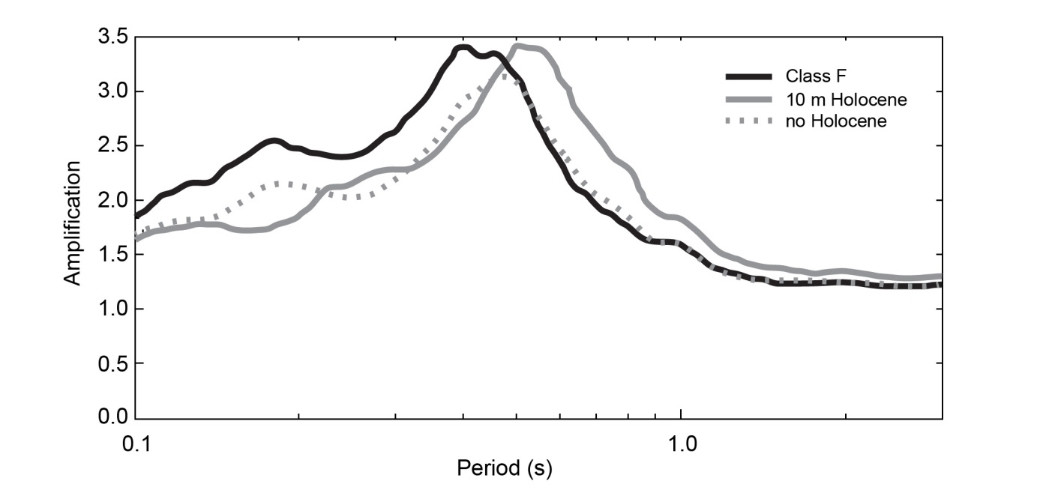
Figure 7. Plot showing the effect of including Holocene clay and mud in the generation of amplification factors for Site Class F.
The implications of these results are that the quality and reliability of the geological and geotechnical data used in the regolith models strongly impacts on the quality and reliability of the amplification factors calculated. The amplification factors presented here are felt to be broadly indicative of the real amplification factors, however they are lacking in detail due to the various approximations used in constructing the geotechnical models.

Implications for Earthquake Risk
The Botany Bay area has one of the greatest densities of lifelines, industry and population within Australia, and lies within a broader region that has experienced at least a dozen earthquakes of magnitude 4.0 or greater in the last century. While the amplification factors presented within this report demonstrate the potential for selective amplification of ground shaking, they do not give any real indication of the intensity of ground shaking that could be caused by an earthquake. An event with an epicentral distance and magnitude similar to the 28 December 1989 ML 5.6 Newcastle earthquake has been simulated to provide some understanding of the potential ground shaking that could be experienced during such an earthquake.
The simulated earthquake has a local magnitude (ML) of 5.6, and is located approximately 12 km to the southwest of the centre of the Botany study area. The modelled ground shaking from this earthquake was then attenuated using a modified version of the Toro et al. (1997) attenuation function that is applied in the HAZUS methodology (National Institute of Building Sciences, 1999) and by Geoscience Australia in its study of earthquake risk in Newcastle and Lake Macquarie (Dhu and Jones, 2002). Spectral accelerations at periods of 1.0 s and 0.3 s were then calculated, both with and without amplification due to regolith, on a 10 m × 10 m grid across the study area. The spectral accelerations at periods of 1.0 s and 0.3 s are presented in Figures 8-11.
Before discussing the implications of these maps it is imperative to emphasise the assumptions and limitations of the results, specifically:
1. As mentioned previously there are numerous uncertainties within the amplification factors calculated for the various site classes, and these uncertainties will also be contained within the maps of ground shaking on regolith.
2. The attenuation function used was developed for eastern North America and there has been no detailed study as to whether it is the most appropriate attenuation function for the Botany Bay area.
3. The levels of ground shaking have not been derived from a probabilistic assessment of the Botany Bay area. Rather, ground shaking has been derived from a single, discrete event with similar characteristics to the Newcastle 1989 earthquake. There has not been any detailed study of the chances of this level of ground shaking actually occurring.
4. The pattern of ground shaking seen is strongly controlled by the location of the simulated earthquake. Consequently, an earthquake with a different epicentre could lead to a significantly different pattern of ground shaking.
These results are presented purely to provide a more intuitive understanding of the amount and nature of ground motion amplification likely to be caused by the soils in the study area.
Figure 8 shows the response spectral acceleration for a period of 1.0 s in the absence of any amplification due to local site conditions. The accelerations here are controlled primarily by the distance from the earthquake, which varies from as little as 8 km in the south west to as much as 18 km in the north east. The accelerations in the centre of the study area have an intensity of approximately 0.1 g. This intensity of ground shaking at a period of 1.0 s corresponds to more than twice the level of ground shaking associated with a return period of 2,500 years in Sydney (Standards Australia/Standards New Zealand, 2000).
Figure 9 demonstrates the effect of applying the regolith models created for the Botany study area. Periods of 1.0 s correspond to the natural periods of mid- to high-rise structures. The ground shaking at a period of 1.0 s has been amplified across the entire study area, however the amplification is most pronounced in those areas classified as Site Class D (refer to Figure 3). This increased amplification is due to the fact that the peak amplification for Site Class D is localised around a period of 0.8 s. This amplification has caused the already significant levels of acceleration to be amplified to intensities of up to 0.4 g.
The effective structural response at a period of 0.3 s is presented without any amplification from local site conditions in Figure 10. At this period, the levels of acceleration are as large as 0.7 g in the south west of the study area. The amplification of this period of motion taking into account the local site response is presented in Figure 11. A period of 0.3 s corresponds to the natural periods of low- to mid-rise buildings. Again, modelled ground motion in the study area has been amplified by the regolith. However at this period, the highest amplification values are noted in areas classified as Site Class F (refer to Figure 3).
In general, the results presented here suggest that if an earthquake were to occur near the Botany study area, the regolith would cause significant amplification of ground motion, and could lead to large response spectral accelerations. The shallower regolith that covers the majority of the study area tends to strongly amplify periods of ground motion corresponding to the natural period of low- to mid-rise structures. The deeper regolith in the south of the study area tends to more strongly amplify periods of ground motion associated with mid- to high-rise structures. As mentioned previously, the work presented here does not constitute a full probabilistic assessment of the earthquake risk in the Botany area. However, it does emphasise the potential for significant ground shaking in the area, and consequently the need to better understand the potential risk posed by earthquakes.
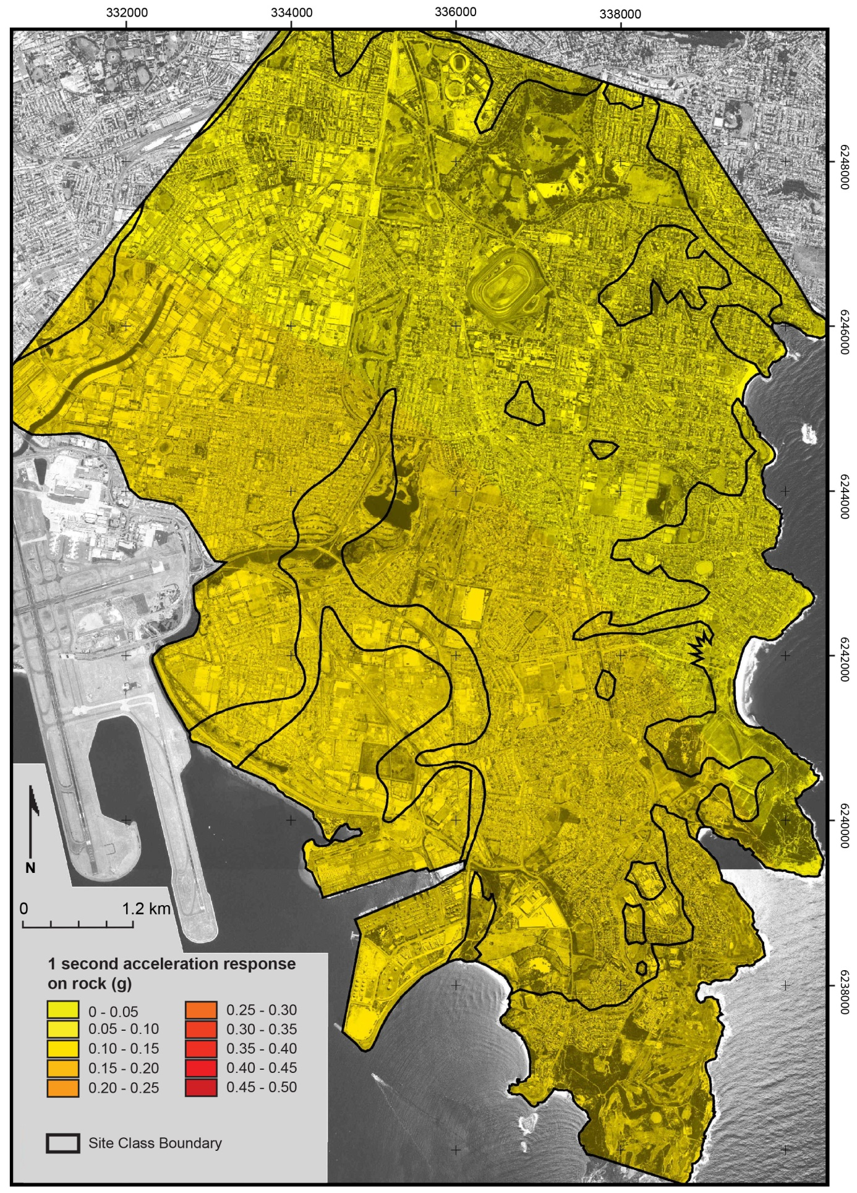
Figure 8. Map of effective structural acceleration for a period of 1.0 s on rock.
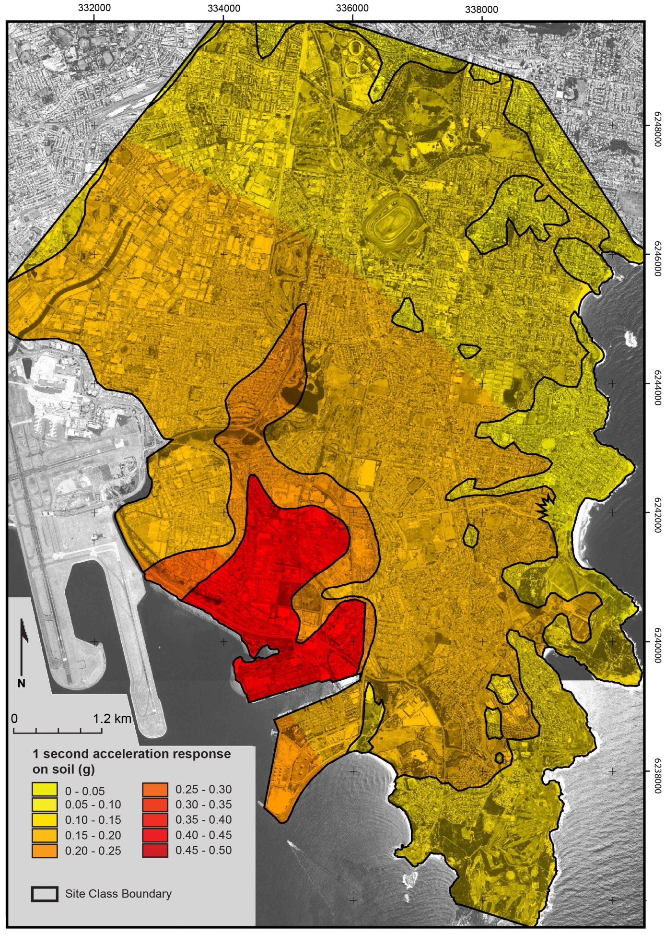
Figure 9. Map of effective structural acceleration for a period of 1.0 s on regolith (soil).
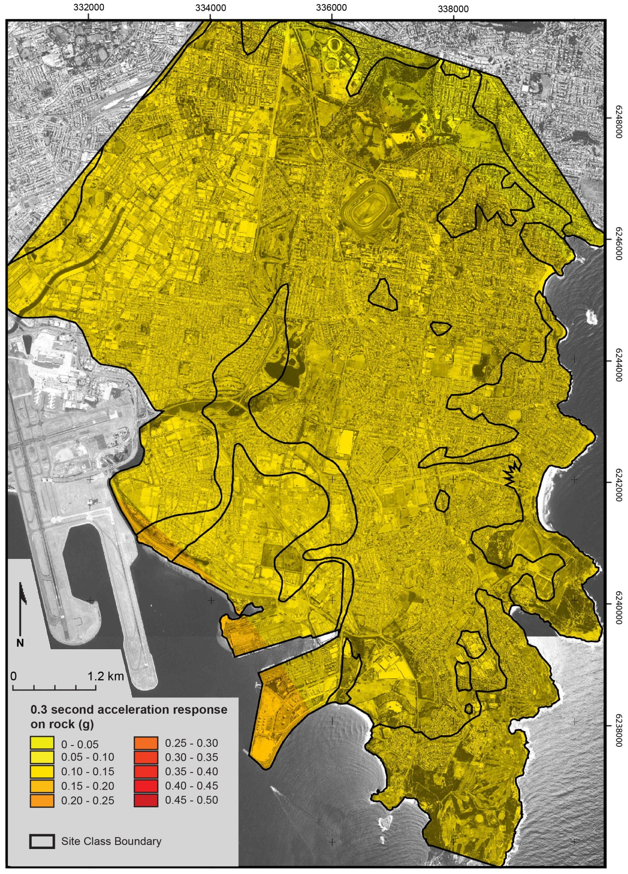
Figure 10. Map of effective structural acceleration for a period of 0.3 s on rock.
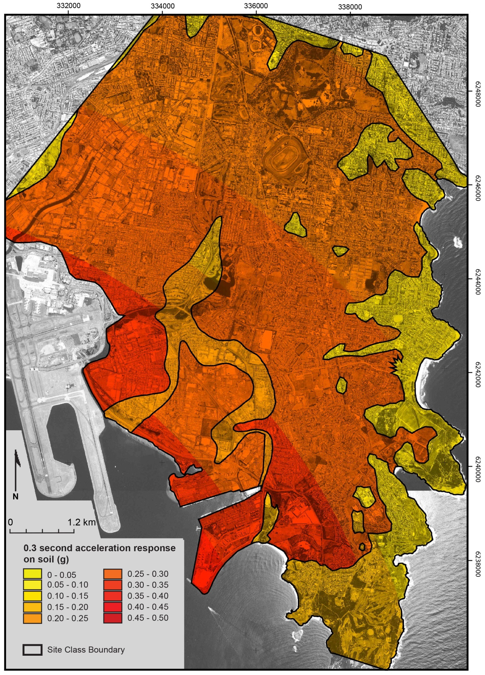
Figure 11. Map of effective structural acceleration for a period of 0.3 s on regolith (soil).

Conclusions
The modelling presented within this study is preliminary, in the sense that there has been little analysis on the uncertainties within either the modelling process or the geotechnical parameters used. Nevertheless, all of the regolith site classes had peak median amplification factors greater than three, suggesting significant amplification of ground shaking would be expected for the majority of the Botany area compared to earthquake ground shaking on hard rock.
As mentioned previously, this work is not meant to be a definitive product for the Botany study area, rather it is a starting point designed to highlight some of the potential risks presented by earthquakes in the area. A detailed understanding of the earthquake risk would require a much more detailed analysis of both the hazard presented by earthquakes in the region more broadly, and the vulnerability of the local structures and lifelines to earthquake ground shaking. An example of the type of study that could be undertaken is the Geoscience Australia study of Newcastle and Lake Macquarie (Dhu and Jones, 2002). That work represents a detailed analysis of the earthquake risk in the Newcastle and Lake Macquarie region, and points towards the style of investigation that would be appropriate for the Botany area. Such an investigation could produce the following outputs:
- More detailed geotechnical models;
- Building and lifeline damage, and casualty vulnerability curves for different site classes and building types;
- Detailed local seismicity models and probabilistic hazard maps;
- Probabilistic damage and casualty maps;
- Annualised damage and casualty figures for the entire area, or any site or combination of sites; and
- Recommendations on issues relating to mitigation.
This report has not considered the liquefaction potential of regolith in the study area. In order for regolith to liquefy, a number of conditions need to exist. For example, the regolith would need to be saturated, consist of relatively soft material and have liquefiable sands located at relevant depths. While no work has been undertaken to assess the occurrence of these and other relevant conditions, it is obvious from the geotechnical data provided within this report that the Botany area’s regolith is very soft with low shear wave velocities and SPT N-values. The Botany Basin sediments are a groundwater source. Numerous swamps and lakes (refer to Figure 2) show that groundwater levels are close to the land surface, indicating that the regolith is saturated. Accordingly, the regolith in the Botany area may be susceptible to liquefaction during ground shaking, and further work is required to determine the true nature of this hazard.
In summary, the Botany area exhibits significant potential for the amplification of earthquake ground motion. The results presented here suggest that earthquakes could pose a significant risk to this part of the Sydney region. However, a more detailed seismic hazard assessment of the Botany area would be required to fully understand the potential risk posed by earthquakes.

Acknowledgements
We thank several individuals who contributed to this study. Peta Anderson compiled a comprehensive database of known borehole information for the study area. Neil Corby and Ingo Hartig prepared the original figures. A team from Geoscience Australia conducted an extensive microtremor field survey in the study area. We also thank Geoscience Australia and NSW Public Works internal reviewers of the draft report. This document is published with the permission of the CEO of Geoscience Australia and the Deputy Director-General of NSW Public Works.

References
Albani, A. D. 1981. Sedimentary environments and Pleistocene chronology of the Botany Basin, NSW, Australia. Geo-Marine Letters 1, 467–500.
Albani, A. D. and Rickwood, P. C. 1998. The Botany Basin: its bedrock topography and recent geological history. In: G. H. McNally and J. Jankowski (eds.), Environmental Geology of the Botany Basin. pp. 190-196. Environmental Engineering and Hydrogeological Specialist Group Collected Case Studies in Engineering Geology, Geological Society of Australia.
Beck, P. and Jankowski, J. 1998. A review of the Botany Basin: Bedrock topography and grainsize distribution in the Botany Sands Aquifer. In: G. H. McNally and J. Jankowski (eds.), Environmental Geology of the Botany Basin. pp. 179-189. Environmental Engineering and Hydrogeological Specialist Group Collected Case Studies in Engineering Geology, Geological Society of Australia.
Blong, R. 1993. Earthquake probable maximum loss - Household Buildings, Sydney. Greig Fester. Risk Frontiers, Sydney.
Blong, R. 1997. Earthquake probable maximum loss - Household Buildings, Sydney 2. Greig Fester. Risk Frontiers, Sydney.
Borcherdt, R. D. and Gibbs, J. F. 1976. Effects of local geologic conditions in the San Francisco Bay region on ground motions and intensities of the 1906 earthquake. Bulletin of the Seismological Society of America 66, 467–500.
Burg, K. 1996. Lifeline seismic risk in the Botany Basin. M.Sc. Thesis, Macquarie University (unpublished).
Chandler, A. M., Pappin, J. W. and Coburn, A. W. 1991. Vulnerability and seismic risk assessment of buildings following the 1989 Newcastle, Australia earthquake. Bulletin of the New Zealand National Society for Earthquake Engineering 24, 116-138.
Conaghan, P. J. 1980. The Hawkesbury Sandstone: gross characteristics and depositional environment. In: C. Herbert and R. Helby (eds.), A guide to the Sydney Basin. Geological Survey of New South Wales Bulletin 26, 188-253.
Dhu, T. and Jones, T. (eds.) 2002. Earthquake risk in Newcastle and Lake Macquarie. Geoscience Australia Record 2002/15.
Standards Australia/Standards New Zealand. 2000. Structural design - General requirements and design actions DR00902 Part 4: Earthquake actions. Draft Australian/New Zealand Standard for comment. Standards Australia and Standards New Zealand.
Everingham, I. B., McEwin, A. J. and Denham, D. 1982. Atlas of isoseismal maps of Australian earthquakes, Part 1. Bureau of Mineral Resources Australia, Bulletin 214.
EduPro Civil Systems Inc. 1999. ProShake Version 1.1 [software]. EduPro Civil Systems, Inc., Redmond, Washington.
Griffin, R. J. 1963. The Botany Basin. Bulletin of the Geological Survey of New South Wales 18, 110 p.
Herbert. C. 1979. The geology and resource potential of the Wianamatta Group. Geological Survey of New South Wales Bulletin 25. 203 p.
Hunter, C. 1991. Earthquake tremors felt in the Hunter Valley since white settlement. Hunter House Publications, Newcastle, Australia.
Idriss, I. M. 1991. Earthquake ground motions at soft soil sites. Proceedings of the 2nd International Conference on Recent Advances in Geotechnical Earthquake Engineering and Soil Dynamics, Saint Louis, Missouri. Invited Paper LP01, 2265-2272.
Jeffery, R. P. 1985. Botany Basin deposits. In: P. J. N. Pells (ed.), Engineering Geology of the Sydney Region. pp. 81-98. Balkema, Rotterdam.
McCue, K. F. (compiler) 1995. Atlas of isoseismal maps of Australian earthquakes – Part 3. Australian Geological Survey Organisation Record 1995/44.
McCue, K. F. (compiler) 1999. Australian Seismological Report – 1999. Australian Seismological Centre, Canberra. http://www.aees.org.au/Articles/McCue_ASR99.pdf (last accessed 21 January 2013).
McCue, K. F. and Gregson, P. (compilers) 1996. Australian Seismological Report, 1994. Australian Geological Survey Organisation Record 1996/19.
McCue, K. F., Wesson, V. and Gibson, G. M., 1990. The Newcastle, New South Wales, earthquake of 28 December 1989. Bureau of Mineral Resources Journal of Australian Geology and Geophysics 11, 559-567.
McNally, G. H. and Branagan, D. F. 1998. An overview of engineering geology in the Botany Basin. In: G. H. McNally and J. Jankowski (eds.), Environmental Geology of the Botany Basin. pp. 1-23. Environmental Engineering and Hydrogeological Specialist Group Collected Case Studies in Engineering Geology, Geological Society of Australia.
Meremonte, M., Frankel, A., Cranswick, E., Carver, D. and Worley, D. 1996. Urban seismology—Northridge Aftershocks recorded by multi-scale arrays of portable digital seismographs. Bulletin of the Seismological Society of America 86, 1350–1363.
Murphy, J. R., Davis, A. H. and Weavers, N. L. 1971. Amplification of seismic body waves by low-velocity surface layers. Bulletin of the Seismological Society of America 61, 109–145.
Nakamura, Y. 1989. A method for dynamic characteristics estimation of subsurface using microtremor on the ground surface. Quarterly Report of the Railway Technology Research Institute 30, 25-32.
National Institute of Building Sciences. 1999. Hazards U.S. (HAZUS) [software]. National Institute of Building Sciences, USA. http://www.lib.ncsu.edu/gis/hazus.html [superseded by HAZUS-MH (2005)].
Reiter, L.1991. Earthquake Hazard Analysis: Issues and Insights. Columbia University Press, New York, 245 p.
Robinson, D., Dhu, T. and Schneider, J. 2006. SUA: A computer program to compute regolith site-response and estimate uncertainty for probabilistic seismic hazard analysis. Computers & Geosciences 32, 109-123.
Roy, P. S. 1983. Quaternary geology. In: C. Herbert (ed.), Geology of the Sydney 1:100 000 sheet 9130, Explanatory Notes. pp. 41-92. Geological Survey of NSW, Department of Mineral Resources, Sydney.
Rynn, J. M. W., Denham, D., Greenhalgh, S., Jones, T., Gregson, P. J., McCue, K. F. and Smith, R. S. 1987. Atlas of isoseismal maps of Australian earthquakes, Part 2. Bureau of Mineral Resources Australia, Bulletin 222.
Seed, H. B. and Idriss, I. M. 1970. Soil moduli and damping factors for dynamic response analyses. Earthquake Engineering Research Centre Report No. EERC 70-10, University of California, Berkeley.
Somerville, M., McCue, K. and Sinadinovski, C. 1998. Response spectra recommended for Australia. Proceedings of the Australasian Structural Engineering Conference, Auckland, New Zealand, 439-444.
Standards Australia/Standards New Zealand. 2000. Structural Design – General Requirements and Design Actions DR00902 Part 4: Earthquake Actions. DR00903 Part 4: Earthquake Actions Volume 2 – Commentary. DR00904 Part 0: General Requirements. Draft Australian/New Zealand Standard for Comment.
Sun, J. I., Golesorkhi, R. and Seed, H. B. 1988. Dynamic moduli and damping ratios for cohesive soils. Earthquake Engineering Research Centre Report No. 88-15, University of California, Berkeley.
Thorne, C. P. 1985. Deep marine fissured clays. In: P. J. N. Pells (ed.), Engineering Geology of the Sydney Region. pp. 63-80. Balkema, Rotterdam.
Toro, G. R., Abrahamson, N. A. and Schneider, J. F. 1997. Model of strong ground motions from earthquakes in central and eastern North America; best estimates and uncertainties. Seismological Research Letters 68, 41-57.

Personal communication with Anselm Smolka, Munich Reinsurance Company, Germany, 2001

