Australian Flood Studies Database

Cataloguing and Uploading Guidelines
Release 1.9.2, May 2013
Geoscience Australia
RECORD 2013/13
Martin, S., Zeilinger, I., Middelmann-Fernandes M., Branford M., Peljo, N.
Department of Resources, Energy and Tourism
Minister for Resources and Energy: The Hon Gary Gray AO MP
Secretary: Mr Blair Comley, PSM
Geoscience Australia
Chief Executive Officer: Dr Chris Pigram
This paper is published with the permission of the CEO, Geoscience Australia
© Commonwealth of Australia (Geoscience Australia) 2013
With the exception of the Commonwealth Coat of Arms and where otherwise noted, all material in this publication is provided under a Creative Commons Attribution 3.0 Australia Licence. (http://www.creativecommons.org/licenses/by/3.0/au/deed.en)
Geoscience Australia has tried to make the information in this product as accurate as possible. However, it does not guarantee that the information is totally accurate or complete. Therefore, you should not solely rely on this information when making a commercial decision.
Geoscience Australia is committed to providing web accessible content wherever possible. If you are having difficulties with accessing this document please contact feedback@ga.gov.au.
ISSN 2201-702X (PDF)
ISBN 978-1-922201-36-2 (PDF)
GeoCat 75516
Bibliographic reference: Martin, S., Zeilinger, I., Middelmann-Fernandes, M., Branford, M. and Peljo, N. 2013. Australian Flood Studies Database: cataloguing and uploading guidelines. Release 1.9.2, May 2013. Record 2013/13. Geoscience Australia: Canberra..
Current as at May 2, 2013

Contents
1. Introduction 1
2. Purpose 2
3. Intellectual Property Permissions 3
4. General Processes 4
4.1. Obtaining a log in and changing your Account Details 4
4.2. Should a study be entered? 5
5. Overall Data Capture and Quality Review Process 6
5.1. General Tab 9
5.2. Analysis Tab 12
5.2.1. Events Modelled 13
5.2.2. Hydrological Estimates 16
5.2.3. Hydraulic Modelling 18
5.2.4. Damage Assessment 20
5.3. Survey Tab 22
5.4. Terrain Survey 23
5.4.1. Floor Survey 26
5.5. Mapping Tab 28
5.5.1. Flood Inundation Mapping 29
5.5.2. Flood Hazard Mapping 31
5.6. Mitigation Tab 33
5.6.1. Flood Study Recommendations 34
5.6.2. Post Flood Study Information 35
5.7. Attachments Tab 37
5.8. Study Links Tab 39
5.9. Submission Tab 40
Appendix A. Glossary 41
A.1. Glossary References 45
Appendix B. Checklist of all Fields in the Australian Flood Studies Database 46

Introduction
The Australian Flood Studies Database (AFSD) was developed in 2003-2004, and was made available online by Geoscience Australia in 2006. The database provides metadata on Australian flood studies and information on flood risk, a digital version of the flood study is provided where available. The database was designed to capture Australian flood studies and summaries. It notes the techniques that were used, the data that has been used and the data’s custodian (Middelmann et al. 2005).
The initial design was developed with the view to encourage commissioning agents to more comprehensively capture relevant metadata in future flood study reports, such as the horizontal and vertical accuracy of surveys and data custodian (Middelmann et al. 2005¹). In turn, more detailed reporting might then help facilitate―where appropriate―the potential reuse of survey data. The database enables consultants and others tendering and undertaking work for local government to discover quickly existing flood studies relating to an area. Organisations wishing to commission flood studies (particularly small councils with less experience with flooding or risk analysis) may also find exploring the database useful in order to gain experience from work undertaken in other regions (Middelmann et al. 2005¹).

Purpose
This document is intended to familiarise new users with the fields in the AFSD Data Entry Application as well as provide guidance on completing data entry to a level acceptable for inclusion in the Application. This guide is designed to be used by people with a range of experience, from those with very limited experience with flood study reports through to highly experienced flood modellers. The guidance provided sets out the minimum level of information required for each field, and also seeks to clarify some issues that may arise during the data entry process.
Any feedback on this document may be emailed to hazards@ga.gov.au with “Australian Flood Studies Database, Release 1.9” in the subject line.

Intellectual Property Permissions
Some documents available from the database include additional copyright or disclaimer statements. These should be carefully read as some may require you to obtain permission before entering the document into the database. Flood studies with such statements should be cleared for inclusion in the database by discussing them with your direct supervisor, the person/agency who gave you the report, the commissioning organisation and/or the authors (e.g. consultancy) who produced the report. Please consult with your organisation’s intellectual property policy if you have any doubt.

General Processes

Obtaining a log in and changing your Account Details
Log in details can be provided on request to appropriate individuals. The initial request should be by email to hazards@ga.gov.au and include the following details:
- Name
- Job Title
- Place of Employment
- State
- Email Address
- Telephone Contact Number
A confirmation email will be sent when your account has been set up.
Your log in and account details can be changed via the home page by clicking your username as shown below after you have logged in:
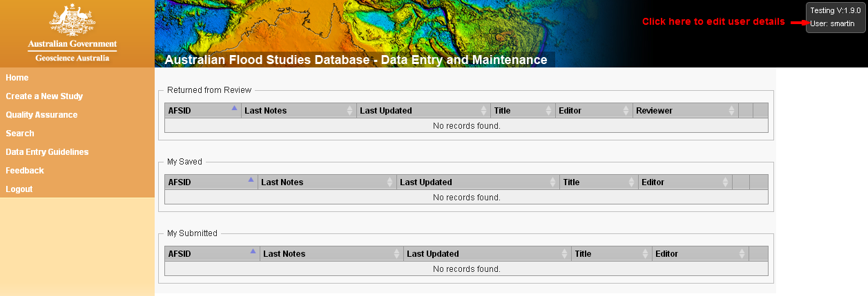
Figure 1 Changing User Details.

Should a study be entered?
For a study to be included in the AFSD, it must first satisfy a number of criteria and/or undergo a number of checks. These suitability checks are designed to ensure a consistent level of detail and content in the AFSD. The criteria include:
- The study must not already be in database. The database can be searched at the Australian Flood Studies Database Search (http://www.ga.gov.au/flood-study-search/).
- The study must be a “Flood Study”, that is, it must include some modelling (usually software based) of flooding undertaken to a professional standard. Relevant modelling would usually include hydrological estimates and/or hydraulic modelling.
- Other related studies, such as floodplain management studies or plans, should be added as attachments to the “Flood Study”, and all relevant information should be included under the flood study entry. For example, damage assessments based on the modelling of a flood study should always be entered into the database, preferably attached to the flood study from which they are derived.
- Reports where the primary focus is not to document the techniques and results of a flood study (for example levee construction, town plans, discussion papers and council meetings) should not be included in the database as a new flood study entry. These studies may become extra attachments to relevant flood studies if they add important content to the entry. For example, any completed or planned action resulting from the study could be included as an attachment to the original study.
- Documents that are in an preliminary draft state (e.g. hand written comments or an incomplete document) should generally not be included in the database. Contacting the person who provided the report to obtain the final report is encouraged. If the draft is complete and currently in use by the commissioning organisation, then it should be entered into the database.
Studies that have not considered these suitability checks may not pass quality assurance procedures if submitted.

Overall Data Capture and Quality Review Process
Flood study data suitable for capture in the database includes general information about the study, flood study analyses, surveys, mapping, flood mitigation strategies and digital copies of relevant documents (scanned if necessary). Existing studies can be linked to new studies and vice versa. New reports are submitted using the submissions page which includes all of the information entered.
Once a study has been submitted, the metadata entered undergoes a quality assurance process at Geoscience Australia. During this process a submitted study may be returned to the submitter with a request for changes or additional information. Additional information that has been clearly missed during data entry or missing appendices and other attachments may be sort. After the requests have been addressed the user can re-submit the study.
Further detail on the attributes captured in the database are covered in the following pages.
The process of data entry into the Australian Flood Studies Database is summarised in Figure 2.
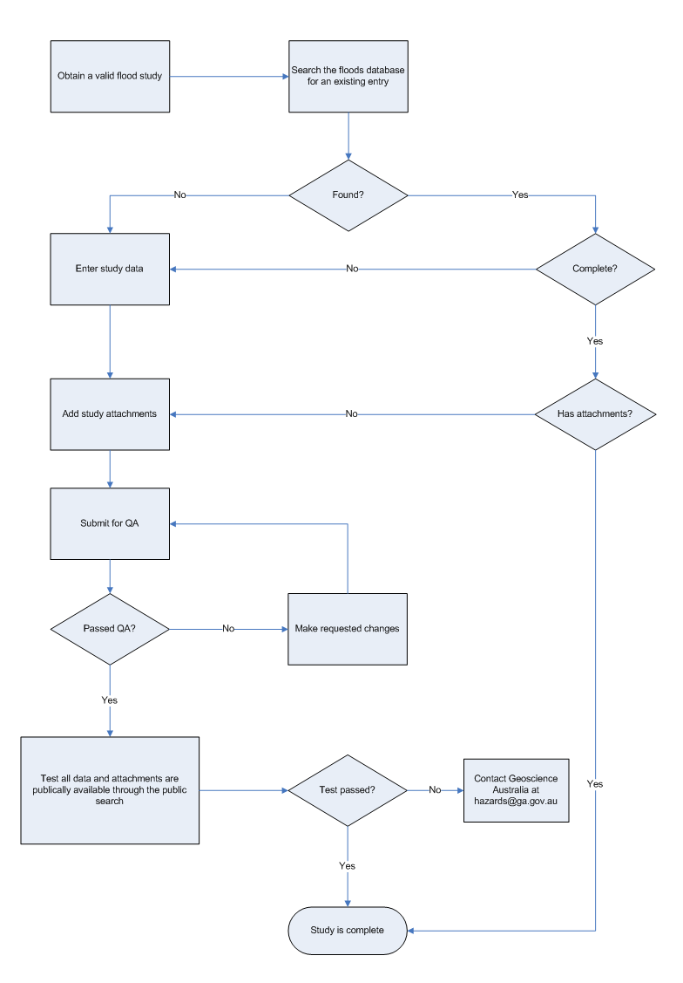
Figure 2 Flowchart of Australian Flood Studies Database cataloguing process.
This Page is Intentionally Left Blank

General Tab

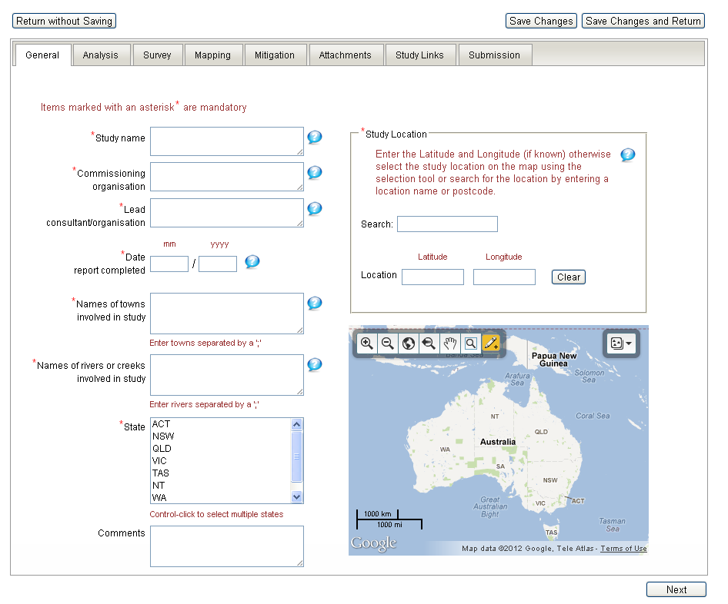
Figure 3 Screenshot of the General Tab.
The general tab captures the mandatory information required for entry into the database (with the exception of the comments field which is non-mandatory). This information can usually be sourced from the introductory parts of a flood study such as the Executive Summary, Introduction and Title pages.
Where there are multiple documents attached to the one entry (e.g. Flood Study, Floodplain Risk Management Study), the mandatory fields should be filled out using information from the Flood Study.

Table 1 General tab field descriptions and guidance.
Field Name | Definition | Field Rules | Field Entry Guidance
AFSID | The Australian Flood Studies Identifier (AFSID) for the Flood Study. The AFSID is a unique identifier automatically assigned by Geoscience Australia to unambiguously identify a Flood Study entry. Typically a Flood Study and related Floodplain Management Studies and Plans are assigned the same AFSID. | Computer generated number which identifies the Flood Study uniquely. | May be useful when discussing flood studies, especially where title names are similar.
Study name | The name of the flood study. | Use a capital letter for each word in the title Exceptions:  and, in, of, to, a, on etc…  Do not include full stops. | This should accurately reflect the title given to the report on the title page but should not include information on the version of the report (final draft, draft, final etc…). If the report is a draft this should be noted in the comments section of the general tab.
Commissioning organisation | The original organisation that commissioned the study. | Do not include trailing Pty Ltd or other similar abbreviations.  Use a capital letter for each word in the title Exceptions:  and, in, of, to, a, on etc…  Do not include full stops. Current character limit of 300. | Usually a council, but can sometimes be both a Council and another consultant. Do not include full stops.
Lead consultant / organisation | The organisation completing the majority of the work and authoring the flood study. | Use a capital letter for each word in the title Exceptions:  and, in, of, to, a, on etc…  Do not include full stops. Current character limit of 300. | Where multiple organisations are involved in the creation of a study, a close reading of the introduction text can help you decide which organisation was ultimately responsible for the report. Do not include full stops.
Date report completed | The date the report was completed. |  | Most accurate date is usually found in a version history part of the study on the first few pages.
Latitude and longitude | The latitude and longitude of the Flood Study extent centroid. | No more than 3 decimal places. | Represent the study area logically. For example if the study is focused on a single town (eg AFSID 2794) then the latitude and longitude should be those of the town. However if the study encompasses large areas (such as AFSID 2781) then the latitude and longitude should be an approximation of the centre of the study area. In cases where the study area is not clear and the study is wide ranging (eg AFSID 2875) then the latitude and longitude entered should reflect a logical main population centre in that area.
Names of towns included in study | Names of towns included in the study.  e.g. Queanbeyan; Canberra. | If more than one, values are delimited by semicolons. | Include any towns that the report mentions by name and that are of importance to the study. This information can often be found summarised in the introductory sections of a flood study. For example, the river focused on in the flood study may flow past and inundate several towns, not only the one primary town of the report.
Names of rivers or creeks included in study | Names of rivers or creeks included in the study.  e.g. Murrumbidgee River; Queanbeyan River. | If more than one, values are delimited by semicolons. | This should be a complete list of all the watercourses included in the modelling of the study. These could include creeks, rivers, drains etc. This information can usually be found summarised in the introductory sections of the report with more detail in the modelling specific sections.
State jurisdiction | The Australian State or Territory on which the study focuses on. | Select one or more from the authority list. | More than one State or Territory can be entered for a study. For example studies along the Murray River may be relevant to more than one state.
Comments | Optional field for additional general information about the flood study. | Free text. Current character limit of 1000.  Proper sentences or else a short note without a full stop. | Include information such as the version of the report if it is not the final. Anything else notable about the study that does not fit into the comments sections of the other tabs can be noted here. For example “The attached report is missing some appendices and figures”.

Analysis Tab
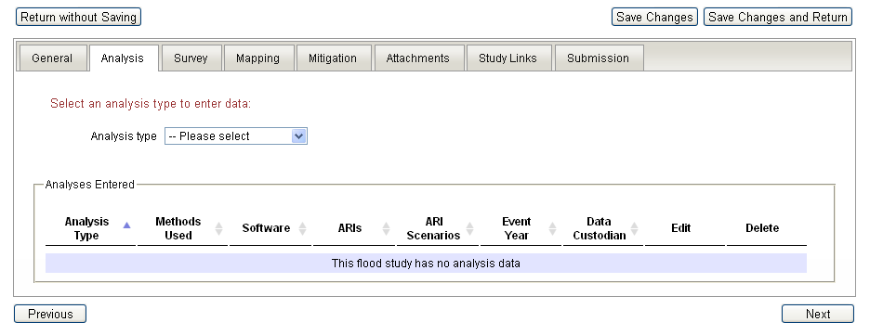
Figure 4 Screenshot of the Analysis Tab.

The analysis tab can capture information about three types of analysis often present in flood study reports,; namely: Hydrological Estimates, Hydraulic Modelling, and Damage Estimates. The analysis tab can be the most time consuming to fill out and requires the closest reading of the study material to obtain the relevant information. This information can be found in section titled Modelling Methodology, Hydrological Modelling, and Hydraulic Modelling”. This information may be summarised in the Introduction and the “Executive Summary” but usually you will need to read the text in the relevant section of the report to obtain the details needed to fill out the fields on this section. A check of the studies Table of Contents can help you quickly locate these sections.
Data can be entered for hydrological estimates, hydraulic modelling and damage assessment analyses. Each analysis type can include several modelled events and are described as follows.

Events Modelled

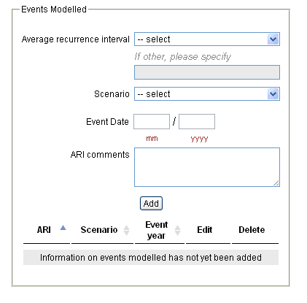
Figure 5 Screenshot –shows how the Events Modelled box appears for Hydrological Estimates and Hydraulic Modelling sections.
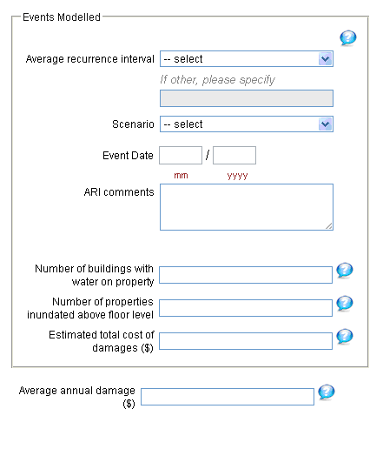
Figure 6 Screenshot shows how the Events Modelled box appears for Damage Assessments section.
The Events Modelled section is common to Hydrological Estimates(5.2.2), Hydraulic Modelling (5.2.3) and Damage Assessments (5.2.4) sections under the Analysis tab with some extra fields included to help quantify the damage assessment. The information required here can often be first identified from lists of figures (for example sets of figures for 10, 25, 50 and 100 ARI scenarios) and found in detail somewhere at the beginning of Modelling Methodology or similar sections.

Table 2: Analysis Tab - Events Modelled fields and guidance
Field Name | Definition | Field Rules | Field Entry Guidance
Average recurrence interval (ARI) | A statistical estimate of the average period in years between the occurrence of a flood of a given size or larger than the selected event. For example, floods with a discharge as great as, or greater than the 20 year ARI flood event will occur on average once every 20 years. ARI is another way of expressing the likelihood of occurrence of a flood event. The ARI is related to the "Annual Exceedance Probability" (AEP): ARI = 100 / AEP. | If the term ‘Other’ is selected a value is required.
Other ARI | Non-standard Average Recurrence Interval entered by the user when 'Average Recurrence Interval' is 'Other'. | Must be filled in if “Other” is chosen in the above field. | Usually filled out for “Historical” scenarios where the study has assigned a precise ARI to the event.
Scenario | The scenario being modelled, including: A Design Event, a Historical Event or The Probable Maximum Flood (PMF) (Probable Maximum Precipitation [PMP] for Hydrology). |  | Any calibration and validation runs should be included and marked as “Historical” for the scenario. For an example see flood study 2854 and section 5 of the attached Flood Mapping Study.
Event date | The year and month of the historical event.
ARI comments | Free text entered by the user about the ARI. | Free text. Current character limit of 1000. | Enter the month of a historical scenario here.  If the ARI/AEP has incorporated climate change, the scenario should be noted here e.g. Applied 1m sea level rise.
Table 3: Analysis Tab - Damage Assessment specific Event Modelled field and guidance
Field Name | Definition | Field Rules | Field Entry Guidance
Number of buildings with water on property | The number of buildings that have water on the property for the scenario modelled.
Number of properties  inundated above floor level | The number of buildings with water over the floor for the scenario modelled.
Estimated total cost of  damages ($) | Estimate of the total cost of damages for the scenario modelled. |  | Remember to note the year of the estimate i.e. $140,000 (2006 dollars) in the comments section.
Average annual damage ($) | Depending on its size (or severity), each flood will cause a different amount of flood damage to a flood prone area. Average annual damage (AAD) is the average damage per year that would occur in a nominated development situation from flooding over a very long period of time. If the damage associated with various annual events is plotted against their probability of occurrence, the AAD is equal to the area under the consequence-probability curve. AAD provides a basis for comparing the economic effectiveness of different management measures, (i.e. their ability to reduce the AAD). | Recorded in Australian dollars. | Remember to note the year of the estimate i.e. $140,000 (2006 dollars) in the Comments section.

Hydrological Estimates
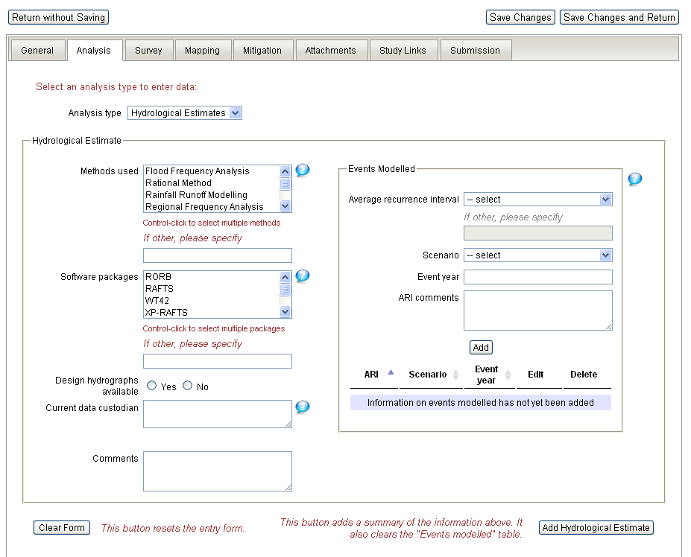
Figure 7 Screenshot of the Analysis Tab - Hydrological Estimates.
The Hydrological Estimates section is intended to capture information on the methods, software and scenarios used in the study. This may involve the evaluation of peak flows, flow volumes and the derivation of hydrographs for a range of floods.
For information on the data to be entered under Events Modelled see section see 5.2.1.

Table 4: Analysis Tab - Hydrological fields and guidance
Field Name | Definition | Field Rules | Field Entry Guidance
Methods used | The method (methodology or mathematical algorithm) used to develop the hydrological estimate. | If the term ‘Other’ is selected a value is required.
Other method | Non-standard method. | Must be filled in if “Other” is chosen in the above field.
Software packages | The software package or combination of packages used in the study to do hydrological modelling. | If the term ‘Other’ is selected a value is required.
Other software package | Non-standard software package. | Must be filled in if “Other” is chosen in the above field. | Version numbers should not be included.
Design hydrographs  available | Flag to indicate whether the design hydrographs used for the modelled scenario are available.
Current data custodian | The current custodian of the hydrological estimate data. | Do not include trailing Pty Ltd or other similar abbreviations. | Usually the lead consultant but sometimes the council or other commissioning body.
Comments | Optional additional information about the hydrological estimates. | Free text. Current character limit of 1000.  Proper sentences else a short note without a full stop. | Useful to note anything specifically about the modelling undertaken. For example “earlier modelling in year xx found to be not satisfactory and should be replaced with modelling in this report”.

Hydraulic Modelling
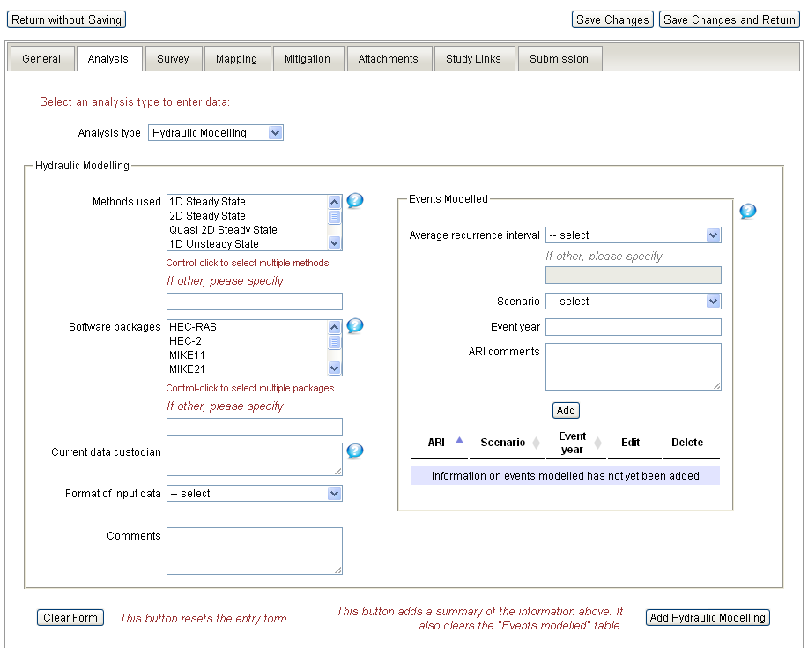
Figure 8 Screenshot of the Analysis Tab - Hydraulic Modelling.
The Hydraulic Modelling section is intended to capture information about the software used to model the various scenarios hydraulically. Hydraulic models simulate water flow, evaluating flow parameters such as water level, extent and velocity.
For information on the data to be entered under Events Modelled see section see 5.2.1

Table 5: Analysis Tab - Hydraulic Modelling fields and guidance
Field Name | Definition | Field Rules | Field Entry Guidance
Methods used | The method (methodology or approach) used to develop the hydraulic model. | If the term ‘Other’ is selected a value is required. | Very rarely is this information specified directly in a flood study and selecting “Unspecified” is acceptable.
Other method | Non-standard method | Must be filled in if “Other” is chosen in the above field.
Software package | The software package used to develop the model. | If the term ‘Other’ is selected a value is required.
Other software package | Non-standard software package. | Must be filled in if “Other” is chosen in the above field.  Do not include software version info or prefixes. | For example visual MODFLOW version 2.34 should be entered as just MODFLOW in the “Other” field.
Current data custodian | The current custodian of the hydraulic modelling data. | Do not include trailing Pty Ltd or other similar abbreviations. | Usually the consultant that used the software to produce the model. Sometimes explicitly stated otherwise.
Format of input data | The format of the data used as input into the Hydraulic model used in the study. |  | Examples of “Hard Copy” input data include instrument recorded or hand graphed hydrographs etc. “Soft Copy (other)” is chosen when the input into the hydraulic model is the direct output from a hydrological model.
Comments | Optional additional information about the hydraulic modelling. | Free text.  Current character limit of 1000.  Proper sentences else a short note without a full stop.  To be used sparingly. | Items noted here tend to include specific details found in the modelling sections that you deem important enough to be recorded e.g. “The authors of the report have doubts about the modelling presented due to low quality input elevation data”.

Damage Assessment
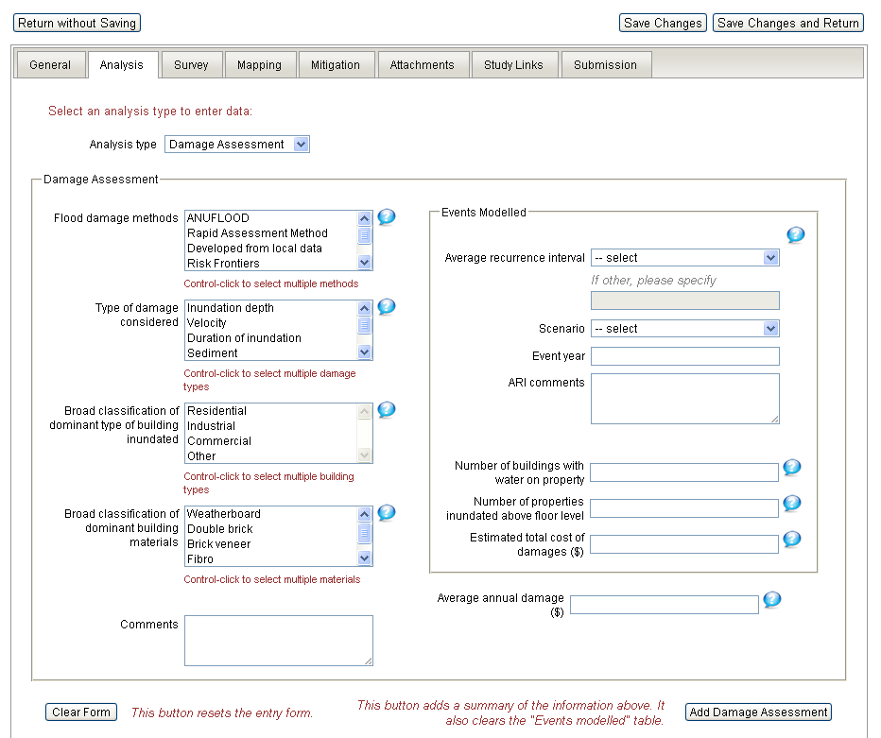
Figure 9 Screenshot of the Analysis Tab - Damage Assessment.
The Damage Assessment relates to the damage caused by the flooding. Usually there is a relatively detailed section in the study devoted to the calculation of these values. These can usually be found after the discussion of the modelling. Sometimes a separate report or volume specifically dealing with damage costs will include this analysis. This information is often presented in tabular form. The List of Tables following the Table of Contents may help to locate the section relating to this data.
For information on the data to be entered under Event Modelled see section see 5.2.1

Table 6: Analysis Tab - Damage Assessment field descriptions and guidance
Field Name | Definition | Field Rules | Field Entry Guidance
Flood damage method | The method (methodology or approach) used to develop the damage assessment.
Type of damage  considered | The type of damage considered in the assessment. |  | Typically inundation depth only but if a study has modelled velocity or other parameters the study should be checked in detail to ascertain if this data was used in the calculation of damage.
Dominant building type | The broad classification of the dominant type of building inundated for the modelled event. |  | Can usually be inferred from the text around the calculations of Estimated Damage or in tables found in those sections of the report.
Dominant building material | The broad classification of the dominant construction materials for buildings estimated as damaged in the modelled or actual event. |  | Do not fill this field out unless the details of building materials were specifically taken into account in the report during damage calculations.
Comments | Additional information about the damage assessment analysis. | Free text. Current character limit of 1000.  Proper sentences else a short note without a full stop.  Note the year of the estimate i.e. $140,000 (2006 dollars). | Items read in the report that relate directly to the accuracy of the assessment may be reported here e.g. “The damage in the area west of the river would be less in practice because of the change in building codes that were not included in this modelling.”

Survey Tab
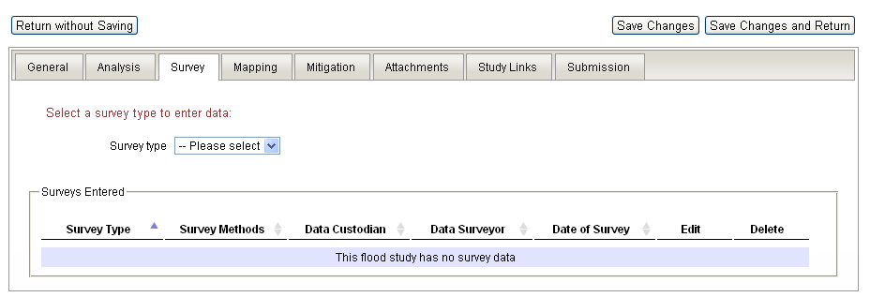
Figure 10 Screenshot of the Survey Tab.
The survey tab is set up to capture information gathered in order to complete the flood study. It can record two types of survey data; Terrain Surveys and Floor Surveys. Survey data is generally not captured in a consistent way across different flood studies, and rarely is there a detailed section relating to it in older studies. The information that this tab seeks to record is best found by key word searches for example “Survey”, “Terrain”, “Cross-section”, “LiDAR”, “Floor”, “Conducted”. The floor survey data can often be found mentioned or referred to in the sections of the report focused on damage assessment in sentences similar to “A floor survey was conducted by/in …] for the purposes of evaluating the amount of inundation above floor height”.

Terrain Survey
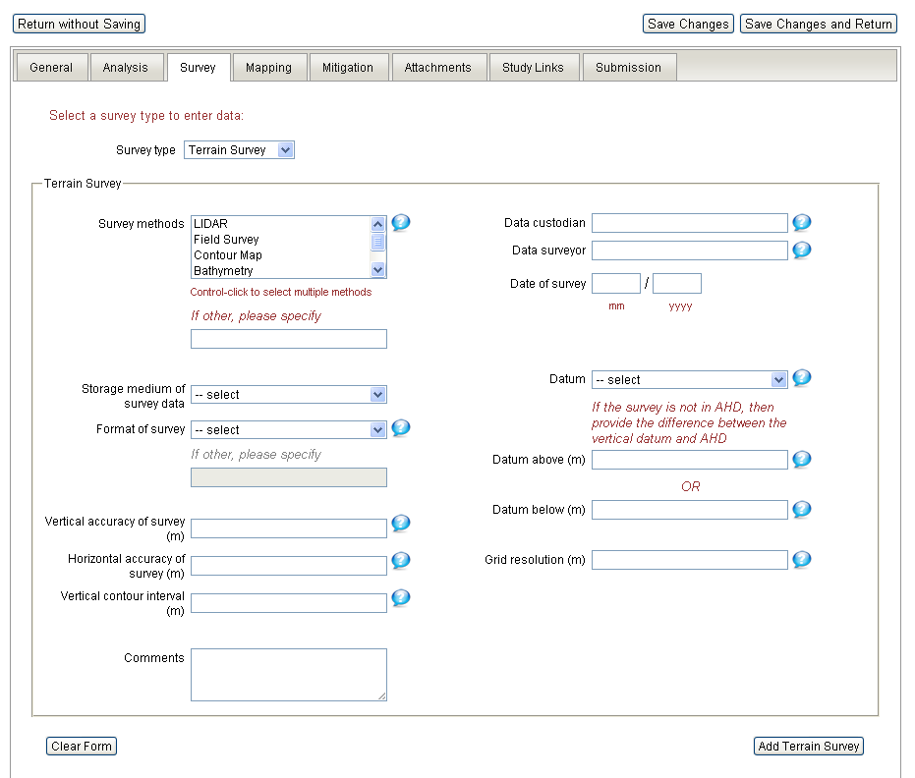
Figure 11 Screenshot of the Survey Tab - Terrain Survey.
The information needed to fill the Terrain Survey section of the Survey Tab is sparsely recorded in flood studies. The Survey Tab serves as a template of the information that ought to be easily accessible in all flood study reports. Flood modelling is reliant on, and sensitive to, the elevation data that is used as input. Upmost effort should be made in filling out the survey tab with any survey information mentioned in the report; whether or not it was commissioned for the report. This will give an initial indication of the survey data (if any) used by the study in order to aid any attempt at replication of the model setup.

Table 7: Survey Tab - Terrain Survey fields and guidance
Field Name | Definition | Field Rules | Field Entry Guidance
Survey method | The method (methodology or approach) used to conduct the terrain survey. | If the term ‘Other’ is selected a value is required. | Field surveys usually produce cross sections that are used in the flood modelling. Photogrammetry can be used in older surveys but most often the format is a combination of LiDAR (sometimes referred to as Airborne Laser Survey, ALS) data with cross-section field surveys.
Other survey method | Non-standard terrain survey method. | Must be filled in if “Other” is chosen in the above field.
Storage medium of  survey data | The medium that the survey is stored in. | If the term ‘Other’ is selected a value is required. | Examples of hard copy documents include hand drawn cross-sections or detailed field survey notes.  Geographic Information Systems (GIS) can include any software that is designed for processing geographic data.
Format of survey | The format the survey data is available in. | If the term ‘Other’ is selected a value is required.
Other format of survey | Non-standard format. | Must be filled in if “Other” is chosen in the above field.
Vertical accuracy of survey (m) | The vertical accuracy of survey measurements, in metres. | To two decimal places.
Horizontal accuracy of survey (m) | The horizontal accuracy of survey measurements, in metres. | To two decimal places.
Vertical contour interval (m) | Vertical contour interval of the survey, in metres. | To two decimal places.
Comments | Additional information about the terrain survey. | Free text. Proper sentences else a short note without a full stop.  Current character limit of 1000.
Data custodian | Current custodians of the survey. | Do not include trailing Pty Ltd or other similar abbreviations. | Usually the consultant or council who commissioned the surveyor, most commonly the same consultant or council responsible for commissioning the report.
Data surveyor | The organisation that performed the survey. | Do not include trailing Pty Ltd or other similar abbreviations. | Can usually be found in sentences like “~ Surveyors and Co obtained ~ cross-sections along the ~ river…” Use keyword searches for “Survey” or “cross” for example.
Date of survey | Date that the survey was completed. |  | If a month is not specified enter only the year.
Datum | The datum that the survey was based on. | If not Australian Height Datum (AHD), the offset above or below AHD must be entered at 'Datum above (m)' or 'Datum below (m)'.
Datum above (m) | The measurement of the datum relative to the Australian Height Datum (AHD). | To two decimal places.
Datum below (m) | The measurement of the datum relative to the Australian Height Datum (AHD). | To two decimal places.
Grid resolution (m) | The grid resolution of the survey map, in metres. | To two decimal places.

Floor Survey
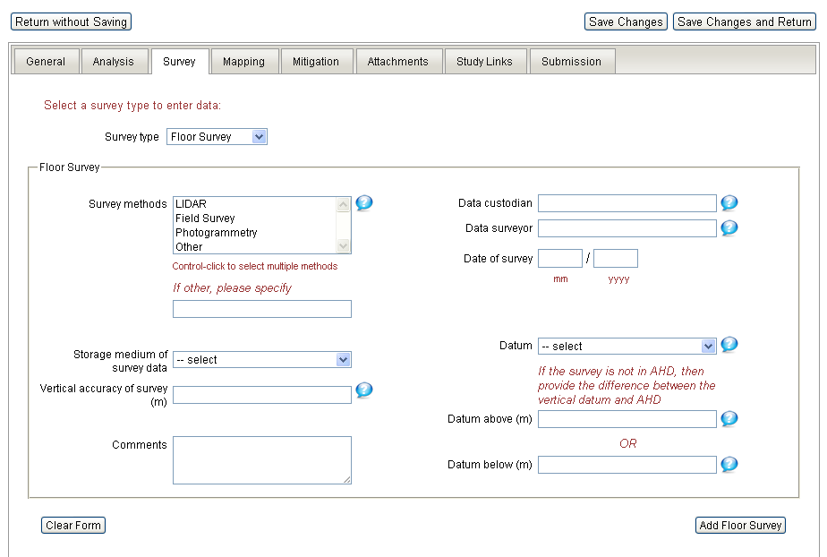
Figure 12 Screenshot of the Survey Tab - Floor Survey.
The Floor Survey section of the Survey Tab is usually filled out by reading sections of the flood study or other document dealing with damage assessment and mitigation options. If no section is available for review suggested keyword searches include “Survey”, “Terrain”, “Floor”, “Conducted” etc… Sentences similar to “A floor survey was conducted by/in […] for the purposes of evaluating the amount of inundation above floor height… are often the only place any of the information requested in these fields can be found.

Table 8: Survey Tab - Floor Survey fields and guidance
Field Name | Definition | Field Rules | Field Entry Guidance
Floor survey method | The method (methodology or approach) used to conduct the floor survey. | If the term ‘Other’ is selected a value is required.
Other survey method | Non-standard survey method. | Must be filled in if “Other” is chosen in the above field.
Storage medium of survey data | The medium that the survey is stored in. |  | Hand written survey field notes are an example of a “Hard Copy” storage medium.
Vertical accuracy of survey (m) | Vertical accuracy of the survey conducted, in metres. | To two decimal places.
Comments | Additional information about the floor survey. | Free text.  Current character limit of 1000.  Proper sentences else a short note without a full stop.
Data custodian | Current custodians of the survey. |  | Usually the consultant or council who commissioned the surveyor, most commonly the same consultant or council responsible for the report as a whole.
Data surveyor | The organisation that performed the survey. |  | Can usually be found by keyword search for words in sentences like “…Surveyors and Co obtained floor heights for […] properties within the modelled extents …”.
Date of survey | Date that the survey was completed. |  | If a month is not specified enter only the year.
Datum | The datum that the survey was based on. | If not Australian Height Datum (AHD), the offset above or below AHD must be entered at 'Datum above (m)' or 'Datum below (m)'.
Datum above (m) | Meters above the Australian Height Datum (AHD). | To two decimal places.
Datum below (m) | Meters below AHD. | To two decimal places.

Mapping Tab
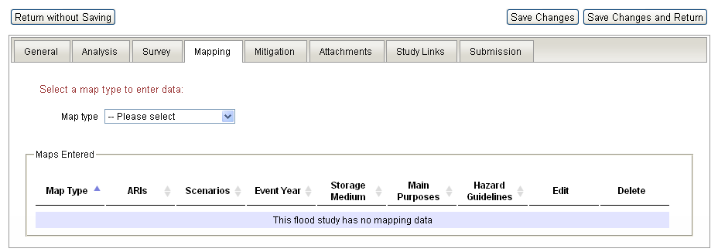
Figure 13 Screenshot of the Mapping Tab.
The Mapping Tab records information about two types of maps often present in flood studies and floodplain risk management documents:; Flood Inundation Maps and Flood Hazard Maps. These maps can be found throughout flood study documents, and can sometimes form large appendices. Sometimes a study may be missing the relevant appendices, figures may form a separate document that you do not have, or the figures may just be missing from the report. In this case the List of Figures typically following the reports Table of Contents or careful skimming of the document can help ascertain how many figures the report produced. These figures should be entered into the appropriate fields and comment made that at the time of data entry the figures were not available and may not necessarily be attached to the study.

Flood Inundation Mapping
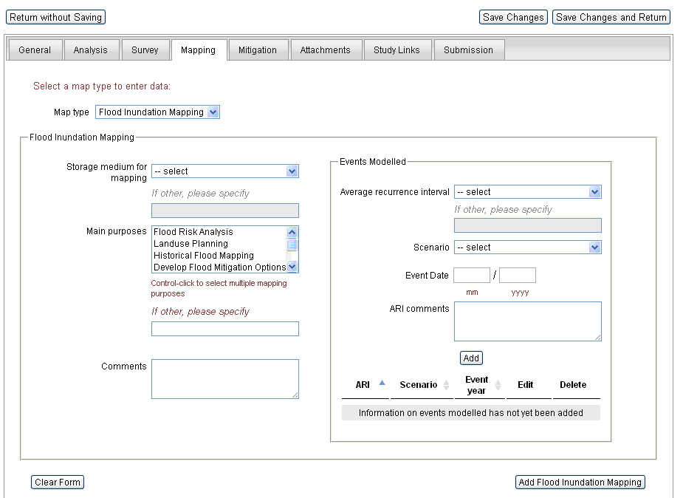
Figure 14 Screenshot of the Mapping Tab - Flood Inundation Mapping.
Flood inundation maps display the extent or depth of flooding for specific modelled scenarios and can be presented in different ways. They are usually easy to find during a skim of the report or reading a ‘List of Figures. If the document you are using for data entry clearly refers to figures but those figures are missing from your digital copy then contact your source for the document and request the figures. You should still record those maps in the Mapping Tab fields.
For information on the data to be entered under Event Modelled see section see 5.2.1

Table 9: Mapping Tab - Flood Inundation Mapping fields and guidance
Field Name | Definition | Field Rules | Field Entry Guidance
Storage medium for mapping | The medium that the map is stored in. | If the term ‘Other’ is selected a value is required.
Other storage medium for mapping | Non-standard storage medium. | Must be filled in if “Other” is chosen in the above field.
Main purposes | Standardised classifications of the main purpose for which the flood inundation map was developed. | If the term ‘Other’ is selected an entry is required. | The purpose of the mapping is often the same as the purpose of the study as a whole and this information can be obtained from the Introductory sections of most flood studies.
Other main purposes | Non-standard main purpose of mapping. | Must be filled in if “Other” is chosen in the above field.
Comments | Additional information about the flood inundation mapping. | Free text.  Current character limit of 1000.  Proper sentences else a short note without a full stop. | Use this field to describe constraints or issues relating to the maps raised in the report such as “Maps to be updated when the ~ levee is completed.”  - Maps missing from study. A comment stating; at the time of data entry the figures were not available and may not necessarily be attached to the study.

Flood Hazard Mapping
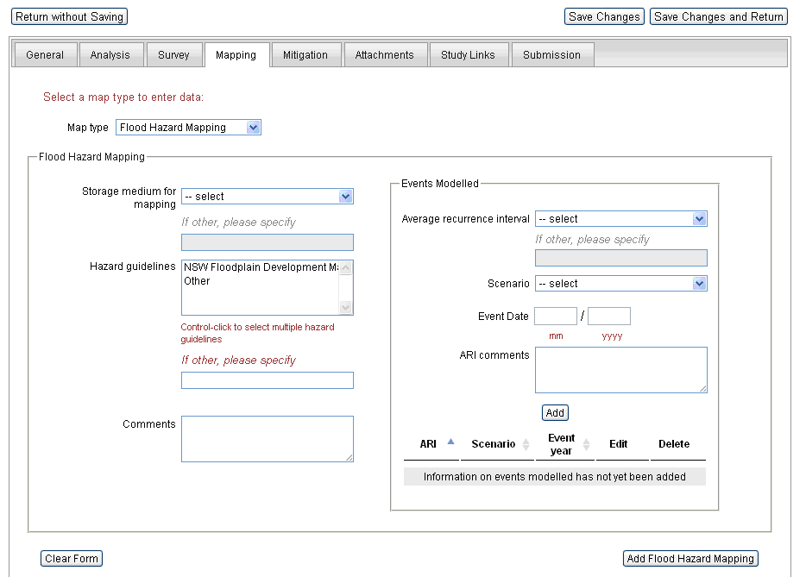
Figure 15 Screenshot of the Mapping Tab - Flood Hazard Mapping.
Flood hazard maps generally delineate several hazard levels (for example low, medium and high hazard) which are defined through a combination of parameters, such as water depth and velocity. If present they are usually easy to locate through a List of Figures or a skim of the document. If the document you are using for data entry clearly refers to figures but those figures are missing from your digital copy, then contact the source of the document and request the figures.
For information on the data to be entered under Event Modelled see section see 5.2.1.

Table 10: Mapping Tab - Flood Hazard Mapping
Field Name | Definition | Field Rules | Field Entry Guidance
Storage medium for mapping | The medium that the map is stored in. | If the term ‘Other’ is selected a value is required.
Other storage medium for mapping | Non-standard storage medium. | Must be filled in if “Other” is chosen in the above field.
Hazard guideline | Standardised classifications which define what combinations of parameters (for example, water depth and velocity) describe the different hazard zones (for example, low, medium and high hazard). | If the term ‘Other’ is selected an entry is required. | Not often given in reports although if the guidelines used were the 1986 NSW Floodplain Development Manual this is usually stated in the text introducing the maps.
Other hazard guidelines | Non-standard Hazard Guideline. | Must be filled in if “Other” is chosen in the above field.
Comments | Additional information about the Flood Hazard Mapping. | Free text.  Current character limit of 1000.  Proper sentences else a short note without a full stop.

Mitigation Tab
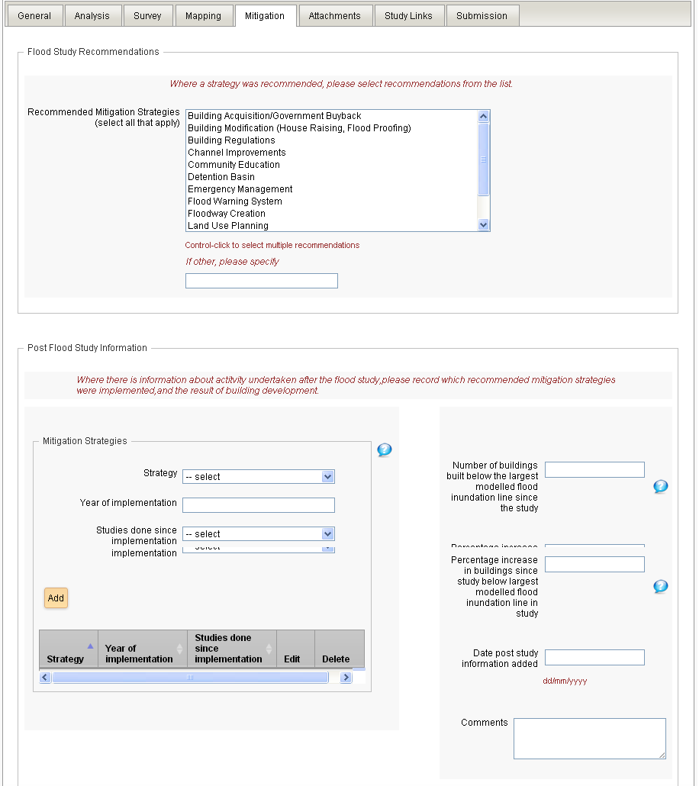
Figure 16 Screenshot of the Mitigation Tab.
The Mitigation Tab records information about mitigation strategies that have been recommended by, or undertaken in direct response to, the flood study. Flood studies may include comparisons of various mitigation options that end in solid recommendations., However, sometimes that analysis is dealt with in a separate report. When available that document should be attached to the flood study entry and used to fill in the recommended strategies. For example, studies following the NSW State Government’s flood policy have this information separated from the Flood Study into a Floodplain Risk Management Study (see ASFID 2842 as an example).
Only strategies that are unambiguously recommended in the document should be selected here. Sometimes it can be difficult to find strong recommendations in amongst the many options for mitigation being considered. In the absence of a section titled Recommendations, look in the summary sections related to the mitigation options for sentences similar to “Of all the strategies discussed here the following are cost effective and should be implemented…”.

Flood Study Recommendations
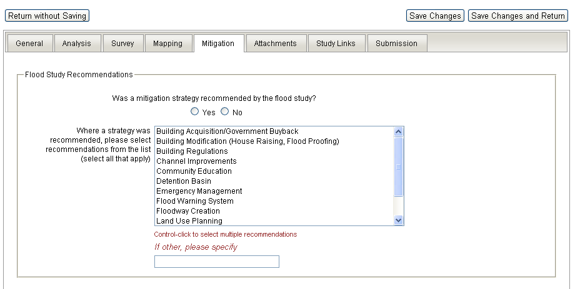
Figure 17 Screenshot of the Mitigation Tab
Be careful of options that are found to be highly effective but too expensive to be recommended as these should not be selected under this tab e.g. “The construction of the ~ levee was found to almost completely mitigate the worst areas of the flooding and would be built in an area of unoccupied land, however due to it’s high cost and the presence of other cheaper mitigation options it is not suggested”. As with other sections, if “Other” is selected, the item must be specified.

Post Flood Study Information
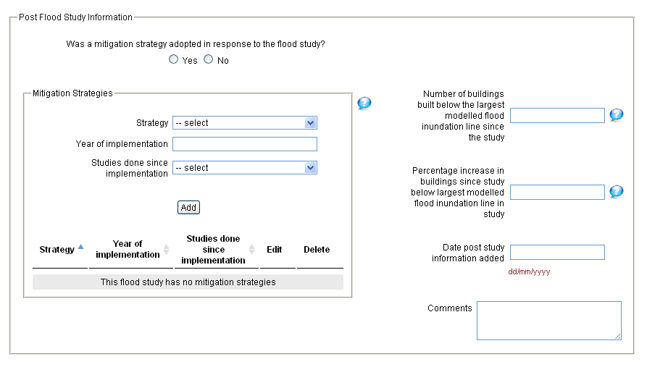
Figure 18 Screenshot of the Mitigation Tab - Post Flood Study Information.
The Post Flood Study Information section of the Mitigation Tab can only typically be filled in some time after the original study is completed. There are rare cases where the studies recommendations have been accepted before the final report is complete and so are mentioned in the report itself. For initial data entry of recent studies it is usually not possible to complete these fields. Checking with your data source or contacting the commissioning organisation to request information on the recommendations and any flooding since the completion of the report will help to fill in the information requested on this tab, and add value to the entered information.
Table 11 Mitigation Tab - Post Flood Study Information fields and guidance.
Field Name | Definition | Field Rules | Field Entry Guidance
Strategy | Mitigation strategy or mechanism to reduce or offset the impact of flood damage implemented in response to the flood study.
Year of implementation | The year in which the strategy was implemented.
Studies done since  implementation | Have additional flood studies been done following the implementation.
Number of buildings built below largest modelled flood inundation since the flood study | Buildings built in the flood inundation extent identified in this study since its completion.
Percentage increase in  buildings since study below largest flood inundation line in study | The percentage increase in buildings that have been built since the study (of the total modelled) during the most severe event.
Date post study  information added | The date that 'Post Flood Study' information was entered.
Comments | Additional information about  the post study mitigation. | Free text.  Current character limit of 1000.  Proper sentences else a short note without a full stop.

Attachments Tab
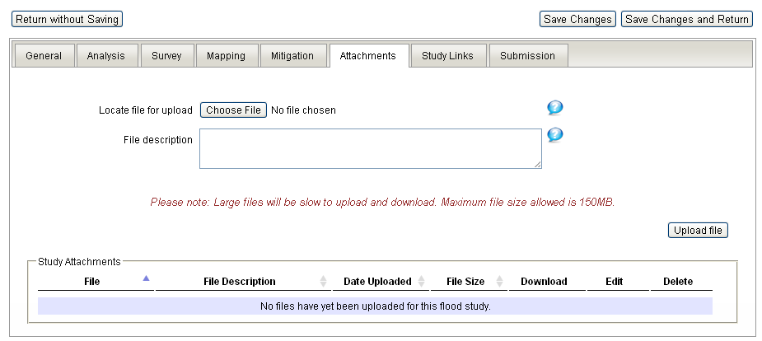
Figure 19 Screenshot of the Attachments Tab.

The Attachment Tab enables upload of a digital copy of the document you are using to complete the data entry. If you only have a hard copy please upload a scanned version of it here. If the study being upload is larger than the 150 Mb limit please use software to create a multi volume zip and upload each piece separately (see AFSID 2814 for an example).
Any set of clearly related documents should be uploaded. For example AFSID 2408 includes a report on flood prioritisation. Where such directly relevant reports exist there is no reason not to include them as well commented, titled and uploaded attachments. This information is requested because while minor reports and other strictly “non-flood study” documents are not valuable as entries in their own right, attached logically to a relevant flood study they have value.
Attached files should be logically named, for example 20040748RA4.pdf could be replaced with Dry_Creek_Floodplain_Mapping.pdf.

Table 12 Attachments Tab fields and guidance
Field Name | Definition | Field Rules | Field Entry Guidance
File | The actual electronic file attached to the Flood Study record. | Must be less than 150 Mb.  Name must not include any spaces, replace them with underscores. | If the study comprises many files i.e. the report is split into chapters, figures and appendices for example (see AFSID 2874), then the files should all be zipped together in a logical way and uploaded.
File description | A description of the file content. | Free text.  Current character limit of 1000.  Proper sentences else a short note without a full stop. | Use the following template:  Where a version (Draft, Final) is clear from the report:  Flood Study Title – Version – Date (Month Year)  For example:  Emu Creek Flood Study – Final Report – February 2007.  Where the version is not clear, omit the version from the description.

Study Links Tab
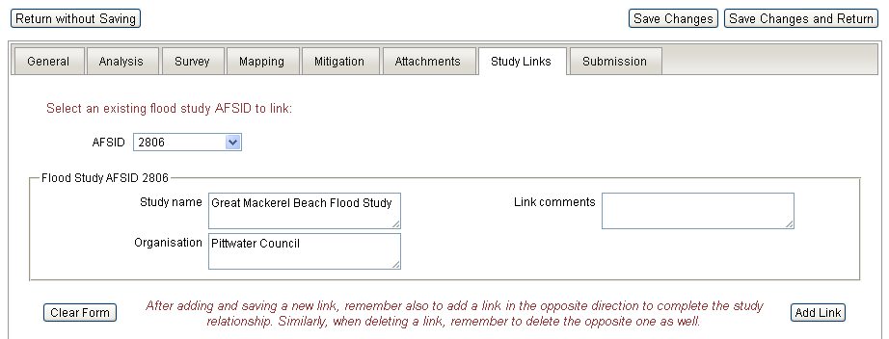
Figure 20 Screenshot of the Study Links Tab.
The Study Links tab is intended to link the study you are creating with other studies already in the Australian Flood Studies Database. Conditions for linking include Flood Studies that analyse the same town, river, region or catchment. When you select an AFSID check that the details, “Study Name” and “Organisation”, are accurate, and add any comments relating to the linking in the “Link comments” box.
Table 14 Study Links Tab fields and guidance.
Field Name | Definition | Field Rules | Field Entry Guidance
Link comments | Provide additional useful information relating to the linking of studies. | Free text.  Current character limit of 1000.  Proper sentences else a short note without a full stop. | Example Link Comments could be something similar to: “The original Flood Study for Great Mackerel Beach that this study is based on”.

Submission Tab
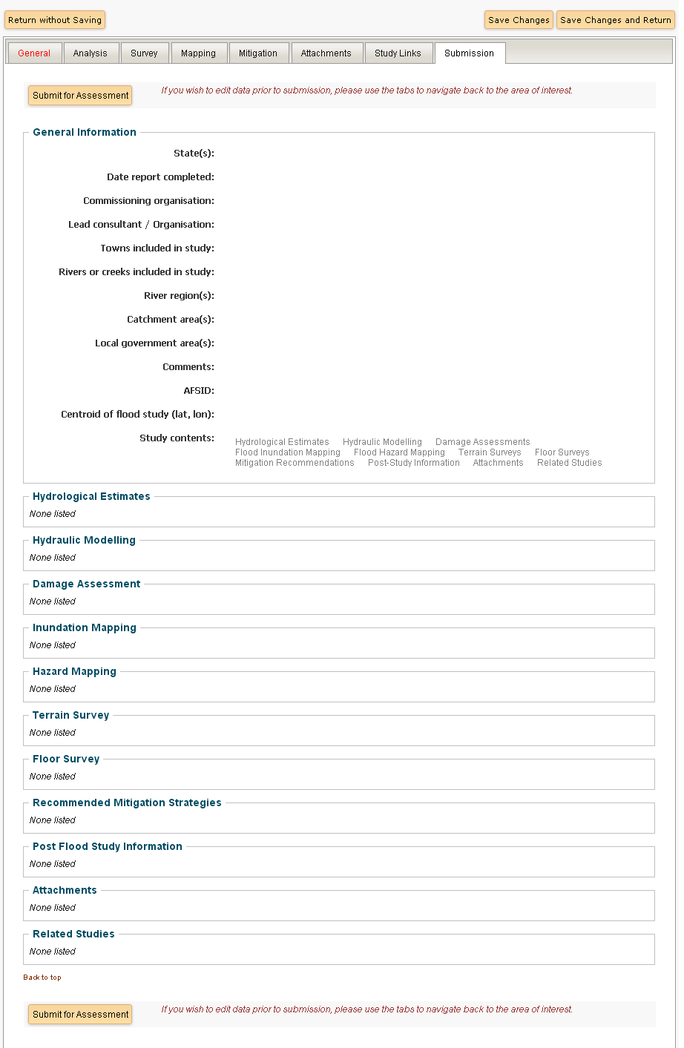
Figure 21 Screenshot of Submission Tab.
The Submissions tab provides an overview of all data entered as a final check before submission for quality assurance. Use this summary to check for spelling mistakes and to ensure that all the information entered is correct and complete. Double check that you have attached the digital copy of the flood study, (and any other relevant reports and figures). Also check that you can download and open attachments from the submissions page.
When you are satisfied that the study is complete and accurate, click the “Submit for Assessment” button.

Glossary
Table 15 Glossary
Terms | Acronym | Description
Aerial Photogrammetry |  | Aerial photogrammetry uses aerial photographs to produce topographic maps of the earth's surface and of features of the built environment.4
Annual Exceedence Probability | AEP | The likelihood of occurrence of a flood of a given or larger size occurring in any one year, usually expressed as a percentage. For example, if a peak flood discharge of 500 m³/s has an AEP of 5% it means that there is a 5% risk (i.e. a probability of 0.05 or a likelihood of 1 in 20) of a peak flood discharge of 500 m³/s or larger occurring in any one year (see Average Recurrence Interval). 1
Australian Height Datum | AHD | The survey height datum adopted by the National Mapping Council of Australia as the reference datum for defining reduced levels (0.0 m AHD is approximately mean sea level).1
Average Annual Consequences |  | The average consequence associated with a series of annual events, each with its own probability of occurrence and consequence (see also Average annual damage) .1
Average Annual Damage | AAD | Average annual damage (AAD).The total damage caused by all floods over a long time divided by the number of years in that period. (It is assumed that the population and development situation of interest does not change over the period of analysis). If the damage associated with various annual events is plotted against their probability of occurrence, the AAD is equal to the area under the consequence-probability curve. AAD provides a basis for comparing the economic effectiveness of different management measures, (i.e. their ability to reduce the AAD) (see also Average annual consequence) .1
Average Recurrence Interval | ARI | A statistical estimate of the average period in years between the occurrence of a flood of a given size or larger (eg. floods with a discharge as big as or larger than the 100-year ARI flood event will occur on average once very 100 years). The ARI of a flood event gives no indication of when a flood of that size will occur next. 1
Bathymetry |  | The configuration of the bed of a water body, as measured by depth contours. 1
Cadastre |  | Legal lot boundaries. 4
Catchment |  | The area of land draining to a particular site. It always relates to a specific location and includes the catchments of tributary streams as well as the main stream. 1
Chance |  | The likelihood of something happening that will have beneficial consequences (e.g. the chance of a win in a lottery). Chance is often thought of as the "upside of a gamble" (Rowe 1990) (see also Risk). 1
Critical Storm Duration |  | The duration of the storm event of nominated severity (e.g. the 2% AEP flood) that produces the largest flood discharge at the location of interest. Critical storm duration depends upon catchment size, topography and land use and on the temporal pattern of rainfall. 1
Defined Flood Event | DFE | The flood event selected for the management of flood hazard, as determined in floodplain management studies and incorporated in floodplain management plans. Selection of DFEs should be based on an understanding of flood behaviour and the associated risk and consequences of flooding. The DFE should also take into account the social, economic and environmental consequences associated with floods of different severities. Different DFEs may be appropriate for structural measures (e.g. levees), different categories of land use and for emergency services planning. The concept of a range of DFEs supersedes sole focus on the 1 % AEP flood event, as in earlier practice. DFEs do not define the extent of flood-prone land, which is defined by the PMF (see also Probable maximum flood). 1
Design Flood |  | A significant event to be considered in the design process. Various works or activities within the floodplain may have different design events. 4
Design Rainfall Event |  | A synthetic rainfall profile used for design or analysis of a hydraulic structure or system.3
Digital Terrain Model | DTM | Electronic representation of ground terrain (topography) used as a basis for interpolation of cross-sections and for generating contour lines. 4
Discharge |  | The rate of low of water, as measured in terms of volume per unit time [eg. cubic metres per second (m3/s)]. (see also Hydrograph). 1
Extreme Flood |  | Approximation of the PMF. Peak discharge is generally a factor of five or six times the calculated 1% AEP discharge. 4
Flash Flooding |  | Sudden and unexpected flooding caused by local heavy rainfall or rainfall in another area. Often defined as flooding which occurs within six hours of the rain which causes flooding. 1
Flood Frequency Analysis |  | A statistical analysis to determine the relationship between peak discharge and the likelihood of the occurrence of the peak discharge. This is undertaken based on recorded historical data.2
Flood Fringe |  | Or Defined Flood Fringe.  The remaining area of land inundated by the DFE after defined floodway areas have been defined. 1
Flood Hazard |  | The degree of hazard varies with the severity of flooding and is affected by flood behaviour (extent, depth, velocity, duration, and rate of rise of floodwaters) topography, population at risk and emergency management. 1
Flood Storage Areas |  | Those parts of the floodplain that are important for the temporary storage of floodwaters during the passage of a flood. The extent and behaviour of flood storage areas may change with flood severity. Flood storage should be treated as part of the floodway (see Floodway).
Floodplain |  | Area of land adjacent to a creek, river, estuary, lake, dam or artificial channel, which is subject to inundation by the PMF (i.e. flood-prone land).1
Floodplain Management Plan |  | The recommended means of assessing and managing the flood risk associated with the use of the floodplain for various purposes. It represents the considered opinion of the local community, local agency and State agencies on how best to manage flood-prone land and provides a long-term path for the future development of the community. Usually includes both written and diagrammatic information. It fosters flood warning, response, evacuation, cleanup and recovery in the onset and aftermath of a flood and suggestions on organisational structure for integrated risk management for existing, future and residual flood risks. A floodplain management plan should be developed in accordance with the principles and guidelines of this document. Plans need to be reviewed regularly to assess progress and to consider the consequences of any changed circumstances that have arisen since the last review. 1
Floodway |  | Defined Floodway. The area of the floodplain where significant discharge or storage of water occurs during a Defined Flood Event (DFE).  Floodways are areas which, if filled or even partially blocked, would cause a significant redistribution of flood flow, or significant increase in flood levels. Floodways are often aligned with naturally defined channels and are often, but not necessarily, areas of deeper flow or areas where higher velocities occur, and also include areas where significant storage of floodwaters occurs. Each DFE has defined floodway and the extent and behaviours of floodways may change with flood severity. Areas that are benign for small floods may experience much greater and more hazardous flows during larger floods (see also Defined Flood Fringe).
Freeboard |  | The height above a defined flood level, typically used to provide a factor of safety in, for example, the setting of floor levels and levee crest levels (i.e. design flood event). Freeboard compensates for effects such as wave action, localised hydraulic behaviour and settlement of levees, which increase flood levels or reduce the level of protection provided by levees. Freeboard also provides protection from floods that are marginally above the defined flood level. However, freeboard should not be relied upon to provide protection for flood events larger than the DFE.1
Geographical Information Systems | GIS | A system of software and procedures designed to support the management, manipulation, analysis and display of spatially referenced data. 4
Hydraulic Analysis |  | The study of the flow of water in waterways. In particular location, the variation with time of discharge (discharge hydrograph) or water level (stage hydrograph) during the course of a flood.1
Hydraulics |  | A term given to the study of water flow in waterways; in particular, the evaluation of flow parameters such as water level and velocity.4
Hydrograph |  | A graph that shows for a particular location, the variation with time of discharge (discharge hydrograph) or water level (stage hydrograph) during the course of a flood. 1
Hydrologic Analysis |  | The study of water and its constituents as they move through the natural processes that constitute the hydrological cycle (i.e. rainfall, runoff, evaporation, infiltration).1
Hydrology |  | A term given to the study of the rainfall and runoff process; in particular, the evaluation of peak flows, flow volumes and the derivation of hydrographs for a range of floods. 4
Impervious |  | A surface or area within the catchment where the majority of the rainfall becomes runoff e.g. roads, car parks and roofs etc.2
Manning’s Roughness Coefficient (n) |  | Variable used in mathematical computations to represent the relative roughness of ground terrain. 4
Peak Discharge |  | The maximum discharge occurring during or following a rainfall event past a given point on a river system. 1
Pluviograph |  | An instrument that automatically records the amount of rainfall as a function of time normally at sub-daily interval.2
Probable Maximum Flood | PMF | Probable maximum flood (PMF) The largest flood that could conceivably occur at a particular location, resulting from the PMP. The PMF defines the extent of flood-prone land. Generally, it is not physically or financially possible to provide general protection against this event. It is difficult to define a meaningful annual exceedance probability for the PMF event. It is commonly assumed to be of the order of 10-4 to 10-7 (i.e. a flood risk of 1 in 10 000 to 1 in 10 000 000, Laurenson 1994) (see also Probable maximum precipitation). 1
Probable Maximum Precipitation | PMP | Probable maximum precipitation (PMP) is the greatest depth of precipitation for a given duration meteorologically possible over a given size storm area at a particular location at a particular time of year, with no allowance made for long-term climatic trends (World Meteorological Organization). It is the primary input to the estimation of the PMF (see also Probable maximum flood). 1
Risk |  | Is defined (Standards Australia/Standards New Zealand 1995) as the chance of something happening that will have an impact on objectives. It is measured in terms of consequences and likelihood. For example, if the 50 year ARI flood event causes $20 million in flood damage, the risk of a flood causing $20 million damage is 1 in 50. Risk is often thought of as the "downside of a gamble" (Rowe 1990) (see also Chance). 1
Runoff |  | The amount of rainfall that drains into surface drainage network to become stream flow, also known as rainfall excess. 1
Stage |  | Equivalent to ‘water level’. Both are measured relative to a specified datum. 1
Storm Duration |  | The period of which rainfall occurs in the catchment.2
Stormwater Flooding |  | Inundation by local runoff caused by heavier than usual rainfall. Stormwater flooding can be caused by local runoff exceeding the capacity of an urban stormwater drainage system or by the backwater effects of mainstream flooding causing urban stormwater drainage systems to overflow. 1
Temporal Pattern |  | The variation of rainfall intensity with time over the course of a rainfall event. 1
Vulnerability |  | The degree of susceptibility and resilience of a community and the environment to flood hazards. Vulnerability is assessed in terms of the ability of the community and environment to anticipate, cope with and recover from flood events. Flood awareness is an important indicator of vulnerability. 1
Water Surface Profile |  | A diagram showing the variation of surface water level along a water course. 1
  - Glossary References
1 SCARM (2000) ‘Floodplain management in Australia: Best practice principles and guidelines’, Agriculture and Resource Management Council of Australia and New Zealand, Standing Committee on Agriculture and Resource Management, Report No. 73, CSIRO Publishing, Collingwood, Victoria, ISBN 0643-06034-0, pp. 94-101.
2 Sinclair Knight Merz (2009) ‘Shire of Boddington Floodplain Management Study. Flood Modelling Report’, Report for The Shire of Boddington, pp. iii-iv.
3 Department of Water (2011) ‘Murray drainage and water management plan’, Department of Water. Government of Western Australia, pp. 85-88.
4 Armidale Dumaresq Council and Paterson Consulting (2005) ‘Armidale Flood Study’, Report for The Armidale Dumaresq Council, pp. i-vii.
5 Rowe, WD. (1990) ‘Perspective on Rare Events for Decision Making’, In: Proceedings of a Conference on Risk Based Decision Making in Water Resources, Santa Barbara, California, 15-20 October 1989, American Society of Civil Engineers, (ASCE), pp. 1-15.
6 Laurenson, E.M. (1994) ‘The probability of extreme floods in Australia’, In: Acceptable Risks for Extreme Events in the Planning and Design of Major Infrastructure, Australian National Committee on Large Dams (ANCOLD) Seminar, Sydney, April, 1994.

Checklist of all Fields in the Australian Flood Studies Database
A spread sheet of fields in the Australian Flood Studies Database has been reproduced by the Floodplain Management Unit at the Victorian Department of Sustainability & Environment, and can be found in Appendix A. The spread sheet is intended to help people new to this data entry process familiarise themselves with the contents of the database. It may also be useful to include in tender documentation prior to commencing a flood study to ensure that all relevant information is captured in the flood study report (depending on the purpose of the study). Additional choices may be added to the fields by sending an email to hazards@ga.gov.au with Australian Flood Studies Database in the subject heading.
General
Study Name |  |  | Commissioning Organisation |  |  | Lead Consultant/Organisation
Names of rivers or creeks involved in study |  |  | Date completed |  |  | Names of towns involved in study
 |  |  | Lat and Long of Study Area
Analyses
Hydrological Estimates |  |  | Hydraulic Modelling |  |  | Damage Assessment
Methods Used |  |  | Methods Used |  |  | Methods Used
Flood Frequency Analysis |  |  | 1D Steady State |  |  | ANUFLOOD
Rational Method |  |  | 2D Steady State |  |  | Rapid Assessment Method
Rainfall Runoff Modelling |  |  | Quasi 2D Steady State |  |  | Developed from local data
Regional Frequency Analysis |  |  | 1D Unsteady State |  |  | Risk Frontiers
Clark-Johnstone Method |  |  | 2D Unsteady State |  |  | Geoscience Australia
Regression and Gerny Method |  |  | Quasi 2D Unsteady State |  |  | Other
Unit Hydrograph |  |  | Physical Model |  |  | If Other, please specify
Mass Balance |  |  | Backwater Analysis
Rating Curve |  |  | Standard Step Method
Not Applicable |  |  | Not Applicable
Other |  |  | Unspecified
If Other, please specify |  |  | Other
 |  |  | If Other, please specify
Software Packages |  |  | Software Packages |  |  | Type of Damage Considered
RORB |  |  | HEC-RAS |  |  | Inundation depth
RAFTS |  |  | HEC-2 |  |  | Velocity
WT42 |  |  | MIKE11 |  |  | Duration of Inundation
XP-RAFTS |  |  | MIKE21 |  |  | Sediment
Timestudio Modelling |  |  | MIKE_Flood |  |  | Debris
RSWM |  |  | ANUGA |  |  | Contamination
RRR |  |  | CELLS
RFRT |  |  | SAMOD
Regional Stormwater Model |  |  | DRAINS |  |  | Dominant type of building inundated
IQQM |  |  | IRWASP |  |  | Residential
REALM |  |  | MOUSE |  |  | Industrial
URBS |  |  | PL2DFLOW |  |  | Commercial
WBNM |  |  | RSWM(RAFTS) |  |  | Other
HEC-1 |  |  | SAMOZ
FLIKE |  |  | SMS |  |  | Broad classification of dominant  building materials
Custom |  |  | SOBEK
FLOUT |  |  | Rating Curve |  |  | Weatherboard
ESTFLO |  |  | ESTFLOW |  |  | Double Brick
EXTRAN |  |  | ESTRY |  |  | Brick Veneer
RatHGL Computer Model |  |  | EXTRAN |  |  | Fibro
RD11 |  |  | FLOW2D |  |  | Other
CELLS |  |  | DELFT FLS
DRAINS |  |  | FPLAIN |  |  | For each event modelled the following  information is to be provided
MOUSE |  |  | RUBICON
ESTRY |  |  | ILSAX |  |  | ARI
RUBICON |  |  | TUFLOW |  |  | Design, Historical or PMF Scenario
ILSAX |  |  | UNET |  |  | Event Year (if historical)
XP-SWMM |  |  | WASP |  |  | No of buildings with water on property
Not Applicable |  |  | WASURF |  |  | No of buildings inundated above floor level
Unspecified |  |  | WICELL |  |  | Estimated total cost of damages
Other |  |  | Wallingford Hydraulic Model |  |  | Average annual damage (will be same across all scenarios)
If Other, please specify |  |  | XP-SWMM
 |  |  | XP-Storm
 |  |  | XP-UDD2000
 |  |  | Not Applicable
 |  |  | Unspecified
 |  |  | Other
 |  |  | If Other, please specify
Design Hydrographs Available? Yes/No. |  |  | Current Data Custodian
Yes
No
Current Data Custodian |  |  | Format of Input Data
 |  |  | Hard copy
 |  |  | Soft copy (GIS)
 |  |  | Soft copy (other)
For each event modelled the following  information is to be provided |  |  | For each event modelled the following  information is to be provided
ARI |  |  | ARI
Design, Historical or PMP Scenario |  |  | Design, Historical or PMF Scenario
Event Year |  |  | Event Year

This Page is Intentionally Left Blank

Survey
Terrain Survey |  |  | Floor Survey
Survey Methods |  |  | Survey Methods
LIDAR |  |  | LIDAR
Field Survey |  |  | Field Survey
Contour Map |  |  | Photogrammetry
Bathymetry |  |  | Other
Photogrammetry |  |  | If Other, please specify
Other
If Other, please specify
Storage medium of survey data |  |  | Storage medium of survey data
Hard copy |  |  | Hard copy
Soft copy (GIS) |  |  | Soft copy (GIS)
Soft copy (other) |  |  | Soft copy (other)
Format of Survey |  |  | Vertical accuracy of survey (m)
Cross-sections |  |  | Data custodian
Digital elevation model |  |  | Data surveyor
Digital terrain model |  |  | Date of survey
Floodplain contours |  |  | Datum
Spot heights |  |  | Datum above/below AHD (m)
Not stated
Other
If Other, please specify
Vertical accuracy of survey (m)
Horizontal accuracy of survey (m)
Vertical contour interval
Data custodian
Data surveyor
Date of survey
Datum
Datum above/below AHD (m)
Mapping
Flood Inundation Mapping |  |  | Flood Hazard Mapping
Storage Medium |  |  | Storage Medium
Hard copy |  |  | Hard copy
Soft copy (GIS) |  |  | Soft copy (GIS)
Soft copy (CAD) |  |  | Soft copy (CAD)
Soft copy (other) |  |  | Soft copy (other)
Not stated |  |  | Not stated
Other |  |  | Other
If Other, please specify |  |  | If Other, please specify
Main Purposes |  |  | Hazard guidelines
Flood Risk Analysis |  |  | NSW Floodplain Development Manual
Landuse Planning |  |  | Other
Historical Flood Mapping |  |  | If Other, please specify
Develop Flood Mitigation Options
Infrastructure (Road/Rail) Design
Emergency Management
Other
If Other, please specify
For each events modelled the relevant following information is to be provided |  |  | For each events modelled the relevant following information is to be provided
ARI |  |  | ARI
Design, Historical or PMF |  |  | Design, Historical or PMF
Event Year |  |  | Event Year
Mitigation
Was a mitigation strategy recommended? If so what was recommended?
Building Acquisition/government Buyback
Building Modification (House Raising, Flood Proofing)
Building Regulations
Channel Improvements
Community Education
Detention Basin
Emergency Management
Flood Warning System
Floodway Creation
Landuse Planning
Levee (New/Raise/Maintenance)
Planning Controls
Other
If Other, please specify

Middelmann, M., Sheehan, D., Jordon, P., Zoppou, C., & Druery, C. (2005) ‘National Catalogue of Flood Studies’. NSW Floodplain Management Conference, 22-25 February 2005, Narooma.

