Geodetic Survey of the Molonglo Radio Observatory

November 2012
Geoscience Australia
Record 2013/14
Matthew C. Garthwaite, Anna R. Hill, Steve Yates and Bob Twilley
Department of Resources, Energy and Tourism
Minister for Resources and Energy: The Hon Gary Gray AO MP
Secretary: Mr Blair Comley, PSM
Geoscience Australia
Chief Executive Officer: Dr Chris Pigram
This paper is published with the permission of the CEO, Geoscience Australia
© Commonwealth of Australia (Geoscience Australia) 2013
With the exception of the Commonwealth Coat of Arms and where otherwise noted, all material in this publication is provided under a Creative Commons Attribution 3.0 Australia Licence. (http://www.creativecommons.org/licenses/by/3.0/au/deed.en)
Geoscience Australia has tried to make the information in this product as accurate as possible. However, it does not guarantee that the information is totally accurate or complete. Therefore, you should not solely rely on this information when making a commercial decision.
Geoscience Australia is committed to providing web accessible content wherever possible. If you are having difficulties with accessing this document please contact feedback@ga.gov.au.
ISSN 2201-702X (PDF)
ISBN 978-1-922201-38-6 (PDF)
GeoCat 75653
Bibliographic reference: Garthwaite, M. C., Hill, A. R., Yates, S., and Twilley, B. 2013. Geodetic Survey of the Molonglo Radio Observatory. November 2012. Record 2013/14. Geoscience Australia: Canberra.
Current as at May 10, 2013

Contents
1. Introduction 1
2. Survey Methods 3
3. Survey Results 4
4. Comparison of Coordinates. 5

- Introduction
Geoscience Australia (GA) was approached by the Molonglo Radio Observatory to provide an up-to-date geodetic position relative to a modern datum for the Radio Telescope array located in the Captains Flat region, close to Hoskinstown, NSW. An up-to-date position is required because it is believed that inaccurate knowledge of the array location is introducing considerable errors to the measured radio signals.
A geodetic survey was conducted during construction of the telescope array in the 1970s. GA was provided with the position derived from this survey, believed to be the ground mark (GM) situated in the centre of the telescope infrastructure (hereafter referred to as the Original Position). It is believed this initial survey made use of two concrete monuments (hereafter referred to as the East and West Pillars; see Figure 1) located along the western arm of the telescope array.
GA was asked to provide the geodetic positions of the Centre GM of the telescope array, in addition to three further GMs located on the East, North and West arms of the telescope array. Figure 1 shows the location of the Original Position, surveyed ground marks and East and West Pillars.
GA personnel conducted the geodetic survey during two visits to the site on 16th November 2012, and 22nd November 2012. During the first visit the East and West Pillars were prepared for the survey by installing survey spigots suitable for modern Global Navigation Satellite System (GNSS) instrumentation. The longevity of these spigots should enable a meaningful repeat survey to be conducted at some time in the future. During the second visit, GNSS campaign surveys were conducted at the East and West pillars, followed by a radiation survey from the East Pillar to the other ground marks.
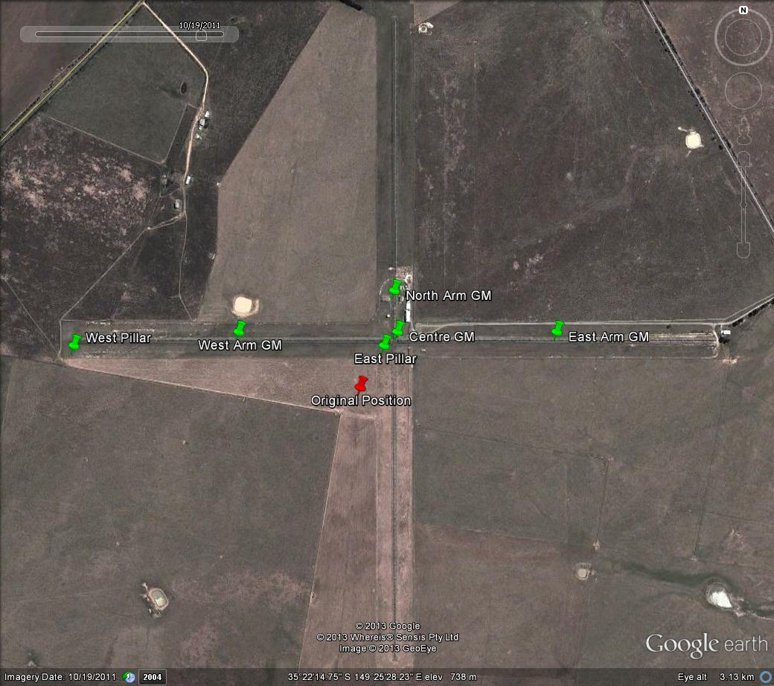
Figure 1: Overview location map of the Molonglo Radio Observatory, the provided Original Position (red pin) and ground marks (green pins) referenced in the text whose coordinates were determined during the survey.
- Survey Methods
Firstly, a simultaneous campaign GNSS survey was made on the East and West pillars. Two sets of Altus APS-3G GNSS Antenna and Receiver units were used for the campaign surveys. The duration of data acquired was 2hr 14 mins for the East Pillar (designated CAPE) and 2hr 21 mins for the West Pillar (designated CAPW). Figure 2 shows the GNSS survey setup at the West Pillar.
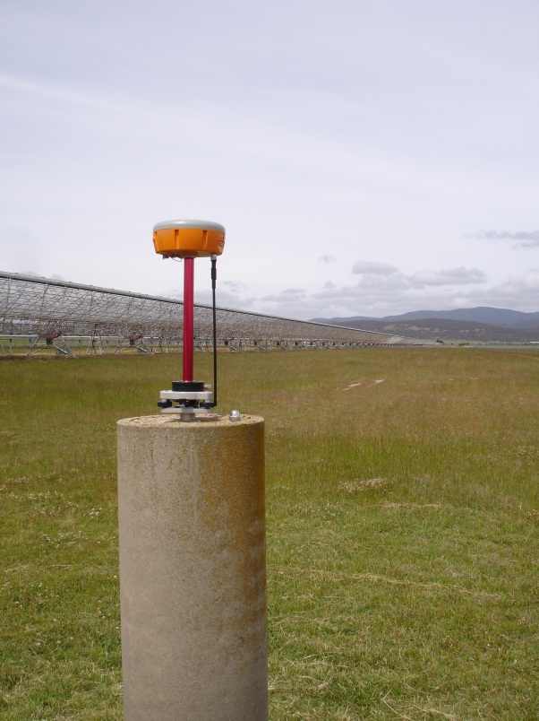
Figure 2: GNSS campaign survey set-up at the West Pillar (CAPW)
Raw data files (converted to RINEX format) were uploaded to the GA AUSPOS online GPS processing service (http://www.ga.gov.au/earth-monitoring/geodesy/auspos-online-gps-processing-service.html). From the AUSPOS processing results we obtained the coordinates of the two pillars in the GDA94 reference frame (Table 1) and in the ITRF08 reference frame (Table 2).
Secondly, a radiation survey was conducted. A Leica TM30 Total Station (S/N: 361445) and Leica precision prisms were used to conduct the survey. The Total Station equipment uses a precision prism positioned at the target to reflect incoming laser radiation back to the instrument. Radiations were measured from the East Pillar to the West Pillar (for tying the full survey to the geodetic reference frame) and then all four ground marks located around the radio telescope infrastructure (West Arm, East Arm, North Arm and Centre; Figure 1). During each radiation measurement, an azimuth and distance measurement to the target was recorded.
Post-processing of the collected radiation measurements involves converting the azimuths and distances to geodetic coordinates using the two positions of the East and West pillars (determined by AUSPOS) and setting the azimuth between the two monuments to zero (Table 1). All other pairs of azimuth and distance measurements can then be converted to positions in the same reference frame as the monuments (Tables 2 and 3).
- Survey Results
Table 1: Results of azimuth calculation between East Pillar and West Pillar calculated using an online azimuth calculator (http://www.movable-type.co.uk/scripts/latlong.html).
Distance (m) | Bearing (Degrees/Minutes/Seconds) | Midpoint Latitude | Midpoint Longitude
765.7 | 270° 00' 09" | -35° 22’ 16.00" | 149° 25' 12.00"
Table 2: GDA94 geodetic coordinates on GRS80. Using the GDA94 coordinates provided in the AUSPOS processing report for the East and West pillars. Other coordinates calculated using an online bearing and distance calculator (http://www.geomidpoint.com/destination/) with GRS80 ellipsoid.
Survey Point | Latitude (Degrees/Minutes/Seconds) | Latitude (Decimal Degrees) | Longitude (Degrees/Minutes/Seconds) | Longitude (Decimal Degrees)
East Pillar | -35 22’ 15.64008” | -35.371011 | 149 25’ 27.58945” | 149.424330
West Pillar | -35° 22’ 15.6386” | -35.371011 | 149° 24’ 57.16438” | 149.415879
West Arm GM | -35° 22' 14.5452" | -35.370707 | 149° 25' 13.2384" | 149.420344
Centre GM | -35° 22' 14.5452" | -35.370707 | 149° 25' 28.7682" | 149.424658
North Arm GM | -35° 22' 11.247" | -35.369791 | 149° 25' 28.4628" | 149.424573
East Arm GM | -35° 22' 14.5452" | -35.370707 | 149° 25' 44.2986" | 149.428972
Table 3: ITRF08 geodetic coordinates on GRS80. Using the ITRF08 coordinates provided in the AUSPOS processing report for East and West pillars. Other coordinates calculated using an online bearing and distance calculator (http://www.geomidpoint.com/destination/) with GRS80 ellipsoid.
Survey Point | Latitude (Degrees/Minutes/Seconds) | Latitude (Decimal Degrees) | Longitude (Degrees/Minutes/Seconds) | Longitude (Decimal Degrees)
East Pillar | -35° 22’ 15.6064” | -35.371002 | 149° 25’ 27.6040” | 149.424334
West Pillar | -35° 22’ 15.6050” | -35.371001 | 149° 24’ 57.1789” | 149.415883
West Arm GM | -35° 22' 14.5518" | -35.370709 | 149° 25' 13.3602" | 149.420378
Centre GM | -35° 22' 14.5518" | -35.370709 | 149° 25' 28.8906" | 149.424692
North Arm GM | -35° 22' 11.2548" | -35.369793 | 149° 25' 28.5852" | 149.424607
East Arm GM | -35° 22' 14.5518" | -35.370709 | 149° 25' 44.4252" | 149.429006
- Comparison of Coordinates.
There is a considerable offset of 164.4 m between the given Original Position and the position of the Centre GM determined during the November 2012 survey (Table 3 and Figure 4). We note that the reference frame and method of determination of the Original Position is unknown at the time of the November 2012 survey.
Table 4: Difference between the given Original Position and surveyed Centre GM ITRF08 geodetic position.
Given Latitude | New Latitude | Latitude Difference | Given Longitude | New Longitude
-35° 22' 18.97" | -35° 22' 14.5518" | 0° 0’ -4.4182" | 149° 25' 25.25" | 149° 25' 28.8906"

Longitude Difference | Distance (m) | Bearing | Midpoint Latitude | Midpoint Longitude
0° 0' 3.6406" | 164.4 | 033° 53' 49" | -35° 22’ 17.00" | 149° 25' 27.00"
Centre GM
Original Position
Figure 3: Difference between the given Original Position and surveyed Centre GM position.

