Australian Marine Environmental Data

Descriptions and Metadata
Geoscience Australia
RECORD 2013/21
Zhi Huang1, Rachel Przeslawski1, Johnathan Kool1, Jin Li1, Phil Bouchet2, Scott Nichol1
- Coastal, Marine and Climate Change Group, Geoscience Australia
- Oceans Institute, University of Western Australia
Department of Resources, Energy and Tourism
Minister for Resources and Energy: The Hon Gary Gray AO MP
Secretary: Mr Blair Comley, PSM
Geoscience Australia
Chief Executive Officer: Dr Chris Pigram
This paper is published with the permission of the CEO, Geoscience Australia
© Commonwealth of Australia (Geoscience Australia) 2013
With the exception of the Commonwealth Coat of Arms and where otherwise noted, all material in this publication is provided under a Creative Commons Attribution 3.0 Australia Licence. (http://www.creativecommons.org/licenses/by/3.0/au/deed.en)
Geoscience Australia has tried to make the information in this product as accurate as possible. However, it does not guarantee that the information is totally accurate or complete. Therefore, you should not solely rely on this information when making a commercial decision.
Geoscience Australia is committed to providing web accessible content wherever possible. If you are having difficulties with accessing this document please contact clientservices@ga.gov.au.
ISSN 1448-2177 (Print)
ISSN 2201-702X (PDF)
ISBN 978-1-922201-52-2 (Print)
ISBN 978-1-922201-51-5 (PDF)
GeoCat 75846
Bibliographic reference: Huang, Z., Przeslawski, R., Kool, J., Li, J., Bouchet, P. & Nichol, S. 2013. Australian Marine Environmental Data: Descriptions and metadata. Record 2013/21. Geoscience Australia: Canberra.
Version: 1307-01.

Contents
List of Figures v
Acknowledgements vii
Executive Summary viii
1 Introduction 1
1.1 Background 1
1.2 Objective & Scope 1
1.3 Characteristics, Strengths & Limitations of the New Datasets 2
2 Metadata for National Marine Datasets 4
2.1 Bathymetry & Geomorphology 4
2.1.1 Australian Bathymetry and Topography 4
2.1.2 Topographic Aspect 10
2.1.3 Topographic Slope 15
2.1.4 Topographic Relief 20
2.1.5 Topographic Rugosity 25
2.1.6 50 metre multibeam bathymetry grids 30
2.2 Seabed Sediment Data 35
2.2.1 Gravel Percentage 35
2.2.2 Mud Percentage 40
2.2.3 Sand Percentage 45
2.3 Geological and Oceanographic Model of Australia’s Continental Shelf (GEOMACS) 50
2.3.1 Percentage of time the Shields Parameter Exceeds 0.25 50
2.3.2 The Integrated Shields Parameter Exceeding 0.25 Divided by the Integrated Total Shields Parameter 55
2.3.3 Average Time between Events When the Shields Parameter Exceeds 0.25 Based on a POT Analysis 60
2.3.4 Ecological Disturbance Index 65
2.4 Time-series MODIS Water Quality Datasets 71
2.4.1 Chlorophyll a 71
2.4.2 Coloured Dissolved Organic Matter 77
2.4.3 Total Suspended Sediment 83
2.4.4 K490 89
2.4.5 Euphotic Depth 94
2.4.6 Sea Surface Temperature 99
2.5 National Submarine Canyons of Australia 104
2.6 Modelled Oceanographic Layers 109
2.6.1 Sea surface height 109
2.6.2 Mixed layer depth – definition 1 114
2.6.3 Mixed layer depth – definition 2 119
2.6.4 Air-sea flux 124
2.6.5 East-west current velocity 129
2.6.6 North-south current velocity 134
2.6.7 Vertical current velocity 139
2.7 Atmospheric and Climate Layers 144
2.7.1 Tropical Cyclone Data 144
2.7.2 Calcite 148
2.7.3 Cloud mean 153
2.7.4 Cloud minimum 158
2.7.5 Cloud maximum 163
2.7.6 PH 168
2.8 Predicted and Modelled Connectivity/Dispersal Layers 173
2.8.1 Particle Tracks 173
2.8.2 Dispersal Surface 178
2.8.3 Source Capacity 183
2.8.4 Sink Capacity 188
2.8.5 Total Activity 193
2.8.6 Net Activity 198
2.9 Biological Data 203
2.9.1 Western Australian Sea Around Us Fish Data 203
2.9.2 Australian Brittlestars 207
2.9.3 Fish AFMA catch data 211
2.9.4 Australian National Fish Collection (CSIRO) 215
2.9.5 Australian megavertebrates 220
2.9.6 Australian Porifera 225
2.9.7 Australian squat lobsters 229
References 233

List of Figures
Figure 2.1.1 Australian bathymetry grid, 2009 9
Figure 2.1.2 Topographic aspect 14
Figure 2.1.3 Topographic slope 19
Figure 2.1.4 Topographic relief 24
Figure 2.1.5 Topographic rugosity 29
Figure 2.1.6 Coverage of 50m multibeam bathymetry grids 34
Figure 2.2.1 Predicted seabed gravel content for the North and North-West Marine Regions 39
Figure 2.2.2 Predicted seabed mud content for the North and North-West Marine Regions 44
Figure 2.2.3 Predicted seabed sand content for the North and North-West Marine Regions 49
Figure 2.3.1. Percentage of time the Shields Parameter exceeds 0.25 54
Figure 2.3.2 The Integrated Shields Parameter exceeding 0.25 divided by the Integrated Total Shields Parameter 59
Figure 2.3.3 Average time between events when the Shields Parameter exceeds 0.25 based on a POT analysis 64
Figure 2.3.4 Ecological Disturbance Index 70
Figure 2.4.1 MODIS-derived Chlorophyll-a concentrations for May 2009 76
Figure 2.4.2 MODIS-derived Coloured Dissolved Organic Matter concentrations for May 2009 82
Figure 2.4.3 MODIS-derived Total Suspended Materials concentrations for May 2009 88
Figure 2.4.4 MODIS-derived K490 measures for May 2009 93
Figure 2.4.5 MODIS-derived Euphotic Depth for May 2009 98
Figure 2.4.6 MODIS-derived Sea Surface Temperature for May 2009 103
Figure 2.5 Submarine Canyons 108
Figure 2.6.1 Modelled (HYCOM) Sea Surface Height 113
Figure 2.6.2 Modelled (HYCOM) Mixed Layer Depth (definition 1 - 0.20 ºC change from the surface) 118
Figure 2.6.3 Modelled (HYCOM) Mixed Layer Depth (definition 2 - 0.03 kg/m³ change from the surface) 123
Figure 2.6.4 Modelled (HYCOM) Air Sea Flux 128
Figure 2.6.5 Modelled (HYCOM) East-West Current Velocity 133
Figure 2.6.6 Modelled (HYCOM) North-South Current Velocity 138
Figure 2.6.7 Modelled (HYCOM) Vertical Current Velocity 143
Figure 2.7.1 Historical tropical cyclone tracks 147
Figure 2.7.2 Modelled (Bio-ORACLE) Calcite concentrations 152
Figure 2.7.3 MODIS-derived Temporal Mean Cloud Cover 157
Figure 2.7.4 MODIS-derived Temporal Minimum Cloud Cover 162
Figure 2.7.5 MODIS-derived Temporal Maximum Cloud Cover 167
Figure 2.7.6 Modelled (Bio-ORACLE) pH Values 172
Figure 2.8.1 Modelled (Conn4D) particle tracks released from the Ningaloo area, Western Australia 177
Figure 2.8.2 Modelled (Conn4D) dispersal surface (as Log10 Point Density within 20km Radius) from particles released from the Ningaloo area, Western Australia 182
Figure 2.8.3 Modelled (Conn4D) source capacity (as Log Count) from particles intersecting the Ningaloo area, Western Australia 187
Figure 2.8.4 Modelled (Conn4D) sink capacity (as Log Count) from particles released from the Ningaloo area, Western Australia 192
Figure 2.8.5 Modelled (Conn4D) total activity from particles released from the Ningaloo area, Western Australia 197
Figure 2.8.6 Modelled (Conn4D) net activity from particles released from the Ningaloo area, Western Australia 202
Figure 2.9.1 Locations of Sea-Around-Us fish data 206
Figure 2.9.2 Locations of Australian Brittlestars Data 210
Figure 2.9.3 Locations of AFMA fish catch data 214
Figure 2.9.4 Locations of CSIRO fish data 219
Figure 2.9.5 Locations of OBIS megavertebrates data 224
Figure 2.9.6 Locations of Queensland Museum sponge data 228
Figure 2.9.7 Locations of Squat Lobsters Data 232

Acknowledgements
This work was undertaken for the Marine Biodiversity Hub, a collaborative partnership supported through funding from the Australian Government’s National Environmental Research Program (NERP). NERP Marine Biodiversity Hub partners include the Institute for Marine and Antarctic Studies, University of Tasmania; CSIRO, Geoscience Australia, Australian Institute of Marine Science, Museum Victoria, Charles Darwin University and the University of Western Australia. We would like to acknowledge the various parties and individuals that contributed to the generation, collection and compilation of the datasets and their metadata listed in this report. Their contributions have been acknowledged in the metadata records. Alix Post and Martyn Hazelwood (GA) provided constructive reviews of the draft. Published with permission of the Chief Executive Officer, Geoscience Australia.

Executive Summary
This report provides detailed descriptions (metadata) of 45 Australian marine environmental datasets that have been generated and collated by the Marine Biodiversity Hub as part of Theme 3 – National Ecosystems Knowledge, Project 1 – Shelf and Canyon Ecosystems Functions and Processes. The report also includes a map for each dataset to illustrate coverage and general spatial structure. The datasets contain both marine environmental and biological variables from diverse data sources and include both new and updated information. Among them, the national bathymetry grid and derived products, seabed sediment grids, seabed exposure (GEOMACS) parameters, water quality data, the national canyon dataset and connectivity layers were produced by Geoscience Australia. Other environmental and biological datasets are the outputs of oceanographic models and collections of various governmental and research organisations.
These datasets are important for the success of marine biodiversity research in Theme 3 Project 1 in that they describe key aspects of Australian marine physical, geochemical and biological environments. The physical and geochemical datasets not only characterise the static seabed features but also capture the temporal variation and three-dimensional interactions within marine ecosystems. The biological datasets represent a unique collection of fish and megafauna data available at the national scale. Together, these marine environmental datasets enhance our understanding of large-scale ecological processes driving marine biodiversity patterns. However, it should be noted that uncertainties and potential errors exist in these datasets due to limitations of data collection and processing methods. Data quality issues for individual datasets have been documented in this report where possible.

Introduction

Background
National marine environmental and biological data are valuable to marine resource management due to their capacity to provide a broad overview of marine ecosystems at a continental scale that is relevant to the jurisdiction of the Commonwealth Government. These data can assist in the identification and monitoring of important or vulnerable habitats, biota, and biophysical functions. For example, national biological (e.g. sponge, ophiuroid, demersal fish) and physical (e.g. geomorphic) datasets were instrumental in the establishment of Australian bioregions (Commonwealth of Australia 2005) and key ecological features upon which the Commonwealth Marine Reserve network was based (Commonwealth of Australia 2013).
The Marine Biodiversity Hub was established as part of the Australian Government’s continuing effort to effectively manage its biodiversity and is funded through the National Environmental Research Program (NERP). The Hub includes four major themes, with Theme 3 being the development of ecosystems knowledge at a national scale, and incorporating the investigation of shelf and canyon ecosystem function and processes (Project 3.1). The aim of this project is to provide a better understanding of linkages between seabed physical features and ecological processes that sustain important areas for marine biodiversity (including Key Ecological Features; KEFs), and estimate and test connectivity between these important areas and those areas being actively managed for biodiversity conservation (i.e. Commonwealth Marine Reserves; CMRs). The work will also provide a perspective on biodiversity dynamics to inform future management under climate change. One of the key tasks of Project 3.1 is to generate and collate national marine environmental and biological datasets for use in the research and analysis of national shelf and canyon ecosystems. This report provides a summary of those datasets.

Objective & Scope
The objective of this report is to catalogue environmental and biological datasets that have been generated and collated by the NERP Marine Biodiversity Hub as part of Theme 3 Project 1 – Shelf and Canyon Ecosystems: Functions and Processes. This is accomplished through an itemised list of datasets grouped by discipline and supported by metadata and maps of data coverage. All metadata records contained in this report conform to the ANZLIC Metadata Profile (version 1.1; August 2007).
This catalogue is an update to Huang et al. (2010), meaning that the datasets presented in this report are either new or updated versions of those presented in that previous document. The catalogue includes only national-scale datasets developed by or relevant to NERP Project 3.1. In overview, the datasets include:
- Bathymetry and geomorphology data which includes the latest version of national bathymetry data published by Geoscience Australia (Whiteway, 2009), several derivatives of the bathymetry data that characterise the seabed geomorphology and the newly published 50 m multibeam bathymetry grids produced by Geoscience Australia (https://www.ga.gov.au/products/servlet/controller?event=GEOCAT_DETAILS&catno=75175);
- Seabed sediment data which includes three updated sediment parameters for north and northwest Australia predicted from Geoscience Australia’s Marine Sediments (MARS) database (Passlow et al., 2005; Li, 2012);
- Seabed exposure data represented by new variables from the Geological and Oceanographic Model of Australia’s Continental Shelf (GEOMACS) developed by Geoscience Australia (Hughes et al., 2010);
- Sea surface water quality variables derived from time-series analysis of MODIS satellite data generated by Geoscience Australia as part of Project 3.1;
- A new national map of submarine canyons generated by Geoscience Australia as part of Project 3.1;
- Oceanographic data derived by Geoscience Australia from the global Hybrid Coordinate Ocean Model (HYCOM);
- Atmospheric and climate data obtained from the Bureau of Meteorology and a recently published global environmental dataset (Tyberghein et al., 2012);
- Predicted and modelled connectivity/dispersal layers developed by Geoscience Australia as part of Project 3.1, and;
- A number of biological data including information on fish, brittlestars, sponges, squat lobsters and megavertebrates that were collected and collated by various Australian and international agencies.

Characteristics, Strengths & Limitations of the New Datasets
The new marine datasets are from diverse data sources. They describe key aspects of Australian marine physical, geochemical and biological environments. The new physical and geochemical datasets not only characterise the static seabed features (e.g. bathymetry, geomorphology and seabed sediment type) but also capture the temporal variation and three-dimensional interactions within marine ecosystems (e.g. new GEOMACS variables, MODIS variables and connectivity/dispersal layers). The ability to describe spatial and temporal dynamics of marine physical/geochemical ecosystems is critical for understanding the influence of ecosystem processes on biodiversity dynamics, a key objective of Theme 3 Project 1. In addition, these datasets include several physical variables that are of improved quality from previous versions, due to either updated base data and/or improved modelling techniques (e.g. the bathymetry and sediment variables). However, the new physical and geochemical datasets also have various degrees of uncertainties and errors because they are the outputs of prediction, modelling and human interpretation. The uncertainties and errors on the base data have also been accumulated through the prediction and modelling processes. In recognition of these factors, the metadata records contained in this report detail the data quality information of the individual physical/geochemical datasets.
The biological datasets in this catalogue are confined to observational data at a national scale. Using only observational data has avoided uncertainties introduced by, for example, predicted biological datasets. An additional strength of the biological datasets included in this catalogue is that they are known to be collected or compiled by a single research team. This maximises the consistency of the data collection and processing procedures across time and space and thus reduces the impacts of various sampling times, taxonomic resolutions, and sampling methods and efforts on data quality. However, sparse data density, unbalanced spatial distribution and coarse spatial resolution are among the limitations of the biological datasets. Again, details of the data quality information of these individual biological datasets can be found in their metadata records.

Metadata for National Marine Datasets

Bathymetry & Geomorphology

Australian Bathymetry and Topography
Dataset TITLE
Australian bathymetry and topography grid, June 2009
Dataset ALTERNATE TITLE (i.e. Dataset Name)
ausbath_09_v4
Dataset AUTHOR(S)
Tanya Whiteway
Dataset CUSTODIAN
Geoscience Australia
Dataset JURISDICTION
Australia
Description ABSTRACT
In 2005 Geoscience Australia and the National Oceans Office undertook a joint project to produce a consistent, high-quality 9 arc second (0.0025 decimal degree (dd) or ~250m at the equator) bathymetric grid for Australian waters. In 2009 a number of new datasets were included in an updated version of the grid.
The 2009 bathymetric grid of Australia was produced to include recently acquired datasets, and solutions to issues identified in the previous version. The revised grid has the same extents as its 2005 counterpart, including the Australian water column jurisdiction lying between 92o E and 172o E, and 8o S and 60o S. The waters adjacent to the continent of Australia and Tasmania are included, as are areas surrounding Macquarie Island, and the Australian Territories of Norfolk Island, Christmas Island, and Cocos (Keeling) Islands. The area selected does not include Australia's marine jurisdiction offshore from the Territory of Heard and McDonald Islands and the Australian Antarctic Territory.
As per the 2005 grid, the 0.0025 dd resolution is only supported where direct bathymetric observations are sufficiently dense (e.g. where swath bathymetry data or digitised chart data exist) (Webster and Petkovic, 2005). In areas where no sounding data are available (in waters off the Australian shelf), the grid is based on the 2 arc minute ETOPO (Smith and Sandwell, 1997) and 1 arc minute ETOPO (Amante and Eakins, 2008) satellite derived bathymetry. The topographic data (on shore data) is based on the revised Australian 0.0025dd topography grid (Geoscience Australia, 2008), the 0.0025dd New Zealand topography grid (Geographx, 2008) and the 90m SRTM DEM (Jarvis et al, 2008).
The final dataset has been provided in ESRI grid and ER Mapper (ers) formats. An associated shapefile has been produced so that the user can identify the input datasets that were used in the final grid.
IMPORTANT INFORMATION
This grid is not suitable for use as an aid to navigation, or to replace any products produced by the Australian Hydrographic Service. Geoscience Australia produces the 0.0025dd bathymetric grid of Australia specifically to provide regional and local broad scale context for scientific and industry projects, and public education.
The 0.0025dd grid size is, in many regions of this grid, far in excess of the optimal grid size for some of the input data used. On parts of the continental shelf it may be possible to produce grids at higher resolution, especially where LADS or multibeam surveys exist. However these surveys typically only cover small areas and hence do not warrant the production a regional scale grid at less than 0.0025dd.
There are a number of bathymetric datasets that have not been included in this grid for various reasons. Comments or queries about the data included in the grid (or excluded) can be directed to: IDEASRequests@ga.gov.au.
Description Data Category
Oceans
Environment
Description Keyword
Oceans, Bathymetry
Description GEOGRAPHIC EXTENT POLYGON(S)
N_LAT: -8
S_LAT: -60
E_LONG: 92
W_LONG: 172
COORDINATE SYSTEM DESCRIPTION
Projection: Geographic
Datum: WGS84
Units: Decimal Degree
Description Temporal EXTENT
Description NOMINAL SCALE
Spatial Resolution: 0.0025
Temporal Resolution:
Data Currency BEGINNING DATE
Jun-09
Data Currency ENDING DATE
Dataset Status PROGRESS
Completed
Dataset Status MAINTENANCE AND UPDATE FREQUENCY
Not Known
Access STORED FORMATS Digital/Non-Digital Description
DIGITAL ArcInfo grid
Access AVAILABLE FORMATS Digital/Non-Digital Description
DIGITAL ArcInfo grid
Access ACCESS CONSTRAINT
Please cite the data set using the following format: National Environmental Research Program (NERP) Marine Biodiversity Hub [year-of-data-download], [Title], [data-access-URL], accessed [date-of-access].
Data Quality LINEAGE
The data came from a variety of systems with differing data densities and levels of accuracy. In the geographic extents 34oN – 79oS, 90oE – 180oE, GA holds approximately 1400 surveys that collected bathymetric data.
The procedures used to construct the bathymetric grid and their associated displays are detailed here. The input data were derived from a number of sources, were of variable vintages and quality. A number of approaches were required to process, check and edit the data. The availability of data also varied considerably throughout the region, effectively restricting the maximum useful resolution of the grid in areas where no soundings exist, to that of the satellite predicted bathymetry that was used as infill.
Acknowledgements:
The Digital Elevation Model (DEM) for New Zealand is based on the 250m DEM data supplied by Geographx New Zealand (www.geographx.co.nz).
The DEMs for Indonesian and Papua New Guinea are based on the SRTM DEM data supplied by the CGIAR Consortium (srtm.csi.cgiar.org/).
The deep ocean data (where high resolution data were not available) is based on the ETOPO1 and ETOPOV2G data supplied by the National Geophysical Data Center, US Department of Commerce (NGDC) (www.ngdc.noaa.gov/).
Data Quality POSITIONAL ACCURACY
The grid incorporates data from surveys acquired since 1963. Modern surveys which used GPS have a positional accuracy of 5 – 30 m depending on several factors, while earlier surveys which used dead reckoning and Transit satellite fixes had positions accurate to 50 – 2000 m depending upon the water depth and strength of currents. These surveys overlap in an irregular distribution. The grid cell size is 0.0025 deg (close to 250m), and it is estimated that 90% of cells give depths within 1 cell of their measured position. Nominal scale: 1:10,000,000 when imaged at 300 dpi
Data Quality ATTRIBUTE ACCURACY
Because various data sources were used to generate the Australian bathymetry grid, including single beam, multibeam and satellite derived bathymetry (see the History entry), the attribute accuracy also varies with locations. Generally, the attribute accuracy is much higher in continental shelf than in deeper areas. Nevertheless, no systematic and quantitative assessment of attribute accuracy has been carried out.
Data Quality LOGICAL CONSISTENCY
All the grids are checked at scale to verify that no data is incorrect, that there were no extraneous point segments, and that all values have the estimated correct bathymetric contour value.
Data Quality COMPLETENESS
This dataset is complete.
Contact Information CONTACT ORGANISATION
Geoscience Australia
Contact Information CONTACT POSITION
Marine Data Manager
Contact Information MAIL ADDRESS 1
GPO Box 378
Contact Information SUBURB/PLACE/LOCALITY
Canberra
Contact Information STATE/LOCALITY 2
ACT
Contact Information COUNTRY
Australia
Contact Information POSTCODE
2601
Contact Information TELEPHONE
+61 2 6249 9111
Contact Information FACSIMILE
+61 2 6249 9999
Contact Information ELECTRONIC MAIL ADDRESS
marine@ga.gov.au
Metadata Date METADATA DATE
20MAR2013
Additional Metadata METADATA AUTHOR
Zhi Huang
Additional Metadata ACKNOWLEDGEMENTS
Webster, M.A.
Petkovic, P.
Additional Metadata REFERENCES

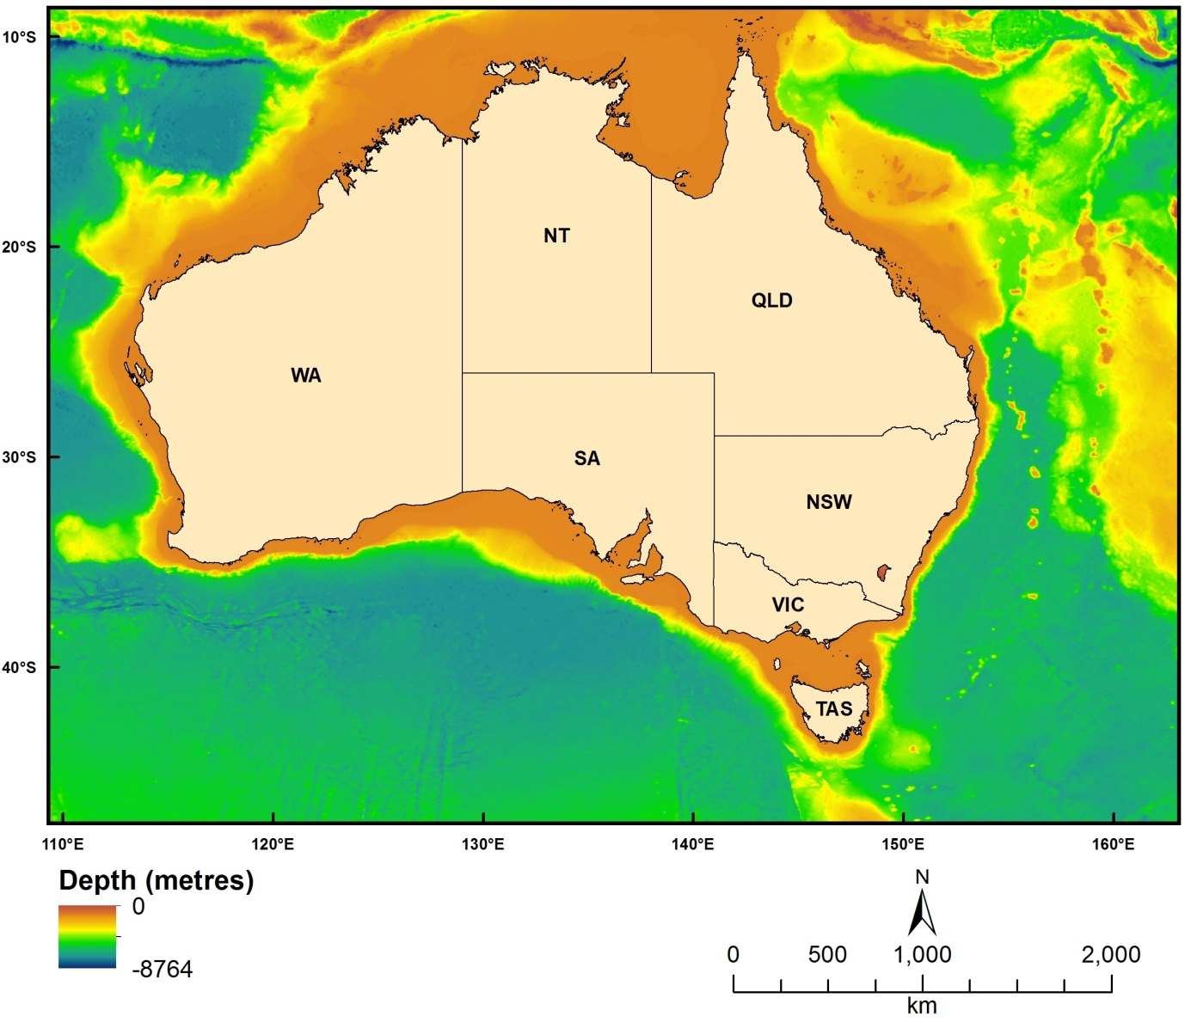
Figure 2.1.1 Australian bathymetry grid, 2009

Topographic Aspect
Dataset TITLE
Bathymetry derived topographic aspect grid
Dataset ALTERNATE TITLE (i.e. Dataset Name)
aspect_all1
Dataset AUTHOR(S)
Zhi Huang
Dataset CUSTODIAN
Geoscience Australia
Dataset JURISDICTION
Australia
Description ABSTRACT
The grid was created from the Australian bathymetry and topography grid (2009, version 4). The data represents the degree of aspect of a slope surface (a rectangle of 3 by 3 cells).
Description Data Category
Oceans
Environment
Elevation
Description Keyword
Oceans, Bathymetry, Seafloor Topography
Description GEOGRAPHIC EXTENT POLYGON(S)
N_LAT: -8
S_LAT: -60
E_LONG: 92
W_LONG: 172
COORDINATE SYSTEM DESCRIPTION
Projection: Geographic
Datum: WGS84
Units: Decimal Degree
Description Temporal EXTENT
Description NOMINAL SCALE
Spatial Resolution: 0.0025
Temporal Resolution:
Data Currency BEGINNING DATE
Dec-12
Data Currency ENDING DATE
Dec-12
Dataset Status PROGRESS
completed
Dataset Status MAINTENANCE AND UPDATE FREQUENCY
Not Planned
Access STORED FORMATS Digital/Non-Digital Description
DIGITAL ArcInfo grid
Access AVAILABLE FORMATS Digital/Non-Digital Description
DIGITAL ArcInfo grid
Access ACCESS CONSTRAINT
Please cite the data set using the following format: National Environmental Research Program (NERP) Marine Biodiversity Hub [year-of-data-download], [Title], [data-access-URL], accessed [date-of-access].
Data Quality LINEAGE
The data is a derived product from the 250 bathymetry and topography grid (2009, v4). The processing steps included:
- The bathymetry grid was first subset into 14 grids, each of which covers an UTM zone (from 46oS to 59oS).
- They were then projected into UTM coordinate system.
- The aspect was calculated from these UTM grids separately using ArcGIS desktop with a rectangle window of 3 by 3 cells.
- The 14 aspect grids were projected back to WGS84 coordinate system.
- The final grid (this data) was the result of mosaicing the 14 aspect grids.
Data Quality POSITIONAL ACCURACY
This grid is a derived product from the Australian bathymetry and topography grid (2009, v4). The positional accuracy therefore inherits that of the bathymetry grid as below.
The bathymetry grid incorporates data from surveys acquired since 1963. Modern surveys which used GPS have a positional accuracy of 5 – 30 m depending on several factors, while earlier surveys which used dead reckoning and Transit satellite fixes had positions accurate to 50 – 2000 m depending upon the water depth and strength of currents. These surveys overlap in an irregular distribution. The grid cell size is 0.025 deg (close to 250m), and it is estimated that 90% of cells give depths within 1 cell of their measured position. Nominal scale: 1:10,000,000 when imaged at 300 dpi
Data Quality ATTRIBUTE ACCURACY
This grid is a derived product from Australian bathymetry and topography grid (2009, v4). Its attribute accuracy depends on that of the bathymetry grid.
Data Quality LOGICAL CONSISTENCY
The same procedure was used to process the 14 sub-grids.
Data Quality COMPLETENESS
This dataset is completed.
Contact Information CONTACT ORGANISATION
Geoscience Australia
Contact Information CONTACT POSITION
Marine Data Manager
Contact Information MAIL ADDRESS 1
GPO Box 378
Contact Information SUBURB/PLACE/LOCALITY
Canberra
Contact Information STATE/LOCALITY 2
ACT
Contact Information COUNTRY
Australia
Contact Information POSTCODE
2601
Contact Information TELEPHONE
+61 2 6249 9111
Contact Information FACSIMILE
+61 2 6249 9999
Contact Information ELECTRONIC MAIL ADDRESS
marine@ga.gov.au
Metadata Date METADATA DATE
20MAR2013
Additional Metadata METADATA AUTHOR
Zhi Huang
Additional Metadata ACKNOWLEDGEMENTS
Webster, M.A.
Petkovic, P.
Whiteway, T.
Data was sourced from the NERP Marine Biodiversity Hub – the Marine Biodiversity Hub is supported through funding from the Australian Government’s National Environmental Research Program (NERP), administered by the Department of Sustainability, Environment, Water, Population and Communities (DSEWPaC).
Additional Metadata REFERENCES

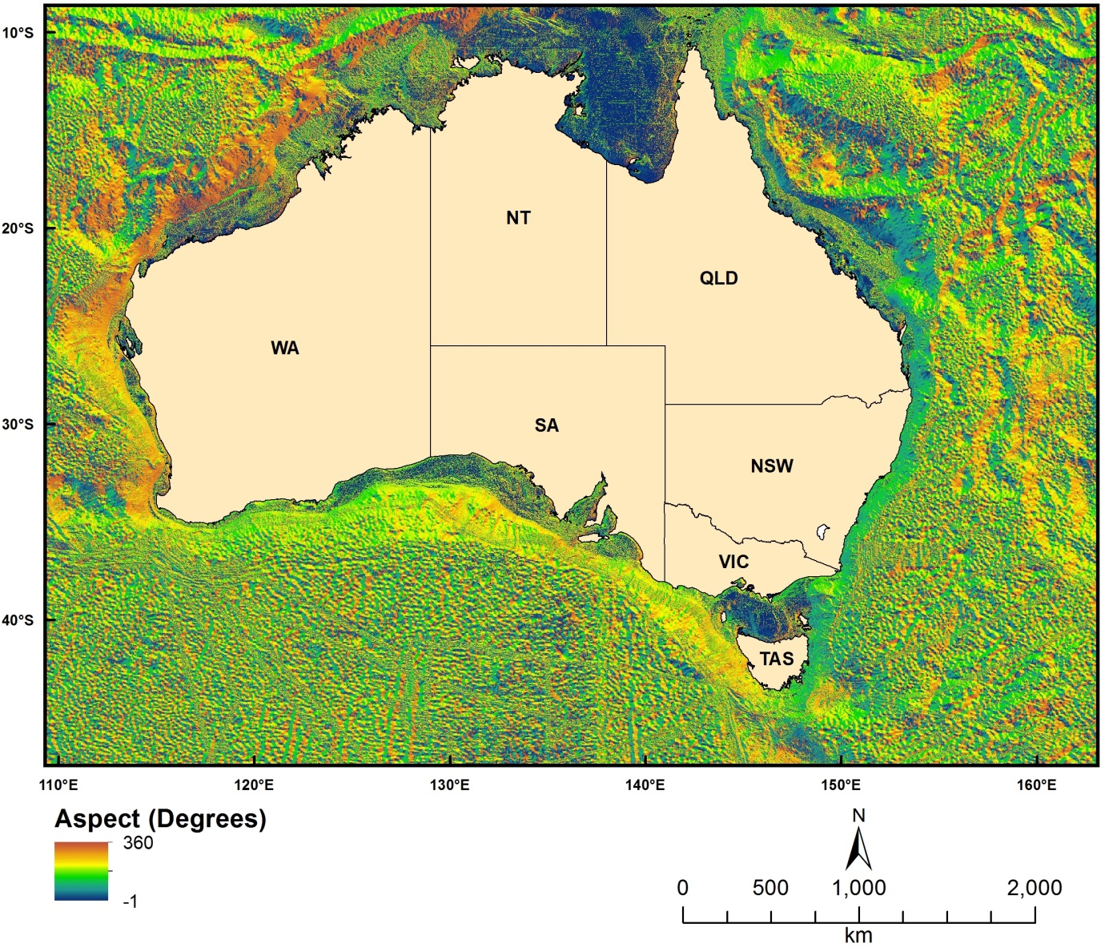
Figure 2.1.2 Topographic aspect

Topographic Slope
Dataset TITLE
Bathymetry derived topographic slope grid
Dataset ALTERNATE TITLE (i.e. Dataset Name)
slope_all1
Dataset AUTHOR(S)
Zhi Huang
Dataset CUSTODIAN
Geoscience Australia
Dataset JURISDICTION
Australia
Description ABSTRACT
The grid was created from the Australian bathymetry and topography grid (2009, version 4). The data represents the degree of slope of an area of seabed (a rectangle of 3 by 3 cells).
Description Data Category
Oceans
Environment
Elevation
Description Keyword
Oceans, Bathymetry, Seafloor Topography
Description GEOGRAPHIC EXTENT POLYGON(S)
N_LAT: -8
S_LAT: -60
E_LONG: 92
W_LONG: 172
COORDINATE SYSTEM DESCRIPTION
Projection: Geographic
Datum: WGS84
Units: Decimal Degree
Description Temporal EXTENT
Description NOMINAL SCALE
Spatial Resolution: 0.0025
Temporal Resolution:
Data Currency BEGINNING DATE
Dec-12
Data Currency ENDING DATE
Dec-12
Dataset Status PROGRESS
Completed
Dataset Status MAINTENANCE AND UPDATE FREQUENCY
Not Planned
Access STORED FORMATS Digital/Non-Digital Description
DIGITAL ArcInfo grid
Access AVAILABLE FORMATS Digital/Non-Digital Description
DIGITAL ArcInfo grid
Access ACCESS CONSTRAINT
Please cite the data set using the following format: National Environmental Research Program (NERP) Marine Biodiversity Hub [year-of-data-download], [Title], [data-access-URL], accessed [date-of-access].
Data Quality LINEAGE
The data is a derived product from the 250 bathymetry and topography grid (2009, v4). The processing steps included:
1. The bathymetry grid was first subset into 14 grids, each of which covers an UTM zone (from 46s to 59s).
2. They were then projected into UTM coordinate system.
3. The slope (in degree) was calculated from these UTM grids separately using ArcGIS desktop with a rectangle window of 3 by 3 cells.
4. The 14 slope grids were projected back to WGS84 coordinate system.
5. The final grid (this data) was the result of mosaicing the 14 slope grids.
Data Quality POSITIONAL ACCURACY
This grid is a derived product from the Australian bathymetry and topography grid (2009, v4). The positional accuracy therefore inherits that of the bathymetry grid as below.
The bathymetry grid incorporates data from surveys acquired since 1963. Modern surveys which used GPS have a positional accuracy of 5 – 30 m depending on several factors, while earlier surveys which used dead reckoning and Transit satellite fixes had positions accurate to 50 – 2000 m depending upon the water depth and strength of currents. These surveys overlap in an irregular distribution. The grid cell size is 0.025 deg (close to 250m), and it is estimated that 90% of cells give depths within 1 cell of their measured position. Nominal scale: 1:10,000,000 when imaged at 300 dpi
Data Quality ATTRIBUTE ACCURACY
This grid is a derived product from Australian bathymetry and topography grid (2009, v4). Its attribute accuracy depends on that of the bathymetry grid.
Because various data sources were used to generate the Australian bathymetry grid, including single beam, multibeam and satellite derived bathymetry (see the History entry of the Australian bathymetry grid), the attribute accuracy also varies with locations. Generally, the attribute accuracy is much higher in continental shelf than in deeper areas. Nevertheless, no systematic and quantitative assessment of attribute accuracy has been carried out.
Data Quality LOGICAL CONSISTENCY
The same procedure was used to process the 14 sub-grids.
Data Quality COMPLETENESS
This dataset is completed.
Contact Information CONTACT ORGANISATION
Geoscience Australia
Contact Information CONTACT POSITION
Marine Data Manager
Contact Information MAIL ADDRESS 1
GPO Box 378
Contact Information SUBURB/PLACE/LOCALITY
Canberra
Contact Information STATE/LOCALITY 2
ACT
Contact Information COUNTRY
Australia
Contact Information POSTCODE
2601
Contact Information TELEPHONE
+61 2 6249 9111
Contact Information FACSIMILE
+61 2 6249 9999
Contact Information ELECTRONIC MAIL ADDRESS
marine@ga.gov.au
Metadata Date METADATA DATE
20MAR2013
Additional Metadata METADATA AUTHOR
Zhi Huang
Additional Metadata ACKNOWLEDGEMENTS
Webster, M.A.
Petkovic, P.
Whiteway, T.
Data was sourced from the NERP Marine Biodiversity Hub – the Marine Biodiversity Hub is supported through funding from the Australian Government’s National Environmental Research Program (NERP), administered by the Department of Sustainability, Environment, Water, Population and Communities (DSEWPaC).
Additional Metadata REFERENCES

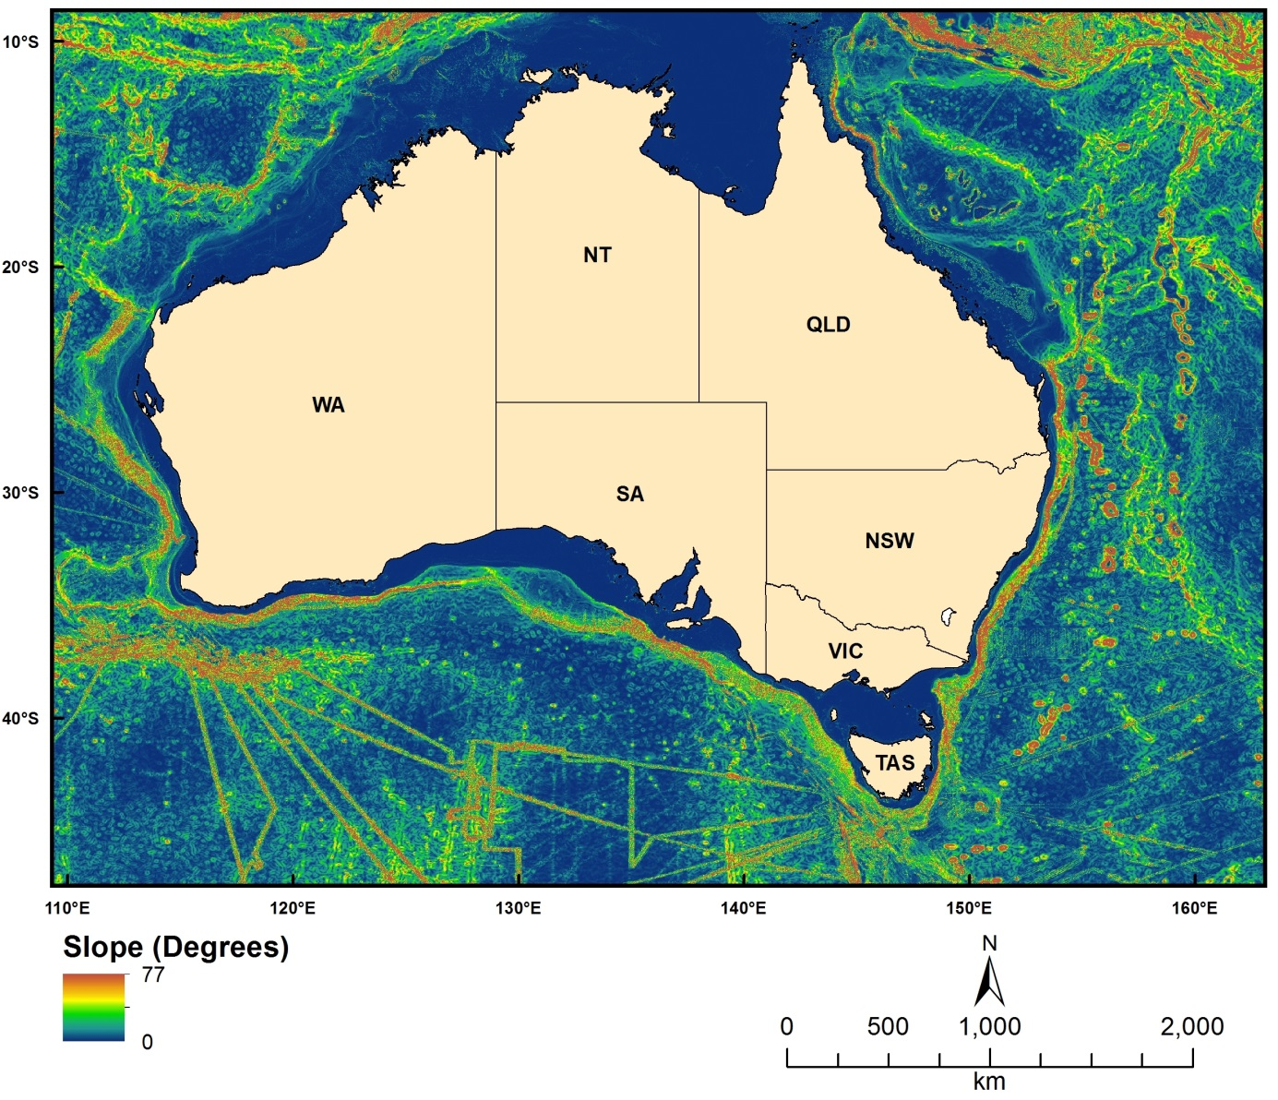
Figure 2.1.3 Topographic slope

Topographic Relief
Dataset TITLE
Bathymetry derived topographic relief grid
Dataset ALTERNATE TITLE (i.e. Dataset Name)
relief1
Dataset AUTHOR(S)
Zhi Huang
Dataset CUSTODIAN
Geoscience Australia
Dataset JURISDICTION
Australia
Description ABSTRACT
The grid was created from the Australian bathymetry and topography grid (2009, version 4). The data represents the difference in elevation between the highest and lowest point within a specified area (a rectangle of 3 by 3 cells). The units are metres.
Description Data Category
Oceans
Environment
Elevation
Description Keyword
Oceans, Bathymetry, Seafloor Topography
Description GEOGRAPHIC EXTENT POLYGON(S)
N_LAT: -8
S_LAT: -60
E_LONG: 92
W_LONG: 172
COORDINATE SYSTEM DESCRIPTION
Projection: Geographic
Datum: WGS84
Units: Decimal Degree
Description Temporal EXTENT
Description NOMINAL SCALE
Spatial Resolution: 0.0025
Temporal Resolution:
Data Currency BEGINNING DATE
Dec-12
Data Currency ENDING DATE
Dec-12
Dataset Status PROGRESS
Completed
Dataset Status MAINTENANCE AND UPDATE FREQUENCY
Not Planned
Access STORED FORMATS Digital/Non-Digital Description
DIGITAL ArcInfo grid
Access AVAILABLE FORMATS Digital/Non-Digital Description
DIGITAL ArcInfo grid
Access ACCESS CONSTRAINT
Please cite the data set using the following format: National Environmental Research Program (NERP) Marine Biodiversity Hub [year-of-data-download], [Title], [data-access-URL], accessed [date-of-access].
Data Quality LINEAGE
The data is a derived product from the 250 bathymetry and topography grid (2009, v4). The relief grid was obtained by using the focal range function in ArcGIS desktop with a rectangle window of 3 by 3 cells.
Data Quality POSITIONAL ACCURACY
This grid is a derived product from the Australian bathymetry and topography grid (2009, v4). The positional accuracy therefore inherits that of the bathymetry grid as below.
The bathymetry grid incorporates data from surveys acquired since 1963. Modern surveys which used GPS have a positional accuracy of 5 – 30 m depending on several factors, while earlier surveys which used dead reckoning and Transit satellite fixes had positions accurate to 50 – 2000 m depending upon the water depth and strength of currents. These surveys overlap in an irregular distribution. The grid cell size is 0.025 deg (close to 250m), and it is estimated that 90% of cells give depths within 1 cell of their measured position. Nominal scale: 1:10,000,000 when imaged at 300 dpi
Data Quality ATTRIBUTE ACCURACY
This grid is a derived product from Australian bathymetry and topography grid (2009, v4). Its attribute accuracy depends on that of the bathymetry grid.
Data Quality LOGICAL CONSISTENCY
The same procedure was used to process the 14 sub-grids.
Data Quality COMPLETENESS
This dataset is completed.
Contact Information CONTACT ORGANISATION
Geoscience Australia
Contact Information CONTACT POSITION
Marine Data Manager
Contact Information MAIL ADDRESS 1
GPO Box 378
Contact Information SUBURB/PLACE/LOCALITY
Canberra
Contact Information STATE/LOCALITY 2
ACT
Contact Information COUNTRY
Australia
Contact Information POSTCODE
2601
Contact Information TELEPHONE
+61 2 6249 9111
Contact Information FACSIMILE
+61 2 6249 9999
Contact Information ELECTRONIC MAIL ADDRESS
marine@ga.gov.au
Metadata Date METADATA DATE
20MAR2013
Additional Metadata METADATA AUTHOR
Zhi Huang
Additional Metadata ACKNOWLEDGEMENTS
Webster, M.A.
Petkovic, P.
Whiteway, T.
Data was sourced from the NERP Marine Biodiversity Hub – the Marine Biodiversity Hub is supported through funding from the Australian Government’s National Environmental Research Program (NERP), administered by the Department of Sustainability, Environment, Water, Population and Communities (DSEWPaC).
Additional Metadata REFERENCES

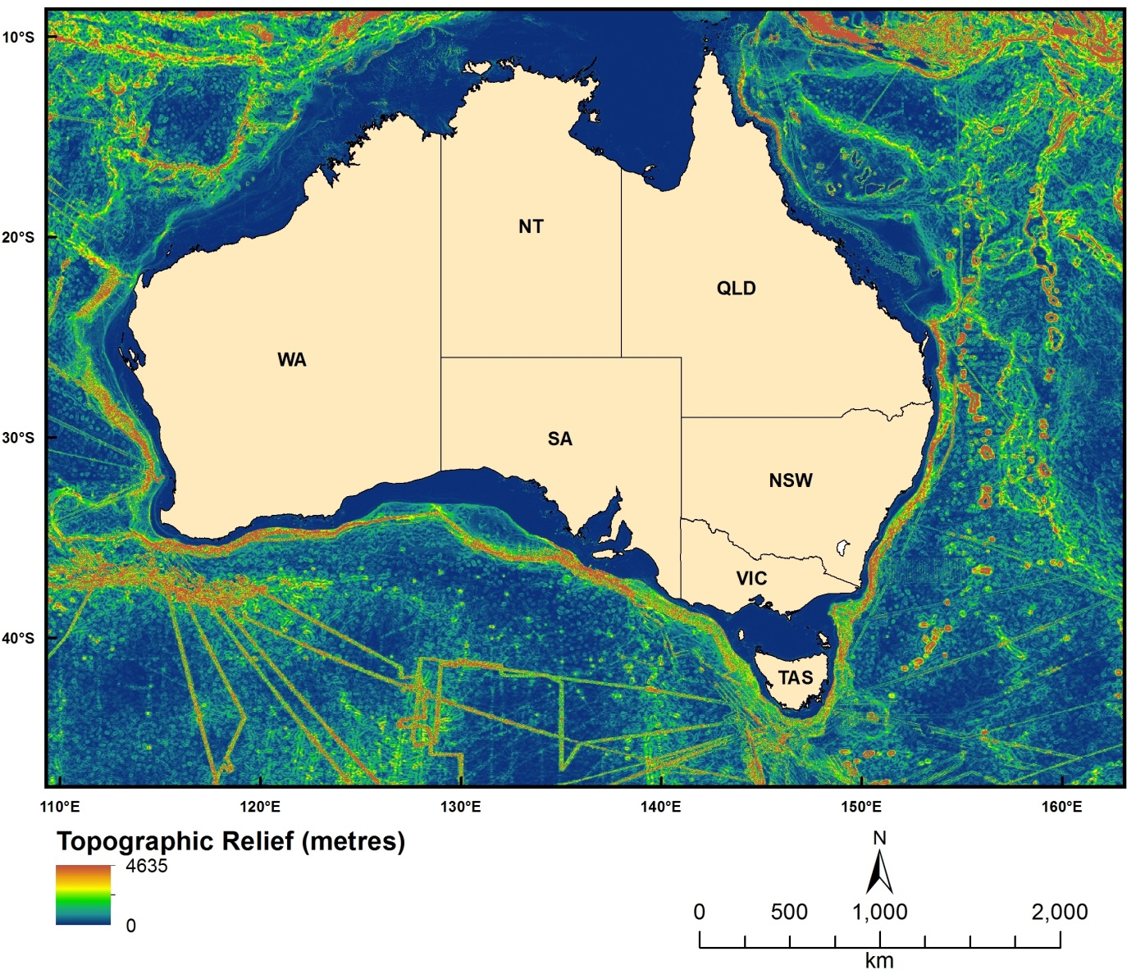
Figure 2.1.4 Topographic relief

Topographic Rugosity
Dataset TITLE
Bathymetry derived topographic rugosity grid
Dataset ALTERNATE TITLE (i.e. Dataset Name)
surface_all1
Dataset AUTHOR(S)
Zhi Huang
Dataset CUSTODIAN
Geoscience Australia
Dataset JURISDICTION
Australia
Description ABSTRACT
The grid was created from the Australian bathymetry and topography grid (2009, version 4). The data represents seabed rugosity of an area of seabed (a rectangle of 3 by 3 cells). The rugosity was measured as surface area (Jenness, 2004). Higher surface area corresponds with higher rugosity.
Jenness, J. S. (2004). "Calculating landscape surface area from digital elevation models," Wildlife Society Bulletin 32, 829-839.
Description Data Category
Oceans
Environment
Elevation
Description Keyword
Oceans, Bathymetry, Seafloor Topography
Description GEOGRAPHIC EXTENT POLYGON(S)
N_LAT: -8
S_LAT: -60
E_LONG: 92
W_LONG: 172
COORDINATE SYSTEM DESCRIPTION
Projection: Geographic
Datum: WGS84
Units: Decimal Degree
Description Temporal EXTENT
Description NOMINAL SCALE
Spatial Resolution: 0.0025
Temporal Resolution:
Data Currency BEGINNING DATE
Dec-12
Data Currency ENDING DATE
Dec-12
Dataset Status PROGRESS
Completed
Dataset Status MAINTENANCE AND UPDATE FREQUENCY
Not Planned
Access STORED FORMATS Digital/Non-Digital Description
DIGITAL ArcInfo grid
Access AVAILABLE FORMATS Digital/Non-Digital Description
DIGITAL ArcInfo grid
Access ACCESS CONSTRAINT
Please cite the data set using the following format: National Environmental Research Program (NERP) Marine Biodiversity Hub [year-of-data-download], [Title], [data-access-URL], accessed [date-of-access].
Data Quality LINEAGE
The data is a derived product from the 250 bathymetry and topography grid (2009, v4). The processing steps include:
1. The bathymetry grid was first subset into 14 grids, each of which covers an UTM zone (from 46s to 59s).
2. They were then projected into UTM coordinate system.
3. The rugosity (surface area) was calculated from these UTM grids separately using an AML program written after Jenness (2004) with a rectangle window of 3 by 3 cells.
4. The 14 rugosity grids were projected back to WGS84 coordinate system.
5. The final grid (this data) was the result of mosaicing the 14 rugosity grids.
Data Quality POSITIONAL ACCURACY
This grid is a derived product from the Australian bathymetry and topography grid (2009, v4). The positional accuracy therefore inherits that of the bathymetry grid as below.
The bathymetry grid incorporates data from surveys acquired since 1963. Modern surveys which used GPS have a positional accuracy of 5 – 30 m depending on several factors, while earlier surveys which used dead reckoning and Transit satellite fixes had positions accurate to 50 – 2000 m depending upon the water depth and strength of currents. These surveys overlap in an irregular distribution. The grid cell size is 0.025 deg (close to 250m), and it is estimated that 90% of cells give depths within 1 cell of their measured position. Nominal scale: 1:10,000,000 when imaged at 300 dpi.
Data Quality ATTRIBUTE ACCURACY
This grid is a derived product from Australian bathymetry and topography grid (2009, v4). Its attribute accuracy depends on that of the bathymetry grid.
Because various data sources were used to generate the Australian bathymetry grid, including single beam, multibeam and satellite derived bathymetry (see the History entry of the Australian bathymetry grid), the attribute accuracy also varies with locations. Generally, the attribute accuracy is much higher in continental shelf than in deeper areas. Nevertheless, no systematic and quantitative assessment of attribute accuracy has been carried out.
Data Quality LOGICAL CONSISTENCY
The same procedure was used to process the 14 sub-grids.
Data Quality COMPLETENESS
This dataset is completed.
Contact Information CONTACT ORGANISATION
Geoscience Australia
Contact Information CONTACT POSITION
Marine Data Manager
Contact Information MAIL ADDRESS 1
GPO Box 378
Contact Information SUBURB/PLACE/LOCALITY
Canberra
Contact Information STATE/LOCALITY 2
ACT
Contact Information COUNTRY
Australia
Contact Information POSTCODE
2601
Contact Information TELEPHONE
+61 2 6249 9111
Contact Information FACSIMILE
+61 2 6249 9999
Contact Information ELECTRONIC MAIL ADDRESS
marine@ga.gov.au
Metadata Date METADATA DATE
20MAR2013
Additional Metadata METADATA AUTHOR
Zhi Huang
Additional Metadata ACKNOWLEDGEMENTS
Webster, M.A.
Petkovic, P.
Whiteway, T.
Data was sourced from the NERP Marine Biodiversity Hub – the Marine Biodiversity Hub is supported through funding from the Australian Government’s National Environmental Research Program (NERP), administered by the Department of Sustainability, Environment, Water, Population and Communities (DSEWPaC).
Additional Metadata REFERENCES
Jenness, J. S. (2004). "Calculating landscape surface area from digital elevation models," Wildlife Society Bulletin 32, 829-839.

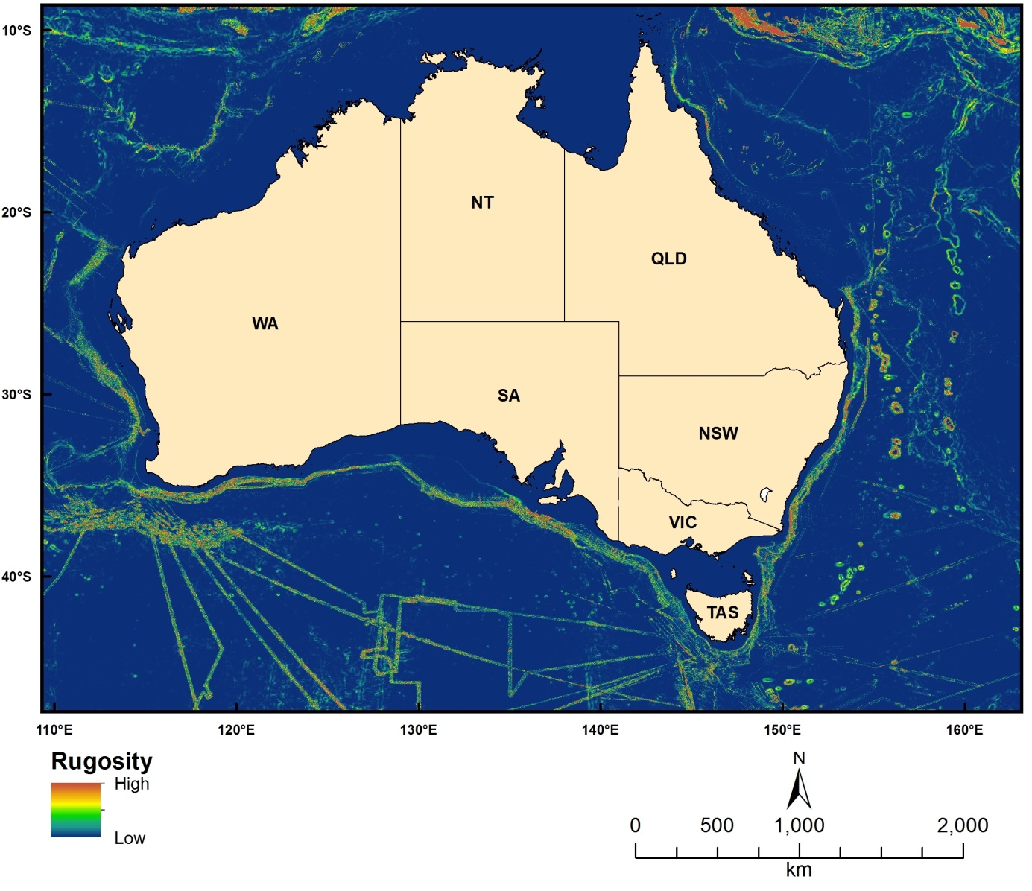
Figure 2.1.5 Topographic rugosity

50 metre multibeam bathymetry grids
Dataset TITLE
50m Multibeam Dataset of Australia 2012
Dataset ALTERNATE TITLE (i.e. Dataset Name)
Dataset AUTHOR(S)
Dataset CUSTODIAN
Geoscience Australia
Dataset JURISDICTION
Australia
Description ABSTRACT
This dataset contains all multibeam data (as tiles) held by Geoscience Australia on August 2012 within the specified area. The data has been gridded to 50m resolution. The tiles are projected into suitable WGS84 UTM zones.
Some deeper data has also been interpolated within the mapped area.
Description Data Category
Oceans
Environment
Elevation
Description Keyword
Oceans, Bathymetry, Multibeam
Description GEOGRAPHIC EXTENT POLYGON(S)
N_LAT: -8
S_LAT: -60
E_LONG: 90
W_LONG: 174
COORDINATE SYSTEM DESCRIPTION
Projection: UTM
Datum: WGS84
Units: metre
Description Temporal EXTENT
Description NOMINAL SCALE
Spatial Resolution: 50
Temporal Resolution:
Data Currency BEGINNING DATE
2012
Data Currency ENDING DATE
25-Jan-13
Dataset Status PROGRESS
Completed
Dataset Status MAINTENANCE AND UPDATE FREQUENCY
Not Planned
Access STORED FORMATS Digital/Non-Digital Description
DIGITAL ArcInfo grid
DIGITAL ASCII xyz text
DIGITAL CARIS Grid file
DIGITAL GeoTIFF
Access AVAILABLE FORMATS Digital/Non-Digital Description
DIGITAL ArcInfo grid
DIGITAL ASCII xyz text
DIGITAL CARIS Grid file
DIGITAL GeoTIFF
Access ACCESS CONSTRAINT
Public Access
Data Quality LINEAGE
Geoscience Australia is the national custodian of an extensive multibeam dataset. Along with the multibeam data collected by the Australian Government, Geoscience Australia also holds numerous datasets that have been submitted from other institutions in the international scientific community and that lie within and around Australian waters.
Geoscience Australia is releasing this data to facilitate the use of, and access to, bathymetry data in the wider mapping community. This dataset is a tiled compilation of all the multibeam data held by Geoscience Australia lying within the outer edge of the offshore area of Australia, as well as some data in international waters, as at August 2012. The data is gridded to a resolution of 50 metres, which allows for a significant amount of detail to be seen. The data is also projected into suitable WGS84 UTM zones.
Data Quality POSITIONAL ACCURACY
Data Quality ATTRIBUTE ACCURACY
Data Quality LOGICAL CONSISTENCY
Data Quality COMPLETENESS
Contact Information CONTACT ORGANISATION
Geoscience Australia
Contact Information CONTACT POSITION
Marine Data Manager
Contact Information MAIL ADDRESS 1
GPO Box 378
Contact Information SUBURB/PLACE/LOCALITY
Canberra
Contact Information STATE/LOCALITY 2
ACT
Contact Information COUNTRY
Australia
Contact Information POSTCODE
2601
Contact Information TELEPHONE
+61 2 6249 9111
Contact Information FACSIMILE
+61 2 6249 9999
Contact Information ELECTRONIC MAIL ADDRESS
marine@ga.gov.au
Metadata Date METADATA DATE
20MAR2013
Additional Metadata METADATA AUTHOR
Zhi Huang
Additional Metadata ACKNOWLEDGEMENTS
Wilson, O.
Spinoccia, M.
Buchanan, C .
Additional Metadata REFERENCES

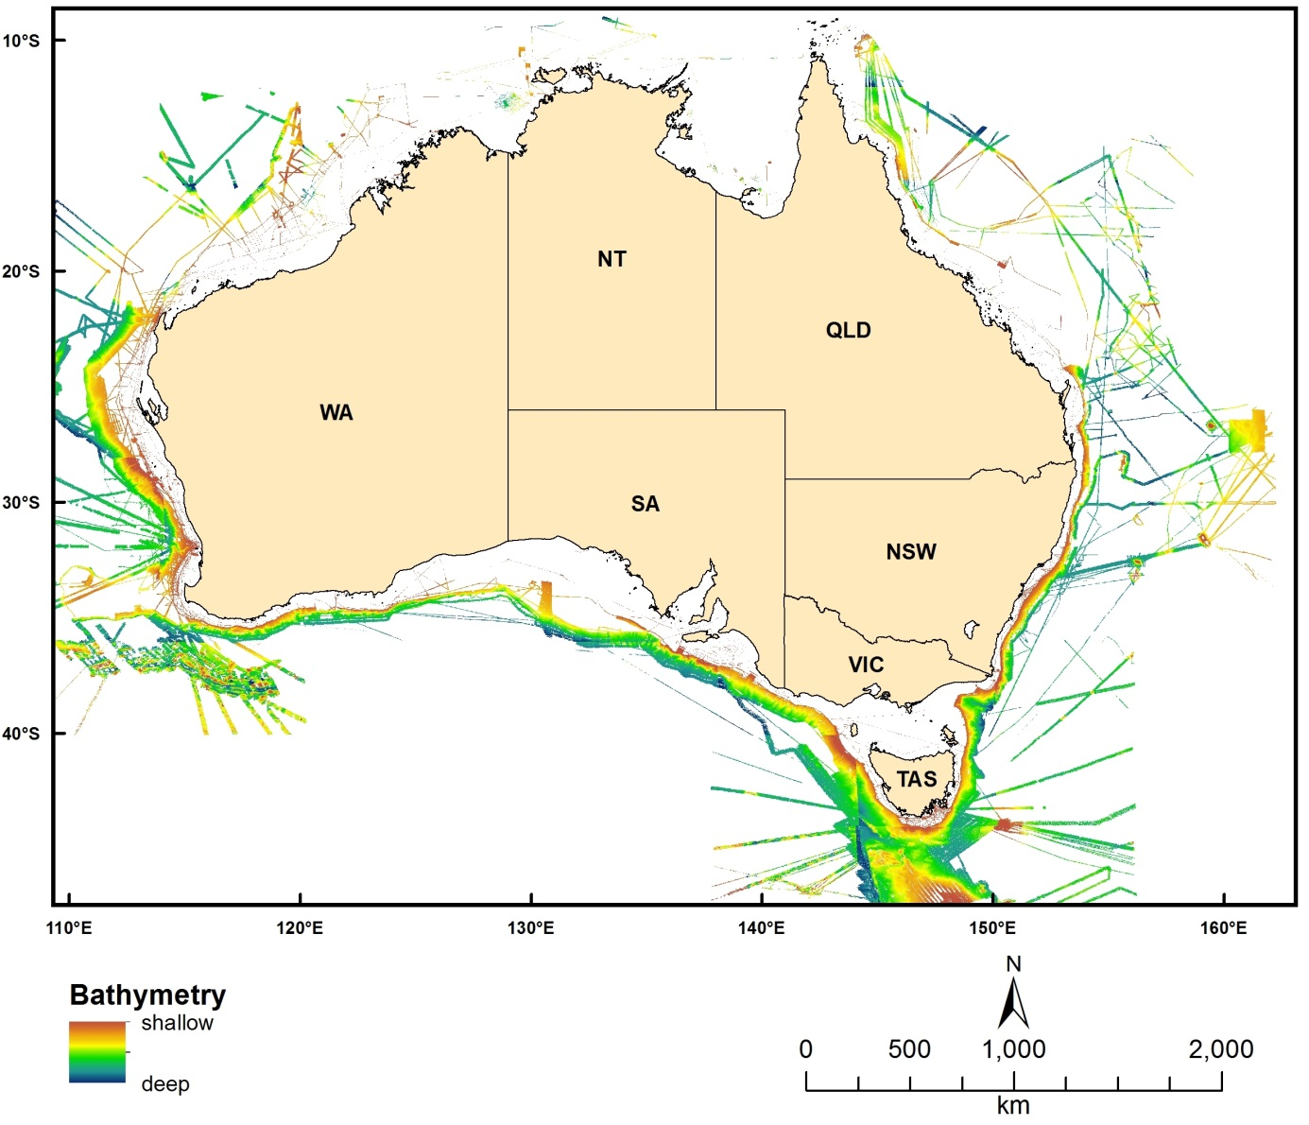
Figure 2.1.6 Coverage of 50m multibeam bathymetry grids

Seabed Sediment Data

Gravel Percentage
Dataset TITLE
Predicted seabed gravel content in the north-northwest region of the Australian continental EEZ 2013
Dataset ALTERNATE TITLE (i.e. Dataset Name)
Predicted seabed gravel content in the NNW region of the Australian continental EEZ
Dataset AUTHOR(S)
Jin Li
Dataset CUSTODIAN
Geoscience Australia
Dataset JURISDICTION
Australia
Description ABSTRACT
This dataset provides the spatially continuous data of predicted seabed gravel content (sediment fraction greater than 2000 µm) expressed as a weight percentage ranging from 0 to 100%, presented in 0.0025 decimal degree (dd) resolution raster grids format and ascii text file. The dataset covers the north-northwest region of the Australian continental EEZ. This dataset supersedes previous predictions of seabed gravel content for the region with demonstrated improvements in accuracy. Accuracy of predictions varies based on density of underlying data and level of seabed complexity. Artefacts occur in this dataset as a result of insufficient samples in relevant areas. This dataset is intended for use at regional scale. The dataset may not be appropriate for use at local scales in areas where sample density is insufficient to detect local variation in sediment properties. To obtain the most accurate interpretation of sediment distribution in these areas, it is recommended that additional samples be collected and interpolations updated.
Description Data Category
Oceans
Environment
Description Keyword
Oceans, Marine Sediments, Sediment Composition
Description GEOGRAPHIC EXTENT POLYGON(S)
N_LAT: -8.884891
S_LAT: -25.532391
E_LONG: 112.9222
W_LONG: 142.1522
COORDINATE SYSTEM DESCRIPTION
Projection: Geographic
Datum: WGS84
Units: Decimal Degree
Description Temporal EXTENT
Description NOMINAL SCALE
Spatial Resolution: 0.0025
Temporal Resolution:
Data Currency BEGINNING DATE
Mar-31-03
Data Currency ENDING DATE
Dataset Status PROGRESS
Completed
Dataset Status MAINTENANCE AND UPDATE FREQUENCY
Not Planned
Access STORED FORMATS Digital/Non-Digital Description
DIGITAL ArcInfo grid
DIGITAL text (.csv) file
Access AVAILABLE FORMATS Digital/Non-Digital Description
DIGITAL ArcInfo grid
DIGITAL text (.csv) file
Access ACCESS CONSTRAINT
Please cite the data set using the following format: National Environmental Research Program (NERP) Marine Biodiversity Hub [year-of-data-download], [Title], [data-access-URL], accessed [date-of-access].
Data Quality LINEAGE
Sediment samples were exported from Geoscience Australia’s Marine Sediments database (MARS), an Oracle database developed by Geoscience Australia in line with ANZLIC data standards. A subset of this data was selected for use in predicting spatial distribution of gravel content based on a set of data quality control criteria (see Li et al. 2010 and 2012). Predicting the spatial distribution of gravel content at a 0.0025 decimal degree resolution was undertaken using a combined method of random forest and ordinary kriging (see Li et al. 2010, 2011a and 2012). The spatial interpolation method used was experimentally selected from over 40 methods/sub-methods based on assessment of predictive errors (Li et al. 2010, 2011a and 2012) and was refined for gravel content based on further experimental testing during Nov 2012 to March 2013. The predictions in raster grids and ascii text file were generated in R. Final file is in WGS 84 coordinate system with a 0.0025 dd spatial resolution.
Data Quality POSITIONAL ACCURACY
Sediment samples used in the interpolation incorporate data from various surveys since 1899 by a range of organisations. Modern surveys which used GPS have a positional accuracy of 5-30 m, while earlier surveys which had positions probably accurate to 50 – 2000 m depending upon the water depth and strength of currents. Only samples with positional information recorded to 0.001 dd accuracy were used in the spatial interpolation.
Data Quality ATTRIBUTE ACCURACY
Not Applicable
Data Quality LOGICAL CONSISTENCY
Point data at each grid cell was checked to ensure that the sum of gravel, mud and sand content was 100%. Interpolated grids were further checked by visual comparison with maps initially produced in R to ensure no errors were introduced during the process of producing the grid file.
Data Quality COMPLETENESS
This dataset is completed.
Contact Information CONTACT ORGANISATION
Geoscience Australia
Contact Information CONTACT POSITION
Marine Data Manager
Contact Information MAIL ADDRESS 1
GPO Box 378
Contact Information SUBURB/PLACE/LOCALITY
Canberra
Contact Information STATE/LOCALITY 2
ACT
Contact Information COUNTRY
Australia
Contact Information POSTCODE
2601
Contact Information TELEPHONE
+61 2 6249 9111
Contact Information FACSIMILE
+61 2 6249 9999
Contact Information ELECTRONIC MAIL ADDRESS
marine@ga.gov.au
Metadata Date METADATA DATE
20MAR2013
Additional Metadata METADATA AUTHOR
Jin Li
Additional Metadata ACKNOWLEDGEMENTS
Xiaojing Li extracted sediment samples from MARS database. Tony Nicholas and Scott Nichol provided some samples collected in 2012. Zhi Huang provided bathymetry, slope, distance to coast, and relief data. Tanya Whiteway and Chris Lawson clarified relevant issues associated with bathymetry data. Anna Potter provided clarification on data quality control aspects.
Data was sourced from the NERP Marine Biodiversity Hub – the Marine Biodiversity Hub is supported through funding from the Australian Government’s National Environmental Research Program (NERP), administered by the Department of Sustainability, Environment, Water, Population and Communities (DSEWPaC).
Additional Metadata REFERENCES
Li, J., Heap, A. D., Potter, A., Daniell, J. J., 2011a. Predicting Seabed Mud Content across the Australian Margin II: the Performance of Machine Learning Methods and Their Combinations with Ordinary Kriging and Inverse Distance Squared. Geoscience Australia Record 2011/07. Geoscience Australia, Canberra, 69 pp.
Li, J., Potter, A., Huang, Z., Daniell, J. J., Heap, A. D., 2010. Predicting Seabed Mud Content across the Australian Margin: Comparison of Statistical and Mathematical Techniques Using a Simulation Experiment. Geoscience Australia, Record 2010/11. Geoscience Australia, Canberra, 146 pp.
Li, J., Potter, A., Huang, Z., Heap, A., 2012. Predicting Seabed Sand Content across the Australian Margin Using Machine Learning and Geostatistical Methods. Geoscience Australia Record 2012/48, Geoscience Australia, Canberra,115pp.

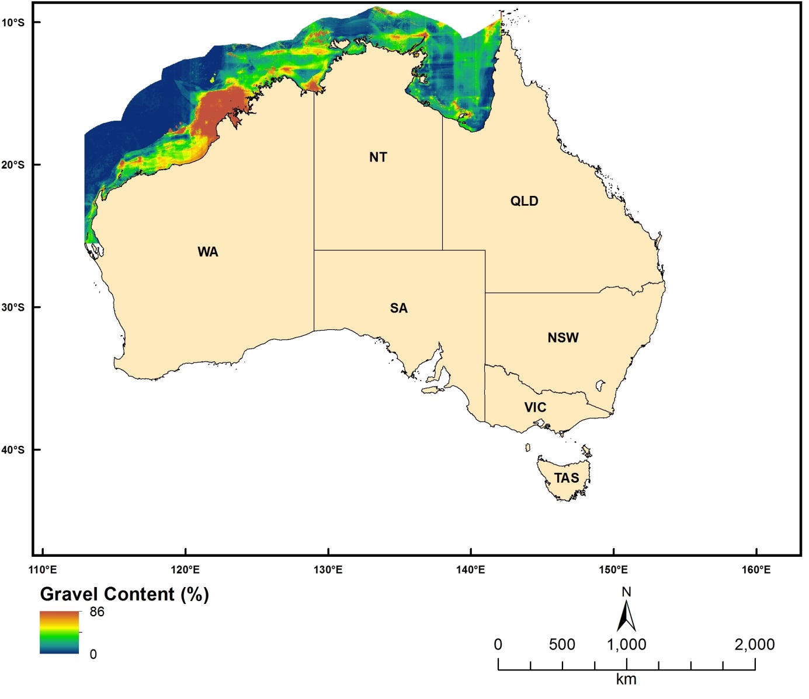
Figure 2.2.1 Predicted seabed gravel content for the North and North-West Marine Regions

Mud Percentage
Dataset TITLE
Predicted seabed mud content in the north-northwest region of the Australian continental EEZ 2013
Dataset ALTERNATE TITLE (i.e. Dataset Name)
Dataset AUTHOR(S)
Jin Li
Dataset CUSTODIAN
Geoscience Australia
Dataset JURISDICTION
Australia
Description ABSTRACT
This dataset provides the spatially continuous data of predicted seabed mud content (sediment fraction finer than 63 µm) expressed as a weight percentage ranging from 0 to 100%, presented in 0.0025 decimal degree (dd) resolution raster grids format and an ascii text file. The dataset covers the north-northwest region of the Australian continental EEZ. This dataset supersedes previous predictions of seabed mud content for the region with demonstrated improvements in accuracy. Accuracy of predictions varies based on density of underlying data and level of seabed complexity. Artefacts occur in this dataset as a result of insufficient samples in relevant areas. This dataset is intended for use at regional scale. The dataset may not be appropriate for use at local scales in areas where sample density is insufficient to detect local variation in sediment properties. To obtain the most accurate interpretation of sediment distribution in these areas, it is recommended that additional samples be collected and interpolations updated.
Description Data Category
Oceans
Environment
Description Keyword
Oceans, Marine Sediments, Sediment Composition
Description GEOGRAPHIC EXTENT POLYGON(S)
N_LAT: -8.884891
S_LAT: -25.532391
E_LONG: 112.9222
W_LONG: 142.1522
COORDINATE SYSTEM DESCRIPTION
Projection: Geographic
Datum: WGS84
Units: Decimal Degree
Description Temporal EXTENT
Description NOMINAL SCALE
Spatial Resolution: 0.0025
Temporal Resolution:
Data Currency BEGINNING DATE
Mar-31-03
Data Currency ENDING DATE
Dataset Status PROGRESS
Completed
Dataset Status MAINTENANCE AND UPDATE FREQUENCY
Not Planned
Access STORED FORMATS Digital/Non-Digital Description
DIGITAL ArcInfo grid
DIGITAL text (.csv) file
Access AVAILABLE FORMATS Digital/Non-Digital Description
DIGITAL ArcInfo grid
DIGITAL text (.csv) file
Access ACCESS CONSTRAINT
Please cite the data set using the following format: National Environmental Research Program (NERP) Marine Biodiversity Hub [year-of-data-download], [Title], [data-access-URL], accessed [date-of-access].
Data Quality LINEAGE
Sediment samples were exported from Geoscience Australia’s Marine Sediments database (MARS), an Oracle database developed by Geoscience Australia in line with ANZLIC data standards. A subset of this data was selected for use in predicting spatial distribution of gravel content based on a set of data quality control criteria (see Li et al. 2010 and 2012). Predicting the spatial distribution of mud content at a 0.0025 decimal degree resolution was undertaken using a combined method of random forest and ordinary kriging (see Li et al. 2010, 2011a and 2012). The spatial interpolation method used was experimentally selected from over 40 methods/sub-methods based on assessment of predictive errors (Li et al. 2010, 2011a and 2012) and was refined for mud content based on further experimental testing during Nov 2012 to March 2013. The predictions in raster grids and as an ascii text file were generated in R. Final file is in WGS 84 coordinate system with a 0.0025 dd spatial resolution.
Data Quality POSITIONAL ACCURACY
Sediment samples used in the interpolation incorporate data from various surveys since 1899 by a range of organisations. Modern surveys which used GPS have a positional accuracy of 5-30 m, while earlier surveys which had positions probably accurate to 50 – 2000 m depending upon the water depth and strength of currents. Only samples with positional information recorded to 0.001 dd accuracy were used in the spatial interpolation.
Data Quality ATTRIBUTE ACCURACY
Not Applicable
Data Quality LOGICAL CONSISTENCY
Point data at each grid cell was checked to ensure that the sum of gravel, mud and sand content was 100%. Interpolated grids were further checked by visual comparison with maps initially produced in R to ensure no errors were introduced during the process of producing the grid file.
Data Quality COMPLETENESS
This dataset is completed.
Contact Information CONTACT ORGANISATION
Geoscience Australia
Contact Information CONTACT POSITION
Marine Data Manager
Contact Information MAIL ADDRESS 1
GPO Box 378
Contact Information SUBURB/PLACE/LOCALITY
Canberra
Contact Information STATE/LOCALITY 2
ACT
Contact Information COUNTRY
Australia
Contact Information POSTCODE
2601
Contact Information TELEPHONE
+61 2 6249 9111
Contact Information FACSIMILE
+61 2 6249 9999
Contact Information ELECTRONIC MAIL ADDRESS
marine@ga.gov.au
Metadata Date METADATA DATE
20MAR2013
Additional Metadata METADATA AUTHOR
Jin Li
Additional Metadata ACKNOWLEDGEMENTS
Xiaojing Li extracted sediment samples from MARS database. Tony Nicholas and Scott Nichol provided some samples collected in 2012. Zhi Huang provided bathymetry, slope, distance to coast, and relief data. Tanya Whiteway and Chris Lawson clarified relevant issues associated with bathymetry data. Anna Potter provided clarification on data quality control aspect.
Data was sourced from the NERP Marine Biodiversity Hub – the Marine Biodiversity Hub is supported through funding from the Australian Government’s National Environmental Research Program (NERP), administered by the Department of Sustainability, Environment, Water, Population and Communities (DSEWPaC).
Additional Metadata REFERENCES
Li, J., Heap, A. D., Potter, A., Daniell, J. J., 2011a. Predicting Seabed Mud Content across the Australian Margin II: the Performance of Machine Learning Methods and Their Combinations with Ordinary Kriging and Inverse Distance Squared. Geoscience Australia Record 2011/07. Geoscience Australia, Canberra, 69 pp.
Li, J., Potter, A., Huang, Z., Daniell, J. J., Heap, A. D., 2010. Predicting Seabed Mud Content across the Australian Margin: Comparison of Statistical and Mathematical Techniques Using a Simulation Experiment. Geoscience Australia, Record 2010/11. Geoscience Australia, Canberra, 146 pp.
Li, J., Potter, A., Huang, Z., Heap, A., 2012. Predicting Seabed Sand Content across the Australian Margin Using Machine Learning and Geostatistical Methods. Geoscience Australia Record 2012/48, Geoscience Australia, Canberra,115pp.
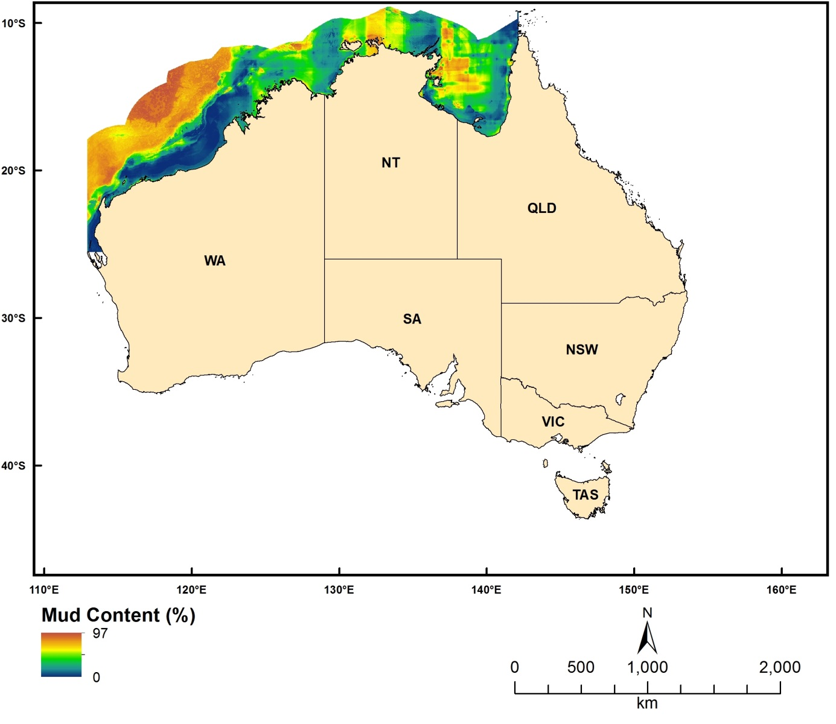
Figure 2.2.2 Predicted seabed mud content for the North and North-West Marine Regions

Sand Percentage
Dataset TITLE
Predicted seabed sand content in the north-northwest region of the Australian continental EEZ 2013
Dataset ALTERNATE TITLE (i.e. Dataset Name)
Dataset AUTHOR(S)
Jin Li
Dataset CUSTODIAN
Geoscience Australia
Dataset JURISDICTION
Australia
Description ABSTRACT
This dataset provides the spatially continuous data of predicted seabed sand content (sediment fraction greater than 2000 µm) expressed as a weight percentage ranging from 0 to 100%, presented in 0.0025 decimal degree (dd) resolution raster grids format and an ascii text file. The dataset covers the north-northwest region of the Australian continental EEZ. This dataset supersedes previous predictions of seabed sand content for the region with demonstrated improvements in accuracy. Accuracy of predictions varies based on density of underlying data and level of seabed complexity. Artefacts occur in this dataset as a result of insufficient samples in relevant areas. This dataset is intended for use at regional scale. The dataset may not be appropriate for use at local scales in areas where sample density is insufficient to detect local variation in sediment properties. To obtain the most accurate interpretation of sediment distribution in these areas, it is recommended that additional samples be collected and interpolations updated.
Description Data Category
Oceans
Environment
Description Keyword
Oceans, Marine Sediments, Sediment Composition
Description GEOGRAPHIC EXTENT POLYGON(S)
N_LAT: -8.884891
S_LAT: -25.532391
E_LONG: 112.9222
W_LONG: 142.1522
COORDINATE SYSTEM DESCRIPTION
Projection: Geographic
Datum: WGS84
Units: Decimal Degree
Description Temporal EXTENT
Description NOMINAL SCALE
Spatial Resolution: 0.0025
Temporal Resolution:
Data Currency BEGINNING DATE
Mar-31-03
Data Currency ENDING DATE
Dataset Status PROGRESS
Completed
Dataset Status MAINTENANCE AND UPDATE FREQUENCY
Unknown
Access STORED FORMATS Digital/Non-Digital Description
DIGITAL ArcInfo grid
DIGITAL text (.csv) file
Access AVAILABLE FORMATS Digital/Non-Digital Description
DIGITAL ArcInfo grid
DIGITAL text (.csv) file
Access ACCESS CONSTRAINT
Please cite the data set using the following format: National Environmental Research Program (NERP) Marine Biodiversity Hub [year-of-data-download], [Title], [data-access-URL], accessed [date-of-access].
Data Quality LINEAGE
Sediment samples were exported from Geoscience Australia’s Marine Sediments database (MARS), an Oracle database developed by Geoscience Australia in line with ANZLIC data standards. A subset of this data was selected for use in predicting spatial distribution of sand content based on a set of data quality control criteria (see Li et al. 2010 and 2012). Predicting the spatial distribution of sand content at a 0.0025 decimal degree resolution was undertaken using a combined method of random forest and ordinary kriging (see Li et al. 2010, 2011a and 2012). The spatial interpolation method used was experimentally selected from over 40 methods/sub-methods based on assessment of predictive errors (Li et al. 2010, 2011a and 2012) and was refined for sand content based on further experimental testing during Nov 2012 to March 2013. The predictions in raster grids and as an ascii text file were generated in R. Final file is in WGS 84 coordinate system with a 0.0025 dd spatial resolution.
Data Quality POSITIONAL ACCURACY
Sediment samples used in the interpolation incorporate data from various surveys since 1899 by a range of organisations. Modern surveys which used GPS have a positional accuracy of 5-30 m, while earlier surveys which had positions probably accurate to 50 – 2000 m depending upon the water depth and strength of currents. Only samples with positional information recorded to 0.001 dd accuracy were used in the spatial interpolation.
Data Quality ATTRIBUTE ACCURACY
Not Applicable
Data Quality LOGICAL CONSISTENCY
Point data at each grid cell was checked to ensure that the sum of gravel, mud and sand content was 100%. Interpolated grids were further checked by visual comparison with maps initially produced in R to ensure no errors were introduced during the process of producing the grid file.
Data Quality COMPLETENESS
This dataset is completed.
Contact Information CONTACT ORGANISATION
Geoscience Australia
Contact Information CONTACT POSITION
Marine Data Manager
Contact Information MAIL ADDRESS 1
GPO Box 378
Contact Information SUBURB/PLACE/LOCALITY
Canberra
Contact Information STATE/LOCALITY 2
ACT
Contact Information COUNTRY
Australia
Contact Information POSTCODE
2601
Contact Information TELEPHONE
+61 2 6249 9111
Contact Information FACSIMILE
+61 2 6249 9999
Contact Information ELECTRONIC MAIL ADDRESS
marine@ga.gov.au
Metadata Date METADATA DATE
20MAR2013
Additional Metadata METADATA AUTHOR
Jin Li
Additional Metadata ACKNOWLEDGEMENTS
Xiaojing Li extracted sediment samples from MARS database. Tony Nicholas and Scott Nichol provided some samples collected in 2012. Zhi Huang provided bathymetry, slope, distance to coast, and relief data. Tanya Whiteway and Chris Lawson clarified relevant issues associated with bathymetry data. Anna Potter provided clarification on data quality control aspect.
Data was sourced from the NERP Marine Biodiversity Hub – the Marine Biodiversity Hub is supported through funding from the Australian Government’s National Environmental Research Program (NERP), administered by the Department of Sustainability, Environment, Water, Population and Communities (DSEWPaC).
Additional Metadata REFERENCES
Li, J., Heap, A. D., Potter, A., Daniell, J. J., 2011a. Predicting Seabed Mud Content across the Australian Margin II: the Performance of Machine Learning Methods and Their Combinations with Ordinary Kriging and Inverse Distance Squared. Geoscience Australia Record 2011/07. Geoscience Australia, Canberra, 69 pp.
Li, J., Potter, A., Huang, Z., Daniell, J. J., Heap, A. D., 2010. Predicting Seabed Mud Content across the Australian Margin: Comparison of Statistical and Mathematical Techniques Using a Simulation Experiment. Geoscience Australia, Record 2010/11. Geoscience Australia, Canberra, 146 pp.
Li, J., Potter, A., Huang, Z., Heap, A., 2012. Predicting Seabed Sand Content across the Australian Margin Using Machine Learning and Geostatistical Methods. Geoscience Australia Record 2012/48, Geoscience Australia, Canberra,115pp.

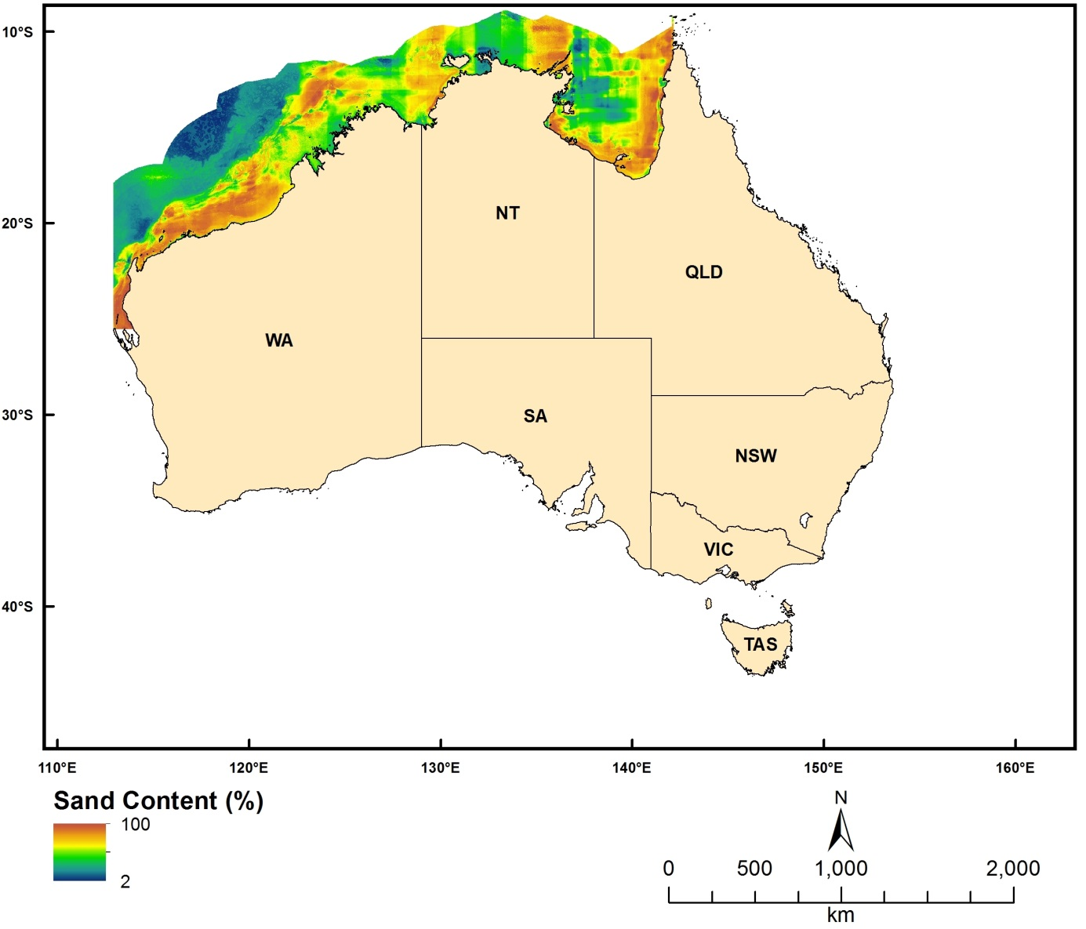
Figure 2.2.3 Predicted seabed sand content for the North and North-West Marine Regions

Geological and Oceanographic Model of Australia’s Continental Shelf (GEOMACS)

Percentage of time the Shields Parameter Exceeds 0.25
Dataset TITLE
Percentage of time the Shields parameter exceeds 0.25
Dataset ALTERNATE TITLE (i.e. Dataset Name)
geomacs_pe
Dataset AUTHOR(S)
Michael Hughes
Dataset CUSTODIAN
Geoscience Australia
Dataset JURISDICTION
Australia
Description ABSTRACT
This data represents the percentage of time the Shields parameter (Shields, 1936) exceeds 0.25. The Shields parameter (non-dimensional bed shear stress) value of 0.25 is assumed to be the threshold for creating disturbed patches on the seabed. This value is several times larger than that required to initiate traction bedload transport (~0.05) and falls in the middle of the ripple and dune bedform stability field. It represents conditions when the seabed is highly mobile and where patches of disturbed habitat are likely to be created.
Shields, A. 1936. Application of similarity principles and turbulence research to bed-load movement. Mitteilunger der Preussischen Versuchsanstalt f¨ur Wasserbau und Schiffbau 26: 5–24
Description Data Category
Oceans
Environment
Description Keyword
Oceans, Marine Biology, Marine Habitat, Marine Sediments
Description GEOGRAPHIC EXTENT POLYGON(S)
N_LAT: -7
S_LAT: -44
E_LONG: 110
W_LONG: 156
COORDINATE SYSTEM DESCRIPTION
Projection: Geographic
Datum: WGS84
Units: Decimal Degree
Description Temporal EXTENT
Description NOMINAL SCALE
Spatial Resolution: 0.1
Temporal Resolution:
Data Currency BEGINNING DATE
Jan-10
Data Currency ENDING DATE
Jan-10
Dataset Status PROGRESS
Completed
Dataset Status MAINTENANCE AND UPDATE FREQUENCY
Not Planned
Access STORED FORMATS Digital/Non-Digital Description
DIGITAL ArcInfo grid
Access AVAILABLE FORMATS Digital/Non-Digital Description
DIGITAL ArcInfo grid
Access ACCESS CONSTRAINT
Please cite the data set using the following format: National Environmental Research Program (NERP) Marine Biodiversity Hub [year-of-data-download], [Title], [data-access-URL], accessed [date-of-access].
Data Quality LINEAGE
Geoscience Australia's GEOMACS (Geological and Oceanographic Model of Australia's Continental Shelf) model was utilised to produce hindcast hourly time series of continental shelf (~20 – 300 m depth) bed shear stress on a 0.1 degree grid covering the period March 1997 to February 2008 (inclusive). The hindcast data represents the combined contribution to the bed shear stress by waves, tides, wind and density-driven circulation. The Shields parameter was obtained from the GEOMACS model.
Please refer to Hughes et al. (2010) for further details.
Hughes, M.G., Harris, P.T., Brooke, B.P., 2010. Seabed exposure and ecological disturbance on Australia's continental shelf: Potential surrogates for marine biodiversity. Geoscience Australia Record 2010/43, 77pp.
Data Quality POSITIONAL ACCURACY
The dataset is estimated on a 0.1 dd grid resolution.
Data Quality ATTRIBUTE ACCURACY
Output is from a mathematical model – there are no direct field observations. The GEOMACS model does not include the effects of wave breaking and refraction/diffraction or non-linear shallow-water effects on the tide, therefore the model is not considered useful in <10 m water depth, and in many regions in <30 m water depth; depending on the dominant wave period, tidal range and bathymetric complexity (Hughes & Harris 2008). Conversely, seabed disturbance produced by the wave, tide and current input variables appears not to extend beyond 150 m depth. The temporal domain includes 11 years and therefore contains limited information on events with long return intervals at specific locations, e.g. tropical cyclones.
Data Quality LOGICAL CONSISTENCY
The model output has been visually checked for artefacts and spurious data. Tests conducted to ensure data are reliable and valid.
Data Quality COMPLETENESS
This dataset is completed.
Contact Information CONTACT ORGANISATION
Geoscience Australia
Contact Information CONTACT POSITION
Marine Data Manager
Contact Information MAIL ADDRESS 1
GPO Box 378
Contact Information SUBURB/PLACE/LOCALITY
Canberra
Contact Information STATE/LOCALITY 2
ACT
Contact Information COUNTRY
Australia
Contact Information POSTCODE
2601
Contact Information TELEPHONE
+61 2 6249 9111
Contact Information FACSIMILE
+61 2 6249 9999
Contact Information ELECTRONIC MAIL ADDRESS
marine@ga.gov.au
Metadata Date METADATA DATE
20MAR2013
Additional Metadata METADATA AUTHOR
Zhi Huang
Additional Metadata ACKNOWLEDGEMENTS
Peter Harris
Brendan Brooke
Data was sourced from the NERP Marine Biodiversity Hub – the Marine Biodiversity Hub is supported through funding from the Australian Government’s National Environmental Research Program (NERP), administered by the Department of Sustainability, Environment, Water, Population and Communities (DSEWPaC).
Additional Metadata REFERENCES
Hughes, M.G., Harris, P.T., Brooke, B.P., 2010. Seabed exposure and ecological disturbance on Australia's continental shelf: Potential surrogates for marine biodiversity. Geoscience Australia Record 2010/43, 77pp.

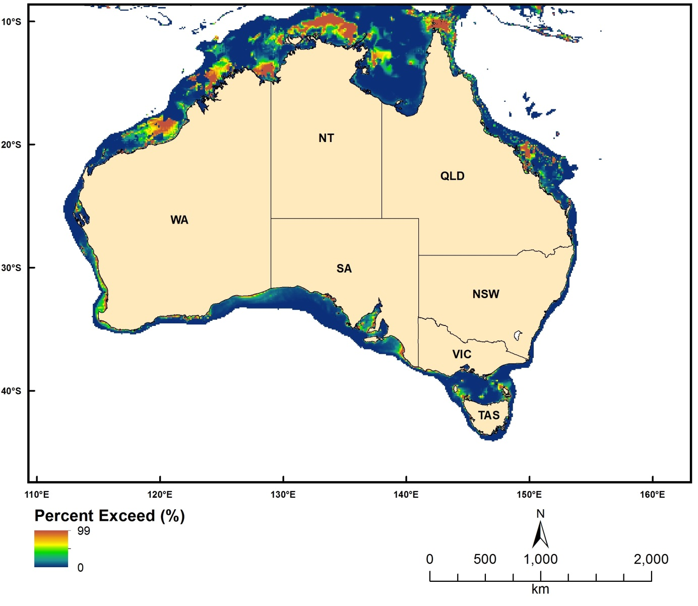
Figure 2.3.1. Percentage of time the Shields Parameter exceeds 0.25

The Integrated Shields Parameter Exceeding 0.25 Divided by the Integrated Total Shields Parameter
Dataset TITLE
The integrated Shields parameter exceeding 0.25 divided by the integrated total Shields parameter
Dataset ALTERNATE TITLE (i.e. Dataset Name)
geomacs_r
Dataset AUTHOR(S)
Michael Hughes
Dataset CUSTODIAN
Geoscience Australia
Dataset JURISDICTION
Australia
Description ABSTRACT
This data represents the integrated Shields (Shields, 1936) parameter exceeding 0.25 divided by the integrated total Shields parameter. The Shields parameter (non-dimensional bed shear stress) value of 0.25 is assumed to be the threshold for creating disturbed patches. This value is several times larger than that required to initiate traction bedload transport (~0.05) and falls in the middle of the ripple and dune bedform stability field. It represents conditions when the seabed is highly mobile and where patches of disturbed habitat are likely to be created.
Shields, A. 1936. Application of similarity principles and turbulence research to bed-load movement. Mitteilunger der Preussischen Versuchsanstalt f¨ur Wasserbau und Schiffbau 26: 5–24
Description Data Category
Oceans
Environment
Description Keyword
Oceans, Marine Biology, Marine Habitat, Marine Sediments
Description GEOGRAPHIC EXTENT POLYGON(S)
N_LAT: -7
S_LAT: -44
E_LONG: 110
W_LONG: 156
COORDINATE SYSTEM DESCRIPTION
Projection: Geographic
Datum: WGS84
Units: Decimal Degree
Description Temporal EXTENT
Description NOMINAL SCALE
Spatial Resolution: 0.1
Temporal Resolution:
Data Currency BEGINNING DATE
Jan-10
Data Currency ENDING DATE
Jan-10
Dataset Status PROGRESS
Completed
Dataset Status MAINTENANCE AND UPDATE FREQUENCY
Not Planned
Access STORED FORMATS Digital/Non-Digital Description
DIGITAL ArcInfo grid
Access AVAILABLE FORMATS Digital/Non-Digital Description
DIGITAL ArcInfo grid
Access ACCESS CONSTRAINT
Please cite the data set using the following format: National Environmental Research Program (NERP) Marine Biodiversity Hub [year-of-data-download], [Title], [data-access-URL], accessed [date-of-access].
Data Quality LINEAGE
Geoscience Australia's GEOMACS (Geological and Oceanographic Model of Australia's Continental Shelf) model was utilised to produce hindcast hourly time series of continental shelf (~20 – 300 m depth) bed shear stress on a 0.1 degree grid covering the period March 1997 to February 2008 (inclusive). The hindcast data represents the combined contribution to the bed shear stress by waves, tides, wind and density-driven circulation. The Shields parameter was obtained from the GEOMACS model. The dataset was calculated using Equation 5.2 in Hughes et al. (2010).
Please refer to Hughes et al. (2010) for further details.
Hughes, M.G., Harris, P.T., Brooke, B.P., 2010. Seabed exposure and ecological disturbance on Australia's continental shelf: Potential surrogates for marine biodiversity. Geoscience Australia Record 2010/43, 77pp.
Data Quality POSITIONAL ACCURACY
The dataset is estimated on a 0.1 dd grid resolution.
Data Quality ATTRIBUTE ACCURACY
Output is from a mathematical model – there are no direct field observations. The GEOMACS model does not include the effects of wave breaking and refraction/diffraction or non-linear shallow-water effects on the tide, therefore the model is not considered useful in <10 m water depth, and in many regions in <30 m water depth; depending on the dominant wave period, tidal range and bathymetric complexity (Hughes & Harris 2008). Conversely, seabed disturbance produced by the wave, tide and current input variables appears not to extend beyond 150 m depth. The temporal domain includes 11 years and therefore contains limited information on events with long return intervals at specific locations, e.g. tropical cyclones.
Data Quality LOGICAL CONSISTENCY
The model output has been visually checked for artefacts and spurious data. Tests conducted to ensure data are reliable and valid.
Data Quality COMPLETENESS
This dataset is completed.
Contact Information CONTACT ORGANISATION
Geoscience Australia
Contact Information CONTACT POSITION
Marine Data Manager
Contact Information MAIL ADDRESS 1
GPO Box 378
Contact Information SUBURB/PLACE/LOCALITY
Canberra
Contact Information STATE/LOCALITY 2
ACT
Contact Information COUNTRY
Australia
Contact Information POSTCODE
2601
Contact Information TELEPHONE
+61 2 6249 9111
Contact Information FACSIMILE
+61 2 6249 9999
Contact Information ELECTRONIC MAIL ADDRESS
marine@ga.gov.au
Metadata Date METADATA DATE
20MAR2013
Additional Metadata METADATA AUTHOR
Zhi Huang
Additional Metadata ACKNOWLEDGEMENTS
Peter Harris
Brendan Brooke
Data was sourced from the NERP Marine Biodiversity Hub – the Marine Biodiversity Hub is supported through funding from the Australian Government’s National Environmental Research Program (NERP), administered by the Department of Sustainability, Environment, Water, Population and Communities (DSEWPaC).
Additional Metadata REFERENCES
Hughes, M.G., Harris, P.T., Brooke, B.P., 2010. Seabed exposure and ecological disturbance on Australia's continental shelf: Potential surrogates for marine biodiversity. Geoscience Australia Record 2010/43, 77pp.

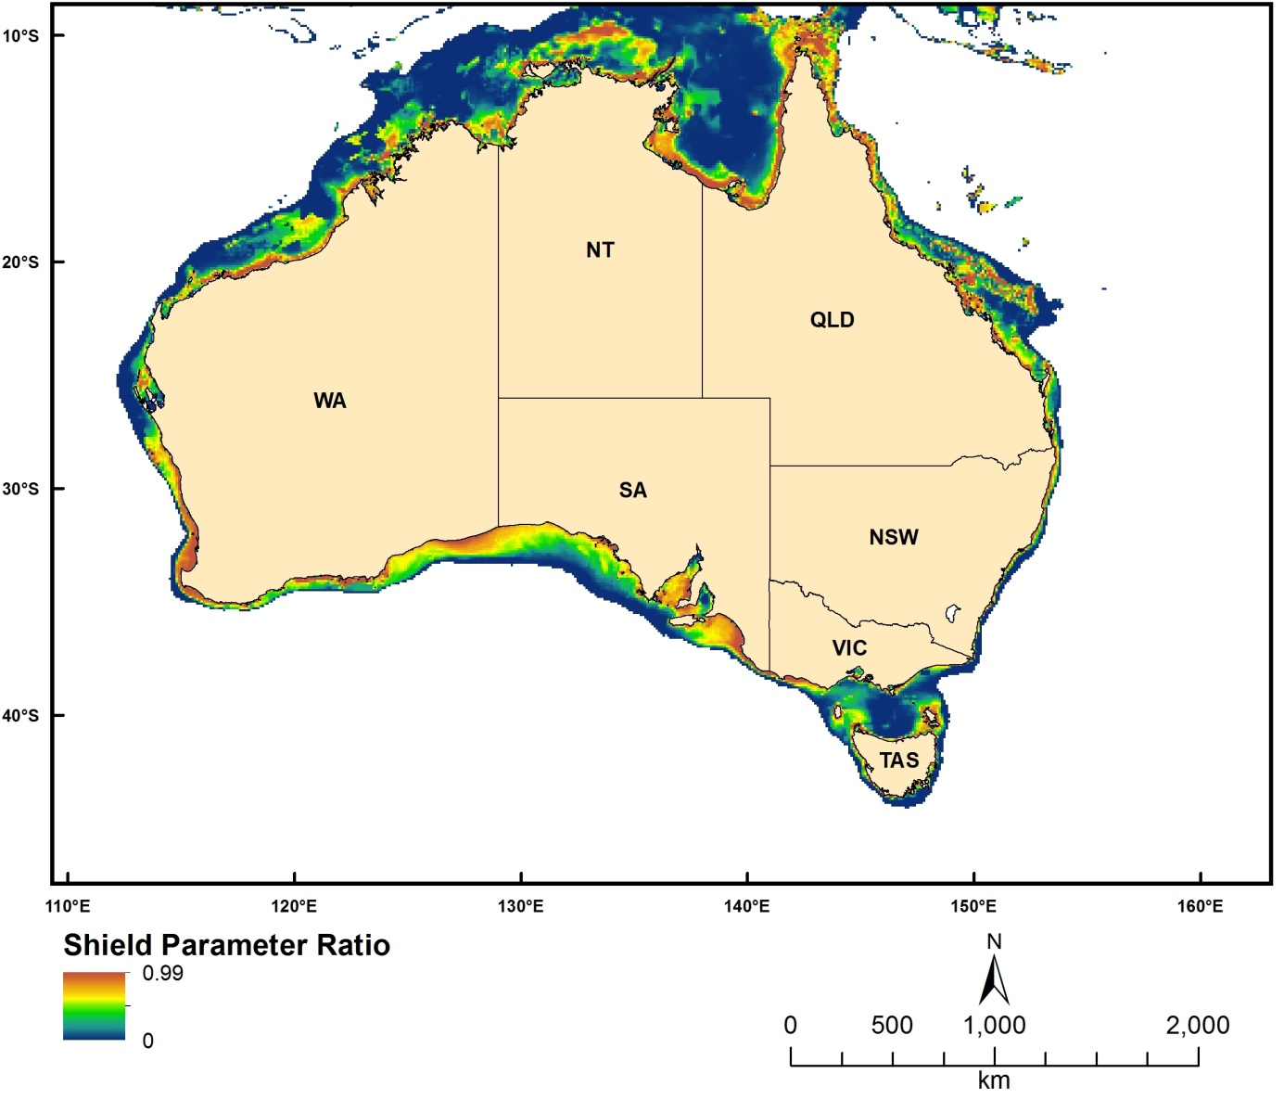
Figure 2.3.2 The Integrated Shields Parameter exceeding 0.25 divided by the Integrated Total Shields Parameter

Average Time between Events When the Shields Parameter Exceeds 0.25 Based on a POT Analysis
Dataset TITLE
Average time between events when the Shields parameter exceeds 0.25
Dataset ALTERNATE TITLE (i.e. Dataset Name)
geomacs_ri
Dataset AUTHOR(S)
Michael Hughes
Dataset CUSTODIAN
Geoscience Australia
Dataset JURISDICTION
Australia
Description ABSTRACT
This data represents the average time between events when the Shields parameter (Shields, 1936) exceeds 0.25 based on a Peaks-Over-Thresholds (POT) analysis. The Shields parameter (non-dimensional bed shear stress) value of 0.25 is assumed to be the threshold for creating disturbed patches. This value is several times larger than that required to initiate traction bedload transport (~0.05) and falls in the middle of the ripple and dune bedform stability field. It represents conditions when the seabed is highly mobile and where patches of disturbed habitat are likely to be created. The unit for the dataset is day.
Shields, A. 1936. Application of similarity principles and turbulence research to bed-load movement. Mitteilunger der Preussischen Versuchsanstalt f¨ur Wasserbau und Schiffbau 26: 5–24
Description Data Category
Oceans
Environment
Description Keyword
Oceans, Marine Biology, Marine Habitat, Marine Sediments
Description GEOGRAPHIC EXTENT POLYGON(S)
N_LAT: -7
S_LAT: -44
E_LONG: 110
W_LONG: 156
COORDINATE SYSTEM DESCRIPTION
Projection: Geographic
Datum: WGS84
Units: Decimal Degree
Description Temporal EXTENT
Description NOMINAL SCALE
Spatial Resolution: 0.1
Temporal Resolution:
Data Currency BEGINNING DATE
Jan-10
Data Currency ENDING DATE
Jan-10
Dataset Status PROGRESS
Completed
Dataset Status MAINTENANCE AND UPDATE FREQUENCY
Not Planned
Access STORED FORMATS Digital/Non-Digital Description
DIGITAL ArcInfo grid
Access AVAILABLE FORMATS Digital/Non-Digital Description
DIGITAL ArcInfo grid
Access ACCESS CONSTRAINT
Please cite the data set using the following format: National Environmental Research Program (NERP) Marine Biodiversity Hub [year-of-data-download], [Title], [data-access-URL], accessed [date-of-access].
Data Quality LINEAGE
Geoscience Australia's GEOMACS (Geological and Oceanographic Model of Australia's Continental Shelf) model was utilised to produce hindcast hourly time series of continental shelf (~20 – 300 m depth) bed shear stress on a 0.1 degree grid covering the period March 1997 to February 2008 (inclusive). The hindcast data represents the combined contribution to the bed shear stress by waves, tides, wind and density-driven circulation. The Shields parameter was obtained from the GEOMACS model.
Please refer to Hughes et al. (2010) for further details.
Hughes, M.G., Harris, P.T., Brooke, B.P., 2010. Seabed exposure and ecological disturbance on Australia's continental shelf: Potential surrogates for marine biodiversity. Geoscience Australia Record 2010/43, 77pp.
Data Quality POSITIONAL ACCURACY
The dataset is estimated on a 0.1 dd grid resolution.
Data Quality ATTRIBUTE ACCURACY
Output is from a mathematical model – there are no direct field observations. The GEOMACS model does not include the effects of wave breaking and refraction/diffraction or non-linear shallow-water effects on the tide, therefore the model is not considered useful in <10 m water depth, and in many regions in <30 m water depth; depending on the dominant wave period, tidal range and bathymetric complexity (Hughes & Harris 2008). Conversely, seabed disturbance produced by the wave, tide and current input variables appears not to extend beyond 150 m depth. The temporal domain includes 11 years and therefore contains limited information on events with long return intervals at specific locations, e.g. tropical cyclones.
Data Quality LOGICAL CONSISTENCY
The model output has been visually checked for artefacts and spurious data. Tests conducted to ensure data are reliable and valid.
Data Quality COMPLETENESS
This dataset is completed.
Contact Information CONTACT ORGANISATION
Geoscience Australia
Contact Information CONTACT POSITION
Marine Data Manager
Contact Information MAIL ADDRESS 1
GPO Box 378
Contact Information SUBURB/PLACE/LOCALITY
Canberra
Contact Information STATE/LOCALITY 2
ACT
Contact Information COUNTRY
Australia
Contact Information POSTCODE
2601
Contact Information TELEPHONE
+61 2 6249 9111
Contact Information FACSIMILE
+61 2 6249 9999
Contact Information ELECTRONIC MAIL ADDRESS
marine@ga.gov.au
Metadata Date METADATA DATE
20MAR2013
Additional Metadata METADATA AUTHOR
Zhi Huang
Additional Metadata ACKNOWLEDGEMENTS
Peter Harris
Brendan Brooke
Data was sourced from the NERP Marine Biodiversity Hub – the Marine Biodiversity Hub is supported through funding from the Australian Government’s National Environmental Research Program (NERP), administered by the Department of Sustainability, Environment, Water, Population and Communities (DSEWPaC).
Additional Metadata REFERENCES
Hughes, M.G., Harris, P.T., Brooke, B.P., 2010. Seabed exposure and ecological disturbance on Australia's continental shelf: Potential surrogates for marine biodiversity. Geoscience Australia Record 2010/43, 77pp.

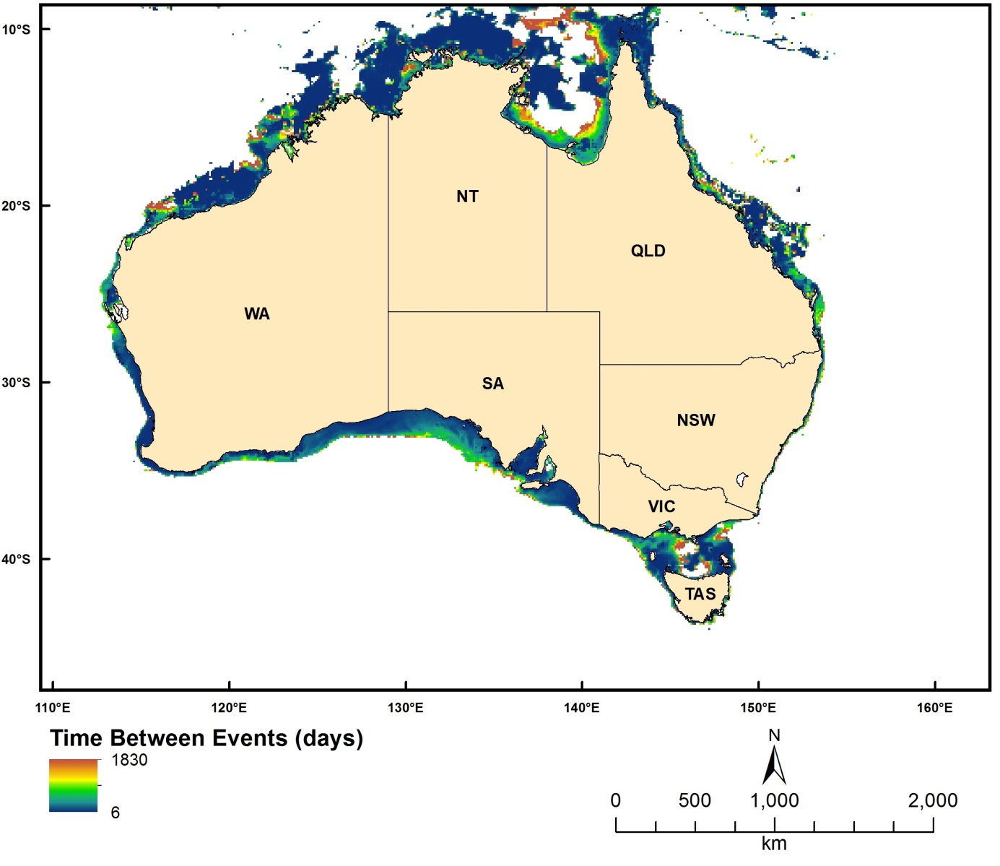
Figure 2.3.3 Average time between events when the Shields Parameter exceeds 0.25 based on a POT analysis

Ecological Disturbance Index
Dataset TITLE
Ecological disturbance index
Dataset ALTERNATE TITLE (i.e. Dataset Name)
geomacs_ed
Dataset AUTHOR(S)
Michael Hughes
Dataset CUSTODIAN
Geoscience Australia
Dataset JURISDICTION
Australia
Description ABSTRACT
This data represents a dimensionless ecological disturbance index, as the ratio of ecological succession and disturbance recurrence interval times the fraction of the area disturbed in any event. Small values of the ecological disturbance index represent decreasing proportions of time when disturbed/recovering habitats are present.
Description Data Category
Oceans
Environment
Description Keyword
Oceans, Marine Biology, Marine Habitat, Marine Sediments
Description GEOGRAPHIC EXTENT POLYGON(S)
N_LAT: -7
S_LAT: -44
E_LONG: 110
W_LONG: 156
COORDINATE SYSTEM DESCRIPTION
Projection: Geographic
Datum: WGS84
Units: Decimal Degree
Description Temporal EXTENT
Description NOMINAL SCALE
Spatial Resolution: 0.1
Temporal Resolution:
Data Currency BEGINNING DATE
Jan-10
Data Currency ENDING DATE
Jan-10
Dataset Status PROGRESS
Completed
Dataset Status MAINTENANCE AND UPDATE FREQUENCY
Not Planned
Access STORED FORMATS Digital/Non-Digital Description
DIGITAL ArcInfo grid
Access AVAILABLE FORMATS Digital/Non-Digital Description
DIGITAL ArcInfo grid
Access ACCESS CONSTRAINT
Please cite the data set using the following format: National Environmental Research Program (NERP) Marine Biodiversity Hub [year-of-data-download], [Title], [data-access-URL], accessed [date-of-access].
Data Quality LINEAGE
Geoscience Australia's GEOMACS (Geological and Oceanographic Model of Australia's Continental Shelf) model was utilised to produce hindcast hourly time series of continental shelf (~20 – 300 m depth) bed shear stress on a 0.1 degree grid covering the period March 1997 to February 2008 (inclusive). The hindcast data represents the combined contribution to the bed shear stress by waves, tides, wind and density-driven circulation.
The ecological disturbance index is calculated using the following equation:
ED=FA*ES/RI
Where ED is the ecological disturbance index, FA is the spatial fraction multiplier, ES is the ecological succession (in days), and RI is the recurrence interval (in days). In this study, FA was assigned 1.0. ES equals 1 year (365 days) for mud, 3 years (1095 days) for sand and 5 years (1825 days) for gravel. While, RI is the average time between events when the Shields parameter exceeding 0.25 (the geomacs_ri layer).The seabed sediment was classified into gravel, sand or mud using a simple classification scheme (Folk, 1974). Grid cells were assigned to the gravel class if percent gravel was >30, and if the percent gravel was <30 they were assigned to either the sand or mud class depending on which ever had the largest percentage. The sediment grain size data used for this exercise were from the predicted layers of Li et al. (2011).
Please refer to Hughes et al. (2010) for further details.
Hughes, M.G., Harris, P.T., Brooke, B.P., 2010. Seabed exposure and ecological disturbance on Australia's continental shelf: Potential surrogates for marine biodiversity. Geoscience Australia Record 2010/43, 77pp.
Li, J., Heap, A.D., Potter, A., Huang, Z., 2011. Seabed gravel content across the Australian continental EEZ 2011, http://www.ga.gov.au/meta/ANZCW0703014835.html
Li, J., Heap, A.D., Potter, A., Huang, Z., 2011. Seabed sand content across the Australian continental EEZ 2011, http://www.ga.gov.au/meta/ANZCW0703014867.html
Data Quality POSITIONAL ACCURACY
The dataset is estimated on a 0.1 dd grid resolution.
Data Quality ATTRIBUTE ACCURACY
Output is from a mathematical model – there are no direct field observations. The GEOMACS model does not include the effects of wave breaking and refraction/diffraction or non-linear shallow-water effects on the tide, therefore the model is not considered useful in <10 m water depth, and in many regions in <30 m water depth; depending on the dominant wave period, tidal range and bathymetric complexity (Hughes & Harris 2008). Conversely, seabed disturbance produced by the wave, tide and current input variables appears not to extend beyond 150 m depth. The temporal domain includes 11 years and therefore contains limited information on events with long return intervals at specific locations, e.g. tropical cyclones.
The attribute accuracy of the sediment layers also influences the attribute accuracy of this dataset.
Data Quality LOGICAL CONSISTENCY
The model output has been visually checked for artefacts and spurious data. Tests conducted to ensure data are reliable and valid.
Data Quality COMPLETENESS
This dataset is completed.
Contact Information CONTACT ORGANISATION
Geoscience Australia
Contact Information CONTACT POSITION
Marine Data Manager
Contact Information MAIL ADDRESS 1
GPO Box 378
Contact Information SUBURB/PLACE/LOCALITY
Canberra
Contact Information STATE/LOCALITY 2
ACT
Contact Information COUNTRY
Australia
Contact Information POSTCODE
2601
Contact Information TELEPHONE
+61 2 6249 9111
Contact Information FACSIMILE
+61 2 6249 9999
Contact Information ELECTRONIC MAIL ADDRESS
marine@ga.gov.au
Metadata Date METADATA DATE
20MAR2013
Additional Metadata METADATA AUTHOR
Zhi Huang
Additional Metadata ACKNOWLEDGEMENTS
Peter Harris
Brendan Brooke
Jin Li
Zhi Huang
Data was sourced from the NERP Marine Biodiversity Hub – the Marine Biodiversity Hub is supported through funding from the Australian Government’s National Environmental Research Program (NERP), administered by the Department of Sustainability, Environment, Water, Population and Communities (DSEWPaC).
Additional Metadata REFERENCES
Folk, R.L., 1974. Petrology of sedimentary rocks. Austin, Texas, Hemphills, 182pp.
Hughes, M.G., Harris, P.T., Brooke, B.P., 2010. Seabed exposure and ecological disturbance on Australia's continental shelf: Potential surrogates for marine biodiversity. Geoscience Australia Record 2010/43, 77pp.
Li, J., Heap, A.D., Potter, A., Huang, Z., 2011. Seabed gravel content across the Australian continental EEZ 2011, http://www.ga.gov.au/meta/ANZCW0703014835.html
Li, J., Heap, A.D., Potter, A., Huang, Z., 2011. Seabed sand content across the Australian continental EEZ 2011, http://www.ga.gov.au/meta/ANZCW0703014867.html

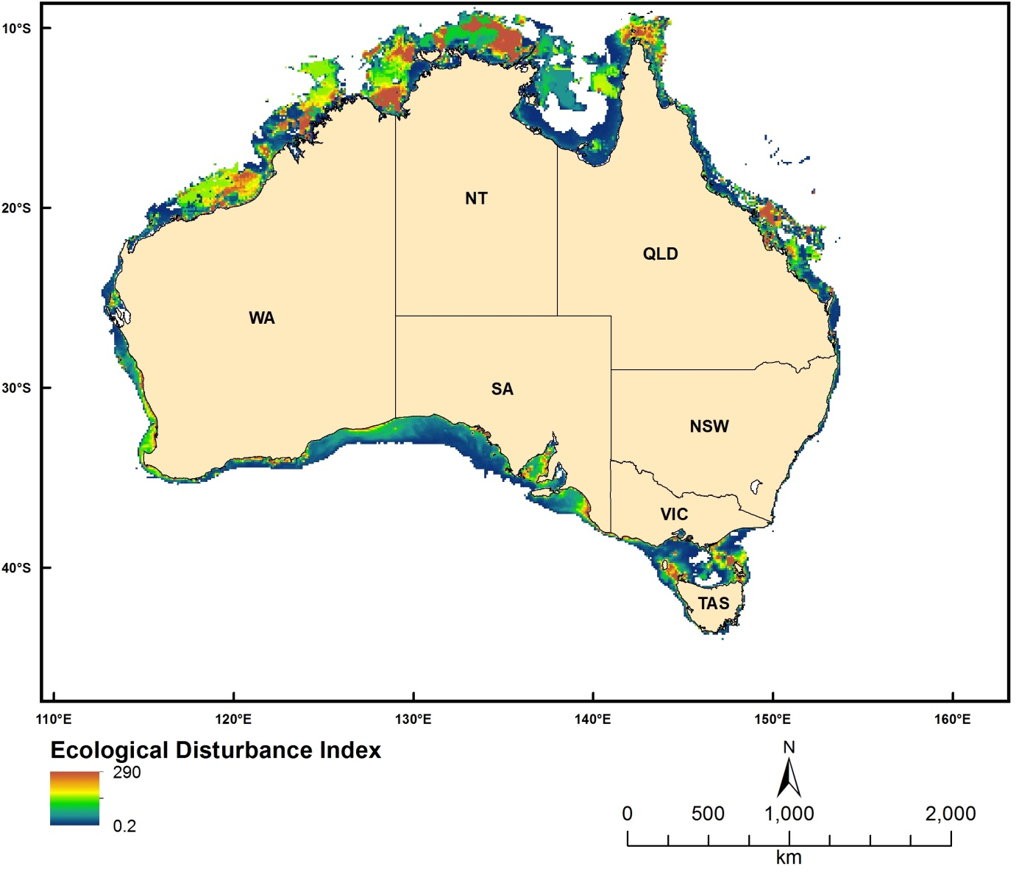
Figure 2.3.4 Ecological Disturbance Index

Time-series MODIS Water Quality Datasets

Chlorophyll a
Dataset TITLE
MODIS derived Chlorophyll a datasets
Dataset ALTERNATE TITLE (i.e. Dataset Name)
Dataset AUTHOR(S)
Zhi Huang
Dataset CUSTODIAN
Geoscience Australia
Dataset JURISDICTION
Australia
Description ABSTRACT
The datasets measure the Chlorophyll a concentrations of ocean surface waters. They are derived products from MODIS (aqua) images using NASA's SeaDAS image processing software. The extent of the datasets covers the entire Australian EEZ and surrounding waters (including the southern ocean). The spatial resolution of the datasets is 0.01 dd. The datasets contain 36 monthly Chlorophyll a layers between 2009 and 2011. The unit of the datasets is mg/m3.
Description Data Category
Oceans
Environment
Description Keyword
Oceans, Water Quality
Description GEOGRAPHIC EXTENT POLYGON(S)
N_LAT: -5
S_LAT: -60
E_LONG: 100
W_LONG: 170
COORDINATE SYSTEM DESCRIPTION
Projection: Geographic
Datum: WGS84
Units: Decimal Degree
Description Temporal EXTENT
Jan-09 to Dec-11
Description NOMINAL SCALE
Spatial Resolution: 0.01
Temporal Resolution: monthly
Data Currency BEGINNING DATE
Dec-12
Data Currency ENDING DATE
Dec-12
Dataset Status PROGRESS
Completed
Dataset Status MAINTENANCE AND UPDATE FREQUENCY
Not Planned
Access STORED FORMATS Digital/Non-Digital Description
DIGITAL ArcInfo grid
Access AVAILABLE FORMATS Digital/Non-Digital Description
DIGITAL ArcInfo grid
Access ACCESS CONSTRAINT
Please cite the data set using the following format: National Environmental Research Program (NERP) Marine Biodiversity Hub [year-of-data-download], [Title], [data-access-URL], accessed [date-of-access].
Data Quality LINEAGE
The Chlorophyll a datasets were derived products of MODIS (Aqua) images. SeaDAS (version 6.1) was used to process the MODIS data from raw to L3 products. SeaDAS provides several algorithms for Chlorophyll products. The algorithm used here is the standard algorithm (OC3) (O'Reilly et al., 1998). The sequences of processing included:
1. raw - L1A,
2. L1A - L1B,
3. L1B - L2,
4. L2 - L3 (spatial) binning, and
5. L3 binning to L3 time-binning.
The first four steps were applied to all individual (daily) raw images. After completing the above steps for one-month-worth-of images (around 300 images), in the fifth step, four weekly images were generated:
1. week1: from the 1st to the 7th of the month;
2. week2: from the 8th to the 14th of the month;
3. week3: from the 15th to the 21st of the month;
4. week4: from the 22nd to the last day of the month.
The four weekly images were exported as HDF files, then imported into ArcGIS and converted into ArcInfo grids. Next, the four grids were mosaiced into a monthly image using the averaging method.
The above processes were repeated to generate the final 36 monthly datasets between 2009 and 2011.

O’Reilly, J.E., Maritorena, S., Mitchell, B.G., Siegel, D.A., Carder, K.L., Garver, S.A., et al., 1998. Ocean color algorithms for SeaWiFS, Journal of Geophysical Research, 103, 24937-24953.
Data Quality POSITIONAL ACCURACY
The spatial resolution of the MODIS data used to derive Ocean Color products are about 1km. The same resolution was maintained for the final monthly data (e.g. 0.01 dd). Given the high accuracy of spatial referencing during the SeaDAS processing, the positional accuracy was estimated to be within 1 km.
Data Quality ATTRIBUTE ACCURACY
The attribute accuracy of the Chlorophyll a datasets depends on the algorithm used. The OC3 algorithm is suitable for case-1 water (open ocean). In the case of Australian waters, the estimated Chlorophyll a concentrations are reliable for the vast majority of areas except along the coast (e.g., within 10-20 km from the coast, case 2 waters). However, a quantitative test on the attribute accuracy could not be carried out due to the lack of ground truth samples.
Data Quality LOGICAL CONSISTENCY
The same algorithm and processing steps and parameters were used to process all images.
Data Quality COMPLETENESS
The datasets cover an extent between 100 to 170 longitude and -60 to -5 latitude. The holes (NoDATA) in the datasets were the results of the quality flags applied during the MODIS processing.
Contact Information CONTACT ORGANISATION
Geoscience Australia
Contact Information CONTACT POSITION
Marine Data Manager
Contact Information MAIL ADDRESS 1
GPO Box 378
Contact Information SUBURB/PLACE/LOCALITY
Canberra
Contact Information STATE/LOCALITY 2
ACT
Contact Information COUNTRY
Australia
Contact Information POSTCODE
2601
Contact Information TELEPHONE
+61 2 6249 9111
Contact Information FACSIMILE
+61 2 6249 9999
Contact Information ELECTRONIC MAIL ADDRESS
marine@ga.gov.au
Metadata Date METADATA DATE
20MAR2013
Additional Metadata METADATA AUTHOR
Zhi Huang
Additional Metadata ACKNOWLEDGEMENTS
Edward King of CSIRO (for providing access to the MODIS raw data and permission to use SeaDAS software)
NCI facilities
Data was sourced from the NERP Marine Biodiversity Hub – the Marine Biodiversity Hub is supported through funding from the Australian Government’s National Environmental Research Program (NERP), administered by the Department of Sustainability, Environment, Water, Population and Communities (DSEWPaC).
Additional Metadata REFERENCES
O’Reilly, J.E., Maritorena, S., Mitchell, B.G., Siegel, D.A., Carder, K.L., Garver, S.A., et al., 1998. Ocean color algorithms for SeaWiFS, Journal of Geophysical Research, 103, 24937-24953.

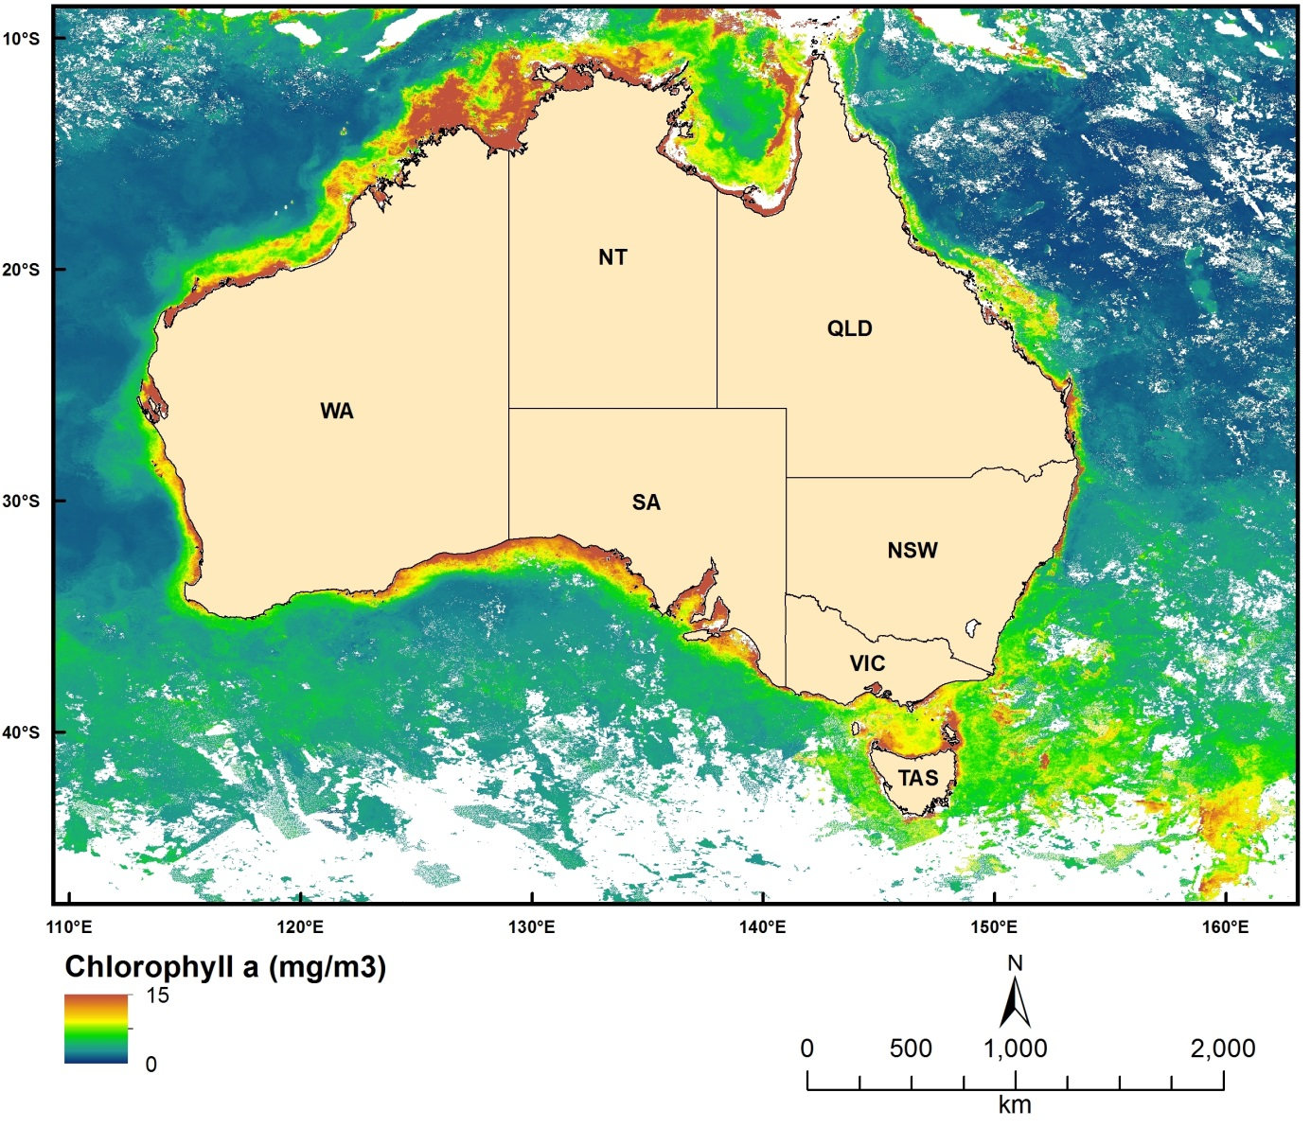
Figure 2.4.1 MODIS-derived Chlorophyll-a concentrations for May 2009

Coloured Dissolved Organic Matter
Dataset TITLE
MODIS derived CDOM datasets
Dataset ALTERNATE TITLE (i.e. Dataset Name)
Dataset AUTHOR(S)
Zhi Huang
Dataset CUSTODIAN
Geoscience Australia
Dataset JURISDICTION
Australia
Description ABSTRACT
The datasets measure the Coloured Dissolved Organic Matter (CDOM) concentrations of ocean surface waters. They are derived products from MODIS (aqua) images using NASA's SeaDAS image processing software. The extent of the datasets covers the entire Australian EEZ and surrounding waters (including the southern ocean). The spatial resolution of the datasets is 0.01 dd. The datasets contain 36 monthly CDOM layers between 2009 and 2011. The unit of the datasets is 1/m.
Description Data Category
Oceans
Environment
Description Keyword
Oceans, Water Quality
Description GEOGRAPHIC EXTENT POLYGON(S)
N_LAT: -5
S_LAT: -60
E_LONG: 100
W_LONG: 170
COORDINATE SYSTEM DESCRIPTION
Projection: Geographic
Datum: WGS84
Units: Decimal Degree
Description Temporal EXTENT
Jan-09 to Dec-11
Description NOMINAL SCALE
Spatial Resolution: 0.01
Temporal Resolution: monthly
Data Currency BEGINNING DATE
Dec-12
Data Currency ENDING DATE
Dec-12
Dataset Status PROGRESS
Completed
Dataset Status MAINTENANCE AND UPDATE FREQUENCY
Not Planned
Access STORED FORMATS Digital/Non-Digital Description
DIGITAL ArcInfo grid
Access AVAILABLE FORMATS Digital/Non-Digital Description
DIGITAL ArcInfo grid
Access ACCESS CONSTRAINT
Please cite the data set using the following format: National Environmental Research Program (NERP) Marine Biodiversity Hub [year-of-data-download], [Title], [data-access-URL], accessed [date-of-access].
Data Quality LINEAGE
The CDOM datasets are derived products of MODIS (Aqua) images. SeaDAS (version 6.1) was used to process the MODIS data from raw to L3 products. The algorithm used here was based on a modified QAA (Lee et al., 2002) algorithm (Zhu and Yu, 2012):
j1=0.63
j2=0.88
aw_443=0.00696
ap_443=j1 * power(bbp_555,j2)
ag_443=a_443 - aw_443 - ap_443
Where a_443 is total absorption coefficient at 443 nm, aw_443 is water absorption coefficient at 443 nm, ap_443 is particles absorption coefficient at 443 nm, bbp_555 is particles backscatter coefficient at 555 nm, and ag_443 is CDOM absorption coefficient at 443 nm.
bbp_555 and a_443 from QAA algorithm can be directly derived using SeaDAS.
The sequences of processing included:
1. raw - L1A,
2. L1A - L1B,
3. L1B - L2,
4. L2 - L3 (spatial) binning, and
5. L3 binning to L3 time-binning.
The first four steps were applied to all individual (daily) raw images to obtain bbp_555 and a_443 products. After completing the above steps for one-month-worth images (around 300 images), in the fifth step, four weekly images were generated:
1. week1: from the 1st to the 7th of the month;
2. week2: from the 8th to the 14th of the month;
3. week3: from the 15th to the 21st of the month;
4. week4: from the 22nd to the last day of the month.
The four weekly images were exported as HDF files, then imported into ArcGIS and converted into ArcInfo grids. Next, the weekly products of bbp_555 and a_443 were entered into the above-described algorithm to calculate weekly CDOM products. Finally, the four weekly CDOM grids were mosaiced into a monthly image using the averaging method.
The above processes were repeated to generate the final 36 monthly datasets between 2009 and 2011.
Lee, Z.P., Carder, K.L., Arnone, R.A., 2002. Deriving inherent optical properties from water color: a multiband quasi-analytical algorithm for optically deep waters, Applied Optics, 41, 5755-5772.
Zhu, W.; Yu, Q.; , "Inversion of Chromophoric Dissolved Organic Matter From EO-1 Hyperion Imagery for Turbid Estuarine and Coastal Waters," Geoscience and Remote Sensing, IEEE Transactions on , vol.PP, no.99, pp.1-13, 0 doi: 10.1109/TGRS.2012.2224117
Data Quality POSITIONAL ACCURACY
The spatial resolution of the MODIS data used to derive Ocean Color products are about 1km. The same resolution was maintained for the final monthly data (e.g., 0.01 dd). Given the high accuracy of spatial referencing during the SeaDAS processing, the positional accuracy was estimated to be within 1 km.
Data Quality ATTRIBUTE ACCURACY
The attribute accuracy of the CDOM datasets depends on the algorithm used. The modified QAA algorithm is suitable for case-1 and case-2 waters. However, a quantitative test on the attribute accuracy could not be carried out due to the lack of ground truth samples.
Data Quality LOGICAL CONSISTENCY
The same algorithm and processing steps and parameters were used to process all images.
Data Quality COMPLETENESS
The datasets cover an extent between 100 to 170 longitude and -60 to -5 latitude. The holes (NoDATA) in the datasets were the results of the quality flags applied during the MODIS processing.
Contact Information CONTACT ORGANISATION
Geoscience Australia
Contact Information CONTACT POSITION
Marine Data Manager
Contact Information MAIL ADDRESS 1
GPO Box 378
Contact Information SUBURB/PLACE/LOCALITY
Canberra
Contact Information STATE/LOCALITY 2
ACT
Contact Information COUNTRY
Australia
Contact Information POSTCODE
2601
Contact Information TELEPHONE
+61 2 6249 9111
Contact Information FACSIMILE
+61 2 6249 9999
Contact Information ELECTRONIC MAIL ADDRESS
marine@ga.gov.au
Metadata Date METADATA DATE
20MAR2013
Additional Metadata METADATA AUTHOR
Zhi Huang
Additional Metadata ACKNOWLEDGEMENTS
Edward King of CSIRO (for providing access to the MODIS raw data and permission to use SeaDAS software)
NCI facilities
Data was sourced from the NERP Marine Biodiversity Hub – the Marine Biodiversity Hub is supported through funding from the Australian Government’s National Environmental Research Program (NERP), administered by the Department of Sustainability, Environment, Water, Population and Communities (DSEWPaC).
Additional Metadata REFERENCES
Lee, Z.P., Carder, K.L., Arnone, R.A., 2002. Deriving inherent optical properties from water color: a multiband quasi-analytical algorithm for optically deep waters, Applied Optics, 41, 5755-5772.
Zhu, W.; Yu, Q, "Inversion of Chromophoric Dissolved Organic Matter From EO-1 Hyperion Imagery for Turbid Estuarine and Coastal Waters," Geoscience and Remote Sensing, IEEE Transactions, vol.PP, no.99, pp.1-13, 0 doi: 10.1109/TGRS.2012.2224117

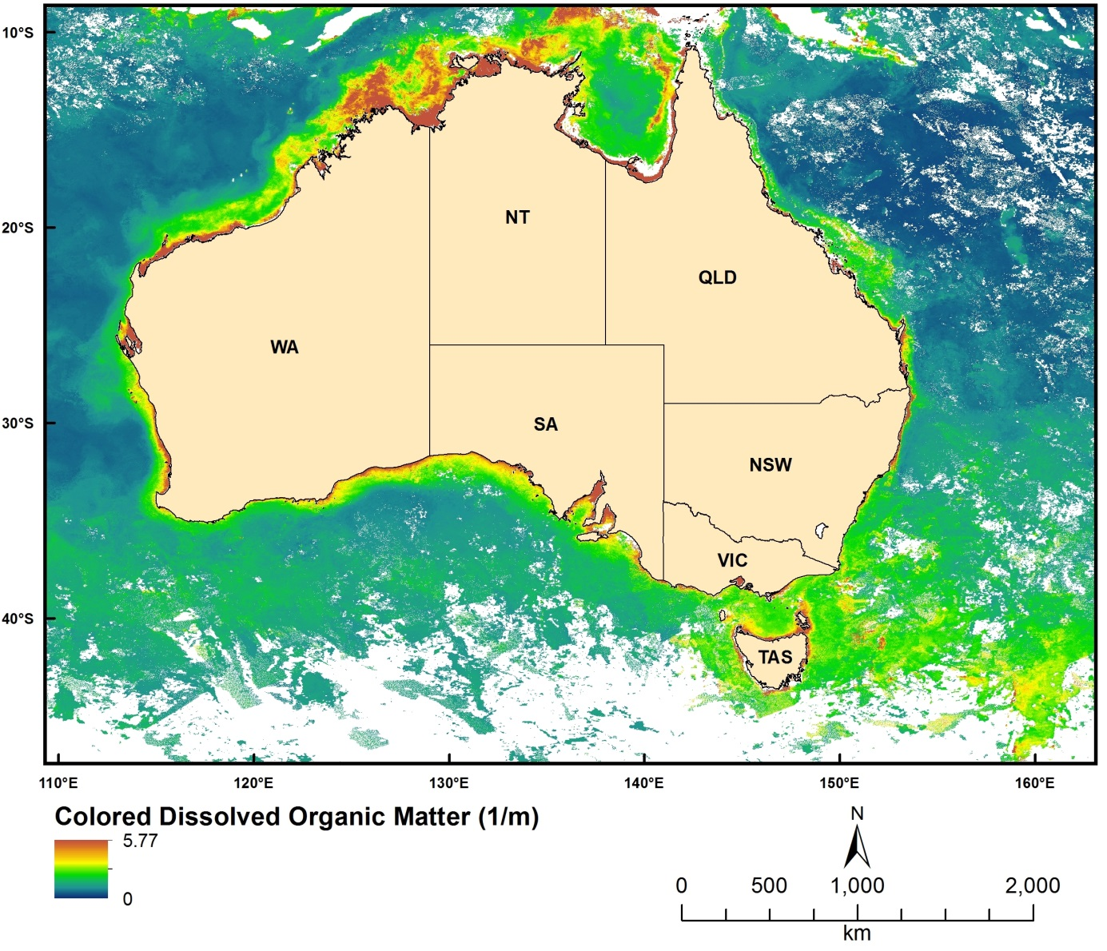
Figure 2.4.2 MODIS-derived Coloured Dissolved Organic Matter concentrations for May 2009

Total Suspended Sediment
Dataset TITLE
MODIS derived TSM datasets
Dataset ALTERNATE TITLE (i.e. Dataset Name)
Dataset AUTHOR(S)
Zhi Huang
Dataset CUSTODIAN
Geoscience Australia
Dataset JURISDICTION
Australia
Description ABSTRACT
The datasets measure the Total Suspended Materials (TSM) concentrations of ocean surface waters. They are derived products from MODIS (aqua) images using NASA's SeaDAS image processing software. The extent of the datasets covers the entire Australian EEZ and surrounding waters (including the southern ocean). The spatial resolution of the datasets is 0.01 dd. The datasets contain 36 monthly TSM layers between 2009 and 2011. The unit of the datasets is g/m3.
Description Data Category
Oceans
Environment
Description Keyword
Oceans, Water Quality
Description GEOGRAPHIC EXTENT POLYGON(S)
N_LAT: -5
S_LAT: -60
E_LONG: 100
W_LONG: 170
COORDINATE SYSTEM DESCRIPTION
Projection: Geographic
Datum: WGS84
Units: Decimal Degree
Description Temporal EXTENT
Jan-09 to Dec-11
Description NOMINAL SCALE
Spatial Resolution: 0.01
Temporal Resolution: monthly
Data Currency BEGINNING DATE
Dec-12
Data Currency ENDING DATE
Dec-12
Dataset Status PROGRESS
Completed
Dataset Status MAINTENANCE AND UPDATE FREQUENCY
Not Planned
Access STORED FORMATS Digital/Non-Digital Description
DIGITAL ArcInfo grid
Access AVAILABLE FORMATS Digital/Non-Digital Description
DIGITAL ArcInfo grid
Access ACCESS CONSTRAINT
Please cite the data set using the following format: National Environmental Research Program (NERP) Marine Biodiversity Hub [year-of-data-download], [Title], [data-access-URL], accessed [date-of-access].
Data Quality LINEAGE
The TSM datasets are derived products of MODIS (Aqua) images. SeaDAS (version 6.1) was used to process the MODIS data from raw to L3 products. The algorithm used here is the Clark algorithm (Clark et al., 1980):

a0=0.490330
a1=-2.712882
a2=3.412666
a3=-8.336478
a4=12.111023
a5=-5.961926
nLw1: Normalised water-leaving radiance at 443 nm
nLw2: Normalised water-leaving radiance at 488 nm
nLw4: Normalised water-leaving radiance at 551 nm
X=log10((nLw1 + nLw2) / nLw4)
TSM=power(10, (a0 + X * (a1 + X * (a2 + X * (a3 + X * (a4 + X * a5))))))
The nLw1 and nLw2 can be derived directly using SeaDAS. In addition, Normalised water-leaving radiance at 547 nm and 555 nm were derived to calculate nLw4 (simple averaging).
The sequences of processing included:
1. raw - L1A,
2. L1A - L1B,
3. L1B - L2,
4. L2 - L3 (spatial) binning, and
5. L3 binning to L3 time-binning.
The first four steps were applied to all individual (daily) raw images to obtain the four Normalised water-leaving radiance products. After completing the above steps for one-month-worth images (around 300 images), in the fifth step, four weekly images were generated:
1. week1: from the 1st to the 7th of the month;
2. week2: from the 8th to the 14th of the month;
3. week3: from the 15th to the 21st of the month;
4. week4: from the 22nd to the last day of the month.
The four weekly images were exported as HDF files, then imported into ArcGIS and converted into ArcInfo grids. Next, the weekly images of the four products were entered into the Clark algorithm described above to calculate weekly TSM products. Finally, the four TSM weekly grids were mosaiced into a monthly image using the averaging method.
The above processes were repeated to generate the final 36 monthly datasets between 2009 and 2011.
Clark, D.K., Baker, E.T., Strong, A.E., 1980. Upwelled spectral radiance distribution in relation to particulate matter in sea water, Boundary-Layer Meteorology, 18, 287-298.
Data Quality POSITIONAL ACCURACY
The spatial resolution of the MODIS data used to derive Ocean Color products are about 1km. The same resolution was maintained for the final monthly data (e.g., 0.01 dd). Given the high accuracy of spatial referencing during the SeaDAS processing, the positional accuracy was estimated to be within 1 km.
Data Quality ATTRIBUTE ACCURACY
The attribute accuracy of the TSM datasets depends on the algorithm used. The Clark algorithm is suitable for case-1 water (open ocean). In the case of Australian waters, the estimated TSM concentrations are reliable for the vast majority of areas except along the coast (e.g., within 10-20 km from the coast, case 2 waters). However, a quantitative test on the attribute accuracy could not be carried out due to the lack of ground truth samples.
Data Quality LOGICAL CONSISTENCY
The same algorithm and processing steps and parameters were used to process all images.
Data Quality COMPLETENESS
The datasets cover an extent between 100 to 170 longitude and -60 to -5 latitude. The holes (NoDATA) in the datasets were the results of the quality flags applied during the MODIS processing.
Contact Information CONTACT ORGANISATION
Geoscience Australia
Contact Information CONTACT POSITION
Marine Data Manager
Contact Information MAIL ADDRESS 1
GPO Box 378
Contact Information SUBURB/PLACE/LOCALITY
Canberra
Contact Information STATE/LOCALITY 2
ACT
Contact Information COUNTRY
Australia
Contact Information POSTCODE
2601
Contact Information TELEPHONE
+61 2 6249 9111
Contact Information FACSIMILE
+61 2 6249 9999
Contact Information ELECTRONIC MAIL ADDRESS
marine@ga.gov.au
Metadata Date METADATA DATE
20MAR2013
Additional Metadata METADATA AUTHOR
Zhi Huang
Additional Metadata ACKNOWLEDGEMENTS
Edward King of CSIRO (for providing access to the MODIS raw data and permission to use SeaDAS software)
NCI facilities
Data was sourced from the NERP Marine Biodiversity Hub – the Marine Biodiversity Hub is supported through funding from the Australian Government’s National Environmental Research Program (NERP), administered by the Department of Sustainability, Environment, Water, Population and Communities (DSEWPaC).
Additional Metadata REFERENCES
Clark, D.K., Baker, E.T., Strong, A.E., 1980. Upwelled spectral radiance distribution in relation to particulate matter in sea water, Boundary-Layer Meteorology, 18, 287-298.

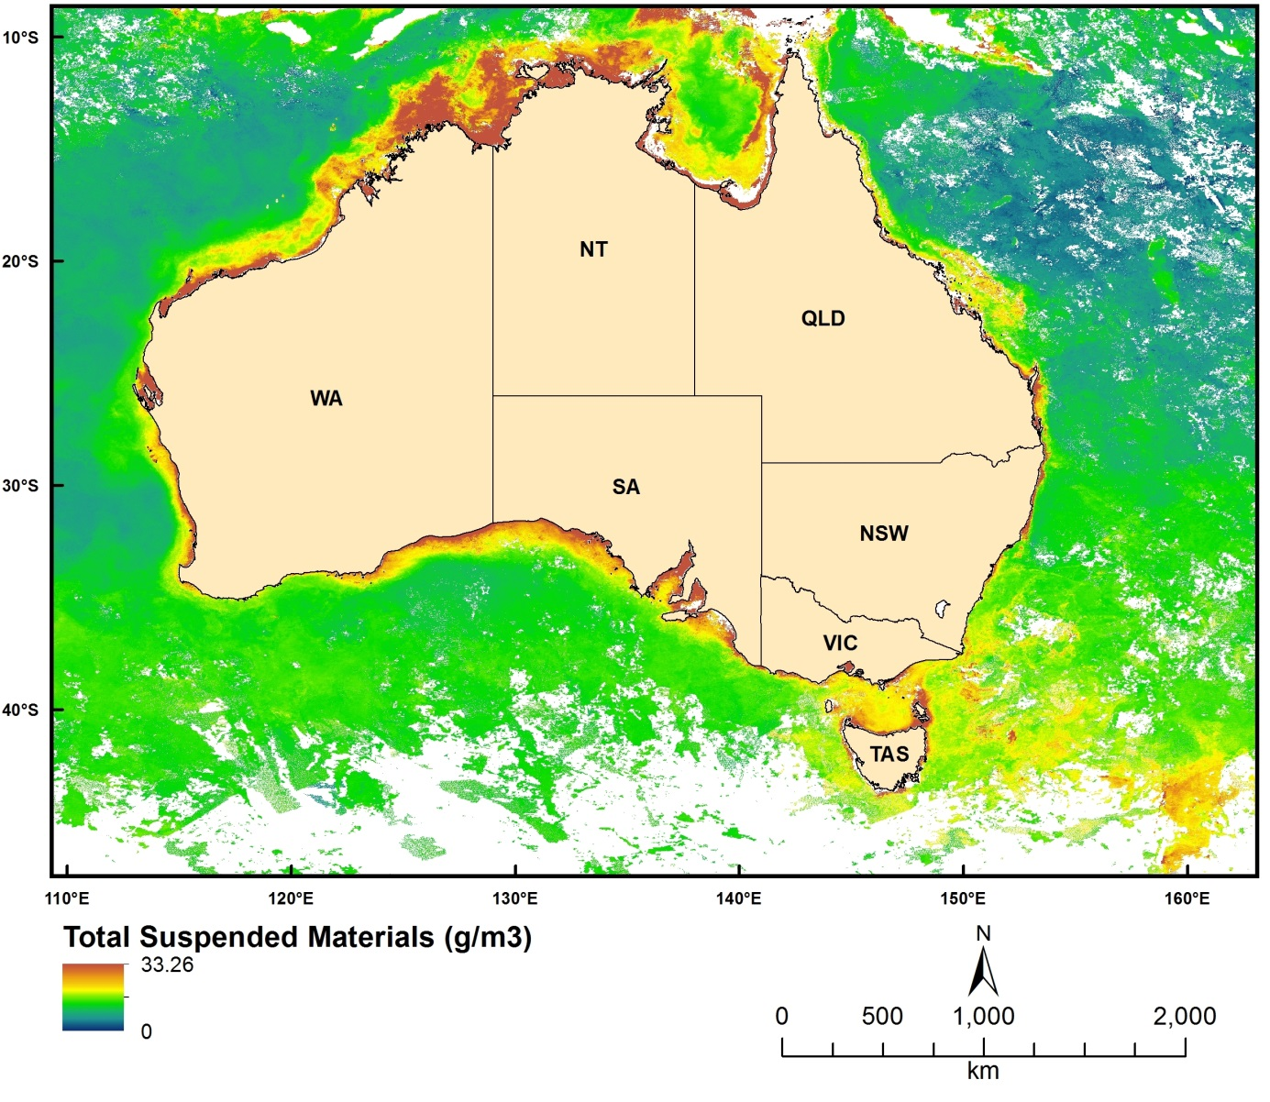
Figure 2.4.3 MODIS-derived Total Suspended Materials concentrations for May 2009

K490
Dataset TITLE
MODIS derived K490 datasets
Dataset ALTERNATE TITLE (i.e. Dataset Name)
Dataset AUTHOR(S)
Zhi Huang
Dataset CUSTODIAN
Geoscience Australia
Dataset JURISDICTION
Australia
Description ABSTRACT
The datasets measure the K490 parameter (Downwelling diffuse attenuation coefficient at 490 nm, a turbidity parameter) of Australian oceans. They are derived products from MODIS (aqua) images using NASA's SeaDAS image processing software. The extent of the datasets covers the entire Australian EEZ and surrounding waters (including the southern ocean). The spatial resolution of the datasets is 0.01 dd. The datasets contain 36 monthly k490 layers between 2009 and 2011. The unit of the datasets is 1/m.
Description Data Category
Oceans
Environment
Description Keyword
Oceans, Water Quality
Description GEOGRAPHIC EXTENT POLYGON(S)
N_LAT: -5
S_LAT: -60
E_LONG: 100
W_LONG: 170
COORDINATE SYSTEM DESCRIPTION
Projection: Geographic
Datum: WGS84
Units: Decimal Degree
Description Temporal EXTENT
Jan-09 to Dec-11
Description NOMINAL SCALE
Spatial Resolution: 0.01
Temporal Resolution: monthly
Data Currency BEGINNING DATE
Dec-12
Data Currency ENDING DATE
Dec-12
Dataset Status PROGRESS
Completed
Dataset Status MAINTENANCE AND UPDATE FREQUENCY
Not Planned
Access STORED FORMATS Digital/Non-Digital Description
DIGITAL ArcInfo grid
Access AVAILABLE FORMATS Digital/Non-Digital Description
DIGITAL ArcInfo grid
Access ACCESS CONSTRAINT
Please cite the data set using the following format: National Environmental Research Program (NERP) Marine Biodiversity Hub [year-of-data-download], [Title], [data-access-URL], accessed [date-of-access].
Data Quality LINEAGE
The K490 datasets are derived products of MODIS (Aqua) images. SeaDAS (version 6.1) was used to process the MODIS data from raw to L3 products. SeaDAS provides several algorithms for K490 products. The algorithm used here is the standard algorithm (OBPG) (Werdell, 2005). The sequences of processing included:
1. raw - L1A,
2. L1A - L1B,
3. L1B - L2,
4. L2 - L3 (spatial) binning, and
5. L3 binning to L3 time-binning.
The first four steps were applied to all individual (daily) raw images. After completing the above steps for one-month-worth images (around 300 images), in the fifth step, four weekly images were generated:
1. week1: from the 1st to the 7th of the month;
2. week2: from the 8th to the 14th of the month;
3. week3: from the 15th to the 21st of the month;
4. week4: from the 22nd to the last day of the month.
The four weekly images were exported as HDF files, then imported into ArcGIS and converted into ArcInfo grids. Next, the four grids were mosaiced into a monthly image using the averaging method.
The above processes were repeated to generate the final 36 monthly datasets between 2009 and 2011.
Werdell, P.J., 2005. OceanColor K490 algorithm evaluation. http://oceancolor.gsfc.nasa.gov/REPROCESSING/SeaWiFS/R5.1/k490_update.html (accessed 10/10/2011).
Data Quality POSITIONAL ACCURACY
The spatial resolution of the MODIS data used to derive Ocean Color products are about 1km. The same resolution was maintained for the final monthly data (e.g., 0.01 dd). Given the high accuracy of spatial referencing during the SeaDAS processing, the positional accuracy was estimated to be within 1 km.
Data Quality ATTRIBUTE ACCURACY
The attribute accuracy of the K490 datasets depends on the algorithm used. The OBPG algorithm is suitable for case-1 water (open ocean). In the case of Australian waters, the estimated K490 parameter are reliable for the vast majority of areas except along the coast (e.g., within 10-20 km from the coasts, case 2 waters). However, a quantitative test on the attribute accuracy could not be carried out due to the lack of ground truth samples.
Data Quality LOGICAL CONSISTENCY
The same algorithm and processing steps and parameters were used to process all images.
Data Quality COMPLETENESS
The datasets cover an extent between 100 to 170 longitude and -60 to -5 latitude. The holes (NoDATA) in the datasets were the results of the quality flags applied during the MODIS processing.
Contact Information CONTACT ORGANISATION
Geoscience Australia
Contact Information CONTACT POSITION
Marine Data Manager
Contact Information MAIL ADDRESS 1
GPO Box 378
Contact Information SUBURB/PLACE/LOCALITY
Canberra
Contact Information STATE/LOCALITY 2
ACT
Contact Information COUNTRY
Australia
Contact Information POSTCODE
2601
Contact Information TELEPHONE
+61 2 6249 9111
Contact Information FACSIMILE
+61 2 6249 9999
Contact Information ELECTRONIC MAIL ADDRESS
marine@ga.gov.au
Metadata Date METADATA DATE
20MAR2013
Additional Metadata METADATA AUTHOR
Zhi Huang
Additional Metadata ACKNOWLEDGEMENTS
Edward King of CSIRO (for providing access to the MODIS raw data and permission to use SeaDAS software)
NCI facilities
Data was sourced from the NERP Marine Biodiversity Hub – the Marine Biodiversity Hub is supported through funding from the Australian Government’s National Environmental Research Program (NERP), administered by the Department of Sustainability, Environment, Water, Population and Communities (DSEWPaC).
Additional Metadata REFERENCES
Werdell, P.J., 2005. OceanColor K490 algorithm evaluation. http://oceancolor.gsfc.nasa.gov/REPROCESSING/SeaWiFS/R5.1/k490_update.html (accessed 10/10/2011).
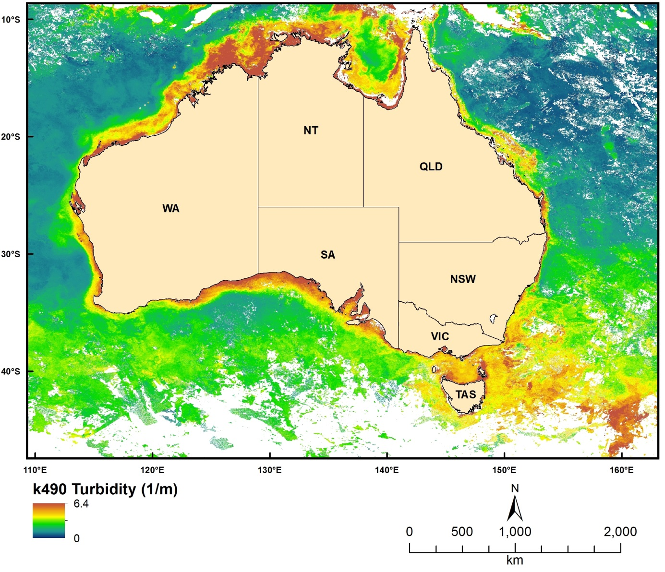
Figure 2.4.4 MODIS-derived K490 measures for May 2009

Euphotic Depth
Dataset TITLE
MODIS derived Zeu datasets
Dataset ALTERNATE TITLE (i.e. Dataset Name)
Dataset AUTHOR(S)
Zhi Huang
Dataset CUSTODIAN
Geoscience Australia
Dataset JURISDICTION
Australia
Description ABSTRACT
The datasets measure the Euphotic Depth (Zeu) of Australian oceans. They are derived products from MODIS (aqua) images using NASA's SeaDAS image processing software. The extent of the datasets covers the entire Australian EEZ and surrounding waters (including the southern ocean). The spatial resolution of the datasets is 0.01 dd. The datasets contain 36 monthly Zeu layers between 2009 and 2011. The unit of the datasets is metre.
Description Data Category
Oceans
Environment
Description Keyword
Oceans, Water Quality
Description GEOGRAPHIC EXTENT POLYGON(S)
N_LAT: -5
S_LAT: -60
E_LONG: 100
W_LONG: 170
COORDINATE SYSTEM DESCRIPTION
Projection: Geographic
Datum: WGS84
Units: Decimal Degree
Description Temporal EXTENT
Jan-09 to Dec-11
Description NOMINAL SCALE
Spatial Resolution: 0.01
Temporal Resolution: monthly
Data Currency BEGINNING DATE
Dec-12
Data Currency ENDING DATE
Dec-12
Dataset Status PROGRESS
Completed
Dataset Status MAINTENANCE AND UPDATE FREQUENCY
Not Planned
Access STORED FORMATS Digital/Non-Digital Description
DIGITAL ArcInfo grid
Access AVAILABLE FORMATS Digital/Non-Digital Description
DIGITAL ArcInfo grid
Access ACCESS CONSTRAINT
Please cite the data set using the following format: National Environmental Research Program (NERP) Marine Biodiversity Hub [year-of-data-download], [Title], [data-access-URL], accessed [date-of-access].
Data Quality LINEAGE
The Zeu datasets are derived products of MODIS (Aqua) images. SeaDAS (version 6.1) was used to process the MODIS data from raw to L3 products. The algorithm used here is based on the model of Morel (Morel and Maritorena, 2001). The sequences of processing included:
1. raw - L1A,
2. L1A - L1B,
3. L1B - L2,
4. L2 - L3 (spatial) binning, and
5. L3 binning to L3 time-binning.
The first four steps were applied to all individual (daily) raw images. After completing the above steps for one-month-worth images (around 300 images), in the fifth step, four weekly images were generated:
1. week1: from the 1st to the 7th of the month;
2. week2: from the 8th to the 14th of the month;
3. week3: from the 15th to the 21st of the month;
4. week4: from the 22nd to the last day of the month.
The four weekly images were exported as HDF files, then imported into ArcGIS and converted into ArcInfo grids. Next, the four grids were mosaiced into a monthly image using the averaging method.
The above processes were repeated to generate the final 36 monthly datasets between 2009 and 2011.

Morel, A. and Maritorena, S., 2001. Bio-optical properties of oceanic waters: A reappraisal, Journal of Geophysical Research, 106, 7163-7180.
Data Quality POSITIONAL ACCURACY
The spatial resolution of the MODIS data used to derive Ocean Color products are about 1km. The same resolution was maintained for the final monthly data (e.g., 0.01 dd). Given the high accuracy of spatial referencing during the SeaDAS processing, the positional accuracy was estimated to be within 1 km.
Data Quality ATTRIBUTE ACCURACY
The attribute accuracy of the Zeu datasets depends on the algorithm used. The Morel algorithm is suitable for case-1 water (open ocean). In the case of Australian waters, the estimated Euphotic depths are reliable for the vast majority of areas except along the coast (e.g., within 10-20 km from the coast, case 2 waters). However, a quantitative test on the attribute accuracy could not be carried out due to the lack of ground truth samples.
Data Quality LOGICAL CONSISTENCY
The same algorithm and processing steps and parameters were used to process all images.
Data Quality COMPLETENESS
The datasets cover an extent between 100 to 170 longitude and -60 to -5 latitude. The holes (NoDATA) in the datasets were the results of the quality flags applied during the MODIS processing.
Contact Information CONTACT ORGANISATION
Geoscience Australia
Contact Information CONTACT POSITION
Marine Data Manager
Contact Information MAIL ADDRESS 1
GPO Box 378
Contact Information SUBURB/PLACE/LOCALITY
Canberra
Contact Information STATE/LOCALITY 2
ACT
Contact Information COUNTRY
Australia
Contact Information POSTCODE
2601
Contact Information TELEPHONE
+61 2 6249 9111
Contact Information FACSIMILE
+61 2 6249 9999
Contact Information ELECTRONIC MAIL ADDRESS
marine@ga.gov.au
Metadata Date METADATA DATE
20MAR2013
Additional Metadata METADATA AUTHOR
Zhi Huang
Additional Metadata ACKNOWLEDGEMENTS
Edward King of CSIRO (for providing access to the MODIS raw data and permission to use SeaDAS software)
NCI facilities
Data was sourced from the NERP Marine Biodiversity Hub – the Marine Biodiversity Hub is supported through funding from the Australian Government’s National Environmental Research Program (NERP), administered by the Department of Sustainability, Environment, Water, Population and Communities (DSEWPaC).
Additional Metadata REFERENCES
Morel, A. and Maritorena, S., 2001. Bio-optical properties of oceanic waters: A reappraisal, Journal of Geophysical Research, 106, 7163-7180.

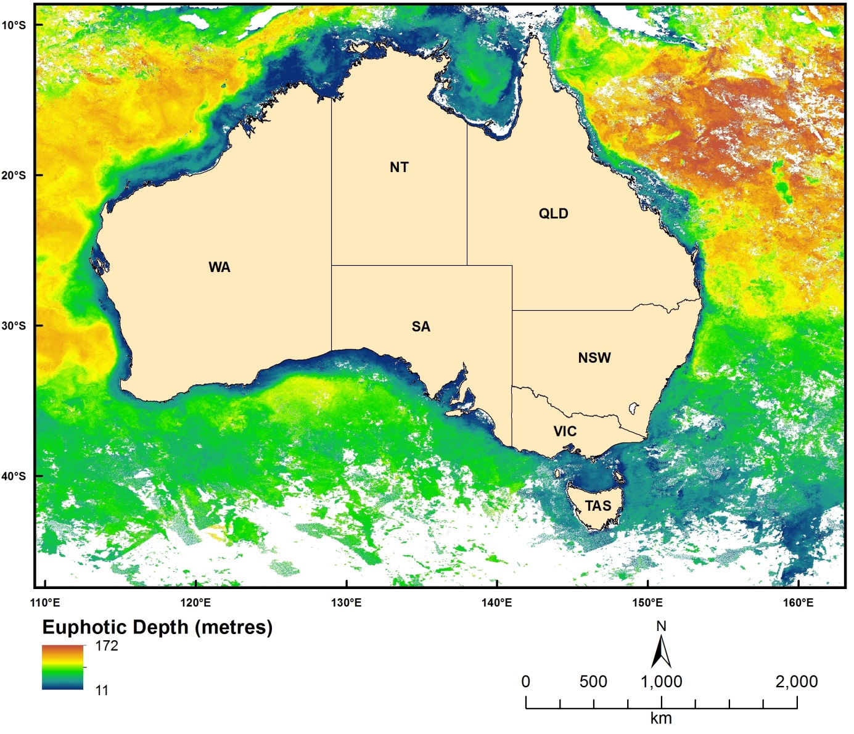
Figure 2.4.5 MODIS-derived Euphotic Depth for May 2009

Sea Surface Temperature
Dataset TITLE
MODIS derived SST datasets
Dataset ALTERNATE TITLE (i.e. Dataset Name)
Dataset AUTHOR(S)
Zhi Huang
Dataset CUSTODIAN
Geoscience Australia
Dataset JURISDICTION
Australia
Description ABSTRACT
The datasets measure the Sea Surface Temperature (SST) of Australian oceans. They are derived products from MODIS (aqua) images using NASA's SeaDAS image processing software. The extent of the datasets covers the entire Australian EEZ and surrounding waters (including the southern ocean). The spatial resolution of the datasets is 0.01 dd. The datasets contain 36 monthly SST layers between 2009 and 2011.
Description Data Category
Oceans
Environment
Description Keyword
Oceans, Water Quality
Description GEOGRAPHIC EXTENT POLYGON(S)
N_LAT: -5
S_LAT: -60
E_LONG: 100
W_LONG: 170
COORDINATE SYSTEM DESCRIPTION
Projection: Geographic
Datum: WGS84
Units: Decimal Degree
Description Temporal EXTENT
Jan-09 to Dec-11
Description NOMINAL SCALE
Spatial Resolution: 0.01
Temporal Resolution: monthly
Data Currency BEGINNING DATE
Dec-12
Data Currency ENDING DATE
Dec-12
Dataset Status PROGRESS
Completed
Dataset Status MAINTENANCE AND UPDATE FREQUENCY
Not Planned
Access STORED FORMATS Digital/Non-Digital Description
DIGITAL ArcInfo grid
Access AVAILABLE FORMATS Digital/Non-Digital Description
DIGITAL ArcInfo grid
Access ACCESS CONSTRAINT
Please cite the data set using the following format: National Environmental Research Program (NERP) Marine Biodiversity Hub [year-of-data-download], [Title], [data-access-URL], accessed [date-of-access].
Data Quality LINEAGE
The SST datasets are derived products of MODIS (Aqua) images. SeaDAS (version 6.1) was used to process the MODIS data from raw to L3 products. SeaDAS provides two SST products. The products presented here are sea surface temperature measured using the 11 and 12 micron channels. The algorithm used is the standard algorithm (OBPG) (Franz, 2006). The sequences of processing included:
1. raw - L1A,
2. L1A - L1B,
3. L1B - L2,
4. L2 - L3 (spatial) binning, and
5. L3 binning to L3 time-binning.
The first four steps were applied to all individual (daily) raw images. After completing the above steps for one-month-worth images (around 300 images), in the fifth step, four weekly images were generated:
1. week1: from the 1st to the 7th of the month;
2. week2: from the 8th to the 14th of the month;
3. week3: from the 15th to the 21st of the month;
4. week4: from the 22nd to the last day of the month.
The four weekly images were exported as HDF files, then imported into ArcGIS and converted into ArcInfo grids. Next, the four grids were mosaiced into a monthly image using the averaging method.
The above processes were repeated to generate the final 36 monthly datasets between 2009 and 2011.
Franz, B. 2006. Implementation of SST Processing within the OBPG, http://oceancolor.gsfc.nasa.gov/DOCS/modis_sst/ (accessed: 10/10/2011).
Data Quality POSITIONAL ACCURACY
The spatial resolution of the MODIS data used to derive Ocean Colour products are about 1km. The same resolution was maintained for the final monthly data (e.g., 0.01 dd). Given the high accuracy of spatial referencing during the SeaDAS processing, the positional accuracy was estimated to be within 1 km.
Data Quality ATTRIBUTE ACCURACY
The attribute accuracy of the SST datasets depends on the algorithm used. The OBPG algorithm is suitable for case-1 and case-2 waters. Note that because we chose the quality levels better than 2, this would generally ensure high quality SST data. However, a quantitative test on the attribute accuracy could not be carried out due to the lack of ground truth samples.
Data Quality LOGICAL CONSISTENCY
The same algorithm and processing steps and parameters were used to process all images.
Data Quality COMPLETENESS
The datasets cover an extent between 100 to 170 longitude and -60 to -5 latitude. The holes (NoDATA) in the datasets were the results of the quality flags applied during the MODIS processing.
Contact Information CONTACT ORGANISATION
Geoscience Australia
Contact Information CONTACT POSITION
Marine Data Manager
Contact Information MAIL ADDRESS 1
GPO Box 378
Contact Information SUBURB/PLACE/LOCALITY
Canberra
Contact Information STATE/LOCALITY 2
ACT
Contact Information COUNTRY
Australia
Contact Information POSTCODE
2601
Contact Information TELEPHONE
+61 2 6249 9111
Contact Information FACSIMILE
+61 2 6249 9999
Contact Information ELECTRONIC MAIL ADDRESS
marine@ga.gov.au
Metadata Date METADATA DATE
20MAR2013
Additional Metadata METADATA AUTHOR
Zhi Huang
Additional Metadata ACKNOWLEDGEMENTS
Edward King of CSIRO (for providing access to the MODIS raw data and permission to use SeaDAS software)
NCI facilities
Data was sourced from the NERP Marine Biodiversity Hub – the Marine Biodiversity Hub is supported through funding from the Australian Government’s National Environmental Research Program (NERP), administered by the Department of Sustainability, Environment, Water, Population and Communities (DSEWPaC).
Additional Metadata REFERENCES
Franz, B. 2006. Implementation of SST Processing within the OBPG, http://oceancolor.gsfc.nasa.gov/DOCS/modis_sst/ (accessed: 10/10/2011).

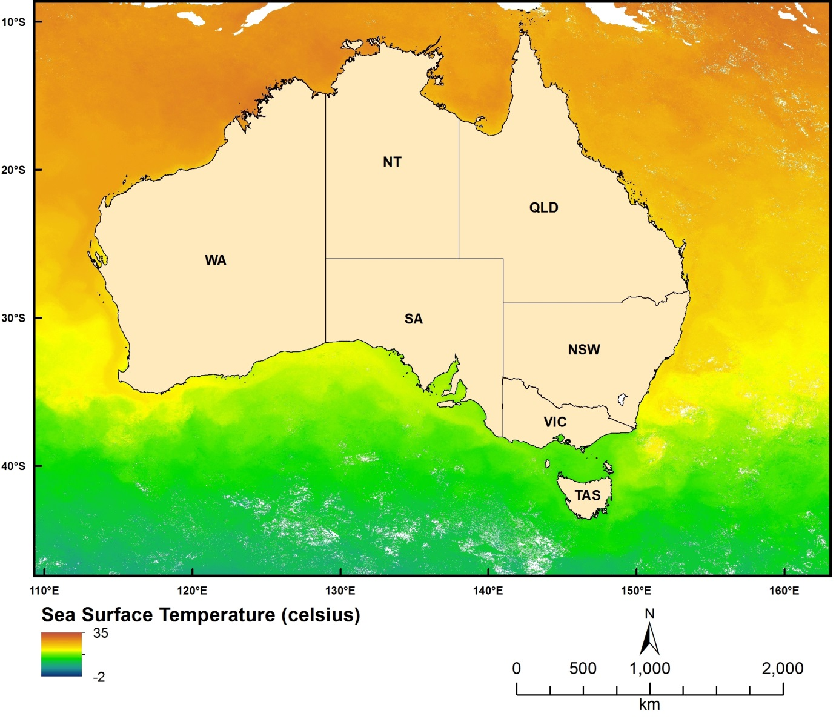
Figure 2.4.6 MODIS-derived Sea Surface Temperature for May 2009

National Submarine Canyons of Australia
Dataset TITLE
National Submarine Canyons of Australia
Dataset ALTERNATE TITLE (i.e. Dataset Name)
Canyons_final.shp
Dataset AUTHOR(S)
Zhi Huang
Dataset CUSTODIAN
Geoscience Australia
Dataset JURISDICTION
Australia
Description ABSTRACT
On the Australian margin, submarine canyons have formed along all sides of the continent and are exposed to the potential influence of large-scale ocean currents, including the Leeuwin Current (western to southern margins) and the East Australian Current (eastern margin). Recognised in marine bioregional plans as potential biodiversity hotspots, many of these canyons sit within the new national network of Commonwealth Marine Reserves.
This GIS polygon layer contains 713 submarine canyons along the Australian continental margin. The locations and extents of these canyons were derived from a range of bathymetry datasets.
Description Data Category
Oceans
Environment
Description Keyword
Oceans, Marine Geophysics, Submarine Canyons, Bathymetry
Description GEOGRAPHIC EXTENT POLYGON(S)
N_LAT: -8.88
S_LAT: -46.86
E_LONG: 110.63
W_LONG: 159.23
COORDINATE SYSTEM DESCRIPTION
Projection: Geographic
Datum: WGS84
Units: Decimal Degree
Description Temporal EXTENT
Description NOMINAL SCALE
Spatial Resolution:
Temporal Resolution:
Data Currency BEGINNING DATE
12-Feb-2013
Data Currency ENDING DATE
12-Feb-2013
Dataset Status PROGRESS
Completed
Dataset Status MAINTENANCE AND UPDATE FREQUENCY
Not Planned
Access STORED FORMATS Digital/Non-Digital Description
DIGITAL Shapefile
Access AVAILABLE FORMATS Digital/Non-Digital Description
DIGITAL Shapefile
Access ACCESS CONSTRAINT
Please cite the data set using the following format: National Environmental Research Program (NERP) Marine Biodiversity Hub [year-of-data-download], [Title], [data-access-URL], accessed [date-of-access].
Data Quality LINEAGE
Three bathymetry datasets were used:
- Geoscience Australia's 250m national bathymetry grid,
- Geoscience Australia's 50m multibeam bathymetry grids, and
- James Cook University's 100m Great Barrier Reef and Coral Sea bathymetry grid.
The hill-shaded layers of these bathymetry grids were generated to display 3-D effects. The extent of individual canyons was manually digitised as a GIS polygon using these hill-shaded layers to aid mapping. The heads and foots of individual canyons were also identified in the process. After mapping the initial number of submarine canyon candidates a filtering process was applied by defining a canyon as a feature with the following bathymetric characteristics: (i) water depth at the canyon head less than 4000 m; (ii) depth range between the canyon head and foot greater than 600 m, and; (iii) incision of the canyon head greater than 100 m. On this basis, a total of 713 canyons were mapped for the Australian mainland margin.
Data Quality POSITIONAL ACCURACY
The canyon polygons were digitised from the bathymetry datasets. There are two major sources of positional errors. The first one is associated with the accuracy and spatial resolution of the bathymetry datasets. Most canyons were located from the 50m multibeam bathymetry grids and thus have highest positional accuracy. The second source is associated with the manual digitising process which has caused a small degree of positional error along the canyon boundary. An approximate estimation of the averaged positional error is within 200 metres.
Data Quality ATTRIBUTE ACCURACY
no attribute
Data Quality LOGICAL CONSISTENCY
The same person was involved in the whole identifying and digitising process using the same procedures. There was slight but minimum inconsistency in different stages of processes.
Data Quality COMPLETENESS
This dataset is completed.
Contact Information CONTACT ORGANISATION
Geoscience Australia
Contact Information CONTACT POSITION
Marine Data Manager
Contact Information MAIL ADDRESS 1
GPO Box 378
Contact Information SUBURB/PLACE/LOCALITY
Canberra
Contact Information STATE/LOCALITY 2
ACT
Contact Information COUNTRY
Australia
Contact Information POSTCODE
2601
Contact Information TELEPHONE
+61 2 6249 9111
Contact Information FACSIMILE
+61 2 6249 9999
Contact Information ELECTRONIC MAIL ADDRESS
marine@ga.gov.au
Metadata Date METADATA DATE
20MAR2013
Additional Metadata METADATA AUTHOR
Zhi Huang
Additional Metadata ACKNOWLEDGEMENTS
Data was sourced from the NERP Marine Biodiversity Hub – the Marine Biodiversity Hub is supported through funding from the Australian Government’s National Environmental Research Program (NERP), administered by the Department of Sustainability, Environment, Water, Population and Communities (DSEWPaC).
Additional Metadata REFERENCES

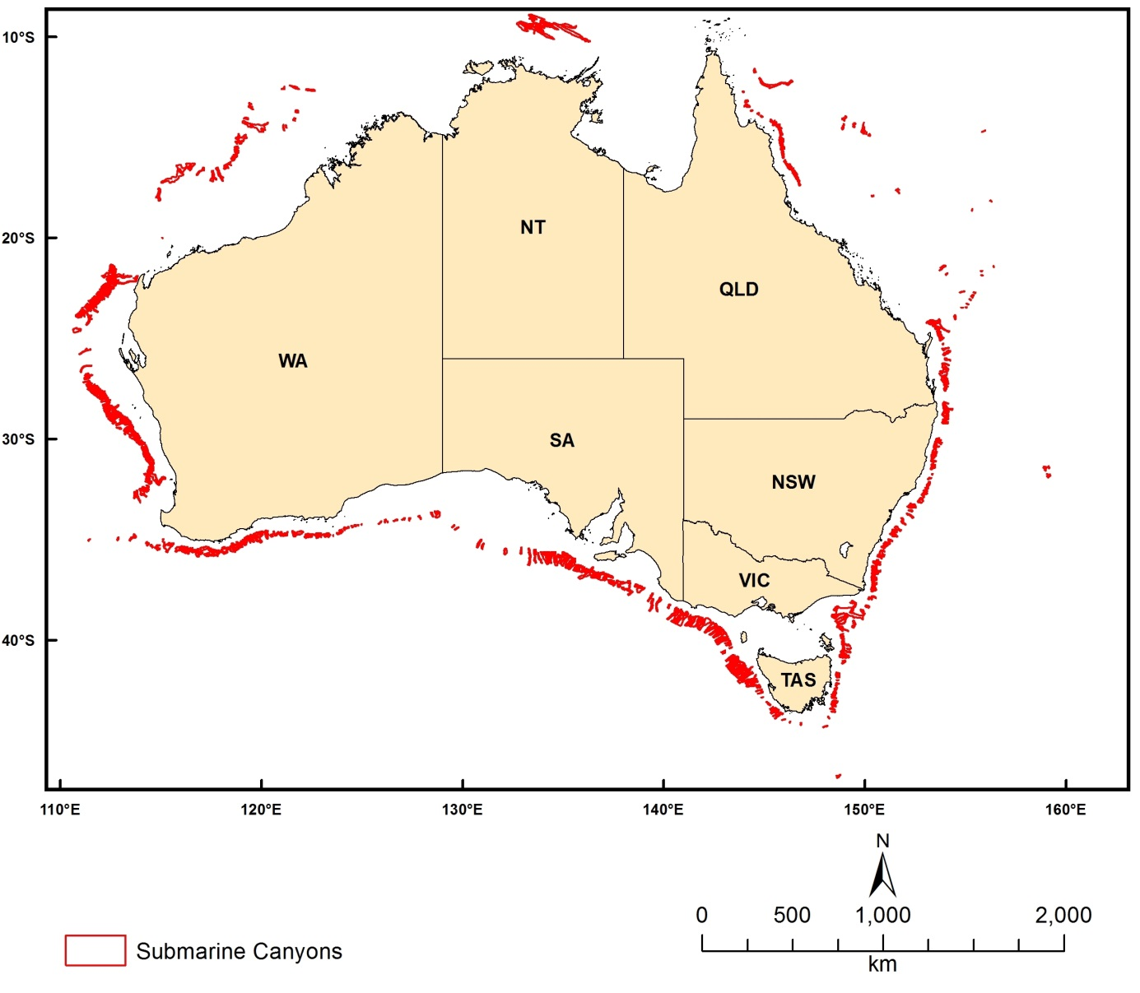
Figure 2.5 Submarine Canyons

Modelled Oceanographic Layers

Sea surface height
Dataset TITLE
HYbrid Coordinate Ocean Model (HYCOM) sea surface height
Dataset ALTERNATE TITLE (i.e. Dataset Name)
Dataset AUTHOR(S)
HYCOM Consortium
Dataset CUSTODIAN
HYCOM Consortium
Dataset JURISDICTION
Australia
Description ABSTRACT
Modeled sea surface height produced by the HYbrid isopycnal COordinate Model (HYCOM). See www.hycom.org.
The HYCOM consortium is a multi-institutional effort sponsored by the National Ocean Partnership Program (NOPP), as part of the U. S. Global Ocean Data Assimilation Experiment (GODAE), to develop and evaluate a data-assimilative hybrid isopycnal-sigma-pressure (generalized) coordinate ocean model (called HYbrid Coordinate Ocean Model or HYCOM). The GODAE objectives of three-dimensional depiction of the ocean state at fine resolution in real time, provision of boundary conditions for coastal and regional models, and provision of oceanic boundary conditions for a global coupled ocean-atmosphere prediction model, are being addressed by a partnership of institutions that represent a broad spectrum of the oceanographic community.
The partnership members are the Florida State University Center for Ocean-Atmospheric Prediction Studies (FSU/COAPS), the University of Miami Rosenstiel School of Marine and Atmospheric Science (UM/RSMAS), the Naval Research Laboratory/Stennis Space Center (NRL/STENNIS), the Naval Oceanographic Office (NAVOCEANO), the Fleet Numerical Meteorology and Oceanography Center (FNMOC), the Naval Research Laboratory/Monterey (NRL/MONTEREY), the National Oceanographic and Atmospheric Administration/National Centers for Atmospheric Prediction/Marine Modeling and Analysis Branch (NOAA/NCEP/MMAB), the NOAA National Ocean Service (NOAA/NOS), the NOAA Atlantic Oceanographic and Meteorological Laboratory (NOAA/AOML), the NOAA Pacific Marine Environmental Laboratory (NOAA/PMEL), Planning Systems Inc., Los Alamos National Laboratory (LANL), Service Hydrographique et Océanographique de la Marine (SHOM), Laboratoire des Ecoulements Géophysiques et Industriels (LEGI), The Open Source Project for a Network Data Access Protocol (OPeNDAP), the University of North Carolina (UNC), Rutgers University, the University of South Florida (USF), Fugro-GEOS/Ocean Numerics, Horizon Marine Inc., Roffer's Ocean Fishing Forecasting Service Inc. (ROFFS), Orbimage, Shell Oil Company, ExxonMobil Corp., the NOAA/National Weather Service/Tropical Prediction Center (NOAA/NWS/TPC), the NOAA/National Weather Service/Ocean Prediction Center (NOAA/NWS/OPC), the University of Michigan, and the University of the Virgin Islands (UVI).
The academic, governmental, and commercial entities involved in the partnership have long histories of supporting and carrying out a wide range of oceanographic and ocean prediction-related research. All institutions are committed to developing and demonstrating the performance and application of eddy-resolving, real-time global, Atlantic, and Pacific Ocean prediction systems using the HYbrid Coordinate Ocean Model (HYCOM), a data-assimilative hybrid isopycnal-sigma-pressure (generalized) coordinate ocean model.
The prediction systems will be transitioned for operational use by the U.S. Navy at the Naval Oceanographic Office (NAVOCEANO), Stennis Space Center, MS, and at the Fleet Numerical Meteorology and Oceanography Centre (FNMOC), Monterey, CA, and by NOAA at the National Centers for Environmental Prediction (NCEP), Washington, D.C. The systems will run efficiently on a variety of massively parallel computers and will include sophisticated data assimilation techniques for assimilation of satellite altimeter sea surface height and sea surface temperature as well as in situ temperature, salinity, and float displacement. The partners intend to make results available to the GODAE modeling community and to general users on a 24/7 basis via a comprehensive data management strategy.
This collaborative partnership provides the means to leverage and accelerate the efforts of existing and planned projects, as well as new opportunities for collaboration and cooperation among the partners ranging from research to the operational level. The anticipated results of this effort include integrated analyses/reanalyses for research programs, a foundation for model enhancement based on testing of hypotheses, synthesis of remotely sensed and in situ data, and inputs to coastal, regional, atmospheric, and ice prediction systems. Improved open-ocean nowcasts and forecasts will be applied to search and rescue operations, shipping routes, tracking of icebergs and major pollutants, commercial fisheries, etc.
Description Data Category
Oceans
Environment
Description Keyword
Oceans, Ocean Circulation, Ocean Currents, Sea Surface Height
Description GEOGRAPHIC EXTENT POLYGON(S)
N_LAT: -5
S_LAT: -50
E_LONG: 100
W_LONG: 170
COORDINATE SYSTEM DESCRIPTION
Projection: Geographic
Datum: WGS84
Units: Decimal Degree
Description Temporal EXTENT
Description NOMINAL SCALE
Spatial Resolution:
Temporal Resolution:
Data Currency BEGINNING DATE
2000
Data Currency ENDING DATE
27-Feb-13
Dataset Status PROGRESS
onGoing
Dataset Status MAINTENANCE AND UPDATE FREQUENCY
Updated each day
Access STORED FORMATS Digital/Non-Digital Description
DIGITAL NetCDF
Access AVAILABLE FORMATS Digital/Non-Digital Description
Access ACCESS CONSTRAINT
Public Access
Data Quality LINEAGE
Data is available from the HYCOM data server (http://hycom.org/dataserver). Data was subset for the Australian region using wget in a bash script. Example:
wget "http://tds.hycom.org/thredds/ncss/grid/GLBa0.08/expt_90.6/2009?var=u&spatial=bb&north=-5&south=-50&east=170&west=100&time_start=2009-01-01T00:00:00Z&time_end=2009-01-02T00:00:00Z&addLatLon" -O outputfile.nc -b
For details on the HYCOM model itself, refer to the documentation at www.hycom.org.
Data Quality POSITIONAL ACCURACY
Data Quality ATTRIBUTE ACCURACY
Data Quality LOGICAL CONSISTENCY
Data Quality COMPLETENESS
Contact Information CONTACT ORGANISATION
HYCOM Consortium
Contact Information CONTACT POSITION
Contact Information MAIL ADDRESS 1
Contact Information SUBURB/PLACE/LOCALITY
Contact Information STATE/LOCALITY 2
Contact Information COUNTRY
Contact Information POSTCODE
Contact Information TELEPHONE
Contact Information FACSIMILE
Contact Information ELECTRONIC MAIL ADDRESS
wallcraft@nrlssc.navy.mil
Metadata Date METADATA DATE
20MAR2013
Additional Metadata METADATA AUTHOR
Johnathan Kool
Additional Metadata ACKNOWLEDGEMENTS
Alan Wallcraft (US Naval Research Laboratory)
George Halliwell (NOAA Atlantic Oceanographic and Meteorological Laboratory)
Rainer Bleck (Columbia University; NASA Goddard Institute for Space Studies)
Eric Chassignet (Florida State University)
Joe Metzger (US Naval Research Laboratory)
Michael McDonald (Florida State University)
Additional Metadata REFERENCES

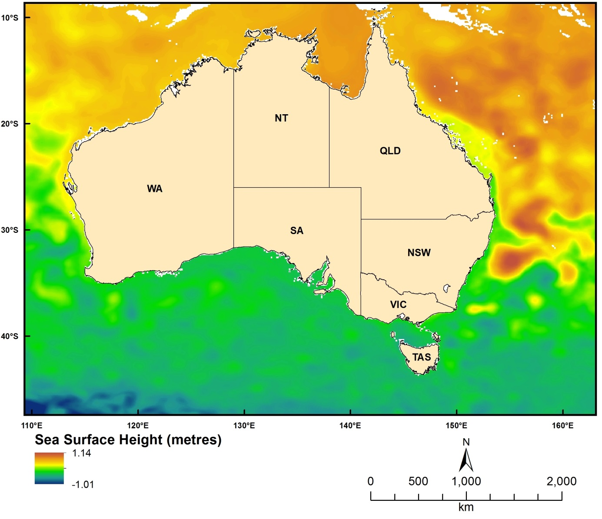
Figure 2.6.1 Modelled (HYCOM) Sea Surface Height

Mixed layer depth – definition 1
Dataset TITLE
HYbrid Coordinate Ocean Model (HYCOM) mixed layer depth (definition 1 - 0.20°C change from the surface)
Dataset ALTERNATE TITLE (i.e. Dataset Name)
Dataset AUTHOR(S)
HYCOM Consortium
Dataset CUSTODIAN
HYCOM Consortium
Dataset JURISDICTION
Australia
Description ABSTRACT
Modeled oceanographic data produced by the HYbrid isopycnal COordinate Model (HYCOM). See www.hycom.org.
The HYCOM consortium is a multi-institutional effort sponsored by the National Ocean Partnership Program (NOPP), as part of the U. S. Global Ocean Data Assimilation Experiment (GODAE), to develop and evaluate a data-assimilative hybrid isopycnal-sigma-pressure (generalized) coordinate ocean model (called HYbrid Coordinate Ocean Model or HYCOM). The GODAE objectives of three-dimensional depiction of the ocean state at fine resolution in real time, provision of boundary conditions for coastal and regional models, and provision of oceanic boundary conditions for a global coupled ocean-atmosphere prediction model, are being addressed by a partnership of institutions that represent a broad spectrum of the oceanographic community.
The partnership members are the Florida State University Center for Ocean-Atmospheric Prediction Studies (FSU/COAPS), the University of Miami Rosenstiel School of Marine and Atmospheric Science (UM/RSMAS), the Naval Research Laboratory/Stennis Space Center (NRL/STENNIS), the Naval Oceanographic Office (NAVOCEANO), the Fleet Numerical Meteorology and Oceanography Center (FNMOC), the Naval Research Laboratory/Monterey (NRL/MONTEREY), the National Oceanographic and Atmospheric Administration/National Centers for Atmospheric Prediction/Marine Modeling and Analysis Branch (NOAA/NCEP/MMAB), the NOAA National Ocean Service (NOAA/NOS), the NOAA Atlantic Oceanographic and Meteorological Laboratory (NOAA/AOML), the NOAA Pacific Marine Environmental Laboratory (NOAA/PMEL), Planning Systems Inc., Los Alamos National Laboratory (LANL), Service Hydrographique et Océanographique de la Marine (SHOM), Laboratoire des Ecoulements Géophysiques et Industriels (LEGI), The Open Source Project for a Network Data Access Protocol (OPeNDAP), the University of North Carolina (UNC), Rutgers University, the University of South Florida (USF), Fugro-GEOS/Ocean Numerics, Horizon Marine Inc., Roffer's Ocean Fishing Forecasting Service Inc. (ROFFS), Orbimage, Shell Oil Company, ExxonMobil Corp., the NOAA/National Weather Service/Tropical Prediction Center (NOAA/NWS/TPC), the NOAA/National Weather Service/Ocean Prediction Center (NOAA/NWS/OPC), the University of Michigan, and the University of the Virgin Islands (UVI).
The academic, governmental, and commercial entities involved in the partnership have long histories of supporting and carrying out a wide range of oceanographic and ocean prediction-related research. All institutions are committed to developing and demonstrating the performance and application of eddy-resolving, real-time global, Atlantic, and Pacific Ocean prediction systems using the HYbrid Coordinate Ocean Model (HYCOM), a data-assimilative hybrid isopycnal-sigma-pressure (generalized) coordinate ocean model.
The prediction systems will be transitioned for operational use by the U.S. Navy at the Naval Oceanographic Office (NAVOCEANO), Stennis Space Center, MS, and at the Fleet Numerical Meteorology and Oceanography Centre (FNMOC), Monterey, CA, and by NOAA at the National Centers for Environmental Prediction (NCEP), Washington, D.C. The systems will run efficiently on a variety of massively parallel computers and will include sophisticated data assimilation techniques for assimilation of satellite altimeter sea surface height and sea surface temperature as well as in situ temperature, salinity, and float displacement. The partners intend to make results available to the GODAE modeling community and to general users on a 24/7 basis via a comprehensive data management strategy.
This collaborative partnership provides the means to leverage and accelerate the efforts of existing and planned projects, as well as new opportunities for collaboration and cooperation among the partners ranging from research to the operational level. The anticipated results of this effort include integrated analyses/reanalyses for research programs, a foundation for model enhancement based on testing of hypotheses, synthesis of remotely sensed and in situ data, and inputs to coastal, regional, atmospheric, and ice prediction systems. Improved open-ocean nowcasts and forecasts will be applied to search and rescue operations, shipping routes, tracking of icebergs and major pollutants, commercial fisheries, etc.
Description Data Category
Oceans
Environment
Description Keyword
Oceans, Ocean Circulation, Ocean Currents, Ocean Mixed Layer, Ocean Temperature
Description GEOGRAPHIC EXTENT POLYGON(S)
N_LAT: -5
S_LAT: -50
E_LONG: 100
W_LONG: 170
COORDINATE SYSTEM DESCRIPTION
Projection: Geographic
Datum: WGS84
Units: Decimal Degree
Description Temporal EXTENT
Description NOMINAL SCALE
Spatial Resolution:
Temporal Resolution:
Data Currency BEGINNING DATE
2000
Data Currency ENDING DATE
27-Feb-13
Dataset Status PROGRESS
onGoing
Dataset Status MAINTENANCE AND UPDATE FREQUENCY
Updated each day
Access STORED FORMATS Digital/Non-Digital Description
DIGITAL NetCDF
Access AVAILABLE FORMATS Digital/Non-Digital Description
Access ACCESS CONSTRAINT
Public Access
Data Quality LINEAGE
Data is available from the HYCOM data server (http://hycom.org/dataserver). Data was subset for the Australian region using wget in a bash script. Example:
wget "http://tds.hycom.org/thredds/ncss/grid/GLBa0.08/expt_90.6/2009?var=u&spatial=bb&north=-5&south=-50&east=170&west=100&time_start=2009-01-01T00:00:00Z&time_end=2009-01-02T00:00:00Z&addLatLon" -O outputfile.nc -b
For details on the HYCOM model itself, refer to the documentation at www.hycom.org.
Data Quality POSITIONAL ACCURACY
Data Quality ATTRIBUTE ACCURACY
Data Quality LOGICAL CONSISTENCY
Data Quality COMPLETENESS
.
Contact Information CONTACT ORGANISATION
HYCOM Consortium
Contact Information CONTACT POSITION
Contact Information MAIL ADDRESS 1
Contact Information SUBURB/PLACE/LOCALITY
Contact Information STATE/LOCALITY 2
Contact Information COUNTRY
Contact Information POSTCODE
Contact Information TELEPHONE
Contact Information FACSIMILE
Contact Information ELECTRONIC MAIL ADDRESS
wallcraft@nrlssc.navy.mil
Metadata Date METADATA DATE
20MAR2013
Additional Metadata METADATA AUTHOR
Johnathan Kool
Additional Metadata ACKNOWLEDGEMENTS
Alan Wallcraft (US Naval Research Laboratory)
George Halliwell (NOAA Atlantic Oceanographic and Meteorological Laboratory)
Rainer Bleck (Columbia University; NASA Goddard Institute for Space Studies)
Eric Chassignet (Florida State University)
Joe Metzger (US Naval Research Laboratory)
Michael McDonald (Florida State University)
Additional Metadata REFERENCES

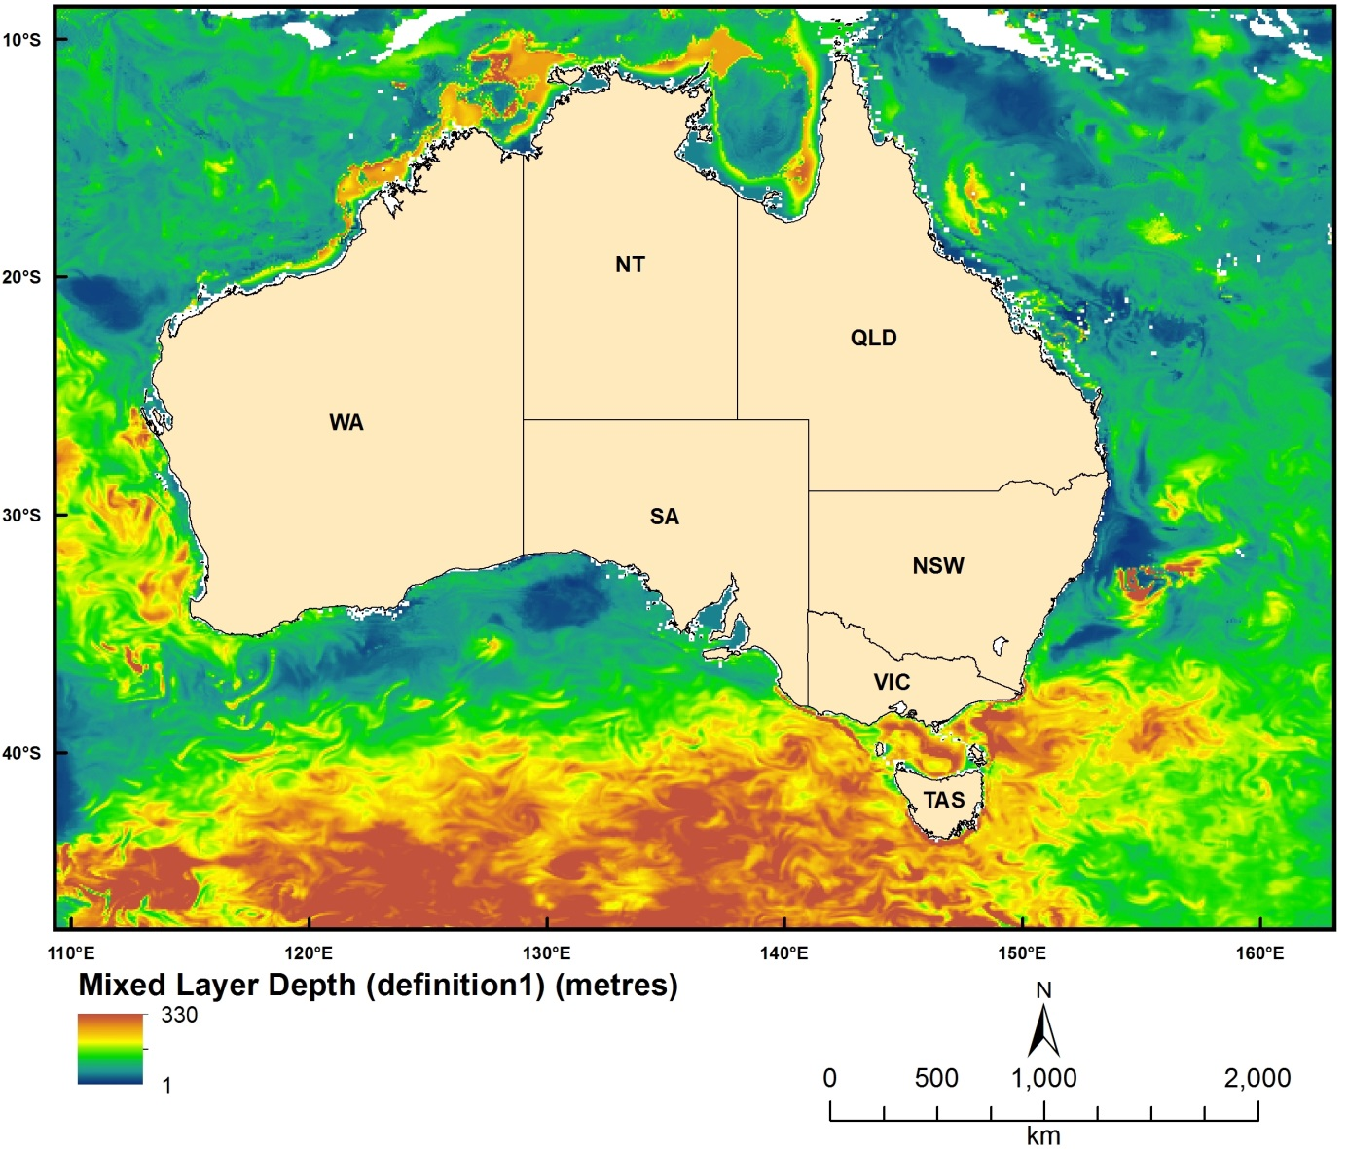
Figure 2.6.2 Modelled (HYCOM) Mixed Layer Depth (definition 1 - 0.20 oC change from the surface)

Mixed layer depth – definition 2
Dataset TITLE
HYbrid Coordinate Ocean Model (HYCOM) mixed layer depth (definition 2 - 0.03 kg/m3 change from the surface)
Dataset ALTERNATE TITLE (i.e. Dataset Name)
Dataset AUTHOR(S)
HYCOM Consortium
Dataset CUSTODIAN
HYCOM Consortium
Dataset JURISDICTION
Australia
Description ABSTRACT
Modeled oceanographic data produced by the HYbrid isopycnal COordinate Model (HYCOM). See www.hycom.org.
The HYCOM consortium is a multi-institutional effort sponsored by the National Ocean Partnership Program (NOPP), as part of the U. S. Global Ocean Data Assimilation Experiment (GODAE), to develop and evaluate a data-assimilative hybrid isopycnal-sigma-pressure (generalized) coordinate ocean model (called HYbrid Coordinate Ocean Model or HYCOM). The GODAE objectives of three-dimensional depiction of the ocean state at fine resolution in real time, provision of boundary conditions for coastal and regional models, and provision of oceanic boundary conditions for a global coupled ocean-atmosphere prediction model, are being addressed by a partnership of institutions that represent a broad spectrum of the oceanographic community.
The partnership members are the Florida State University Center for Ocean-Atmospheric Prediction Studies (FSU/COAPS), the University of Miami Rosenstiel School of Marine and Atmospheric Science (UM/RSMAS), the Naval Research Laboratory/Stennis Space Center (NRL/STENNIS), the Naval Oceanographic Office (NAVOCEANO), the Fleet Numerical Meteorology and Oceanography Center (FNMOC), the Naval Research Laboratory/Monterey (NRL/MONTEREY), the National Oceanographic and Atmospheric Administration/National Centers for Atmospheric Prediction/Marine Modeling and Analysis Branch (NOAA/NCEP/MMAB), the NOAA National Ocean Service (NOAA/NOS), the NOAA Atlantic Oceanographic and Meteorological Laboratory (NOAA/AOML), the NOAA Pacific Marine Environmental Laboratory (NOAA/PMEL), Planning Systems Inc., Los Alamos National Laboratory (LANL), Service Hydrographique et Océanographique de la Marine (SHOM), Laboratoire des Ecoulements Géophysiques et Industriels (LEGI), The Open Source Project for a Network Data Access Protocol (OPeNDAP), the University of North Carolina (UNC), Rutgers University, the University of South Florida (USF), Fugro-GEOS/Ocean Numerics, Horizon Marine Inc., Roffer's Ocean Fishing Forecasting Service Inc. (ROFFS), Orbimage, Shell Oil Company, ExxonMobil Corp., the NOAA/National Weather Service/Tropical Prediction Center (NOAA/NWS/TPC), the NOAA/National Weather Service/Ocean Prediction Center (NOAA/NWS/OPC), the University of Michigan, and the University of the Virgin Islands (UVI).
The academic, governmental, and commercial entities involved in the partnership have long histories of supporting and carrying out a wide range of oceanographic and ocean prediction-related research. All institutions are committed to developing and demonstrating the performance and application of eddy-resolving, real-time global, Atlantic, and Pacific Ocean prediction systems using the HYbrid Coordinate Ocean Model (HYCOM), a data-assimilative hybrid isopycnal-sigma-pressure (generalized) coordinate ocean model.
The prediction systems will be transitioned for operational use by the U.S. Navy at the Naval Oceanographic Office (NAVOCEANO), Stennis Space Center, MS, and at the Fleet Numerical Meteorology and Oceanography Centre (FNMOC), Monterey, CA, and by NOAA at the National Centers for Environmental Prediction (NCEP), Washington, D.C. The systems will run efficiently on a variety of massively parallel computers and will include sophisticated data assimilation techniques for assimilation of satellite altimeter sea surface height and sea surface temperature as well as in situ temperature, salinity, and float displacement. The partners intend to make results available to the GODAE modeling community and to general users on a 24/7 basis via a comprehensive data management strategy.
This collaborative partnership provides the means to leverage and accelerate the efforts of existing and planned projects, as well as new opportunities for collaboration and cooperation among the partners ranging from research to the operational level. The anticipated results of this effort include integrated analyses/reanalyses for research programs, a foundation for model enhancement based on testing of hypotheses, synthesis of remotely sensed and in situ data, and inputs to coastal, regional, atmospheric, and ice prediction systems. Improved open-ocean nowcasts and forecasts will be applied to search and rescue operations, shipping routes, tracking of icebergs and major pollutants, commercial fisheries, etc.
Description Data Category
Oceans
Environment
Description Keyword
Oceans, Ocean Circulation, Ocean Currents, Ocean Mixed Layer, Ocean Temperature
Description GEOGRAPHIC EXTENT POLYGON(S)
N_LAT: -5
S_LAT: -50
E_LONG: 100
W_LONG: 170
COORDINATE SYSTEM DESCRIPTION
Projection: Geographic
Datum: WGS84
Units: Decimal Degree
Description Temporal EXTENT
Description NOMINAL SCALE
Spatial Resolution:
Temporal Resolution:
Data Currency BEGINNING DATE
2000
Data Currency ENDING DATE
27-Feb-13
Dataset Status PROGRESS
onGoing
Dataset Status MAINTENANCE AND UPDATE FREQUENCY
Updated each day
Access STORED FORMATS Digital/Non-Digital Description
DIGITAL NetCDF
Access AVAILABLE FORMATS Digital/Non-Digital Description
Access ACCESS CONSTRAINT
Public Access
Data Quality LINEAGE
Data is available from the HYCOM data server (http://hycom.org/dataserver). Data was subset for the Australian region using wget in a bash script. Example:
wget "http://tds.hycom.org/thredds/ncss/grid/GLBa0.08/expt_90.6/2009?var=u&spatial=bb&north=-5&south=-50&east=170&west=100&time_start=2009-01-01T00:00:00Z&time_end=2009-01-02T00:00:00Z&addLatLon" -O outputfile.nc -b
For details on the HYCOM model itself, refer to the documentation at www.hycom.org.
Data Quality POSITIONAL ACCURACY
Data Quality ATTRIBUTE ACCURACY
Data Quality LOGICAL CONSISTENCY
Data Quality COMPLETENESS
Contact Information CONTACT ORGANISATION
HYCOM Consortium
Contact Information CONTACT POSITION
Contact Information MAIL ADDRESS 1
Contact Information SUBURB/PLACE/LOCALITY
Contact Information STATE/LOCALITY 2
Contact Information COUNTRY
Contact Information POSTCODE
Contact Information TELEPHONE
Contact Information FACSIMILE
Contact Information ELECTRONIC MAIL ADDRESS
wallcraft@nrlssc.navy.mil
Metadata Date METADATA DATE
20MAR2013
Additional Metadata METADATA AUTHOR
Johnathan Kool
Additional Metadata ACKNOWLEDGEMENTS
Alan Wallcraft (US Naval Research Laboratory)
George Halliwell (NOAA Atlantic Oceanographic and Meteorological Laboratory)
Rainer Bleck (Columbia University; NASA Goddard Institute for Space Studies)
Eric Chassignet (Florida State University)
Joe Metzger (US Naval Research Laboratory)
Michael McDonald (Florida State University)
Additional Metadata REFERENCES

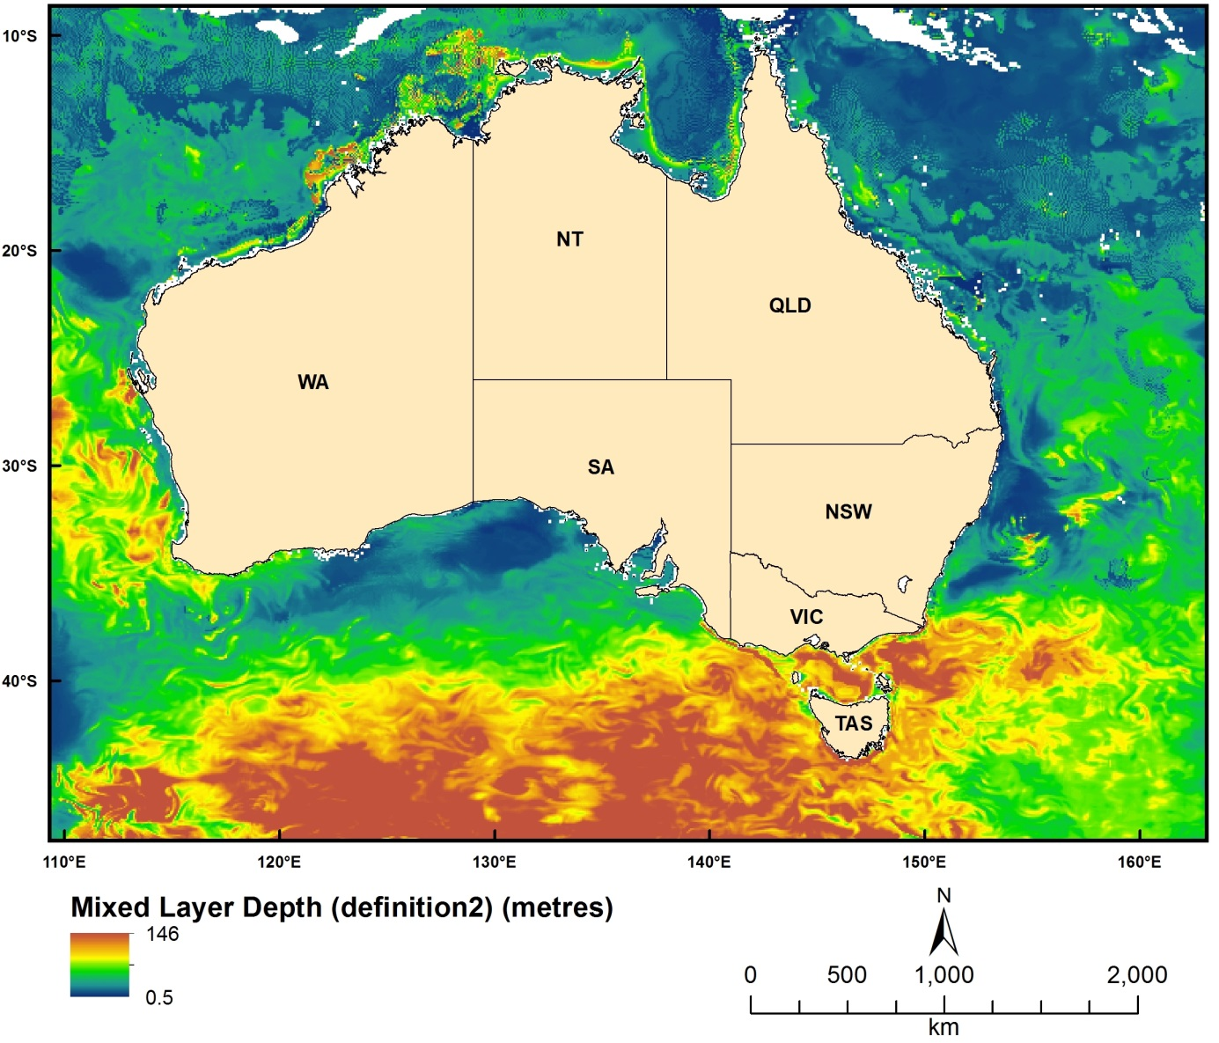
Figure 2.6.3 Modelled (HYCOM) Mixed Layer Depth (definition 2 - 0.03 kg/m3 change from the surface)

Air-sea flux
Dataset TITLE
HYbrid Coordinate Ocean Model (HYCOM) water flux into the ocean (kg/m²/s)
Dataset ALTERNATE TITLE (i.e. Dataset Name)
Dataset AUTHOR(S)
HYCOM Consortium
Dataset CUSTODIAN
HYCOM Consortium
Dataset JURISDICTION
Australia
Description ABSTRACT
Modeled oceanographic data produced by the HYbrid isopycnal COordinate Model (HYCOM). See www.hycom.org.
The HYCOM consortium is a multi-institutional effort sponsored by the National Ocean Partnership Program (NOPP), as part of the U. S. Global Ocean Data Assimilation Experiment (GODAE), to develop and evaluate a data-assimilative hybrid isopycnal-sigma-pressure (generalized) coordinate ocean model (called HYbrid Coordinate Ocean Model or HYCOM). The GODAE objectives of three-dimensional depiction of the ocean state at fine resolution in real time, provision of boundary conditions for coastal and regional models, and provision of oceanic boundary conditions for a global coupled ocean-atmosphere prediction model, are being addressed by a partnership of institutions that represent a broad spectrum of the oceanographic community.
The partnership members are the Florida State University Center for Ocean-Atmospheric Prediction Studies (FSU/COAPS), the University of Miami Rosenstiel School of Marine and Atmospheric Science (UM/RSMAS), the Naval Research Laboratory/Stennis Space Center (NRL/STENNIS), the Naval Oceanographic Office (NAVOCEANO), the Fleet Numerical Meteorology and Oceanography Center (FNMOC), the Naval Research Laboratory/Monterey (NRL/MONTEREY), the National Oceanographic and Atmospheric Administration/National Centers for Atmospheric Prediction/Marine Modeling and Analysis Branch (NOAA/NCEP/MMAB), the NOAA National Ocean Service (NOAA/NOS), the NOAA Atlantic Oceanographic and Meteorological Laboratory (NOAA/AOML), the NOAA Pacific Marine Environmental Laboratory (NOAA/PMEL), Planning Systems Inc., Los Alamos National Laboratory (LANL), Service Hydrographique et Océanographique de la Marine (SHOM), Laboratoire des Ecoulements Géophysiques et Industriels (LEGI), The Open Source Project for a Network Data Access Protocol (OPeNDAP), the University of North Carolina (UNC), Rutgers University, the University of South Florida (USF), Fugro-GEOS/Ocean Numerics, Horizon Marine Inc., Roffer's Ocean Fishing Forecasting Service Inc. (ROFFS), Orbimage, Shell Oil Company, ExxonMobil Corp., the NOAA/National Weather Service/Tropical Prediction Center (NOAA/NWS/TPC), the NOAA/National Weather Service/Ocean Prediction Center (NOAA/NWS/OPC), the University of Michigan, and the University of the Virgin Islands (UVI).
The academic, governmental, and commercial entities involved in the partnership have long histories of supporting and carrying out a wide range of oceanographic and ocean prediction-related research. All institutions are committed to developing and demonstrating the performance and application of eddy-resolving, real-time global, Atlantic, and Pacific Ocean prediction systems using the HYbrid Coordinate Ocean Model (HYCOM), a data-assimilative hybrid isopycnal-sigma-pressure (generalized) coordinate ocean model.
The prediction systems will be transitioned for operational use by the U.S. Navy at the Naval Oceanographic Office (NAVOCEANO), Stennis Space Center, MS, and at the Fleet Numerical Meteorology and Oceanography Centre (FNMOC), Monterey, CA, and by NOAA at the National Centers for Environmental Prediction (NCEP), Washington, D.C. The systems will run efficiently on a variety of massively parallel computers and will include sophisticated data assimilation techniques for assimilation of satellite altimeter sea surface height and sea surface temperature as well as in situ temperature, salinity, and float displacement. The partners intend to make results available to the GODAE modeling community and to general users on a 24/7 basis via a comprehensive data management strategy.
This collaborative partnership provides the means to leverage and accelerate the efforts of existing and planned projects, as well as new opportunities for collaboration and cooperation among the partners ranging from research to the operational level. The anticipated results of this effort include integrated analyses/reanalyses for research programs, a foundation for model enhancement based on testing of hypotheses, synthesis of remotely sensed and in situ data, and inputs to coastal, regional, atmospheric, and ice prediction systems. Improved open-ocean nowcasts and forecasts will be applied to search and rescue operations, shipping routes, tracking of icebergs and major pollutants, commercial fisheries, etc.
Description Data Category
Oceans
Environment
Description Keyword
Oceans, Ocean Circulation, Ocean Mixed Layer, Ocean Temperature, Sea Surface Height, Ocean Pressure, Water Pressure, Atmosphere, Atmosphere Water Vapor, Precipitable Water
Description GEOGRAPHIC EXTENT POLYGON(S)
N_LAT: -5
S_LAT: -50
E_LONG: 100
W_LONG: 170
COORDINATE SYSTEM DESCRIPTION
Projection: Geographic
Datum: WGS84
Units: Decimal Degree
Description Temporal EXTENT
Description NOMINAL SCALE
Spatial Resolution:
Temporal Resolution:
Data Currency BEGINNING DATE
2000
Data Currency ENDING DATE
27-Feb-13
Dataset Status PROGRESS
onGoing
Dataset Status MAINTENANCE AND UPDATE FREQUENCY
Updated each day
Access STORED FORMATS Digital/Non-Digital Description
DIGITAL NetCDF
Access AVAILABLE FORMATS Digital/Non-Digital Description
Access ACCESS CONSTRAINT
Public Access
Data Quality LINEAGE
Data is available from the HYCOM data server (http://hycom.org/dataserver). Data was subset for the Australian region using wget in a bash script. Example:
wget "http://tds.hycom.org/thredds/ncss/grid/GLBa0.08/expt_90.6/2009?var=u&spatial=bb&north=-5&south=-50&east=170&west=100&time_start=2009-01-01T00:00:00Z&time_end=2009-01-02T00:00:00Z&addLatLon" -O outputfile.nc -b
For details on the HYCOM model itself, refer to the documentation at www.hycom.org.
Data Quality POSITIONAL ACCURACY
Data Quality ATTRIBUTE ACCURACY
Data Quality LOGICAL CONSISTENCY
Data Quality COMPLETENESS
Contact Information CONTACT ORGANISATION
HYCOM Consortium
Contact Information CONTACT POSITION
Contact Information MAIL ADDRESS 1
Contact Information SUBURB/PLACE/LOCALITY
Contact Information STATE/LOCALITY 2
Contact Information COUNTRY
Contact Information POSTCODE
Contact Information TELEPHONE
Contact Information FACSIMILE
Contact Information ELECTRONIC MAIL ADDRESS
wallcraft@nrlssc.navy.mil
Metadata Date METADATA DATE
20MAR2013
Additional Metadata METADATA AUTHOR
Johnathan Kool
Additional Metadata ACKNOWLEDGEMENTS
Alan Wallcraft (US Naval Research Laboratory)
George Halliwell (NOAA Atlantic Oceanographic and Meteorological Laboratory)
Rainer Bleck (Columbia University; NASA Goddard Institute for Space Studies)
Eric Chassignet (Florida State University)
Joe Metzger (US Naval Research Laboratory)
Michael McDonald (Florida State University)
Additional Metadata REFERENCES

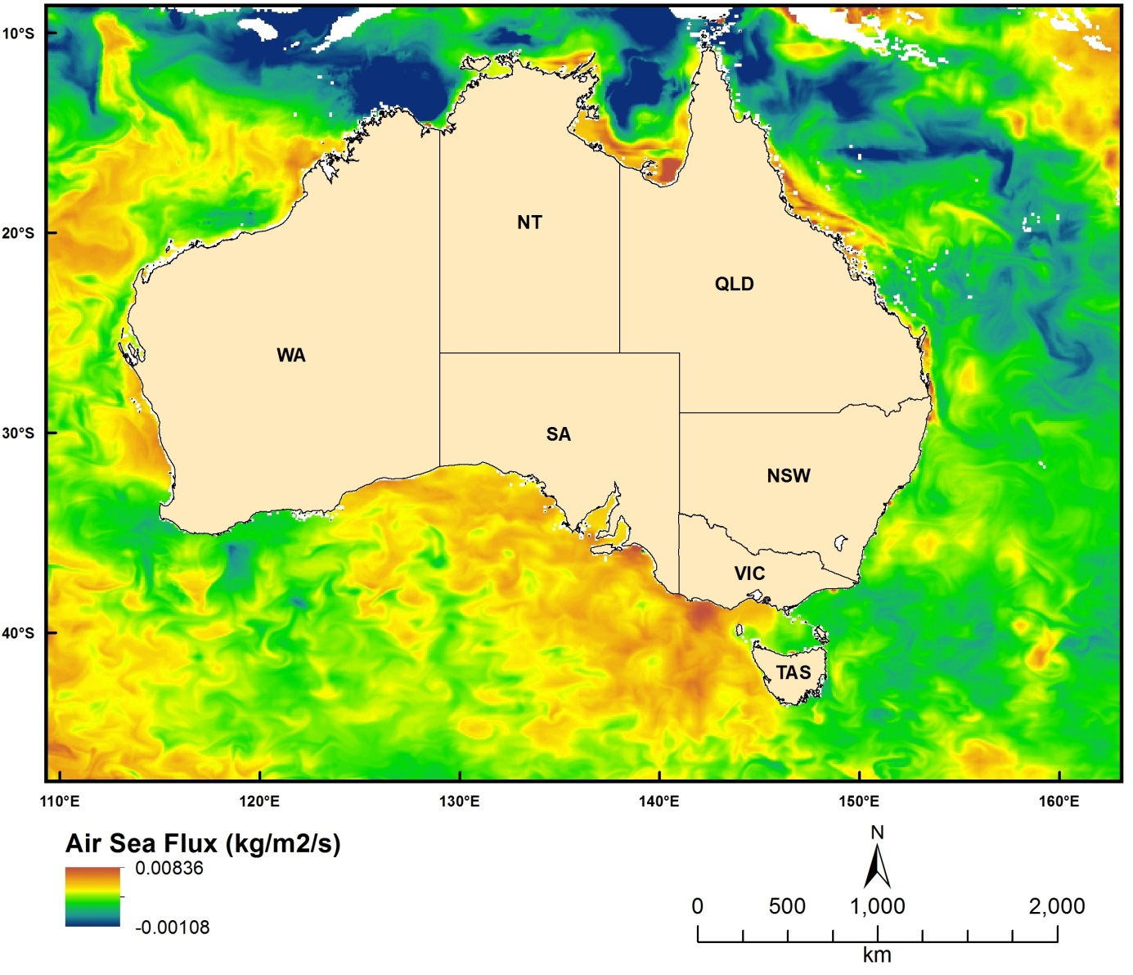
Figure 2.6.4 Modelled (HYCOM) Air Sea Flux

East-west current velocity
Dataset TITLE
HYbrid Coordinate Ocean Model (HYCOM) east-west current velocity (u - m/s)
Dataset ALTERNATE TITLE (i.e. Dataset Name)
Dataset AUTHOR(S)
HYCOM Consortium
Dataset CUSTODIAN
HYCOM Consortium
Dataset JURISDICTION
Australia
Description ABSTRACT
Modeled oceanographic data produced by the HYbrid isopycnal COordinate Model (HYCOM). See www.hycom.org.
The HYCOM consortium is a multi-institutional effort sponsored by the National Ocean Partnership Program (NOPP), as part of the U. S. Global Ocean Data Assimilation Experiment (GODAE), to develop and evaluate a data-assimilative hybrid isopycnal-sigma-pressure (generalized) coordinate ocean model (called HYbrid Coordinate Ocean Model or HYCOM). The GODAE objectives of three-dimensional depiction of the ocean state at fine resolution in real time, provision of boundary conditions for coastal and regional models, and provision of oceanic boundary conditions for a global coupled ocean-atmosphere prediction model, are being addressed by a partnership of institutions that represent a broad spectrum of the oceanographic community.
The partnership members are the Florida State University Center for Ocean-Atmospheric Prediction Studies (FSU/COAPS), the University of Miami Rosenstiel School of Marine and Atmospheric Science (UM/RSMAS), the Naval Research Laboratory/Stennis Space Center (NRL/STENNIS), the Naval Oceanographic Office (NAVOCEANO), the Fleet Numerical Meteorology and Oceanography Center (FNMOC), the Naval Research Laboratory/Monterey (NRL/MONTEREY), the National Oceanographic and Atmospheric Administration/National Centers for Atmospheric Prediction/Marine Modeling and Analysis Branch (NOAA/NCEP/MMAB), the NOAA National Ocean Service (NOAA/NOS), the NOAA Atlantic Oceanographic and Meteorological Laboratory (NOAA/AOML), the NOAA Pacific Marine Environmental Laboratory (NOAA/PMEL), Planning Systems Inc., Los Alamos National Laboratory (LANL), Service Hydrographique et Océanographique de la Marine (SHOM), Laboratoire des Ecoulements Géophysiques et Industriels (LEGI), The Open Source Project for a Network Data Access Protocol (OPeNDAP), the University of North Carolina (UNC), Rutgers University, the University of South Florida (USF), Fugro-GEOS/Ocean Numerics, Horizon Marine Inc., Roffer's Ocean Fishing Forecasting Service Inc. (ROFFS), Orbimage, Shell Oil Company, ExxonMobil Corp., the NOAA/National Weather Service/Tropical Prediction Center (NOAA/NWS/TPC), the NOAA/National Weather Service/Ocean Prediction Center (NOAA/NWS/OPC), the University of Michigan, and the University of the Virgin Islands (UVI).
The academic, governmental, and commercial entities involved in the partnership have long histories of supporting and carrying out a wide range of oceanographic and ocean prediction-related research. All institutions are committed to developing and demonstrating the performance and application of eddy-resolving, real-time global, Atlantic, and Pacific Ocean prediction systems using the HYbrid Coordinate Ocean Model (HYCOM), a data-assimilative hybrid isopycnal-sigma-pressure (generalized) coordinate ocean model.
The prediction systems will be transitioned for operational use by the U.S. Navy at the Naval Oceanographic Office (NAVOCEANO), Stennis Space Center, MS, and at the Fleet Numerical Meteorology and Oceanography Centre (FNMOC), Monterey, CA, and by NOAA at the National Centers for Environmental Prediction (NCEP), Washington, D.C. The systems will run efficiently on a variety of massively parallel computers and will include sophisticated data assimilation techniques for assimilation of satellite altimeter sea surface height and sea surface temperature as well as in situ temperature, salinity, and float displacement. The partners intend to make results available to the GODAE modeling community and to general users on a 24/7 basis via a comprehensive data management strategy.
This collaborative partnership provides the means to leverage and accelerate the efforts of existing and planned projects, as well as new opportunities for collaboration and cooperation among the partners ranging from research to the operational level. The anticipated results of this effort include integrated analyses/reanalyses for research programs, a foundation for model enhancement based on testing of hypotheses, synthesis of remotely sensed and in situ data, and inputs to coastal, regional, atmospheric, and ice prediction systems. Improved open-ocean nowcasts and forecasts will be applied to search and rescue operations, shipping routes, tracking of icebergs and major pollutants, commercial fisheries, etc.
Description Data Category
Oceans
Environment
Description Keyword
Oceans, Ocean Circulation, Ocean Currents, Eddies
Description GEOGRAPHIC EXTENT POLYGON(S)
N_LAT: -5
S_LAT: -50
E_LONG: 100
W_LONG: 170
COORDINATE SYSTEM DESCRIPTION
Projection: Geographic
Datum: WGS84
Units: Decimal Degree
Description Temporal EXTENT
Description NOMINAL SCALE
Spatial Resolution:
Temporal Resolution:
Data Currency BEGINNING DATE
2000
Data Currency ENDING DATE
27-Feb-13
Dataset Status PROGRESS
onGoing
Dataset Status MAINTENANCE AND UPDATE FREQUENCY
Updated each day
Access STORED FORMATS Digital/Non-Digital Description
DIGITAL NetCDF
Access AVAILABLE FORMATS Digital/Non-Digital Description
Access ACCESS CONSTRAINT
Public Access
Data Quality LINEAGE
Data is available from the HYCOM data server (http://hycom.org/dataserver). Data was subset for the Australian region using wget in a bash script. Example:
wget "http://tds.hycom.org/thredds/ncss/grid/GLBa0.08/expt_90.6/2009?var=u&spatial=bb&north=-5&south=-50&east=170&west=100&time_start=2009-01-01T00:00:00Z&time_end=2009-01-02T00:00:00Z&addLatLon" -O outputfile.nc -b
For details on the HYCOM model itself, refer to the documentation at www.hycom.org.
Data Quality POSITIONAL ACCURACY
Data Quality ATTRIBUTE ACCURACY
Data Quality LOGICAL CONSISTENCY
Data Quality COMPLETENESS
Contact Information CONTACT ORGANISATION
HYCOM Consortium
Contact Information CONTACT POSITION
Contact Information MAIL ADDRESS 1
Contact Information SUBURB/PLACE/LOCALITY
Contact Information STATE/LOCALITY 2
Contact Information COUNTRY
Contact Information POSTCODE
Contact Information TELEPHONE
Contact Information FACSIMILE
Contact Information ELECTRONIC MAIL ADDRESS
wallcraft@nrlssc.navy.mil
Metadata Date METADATA DATE
20MAR2013
Additional Metadata METADATA AUTHOR
Johnathan Kool
Additional Metadata ACKNOWLEDGEMENTS
Alan Wallcraft (US Naval Research Laboratory)
George Halliwell (NOAA Atlantic Oceanographic and Meteorological Laboratory)
Rainer Bleck (Columbia University; NASA Goddard Institute for Space Studies)
Eric Chassignet (Florida State University)
Joe Metzger (US Naval Research Laboratory)
Michael McDonald (Florida State University)
Additional Metadata REFERENCES

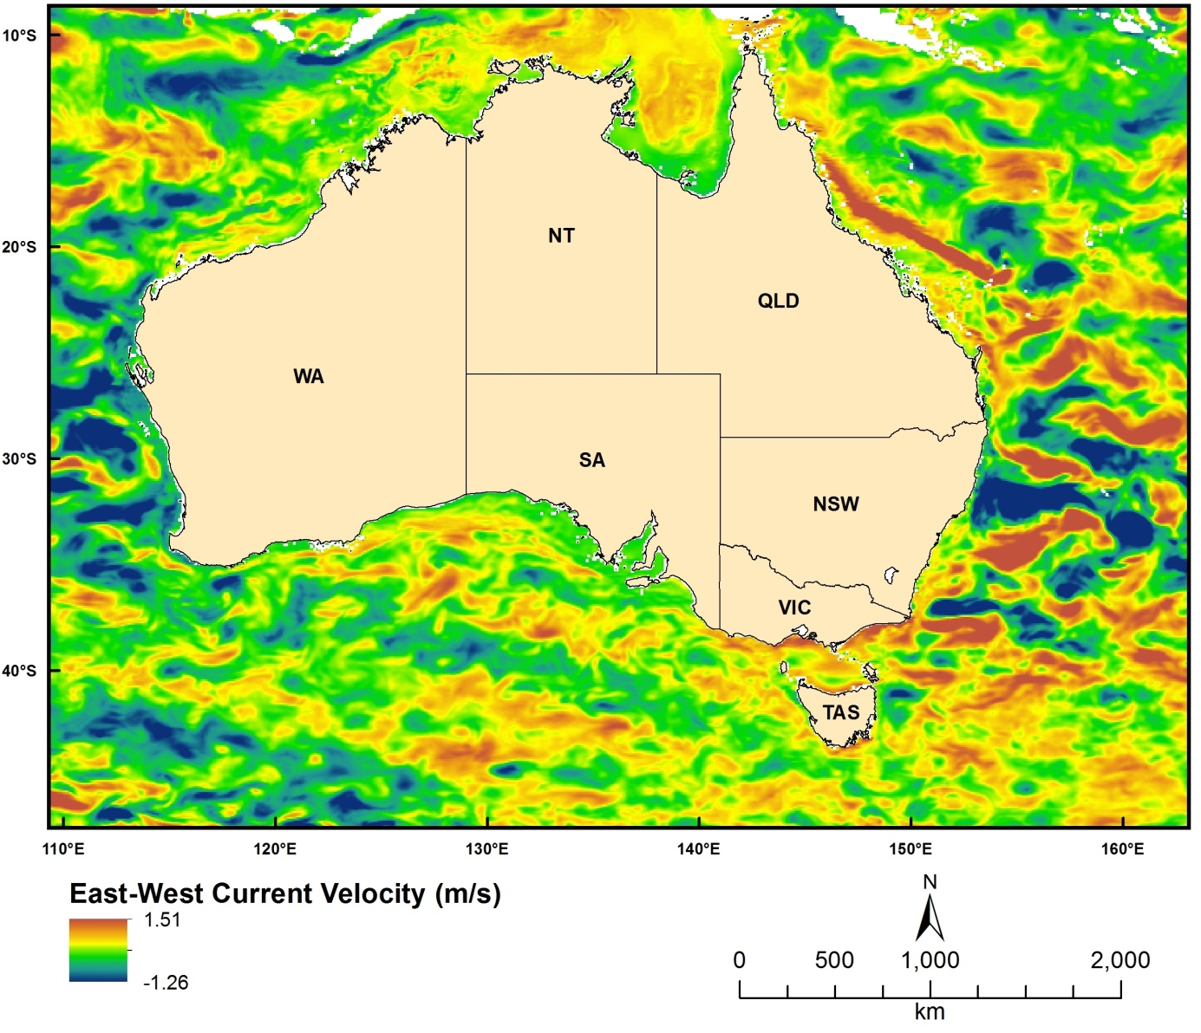
Figure 2.6.5 Modelled (HYCOM) East-West Current Velocity

North-south current velocity
Dataset TITLE
HYbrid Coordinate Ocean Model (HYCOM) north south current velocity (v - m/s)
Dataset ALTERNATE TITLE (i.e. Dataset Name)
Dataset AUTHOR(S)
HYCOM Consortium
Dataset CUSTODIAN
HYCOM Consortium
Dataset JURISDICTION
Australia
Description ABSTRACT
Modeled oceanographic data produced by the HYbrid isopycnal COordinate Model (HYCOM). See www.hycom.org.
The HYCOM consortium is a multi-institutional effort sponsored by the National Ocean Partnership Program (NOPP), as part of the U. S. Global Ocean Data Assimilation Experiment (GODAE), to develop and evaluate a data-assimilative hybrid isopycnal-sigma-pressure (generalized) coordinate ocean model (called HYbrid Coordinate Ocean Model or HYCOM). The GODAE objectives of three-dimensional depiction of the ocean state at fine resolution in real time, provision of boundary conditions for coastal and regional models, and provision of oceanic boundary conditions for a global coupled ocean-atmosphere prediction model, are being addressed by a partnership of institutions that represent a broad spectrum of the oceanographic community.
The partnership members are the Florida State University Center for Ocean-Atmospheric Prediction Studies (FSU/COAPS), the University of Miami Rosenstiel School of Marine and Atmospheric Science (UM/RSMAS), the Naval Research Laboratory/Stennis Space Center (NRL/STENNIS), the Naval Oceanographic Office (NAVOCEANO), the Fleet Numerical Meteorology and Oceanography Center (FNMOC), the Naval Research Laboratory/Monterey (NRL/MONTEREY), the National Oceanographic and Atmospheric Administration/National Centers for Atmospheric Prediction/Marine Modeling and Analysis Branch (NOAA/NCEP/MMAB), the NOAA National Ocean Service (NOAA/NOS), the NOAA Atlantic Oceanographic and Meteorological Laboratory (NOAA/AOML), the NOAA Pacific Marine Environmental Laboratory (NOAA/PMEL), Planning Systems Inc., Los Alamos National Laboratory (LANL), Service Hydrographique et Océanographique de la Marine (SHOM), Laboratoire des Ecoulements Géophysiques et Industriels (LEGI), The Open Source Project for a Network Data Access Protocol (OPeNDAP), the University of North Carolina (UNC), Rutgers University, the University of South Florida (USF), Fugro-GEOS/Ocean Numerics, Horizon Marine Inc., Roffer's Ocean Fishing Forecasting Service Inc. (ROFFS), Orbimage, Shell Oil Company, ExxonMobil Corp., the NOAA/National Weather Service/Tropical Prediction Center (NOAA/NWS/TPC), the NOAA/National Weather Service/Ocean Prediction Center (NOAA/NWS/OPC), the University of Michigan, and the University of the Virgin Islands (UVI).
The academic, governmental, and commercial entities involved in the partnership have long histories of supporting and carrying out a wide range of oceanographic and ocean prediction-related research. All institutions are committed to developing and demonstrating the performance and application of eddy-resolving, real-time global, Atlantic, and Pacific Ocean prediction systems using the HYbrid Coordinate Ocean Model (HYCOM), a data-assimilative hybrid isopycnal-sigma-pressure (generalized) coordinate ocean model.
The prediction systems will be transitioned for operational use by the U.S. Navy at the Naval Oceanographic Office (NAVOCEANO), Stennis Space Center, MS, and at the Fleet Numerical Meteorology and Oceanography Centre (FNMOC), Monterey, CA, and by NOAA at the National Centers for Environmental Prediction (NCEP), Washington, D.C. The systems will run efficiently on a variety of massively parallel computers and will include sophisticated data assimilation techniques for assimilation of satellite altimeter sea surface height and sea surface temperature as well as in situ temperature, salinity, and float displacement. The partners intend to make results available to the GODAE modeling community and to general users on a 24/7 basis via a comprehensive data management strategy.
This collaborative partnership provides the means to leverage and accelerate the efforts of existing and planned projects, as well as new opportunities for collaboration and cooperation among the partners ranging from research to the operational level. The anticipated results of this effort include integrated analyses/reanalyses for research programs, a foundation for model enhancement based on testing of hypotheses, synthesis of remotely sensed and in situ data, and inputs to coastal, regional, atmospheric, and ice prediction systems. Improved open-ocean nowcasts and forecasts will be applied to search and rescue operations, shipping routes, tracking of icebergs and major pollutants, commercial fisheries, etc.
Description Data Category
Oceans
Environment
Description Keyword
Oceans, Ocean Circulation, Ocean Currents, Eddies
Description GEOGRAPHIC EXTENT POLYGON(S)
N_LAT: -5
S_LAT: -50
E_LONG: 100
W_LONG: 170
COORDINATE SYSTEM DESCRIPTION
Projection: Geographic
Datum: WGS84
Units: Decimal Degree
Description Temporal EXTENT
Description NOMINAL SCALE
Spatial Resolution:
Temporal Resolution:
Data Currency BEGINNING DATE
2000
Data Currency ENDING DATE
27-Feb-13
Dataset Status PROGRESS
onGoing
Dataset Status MAINTENANCE AND UPDATE FREQUENCY
Updated each day
Access STORED FORMATS Digital/Non-Digital Description
DIGITAL NetCDF
Access AVAILABLE FORMATS Digital/Non-Digital Description
Access ACCESS CONSTRAINT
Public Access
Data Quality LINEAGE
Data is available from the HYCOM data server (http://hycom.org/dataserver). Data was subset for the Australian region using wget in a bash script. Example:
wget "http://tds.hycom.org/thredds/ncss/grid/GLBa0.08/expt_90.6/2009?var=u&spatial=bb&north=-5&south=-50&east=170&west=100&time_start=2009-01-01T00:00:00Z&time_end=2009-01-02T00:00:00Z&addLatLon" -O outputfile.nc -b
For details on the HYCOM model itself, refer to the documentation at www.hycom.org.
Data Quality POSITIONAL ACCURACY
Data Quality ATTRIBUTE ACCURACY
Data Quality LOGICAL CONSISTENCY
Data Quality COMPLETENESS
Contact Information CONTACT ORGANISATION
HYCOM Consortium
Contact Information CONTACT POSITION
Contact Information MAIL ADDRESS 1
Contact Information SUBURB/PLACE/LOCALITY
Contact Information STATE/LOCALITY 2
Contact Information COUNTRY
Contact Information POSTCODE
Contact Information TELEPHONE
Contact Information FACSIMILE
Contact Information ELECTRONIC MAIL ADDRESS
wallcraft@nrlssc.navy.mil
Metadata Date METADATA DATE
20MAR2013
Additional Metadata METADATA AUTHOR
Johnathan Kool
Additional Metadata ACKNOWLEDGEMENTS
Alan Wallcraft (US Naval Research Laboratory)
George Halliwell (NOAA Atlantic Oceanographic and Meteorological Laboratory)
Rainer Bleck (Columbia University; NASA Goddard Institute for Space Studies)
Eric Chassignet (Florida State University)
Joe Metzger (US Naval Research Laboratory)
Michael McDonald (Florida State University)
Additional Metadata REFERENCES

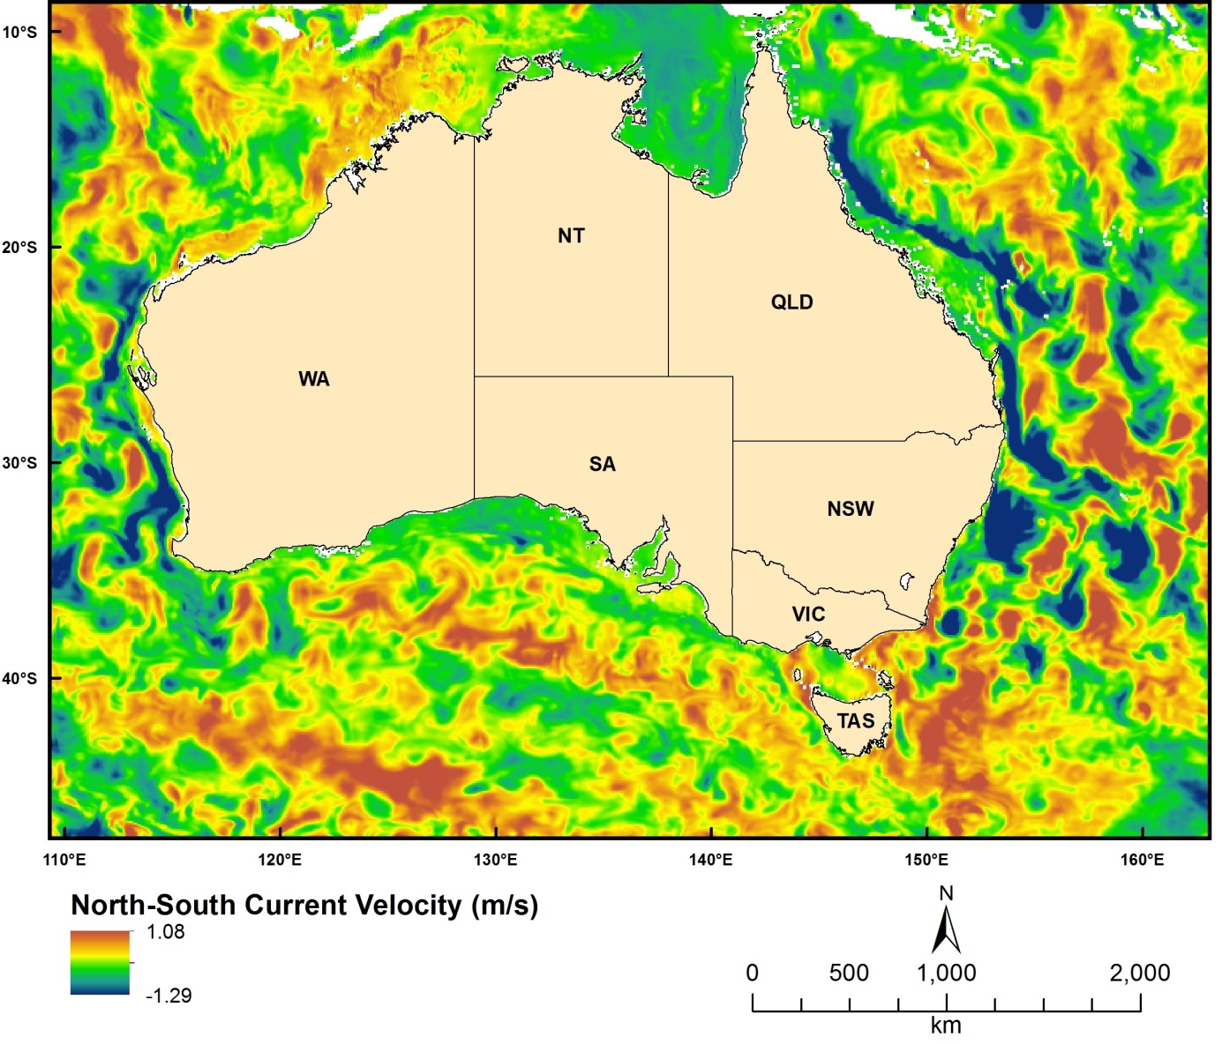
Figure 2.6.6 Modelled (HYCOM) North-South Current Velocity

Vertical current velocity
Dataset TITLE
HYbrid Coordinate Ocean Model (HYCOM) vertical velocity (w - m/s)
Dataset ALTERNATE TITLE (i.e. Dataset Name)
Dataset AUTHOR(S)
HYCOM Consortium
Dataset CUSTODIAN
HYCOM Consortium
Dataset JURISDICTION
Australia
Description ABSTRACT
Derived product from modeled oceanographic data produced by the HYbrid isopycnal COordinate Model (HYCOM). See www.hycom.org.
The HYCOM consortium is a multi-institutional effort sponsored by the National Ocean Partnership Program (NOPP), as part of the U. S. Global Ocean Data Assimilation Experiment (GODAE), to develop and evaluate a data-assimilative hybrid isopycnal-sigma-pressure (generalized) coordinate ocean model (called HYbrid Coordinate Ocean Model or HYCOM). The GODAE objectives of three-dimensional depiction of the ocean state at fine resolution in real time, provision of boundary conditions for coastal and regional models, and provision of oceanic boundary conditions for a global coupled ocean-atmosphere prediction model, are being addressed by a partnership of institutions that represent a broad spectrum of the oceanographic community.
The partnership members are the Florida State University Center for Ocean-Atmospheric Prediction Studies (FSU/COAPS), the University of Miami Rosenstiel School of Marine and Atmospheric Science (UM/RSMAS), the Naval Research Laboratory/Stennis Space Center (NRL/STENNIS), the Naval Oceanographic Office (NAVOCEANO), the Fleet Numerical Meteorology and Oceanography Center (FNMOC), the Naval Research Laboratory/Monterey (NRL/MONTEREY), the National Oceanographic and Atmospheric Administration/National Centers for Atmospheric Prediction/Marine Modeling and Analysis Branch (NOAA/NCEP/MMAB), the NOAA National Ocean Service (NOAA/NOS), the NOAA Atlantic Oceanographic and Meteorological Laboratory (NOAA/AOML), the NOAA Pacific Marine Environmental Laboratory (NOAA/PMEL), Planning Systems Inc., Los Alamos National Laboratory (LANL), Service Hydrographique et Océanographique de la Marine (SHOM), Laboratoire des Ecoulements Géophysiques et Industriels (LEGI), The Open Source Project for a Network Data Access Protocol (OPeNDAP), the University of North Carolina (UNC), Rutgers University, the University of South Florida (USF), Fugro-GEOS/Ocean Numerics, Horizon Marine Inc., Roffer's Ocean Fishing Forecasting Service Inc. (ROFFS), Orbimage, Shell Oil Company, ExxonMobil Corp., the NOAA/National Weather Service/Tropical Prediction Center (NOAA/NWS/TPC), the NOAA/National Weather Service/Ocean Prediction Center (NOAA/NWS/OPC), the University of Michigan, and the University of the Virgin Islands (UVI).
The academic, governmental, and commercial entities involved in the partnership have long histories of supporting and carrying out a wide range of oceanographic and ocean prediction-related research. All institutions are committed to developing and demonstrating the performance and application of eddy-resolving, real-time global, Atlantic, and Pacific Ocean prediction systems using the HYbrid Coordinate Ocean Model (HYCOM), a data-assimilative hybrid isopycnal-sigma-pressure (generalized) coordinate ocean model.
The prediction systems will be transitioned for operational use by the U.S. Navy at the Naval Oceanographic Office (NAVOCEANO), Stennis Space Center, MS, and at the Fleet Numerical Meteorology and Oceanography Centre (FNMOC), Monterey, CA, and by NOAA at the National Centers for Environmental Prediction (NCEP), Washington, D.C. The systems will run efficiently on a variety of massively parallel computers and will include sophisticated data assimilation techniques for assimilation of satellite altimeter sea surface height and sea surface temperature as well as in situ temperature, salinity, and float displacement. The partners intend to make results available to the GODAE modeling community and to general users on a 24/7 basis via a comprehensive data management strategy.
This collaborative partnership provides the means to leverage and accelerate the efforts of existing and planned projects, as well as new opportunities for collaboration and cooperation among the partners ranging from research to the operational level. The anticipated results of this effort include integrated analyses/reanalyses for research programs, a foundation for model enhancement based on testing of hypotheses, synthesis of remotely sensed and in situ data, and inputs to coastal, regional, atmospheric, and ice prediction systems. Improved open-ocean nowcasts and forecasts will be applied to search and rescue operations, shipping routes, tracking of icebergs and major pollutants, commercial fisheries, etc.
Description Data Category
Oceans
Environment
Description Keyword
Oceans, Ocean Circulation, Ocean Currents, Eddies. Ocean Mixed Layer, Ocean Temperature, Sea Surface Temperature, Water Temperature, Salinity/density, Salinity, Sea Surface Height
Description GEOGRAPHIC EXTENT POLYGON(S)
N_LAT: -5
S_LAT: -50
E_LONG: 100
W_LONG: 170
COORDINATE SYSTEM DESCRIPTION
Projection: Geographic
Datum: WGS84
Units: Decimal Degree
Description Temporal EXTENT
Description NOMINAL SCALE
Spatial Resolution:
Temporal Resolution:
Data Currency BEGINNING DATE
2000
Data Currency ENDING DATE
27-Feb-13
Dataset Status PROGRESS
onGoing
Dataset Status MAINTENANCE AND UPDATE FREQUENCY
Updated each day
Access STORED FORMATS Digital/Non-Digital Description
DIGITAL NetCDF
Access AVAILABLE FORMATS Digital/Non-Digital Description
Access ACCESS CONSTRAINT
Public Access
Data Quality LINEAGE
Data was generated calculating vertical velocity from horizontal velocity values on the basis of the continuity equation. Values were written into NetCDF format using a Java-based program.
For details on the HYCOM model itself, refer to the documentation at www.hycom.org.
Data Quality POSITIONAL ACCURACY
Data Quality ATTRIBUTE ACCURACY
Data Quality LOGICAL CONSISTENCY
Data Quality COMPLETENESS
Contact Information CONTACT ORGANISATION
HYCOM Consortium
Contact Information CONTACT POSITION
Contact Information MAIL ADDRESS 1
Contact Information SUBURB/PLACE/LOCALITY
Contact Information STATE/LOCALITY 2
Contact Information COUNTRY
Contact Information POSTCODE
Contact Information TELEPHONE
Contact Information FACSIMILE
Contact Information ELECTRONIC MAIL ADDRESS
johnathan.kool@ga.gov.au
Metadata Date METADATA DATE
20MAR2013
Additional Metadata METADATA AUTHOR
Johnathan Kool
Additional Metadata ACKNOWLEDGEMENTS
Alan Wallcraft (US Naval Research Laboratory)
George Halliwell (NOAA Atlantic Oceanographic and Meteorological Laboratory)
Rainer Bleck (Columbia University; NASA Goddard Institute for Space Studies)
Eric Chassignet (Florida State University)
Joe Metzger (US Naval Research Laboratory)
Michael McDonald (Florida State University)
Additional Metadata REFERENCES

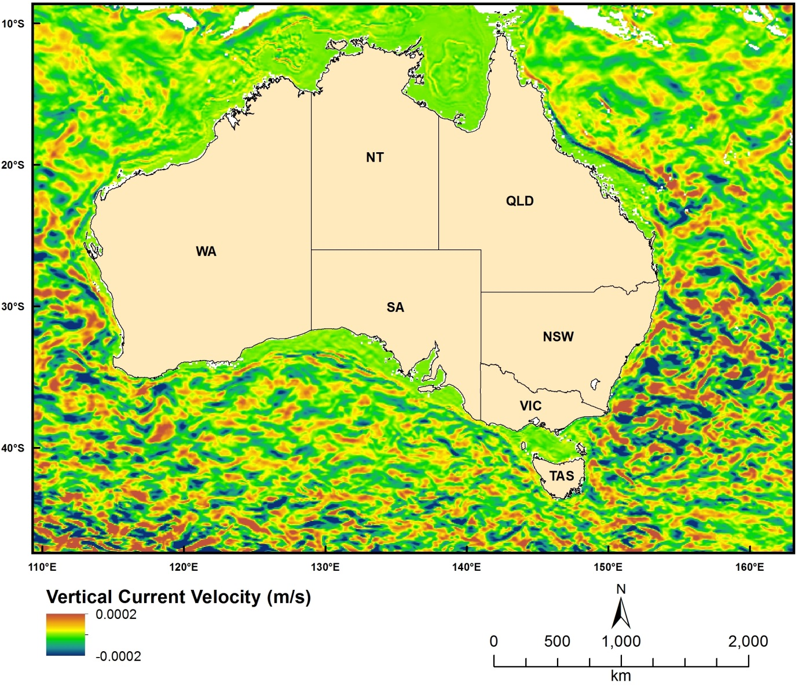
Figure 2.6.7 Modelled (HYCOM) Vertical Current Velocity

Atmospheric and Climate Layers

Tropical Cyclone Data
Dataset TITLE
Australian Government Bureau of Meteorology (BOM) Tropical Cyclone Database
Dataset ALTERNATE TITLE (i.e. Dataset Name)
Dataset AUTHOR(S)
BOM
Dataset CUSTODIAN
BOM
Dataset JURISDICTION
Australia
Description ABSTRACT
Details of all tropical cyclones that are known to have occurred are contained in a database maintained by the Bureau of Meteorology. After a tropical cyclone has occurred, tropical cyclone meteorologists reanalyse the cyclone and compile what is known as the 'best track' and a report.
Description Data Category
Oceans
Environment
ClimatologyMeteorologyAtmosphere
Description Keyword
Atmosphere, Atmospheric Phenomena, Cyclones
Description GEOGRAPHIC EXTENT POLYGON(S)
N_LAT: -3
S_LAT: -45
E_LONG: 38
W_LONG: 180
COORDINATE SYSTEM DESCRIPTION
Projection: Geographic
Datum: WGS84
Units: Decimal Degree
Description Temporal EXTENT
Description NOMINAL SCALE
Spatial Resolution:
Temporal Resolution:
Data Currency BEGINNING DATE
1970
Data Currency ENDING DATE
04-Mar-13
Dataset Status PROGRESS
onGoing
Dataset Status MAINTENANCE AND UPDATE FREQUENCY
Updated each day
Access STORED FORMATS Digital/Non-Digital Description
DIGITAL Shapefile
Access AVAILABLE FORMATS Digital/Non-Digital Description
Access ACCESS CONSTRAINT
Public Access
Data Quality LINEAGE
Data Quality POSITIONAL ACCURACY
Data Quality ATTRIBUTE ACCURACY
Data Quality LOGICAL CONSISTENCY
Data Quality COMPLETENESS
Contact Information CONTACT ORGANISATION
Australian Government - Bureau of Meteorology
Contact Information CONTACT POSITION
Contact Information MAIL ADDRESS 1
Contact Information SUBURB/PLACE/LOCALITY
Contact Information STATE/LOCALITY 2
Contact Information COUNTRY
Contact Information POSTCODE
Contact Information TELEPHONE
Contact Information FACSIMILE
Contact Information ELECTRONIC MAIL ADDRESS
Metadata Date METADATA DATE
20MAR2013
Additional Metadata METADATA AUTHOR
Johnathan Kool
Additional Metadata ACKNOWLEDGEMENTS
Australian Government - Bureau of Meteorology
Additional Metadata REFERENCES

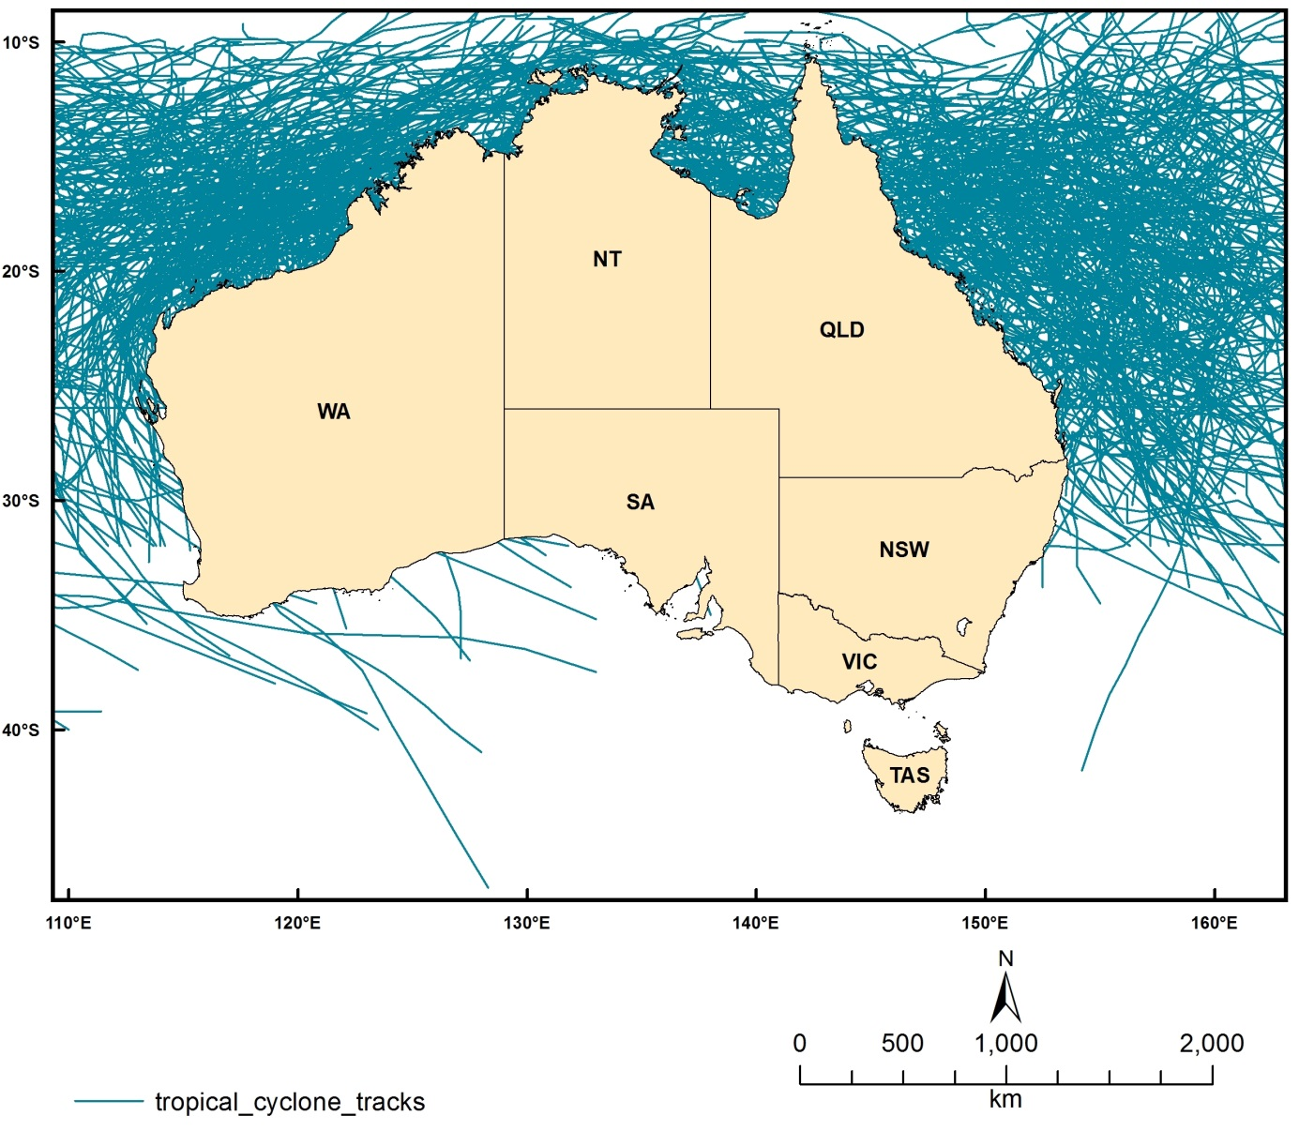
Figure 2.7.1 Historical tropical cyclone tracks

Calcite
Dataset TITLE
Bio-Oracle climate data - calcite (mol/m3)
Dataset ALTERNATE TITLE (i.e. Dataset Name)
Dataset AUTHOR(S)
Lennert Tyberghein
Dataset CUSTODIAN
Lennert Tyberghein, Ghent University
Dataset JURISDICTION
Australia
Description ABSTRACT
The oceans harbour a great diversity of organisms whose distribution and ecological preferences are often poorly understood. Species distribution modelling (SDM) could improve our knowledge and inform marine ecosystem management and conservation. Although marine environmental data are available from various sources, there are currently no user-friendly, high-resolution global datasets designed for SDM applications. This study aims to fill this gap by assembling a comprehensive, uniform, high-resolution and readily usable package of global environmental rasters. This particular dataset provides a modelled estimate of the amount of calcite (CaCO3) present in the surface layer of ocean water. The value is a temporal mean (mol/m3) derived from seasonal climatologies (2002-2009). Calcite is an essential chemical requirement for a wide variety of organisms producing hard skeletons and shells (e.g. coral reefs, crustaceans, molluscs), and calcite levels are expected to change in response to ongoing ocean acidification.
Description Data Category
Oceans
Environment
Description Keyword
Oceans, Ocean Chemistry
Description GEOGRAPHIC EXTENT POLYGON(S)
N_LAT: 90
S_LAT: -90
E_LONG: -180
W_LONG: 180
COORDINATE SYSTEM DESCRIPTION
Projection: Geographic
Datum: WGS84
Units: Decimal Degree
Description Temporal EXTENT
Description NOMINAL SCALE
Spatial Resolution:
Temporal Resolution:
Data Currency BEGINNING DATE
2010
Data Currency ENDING DATE
04-Mar-11
Dataset Status PROGRESS
Completed
Dataset Status MAINTENANCE AND UPDATE FREQUENCY
Updated as needed
Access STORED FORMATS Digital/Non-Digital Description
DIGITAL ArcInfo Grid
Access AVAILABLE FORMATS Digital/Non-Digital Description
Access ACCESS CONSTRAINT
Contact the data custodian
Data Quality LINEAGE
Please refer to the following article:
Tyberghein, Lennert; Verbruggen, Heroen; Pauly, Klaas; Troupin, Charles ;
Mineur, Frederic and De Clerck, Olivier 2012. Bio-ORACLE: a global environmental
dataset for marine species distribution modelling. Global Ecology and Biogeography 21, 272-281.
http://www.oracle.ugent.be/
http://www.phycology.ugent.be/reprints/oracle.pdf
Data Quality POSITIONAL ACCURACY
Data Quality ATTRIBUTE ACCURACY
Data Quality LOGICAL CONSISTENCY
Data Quality COMPLETENESS
Contact Information CONTACT ORGANISATION
Ghent University
Contact Information CONTACT POSITION
Contact Information MAIL ADDRESS 1
Phycology Research Group, Biology Department, Ghent University, Krijgslaan 281 (S8)
Contact Information SUBURB/PLACE/LOCALITY
Contact Information STATE/LOCALITY 2
Contact Information COUNTRY
Belgium
Contact Information POSTCODE
9000
Contact Information TELEPHONE
Contact Information FACSIMILE
Contact Information ELECTRONIC MAIL ADDRESS
Lennert.tyberghein@ugent.be
Metadata Date METADATA DATE
20MAR2013
Additional Metadata METADATA AUTHOR
Johnathan Kool
Additional Metadata ACKNOWLEDGEMENTS
Lennert Tyberghein (Ghent University, Belgium)
Heroen Verbruggen (Ghent University, Belgium)
Klaas Pauly (Ghent University, Belgium)
Charles Troupin (Universite de Liege, Belgium)
Frederic Mineur (Queens University Belfast, UK)
Olivier De Clerck (Ghent University, Belgium)
Additional Metadata REFERENCES
Tyberghein, Lennert; Verbruggen, Heroen; Pauly, Klaas; Troupin, Charles ;
Mineur, Frederic and De Clerck, Olivier 2012. Bio-ORACLE: a global environmental
dataset for marine species distribution modelling. Global Ecology and Biogeography 21, 272-281.

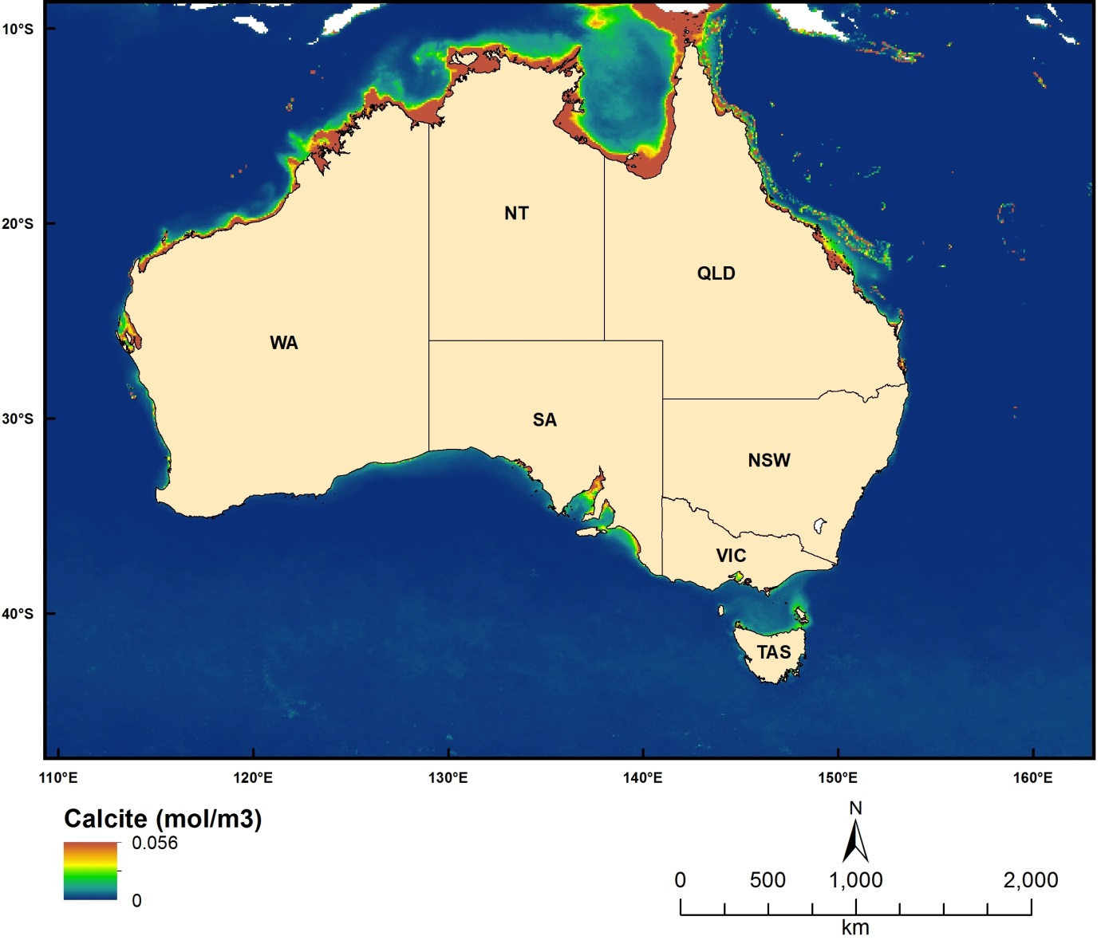
Figure 2.7.2 Modelled (Bio-ORACLE) Calcite concentrations

Cloud mean
Dataset TITLE
Bio-Oracle climate data - cloud cover (temporal mean from monthly images 2005-2010)
Dataset ALTERNATE TITLE (i.e. Dataset Name)
Dataset AUTHOR(S)
Lennert Tyberghein
Dataset CUSTODIAN
Lennert Tyberghein, Ghent University
Dataset JURISDICTION
Australia
Description ABSTRACT
The oceans harbour a great diversity of organisms whose distribution and ecological preferences are often poorly understood. Species distribution modelling (SDM) could improve our knowledge and inform marine ecosystem management and conservation. Although marine environmental data are available from various sources, there are currently no user-friendly, high-resolution global datasets designed for SDM applications. This study aims to fill this gap by assembling a comprehensive, uniform, high-resolution and readily usable package of global environmental rasters. This particular dataset provides an estimate of the mean cloud cover as a percentage/frequency over a particular pixel location, derived from monthly sets of Terra-MODIS images (2005-2010). Cloud coverage has the potential to mitigate the impacts of solar radiation exposure – e.g. heat-induced coral bleaching.
Description Data Category
Oceans
Environment
Description Keyword
Atmosphere, Clouds, Cloud Amount/frequency
Description GEOGRAPHIC EXTENT POLYGON(S)
N_LAT: 90
S_LAT: -90
E_LONG: -180
W_LONG: 180
COORDINATE SYSTEM DESCRIPTION
Projection: Geographic
Datum: WGS84
Units: Decimal Degree
Description Temporal EXTENT
Description NOMINAL SCALE
Spatial Resolution:
Temporal Resolution:
Data Currency BEGINNING DATE
2010
Data Currency ENDING DATE
04-Mar-11
Dataset Status PROGRESS
Completed
Dataset Status MAINTENANCE AND UPDATE FREQUENCY
Updated as needed
Access STORED FORMATS Digital/Non-Digital Description
DIGITAL ArcInfo Grid
Access AVAILABLE FORMATS Digital/Non-Digital Description
Access ACCESS CONSTRAINT
Contact the data custodian
Data Quality LINEAGE
Please refer to the following article:
Tyberghein, Lennert; Verbruggen, Heroen; Pauly, Klaas; Troupin, Charles ;
Mineur, Frederic and De Clerck, Olivier 2012. Bio-ORACLE: a global environmental
dataset for marine species distribution modelling. Global Ecology and Biogeography 21, 272-281.
http://www.oracle.ugent.be/
http://www.phycology.ugent.be/reprints/oracle.pdf
Data Quality POSITIONAL ACCURACY
Data Quality ATTRIBUTE ACCURACY
Data Quality LOGICAL CONSISTENCY
Data Quality COMPLETENESS
Contact Information CONTACT ORGANISATION
Ghent University
Contact Information CONTACT POSITION
Contact Information MAIL ADDRESS 1
Phycology Research Group, Biology Department, Ghent University, Krijgslaan 281 (S8)
Contact Information SUBURB/PLACE/LOCALITY
Contact Information STATE/LOCALITY 2
Contact Information COUNTRY
Belgium
Contact Information POSTCODE
9000
Contact Information TELEPHONE
Contact Information FACSIMILE
Contact Information ELECTRONIC MAIL ADDRESS
Lennert.tyberghein@ugent.be
Metadata Date METADATA DATE
20MAR2013
Additional Metadata METADATA AUTHOR
Johnathan Kool
Additional Metadata ACKNOWLEDGEMENTS
Lennert Tyberghein (Ghent University, Belgium)
Heroen Verbruggen (Ghent University, Belgium)
Klaas Pauly (Ghent University, Belgium)
Charles Troupin (Universite de Liege, Belgium)
Frederic Mineur (Queens University Belfast, UK)
Olivier De Clerck (Ghent University, Belgium)
Additional Metadata REFERENCES
Tyberghein, Lennert; Verbruggen, Heroen; Pauly, Klaas; Troupin, Charles ;
Mineur, Frederic and De Clerck, Olivier 2012. Bio-ORACLE: a global environmental
dataset for marine species distribution modelling. Global Ecology and Biogeography 21, 272-281.

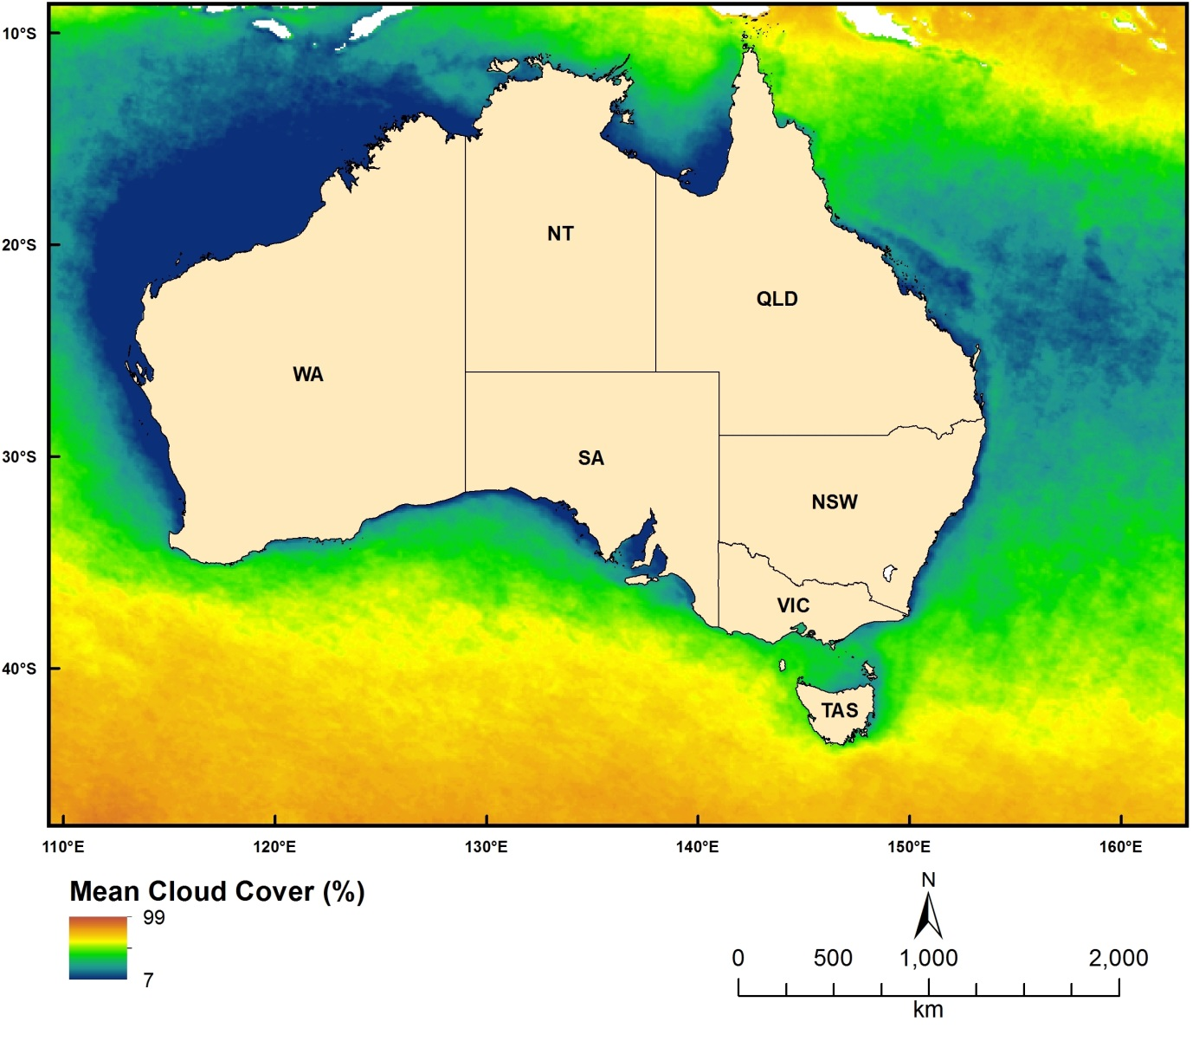
Figure 2.7.3 MODIS-derived Temporal Mean Cloud Cover

Cloud minimum
Dataset TITLE
Bio-Oracle climate data - cloud cover (temporal minimum from monthly images 2005-2010)
Dataset ALTERNATE TITLE (i.e. Dataset Name)
Dataset AUTHOR(S)
Lennert Tyberghein
Dataset CUSTODIAN
Lennert Tyberghein, Ghent University
Dataset JURISDICTION
Australia
Description ABSTRACT
The oceans harbour a great diversity of organisms whose distribution and ecological preferences are often poorly understood. Species distribution modelling (SDM) could improve our knowledge and inform marine ecosystem management and conservation. Although marine environmental data are available from various sources, there are currently no user-friendly, high-resolution global datasets designed for SDM applications. This study aims to fill this gap by assembling a comprehensive, uniform, high-resolution and readily usable package of global environmental rasters. This particular dataset provides an estimate of the minimum cloud cover as a percentage/frequency over a particular pixel location, derived from monthly sets of Terra-MODIS images (2005-2010). Cloud coverage has the potential to mitigate the impacts of solar radiation exposure – e.g. heat-induced coral bleaching.
Description Data Category
Oceans
Environment
Description Keyword
Atmosphere, Clouds, Cloud Amount/frequency
Description GEOGRAPHIC EXTENT POLYGON(S)
N_LAT: 90
S_LAT: -90
E_LONG: -180
W_LONG: 180
COORDINATE SYSTEM DESCRIPTION
Projection: Geographic
Datum: WGS84
Units: Decimal Degree
Description Temporal EXTENT
Description NOMINAL SCALE
Spatial Resolution:
Temporal Resolution:
Data Currency BEGINNING DATE
2010
Data Currency ENDING DATE
04-Mar-11
Dataset Status PROGRESS
Completed
Dataset Status MAINTENANCE AND UPDATE FREQUENCY
Updated as needed
Access STORED FORMATS Digital/Non-Digital Description
DIGITAL ArcInfo Grid
Access AVAILABLE FORMATS Digital/Non-Digital Description
Access ACCESS CONSTRAINT
Contact the data custodian
Data Quality LINEAGE
Please refer to the following article:
Tyberghein, Lennert; Verbruggen, Heroen; Pauly, Klaas; Troupin, Charles ;
Mineur, Frederic and De Clerck, Olivier 2012. Bio-ORACLE: a global environmental
dataset for marine species distribution modelling. Global Ecology and Biogeography 21, 272-281.
http://www.oracle.ugent.be/
http://www.phycology.ugent.be/reprints/oracle.pdf
Data Quality POSITIONAL ACCURACY
Data Quality ATTRIBUTE ACCURACY
Data Quality LOGICAL CONSISTENCY
Data Quality COMPLETENESS
Contact Information CONTACT ORGANISATION
Ghent University
Contact Information CONTACT POSITION
Contact Information MAIL ADDRESS 1
Phycology Research Group, Biology Department, Ghent University, Krijgslaan 281 (S8)
Contact Information SUBURB/PLACE/LOCALITY
Contact Information STATE/LOCALITY 2
Contact Information COUNTRY
Belgium
Contact Information POSTCODE
9000
Contact Information TELEPHONE
Contact Information FACSIMILE
Contact Information ELECTRONIC MAIL ADDRESS
Lennert.tyberghein@ugent.be
Metadata Date METADATA DATE
20MAR2013
Additional Metadata METADATA AUTHOR
Johnathan Kool
Additional Metadata ACKNOWLEDGEMENTS
Lennert Tyberghein (Ghent University, Belgium)
Heroen Verbruggen (Ghent University, Belgium)
Klaas Pauly (Ghent University, Belgium)
Charles Troupin (Universite de Liege, Belgium)
Frederic Mineur (Queens University Belfast, UK)
Olivier De Clerck (Ghent University, Belgium)
Additional Metadata REFERENCES
Tyberghein, Lennert; Verbruggen, Heroen; Pauly, Klaas; Troupin, Charles ;
Mineur, Frederic and De Clerck, Olivier 2012. Bio-ORACLE: a global environmental
dataset for marine species distribution modelling. Global Ecology and Biogeography 21, 272-281.

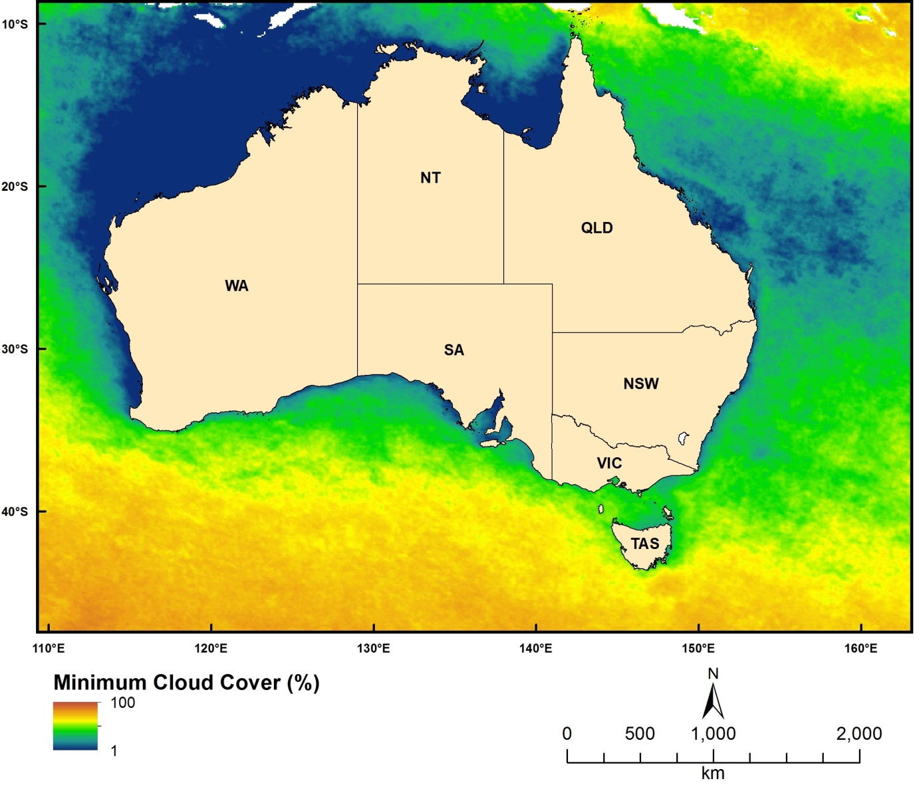
Figure 2.7.4 MODIS-derived Temporal Minimum Cloud Cover

Cloud maximum
Dataset TITLE
Bio-Oracle climate data - cloud cover (temporal maximum from monthly images 2005-2010)
Dataset ALTERNATE TITLE (i.e. Dataset Name)
Dataset AUTHOR(S)
Lennert Tyberghein
Dataset CUSTODIAN
Lennert Tyberghein, Ghent University
Dataset JURISDICTION
Australia
Description ABSTRACT
The oceans harbour a great diversity of organisms whose distribution and ecological preferences are often poorly understood. Species distribution modelling (SDM) could improve our knowledge and inform marine ecosystem management and conservation. Although marine environmental data are available from various sources, there are currently no user-friendly, high-resolution global datasets designed for SDM applications. This study aims to fill this gap by assembling a comprehensive, uniform, high-resolution and readily usable package of global environmental rasters. This particular dataset provides an estimate of the maximum cloud cover as a percentage/frequency over a particular pixel location, derived from monthly sets of Terra-MODIS images (2005-2010). Cloud coverage has the potential to mitigate the impacts of solar radiation exposure – e.g. heat-induced coral bleaching.
Description Data Category
Oceans
Environment
Description Keyword
Atmosphere, Clouds, Cloud Amount/frequency
Description GEOGRAPHIC EXTENT POLYGON(S)
N_LAT: 90
S_LAT: -90
E_LONG: -180
W_LONG: 180
COORDINATE SYSTEM DESCRIPTION
Projection: Geographic
Datum: WGS84
Units: Decimal Degree
Description Temporal EXTENT
Description NOMINAL SCALE
Spatial Resolution:
Temporal Resolution:
Data Currency BEGINNING DATE
2010
Data Currency ENDING DATE
04-Mar-11
Dataset Status PROGRESS
Completed
Dataset Status MAINTENANCE AND UPDATE FREQUENCY
Updated as needed
Access STORED FORMATS Digital/Non-Digital Description
DIGITAL ArcInfo Grid
Access AVAILABLE FORMATS Digital/Non-Digital Description
Access ACCESS CONSTRAINT
Contact the data custodian
Data Quality LINEAGE
Please refer to the following article:
Tyberghein, Lennert; Verbruggen, Heroen; Pauly, Klaas; Troupin, Charles ;
Mineur, Frederic and De Clerck, Olivier 2012. Bio-ORACLE: a global environmental
dataset for marine species distribution modelling. Global Ecology and Biogeography 21, 272-281.
http://www.oracle.ugent.be/
http://www.phycology.ugent.be/reprints/oracle.pdf
Data Quality POSITIONAL ACCURACY
Data Quality ATTRIBUTE ACCURACY
Data Quality LOGICAL CONSISTENCY
Data Quality COMPLETENESS
Contact Information CONTACT ORGANISATION
Ghent University
Contact Information CONTACT POSITION
Contact Information MAIL ADDRESS 1
Phycology Research Group, Biology Department, Ghent University, Krijgslaan 281 (S8)
Contact Information SUBURB/PLACE/LOCALITY
Contact Information STATE/LOCALITY 2
Contact Information COUNTRY
Belgium
Contact Information POSTCODE
9000
Contact Information TELEPHONE
Contact Information FACSIMILE
Contact Information ELECTRONIC MAIL ADDRESS
Lennert.tyberghein@ugent.be
Metadata Date METADATA DATE
20MAR2013
Additional Metadata METADATA AUTHOR
Johnathan Kool
Additional Metadata ACKNOWLEDGEMENTS
Lennert Tyberghein (Ghent University, Belgium)
Heroen Verbruggen (Ghent University, Belgium)
Klaas Pauly (Ghent University, Belgium)
Charles Troupin (Universite de Liege, Belgium)
Frederic Mineur (Queens University Belfast, UK)
Olivier De Clerck (Ghent University, Belgium)
Additional Metadata REFERENCES
Tyberghein, Lennert; Verbruggen, Heroen; Pauly, Klaas; Troupin, Charles ;
Mineur, Frederic and De Clerck, Olivier 2012. Bio-ORACLE: a global environmental
dataset for marine species distribution modelling. Global Ecology and Biogeography 21, 272-281.

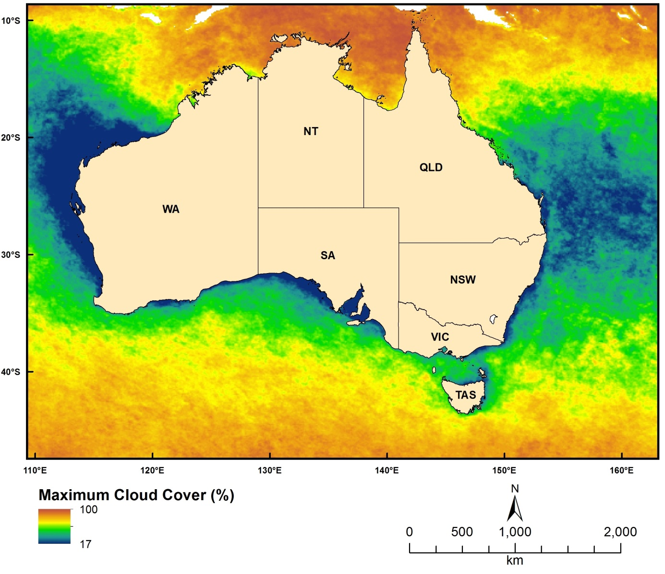
Figure 2.7.5 MODIS-derived Temporal Maximum Cloud Cover

PH
Dataset TITLE
Bio-Oracle climate data - pH (mean of interpolated measurements)
Dataset ALTERNATE TITLE (i.e. Dataset Name)
Dataset AUTHOR(S)
Lennert Tyberghein
Dataset CUSTODIAN
Lennert Tyberghein, Ghent University
Dataset JURISDICTION
Australia
Description ABSTRACT
The oceans harbour a great diversity of organisms whose distribution and ecological preferences are often poorly understood. Species distribution modelling (SDM) could improve our knowledge and inform marine ecosystem management and conservation. Although marine environmental data are available from various sources, there are currently no user-friendly, high-resolution global datasets designed for SDM applications. This study aims to fill this gap by assembling a comprehensive, uniform, high-resolution and readily usable package of global environmental rasters. This particular dataset provides a modelled estimate of pH, derived from interpolations of in-situ measurements (World Ocean Database 2009). Ocean pH levels are expected to be affected by ongoing ocean acidification.
Description Data Category
Oceans
Environment
Description Keyword
Atmosphere, Clouds, Cloud Amount/frequency
Description GEOGRAPHIC EXTENT POLYGON(S)
N_LAT: 90
S_LAT: -90
E_LONG: -180
W_LONG: 180
COORDINATE SYSTEM DESCRIPTION
Projection: Geographic
Datum: WGS84
Units: Decimal Degree
Description Temporal EXTENT
Description NOMINAL SCALE
Spatial Resolution:
Temporal Resolution:
Data Currency BEGINNING DATE
2010
Data Currency ENDING DATE
04-Mar-11
Dataset Status PROGRESS
Completed
Dataset Status MAINTENANCE AND UPDATE FREQUENCY
Updated as needed
Access STORED FORMATS Digital/Non-Digital Description
DIGITAL ArcInfo Grid
Access AVAILABLE FORMATS Digital/Non-Digital Description
Access ACCESS CONSTRAINT
Contact the data custodian
Data Quality LINEAGE
Please refer to the following article:
Tyberghein, Lennert; Verbruggen, Heroen; Pauly, Klaas; Troupin, Charles ;
Mineur, Frederic and De Clerck, Olivier 2012. Bio-ORACLE: a global environmental
dataset for marine species distribution modelling. Global Ecology and Biogeography 21, 272-281.
http://www.oracle.ugent.be/
http://www.phycology.ugent.be/reprints/oracle.pdf
Data Quality POSITIONAL ACCURACY
Data Quality ATTRIBUTE ACCURACY
Data Quality LOGICAL CONSISTENCY
Data Quality COMPLETENESS
Contact Information CONTACT ORGANISATION
Ghent University
Contact Information CONTACT POSITION
Contact Information MAIL ADDRESS 1
Phycology Research Group, Biology Department, Ghent University, Krijgslaan 281 (S8)
Contact Information SUBURB/PLACE/LOCALITY
Contact Information STATE/LOCALITY 2
Contact Information COUNTRY
Belgium
Contact Information POSTCODE
9000
Contact Information TELEPHONE
Contact Information FACSIMILE
Contact Information ELECTRONIC MAIL ADDRESS
Lennert.tyberghein@ugent.be
Metadata Date METADATA DATE
20MAR2013
Additional Metadata METADATA AUTHOR
Johnathan Kool
Additional Metadata ACKNOWLEDGEMENTS
Lennert Tyberghein (Ghent University, Belgium)
Heroen Verbruggen (Ghent University, Belgium)
Klaas Pauly (Ghent University, Belgium)
Charles Troupin (Universite de Liege, Belgium)
Frederic Mineur (Queens University Belfast, UK)
Olivier De Clerck (Ghent University, Belgium)
Additional Metadata REFERENCES
Tyberghein, Lennert; Verbruggen, Heroen; Pauly, Klaas; Troupin, Charles ; Mineur, Frederic and De Clerck, Olivier 2012. Bio-ORACLE: a global environmental dataset for marine species distribution modelling. Global Ecology and Biogeography 21, 272-281.

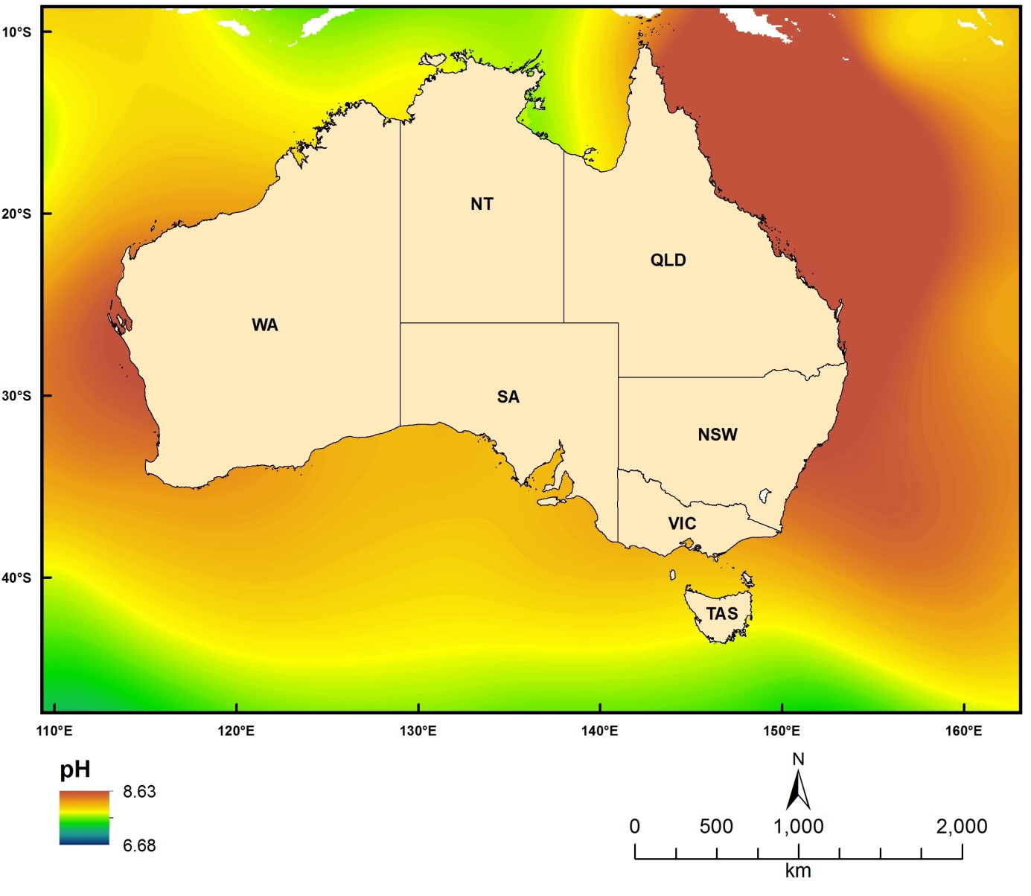
Figure 2.7.6 Modelled (Bio-ORACLE) pH Values

Predicted and Modelled Connectivity/Dispersal Layers

Particle Tracks
Dataset TITLE
Conn4D - 4-dimensional biophysical connectivity model - particle tracks
Dataset ALTERNATE TITLE (i.e. Dataset Name)
Dataset AUTHOR(S)
Johnathan Kool
Dataset CUSTODIAN
Geoscience Australia
Dataset JURISDICTION
Australia
Description ABSTRACT
Connectivity research involves investigating the presence, strength and characteristics of spatiotemporal relationships between populations of organisms. Typically, marine organisms release large numbers (often on the order of millions) of young (larvae), which are difficult to follow via physical tracking. Instead, researchers have turned to numerical simulations, coupling models of ocean movement with larval behaviour.
The model described here uses oceanographic data (typically provided by ocean models such as HYCOM, BlueLink, POM or ROMS) to disperse artificially intelligent particles. The fundamental physical processes at work are advection and diffusion, however the particles are able to respond in a flexible manner to other parameters as well, for example temperature, salinity, or prey fields. Due to the object-oriented architecture of the model, various components can be changed, improved or modified without altering the base structure of the code.
This particular data set contains point locations of the simulated particles over time. This point cloud data forms the basis of the other analytical products (i.e. dispersal surfaces, source and sink capacity, total and net activity).
Description Data Category
Oceans
Environment
Description Keyword
Oceans, Marine Biology, Marine Invertebrates, Fish, Coastal Processes, Coral Reefs, Marine Geophysics, Submarine Canyons, Ocean Circulation, Advection, Diffusion, Ocean Currents
Description GEOGRAPHIC EXTENT POLYGON(S)
N_LAT: -5
S_LAT: -50
E_LONG: 100
W_LONG: 170
COORDINATE SYSTEM DESCRIPTION
Projection: Geographic
Datum: WGS84
Units: Decimal Degree
Description Temporal EXTENT
01-Jan-09 to 27-Feb-13
Description NOMINAL SCALE
Spatial Resolution:
Temporal Resolution:
Data Currency BEGINNING DATE
04-Apr-2013
Data Currency ENDING DATE
Dataset Status PROGRESS
underDevelopment
Dataset Status MAINTENANCE AND UPDATE FREQUENCY
Access STORED FORMATS Digital/Non-Digital Description
Access AVAILABLE FORMATS Digital/Non-Digital Description
Access ACCESS CONSTRAINT
Please cite the data set using the following format: National Environmental Research Program (NERP) Marine Biodiversity Hub [year-of-data-download], [Title], [data-access-URL], accessed [date-of-access].
Data Quality LINEAGE
The data was produced by using ocean velocity fields provided by the HYCOM model (www.hycom.org) to drive a biophysical dispersal model written in Java (Conn4D: source code available at https://github.com/jkool/Conn4D).
Data Quality POSITIONAL ACCURACY
Data Quality ATTRIBUTE ACCURACY
Data Quality LOGICAL CONSISTENCY
Data Quality COMPLETENESS
Contact Information CONTACT ORGANISATION
Geoscience Australia
Contact Information CONTACT POSITION
Marine Data Manager
Contact Information MAIL ADDRESS 1
GPO Box 378
Contact Information SUBURB/PLACE/LOCALITY
Canberra
Contact Information STATE/LOCALITY 2
ACT
Contact Information COUNTRY
Australia
Contact Information POSTCODE
2601
Contact Information TELEPHONE
+61 2 6249 9111
Contact Information FACSIMILE
+61 2 6249 9999
Contact Information ELECTRONIC MAIL ADDRESS
marine@ga.gov.au
Metadata Date METADATA DATE
20MAR2013
Additional Metadata METADATA AUTHOR
Johnathan Kool
Additional Metadata ACKNOWLEDGEMENTS
Johnathan Kool
Claire Paris (University of Miami, Florida)
Ashwanth Srinivasan (University of Miami, Florida)
Bob Cowen (Oregon State University, Oregon)
Data was sourced from the NERP Marine Biodiversity Hub – the Marine Biodiversity Hub is supported through funding from the Australian Government’s National Environmental Research Program (NERP), administered by the Department of Sustainability, Environment, Water, Population and Communities (DSEWPaC).
Additional Metadata REFERENCES

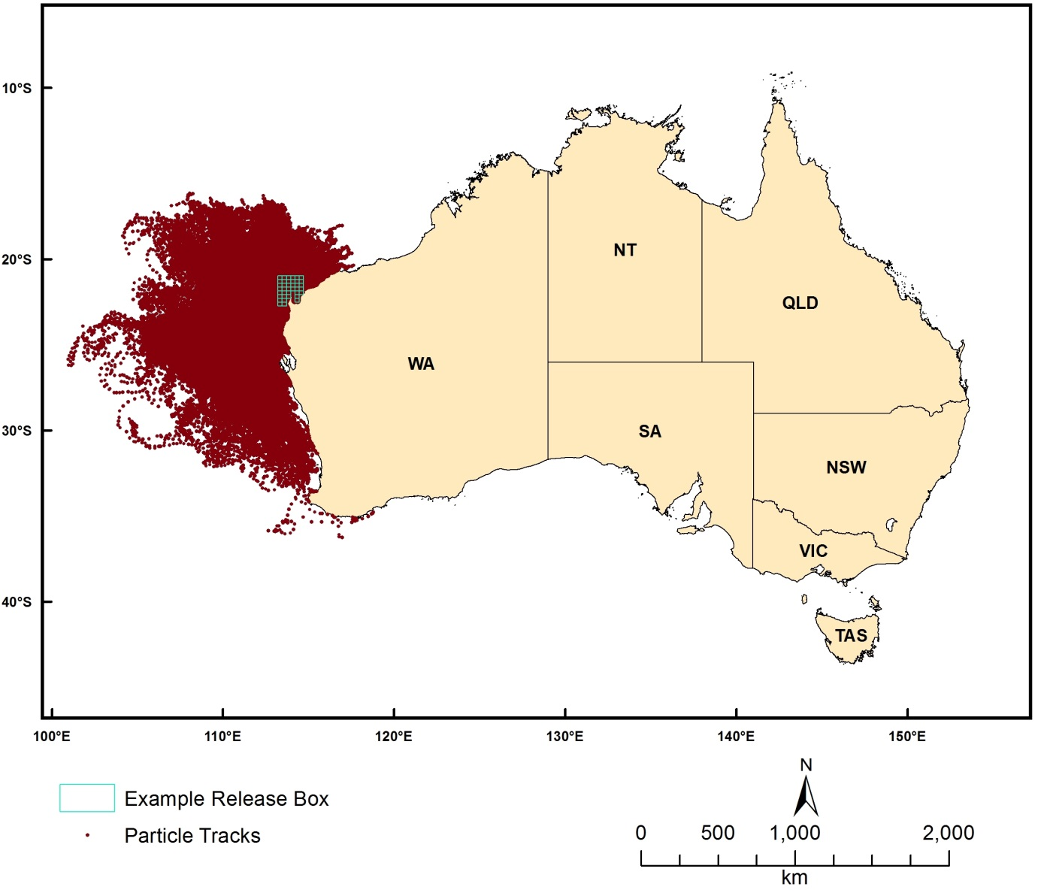
Figure 2.8.1 Modelled (Conn4D) particle tracks released from the Ningaloo area, Western Australia

Dispersal Surface
Dataset TITLE
Conn4D - 4-dimensional biophysical connectivity model - dispersal surface
Dataset ALTERNATE TITLE (i.e. Dataset Name)
Dataset AUTHOR(S)
Johnathan Kool
Dataset CUSTODIAN
Geoscience Australia
Dataset JURISDICTION
Australia
Description ABSTRACT
Connectivity research involves investigating the presence, strength and characteristics of spatiotemporal relationships between populations of organisms. Typically, marine organisms release large numbers (often on the order of millions) of young (larvae), which are difficult to follow via physical tracking. Instead, researchers have turned to numerical simulations, coupling models of ocean movement with larval behaviour.
The model described here uses oceanographic data (typically provided by ocean models such as HYCOM, BlueLink, POM or ROMS) to disperse artificially intelligent particles. The fundamental physical processes at work are advection and diffusion, however the particles are able to respond in a flexible manner to other parameters as well, for example temperature, salinity, or prey fields. Due to the object-oriented architecture of the model, various components can be changed, improved or modified without altering the base structure of the code.
This particular data set represents the density of particles integrated over time. Density is estimated using a radial focal function. The density values are generally best visualized using a log scale.
Description Data Category
Oceans
Environment
Description Keyword
Oceans, Marine Biology, Marine Invertebrates, Fish, Coastal Processes, Coral Reefs, Marine Geophysics, Submarine Canyons, Ocean Circulation, Advection, Diffusion, Ocean Currents
Description GEOGRAPHIC EXTENT POLYGON(S)
N_LAT: -5
S_LAT: -50
E_LONG: 100
W_LONG: 170
COORDINATE SYSTEM DESCRIPTION
Projection: Geographic
Datum: WGS84
Units: Decimal Degree
Description Temporal EXTENT
01-Jan-09 to 27-Feb-13
Description NOMINAL SCALE
Spatial Resolution:
Temporal Resolution:
Data Currency BEGINNING DATE
04-Apr-2013
Data Currency ENDING DATE
Dataset Status PROGRESS
underDevelopment
Dataset Status MAINTENANCE AND UPDATE FREQUENCY
Access STORED FORMATS Digital/Non-Digital Description
Access AVAILABLE FORMATS Digital/Non-Digital Description
Access ACCESS CONSTRAINT
Please cite the data set using the following format: National Environmental Research Program (NERP) Marine Biodiversity Hub [year-of-data-download], [Title], [data-access-URL], accessed [date-of-access].
Data Quality LINEAGE
The data was produced by using ocean velocity fields provided by the HYCOM model (www.hycom.org) to drive a biophysical dispersal model written in Java (Conn4D: source code available at https://github.com/jkool/Conn4D).
Data Quality POSITIONAL ACCURACY
Data Quality ATTRIBUTE ACCURACY
Data Quality LOGICAL CONSISTENCY
Data Quality COMPLETENESS
Contact Information CONTACT ORGANISATION
Geoscience Australia
Contact Information CONTACT POSITION
Marine Data Manager
Contact Information MAIL ADDRESS 1
GPO Box 378
Contact Information SUBURB/PLACE/LOCALITY
Canberra
Contact Information STATE/LOCALITY 2
ACT
Contact Information COUNTRY
Australia
Contact Information POSTCODE
2601
Contact Information TELEPHONE
+61 2 6249 9111
Contact Information FACSIMILE
+61 2 6249 9999
Contact Information ELECTRONIC MAIL ADDRESS
marine@ga.gov.au
Metadata Date METADATA DATE
20MAR2013
Additional Metadata METADATA AUTHOR
Johnathan Kool
Additional Metadata ACKNOWLEDGEMENTS
Johnathan Kool
Claire Paris (University of Miami, Florida)
Ashwanth Srinivasan (University of Miami, Florida)
Bob Cowen (Oregon State University, Oregon)
Data was sourced from the NERP Marine Biodiversity Hub – the Marine Biodiversity Hub is supported through funding from the Australian Government’s National Environmental Research Program (NERP), administered by the Department of Sustainability, Environment, Water, Population and Communities (DSEWPaC).
Additional Metadata REFERENCES

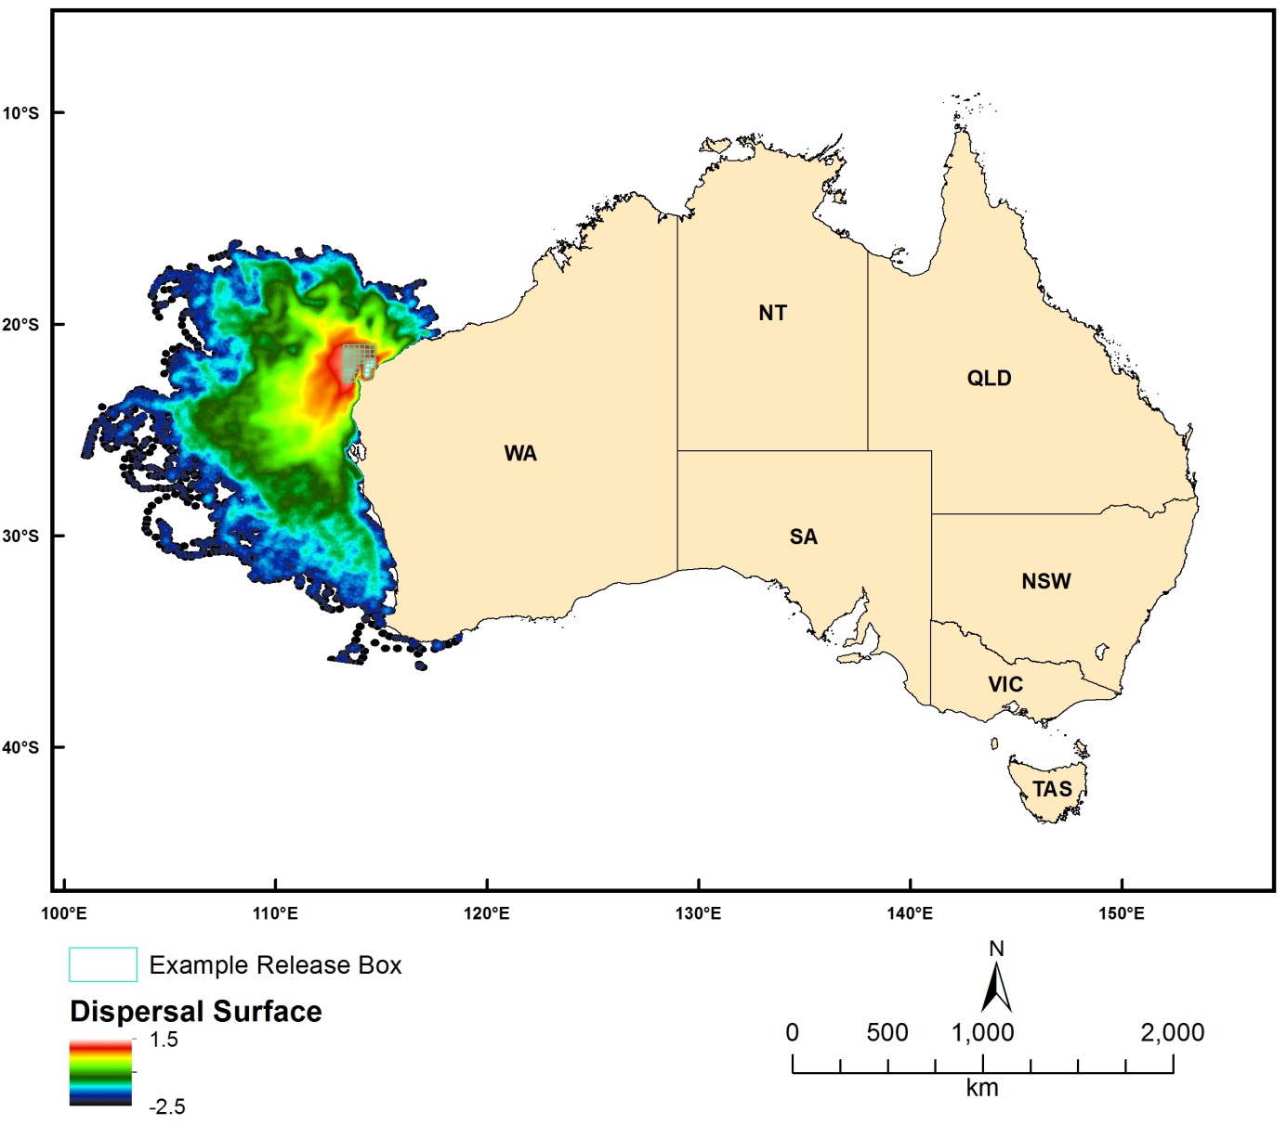
Figure 2.8.2 Modelled (Conn4D) dispersal surface (as Log10 Point Density within 20km Radius) from particles released from the Ningaloo area, Western Australia

Source Capacity
Dataset TITLE
Conn4D - 4-dimensional biophysical connectivity model - source capacity
Dataset ALTERNATE TITLE (i.e. Dataset Name)
Dataset AUTHOR(S)
Johnathan Kool
Dataset CUSTODIAN
Geoscience Australia
Dataset JURISDICTION
Australia
Description ABSTRACT
Connectivity research involves investigating the presence, strength and characteristics of spatiotemporal relationships between populations of organisms. Typically, marine organisms release large numbers (often on the order of millions) of young (larvae), which are difficult to follow via physical tracking. Instead, researchers have turned to numerical simulations, coupling models of ocean movement with larval behaviour.
The model described here uses oceanographic data (typically provided by ocean models such as HYCOM, BlueLink, POM or ROMS) to disperse artificially intelligent particles. The fundamental physical processes at work are advection and diffusion, however the particles are able to respond in a flexible manner to other parameters as well, for example temperature, salinity, or prey fields. Due to the object-oriented architecture of the model, various components can be changed, improved or modified without altering the base structure of the code.
This data set represents the degree to which polygons act as a source of particles to a selected set of destination polygons (from a general set of sources to a selected set of destinations). The source polygons can be of arbitrary size, shape and configuration.
Description Data Category
Oceans
Environment
Description Keyword
Oceans, Marine Biology, Marine Invertebrates, Fish, Coastal Processes, Coral Reefs, Marine Geophysics, Submarine Canyons, Ocean Circulation, Advection, Diffusion, Ocean Currents
Description GEOGRAPHIC EXTENT POLYGON(S)
N_LAT: -5
S_LAT: -50
E_LONG: 100
W_LONG: 170
COORDINATE SYSTEM DESCRIPTION
Projection: Geographic
Datum: WGS84
Units: Decimal Degree
Description Temporal EXTENT
01-Jan-09 to 27-Feb-13
Description NOMINAL SCALE
Spatial Resolution:
Temporal Resolution:
Data Currency BEGINNING DATE
04-Apr-2013
Data Currency ENDING DATE
Dataset Status PROGRESS
underDevelopment
Dataset Status MAINTENANCE AND UPDATE FREQUENCY
Access STORED FORMATS Digital/Non-Digital Description
Access AVAILABLE FORMATS Digital/Non-Digital Description
Access ACCESS CONSTRAINT
Please cite the data set using the following format: National Environmental Research Program (NERP) Marine Biodiversity Hub [year-of-data-download], [Title], [data-access-URL], accessed [date-of-access].
Data Quality LINEAGE
The data was produced by using ocean velocity fields provided by the HYCOM model (www.hycom.org) to drive a biophysical dispersal model written in Java (Conn4D: source code available at https://github.com/jkool/Conn4D).
Data Quality POSITIONAL ACCURACY
Data Quality ATTRIBUTE ACCURACY
Data Quality LOGICAL CONSISTENCY
Data Quality COMPLETENESS
Contact Information CONTACT ORGANISATION
Geoscience Australia
Contact Information CONTACT POSITION
Marine Data Manager
Contact Information MAIL ADDRESS 1
GPO Box 378
Contact Information SUBURB/PLACE/LOCALITY
Canberra
Contact Information STATE/LOCALITY 2
ACT
Contact Information COUNTRY
Australia
Contact Information POSTCODE
2601
Contact Information TELEPHONE
+61 2 6249 9111
Contact Information FACSIMILE
+61 2 6249 9999
Contact Information ELECTRONIC MAIL ADDRESS
marine@ga.gov.au
Metadata Date METADATA DATE
20MAR2013
Additional Metadata METADATA AUTHOR
Johnathan Kool
Additional Metadata ACKNOWLEDGEMENTS
Johnathan Kool
Claire Paris (University of Miami, Florida)
Ashwanth Srinivasan (University of Miami, Florida)
Bob Cowen (Oregon State University, Oregon)
Data was sourced from the NERP Marine Biodiversity Hub – the Marine Biodiversity Hub is supported through funding from the Australian Government’s National Environmental Research Program (NERP), administered by the Department of Sustainability, Environment, Water, Population and Communities (DSEWPaC).
Additional Metadata REFERENCES

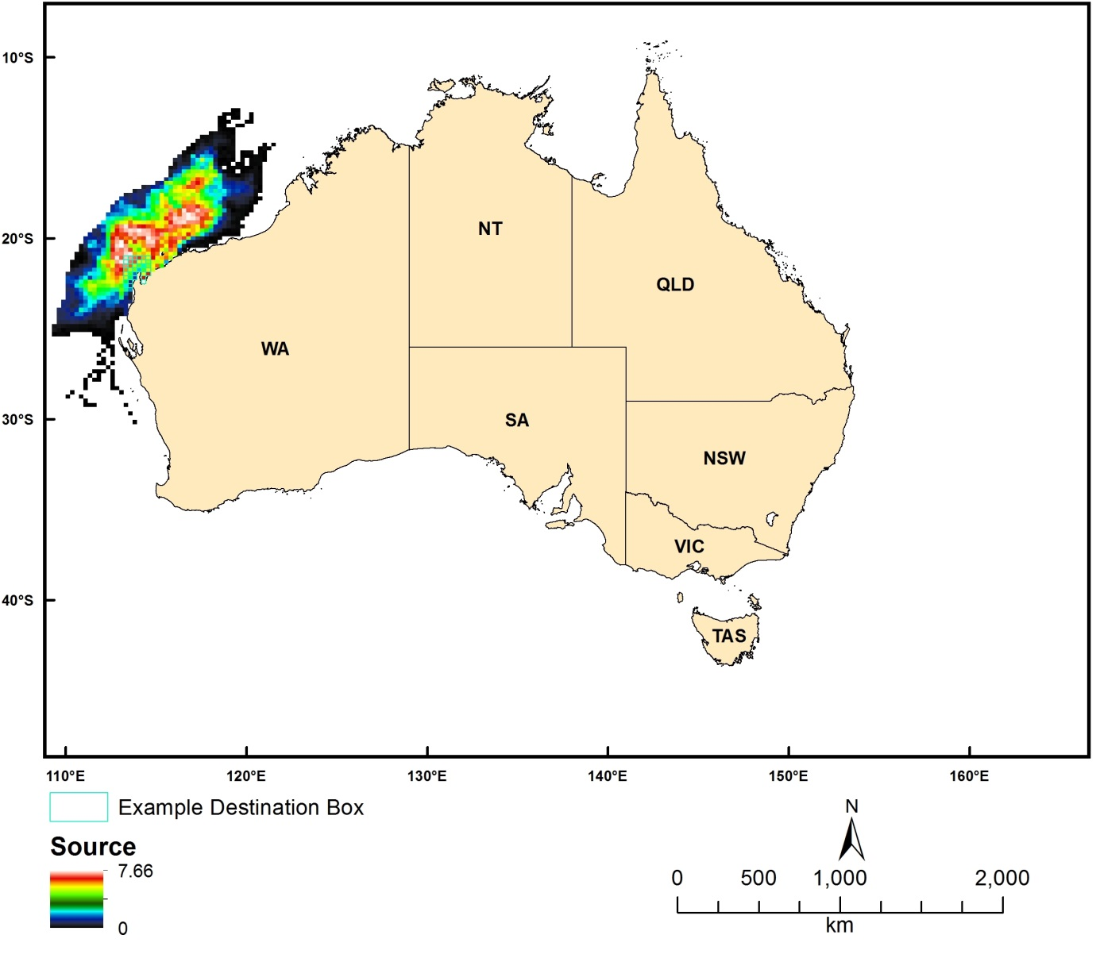
Figure 2.8.3 Modelled (Conn4D) source capacity (as Log Count) from particles intersecting the Ningaloo area, Western Australia

Sink Capacity
Dataset TITLE
Conn4D - 4-dimensional biophysical connectivity model - sink capacity
Dataset ALTERNATE TITLE (i.e. Dataset Name)
Dataset AUTHOR(S)
Johnathan Kool
Dataset CUSTODIAN
Geoscience Australia
Dataset JURISDICTION
Australia
Description ABSTRACT
Connectivity research involves investigating the presence, strength and characteristics of spatiotemporal relationships between populations of organisms. Typically, marine organisms release large numbers (often on the order of millions) of young (larvae), which are difficult to follow via physical tracking. Instead, researchers have turned to numerical simulations, coupling models of ocean movement with larval behaviour.
The model described here uses oceanographic data (typically provided by ocean models such as HYCOM, BlueLink, POM or ROMS) to disperse artificially intelligent particles. The fundamental physical processes at work are advection and diffusion, however the particles are able to respond in a flexible manner to other parameters as well, for example temperature, salinity, or prey fields. Due to the object-oriented architecture of the model, various components can be changed, improved or modified without altering the base structure of the code.
This data set represents the degree to which destination polygons act as a sink to particles sent out from a selected set of source polygons (from selected source to a general set of destinations). The destination polygons can be of arbitrary size, shape and configuration.
Description Data Category
Oceans
Environment
Description Keyword
Oceans, Marine Biology, Marine Invertebrates, Fish, Coastal Processes, Coral Reefs, Marine Geophysics, Submarine Canyons, Ocean Circulation, Advection, Diffusion, Ocean Currents
Description GEOGRAPHIC EXTENT POLYGON(S)
N_LAT: -5
S_LAT: -50
E_LONG: 100
W_LONG: 170
COORDINATE SYSTEM DESCRIPTION
Projection: Geographic
Datum: WGS84
Units: Decimal Degree
Description Temporal EXTENT
01-Jan-09 to 27-Feb-13
Description NOMINAL SCALE
Spatial Resolution:
Temporal Resolution:
Data Currency BEGINNING DATE
04-Apr-2013
Data Currency ENDING DATE
Dataset Status PROGRESS
underDevelopment
Dataset Status MAINTENANCE AND UPDATE FREQUENCY
Access STORED FORMATS Digital/Non-Digital Description
Access AVAILABLE FORMATS Digital/Non-Digital Description
Access ACCESS CONSTRAINT
Please cite the data set using the following format: National Environmental Research Program (NERP) Marine Biodiversity Hub [year-of-data-download], [Title], [data-access-URL], accessed [date-of-access].
Data Quality LINEAGE
The data was produced by using ocean velocity fields provided by the HYCOM model (www.hycom.org) to drive a biophysical dispersal model written in Java (Conn4D: source code available at https://github.com/jkool/Conn4D).
Data Quality POSITIONAL ACCURACY
Data Quality ATTRIBUTE ACCURACY
Data Quality LOGICAL CONSISTENCY
Data Quality COMPLETENESS
Contact Information CONTACT ORGANISATION
Geoscience Australia
Contact Information CONTACT POSITION
Marine Data Manager
Contact Information MAIL ADDRESS 1
GPO Box 378
Contact Information SUBURB/PLACE/LOCALITY
Canberra
Contact Information STATE/LOCALITY 2
ACT
Contact Information COUNTRY
Australia
Contact Information POSTCODE
2601
Contact Information TELEPHONE
+61 2 6249 9111
Contact Information FACSIMILE
+61 2 6249 9999
Contact Information ELECTRONIC MAIL ADDRESS
marine@ga.gov.au
Metadata Date METADATA DATE
20MAR2013
Additional Metadata METADATA AUTHOR
Johnathan Kool
Additional Metadata ACKNOWLEDGEMENTS
Johnathan Kool
Claire Paris (University of Miami, Florida)
Ashwanth Srinivasan (University of Miami, Florida)
Bob Cowen (Oregon State University, Oregon)
Data was sourced from the NERP Marine Biodiversity Hub – the Marine Biodiversity Hub is supported through funding from the Australian Government’s National Environmental Research Program (NERP), administered by the Department of Sustainability, Environment, Water, Population and Communities (DSEWPaC).
Additional Metadata REFERENCES

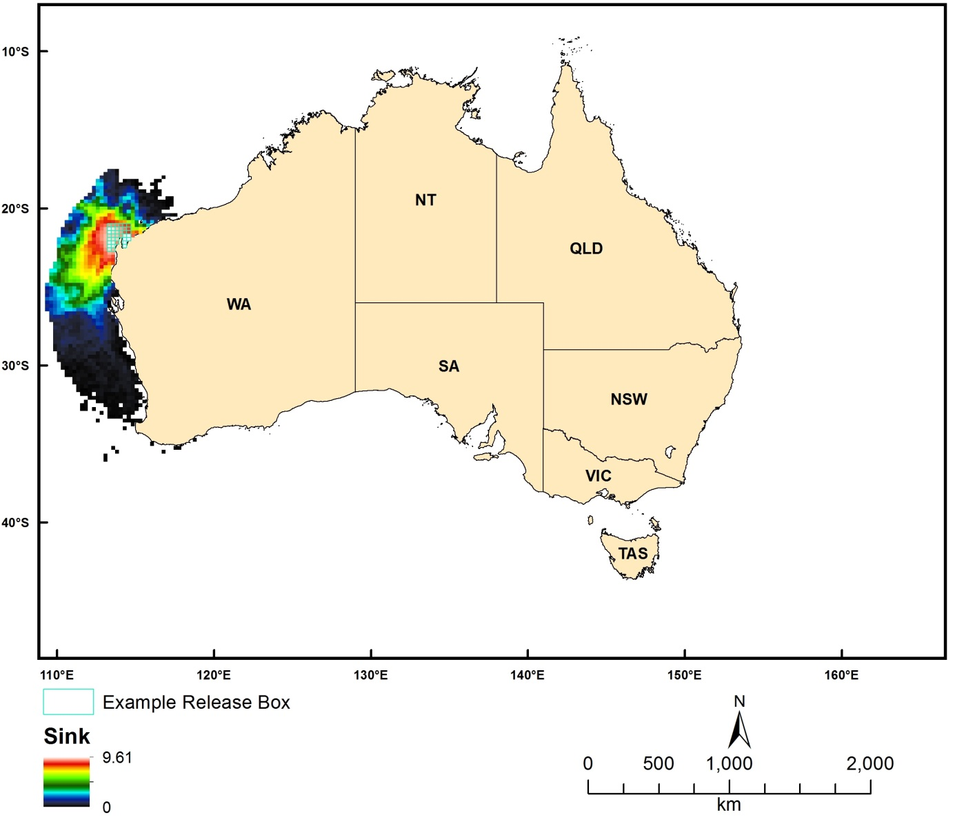
Figure 2.8.4 Modelled (Conn4D) sink capacity (as Log Count) from particles released from the Ningaloo area, Western Australia

Total Activity
Dataset TITLE
Conn4D - 4-dimensional biophysical connectivity model - total activity
Dataset ALTERNATE TITLE (i.e. Dataset Name)
Dataset AUTHOR(S)
Johnathan Kool
Dataset CUSTODIAN
Geoscience Australia
Dataset JURISDICTION
Australia
Description ABSTRACT
Connectivity research involves investigating the presence, strength and characteristics of spatiotemporal relationships between populations of organisms. Typically, marine organisms release large numbers (often on the order of millions) of young (larvae), which are difficult to follow via physical tracking. Instead, researchers have turned to numerical simulations, coupling models of ocean movement with larval behaviour.
The model described here uses oceanographic data (typically provided by ocean models such as HYCOM, BlueLink, POM or ROMS) to disperse artificially intelligent particles. The fundamental physical processes at work are advection and diffusion, however the particles are able to respond in a flexible manner to other parameters as well, for example temperature, salinity, or prey fields. Due to the object-oriented architecture of the model, various components can be changed, improved or modified without altering the base structure of the code.
This data set represents the degree to which polygons act as both a source and sink of particles, giving an indication of the total activity taking place (source capacity + sink capacity).
Description Data Category
Oceans
Environment
Description Keyword
Oceans, Marine Biology, Marine Invertebrates, Fish, Coastal Processes, Coral Reefs, Marine Geophysics, Submarine Canyons, Ocean Circulation, Advection, Diffusion, Ocean Currents
Description GEOGRAPHIC EXTENT POLYGON(S)
N_LAT: -5
S_LAT: -50
E_LONG: 100
W_LONG: 170
COORDINATE SYSTEM DESCRIPTION
Projection: Geographic
Datum: WGS84
Units: Decimal Degree
Description Temporal EXTENT
01-Jan-09 to 27-Feb-13
Description NOMINAL SCALE
Spatial Resolution:
Temporal Resolution:
Data Currency BEGINNING DATE
04-Apr-2013
Data Currency ENDING DATE
Dataset Status PROGRESS
underDevelopment
Dataset Status MAINTENANCE AND UPDATE FREQUENCY
Access STORED FORMATS Digital/Non-Digital Description
Access AVAILABLE FORMATS Digital/Non-Digital Description
Access ACCESS CONSTRAINT
Please cite the data set using the following format: National Environmental Research Program (NERP) Marine Biodiversity Hub [year-of-data-download], [Title], [data-access-URL], accessed [date-of-access].
Data Quality LINEAGE
The data was produced by using ocean velocity fields provided by the HYCOM model (www.hycom.org) to drive a biophysical dispersal model written in Java (Conn4D: source code available at https://github.com/jkool/Conn4D).
Data Quality POSITIONAL ACCURACY
Data Quality ATTRIBUTE ACCURACY
Data Quality LOGICAL CONSISTENCY
Data Quality COMPLETENESS
Contact Information CONTACT ORGANISATION
Geoscience Australia
Contact Information CONTACT POSITION
Marine Data Manager
Contact Information MAIL ADDRESS 1
GPO Box 378
Contact Information SUBURB/PLACE/LOCALITY
Canberra
Contact Information STATE/LOCALITY 2
ACT
Contact Information COUNTRY
Australia
Contact Information POSTCODE
2601
Contact Information TELEPHONE
+61 2 6249 9111
Contact Information FACSIMILE
+61 2 6249 9999
Contact Information ELECTRONIC MAIL ADDRESS
marine@ga.gov.au
Metadata Date METADATA DATE
20MAR2013
Additional Metadata METADATA AUTHOR
Johnathan Kool
Additional Metadata ACKNOWLEDGEMENTS
Johnathan Kool
Claire Paris (University of Miami, Florida)
Ashwanth Srinivasan (University of Miami, Florida)
Bob Cowen (Oregon State University, Oregon)
Data was sourced from the NERP Marine Biodiversity Hub – the Marine Biodiversity Hub is supported through funding from the Australian Government’s National Environmental Research Program (NERP), administered by the Department of Sustainability, Environment, Water, Population and Communities (DSEWPaC).
Additional Metadata REFERENCES

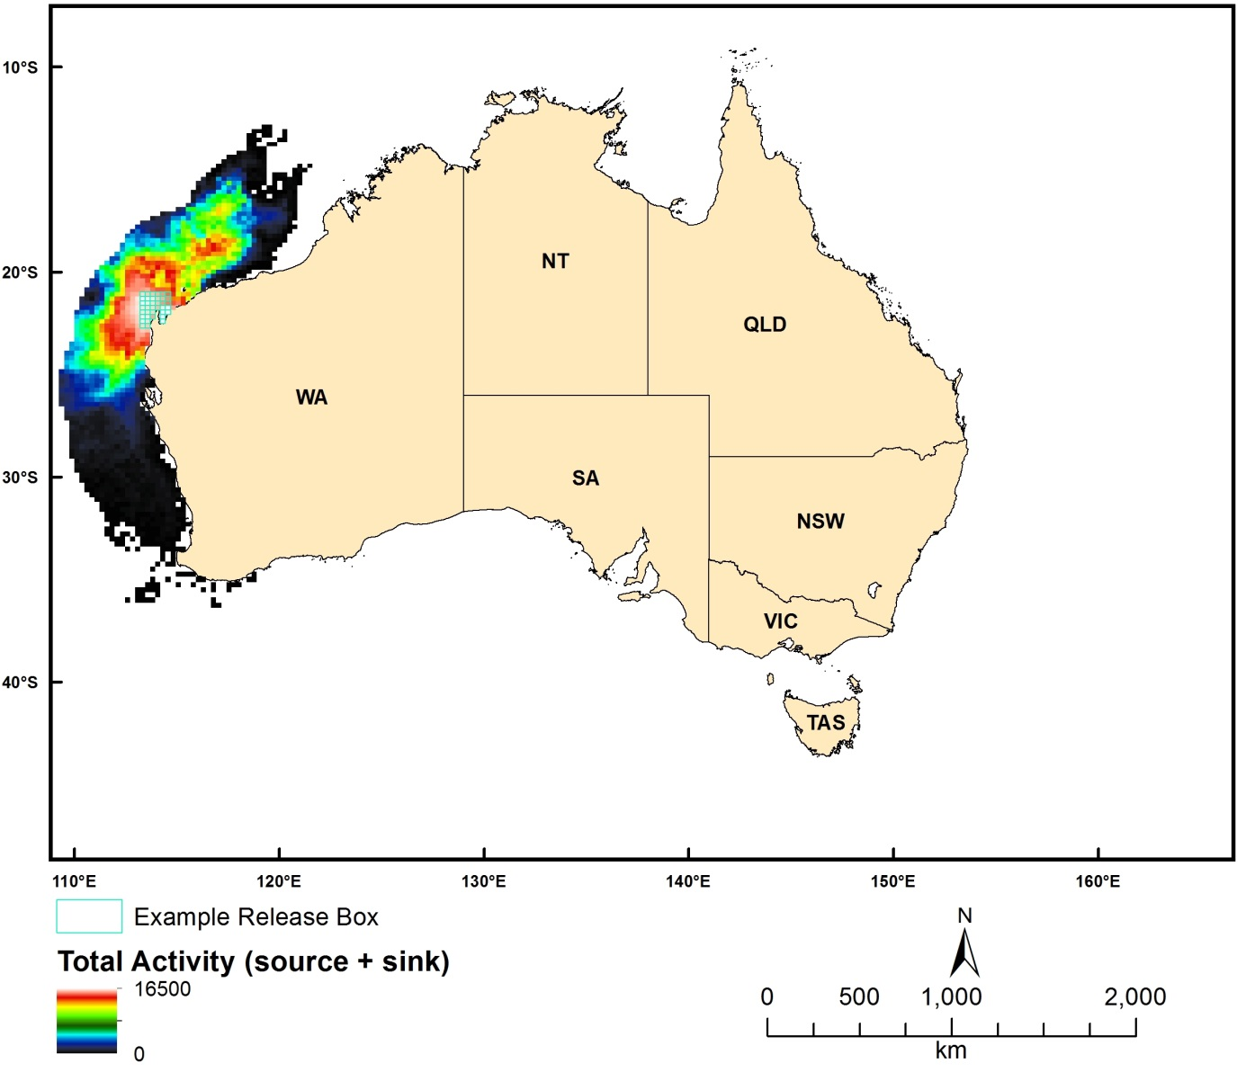
Figure 2.8.5 Modelled (Conn4D) total activity from particles released from the Ningaloo area, Western Australia

Net Activity
Dataset TITLE
Conn4D - 4-dimensional biophysical connectivity model - net activity
Dataset ALTERNATE TITLE (i.e. Dataset Name)
Dataset AUTHOR(S)
Johnathan Kool
Dataset CUSTODIAN
Geoscience Australia
Dataset JURISDICTION
Australia
Description ABSTRACT
Connectivity research involves investigating the presence, strength and characteristics of spatiotemporal relationships between populations of organisms. Typically, marine organisms release large numbers (often on the order of millions) of young (larvae), which are difficult to follow via physical tracking. Instead, researchers have turned to numerical simulations, coupling models of ocean movement with larval behaviour.
The model described here uses oceanographic data (typically provided by ocean models such as HYCOM, BlueLink, POM or ROMS) to disperse artificially intelligent particles. The fundamental physical processes at work are advection and diffusion, however the particles are able to respond in a flexible manner to other parameters as well, for example temperature, salinity, or prey fields. Due to the object-oriented architecture of the model, various components can be changed, improved or modified without altering the base structure of the code.
This data set represents the difference between the degree to which polygons act as source and sink of particles, giving an indication of the net activity taking place (source capacity - sink capacity).
Description Data Category
Oceans
Environment
Description Keyword
Oceans, Marine Biology, Marine Invertebrates, Fish, Coastal Processes, Coral Reefs, Marine Geophysics, Submarine Canyons, Ocean Circulation, Advection, Diffusion, Ocean Currents
Description GEOGRAPHIC EXTENT POLYGON(S)
N_LAT: -5
S_LAT: -50
E_LONG: 100
W_LONG: 170
COORDINATE SYSTEM DESCRIPTION
Projection: Geographic
Datum: WGS84
Units: Decimal Degree
Description Temporal EXTENT
01-Jan-09 to 27-Feb-13
Description NOMINAL SCALE
Spatial Resolution:
Temporal Resolution:
Data Currency BEGINNING DATE
04-Apr-2013
Data Currency ENDING DATE
Dataset Status PROGRESS
underDevelopment
Dataset Status MAINTENANCE AND UPDATE FREQUENCY
Access STORED FORMATS Digital/Non-Digital Description
Access AVAILABLE FORMATS Digital/Non-Digital Description
Access ACCESS CONSTRAINT
Please cite the data set using the following format: National Environmental Research Program (NERP) Marine Biodiversity Hub [year-of-data-download], [Title], [data-access-URL], accessed [date-of-access].
Data Quality LINEAGE
The data was produced by using ocean velocity fields provided by the HYCOM model (www.hycom.org) to drive a biophysical dispersal model written in Java (Conn4D: source code available at https://github.com/jkool/Conn4D).
Data Quality POSITIONAL ACCURACY
Data Quality ATTRIBUTE ACCURACY
Data Quality LOGICAL CONSISTENCY
Data Quality COMPLETENESS
Contact Information CONTACT ORGANISATION
Geoscience Australia
Contact Information CONTACT POSITION
Marine Data Manager
Contact Information MAIL ADDRESS 1
GPO Box 378
Contact Information SUBURB/PLACE/LOCALITY
Canberra
Contact Information STATE/LOCALITY 2
ACT
Contact Information COUNTRY
Australia
Contact Information POSTCODE
2601
Contact Information TELEPHONE
+61 2 6249 9111
Contact Information FACSIMILE
+61 2 6249 9999
Contact Information ELECTRONIC MAIL ADDRESS
marine@ga.gov.au
Metadata Date METADATA DATE
20MAR2013
Additional Metadata METADATA AUTHOR
Johnathan Kool
Additional Metadata ACKNOWLEDGEMENTS
Johnathan Kool
Claire Paris (University of Miami, Florida)
Ashwanth Srinivasan (University of Miami, Florida)
Bob Cowen (Oregon State University, Oregon)
Data was sourced from the NERP Marine Biodiversity Hub – the Marine Biodiversity Hub is supported through funding from the Australian Government’s National Environmental Research Program (NERP), administered by the Department of Sustainability, Environment, Water, Population and Communities (DSEWPaC).
Additional Metadata REFERENCES

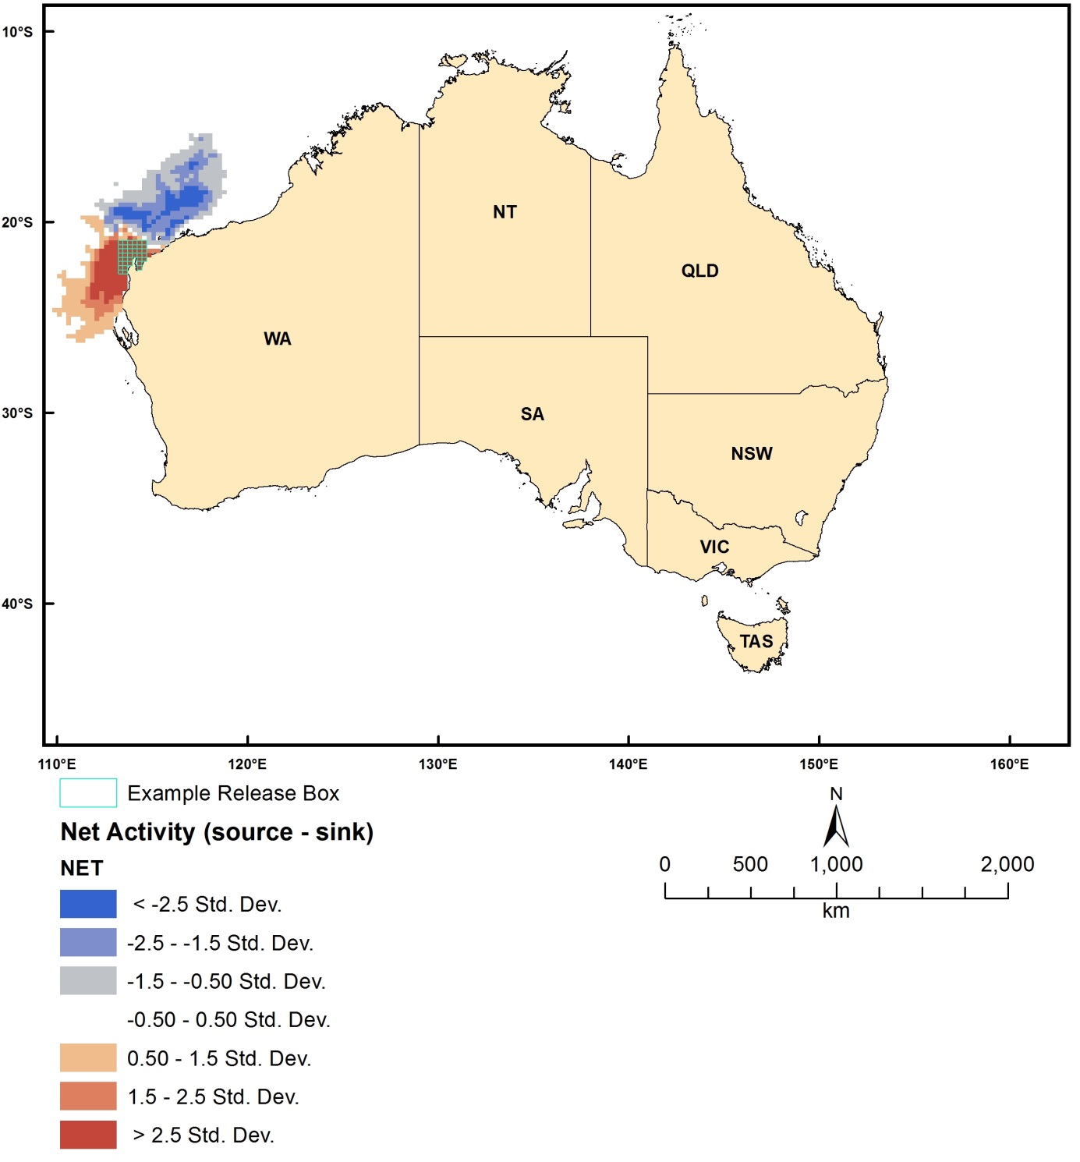
Figure 2.8.6 Modelled (Conn4D) net activity from particles released from the Ningaloo area, Western Australia

Biological Data

Western Australian Sea Around Us Fish Data
Dataset TITLE
Sea Around Us Project (SAUP) - West Australian Marine Fisheries
Dataset ALTERNATE TITLE (i.e. Dataset Name)
SAUP
Dataset AUTHOR(S)
Dataset CUSTODIAN
Fisheries Centre, The University of British Columbia
Dataset JURISDICTION
Western Australia
Description ABSTRACT
Fisheries landings and associated expanded effort for the West Australian EEZ and coastal waters. Catches expressed as annual, gear-specific tonnage of species caught in each half degree spatial cell over period spanning 1950-2006. Effort expressed as kilowatt sea days, which corresponds to the power of the vessel's main engine and the days of fishing it was employed for (in measures where there is no time unit, this has been annualised to make it the equivalent of continuous power).
Positional accuracy is 0.5 decimal degrees
Description Data Category
Oceans
Environment
Biota
Description Keyword
Biosphere, Aquatic Habitat, Pelagic Habitat, Zoology, Fish, Marine Biology, Oceans, Agriculture, Agricultural Aquatic Sciences, Fisheries
Description GEOGRAPHIC EXTENT POLYGON(S)
N_LAT: -8.25
S_LAT: -38.75
E_LONG: 93.25
W_LONG: 129.75
COORDINATE SYSTEM DESCRIPTION
Projection: Geographic
Datum: WGS84
Units: Decimal Degree
Description Temporal EXTENT
Description NOMINAL SCALE
Spatial Resolution:
Temporal Resolution:
Data Currency BEGINNING DATE
Data Currency ENDING DATE
31-Dec-06
Dataset Status PROGRESS
Completed
Dataset Status MAINTENANCE AND UPDATE FREQUENCY
Updated as needed
Access STORED FORMATS Digital/Non-Digital Description
DIGITAL shapefile
Access AVAILABLE FORMATS Digital/Non-Digital Description
Access ACCESS CONSTRAINT
Contact data custodian
Data Quality LINEAGE
Dataset derived by disaggregating and assigning reported catches from FAO, ICES, NAFO and other international agencies into half degree spatial cells using a series of constraints including the statistical areas used in the original datasets (e.g. FAO statistical areas), the known distributions of the exploited species, and a database of fishing access arrangements developed by J. Alder, W. Swartz, and others, and which provides information on the operations of distant water fishing fleets in the waters (or EEZ) of maritime countries. Effort dataset consists of independently derived measures of spatialised fishing effort.
Potential human error when identifying species. Some catches recorded as unidentified
Effort dataset was derived independently and is incomplete (does not cover all grid cells in all years)
Data Quality POSITIONAL ACCURACY
0.5 decimal degree
Data Quality ATTRIBUTE ACCURACY
Data Quality LOGICAL CONSISTENCY
Data Quality COMPLETENESS
Contact Information CONTACT ORGANISATION
Fisheries Centre The University of British Columbia
Contact Information CONTACT POSITION
Dirk Zeller
Contact Information MAIL ADDRESS 1
2202 Main Mal
Contact Information SUBURB/PLACE/LOCALITY
Vancouver
Contact Information STATE/LOCALITY 2
British Columbia
Contact Information COUNTRY
Canada
Contact Information POSTCODE
V6T 1Z4
Contact Information TELEPHONE
+1 604 822 1950
Contact Information FACSIMILE
+1 604 822 8934
Contact Information ELECTRONIC MAIL ADDRESS
d.zeller@fisheries.ubc.ca
Metadata Date METADATA DATE
20MAR2013
Additional Metadata METADATA AUTHOR
Reg Watson
Additional Metadata ACKNOWLEDGEMENTS
Additional Metadata REFERENCES
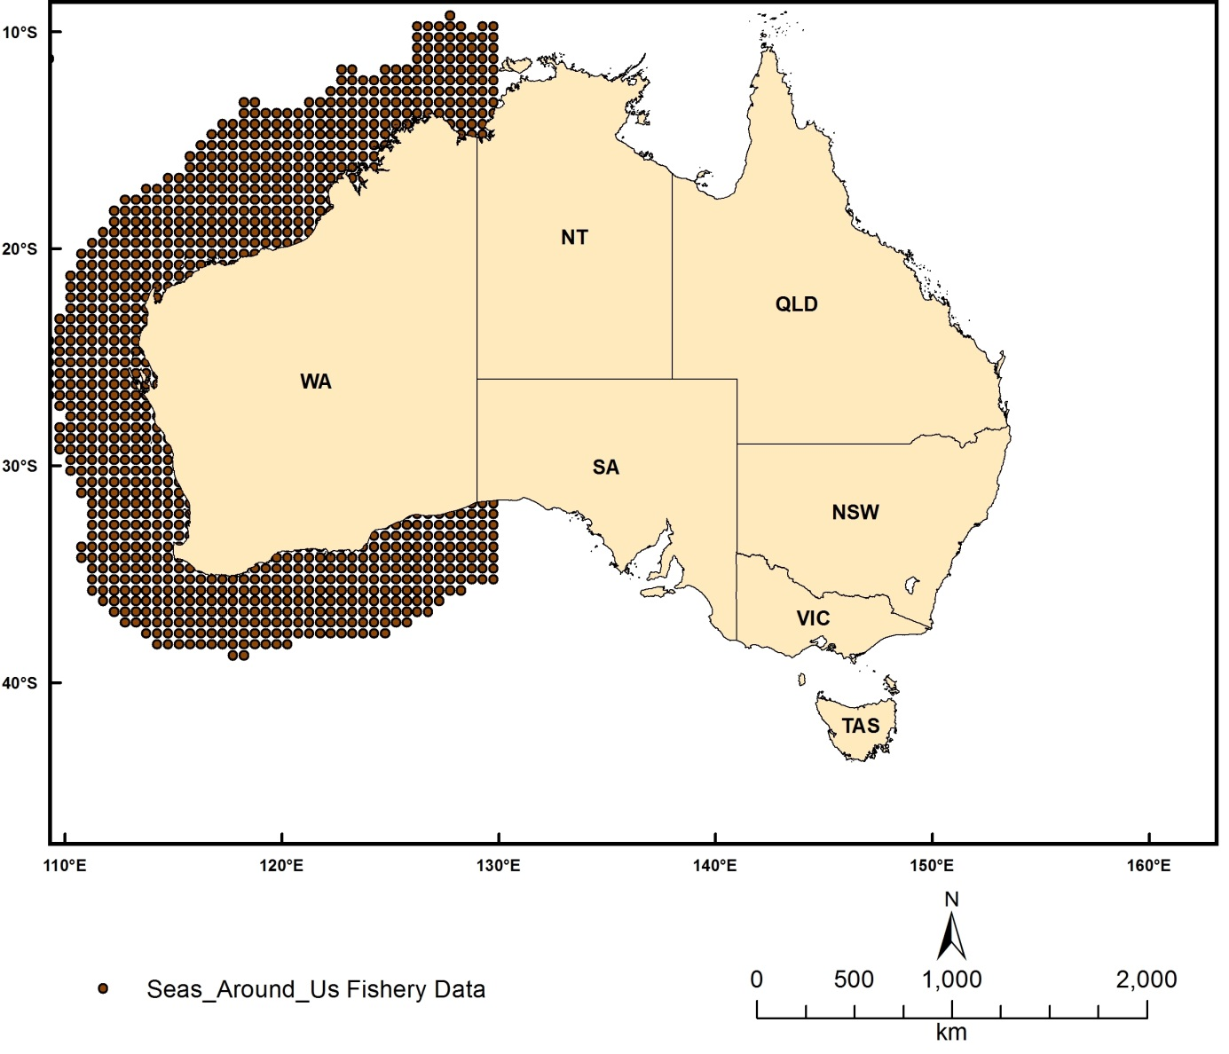
Figure 2.9.1 Locations of Sea-Around-Us fish data

Australian Brittlestars
Dataset TITLE
Brittlestars of Australia
Dataset ALTERNATE TITLE (i.e. Dataset Name)
Ophiuroids of Australia
Dataset AUTHOR(S)
Dataset CUSTODIAN
Museum of Victoria
Dataset JURISDICTION
Australia
Description ABSTRACT
This dataset comprises records of brittle stars (Ophiuroidea) collected from within Australia's EEZ. Data is collated from museum collections in Australia and overseas and from the scientific literature. Records includes the number of specimens collected, the institution where they are lodged and a catalogue number where available; taxonomic information (species name, higher taxonomy, identifier, taxomomic certainty) and locality information (latitude, longitude, depth, survey, station).
Description Data Category
Oceans
Environment
Biota
Description Keyword
Biosphere, Aquatic Habitat, Benthic Habitat, Zoology, Echinoderms, Oceans, Marine Biology, Marine Invertebrates
Description GEOGRAPHIC EXTENT POLYGON(S)
N_LAT: -8
S_LAT: -50
E_LONG: 105
W_LONG: 165
COORDINATE SYSTEM DESCRIPTION
Projection: Geographic
Datum: WGS84
Units: Decimal Degree
Description Temporal EXTENT
Description NOMINAL SCALE
Spatial Resolution:
Temporal Resolution:
Data Currency BEGINNING DATE
2013
Data Currency ENDING DATE
15-Feb-13
Dataset Status PROGRESS
onGoing
Dataset Status MAINTENANCE AND UPDATE FREQUENCY
Updated as needed
Access STORED FORMATS Digital/Non-Digital Description
Access AVAILABLE FORMATS Digital/Non-Digital Description
Access ACCESS CONSTRAINT
Please cite the data set using the following format: National Environmental Research Program (NERP) Marine Biodiversity Hub [year-of-data-download], [Title], [data-access-URL], accessed [date-of-access].
Data Quality LINEAGE
Data is collated from museum collections in Australia and overseas and from the scientific literature
Data Quality POSITIONAL ACCURACY
Data Quality ATTRIBUTE ACCURACY
Data Quality LOGICAL CONSISTENCY
Data Quality COMPLETENESS
Contact Information CONTACT ORGANISATION
Museum of Victoria
Contact Information CONTACT POSITION
Tim O’Hara
Contact Information MAIL ADDRESS 1
Museum of Victoria
Contact Information SUBURB/PLACE/LOCALITY
Melbourne
Contact Information STATE/LOCALITY 2
VIC
Contact Information COUNTRY
Australia
Contact Information POSTCODE
3001
Contact Information TELEPHONE
+61 3 8341 7441
Contact Information FACSIMILE
Contact Information ELECTRONIC MAIL ADDRESS
tohara@museum.vic.gov.au
Metadata Date METADATA DATE
20MAR2013
Additional Metadata METADATA AUTHOR
Rachel Przeslawski
Additional Metadata ACKNOWLEDGEMENTS
Data was sourced from the NERP Marine Biodiversity Hub – the Marine Biodiversity Hub is supported through funding from the Australian Government’s National Environmental Research Program (NERP), administered by the Department of Sustainability, Environment, Water, Population and Communities (DSEWPaC).
Additional Metadata REFERENCES

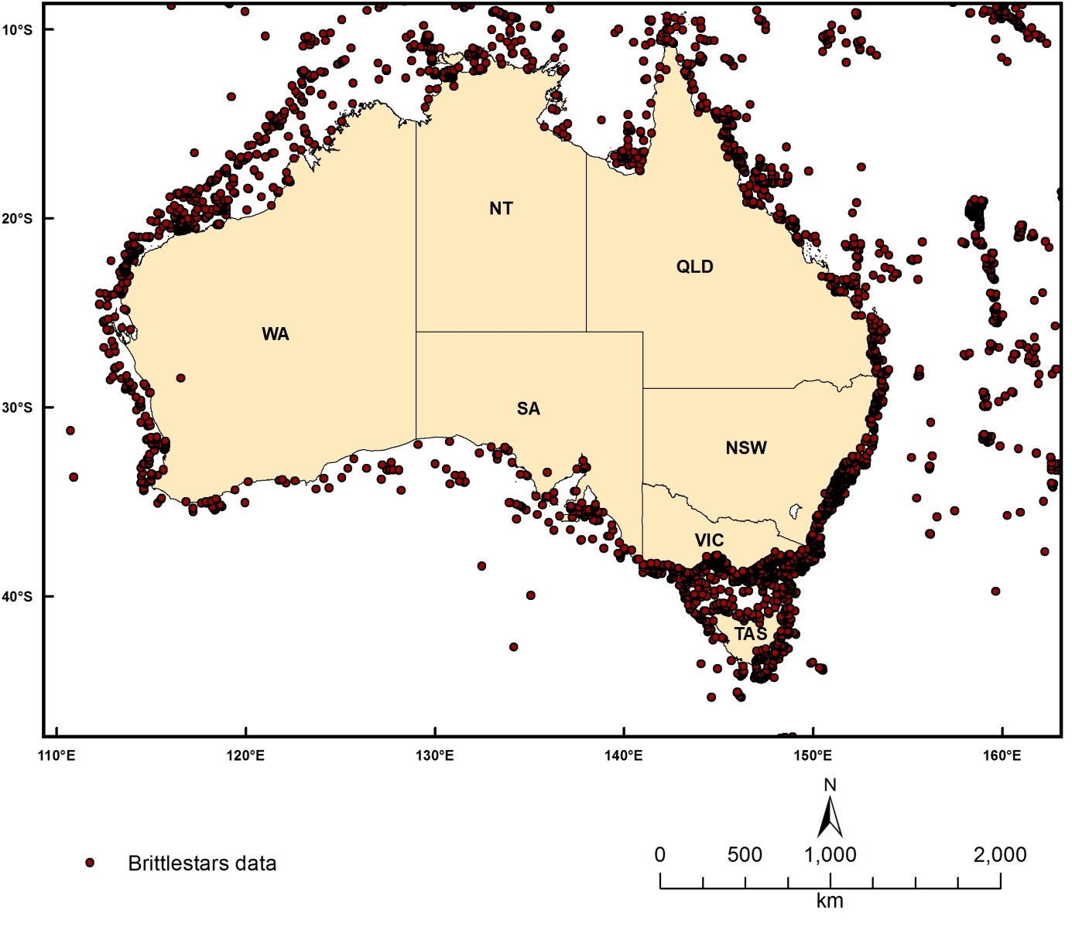
Figure 2.9.2 Locations of Australian Brittlestars Data

Fish AFMA catch data
Dataset TITLE
Commonwealth Fisheries Footprint
Dataset ALTERNATE TITLE (i.e. Dataset Name)
Dataset AUTHOR(S)
Dataset CUSTODIAN
Australian Fisheries Management Authority (AFMA)
Dataset JURISDICTION
Australia
Description ABSTRACT
These coverages are from AFMA logbook data summarised to a common six minute grid by BRS for DSEWPaC. The following gear types are covered: scallop dredge, other line, unknown net, gill net, unknown line, pelagic long line, demersal long line auto, demersal long line, squid jig, aquaculture hand dive, lobster hand dive, abalone hand dive, pelagic purse seine trawl, pelagic mid-water trawl, pelagic demersal otter, demersal Danish seine trawl, demersal beam trawl, spanner trap, finfish crab lobster trap. All data are vetted for confidentiality, such that data are not shown where a reporting cell contains the catches of less than 5 boats.
The data provided is a summary where any activity has a value of 1 and cells without any fishing are given a value of zero.
Description Data Category
Oceans
Environment
Biota
Description Keyword
Oceans, Marine Biology, Fish
Description GEOGRAPHIC EXTENT POLYGON(S)
N_LAT: -10
S_LAT: -45
E_LONG: 110
W_LONG: 165
COORDINATE SYSTEM DESCRIPTION
Projection: Geographic
Datum: WGS84
Units: Decimal Degree
Description Temporal EXTENT
1996 to 2003
Description NOMINAL SCALE
Spatial Resolution:
Temporal Resolution:
Data Currency BEGINNING DATE
2012
Data Currency ENDING DATE
04-Apr-13
Dataset Status PROGRESS
Completed
Dataset Status MAINTENANCE AND UPDATE FREQUENCY
notPlanned
Access STORED FORMATS Digital/Non-Digital Description
Access AVAILABLE FORMATS Digital/Non-Digital Description
Access ACCESS CONSTRAINT
Contact data custodian
Data Quality LINEAGE
Data Quality POSITIONAL ACCURACY
Data Quality ATTRIBUTE ACCURACY
Data Quality LOGICAL CONSISTENCY
Data Quality COMPLETENESS
Contact Information CONTACT ORGANISATION
Australian Fisheries Management Authority (AFMA)
Contact Information CONTACT POSITION
Collection Manager
Contact Information MAIL ADDRESS 1
73 Northbourne Avenue
Contact Information SUBURB/PLACE/LOCALITY
Canberra City
Contact Information STATE/LOCALITY 2
ACT
Contact Information COUNTRY
Australia
Contact Information POSTCODE
2600
Contact Information TELEPHONE
Contact Information FACSIMILE
Contact Information ELECTRONIC MAIL ADDRESS
Metadata Date METADATA DATE
20MAR2013
Additional Metadata METADATA AUTHOR
Piers Dunstan (CSIRO)
Additional Metadata ACKNOWLEDGEMENTS
Additional Metadata REFERENCES

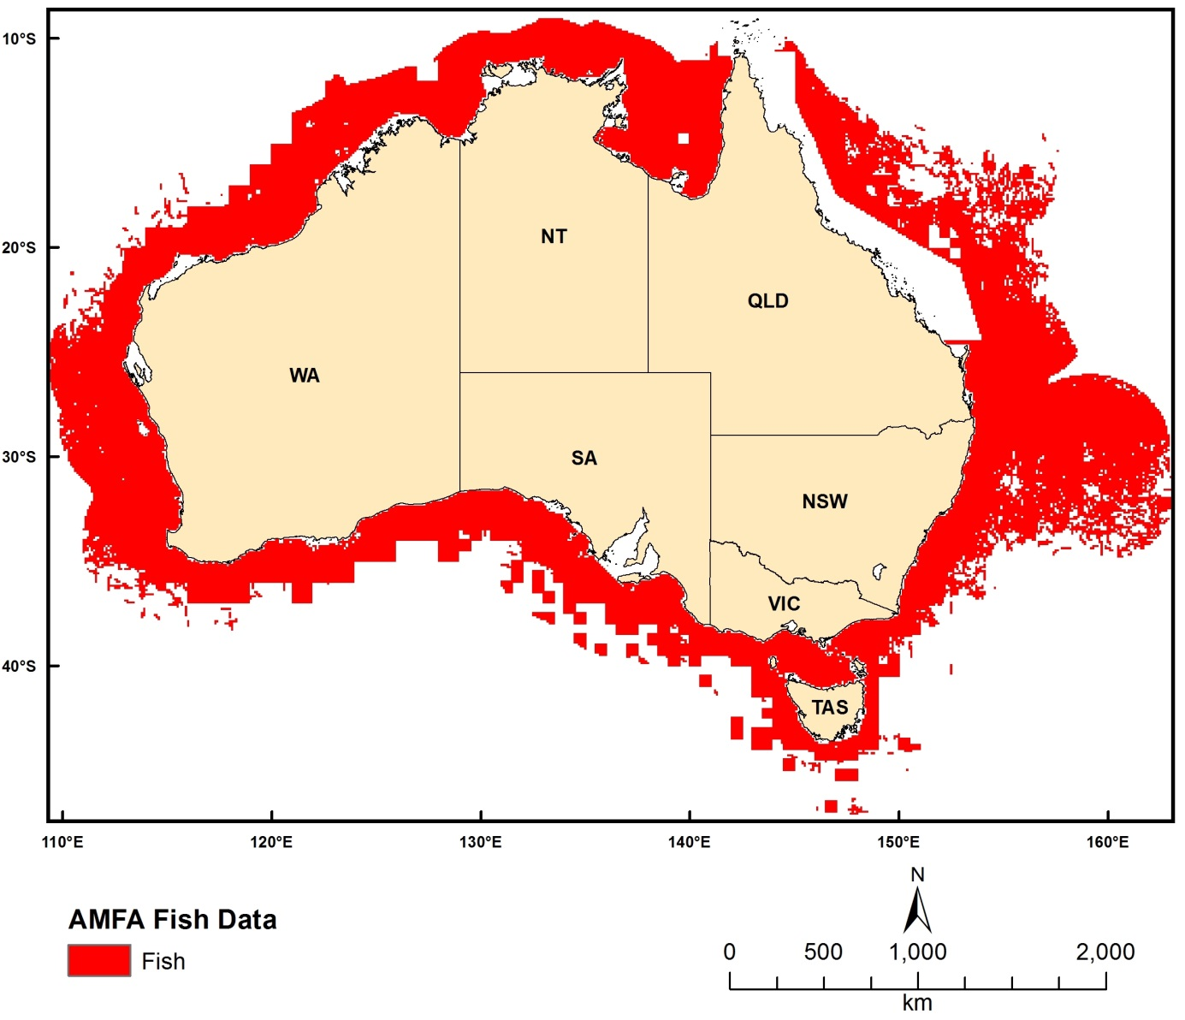
Figure 2.9.3 Locations of AFMA fish catch data

Australian National Fish Collection (CSIRO)
Dataset TITLE
Australian National Fish Collection
Dataset ALTERNATE TITLE (i.e. Dataset Name)
CSIRO Australian National Fish Collection
Dataset AUTHOR(S)
Dataset CUSTODIAN
CSIRO Marine and Atmospheric Research (CMAR)
Dataset JURISDICTION
Australia
Description ABSTRACT
This dataset gives species-level identifications for ~22% of finfish housed in the Australian National Fish Collection at CSIRO Marine and Atmospheric Research in Hobart (~148,000 specimens as of Feb 2013 which includes marine, estuarine, and freshwater species). The dataset is available via the Atlas of Living Australia (www.ala.org) with ~26,000 marine species listed. The Australian National Fish Collection is a comprehensive and internationally-renowned biodiversity reference and research facility. Since its foundation by Ian Munro in 1943, the collection has grown to house more than 148 000 finfish specimens representing more than 3000 species. These include Australian, Antarctic and Indo-Pacific oceanic, inshore, estuarine and river fishes. The Collection holds 195 holotypes (primary type specimens) and 1540 paratypes (supplementary specimens) of 300 newly described species. It also contains a substantial amount of voucher material relating to published books and papers, illustrations and photographs. A valuable component of the Collection is the large Photographic Index of Australian Fishes and the radiographs, which are useful for detailed bone studies. The Collection also contains hundreds of jars of ichthyoplankton (fish eggs and larval fish), some of which are unsorted, and collections of otoliths (ear bones, for determining the age of fish).
Description Data Category
Oceans
Environment
Biota
Description Keyword
Biosphere, Aquatic Habitat, Benthic Habitat, Estuarine Habitat, Pelagic Habitat, Zoology, Fish, Oceans, Marine Biology
Description GEOGRAPHIC EXTENT POLYGON(S)
N_LAT: 45
S_LAT: -85
E_LONG: 75
W_LONG: 180
COORDINATE SYSTEM DESCRIPTION
Projection: Geographic
Datum: WGS84
Units: Decimal Degree
Description Temporal EXTENT
Description NOMINAL SCALE
Spatial Resolution:
Temporal Resolution:
Data Currency BEGINNING DATE
1943
Data Currency ENDING DATE
2011
Dataset Status PROGRESS
Completed
Dataset Status MAINTENANCE AND UPDATE FREQUENCY
Updated as needed
Access STORED FORMATS Digital/Non-Digital Description
Access AVAILABLE FORMATS Digital/Non-Digital Description
Access ACCESS CONSTRAINT
Contact data custodian
Data Quality LINEAGE
Approximately 2,800 of Australia's estimated 4,500 fish species are represented in the collection. Judged by the diversity of species it holds, the Collection is among the largest in the Southern Hemisphere. All specialist collections strive for quality and diversity. The Collection focuses on Indo Pacific shark and ray, and temperate and Southern Ocean species making it a pre-eminence among international collections. The 135,000 specimens from 2,800 species (representing 300 fish families) include oceanic, deep-water, demersal, inshore, estuarine, river and lake fishes. Most are from Australian waters, but there are also collections from Papua New Guinea, the Bismarck Archipelago and the Solomon Islands, as well as fish from New Zealand, the Antarctic continent and sub-Antarctic islands, Europe and South-east Asia, including Sri Lanka, Malaysia, the Philippines and Japan. The Collection holds 35 holotypes and 200 paratypes of 70 species new to science. It also contains a substantial amount of voucher material relating to published books and papers, illustrations and photographs. A valuable component of the Collection is the large Photographic Index of Australian Fishes (PIAF) and the radiographs, which are useful for detailed bone studies. The Collection also contains hundreds of jars of ichthyoplankton (fish eggs and larval fish), some of which are unsorted, and collections of otoliths (ear bones, for determining the age of fish). A computerized index of the contents of the Collection has been developed using Texpress software designed by KE Software of Melbourne. This index will be linked up with other CSIRO collections and museum systems in the near future. A substantial collection from the Tasmanian Department of Sea Fisheries, together with material from museums, professional fishermen and other Government organisations, has been incorporated into the Collection, which is managed by a staff of three people. The in-house CSIRO database was partially uploaded to the Atlas of Living Australia in 2011 for public access.
Data Quality POSITIONAL ACCURACY
Data Quality ATTRIBUTE ACCURACY
Data Quality LOGICAL CONSISTENCY
Data Quality COMPLETENESS
Contact Information CONTACT ORGANISATION
CSIRO Marine and Atmospheric Research (CMAR)
Contact Information CONTACT POSITION
Collection Manager
Contact Information MAIL ADDRESS 1
Castray Esplanade
Contact Information SUBURB/PLACE/LOCALITY
Hobart
Contact Information STATE/LOCALITY 2
TAS
Contact Information COUNTRY
Australia
Contact Information POSTCODE
7000
Contact Information TELEPHONE
Contact Information FACSIMILE
Contact Information ELECTRONIC MAIL ADDRESS
alastair.graham@csiro.au
Metadata Date METADATA DATE
20MAR2013
Additional Metadata METADATA AUTHOR
Rachel Przeslawski
Additional Metadata ACKNOWLEDGEMENTS
Additional Metadata REFERENCES

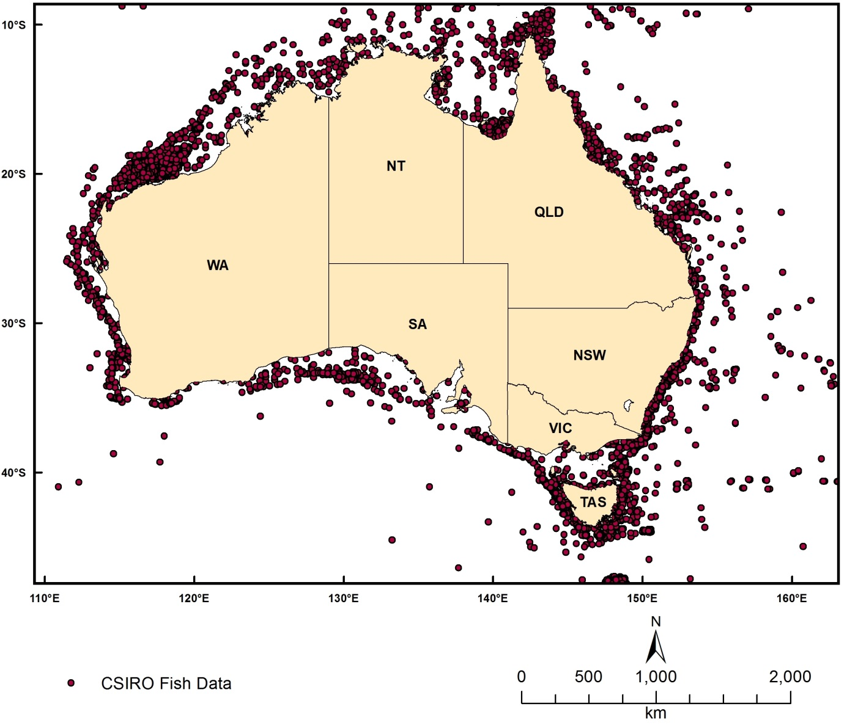
Figure 2.9.4 Locations of CSIRO fish data

Australian megavertebrates
Dataset TITLE
Megavertebrates of Australian EEZ
Dataset ALTERNATE TITLE (i.e. Dataset Name)
OBIS-SEAMAP for Australian EEZ
Dataset AUTHOR(S)
Dataset CUSTODIAN
Duke University (Global Database); CSIRO (Australian database; custodian Tony Rees)
Dataset JURISDICTION
Australia
Description ABSTRACT
OBIS-SEAMAP (Ocean Biogeographic Information System Spatial Ecological Analysis of Megavertebrate Populations) is an initiative of the Census of Marine Life which was started in 2002 under researchers at Duke University. OBIS-SEAMAP is a spatially and temporally interactive online archive for marine mammal, sea turtle, and seabird data. Data is contributed from providers all over the world.
OBIS-SEAMAP can be accessed here: http://seamap.env.duke.edu.
The observation data held by OBIS-SEAMAP are collected from various data providers worldwide. They are registered into the OBIS-SEAMAP database and presented on the web site upon data providers' permission. The ownership of the data belongs to the data providers.
Description Data Category
Oceans
Environment
Biota
Description Keyword
Biosphere, Aquatic Habitat, Pelagic Habitat, Zoology, Reptiles, Vertebrates, Birds, Mammals, Oceans, Marine Biology, Fish, Marine Birds, Marine Mammals
Description GEOGRAPHIC EXTENT POLYGON(S)
N_LAT: -8
S_LAT: -50
E_LONG: 105
W_LONG: 165
COORDINATE SYSTEM DESCRIPTION
Projection: Geographic
Datum: WGS84
Units: Decimal Degree
Description Temporal EXTENT
Description NOMINAL SCALE
Spatial Resolution:
Temporal Resolution:
Data Currency BEGINNING DATE
2002
Data Currency ENDING DATE
2013
Dataset Status PROGRESS
Completed
Dataset Status MAINTENANCE AND UPDATE FREQUENCY
Frequently
Access STORED FORMATS Digital/Non-Digital Description
Access AVAILABLE FORMATS Digital/Non-Digital Description
Access ACCESS CONSTRAINT
Contact data custodian
Data Quality LINEAGE
OBIS-SEAMAP project was established by the Census of Marine Life program in 2002 under the leadership of Duke University. The project involves a consortium of organisations and individuals who share a vision to make marine biogeographic data freely available to the public. SEAMAP is one of the participating network data nodes of OBIS (http://www.iobis.org), which in turn, is a member and data provider of the Global Biodiversity Information Facility (GBIF; http://www.gbif.org). Data providers contribute data which are then aggregated by specific marine taxa (SEAMAP), up to all marine biogeographic data (OBIS), and finally to global (including terrestrial) biogeographic data (GBIF). Compared to GBIF and OBIS, SEAMAP promotes the storage and publication of many more types of data (i.e., effort, animal behavior, etc.) while providing additional features and tools for both data providers and potential users interested in marine megavertebrates.
Each dataset which is contributed to OBS-SEAMAP has its own history and lineage which can be accessed via meta-data for individual datasets at http://seamap.env.duke.edu.
[lineage text was modified from Kot CY, Fujioka E, Hazen LJ, Best BD, Read AJ, et al. (2010) Spatio-Temporal Gap Analysis of OBIS-SEAMAP Project Data: Assessment and Way Forward. PLoS ONE 5(9): e12990. doi:10.1371/journal.pone.0012990]
Data Quality POSITIONAL ACCURACY
Data Quality ATTRIBUTE ACCURACY
Data Quality LOGICAL CONSISTENCY
Data Quality COMPLETENESS
Contact Information CONTACT ORGANISATION
Duke University
Contact Information CONTACT POSITION
Patrick Halpin
Contact Information MAIL ADDRESS 1
A328 Levine Science Research Center, Nicholas School of the Environment
Contact Information SUBURB/PLACE/LOCALITY
Durham
Contact Information STATE/LOCALITY 2
North Carolina
Contact Information COUNTRY
United States
Contact Information POSTCODE
27708
Contact Information TELEPHONE
Contact Information FACSIMILE
Contact Information ELECTRONIC MAIL ADDRESS
mgel-tech@env.duke.edu
Metadata Date METADATA DATE
20MAR2013
Additional Metadata METADATA AUTHOR
Rachel Przeslawski
Additional Metadata ACKNOWLEDGEMENTS
Census of Marine Life;
Various data providers as listed at http://seamap.env.duke.edu
Additional Metadata REFERENCES
Kot CY, Fujioka E, Hazen LJ, Best BD, Read AJ, et al. (2010) Spatio-Temporal Gap Analysis of OBIS-SEAMAP Project Data: Assessment and Way Forward. PLoS ONE 5(9): e12990. doi:10.1371/journal.pone.0012990

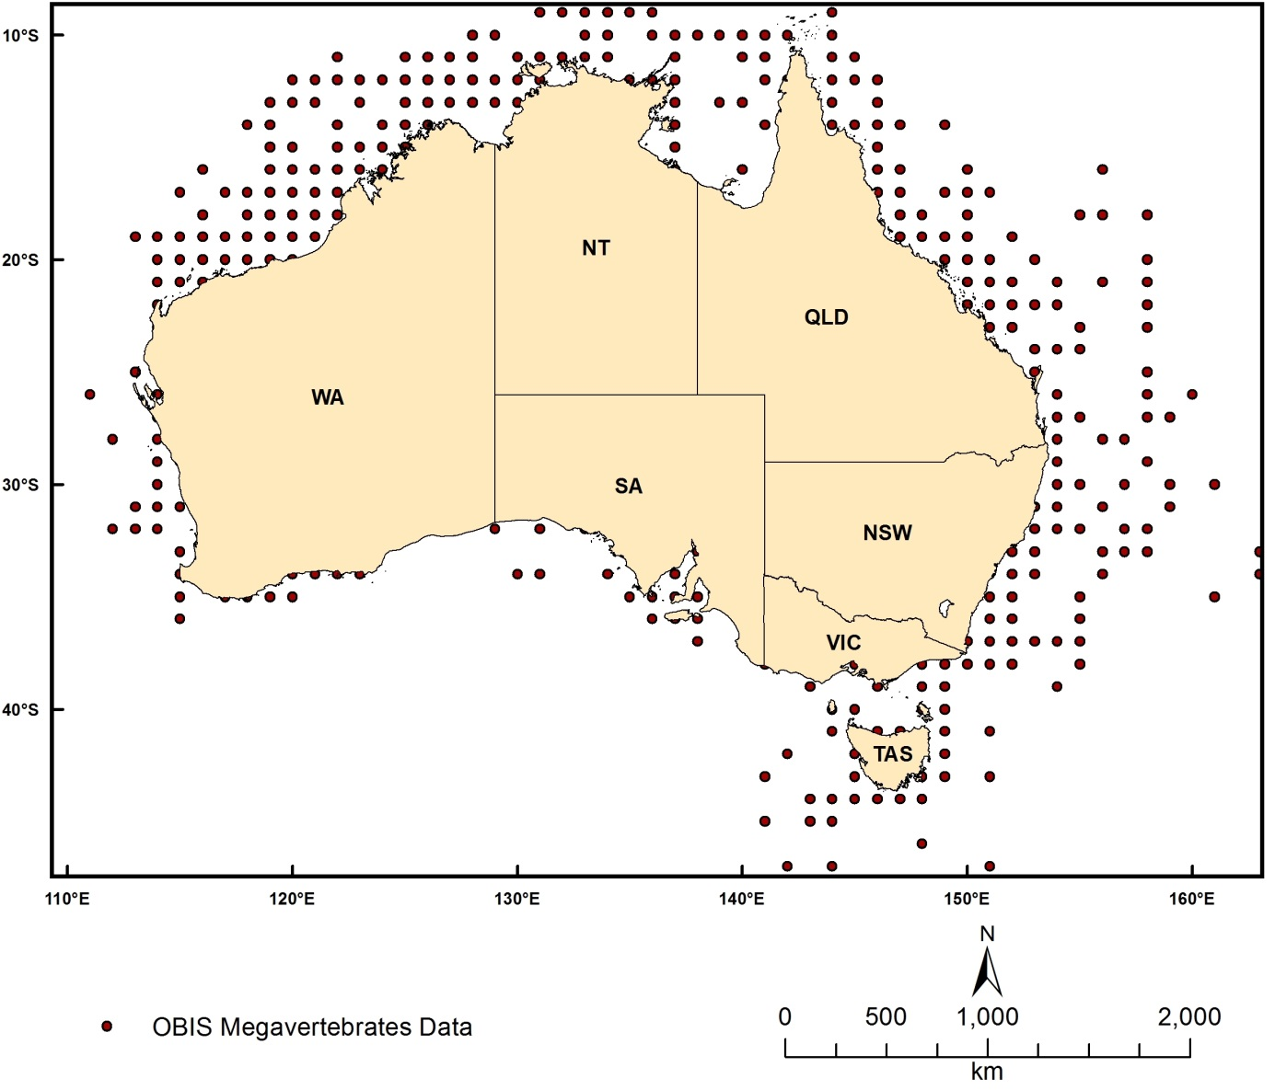
Figure 2.9.5 Locations of OBIS megavertebrates data

Australian Porifera
Dataset TITLE
Queensland Museum Porifera
Dataset ALTERNATE TITLE (i.e. Dataset Name)
Queensland Museum Sponges
Dataset AUTHOR(S)
Dataset CUSTODIAN
Museum of Queensland
Dataset JURISDICTION
Australia
Description ABSTRACT
This dataset gives species-level identifications for all sponges housed in the collection of the Queensland Museum (~22, 000 specimens as of Feb 2013). The Queensland Museum has a strong focus on marine invertebrates as the dominant components of Australia's vast reef and seabed faunas. Sponges (Porifera) are an important contributor to this the seabed and reef faunas, including the Great Barrier Reef. The collection contains over 22,000 specimens of approximately 5,000 nominal species housed at South Bank Brisbane, being amongst the largest in the southern hemisphere, including 169 type specimens. 100% of the collection is databased at the Atlas of Living Australia (www.ala.org.au). Most specimens were purpose-collected during the 1990s and 2000s in collaboration with the marine natural products chemistry industry, and tested for bioactive compounds of potential interest to the pharmaceutical industry, available through nature bank http://www.nature-bank.com.au. A large proportion of the collection has now been genetically sequenced (http://www.spongebarcoding.org)
Description Data Category
Oceans
Environment
Biota
Description Keyword
Biosphere, Aquatic Habitat, Benthic Habitat, Zoology, Sponges, Oceans, Marine Biology, Marine Invertebrates
Description GEOGRAPHIC EXTENT POLYGON(S)
N_LAT: -8
S_LAT: -50
E_LONG: 105
W_LONG: 165
COORDINATE SYSTEM DESCRIPTION
Projection: Geographic
Datum: WGS84
Units: Decimal Degree
Description Temporal EXTENT
Description NOMINAL SCALE
Spatial Resolution:
Temporal Resolution:
Data Currency BEGINNING DATE
2012
Data Currency ENDING DATE
2012
Dataset Status PROGRESS
Completed
Dataset Status MAINTENANCE AND UPDATE FREQUENCY
Updated as needed
Access STORED FORMATS Digital/Non-Digital Description
Access AVAILABLE FORMATS Digital/Non-Digital Description
Access ACCESS CONSTRAINT
Contact data custodian
Data Quality LINEAGE
Species-level identifications of sponges were completed at the Queensland Museum (led by Dr John Hooper), and the associated in-house database was uploaded to the Atlas of Living Australia in 2012 for public access.
Data Quality POSITIONAL ACCURACY
Data Quality ATTRIBUTE ACCURACY
Data Quality LOGICAL CONSISTENCY
Data Quality COMPLETENESS
Contact Information CONTACT ORGANISATION
Museum of Queensland
Contact Information CONTACT POSITION
John Hooper
Contact Information MAIL ADDRESS 1
Museum of Queensland
Contact Information SUBURB/PLACE/LOCALITY
South Brisbane
Contact Information STATE/LOCALITY 2
QLD
Contact Information COUNTRY
Australia
Contact Information POSTCODE
4101
Contact Information TELEPHONE
+61 7 3840 7555
Contact Information FACSIMILE
Contact Information ELECTRONIC MAIL ADDRESS
john.hooper@qm.qld.gov.au
Metadata Date METADATA DATE
20MAR2013
Additional Metadata METADATA AUTHOR
Rachel Przeslawski
Additional Metadata ACKNOWLEDGEMENTS
Paul Alvern
Additional Metadata REFERENCES

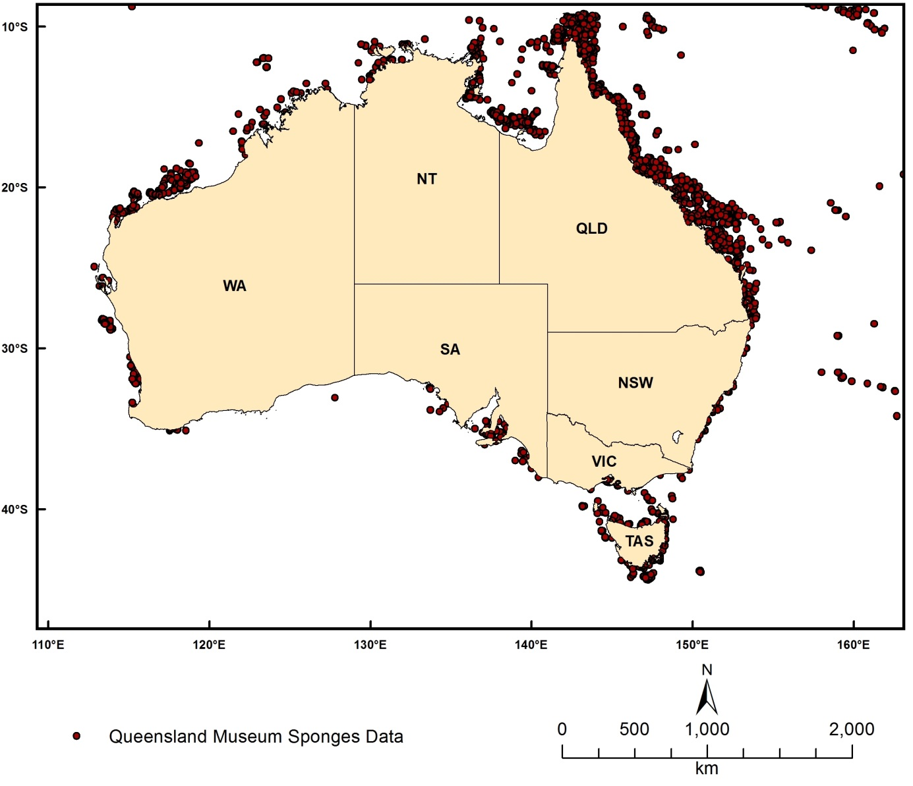
Figure 2.9.6 Locations of Queensland Museum sponge data

Australian squat lobsters
Dataset TITLE
Squat lobsters of Australia
Dataset ALTERNATE TITLE (i.e. Dataset Name)
Galatheids of Australia
Dataset AUTHOR(S)
Dataset CUSTODIAN
Museum of Victoria
Dataset JURISDICTION
Australia
Description ABSTRACT
This dataset comprises records of squat lobsters (Galatheoidea and Chirostyloidea) collected from within Australia's EEZ. Data is collated from museum collections in Australia and overseas and from the scientific literature. Records includes the number of specimens collected, the institution where they are lodged and a catalogue number where available; taxonomic information (species name, higher taxonomy, identifier, taxonomic certainty) and locality information (latitude, longitude, depth, survey, station)
Description Data Category
Oceans
Environment
Biota
Description Keyword
Biosphere, Aquatic Habitat, Benthic Habitat, Zoology, Crustaceans, Oceans, Marine Biology, Marine Invertebrates
Description GEOGRAPHIC EXTENT POLYGON(S)
N_LAT: -8
S_LAT: -50
E_LONG: 105
W_LONG: 165
COORDINATE SYSTEM DESCRIPTION
Projection: Geographic
Datum: WGS84
Units: Decimal Degree
Description Temporal EXTENT
Description NOMINAL SCALE
Spatial Resolution:
Temporal Resolution:
Data Currency BEGINNING DATE
2013
Data Currency ENDING DATE
2013
Dataset Status PROGRESS
onGoing
Dataset Status MAINTENANCE AND UPDATE FREQUENCY
Not Planned
Access STORED FORMATS Digital/Non-Digital Description
Access AVAILABLE FORMATS Digital/Non-Digital Description
Access ACCESS CONSTRAINT
Contact data custodian
Data Quality LINEAGE
Data was collated from museum collections in Australia and overseas and from the scientific literature
Data Quality POSITIONAL ACCURACY
Data Quality ATTRIBUTE ACCURACY
Data Quality LOGICAL CONSISTENCY
Data Quality COMPLETENESS
Contact Information CONTACT ORGANISATION
Museum of Victoria
Contact Information CONTACT POSITION
Researcher
Contact Information MAIL ADDRESS 1
Museum of Victoria
Contact Information SUBURB/PLACE/LOCALITY
Melbourne
Contact Information STATE/LOCALITY 2
VIC
Contact Information COUNTRY
Australia
Contact Information POSTCODE
3001
Contact Information TELEPHONE
+61 3 8341 7440
Contact Information FACSIMILE
Contact Information ELECTRONIC MAIL ADDRESS
amccall@museum.vic.gov.au
Metadata Date METADATA DATE
20MAR2013
Additional Metadata METADATA AUTHOR
Rachel Przeslawski
Additional Metadata ACKNOWLEDGEMENTS
McCallum, A. W. (Museum of Victoria), Ahyong, S., Poore, G.C.B., Taylor, J., Schnabel, K., Baba, K., Macpherson, E
Additional Metadata REFERENCES

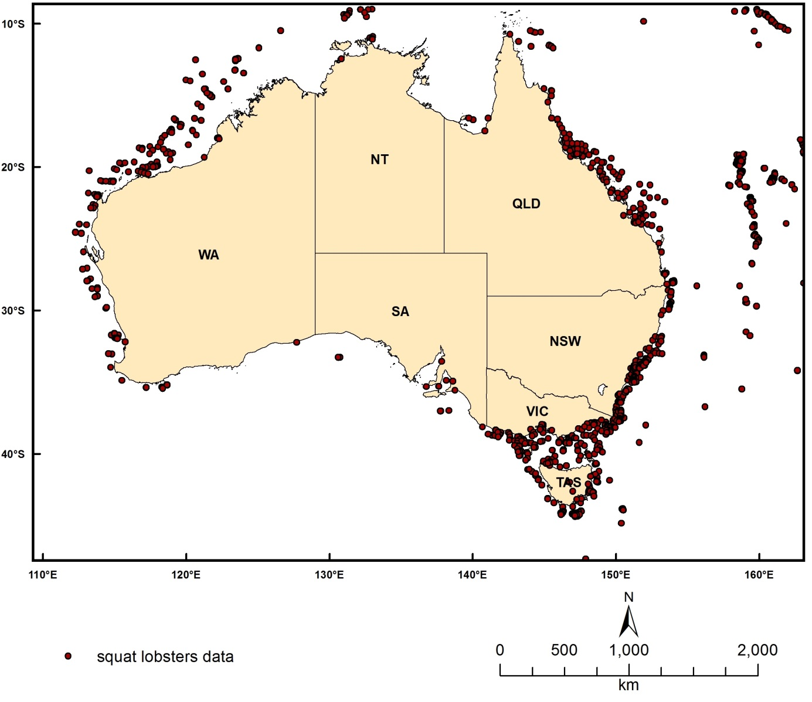
Figure 2.9.7 Locations of Squat Lobsters Data

References
Amante, C. and Eakins, B.W., 2008. ETOPO1 1 Arc-Minute Global Relief Model: Procedures, Data Sources and Analysis, National Geophysical Data Center, NESDIS, NOAA, U.S. Department of Commerce, Boulder, CO, August 2008.
Clark, D.K., Baker, E.T., Strong, A.E., 1980. Upwelled spectral radiance distribution in relation to particulate matter in sea water. Boundary-Layer Meteorology 18, 287-298.
Commonwealth of Australia, 2005. National Marine Bioregionalisation of Australia—Summary. Department of Environment and Heritage, Canberra, Australia.
Commonwealth of Australia, 2013. Australia's network of Commonwealth marine reserves, http://www.environment.gov.au/marinereserves/pubs/map-national.pdf (accessed 12 June, 2013).
Folk, R.L., 1974. Petrology of sedimentary rocks. Austin, Texas, Hemphills, 182pp.
Franz, B., 2006. Implementation of SST Processing within the OBPG. http://oceancolor.gsfc.nasa.gov/DOCS/modis_sst/ (accessed: 10/10/2011).
Geographx, 2008. New Zealand 250m Digital Elevation Model, available from http://www.geographx.co.nz/downloads.html
Huang, Z., Brooke, B., Whitta, N., Potter, A., Fuller, M., Dunn, J., Pitcher, R., 2010. Australian Marine Physical Environmental Data. Geoscience Australia Record 2010/32. Geoscience Australia, Canberra, 141pp.
Hughes, M.G., Harris, P.T., Brooke, B.P., 2010. Seabed exposure and ecological disturbance on Australia's continental shelf: Potential surrogates for marine biodiversity. Geoscience Australia Record 2010/43. Geoscience Australia, Canberra. 78pp.
Jarvis, A., Reuter, H.I., Nelson, A., Guevara, E., 2008. Hole-filled seamless SRTM data V4, International Centre for Tropical Agriculture (CIAT), available from http://srtm.csi.cgiar.org.
Jenness, J. S., 2004. Calculating landscape surface area from digital elevation models. Wildlife Society Bulletin 32, 829-839.
Kot, C.Y., Fujioka, E., Hazen, L.J., Best, B.D., Read, A.J., et al., 2010. Spatio-Temporal Gap Analysis of OBIS-SEAMAP Project Data: Assessment and Way Forward. PLoS ONE 5, e12990. doi:10.1371/journal.pone.0012990
Lee, Z.P., Carder, K.L., Arnone, R.A., 2002. Deriving inherent optical properties from water color: a multiband quasi-analytical algorithm for optically deep waters. Applied Optics 41, 5755-5772.
Li, J., Heap, A.D., Potter, A., Daniell, J.J., 2011a. Predicting Seabed Mud Content across the Australian Margin II: the Performance of Machine Learning Methods and Their Combinations with Ordinary Kriging and Inverse Distance Squared. Geoscience Australia Record 2011/07. Geoscience Australia, Canberra, 69pp.
Li, J., Heap, A.D., Potter, A., Huang, Z., 2011b. Seabed gravel content across the Australian continental EEZ 2011. http://www.ga.gov.au/meta/ANZCW0703014835.html (accessed 04/04/2013).
Li, J., Heap, A.D., Potter, A., Huang, Z., 2011c. Seabed sand content across the Australian continental EEZ 2011. http://www.ga.gov.au/meta/ANZCW0703014867.html (accessed 04/04/2013).
Li, J., Potter, A., Huang, Z., Daniell, J.J., Heap, A.D., 2010. Predicting Seabed Mud Content across the Australian Margin: Comparison of Statistical and Mathematical Techniques Using a Simulation Experiment. Geoscience Australia, Record 2010/11. Geoscience Australia, Canberra, 146pp.
Li, J., Potter, A., Huang, Z., Heap, A., 2012. Predicting Seabed Sand Content across the Australian Margin Using Machine Learning and Geostatistical Methods. Geoscience Australia Record 2012/48, Geoscience Australia, Canberra, 115pp.
Morel, A. and Maritorena, S., 2001. Bio-optical properties of oceanic waters: A reappraisal. Journal of Geophysical Research 106, 7163-7180.
O’Reilly, J.E., Maritorena, S., Mitchell, B.G., Siegel, D.A., Carder, K.L., Garver, S.A., et al., 1998. Ocean color algorithms for SeaWiFS. Journal of Geophysical Research 103, 24937-24953.
Passlow, V., Rogis, J., Hancock, A., Hemer, M., Glenn, K., Habib, A., 2005. Final Report, National marine sediments database and seafloor characteristics project. Geoscience Australia Record 2005/08. Geoscience Australia, Canberra, 74pp.
Shields, A., 1936. Application of similarity principles and turbulence research to bed-load movement. Mitteilunger der Preussischen Versuchsanstalt f¨ur Wasserbau und Schiffbau 26, 5–24.
Smith, W.H.F., and Sandwell, D.T., 1997. Global seafloor topography from satellite altimetry and ship depth soundings. Science 277, pp. 1957-1962.
Tyberghein, L., Verbruggen, H., Pauly, K., Troupin, C., Mineur, F., De Clerck, O., 2012. Bio-ORACLE: a global environmental dataset for marine species distribution modelling. Global Ecology and Biogeography 21, 272-281.
Webster, M., and Petkovic, P., 2005. Australian Bathymetry and Topography Grid. Geoscience Australia Record 2005/12. Geoscience Australia, Canberra. 2DVDs.
Werdell, P.J., 2005. OceanColor K490 algorithm evaluation. http://oceancolor.gsfc.nasa.gov/REPROCESSING/SeaWiFS/R5.1/k490_update.html (accessed 10/10/2011).
Whiteway, T.G., 2009. Australian Bathymetry and Topography Grid, June 2009. Geoscience Australia Record 2009/21, Geoscience Australia, Canberra, 46pp.
Zhu, W.; Yu, Q., Inversion of Chromophoric Dissolved Organic Matter From EO-1 Hyperion Imagery for Turbid Estuarine and Coastal Waters. IEEE Transactions on Geoscience and Remote Sensing, doi: 10.1109/TGRS.2012.2224117.

