Heat Flow Determinations for the Australian Continent

Release 5
Geoscience Australia
RECORD 2013/34
Kirkby, A.L., Gerner, E.J.
Department of Industry
Minister for Industry: The Hon Ian Macfarlane MP
Parliamentary Secretary: The Hon Bob Baldwin MP
Secretary: Ms Glenys Beauchamp PSM
Geoscience Australia
Chief Executive Officer: Dr Chris Pigram
This paper is published with the permission of the CEO, Geoscience Australia
© Commonwealth of Australia (Geoscience Australia) 2013
With the exception of the Commonwealth Coat of Arms and where otherwise noted, all material in this publication is provided under a Creative Commons Attribution 3.0 Australia Licence. (http://www.creativecommons.org/licenses/by/3.0/au/deed.en)
Geoscience Australia has tried to make the information in this product as accurate as possible. However, it does not guarantee that the information is totally accurate or complete. Therefore, you should not solely rely on this information when making a commercial decision.
Geoscience Australia is committed to providing web accessible content wherever possible. If you are having difficulties with accessing this document please contact clientservices@ga.gov.au.
ISSN 2201-702X (PDF)
ISBN 978-1-922201-69-0 (PDF)
GeoCat 76166
Bibliographic reference: Kirkby, A.L., Gerner, E. J., 2013. Heat Flow Determinations for the Australian Continent. Release 5. Record 2013/34. Geoscience Australia: Canberra.
Version: 1309

Contents
Executive Summary 1
1 Introduction 2
2 Input Data 4
2.1 Temperature logs 4
2.2 Gamma logs 4
2.3 Thermal conductivity measurements 4
2.4 Lithology logs 5
3 Heat Flow Calculation Method 6
4 Results 7
4.1 Yorke Peninsula, South Australia 7
4.1.1 HDD180 7
4.1.2 HDD131 9
4.1.3 HDD162 11
4.1.4 Summary 14
4.2 Pine Creek Inlier 16
4.2.1 VB12_003 16
4.2.2 VB12_010 18
4.2.3 CP018 20
4.2.4 Summary 22
4.3 Mt Isa 23
4.3.1 K-106C 23
4.4 Boulia 26
4.4.1 11004 26
5 Conclusions 29
Acknowledgements 30
References 31
Appendices 32
A.1 Drillhole information 32
A.2 LAS files 32
A.3 Thermal Conductivity data 33

Executive Summary
Heat flow data across Australia are sparse, with around 200 publicly-available data points. The heat flow data are unevenly distributed and mainly come from studies undertaken in the 1960s and 1970s by the Bureau of Mineral Resources (BMR) and the Research School of Earth Sciences at the Australian National University. Geoscience Australia initiated a new continent-wide heat flow data acquisition program under the Onshore Energy Security Program (OESP) (2006 to 2011) and has continued that work since the close of the OESP.
This report presents temperature, natural gamma and thermal conductivity data for eight drillholes across Australia. Temperature logging was performed down hole with temperatures recorded at intervals of 20 cm or less. Samples of drill core were taken from each drillhole and measured for thermal conductivity at Geoscience Australia.
These measurements were used to construct one dimensional, conductive heat flow models. These new heat flow determinations will add to the 53 already released by Geoscience Australia, totalling 61 heat flow determinations added to the Australian continental heat flow dataset since 2007.

Introduction
Geoscience Australia has released 53 heat flow determinations to date (Kirkby and Gerner, 2010; Jones et al., 2011, Weber et al., 2011, Gerner et al., 2012), 41 of these under the Australian Government-funded Onshore Energy Security Program (OESP) (Geoscience Australia, 2011). After the completion of the OESP in June 2011, heat flow data collection continued and this record presents an additional eight heat flow determinations (Table 1.1) bringing the total to 61 heat flow determinations for the Australian continent since 2007. The locations of the heat flow determinations produced by Geoscience Australia are shown in Figure 1.1.
Figure 1.1 Heat flow determinations made by Geoscience Australia. Red points are from Release 1 (Kirkby and Gerner, 2010), green points are from Release 2 (Jones et al., 2011), blue points are from Release 3 (Weber et al. 2011), yellow points are from Release 4 (Gerner et al., 2012), and brown points are from Release 5 (this report). The smallest black points are legacy heat flow determinations from prior to 2008. (Note: Only the new heat flow determinations are labelled and at this scale, some data points appear on top of one another).
Table 1.1 Location, depth, dip and heat flow determinations of the eight drillholes discussed in this report. UE means the drillhole is un-equilibrated and thus the heat flow value should be used with caution. A spreadsheet version of this table is provided in electronic Appendix 1.
Drillhole Name | Region | Latitude (GDA 94) | Longitude (GDA 94) | Logged Depth, m | True Vertical Logged Depth, m | Collar Dip, -° | Heat Flow, mW/m2
HDD180 | Yorke Peninsula | -34.54556 | 137.86927 | 377 | 373 | -81 | 98 ± 20
HDD131 | Yorke Peninsula | -34.54370 | 137.87439 | 591 | 522 | -60 | 98 ± 10
HDD162 | Yorke Peninsula | -34.53867 | 137.87879 | 873 | 733 | -61 | 90 ± 3 (UE)
VB12_003 | Pine Creek | -14.14231 | 132.10214 | 602 | 521 | -60 | 72 ± 3
VB12_010 | Pine Creek | -14.13320 | 132.10511 | 581 | 503 | -60 | 67 ± 3 (UE)
CP018 | Pine Creek | -13.53628 | 131.37014 | 421 | 362 | -59.2 | 76 ± 14
K-106C | Mt Isa | -21.05294 | 139.96343 | 834 | 786 | -85 | 61 ± 5
11004 | Boulia | -22.66562 | 138.65263 | 1311 | 1311 | -90 | 68 ± 4

Input Data

Temperature logs
The drillholes were logged by Geoscience Australia using the Auslog A626 combined temperature/natural gamma probe. This probe has a temperature precision of 0.007 ºC and can measure temperatures up to 70 ºC. The probe is connected to a winch with 1800 m of four-conductor cable, which was sufficient to log all drillholes reported here to maximum depth or to where blockages were encountered.
The Auslog DLS5 digital logging system connects the tool to a laptop computer. Wellvision software was used to record the data. The temperature (and natural gamma) readings were recorded down the drillhole at a speed of approximately five metres per minute and the probe was set to take measurements every 20 cm, regardless of speed. Geoscience Australia has experimented with sampling intervals and found one sample every 20 cm to be sufficient for heat flow determinations.
Logging was undertaken as long as possible after drilling was completed to increase the chances of drillholes reaching an equilibrium state before logging. In some cases, due to accessibility constraints, drillholes were logged within days of drilling and it is very unlikely that equilibrium had been reached before logging. Where this is the case it has been noted in the results.
Where necessary, the temperature logs were converted from measured depth (length of drillhole) to true vertical depth (perpendicular depth from the surface) using survey information provided by the companies that drilled each drillhole (see Table 1.1). Where survey data were unavailable, the conversion to true depth was done based on the collar orientation, with the assumption that the drillhole did not deviate from this orientation. The temperature data were then smoothed using a three-point running average. The raw temperature files can be found in electronic Appendix 2.

Gamma logs
The Auslog A626 probe collects natural gamma data in addition to the temperature data. The natural gamma data were collected at the same depth intervals down the drillhole as the temperature measurements. The natural gamma logs were converted from measured depth to true vertical depth and smoothed with a three point running average for visualisation. The raw natural gamma logs can be found in electronic Appendix 2.

Thermal conductivity measurements
Core specimens were collected from each drillhole for thermal conductivity analysis. Where possible, specimens approximately 15 to 20 cm in length were collected at intervals of 50 to 100 m down each drillhole. Sampling was guided by lithology logs where available, with the aim of sampling each lithology in the drillhole while avoiding mineralised zones. This was not possible in all drillholes, due to a variety of limitations on sampling, resulting in a less-than-ideal sample distribution in some drillholes. The sample depths were converted to true vertical depth using down-hole survey data or collar inclination as described for the temperature logs in Section 2.1.
Core specimens were analysed for thermal conductivity by Geoscience Australia. Each core specimen was cut to create up to three discs. Where possible the disks were cut parallel to the core axis, however, in some cases only half core was available for sampling, and in these cases disks were cut perpendicular to the core axis. Where this is the case it has been noted in the report. The discs were subsequently cut to ensure that the top and bottom faces were parallel and then polished, prior to measurement. The discs were measured using a divided bar apparatus (Anter Unitherm 2022). Where multiple discs were available, the harmonic mean was computed. Details of the samples measured for this study are provided in electronic Appendix 3.
All samples were measured in a saturated state at a temperature of 30 ± 3 ºC. In order to saturate the samples, they were first evacuated under a >95 % vacuum for 3 to 4 hours to remove air from the pore spaces. Discs were then submerged in water under vacuum and then returned to atmospheric pressure. Discs were left in the water at atmospheric pressure for a minimum of 12 hours or until just prior to thermal conductivity measurement.

Lithology logs
A number of companies provided lithology logs for their drillholes. Where available, the logs were used in conjunction with the measured thermal conductivities to aid with the interpretation as described in Section 3 .

Heat Flow Calculation Method
Heat flow determinations were calculated using the following method, modified from Kirkby and Gerner (2010).
- Drillhole collar orientation data or down-hole survey data were used to correct the recorded logs and the depth of the samples taken to a vertical depth. A temperature gradient log was calculated from the temperature log at a 5 m interval.
- The depth-corrected temperature log and gradient log were visually inspected to select a conductive interval on which to undertake the heat flow determination. This conductive zone:
  - avoids the near surface (which is likely to be affected by seasonal and/or topographic variations in temperature); and
  - avoids sections of the log that appear to be influenced by significant advective heat flow.
- The thermal conductivity values were plotted alongside the log to determine which values correspond to the above-defined conductive zone.
- Where necessary, the conductive zone described in point 2 was divided into sub-sections. The division into sub-sections was based on the supplied lithology logs (where available) with reference to the temperature gradient and natural gamma logs. In the absence of lithology information, the sub-section boundaries were based on changes in the magnitude and character of the temperature gradient and natural gamma logs. Where there were no obvious breaks in the natural gamma or temperature gradient logs (or where the density of thermal conductivity samples was insufficient to adequately characterise multiple sub-sections) the drillhole was modelled in a single section.
- The samples and sub-section boundaries were used to calculate a weighted harmonic mean thermal conductivity for the drillhole. The weighting factors for each sample were calculated according to the vertical extent of the sub-section relative to the vertical extent of the conductive section. The following formula was used to calculate the standard error of the harmonic mean:
$s_{H}=\frac{1}{a^{2}}\frac{s_{\frac{1}{x}}}{\sqrt{n-1}}$
where $a$ is the weighted mean of the reciprocals of the observations comprising the sample, $s_{1/x}$ is the weighted standard deviation of the reciprocals of the observations, and n is the number of samples (Norris, 1940). Reported uncertainties are ± 1 standard error from the mean.
- Heat flow was calculated by multiplying the thermal conductivity value obtained in step 5 by the overall temperature gradient over the conductive section of the log.
- Finally, the calculated heat flow value from step 6 was used together with the harmonic mean of the thermal conductivity values for each sub-section (step 5) to model the temperature profile in the drillhole. This model was visually compared to the temperature log to assess the model’s fit to the temperature data. Where a poor fit was observed, the conductive interval and sub-section boundary positions were re-examined to see if there was cause to refine the positioning of each.

Results

Yorke Peninsula, South Australia
HDD131, HDD162 and HDD180 were drilled by Rex Minerals Limited at its Hillside project on the Yorke Peninsula, South Australia. All three drillholes were drilled within 1.2 km of each other (Figure 4.1), on flat, grassed areas. Lithological logs were provided to Geoscience Australia for all three drillholes.
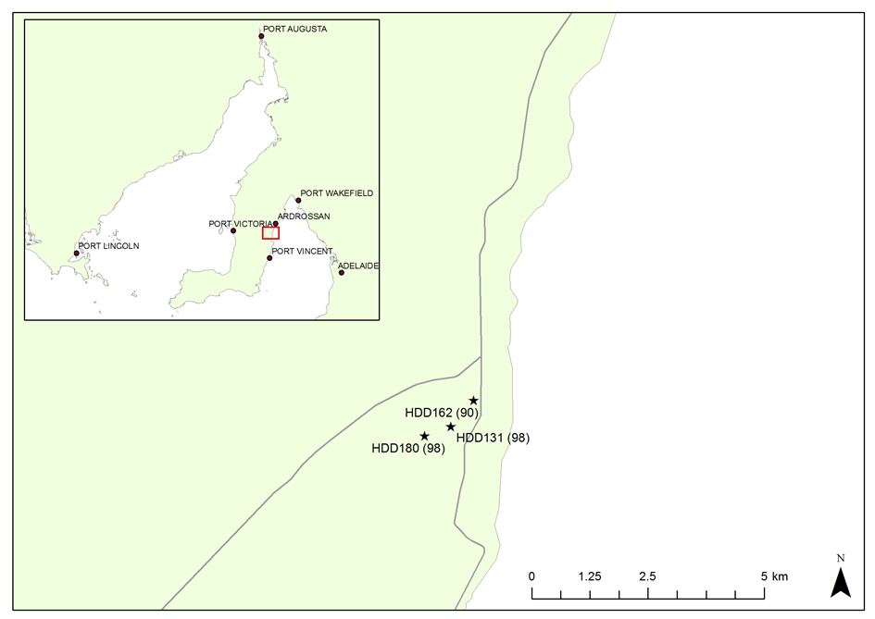
Figure 4.1: Map showing the relative locations of HDD131, HDD162, and HDD180 on the Yorke Peninsula.

HDD180
HDD180 is the southernmost of the three drillholes logged at the Hillside project. It was completed on the 14th March 2011 to 577 m at a collar inclination of -81°. It was logged by Geoscience Australia on the 16th July 2011 using the combined temperature/natural gamma probe to 377 m. Down-hole survey data were provided to Geoscience Australia by Rex Minerals; using these data the log was converted to vertical depth. Based on these corrected data the vertical depth extent of logging is 373 m. Four samples were selected for thermal conductivity analysis. All of these were half core and therefore it was necessary to measure thermal conductivity perpendicular to the core axis.
The temperature, temperature gradient, natural gamma and thermal conductivity data are shown in Figure 4.2. From these data the conductive section has been defined to be from 175 to 368 m true vertical depth.
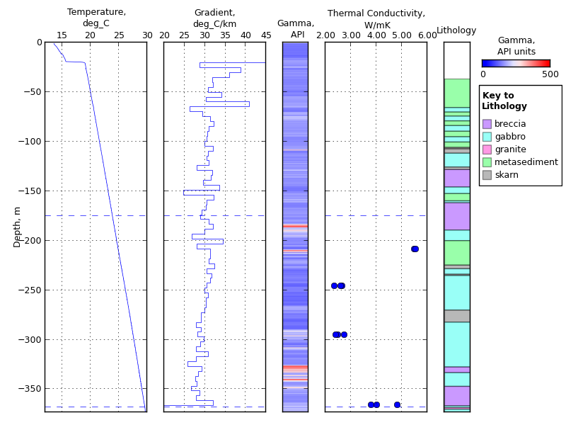
Figure 4.2: Graphs of temperature, temperature gradient (calculated over intervals of 5 m), natural gamma and thermal conductivity vs depth for drillhole HDD180. Horizontal dashed lines indicate the extent of the conductive zone referred to in text.
Figure 4.2 shows that there are two sub-sections represented with different gradients: 175 to 275 m and 275 to 368 m vertical depth (approximately 31 and 29 °C/km respectively). However, no major lithological changes occur at this point in the lithology log, and there does not appear to be a shift in thermal conductivity at this point (although there are insufficient samples to determine this conclusively). Therefore, HDD180 has been modelled as a single section from 175 to 368 m vertical depth (Figure 4.3). The mean temperature gradient in this section is 29.71 ± 0.05 °C/km. The harmonic mean thermal conductivity is 3.31 ± 0.69 W/mK. This results in a heat flow for HDD180 of 98 ± 20 mW/m2.
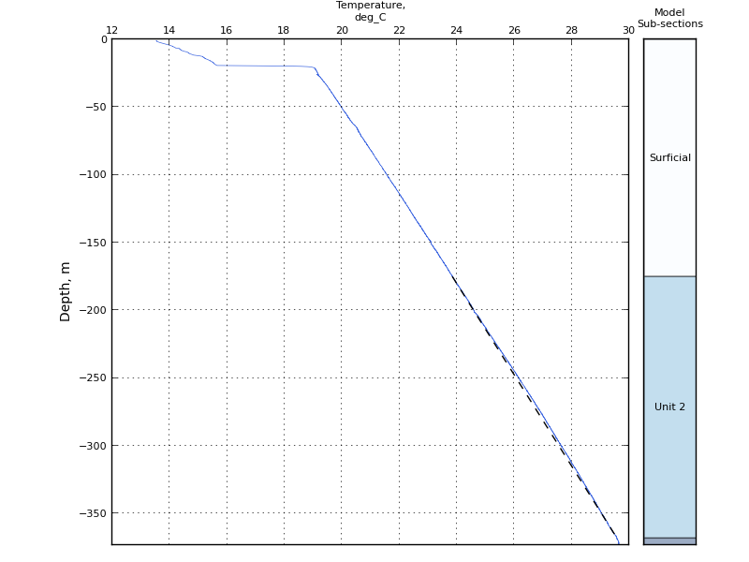
Figure 4.3. Temperature profile predicted by the 1D heat flow model and thermal conductivity measured in HDD180 (dashed black line), plotted on top of the temperature log recorded in HDD180 (blue solid line). Column on the right hand side of the figure shows the sub-sections used for heat flow modelling as described in the text.

HDD131
HDD131 is located 520 m northeast of HDD180. It was completed to 714 m on the 5th November 2010 at a collar inclination of 60° and logged by Geoscience Australia on the 7th July 2011 using the combined temperature/natural gamma probe to 591 m where a blockage prevented further logging. Based on down-hole survey data provided to Geoscience Australia by Rex Minerals, the vertical depth extent of logging is 522 m. Ten samples were selected for thermal conductivity analysis. All of these except for one sample at 392.73 to 392.93 m (347.09 to 347.26 m vertical depth) were half core and therefore it was necessary to measure thermal conductivity perpendicular to the core axis.
The temperature, temperature gradient, natural gamma and thermal conductivity data are shown in Figure 4.4. From these data the conductive section has been defined to be between 200 and 516 m vertical depth. Figure 4.4 shows that the gradient is relatively uniform from 200 to approximately 350 m vertical depth, and although it shows considerable fluctuation on a small scale (5 m) from 350 to 500 m vertical depth, the mean gradient over this whole section is similar to that in the top section (30.9 °C/km compared to 30.4 °C/km in the top section). This is despite the fact that both the lithology log and the thermal conductivity measurements show considerable variation throughout this section. However, the variation in thermal conductivity does not appear to correspond to the lithological variation recorded on the lithology log provided to Geoscience Australia. For this reason, HDD131 has been modelled as a single section from 200 to 516 m vertical depth (Figure 4.5). The mean gradient over this section is 30.06 ± 0.03 °C/km; the harmonic mean thermal conductivity is 3.25 ± 0.34 W/mK. The resulting heat flow is 98 ± 10 mW/m2; in agreement with the value obtained for HDD180.
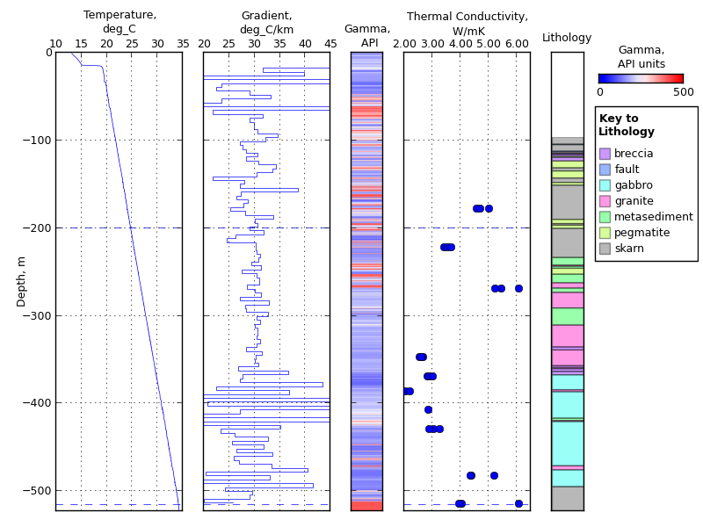
Figure 4.4: Graphs of temperature, temperature gradient (calculated over intervals of 5 m), natural gamma and thermal conductivity vs depth for drillhole HDD131. Horizontal dashed lines indicate sub-section boundaries referred to in text.
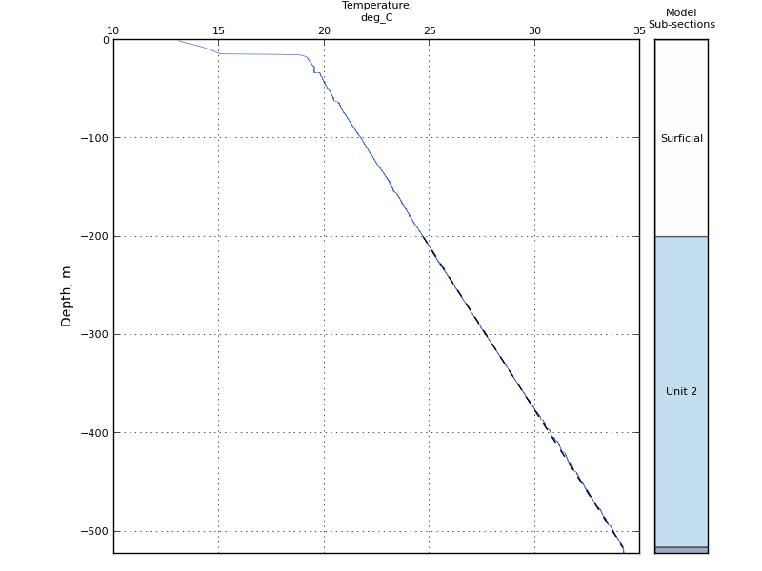
Figure 4.5: Temperature profile predicted by the 1D heat flow model and thermal conductivity measured in HDD131 (dashed black line), plotted on top of the temperature log recorded in HDD131 (blue solid line). Column on the right hand side of the figure shows the sub-sections used for heat flow modelling as described in the text.

HDD162
HDD162 is located 690 m northeast of HDD131. It was completed on the 26th of February 2011 to a depth of 930 m, at a collar inclination of 61°. Some flushing of HDD162 occurred between the 8th and 10th July 2011 whilst 50 mm PVC casing was inserted in preparation for geophysical logging. Geophysical logging was performed on the 14th and 15th July 2011. HDD162 was logged by Geoscience Australia to a depth of 873 m on the 16th July 2011 using the combined temperature/natural gamma probe. Because of the short time gap between flushing and temperature logging of the hole, it is likely that the log is not equilibrated. Based on the down-hole survey data provided to Geoscience Australia by Rex Minerals, the vertical depth extent of logging is 733 m. Fifteen samples were taken for thermal conductivity analysis, of which three (located at 548.12 to 548.32 m, 799.46 to 799.58 m, and 850.45 to 850.62 m depth; approximately 468 m, 674.5 m and 715 m vertical depth) were half core and therefore it was necessary to measure these perpendicular to the core axis. The remainder of the samples were full core and were therefore measured parallel to the core axis.
The temperature, temperature gradient, natural gamma and thermal conductivity data are shown in Figure 4.6. From these data, the conductive section has been defined to be from 175 to 710 m depth. Within the conductive section, two sub-sections can be observed with stable temperature gradients: the upper section from about 175 to 330 m vertical depth, with a mean gradient of 30.8 °C/km, and the lower section from about 420 to 710 m vertical depth, with a mean of 27.8 °C/km. In between these two sections, from 330 to 420 m, the gradient is strongly variable on the scale of 20 to 30 m.
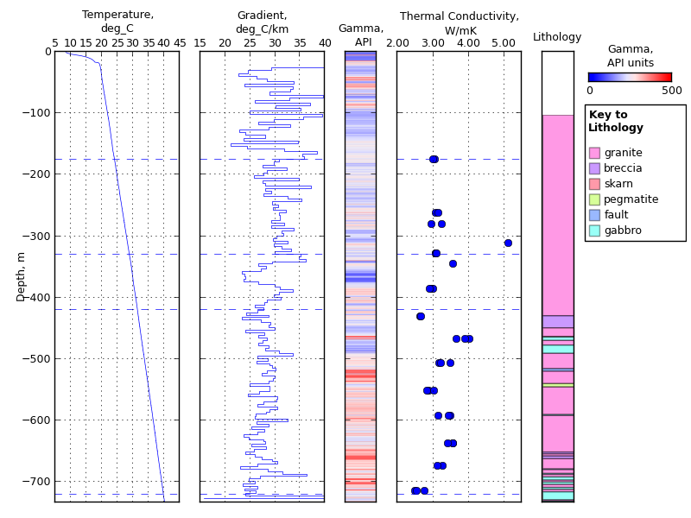
Figure 4.6. Plots showing temperature, temperature gradient (calculated over intervals of 5 m), natural gamma and thermal conductivity vs depth for drillhole HDD162. Horizontal dashed lines indicate sub-section boundaries referred to in text.
Seven samples were available from the lower section, giving a harmonic mean thermal conductivity of 3.13 W/mK. This combined with a mean gradient of 31.1 °C/km results in a heat flow of 87 mW/m2. Three samples were available from the middle section, giving a harmonic mean thermal conductivity of 3.23 W/mK. This combined with a mean gradient of 28.8 °C/km results in a heat flow of 93 mW/m2. The upper section contains three samples; however one of the samples in this section has a much higher thermal conductivity than the other samples, 5.11 W/mK. This value represents only one disk: the sample was highly fractured and therefore it was only possible to obtain one disk from it. For this reason, and because the thermal conductivity measured is so different from the rest of the thermal conductivity values in this section, this disk has been excluded from further calculations. When this disk is excluded, the harmonic mean thermal conductivity for the upper section is 3.09 W/mK, resulting in a heat flow of 95 mW/m2.
The above calculations for the individual sections show that heat flow appears to decrease with depth in HDD162. There are several possible explanations for the apparent difference in heat flow in the top and bottom sections of HDD162.
One possible explanation is that the flushing of the drillhole that occurred between the 8th and 10th of July, and subsequent geophysical logging on the 14th to 15th July, may have perturbed the temperature gradient in the drillhole. The flushing fluid temperature is likely to be similar to the mean average surface air temperature for July in the area. We estimate this temperature to be about 11 °C, obtained by taking an average of the mean maximum and mean minimum air temperatures for July in the nearest town, Maitland (Bureau of Meteorology, 2013). This temperature is cooler than all temperatures observed in the drillhole below about 5 m depth, and therefore the flushing fluid is likely to have had a cooling effect on the drillhole. This cooling effect is likely to have been stronger in the deeper, hotter parts of the drillhole purely due to the larger temperature difference. Furthermore, during the flushing process the flushing fluid will have sat on the bottom of the drillhole and therefore the bottom parts of the drillhole will have had a longer period of time to cool. A cooling effect in the bottom part of the drillhole is consistent with a lower heat flow value being calculated in the bottom section of the drillhole.
Another possible explanation for the apparent difference in heat flow between the upper and lower part of the drillhole is that heat production between the bottom of the drillhole and about 350 m depth has resulted in a higher heat flow toward the top of the drillhole. HDD162 is drilled into granite, and while heat production has not been calculated for samples for this drillhole, there is a cluster of measurements on granite located approximately 50 km to the northwest, with a median heat production of 6.6 μW/m3. Elevated values are recorded on the natural gamma log, with a median of 240 API units. Using the equation of Bücker and Rybach (1996) to estimate heat production based on natural gamma readings, this equates to a heat production of about 3.8 μW/m3. If these heat production values are applied over the lower section (300 m depth extent), this gives a difference of 1.1 to 2.0 mW/m2 in the upper section of the drillhole compared to the lower section, which would explain some of the difference in heat flow between the upper and lower sections of the drillhole.
A final possible explanation for the apparent difference in heat flow is that it may simply reflect inadequate sampling for thermal conductivity: both the thermal conductivity and temperature gradient are quite variable over the conductive section, and there are inadequate samples to characterise the small scale gradient changes occurring in HDD162, especially from 330 to 420 m depth. For this reason, heat flow has been calculated for HDD162 over the entire conductive interval, giving a value of 90 ± 3 mW/m2 (Figure 4.7). This value is lower than, but within error of, the values obtained for the other two Yorke Peninsula drillholes, HDD131 and HDD180.
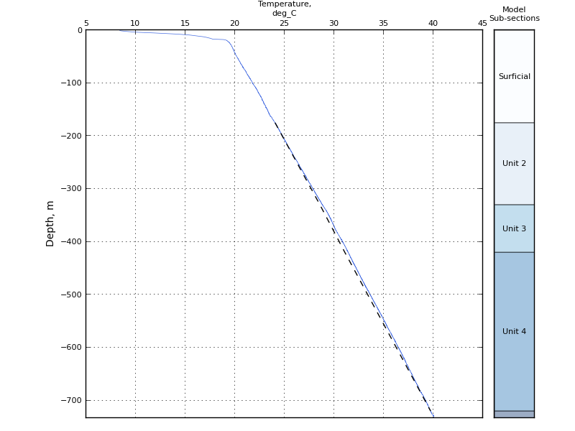
Figure 4.7. Temperature profile predicted by the 1D heat flow model and thermal conductivity measured in HDD162 (dashed black line), plotted on top of the temperature log recorded in HDD162 (blue solid line). Column on the right hand side of the figure shows the sub-sections used for heat flow modelling as described in the text.

Summary
Heat flow has been determined for three drillholes on the Yorke Peninsula, South Australia. For the two southernmost drillholes, HDD180 and HDD131, calculation of heat flow was straightforward, and values of 98 ± 20 and 98 ± 10 mW/m2 respectively were obtained. For HDD162, the calculation of heat flow was less straightforward; there is an apparent difference in heat flow between the top and bottom half of the drillhole. This may have been caused by several factors, including flushing of the drillhole six to eight days prior to logging, by heat production within the lower part of the drilled section, or inadequate sampling for thermal conductivity. Because the difference in heat flow between the upper and lower sections is small, and because of the uncertainty around the cause of the difference, heat flow has been modelled over the entire conductive section of HDD162, giving a heat flow value of 90 ± 3 mW/m2.
The heat flow values presented here for the three Yorke Peninsula drillholes are elevated compared with average crustal heat flow values (Figure 4.8). They are also consistent with, although slightly higher than, previous heat flow determinations in the surrounding region. Four heat flow determinations have been performed 70 to 90 km north of the Hillside drillholes, with values of 100.6, 88, 87, and 91 mW/m2 (Sass et al., 1976; Lilley et al., 1978). There is also a heat flow value of 88 mW/m2 (Sass et al., 1976) measured about 90 km east-southeast of the Hillside drillholes (Figure 4.8). The Hillside heat flow values are consistent with these legacy values. These heat flow determinations fill a gap in the Australian heat flow database, extending a known region of elevated heat flow south into the Yorke Peninsula.
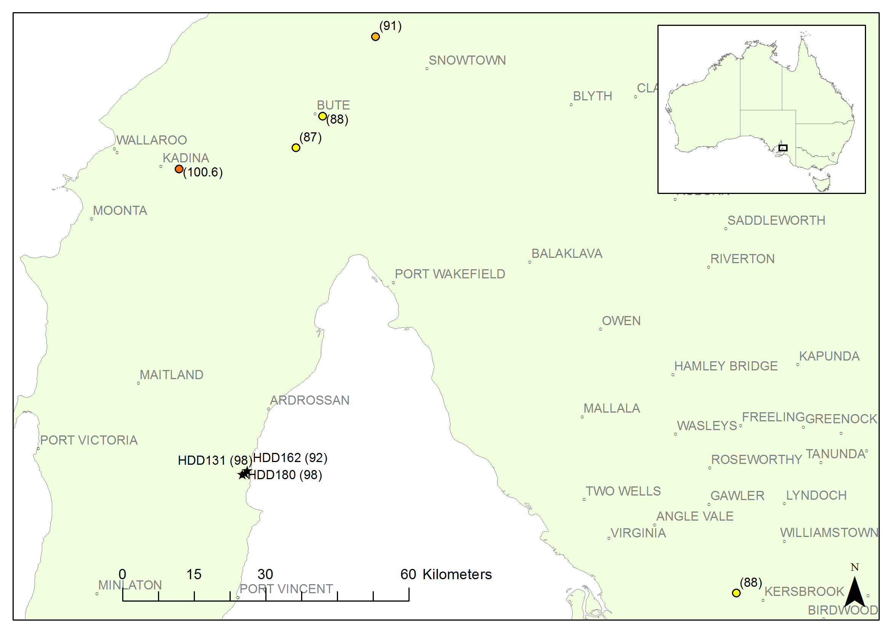
Figure 4.8. Map showing locations of new heat flow determinations from the Yorke Peninsula (HDD131, HDD162 and HDD180) together with previously collected heat flow data (Sass et al., 1976; Lilley et al., 1978). Heat flow values are in mW/m2 and are shown in parentheses.

Pine Creek Inlier
Three heat flow determinations are presented for the Pine Creek Inlier, Northern Territory: VB12_003 and VB12_010, drilled by Vista Gold Corporation, and CP018, drilled by Crocodile Gold Australia (Figure 4.9). For all three of these drillholes, only half core was available for sampling, and therefore thermal conductivity has been measured perpendicular to the core axis.
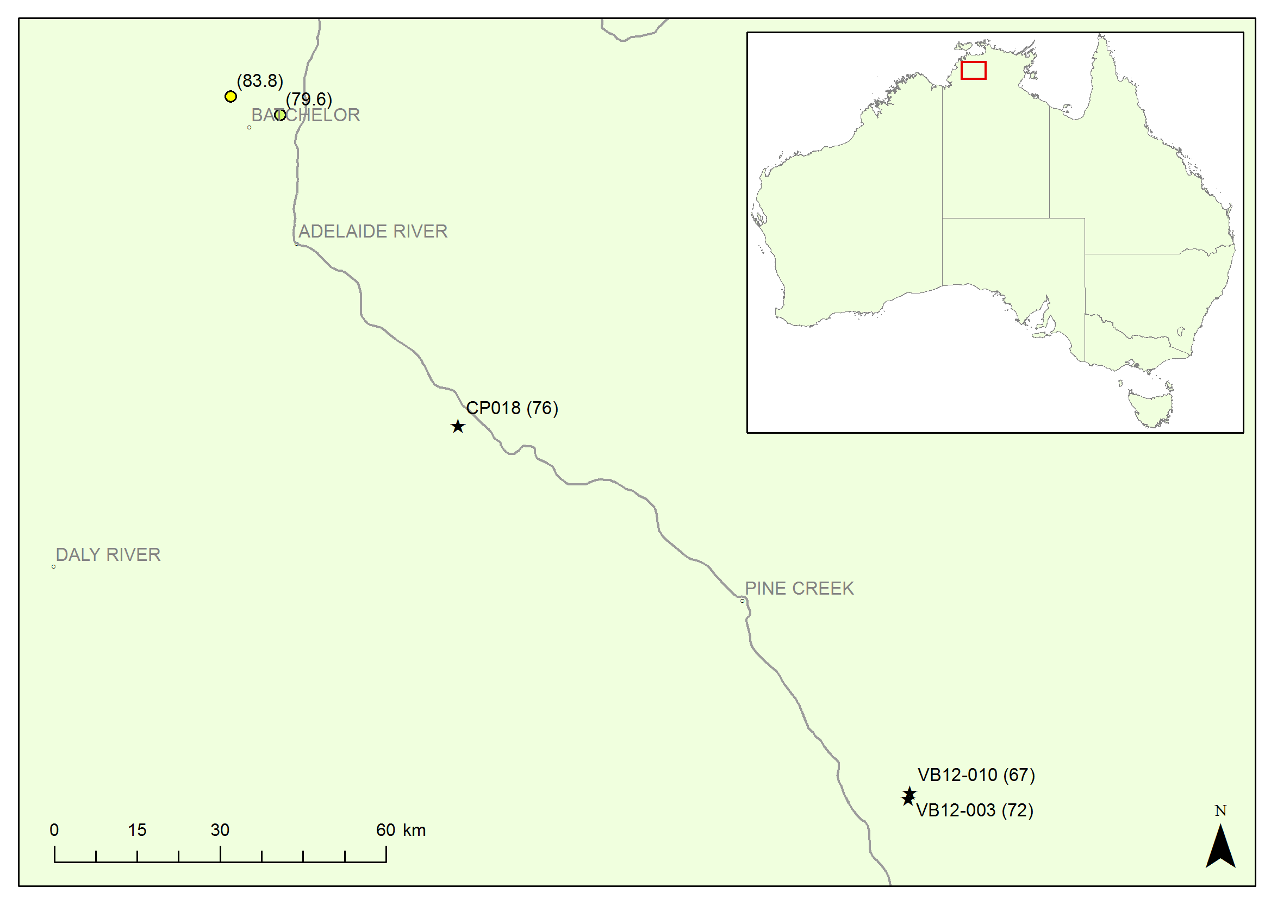
Figure 4.9. Map showing locations of new heat flow determinations from the Pine Creek Inlier (VB12_003, VB12_010 and CP018) together with previously existing data (Howard and Sass, 1964; Sass et al., 1976). Heat flow values are in mW/m2 and are shown in parentheses.

VB12_003
VB12_003 is the southernmost of the three drillholes and is located approximately 45 km southeast of Pine Creek (Figure 4.9). It was completed in late February 2011 at a collar inclination of -60° and logged by Geoscience Australia on the 25th of May 2011 to 602 m (521 m vertical depth) using the combined temperature/natural gamma probe. Ten samples were collected for thermal conductivity analysis.
The temperature, temperature gradient, natural gamma, and thermal conductivity data collected from VB12_003 are presented in Figure 4.10. From these data, the conductive section has been defined to be from 150 to 511 m vertical depth.
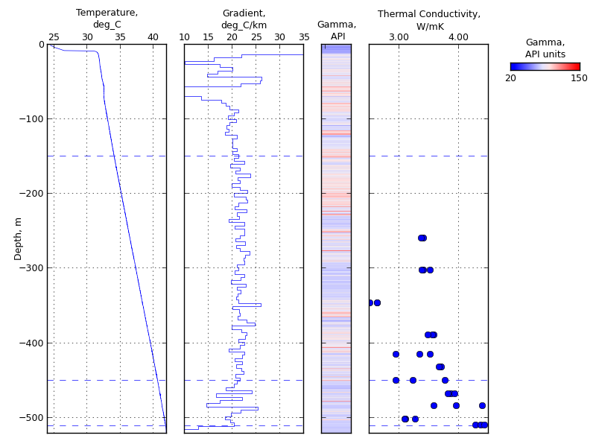
Figure 4.10: Plots showing temperature, temperature gradient (calculated over intervals of 5 m), natural gamma and thermal conductivity vs depth for drillhole VB12_003. Horizontal dashed lines indicate sub-section boundaries referred to in text.
The gradient is stable from 150 to 450 m vertical depth but shows a change in character below approximately 350 m (Figure 4.10). The gradient decreases slightly below 450 m vertical depth, from 21.8 °C/km to 20.2 °C/km. The harmonic mean thermal conductivity is also slightly higher below 450 m vertical depth than above it, with a harmonic mean of 3.28 ± 0.20 W/mK above, and 3.68 ± 0.25 W/mK below, this point. The resulting heat flow values are 72 ± 4 mW/m2 for the upper section (200 to 450 m), and 74 ± 5 mW/m2 for the lower section. These heat flow values are within error of each other, and therefore the heat flow for VB12_003 can be modelled using one heat flow over the entire conductive section. The mean gradient between 150 and 511 m depth is 21.52 ± 0.03 °C/km and the harmonic mean thermal conductivity is 3.35 ± 0.14 W/mK. The resulting heat flow value is 72 ± 3 mW/m2 (Figure 4.11).
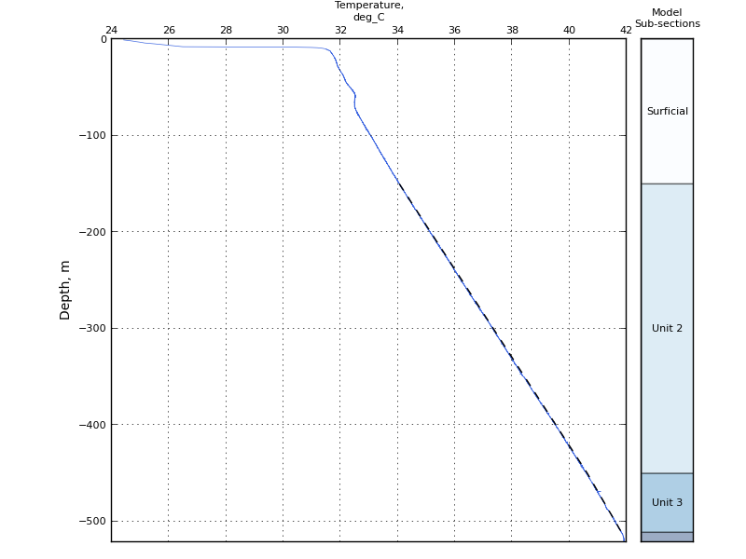
Figure 4.11. Temperature profile predicted by the 1D heat flow model and thermal conductivity measured in VB12_003 (dashed black line), plotted on top of the temperature log recorded in VB12_003 (blue solid line). Column on the right hand side of the figure shows the sub-sections used for heat flow modelling as described in the text.

VB12_010
VB12_010 is located approximately 1 km north of VB12_003 (Figure 4.9). It was completed on the 15th of May 2011 at a collar inclination of -60° and logged by Geoscience Australia on the 24th of May 2011 to 581 m (503 m vertical depth) using the combined temperature/natural gamma probe. Due to the short time period between completion and temperature logging, it is unlikely that VB12_010 is equilibrated. Eleven samples were collected for thermal conductivity analysis.
The temperature, temperature gradient, natural gamma, and thermal conductivity data collected from VB12_010 are presented in Figure 4.12. From these data, the conductive section has been defined to be from 220 to 495 m (vertical depth). The temperature gradient is stable throughout this section with a slight change in character below 400 m. The temperature gradient over this section is 20.33 ± 0.04 °C/km. The thermal conductivity in this section shows considerable variation, with a harmonic mean of 3.30 ± 0.16 W/mK. The resulting heat flow is 67 ± 3 mW/m2 (Figure 4.13), consistent with the value obtained for VB12_003.
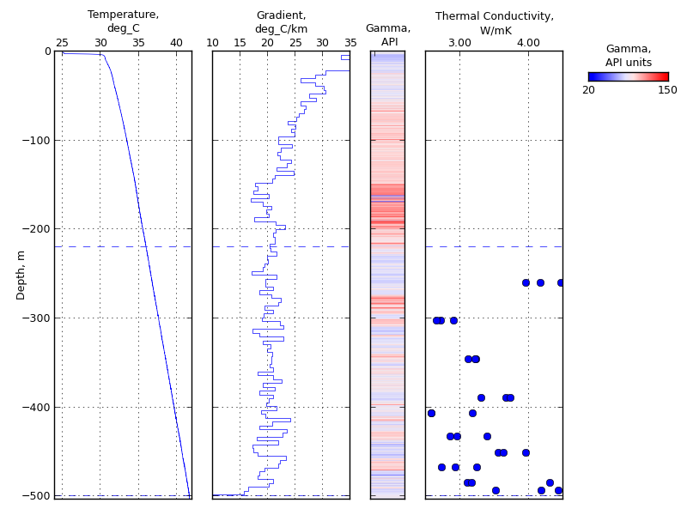
Figure 4.12. Plots showing temperature, temperature gradient (calculated over intervals of 5 m), natural gamma and thermal conductivity vs depth for drillhole VB12_010. Horizontal dashed lines indicate the extent of the conductive section referred to in text.
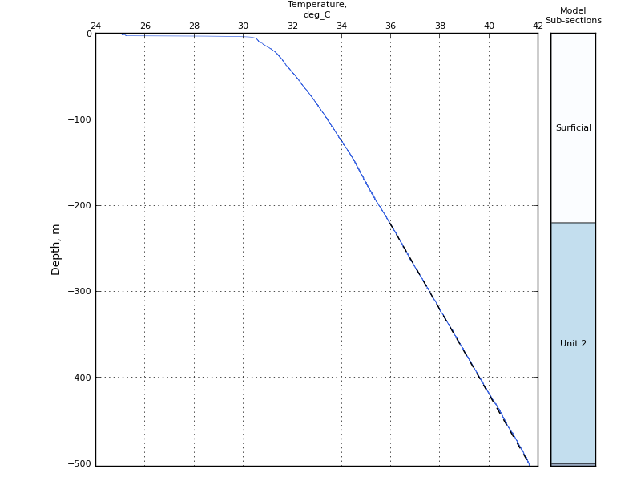
Figure 4.13. Temperature profile predicted by the 1D heat flow model and thermal conductivity measured in VB12_010 (dashed black line), plotted on top of the temperature log recorded in VB12_010 (blue solid line). Column on the right hand side of the figure shows the sub-sections used for heat flow modelling as described in the text.

CP018
CP018 is located approximately 60 km northwest of Pine Creek (about 100 km northwest of VB12_003 and VB12_010; Figure 4.9). It was completed to a depth of 421 m at a collar inclination of -59.2° (362 m vertical depth) on the 19th June 2011, and logged by Geoscience Australia on the 27th May 2012.
The temperature, temperature gradient, natural gamma, and thermal conductivity data collected from CP018 are presented in Figure 4.14. The temperature profile is disturbed at about 180 m true depth, showing a decrease followed by a sharp increase in temperature. Below about 200 m, the gradient is much more stable, although it is slightly higher between 200 and 225 m depth than below this point.
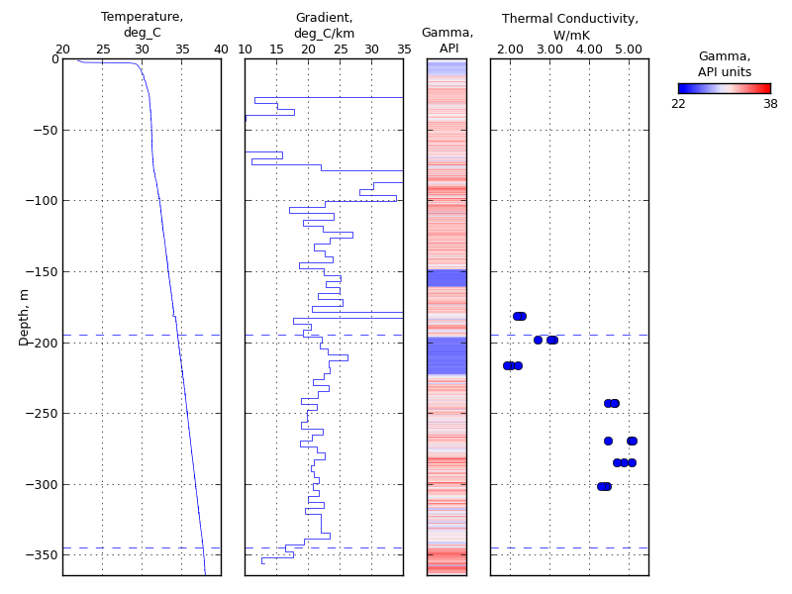
Figure 4.14. Plots showing temperature, temperature gradient (calculated over intervals of 5 m), natural gamma and thermal conductivity vs depth for drillhole CP018. Horizontal dashed lines indicate the extent of the conductive section referred to in text.
The thermal conductivity measurements in this drillhole show an abrupt break between 214 and 241 m depth. The harmonic mean thermal conductivity is 2.41 ± 0.61 W/mK above this point and 4.67 ± 0.14 W/mK below. This break in thermal conductivity coincides with the slight change in gradient described above (24 °C/km above 230 m depth and 21 °C/km below it), but the temperature gradient change is not sufficient to explain the change in thermal conductivity.
Because the temperature gradient shows minimal change despite the large change in thermal conductivity, CP018 has been modelled in one section. The conductive section has been defined to include all data below the temperature disturbance at 180 m depth. The conductive section starts at approximately 15 m below this point, at 195 m depth. This depth allows all but the top thermal conductivity sample in the drillhole to be included in the calculation. The conductive section has been defined to continue down to 345 m depth. Below this point the temperature gradient decreases strongly toward the bottom of the logged section at 357 m depth.
The mean gradient between 195 and 345 m depth is 21.33 ± 0.07 °C/km. This gradient, combined with the harmonic mean thermal conductivity of 3.56 ± 0.64 W/mK, gives a heat flow of 76 ± 14 mW/m2 (Figure 4.15).
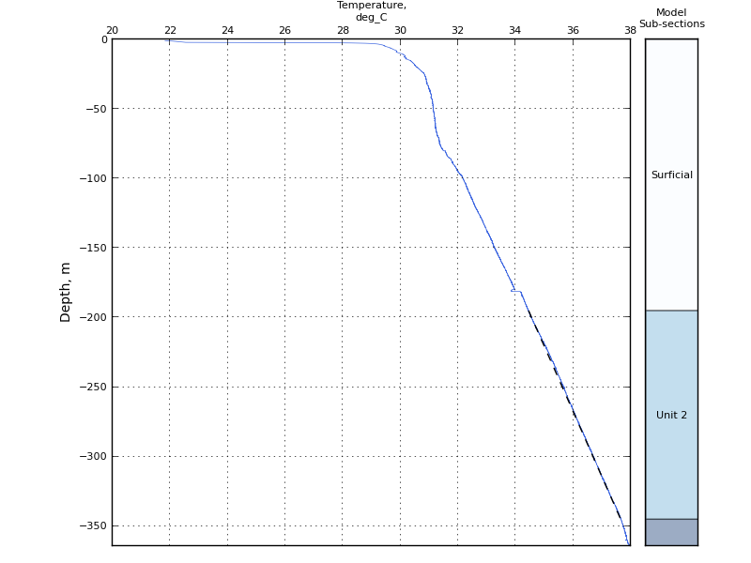
Figure 4.15. Temperature profile predicted by the 1D heat flow model and thermal conductivity measured in CP018 (dashed black line), plotted on top of the temperature log recorded in CP018 (blue solid line). Column on the right hand side of the figure shows the sub-sections used for heat flow modelling as described in the text.
Note that if the bottom section of the drillhole (below about 230 m) is modelled in isolation, the resulting heat flow is 97 ± 3 mW/m2. Conversely, if the top half of the drillhole is modelled by itself, the heat flow is 55 ± 14 mW/m2. However, neither of these values utilise all of the data in the drillhole, and, because there are no other heat flow determinations or thermal conductivity values in close proximity to CP018, it is impossible to tell which of these values is more representative. Therefore, we have modelled CP018 as a single section from 195 to 345 m vertical depth.

Summary
The three heat flow determinations presented here for the Pine Creek Inlier for drillholes VB12-003, VB12-010 and CP018 fill a gap in the publicly-available heat flow determinations for Australia (Figure 4.9). The values, 72 ± 3 mW/m2, 67 ± 3 mW/m2 (unequilibrated), and 76 ± 12 mW/m2 respectively, are lower than the two nearest existing heat flow determinations. These heat flow determinations, with values of 84 and 80 mW/m2 (Howard and Sass, 1964; Sass et al., 1976), are located approximately 70 km northwest of CP018 and 170 km northwest of VB12-003 and VB12-010.

Mt Isa

K-106C
K-106C is located approximately 60 km southeast of Mt Isa (Figure 4.16). The drillhole was completed to a depth of 843 m at a collar inclination of -85° by Kings Minerals (now Cerro Resources) in 2008. The drillhole was logged by Geoscience Australia in 2011 to a measured depth of 834 m. The measured depth has been corrected to vertical depth using the provided drillhole survey data. The dip of the hole changes from -85° at the collar to approximately -66° at total depth. The most significant change occurs between about 250m and 300m (measured depth) (Cerro Resources, 2013).
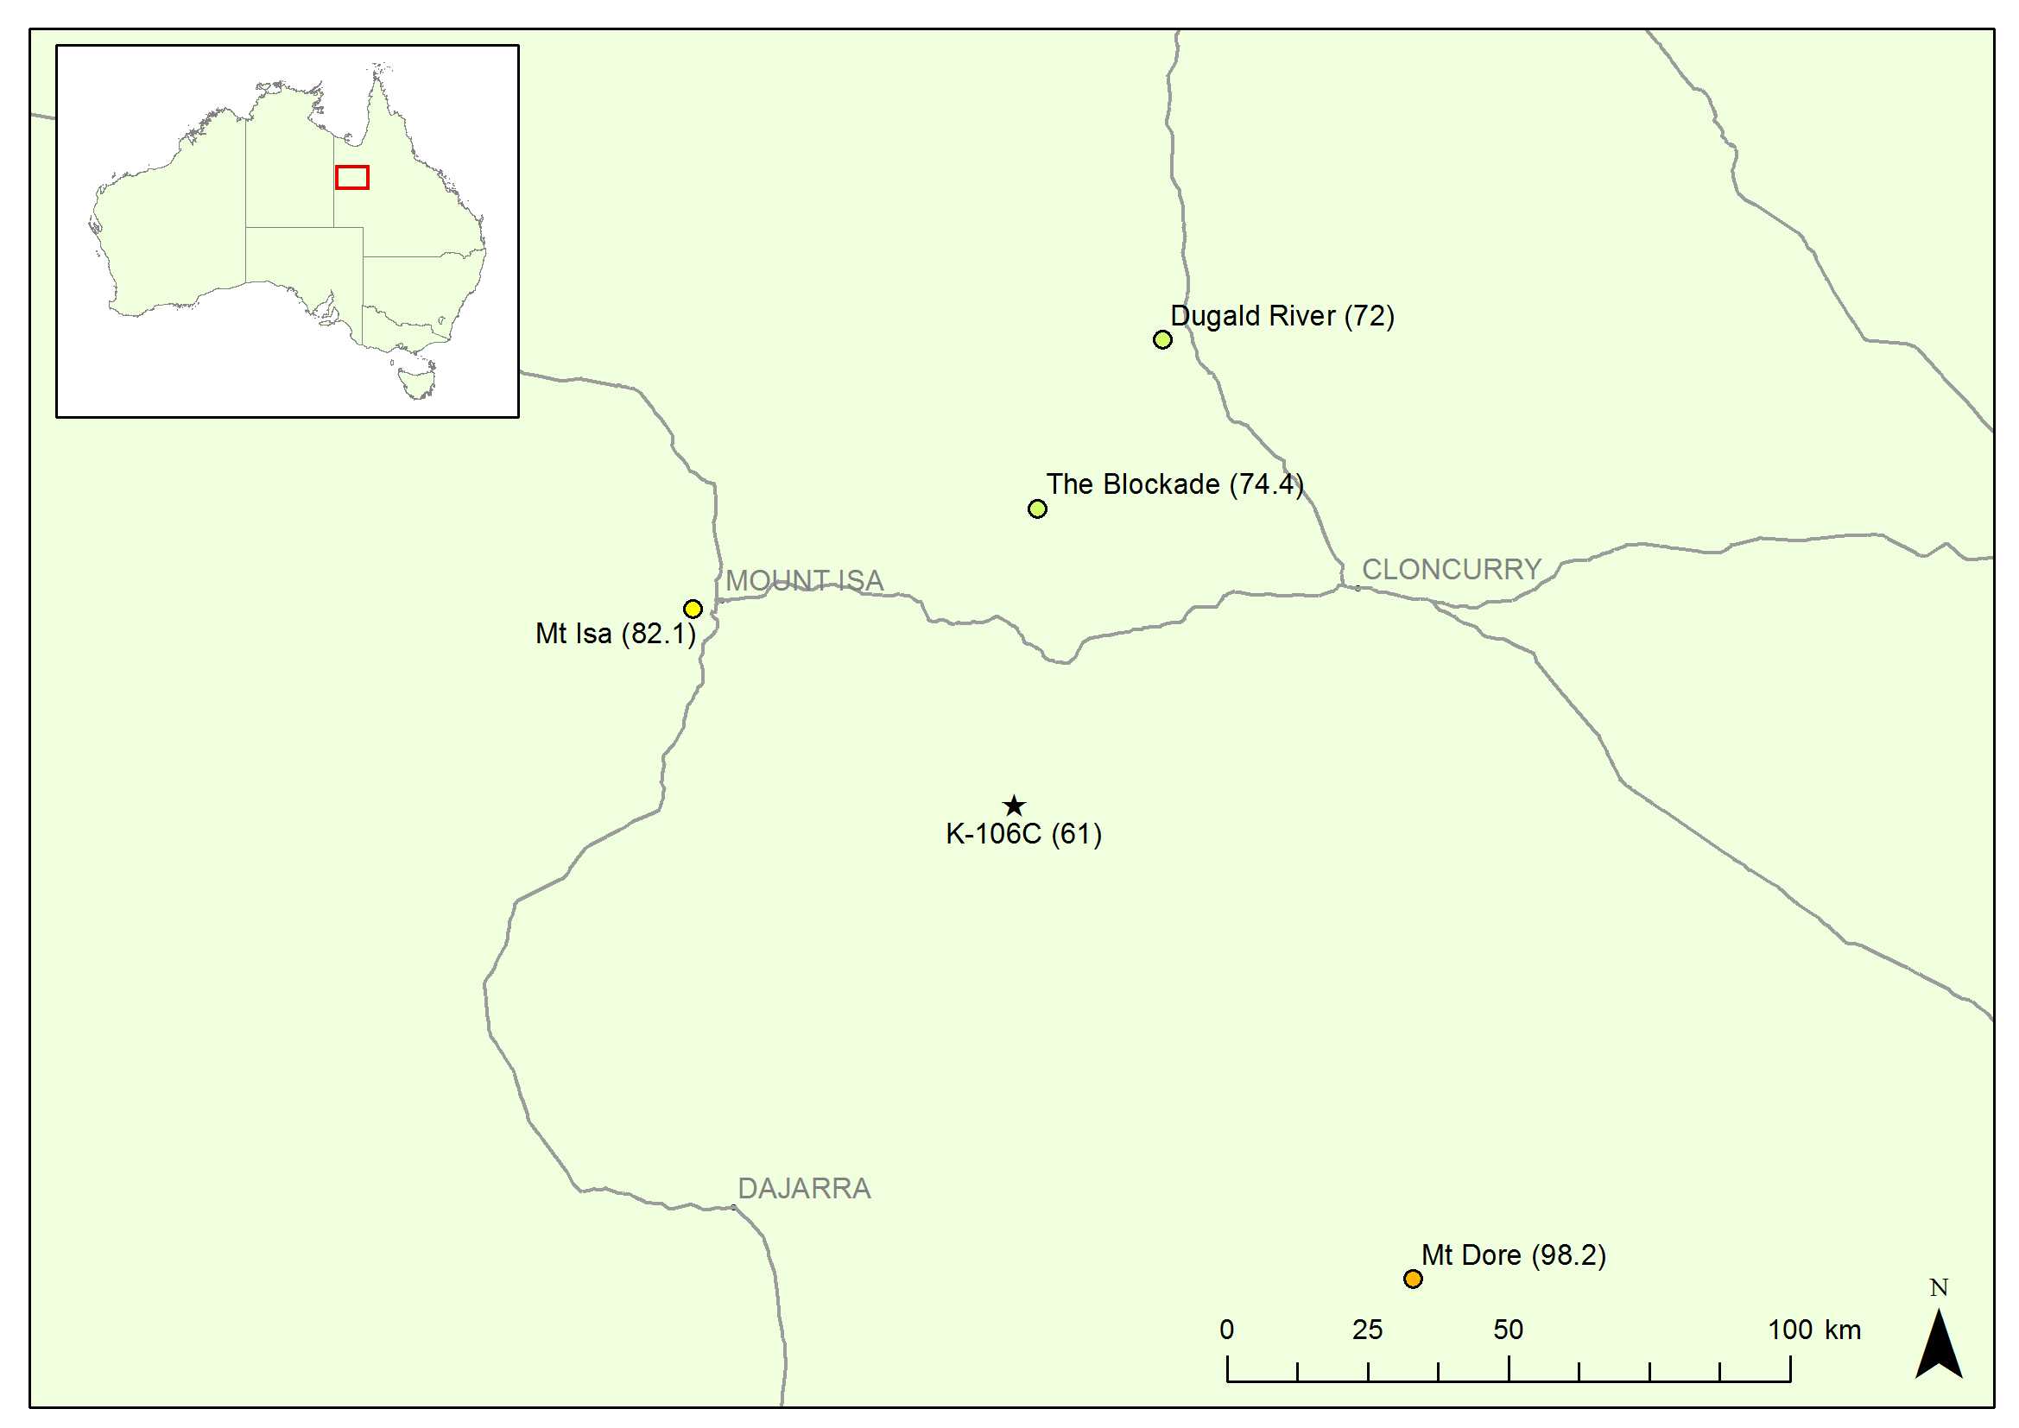
Figure 4.16 Location diagram of the greater Mt Isa region showing heat flow determinations that have been made within 100km of K106C. Heat flow values are in mW/m2 and are shown in parentheses next to the names.
The temperature, temperature gradient, natural gamma, thermal conductivity data, and lithology log are shown in Figure 4.17. The temperature log shows a number of irregularities. Most notable are steps in the log at approximately 230 m, 320 m and 400 m vertical depth. It is possible that these are due to the logging tool becoming stuck during logging, however there was no mention of this made in the logging notes. Deeper in the drillhole there are some more subtle features which indicate perturbation of the temperature profile in the drillhole, at approximately 590 m and between 650 m and about 750 m. The available data offer no explanation for these features. It is worth noting that while these features have a strong impact on the gradient on a local scale, the gradient in between each of these features is similar, and therefore it does not appear that the features have a strong impact on the overall temperature gradient in the drillhole when examined as a complete log.
The lithology log shows a change at approximately 470 m depth from metavolcanic rocks to predominantly metasedimentary rocks. This change is accompanied by a change in thermal conductivity from an average of about 2 mW/m2 to about 3 mW/m2. However, it is not possible to distinguish a change in gradient at this point, suggesting that either the sampling is not representative of the section, or the irregularities in the gradient have masked any gradient change. For this reason, K-106C has been modelled as a single interval from 300 m to 779 m vertical depth, which gives a temperature gradient of 23.17 ± 0.02 °C/km. The harmonic mean thermal conductivity over this interval is 2.73 ± 0.22 W/mK. This results in a heat flow of 61 ± 5 mW/m2 (Figure 4.18).
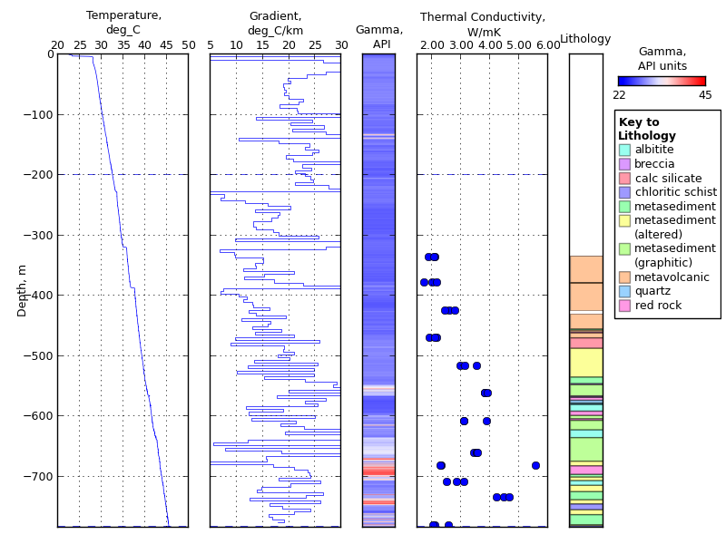
Figure 4.17: Plots showing temperature, temperature gradient (calculated over intervals of 5 m), natural gamma and thermal conductivity vs depth for drillhole K-106C. Horizontal dashed lines indicate the extent of the conductive section referred to in the text.
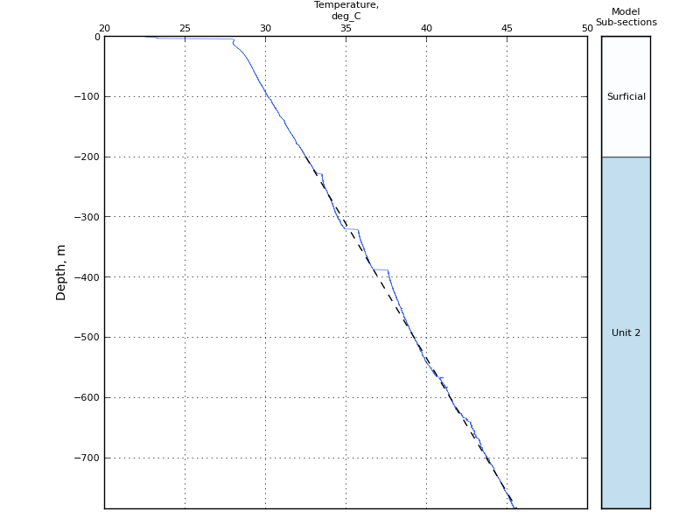
Figure 4.18. Temperature profile predicted by the 1D heat flow model and thermal conductivity measured in K-106C (dashed black line), plotted on top of the temperature log recorded in K-106C (blue solid line). Column on the right hand side of the figure shows the sub-sections used for heat flow modelling as described in the text.
There are five other available heat flow determinations within 100 km of K-106C, one produced by Geoscience Australia (MEQ1180, 65.5 ± 1 mW/m2; Weber et al., 2011) two published in 1979 (Mt Dore, 98.2 ± 4.1 mW/m2 and Dugald River, 72.0 ± 2.9 mW/m2; Cull and Denham, 1979) and two values aggregated from several drillholes in 1966 (Mt Isa, 82.1 mW/m2 and The Blockade, 74.4 mW/m2; Hyndman and Sass, 1966) (Figure 4.16). The new value of 62 ± 4 mW/m2 is lower than all of these existing values, although it is within error of the MEQ1180 value. Hyndman and Sass (1966) discuss the variability of the heat flow determinations being possibly due to steeply dipping structures causing refraction of heat flow. The geology in the area of K106-C is steeply-dipping and although not sampled for thermal conductivity, graphitic metasediments form part of the ore zone of the prospect (Cerro Resources, 2013). This lithology could be expected to have a higher thermal conductivity than the sampled lithologies, and could also be anisotropic, which would influence the magnitude and direction of heat flow on a local scale. A greater density of heat flow determinations is needed to better characterise the variation of the heat flow at both the local and regional scales.

Boulia

11004
11004 is located approximately 131 km west-northwest of Boulia in western Queensland (Figure 4.19). It was completed on the 11th August 2011 by AMC Consultants on behalf of their client Boulia Operation Pty Ltd, the operating company for a consortium of Hanwha Australia Pty Limited: 33.34 %, Kores Australia Pty Limited: 33.33 % and Sun Metals Corporation Pty Ltd: 33.33 %. 11004 was logged by Geoscience Australia on the 6th September 2011 to a depth of 1311 m. 11004 was drilled vertically and in the absence of further data it is assumed to not have deviated significantly. The timing of the completion of drilling and the logging means that the equilibration time is on the low end of the time required. The log presented in Figure 4.20 shows a number of changes in the temperature gradient; some of these correspond to sharp changes in the natural gamma log (e.g. at 1040 m depth), while others are more subtly reflected in the natural gamma (e.g. at about 450 m depth).
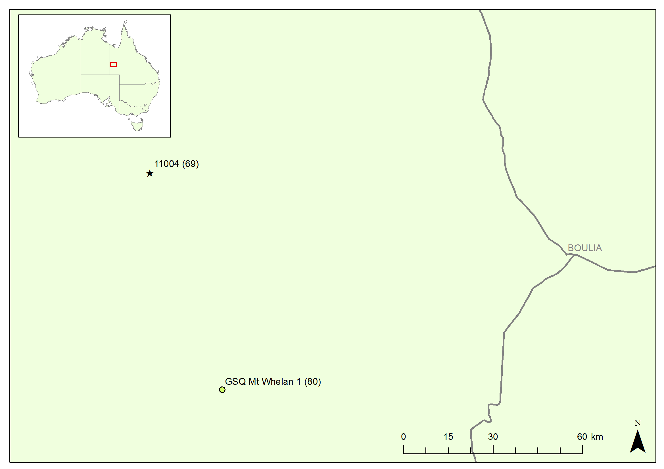
Figure 4.19. Location diagram of the Boulia region showing heat flow determinations that have been made within 100 km of 11004. Heat flow values are in mW/m2 and are shown in parentheses next to the names.
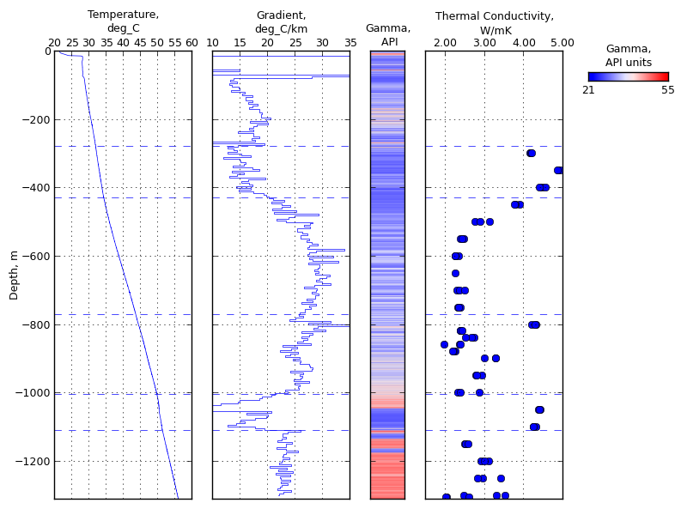
Figure 4.20. Plots showing temperature, temperature gradient (calculated over intervals of 5 m), natural gamma and thermal conductivity vs depth for drillhole 11004. Horizontal dashed lines indicate sub-section boundaries referred to in text.
The thermal conductivity measurements also show a number of abrupt changes in this drillhole that align with the changes in temperature gradient. It is apparent that the lithologies with strongly-contrasting thermal conductivities are found in discrete intervals with little inter-layering. This has allowed the definition of a number of intervals for which it is possible to characterise the thermal conductivity.
The log was divided into 5 intervals (Figure 4.21) based on the changes in temperature gradient, character of the natural gamma log and, because of the high sampling density, variations in thermal conductivity. These intervals were used to calculate a weighted harmonic mean thermal conductivity for 11004 of 2.96 ± 0.16 W/mK. The mean gradient over the conductive section is 23.33 ± 0.01 °C/km, resulting in a heat flow of 69 ± 4 mW/m2 (Figure 4.21).
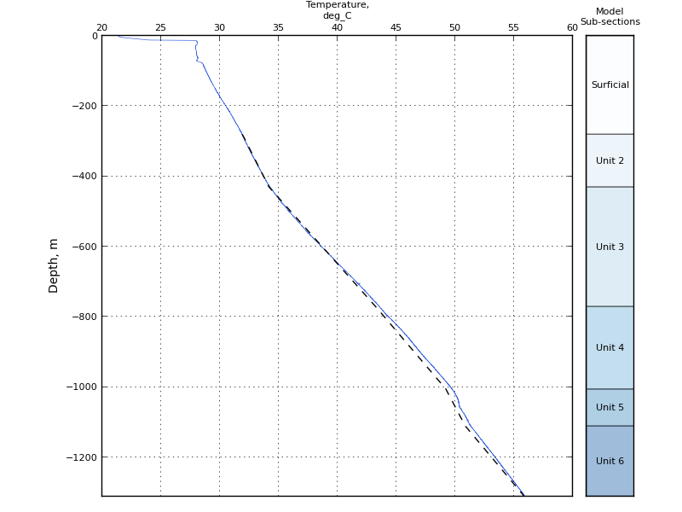
Figure 4.21. Temperature profile predicted by the 1D heat flow model and thermal conductivity measured in 11004 (dashed black line), plotted on top of the temperature log recorded in 11004 (blue solid line). Column on the right hand side of the figure shows the sub-sections used for heat flow modelling as described in the text.
There is only one other heat flow determination available within 100 km of 11004, GSQ Mt Whelan 1, which is located approximately 75 km to the south-southeast and has a value of 80 ± 3 mW/m2 (Cull, 1982; Figure 4.19). While this value is only slightly higher than the new determination for 11004, the reasons they are not within error of each other are worth further examination. One possible explanation for this difference could be due to the comparative heat production at the two sites. The Mt Whelan drillhole intersected granite basement and the heat production was measured and found to be 10.78 ± 1 μW/m3 (Cull, 1982). It is not known what the basement heat production is in the region of 11004. It is also possible that 11004 was not fully equilibrated at the time of logging and is therefore producing a lower than expected heat flow determination. Unfortunately the drillhole was plugged and abandoned shortly after it was logged so this is unable to be confirmed.

Conclusions
The heat flow determinations included in this report are the fifth release of heat flow data from Geoscience Australia’s Geothermal Energy Section. This data is making a significant contribution to improving the heat flow coverage of Australia. Future data collection will be aimed at filling in the gaps in coverage to enhance the spatial distribution across the country. These data will improve the understanding of the thermal structure of the Australian continent and will be used as inputs to geothermal modelling and geothermal energy prospectivity analysis by Geoscience Australia in the future.

Acknowledgements
The authors would like to thank Rex Minerals Limited, Vista Gold Corporation, Crocodile Gold Australia, Cerro Resources (formerly Kings Minerals) and AMC Consultants Pty Ltd and their client Boulia Operation Pty Ltd, the operating company for a consortium of Hanwha Australia Pty Limited: 33.34 %, Kores Australia Pty Limited: 33.33 % and Sun Metals Corporation Pty Ltd: 33.33 %, for providing Geoscience Australia access to their drillholes, core samples, and supporting data used to produce the heat flow determinations presented in this report.

References
Bücker, C., and Rybach, L. 1996. A simple method to determine heat production from gamma logs. Marine and Petroleum Geology, v.13, no.4, pp. 373 – 375.
Bureau of Meteorology, 2013. Climate statistics for Australian locations: Maitland. http://www.bom.gov.au/climate/averages/tables/cw_022008.shtml. Accessed 29 April 2013.
Cerro Resources, 2013 Kalman Geology Retrieved May 6th 2013, from http://www.cerroresources.com/index.cfm/projects/australia/kalman-project/geology/ .
Cull, J.P., 1982. An Appraisal of Australian Heat Flow Data. BMR Journal of Australian Geology & Geophysics, 7, pp. 11-21.
Cull, J.P., and Denham, D. 1979. Regional variations in Australian heat flow. BMR Journal of Australian Geology & Geophysics, 4, pp. 1-13.
Geoscience Australia, 2011. Energy Security Program Achievements – Towards Future Energy Discovery. Geoscience Australia, 101pp.
Gerner, E.J., Kirkby, A.L., and Ayling B.F., 2012. Heat flow determinations for the Australian continent: Release 4. Record 2012/75. Geoscience Australia: Canberra.
Howard, L.E., and Sass, J.H., 1964. Terrestrial heat flow in Australia. Journal of Geophysical Research, v.69, pp.1617-1626.
Hyndman, R.D., and Sass, J.H., 1966. Geothermal Measurements at Mt Isa, Queensland. Journal of Geophysical Research, v.71, no. 2, pp. 587-601.
Jones, T.D., Kirkby, A.L., Gerner, E.J., and Weber, R.D. 2011. Heat flow determinations for the Australian Continent: Release 2. Geoscience Australia Record 2011/28, 24pp.
Kirkby, A.L., and Gerner, E.J., 2010. Heat flow interpretations for the Australian continent: Release 1. Geoscience Australia Record 2010/41, 28pp.
Lilley, F.E.M., Sloane, M.N., and Sass, J.H., 1978. A compilation of Australian heat flow measurements. Journal of the Geological Society of Australia, v.24, pp. 439-45.
Norris, N. 1940. The standard errors of the geometric and harmonic means and their application to index numbers. The Annals of Mathematical Statistics, v.11, no.4, pp. 445-448.
Sass, J.H., Jaeger, J.C., and Munroe, R.J., 1976. Heat flow and near surface radioactivity in the Australian continental crust. United States Geological Survey, Open File Report 76-250.
Weber, R.D, Kirkby, A.L. and Gerner, E.J. 2011. Heat flow determinations for the Australian Continent: Release 3. Geoscience Australia Record 2011/30, 60pp.

Appendices
Included with this document are electronic files containing the data used to undertake the heat flow determinations included in this report. A brief description of the data is included here.
  - Drillhole information
This folder contains the information in Table 1.1 in Microsoft Excel® format:
Drillhole data.xlsx
This folder also contains lithology logs (simplified) and down-hole survey data provided to Geoscience Australia by Rex Minerals Ltd for HDD131, HDD162, and HDD180, and by Cerro Resources (formerly Kings Minerals) for K-106C:
HDD131_deviation.csv
HDD131_lithlog.csv
HDD162_deviation.csv
HDD162_lithlog.csv
HDD180_deviation.csv
HDD180_lithlog.csv
K-106C_deviation.csv
K-106C_lithlog.csv
  - LAS files
This folder contains LAS files containing the raw temperature and natural gamma measurements collected from each of the drillholes in this report:
HDD131_NF.las
HDD162_NF.las
HDD180_NF.las
VB12_003_NF.las
VB12_010_NF.las
CP018_NF.las
K-106C_NF.las
11004_NF.las
  - Thermal Conductivity data
This appendix contains the disk thermal conductivity measurements collected from the drillholes discussed in this report:
Appendix 3 - thermal conductivity data.csv
Table A.1 contains an explanation of the data contained in this appendix:
Table A.1: Data contained in electronic Appendix 3.
Drillhole | Name of drillhole given by company or state survey.
SampleID_Geoscience Australia | Name given to the sample when collected in the field.
Sample Number | Geoscience Australia corporate sample number.
Disk Number | Number given to the disks cut from each sample.
Longitude | Drillhole location, longitude, GDA94.
Latitude | Drillhole location, latitude, GDA94.
State | Australian state the drillhole is located in; NSW, ACT, NT, WA, SA, TAS, VIC.
Depth from | Start of depth interval sample was collected from in the drillhole (in metres).
Depth to | End of depth interval sample was collected from in the drillhole (in metres).
Thermal Conductivity | The thermal conductivity measured on the disk (in W/mK). If there is more than one value for a particular sample this means that this sample was measured more than once.
Lithological description | Description of the lithology of the sample, can include; colour, grain size; rock type; bedding; veining etc.
Lithology | Rock type of sample.
Formation | Official stratigraphic unit name which sample belongs to, has been reported where provided by the company or state surveys.
Strat No | The stratigraphic number for the unit from the Australian Stratigraphic Units Database.
Company/Core Library | The name of company or core library that provided access to the sample measured.
Measured by | Organisation that carried out the thermal conductivity measurements. This is either Geoscience Australia or Hot Dry Rocks Pty Ltd.
Measurement state | State in which the core sample was measured. Values are d (dry), w (saturated with pure water), or b (saturated with brine).
Measurement temperature | Mean temperature of measurement. For samples measured by Geoscience Australia this is the mean value for up to three thermal conductivity measurements for a sample (in °C). For samples measured by HDR the value represents the mean temperature for all samples in the batch.
Preparation method | Indicates which preparation method was used for each disk, options are Whole rock (a solid disk) or Whole rock, hollow cell (rock saturated and measured in a hollow cell as described above).
Measurement date | Date on which disk was measured in format dd/mm/yyyy.

