The Effects of Spatial Reference Systems on the Predictive Accuracy of Spatial Interpolation Methods

Geoscience Australia  
Record 2014/01

Wenping Jiang, Jin Li



Department of Industry

Minister for Industry: The Hon Ian Macfarlane MP  
Parliamentary Secretary: The Hon Bob Baldwin MP  
Secretary: Ms Glenys Beauchamp PSM

Geoscience Australia

Chief Executive Officer: Dr Chris Pigram  
This paper is published with the permission of the CEO, Geoscience Australia



© Commonwealth of Australia (Geoscience Australia) 2014

With the exception of the Commonwealth Coat of Arms and where otherwise noted, all material in this publication is provided under a Creative Commons Attribution 3.0 Australia Licence. (<http://www.creativecommons.org/licenses/by/3.0/au/deed.en>)

Geoscience Australia has tried to make the information in this product as accurate as possible. However, it does not guarantee that the information is totally accurate or complete. Therefore, you should not solely rely on this information when making a commercial decision.

Geoscience Australia is committed to providing web accessible content wherever possible. If you are having difficulties with accessing this document please email [clientservices@ga.gov.au](mailto:clientservices@ga.gov.au).

ISSN 2201-702X (PDF)

ISBN 978-1-922201-87-4 (PDF)

GeoCat 76314

Bibliographic reference: Jiang, W. & Li, J. 2014. The effects of spatial reference systems on the predictive accuracy of spatial interpolation methods. Record 2014/01. Geoscience Australia: Canberra. <http://dx.doi.org/10.11636/Record.2014.001>

Version: 1401

Contents

Abbreviations vi

Executive Summary 1

1 Introduction 2

2 A Review of Spatial Reference Systems 4

2.1 Geographic Coordinate Systems 4

2.2 Map Projections 5

2.2.1 Map Projection Classification 5

2.2.2 Map Projection Distortion 9

2.2.3 Map Projection Selection 12

3 Materials and Methods 15

3.1 Study Area and Dataset 15

3.2 Spatial Interpolation Methods 16

3.3 Selection of Spatial Reference Systems 16

3.4 Model Specifications and Implementation 18

3.5 Assessment of Method Accuracy 19

4 Results 21

4.1 Predictions Based on WGS84 and GDA94 21

4.2 Predictions Based on WGS84 and Map Projections 21

4.3 Predictions Based on Map Projections 21

4.4 Prediction Maps 23

5 Discussions 25

5.1 The Effects of WGS84 and GDA94 25

5.2 The Effects of WGS84 and Map Projections 25

5.3 The Effects of Map Projections 26

6 Conclusions 27

7 Acknowledgements 28

References 29

Appendix A Listed Well-Known Map Projections 31

List of Figures

Figure 2.1 Illustration of a geographic coordinate system showing the longitude and latitude values for a feature on the globe. source: (Kennedy and Kopp, 2000). Image used by permission. Copyright © 1994, 1997, 1999, 2000 Esri. All rights reserved. 4

Figure 2.2 Three types of developable surface commonly used in map projections: (a) cylinder, (b) cone, and (c) plane (http://visual.merriam-webster.com/images/earth/geography/cartography/map-projections.jpg). 6

Figure 2.3 Three types of aspect the cylindrical surface can be placed relative to the globe (Kennedy and Kopp, 2000). Image used by permission. Copyright © 1994, 1997, 1999, 2000 Esri. All rights reserved. 6

Figure 2.4 Two types of aspect the conic surface can be placed relative to the globe (Kennedy and Kopp, 2000). Image used by permission. Copyright © 1994, 1997, 1999, 2000 Esri. All rights reserved. 7

Figure 2.5 Three types of aspect the planar surface can be placed relative to the globe (Kennedy and Kopp, 2000). Image used by permission. Copyright © 1994, 1997, 1999, 2000 Esri. All rights reserved. 7

Figure 2.6 Three perspectives from which the Earth’s surface can be projected onto the flat surface (Kennedy and Kopp, 2000). Image used by permission. Copyright © 1994, 1997, 1999, 2000 Esri. All rights reserved. 7

Figure 2.7: Tissot's indicatrix: Smaller circle represents infinitesimal small circle on globe of unit radius. Ellipse represents same circle on projected image. Values a=OA′ and b=OB′ represent scale factors used to define angular and areal deformation at point in projection. Source: Brainerd and Pang (2001) 10

Figure 2.8: Map projected using a conformal projection (the Mercator conformal cylindrical projection) showing all Tissot’s indicatrices are circles. (Image source: http://blogs.esri.com/esri/arcgis/2011/03/24/tissot-s-indicatrix-helps-illustrate-map-projection-distortion, posted by Aileen Buckley) 11

Figure 2.9: Map projected using an equal-area projection (the Mollweide equal-area cylindrical projection) showing all Tissot’s indicatrices are equal in size. (Image source: http://blogs.esri.com/esri/arcgis/2011/03/24/tissot-s-indicatrix-helps-illustrate-map-projection-distortion, posted by Aileen Buckley) 11

Figure 2.10: Map projected using a compromise projection (the Winkel Tripel cylindrical projection) showing all Tissot’s indicatrices vary in size, shape, and orientation. (Image source: http://blogs.esri.com/esri/arcgis/2011/03/24/tissot-s-indicatrix-helps-illustrate-map-projection-distortion, posted by Aileen Buckley) 11

Figure 2.11: Demonstration of Young’s rule for a country with maximum extent z and minimum width δ (image source: http://www.geo.hunter.cuny.edu/): Sudan (top) and Turkey (bottom). 13

Figure 3.1 Spatial distribution of mud samples in the southwest region of AEEZ (Li et al., 2011b). 15

Figure 3.2 Map showing the continental AEEZ region with maximum extent z and minimum width δ. The AEEZ image is produced by Geoscience Australia (http://www.ga.gov.au/webtemp/image_cache/GA8896.pdf). 17

Figure 4.1 Predicted spatial distribution of seabed mud content in the southwest region of the continental AEEZ using IDS based on different spatial reference systems. 23

Figure 4.2 Predicted spatial distribution of seabed mud content in the southwest region of the continental AEEZ using OK based on different spatial reference systems. 24

List of Tables

Table 2.1 Snyder’s decision tree for map projection selection (modified from Snyder (1987)). 13

Table 2.2 Main uses of map projections according to special distortion properties (modified from Mailing (1992)). 14

Table 3.1 The values of parameters set for selected map projections for the continental AEEZ. 18

Table 3.2 The values of parameters used in variogram models based on different map projections. 19

Table 4.1 The predictive errors of the IDS predictions based on different spatial reference systems in predicting seabed mud content in the southwest region of AEEZ. 22

Table 4.2 The predictive errors of OK predictions based on different spatial reference systems in predicting seabed mud content in the southwest region of AEEZ. 22

Table 4.3 P-values from paired Mann-Whitney tests comparing the predictive errors between WGS84 and the six map projections in terms of RMAE for both IDS and OK. 22

Abbreviations

AEEZ: Australian Exclusive Economic Zone

GCS: geographic coordinate system

GDA94: Geocentric Datum of Australia 1994

GIS: geographic information systems

IDS: inverse distance squared

IDW: inverse distance weighting

MAE: mean absolute error

MARS: the Marine Samples database

OK: ordinary kriging

RMAE: relative mean absolute error

RMSE: root mean square error

RRMSE: relative root mean square error

WGS84: World Geodetic System 1984

Executive Summary

Spatially continuous data are important for modelling, planning, risk assessment and decision making in environmental management and conservation. Geoscience Australia has been deriving raster sediment datasets for the continental Australian Exclusive Economic Zone (AEEZ) using marine samples collected by Geoscience Australia and external organisations. Since the samples are collected at sparsely and unevenly distributed locations, spatial interpolation methods become essential tools for generating spatially continuous information. Previous studies have examined a number of factors that affect the performance of spatial interpolation methods. These factors include sample density, data variation, sampling design, spatial distribution of samples, data quality, correlation of primary and secondary variables, and interaction among some of these factors. Apart from these factors, the spatial reference system used to define sample locations is potentially another factor impacting on prediction accuracy and is worth investigating.

In this study, we aim to examine the degree to which spatial reference systems can affect the predictive accuracy of spatial interpolation methods in predicting marine environmental variables in the continental AEEZ. Firstly, we reviewed spatial reference systems including geographic coordinate systems and projected coordinate systems/map projections, with particular attention paid to map projection classification, distortion and selection schemes. Secondly, we selected eight systems that are suitable for the spatial prediction of marine data in the continental AEEZ. These systems include two geographic coordinate systems (WGS84 and GDA94) and six map projections (Lambert Equal-Area Azimuthal, Equidistant Azimuthal, Stereographic Conformal Azimuthal, Albers Equal-Area Conic, Equidistant Conic and Lambert Conformal Conic). Finally, we applied the two most commonly used spatial interpolation methods, i.e. inverse distance squared (IDS) and ordinary kriging (OK), to a seabed mud content dataset projected using the eight systems. The accuracies of the methods were assessed using leave-one-out cross validation in terms of their predictive errors, and visualization of prediction maps. The differences in the predictive errors between WGS84 and the map projections were analysed using paired Mann-Whitney tests for both IDW and OK. The data manipulation and modelling work were implemented in ArcGIS and R.

Results from this study confirm that the small shift between WGS84 and GDA94 has no effect on the accuracy of the spatial interpolation methods examined (IDS and OK). Results also show that whether the data is projected on spherical surfaces based on the geographic coordinate systems or on planar surfaces based on the map projections, the accuracies of the spatial interpolation methods are similar and the differences are considered negligible, in terms of both predictive errors and prediction map visualisations. Among the six map projections, the marginally better prediction performance of IDS and OK based on Lambert Equal-Area Azimuthal and Equidistant Azimuthal projections indicates that Equal-Area and Equidistant projections with Azimuthal surfaces might be more suitable than other projections for spatial predictions of seabed mud content in the southwest region of AEEZ.

The outcomes of this study have significant implications for spatial predictions in environmental science. The results suggest that spatial predictions using datasets with a density comparable to, or greater than that in this study may use WGS84 directly. This would greatly increase data processing efficiency. The findings are applicable to spatial predictions of both marine and terrestrial environmental variables.

# Introduction

Spatially continuous data are important for modelling, planning, risk assessment and decision making in environmental management and conservation. However, they are often difficult and expensive to acquire, especially for deep marine regions. Therefore, spatial interpolation methods become essential tools for generating spatially continuous data from point data collected at sparsely and unevenly distributed locations. Previous studies have examined a number of factors that affect the performance of spatial interpolation methods. These factors include sample density, data variation (Li et al., 2010, Li et al., 2011c, Li and Heap, 2011), spatial structure of data, sampling design, spatial distribution of samples, data quality, correlation of primary and secondary variables, and interaction among some of these factors (Li and Heap, 2008). Apart from these factors, a spatial reference system used to define sample locations is another potential factor that may impact on the accuracy of interpolated datasets.

Spatial reference systems provide a framework for defining locations on the surface of the Earth. There are two types of spatial reference systems, referred to as geographic coordinate systems and projected coordinate systems, also known as map projections. A geographic coordinate system (GCS) defines locations on the earth using a three-dimensional spherical surface that approximates the shape of the Earth. Map projections provide various mechanisms to project the Earth's spherical surface onto a two-dimensional planar surface for creating maps (Snyder, 1987) and other spatial data related work. Depending on mapping purpose, one can choose from several hundred geographic coordinate systems and a few thousand map projections, or create a new spatial reference system. There is no limit to the development of possible spatial reference systems for a variety of mapping and spatial analysis purposes.

A majority of spatial interpolation methods treat the spatial dimension as planar, although spatial data are located on the non-planar surface of the Earth. In a geographic coordinate system, longitude and latitude are not uniform units of measure, however, spatial interpolation methods assume they are in some planar system and ignore the changes in distance along the latitude (Li et al. 2011b). Li et al. (2010, 2011c) propose in their series of spatial modelling studies that data are expected to be appropriately projected in which the unit difference in the x axis reflects approximately the same distance in the y axis. However, as Tissot (1881) pointed out, there is no map projection that can transform the non-planar Earth onto a planar map without introducing distortions in spatial properties such as distance, area, shape and direction. The projection of data from geographic coordinates to a plane map may be subject to significant variation and error. The remaining question is whether the unit difference in geographical coordinates or distortion introduced by map projections has more effect on the accuracy of spatial interpolation methods.

A comparable study (Usery and Seong, 2000), in which four equal-area map projections were compared for generating regional and global raster data, indicates that the accuracy of projection varies with the projection type, the latitude of the location, and the raster resolution. Results from a perceptual land-area estimation study (Battersby, 2009) show that the impact of projection distortion on perceived land areas can be substantial on a global scale. It has also been found that large interpolation errors can be produced when interpolating over large areas of the Earth (Robeson, 1997). Willmott et al. (1985) conducted a sensitivity study, using mean annual air temperatures drawn from 100 irregularly-spaced weather stations over the western half of the northern hemisphere, to investigate errors on small-scale climate maps caused by the common practice of interpolation and contouring. They developed two algorithms based on Shepard’s (1984, 1968) well-known local-search interpolation function to perform the interpolation and contouring process both on the surface of sphere and in Cartesian two-space. It was found that planar interpolation methods can produce interpolation errors as large as 10° C. Thus, they strongly suggest that the interpolation to grid points and subsequent contour lacing on small-scale climate maps should be carried out on the surface of the sphere, namely, in “spherical space”, using modified algorithms that account for spherical geometry. However, while numerous methods are available for planar interpolation, only a handful of procedures have been modified to account for spherical geometry (Robeson, 1997). Due to the complexity of the interpolating procedure, these methods are rarely used in practical applications thus that they are not in the scope of this study.

In this study, we aim to examine the effects of spatial reference systems on the accuracy of two most commonly compared spatial interpolation methods in predicting marine environmental variables in the continental AEEZ. The size of the continental AEEZ is much smaller than global or large regional areas examined by previous studies, thus, the effects are not expected to be as significant as that found in those studies. The main objectives are: (1) to review spatial reference systems including geographic coordinate systems and map projections, particular attention is paid to map projection classifications, distortions and selection schemes; (2) to select a number of spatial reference systems that are suitable for the spatial prediction of seabed mud content for the continental AEEZ and; 3) to examine the effects of the chosen spatial reference systems on the performance of the most commonly compared spatial interpolation methods, in terms of their predictive errors and prediction map visualisations.

# A Review of Spatial Reference Systems

## Geographic Coordinate Systems

A geographic coordinate system defines locations on the earth using an angular unit of measure, a prime meridian, and a datum (Kennedy, 1989). Longitude and latitude are angles measured from the Earth’s centre to a point on the Earth’s surface (shown in Figure 2.1). Various prime meridians have been defined in different regions and throughout history. In October 1884 the [Greenwich Meridian](http://en.wikipedia.org/wiki/Prime_meridian_(Greenwich)) was selected to be the international prime meridian by the [International Meridian Conference](http://en.wikipedia.org/wiki/International_Meridian_Conference) (<http://www.gutenberg.org/files/17759/17759-h/17759-h.htm>). A datum provides a frame of reference for measuring locations on the surface of the earth. It defines the origin and orientation of latitude and longitude lines. Based on surveys on the Earth’s surface features and their peculiar irregularities, a spheroid is commonly chosen to fit one country or a particular area (Kennedy and Kopp, 2000). Since a spheroid that best fits one region is not necessarily the same one that fits another region, more than one datum exists.

Illustration of a geographic coordinate system

Figure 2.1 Illustration of a geographic coordinate system showing the longitude and latitude values for a feature on the globe. source: (Kennedy and Kopp, 2000). Image used by permission. Copyright © 1994, 1997, 1999, 2000 Esri. All rights reserved.

The most widely used datum is the World Geodetic System of 1984 (WGS84), which is the geodetic reference system used by the Global Positioning System (GPS) and serves as the framework for locational measurement worldwide (Kennedy, 1989). It has become an internationally recognised standard datum used by within the geodesy and cartographic professions (personal communication with Liz Mansfield, 2013). The Geodetic Datum of Australia 1994 (GDA94) is a coordinate system specifically developed for Australia. Both WGS84 and GDA94 use the Earth’s centre of mass as the origin, referred to as earth-centred, or geocentric datum. Except for a small difference in the inverse flattening term, the reference spheroids used by the two datum system are essentially the same (<http://www.icsm.gov.au/gda/wgs84fact.pdf>). However, WGS84 is compatible with the International Terrestrial Reference Frame (ITRF) (NIMA, 2000) in which site coordinates are constantly adjusted to reflect tectonic movement on a global scale while GDA94 is a static datum fixed at the beginning of 1994 to the ITRF realisation at that time (Epoch 1994.0) (Stanaway, 2007). Because the Australian plate is drifting in a north-easterly direction about 7 cm per year (<http://www.icsm.gov.au/gda/wgs84fact.pdf>), a discrepancy between the two coordinate systems occurs.

## Map Projections

Map projections provide various systematic methods of transforming the non-planar surface of a sphere or a spheroid/ellipsoid onto a planar map. The challenge of portraying the curved Earth surface onto a flat map has led to an extensive development of different map projections since Ptolemeus established that the Earth was round. Unfortunately, as Tissot (1881) pointed out, the perfect projection does not exist, because it is impossible to combine all geometric properties together in a single projection. The transformation process of flattening the Earth must involve some “stretching” or “squashing” of some areas causing distortion in one or more of the following spatial properties: distance, area, shape, direction, angle and scale (Clarke and Mulcahy, 2001). None of the map projections can preserve all these properties simultaneously. As a result, a variety of map projections have been created to suit a wide range of mapping purposes. Each is distinguished by its ability to preserve one or more spatial properties and its suitability for representing a particular portion and amount of the Earth’s surface (Eldrandaly, 2006). A list of world well-known map projections is given in Appendix A.

Information on the type, amount, and distribution of distortion are essential for choosing the most appropriate projection that will allow the final product to retain the important properties for a particular map or dataset. A classification scheme for map projections provides a practical method for selecting a suitable map projection for specific requirements (Canters and Decleir, 1989). Knowledge about map projection classification, distortion and selection has been discussed extensively by many authors (e.g. Snyder, 1987, Mailing, 1992, Nyerges and Jankowski, 1989, Canters and Decleir, 1989, Canters, 2002, Kennedy and Kopp, 2000, Eldrandaly, 2006, Young, 1920).

### Map Projection Classification

A fundamental classification of map projections is by their geometric construction method, according to the type of developable surface onto which the globe is conceptually projected. A developable surface is a surface that can be laid out flat without distortion. Cylinders, cones, and planes are the most common developable surfaces. Early compilers of this type of classification scheme include Tissot (1881), Close and Clarke (1911), Lee (1944), and Snyder (1987). As Lee (1944) preferred terms based on the pattern formed by the meridians and parallels in the normal aspect or orientation, Snyder and Voxland (1989) summarised each class as follows:

* Cylindrical: the meridians are represented by a system of equidistant parallel straight lines, and the parallels by a system of parallel straight lines at right angles to the meridians (Figure 2.2a).
* Conic: the meridians are presented by a system of equally inclined concurrent straight lines and the parallels by concentric circular arcs, the angles between any two meridians being less that their true difference of longitude (Figure 2.2b).
* Azimuthal or planar: the meridians are presented by a system of concurrent straight lines inclined to each other at their true difference of longitude, and the parallels by a system of concentric circles with their common centre at the point of concurrency of the meridians (Figure 2.2c).

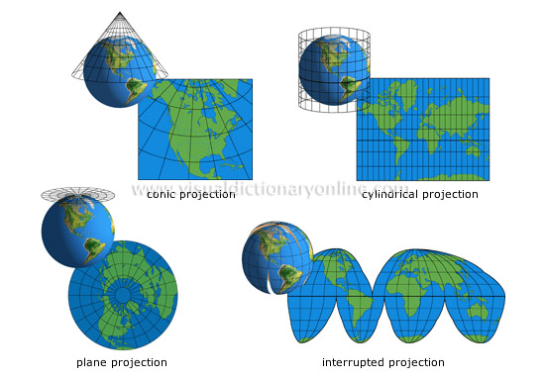a b 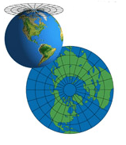c

Figure 2.2 Three types of developable surface commonly used in map projections: (a) cylinder, (b) cone, and (c) plane (<http://visual.merriam-webster.com/images/earth/geography/cartography/map-projections.jpg>).

Many mathematical projections, however, do not neatly fit into any of these three conceptual projection methods. Hence alternative categories have been developed, such as pseudoconical, pseudocylindric (Robinson, 1988), [polyconic](http://en.wikipedia.org/wiki/Polyconic_projection), and pseudoazimuthal (Mailing 1960). More details can be found in Snyder and Voxland (1989).

Furthermore, the project aspect describes how the developable surface is placed in relation to the globe. The aspect varies according to the type of developable surfaces. For a cylindrical surface, the aspect can be normal, transverse or oblique, as shown in Figure 2.3.

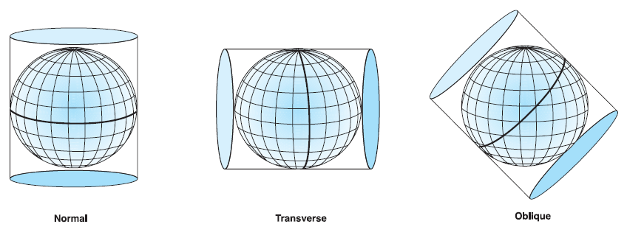

Figure 2.3 Three types of aspect the cylindrical surface can be placed relative to the globe (Kennedy and Kopp, 2000). Image used by permission. Copyright © 1994, 1997, 1999, 2000 Esri. All rights reserved.

For conic projections, the developable surface can be placed either [tangent](http://en.wikipedia.org/wiki/Tangent) or [secant](http://en.wikipedia.org/wiki/Secant_line) to the globe. As illustrated in Figure 2.4, when the surface is tangent to the globe along a line of latitude, this line is called the standard parallel. When the surface slices through the globe (secant aspect), two standard parallels define the contact locations.

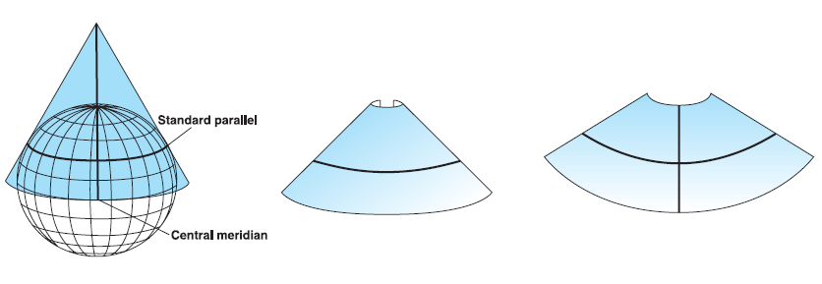

Figure 2.4 Two types of aspect the conic surface can be placed relative to the globe (Kennedy and Kopp, 2000). Image used by permission. Copyright © 1994, 1997, 1999, 2000 Esri. All rights reserved.

While for a planar surface, the aspect can be specified as polar, equatorial, or oblique, as shown in Figure 2.5. In addition, the perspective point determines how the Earth’s surface can be projected onto the flat surface. For example, Figure 2.6 shows three different perspectives for planar projections with polar aspects. The view points are from the centre of the Earth, from pole to pole, and from an infinite point in deep space.

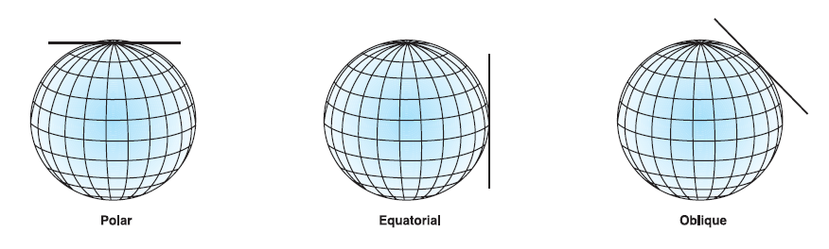

Figure 2.5 Three types of aspect the planar surface can be placed relative to the globe (Kennedy and Kopp, 2000). Image used by permission. Copyright © 1994, 1997, 1999, 2000 Esri. All rights reserved.

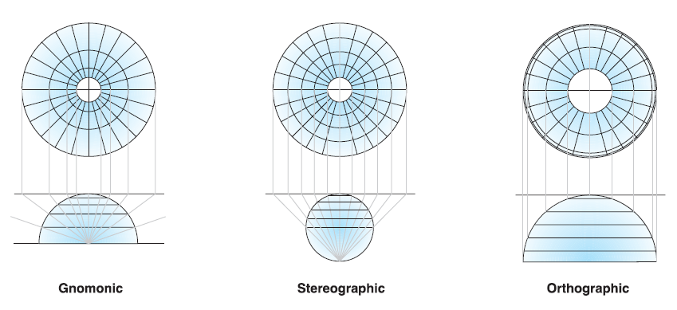

Figure 2.6 Three perspectives from which the Earth’s surface can be projected onto the flat surface (Kennedy and Kopp, 2000). Image used by permission. Copyright © 1994, 1997, 1999, 2000 Esri. All rights reserved.

Spatial properties that a map projection preserves are essential to projection selection and often are included as an additional criterion in the classification scheme. According to the term describing the extent to which the spatial properties are preserved, map projections can be classified as follows (Snyder and Voxland, 1989):

* Conformal projections preserve local shape. This is accomplished by maintaining all angles, which describe the spatial relationships. To preserve individual angles, a conformal projection must show graticule lines intersecting at 90-degree angles on the map. However, no map projection can preserve shapes of large regions. A conformal projection increasingly distorts areas away from the map’s point or lines of true scale and shapes of large regions.
* Equal-Area projections preserve area on the map. In equal-area projections, the meridians and parallels may not intersect at right angles. When this type of projection is used for small-scale maps showing larger regions, the distortion of angles and shapes increases as the distance of an area from the projection origin increases. Whereas, in some instances, especially maps of smaller regions, shapes are not obviously distorted, and distinguishing an equal-area projection from a conformal projection may prove difficult unless documented or measured.
* Equidistant projections preserve the distances between certain points, but not distances from all points to all other points. Scale is not maintained correctly throughout an entire map; however, there is one or more lines on a map along which scale are maintained correctly. Most projections have one or more lines for which the length of the line on a map is the same length (at map scale) as the same line on the globe, regardless of whether it is a great or small circle or straight or curved. Such distances are said to be true.
* True-direction or Azimuthal projections preserve direction from one point to all other points. The shortest route between two points on a curved surface such as the Earth is along the spherical equivalent of a straight line on a flat surface, known as a great circle. True-direction or azimuthal projections maintain some of the great circle arcs, giving the directions or azimuths of all points on the map correctly with respect to the centre. This quality can be combined with Equal-Area, Conformal, and Equidistant projections, as in the Lambert Equal-Area Azimuthal and the Equidistant Azimuthal projections.
* Compromise projections minimise overall distortion but do not preserve any of the four spatial properties of area, shape, distance, and direction.

A few of other classification schemes exist in the cartographic literature, according to different criteria. For example, on the basis of the appearance of the meridians and parallels, Maurer (1935) developed a hierarchical classification scheme to contain all map projections. Unfortunately, this scheme is too difficult to comprehend and too purely theoretical based to be useful as a practical reference for map projection selection (Canters, 2002). Starostin et al. (1981) proposed another all-inclusive classification that is based on the shape of the normal graticule of the meridians and parallels. It consists of one group including projections with parallels of constant curvature while another group including projections with parallels of various curvature. The first group includes three families depending on whether the parallels are straight, concentric or eccentric circles (or circular arcs). Each family is subdivided into a number of classes including the six geometric classes already found in Lee’s (1944) classification, as well as the so-called psedoazimuthal class, already defined by Tissot (1881). The latter consists of projections with concentric, circular parallels, just like the azimuthal projections, yet with curved meridians converging in the centre of the parallels. Moreover, Mailing (1992) suggested a combination of the traditional geometric approach with a parametric classification by Tobler (1962) that is based on the mathematical relationships between the coordinates in the plane for rectangular and for polar coordinates and the geographical coordinates (longitude and latitude). The first has been well adapted to the present diversity of well-known and frequently used projections while the second has the advantage of being all-inclusive.

In this study, we adopt the classification scheme based on first, the geometric construction method, and second, the preservation of spatial properties, according to Snyder and Voxland’s summary (1989). This is consistent with Mailing’s suggestion (1968) on the nomenclature of map projections. As he proposed, a series of descriptive terms are necessarily required to avoid ambiguity in describing a map projection. Firstly, the class a map projection belongs to should be given, then the geometric properties that a map projection preserves should be specified; and finally its distinctive characteristics should be provided, which then lead to an unequivocal identification of a projection. For example, the most commonly used map projections are Albers Equal-Area Conic, Lambert Equal-Area Azimuthal, Transverse Equal-Area Cylindrical, Equidistant Conic, Equidistant Azimuthal, Equidistant Cylindrical Lambert Conformal Conic, Stereographic Conformal Azimuthal, Mercator Conformal Cylindrical projections, plus some compromise projections, e.g. Miller Cylindrical and Robinson Cylindrical projections.

### Map Projection Distortion

As mentioned earlier, no single map projection can portray the Earth correctly without any distortion. The most common types of distortion include changes in scale, distance, area, and shape (Clarke and Mulcahy, 2001). Knowledge of the type, amount, and distribution of distortion is essential for choosing the most appropriate projection to allow the final product to retain the most important properties for a particular map or dataset. As Clarke and Mulcahy (2001) propose, map distortion should be carried along with map data as confidence layers, and the easily accessible distortion displays should be available to help in the selection of map projections. Maps showing projection distortion have been included as backdrops to a base map, as supplemental insets, or as parallel maps. For example, Snyder and Voxland (1989) created parallel distortion maps for most maps in their “Album of Map Projections”. As another example, Canters and Decleir (1989) provided a display of isolines of angular and area distortion on their maps in “The World in Perspective: A Directory of World Map Projections”.

Map projection distortion resulting from the transformation of the globe to the flattened map can be measured, characterised and visualised. Conceived in 1881, Tissot's indicatrix is still considered the standard method for representing map projection distortion. According to Tissot’s (1881) theory, every map projection is locally an affine transformation. An infinitesimal circle surrounding a point on the globe is transformed into an infinitesimal ellipse, the so-called indicatrix of Tissot, surrounding the corresponding point on the image surface. Once the lengths of the axes of the indicatrix are known, it is possible to determine all distortion characteristics of the immediate vicinity of the position for which they are calculated. Thus, local distortion inherent in a projection can be measured and visualised by mapping Tissot’s indicatrix for selected positions on the graticule or by constructing lines of constant distortion.

Figure 2.7 is a representation of the basic idea of Tissot's indicatrix (Brainerd and Pang, 2001). The circle centred at O of radius OA = OB represents an infinitesimal circle on the surface of the sphere. The radius is considered unity. The values a and b represent the scale factors of point O in the directions of OA and OB, respectively. The lengths shown in the diagram are only representative of scale factors at a point and do not correspond to any actual distance. Once projected, the circle will be deformed. If the projection is conformal, the shape will remain circular since the scale factors along the principal directions must be equal. The area, however, is not constrained and therefore will vary from point to point. An equal-area projection, on the other hand, must retain relative areas, so the product of a and b must be equal to unity, but a = b does not hold, so the shape of the indicatrix becomes elliptical and angular distortion is introduced. Segment OA is transformed in OA’, and segment OB is transformed in OB’. The semi-major (OA′) and semi-minor axes (OB′) of the ellipse indicate the maximum scale enlargement and reduction at the point on the projection relative to the globe. The point M on the circle and the corresponding point M’ on the ellipse are points subject to the maximum angular deflection. The amount of angular distortion in a quadrant ω, is given by the relation ω= U – U’ where U=MOA and U’= M’OA. The maximum angular distortion at a point is given as 2ω, which represents the maximum angle deflection in two quadrants adjoining the major axis of the ellipse.

Tissot's indicatrix

Figure 2.7: Tissot's indicatrix: Smaller circle represents infinitesimal small circle on globe of unit radius. Ellipse represents same circle on projected image. Values a=OA′ and b=OB′ represent scale factors used to define angular and areal deformation at point in projection. Source: Brainerd and Pang (2001)

As illustrated in Snyder (1987), since each ellipse is representative of the scale factors at an infinitesimal point, distortion over area extents if a projection is generally achieved by placing ellipses on convenient intersections of the graticule. For example, every 30 degrees parallels and meridians make up the graticule between 60 degrees north and south. As shown in Figure 2.8, on maps that use a conformal projection (e.g. Mercator conformal cylindrical projection), in which each point preserves angles projected from the geometric model, the Tissot’s indicatrices are all circles, but the apparent sizes of the ellipses will vary across the map. With increased distance from the equator, north or south, the amount of area distortion increases dramatically. While on maps that use an equal-area projection (e.g. Mollweide equal-area cylindrical projection) in which the property of equivalence is preserved, the relative sizes of the indicatrices are retained, but the ellipses are distorted in shape and orientation across the map (Figure 2.9). For other map projections, such as compromise projections (e.g. Winkel Tripel cylindrical projection), which are neither equal area nor conformal, the area, shape, and orientation of the indicatrices may vary across the map, as shown in Figure 2.10.

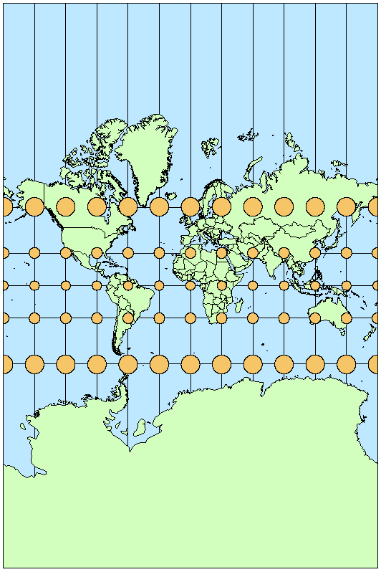

Figure 2.8: Map projected using a conformal projection (the Mercator conformal cylindrical projection) showing all Tissot’s indicatrices are circles. (Image source: <http://blogs.esri.com/esri/arcgis/2011/03/24/tissot-s-indicatrix-helps-illustrate-map-projection-distortion>, posted by Aileen Buckley)

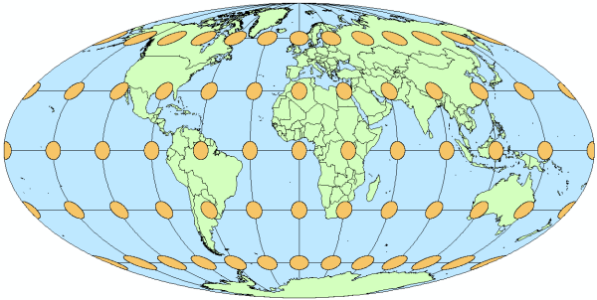

Figure 2.9: Map projected using an equal-area projection (the Mollweide equal-area cylindrical projection) showing all Tissot’s indicatrices are equal in size. (Image source: <http://blogs.esri.com/esri/arcgis/2011/03/24/tissot-s-indicatrix-helps-illustrate-map-projection-distortion>, posted by Aileen Buckley)

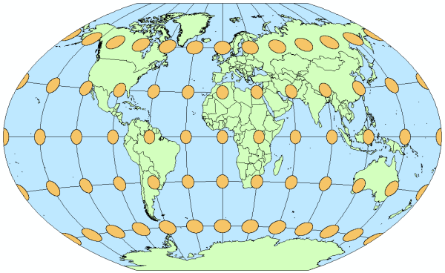

Figure 2.10: Map projected using a compromise projection (the Winkel Tripel cylindrical projection) showing all Tissot’s indicatrices vary in size, shape, and orientation. (Image source: <http://blogs.esri.com/esri/arcgis/2011/03/24/tissot-s-indicatrix-helps-illustrate-map-projection-distortion>, posted by Aileen Buckley)

The limitation of this method is that the distortion distribution shown by Tissot's indicatrix only describes the infinitesimal areas near the centre of the ellipses, which is not the same as the area of the ellipses indicated visually. This may lead to misinterpretations of the location of distortion (Clarke and Mulcahy, 2001). Another problem, raised by Brainerd and Pang (2001), is that the distortion scale cannot be known at arbitrary points on the projection, and the presence of many such ellipses on a static projection image may obscure geographic and overlaid data.

Cartographers have measured, categorised, and visualised map projection distortion characteristics using various methods. Clarke and Mulcahy (2001) conducted a review study on cartographic symbolisation methods in the display of map projection distortions, from familiar shapes to checkerboards in approximate order of interpretive complexity. Each method has its own advantages and disadvantages.

### Map Projection Selection

As Canters and Decleir (1989) suggested, the choice of a map projection among a variety of map projections needs a systematic selection process involving qualitative and quantitative analysis of map projection principles and the purpose of mapping. Generally, qualitative analysis, in relation to the intended mapping purpose, often impose the special property that is desired (equal-area, conformal, equidistant, etc.), the construction method (conic, cylindrical, azimuthal), the aspect (normal, transverse, oblique), and the way of representing the pole (point, straight line, curved line). This may lead to a number of candidate projections. A quantitative analysis based on distortion characteristics is then used to determine the most appropriate map projection.

Young’s Rule

There is a strong correlation between map projection selection and classification. Young (1920) suggests a simple measure to choose from the three classes of cylindrical, conic and azimuthal projections, based on the comparison of the maximum radial distance z and minimum extent δ of the area to be mapped. As demonstrated in Figure 2.11, the area can be regarded being bounded by two parallel arcs of small circles which δ lies apart. They may be parallels of latitude, but they may just as well be transverse or oblique lines. The angular distance from the centre of the area of interest to the point farthest is z. Young (1920) originally noted that if z/ δ<1.41, an azimuthal projection is preferred. Conversely if z/ δ is greater than this critical value a conic or cylindrical projection should be used.

Basically, Young’s rule is that an area of the Earth approximately circular in outline is best represented by one of the azimuthal projections, in which distortion increases radially in all directions, whereas asymmetrical or elongated areas are better mapped using conical or cylindrical projections with lines of zero distortion.

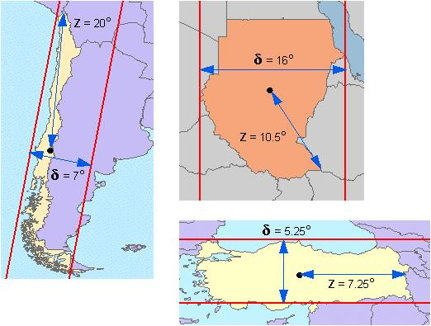

Figure 2.11: Demonstration of Young’s rule for a country with maximum extent z and minimum width δ (image source: [http://www.geo.hunter.cuny.edu/](http://www.geo.hunter.cuny.edu/~jochen/gtech201/lectures/lec6concepts/map%20coordinate%20systems/how%20to%20choose%20a%20projection.htm)): Sudan (top) and Turkey (bottom).

Snyder’s decision tree

To further consider the combination of the area properties, distortion features and application requirements, Snyder (1987) systematically analyses the selection process and presents a decision tree on the basis of:

* 1. size, shape, orientation and location of the region to be mapped;
  2. special distortion properties (conformal, equal-area, equidistant, correct scale along a chosen great circle); and
  3. application-specific considerations (e.g. straight rhumb lines, straight great-circle routes, interrupted designs).

For world maps many types of projections are listed, depending on the application. For smaller areas Snyder (1987) recommends the use of conic type projections. Maps of a hemisphere, which usually have a circular outline, are also treated separately, and the use of azimuthal projections is recommended. Table 2.1 gives recommended map projections for regional and smaller areas that are relevant to this study.

Table 2.1 Snyder’s decision tree for map projection selection (modified from Snyder (1987)).

|  |
| --- |
| CONTINENT, OCEAN AND SMALLER REGION   1. Predominant east-west    1. Along Equator   Conformal: Mercator  Equal-Area: Cylindrical Equal-Area   * 1. Away from Equator   Conformal: Lambert Conformal Conic  Equal-Area: Albers Equal-Area Conic   1. Predominant north-south   Conformal: Transverse Mercator  Equal-Area: Transverse Cylindrical Equal-Area   1. Predominant oblique   Conformal: Oblique Mercator  Equal-Area: Oblique Cylindrical Equal-Area   1. Equal extent in all directions    1. Centre at pole   Conformal: Polar Stereographic  Equal-Area: Polar Lambert Azimuthal Equal-Area   * 1. Centre along Equator   Conformal: Equatorial Stereographic Azimuthal  Equal-Area: Equatorial Lambert Azimuthal Equal-Area   * 1. Centre away from pole or Equator   Conformal: Oblique Stereographic Azimuthal  Equal-Area: Oblique Lambert Azimuthal Equal-Area   1. Straight rhumb lines (principally for oceans)   Mercator   1. Straight great-circle routes   Gnomonic (for less than hemisphere)   1. Correct scale along meridians    1. Centre at pole   Polar Lambert Azimuthal Equidistant   * 1. Centre along Equator   Plate Carree (Equidistant Cylindrical)   * 1. Centre away from pole or Equator   Equidistant Conic |

Mailing’s property-use table

Mailing (1992) analysed different elements related to the function and the intended use of the map in relation to the spatial properties preserved, mostly distinguishing between conformal, equal-area and equidistant projections. Mailing (1992) also included projections with small angular distortion and small exaggeration of area, which are not considered here. Table 2.2 shows the major groups and associates different map uses (Mailing, 1992).

Table 2.2 Main uses of map projections according to special distortion properties (modified from Mailing (1992)).

| Main Uses | Conformal | Equal - Area | Equidistant |
| --- | --- | --- | --- |
| Navigation charts | X |  |  |
| Synoptic meteorological charts | X |  |  |
| Topographical, military and large-scale maps | X |  |  |
| Small-scale strategic planning maps | X |  | X |
| Climatic and oceanographic distribution maps | X |  | X |
| Spatial distribution maps |  | X |  |
| General reference maps |  | X | X |
| Atlas maps |  |  | X |

# Materials and Methods

## Study Area and Dataset

The study was undertaken using point datasets of seabed sediment properties for the continental AEEZ stored in the Marine Samples Database (MARS) at Geoscience Australia. Details of data collection, processing and cleaning can be found in Li et al. (2010), Li et al. (2011a) and Li et al. (2011d). After data filtering and quality control, 4,817 samples with mud content information were identified as suitable for this study.

Samples in the southwest region of AEEZ were then selected to test the effects of spatial reference systems on the accuracy of spatial interpolation methods in predicting the mud content of seabed (Figure 3.1). The region covers an area of 523,000 km2, with water depths ranging from 0 to 5,539 m, and comprises four geomorphic provinces (Heap and Harris, 2008). The mud content (weight %) is derived by the relative weight proportion of 10-20 g dry sediment passing through a standard mesh size (Li et al., 2010) where the grain size of mud is <63 µm. A total of 177 cleaned samples with a density of 0.34 samples per 1,000 km2 (Li et al., 2011a) were used. The spatial distribution of the samples is uneven, with 65 on the shelf, 101 on the slope, 3 on the rise and 8 on the abyssal plain/deep ocean floor.

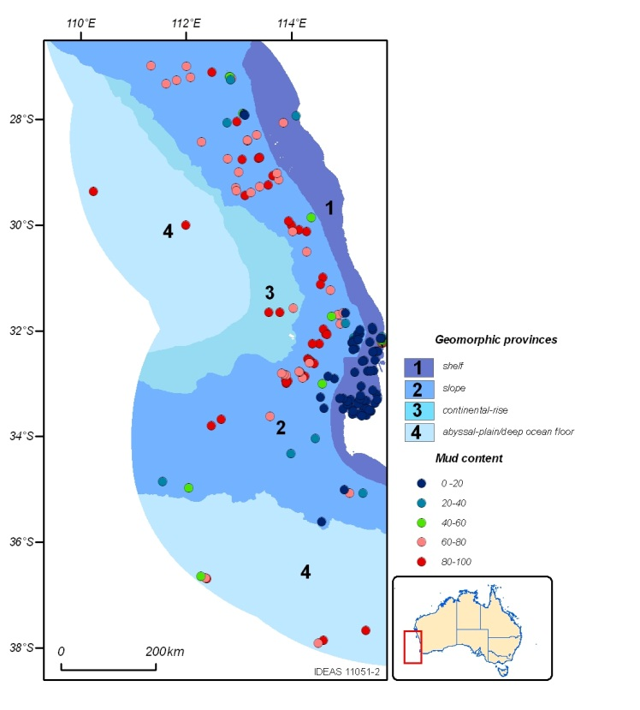

Figure 3.1 Spatial distribution of mud samples in the southwest region of AEEZ (Li et al., 2011b).

## Spatial Interpolation Methods

In this study, we examined two types of spatial interpolation methods that are most commonly compared in environmental studies (Li and Heap, 2008, 2011): inverse distance weighted (IDW) and ordinary kriging (OK).

IDW estimates the values of a spatial variable at unsampled locations using a linear combination of values at sampled points weighted by an inverse function of the distance from the location of interest to the sampled points (ESRI, 2000). The main factor affecting the accuracy of IDW is the value of the power parameter (p) (Isaaks and Srivastava, 1989). The most popular choice of p is 2; and the resulting method is often called inverse distance squared (IDS) (Collins and Bolstad, 1996).

Kriging is a generic name for a family of generalised least-squares regression algorithms, used in recognition of the pioneering work of Danie Krige (1951). OK is the most general and widely used kriging method. Kriging assumes that the distance between sample points reflects a spatial correlation that can be used to explain variations in the surface. Before making a prediction, kriging creates the variograms and covariance functions to estimate the statistical dependence values derived from the model autocorrelation (ESRI, 2000). Five empirical variogram models are commonly used, including exponential, spherical, gaussian, linear, and circular. To make a prediction, Kriging weights are estimated by minimising the variance. More details on kriging method philosophy can be found in the work of Krige (1951), Burrough and McDonnell (1998), Webster and Oliver (2001), Pebesma (2004) and Li and Heap (2008).

## Selection of Spatial Reference Systems

Two widely used geographic coordinate systems were chosen: the World Geodetic System of 1984 (WGS84) and the Geodetic Datum of Australia 1994 (GDA94). WGS84 serves as a standard framework for locational measurement worldwide (Kennedy, 1989) while GDA94 was specifically developed for Australia. The values of parameters for the two geographic coordinate systems are listed below:

GCS_WGS_1984

Angular Unit: Degree (0.017453292519943299)

Prime Meridian: Greenwich (0.000000)

Datum: D_WGS_1984

Spheroid: WGS_1984

Semimajor Axis: 6378137.00000000

Semiminor Axis: 6356752.31424517930000

Inverse Flattening: 298.25722356300003

GCS_GDA_1994

Angular Unit: Degree (0.017453292519943299)

Prime Meridian: Greenwich (0.000000)

Datum: D_GDA_1994

Spheroid: GRS_1980

Semimajor Axis: 6378137.000000000

Semiminor Axis: 6356752.31414035610000

Inverse Flattening: 298.25722210100002

Selection of appropriate map projections is a complex process involving an evaluation of the characteristics of the projected region and/or the type of analysis to be performed. We apply some well-recognised criteria to select a few map projection alternatives that are suitable for the spatial interpolation purpose for the entire AEEZ region.

Firstly we apply Young’s rule (1920). Refer to Figure 3.2, the continental AEEZ lies between latitudes 8° and 45°S, and longitudes 108° and 164°E. The greatest extent from the centre is approximately 25° while distance between two parallel arcs is about 37°. Thus, we find z/ δ=0.68, indicating a preference for an azimuthal projection. This is consistent with the conclusion by Sear (1967) in his argument of selecting the projection for a general reference map of Australia.

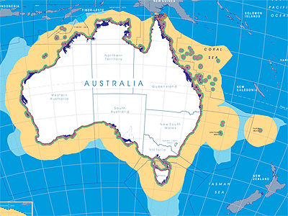

δ

z

Figure 3.2 Map showing the continental AEEZ region with maximum extent z and minimum width δ. The AEEZ image is produced by Geoscience Australia (<http://www.ga.gov.au/webtemp/image_cache/GA8896.pdf>).

Secondly, we consider Snyder’s decision tree (1987). If the shape of the AEEZ is treated as predominant east-west, as recommended by Geoscience Australia, Lambert Conformal or Albers Equal-Area Conic projections should be selected. However, if its shape is considered as proximately round with similar extent in all directions, the choice falls into Stereographic Conformal or Lambert Azimuthal projections.

With respect to Mailing’s property-use table (1992), spatial interpolation does not fall into any category listed in the table. Spatial interpolation methods make predictions based on the distance or direction between sample locations; however, there is no map projection that can preserve the distances between any two points, nor the directions. Therefore, equidistant, equal-area and conformal projections all need to be tested in terms of their effects on the accuracy of spatial interpolation methods.

Eventually, we selected Lambert Equal-Area Azimuthal, Stereographic Conformal Azimuthal, Equidistant Conic and Equidistant Azimuthal map projections, plus Lambert Conformal Conic and Albers Equal-Area Conic. Basically, they are equidistant, equal-area and conformal projections with conic or azimuthal developable surfaces respectively. Thus, we can test these map projections in terms of the spatial properties preserved and the geometric construction methods used.

The projection parameters for each map projection were optimised for the continental AEEZ to minimise distortions (shown in Table 3.1). Note, the linear unit is meter (1.0000) and the scale factor is 1.0000 for all the projections. All the map projections were projected based on WGS84 and GDA94, respectively.

Table 3.1 The values of parameters set for selected map projections for the continental AEEZ.

| Map Projection | False_  Easting | False_  Northing | Central_  Meridian | Standard_  Parallel_1 | Standard_  Parallel_2 | Latitude_  Of_Origin |
| --- | --- | --- | --- | --- | --- | --- |
| Albers Equal-Area Conic | 0° | 0° | 134° | -18° | -36° | 0° |
| Lambert Equal-Area Azimuthal | 0° | 0° | 134° | N/A | N/A | 0° |
| Lambert Conformal Conic | 0° | 0° | 134° | -18° | -36° | 0° |
| Stereographic Conformal Azimuthal | 0° | 0° | 134° | N/A | N/A | 0° |
| Equidistant Conic | 0° | 0° | 134° | -18° | -36° | 0° |
| Equidistant Azimuthal | 0° | 0° | 134° | N/A | N/A | 0° |

## Model Specifications and Implementation

The modelling processes include data transformation, data projection, spatial interpolation and leave-one-out cross validation. All the modelling work was undertaken using Geostatistical and Spatial Analyst extensions in ArcGIS.

In relation to data transformation, there is no need to transform data for IDS. However, the assumption of data stationary associated with geostatistical methods such as OK requires data to be transformed. An arcsine transformation was identified as an appropriate method to normalise the mud content data in the southwest region of AEEZ (Li et al., 2010, Li and Heap, 2008). The dataset was transformed prior to spatial interpolation and the predicted values were back-transformed before comparing with the validating samples. The empirical variogram model applied in this study was the spherical model, which was selected as the best fit for the southwest region by Li et al. (2010) in their series of work on spatial interpolation of seabed data in the continental AEEZ. The number of lags used to fit the model was set as 15. The values of other parameters, including the nugget, partial sill and range, were calculated using a weighted least-squares algorithm in ArcGIS, given in Table 3.2.

For both IDS and OK, the search window size, i.e. the number of nearest samples used for making predictions, was set a value of 20, to keep consistence with the previous work done in Geoscience Australia (Li et al., 2010).

Table 3.2 The values of parameters used in variogram models based on different map projections.

| Map Projection | Lag size | Nugget | Partial Sill | Range |
| --- | --- | --- | --- | --- |
| WGS84 | 0.17076 | 0.04742 | 0.23288 | 1.62186 |
| GDA94 | 0.17076 | 0.04742 | 0.23288 | 1.62186 |
| Albers Equal-Area Conic | 16329.6 | 0.045232 | 0.23075 | 151912 |
| Lambert Equal-Area Azimuthal | 17173.2 | 0.046499 | 0.23202 | 161162 |
| Lambert Conformal Conic | 16900.1 | 0.045410 | 0.230948 | 151658 |
| Stereographic Conformal Azimuthal | 18095.3 | 0.045677 | 0.23049 | 170559 |
| Equidistant Conic | 16561.6 | 0.045310 | 0.23082 | 151696 |
| Equidistant Azimuthal | 17675.6 | 0.046278 | 0.23182 | 164708 |

## Assessment of Method Accuracy

We applied leave-one-out cross validation to compare the performance of spatial interpolation methods based on different spatial reference systems. Leave-one-out cross-validation removes one observation at a time and predicts its value using the remaining data. The predicted and sampled value at the location of the omitted sample is then compared. For all points, leave-one-out cross-validation compares the measured and predicted values to yield the model accuracy.

Several error measures for assessing accuracy have been considered. Mean absolute error (MAE) and root mean square error (RMSE) are among the best overall measures of model performance as they summarise the mean difference in the units of observed and predicted values (Willmott, 1982). In addition, two newly proposed measures: 1) relative mean absolute error (RMAE); and 2) relative root mean square error (RRMSE), are chosen because they are not sensitive to the changes in unit/scale (Li and Heap, 2008). Their formulae are listed as follows:

 (1)

 (2)

 (3)

 (4)

where n is the number of observations or samples, o is the observed value, p is the predicted value, and om is the mean of the observed values.

Since the data are not normally distributed, paired Mann-Whitney tests were used to compare the predictive errors in terms of RMAE between WGS84 and different map projections for both IDS and OK. If the resulting P-value is small (P<0.05) then a statistically significant difference between observations and predictions can be drawn. This part of testing work was implemented in R (R, Development Core Team, 2012).

In addition, visual examination was undertaken to access the performance of IDS and OK. It is considered as important as the predictive error assessments, because methods with similar prediction error may produce different spatial patterns and visual examination can detect apparent abnormal patterns in the predictions (Li et al., 2011b).

# Results

IDS and OK were applied to the mud content dataset projected on different spatial reference systems. The observed and predicted values were compared using leave-one-out cross validation. The calculated values of MAE, RMSE, RMAE and RRMSE are summarised in Tables 4.1 and 4.2.

The results of paired Mann-Whitney tests comparing the RMAE between WGS84 and the six map projections for IDS and OK are presented in Table 4.3. Given that the observed patterns of other error measurements are similar to RMAE for these two methods, only the testing results of RMAE are presented.

## Predictions Based on WGS84 and GDA94

Firstly we compared the predictive errors from IDS and OK predictions using the two geographic coordinate systems, i.e. WGS84 and GDA94 (Tables 4.1 and 4.2). As can be seen, the errors in terms of MAE, RMAE, RMSE and RRMSE resulted from the two systems were exactly the same for both IDS and OK. We further examined the predicted values from IDS and OK predictions and confirmed that spatial predictions based on WGS84 and GDA94 were consistent.

The result also confirmed that predictions from map projections based on different datum - WGS84 or GDA94 showed no difference. Thus, only results from map projections based on WGS84 are presented in Tables 4.1 and 4.2.

## Predictions Based on WGS84 and Map Projections

We then compared the predictive errors from the geographic coordinate systems with the selected map projections (Tables 4.1 and 4.2). The result shows that in terms of MAE and RMAE, the accuracies of both IDS and OK methods slightly increased after the data was projected on planar surfaces. However, the differences were less than 1.2%. The resulting P-values (0.11-0.97) from the Mann-Whitney tests (Table 4.3) also indicate that the predictive errors from IDS and OK predictions based on WGS84 and the six map projections have no statistically significant difference. In terms of RMSE and RRMSE, the error values of IDS increased whereas those of OK reduced when the data was projected on planar surfaces. This indicates slightly larger variations in the magnitude of the errors in the IDS predictions and smaller variations in the errors in the OK predictions. However, again, the differences of these errors were less than 1.2%.

## Predictions Based on Map Projections

We further examined the predictive errors resulted from the six map projections (Tables 4.1 and 4.2). Firstly, with respect to spatial properties preserved, we compared the equidistant, equal-area and conformal projections with conic developable surfaces. The differences in the predictive errors resulted from these map projections were trivial (≤ 0.10%). Secondly, we compared these projections with azimuthal construction methods. Both IDS and OK methods performed slightly better when the data was projected using the Equal-Area and Equidistant projections than using the Conformal projections. However, the differences in the predictive errors were minor (≤ 0.73%).

With respect to developable surfaces applied in construction methods, the Equal-Area and Equidistant projections with Azimuthal surfaces produced slightly better accuracy than those with Conic surfaces. However, the greatest differences were only 0.73% and 0.66%, respectively. Whereas, the differences in the predictive errors resulted from the Conformal projections were even more negligible (≤0.1%).

Table 4.1 The predictive errors of the IDS predictions based on different spatial reference systems in predicting seabed mud content in the southwest region of AEEZ.

| Map Projection | MAE | RMSE | RMAE % | RRMSE% |
| --- | --- | --- | --- | --- |
| WGS84 | 9.83 | 15.17 | 21.27 | 32.81 |
| GDA94 | 9.83 | 15.17 | 21.27 | 32.81 |
| Albers Equal-Area Conic | 9.78 | 15.31 | 21.15 | 33.10 |
| Lambert Equal-Area Azimuthal | 9.74 | 15.24 | 21.07 | 32.97 |
| Lambert Conformal Conic | 9.79 | 15.30 | 21.17 | 33.10 |
| Stereographic Conformal Azimuthal | 9.78 | 15.31 | 21.16 | 33.11 |
| Equidistant Conic | 9.79 | 15.30 | 21.17 | 33.10 |
| Equidistant Azimuthal | 9.74 | 15.25 | 21.06 | 32.98 |

Table 4.2 The predictive errors of OK predictions based on different spatial reference systems in predicting seabed mud content in the southwest region of AEEZ.

| Map Projection | MAE | RMSE | RMAE % | RRMSE% |
| --- | --- | --- | --- | --- |
| WGS84 | 9.65 | 15.21 | 20.88 | 32.90 |
| GDA94 | 9.65 | 15.21 | 20.88 | 32.90 |
| Albers Equal-Area Conic | 9.60 | 15.16 | 20.76 | 32.79 |
| Lambert Equal-Area Azimuthal | 9.54 | 15.06 | 20.63 | 32.58 |
| Lambert Conformal Conic | 9.61 | 15.17 | 20.78 | 32.82 |
| Stereographic Conformal Azimuthal | 9.61 | 15.17 | 20.78 | 32.80 |
| Equidistant Conic | 9.61 | 15.17 | 20.78 | 32.82 |
| Equidistant Azimuthal | 9.54 | 15.08 | 20.65 | 32.60 |

Table 4.3 P-values from paired Mann-Whitney tests comparing the predictive errors between WGS84 and the six map projections in terms of RMAE for both IDS and OK.

| WGS84 vs. Map Projections | IDS (P-value) | OK (P-value) |
| --- | --- | --- |
| Albers Equal-Area Conic | 0.95 | 0.32 |
| Lambert Equal-Area Azimuthal | 0.31 | 0.11 |
| Lambert Conformal Conic | 0.89 | 0.49 |
| Stereographic Conformal Azimuthal | 0.89 | 0.45 |
| Equidistant Conic | 0.97 | 0.41 |
| Equidistant Azimuthal | 0.56 | 0.26 |

## Prediction Maps

The prediction maps are plotted in Figure 4.1 and Figure 4.2 for visual examination purpose. As can be seen, the predicted patterns from all spatial reference systems are similar, with no major discrepancies observed.

|  |  |  |  |
| --- | --- | --- | --- |
| Sample | WGS84 | GDA94 | legend |
| Sample | WGS84 | GDA94 |
| Lambert azimuthal | Stereographic azimuthal | equidistant azimuthal  Mud Content Weight% |
| Lambert Equal-Area Azimuthal | Stereographic Conformal Azimuthal | Equidistant Azimuthal |
| Albers Conic | Lambert conic | Equidistant conic |
| Albers Equal-Area Conic | Lambert Conformal Conic | Equidistant Conic |

Figure 4.1 Predicted spatial distribution of seabed mud content in the southwest region of the continental AEEZ using IDS based on different spatial reference systems.

|  |  |  |  |
| --- | --- | --- | --- |
| Sample | WGS84 | GDA94 | Legend |
| Sample | WGS84 | GDA94 |
| Lambert Azimuthal | Stereographic Azimuthal | Equidistant Azimuthal  Mud Content Weight% |
| Lambert Equal-Area Azimuthal | Stereographic Conformal Azimuthal | Equidistant Azimuthal |
| Albers conic | Lambert conic | Equidistant conic |
| Albers Equal-Area Conic | Lambert Conformal Conic | Equidistant Conic |

Figure 4.2 Predicted spatial distribution of seabed mud content in the southwest region of the continental AEEZ using OK based on different spatial reference systems.

# Discussions

## The Effects of WGS84 and GDA94

Although both WGS84 and GDA94 are geocentric datum using the Earth’s centre of mass as the origin, the small difference between WGS84 and GDA94 due to the inverse flattening term and tectonic movement needs to be taken into account for applications that require precise absolute positions (Stanaway, 2007). However, the spatial interpolation methods are not expected to be sensitive to the two geographic coordinate systems because they make predictions based on the relative positions between the samples and the samples are time independent in this case. This is confirmed by the finding in this study.

## The Effects of WGS84 and Map Projections

The remaining question is whether the unit difference in geographical coordinates or distortions introduced by map projections has more effect on the accuracy of the spatial interpolation methods. Results from this study show that the accuracies of both IDS and OK methods slightly increase in terms of MAE and RMAE when the data is projected on planar surfaces. However, the improvement is minor (<1.2%). Moreover, IDS and OK respond marginally differently to spatial reference systems in terms of RMSE and RRMSE. This indicates slightly larger variations in the magnitude of the IDS predictive errors and smaller variations in the OK predictive errors when the data is projected. Again, the differences of these errors are negligible (<1.2%). IDS prediction depends solely on the distance from samples to the prediction location, while OK prediction depends on the spatial correlations among the samples. The reason why IDS and OK show different error variations needs to be further investigated in future work.

For predictions using local data with a search window of 20 and a data density of 0.34 samples per 1,000 km2, the difference of less than 1.2% is considered negligible. As expected, because spatial interpolation methods focus on local data, the unit difference in geographical coordinates and distortions introduced by map projections result in minor differences in the accuracy of the two spatial interpolation methods. However, data density and the size of search window control the region size formed by samples; hence they can potentially alter the degree to which spatial reference systems affect spatial predictions. For example, using a dataset with lower data density or using a greater size window than that in this study, the difference in prediction accuracies based on different spatial reference systems may be larger.

Another issue is that both the unit difference in geographical coordinates and distortions introduced by map projections are dependent on the location of an area. This is because the unit difference in latitude and longitude gradually increases from the equator towards the North/South Poles, while different map projections also generate spatially uneven distortions. In this study, data in the southwest region of AEEZ was used. This region is located at medium-latitude (around S30°) and easting 112°. However, using data in other regions, e.g. north region, which is located at lower latitude (around S10°), may potentially alter the results. We recommend that further investigation is needed to test other regions in the continental AEEZ.

## The Effects of Map Projections

Among the six map projections, for both IDS and OK, indicating that Equal-Area and Equidistant projections with Azimuthal surfaces are slightly more suitable than other projections for the spatial predictions of seabed mud content in the continental AEEZ. This is consistent with Young’s rule (1920) and Sear’s recommendation (1967) for choosing map projections for the Australia region. This is also consistent with Snyder’s decision tree (1987) if the shape of the continental AEEZ is considered circular, in which distortions increase radially. However, if the shape is thought to be predominant east-west, Conic projections with zero distortion at central meridians would be more appropriate. Essentially, the choice is dependent on the determination of a circular or elongate shape of the AEEZ. Young’s rule (1920) provides a quantitative means to determine shapes while Snyder’s decision tree (1987) makes choice based on visualisations.

The distance between sample locations is crucial for obtaining accurate spatial predictions. However, there is no map projection that can preserve distances between any two points. The reason why Lambert Equal-Area Azimuthal and Equidistant Azimuthal performed marginally better than the others may also be because Azimuthal projections maintain directions from one point to all other points. When this quality is combined with Equal-Area and Equidistant projections, distortions in distances are likely reduced.

# Conclusions

This study examines the effects of the selected spatial reference systems on the accuracy of the spatial interpolation methods (IDS and OK) based on seabed mud content in the southwest region of AEEZ. The main findings are:

1. The small shift between the two geographic coordinate systems, WGS84 and GDA94, does not affect the accuracy of the spatial interpolation methods examined;
2. Whether the data is projected on spherical surfaces based on the geographic coordinate systems, or on planar surfaces based on the map projections, the accuracies of the spatial interpolation methods are similar and the differences are considered negligible in terms of predictive errors and prediction map visualisations;
3. The slightly better prediction performance from Lambert Equal-Area Azimuthal and Equidistant Azimuthal projections for both IDS and OK indicates that Equal-Area and Equidistant projections with Azimuthal surfaces are more suitable than other projections for spatial predictions of seabed sediment data in the southwest region of AEEZ.

The outcomes of this study have significant implications for spatial predictions in environmental science. The results suggest that spatial predictions using datasets with a density comparable to or greater than that in this study may use WGS84 directly and may not have to project data on a certain spatial reference system. This would greatly increase data processing efficiency. The findings are applicable to spatial predictions of both marine and terrestrial environmental variables.

# Acknowledgements

We thank the two reviewers for the valuable comments. We also thank Christina Baker, Mark Webster, Shoaib Burq and Tanya Whiteway for preparing the datasets used in this study. This GA record is published with permission of the Chief Executive Officer, Geoscience Australia.

References

Battersby, S. E. 2009. The effects of global-scale map projection knowledge on perceived land area. *Cartographica,* 44**,** 33-44.

Brainerd, J. & Pang, A. 2001. Interactive map projections and distortion. *Computers and Geosciences,* 27**,** 299-314. Reprinted image with permission from Elsevier. Copyright (2013).

Burrough, P. A. & McDonnell, R. A. 1998. *Principles of Geographical Information Systems.* Oxford: Oxford University Press.

Canters, F. 2002. *Small-scale Map Projection Design.* London: Taylor & Francis: Research Monographs in Geographic Information Systems.

Canters, F. & Decleir, H. 1989. *The world in perspective, A Directory of World Map Projections.* Chichester, Sussex: John Wiley & Sons Ltd.

Clarke, K. C. & Mulcahy, K. A. 2001. Symbolization of Map Projection Distortion: A Review. *Cartography and Geographic Information Science,* 28**,** 167-181.

Close, C. F. & Clarke, A. R. 1911. Map projections. *Encylopaedia Britannia,11th Ed.,* v. 17**,** 653-663.

Eldrandaly, K. A. 2006. A COM-based expert system for selecting the suitable map projection in ArcGIS. *Expert Systems with Applications,* 31**,** 94-100.

ESRI 2000. Arc/Info. *ESRI, Inc., Redlands, California*.

Heap, A. D. & Harris, P. T. 2008. Geomorphology of the Australian margin and adjacent seafloor. *Australian Journal of Earth Sciences,* 55**,** 555-585.

Kennedy, M. 1989. *Understanding of map projections.* ESRI: Manual of ArcGIS.

Kennedy, M. & Kopp, S. 2000. *Understanding map projections.* Redlands, CA: ESRI Press.

Krige, D. G. 1951. A statistical approach to some mine valuations problems at the Witwatersrand. *Journal of the Chemical, Metallurgical and Mining Society of South Africa,* 52**,** 119-139.

Lee, L. P. 1944. The Nomenclature and Classification of Map Projections. *Empire Survey Review 7***,** 190-200.

Li, J. & Heap, A. 2008. *A Review of Spatial Interpolation Methods for Environmental Scientists.* Canberra: Geoscience Australia. Record 2008/23.

Li, J., Heap, A., Potter, A. & Daniell, J. J. 2011a. *Predicting Seabed Mud Content across the Australian Margin II: Performance of Machine Learning Methods and Their Combination with Ordinary Kriging and Inverse Distance Squared.* Canberra: Geoscience Australia. Record 2011/07, 69pp.

Li, J., Heap, A. D., Potter, A. & Daniell, J. 2011b. Application of machine learning methods to spatial interpolation of environmental variables. *Environmental Modelling & Software,* 26**,** 1647-1659.

Li, J., Heap, A. D., Potter, A., Huang, Z. & Daniell, J. 2011c. Can we improve the spatial predictions of seabed sediments? A case study of spatial interpolation of mud content across the southwest Australian margin. *Continental Shelf Research,* 31**,** 1365-1376.

Li, J., Heap, A. D., Potter, A., Huang, Z. & Daniell, J. 2011d. Seabed mud content across the Australian continental EEZ 2011. Available: [https://www.ga.gov.au/products/servlet/controller?event=FILE_SELECTION&catno=71977](http://www.ga.gov.au/products/servlet/controller?event=FILE_SELECTION&catno=71977) [Accessed GEOMET: 14815].

Li, J., Potter, A., Huang, Z., Daniell, J. J. & Heap, A. 2010. *Predicting Seabed Mud Content across the Australian Margin: Comparison of Statistical and Mathematical Techniques Using a Simulation Experiment.* Canberra: Geoscience Australia. Record 2010/11.

Mailing, D. H. 1968. The terminology of map projections. *International Yearbook of Cartography. ,* 8**,** 11-65.

Mailing, D. H. 1992. *Coordinate systems and map projections.* Oxford: Pergamon Press,1992.

Maurer, H. 1935. Ebene Kugelbilder, ein Linnesches System der Kartenentwiirfe. *etermanns Geographische Mitteilungen, Erganzungsheft,* 221**,** 1-80.

NIMA. 2000. *Department of Defense, World Geodetic System 1984, Its Definition and Relationship with Local Geodetic Systems.* National Imagery and Mapping Agency TR8350.3, Third Edition, Amendment 1, 175.

Nyerges, T. & Jankowski, P. 1989. A Knowledge Base for Map Projection Selection. *Cartography and Geographic Information Science,* 16**,** 29-38.

Pebesma, E. J. 2004. Multivariable geostatistics in S: the gstat package. *Computer & Geosciences,* 30**,** 683-691.

R Development Core Team, 2012. R: A Language and Environment for Statistical Computing. Vienna: R Foundation for Statistical Computing.

Robeson, S. M. 1997. Spherical Methods for Spatial Interpolation: Review and Evaluation. *Cartography and Geographic Information Science,* 24**,** 3-20 (18).

Sear, W. J. 1967. The projection story. *Cartography,* 6**,** 64-72.

Shepard, D. 1968. A two-dimensional interpolation function for irregularly spaced data. *In Proceedings of the 23rd National Conference, ACM.*, Princeton, NJ. Brandon/Systems Press Inc, 517-23.

Shepard, D. 1984. Computer mapping: The SYMAP interpolation algorithm. *In:* GAILE, G. L. & WILLMOTT, C. J. (eds.) *Spatial statistics and models.* Dordrecht, Holland: D. Reidel 133-45.

Snyder, J. P. 1987. *Map Projections--A Working Manual.* Geological Survey Professional Paper,1395*.* Washington, DC: U. S. Government Printing Office.

Snyder, J. P. & Voxland, P. M. 1989. *An album of map projections.* United States Geological Survey Professional Paper,1453*.* Washington, D.C.: U.S. Government Printing Office.

Stanaway, R. 2007. *GDA94, ITRF, WGS84: What’s the difference? Working with dynamic datums* [Online]. Available: [https://www.quickclose.com.au/stanawayssc2007.pdf](http://www.quickclose.com.au/stanawayssc2007.pdf).

Starostin, F. A., Vakhrameyeva, L. A. & Bugayevskiy, L. M. 1981. Obobshchennaya klassifikatsiya kartograficheskikh proyektsiy po vidu izobrazheniya meridianov i paralleley, Izvestiya Vysshikh Uchebnykh Zavedeniy. *Geodeziya i Aerofotos'emka,* 6**,** 111-116.

Tissot, N. A. 1881. *Memoire sur la representation des surfaces et les projections des cartes geographiques.* Paris, France: Gauthier Villars.

Tobler, W. R. 1962. Geographic Area and Map Projections. *Geographical Review,* 53**,** 59-78.

Usery, E. L. & Seong, J. C. 2000. A Comparison of Equal-Area Map Projections for Regional and Global Raster Data. *Proceeding of 29th International Geographical Congress*, Seoul, Korea, 2000.

Webster, R. & Oliver, M. 2001. *Geostatistics for Environmental Scientists.* Chichester: John Wiley & Sons Ltd. 271pp.

Willmott, C. J. 1982. Some comments on the evaluation of model performance. *Bulletin American Meteorological Society,* 63**,** 1309-1313.

Willmott, C. J., Rowe, C. M. & Philpot, W. D. 1985. Small-Scale Climate Maps: A Sensitivity Analysis of Some Common Assumptions Associated with Grid-Point Interpolation and Contouring. *Cartography and Geographic Information Science,* 12**,** 5-16(12).

Young, A. E. 1920. Some investigations in the theory of map projection. Technical series no.1. London: Royal Geographical Society.

1. Listed Well-Known Map Projections

| Map projection | Description |
| --- | --- |
| Aitoff | This compromise projection was developed in 1889 and used for world maps. |
| Alaska Grid | This projection was developed to provide a conformal map of Alaska with less scale distortion than other conformal projections. |
| Alaska series E | This was developed in 1972 by the United States Geological Survey (USGS) to publish a map of Alaska at 1:2,500,000 scale. |
| Albers equal area conic | This conic projection uses two standard parallels to reduce some of the distortion of a projection with one standard parallel. Shape and linear scale distortion are minimized between the standard parallels. |
| Azimuthal equidistant | The most significant characteristic of this projection is that both distance and direction are accurate from the central point. |
| Behrmann equal area cylindrical | This is an equal-area cylindrical projection suitable for world mapping. |
| Berghaus Star | This divides the outer portion of the projection into five points to minimize interruptions to the land masses. |
| Bipolar oblique conformal conic | This projection was developed specifically for mapping North and South America and maintains conformity. |
| Bonne | This equal-area projection has true scale along the central meridian and all parallels. |
| Cassini-Soldner | This transverse cylindrical projection maintains scale along the central meridian and all lines parallel to it. This projection is neither equal area nor conformal. |
| Chamberlin Trimetric | This projection was developed and used by the National Geographic Society for continental mapping. The distance from three input points to any other point is approximately correct. |
| Craster parabolic | This pseudo cylindrical equal-area projection is primarily used for thematic maps of the world. |
| Cube | This is a faceted projection that is used for ArcGlobe. |
| Cylindrical equal area | Lambert first described this equal-area projection in 1772. It is used infrequently. |
| Double stereographic | This azimuthal projection is conformal. |
| Eckert I | This pseudo cylindrical projection is used primarily as a novelty map. |
| Eckert II | This is a pseudo cylindrical equal-area projection. |
| Eckert III | This pseudo cylindrical projection is used primarily for world maps. |
| Eckert IV | This equal-area projection is used primarily for world maps. |
| Eckert V | This pseudo cylindrical projection is used primarily for world maps. |
| Eckert VI | This equal-area projection is used primarily for world maps. |
| Equidistant conic | This conic projection can be based on one or two standard parallels. As the name implies, all circular parallels are spaced evenly along the meridians. |
| Equidistant cylindrical | This is one of the easiest projections to construct because it forms a grid of equal rectangles. |
| Equirectangular | This projection is simple to construct because it forms a grid of equal rectangles. |
| Fuller | The final version of this interrupted projection was described by Buckminster Fuller in 1954. |
| Gall's stereographic | The Gall's stereographic projection is a cylindrical projection designed around 1855 with two standard parallels at latitudes 45° N and 45° S. |
| Gauss-Krüger | This projection is similar to the Mercator except that the cylinder is tangent along a meridian instead of the equator. The result is a conformal projection that does not maintain true directions. |
| Geocentric coordinate system | The geocentric coordinate system is not a map projection. The earth is modelled as a sphere or spheroid in a right-handed x,y,z system. |
| Geographic coordinate system | The geographic coordinate system is not a map projection. The earth is modelled as a sphere or spheroid. |
| Gnomonic | This azimuthal projection uses the centre of the earth as its perspective point. |
| Goodes homolosine | This interrupted equal-area pseudocylindrical projection is used for world raster data. |
| Great Britain National Grid | This coordinate system uses a transverse Mercator projected on the Airy spheroid. The central meridian is scaled to 0.9996. The origin is 49° N and 2° W. |
| Hammer-Aitoff | The Hammer–Aitoff projection is a modification of the Lambert azimuthal equal area projection. |
| Hotine Oblique Mercator | This is an oblique rotation of the Mercator projection developed for conformal mapping of areas that do not follow a north–south or east–west orientation but are obliquely oriented. |
| Krovak | The Krovak projection is an oblique Lambert conformal conic projection designed for the former Czechoslovakia. |
| Lambert azimuthal equal area | This projection preserves the area of individual polygons while simultaneously maintaining true directions from the centre. |
| Lambert conformal conic | This projection is one of the best for middle latitudes. It is similar to the Albers conic equal area projection except that the Lambert conformal conic projection portrays shape more accurately. |
| Local Cartesian projection | This is a specialized map projection that does not take into account the curvature of the earth. |
| Loximuthal | This projection shows loxodromes, or rhumb lines, as straight lines with the correct azimuth and scale from the intersection of the central meridian and the central parallel. |
| McBryde-Thomas flat-polar quartic | This equal-area projection is primarily used for world maps. |
| Mercator | Originally created to display accurate compass bearings for sea travel. An additional feature of this projection is that all local shapes are accurate and clearly defined. |
| Miller cylindrical | This is similar to the Mercator projection except that the polar regions are not as aerially distorted. |
| Mollweide | Carl B. Mollweide created this pseudo cylindrical projection in 1805. It is an equal-area projection designed for small-scale maps. |
| New Zealand National Grid | This is the standard projection for large-scale maps of New Zealand. |
| Orthographic | This perspective projection views the globe from an infinite distance. This gives the illusion of a three-dimensional globe. |
| Perspective | This projection is similar to the orthographic projection in that its perspective is from space. In this projection, the perspective point is not an infinite distance away; instead, you can specify the distance. |
| Plate Carrée | This projection is simple to construct because it forms a grid of equal rectangles. |
| Polar stereographic | This is equivalent to the polar aspect of the stereographic projection on a spheroid. The central point is either the North Pole or the South Pole. |
| Polyconic | The name of this projection translates into "many cones" and refers to the projection methodology. |
| Quartic Authalic | This pseudo cylindrical equal-area projection is primarily used for thematic maps of the world. |
| Rectified Skewed Orthomorphic | This oblique cylindrical projection is provided with two options for the national coordinate systems of Malaysia and Brunei. |
| Robinson | This is a compromise projection used for world maps. |
| Simple conic | This conic projection can be based on one or two standard parallels. |
| Sinusoidal | As a world map, this projection maintains equal area despite conformal distortion. |
| Space Oblique Mercator | This projection is nearly conformal and has little scale distortion within the sensing range of an orbiting mapping satellite, such as Landsat. |
| State Plane Coordinate System (SPCS) | The State Plane Coordinate System is not a projection. It is a coordinate system that divides the 50 states of the United States, Puerto Rico, and the U.S. Virgin Islands into more than 120 numbered sections, referred to as zones. |
| Stereographic | This azimuthal projection is conformal. |
| Times | The Times projection was developed by Moir in 1965 for Bartholomew Ltd., a British mapmaking company. It is a modified Gall's stereographic, but the Times has curved meridians. |
| Transverse Mercator | This is similar to the Mercator except that the cylinder is tangent along a meridian instead of the equator. The result is a conformal projection that does not maintain true directions. |
| Two-Point equidistant | This modified planar projection shows the true distance from either of two chosen points to any other point on a map. |
| Universal Polar Stereographic | This form of the polar stereographic maps areas north of 84° N and south of 80° S that is not included in the Universal Transverse Mercator (UTM) coordinate system. |
| Universal Transverse Mercator | The Universal Transverse Mercator coordinate system is a specialized application of the Transverse Mercator projection. The globe is divided into 60 zones, each spanning six degrees of longitude. |
| Van der Grinten I | This projection is similar to the Mercator projection except that it portrays the world as a circle with a curved graticule. |
| Vertical near-side perspective | Unlike the orthographic projection, this perspective projection views the globe from a finite distance. This perspective gives the overall effect of the view from a satellite. |
| Winkel I | This is a pseudo cylindrical projection used for world maps that averages the coordinates from the equirectangular (equidistant cylindrical) and sinusoidal projections. |
| Winkel II | This is a pseudo cylindrical projection that averages the coordinates from the equirectangular and Mollweide projections. |
| Winkel Tripel | This is a compromise projection used for world maps that averages the coordinates from the equirectangular (equidistant cylindrical) and Aitoff projections. |

Source: (Kennedy and Kopp, 2000). Table used by permission. Copyright © 1994, 1997, 1999, 2000 Esri. All rights reserved.