Standard Operation Procedure for a Multibeam Survey

Acquisition & Processing
Geoscience Australia
RECORD 2013/33
Cameron Buchanan, Michele Spinoccia, Kim Picard, Olivia Wilson, Mike Sexton, Stephen Hodgkin, Robert Parums, Matthew Carey and Justy Siwabessy
Department of Industry
Minister for Industry: The Hon Ian Macfarlane MP
Parliamentary Secretary: The Hon Bob Baldwin MP
Secretary: Ms Glenys Beauchamp PSM
Geoscience Australia
Chief Executive Officer: Dr Chris Pigram
This paper is published with the permission of the CEO, Geoscience Australia
© Commonwealth of Australia (Geoscience Australia) 2013
With the exception of the Commonwealth Coat of Arms and where otherwise noted, all material in this publication is provided under a Creative Commons Attribution 3.0 Australia Licence. (http://www.creativecommons.org/licenses/by/3.0/au/deed.en)
Geoscience Australia has tried to make the information in this product as accurate as possible. However, it does not guarantee that the information is totally accurate or complete. Therefore, you should not solely rely on this information when making a commercial decision.
Geoscience Australia is committed to providing web accessible content wherever possible. If you are having difficulties with accessing this document please contact clientservices@ga.gov.au.
ISSN 1448-2177 (Print)
ISSN 2201-702X (PDF)
ISBN 978-1-922201-67-6 (Print)
ISBN 978-1-922201-68-3 (PDF)
GeoCat 76713
Bibliographic reference: Buchanan, C., Spinoccia, M., Picard, K., Wilson, O., Sexton, M.J, Hodgkin, S., Parums, R. & Siwabessy, P.J.W. 2013. Standard Operation Procedure for a Multibeam Survey: Acquisition & Processing. Record 2013/33. Geoscience Australia: Canberra.

Contents
Executive Summary vi
Acknowledgements vii
1 Introduction 1
1.1 Background 1
1.2 Theory 2
1.2.1 Depth 2
1.2.2 Backscatter 2
2 Acquisition 4
2.1 Static Installation Offset 4
2.2 Vessel Draft 4
2.3 Survey Grid Data Logging 4
2.3.1 Depth/Noise Filter during Acquisition 5
2.3.2 File Naming 5
2.3.3 Pulse Length and Sampling Frequency for Backscatter Data 6
2.3.4 Absorption Coefficient 6
2.3.5 Sound Velocity Profile 6
2.4 Transits Data Logging 7
2.5 ATH Data Logging (Specific to Applanix) 7
2.6 Survey Speed 7
2.7 Spatial Resolution, Swath Width and Line Spacing 7
2.8 Calibration of Sonar System: Patch Test 9
3 Checklist & Deliverables 10
References 14
Appendix A Processing in Caris HIPS & SIPS 15
A.1 Caris HIPS & SIPS Project 15
A.2 Caris HIPS & SIPS Data Conversion 15
A.3 True Heave Correction 17
A.4 Tide Correction 18
A.5 Compute GPS Tide 19
A.6 Sound Velocity Corrections Using Refraction Estimator (Only as Required) 20
A.7 Vessel Draft 21
A.8 Dynamic Draft 'Squat' (Only as Required) 21
A.9 Merge 21
A.10 Post-survey GPS Tide Correction 22

List of Figures
Figure 1.1. Multibeam bathymetric coverage held by Geoscience Australia as in January 2013.The boundaries are indicative of Australia’s Continental Shelf area, subject to treaty arrangements over the north-west shelf.Figure 1.2 1
Figure 2.1. Swath coverage for Kongsberg EM3002 multibeam sonar system as a function of depth for three different seabed types (After SIMRAD, 2005). 8
Figure A.1. Conversion dialog box as to how the survey data is to be imported and whether or not raw data files are to be imported as required for Geocoder backscatter processing. 15
Figure A.2. Conversion dialog box to select navigation coordinate type. 16
Figure A.3. Conversion dialog box for filtering survey data. 16
Figure A.4. Conversion dialog box to select the source of EM3000 data, attitude data, navigation timestamp and GPS height, and whether or not attitude data decimation is required. 17
Figure A.5. Conversion dialog box to select the source of Reson data, attitude data and navigation data. 17
Figure A.6. Load True Heave dialog box. 18
Figure A.7. Load Tide dialog box using tide zone option. 19
Figure A.8. Compute GPS Tide dialog box. 20
Figure A.9. Refraction Estimator within Swath Editor dialog box. 21
Figure A.10. Merge dialog box. 22
Figure A.11. Comparison of the Newby Shoal predicted tide and the computed GPS Tide for the period (a) 18 - 21 May 2012; (b) 18 - 20 May 2012. 24

List of Tables
Table 2.1. Spatial resolution, swath width and line spacing at selected water depths for Kongsberg EM3002 multibeam sonar system considering a relatively calm sea state and a strong reflective seabed (gravel). 7
Table 3.1. Data acquisition checklist. Bolded number in the Action/Setting column relates to the Chapter Section number. 11
Table 3.2. Deliverables. 12

Executive Summary
The Australian Maritime Jurisdiction is approximately 7,000,000 km2 in area. At present not more than 25% of the seabed is adequately surveyed at the appropriate resolution. Since September 2001, under the Commonwealth Policy on Spatial Data Access and Pricing, Intergovernmental Committee on Spatial Data Access and Pricing, the co-custodian of the bathymetry data collected within the Australian Marine Jurisdiction has been assigned to Geoscience Australia (GA) and Australian Hydrographic Service (AHS) Royal Australian Navy (RAN). GA thus hosts various formats of raw as well as processed bathymetry datasets from multiple sensors, including multibeam sonar systems. The quality between datasets varies, depending on the objectives of the survey. As of January 2013, the multibeam sonar bathymetric coverage held by GA was acquired by 48 vessels, 26 different multibeam sonar systems in 9 different frequencies between 12 and 455 kHz. Consequently, GA has to deal with a variety of survey standards, making the post-processing and merging not efficient. The objective of this document is thus to provide standards and guidance to GA personnel and contractors who conduct multibeam data acquisition and processing during marine surveys to maximise consistency and efficiency. This document provides the most critical steps to multibeam acquisition and a mandatory checklist and deliverables. Specific details and tips for processing using Caris HIPS & SIPS software and Kongsberg EM series data are also provided in the appendix.

Acknowledgements
This document was prepared as a joint activity across divisions within Geoscience Australia (GA) involving Geophysical Analysis & Data Access (GADA) within Innovation and Specialist Services Group in Energy Division, Field Engineering Service (FES) within Observatories & Engineering Services Group in Minerals and Natural Hazards Division, and Seabed Mapping and Coastal Information (SMACI), and Marine Biodiversity & Antarctic Geoscience (MBAG) within Coastal, Marine and Climate Change Group in Environmental Geoscience Division. This document provides standards and guidance to GA personnel and contractors who conduct multibeam data acquisition and processing. We thank Ian Atkinson for valuable inputs to the report. Anne Fleming and Andrea Cortese provided constructive and valuable reviews. This record is published with the permission of the Chief Executive Officer, Geoscience Australia.

Introduction

Background
The Australian Maritime Jurisdiction is approximately 7,000,000 km2 in area. At present not more than 25% of the seabed is adequately surveyed at the appropriate resolution. Bathymetric surveys are thus often collecting data in previously unsurveyed areas. Where surveys overlap, the data acquired can be used to cross validate existing surveys.
Since September 2001, Geoscience Australia is the co-custodian of the bathymetry data collected within the Australian marine jurisdiction under Commonwealth Policy on Spatial Data Access and Pricing, Intergovernmental Committee on Spatial Data Access and Pricing. The policy defined 'custodian' as the nominated body, or person, identified by the Commonwealth Spatial Data Policy Executive (CSDPE) as being responsible for the development and/or the management of a fundamental spatial dataset and who has the right to determine the conditions applying to the use or distribution of that data.
Figure 1.1. Multibeam bathymetric coverage held by Geoscience Australia as in January 2013.The boundaries are indicative of Australia’s Continental Shelf area, subject to treaty arrangements over the north-west shelf.
Geoscience Australia (GA) hosts various formats of raw as well as processed bathymetry datasets from multiple sensors, including multibeam sonar systems. The quality varies between datasets, depending on the objectives of the survey. As a result, post-processing and merging of multiple datasets by GA is difficult and not optimised. The multibeam coverage held by Geoscience Australia as of January 2013 came from a total of 48 different vessels from 26 different multibeam sonar systems at 9 different frequencies ranging from 12 to 455 kHz (Figure 1.1).
One way of optimising the acquisition and data delivery of multibeam bathymetry is to establish a Standard Operation Procedure (SOP). The objective of this document is thus to provide standards and guidance to GA personnel and contractors who conduct multibeam data acquisition and processing during marine surveys to maximise consistency and efficiency. This document provides the most critical steps to multibeam acquisition and a mandatory checklist and deliverables. Specific details and tips for processing using Caris HIPS & SIPS software and Kongsberg EM series data are provided in the appendix.

Theory
Multibeam sonar systems provide two equally important datasets, i.e., depth and backscatter.

Depth
Depth is a complex product of 13 acquisition values. The accuracy of the depth value and thus the quality of the survey depends on the accuracy of each of the 13 values recorded. The cumulative accuracy is described by Total Propagated Uncertainty (TPU).
The greatest errors are contributed by:
- Measured offsets of all components with reference to Reference Point (RP), e.g. Sonar head
- GPS positioning accuracy
- Sound velocity profiles
- Heave measurement
- Roll and pitch correction
- Tide correction
- Sonar mounting bias determination (sonar calibration)
Once errors are minimised, the actual depth is a summation and subtraction of the following variables: Observed depth, tide, heave, water line, delta draft and vertical static offset (Caris, 2012).

Backscatter
Backscatter is a diffuse reflection due to scattering, as opposed to specular reflection, which is measured as the ratio of sound energy impinging on a seabed surface to that leaving the seabed surface. It is a function of incidence angle of the acoustic pulse and physical properties of the seabed surface. Assuming that the backscattering coefficient of the seabed, BS(θi), is constant over the incidence angles, θi, within the ensonified area, the sonar equation is simplified and usually expressed in decibels with a reference distance of 1 m and a reference sound pressure of 1 µPa (Kloser, 2007) to:
(1.1)
Where EL(θi) is the echo level, EL(θi) = 10log Ir(θi), at a referenced intensity of a plane wave of root mean square pressure 1 µPa, Ir(θi) is the instantaneous (received) signal intensity, SL(θi) is the source level at 1 m from the transducer face, Is(θi) is the source signal intensity measured at a unit distance from the source, 2TL(θi) is the two-way transmission loss at range R with spherical spreading and seawater absorption coefficient a in dB m-1 and Ains(θi) is the equivalent ensonified area which is beam width constrict or pulse length constrict and given by Parnum & Gavrilov (2011) as following:
(1.2)
Where TW is the transmitted pulse length, ϕ is the along track width of the receive beam and θt is the transverse (across track) width of the receive beam.

Acquisition

Static Installation Offset
The relationship between all components and the vessel reference frame is an essential part of sonar mapping surveys. Offsets and angular biases thus must be recorded (preferably within the raw data files) and reported. The Reference Point (0, 0, 0) must be best determined to suit the survey and fully described in the report (any changes noted and recorded against UTC time).
In the case where these values are only recorded in the motion sensor software (e.g. Applanix POS MV, Navstar), an ASCII output of all installation and calibration values is required at the start of survey and any time changes are made during the survey. These installation parameter files must be supplied with the sonar data files.
Kongsberg/Applanix combination: The Reference Point (0, 0, 0) must be positioned at the sonar head.

Vessel Draft
The vessel draft must be taken into account during data acquisition so that the depths represent water depth, rather than depth under keel. Changes in waterline must be accounted for. The draft file should contain time, date and waterline measurement from a common vessel datum.
Note: It is good practice to record an image of the Plimsoll or load line on the vessel side every time the vessel docks. These images should be stored with the sonar data and if possible should have the date time appearing on the image.

Survey Grid Data Logging
    - Raw data
Continuously log raw data from all sensors such as raw sonar data, one second interval navigation ($GPGGA, $ZDA) data and delayed heave data ('true heave' if using an Applanix MRU; 'iheave' if using Coda/Octopus MRU). Logging as the vessel departs the wharf until the vessel returns to the wharf (port-to-port logging).
- Kongsberg systems: With the exception of the water column datagram, all datagrams available are automatically logged into the raw sonar file.
- Reson systems: The operator selects the type of data/datagram to save into the raw sonar file. It is a requirement that bathymetry with RIθ, snippets and sidescan records are logged into the raw sonar file.
- All other multibeam systems: Bathymetry and backscatter related records must be logged into the raw sonar file.
    - Water column
Logging is optional and on request based on the objective of the survey.
Kongsberg multibeam systems: The water column data should be saved in separate file *.wcd.
    - Delayed heave file
The length of the files should be set between 600 and 720 minutes (1 survey day or 12 hours; whichever is least).
    - Raw sonar file
The length of the files should be set to approximately 30 minutes for shallow surveys and 120 minutes for deep water surveys.
All clock systems must be synchronised with GPS (UTC equivalent) time.

Depth/Noise Filter during Acquisition
The depth and noise filters used during acquisition have a significant effect on the quality of data. Filters often cause data to be irretrievably lost in the case where data drifts outside the parameters. Therefore, filter settings must be monitored and maintained to ensure good data collection.

File Naming
The required line naming convention for GA is as follows:
Survey line number, date, time, vessel name and allocated four digit GA survey identifier, in the following format:
####_yyyymmdd_hhmmss_vesselname_GA ID.*
e.g.: 1342_20020602_232433_Solander_GA0217.all
Where #### is the sequential survey line number, yyyy is the year, mm is the month, dd is the date, hh is the hour, mm is the minute, ss is the second, vesselname is the vessel name, GA ID is the four digit survey identifier prefixed with GA, * is the raw file extension (usually specific to the sonar system).
All these are assigned automatically by the acquisition software such as Seafloor Information System (SIS) and PDS
The survey line numbers used must be continuous and sequential and must not be reset during the survey. The purpose of the sequential number is to provide a check that all data files have been preserved and to provide an indication of where logging was stopped and restarted.
- After a system restart, manually set the line number counter to the last sequence number +1 before restarting logging.
- It is not necessary to have the sub area in the file name.
- If single and dual head installations are both used in one survey, the string 'dual' should be appended to the appropriate file name.
- Calibration lines should be included in the numbering sequence.
- If the survey is divided into two legs, the file sequence should not be reset but continuous and uninterrupted.

Pulse Length and Sampling Frequency for Backscatter Data
The sampling frequency of the system must be considered in order to hold the Nyquist-Shannon sampling theorem, i.e. the pulse length has to be more than twice the period of the sampling frequency. This enables the analogue signal to be reconstructed from the digital data.
Kongsberg EM3002 systems: It is recommended that the minimum pulse length be greater than 100 µsec.

Kongsberg EM300 aboard RV Southern Surveyor: It is recommended to never use the shortest pulse length as the vessel noise will obliterate almost all of the return signal.
The pulse length affects the amount of the transmitted acoustic energy in the water and the vertical resolution of the observed depth. Increasing pulse length enhances penetration through the water column but reduces vertical resolution. The Kongsberg system has limited, pre-defined options for pulse length. Therefore, the selection used may compromise the quality of backscatter data in order to meet the objectives of the survey.

Absorption Coefficient
The absorption coefficient should not be adjusted to compensate for poor bottom detection as it affects the quality of backscatter data. If increasing the seawater absorption coefficient is inevitable, it is strongly recommended that the number of changes be kept to a minimum and maintained across the entire survey.

Sound Velocity Profile
Sound velocity casts should be taken as often as necessary since variations in sound velocity through the water column affect depth calculations via ray tracing. It is essential that the most appropriate sound velocity files be used during acquisition at all times.
A log recording the time, position, water depth and maximum depth of the cast must be provided.
Note: Where multibeam sonar is concerned, it is the variability of the sound velocity with depth that is most significant. The logging method should be set to 'log by velocity'. That is, the recording software will record a depth/velocity value where there is a change in velocity of 0.2 m/s. If the water column is homogeneous and only a surface value and perhaps one other is recorded using this methodology, the software can be changed to 'log by depth' and an additional cast performed (1 m records).

Transits Data Logging
GA values all data that can be collected in Australian waters, including transits. Transit planning should be discussed with GA prior to sailing, so that the data collected complement the existing data.

ATH Data Logging (Specific to Applanix)
Applied True Heave (ATH) must be logged continuously. It is important that ATH data logging be stopped few minutes before midnight on Saturday/Sunday UTC to prevent GPS week seconds to carryover in the *.ath files. The ATH Logging should be restarted a few minutes after each UTC Sunday. Use the GPS clock as an indicator of correct UTC time.

Survey Speed
Survey speed should be determined to maintain full resolution but not compromise acquisition rates. The surveyor must take into account the system’s ping rate, weather, survey objectives, etc. For reasonable weather conditions and for a general geological survey, 8-9 knots is a good survey speed. To maintain survey efficiency, the survey speed should not be less than 7 knots.

Spatial Resolution, Swath Width and Line Spacing
Line planning should consider the survey objectives and swath width. The swath width is affected by swath angle, water depth, sound velocity, temperature, salinity and bottom type. Whilst the survey is underway, additional factors such as sea state should be considered. Table 2.1 is provided as a guide to calculate line spacing. The values in the table may not always be achievable. Therefore line spacing should be monitored and adjusted during the survey.
Table 2.1. Spatial resolution, swath width and line spacing at selected water depths for Kongsberg EM3002 multibeam sonar system considering a relatively calm sea state and a strong reflective seabed (gravel).
Water depth  (m) | Spatial resolution  (m) | Swath width  (m) | Line spacing  (m) | Overlapping  (%)
10 | 0.175 | 43 | 38 | 11
20 | 0.35 | 86 | 77 | 10
28 | 0.5 | 120 | 108 | 10
40 | 0.7 | 172 | 154 | 10
57 | 1 | 245 | 220 | 10
85 | 1.5 | 305 | 274 | 10
114 | 2 | 300 | 270 | 10
125 | 2.19 | 290 | 261 | 10
150 | 2.63 | 275 | 247 | 10
171 | 3 | 250 | 225 | 10
Figure 2.1 shows an example of the swath width for Kongsberg EM3002 (single head) and EM3002D (dual head) as a function of water depth for three seabed types (mud, sand and gravel). Water depths up to 60 m and up to 20 m provide the respective maximum swath width of 4.3×WD for single head and 10×WD for dual head. For single head mode, the swath width to water depth ratio gently decreases until reaching a plateau of 3.6 at 85 m for gravel, 3.5 at 65 m for sand and 3.1 at 55 m for mud (Figure 2.1). The plateau remains until water depths reach 120 m for gravel, 100 m for sand and 80 m for mud before reducing significantly. For dual head mode, the ratio slowly reduces to 6.5 at 55 m for gravel, 3.6 at 70 m for sand and 3.5 at 50 m for mud.
The depth range of the survey also determines the spatial resolution. It is required that equidistant acquisition mode be used at all times in order to spread the soundings evenly across the swath width regardless of the swath angle. High density mode is available but should never be used because the backscatter suffers a lot of missing and bad records. High density mode does not form more beams, it simply interpolates the raw return to create 'pseudo-beams'. Interpolation is more appropriately performed post-processing.
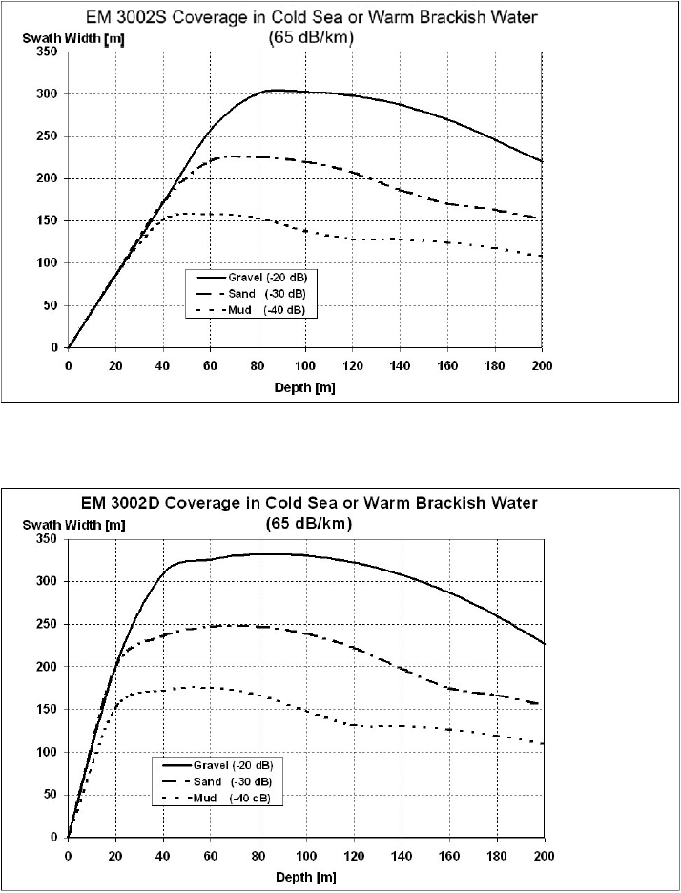
Figure 2.1. Swath coverage for Kongsberg EM3002 multibeam sonar system as a function of depth for three different seabed types (After SIMRAD, 2005).
GA’s Kongsberg EM3002 multibeam sonar is 1°×1° beamwidth system. At nadir, this equates 1.75% of the water depth. At 57 m water depth, the footprint size is 1 m2.

Note: During periods where resolution is not critical, e.g. transits or reconnaissance surveys, the angular coverage should be set to 67/67 degrees for a single head installation, or 74/74 degrees for a dual head installation (A single head setting of 63/63 degrees will result in a 25% reduction in coverage for no improvement in quality or resolution).
In shoaling conditions (adjacent to reef edges or sea walls) and in shallow waters (<20–30 m) (see Figure 2.1), a dual head mode is strongly recommended and swath angle up to 82° can be used on the shallow side. Data resolution is determined not by beam transmit angle but by incident angle, so near vertical surfaces (>45degrees) are better resolved with high angle outer beams (>45degrees). Using greater than 82° may cause system instability.
    - Backscatter specifications
For surveys where backscatter information is critical, the overlapping area should be increased to compensate for the high variability of individual backscatter intensities (Gavrilov & Parnum, 2010). This effect may be due partly to the progressive change of the ensonified area from a simple circle footprint around nadir into an annulus footprint on the oblique angle towards the outer beam (Kloser, 2007) as mathematically shown in Equation 1.2. In addition, this phenomenon leads to a change in the distribution of backscatter intensities , i.e. from K-distribution in the inner beam to log-normal or gamma distribution in the outer beam (de Moustier & Alexandrou, 1991; Gallaudet & de Moustier, 2003; Siwabessy et al., 2006).
For surveys where backscatter information is considered a secondary product, it is recommended that the overlapping be kept as optimum as practical.

Calibration of Sonar System: Patch Test
Patch tests determine the misalignment relative to the motion sensor and gyro as well as the time-offset to the GPS system. Because misalignment erodes accuracy, it is essential to conduct a patch test prior to data acquisition. This is valid for all multibeam systems permanently mounted, routinely calibrated or installed on a vessel of opportunity.
Systems must be recalibrated following any alteration to the components of a survey system as it may cause a misalignment.
The patch test, along with all calibrations must be provided for in the report for all surveys.
Note: Kongsberg systems use beam steering. Therefore, for the system to precisely determine the transmit direction, it is essential that the acquisition system has the accurate angular relationships between all components and these values entered into SIS acquisition software. Conducting the survey uncalibrated is not recommended as inaccurate beam steering will mean that the actual area mapped will not be the same as shown on the display in real time, and significant data gaps between lines may exist.

Checklist & Deliverables
This section summarises all the critical steps for a multibeam survey as required by Geoscience Australia into checklists and deliverables (Tables 3.1 and 3.2). This helps reduce if not completely remove the variability in the quality of the multibeam product, backscatter in particular, due to inconsistent acquisition and processing. For all outsourced multibeam surveys using non Kongsberg multibeam sonars, it is critical that the contractors be responsible for the compatibility of the raw sonar data with Caris HIPS & SIPS and deliver the correct deliverables (Table 3.2).

Table 3.1. Data acquisition checklist. Bolded number in the Action/Setting column relates to the Chapter Section number.
Item | Description | Action/Setting
Installation offsets and lever arms | Static offsets of all auxiliary sensors and lever arms of the MRU | 2.1. Offsets must be recorded and reported. RP positioned to best fit survey. Also see 2.2
Waterline | The vessel draft measured to sonar head at wharf before leaving the port | 2.2. Applied in SIS acquisition software or equivalent acquisition system
Raw sonar data (e.g. *.all, *.s7k, *.xtf) | Raw sonar data in the native format of the multibeam system used. Log complete backscatter i.e. beam intensity (RIθ) and snippets or equivalent | 2.3. 30 minutes for shallow system and 120 minutes for deep system
Water column data (e.g. *.wcd, *.s7k) | Acoustic return from objects in the water column | 2.3. Logged to separate file *.wcd (only applicable for Kongsberg multibeam system)
Delayed heave (e.g. Applanix True Heave) | Delayed heave data produced by the MRU system used | 2.3. 1 survey day to 720 minutes whichever least
Depth filter | Accepted depth within minimum and maximum depth values | 2.3.1. Monitored at all time for best quality data
File naming | The sequentially numbered filename of the raw sonar data | 2.3.2. ####_yyyymmdd_hhmmss_vesselname_GAid.*
Pulse length | The length of acoustic signal sent into the water | 2.3.3. >100 µsec for EM3002. See 2.3.3 for other systems
Absorption coefficient | Acoustic signal attenuated during the travel time within the water column | 2.3.4. Use default
Sound velocity profile | Sound velocity measured using velocimeter as a function of depth | 2.3.5. Conduct sound velocity cast as often as practical in order to maintain accuracy of the depth. Record the time, depth of cast and seafloor, and the location, apply asap to SIS or equivalent acquisition system
Applanix data logging | Continuously logged but required stopping before the start of GPS week | 2.5. Stopped and restarted few minutes before and after midnight Saturday/Sunday UTC* make sure that all clocks are synchronized to GPS clock (UTC)
Survey speed | Speed of vessel over ground during survey | 2.6. Weather dependant and survey requirement (resolution). 8-9 knots at good sea state. No less than 7 knots for survey efficiency. Transit <12kts.
Swath width | The optimum coverage of the swath | 2.7. Seabed type, weather dependant. See Table 2.1 for a guide for Kongsberg EM3002
Swath mode | The spread of sounding across track | 2.7. Equidistant. Never use high density (see Section 2.8)
Overlapping | Overlapping area between adjacent lines | 2.7. 7 - 10%. No greater than 10%
Patch test | Align the installation misalignment | 2.8. Prior to data collection, as soon as practical and after any alterations to the system setup
Table 3.2. Deliverables.
Deliverable item | Comment
Navigation | Continuous navigation at 1 second interval (port to port) in a broken up in daily log files. Values to enable centimetric precision  Data format: ASCII with NMEA string GGA or GGL and ZDA
Raw sonar data | Raw sonar data in native format as created directly from the native acquisition system of the multibeam system used. e.g. *.all for Kongsberg EM series, *.s7k for newer version of Reson SeaBat or *.xtf for the older one  Data format: native format as produced by the acquisition system, except for the *.xtf  Datagram: all logged automatically for Kongsberg EM series but it is not the case for Reson SeaBat series. For Reson SeaBat, datagrams with the following IDs are required:  1003, 1012, 1013, 7000, 7001, 7002, 7004, 7006, 7005, 7007, 7012, 7022, 7028, 7200, 7504  The water column data, recorded as separate files, for both Kongsberg and Reson are only required on request  For all other multibeam systems, it is required that raw data include SV profile, attitude, navigation, heading, raw bathymetry, raw backscatter per beam and if available raw backscatter in time series i.e. the equivalent seabed image or snippet style
Processed sonar data | Processed multibeam bathymetry data, including processed multibeam backscatter data, if requested  Preferred format: Caris HIPS & SIPS project structure including processed bathymetry surface (*.csar and XYZ) and time series-generated backscatter mosaic (*.csar) in Fieldsheets subfolder, processed line data & geobar in HDCS_Data subfolder, tide data used (*.tid) in Tide folder, individual sound velocity profiles (*.csv) used together with additional information on time and location of the cast in SVP subfolder. Backscatter mosaic and geobar are only required on request  Alternative format:  Processed line: SAIC GSF (*.gsf) if no other alternative  Requirement for *.gsf:  - Maintain the same filename used in the native raw sonar data filename  - Contain the same number of records/pings and same start and stop time on all sonar datagrams as in the native raw sonar file  - Contain processed bathymetry and raw time series and per beam backscatter data  - Contain the same timestamps extent in attitude and navigation as in the native raw sonar file. Feeding the smoothed attitude and navigation into *.gsf is not acceptable  - Maintain the same sign convention as in the native raw sonar file or in the standard *.gsf
Vessel config file | Caris *.hvf or equivalent in plain text format  Data format: Caris *.hvf or ASCII text
True Heave | Delayed, processed heave saved independently from raw sonar file, logged in 600-720 minutes period  Data format: Applanix ATH or equivalent (Caris compatible)
Processed bathymetry grids | Processed multibeam bathymetry surface grid  Data format: CSAR and xyz ASCII comma delimited (XY in specified UTM; z in negative metre at 2 decimal places) and/or ESRI ASCII *.asc (values in meter). The 8-bit format is not acceptable
Processed backscatter mosaic | Processed multibeam time series-generated backscatter mosaic  Data format: xyz ASCII comma delimited (XY in specified UTM; z in dB at 2 decimal places) and/or ESRI ASCII *.asc (values in dB). The 8-bit format is not acceptable
Tide | Tide data used for tide correction (date, time and depth(m.mm)/pressure (dBar)  Data format: Caris tide *.tid or ASCII *.csv
Sound velocity profile | Sound velocity casts used in SIS or equivalent acquisition system together  Data format: ASCII *.csv
Log file (SVP cast and POS MV setting used) | SVP cast info (date, time, depth of cast and seafloor, location and line applied to)  POS MV setting including any changes made  Any changes made to acquisition system  Data format: ASCII text
TPU/ CUBE related information | - XYZ of MRU to Transducers  - XYZ of NAV to Transducers  - Transducers mounting angles (if not horizontal)  - Type of Navigation system  - Type of MRU system  - Sign conventions used to calculate XYZ (Down positive etc)  Data format: ASCII text

References
Caris HIPS and SIPS 7.1 Service Pack 2 User Guide, 2012. Fredericton, NB Canada. 542 pp.
de Moustier, C.P., & Alexandrou, D., 1991. "Angular dependence of 12-kHz seafloor acoustic backscatter." Journal of the Acoustical Society of America 90(1), 522-531.
Gallaudet, T.C., & de Moustier, C.P., 2003. "High-frequency volume and boundary acoustic backscatter fluctuations in shallow water." Journal of the Acoustical Society of America 114(2), 707-725.
Gavrilov, A.N., & Parnum, I.M., 2010. "Fluctuations of seafloor backscatter data from multibeam sonar systems." IEEE Journal of Oceanic Engineering 35 (2), 209-219.
Kloser, R., 2007. "Seabed backscatter, data collection, and quality overview." In: Anderson, J.T. (Ed), Acoustic seabed classification of marine physical and biological landscapes. ICES Cooperative Research Report No. 286, August 2007, 45-60.
Parnum, I.M., & Gavrilov, A.N., 2011. "High-frequency multibeam echo-sounder measurements of seafloor backscatter in shallow water: Part 1 - Data acquisition and processing." International Journal of the Society for Underwater Technology 30 (1), 3-12.
SIMRAD. 2005. "Product Description: EM 3002 Multibeam echo sounder." Kongsberg Maritime AS, Norway. 36p.
Siwabessy, P.J.W., Gavrilov, A.N., Duncan, A.J., & Parnum, I.M., 2006. "Statistical Analysis of High-Frequency Multibeam Backscatter Data in Shallow Water." Acoustics 2006, Proceedings of the Conference of the Australasian Acoustical Societies, Christchurch, New Zealand, 507-514.

Processing in Caris HIPS & SIPS
This section provides the most critical steps in processing the bathymetry using Caris HIPS & SIPS for Kongsberg EM series data. The logic remains valid for processing using other bathymetry processing softwares and other multibeam data types.
  - Caris HIPS & SIPS Project
All Caris HIPS & SIPS data is organised in a Project/Vessel/Day/Line directory structure. It is strongly recommended that this Caris HIPS & SIPS project structure be strictly maintained. The day should always be UTC day, not local day. It is unnecessary to annotate day directory name as this creates a data management problem and makes it difficult to check that all files for a day are present when files from different days are found in the same folder and the same day in different folders. If it is necessary to subdivide data into subset areas, the appropriate method is to use Caris HIPS & SIPS session files (*.hsf, *.wrk) as it is designed for this purpose, among other things.
  - Caris HIPS & SIPS Data Conversion
Caris HIPS & SIPS files are created from survey data using the Conversion Wizard. To start the conversion process, activate the HIPS Conversion Wizard, select the Conversion Wizard command in the Caris HIPS & SIPS main interface (or File > Import > Conversion Wizard). This gives the first conversion dialog box to be displayed to select survey data type by clicking the appropriate name. Only critical steps are presented here (Figures A.1 to A.5).
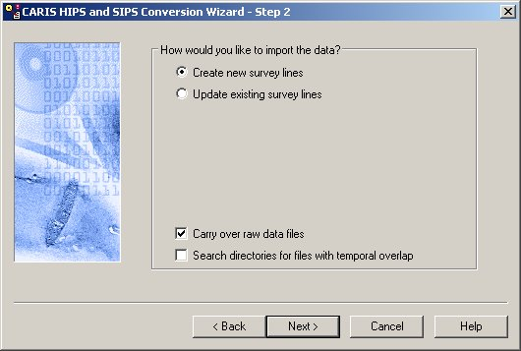
Figure A.1. Conversion dialog box as to how the survey data is to be imported and whether or not raw data files are to be imported as required for Geocoder backscatter processing.
It is important to have 'Carry over raw data files' checkbox checked as this is required for Geocoder backscatter processing. The conversion dialog box shown in Figure A.1 is common to all survey data types.
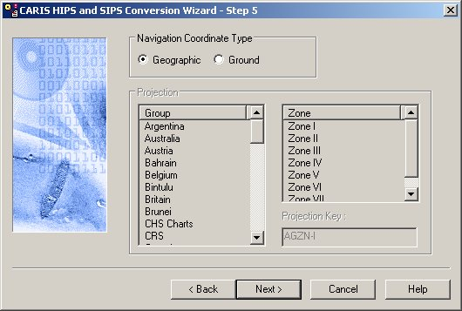
Figure A.2. Conversion dialog box to select navigation coordinate type.
For Kongsberg EM series system, it is always geographic. This can be interrogated by using the Caris HIPS & SIPS dump utility provided in the 'bin' folder. The executable filename of the dump utility starts with 'dump' followed by common name of the survey data type e.g. 'dumpem.exe' for Kongsberg EM series, 'dumpPDS.exe' for Reson SeaBat series, running from within the DOS command terminal. Or by selecting the project and right mouse click – select 'properties'.
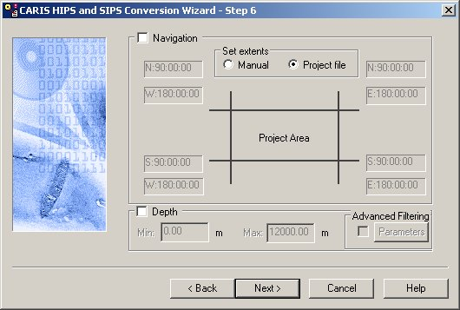
Figure A.3. Conversion dialog box for filtering survey data.
It is important to leave the two checkboxes unchecked. Never use the depth filter during conversion. All soundings should be preserved on conversion and flagged later as appropriate. Either carefully set the minimum/maximum at acquisition or manually apply a depth filter after import if required.
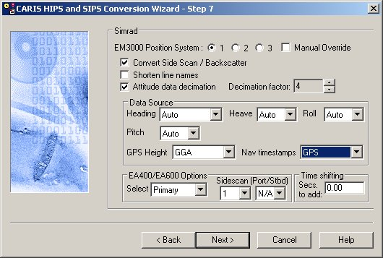
Figure A.4. Conversion dialog box to select the source of EM3000 data, attitude data, navigation timestamp and GPS height, and whether or not attitude data decimation is required.
100 Hz attitude values are not required and in fact provide no additional information. A value of 4 is normally used to decimate to 25 Hz. This adequately reflects the true time resolution of the POS output. The source of the GPS Height is from the GGA navigation string. The source of the Nav Timestamps is from the GPS. Make sure GA-preferred settings correctly apply as shown in Figures A.4 & A.5 for Kongsberg EM series data and for Reson SeaBat series data, respectively.
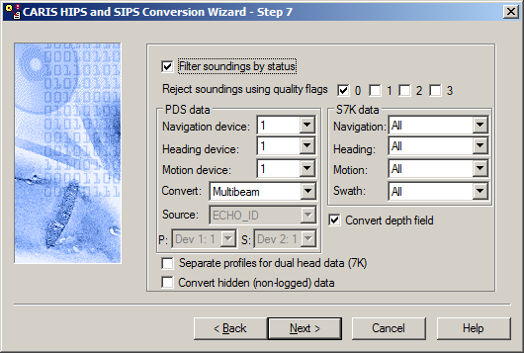
Figure A.5. Conversion dialog box to select the source of Reson data, attitude data and navigation data.
  - True Heave Correction
Applanix TrueHeave values are computed from real-time heave data and stored in a separate binary file along with the corresponding heave data. During regular data conversion (Section A.2), this file is not imported into Caris HIPS & SIPS project and has to be separately loaded to the track line. To start, select the lines and open the Load True Heave dialog box using Process > Load True Heave (Figure A.6).
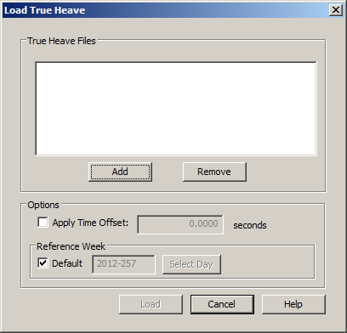
Figure A.6. Load True Heave dialog box.
  - Tide Correction
A tide zone file using predicted values is normally used during the survey. AusTides (previously known as Seafarer Tide) predicted tide produced by the Australian Hydrographic Service Royal Australian Navy is recommended. Prior to the survey, it is a good practice that GA personnel responsible for multibeam processing on a GA marine survey examine the AusTides for tide stations nearby the survey areas. If none are nearby or the tidal range varied significantly within the study areas, it is highly recommended that the tidal constituents be requested prior to the survey from Australian Tide Centre Bureau of Meteorology for geographic location of interest, preferably the centre of each survey grid and the predicted tide be generated using the AusTides for given tidal constituents.
Geoscience Australia does not use Lowest Astronomical Tide (LAT) for any tide corrections. LAT is not a datum, it is solely a safety requirement for charts. It has no relevance for the purposes of Geoscience Australia. Since 1971, GA has exclusively used the Australian Height Datum - AHD (MSL) as vertical datum (See: http://www.ga.gov.au/earth-monitoring/geodesy/geodetic-datums/australian-height-datum-ahd.html).
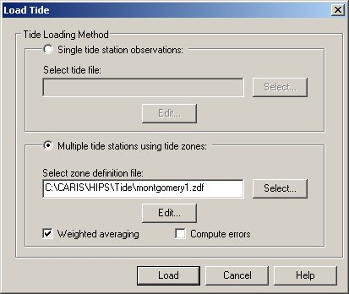
Figure A.7. Load Tide dialog box using tide zone option.
To start, select the lines and open the Load Tide dialog box by selecting Process > Load Tide. This gives the Load Tide dialog box shown in Figure A.7. It is preferred that a tide zone *.zdf file be used for tide corrections in the field (Figure A.7). The tide files used should be in MSL and the tide station offset set to 0 in the *.zdf file (Example 1). If tide files are referenced to LAT, the MSL/LAT offset should be set for each tide station in the *.zdf file (Example 2). Alternatively, the LAT tide can be converted using Geoscience Australia in-house LAT to MSL converter software called GA RefTide maintained by GADA and SMACI.
Example 1: MSL tide files
[TIDE_STATION]
Darwin,-12.46666667,130.85000000,0.0,0.01,darwin_20120501_20120601_utc_msl.tid
Value in bold is the offset value. In the case of MSL tide files, the value is set to 0.0.
Example 2: LAT tide files
[TIDE_STATION]
Darwin,-12.46666667,130.85000000,-4.18,0.01,darwin_20120501_20120601_utc_lat.tid
In the case of LAT referenced tide files, the value is set to the negative of the LAT/MSL offset (or absolute tidal amplitude). This will ensure that the MSL computation is correctly applied.
  - Compute GPS Tide
Post-survey processing involves reprocessing the tide correction using GPS Tide as GPS Tide provides an accurate measurement of the vertical position history of the vessel relative to the spheroid (~AHD) and when continuously logged it will accurately account not only for tide but dynamic draft changes as well. It is therefore critical to perform Compute GPS Tide in Caris HIPS & SIPS during the survey. This helps the GA personnel responsible for post-survey processing save time in reprocessing. To start, select the lines and launch the Compute GPS Tide dialog box by selecting Process > Compute GPS Tide (Figure A.8).
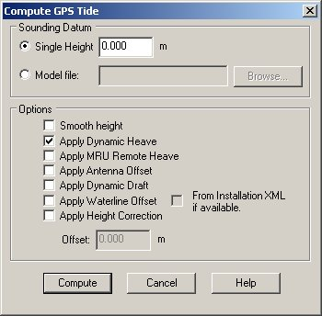
Figure A.8. Compute GPS Tide dialog box.
'Smooth height' option should never be used, as this will cause the dynamic heave to be applied incorrectly. True heave should be applied before GPS Tide is computed, so that the 'Dynamic Heave' applied to the data will be the Applanix True Heave (ATH) or equivalent.
  - Sound Velocity Corrections Using Refraction Estimator (Only as Required)
Sound velocity correction can however be reapplied in the Caris HIPS & SIPS environment using either Sound Velocity Correction tool or Refraction Estimator tool. GA normal practice is to use the Refraction Estimator tool due primarily to the fact that the local variations may have not been adequately sampled by sound velocity casts, e.g. lagoon, river entrances or (even when the cast may not have been taken due to) various reasons. The Refraction Estimator tool in Caris HIPS & SIPS is available within the Swath Editor dialog box by clicking the Refraction Estimator icon inside the brown circle in Figure A.9.
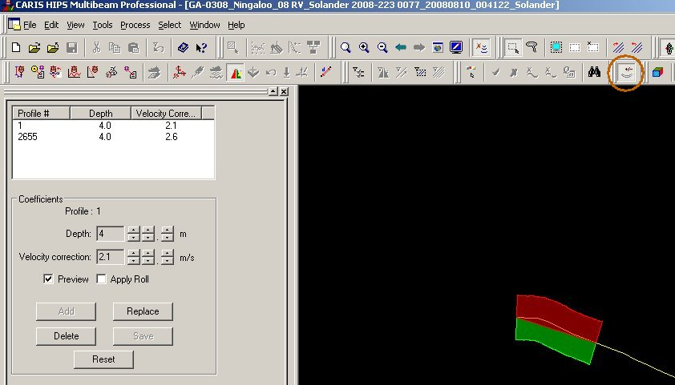
Figure A.9. Refraction Estimator within Swath Editor dialog box.
  - Vessel Draft
Caris HIPS & SIPS uses a delta draft file to interpolate changes in draft. However, frequent pumping of ballast water to trim the vessel often makes this methodology unsustainable. For this reason GA uses the more accurate GPS Tide methodology to correct for this.
  - Dynamic Draft 'Squat' (Only as Required)
Caris HIPS & SIPS cannot compute dynamic draft unless a draft table is applied in the *.hvf file. A dynamic draft table is available (see below) for the RV Solander in the *.hvf file. The merge computation using a dynamic draft table will always provide a more accurate vertical solution particularly where the vessel stops and starts.
Draft (m)  0.000  0.000  0.170 | Speed (kn)  0.000  5.000  12.000
In this example (RV Solander), no squat is applied until 5 knots and then progressively applied to a maximum of 0.17m (at the transducer) at 12 knots and above. These tables are determined by squat tests for different vessels.
  - Merge
The Merge process converts along-track/across-track depths into latitude, longitude and depth by combining the ship navigation with the horizontal and vertical offsets from the Caris HIPS & SIPS vessel configuration file. This geographically references the sounding position and depth.
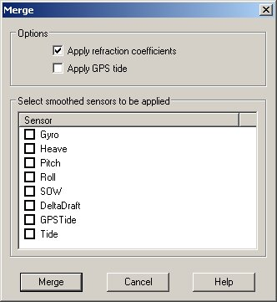
Figure A.10. Merge dialog box.
Selecting the lines and selecting Process > Merge will open the Merge dialog box (Figure A.10). The recommendation for Merge process is shown in Figure A.10. It is a good practice to keep the 'Apply refraction coefficients' checked even if the Refraction Estimators have not been computed. If no refraction coefficients found, Caris HIPS & SIPS skips this (RC) process.
Unfortunately speed over water (SOW) is never measured and hence inapplicable here. It is recommended that a paddle log be attached to the sonar mounting frame. The data logged will then provide an accurate application of dynamic draft, particularly when smaller vessels (<10m) are used.
E.g. If the forward speed is 5 knots (SOG) against a 7 knot tide the 'squat' value will be correctly applied as 0.17m (12 knots SOW) and not 0 m ( 5 knots SOG). When the vessel turns 180 degrees the squat value will then be correctly applied as 0m. Otherwise a 0.17 m mistie between adjacent lines will be recorded.
  - Post-survey GPS Tide Correction
Normal GA practice is to use processed GPS Tide values to create a tide model based on actual measured heights at the vessel. Processed GPS Tide will result in an accurate measurement of the vertical position history of the vessel relative to the spheroid (~AHD) and when continuously logged it will accurately account for tide and dynamic draft changes.
A standard routine for an accurate estimate of GPS Tide values extracted from the Caris HIPS & SIPS GPS Height has been established by Geophysical Analysis and Data Access section (GADA). The post-survey processed applying GA-estimated GPS Tide values is taken care of by GADA, provided the correct GPS Height values are sampled from the correct source and the Compute GPS Tide is conducted correctly. It is therefore essential to continuously perform correct Compute GPS Tide in Caris HIPS & SIPS during the survey (see Section A.4). This section gives an insight into the importance of using the GA-estimated GPS Tide values in comparison to the predicted tide applied during the survey.
The comparison of the Newby shoal predicted tide and computed GPS tide for a three-day period 18-21 May 2012 and a two-day period 18-20 May 2012 is presented in Figure A.11. Figures A.11(a) and (b) demonstrate the following features:
- The high and low tide times show the two datasets to be in phase.
- The amplitudes are significantly different. The vertical position history as measured at the GPS antenna is approximately 1.2 times greater than the predicted values.
- Amplitude of high tide and low tide heights show significant variability.
High frequency components (5-10 cm) probably show:
- variations in the geoid model as the vessel changes location;
- variations in GPS quality;
- dynamic draft changes due to changes in vessel speed while turning at end of line;
- possible trimming effects due to pumping of ballast.
The comparison clearly illustrates the problem of relying solely on tide predictions. The error resulting from predicted tides is often as much as 70 centimetres and is obvious as tide artefacts in the bathymetric model.
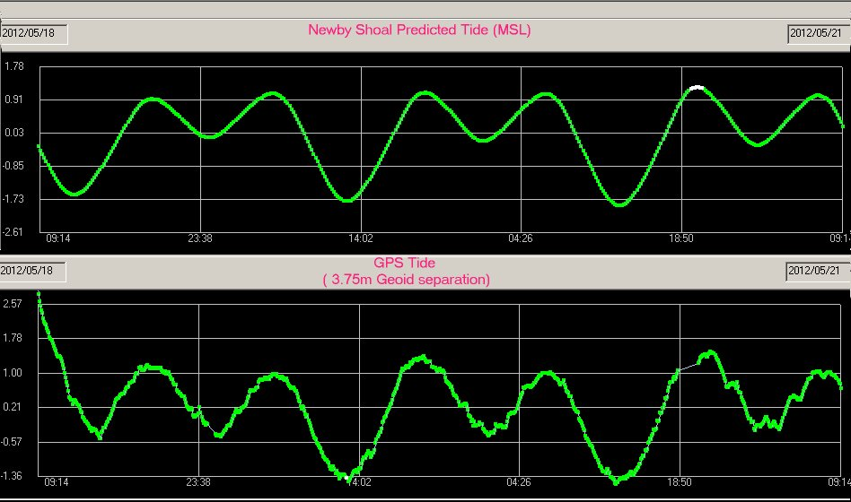
(a)
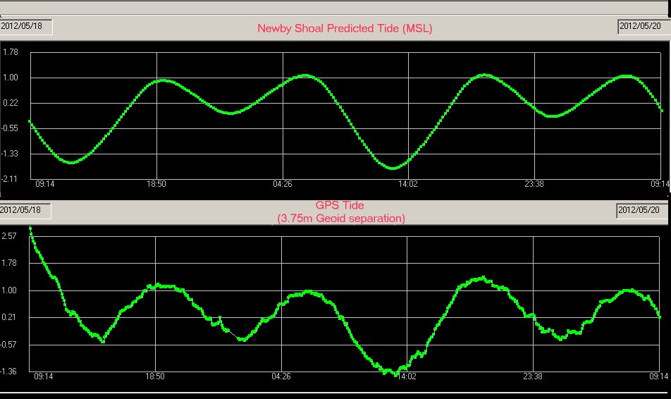
(b)
Figure A.11. Comparison of the Newby Shoal predicted tide and the computed GPS Tide for the period (a) 18 - 21 May 2012; (b) 18 - 20 May 2012.

