Murray-Darling Basin Vegetation Monitoring Project

Using Time Series Landsat Satellite Data for the Assessment of Vegetation Condition
Geoscience Australia
RECORD 2013/37
Rachel Melrose, Jeff Kingwell, Leo Lymburner, Rohan Coghlan
Department of Industry
Minister for Industry: The Hon Ian Macfarlane MP
Parliamentary Secretary: The Hon Bob Baldwin MP
Secretary: Ms Glenys Beauchamp PSM
Geoscience Australia
Chief Executive Officer: Dr Chris Pigram
This paper is published with the permission of the CEO, Geoscience Australia
© Commonwealth of Australia (Geoscience Australia) 2013
With the exception of the Commonwealth Coat of Arms and where otherwise noted, all material in this publication is provided under a Creative Commons Attribution 3.0 Australia Licence. (http://www.creativecommons.org/licenses/by/3.0/au/deed.en)
Geoscience Australia has tried to make the information in this product as accurate as possible. However, it does not guarantee that the information is totally accurate or complete. Therefore, you should not solely rely on this information when making a commercial decision.
Geoscience Australia is committed to providing web accessible content wherever possible. If you are having difficulties with accessing this document please contact clientservices@ga.gov.au.
The work described in this publication was funded by the Murray-Darling Basin Authority.
The views, opinions and conclusions expressed by the authors in this publication are not necessarily those of the Murray-Darling Basin Authority. To the extent permitted by law, the Murray-Darling Basin Authority excludes all liability to any person for any consequences, including but not limited to all losses, damages, costs, expenses and any other compensation, arising directly or indirectly from using this report (in part or in whole) and any information or material contained within it.
ISSN 2201-702X (PDF)
ISBN 978-1-922201-72-0 (PDF))
GeoCat 76780
Bibliographic reference: Melrose, R., Kingwell, J., Lymburner, L. & Coghlan, R., 2013, Murray-Darling Basin Vegetation Monitoring Project: Using time-series Landsat satellite data for the assessment of vegetation. Record 2013/37. Geoscience Australia: Canberra.
Version: 1307

Contents
Executive Summary 1
1 Project reporting period 2
2 Project Background 3
2.1 Overview 3
2.1.1 Nationally 3
2.1.2 Internationally 3
3 Project Information 4
3.1 Project Number 4
3.2 Project Authority 4
3.3 Project Phases 4
3.3.1 Overview 4
3.3.2 Phase 1 – Acquisition of imagery and pre-processing 4
3.3.3 Earth Observation Satellite Data Collections and Coverage 5
3.3.3.1 The primary ground stations’ coverage extent 5
3.3.3.2 Extent of Project coverage 5
3.3.3.3 Preferred Satellites and remote sensing instruments 6
3.3.3.4 Processing Management Application (PMA) 7
3.3.3.5 Landsat Product Generation System (LPGS) 7
3.3.3.6 Atmospheric correction 7
3.3.3.7 National Computational Infrastructure 7
3.3.3.8 Pixel Quality Processing 8
3.3.4 Phase 2 – Data outputs and delivery 9
4 Project Governance 10
4.1 Steering Committee 10
4.2 Geoscience Australia Project Team 10
4.3 Project Management 11
4.4 Project staff resources 11
4.5 Visitors 11
5 MDB vegetation project data 12
5.1 Summary 12
5.2 Selecting, acquiring and mapping project data 12
5.3 Processing Project data 12
5.3.1 Temporal reflectance Statistics 13
5.3.2 Temporal vegetation Index Statistics 13
5.3.3 Mosaicking 15
5.4 Storing and archiving project data 15
5.5 Project products distributed in 2013 16
6 Extent to which Project has met objectives 17
6.1 Summary 17
7 Significant problems encountered, remedies adopted, and suggestions for future projects 18
7.1 Last-minute changes to products 18
7.2 Mis-communication 18
7.3 Information and Communications Technology issues, especially at MDBA 18
References 19
Glossary 20
Appendix A - Milestones 22
A.1 Services and Deliverables 22
Appendix B – Whole of Project Data Across the Murray-Darling Basin 23
Appendix C - National Nested Grid Tiling Scheme 24

Executive Summary
This project commenced in November 2012 and is intended to provide satellite data and related scientific services to support the Murray-Darling Basin Authority’s monitoring of how the condition of riparian vegetation responds to changing river run-off and wetland inundation levels.
Under this project, Geoscience Australia started to build a satellite data processing infrastructure; named the ‘datacube’, as a proof of concept for expected on-going time series analysis applications including historical flood and bathymetry mapping.
The work incorporates an automated processing chain for Landsat satellite images from Geoscience Australia’s extensive archive, into customised high level intermediate products – including automated ortho-rectification, atmospheric correction, cloud-removal, and mosaicking – and finally into statistics on the spectral and derivative indices (that is, vegetation condition indices or various types) for the summer periods of December-March, each year for the period 2000-2013.
These vegetation indices and associate statistics are then used, by the Murray-Darling Basin Authority and its collaborators, as inputs to a mathematical model of vegetation types and their respective conditions within the Murray-Darling Basin (Cunningham et. al. 2009).
Among the notable achievements of the project are:
- Nadir Bi-directional Reflectance Distribution Function-Adjusted Reflectance and Pixel Quality processing and delivery of 72 Landsat scene footprints covering the Murray-Darling Basin for the period 2000-2010; which amounts to total 26,343 Landsat individual scenes.
- Design of Python scripted processing workflows to produce six vegetation indices:
  - Enhanced Vegetation Index
  - Normalised Difference Vegetation Index
  - Normalised Difference Moisture Index
  - Normalised Difference Soil Index
  - Soil Adjusted Total Vegetation Index
  - Specific Leaf Area Vegetation Index
- Delivery of ortho-rectified products to Monash University and the Murray-Darling Basin Authority through the National Computational Infrastructure.

Project reporting period
This report provides detail of all project work completed during the period 29 November 2012 to 30 June 2013, and includes whole of project information:
- Milestones.
- Datasets such as spatial coverage, temporal coverage, volumes and counts.

Project Background

Overview

Nationally
The Murray-Darling Basin Authority (MDBA) funded this project with the aim to determine vegetation condition across the basin on a yearly basis; ultimately to monitor and evaluate the effects environmental watering has had on the floodplain ecosystems.
The goal of environmental watering is to protect and restore the resilience of the Basin's rivers, wetlands, floodplains, lakes and red gum forests, together with the plants and animals that depend on them. Many rivers in the Murray-Darling Basin (MDB) have been declining over the past 30 years; and thus a coordinated approach to overall water use was required by the MDBA. The Basin Plan was developed under the Water Act 2007 to limit water use at environmentally sustainable levels by determining long-term average Sustainable Diversion Limits for both surface water and groundwater resources. The Environmental Watering Plan is a central part of the Basin Plan and has a purpose to achieve the best possible environmental outcomes using the increased, but still finite, amount of water made available by the Basin Plan.
To monitor water at state and national scales, remote sensing is the most efficient method. The current project provides a successful example of the use of the ‘datacube’ software architecture developed as part of Geoscience Australia’s long-term effort to systematically process long time-series Landsat satellite data for environmental applications. Vegetation monitoring is possible using this optical satellite data as it has a unique spectral signature which enables vegetation to be distinguished readily from other types of land cover in the visible and infrared ranges of the electromagnetic spectrum. Long time series analysis of these unique properties allows more detailed temporal information to be examined; Monash University colleagues will be using this data for developing models for vegetation type and condition estimates.

Internationally
Geoscience Australia’s strategic direction in regard to systematic processing of long-term satellite archives is complementary to international efforts (such as the Global Land Survey [GLS]) (Gutman et al., 2008), employing time-series satellite for land-cover analyses.
Overall the most notable outcome of this project is the improved Landsat data processing chain and global monitoring potential of the time-series statistical analysis tool.

Project Information

Project Number
The internal Geoscience Australia project number is N21.0 and project records are saved in the corporate information system (TRIM) container S08/46 ‘REMOTE SENSING SCIENCE AND STRATEGY’, P12/178 ‘VEGETATION MAPPING FOR THE MDBA’.

Project Authority
In November 2012, Geoscience Australia and the MDBA entered into the current project agreement (CMCG3692-PA2) under a National Collaboration Framework “Collaborative Head Agreement” dated 4 May 2011 between the same two organisations.

Project Phases

Overview
An initial planning meeting was organised and held at Geoscience Australia on 11 January 2013 with Monash University and The Victorian Department of Sustainability and Environment (Vic DSE), collaborators with the MDBA. Establishing face-to-face contact with those colleagues helped to better define technical approaches and created a positive atmosphere for the various agencies to work together to achieve the outcomes and outputs of this project.
From that early stage, the project then proceeded in two stages: (1) Acquisition of imagery and pre-processing, and (2) Data processing and delivery. The timeline of project milestones is detailed in Appendix A.

Phase 1 – Acquisition of imagery and pre-processing
This Phase (November 2012-May 2013) included:
- Gathering Landsat-5 Thematic Mapper (TM) and Landsat-7 Enhanced Thematic Mapper (ETM+) satellite data over the MDB from 2000 to 2010 from Geoscience Australia’s Landsat Archive, with additional scenes being obtained from the United States Geological Service (USGS).
- Management of datasets including mechanisms for storage at the National Computational Infrastructure (NCI) and providing access and distribution to collaborators.
- Technical expertise and advice on data acquisition, processing, data mining and applications for Vegetation Condition Monitoring. Advice to Monash University.

Earth Observation Satellite Data Collections and Coverage

The primary ground stations’ coverage extent
The bulk of the project’s Landsat satellite data was originally acquired from Geoscience Australia’s primary ground data collection station in Alice Springs, Northern Territory, Australia. The USGS acquires unique Landsat scenes by programming the satellites’ on-board recorders. It also acquires copies of data collected by the network of International Cooperators, including Alice Springs, which has continuously retrieved Landsat data since 1979. The USGS station in South Dakota USA and Geoscience Australia’s Alice Springs station form the two primary data capture facilities for the Landsat series (U.S. Geological Survey, 2012).

Extent of Project coverage
For the MDBA, Geoscience Australia is collecting, processing and managing Landsat-5 and Landsat-7 satellite data from the following states of Australia: New South Wales, Queensland, Victoria and South Australia. The project data collections span 11 years and provide seasonal MDB wide coverage from 2000 to 2010 (see Figure 1).
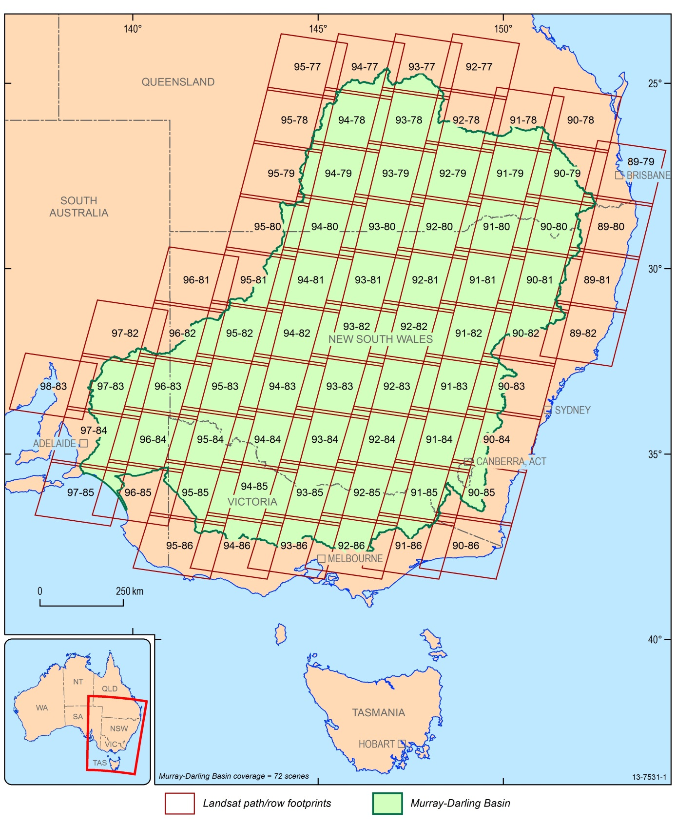
Figure 1 Map showing the Area of Interest of the MDB Project and Landsat scene coverage.

Preferred Satellites and remote sensing instruments
The Landsat satellites owned by the United States of America provide optical images and are preferred as this form of satellite imagery is more familiar to most prospective users. Landsat data is obtained through the USGS, who make the Landsat archive available on-line at no direct cost to users. The Landsat series is unrivalled for longevity; offering consistent, long-term and near-global coverage appropriate for this long time-series analysis project.

Processing Management Application (PMA)
All pre-processing is managed through Geoscience Australia’s Processing Management Application (PMA). This presents a common interface for the initiation and monitoring of processing activities and the management of the associated resource allocation, error management, and auditing required of a large-scale imagery processing environment. The initial version of PMA was developed, tested and accepted by late 2010. Refinement of the system occurred during 2011 in order to implement updates to key components including the Landsat Product Generation System (LPGS), and to improve the system in response to user feedback. PMA was handed over to the Operations team of the Geoscience Australia National Earth Observation Group in December 2011, signifying the end of major development for the system.

Landsat Product Generation System (LPGS)
Geoscience Australia has installed a new version of the LPGS, obtained from the USGS. This has enabled Geoscience Australia to automatically generate bulk ortho-rectified Landsat products where there are sufficient Ground Control Points (GCPs) visible within the scene, and make the Geoscience Australia Landsat products consistent with those of the USGS. Geoscience Australia is using the global collection of GCPs (the chip set generated through the Landsat TM GeoCover 2000 dataset) collected by the USGS and also used for the periodic GLS Collections. The LPGS has been incorporated into the PMA in order to streamline processing jobs. On a per scene level the pixel registration is dependent on the number of GCP’s identified within a scene, and to some extent also their distribution within the scene. Geoscience Australia is currently reviewing its automated Quality Assurance procedures to identify scenes in which mis-registration has occurred. Geoscience Australia plans to investigate the future use, in its automated processing, of high-resolution GCPs such as those included in the Australian Geographic Reference Image (AGRI) (Geoscience Australia, 2012). In the meantime Geoscience Australia is happy to engage with users on any concerns regarding registration accuracy.

Atmospheric correction
The Nadir Bi-directional Reflectance Distribution Function-Adjusted Reflectance (NBAR) approach has been used to correct Landsat (5 and 7) imagery for atmospheric ‘noise’. This correction ensures that Landsat imagery is standardised to allow effective cloud removal and mosaic processing (Li, 2010; Li et. al., 2010, 2012). The sources of ancillary data for the NBAR processing approach have all been identified and automated retrieval mechanisms have been established for the three parameters required to run the NBAR process.

National Computational Infrastructure
The NCI, Australia’s national high-end computing service, is an initiative of the Australian Government, hosted by The Australian National University (ANU). NCI’s advanced computing infrastructure, comprises a petascale High Performance Computing system, a large-scale compute cloud (primarily for data-intensive services), and multi-petabyte high-performance storage. The facility is funded through programs of the Department of Industry, Innovation, Climate Change, Science, Research and Tertiary Education, while its operations are sustained through the substantial co-investment by a number of partner organisations including ANU, CSIRO, the Australian Bureau of Meteorology, Geoscience Australia, a number of Australia’s research-intensive universities, and the Australian Research Council. Geoscience Australia requires this technology to process the 26,343 Landsat scenes across the MDB, for the period 2010-2013.

Pixel Quality Processing
Geoscience Australia has developed a new automated approach to generating near cloud-free composites, including the development and implementation of a pixel quality algorithm. This is expected to result in greater objectivity and efficiency in compositing the best (least- or nil-cloud) pixels for a given Landsat ‘tile’ within a specified time period. An additional benefit of this cloud-free composite approach is that the parameters for the automated production can be readily altered. For example, the process could focus on “all scenes from 2009”, or alternatively, “all scenes between 1 November 2008 and 28 February 2009”. This is important if seasonal factors (for example, dry-season) are the key factors driving land-cover change.
Geoscience Australia’s cloud-masking approach employs two widely-employed algorithms: the “Fmask” (Zhu and Woodcock, 2012) and the “Automated Cloud-Cover Assessment” (ACCA) (Irish et. al., 2006). The quantitative accuracy of these algorithms is described in these references. Both algorithms will occasionally fail to detect thin Cirrus cloud.
The initial version of the compositing software was developed using Interactive Data Language (IDL) in 2010. The compositing software underwent further refinements during 2011-2012, including:
- Rewritten in python language to allow integration with the PMA function
- Refinements to the code to improve processing efficiency
- Separation of the statistical aspect into a separate output product which can then be reused for additional processing
- Code development in order to handle both Landsat 5 and 7 in FAST and Geotiff formats.
Figure 2 shows a subset of one scene that uses the pixel quality to mask final products from January 2009.
Geoscience Australia, 2013a describes the new Landsat time series more completely.
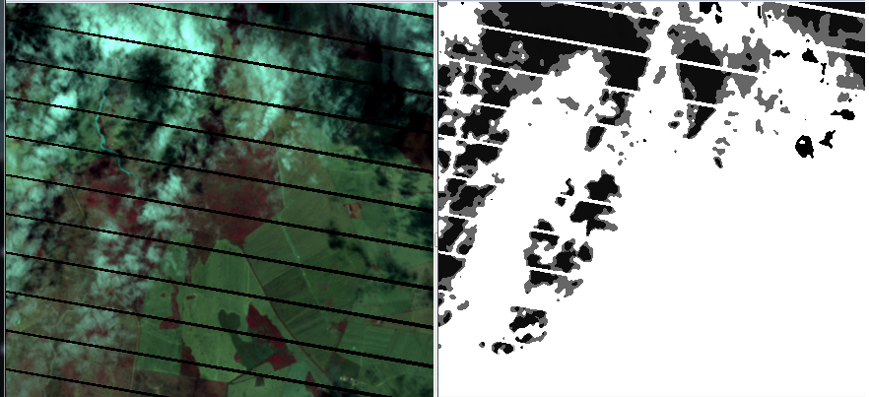
Figure 2 A subset of Landsat-5 data from Path 92, Row 81 captured on 07-01-2009. Automatic pixel quality masking has been applied to the false colour image on the left which results in the right image, showing cloud (black).

Phase 2 – Data outputs and delivery
Geoscience Australia has processed over ten years of Landsat satellite data to be used for the MDB Vegetation Condition Monitoring Project, jointly implemented by Monash University and the Victorian Department of Sustainability and Environment. Vegetation Index ratios are the main deliverables and can be used to establish the foundation of landscape classifications, from identifying the most abundant surface materials, to drawing discrete differences in the health, condition and variety of other natural and man-made features. Landsat data has provided the capability to distinguish characteristics in the data which allow a high-level land use analysis, using Visible and Near Infrared wavelengths. For this project, Landsat data was used to produce derivative products (six vegetation indices) and statistics summarising these products over specific temporal monthly periods over the years 2000-2010. This data will be used to classify broad floodplain vegetation types and to be used with other data in an Artificial Neural Network model developed by Monash University (Cunningham et. al. 2009) to predict floodplain vegetation condition across the MDB.
The project utilises open source technologies - Python and Geospatial Data Abstraction Library (GDAL) - to perform processing on the project data. The Landsat NBAR reflectance data was processed in 1-degree tile (projection agnostic) format and derivative vegetation index products were generated using reflectance band ratio algorithms. The Vegetation Indices include: Enhanced Vegetation Index (EVI), Normalised Difference Vegetation Index (NDVI), Normalised Difference Soil Index (NDSI), Normalised Difference Moisture Index (NDMI), Soil Adjusted Total Vegetation Index (SATVI), Specific Leaf Area Vegetation Index (SLAVI). Statistics were generated for each seasonal time period for each reflectance band and each index. These temporal statistic outputs are summarised in Section 5 of this document, and detailed in Geoscience Australia, 2013b.
Amendments to the Project Agreement (in the form of a formal Change Order) were agreed by both parties on 14 June. Those changes rationalised responsibility for implementing the vegetation typing model (transferring this from Geoscience Australia to Monash University, who developed the model); implicitly extending the data collection period from 2010 to early 2013, and adding an Implementation Plan for longer-term data delivery. That Plan (reference D2013-135009) was approved by the MDBA (reference D2013-135573) on 28 June 2013.

Project Governance
Governance arrangements for the project were as prescribed under the relevant Collaborative Head Agreement and Project Agreement.

Steering Committee
The Project Steering Committee comprised:
- Dr Adam Lewis and Medhavy Thankappan at Geoscience Australia.
- Dr Fraser MacLeod and Dr Michael Wilson, Murray-Darling Basin Authority.
The Project Manager, Jeff Kingwell of Geoscience Australia, also attends Steering Committee meetings, which were held as required.
The Steering Committee is made up of representatives from Geoscience Australia and the MDBA. It is responsible for project administration including:
- Identifying and administering policies and procedures for data ownership, quality, protection and access; technical standards and quality assurance; infrastructure and transmission protocols; and coordinating Risk Management Plans.
- Negotiating contributions between project partners.
- Managing changes to the Project or Project Agreement.
- Reporting to the Management Committee on key achievements, significant problems encountered and measures taken to resolve them.

Geoscience Australia Project Team
The primary Geoscience Australia project team comprised:
- Jeff Kingwell, Section Leader, Forest & Water Monitoring, National Earth Observation Group, Environmental Geoscience Division, Geoscience Australia.
- Dr Leo Lymburner, Team Leader: Dynamic Land Cover Mapping, Earth Observation Science Section, National Earth Observation Group, Environmental Geoscience Division, Geoscience Australia.
- Ms Rachel Melrose, Remote Sensing Scientist, National Earth Observation Group, Environmental Geoscience Division, Geoscience Australia.
Additional assistance was provided by:
- Joshua Sixsmith, Remote Sensing Scientist, National Earth Observation Group, Environmental Geoscience Division, Geoscience Australia.
- Michael O’Keeffe, Software Developer, National Earth Observation Group, Environmental Geoscience Division, Geoscience Australia.
- Alex Ip, Senior Developer, eResearch Infrastructure, National Earth Observation Group, Environmental Geoscience Division, Geoscience Australia.

Project Management
This project employs the PRINCE2 approach, a recognised international (and Commonwealth-endorsed) project management framework of which the project manager is a qualified practitioner.

Project staff resources
From December 2012 at the project’s inception a remote sensing scientist (Rachel Melrose) was employed as the project’s technical leader. Throughout the first half of 2013 the project utilised staff resources from within the National Earth Observation (NEO) group to support data processing requirements until an additional software developer (Michael O’Keeffe) was recruited to join the project in February 2013.

Visitors
The MDB Vegetation Project welcomed the following visitors in 2013:
- A delegation from Vic DSE and Monash University visited Canberra for a full day workshop on 11 January 2013 to meet with key members of the NEO group. The workshop involved discussion of the satellite data processing requirements, outcomes and outputs for the project.
- On 27 March 2013 MDBA visited Geoscience Australia to view the sample outputs of the project and perform quality assurance on the deliverable and sign off payments.
- On the 30 May 2013 representatives from MDBA on the project steering committee visited Geoscience Australia to discuss progress, data flow implementation and also changes to the milestones as an outcome of the progress of other collaborators in the overall project.

MDB vegetation project data

Summary
In 2013, Geoscience Australia continued to acquire unrestricted (open-content) licensed project Landsat satellite data from the USGS.
Additionally, Geoscience Australia significantly developed its satellite data processing capability to better support future time series analyses of this kind for a variety of applications within and outside Geoscience Australia. The portion of the Landsat Archive processed as at 15 June 2013, is from January 2008 to January 2012.

Selecting, acquiring and mapping project data
The satellite data used and products that were generated are summarised in Table 1. Table 5 provides detail on the different sensors and exact numbers of input and output for each product.
Table 1 Collections of Landsat processed data
Non-Global Land Survey Collections | Details
Landsat-5 TM + Landsat-7 ETM+ - Reflectance Data | Atmospheric correction and pixel quality processing
Landsat-5 TM + Landsat-7 ETM+ – Derivative Products | Vegetation Indices based on band ratios
Landsat-5 TM + Landsat-7 ETM+ – Derivative Product Time-series Statistics | Statistics generated for derivative products over a temporal and/or spatial time series
The Landsat scene coverage across the MDB (shown in Figure 1) was clipped to the National nested Grid Specifications (ANZLIC, 2012): 1 degree grid tiles (refer Appendix C). Appendix B illustrates the workflow to produce the time-series satellite images, vegetation indices and statistics.

Processing Project data
Algorithms were developed in Python and GDAL to clip the 24,992 pre-processed Landsat data scenes from each time slice into 1-degree tiles for nesting in a grid format that has been named the ‘datacube’. This datacube architecture is essentially a large and highly efficient database that can be queried to extract or process data into derivative products and formats. Using Python and GDAL, statistics were calculated on each temporal seasonal virtual raster (VRT) dataset (such as Band 4 reflectance or a metric such as NDVI) in small pieces at a time. For instance, rather than trying to load the entire 4000*4000*600 array for a tile, the dataset was processed in smaller pieces such as 100*100*600 at a time. A single 100*100*600 piece was read from disk, processed and the result written out before taking the next 100*100*600 piece.

Temporal reflectance Statistics
A Python code command (see Geoscience Australia, 2013b) was used to query the datacube to produce the Landsat gridded surface reflectance data in 1-degree tile (projection agnostic) format (Appendix C) over seasonal time periods (see Table 2). These data are then transformed into intermediate VRT ‘stacked’ files in XML format to save disk space. The seasonal time slices were fed into the Python statistical code, and the seasonal periods were analysed to produce 16 statistics; the outputs are saved as ENVI files. The statistics were calculated over the temporal domain. Due to the immense size of the arrays being handled, a tiling mechanism incorporated into the code was used to process the seasonal composites piece-by-piece: portions of each array were processed in a chain.

Temporal vegetation Index Statistics
The datacube provided the means to access the tiled Landsat NBAR reflectance data, which was then fed into the Vegetation Indices Python code to produce vegetation index TIF files for each image date. The vegetation indices include EVI, NDVI, NDSI, NDMI, SATVI and SLAVI. The stacking code was then used to select the files within the seasonal time slices (Table 2) and create intermediate VRT ‘stacked’ files in XML format to save disk space. These VRT’s were then processed through the statistical python code, and the seasonal periods were analysed to produce 16 statistical outputs saved as ENVI files in the same way as the reflectance data.
Table 2 Date range for “season” used in the data classification
Season | Date range (note the overlap in seasons by 1 month)
Summer | 1st December to 31st March
Autumn | 1st March to 30th June
Winter | 1st June – 30th September
Spring | 1st September – 31st December
The derivate data outputs using the Landsat Project data are detailed in Tables 3 and 4. Examples of the ‘Median’ statistic for a 2009 autumn time slice over a wetland can be seen in Figure 3.
Table 3 Individual tile outputs of statistics on the Vegetation Indices and Reflectance data over each season
Lat-Long Tiles | Dec-Mar  2000-2010 | Mar-Jun  2000-2010 | Jun-Sep  2000-2010 | Sep-Dec  2000-2010
132 tiles in the MDB | Summary Statistics (Mean, min, Max, Median, Variance, Standard Deviation, 1st Quartile, 3rd Quantile, Geometric Mean) for reflectance bands 1,2,3,4,5 & 7, EVI, NDVI, NDSI, NDMI, SATVI, & SLAVI.
Total number of files | 6336 ENVI files. Approximately 1GB each

Table 4 Mosaics outputs of statistics on the Vegetation Indices and Reflectance data
Lat-Long Tiles Mosaiced | Sep-May  2011-2012 | Nov-Apr  2011-2012
16 tiles across the Murray River | Median and Geometric Mean Mosaics for reflectance bands 1,2,3,4,5 & 7, AND NDVI
Total number of files | 14 files. Approximately 1GB each
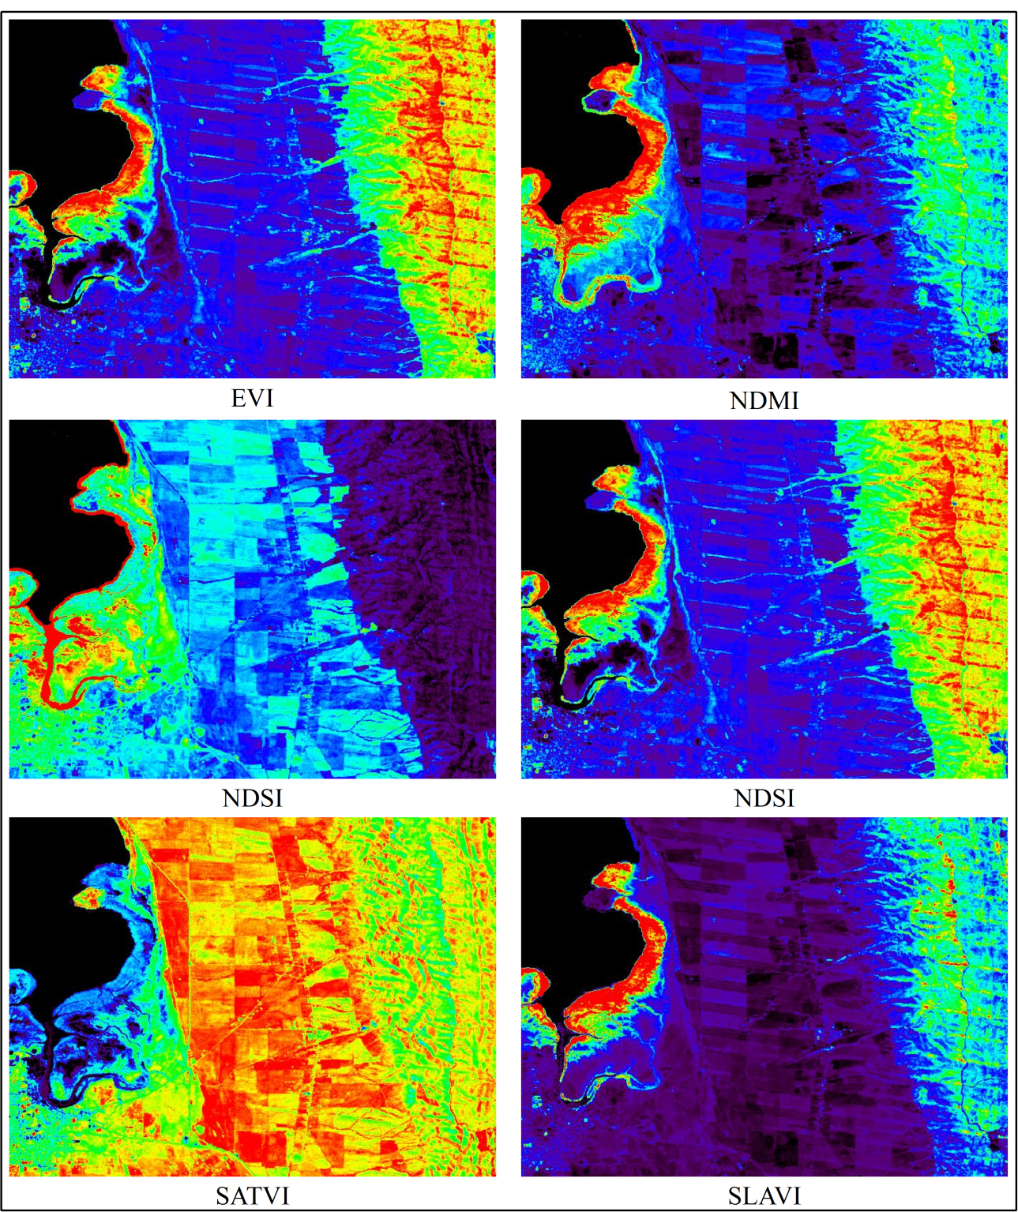
Figure 3 Examples of a wetland (a lake with emergent vegetation around the edges) showing the median value for a 2009 autumn season date range of 01.06.2009 – 30.09.2009.

Mosaicking
Python and GDAL were used to develop a generic mosaic tool to query the datacube and produce mosaics of the whole MDB. An example is shown in figure 4 where a summary product (median NDVI mosaic) was created for a seasonal period (December 2008-March 2009) across the whole basin.
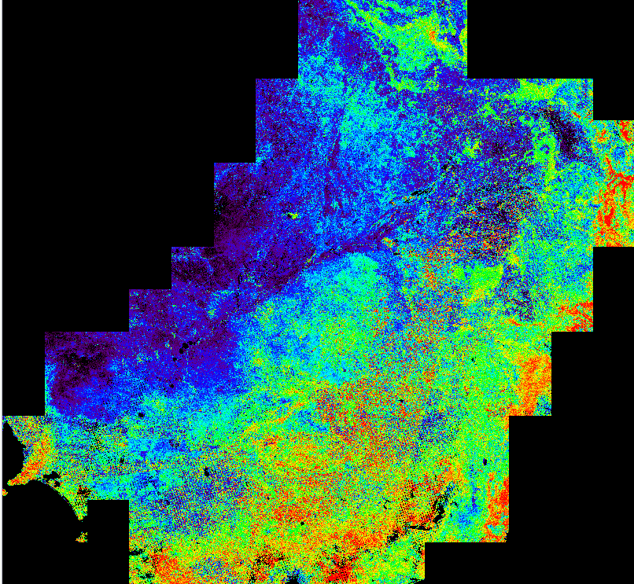
Figure 4 The first multi-scene mosaic created over the Murray-Darling Basin for the median Normalised Difference Vegetation Index (NDVI). The mosaic contains cloud masked composite images created from 957 Landsat-5 and Landsat-7 scenes captured from 1st December 2008 to 30th March 2009.

Storing and archiving project data
The MDB Vegetation Monitoring Project stores satellite data in the NCI in directories named by the lower left lat_long for each 1 degree tile, for the date ranges between 2000 and 2012. For more information on future activity and processing, please consult the Data Implementation Plan.

Project products distributed in 2013
The MDB Vegetation Monitoring Project Products were created in the 2013 calendar year and were distributed to MDBA and Monash University. In total 6864 products (files) were generated and delivered. In Table 5 a breakdown of the different satellite data is provided for acquired and distributed data.
Table 5 Summary of Processed Project Data
Collection by Sensor | Scene Collections  2000-2013 | Grid Tile Collections  2000-2013
Landsat-5 – Geoscience Australia archives | 8,667 | 63,674
Landsat-7 – Geoscience Australia archives | 17,676 | 139,474
TOTAL | 26,343 | 203,148

Extent to which Project has met objectives

Summary
The Project has demonstrated the feasibility of routinely generating, from the systematically-processed Geoscience Australia Landsat archive, the specialised vegetation indices and related derived products which can be utilised in a vegetation typing model (for example, Cunningham et. al. 2009).
The project resulted in the specification of a spatial framework suitable for efficient storage and processing, and which is with ANZLIC’s National Nested Grid guidelines.
Both the underlying satellite data product -Geoscience Australia’s “Australian Reflectance Grid 25” (Geoscience Australia, 2013a) and the derived vegetation indices required to operate the vegetation typing model employed by MDBA (Geoscience Australia, 2013b) have been comprehensively documented.
Both the data and the accompanying documentation (including project reports and product descriptions) are available for all users and uses under the Creative Commons Attribution 3.0 Australia licence, consistent with Paragraph 5, Schedule 3 of the Project Agreement.
Under the aegis of the NCI, Geoscience Australia has established a mass data processing and data distribution environment which (a) met the immediate purposes of this project and (b) forms a robust foundation for future data storage and delivery.

Significant problems encountered, remedies adopted, and suggestions for future projects

Last-minute changes to products
Late changes to the date ranges and specifications for the satellite data and derived vegetation indices required some re-working/re-processing on the part of Geoscience Australia, and perhaps could have been avoided through more frequent consultation between Geoscience Australia and MDBA’s other contractors/colleagues. However the impact was not severe, and given that several outputs were still under development and evaluation by Monash, this situation was understandable and possibly unavoidable.

Mis-communication
Although the project reported on here was governed through a Project Agreement between MDBA and Geoscience Australia, its results also depended on the outcomes and schedule of separate agreements between MDBA, Monash University and others, including the Vic DSE and third-part contractors to Monash/Vic DSE.
At times it was difficult to keep all parties “in the loop”, and occasionally this resulted in mis-communication and misunderstanding. For example, for the Workshop held at Geoscience Australia on 11 January 2013, no suitable MDBA representatives were available and the Authority may have felt disenfranchised in the discussion on the spatial data framework adopted.
Similarly during May-June, some confusion and what the MDBA termed “asynchrony” arose because of changes in the responsibilities of Geoscience Australia and Monash, negotiated separately by MDBA. Fortunately decisive action by MDBA quickly clarified matters and resulted in a formal amendment (Change Order #1) to the Project Agreement.
For future work involving multiple parties and separate contract arrangements, perhaps multi-party regular tele-conferences would reduce the risk of mis-communication and asynchrony.

Information and Communications Technology issues, especially at MDBA
Geoscience Australia and Monash were able to successfully operate the NCI environment to exchange and access data (noting that on occasion, for the convenience of Monash’s off-site sub-contractor, Geoscience Australia transferred data on physical media).
However to date MDBA has not been able to access the NCI. It is understood that this is due to MDBA’s internet gateway restrictions.
For future work, especially any which involves on-going access to the Landsat archive or vegetation index products, it would be necessary to remedy this issue.

References
ANZLIC, 2012, National Nested Grid (NNG) Specification Guideline. ANZLIC, 31 pp.
Cunningham, S.C., Mac Nally, R., Read, J., Baker, P.J., White, M., Thomson, J.R. and Griffioen, P., 2009, A robust technique for mapping vegetation condition across a major river system. Ecosystems v12, 207-219.
Geoscience Australia, 2012, The Australian Geographic Reference Image. AusGeo News, March, Issue No. 105. http://www.ga.gov.au/ausgeonews/ausgeonews201203/productnews.jsp Geoscience Australia, Canberra.
Geoscience Australia, 2013a, Australian Reflectance Grid (ARG25) Product Information Beta Release, V0. Geoscience Australia, Canberra.
Geoscience Australia, 2013b, Vegetation mapping product information for MDBA. V1.0, Record D2013-63185. Geoscience Australia, Canberra.
Gutman, G., Byrnes, R., Masek, J., Covington, S., Justice, C., Franks, S. and Headley, R., 2008, Towards monitoring land-cover and land-use changes at a global scale: The Global Land Survey 2005. Photogrammetric Engineering & Remote Sensing, Jan. 2008, p6-10.
Irish, R. R., Barker, J. L., Goward, S. N., & Arvidson, T., 2006, Characterization of the Landsat-7 ETM+ automated cloud-cover assessment (ACCA) algorithm. Photogrammetric Engineering and Remote Sensing, 72, 1179
Li, F., 2010, ARG25 Theoretical Basis Document. Geoscience Australia, Canberra.
Li, F., Jupp, D. L. B., Reddy, S., Lymburner, L., Mueller, N., Tan, P., and Islam, A., 2010, An Evaluation of the Use of Atmospheric and BRDF Correction to Standardize Landsat Data. IEEE J. Selected Topics in Applied Earth Observations and Remote Sensing 3, 257–70.
Li, F., Jupp, D. L .B., Thankappan, M., Lymburner, L., Mueller, N., Lewis, A., and Held, A., 2012, A physics-based atmospheric and BRDF correction for Landsat data over mountainous terrain. Remote Sensing of Environment 124, 756–70.
U.S. Geological Survey, 2012, Landsat’s International Partnerships. Fact Sheet 2012-3055. U.S. Department of the Interior. http://pubs.usgs.gov/fs/2012/3055/fs2012-3055_508.pdf, accessed 2 July 2013.
Zhu, Z., & Woodcock, C.E., 2012, Object-based cloud and cloud shadow detection in Landsat imagery. Remote Sensing of Environment, 118, 83-94

Glossary
AGRI | Australia Geographic Reference Image
ANU | Australian National University
ANZLIC | Australian and New Zealand Land Information Council
ARG25 | Australian Reflectance Grid 25 – an ortho-rectified and atmospherically-corrected satellite image product from GA Bi-directional Reflectance Distribution Function (see MODIS NBAR)
BRDF | Bidirectional Reflectance Distribution Function
Creative Commons | A suite of open content licences developed by an international non-profit organisation
Creative Commons Attribution Australia Licence | An “off the shelf” generic copyright licence developed for the Australian legal jurisdiction. It gives users a wide variety of rights in return for acknowledging the copyright owner.
CSIRO | Commonwealth Scientific and Industrial Research Organisation (Australia)
ENVI | An Image Analysis Software suite and data format
EODS | Earth Observation Data Store
ETM+ | Enhanced Thematic Mapper Plus sensor on Landsat-7 that includes thermal band, short-wave infrared, near-infrared and visible spectral bands
EVI | Enhanced Vegetation Index
GA | Geoscience Australia
GCP | Ground Control Point
GDAL | Geospatial Data Abstraction Library
GLS | Global Land Survey
ICT | Information Communication Technologies
IDL | Interactive Data Language
LPGS | 1. Landsat Product Generation System (Geoscience Australia)  2. Level 1 Product Generation System (U.S. Geological Survey)
MDB | Murray-Darling Basin
MDBA | Murray-Darling Basin Authority
MODIS | Moderate Resolution Imaging Spectroradiometer
Mosaic | An image mosaic is a visual representation of the spatial data from numerous scenes that when seen together providing a set of images that are ‘patchworked’ together.
NBAR | Nadir BRDF-Adjusted Reflectance (see BRDF)
NCI | National Computational Infrastructure (at ANU)
NDMI | Normalised Difference Moisture Index
NDSI | Normalised Difference Soil Index
NDVI | Normalise Difference Vegetation Index
NEO | National Earth Observation group within Geoscience Australia
PMA | Processing Management Application (Geoscience Australia)
PRINCE2® | A standard for product-based project management developed by the Office of Government Commerce (UK)
SATVI | Soil Adjusted Total vegetation Index
SLAVI | Specific Leaf Area Vegetation Index
TM | Multispectral Thematic Mapper sensor on Landsat-5 that includes thermal band, short-wave infrared, near-infrared and visible spectral bands
USGS | United States Geological Survey
Vic DSE | Victorian Department of Sustainability and Environment
VRT | Virtual Raster

- Milestones
The objective of the project is to implement the Earth Observation System (EOS) Data management and processing systems necessary to support routine monitoring of key vegetation communities within the Murray-Darling Basin (MDB)
  - Services and Deliverables
Geoscience Australia will develop the deliverables (as amended through Change Order #1 of 14 June) outlined in table A.1, by the due dates specified in the table.
Table A.1 Deliverables from the MDB Vegetation Monitoring Project Agreement
No. | Deliverable | Due Date | Comment
1 | Engagement with modellers and MDBA in format requirements for inputs, models and outputs | 30/11/2012 | Completed.
2 | Spatial Framework for storage and processing (including spatial data specifications e.g. grid cell size, projections, etc.) | 21/12/2012 | Completed 25/2/13  See document:  datacube_design_concept.doc
3 | Provision of seasonal composite Surface Reflectance and NDVI Data for selected areas of interest defined by MDBA | 15/01/2013 | Initial provision 11/1/13.
4 | Collaborative computational environment established at the National Computational Infrastructure (NCI) | 15/01/2013 | Set up for Monash et. al. 1/1/13.
5 | Deliver Landsat surface reflectance and six Vegetation Index seasonal composites for the Murray Darling Basin for the years 2000-2012:  NDVI, NDSI, NDMI, SLAVI, SATVI, EVI | 15/03/2013 | Done 22/3/13. Request by Monash for 2013 data subsequently added, in hand at 2/7/13.
6 | Implementation Plan for the development of the processing, storage and ongoing delivery system for the Landsat archive and associated products. | 18/6/13 (draft)  25/6/13 (final) | Delivered 19/6/13  Delivered and accepted (by MDBA) 28/6/13
7 | Data provision systems to the MDBA are tested | Advised in item 6 | Due by 30/11/13
8 | Data flows including NDVI time-series accessible by MDBA. | Advised in item 6 | Due by 30/11/13
9 | A final report on the project, which must include:  (i) a discussion of the extent to which the project has met the objectives of providing a basis for ongoing monitoring specific flood dependent vegetation in the basin.  (ii) a description of any difficulties encountered during the project and identification of recommendations for future projects. | 22/06/2013 | Draft (this paper) provided for MDBA comment 2/7/13.

– Whole of Project Data Across the Murray-Darling Basin
Figure B 1. Graphical workflow of data processing and outputs.

- National Nested Grid Tiling Scheme
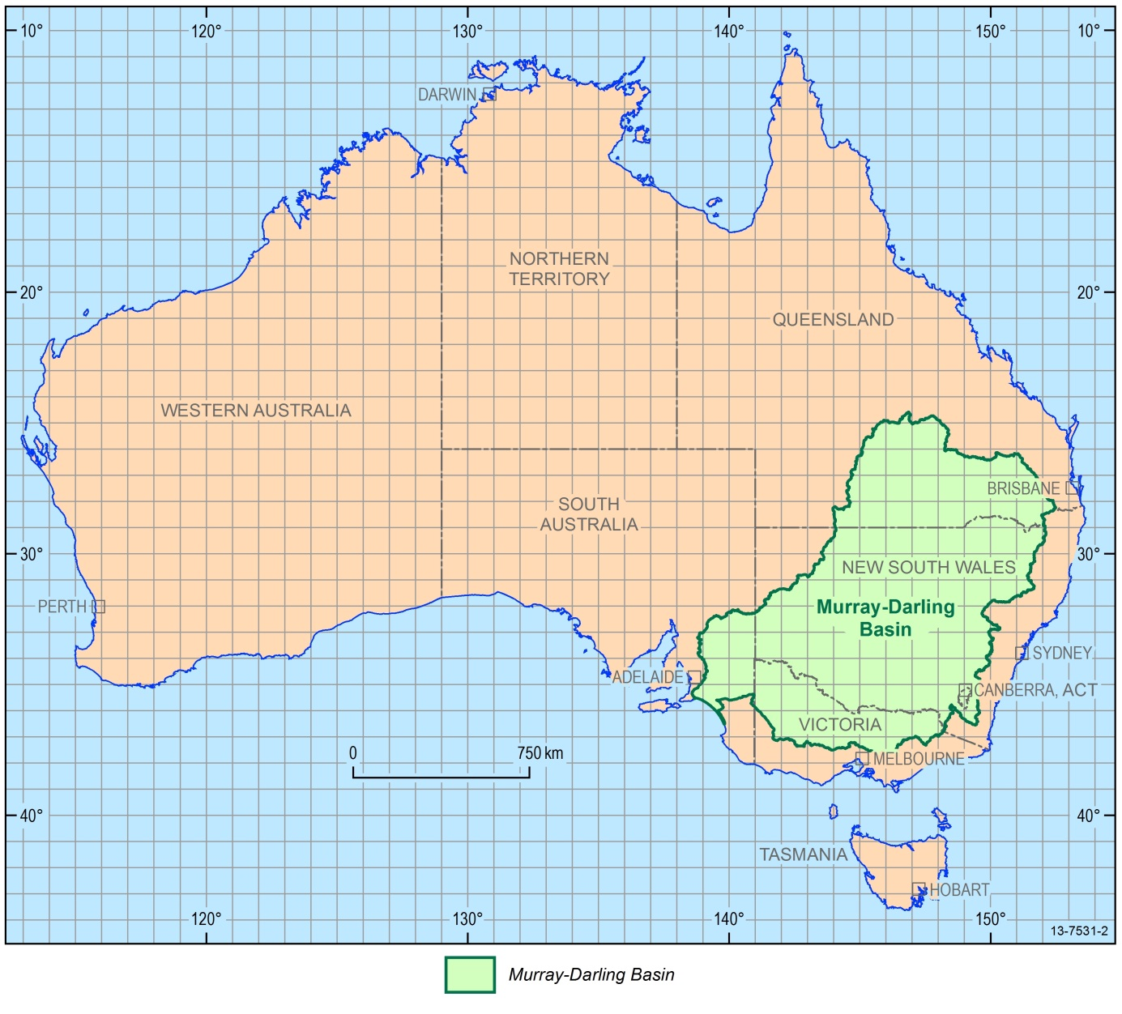
Figure C 1. The 1-degree grid used to tile the Landsat data for the Murray-Darling Basin Vegetation Monitoring Project and produce the outputs.

Landsat 8 was launched in February 2013. Geoscience Australia has an agreement with the satellite’s operator, the U.S. Geological Survey (USGS), to receive and distribute Landsat 8 data, and it is moving to receive certification from the USGS to do so. However Landsat 8 data have not been included in the present study.

