EDM Height Traversing Levelling Survey Report

Tarawa, Kiribati, April 2012

Geoscience Australia  
Record 2014/17

S. J. K. Yates1, A. Lal2



1. National Geospatial Reference Systems, Minerals and Natural Hazards Division, Geoscience Australia GPO Box 378 Canberra ACT 2601
2. Secretariat of the Pacific Community (SPC)

Department of Industry

Minister for Industry: The Hon Ian Macfarlane MP  
Parliamentary Secretary: The Hon Bob Baldwin MP  
Secretary: Ms Glenys Beauchamp PSM

Geoscience Australia

Chief Executive Officer: Dr Chris Pigram  
This paper is published with the permission of the CEO, Geoscience Australia



© Commonwealth of Australia (Geoscience Australia) 2014

With the exception of the Commonwealth Coat of Arms and where otherwise noted, all material in this publication is provided under a Creative Commons Attribution 3.0 Australia Licence. (<http://www.creativecommons.org/licenses/by/3.0/au/deed.en>)

Geoscience Australia has tried to make the information in this product as accurate as possible. However, it does not guarantee that the information is totally accurate or complete. Therefore, you should not solely rely on this information when making a commercial decision.

Geoscience Australia is committed to providing web accessible content wherever possible. If you are having difficulties with accessing this document please email [clientservices@ga.gov.au](mailto:clientservices@ga.gov.au).

ISSN 2201-702X (PDF)

ISBN 978-1-925124-06-4 (PDF)

GeoCat 76783

Bibliographic reference: Yates, S. J. K. & Lal, A., 2014, EDM Height Traversing Levelling Survey Report: Tarawa, Kiribati, April 2012. Record 2014/17. Geoscience Australia, Canberra. <http://dx.doi.org/10.11636/Record.2014.017>

Contents

1 Introduction 1

2 The Survey 2

2.1 Bench Mark Locality Diagram 3

2.2 The Kiribati Datum 3

2.3 Equipment 3

2.4 Method 4

2.5 Survey Support 4

2.6 Issues 4

3 Comparisons 5

3.1 Comparisons between 2012 and 2010 EDM Surveys 5

3.2 Combined Comparisons 1992 to 2012 6

3.3 Time Series of Bench Mark Movement relative to Fixed Deep Bench Mark KIR1 7

4 Deep Bench Mark Locality Diagrams 11

5 Reference Mark Locality Diagrams 17

6 Permanent Holding Mark Locality Diagrams 21

7 References 26

# Introduction

This report outlines the high precision levelling survey completed between the Sea Level Fine Resolution Acoustic Measuring Equipment (SEAFRAME) tide gauge and the Continuous Global Navigation Satellite System (CGNSS) station in Tarawa, Kiribati from 23 – 30 April 2012.

Personnel involved in the survey were Steve Yates, Surveyor, Geoscience Australia and Andrick Lal, Surveyor, Secretariat of the Pacific Islands Community (SPC).

The Electronic Distance Measurement (EDM) height traversing levelling technique was employed to observe differences in height between the deep bench mark arrays in Tarawa, which runs approximately 2.2 km from the tide gauge sensor to the CGNSS antenna. Previous levelling surveys using this technique have been conducted along the route in 2006, 2007, 2009 and 2010.

In addition, precise differential levelling surveys were performed along the deep bench mark (BM) array from 1992 to 2006 by the National Tidal Centre Australia (NTCA). This report contains a comparison between the 2012 and 2010 EDM height traversing results as well as a combined comparison since the first levelling survey in 1992.

# The Survey

The EDM height traversing levelling survey was carried out between the SEAFRAME tide gauge sensor, continuous GNSS station and the deep driven bench marks:

KIR 12 - Project plaque at tide gauge

KIR 13 - SEAFRAME sensor benchmark

KIR 1 - Deep Driven BM

KIR 2 - Deep Driven BM

KIR 3 - Deep Driven BM

KIR 46 - Deep Driven BM

KIR 47 - Deep Driven BM

KIR 49 - Deep Driven BM

All the deep bench marks were located and found in good order and undisturbed. Also included in the survey were the permanent holding marks KIR39, KIR44, KIR100, KIR101, KIR102, KIR104, KIR105 and KIR106 which are stainless steel bolts drilled in concrete and glued in place.

The EDM height traversing levelling technique was performed to the Class L2A specifications (ICSM, Standards and Practices for Control Surveys). After reduction an internal precision of 1mm√K or better was achieved (zero order); well within the specifications of the project which is 2√K where K is the distance in kilometres. A table of results and comparisons and the 2012 reduced levels are detailed later in this report.

## Bench Mark Locality Diagram

Due to the complexity of this document and the niche scientific target audience, no alternative description has been provided. Please email Geoscience Australia at clientservices@ga.gov.au for an alternative description.

## The Kiribati Datum

The adopted reference point for this survey is KIR1. Reduction of the data was calculated holding KIR 1 fixed at 3.5334 metres relative above the Tide Gauge Zero (TGZ) mark from the University of Hawaii tide gauge.

The original reference point for the 1992 survey was UT8 which had a height of 4.027 m above the Tide Gauge Zero (TGZ) mark from the University of Hawaii tide gauge, however, both the UT8 and the tide gauge no longer exist.

## Equipment

* Leica total station model TM30 (Serial No: 361441)
* Leica precision prisms GPH1P (2).
* Leica rigid tripod.
* Stainless steel target poles supported by Leica telescopic bi-poles (2).
* Shortened stainless steel target pole for the SEAFRAME sensor BM connection.
* Leica cast iron change plates (2).
* Kestral 4000 pocket weather tracker

## Method

The “Leap-Frog” EDM height traversing technique was employed for the Betio Island tide gauge levelling survey. This technique involves setting up a total station (TCA1800L) midway between two target/reflectors (on reflector rods with struts). The targets remain at a particular change point for the back-sight and fore-sight observations. The instrument measures slope distances (±1mm) and vertical angle (1”) to derive height differences (between the instrument’s trunnion axis and the reflectors). In support of the slope distance observations, the ambient temperature, pressure and humidity are recorded (Kestral 4000 pocket weather tracker) and input into the instrument to apply the first velocity correction to the observed distances (Rüeger & Brunner, 1982). Four rounds of observations are taken to the back-sight and fore-sight targets from each instrument setup. All levelling runs started and finished with the same reflector and reflector rod, i.e. an even number of setups when the two reflector rod configuration was used. This eliminates any reflector rod zero error. This technique can also be performed using a single set-up / single rod configuration which is particularly useful when levelling between bench marks which are close together e.g. between the CGNSS RMs.

Reduction of the digital data was computed by the Geoscience Australia levelling program “leveling1.exe”. This program computes the height difference between the two reflectors.

## Survey Support

Assistance from Boata Iabeta, Acting Chief Surveyor in Romano Reo’s absence, and his staff; from the Ministry of Lands was appreciated, they provided great support throughout the survey, including assistance in obtaining customs clearances for the surveying equipment. This is a lengthy process and seems to becoming more time consuming throughout most countries in the Pacific.

The staff from the Kiribati Weather Office also provided great assistance during the 2012 visit.

## Issues

No issues of any significance were encountered during the 2012 visit.

# Comparisons

## Comparisons between 2012 and 2010 EDM Surveys

Table 3.1 Tarawa, Kiribati 2012 EDM Height Traversing Levelling & Comparison 2012 - 2010. KIR1 - adopted fixed height of 3.5334 m

| From | To | Levelled Ht. Diff. | RL 2012 | Misclose (mm) | Dist. (km) | 1mm√k | RL 2010 | Difference (mm) 2012 - 2010 |
| --- | --- | --- | --- | --- | --- | --- | --- | --- |
| KIR1 |  |  | 3.5334 |  |  |  |  |  |
| KIR102 | KIR102 | 0.47631 | 4.0097 | 0.10 | 0.051 | 0.227 | 4.0098 | -0.09 |
| KIR100 | KIR100 | -0.17738 | 3.8323 | -0.20 | 0.056 | 0.237 | 3.8325 | -0.16 |
| KIR39 | KIR39 | 0.24661 | 4.0789 | -0.16 | 0.196 | 0.443 | 4.0787 | 0.24 |
| KIR101 | KIR101 | 0.06483 | 4.1438 | 0.44 | 0.204 | 0.452 | 4.1435 | 0.28 |
| KIR49 | KIR49 | -0.12041 | 4.0234 | 0.06 | 0.143 | 0.378 | 4.0229 | 0.47 |
| KIR12 | KIR12 | 0.19764 | 4.2210 | 0.27 | 0.179 | 0.423 | 4.2200 | 1.01 |
|  | KIR13 | 0.41256 | 4.6336 | -0.11 | 0.011 | 0.105 | 4.6322 | 1.36 |
| KIR102 |  |  | 4.0097 |  |  |  | 4.0098 | -0.09 |
| KIR46 | KIR46 | -0.62951 | 3.3802 | 0.42 | 0.160 | 0.400 | 3.3794 | 0.80 |
| KIR106 | KIR106 | 0.42358 | 3.8038 | 0.28 | 0.140 | 0.374 | 3.8032 | 0.59 |
| KIR104 | KIR104 | -0.12327 | 3.6805 | 0.24 | 0.202 | 0.449 | 3.6747 | 5.82 |
|  | KIR2 | -0.49652 | 3.1840 | 0.27 | 0.107 | 0.327 | 3.1828 | 1.19 |
| KIR104 |  |  | 3.6805 |  |  |  |  |  |
| KIR44 | KIR44 | -0.05929 | 3.6212 | -0.09 | 0.187 | 0.432 | 3.6204 | 0.83 |
| KIR47 | KIR47 | -0.32439 | 3.2968 | -0.27 | 0.091 | 0.302 | 3.2954 | 1.44 |
| KIR105 | KIR105 | 0.53270 | 3.8295 | -0.26 | 0.166 | 0.407 | 3.8267 | 2.84 |
| KIR3 | KIR3 | -0.26293 | 3.5666 | 0.19 | 0.211 | 0.459 | 3.5655 | 1.11 |
|  | KIRBM | 0.84791 | 4.4145 | 0.06 | 0.023 | 0.152 | 4.4134 | 1.11 |
|  |  |  | Misclose for all bays levelled = | 1.24 | 2.127 | 1.459 |  |  |
| KIRIBM |  |  | 4.41450 |  |  |  |  |  |
|  | RM1 | -0.8757 | 3.53881 | -0.03 | 0.023 | 0.152 | 3.5378 | 1.06 |
| KIRIBM |  |  |  |  |  |  |  |  |
|  | RM2 | -0.9129 | 3.50159 | 0.06 | 0.023 | 0.152 | 3.5006 | 1.03 |
| KIRIBM |  |  |  |  |  |  |  |  |
|  | RM3 | -0.8977 | 3.51685 | 0.02 | 0.300 | 0.548 | 3.5158 | 1.01 |

All levelling was performed within the project specifications of 2√k

## Combined Comparisons 1992 to 2012

Table 3.2 Tarawa, Kiribati - Comparison of the RL's for Precise Differential Levelling (1992 - 2006) and EDM Height Traversing (2006 - 2012). Units are in metres.

| Year | KIR1 | KIR2 | KIR3 | KIR12 | KIR13 | KIR46 | KIR47 | KIR49 | KIRIBM |
| --- | --- | --- | --- | --- | --- | --- | --- | --- | --- |
| 1992.9 | 3.5334 | 3.1835 | 3.5657 | 4.2176 | 4.6302 |  |  |  |  |
| 1994.2 | 3.5334 | 3.1838 | 3.5655 | 4.2187 | 4.6319 | New point est. 2002 | New point est. 2002 | New point est. 2002 | New point est. 2002 |
| 1995.2 | 3.5334 | 3.1845 | 3.5654 | 4.2195 | 4.6331 | New point est. 2002 | New point est. 2002 | New point est. 2002 | New point est. 2002 |
| 1996.7 | 3.5334 | 3.1843 | 3.5654 | 4.2191 | 4.6321 | New point est. 2002 | New point est. 2002 | New point est. 2002 | New point est. 2002 |
| 1997.9 | 3.5334 | 3.1843 | 3.5657 | 4.2196 | 4.6325 | New point est. 2002 | New point est. 2002 | New point est. 2002 | New point est. 2002 |
| 1999.5 | 3.5334 | 3.1844 | 3.5644 | 4.2195 | 4.6324 | New point est. 2002 | New point est. 2002 | New point est. 2002 | New point est. 2002 |
| 2000.7 | 3.5334 | 3.1847 | 3.5658 | 4.2195 | 4.6321 | New point est. 2002 | New point est. 2002 | New point est. 2002 | New point est. 2002 |
| 2002.4 | 3.5334 | 3.1843 | 3.5648 | 4.2191 | 4.6321 | 3.3782 | 3.2948 | 4.0232 | 4.4124 |
| 2004.4 | 3.5334 | 3.1843 | 3.5653 | 4.2190 | 4.6324 | 3.3788 | 3.2952 | 4.0225 | 4.4130 |
| 2006.2 | 3.5334 | 3.1839 | 3.5662 | 4.2195 | 4.6328 | 3.3788 | 3.2956 | 4.0226 | 4.4139 |
| 2006.2 | 3.5334 | 3.1844 | 3.5646 | 4.2193 | 4.6326 | 3.3794 | 3.2953 | 4.0230 | 4.4124 |
| 2007.9 | 3.5334 | 3.1830 | 3.5641 | 4.2202 | 4.6308 | 3.3795 | 3.2941 | 4.0230 | 4.4119 |
| 2009.2 | 3.5334 | 3.1835 | 3.5646 | 4.2199 | 4.6320 | 3.3791 | 3.2951 | 4.0229 | 4.4125 |
| 2010.7 | 3.5334 | 3.1828 | 3.5655 | 4.2200 | 4.6322 | 3.3794 | 3.2954 | 4.0229 | 4.4134 |
| 2012.2 | 3.5334 | 3.1840 | 3.5666 | 4.2210 | 4.6336 | 3.3802 | 3.2968 | 4.0234 | 4.4145 |

*The RL of the Reference Point KIRI (ARP) is derived from adding the static height difference of 0.9443 m (KIRIBM to KIRI) to the levelled RL of KIRIBM.

The 2012 Reduced Level for KIRI is 5.3588 m.

## Time Series of Bench Mark Movement relative to Fixed Deep Bench Mark KIR1

The purpose of this survey is twofold: firstly, to provide accurate changes in land height to be used in computations of absolute sea level rise and secondly to provide accurate assessments of relative sea level changes due to localised deformation.

Precise Differential Levelling: 1992 - 2006   
EDM Height Traversing: 2006 onwards

Due to the complexity of this document and the niche scientific target audience, no alternative description has been provided. Please email Geoscience Australia at clientservices@ga.gov.au for an alternative description.

Due to the complexity of this document and the niche scientific target audience, no alternative description has been provided. Please email Geoscience Australia at clientservices@ga.gov.au for an alternative description.

Due to the complexity of this document and the niche scientific target audience, no alternative description has been provided. Please email Geoscience Australia at clientservices@ga.gov.au for an alternative description.

Due to the complexity of this document and the niche scientific target audience, no alternative description has been provided. Please email Geoscience Australia at clientservices@ga.gov.au for an alternative description.

Due to the complexity of this document and the niche scientific target audience, no alternative description has been provided. Please email Geoscience Australia at clientservices@ga.gov.au for an alternative description.

Due to the complexity of this document and the niche scientific target audience, no alternative description has been provided. Please email Geoscience Australia at clientservices@ga.gov.au for an alternative description.


Due to the complexity of this document and the niche scientific target audience, no alternative description has been provided. Please email Geoscience Australia at clientservices@ga.gov.au for an alternative description.

Due to the complexity of this document and the niche scientific target audience, no alternative description has been provided. Please email Geoscience Australia at clientservices@ga.gov.au for an alternative description.

# Deep Bench Mark Locality Diagrams

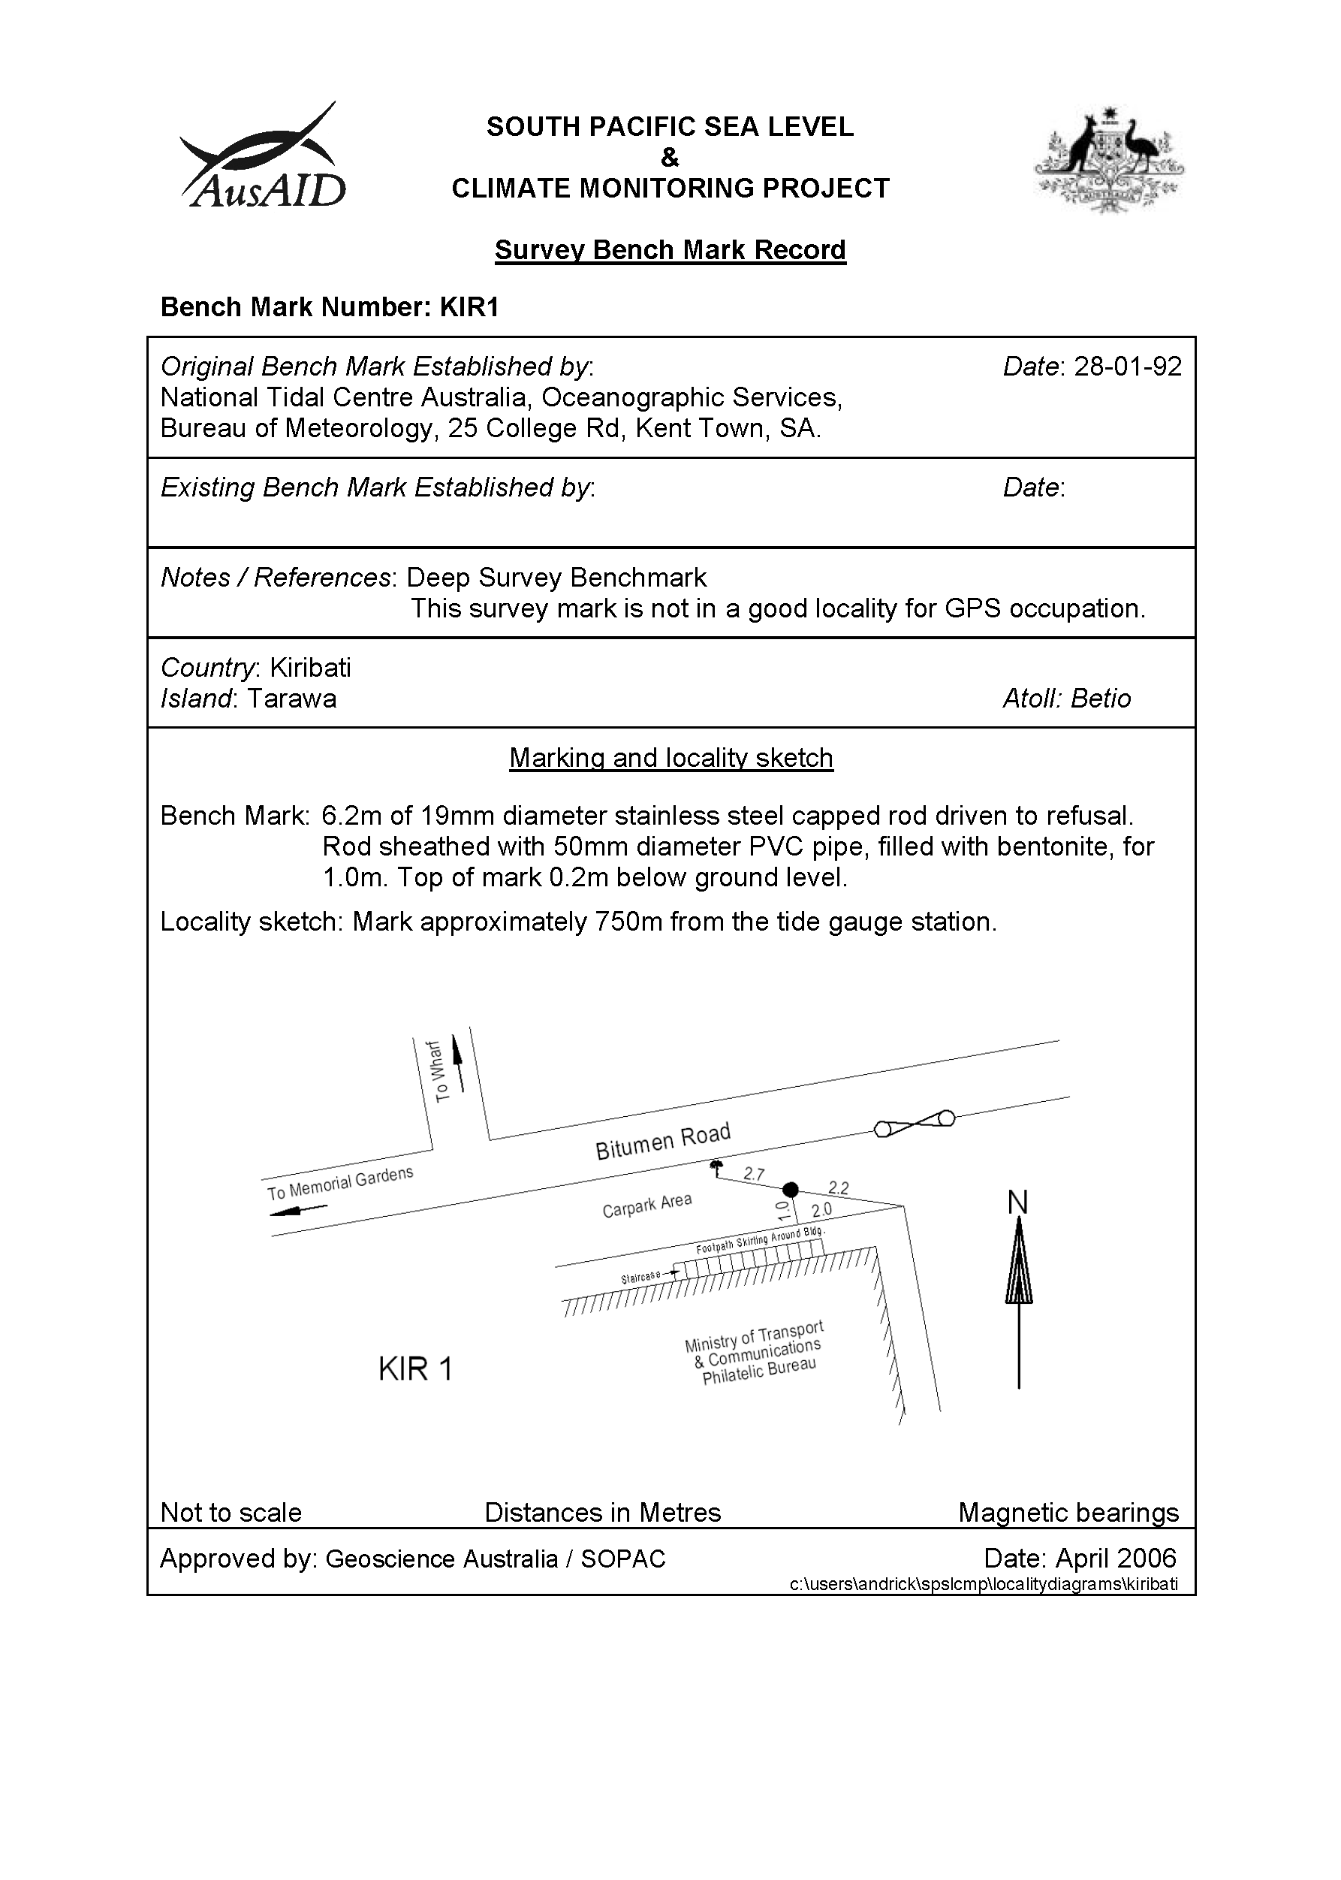

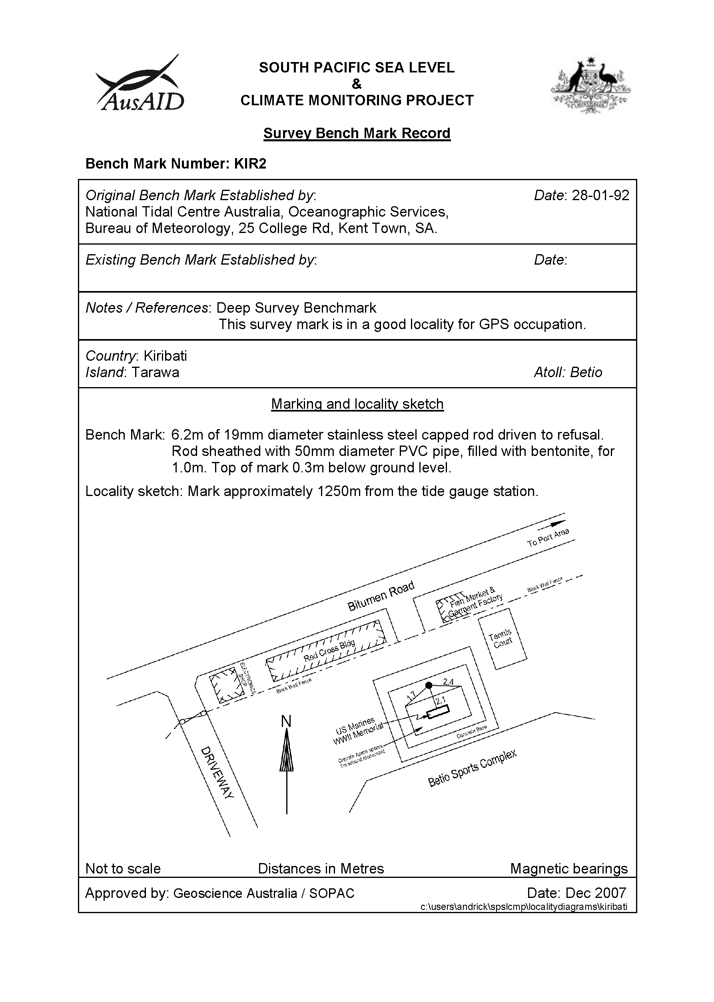

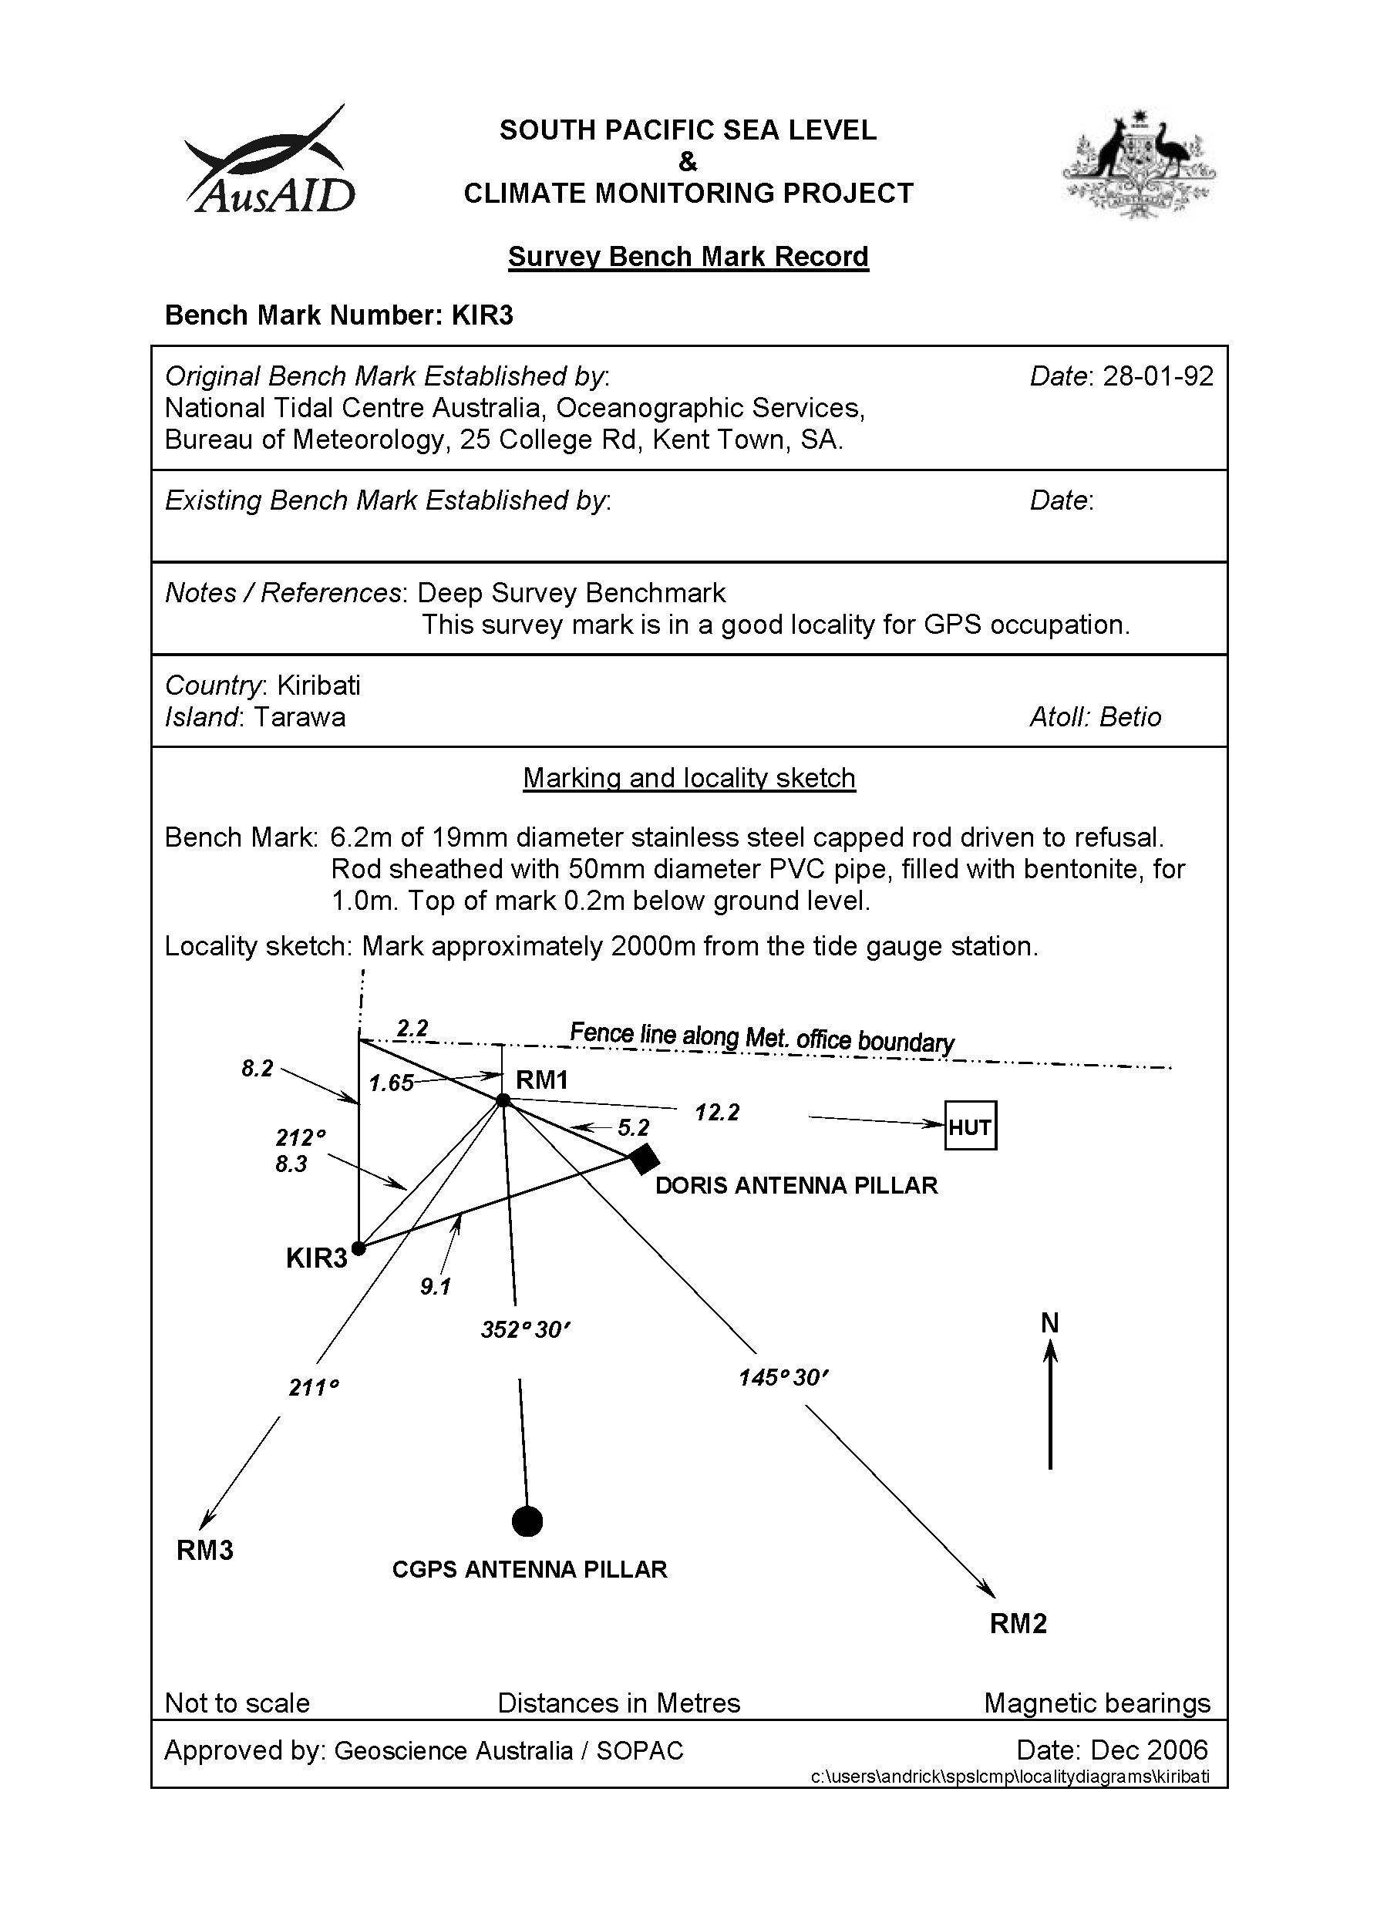

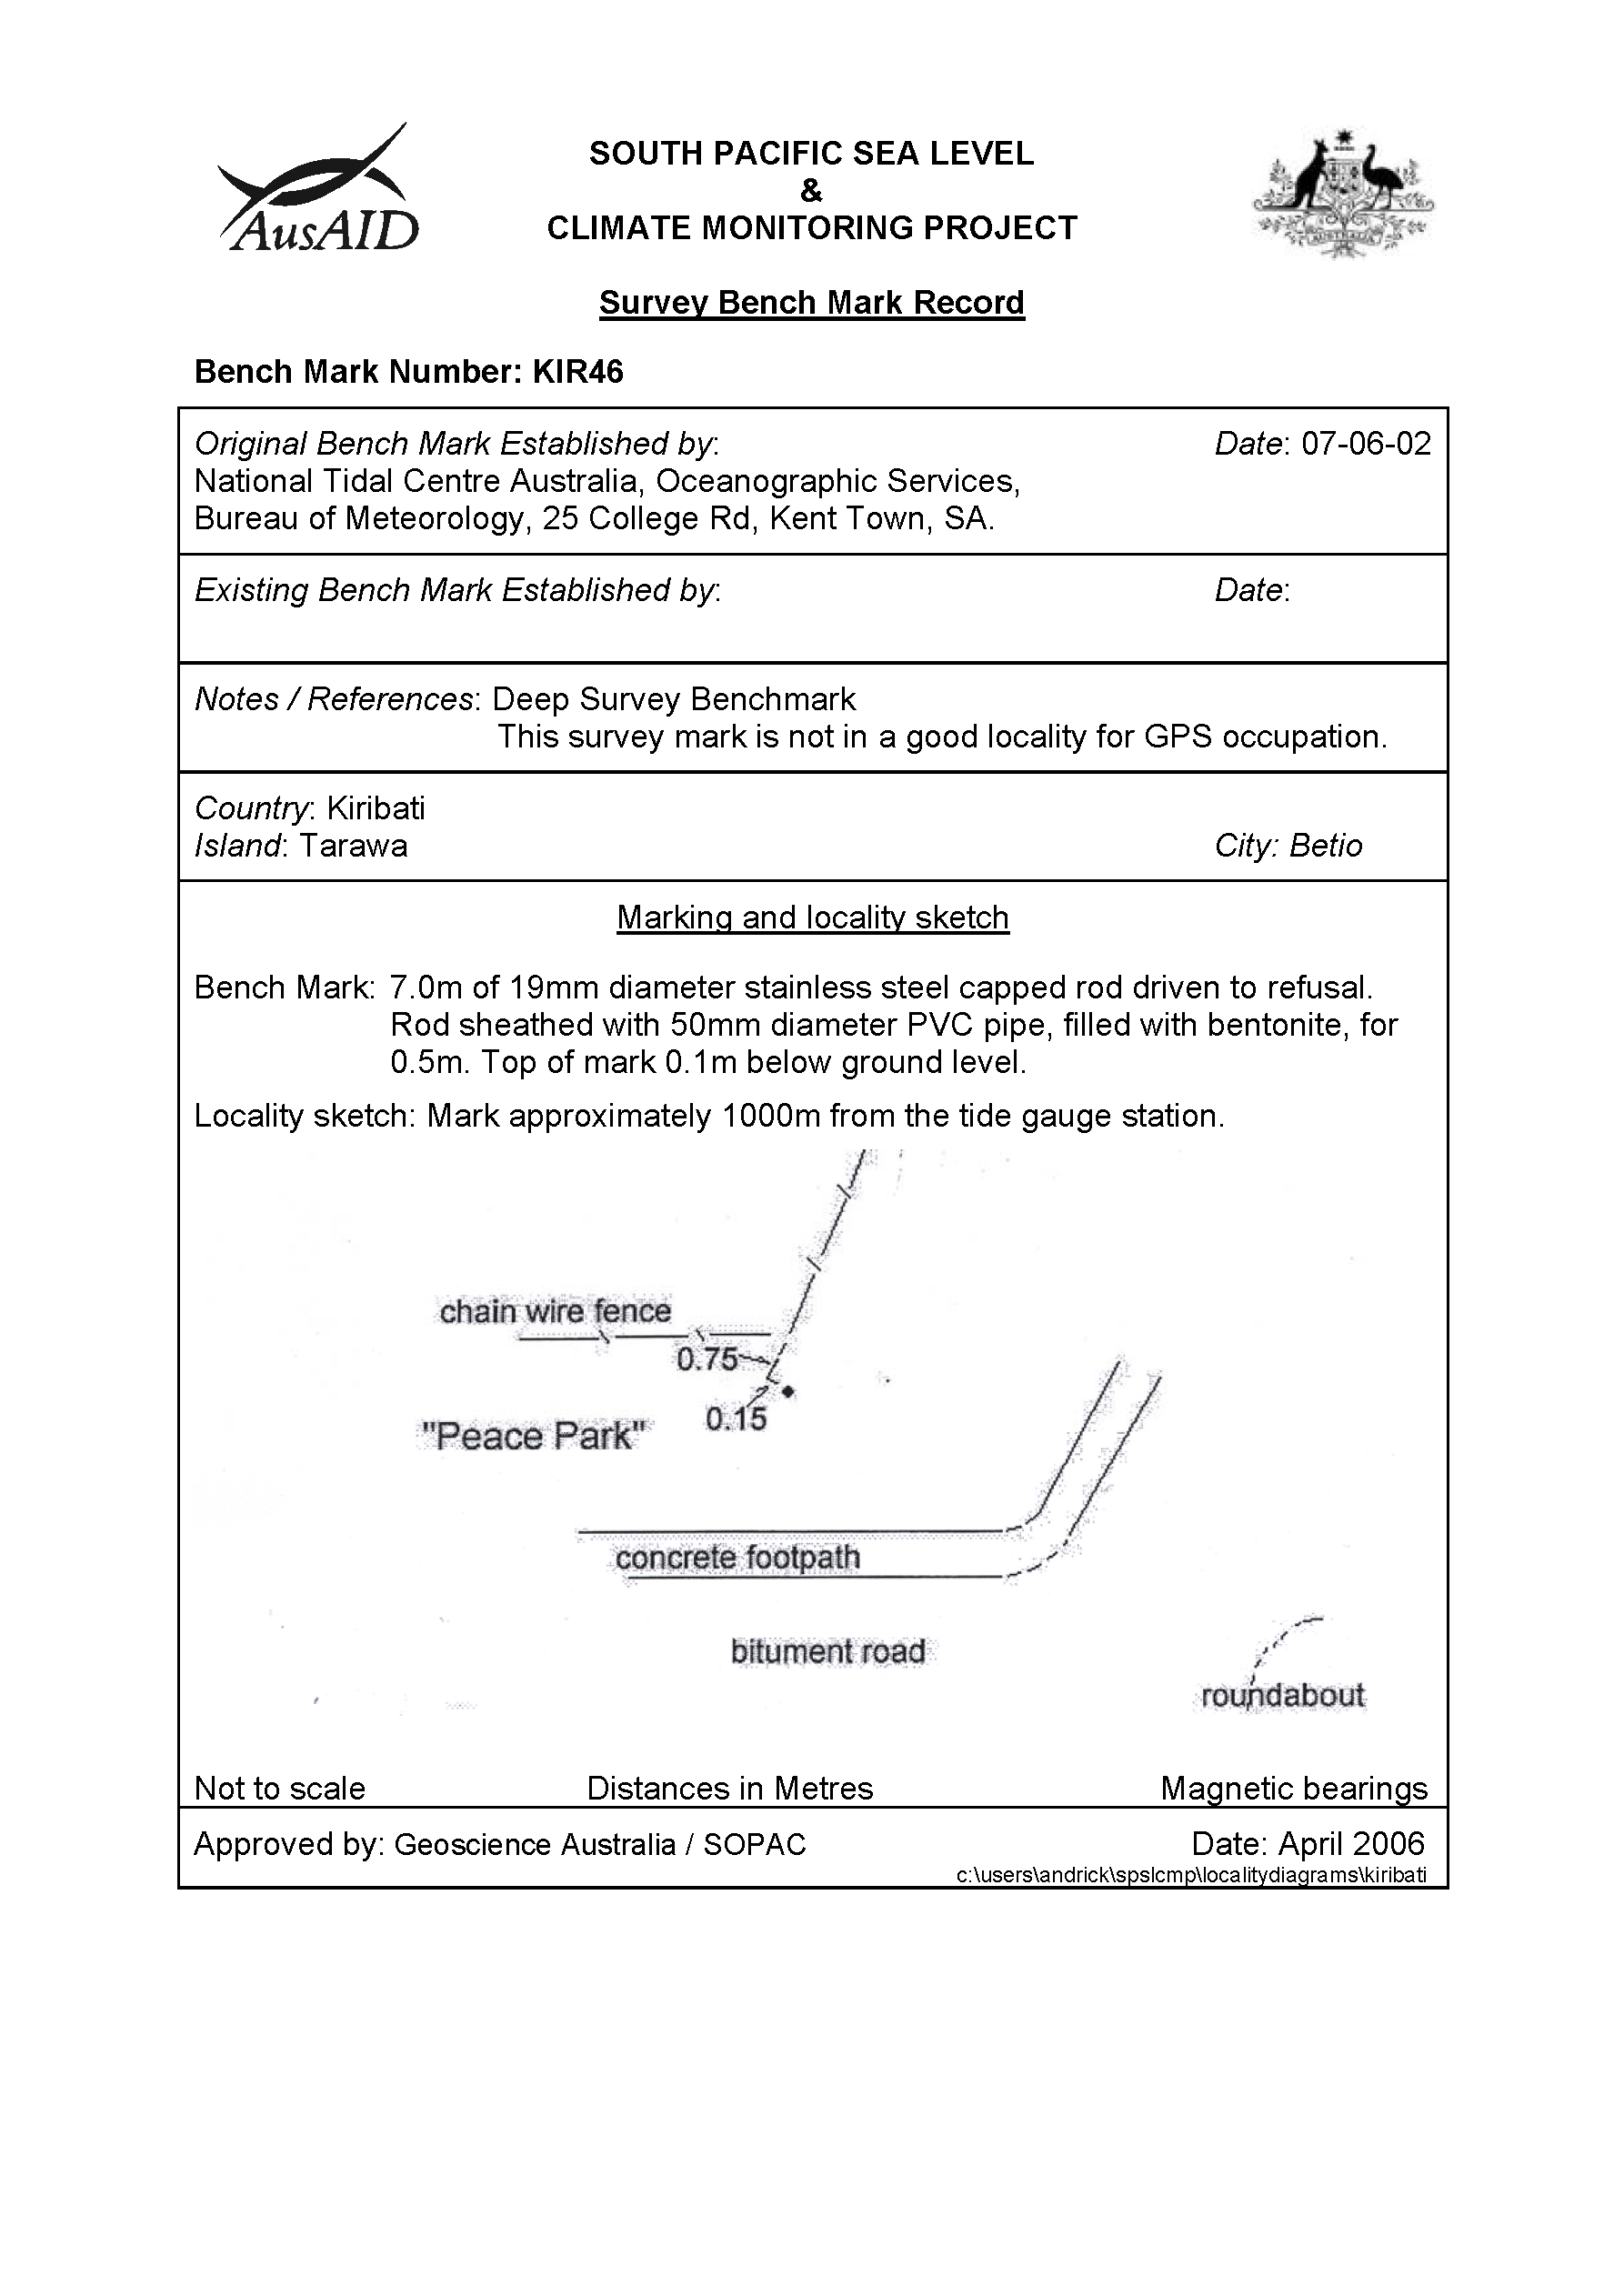

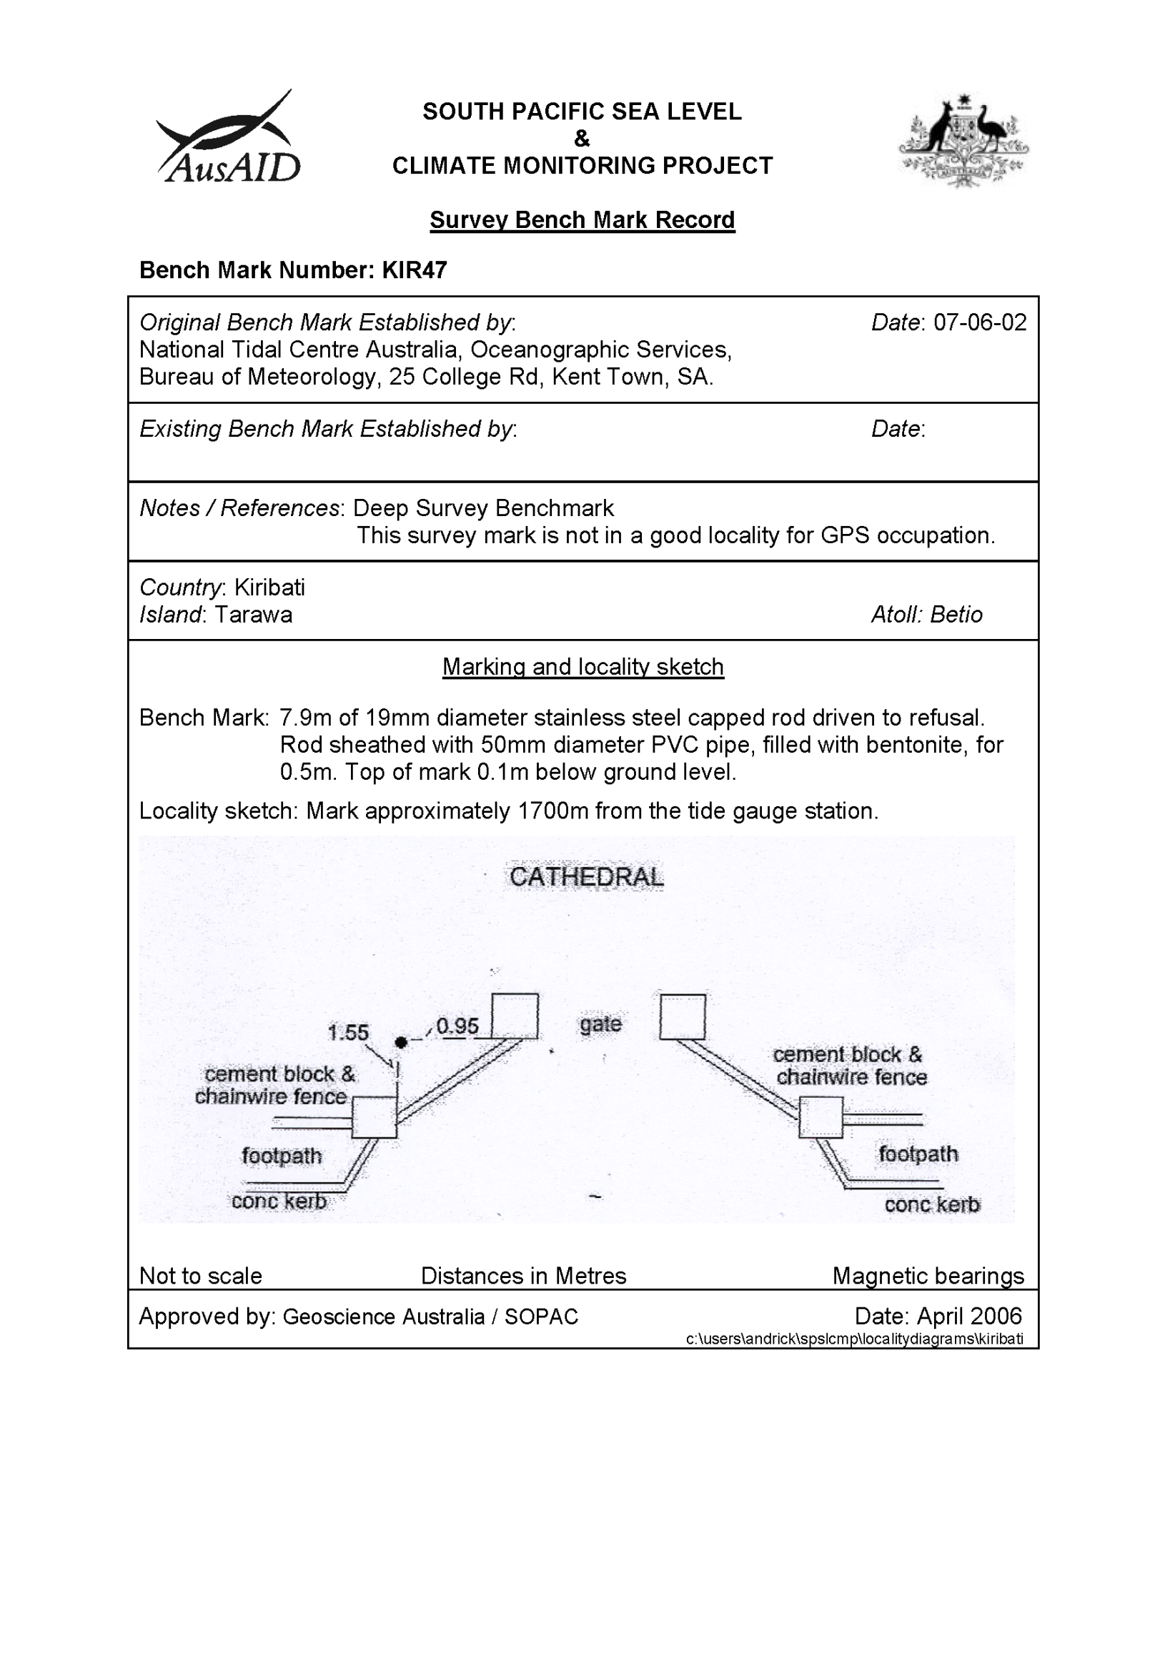

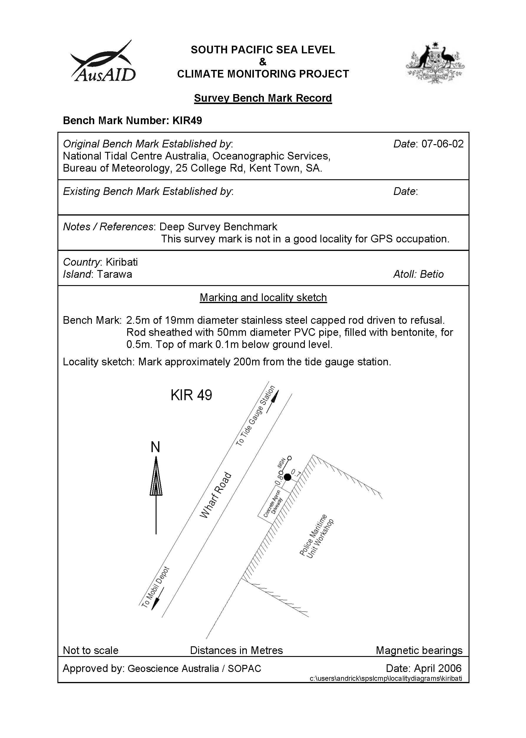

# Reference Mark Locality Diagrams

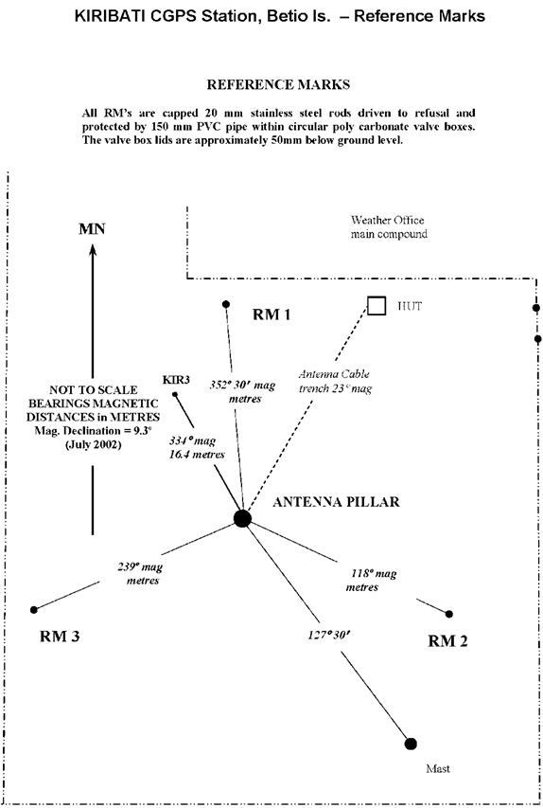

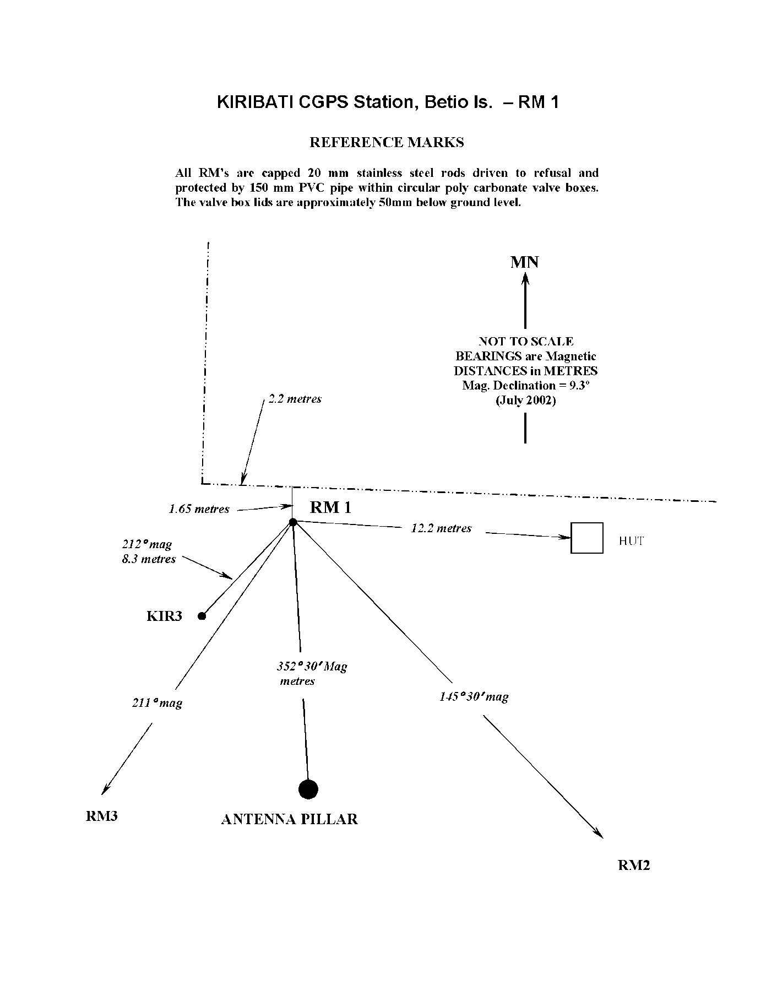

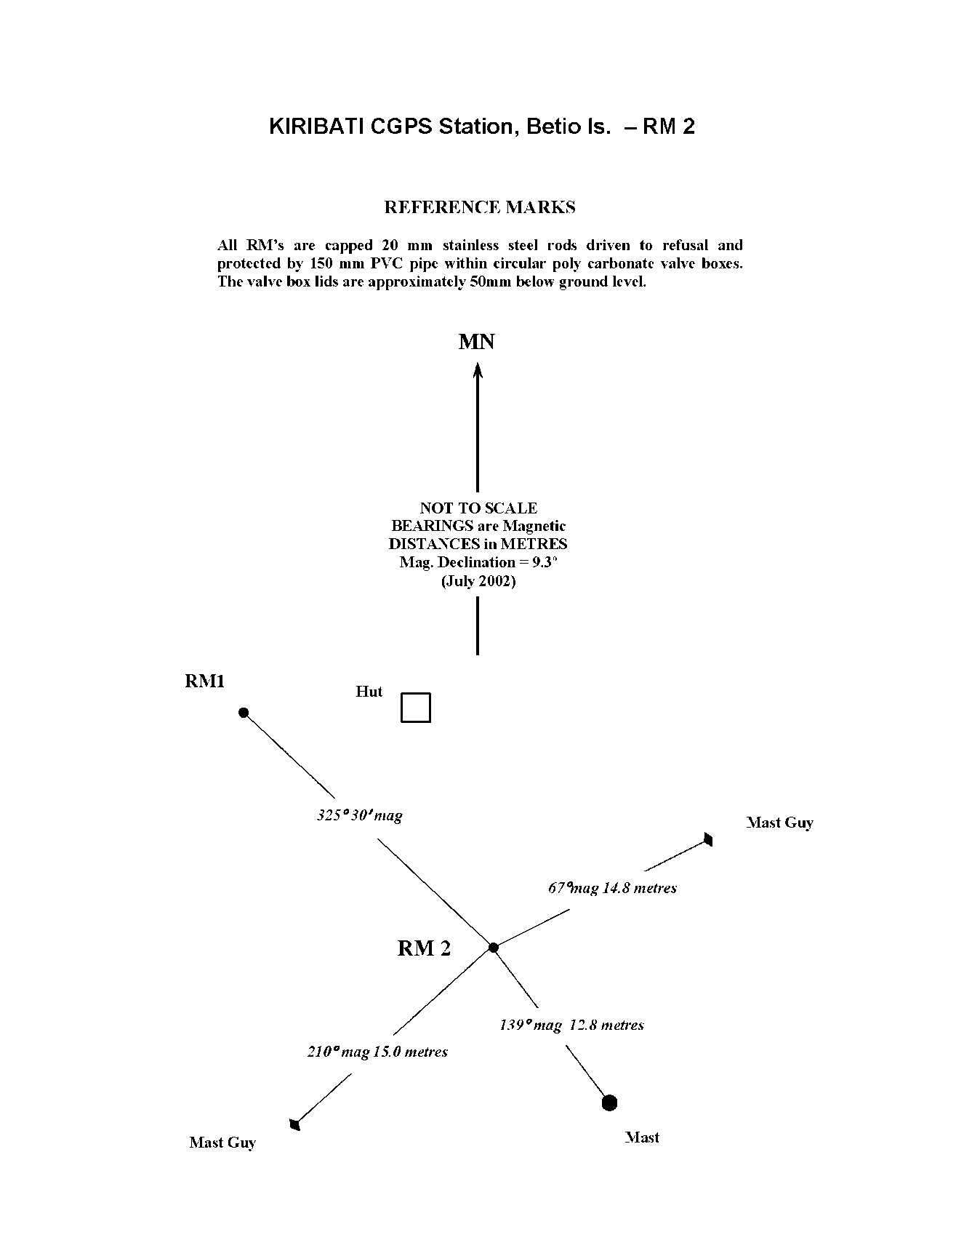

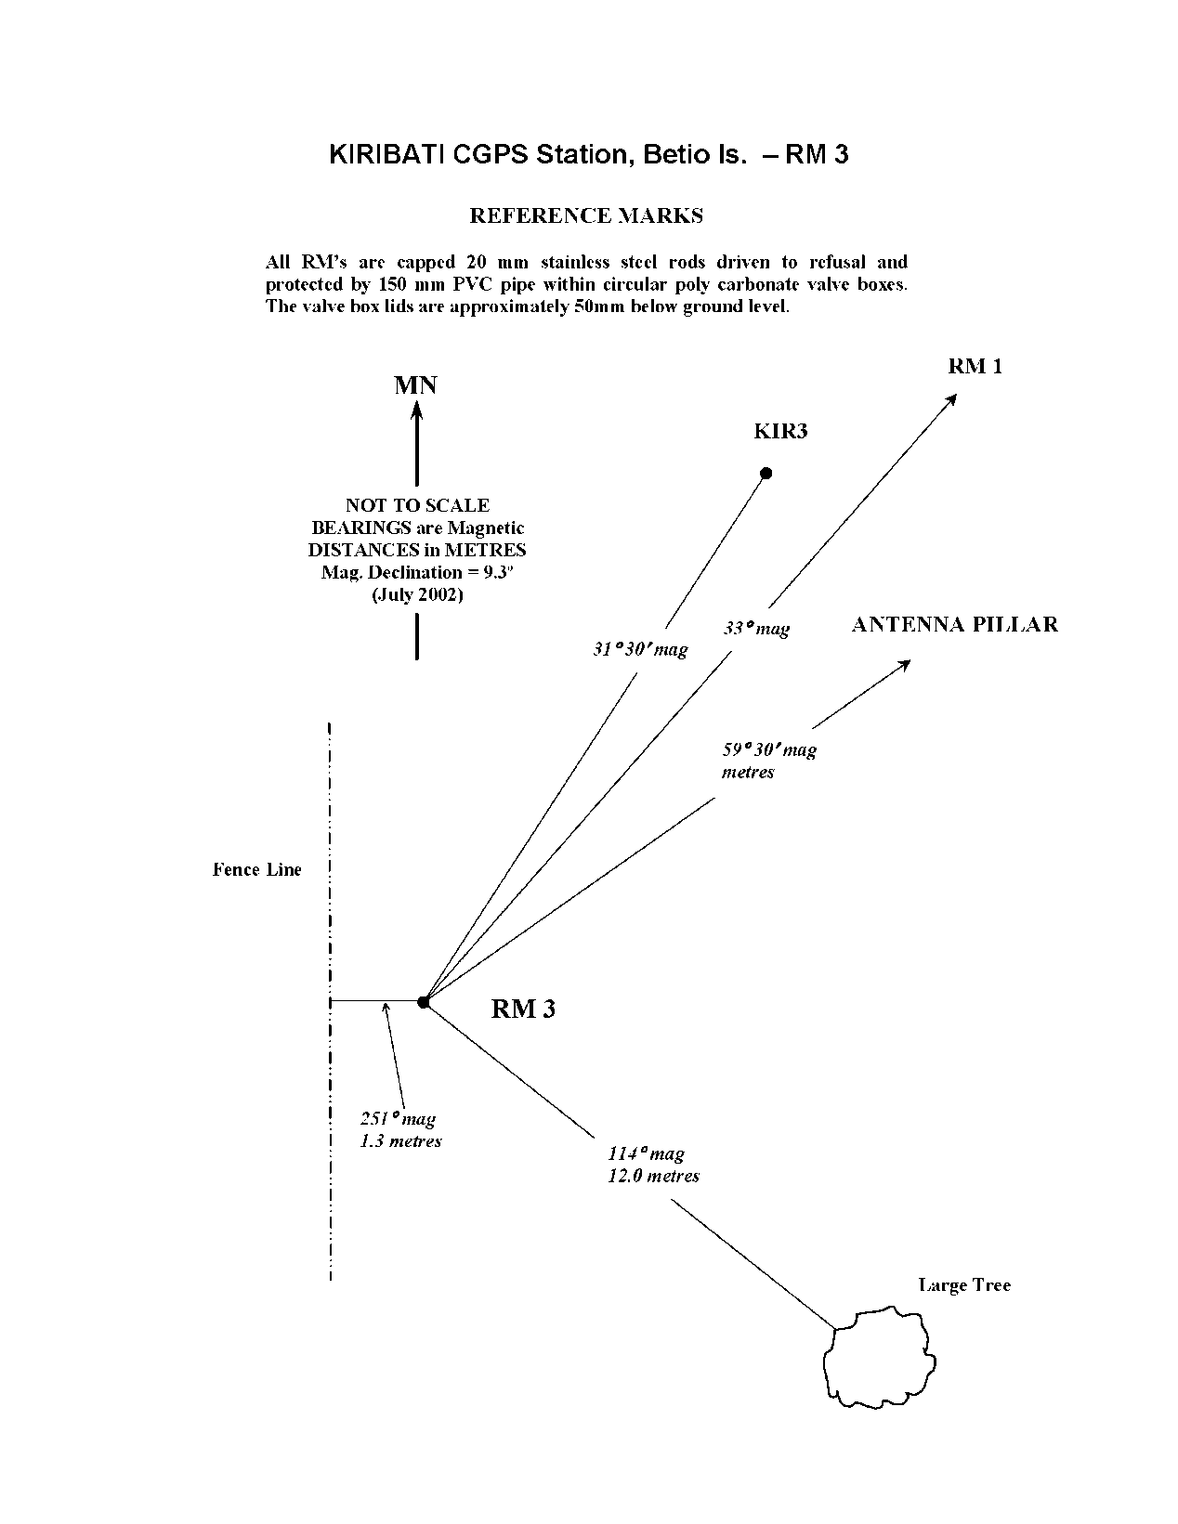

# Permanent Holding Mark Locality Diagrams

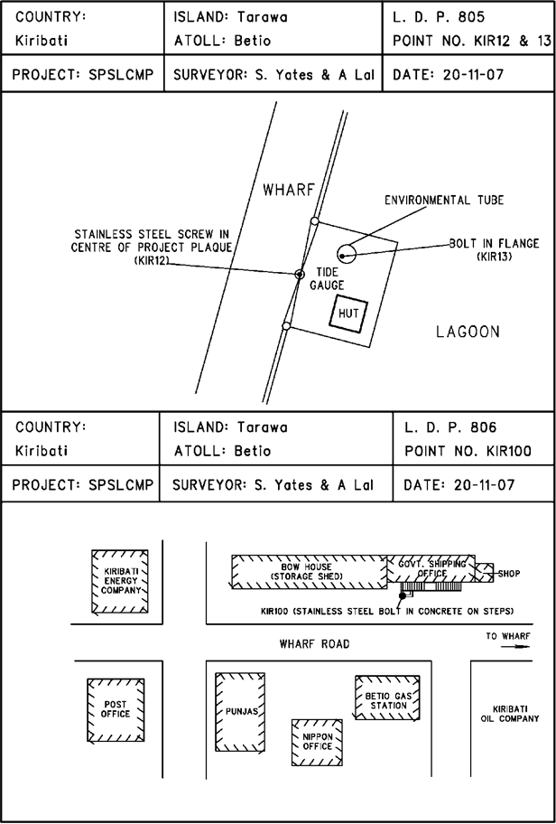

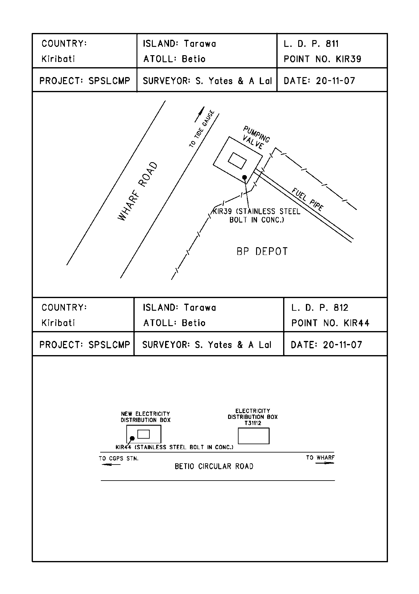

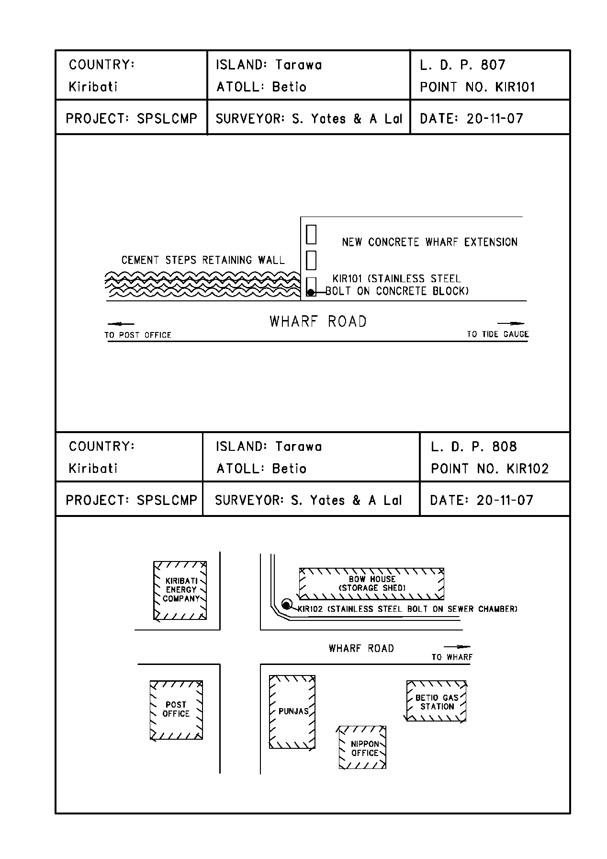

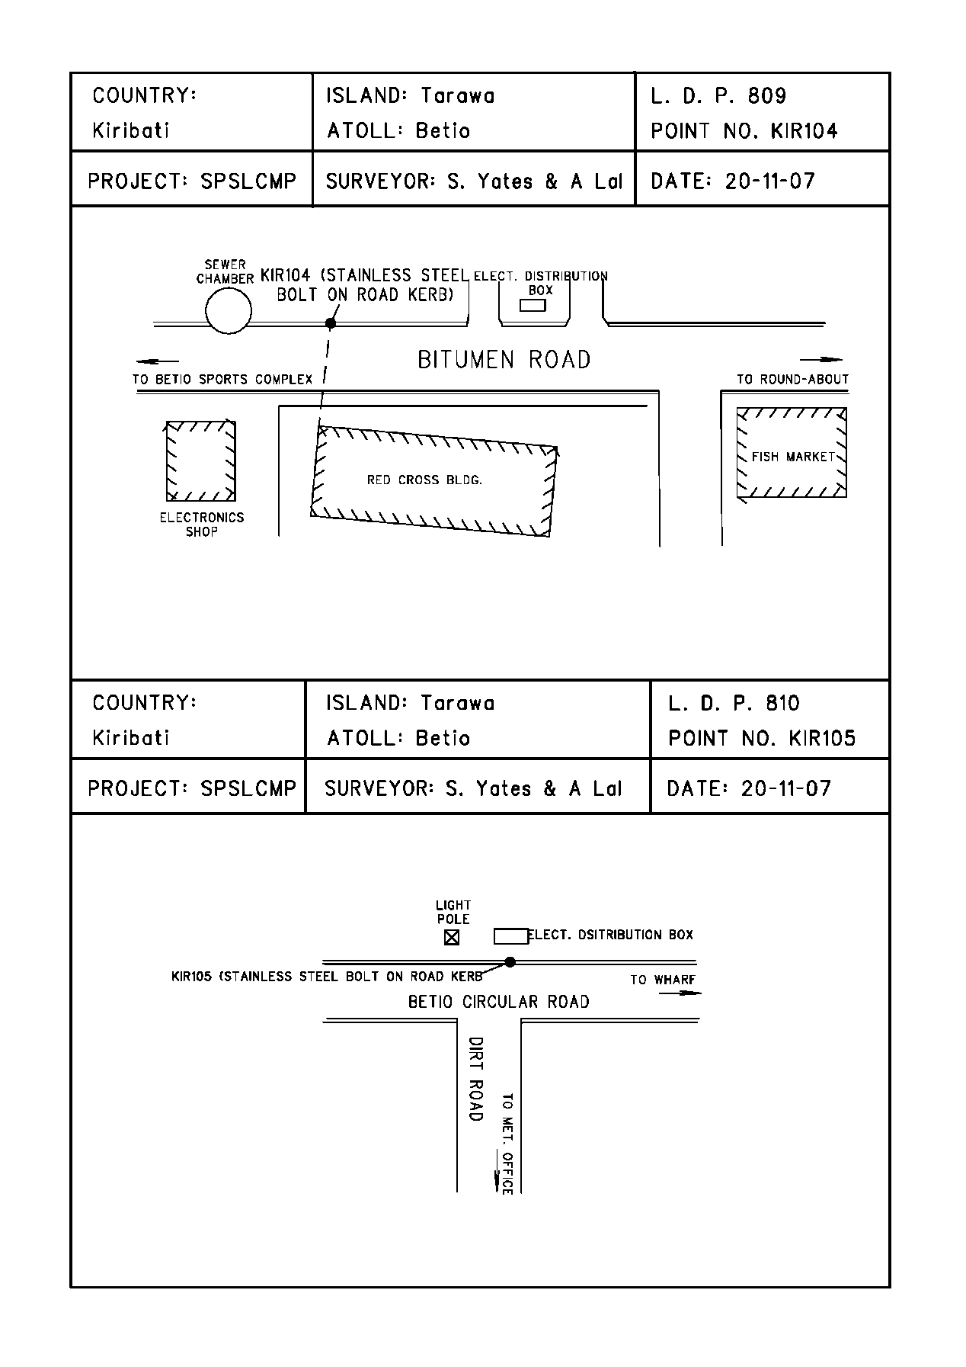

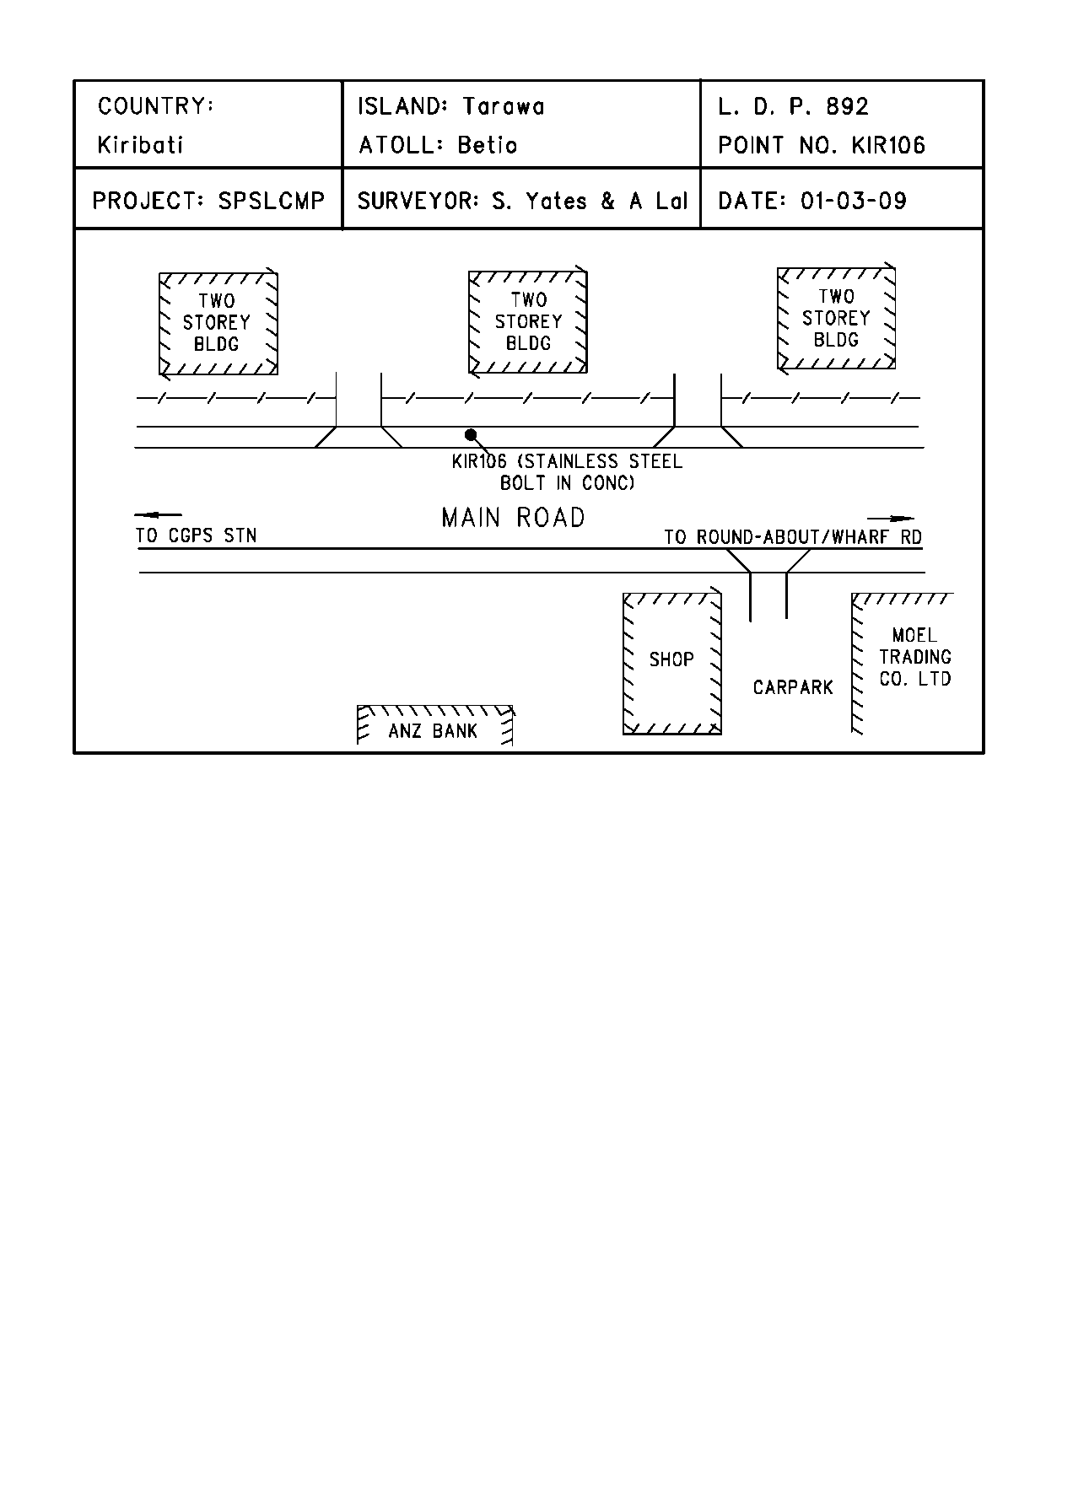

# References

Rüeger, J.M. & Brunner, F.K. 1982, ‘EDM Height Traversing versus Geodetic Levelling’, The Canadian Surveyor, vol. 36, no. 1, pp. 69-87.

Inter-Government Committee on Surveying and Mapping (ICSM) 2002, Standards and Practices for Control Surveys, SP1, Ver. 1.5, May 2002.