EDM Height Traversing Levelling Survey Report

Honiara, Solomon Islands, March 2012

Geoscience Australia  
Record 2014/26

S. J. K. Yates1, A. Lal2



1. National Geospatial Reference Systems, Geospatial and Earth Monitoring Division, Geoscience Australia GPO Box 378 Canberra ACT 2601
2. Secretariat of the Pacific Community (SPC)

Department of Industry

Minister for Industry: The Hon Ian Macfarlane MP  
Parliamentary Secretary: The Hon Bob Baldwin MP  
Secretary: Ms Glenys Beauchamp PSM

Geoscience Australia

Chief Executive Officer: Dr Chris Pigram  
This paper is published with the permission of the CEO, Geoscience Australia



© Commonwealth of Australia (Geoscience Australia) 2014

With the exception of the Commonwealth Coat of Arms and where otherwise noted, all material in this publication is provided under a Creative Commons Attribution 3.0 Australia Licence. (<http://www.creativecommons.org/licenses/by/3.0/au/deed.en>)

Geoscience Australia has tried to make the information in this product as accurate as possible. However, it does not guarantee that the information is totally accurate or complete. Therefore, you should not solely rely on this information when making a commercial decision.

Geoscience Australia is committed to providing web accessible content wherever possible. If you are having difficulties with accessing this document please email [clientservices@ga.gov.au](mailto:clientservices@ga.gov.au).

ISSN 2201-702X (PDF)

ISBN 978-1-925124-15-6 (PDF)

GeoCat 76790

Bibliographic reference: Yates, S. J. K. & Lal, A., 2014, EDM Height Traversing Levelling Survey Report: Honiara, Solomon Islands, March 2012. Record 2014/26. Geoscience Australia, Canberra. <http://dx.doi.org/10.11636/Record.2014.026>

Contents

1 Introduction 1

2 The Survey 2

2.1 Bench Mark Locality Diagram 3

2.2 The Solomon Islands Datum 3

2.3 Equipment 3

2.4 Method 4

2.5 Survey Support 4

2.6 Issues 4

3 Comparisons 5

3.1 Comparisons between 2012 and 2010 EDM Surveys 5

3.2 Combined Comparisons 1994 to 2012 6

3.3 Time Series of Bench Mark Movement 7

4 Deep Bench Mark Locality Diagrams 11

5 Solomon Island Reference Mark Locality Diagram 16

6 Temporary Holding Mark Locality Diagrams 17

7 References 22

# Introduction

This report outlines the high precision level survey completed between the Sea Level Fine Resolution Acoustic Measuring Equipment (SEAFRAME) tide gauge and the Continuous Global Navigation Satellite System (CGNSS) station in Honiara, Solomon Islands from 27 March to 4 April 2012.

Personnel involved in the survey were Steve Yates, Surveyor, Geoscience Australia and Andrick Lal, Surveyor, Secretariat of the Pacific Community (SPC).

The Electronic Distance Measurement (EDM) height traversing levelling technique was employed to observe differences in height between the deep bench mark arrays in Honiara, which runs approximately 2 km from the tide gauge sensor to the CGNSS antenna. Previous levelling surveys have been conducted along the route using this technique in 2007 and 2010.

In addition, precise differential levelling surveys were performed along the deep bench mark (BM) array from 1994 to 1999 by the National Tidal Centre Australia (NTCA). This report contains a comparison between the 2012 and 2010 EDM height traversing results as well as a combined comparison since the first levelling survey in 1994.

# The Survey

The EDM height traversing levelling survey was carried out between the SEAFRAME tide gauge sensor, CGNSS station and the deep driven bench marks:

SOLOBM – GPS Benchmark

SOL103 – SEAFRAME Project Bench Mark

SOL18 – SEAFRAME Project Sensor Bench Mark

FBM1 – DESTROYED

FBM3 – Deep Driven BM

FBM4 – Deep Driven BM

FBM8 – Deep Driven BM

FBM9 – Deep Driven BM

Most of the deep bench marks were located and found in good order and undisturbed, FBM2 was unable to be located and FBM1 (a local Lands and Survey mark) was found to be inaccessible and probably will be destroyed with the construction activity in the area. Also included in the survey were temporary holding marks SOL103, SOL106, SOL107, SOL108, SOL110, SOL111, SOL112, SOL113 and SOL114.

The EDM height traversing levelling technique was performed to the Class L2A specifications (ICSM, Standards and Practices for Control Surveys). After reduction an internal precision of 1mm√K or better was achieved (zero order); well within the specifications of the project which is 2√K where K is the distance in kilometres. A table of results and comparisons and the 2012 reduced levels are detailed later in this report.

## Bench Mark Locality Diagram

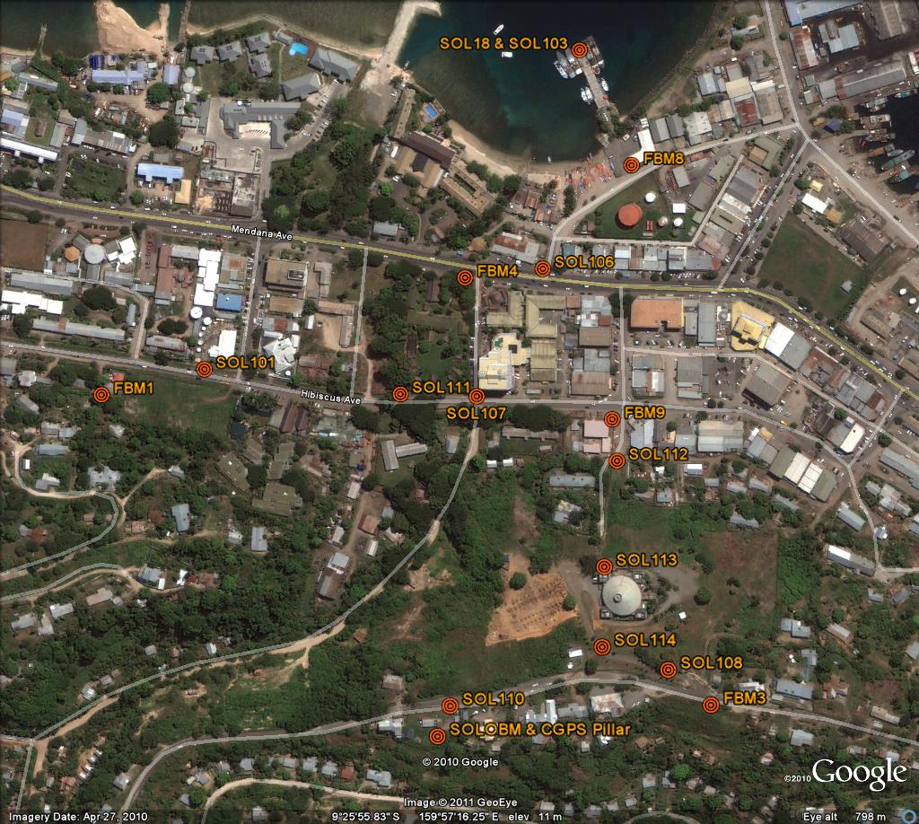

## The Solomon Islands Datum

The adopted reference point for this survey is FBM4. Reduction of the data was calculated holding FBM4 fixed at 3.61966 metres. The height of FBM4 was derived NTC in 1994.

## Equipment

* Leica total station model TM30 (Serial No: 361441)
* Leica precision prisms GPH1P (2).
* Leica rigid tripod.
* Stainless steel target poles supported by Leica telescopic bi-poles (2).
* Shortened stainless steel target pole for the SEAFRAME sensor BM connection.
* Leica cast iron change plates (2).
* Kestral 4000 pocket weather tracker

## Method

The “Leap-Frog” EDM height traversing technique was employed for the Honiara tide gauge levelling survey. This technique involves setting up a total station (TCA1800L) midway between two target/reflectors (on reflector rods with struts). The targets remain at a particular change point for the back-sight and fore-sight observations. The instrument measures slope distances (±1mm) and vertical angle (1”) to derive height differences (between the instrument’s trunnion axis and the reflectors). In support of the slope distance observations, the ambient temperature, pressure and humidity are recorded (Kestral 4000 pocket weather tracker) and input into the instrument to apply the first velocity correction to the observed distances (Rüeger & Brunner, 1982). Four rounds of observations are taken to the back-sight and fore-sight targets from each instrument setup. All levelling runs started and finished with the same reflector and reflector rod, i.e. an even number of setups when the two reflector rod configuration was used. This eliminates any reflector rod zero error. This technique can also be performed using a single set-up / single rod configuration which is particularly useful when levelling between bench marks which are close together e.g. between the CGNSS RMs.

Reduction of the digital data was computed by the Geoscience Australia levelling program “leveling1.exe”. This program computes the height difference between the two reflectors.

## Survey Support

The survey team very much appreciated the assistance from Solomon Islands Meteorological Service, especially the field assistance from Mr. David Tapiei. All the staff from the Solomon Islands Meteorological Service have developed a keen interest in the SPSLCMP project and are always eager to provide assistance when required.

## Issues

Prior approvals needs to be taken to access the following deep benchmarks; -

Tide Gauge Station and Deep Driven Bench Mark, FBM8 – Police Patrol Base

FBM4 is now within a locked compound and due to the heavy traffic, the level run to SOL106 across the road is best attempted early on a Sunday.

CGNSS Station – Meteorological Department

As a matter of courtesy, prior approval should be made for access to the survey array from deep driven bench mark FBM9 to FBM3. This survey array runs across the parliament complex building compounds.

# Comparisons

## Comparisons between 2012 and 2010 EDM Surveys

Table 3. Honiara, Solomon Islands 2010 EDM Height Traversing Levelling & Comparison 2012 - 2010. FBM4 - adopted fixed height of 3.6197 m

| From | To | Levelled Ht. Diff. | RL 2012 | Misclose (mm) | Dist. (km) | 1mm√k | RL 2010 | Difference (mm) 2012 - 2010 |
| --- | --- | --- | --- | --- | --- | --- | --- | --- |
| FBM4 |  |  | 3.6197 |  |  |  | 3.6197 |  |
| SOL106 | SOL106 | -0.4139 | 3.2058 | 0.19 | 0.098 | 0.313 | 3.2064 | -0.64 |
| FBM8 | FBM8 | -1.2440 | 1.9618 | 0.11 | 0.134 | 0.366 | 1.9620 | -0.24 |
| SOL103 | SOL103 | 0.3444 | 2.3062 | 0.16 | 0.124 | 0.352 | 2.3078 | -1.61 |
| SOL18 | SOL18 | 1.2630 | 3.5691 | -0.02 | 0.009 | 0.095 | 3.5707 | -1.56 |
| FBM4 |  |  | 3.6197 |  |  |  |  |  |
| SOL107 | SOL107 | 1.3794 | 4.9991 | 0.20 | 0.116 | 0.341 | 4.9987 | 0.35 |
| FBM9 | FBM9 | -0.2494 | 4.7496 | 0.13 | 0.148 | 0.385 | 4.7500 | -0.39 |
| SOL112 | SOL112 | 1.4691 | 6.2187 | 0.01 | 0.040 | 0.200 | 6.2219 | -3.20 |
| SOL113 | SOL113 | 25.0907 | 31.3094 | -0.06 | 0.099 | 0.315 | 31.3039 | 5.51 |
| SOL114 | SOL114 | 14.3966 | 45.7060 | 0.19 | 0.086 | 0.293 | 45.6886 | 17.42 |
| SOL108 | SOL108 | 4.6018 | 50.3078 | 0.03 | 0.059 | 0.243 | 50.3052 | 2.57 |
|  | FBM3 | 3.7402 | 54.0479 | -0.04 | 0.069 | 0.263 | 54.0467 | 1.22 |
| SOL114 |  |  | 45.7060 |  |  |  |  |  |
| SOL110 | SOL110 | 8.3816 | 54.0876 | 0.31 | 0.016 | 0.128 | 54.0794 | 8.16 |
|  | SOLOBM | 0.2237 | 54.3113 | -0.02 | 0.035 | 0.187 | 54.3032 | 8.08 |
|  |  |  | Misclose for all bays levelled = | 1.19 | 1.033 | 1.017 |  |  |
| SOLOBM |  |  | 54.3113 |  |  |  |  |  |
|  | RM1 | -0.0688 | 54.2425 | 0.05 | 0.027 | 0.164 | 54.23470 | 7.78 |
| SOLOBM |  |  | 54.3113 |  |  |  |  |  |
|  | RM2 | -1.2951 | 53.0162 | -0.04 | 0.014 | 0.118 | 53.00790 | 8.30 |
| SOLOBM |  |  | 54.3113 |  |  |  |  |  |
|  | RM3 | -0.5575 | 53.7538 | 0.00 | 0.028 | 0.167 | 53.74580 | 7.96 |

All levelling was performed within the project specifications of 2√k

## Combined Comparisons 1994 to 2012

Table 3.2 Honiara, Solomon Islands - Comparison of the RL's for Precise Differential Levelling (1994-1999) and EDM Height Traversing (2007 - 2012).

| Year | 1994.7 | 1996.2 | 1997.7 | 1999.3 | 2007.7 | 2009.4 | 2010.9 | 2012.2 |
| --- | --- | --- | --- | --- | --- | --- | --- | --- |
| FBM1 | 6.3860 | 6.3848 | 6.3857 | 6.3856 | 6.3866 | 6.3863 | 6.3868 |  |
| FBM2 | 3.3171 | 3.3175 | 3.3182 | 3.3161 | 3.3177 |  |  |  |
| FBM3 | 54.0460 | 54.0457 | 54.0449 | 54.0444 | 54.0467 | 54.0485 | 54.0467 | 54.0479 |
| FBM4 | 3.6197 | 3.6197 | 3.6197 | 3.6197 | 3.6197 | 3.6197 | 3.6197 | 3.6197 |
| SOL18 | 3.5755 | 3.5758 | 3.5741 | 3.5742 | 3.5720 | 3.5718 | 3.5707 | 3.5691 |
| SOL103 |  |  |  |  | 2.3093 | 2.3085 | 2.3078 | 2.3062 |
| FBM8 |  |  |  |  | 1.9626 | 1.9626 | 1.9620 | 1.9618 |
| FBM9 |  |  |  |  | 4.7500 | 4.7502 | 4.7500 | 4.7496 |
| SOLOBM |  |  |  |  | 54.3111 | 54.3134 | 54.3032 | 54.3113 |
| SOLO |  |  |  |  | 55.7756 | 55.7801 | 55.7678 | 55.7759 |

The ARP (SOLO) was not levelled to during the 2012 survey. The 2012 RL of SOLO was adjusted to the same height difference surveyed for 2012 RL of SOLOBM.

## Time Series of Bench Mark Movement

The purpose of this survey is two folds: firstly, to provide accurate changes in land height to be used in computations of absolute sea level rise and secondly to provide accurate assessments of relative sea level changes due to localised deformation.

Due to the complexity of this document and the niche scientific target audience, no alternative description has been provided. Please email Geoscience Australia at clientservices@ga.gov.au for an alternative description.

Due to the complexity of this document and the niche scientific target audience, no alternative description has been provided. Please email Geoscience Australia at clientservices@ga.gov.au for an alternative description.

Due to the complexity of this document and the niche scientific target audience, no alternative description has been provided. Please email Geoscience Australia at clientservices@ga.gov.au for an alternative description.

Due to the complexity of this document and the niche scientific target audience, no alternative description has been provided. Please email Geoscience Australia at clientservices@ga.gov.au for an alternative description.

Due to the complexity of this document and the niche scientific target audience, no alternative description has been provided. Please email Geoscience Australia at clientservices@ga.gov.au for an alternative description.

Due to the complexity of this document and the niche scientific target audience, no alternative description has been provided. Please email Geoscience Australia at clientservices@ga.gov.au for an alternative description.

Due to the complexity of this document and the niche scientific target audience, no alternative description has been provided. Please email Geoscience Australia at clientservices@ga.gov.au for an alternative description.

# Deep Bench Mark Locality Diagrams

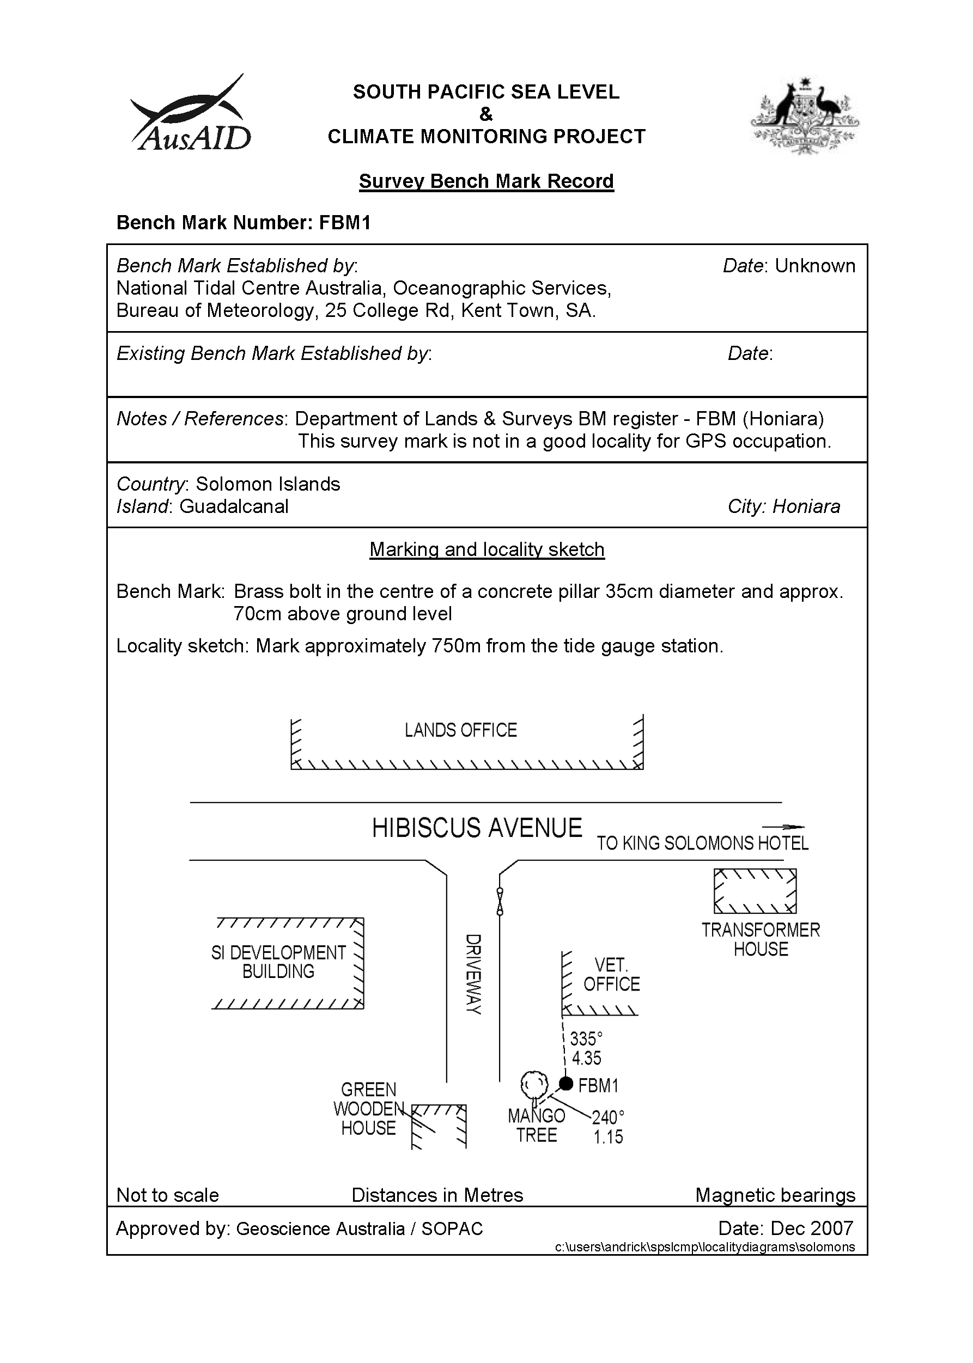

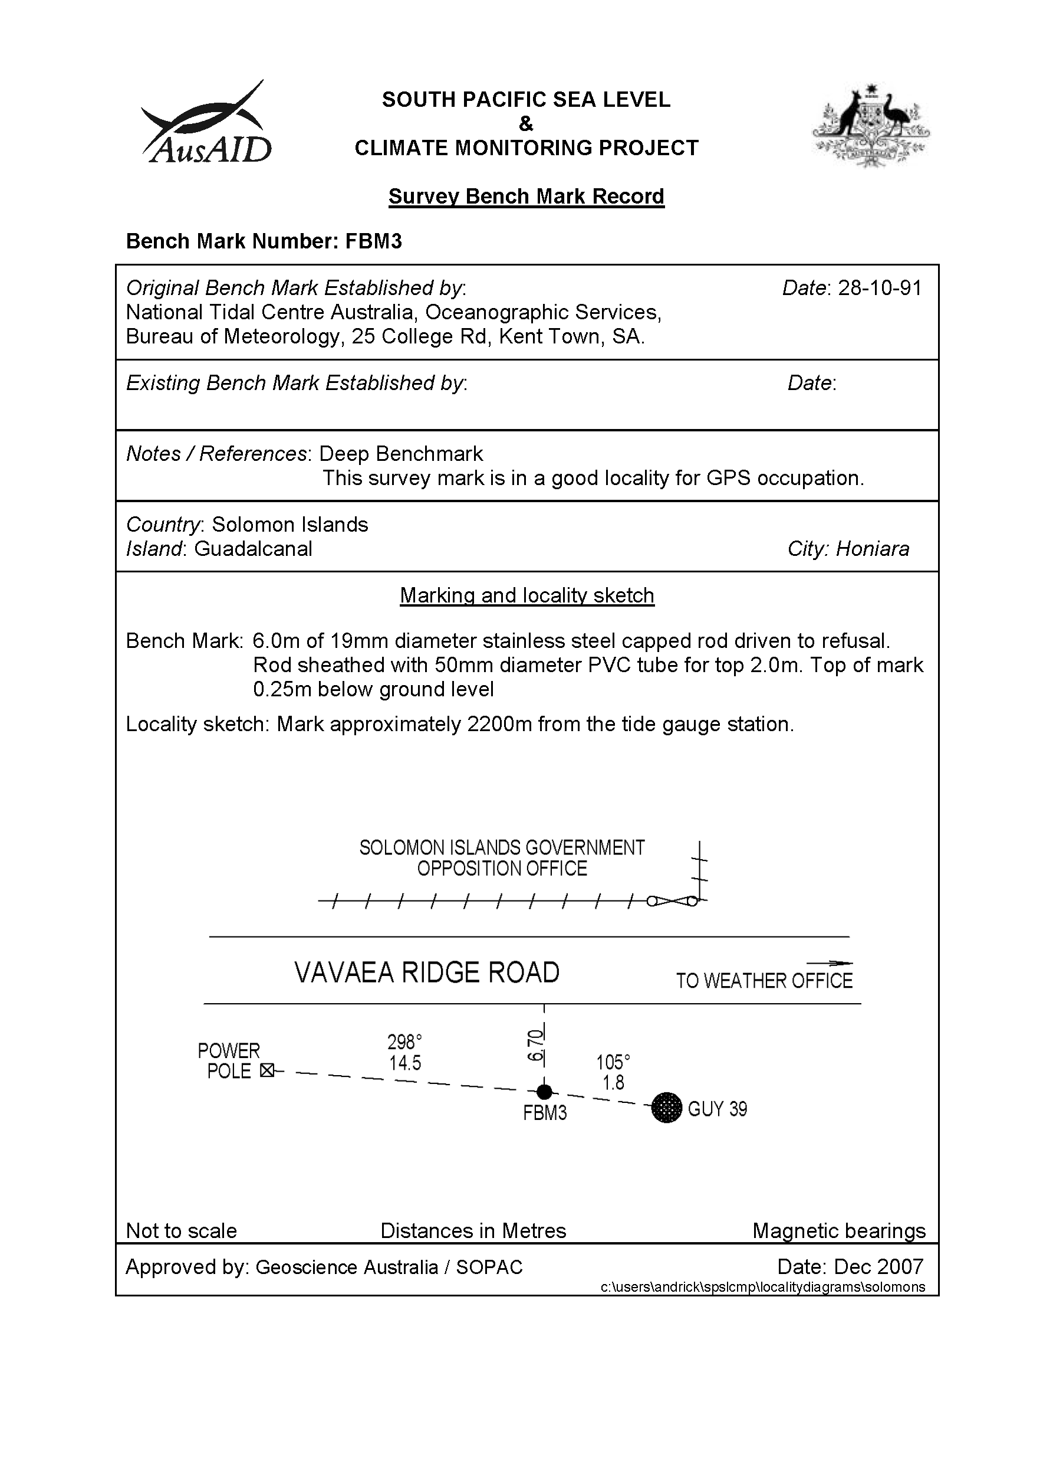

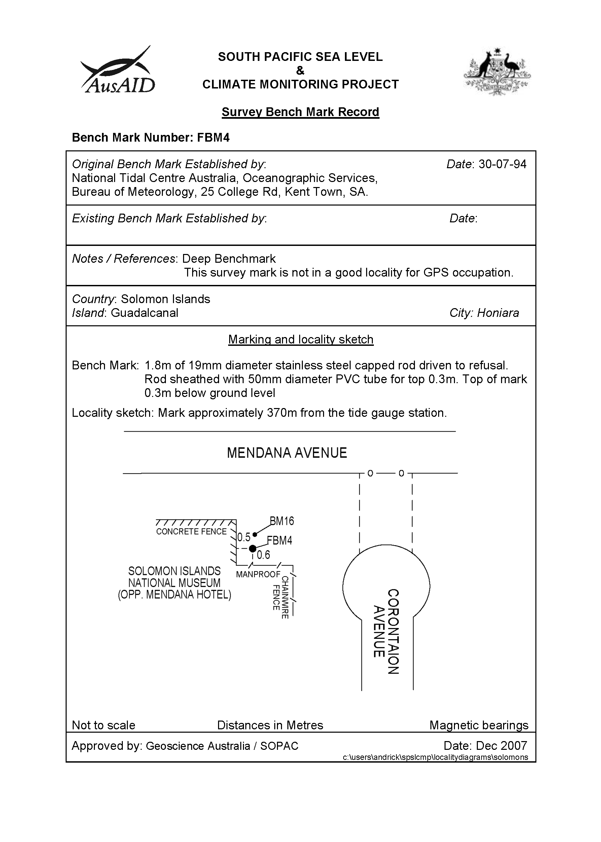

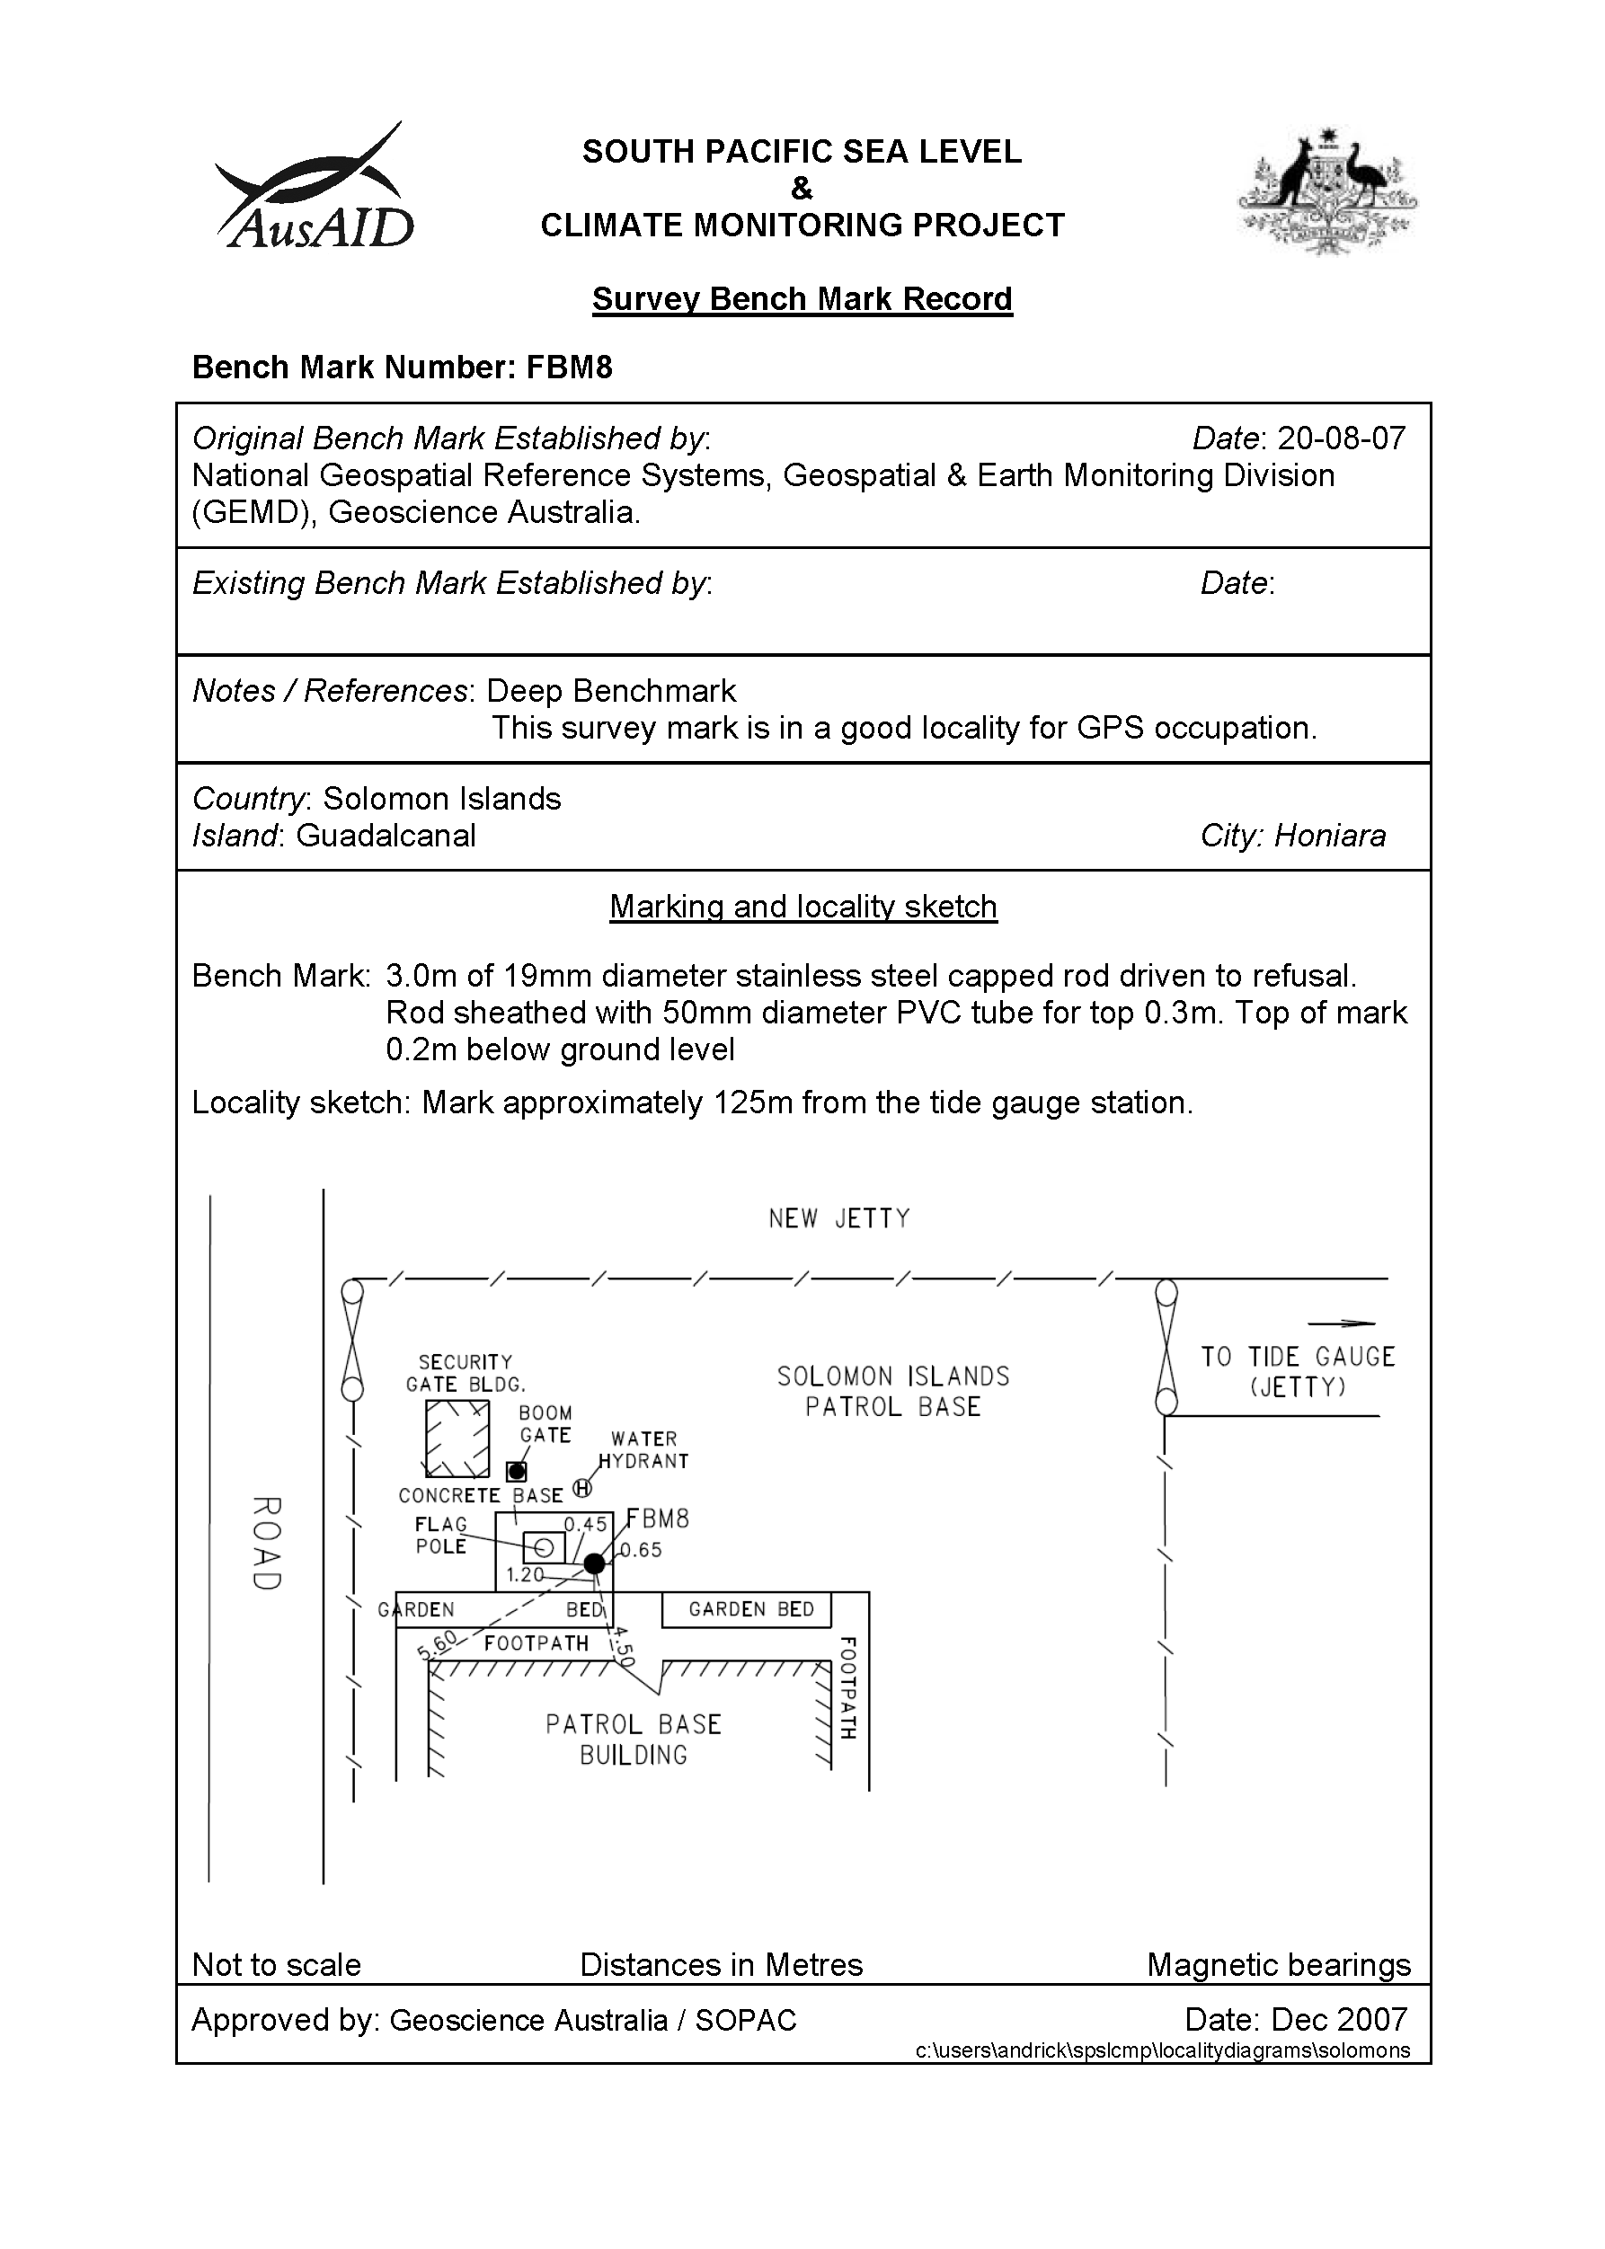

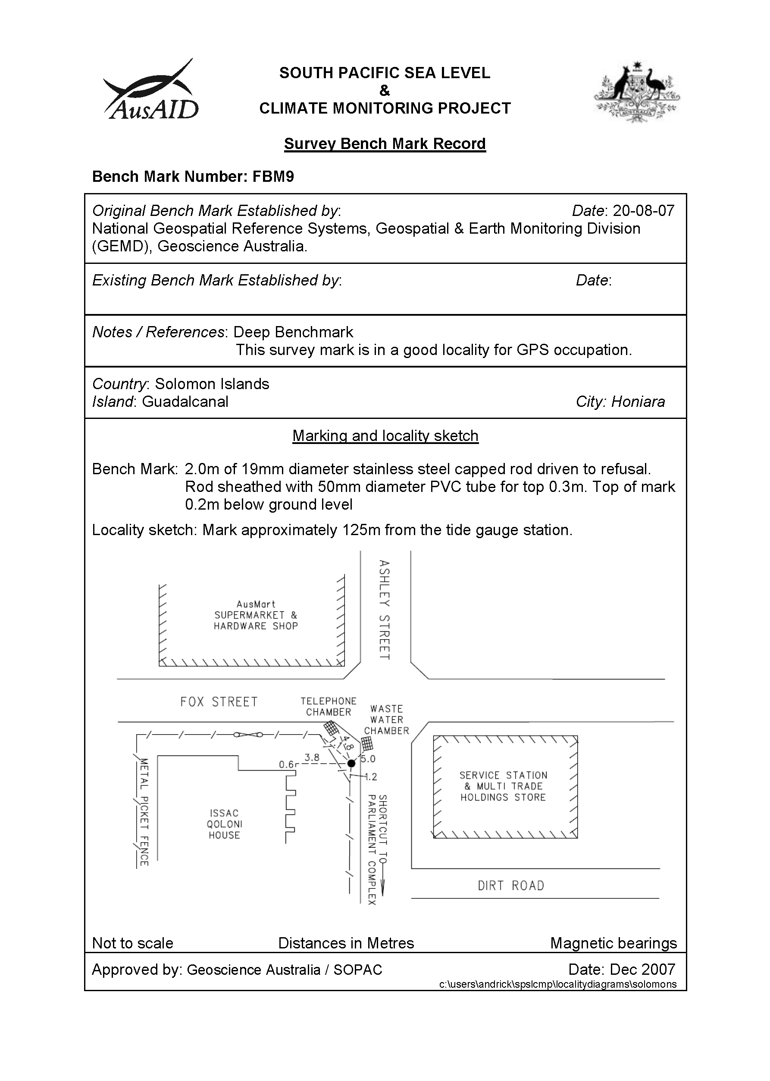

# Solomon Island Reference Mark Locality Diagram

Due to the complexity of this figure no alternative description has been provided. Please email Geoscience Australia at clientservices@ga.gov.au for an alternate description.

# Temporary Holding Mark Locality Diagrams

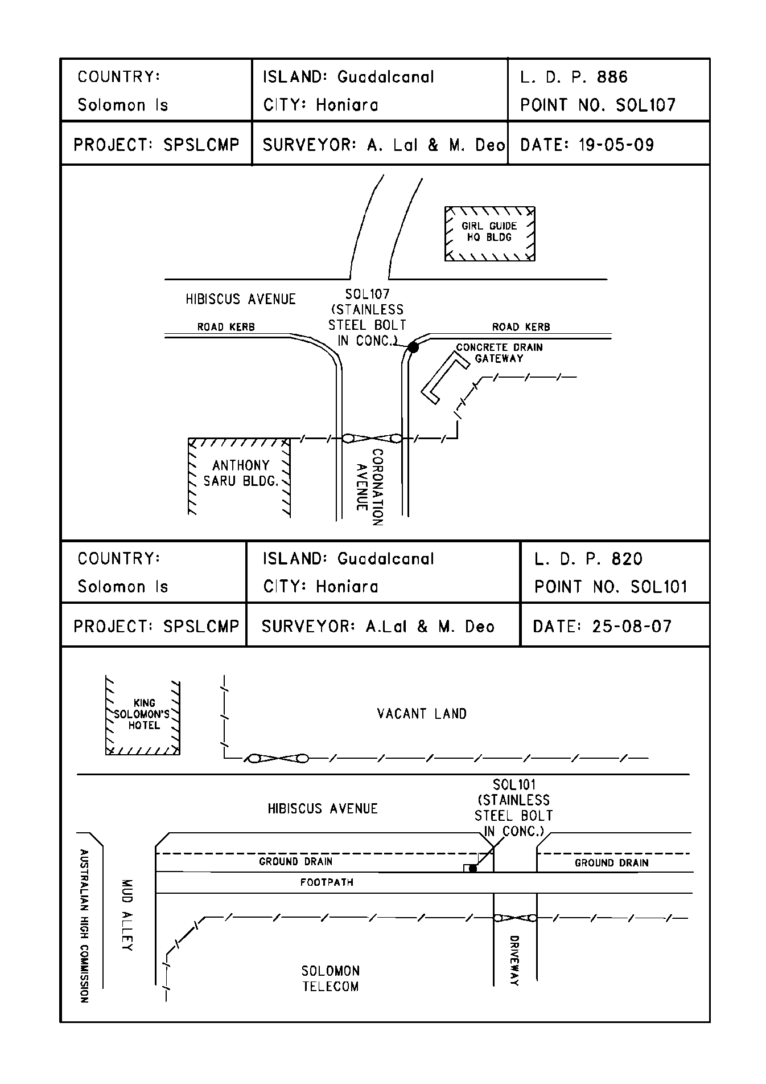

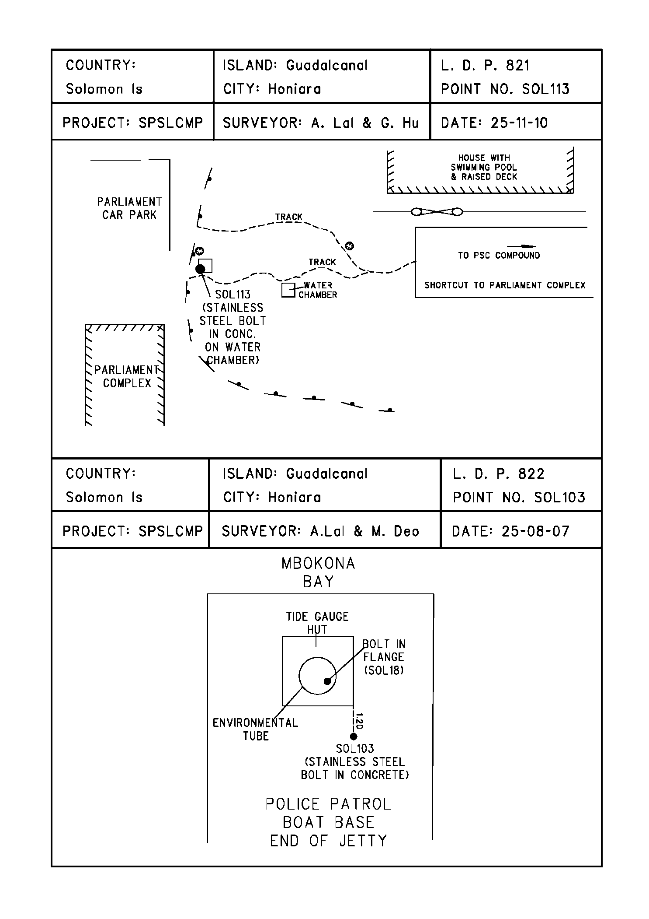

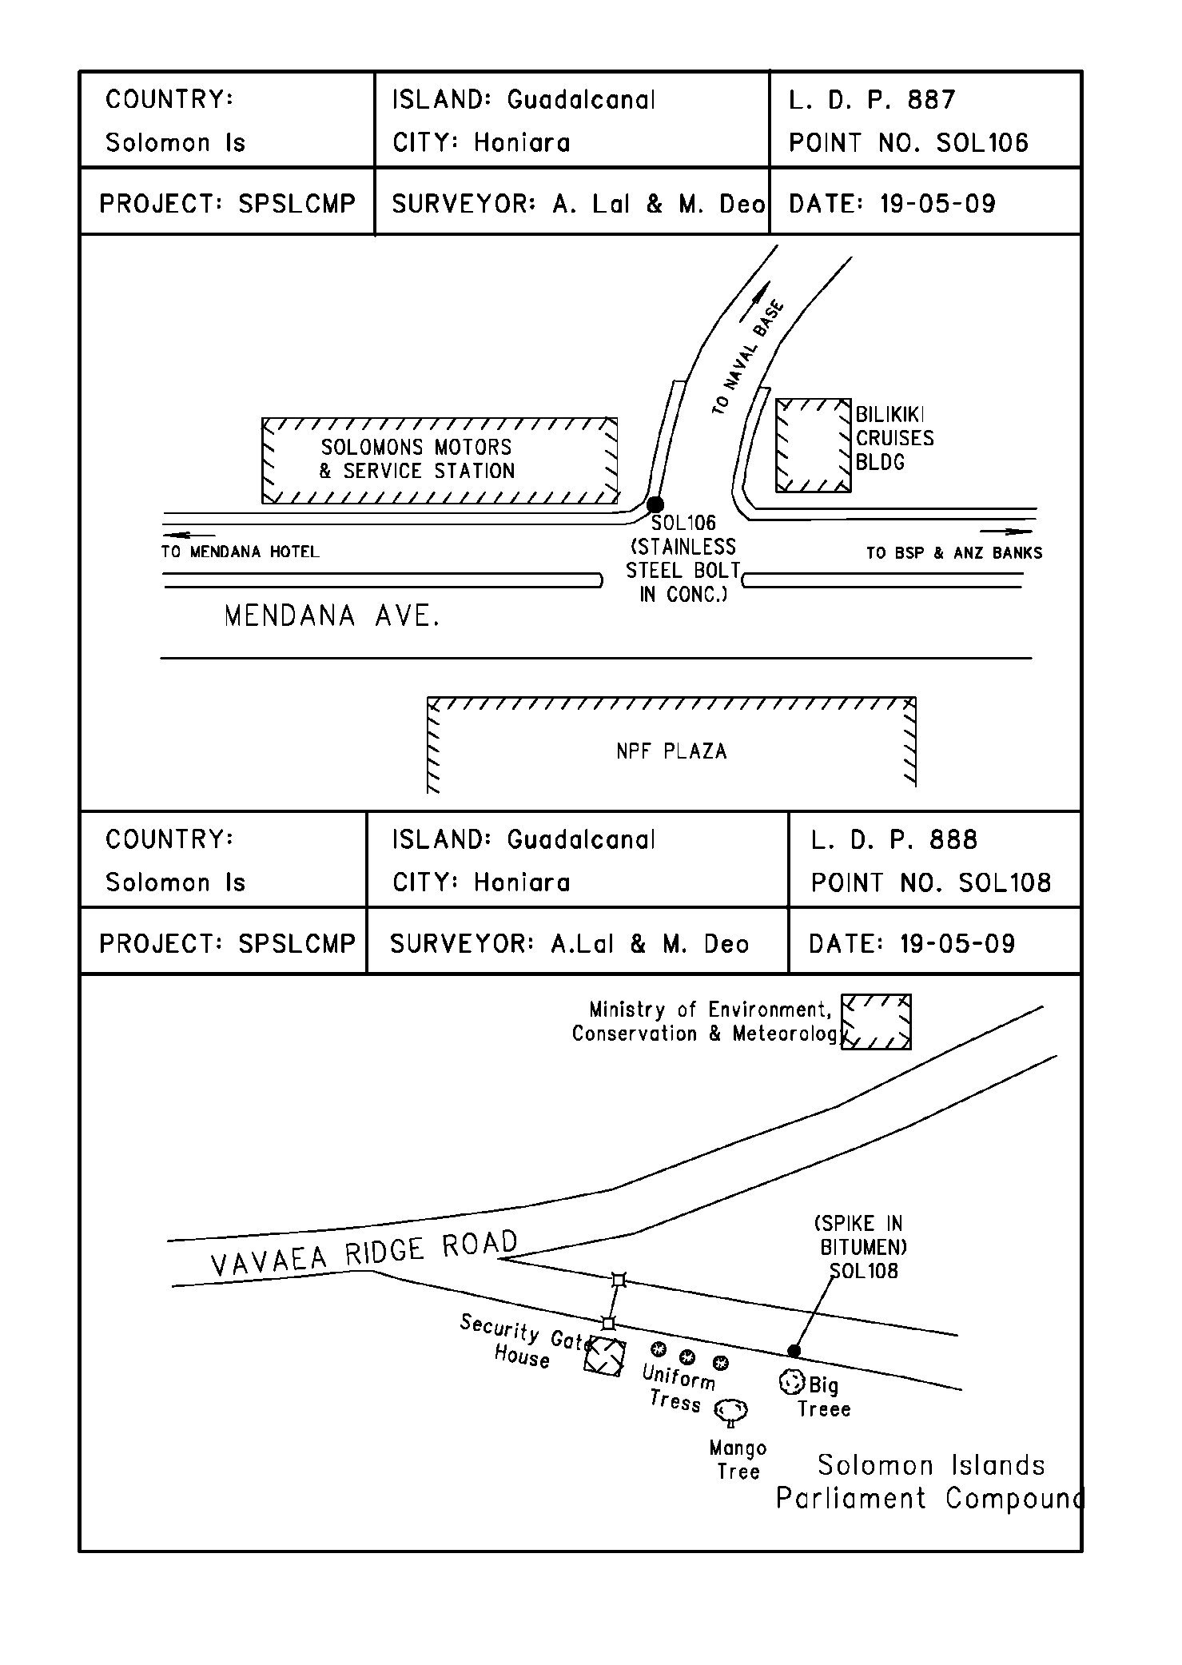

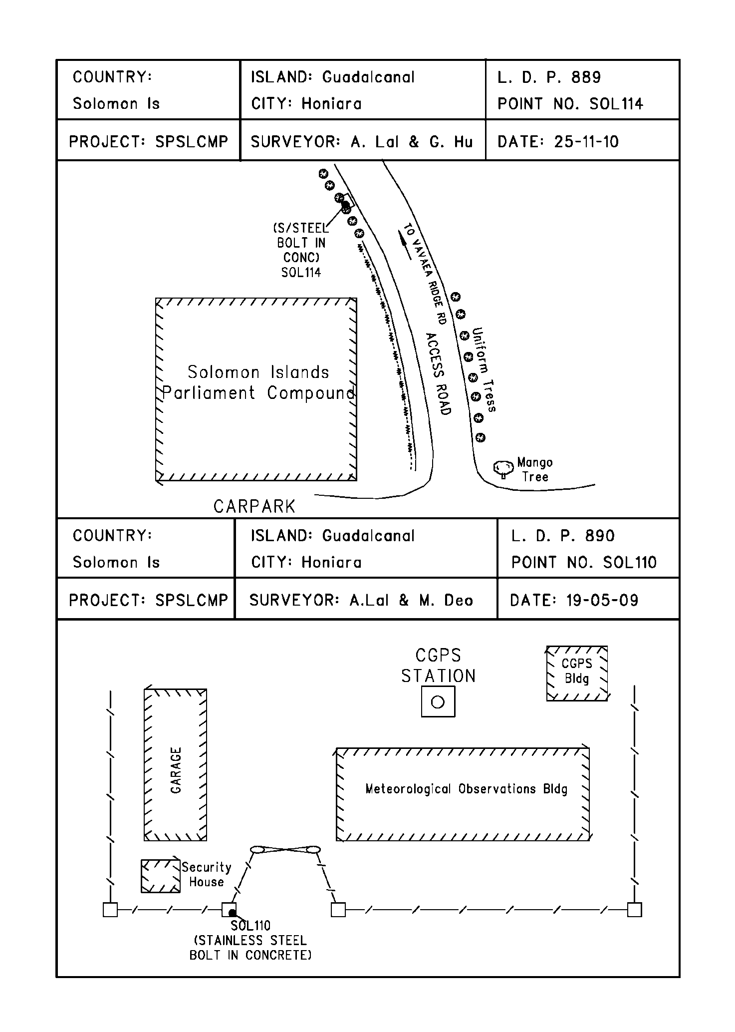

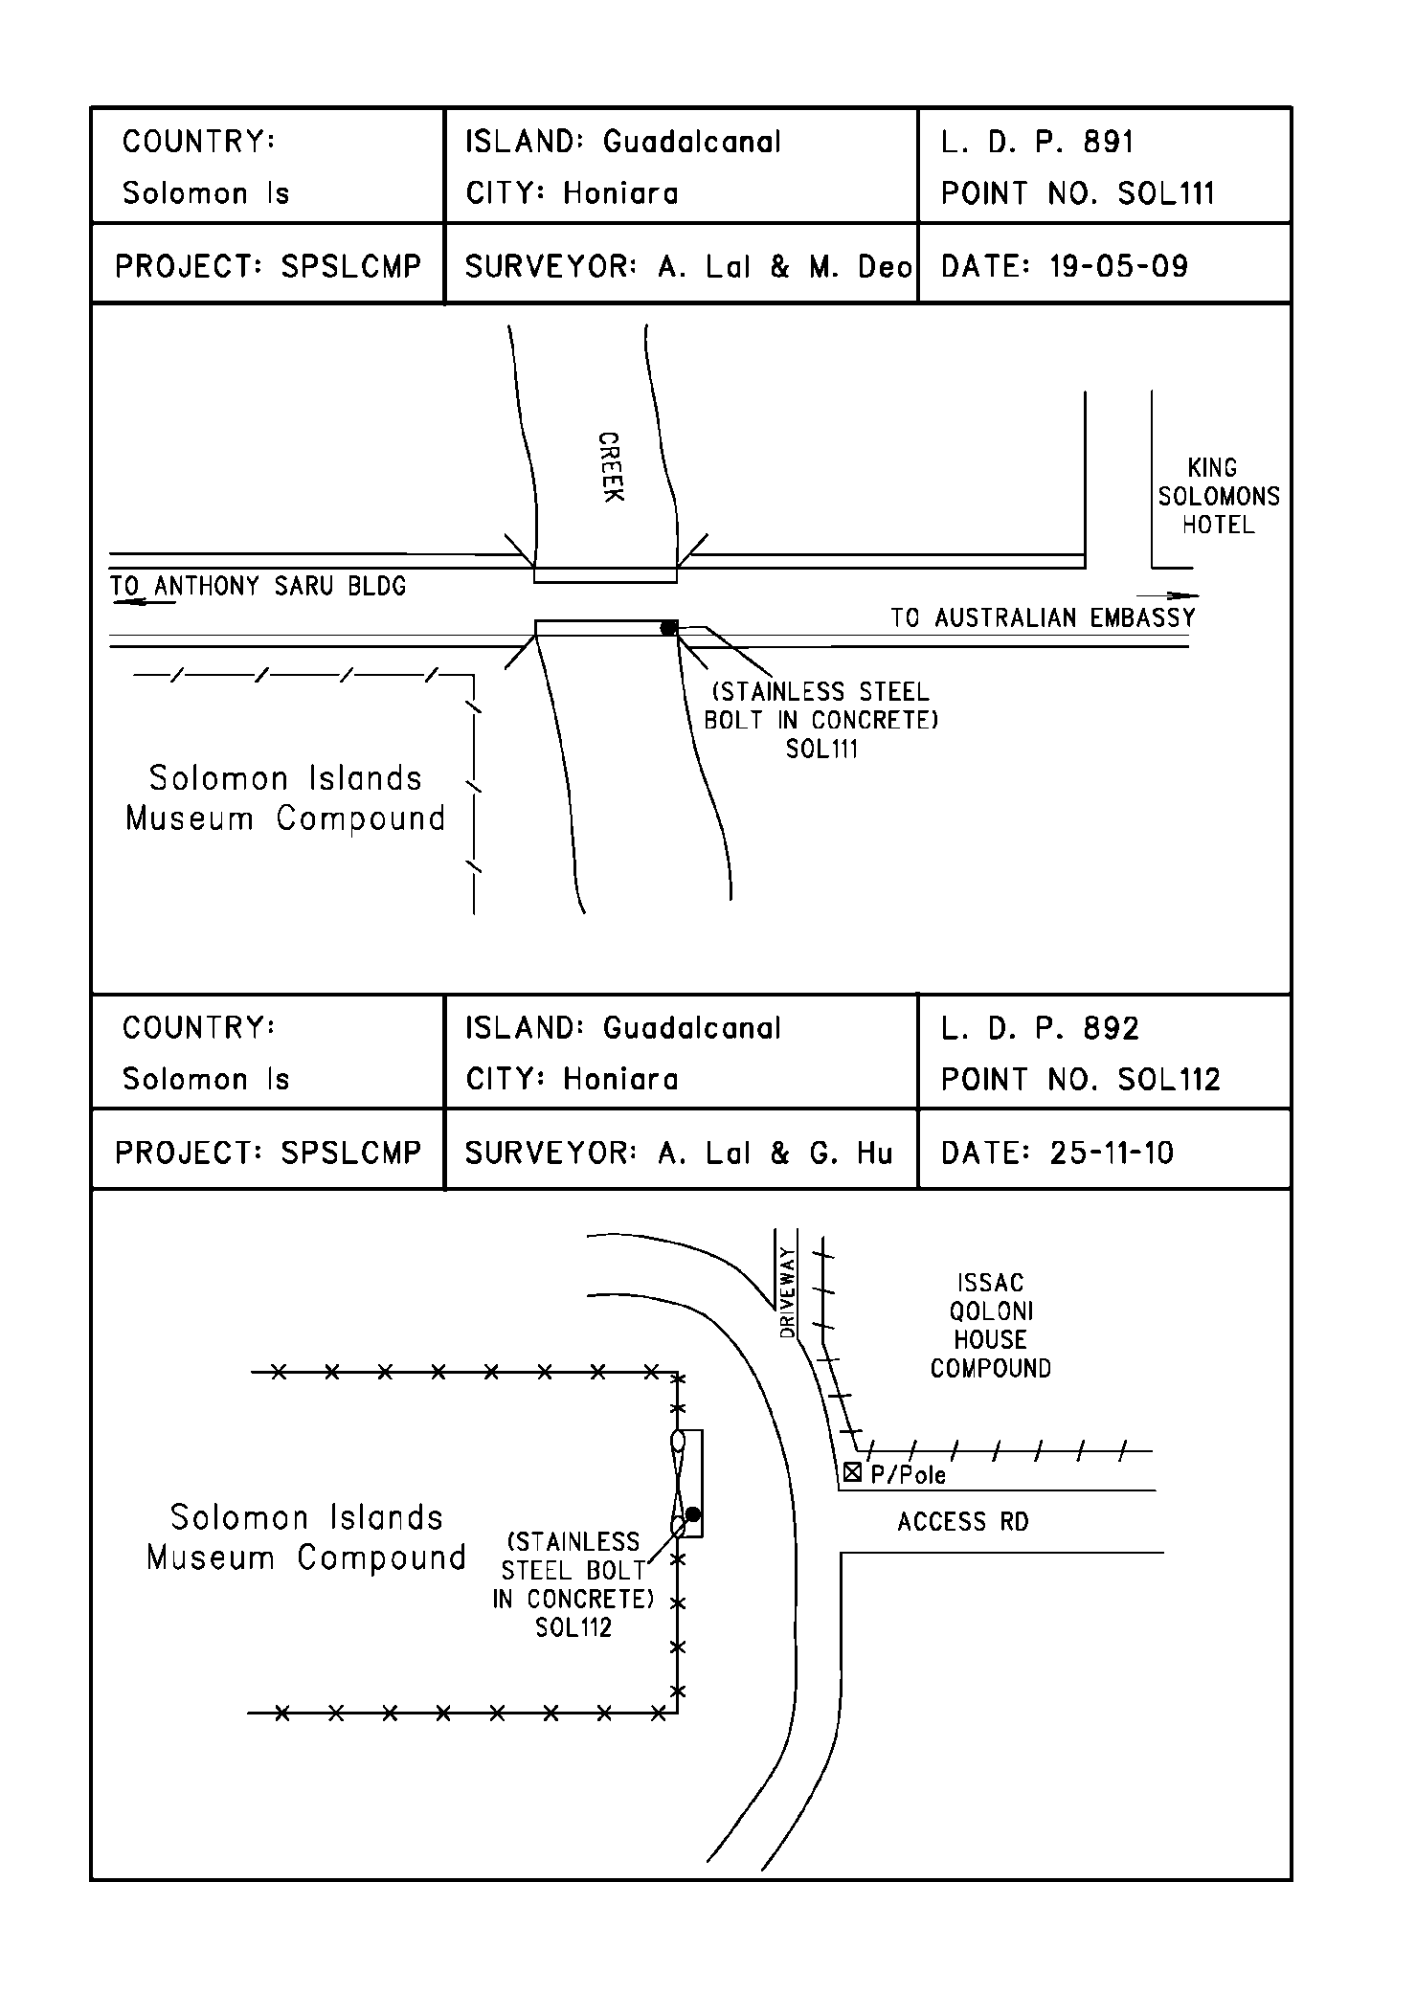

# References

Rüeger, J.M. & Brunner, F.K. 1982, ‘EDM Height Traversing versus Geodetic Levelling’, The Canadian Surveyor, vol. 36, no. 1, pp. 69-87.

Inter-Government Committee on Surveying and Mapping (ICSM) 2002, Standards and Practices for Control Surveys, SP1, Ver. 1.5, May 2002.