EDM Height Traversing Levelling Survey Report

Honiara, Solomon Islands, June 2013

Geoscience Australia  
Record 2014/27

S. J. K. Yates1, A. Lal2



1. National Geospatial Reference Systems, Geospatial and Earth Monitoring Division, Geoscience Australia GPO Box 378 Canberra ACT 2601
2. Secretariat of the Pacific Community (SPC)

Department of Industry

Minister for Industry: The Hon Ian Macfarlane MP  
Parliamentary Secretary: The Hon Bob Baldwin MP  
Secretary: Ms Glenys Beauchamp PSM

Geoscience Australia

Chief Executive Officer: Dr Chris Pigram  
This paper is published with the permission of the CEO, Geoscience Australia



© Commonwealth of Australia (Geoscience Australia) 2014

With the exception of the Commonwealth Coat of Arms and where otherwise noted, all material in this publication is provided under a Creative Commons Attribution 3.0 Australia Licence. (<http://www.creativecommons.org/licenses/by/3.0/au/deed.en>)

Geoscience Australia has tried to make the information in this product as accurate as possible. However, it does not guarantee that the information is totally accurate or complete. Therefore, you should not solely rely on this information when making a commercial decision.

Geoscience Australia is committed to providing web accessible content wherever possible. If you are having difficulties with accessing this document please email [clientservices@ga.gov.au](mailto:clientservices@ga.gov.au).

ISSN 2201-702X (PDF)

ISBN 978-1-925124-16-3 (PDF)

GeoCat 76791

Bibliographic reference: Yates, S. J. K. & Lal, A., 2014, EDM Height Traversing Levelling Survey Report: Honiara, Solomon Islands, June 2013. Record 2014/27. Geoscience Australia, Canberra. <http://dx.doi.org/10.11636/Record.2014.027>

Contents

1 Introduction 1

2 The Survey 2

2.1 Bench Mark Locality Diagram 3

2.2 The Solomon Islands Datum 3

2.3 Equipment 3

2.4 Method 4

2.5 Solomon Islands 2013 Reduced Levels 4

2.6 Survey Support 5

2.7 Issues 5

3 Comparisons 6

3.1 Comparisons between 2013 and 2012 EDM Surveys 6

3.2 Combined Comparisons 1994 to 2013 7

3.3 Time Series of Bench Mark Movement 8

4 Deep Bench Mark Locality Diagrams 12

5 Reference Mark Locality Diagram 17

6 Temporary Holding Marks Locality Diagrams 18

7 References 23

# Introduction

This report outlines the high precision level survey completed between the Sea Level Fine Resolution Acoustic Measuring Equipment (SEAFRAME) Tide Gauge Station and the Continuous Global Navigation Satellite Systems (CGNSS) Station in Honiara, Solomon Islands from 22nd to 27th June 2013.

Personnel involved in the survey were Steve Yates, Surveyor, Geoscience Australia and Andrick Lal, Surveyor, Secretariat of the Pacific Community (SPC).

The Electronic Distance Measuring (EDM) height traversing levelling technique was employed to observe differences in height between the deep bench mark survey arrays in Honiara, which runs approximately 1.2 km from the tide gauge sensor benchmark to the CGNSS Pillar Benchmark. Previous levelling surveys have been conducted along the route using this technique in 2007, 2009, 2010 and 2012.

In addition, precise differential levelling surveys were performed along the deep bench mark (BM) array from 1994 to 1999 by the National Tidal Centre Australia (NTCA). This report contains a comparison between the 2013 and 2012 EDM height traversing results as well as a combined comparison since the first levelling survey in 1994.

# The Survey

The EDM height traversing levelling survey was carried out between the SEAFRAME tide gauge sensor, the CGNSS station and the deep driven bench marks:

SOLOBM – Level reference bench mark for the CGNSS pillar

SOL103 – SEAFRAME Project Bench Mark

SOL18 – SEAFRAME Project Sensor Bench Mark

FBM1 – Local Bench Mark

FBM3 – Deep Driven Bench Mark

FBM4 – Deep Driven Bench Mark

FBM8 – Deep Driven Bench Mark

FBM9 – Deep Driven Bench Mark

SOLO – CGNSS reference point

SOLO RM1 – CGNSS reference mark

SOLO RM2 – CGNSS reference mark

SOLO RM3 – CGNSS reference mark

Most of the deep bench marks were located and found in good order and undisturbed. FBM2 (Deep Driven Bench Mark) was found destroyed in 2012 and therefore was not levelled to. Also included in the survey were temporary holding marks SOL103, SOL106, SOL107, SOL108, SOL110, SOL111, SOL112, SOL113 and SOL114. FBM1 (a local Lands and Survey Bench Mark) was found to be inaccessible.

The EDM height traversing levelling technique was performed to the Class L2A specifications (ICSM, Standards and Practices for Control Surveys). After reduction an internal precision of 1mm√K or better was achieved (zero order); well within the specifications of the project which is 2√K where K is the distance in kilometres. A table of results and comparisons with the 2013 reduced levels are detailed later in this report.

## Bench Mark Locality Diagram

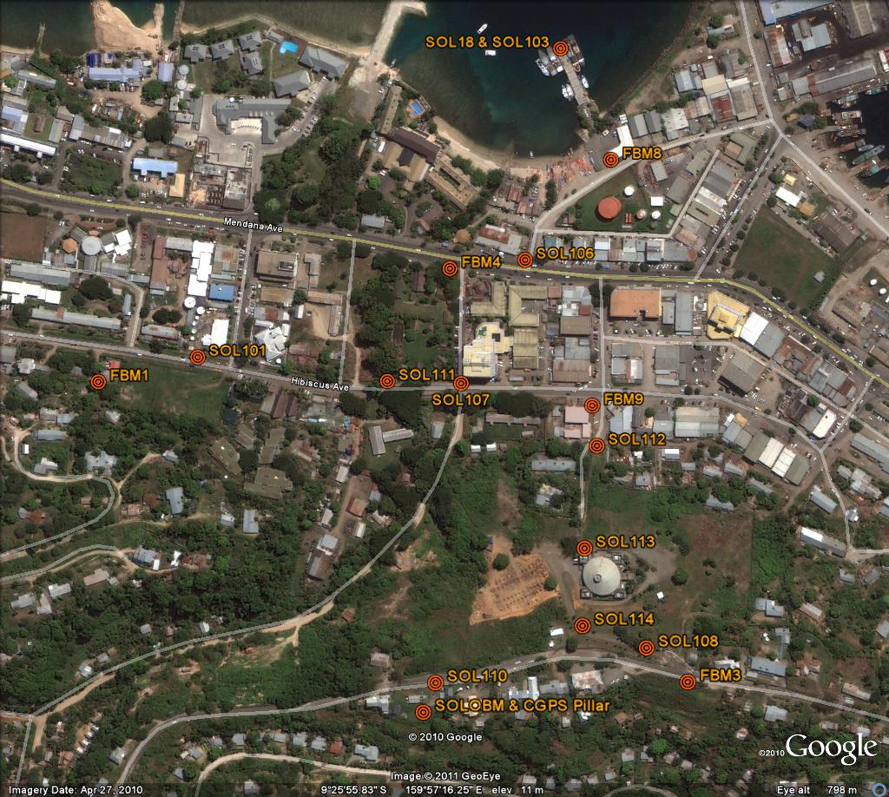

## The Solomon Islands Datum

The Datum for the survey is Mean Sea Level.

Reduction of the data has been calculated holding FBM4 fixed at 3.61966 metres, this value was determined by the National Tidal Centre Australia in July 1994.

The reference point for this survey is FBM4 derived in 1994 by adopting the height of FBM1 (local Bench Mark) RL = 6.386 metres (MSL)

## Equipment

* Leica total station model TM30 (Serial No: 361441)
* Leica precision prisms GPH1P (2).
* Leica rigid tripod.
* Stainless steel target poles supported by Leica telescopic bi-poles (2).
* Shortened stainless steel target pole for the SEAFRAME sensor BM connection.
* Leica cast iron change plates (2).
* Kestral 4000 pocket weather tracker

## Method

The “Leap-Frog” EDM height traversing technique was employed for the Honiara tide gauge levelling survey. This technique involves setting up a total station (TCA1800L) midway between two target/reflectors (on reflector rods with struts). The targets remain at a particular change point for the back-sight and fore-sight observations. The instrument measures slope distances (±1mm) and vertical angle (1”) to derive height differences (between the instrument’s trunnion axis and the reflectors). In support of the slope distance observations, the ambient temperature, pressure and humidity are recorded (Kestral 4000 pocket weather tracker) and input into the instrument to apply the first velocity correction to the observed distances (Rüeger & Brunner, 1982). Four rounds of observations are taken to the back-sight and fore-sight targets from each instrument setup. All levelling runs started and finished with the same reflector and reflector rod, i.e. an even number of setups when the two reflector rod configuration was used. This eliminates any reflector rod zero error. This technique can also be performed using a single set-up / single rod configuration which is particularly useful when levelling between bench marks which are close together e.g. between the CGNSS RMs.

Reduction of the digital data was computed by the Geoscience Australia levelling program “leveling1.exe”. This program computes the height difference between the two reflectors.

## Solomon Islands 2013 Reduced Levels

Table 2.1 Honiara, Solomon Islands – Reduced levels and heights difference relative to FBM4.  
Date: 22 to 29 June 2013  
Datum: Mean Sea Level

| Point ID | Reduced Level 2013 | Type |
| --- | --- | --- |
| FBM4 | 3.6197 | Stainless Steel Rod in Ground |
| SOL106 | 3.2065 | Stainless Steel Pin in Concrete |
| FBM8 | 1.9616 | Stainless Steel Rod in Ground |
| SOL103 | 2.3065 | Stainless Steel Pin in Concrete |
| SOL18 | 3.5697 | Stainless Steel Pin |
| SOL107 | 4.9987 | Stainless Steel Pin in Concrete |
| FBM9 | 4.7507 | Stainless Steel Rod in Ground |
| SOL112 | 6.2180 | Stainless Steel Pin in Concrete |
| SOL113 | 31.3015 | Stainless Steel Pin in Concrete |
| SOL114 | 45.6951 | Stainless Steel Pin in Concrete |
| SOL108 | 50.3082 | Spike in Bitumen |
| FBM3 | 54.0469 | Stainless Steel Rod in Ground |
| SOL110 | 54.0877 | Stainless Steel Pin in Concrete |
| SOLOBM | 54.3134 | Stainless Steel Pillar Pin |
| SOLO RM1 | 54.2449 | Stainless Steel Rod in Ground |
| SOLO RM2 | 53.0183 | Stainless Steel Rod in Ground |
| SOLO RM3 | 53.7558 | Stainless Steel Rod in Ground |

## Survey Support

The survey team very much appreciated the survey from the Solomon Islands Meteorological Service, especially field assistance from Mr. David Tapiei. All the staff from the Solomon Islands Meteorological Service has developed a keen interest in the PSLMP project and is always eager to provide assistance when required.

The Regional Office of the Secretariat of the Pacific Islands Community (SPC) in Honiara provide valuable logistics support for clearance of project survey equipment from the Customs Authority namely; Ms Mia Ramon, Coordinator and Ms Naomi Tagi, Office Assistant for the SPC Regional Office.

## Issues

Prior approval needs to be taken to access the following survey benchmarks;

Tide Gauge Station and Deep Driven Bench Mark, FBM8 – Naval Patrol Base

The fixed deep driven benchmark, FBM4 is now within the locked compound of the National Museum and due to the heavy traffic, the level run to SOL106 across the road is best attempted early on a Sunday morning, a prior arrangement should be discussed with the National Museum’s director to gain early morning access. It is also recommended the tide gauge half-metre pole should be setup on the FBM4 so that visibility through the galvanised iron fence can be attained.

CGNSS Station – Solomon Islands Meteorological Department

As a matter of courtesy, prior approval should be made for access to the survey array from deep driven bench mark FBM9 to FBM3. This survey array runs across the national parliament complex building compound.

# Comparisons

## Comparisons between 2013 and 2012 EDM Surveys

Table 3. Honiara, Solomon Islands 2013 EDM Height Traversing Levelling & Comparison 2013 - 2012. FBM4 - adopted fixed height of 3.61966m

| From | To | Levelled Ht. Diff. | RL 2013 | Misclose (mm) | Dist. (km) | 1mm√k | RL 2012 | Difference (mm) 2013 - 2012 |
| --- | --- | --- | --- | --- | --- | --- | --- | --- |
| FBM4 |  |  | 3.61966 |  |  |  |  |  |
| SOL106 | SOL106 | -0.41314 | 3.20653 | -0.008 | 0.094 | 0.306 | 3.2058 | 0.73 |
| FBM8 | FBM8 | -1.24493 | 1.96160 | -0.258 | 0.136 | 0.368 | 1.9618 | -0.20 |
| SOL103 | SOL103 | 0.34493 | 2.30653 | -0.217 | 0.124 | 0.352 | 2.3062 | 0.33 |
|  | SOL18 | 1.26315 | 3.56968 | 0.020 | 0.014 | 0.120 | 3.5691 | 0.58 |
| FBM4 |  |  | 3.61966 |  |  |  |  |  |
| SOL107 | SOL107 | 1.37903 | 4.99869 | -0.013 | 0.116 | 0.341 | 4.9991 | -0.42 |
| FBM9 | FBM9 | -0.24801 | 4.75068 | 0.380 | 0.149 | 0.387 | 4.7496 | 1.08 |
| SOL112 | SOL112 | 1.46736 | 6.21803 | -0.033 | 0.046 | 0.214 | 6.2187 | -0.67 |
| SOL113 | SOL113 | 25.08343 | 31.30146 | 0.144 | 0.100 | 0.315 | 31.3094 | -7.94 |
| SOL114 | SOL114 | 14.39366 | 45.69512 | 0.025 | 0.087 | 0.295 | 45.7060 | -10.88 |
| SOL108 | SOL108 | 4.61306 | 50.30818 | 0.063 | 0.059 | 0.243 | 50.3078 | 0.38 |
|  | FBM3 | 3.73872 | 54.04690 | -0.169 | 0.070 | 0.264 | 54.0479 | -1.00 |
| SOL114 |  |  | 45.69512 |  |  |  |  |  |
| SOL110 | SOL110 | 8.39260 | 54.08772 | -0.395 | 0.159 | 0.399 | 54.0876 | 0.12 |
|  | SOLOBM | 0.22567 | 54.31339 | 0.133 | 0.035 | 0.186 | 54.3113 | 2.09 |
|  |  |  | Misclose for all bays levelled = | -0.328 | 1.188 | 1.090 |  |  |
| SOLOBM |  |  | 54.31339 |  |  |  |  |  |
|  | RM1 | -0.06852 | 54.24487 | -0.025 | 0.027 | 0.164 | 54.2425 | 2.37 |
| SOLOBM |  |  | 54.31339 |  |  |  |  |  |
|  | RM2 | -1.29506 | 53.01833 | -0.044 | 0.032 | 0.180 | 53.0162 | 2.13 |
| SOLOBM |  |  | 54.31339 |  |  |  |  |  |
|  | RM3 | -0.55761 | 53.75578 | -0.031 | 0.028 | 0.166 | 53.7538 | 1.98 |

All levelling was performed within the project specifications of 2√k

## Combined Comparisons 1994 to 2013

Table 3. Honiara, Solomon Islands - Comparison of the RL's for Precise Differential Levelling (1994-1999) and EDM Height Traversing (2007 - 2013).

| Year | FBM1 | FBM2 | FBM3 | SOL18 | SOL103 | FBM8 | FBM9 | SOLOBM | *SOLO |
| --- | --- | --- | --- | --- | --- | --- | --- | --- | --- |
| 1994.7 | 6.386 | 3.3171 | 54.046 | 3.5755 |  |  |  |  |  |
| 1996.2 | 6.3848 | 3.3175 | 54.0457 | 3.5758 |  |  |  |  |  |
| 1997.7 | 6.3857 | 3.3182 | 54.0449 | 3.5741 |  |  |  |  |  |
| 1999.3 | 6.3856 | 3.3161 | 54.0444 | 3.5742 |  |  |  |  |  |
| 2007.7 | 6.3866 | 3.3177 | 54.0467 | 3.572 | 2.3093 | 1.9626 | 4.75 | 54.3111 | 55.7756 |
| 2009.4 | 6.3863 |  | 54.0485 | 3.5718 | 2.3085 | 1.9626 | 4.7502 | 54.3134 | 55.7801 |
| 2010.9 | 6.3868 |  | 54.0467 | 3.5707 | 2.3078 | 1.962 | 4.75 | 54.3032 | 55.7678 |
| 2012.2 |  |  | 54.0479 | 3.5691 | 2.3062 | 1.9618 | 4.7496 | 54.3113 | 55.7759 |
| 2013.5 |  |  | 54.0469 | 3.5697 | 2.3065 | 1.9616 | 4.7507 | 54.3134 | 55.7780 |

*The RL of the Reference Point SOLO (ARP) is derived from adding the static height difference from the levelled RL of SOLOBM.

## Time Series of Bench Mark Movement

The purpose of this survey is in two folds: firstly, to provide accurate changes in land height to be used in computations of absolute sea level rise and secondly to provide accurate assessments of relative sea level changes due to localised deformation.

Precise Differential Levelling: 1994 - 1999   
EDM Height Traversing: 2007 onwards

Due to the complexity of this document and the niche scientific target audience, no alternative description has been provided. Please email Geoscience Australia at clientservices@ga.gov.au for an alternative description.

Due to the complexity of this document and the niche scientific target audience, no alternative description has been provided. Please email Geoscience Australia at clientservices@ga.gov.au for an alternative description.

Due to the complexity of this document and the niche scientific target audience, no alternative description has been provided. Please email Geoscience Australia at clientservices@ga.gov.au for an alternative description.

Due to the complexity of this document and the niche scientific target audience, no alternative description has been provided. Please email Geoscience Australia at clientservices@ga.gov.au for an alternative description.

Due to the complexity of this document and the niche scientific target audience, no alternative description has been provided. Please email Geoscience Australia at clientservices@ga.gov.au for an alternative description.

Due to the complexity of this document and the niche scientific target audience, no alternative description has been provided. Please email Geoscience Australia at clientservices@ga.gov.au for an alternative description.

Due to the complexity of this document and the niche scientific target audience, no alternative description has been provided. Please email Geoscience Australia at clientservices@ga.gov.au for an alternative description.

# Deep Bench Mark Locality Diagrams

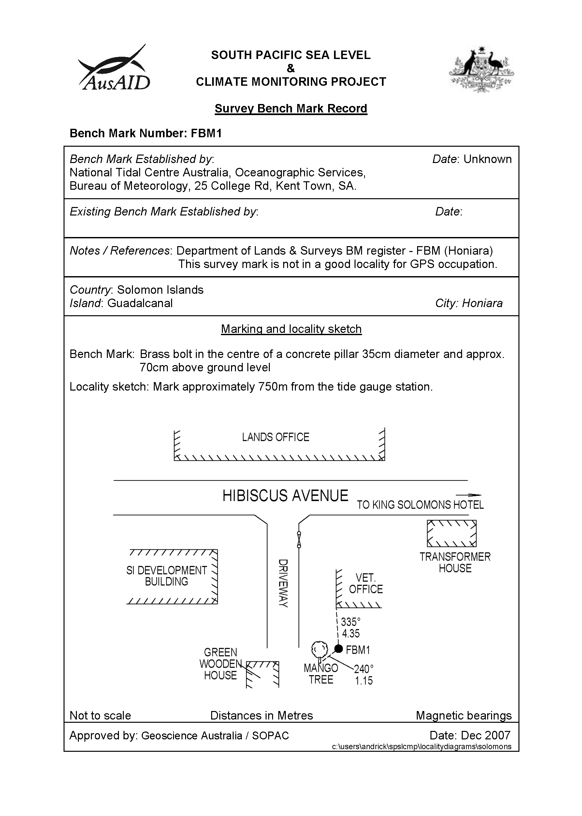

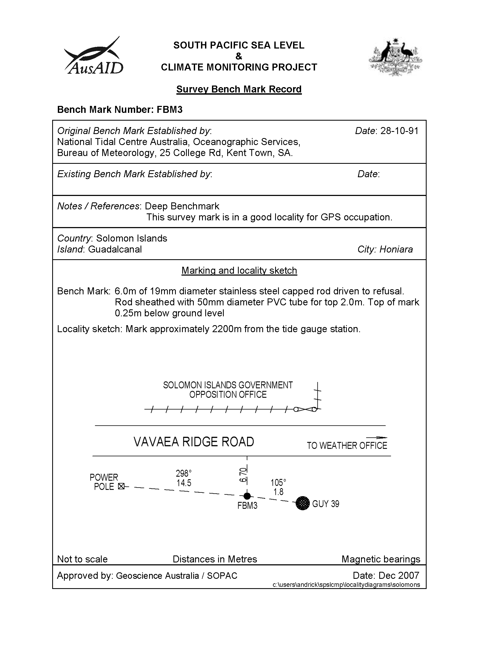

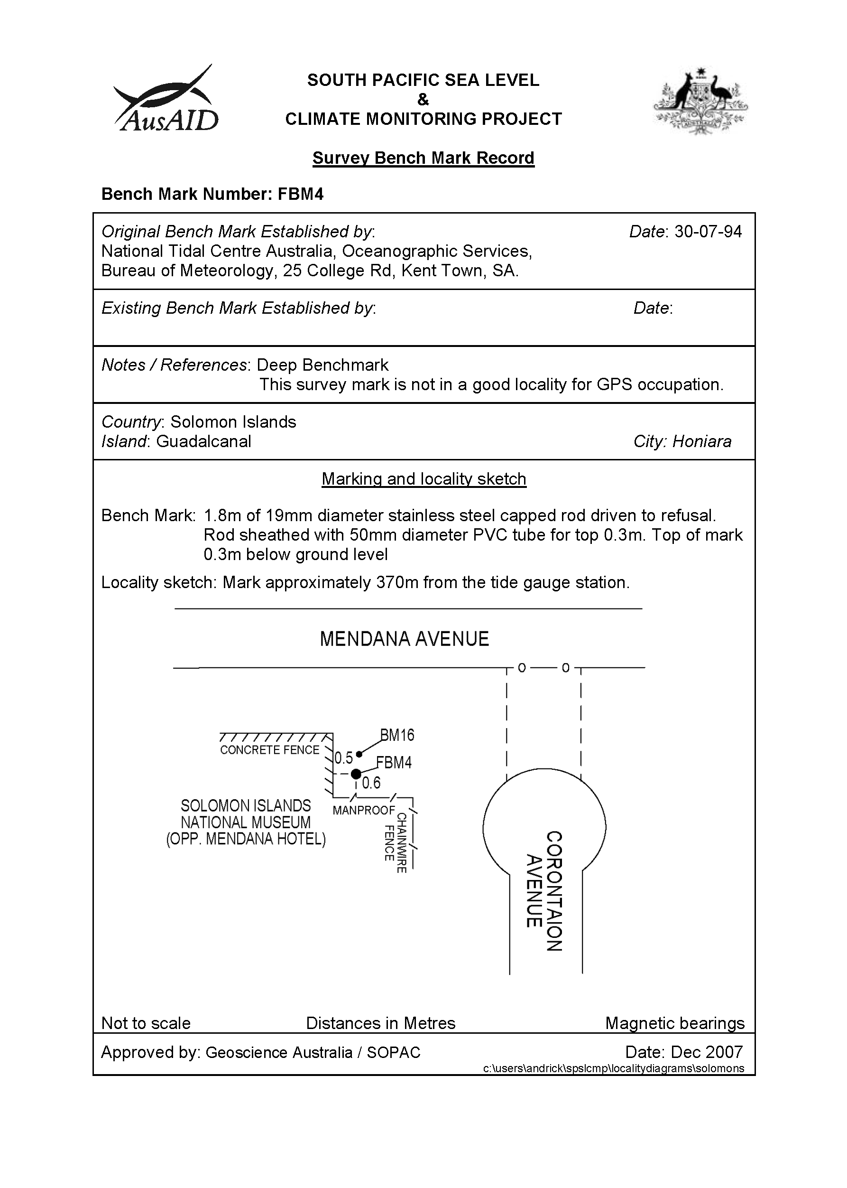

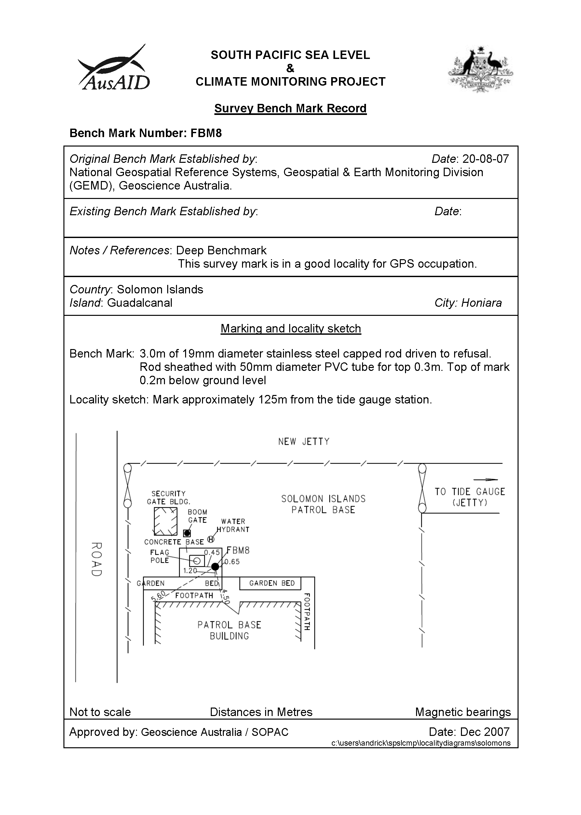

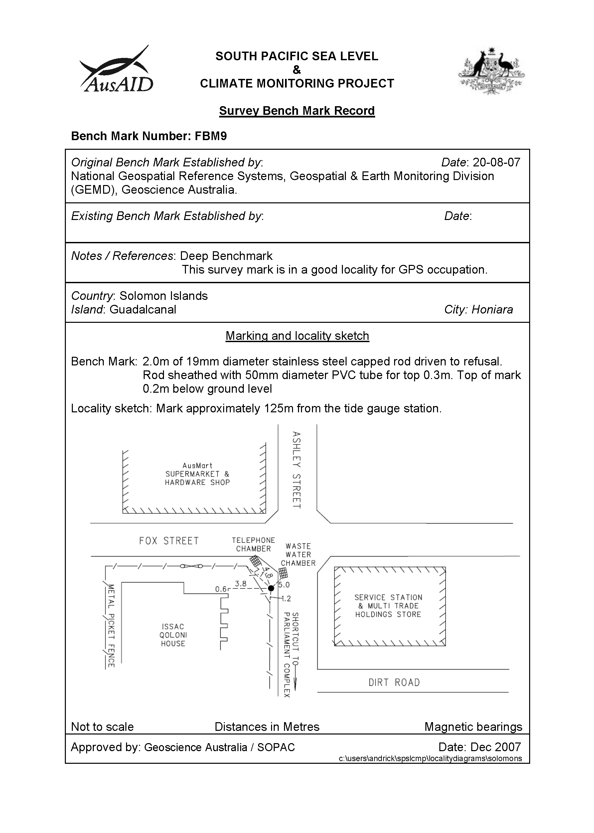

# Reference Mark Locality Diagram

Due to the complexity of this figure no alternative description has been provided. Please email Geoscience Australia at clientservices@ga.gov.au for an alternate description.

# Temporary Holding Marks Locality Diagrams

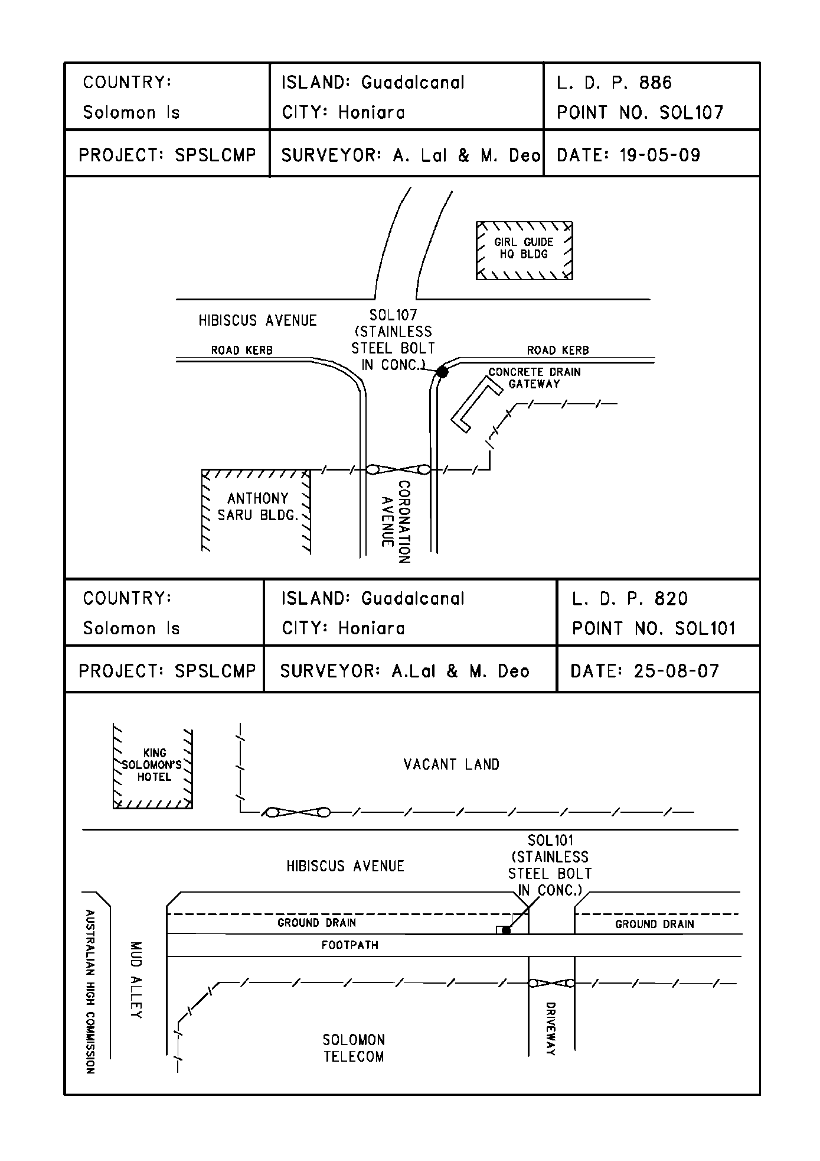

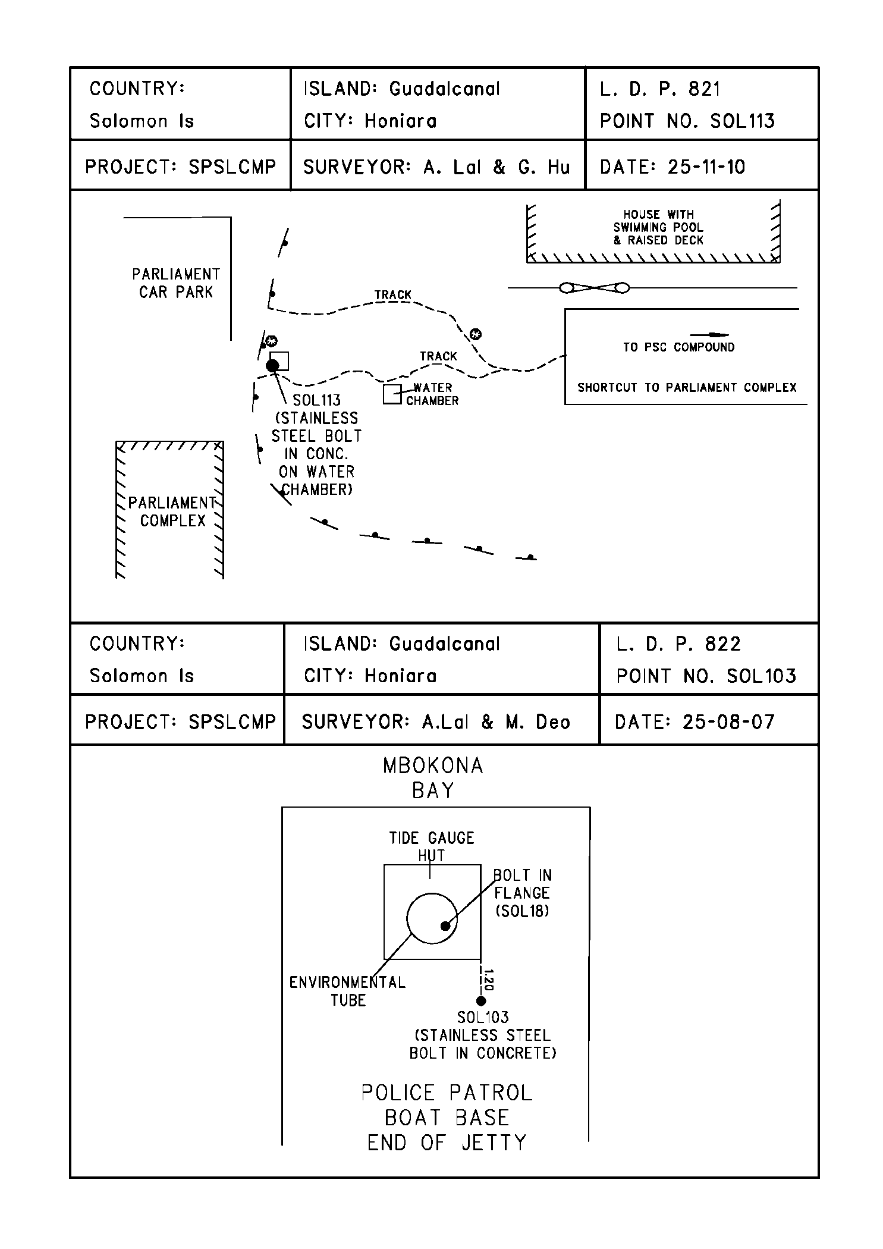

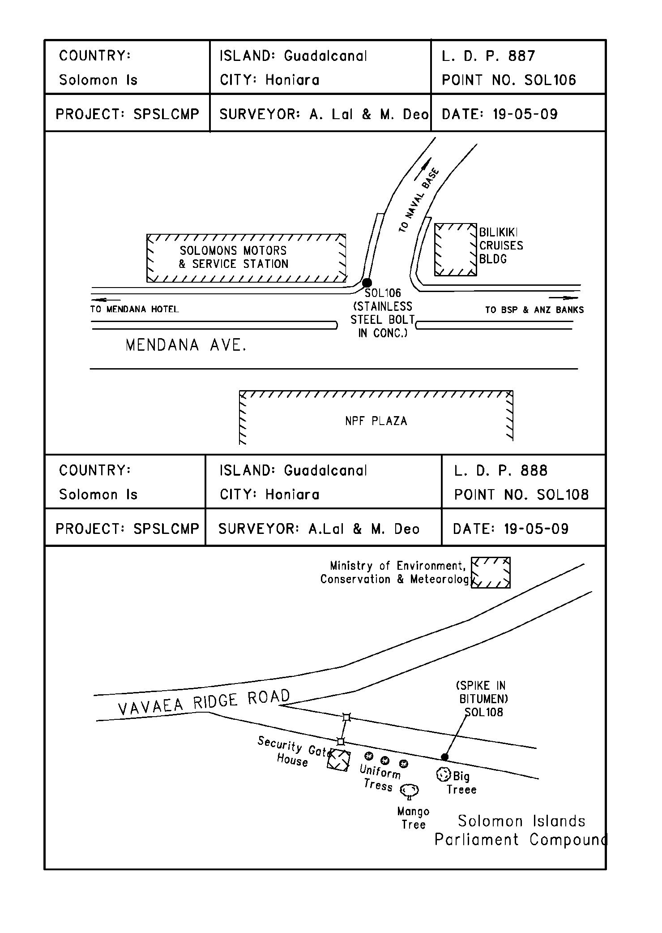

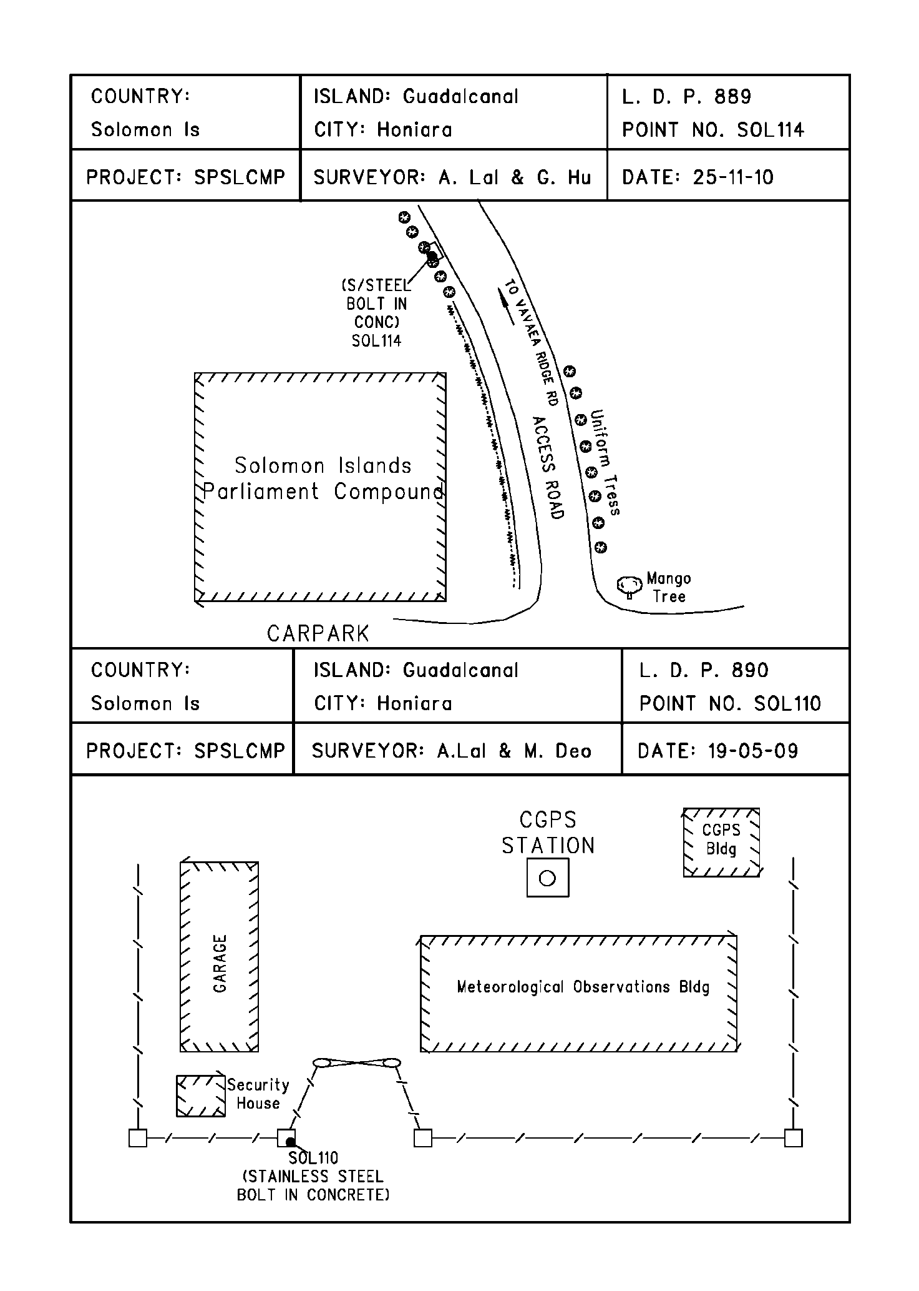

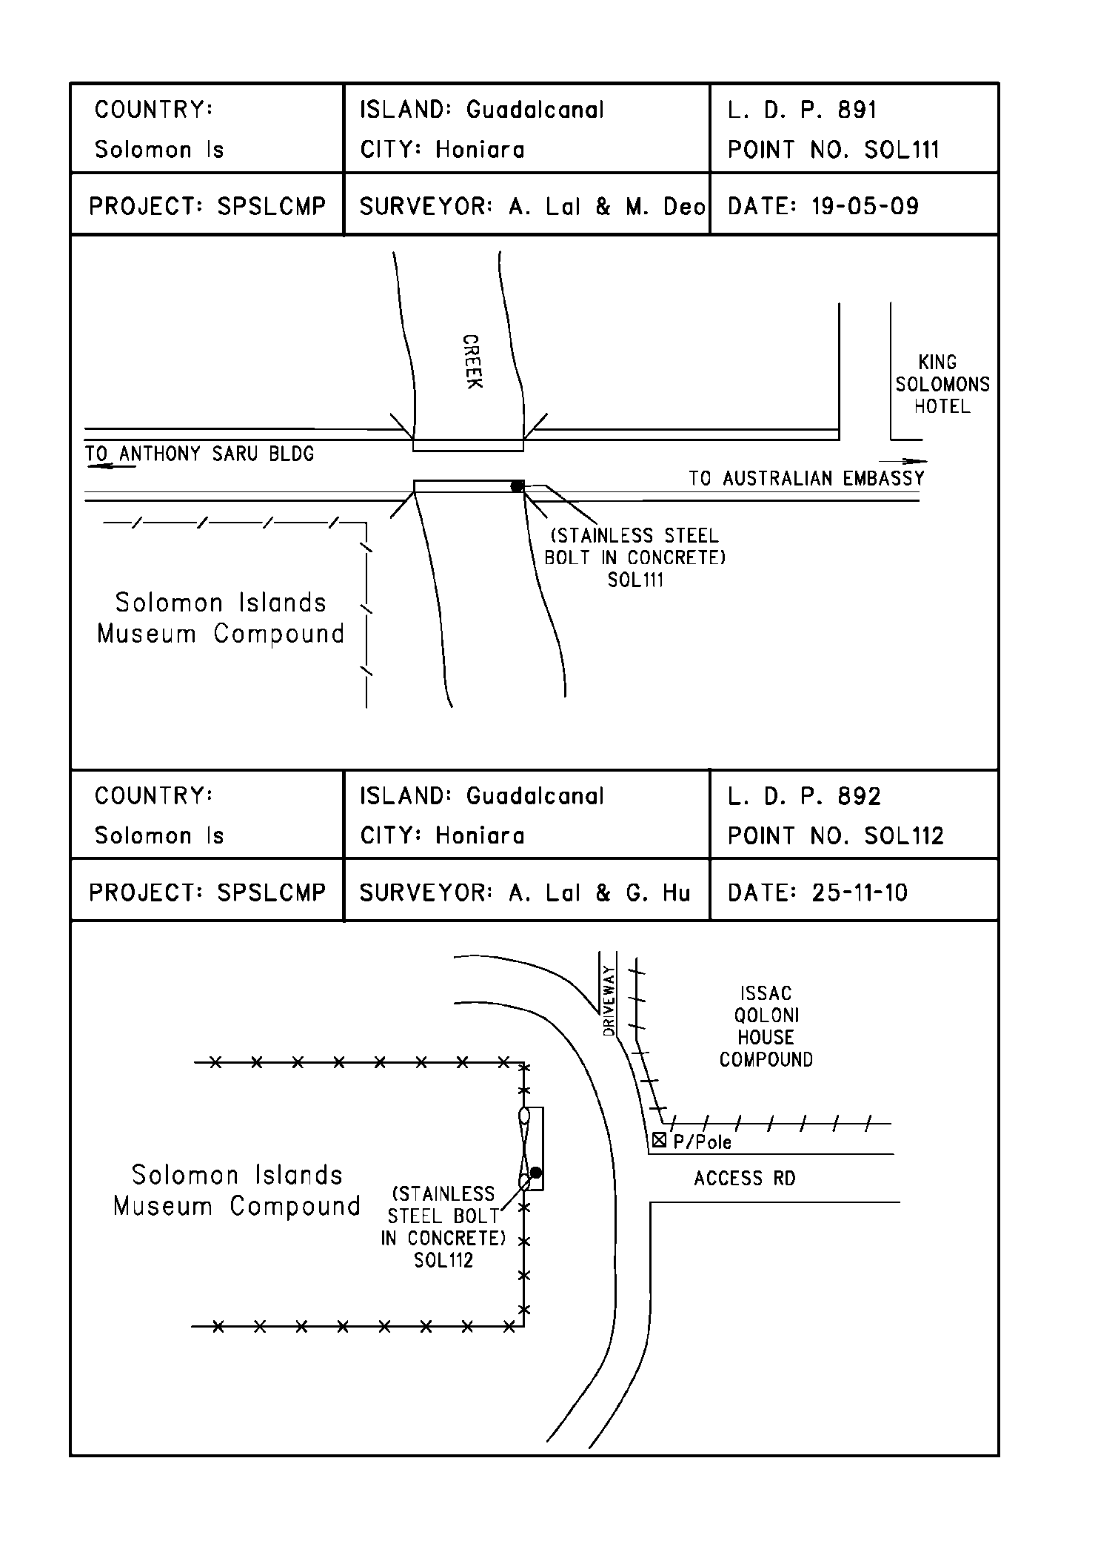

# References

Rüeger, J.M. & Brunner, F.K. 1982, ‘EDM Height Traversing versus Geodetic Levelling’, The Canadian Surveyor, vol. 36, no. 1, pp. 69-87.

Inter-Government Committee on Surveying and Mapping (ICSM) 2002, Standards and Practices for Control Surveys, SP1, Ver. 1.5, May 2002.