EDM Height Traversing Levelling Survey Report

Funafuti, Tuvalu, May 2012

Geoscience Australia  
Record 2014/29

S. J. K. Yates1, A. Lal2



1. National Geospatial Reference Systems, Geospatial and Earth Monitoring Division, Geoscience Australia GPO Box 378 Canberra ACT 2601
2. Secretariat of the Pacific Community (SPC)

Department of Industry

Minister for Industry: The Hon Ian Macfarlane MP  
Parliamentary Secretary: The Hon Bob Baldwin MP  
Secretary: Ms Glenys Beauchamp PSM

Geoscience Australia

Chief Executive Officer: Dr Chris Pigram  
This paper is published with the permission of the CEO, Geoscience Australia



© Commonwealth of Australia (Geoscience Australia) 2014

With the exception of the Commonwealth Coat of Arms and where otherwise noted, all material in this publication is provided under a Creative Commons Attribution 3.0 Australia Licence. (<http://www.creativecommons.org/licenses/by/3.0/au/deed.en>)

Geoscience Australia has tried to make the information in this product as accurate as possible. However, it does not guarantee that the information is totally accurate or complete. Therefore, you should not solely rely on this information when making a commercial decision.

Geoscience Australia is committed to providing web accessible content wherever possible. If you are having difficulties with accessing this document please email [clientservices@ga.gov.au](mailto:clientservices@ga.gov.au).

ISSN 2201-702X (PDF)

ISBN 978-1-925124-18-7 (PDF)

GeoCat 76793

Bibliographic reference: Yates, S. J. K. & Lal, A., 2014, EDM Height Traversing Levelling Survey Report: Funafuti, Tuvalu, May 2012. Record 2014/29. Geoscience Australia, Canberra. <http://dx.doi.org/10.11636/Record.2014.029>

Contents

1 Introduction 1

2 The Survey 2

2.1 Bench Mark Locality Diagram 3

2.2 The Tuvalu Datum 5

2.3 Equipment 5

2.4 Method 5

2.5 Survey Support 6

2.6 Issues 6

2.7 Description of Marks – Funafuti, Tuvalu 6

3 Comparisons 7

3.1 Comparisons between 2012 and 2010 EDM Surveys 7

3.2 Combined Comparisons 1993 to 2012 8

3.3 Time Series of Bench Mark Movement relative to Fixed Deep Bench Mark BM22 9

4 Deep Bench Mark Locality Diagrams 13

5 Permanent Holding Mark Locality Diagrams 19

6 TUVABM and TUVA Reference Mark Locality Diagrams 24

7 References 28

# Introduction

This report outlines the level survey completed during the visit to Funafuti, Tuvalu between 22 and 29 May 2012.

Personnel involved in the survey were Steve Yates, Surveyor, Geoscience Australia and Andrick Lal, Surveyor, Secretariat of the Pacific Community (SPC).

This is the fifth Electronic Distance Measurement (EDM) height traversing levelling survey of the deep bench mark array in Funafuti Atoll, Tuvalu. The previous levelling surveys using this technique were performed in 2005, 2007, 2009 and 2010.

Precise Differential Levelling surveys were performed on eight occasions between 1993 and 2003 by the National Tidal Centre Australia (NTCA) and the survey in 2005 included a comparison between the precise differential levelling and EDM height traversing technique. This report contains a comparison between the 2010 and 2012 EDM height traversing results as well as a combined comparison since the first levelling survey in 1993.

# The Survey

The EDM Height Traversing level survey was carried out between the six deep driven bench marks:

BM22

BM23

BM24

BM26

BM27

BM28

Included in the survey was the Continuous Global Navigation Satellite System (CGNSS) Station bench mark, TUVABM, the Sea Level Fine Resolution Acoustic Measuring Equipment (SEAFRAME) Sensor Bench Mark - TUV20 and the Project Plaque point – TUV19, at the Tide Gauge. Also included were permanent Holding Marks TUV42, TUV100, TUV61, TUV48, TUV74, TUV73 and TUV101. Five new permanent holding marks were established in 2012 – TUV102 to TUV106

All the other deep driven bench marks were located and found undisturbed and in good order.

The EDM Height Traversing levelling technique was performed to the Class L2A, as per the Inter-Government Committee on Surveying and Mapping (ICSM), Standards and Practices for Control Surveys, SP1, Ver. 1.5, May 2002.

After reduction an internal precision of 1mm √K or better was achieved, where K is levelled distance in kilometres. Project Specification precision is 2mm √K

## Bench Mark Locality Diagram

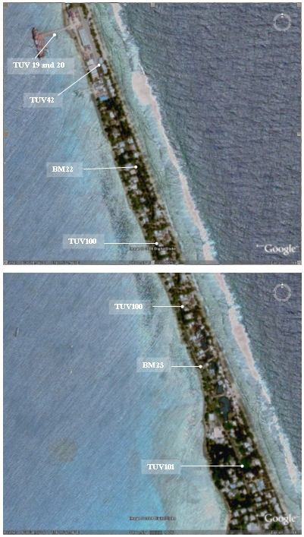

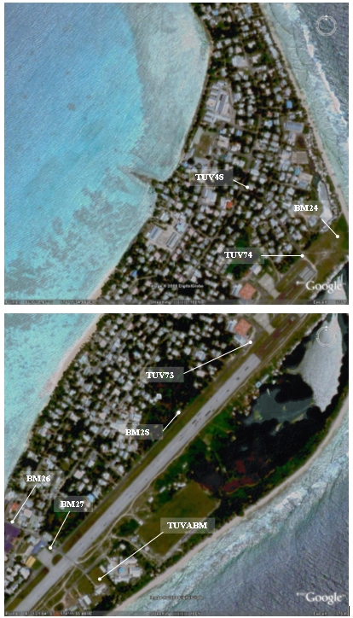

## The Tuvalu Datum

The Datum for the survey is the University of Hawaii Tide Staff Zero (TSZ).

Reduction of the data has been calculated holding BM22 fixed at 3.22540 metres TSZ, this value was determined by the NTCA in 1993 by:

Adopting the height of UH 1

RL = 3.0072 metres TSZ

Adopting the height of BM22 as derived from the 1993 survey

RL = 3.22540 metres.

## Equipment

* Leica total station model TM30 (Serial No: 361441)
* Leica precision prisms GPH1P (2).
* Leica rigid tripod.
* Stainless steel target poles supported by Leica telescopic bi-poles (2).
* Shortened stainless steel target pole for the SEAFRAME sensor BM connection.
* Leica cast iron change plates (2).
* Kestral 4000 pocket weather tracker

## Method

The “Leap-Frog” EDM height traversing technique was employed for the Funafuti tide gauge levelling survey. This technique involves setting up a total station (TCA1800L) midway between two target/reflectors (on reflector rods with struts). The targets remain at a particular change point for the back-sight and fore-sight observations. The instrument measures slope distances (±1mm) and vertical angle (1”) to derive height differences (between the instrument’s trunnion axis and the reflectors). In support of the slope distance observations, the ambient temperature, pressure and humidity are recorded (Kestral 4000 pocket weather tracker) and input into the instrument to apply the first velocity correction to the observed distances (Rüeger & Brunner, 1982). Four rounds of observations are taken to the back-sight and fore-sight targets from each instrument setup. All levelling runs started and finished with the same reflector and reflector rod, i.e. an even number of setups when the two reflector rod configuration was used. This eliminates any reflector rod zero error. This technique can also be performed using a single set-up / single rod configuration which is particularly useful when levelling between bench marks which are close together e.g. between the CGNSS RMs.

Reduction of the digital data was computed by the Geoscience Australia levelling program “leveling1.exe”. This program computes the height difference between the two reflectors.

## Survey Support

The Acting Director of the Tuvalu Meteorological Service, Mr. Tauala Katea and his staff provided valuable support during our visit.

Special mention to Mr. Faatasi Malologa – Director, Lands and Survey Department for arranging the car hire and also providing us with a surveyor for field assistance for the survey.

## Issues

No issues or concerns of any importance with regards to the levelling survey were encountered during the 2012 survey.

Please note that due to fewer flights to Funafuti, it is advisable to book 2 cargo seats for the survey equipment to and from Funafuti as DHL cannot guarantee the air freight to arrive.

## Description of Marks – Funafuti, Tuvalu

BM22 is the bench mark held fixed with an RL = 3.22540 metres

The height of BM22 was derived in 1993 by NTC by means of:

1993 Adopting the height of UH 1

RL = 3.0072 metres TSZ.

1994 Adopting the height of BM22 from the 1993 survey.

RL = 3.22540

Bench Marks:

BM22, BM23, BM24, BM26, BM27 and BM28 are all Deep Driven BM’s

* BM25 has been destroyed.

TUV20 is the SEAFRAME Sensor Bench Mark

TUV19 is the Project Plaque point

TUVABM is the Reference Bench Mark for the CGPS Pillar.

TUV42, TUV100, TUV101, TUV61, TUV48, TUV74 and TUV73 are all permanent stainless steel bolt holding marks, drilled in concrete and glued in place. The holding marks TUV102 to TUV106 are all new marks established in 2012 and are stainless steel bolts glued in place.

# Comparisons

## Comparisons between 2012 and 2010 EDM Surveys

Table 3. Tuvalu EDM Height Traversing Levelling Comparison 2012 - 2010 and Table of Results

Due to the complexity of this document and the niche scientific target audience, no table summary has been provided. If you need assistance with the structure of this table, please contact Geoscience Australia at clientservices@ga.gov.au.

Table 3. TUVALU Reference Mark levels

Due to the complexity of this document and the niche scientific target audience, no table summary has been provided. If you need assistance with the structure of this table, please contact Geoscience Australia at clientservices@ga.gov.au.

## Combined Comparisons 1993 to 2012

Table 3.3 Tuvalu - Comparison of the RL's for Precise Differential Levelling (1993 – 2005) and EDM Height Traversing (2005 - 2012)

Due to the complexity of this document and the niche scientific target audience, no table summary has been provided. If you need assistance with the structure of this table, please contact Geoscience Australia at clientservices@ga.gov.au.

*The RL of the Reference Point TUVA (ARP) is derived from adding the static height difference of 0.9645 m (TUVABM to TUVA) to the levelled RL of TUVABM.

The 2012 Reduced Level of TUVA is 3.7063 m

## Time Series of Bench Mark Movement relative to Fixed Deep Bench Mark BM22

Precise Differential Levelling: 1993 - 2005   
EDM Height Traversing: 2005 onwards

Due to the complexity of this document and the niche scientific target audience, no alternative description has been provided. Please email Geoscience Australia at clientservices@ga.gov.au for an alternative description.

Due to the complexity of this document and the niche scientific target audience, no alternative description has been provided. Please email Geoscience Australia at clientservices@ga.gov.au for an alternative description.

Due to the complexity of this document and the niche scientific target audience, no alternative description has been provided. Please email Geoscience Australia at clientservices@ga.gov.au for an alternative description.

Due to the complexity of this document and the niche scientific target audience, no alternative description has been provided. Please email Geoscience Australia at clientservices@ga.gov.au for an alternative description.

Due to the complexity of this document and the niche scientific target audience, no alternative description has been provided. Please email Geoscience Australia at clientservices@ga.gov.au for an alternative description.

Due to the complexity of this document and the niche scientific target audience, no alternative description has been provided. Please email Geoscience Australia at clientservices@ga.gov.au for an alternative description.

Due to the complexity of this document and the niche scientific target audience, no alternative description has been provided. Please email Geoscience Australia at clientservices@ga.gov.au for an alternative description.

# Deep Bench Mark Locality Diagrams

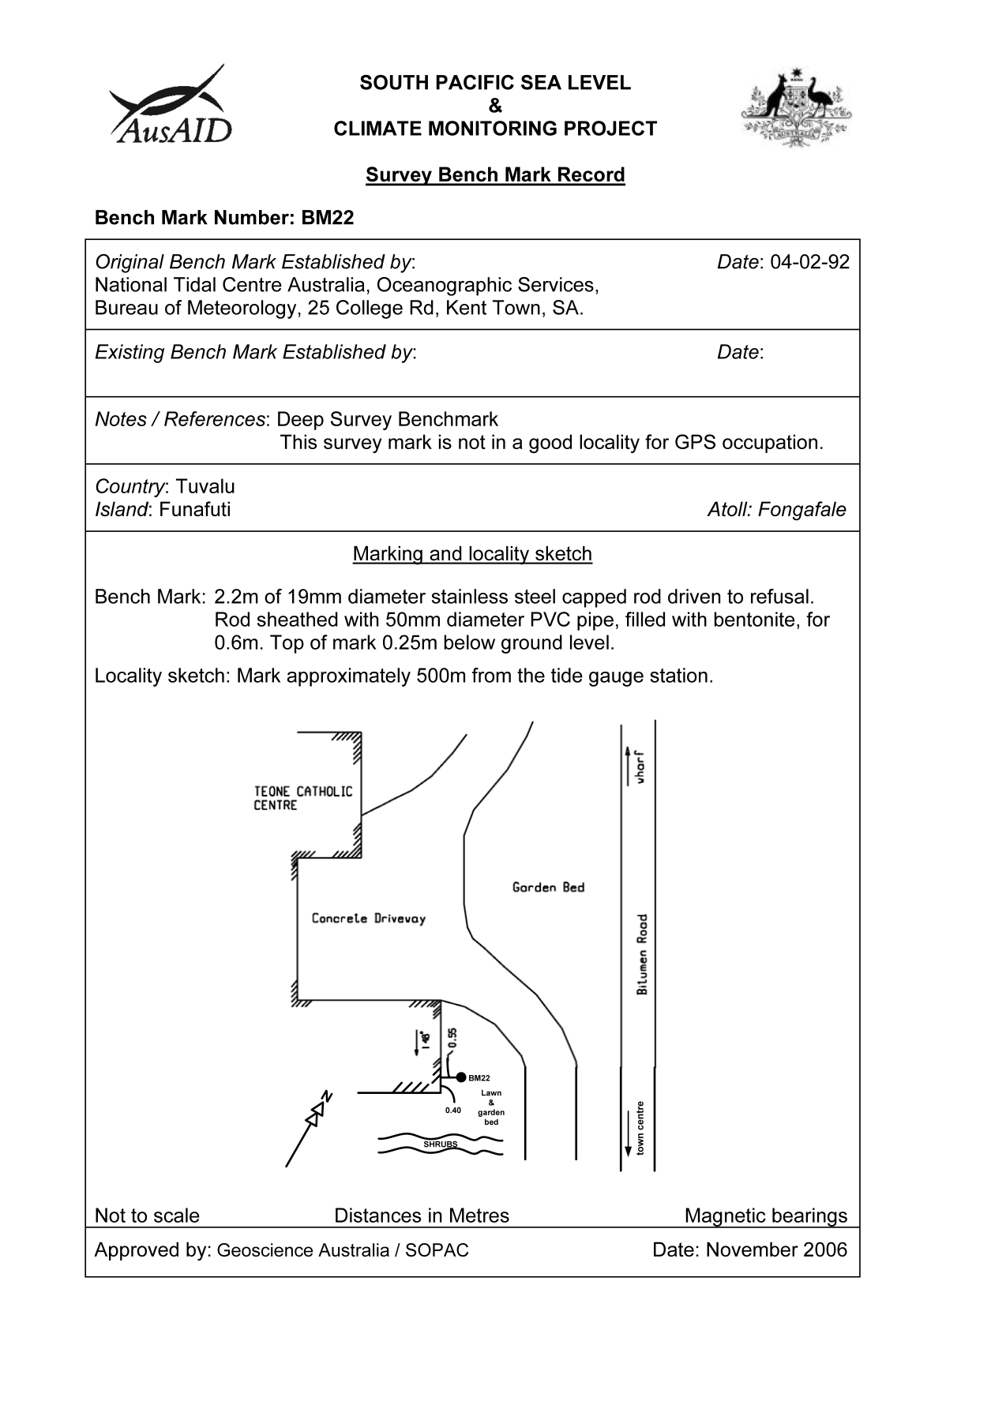

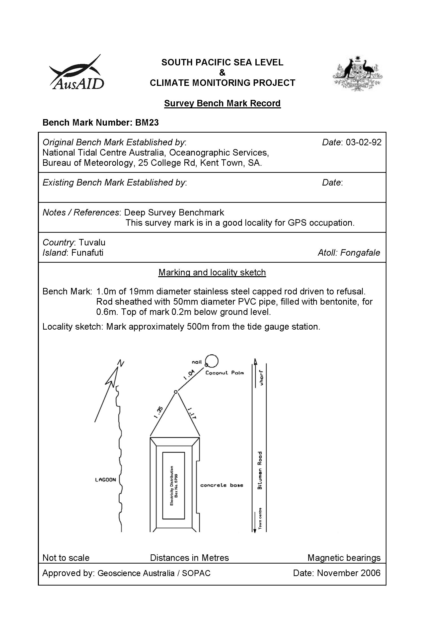

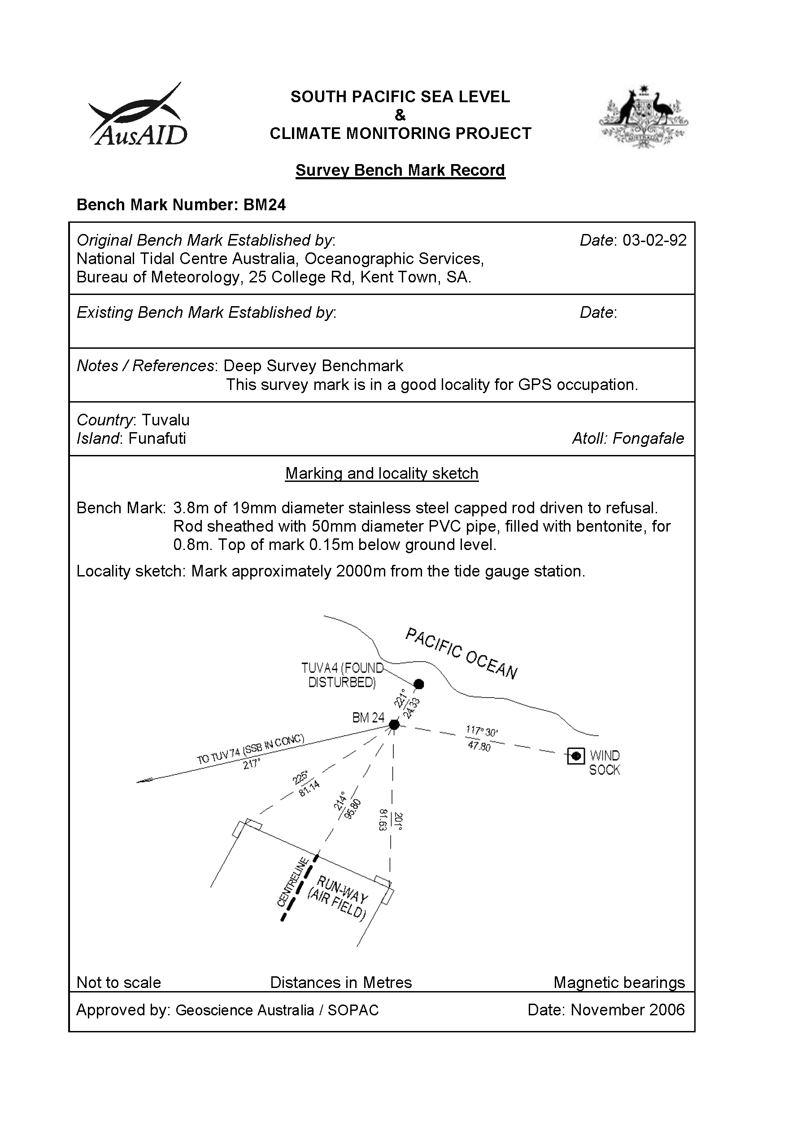

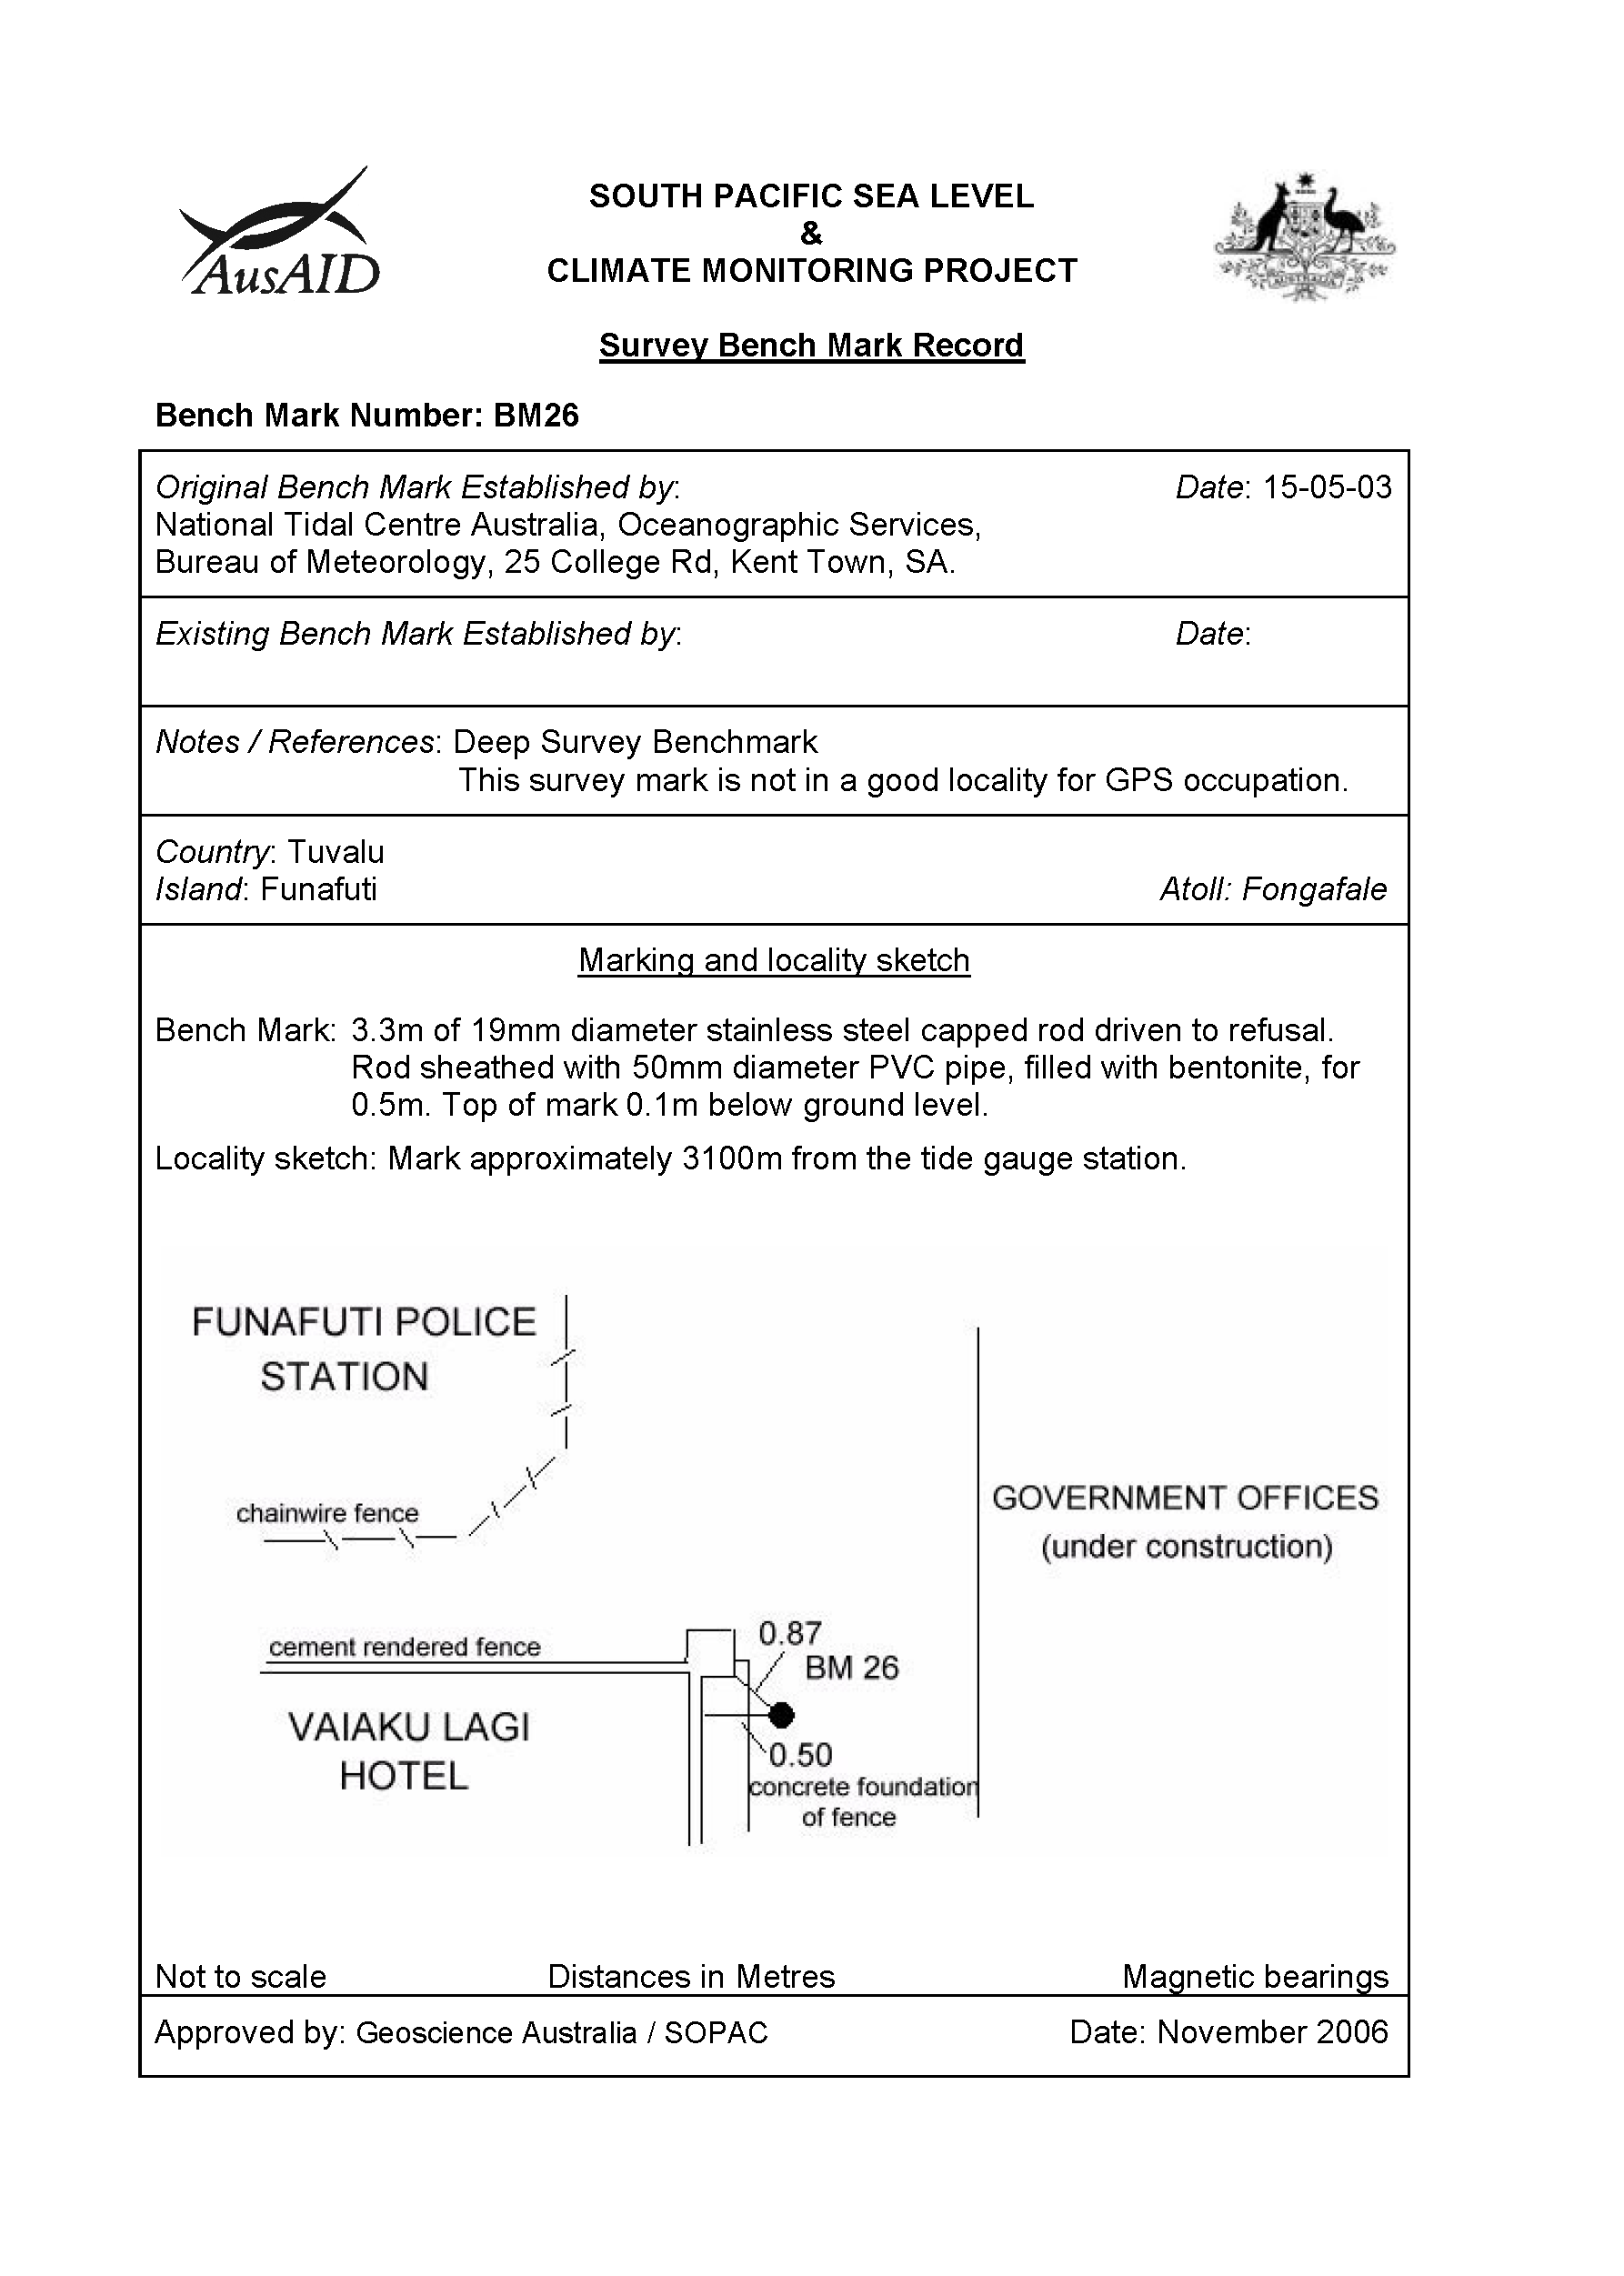

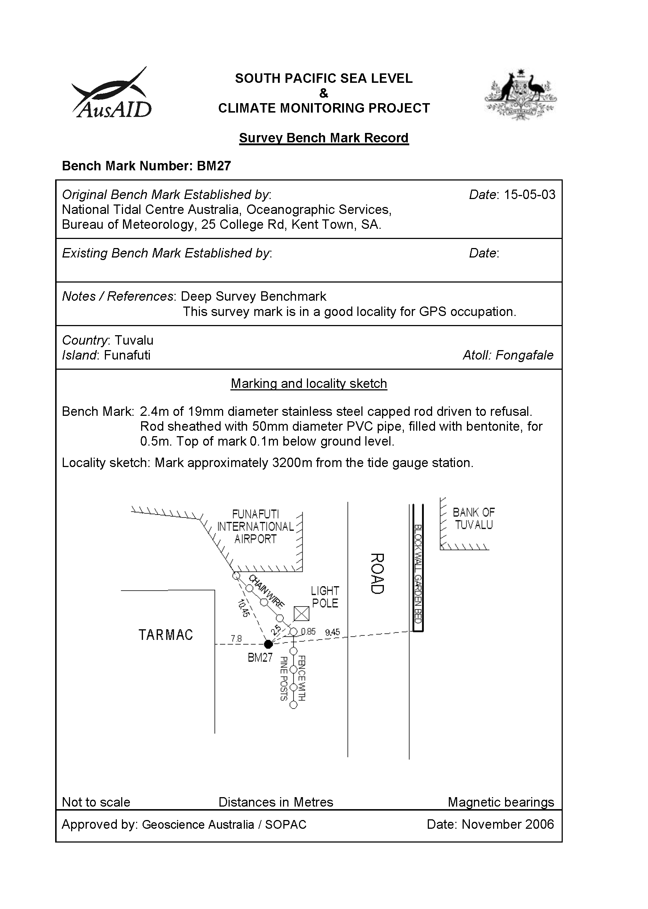

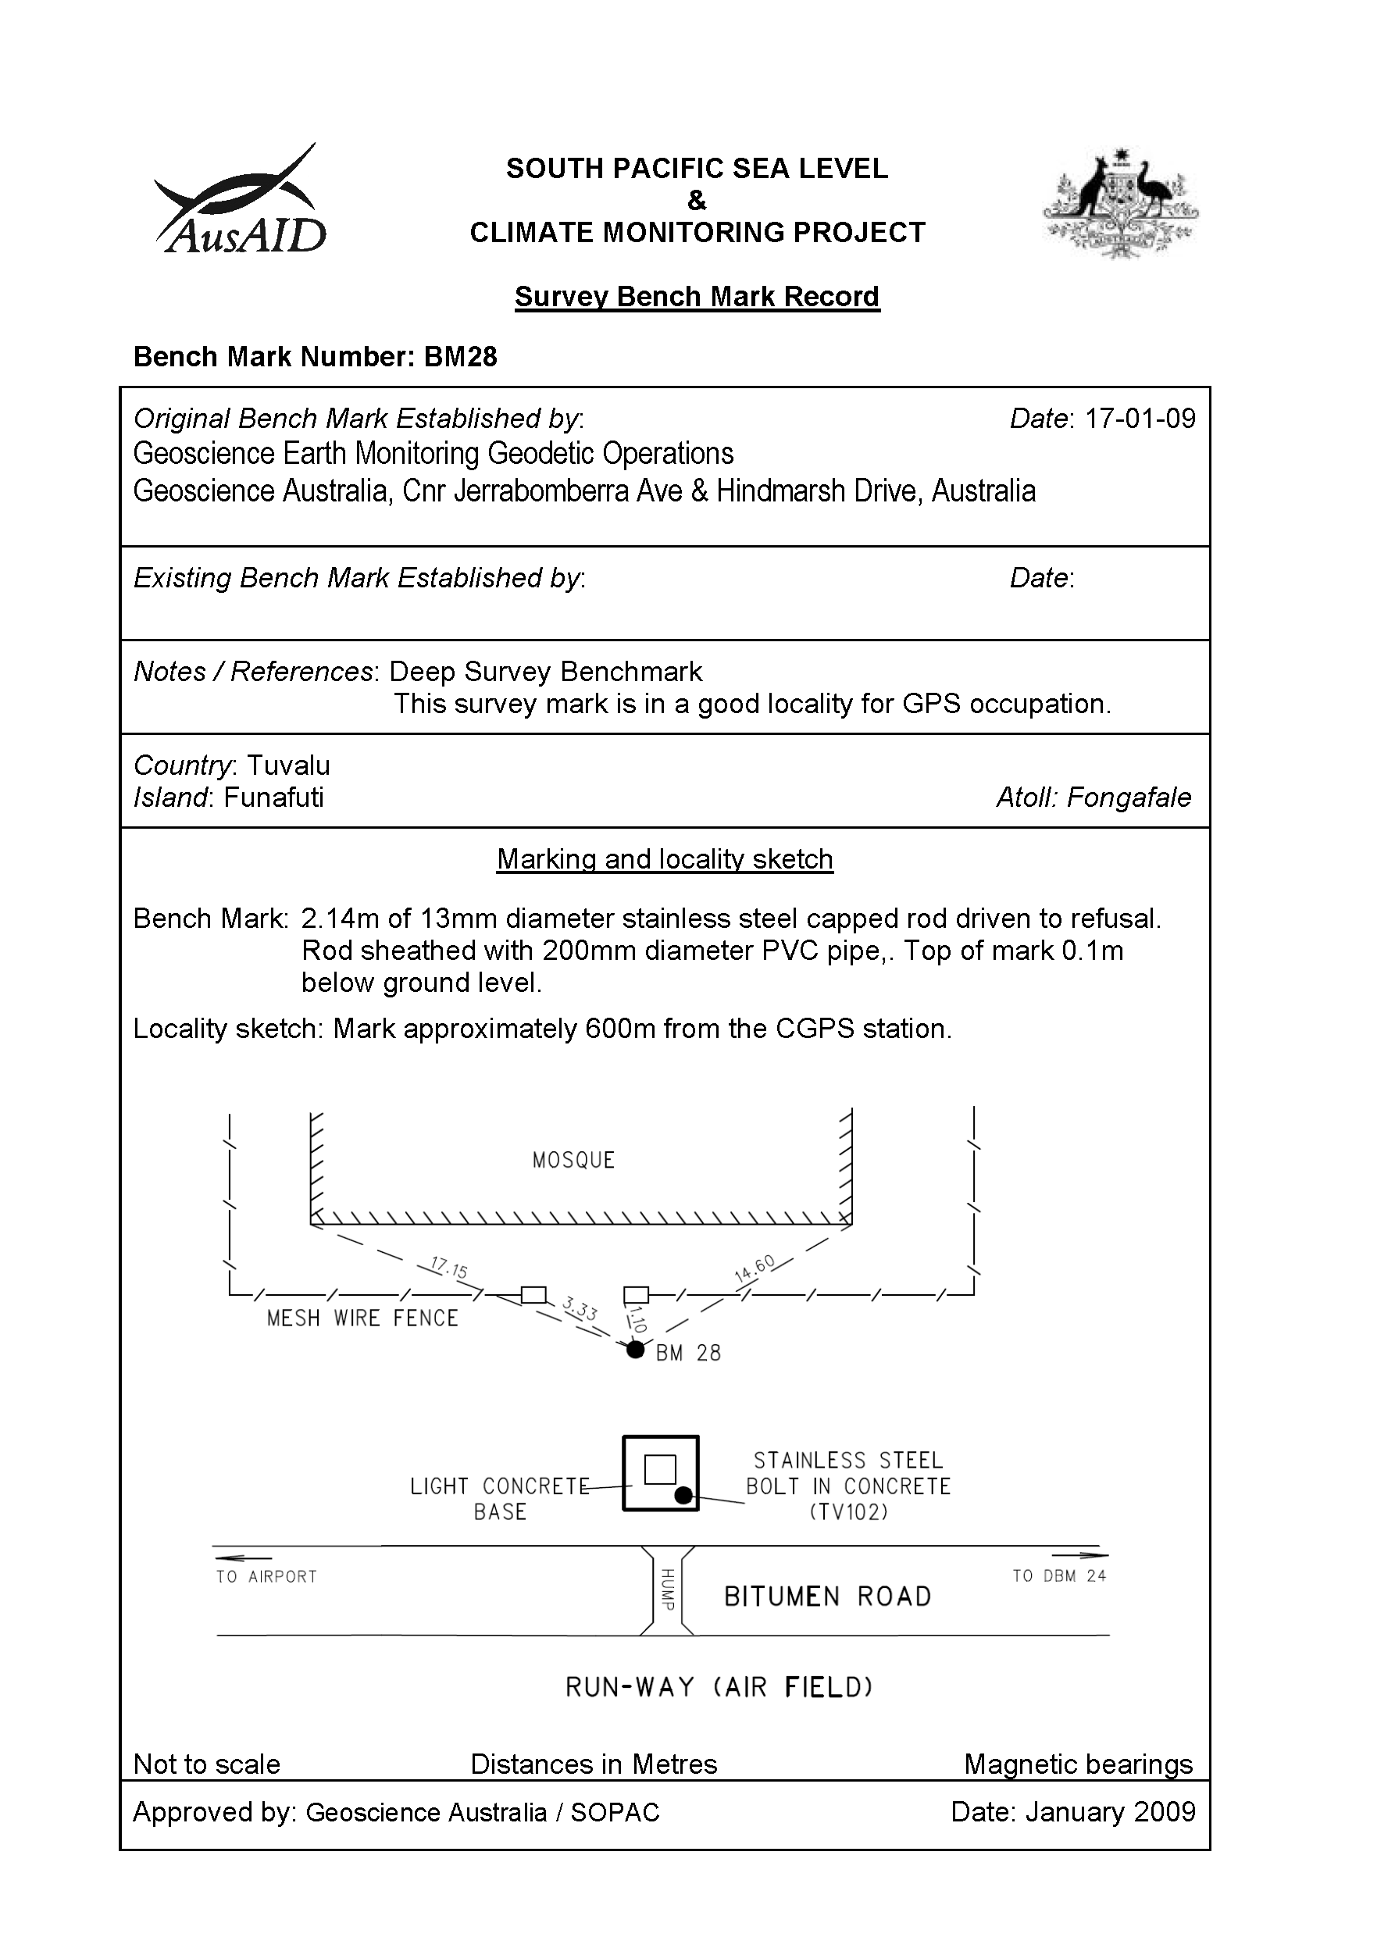

# Permanent Holding Mark Locality Diagrams

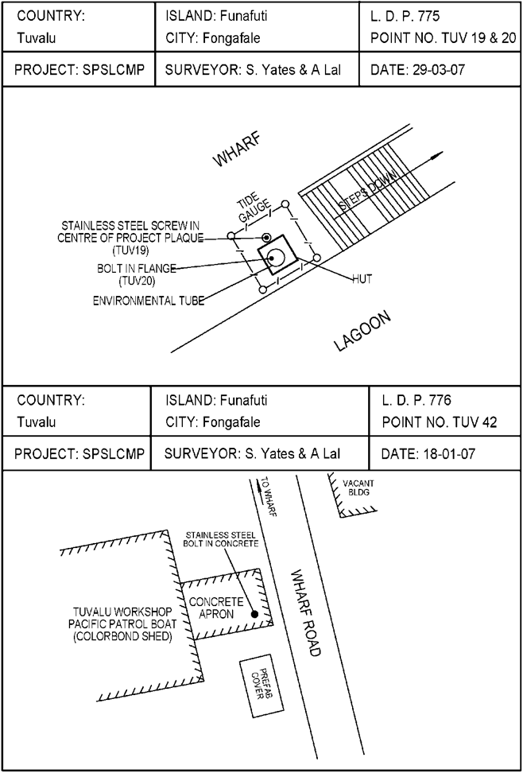

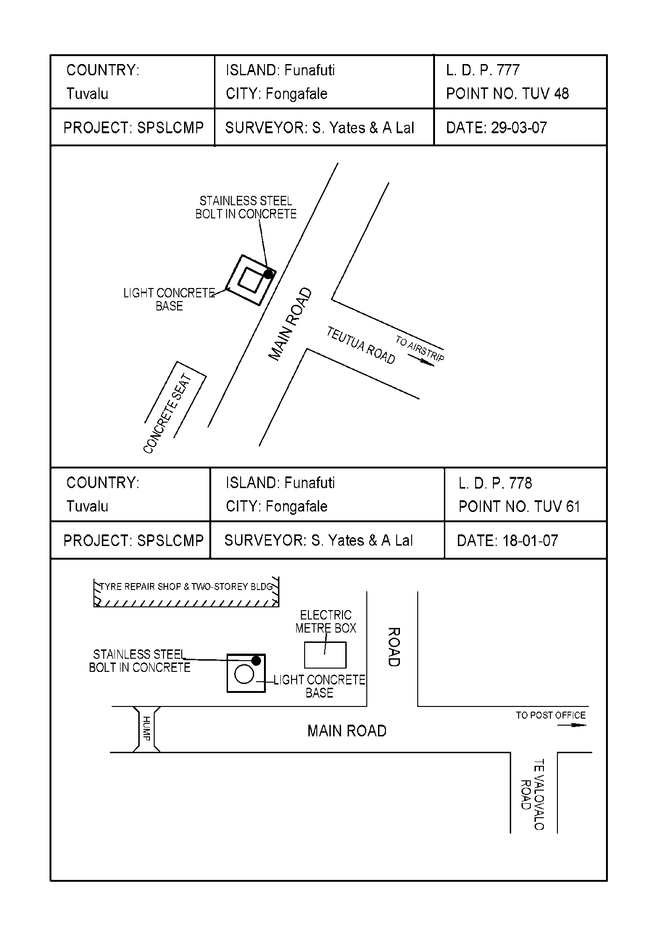

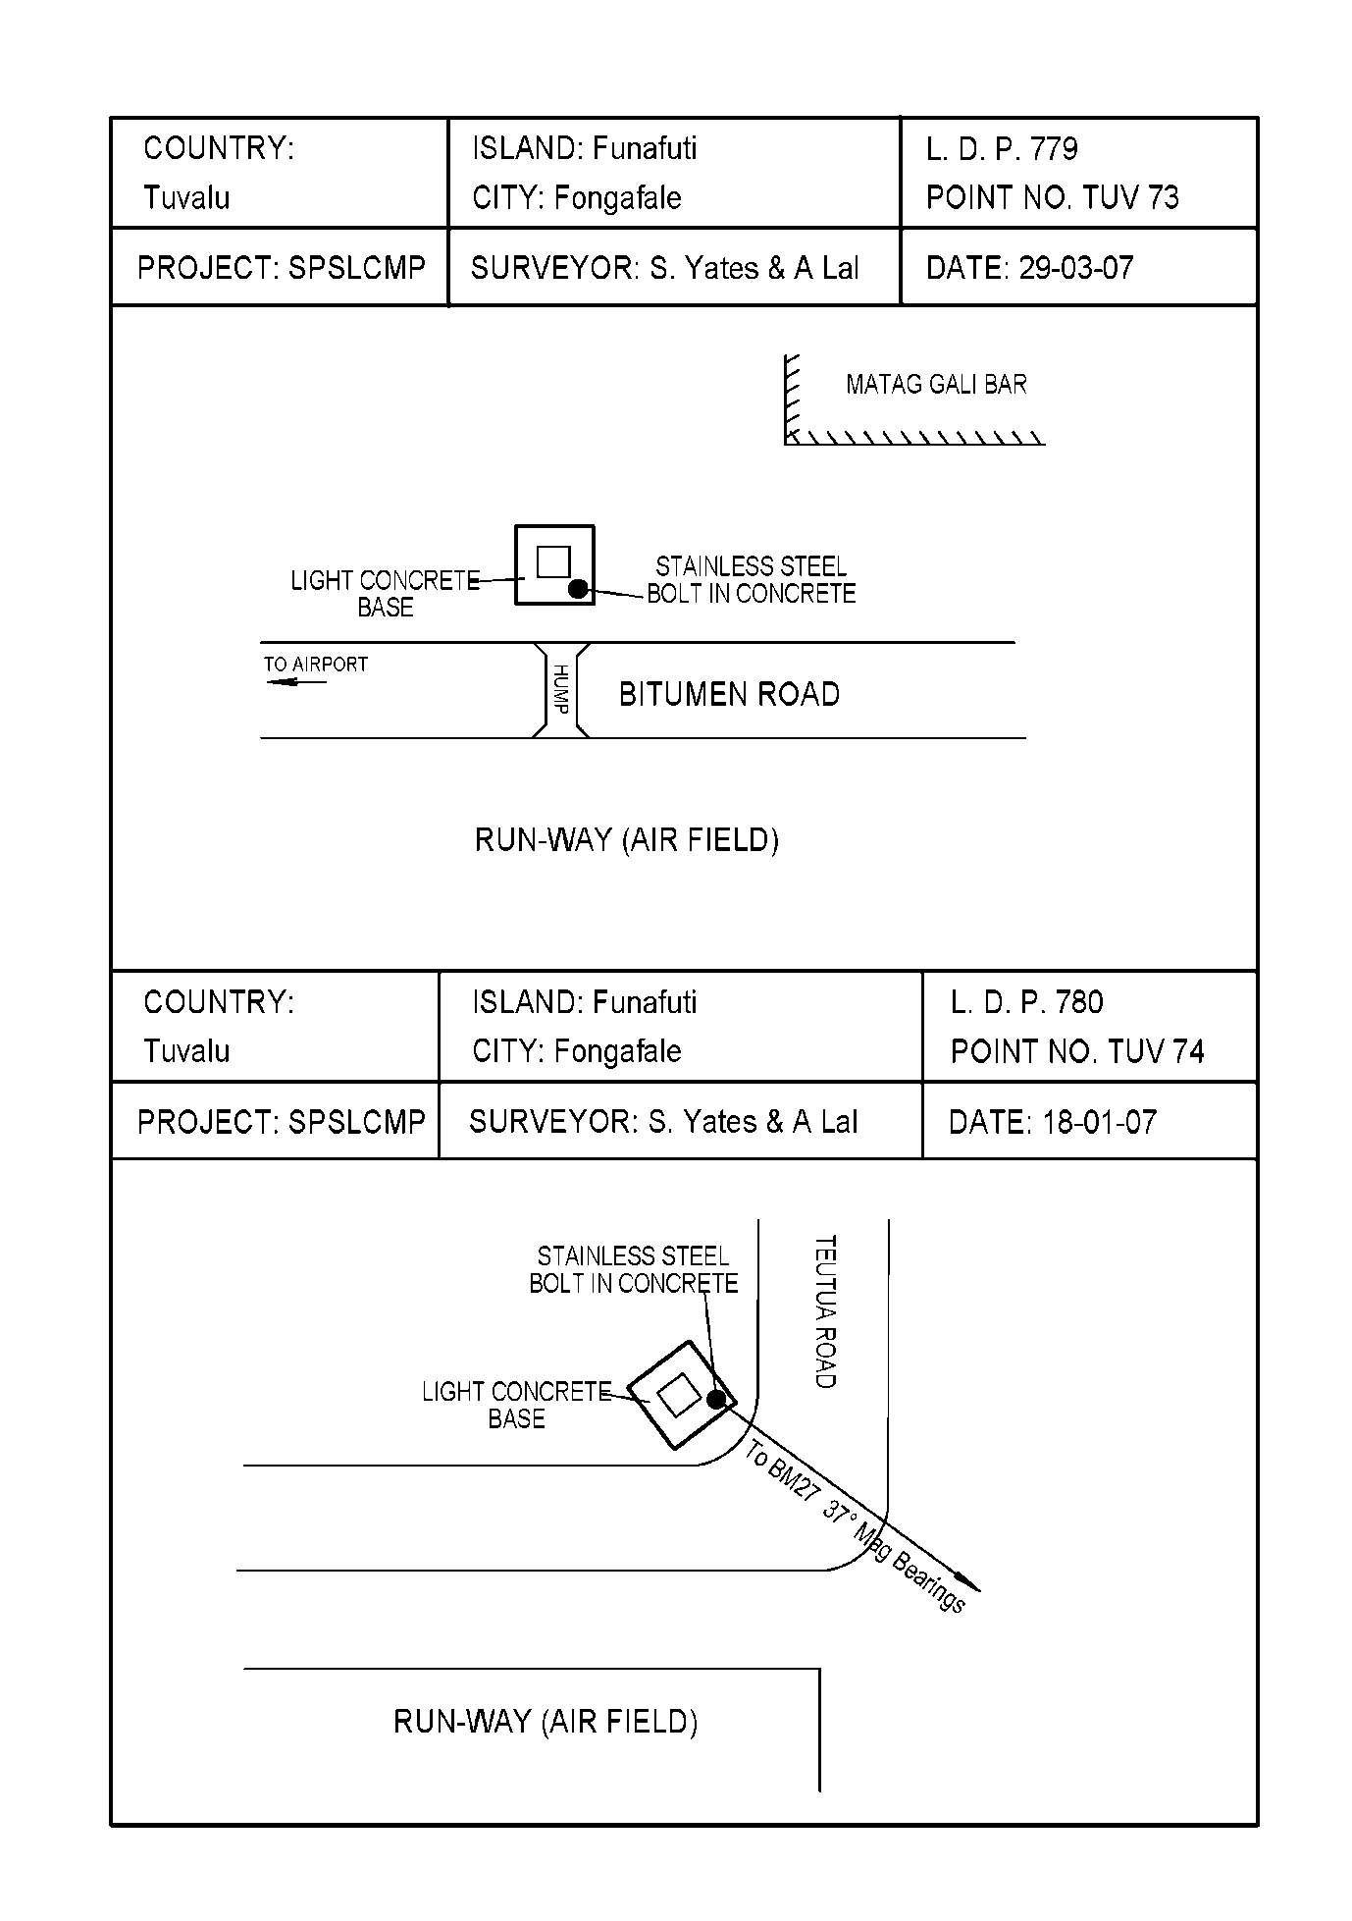

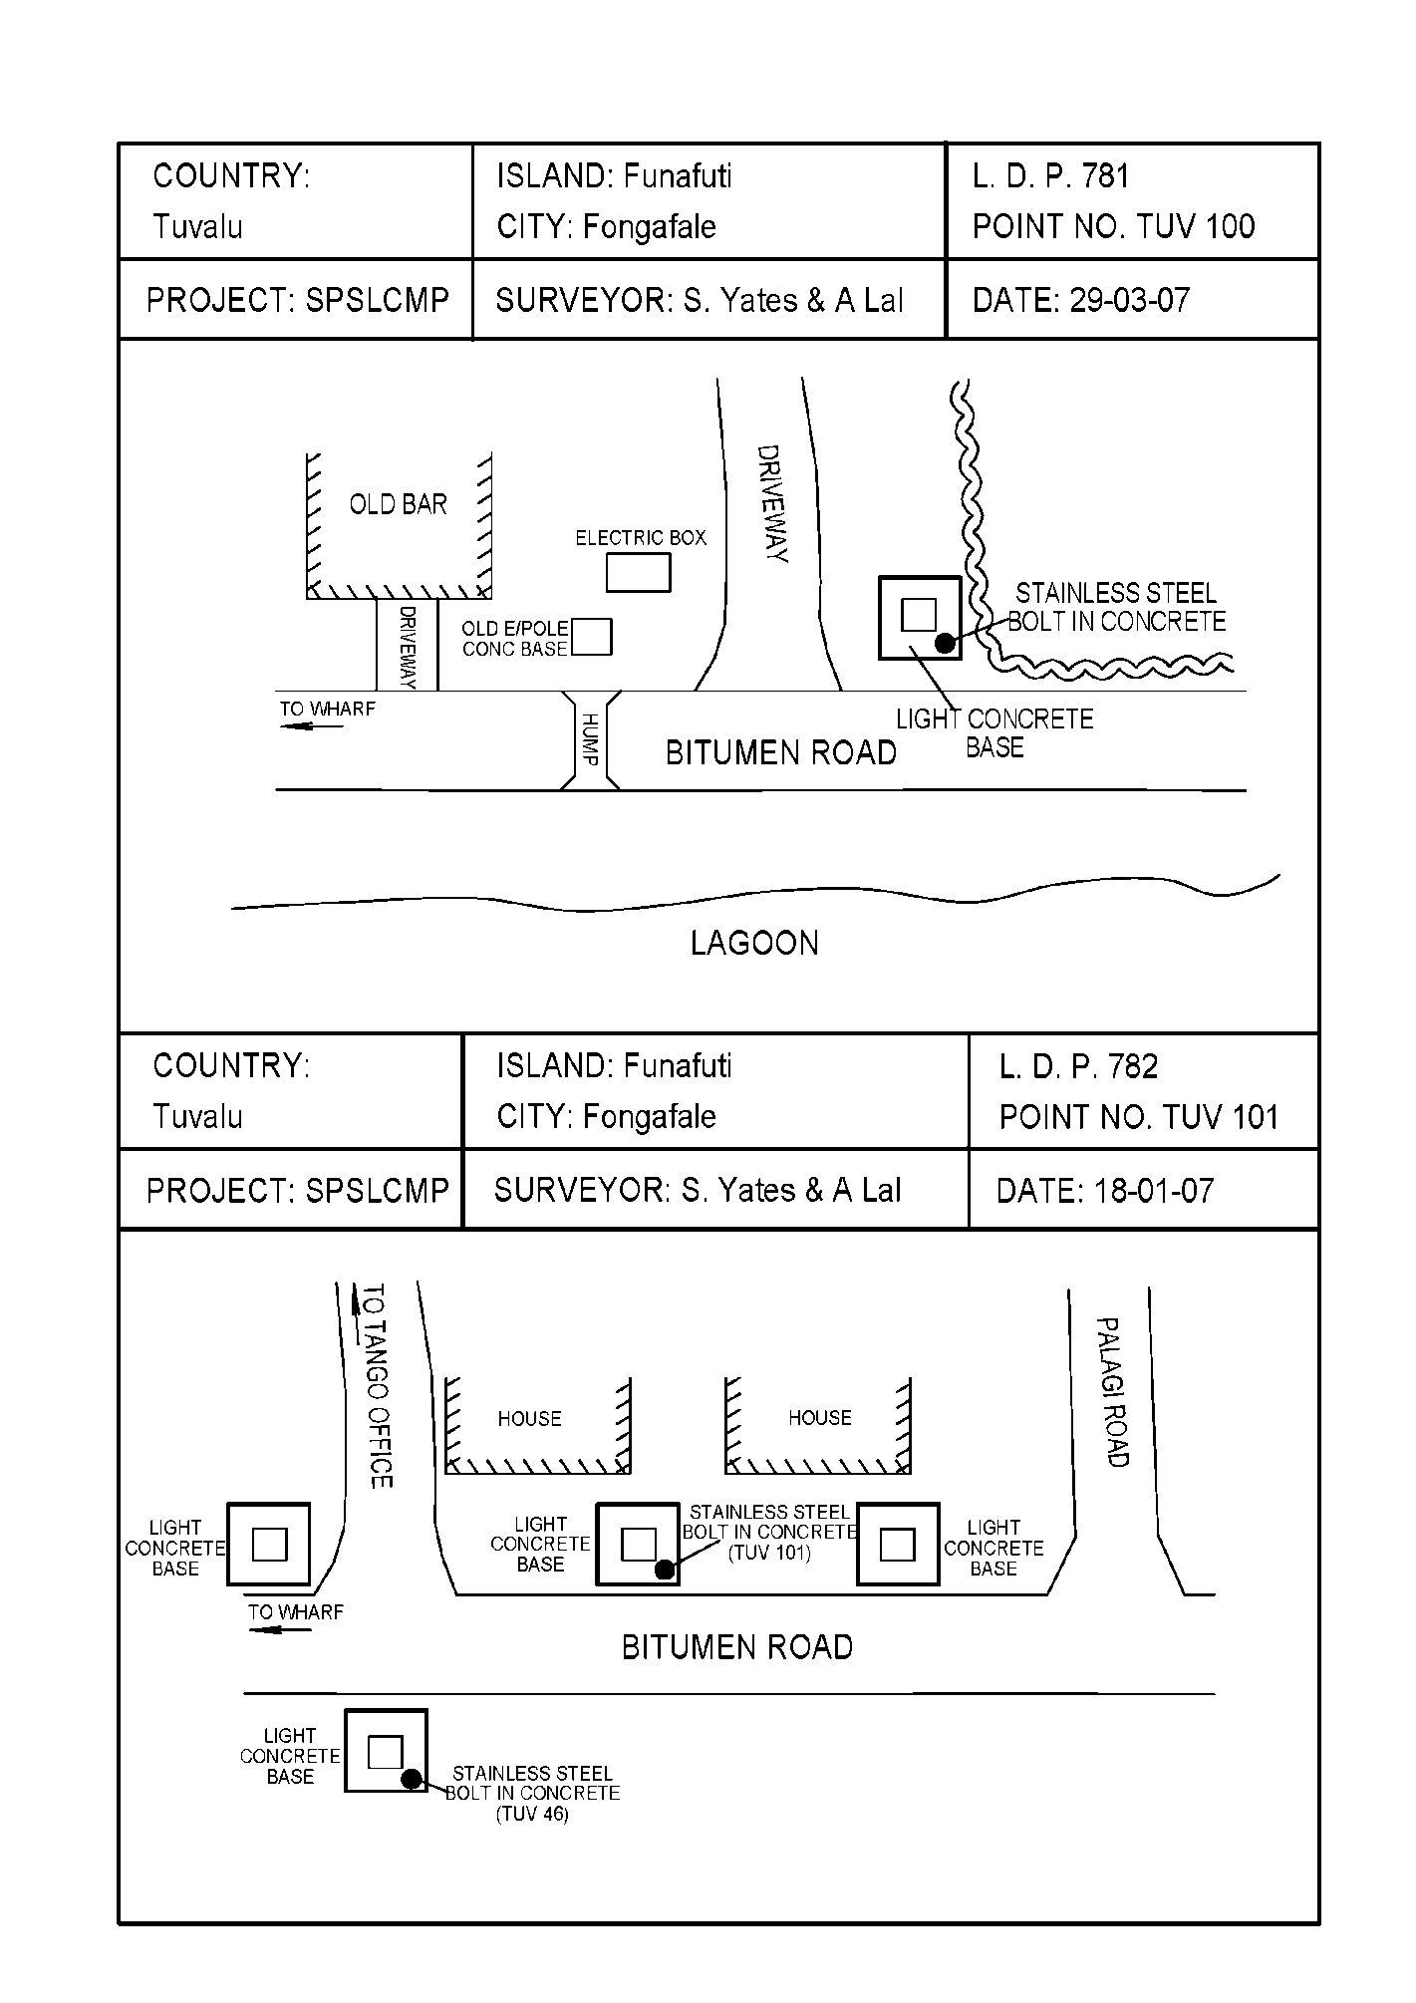

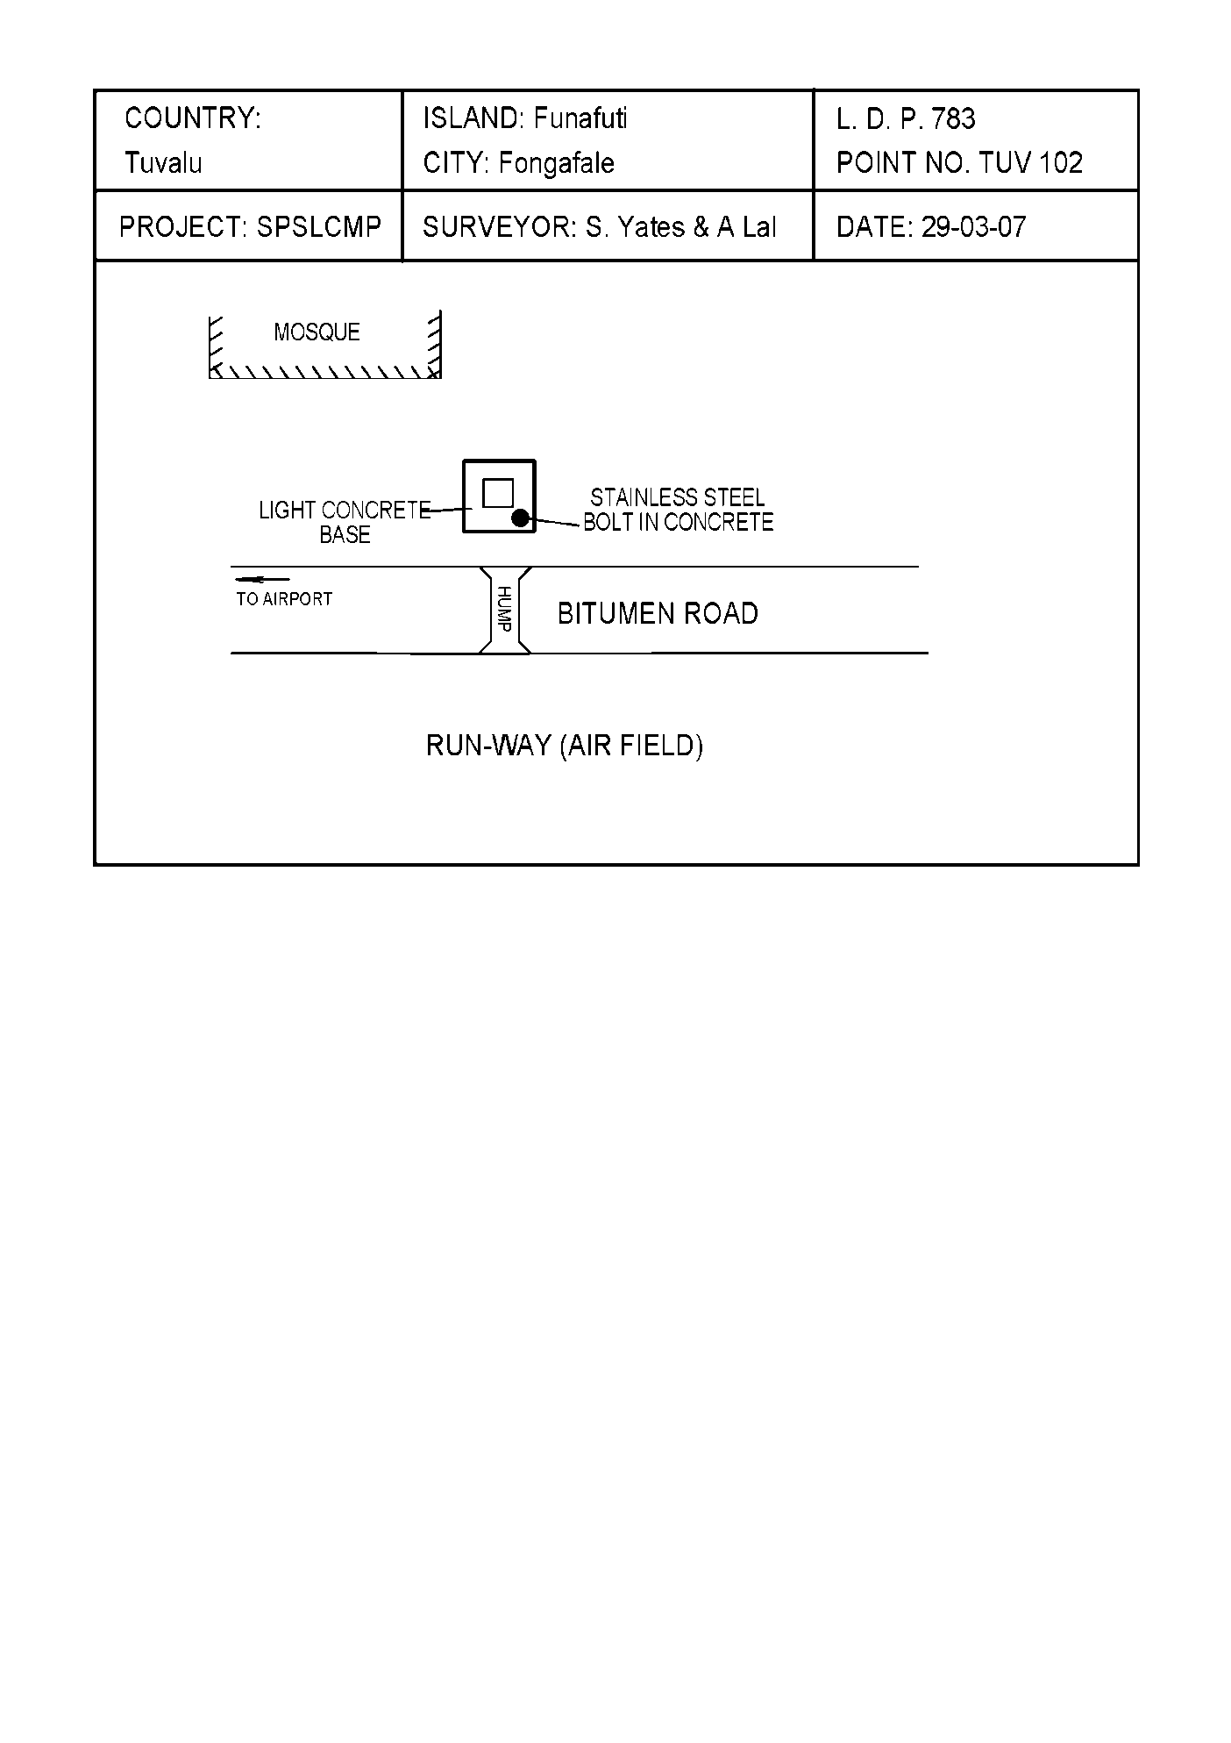

# TUVABM and TUVA Reference Mark Locality Diagrams

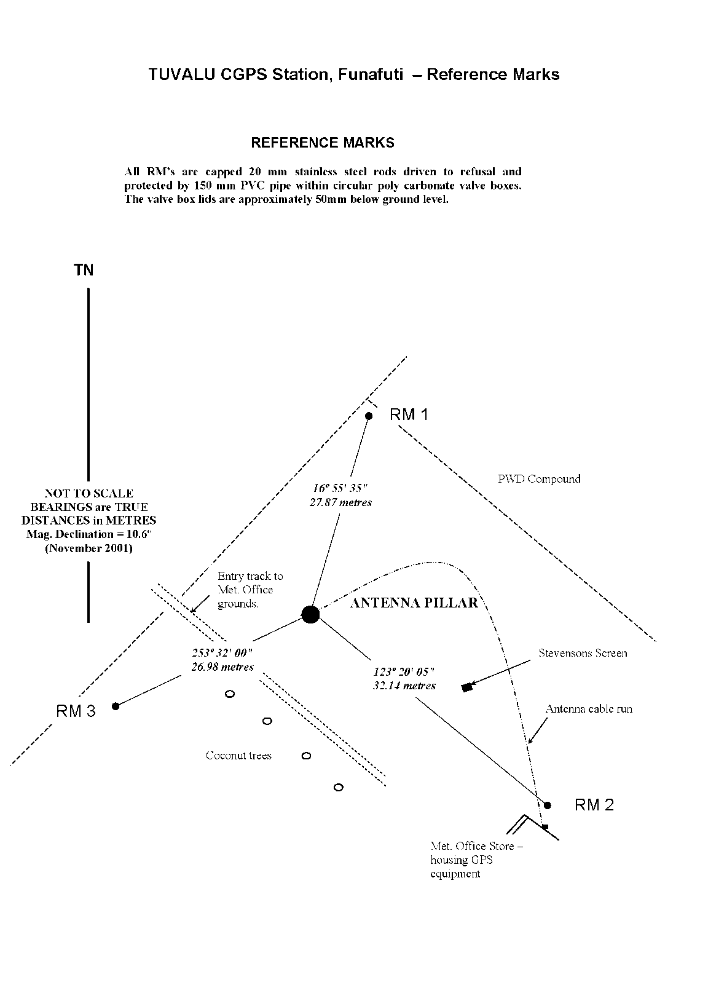

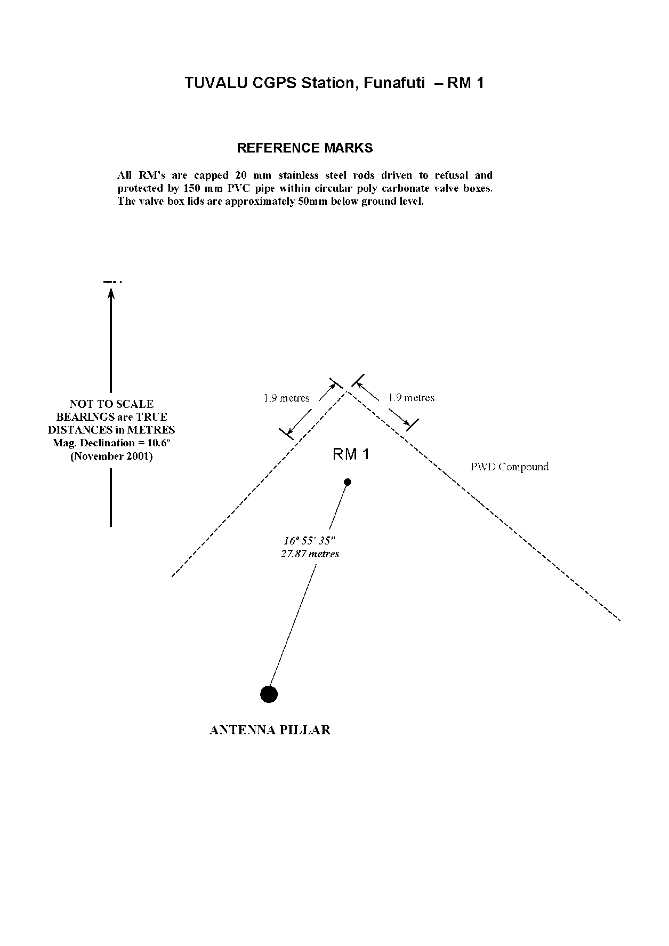

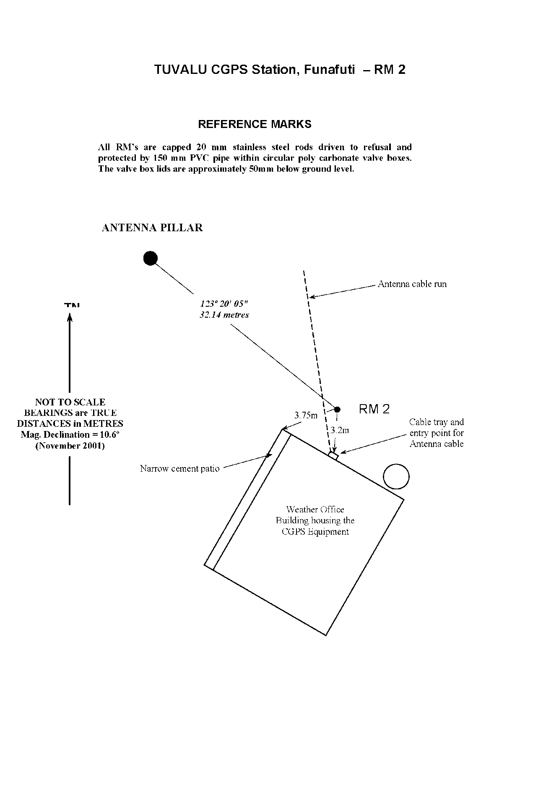

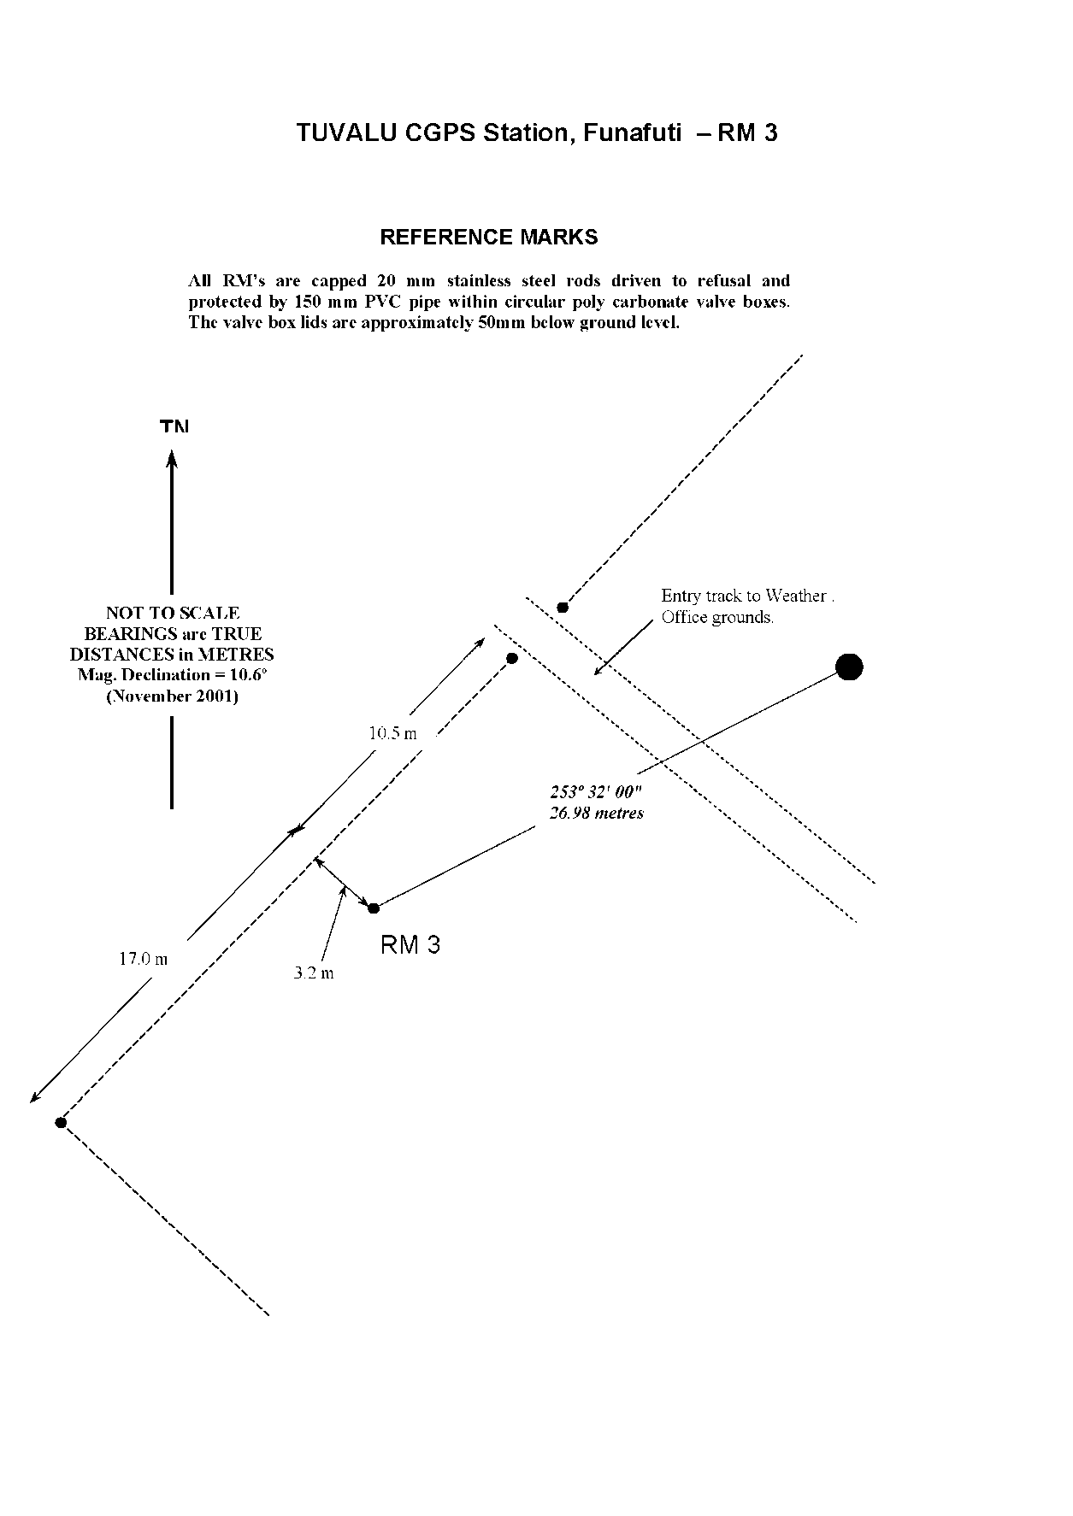

# References

Rüeger, J.M. & Brunner, F.K. 1982, ‘EDM Height Traversing versus Geodetic Levelling’, The Canadian Surveyor, vol. 36, no. 1, pp. 69-87.

Inter-Government Committee on Surveying and Mapping (ICSM) 2002, Standards and Practices for Control Surveys, SP1, Ver. 1.5, May 2002.