Gravity and Granites

Technical notes on mapping relationships of known granites and gravity
Geoscience Australia
RECORD 2014/12
Peter Petkovic
Department of Industry
Minister for Industry: The Hon Ian Macfarlane MP
Parliamentary Secretary: The Hon Bob Baldwin MP
Secretary: Ms Glenys Beauchamp PSM
Geoscience Australia
Chief Executive Officer: Dr Chris Pigram
This paper is published with the permission of the CEO, Geoscience Australia
© Commonwealth of Australia (Geoscience Australia) 2014
With the exception of the Commonwealth Coat of Arms and where otherwise noted, all material in this publication is provided under a Creative Commons Attribution 3.0 Australia Licence. (http://www.creativecommons.org/licenses/by/3.0/au/deed.en)
Geoscience Australia has tried to make the information in this product as accurate as possible. However, it does not guarantee that the information is totally accurate or complete. Therefore, you should not solely rely on this information when making a commercial decision.
Geoscience Australia is committed to providing web accessible content wherever possible. If you are having difficulties with accessing this document please email clientservices@ga.gov.au.
ISSN 2201-702X (PDF)
ISBN 978-1-925124-01-9 (PDF)
GeoCat 77502
Bibliographic reference: Petkovic, P., 2014. Gravity and granites: technical notes on mapping relationships of known granites and gravity. Record 2014/12. Geoscience Australia, Canberra. http://dx.doi.org/10.11636/Record.2014.012

Contents
Executive Summary 1
1 Introduction 2
2 Granite Outcrop and in Wells 3
3 Residual gravity contours 4
3.1 Regional gravity 5
3.2 Processing contours of the residual 11
3.2.1 Produce Contours: GMT Software 12
3.2.2 Filter the contour file: contour_filter 13
3.2.3 Extract outermost contours: outer_contour 14
3.2.4 Compute minimum bounding rectangles (MBRs): polygon_mbr 15
3.2.5 Polygon intersections: intersecting_polygons 15
3.2.6 Point intersections: point_in_polygon 15
3.2.7 Split vector file into components: split_erv 16
3.2.8 Cooper Basin granites 18
4 Worms 19
4.1 Concatenate Worms: join_worms 21
4.2 Close worms into rounded polygons: close_worms 21
4.3 Proximity to known granites 22
5 Discussion and Conclusions 24
Acknowledgements 25
References 26
Appendix A - Format of vector file 27
Appendix B - Processing on a PC 28
Appendix C - Intrepid Multi-scale edge detection job file 31

Executive Summary
Gravity anomalies over granite bodies are often of negative polarity and can be represented as rounded polygons. These characteristics were used to trial a method to map possible locations of subsurface granite bodies.
Two approaches were used to outline the geometry of rounded gravity anomalies:
- Contouring of the residual Bouguer gravity field after removal of a regional field; and
- Detection of edges in the residual Bouguer gravity field.
The resulting polygons are coloured according to proximity to known granite, whether outcropping or found in wells. Three categories of polygon are identified: known granite falling within the gravity polygon, near such outcrop, or not proximal to outcrop.
The processing was done using software developed by the author in the Perl programming language and stored in the Energy Division software repository. The processing was organised to run in batch mode on any system on which Perl is installed: MS-Windows, Unix, Linux or NCI systems.
The input and output data files are ERMapper ASCII vector format and exported to ArcGIS shape files. The visualisation tool was ER-Mapper.
In mapping rounded, negative, gravity anomalies the contouring approach gave a more plentiful range of sites to consider than did the worming approach. However, there is no unique and precise characteristic geophysical signature that buried granites may be expected to manifest, in a regional sense, for an approach such as taken here to work with a high level of confidence. The produced maps, therefore, need to be examined with a geologically trained eye, with consideration to the specific geological setting for each potential site.

Introduction
This work was part of Geoscience Australia’s geothermal resources study group, for which a key question is how to locate high heat-producing granites on a continent-wide scale. This document describes a contribution to solving that problem by examining the relationship of gravity anomalies and known granite locations where outcrop occurs or granite is found in wells.
Gravity anomalies over granite bodies are often negative because the density of granite (2650–2750 kg/m3) is lower than average continental crust of 2830 kg/m3 (Christensen and Mooney, 1995). In laboratory measurements of 334 samples, Olhoeft and Johnson (1989) report a mean granite density of 2660 kg/m3 with a standard deviation of 60 kg/m3.
Furthermore, high heat-producing granites are of still lower density (Sommerville et al., 1994) such as 2600 kg/m3 (Boucher, 1996) measured for granodiorite beneath the Cooper Basin and reaffirmed by Meixner and Holgate (2009) by gravity inversion modelling for the area.
Granite plutons are often rounded, ovoid or lenticular in shape forming either as laccoliths or lopoliths (Bott and Smithson, 1967; Taylor, 2007; Leaman and Richardson, 2003). High heat producing granites of interest to geothermal exploration share these characteristics (Sommerville et al., 1994; Meixner and Holgate, 2009).
These characteristics, of low-valued or negative gravity anomalies and rounded shapes, were used to create a map of Australia showing possible locations of subsurface granite bodies.
Two approaches were used to outline the geometry of rounded gravity anomalies:
- Contouring of the residual Bouguer gravity field after removal of a regional field computed by filtering of the gravity field.
- Detection of edges defined by maximum horizontal gradient of the Bouguer gravity field.

Granite Outcrop and in Wells
The known location of granites, in outcrop and encountered in wells, was used to find where they intersected, or were close to, closed (as distinct from open-ended), rounded gravity contour polygons. The known locations of granites are given in Figure 2.1.
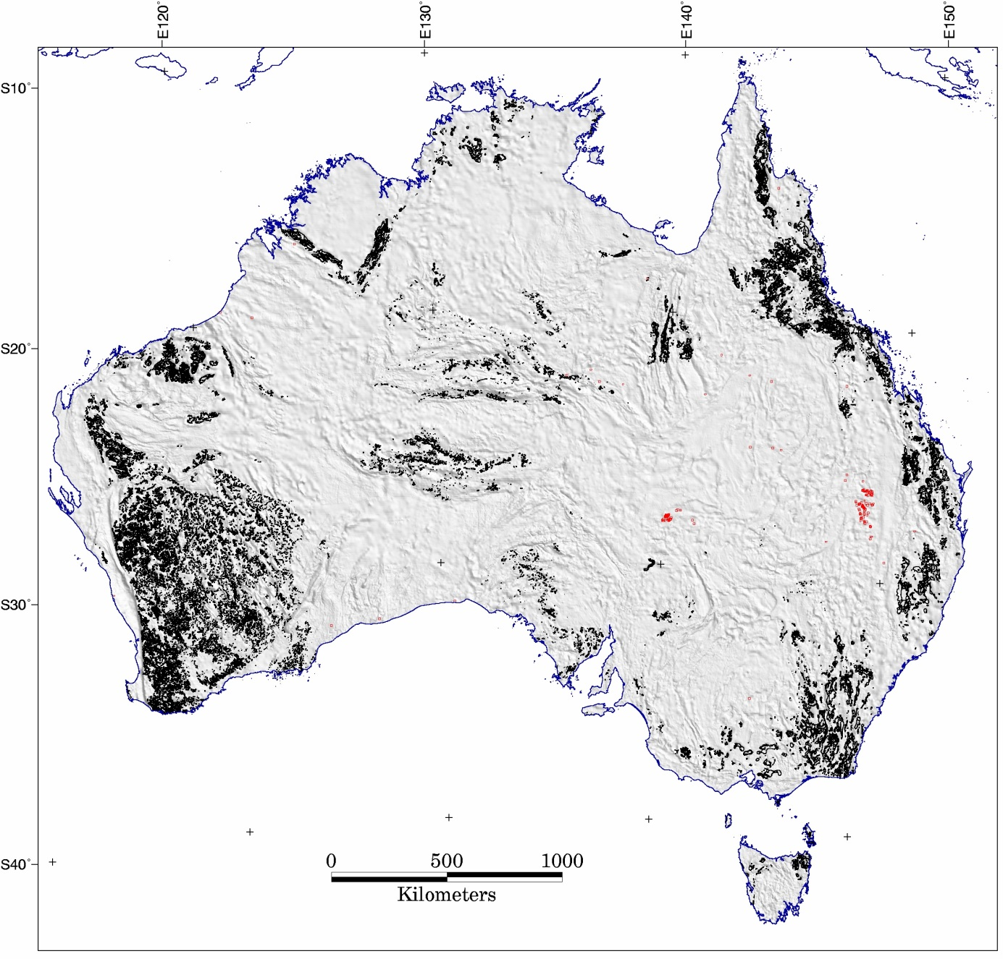
Figure 2.1. Map of mainland Australia showing location of igneous felsic intrusives (black) from Geology Map of Australia, 2012 (Liu et al. 2012, D. Champion, pers. comm.) and granites encountered in wells (red) from Geoscience Australia’s stratigraphic database which includes petroleum wells (D. Rowland, pers. comm.). The onshore well data were sourced from state government databases in late 2011. The greyscale background image is Bouguer gravity residual (described in text). The map projection is Lambert Conformal Conic with standard parallels 18°S and 36°S and central meridian 134°E.

Residual gravity contours
This approach used contours of the Bouguer gravity grid of Australia produced by Geoscience Australia (Figure 3.1) after removal of a regional field computed by filtering (as used in a study of Tasmanian granites by Roach et al., 1993). Closed contours, or polygons, were extracted from the complete set of contours and further filtered by retaining only those which were of a generalised rounded shape.
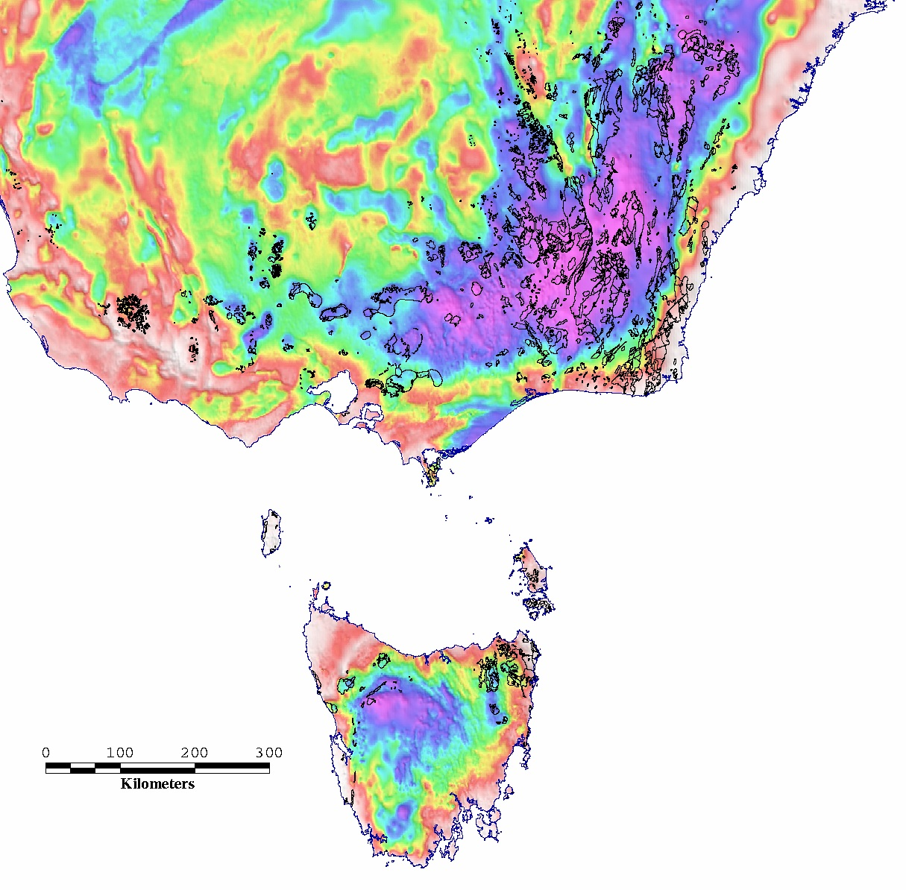
Figure 3.1. Southeast Australia Bouguer gravity anomaly in colour (warm colours +ve, cool colours –ve) with outcropping igneous felsic intrusives from the Geological Map of Australia (Liu et al., 2012) overlaid as black polygons (D. Champion, pers. comm.). This region of Australia was used to test parameters for computing a regional gravity field by smoothing the observed field. The map projection is UTM zone 55. The approximate boundaries across the centre of the map are 34°S – 43°40’S, 139°30’E – 151°30’E.

Regional gravity
A regional gravity field was obtained by filtering the Australian Bouguer gravity grid. Three methods, Gaussian smoothing, low-pass filtering and upward continuation, gave similar results for trials over Tasmania and southeast Australia (Figure 3.1). Filtering was adopted in preference to a more geologically justifiable regional field based on forward modelling, as it was simple to implement, objective, and considered sufficient for the purposes of this trial. A statistical summary of the gravity values in the test region is given in Table 3.1. From this it is evident that the gravity anomaly values within the areas of intrusive outcrop are, on average, of lower magnitude than elsewhere.
Table 3.1. Statistical summary of Bouguer gravity values (µms-2) in the test region comparing regions inside and outside the polygons of igneous felsic intrusive outcrop. A is the area of intrusive outcrop; B is the whole region including the areas of outcrop; C is the area outside the area of outcrop; std is the standard deviation; units are micrometre/s/s. The differences are given for mean and median values.
Region | Range (µms-2) | Mean (µms-2) | Median (µms-2) | std  (µms-2)
A. Intrusives | 63.25 to 108.94 | 80.65 | 79.49 | 8.23
B. Whole region | 63.25 to 111.75 | 85.75 | 86.36 | 6.73
C. Whole region excluding intrusives | 63.25 to 111.75 | 86.26 | 86.74 | 6.34
Difference (A-B) |  | -5.10 | -6.87
Difference (A-C) |  | -5.61 | -7.25
Filtering was carried out on the complete onshore/offshore gravity grid in which onshore values are Bouguer anomaly and offshore values are free-air anomaly. The offshore data consist of survey data from the Geoscience Australia marine survey potential field database ‘Mardat’ with holes in coverage filled by the satellite altimeter data (Sandwell and Smith, 2009).
The images in Figure 3.2 to Figure 3.4 are examples of Gaussian, upward continuation and low pass filters at a range of settings listed with the figures.
For the set of low-pass filter tests (examples of which are in Figure 3.4) the mean and median of differences between the observed and regional gravity for all tests are shown in Figure 3.5. The rate of change in the differences falls off after approximately 125 km cut-off, which was therefore selected as the value to apply to the whole dataset to give the residual shown in Figure 3.6. This is also the cut-off used by Roach et al. (1993) in their analysis of various approaches to selecting a gravity regional field for Tasmanian geology. For a low-pass filter, the cut-off frequency is that frequency above which the signal is attenuated. For a stated cut-off of 125 km, anomalies of shorter wavelength arising from shallow density variations are reduced in amplitude, leaving anomalies of longer wavelengths due to deep density contrasts such as occur at the Moho.
Regional (Gaussian) | Residual (observed – Gaussian regional)
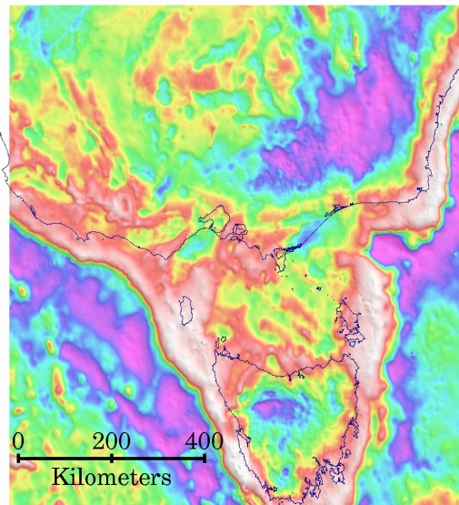  - Std=0.0001 | 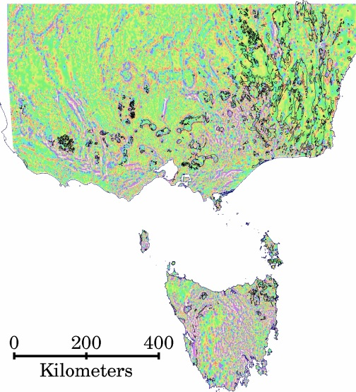  ∆mean = -0.031, ∆median = -0.018
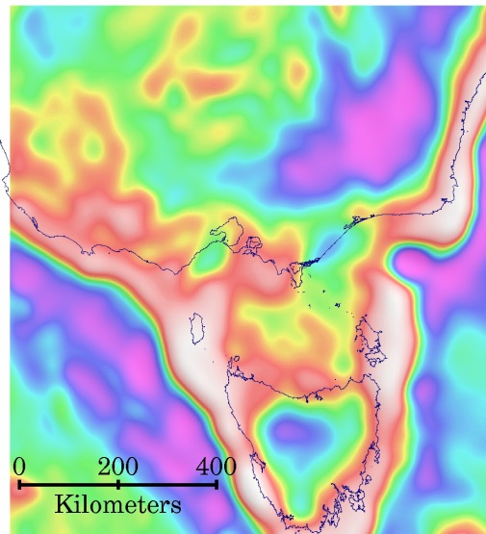  - Std = 0.00001 | 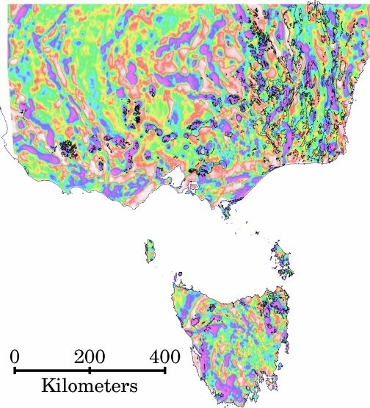  ∆mean = -0.601, ∆median = -0.656
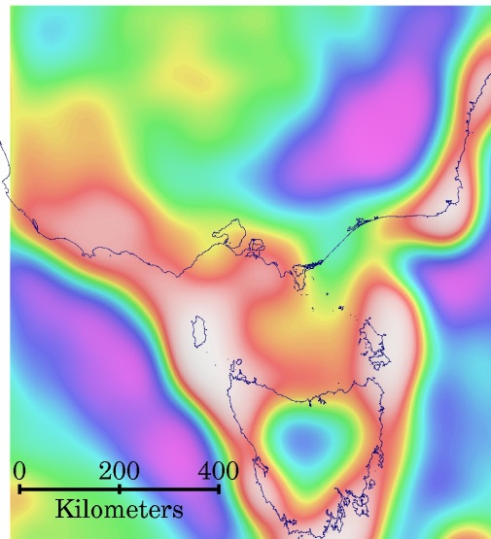  - Std = 0.000004 | 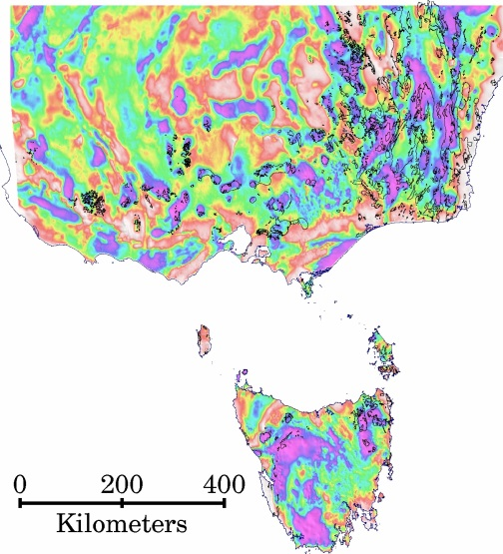  ∆mean = -1.096, ∆median = -1.242
Figure 3.2. Gaussian filter applied to Bouguer/Free-air gravity grid and the onshore residual after subtraction of the filtered output. The column on the left represents the regional field obtained by smoothing the observed field for standard deviation (std) ranging from 0.0001 (least smoothing, a) to 0.000004 (most smoothing, c). The column on the right shows the residual for each case, i.e. the difference between the observed and regional, and gives the mean (∆mean) and median (∆median) of these differences. For each figure, the the map projection is UTM zone 55 and the approximate boundaries across the centre of the map are 34°S – 43°40’S, 139°30’E – 150°40’E.
Regional (upward continuation) | Residual (observed – upward continuation regional)
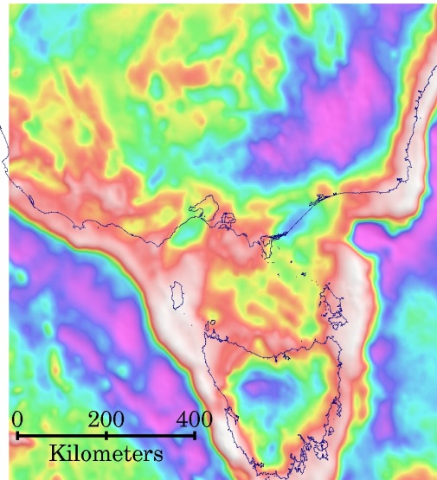  - 5km | 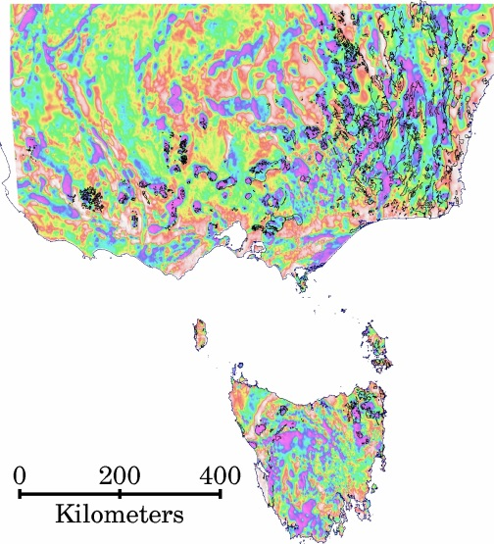  ∆mean = -0.525, ∆median = -0.580
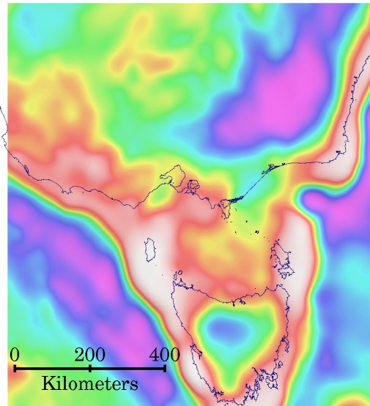  - 20 km, compare Roach et al. (1993) fig 3e | 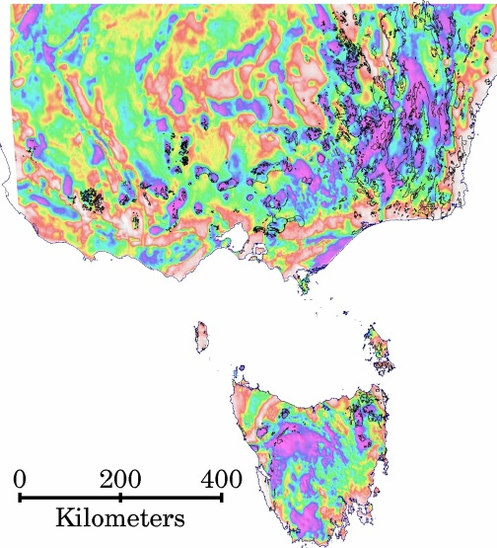  ∆mean = -1.235, ∆median = -1.688
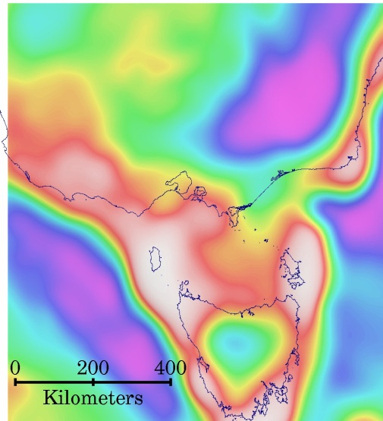  - 40 km | 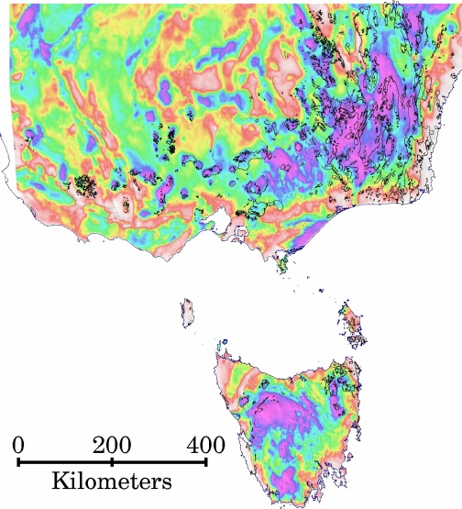  ∆mean = -1.773, ∆median = -2.435
Figure 3.3. Upward continuation filter applied to Bouguer/Free-air gravity grid and the onshore residual after subtraction of the filtered output. The column on the left represents the regional field obtained by upward continuation of the observed field for distances ranging from 5 km (least smoothing) to 40 km (most smoothing). The column on the right shows the residual for each case, i.e. the difference between the observed and regional, and gives the mean (∆mean) and median (∆median) of these differences. For each figure, the the map projection is UTM zone 55 and the approximate boundaries across the centre of the map are 34°S – 43°40’S, 139°30’E – 150°40’E.
Regional (Low-pass filter) | Residual (observed – Low-pass filtered regional)
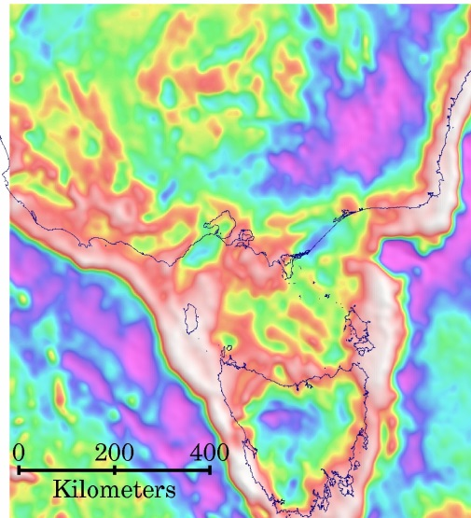  - 25 km | 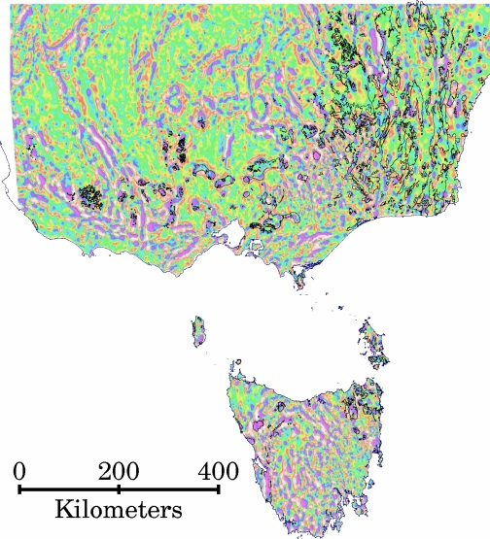  ∆mean = -0.144, ∆median = -0.069
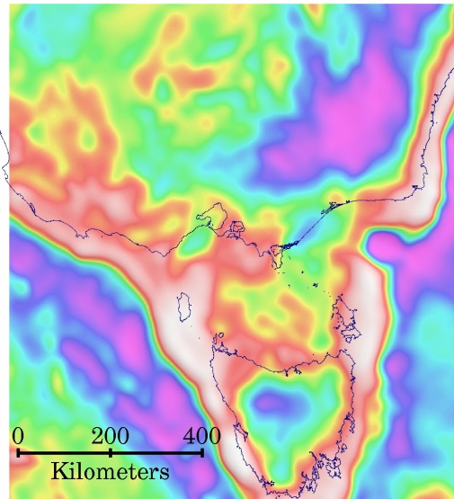  - 125 km | 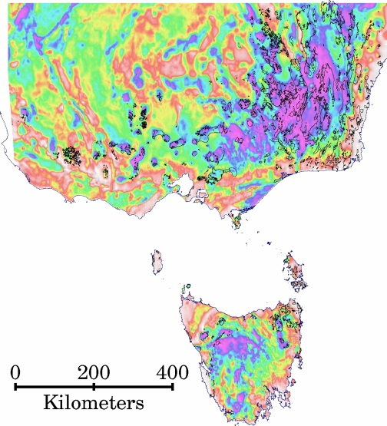  ∆mean = -1.750, ∆median = -2.449
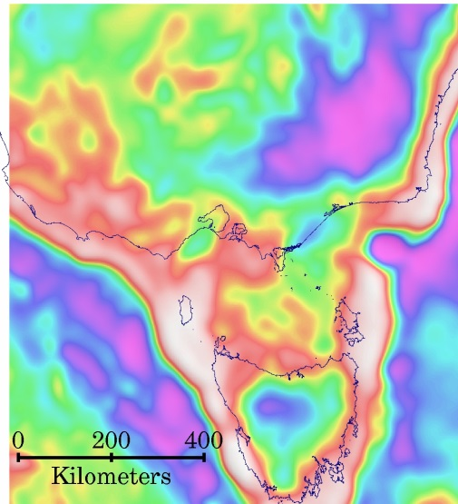  - 200 km | 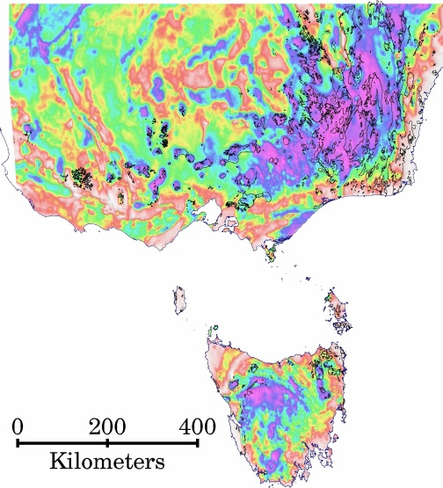  ∆mean = -2.026, ∆median = -2.839
Figure 3.4. Low-pass filter applied to Bouguer/Free-air gravity grid and the onshore residual after subtraction of the filtered output. The column on the left represents the regional field obtained by low-pass filter of the observed field for cut-offs ranging from 25 km (least smoothing) to 200 km (most smoothing). The column on the right shows the residual for each case, i.e. the difference between the observed and regional, and gives the mean (∆mean) and median (∆median) of these differences. For each figure, the the map projection is UTM zone 55 and the approximate boundaries across the centre of the map are 34°S – 43°40’S, 139°30’E – 150°40’E.

Figure 3.5. Low-pass filter regional, gravity difference between region of igneous felsic intrusive outcrops and whole region.
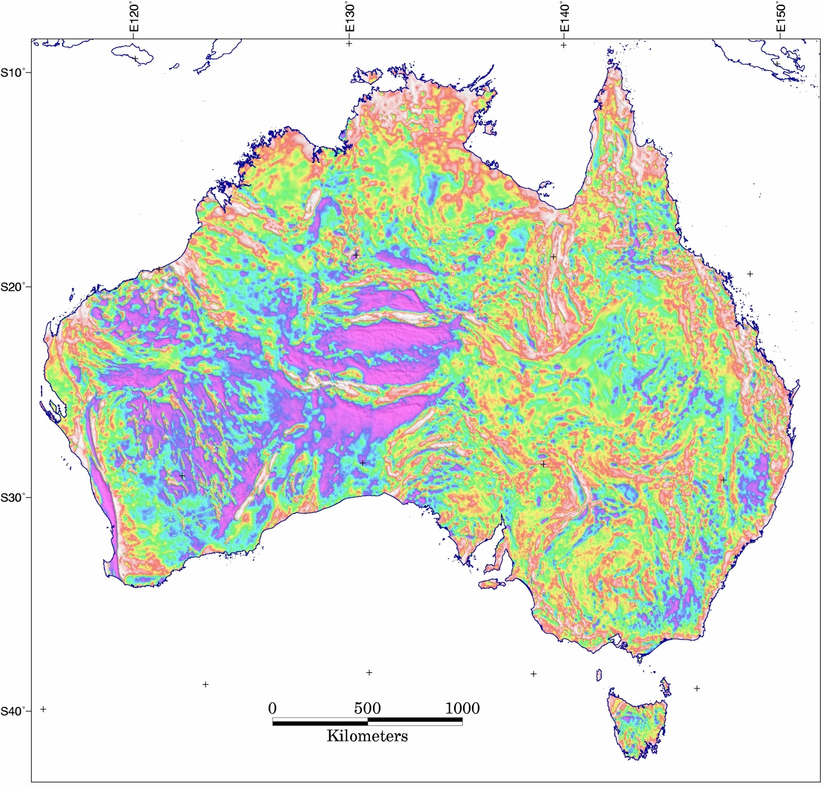
Figure 3.6. Bouguer gravity residual (observed - regional). Regional is low-pass filter of observed with 125 km cut-off. The map projection is Lambert Conformal Conic with standard parallels 18°S and 36°S and central meridian 134°E.

Processing contours of the residual
In the following, the ‘residual’ is the difference between the observed Bouguer gravity and a filtered version of itself after applying a low-pass filter with 125 km cutoff (grv_AUS_residual_LP_125km_asl_EPSG3112.ers). This residual grid was contoured using GMT software and the contours were processed to remove open-ended contours and closed contours which were not rounded in shape. The processing of the contours to determine proximity to intrusive outcrop is described below, with data files listed in Table 3.2 and a listing of software used given in Table 3.3. The process takes ~30 minutes to execute on the author’s PC (Xeon W3530, 2.8 GHz).
The process can be executed by wrapper program ‘gravity_and_granites’ which also writes the default settings and parameters and ERMapper header file for the output vector data file.
See Appendix A for the format of the ASCII vector files. Appendix B gives two ways to execute the processes on a PC.
Table 3.2. Data file names and contents, all projected to Geoscience Australia Lambert Conformal Conic (EPSG3112).
Data file | Contents
grv_AUS_residual_LP_125km_asl_EPSG3112.xy | ASCII export of ERMapper format Bouguer residual after removal of 125km low-pass filtered version, above-sea-level, Lambert Conformal Conic (EPSG3112)
grv_AUS_residual_LP_125km_asl_EPSG3112_20130916.grd | GMT grid of Bouguer residual
grv_AUS_residual_LP_125km_asl_EPSG3112_20130916.con | GMT contouring output
grv_AUS_residual_LP_125km_asl_contours_EPSG3112  _20130916 | Contours of Australia Bouguer gravity residual, ERMapper format.
grv_AUS_residual_LP_125km_asl_contours_EPSG3112  _20130916_rounded | Output from 'contour_filter' operating on above which leaves only the closed, rounded contours. A temporary file.
geo_AUS_IFI_LCC_mbr_20130423 | Igneous felsic intrusives with additional information in the label field as a comma delimited list, containing outcrop name, area in sq km, and minimum bounding rectangle.
intersecting_polygons | Temporary vector file containing gravity contour polygons which are colour-filled according to intersection and proximity to granite outcrop.
geo_AUS_granites_in_wells_EPSG3112_20130830 | Well locations where granites were encountered
grv_AUS_gravity_x_granites_0.5_0.5_EPSG3112_20130916 | The final output is an ERMapper format vector file containing gravity contour polygons which are colour-filled according to intersection and proximity to granite outcrop and granite found in wells.
Table 3.3. Programs developed by the author and their function. Software is written in Perl programming language and stored in the Energy Division software repository on /nas/pmd/prg/bin/ for executables and /nas/pmd/prg/src for development versions. Development versions have the same name but with .pl extension. Most programs write a log file of the same name and with extension *.log. The programs are available for internal Geoscience Australia use only.
Program name | Description
gravity_and_granites | Wrapper program which executes the programs listed below, and is an alternative to running the process in batch as given in the example in Appendix B.
contour_filter | Removes open-ended contours from an erv file, select for 'roundness' and write minimum bounding rectangle into polygon label.
outer_contour | Extracts the outermost contour in an erv file from an overlapping set.
polygon_mbr | Computes minimum bounding rectangle (MBR).
intersecting_polygons | Computes intersections between two sets of polygons.
subsection_erv | Extracts a portion of an erv file, by mapsheet.
merge_regions | Replaces all region names in an erv label with one name.
point_in_polygon | Finds intersections between polygons and points.
split_erv | Split off a section of an ERMapper erv polygon file based on colour.
join_worms | Join pairs of worms whose ends are close to each other. i.e. close small gaps.
close_worms | Form polygons from worms that are nearly closed.
worme-str2erv | Reformat Intrepid’s ASCII worm file to ERMapper vector format

Produce Contours: GMT Software
Software from the Generic Mapping Tools suite was used to compute contours of the residual Bouguer gravity grid. Other software, including ERMapper and Petrosys, gave unsatisfactory results at small scales for contouring. The xyz coordinates were exported from the ERMapper grid format of the residual grid and converted to a GMT format grid using GMT program ‘xyz2grd’, as in the following shell script:
#!/bin/tcsh
set XYZ = "../grav/resid/lopass/grv_AUS_residual_LP_125km_asl_EPSG3112.xy"
set REGION = "-2627964.197/2512391.975/-5466497.999/-944930.309"
set INC = "772.057/1475.226"
set OUT = "../grav/resid/lopass/grv_AUS_residual_LP_125km_asl_EPSG3112_20130916.grd"
xyz2grd $XYZ -G$OUT -R$REGION -V -I$INC
Following this, the contours were generated using the following shell script:
#!/bin/tcsh
set GRID = "../grav/resid/lopass/grv_AUS_residual_LP_125km_asl_EPSG3112_20130916.grd"
set CONTOURS = "../grav/resid/lopass/grv_AUS_residual_LP_125km_asl_EPSG3112_20130916.con"
set PSCON = "../grav/resid/lopass/grv_AUS_residual_LP_125km_asl_contours_EPSG3112_20130916.ps"
set ERV = "../grav/resid/lopass/grv_AUS_residual_LP_125km_asl_contours_EPSG3112_20130916"
set SCALE = "1:1"
grdcontour $GRID -S1 -V -L-20/-1 -C1 -Jx$SCALE -D$CONTOURS -m > $PSCON
and converted to an ERMapper vector format:
grdcontour2erv.pl $CONTOURS > $ERV
The output of this last stage was then filtered as described below.

Filter the contour file: contour_filter
This program was written to remove irregular, triangular and open-ended contours from the polyline contour file and write a contour polygon file. The minimum bounding rectangle was written into the polygon label.
The program accepts a parameter for minimum aspect ratio where 1=circle, 0=accept all. A minimum aspect ratio of 0.5 was specified. The aspect is calculated as 4π*area/perimeter2 which is “1” for a circle.
Other parameters required by the program are the geographic limits and contour range to operate on, and the colour fill for polygons.
Note that the output file has 'polygon' instead of 'poly' as the first word, and that the label contains additional information for contour level, area of contour polygon and the contour polygon MBR. The user input parameters may also have specified different colour and fill for ERMapper display.
grv_AUS_residual_LP_125km_asl_contours_EPSG3112_20130916 → grv_AUS_residual_LP_125km_asl_contours_EPSG3112_20130916_rounded
The output of this process is depicted for southeast Australia in Figure 3.7 for all contours, negative and positive.
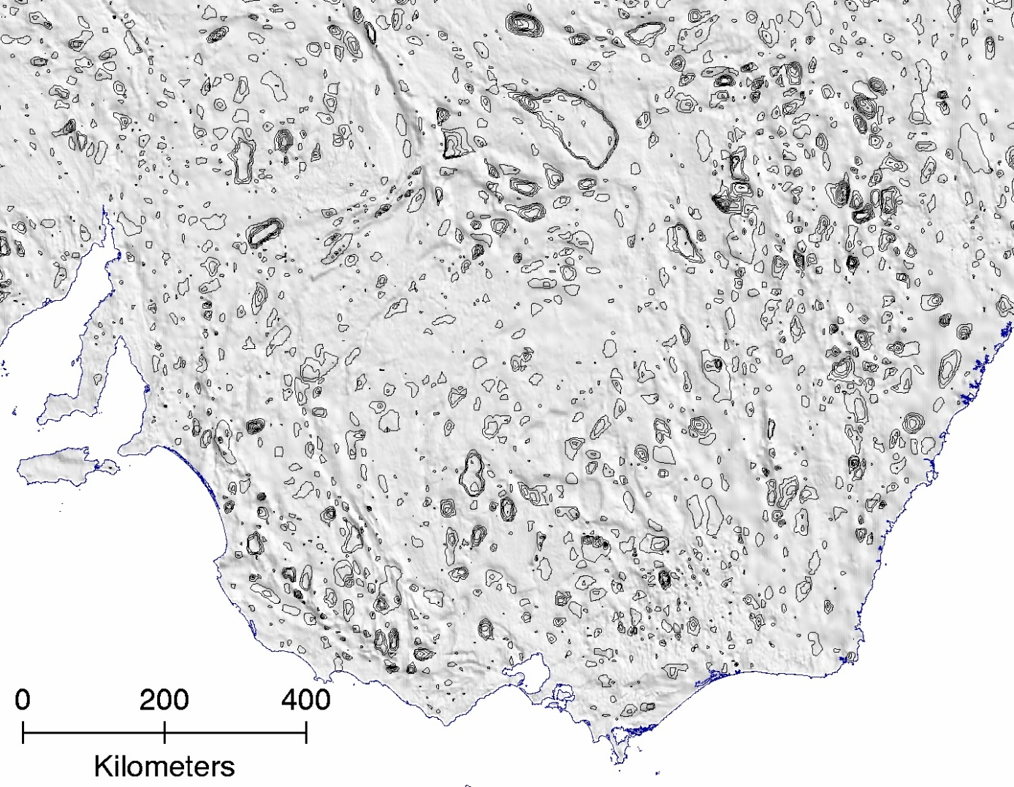
Figure 3.7. Bouguer gravity residual contours, negative and positive, selected for closure and roundness for a region of southeast Australia. The figure demonstrates output of the process contour_filter.pl

Extract outermost contours: outer_contour
The closed, rounded anomalies from the previous step (Figure 3.7) are nested, as in the case of concentric circles. This processing step removes all but the "top" contour for each anomaly. Any contour polygon that is overlain by another is removed. Therefore, for positive anomalies the basal contour is retained, and for negative anomalies the uppermost contour is retained. This is an approximate method for outlining the rounded anomalies using a single contour (Figure 3.8).
This isn't strictly necessary for the next step, but simplifies image display if contour polygons are not filled with colour. It also allows the next steps to complete in a shorter time.
The method takes about 10 minutes to execute on a PC. The program compares every polygon to every other polygon in the file, and keeps the outermost ones.
grv_AUS_residual_LP_125km_asl_contours_EPSG3112_20130916_rounded → grv_AUS_residual_LP_125km_asl_contours_EPSG3112_20130916_rounded_outer
The process accepts no input parameters apart from input and output files.
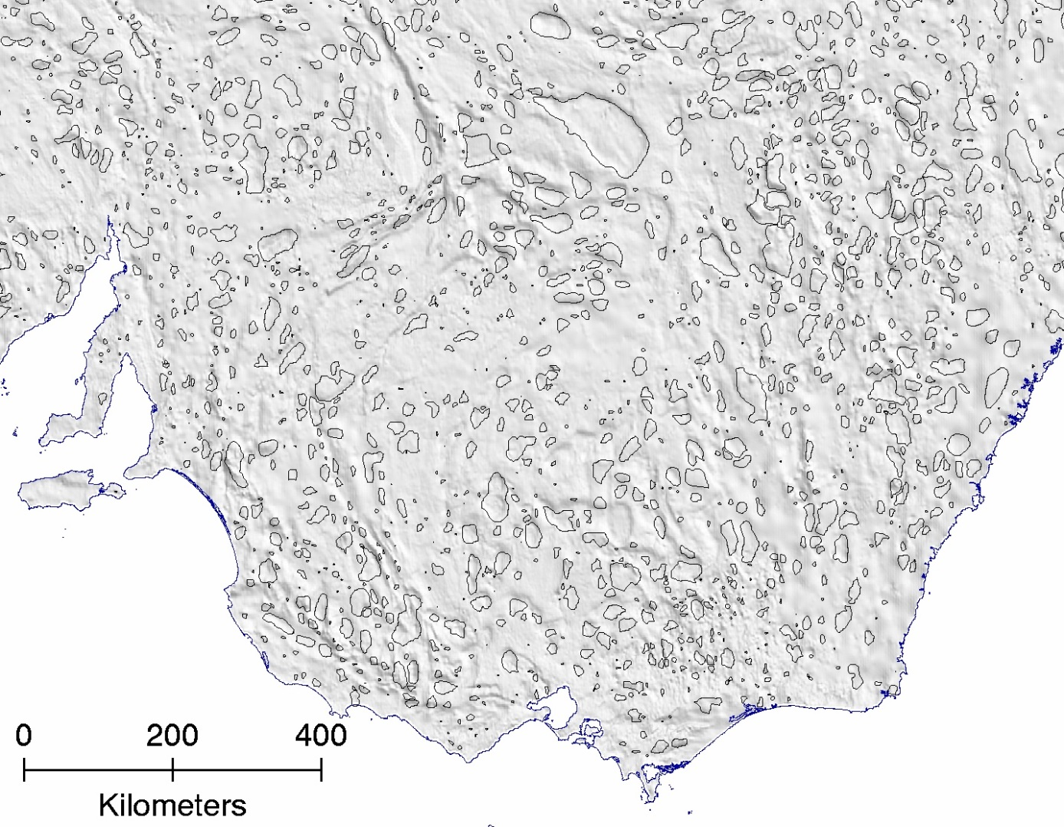
Figure 3.8. Bouguer gravity residual contours, negative and positive, selected for closure and roundness, for a region of southeast Australia, output of the process outer_contour.pl.

Compute minimum bounding rectangles (MBRs): polygon_mbr
To speed up the next step, the MBR is computed for each granite outcrop polygon and written into the label. The area in square km is also computed and written into the label.
Label contains name, area, MBR in EPSG3112 coordinates, eg.
"Gidley Granophyre,0.004,-1775016,-1774945,-2465404,-2465308"
geo_AUS_igneous_felsic_intrusives_LCC_20130423 → geo_AUS_IFI_LCC_mbr_20130423
‘IFI’ in the file name is the acronym for Igneous Felsic Intrusives.

Polygon intersections: intersecting_polygons
This program was written to find intersections between gravity contour polygons and granite outcrop polygons and proximity between them. This is the longest part of the process and takes about 20 minutes to execute on a PC.
File input parameters are for the two input files and the output file.
Input parameters for colour fill of gravity polygons allow colouring according to whether they are intersecting with outcrop polygons, near to outcrop polygons or distant from outcrop.
Gravity contour polygons can be identified by colour if they don’t intersect with granite outcrop polygons but nevertheless are nearby. The nearness threshold is Rf x √(A/π) where Rf is a user-specified factor (here set to 0.5) and A is the area (km2) of the gravity contour polygon.
grv_AUS_residual_LP_125km_asl_contours_EPSG3112_20130916_rounded +
geo_AUS_IFI_LCC_mbr_20130423 → intersecting_polygons (a temporary file)
The output ‘intersecting_polygons’ is an ERMapper format vector file of closed, rounded gravity contour polygons which are coloured according to their overlap or proximity to the granite outcrop.

Point intersections: point_in_polygon
This process was written to find intersections between rounded gravity contour polygons and well locations where granite was encountered in wells.
Three file input parameters are required for input and output files.
As for the previous stage, a nearness factor (Rf) is specified by the user and nearness threshold is calculated in the same way.
Colour is specified for fill of gravity contour polygons which intersect with wells or are close to wells in which granite was encountered.
intersecting_polygons + geo_AUS_granites_in_wells_LCC_20130522 → grv_AUS_gravity_x_granites_0.5_0.5_EPSG3112_20130916
The output file is in ERMapper vector format which is an ASCII file and easily edited if, say, the user wishes to use different colours than those specified during the processing run. See Appendix A for a description of the format.

Split vector file into components: split_erv
The simplest way to view the results to this point in ArcMap is to divide the vector file into separate files for the three components, ‘intersecting’, ‘nearby’ and ‘far’. Each of these vector files can then be exported from ERMapper into ArcMap shapefiles. It must be done this way rather than a single shapefile export because the export from ER Mapper does not retain the colour fill assigned to the polygons. The three separate shapefiles can be coloured in ArcMap according to the user’s needs (Figure 3.9 and Figure 3.10).
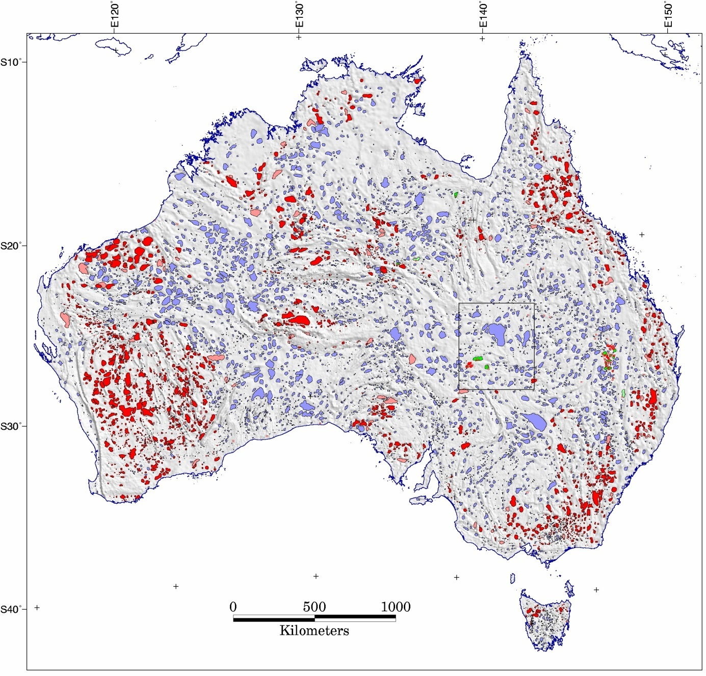
Figure 3.9. Residual Bouguer gravity image with closed, rounded, negative contours, coloured according to proximity to known granite occurrence. Red filled polygons intersect with granite outcrop, while pink filled polygons are close (as defined in the text) to granite outcrop. Green filled polygons contain wells which have granite at total depth, while light green polygons have wells with granite at total depth nearby. Other negative contour polygons, perhaps signifying buried granites, are coloured cyan. The Cooper Basin region (described below, Figure 3.11) is outlined by the black rectangle. The map projection is Lambert Conformal Conic with standard parallels 18°S and 36°S and central meridian 134°E.
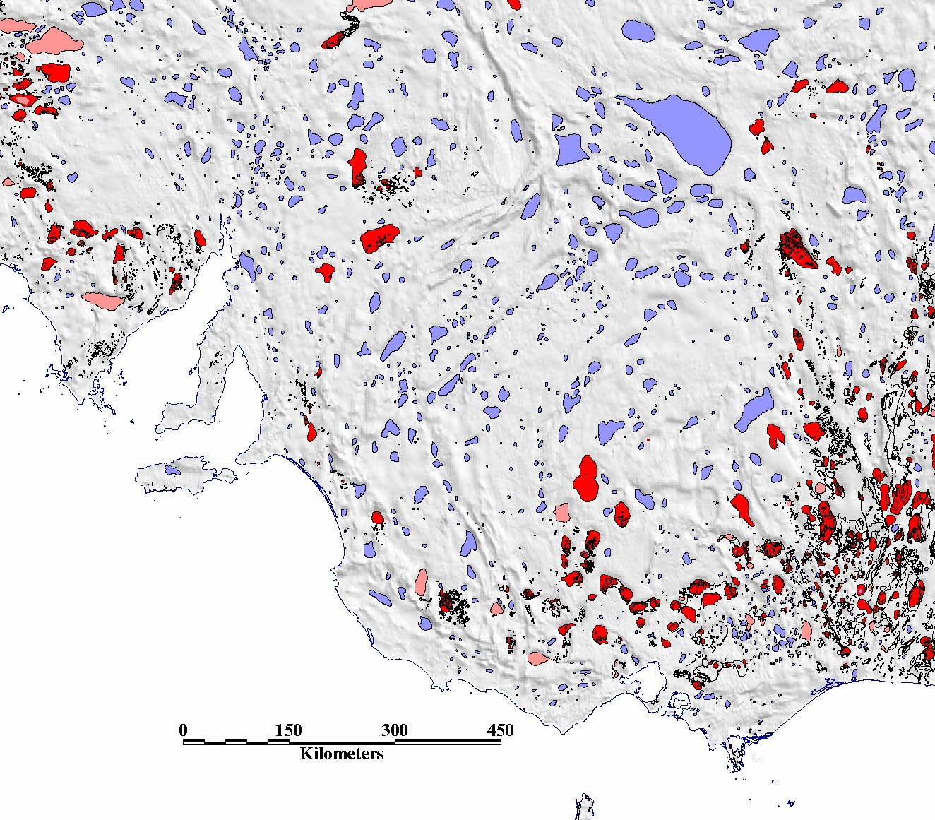
Figure 3.10. A closer view of negative gravity contour polygons (as in Figure 3.9) for southeast Australia with granite outcrop added in black outline. Red filled polygons intersect with granite outcrop. Pink filled polygons are close to granite outcrop. Other negative contour polygons are coloured cyan. The map projection is Lambert Conformal Conic with standard parallels 18°S and 36°S and central meridian 134°E. Latitude range along central meridian is approximately 29°35’S to 39° 55’S and longitude range across centre of map is 134°25’E to 148°15’E.

Cooper Basin granites
A search for granites on a basin scale was undertaken in the Cooper basin by Meixner and Holgate (2009), who produced a map of possible granite locations based on Bouguer gravity inversion. The results of their work are reproduced in Figure 3.11 using data provided by Meixner (pers. comm.), and combined with the results of contour polygon mapping carried out here. All of the inferred granite bodies are in regions of negative gravity residual, and there is general correspondence between the two approaches, as might be expected given that both are based on gravity. The inversion approach has identified many smaller bodies that do not show up in the regional contouring approach adopted here. And vice versa, the contouring approach points to other potential buried granite sites.
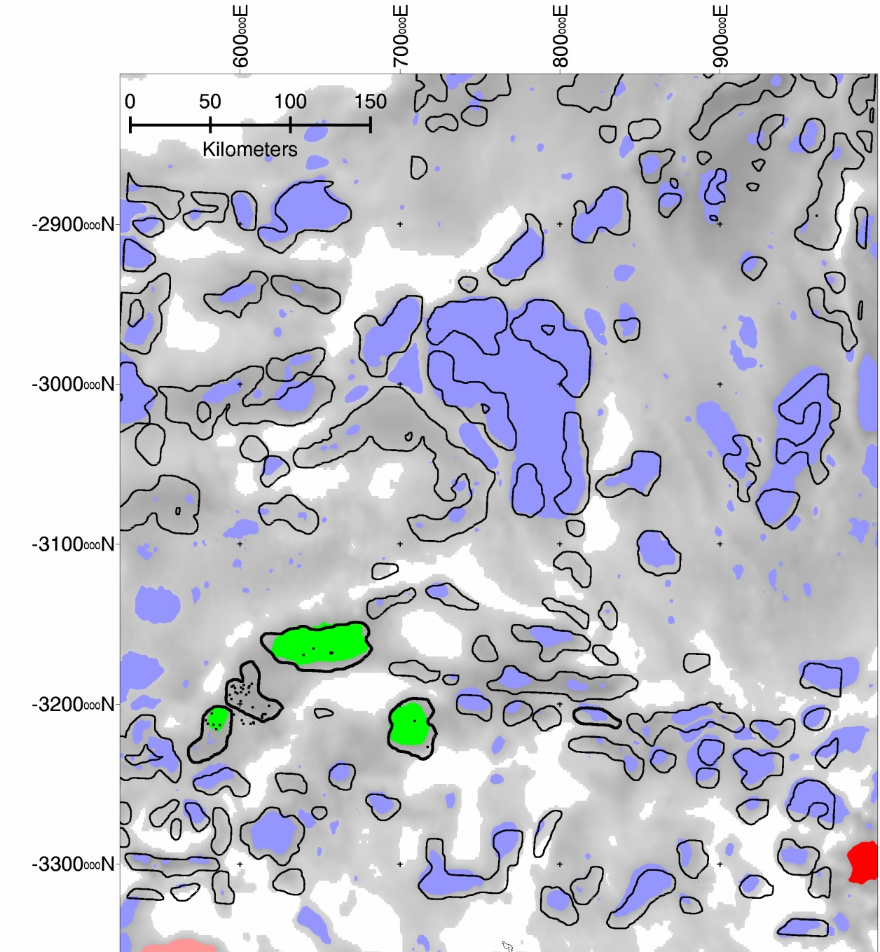
Figure 3.11. Cooper Basin study area of Meixner and Holgate (2009) showing their interpreted granite bodies in black outline. The Big Lake Suite and Devonian granites are outlined in bold. The background greyscale image is Bouguer gravity residual where it is negative and white areas where it is positive. The colour- filled polygons are closed, rounded gravity contours as in Figure 10 where red signifies an intersection with granite outcrop, green signifies intersection with granites found in wells, and cyan for polygons which are distant from outcrop and intersections in wells. The map projection is MGA54 (EPSG28354).

Worms
An alternative approach to the contour processing is to compute the maximum horizontal gradient of the Bouguer gravity field using the Intrepid software multi-scale edge detection component. Application of this process at several levels of upward continuation produces stacked lines along the maxima of horizontal gradient at each level (Archibald, et al., 1999; Boschetti et al., 2001). The resultant image is colloquially described as a ‘worm map’ due to its appearance of meandering lines. Henceforth, the term ‘worms’ will be used to describe these lines.
A number of tests were carried out to determine the minimum upward continuation level that would produce worms of longest extent and least amount of fragmentation. These were found to be 3500m and 4000m for the residual Bouguer gravity and Bouguer gravity grids, respectively.
An example of an Intrepid job file is given in Appendix C. This produces several outputs including worms as ASCII files and ERMapper vector files (Figure 4.1 and Figure 4.4).
The vector files are in the same format as used for the contouring approach (above), so some of the same software was used. However, preliminary steps were executed before intersections with outcrop were computed as before:
- Reformat the Intrepid worm output to ERMapper vector format;
- Join separate worms head to tail where heads and tails are close to each other. Some polygons are formed as a result of this process (Figure 4.2);
- Close worms into polygons where head and tail are close to each other; and
- Close worms across at the closest approach of one end and another. This can be envisaged as closing a carafe-shaped worm at the narrowest part of the neck (Figure 4.3 and Figure 4.5).
These processes were designed to mimic the action that an interpreter may take when looking for closed features on the map.
Following this, the same processing sequence was applied as for the contour processing to give a map of worm polygons intersecting and near to granites (Figure 4.5).
Appendix B contains a batch file for the worm processing for the continental data.
Figure 4.1. Worms computed from residual gravity, negative and positive values, at 3500 m upward continuation for southeast Australia. The map projection is EPSG3112. Latitude range is approximately 34°45’S to 39° 15’S and longitude range is approximately143°50’E to 150°20’E.
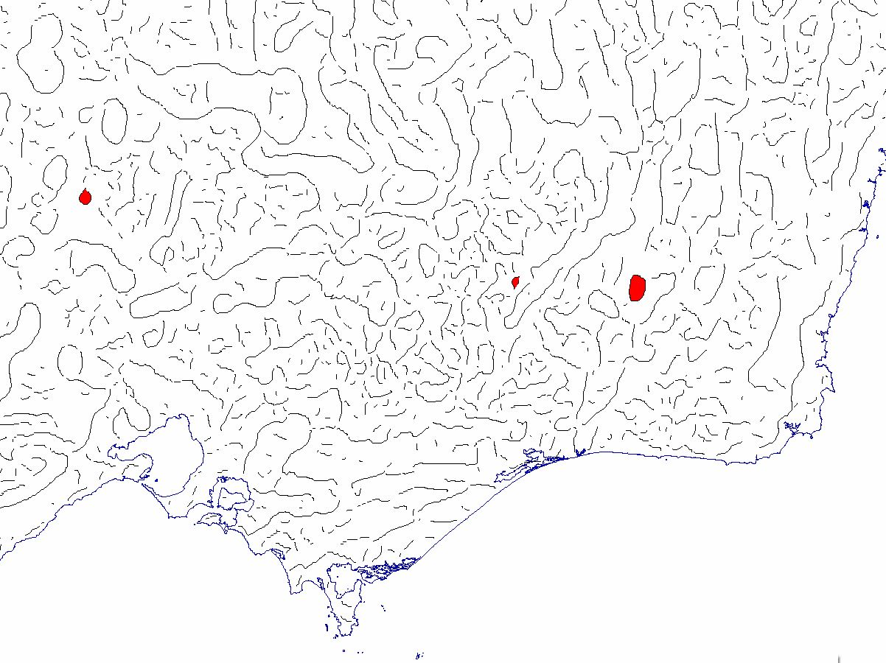
Figure 4.2. Joined worms computed from residual gravity at 3500 m upward continuation for southeast Australia. Resultant polygons are filled with red. Projection and dimensions as in Figure 4.1.
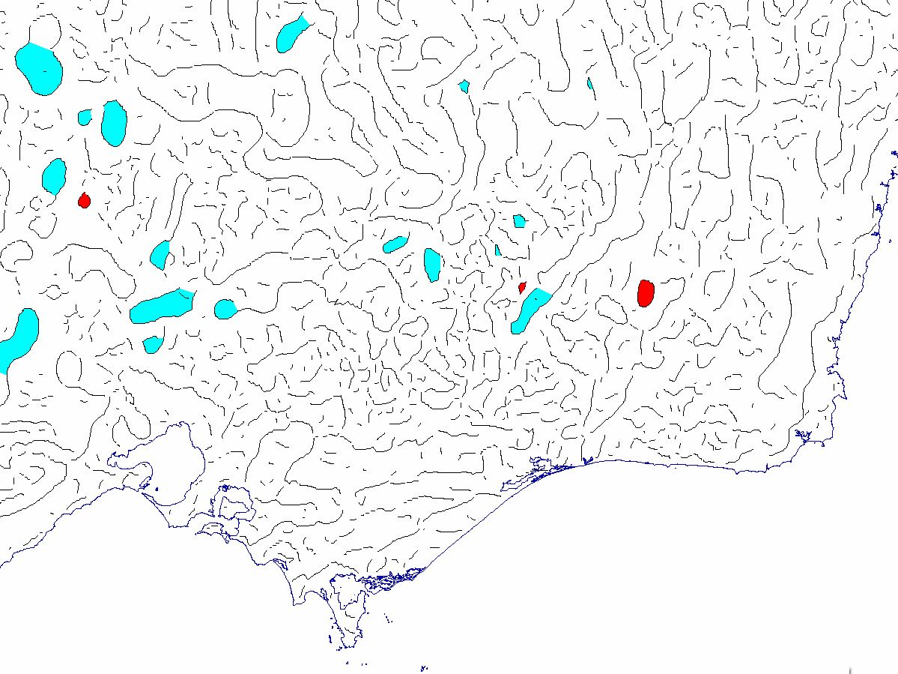
Figure 4.3. Joined and closed worms on residual gravity, positive and negative values, at 3500 m upward continuation for southeast Australia. The join process formed some polygons (red) and the close process formed additional polygons (cyan). Projection and dimensions as in Figure 4.1.

Concatenate Worms: join_worms
In this step the continuity of the worm map is improved by joining up worms whose ends (their heads and tails) are close to each other. The maximum gap to be filled was set to 5000m. Some polygons are also formed by this process (Figure 4.2).
Other parameters required by the process and the values used are:
- minimum number of polygon vertices (10);
- minimum number of points for output worms (10); and
- minimum area of polygons (10 km2).

Close worms into rounded polygons: close_worms
This process closes worms that are nearly closed to mimic how an interpreter may view the map. The closest approach of a worm with itself is closed off to form a polygon (Figure 4.3 and Figure 4.5).
The parameter that controls the threshold for closest approach is the ratio of perimeter:gap. In determining if a pair of points along a worm are to be connected to close off a polygon, the distance along the worm between the points (the ‘perimeter’) is compared to the straight line distance between the points (the ‘gap’). This ratio was set to ‘4’.
As before, the minimum number of vertices for output polygons was set to 10, and the minimum area for a polygon was set to 10 km2.

Proximity to known granites
Following this, the worm polygons were processed as for the contour polygons, firstly filtered for roundness, and finally computing intersections with and nearness to granite outcrop and encounters in wells (Figure 4.5).
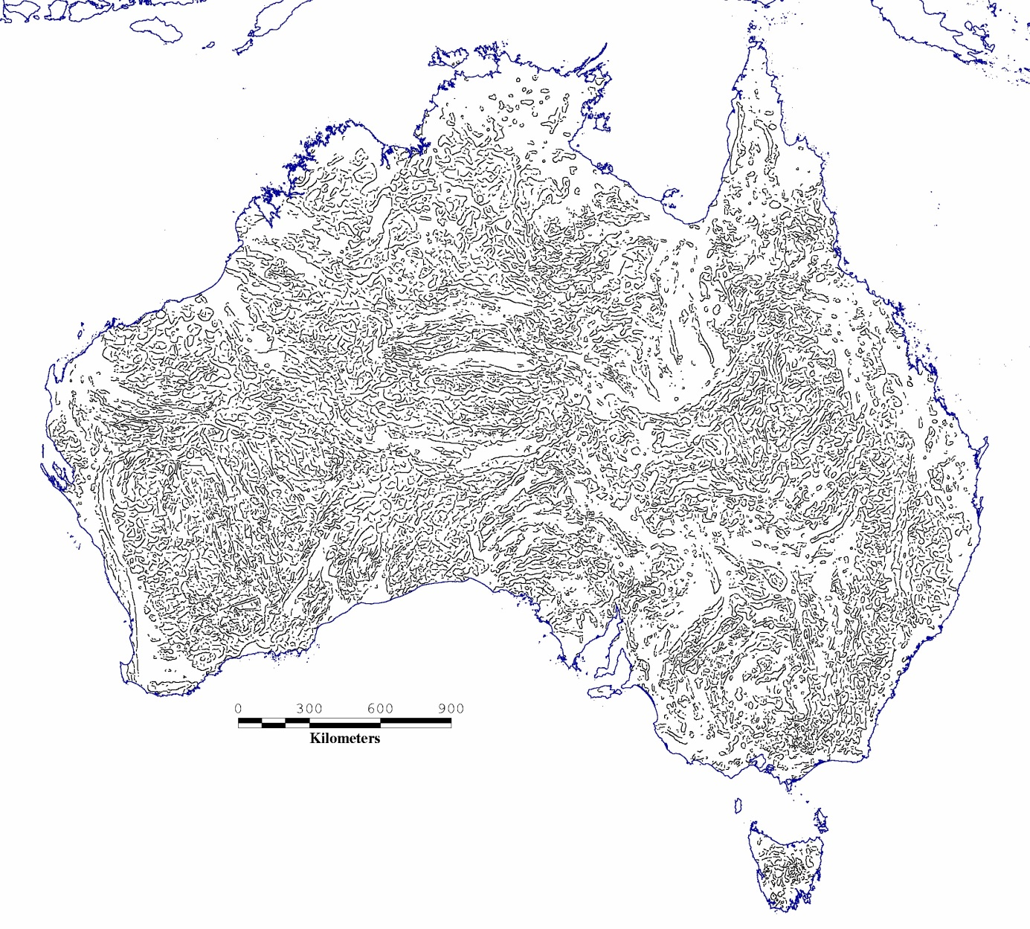
Figure 4.4. Worms of maxima for horizontal gradient for residual gravity, negative values only, upward continued to 3500 m. The map projection is Lambert Conformal Conic with standard parallels 18°S and 36°S and central meridian 134°E. Latitude range along central meridian is approximately 9°45’S to 45° 15’S and longitude range across centre of map is 111°E to 154°E.
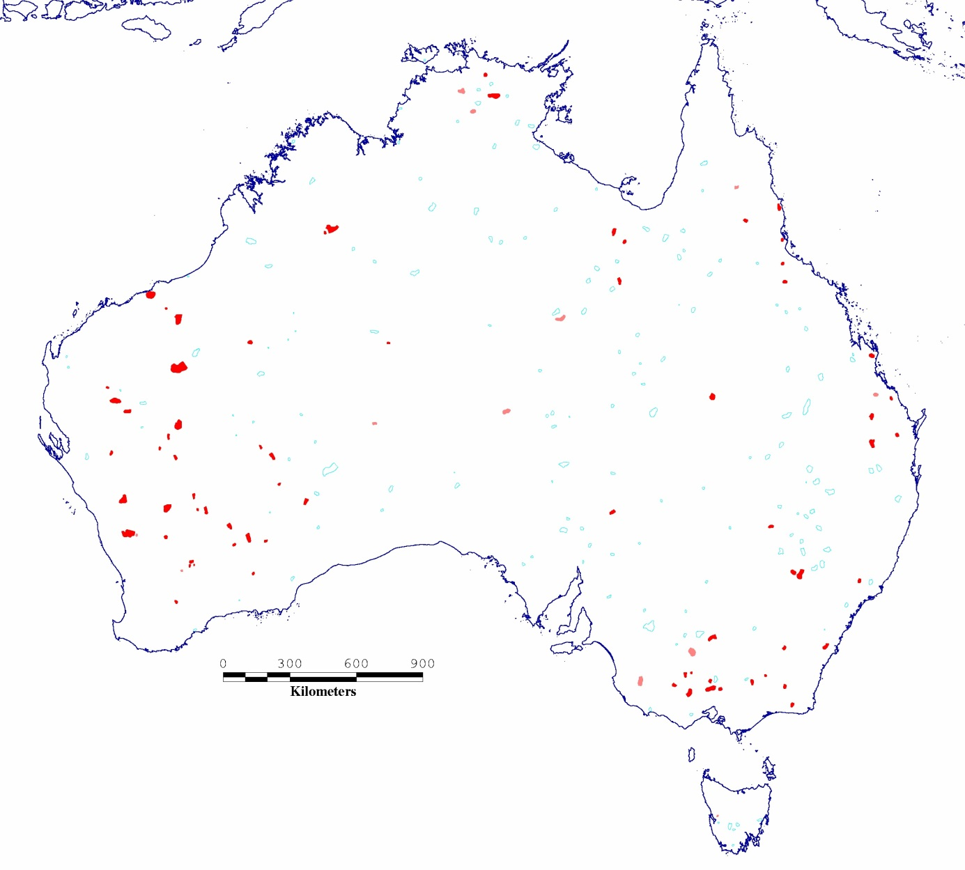
Figure 4.5. Worms on negative values only, joined and closed, filtered for roundness and intersecting with granites (filled red), or near granites (filled pink). The map projection is Lambert Conformal Conic with standard parallels 18°S and 36°S and central meridian 134°E. Latitude range along central meridian is approximately 9°45’S to 45° 15’S and longitude range across centre of map is 111°E to 154°E.

Discussion and Conclusions
This study was based on the observation and assumption that granites tend to be expressed in the gravity field by rounded, ovoid anomalies which, especially for high heat producing granites, are of low value because their density is often lower than the surrounding rock. The mapping of rounded anomalies in the gravity field was carried out, and the proximity of these anomalies to known granite outcrop was noted. Anomalies which are close to, or intersect with granite outcrop could be indicators of the subsurface extent of these granites. Other such anomalies, not intersecting or near to outcrop, could also be indicators of the existence of subsurface granites, however these could also be the expression of other low-density geological objects. The deduction of granite locations from gravity is complicated by this fact and mainly because low density basin sediments overlying hot low density granites are exactly the classic target for geothermal exploration. The maps therefore need to be examined with a geologically trained eye with consideration to the specific geological setting for each potential site.
In mapping rounded, negative, gravity anomalies the contouring approach gave a more plentiful range of sites to consider than did the worming approach. This, however, could be a limitation of the automated worm closure methods which didn’t close open-ended worms into polygons as effectively as a human interpreter may have done. Further work on tweaking the software parameters may improve the worm closures and hence give a greater number of possible granite indicators.
Another direction for future improvement is to use a regional gravity field based on geological knowledge of sediment cover over basement and Moho depth using independent datasets rather than the filtered Bouguer gravity as used here. A seismological 3D model of the crust and upper mantle is available (Kennett and Salmon, 2012) which includes a sediment layer (Frogtech, 2005), and there is a Moho grid for Australia from gravity inversion as well (Aitken, 2010). A regional gravity grid based on geological information would give more confidence in mapping rounded anomalies, but it is not expected to change the general distribution of anomalies presented here. There is no unique and precise characteristic geophysical signature that buried granites may be expected to manifest in a regional sense for an approach such as taken here to work with a high level of confidence.

Acknowledgements
The author acknowledges Anthony Budd and the Geothermal Energy team for criticism and support, Marcus Haynes, David Champion and Andrew Barrett for reviewing the document, David Champion, David Rowland, Tony Meixner and Ed Gerner for supply of granite outcrop and well data, and Daniel Rawson for publishing the document. The author publishes with the permission of the Chief Executive Officer, Geoscience Australia.

References
Aitken, A.R.A, 2010. Moho geometry gravity inversion experiment (MoGGIE): a refined model of the Australian Moho and its tectonic implications. Earth and Planetary Science Letters, 297, 71-83.
Archibald, N., Gow, P., Boschetti, F., 1999, Multiscale edge analysis of potential field data. Exploration Geophysics, 30, 38–44.
Boschetti, F., Hornby, P., Horowitz, F.G., 2001, Wavelet based inversion of gravity data, Exploration Geophysics, 32, 48-55.
Bott, M.H.P., Smithson, S.B., 1967. Gravity investigations of subsurface shape and mass distributions of granite batholiths. Geological Society of America Bulletin, 78(7),859-878. doi: 10.1130/0016-7606(1967)78[859:GIOSSA]2.0.CO;2
Boucher, R.K., 1996. Big Lake Suite not Tirrawarra Sandstone in the Moomba Field, Cooper Basin, SA. Report 96/31, 1-5. South Australia Department of Mines and Energy: Adelaide.
Christensen, N.I., Mooney,W.D., 1995. Seismic velocity structure and composition of the continental crust: a global view. Journal of Geophysical Research: Solid Earth, 100(B6), 9761-9788.
Frogtech, 2005. OZ SEEBASE Study 2005, Report to Shell Development Australia by FrOG Tech Pty Ltd.
Kennett, B.L.N., Salmon, M., 2012. AuSREM: Australian seismological reference model, Australian Journal of Earth Science, 59(8), 1091-1103.
Leaman, D.E., Richardson, R.G., 2003. A geophysical model of the major Tasmanian granitoids. Record 2003/11. Tasmanian Geological Survey: Hobart.
Liu, S., Raymond, O.L., Gallagher, R., Zhang, W., Highet, L.M., 2012. Surface Geology of Australia, 1:1000000 scale, 2012 edition. Geoscience Australia: Canberra.
Meixner, T., Holgate, F., 2009. The Cooper Basin region 3D Geological Map Version 1. Record 2009/15. Geoscience Australia: Canberra.
Olhoeft, G.R., Johnson, G.R., 1989. Densities of rocks and minerals, in, Carmichael, R.S., (ed), Practical handbook of physical properties of rocks and minerals. CRC Press: U.S. (Florida).
Roach, M.J., Leaman, D.E., Richardson, R.G., 1993. A comparison of regional-residual separation techniques for gravity surveys. Exploration Geophysics, 24, 779-784.
Taylor, G.K., 2007. Pluton shapes in the Cornubian Batholith: new perspectives from gravity modelling. Journal of the Geological Society, 164(3), 525–528. doi:10.1144/0016-76492006-104
Sandwell, D.T., Smith, W.H.F., 2009. Global marine gravity from retracked Geosat and ERS-1 altimetry: ridge segmentation versus spreading rate. J. Geophys. Res., 114(B01411). doi:10.1029/2008JB006008.
Sommerville, M., Wyborn, D., Chopra, P., Rahman, S., Estrella, D., Van Der Meulen, T., 1994. Hot dry rock feasability study. Report ERDC 94/243. Energy Research and Development Corporation: Canberra.

- Format of vector file
The contour data are ERMapper format vector files (referred to below as 'erv'), with record format for each contour polygon as follows:
polygon("label",np,[x1,y1,x2,y2,x3, ...,x1,y1],fill,width,pen,curved,r,g,b,page).
A contour file with open-ended contours has format:
poly("label",np,[x1,y1,x2,y2,x3, ...,x1,y1],end,width,pen,reserved,curved,fill,r,g,b,page).
where:
label - for our purposes a comma delimited list consisting of contour level and minimum bounding rectangle (‘MBR’) and so quotes are required. If this field is numeric then quotes are not required. The label is optional.
end - end of line style for open-ended lines. Use 0=plain
curved - spline condition, 0=straight, 1=curved. For display only.
fill - fill style, 0-19
np - number of coordinate values; 4 points need 8 coordinate values
page - coordinate reference, 0=image coordinates
pen - pen style, 0-23
r,g,b - colour components for red, green and blue, 0=255
width - line width in points
For example, a single record from a polygon file:
polygon("-19,5.4,-179840,-176435,-3107804,-3105163",8,[-179839.762,-3106450.079,-179839.762,-3106450.079,-179243.407,-3105791.153,,-179839.762,-3106450.07],1,1,0,0,100,100,255,0).

- Processing on a PC
- This batch file executes the gravity residual contour process in a DOS window on a PC:
@ECHO off
echo Gravity contour file processing

set "GRVdir=O:\Gravity_and_Granites\grav\resid\contour"
set "GRNdir=O:\Gravity_and_Granites\granites\Aust_LCC"
set "WELLSdir=O:\Gravity_and_Granites\wells"
set "bin=p:\bin"
set "src=p:\src"
set "perl=C:\perl64\bin\perl -f"

echo : filter contours for roundness, exclude open-ended contours, and compute MBRs for remainder
%perl% %src%\contour_filter.pl %GRVdir%\grv_AUS_residual_LP_125km_asl_LCC_contours %GRVdir%\grv_AUS_residual_LP_125km_asl_LCC_contours_rounded 0.5 -20 +20 0 0 0 0 -1203299 -5076825 -2196216 1998220

echo : filter by contour polygon size and retain outermost
%perl% %src%\outer_contour.pl %GRVdir%\grv_AUS_residual_LP_125km_asl_LCC_contours_rounded %GRVdir%\grv_AUS_residual_LP_125km_asl_LCC_contours_rounded_outer

echo : compute MBRs for granite outcrop polygons
%perl% %src%\polygon_mbr.pl %GRNdir%\geo_AUS_igneous_felsic_intrusives_LCC_20130423 %GRNdir%\geo_AUS_IFI_LCC_mbr_20130423 Y

echo : find intersections between rounded gravity contour polygons and granite outcrop polygons
%perl% %src%\intersecting_polygons.pl %GRVdir%\grv_AUS_residual_LP_125km_asl_LCC_contours_rounded_outer %GRNdir%\geo_AUS_IFI_LCC_mbr_20130423 %GRVdir%\intersecting_polygons 0.5 0 0 255 255 255 0 0 255 130 130 1

echo : find intersections between rounded gravity contour polygons and wells where granite is found
%perl% %src%\point_in_polygon.pl %GRVdir%\intersecting_polygons %WELLSdir%\geo_AUS_granites_in_wells_LCC_20130522 %GRVdir%\grv_AUS_gravity_x_granites_LCC_20130718 0.5 255 0 0 255 130 130

- Alternatively, the wrapper program can be initiated with the following command:
c:\perl64\bin\perl -f c:\prg\bin\gravity_and_granites gravity_and_granites_MSWin32_20130723.ini Y
which assumes that the wrapper program ‘gravity_and_granites’ has been copied to directory on a local drive.

- This batch file executes the gravity worm processing in a DOS window on a PC
@ECHO off
echo Gravity worm file processing

set "WRMdir=O:\Gravity_and_Granites\grav\wormE\3500L1_2\erv"
set "GRNdir=O:\Gravity_and_Granites\granites\Aust_LCC"
set "WELLSdir=O:\Gravity_and_Granites\wells"
set "bin=p:\bin"
set "src=p:\src"
set "perl=C:\perl64\bin\perl -f"

echo join worms which have head and tail close, i.e. interpolate across small gaps
echo -----------------------------------------------------------------------------
%perl% %src%\join_worms.pl %WRMdir%\worms_3500_mps2 %WRMdir%\worms_3500_mps2_joined=5000 5000 10 10 10 255 0 0
copy %WRMdir%\worms_3500_mps2.erv %WRMdir%\worms_3500_mps2_joined=5000.erv /y
move join_worms.log .\logs\worms_3500_mps2_joined=5000.log

echo close worms that are nearly closed
echo ----------------------------------
%perl% %src%\close_worms.pl %WRMdir%\worms_3500_mps2_joined=5000 %WRMdir%\worms_3500_mps2_joined=5000_closed=4 4 3 10 V
copy %WRMdir%\worms_3500_mps2.erv %WRMdir%\worms_3500_mps2_joined=5000_closed=4.erv /y
move close_worms.log .\logs\worms_3500_mps2_joined=5000_closed=4.log

echo filter worms for roundness, exclude open-ended contours, and compute MBRs for remainder
echo ---------------------------------------------------------------------------------------
%perl% %src%\contour_filter.pl %WRMdir%\worms_3500_mps2_joined=5000_closed=4 %WRMdir%\worms_3500_mps2_joined=5000_closed=4_rounded 0.5 0 0 0 0 0 0 -1203299 -5076825 -2196216 1998220
copy %WRMdir%\worms_3500_mps2.erv %WRMdir%\worms_3500_mps2_joined=5000_closed=4_rounded.erv /y

rem this was done in a previous run
rem echo : compute MBRs for granite outcrop polygons
rem %perl% %bin%\polygon_mbr.pl %GRNdir%\geo_AUS_igneous_felsic_intrusives_LCC_20130423 %GRNdir%\geo_AUS_IFI_LCC_mbr_20130423 Y

echo find intersections between rounded gravity worm polygons and granite outcrop polygons
echo -------------------------------------------------------------------------------------
%perl% %src%\intersecting_polygons.pl %WRMdir%\worms_3500_mps2_joined=5000_closed=4_rounded %GRNdir%\geo_AUS_IFI_LCC_mbr_20130423 %WRMdir%\intersecting_polygons.out 0.5 0 0 255 255 255 0 0 255 130 130 1

echo find intersections between rounded gravity worm polygons and wells where granite is found
echo -----------------------------------------------------------------------------------------
%perl% %src%\point_in_polygon.pl %WRMdir%\intersecting_polygons.out %WELLSdir%\geo_AUS_granites_in_wells_LCC_20130522 grv_AUS_worms_x_granites_LCC_20130802 0.5 255 0 0 255 130 130
copy %WRMdir%\worms_3500_mps2.erv grv_AUS_worms_x_granites_LCC_20130802.erv /y

- Intrepid Multi-scale edge detection job file
This is an example of an Intrepid software job file for computing multi-scale edges. In this case only one level is computed, at 3500m. If other levels are required, they are listed on the same line separated by commas. To set parameters Intrepid also has a wizard operated via the graphical user interface.
To run this job type the following at the DOS prompt:
"C:\Program Files (x86)\Intrepid\Intrepid4.5.598\bin\fmanager.exe" -batch wormE.job
Where an example wormE.job is listed below:

Process Begin
Name = WormE
Parameters Begin
Input_Grid Begin
Input_Grid = C:\Gravity_and_Granites\grav\resid\lopass\grv_AUS_residual_LP_125km_asl_LAM_AUST2.ers
Input_Band = 1
Input_Grid End
UC_Filtering Begin
Perform_RTP = no
Levels = 3500.
Structural_Picking = CURVATURE_GRADIENT_AMPLITUDE
Perform_VD = no
Pre_FFT_Transform Begin
Detrend_Degree = 0
Rolloff_Type = COSINE
Window_Type = None
Fill_Type = ARTHUR
FFT_Grid_Precision = IEEE4ByteComplex
FFT_Border = 120.0
Pre_FFT_Transform End
IGRF Begin
Name = Calculated
Date = 01/01/2001
Elevation = 0.10
IGRF End
Rarify Begin
Height_Mesh_Multiple = 8
Minimum_Rows = 613
Rarify End
IGRF Begin
Name = Calculated
Date = 01/01/2001
Elevation = 0.10
IGRF End
Rarify Begin
Height_Mesh_Multiple = 8
Minimum_Rows = 613
Rarify End
UC_Filtering End
Vector_Processing Begin
Worm_Processing Begin
Maximum_Point_Separation = 2.0
Worm_Dataset = C:\Gravity_and_Granites\grav\wormE\3500L1_2\Worms..DIR
Worm_Min_Nr_Points = 3
Euler_Minimum_Gradient_Amplitude = 0.1
Worm_Processing End
Point_Picking Begin
Minimum_Anomaly = 0.00005
Point_Depth_Estimation = yes
Name = Canny
Point_Dataset = C:\Gravity_and_Granites\grav\wormE\3500L1_2\Points..DIR
Point_Picking End
Vector_Processing End
Supplementry_Outputs Begin
Ascii_Worm_Dataset = C:\Gravity_and_Granites\grav\wormE\3500L1_2\asc\asciiWorms.str
Supplementry_Outputs End
Parameters End
Process End

The nomenclature for this file denotes an ERMapper grid header file for the Australian residual Bouguer gravity grid projected to Geoscience Australia standard continental Lambert Conformal Conic projection EPSG code 3112. EPSG refers to the European Petroleum Survey Group which maintains a registry of geodetic parameters, which are used in software such as ER Mapper and Petrosys. EPSG3112 is the Geoscience Australia Lambert Conformal Conic projection for continental-scale mapping with standard parallels 18°S and 36°S and central meridian 134°E.
See also: Multi-scale edge-detection “worming”: https://wiki.csiro.au/pages/viewpage.action?pageId=512590012 (viewed, 23/12/2013)
Worm closure was needed to take advantage of polygon-polygon and polygon-point intersection software.
Automated closure of worms was done using software ‘join_worms’ and ‘close_worms’.
ERDAS, 2008. ER Mapper customisation guide. ( web document viewed 14/10/2013).

