EDM Height Traversing Levelling Survey Report

Tarawa, Kiribati, August 2013
Geoscience Australia
RECORD 2014/18
S. J. K. Yates1, A. Lal2
- National Geospatial Reference Systems, Minerals and Natural Hazards Division, Geoscience Australia GPO Box 378 Canberra ACT 2601
- Secretariat of the Pacific Community (SPC).
Department of Industry
Minister for Industry: The Hon Ian Macfarlane MP
Parliamentary Secretary: The Hon Bob Baldwin MP
Secretary: Ms Glenys Beauchamp PSM
Geoscience Australia
Chief Executive Officer: Dr Chris Pigram
This paper is published with the permission of the CEO, Geoscience Australia
© Commonwealth of Australia (Geoscience Australia) 2014
With the exception of the Commonwealth Coat of Arms and where otherwise noted, all material in this publication is provided under a Creative Commons Attribution 3.0 Australia Licence. (http://www.creativecommons.org/licenses/by/3.0/au/deed.en)
Geoscience Australia has tried to make the information in this product as accurate as possible. However, it does not guarantee that the information is totally accurate or complete. Therefore, you should not solely rely on this information when making a commercial decision.
Geoscience Australia is committed to providing web accessible content wherever possible. If you are having difficulties with accessing this document please email clientservices@ga.gov.au.
ISSN 2201-702X (PDF)
ISBN 978-1-925124-07-01 (PDF)
GeoCat 78479
Bibliographic reference: Yates S. J. K, Lal A., 2014. EDM Height Traversing Levelling Survey Report, Tarawa, Kiribati, August 2013. Record 2014/18. Geoscience Australia, Canberra. http://dx.doi.org/10.11636/Record.2014.018

Contents
1 Introduction 1
2 The Survey 2
2.1 Bench Mark Locations – Tarawa 3
2.2 The Kiribati Datum 3
2.3 Equipment 3
2.4 Method 4
2.5 Kiribati 2013 Reduced Levels 4
2.6 Survey Support 5
2.7 Issues 5
3 Comparisons 6
3.1 Comparisons between 2013 and 2012 EDM Surveys 6
3.2 Combined Comparisons 7
3.3 Time Series of Bench Mark movement relative to Fixed Deep Bench Mark KIR1 8
4 Deep Bench Mark Locality Diagrams 12
5 Reference Mark Locality Diagram 18
6 Temporary Holding Mark Locality Diagrams 22
7 References 27

Introduction
This report outlines the high precision level survey completed between the Sea Level Fine Resolution Acoustic Measuring Equipment (SEAFRAME) tide gauge and the Continuous Global Navigation Satellite System (CGNSS) Station in Tarawa, Kiribati from 15th – 22nd August 2013.
Personnel involved in the survey were Steve Yates, Project Officer, Geoscience Australia and Andrick Lal, Surveyor, Secretariat of the Pacific Community (SPC).
The Electronic Distance Measurement (EDM) Height Traversing levelling technique was employed to observe differences in height between the deep bench mark arrays in Tarawa, which runs approximately 2.2km from the SEAFRAME tide gauge sensor to the CGNSS Station. Previous levelling surveys have been conducted along the route using this technique in 2006, 2007, 2009, 2010 and 2012.
In addition, precise differential levelling surveys were performed along the deep bench mark array from 1992 to 2006 by the National Tidal Centre Australia (NTCA) and the survey in 2006 included a comparison between the precise differential levelling and EDM height traversing techniques. This report contains a comparison between the 2013 and 2012 EDM height traversing results as well as a combined comparison since the first levelling survey in 1992.

The Survey
The EDM height traversing levelling survey was carried out between the SEAFRAME tide gauge sensor, CGNSS station and the deep driven bench mark array:
KIR1 – reference deep driven bench mark
KIR2 – deep driven bench mark
KIR3 – deep driven bench mark
KIR46 – deep driven bench mark
KIR47 – deep driven bench mark
KIR49 – deep driven bench mark
KIR12 – SEAFRAME sensor bench mark
KIR13 – SEAFRAME Project plaque bench mark
KIRIBM – reference bench mark for the GNSS pillar
Also included in the survey were temporary holding marks – KIR39, KIR44, KIR100, KIR101, KIR102, KIR104, KIR105 and KIR106.
The CGNSS Reference Point - KIRI and the three CGNSS Reference Marks – RM1, RM2 and RM3 were also levelled. All the deep bench marks were located and found in good order and undisturbed.
The EDM Height Traversing levelling technique was performed to the Class L2A specifications. After reduction an internal precision of 1mm √K or better was achieved, where K is distance in kilometres. This is well within the project specification of 2mm √K. A table of results and comparisons and the 2013 reduced levels are detailed later in this report.

Bench Mark Locations – Tarawa
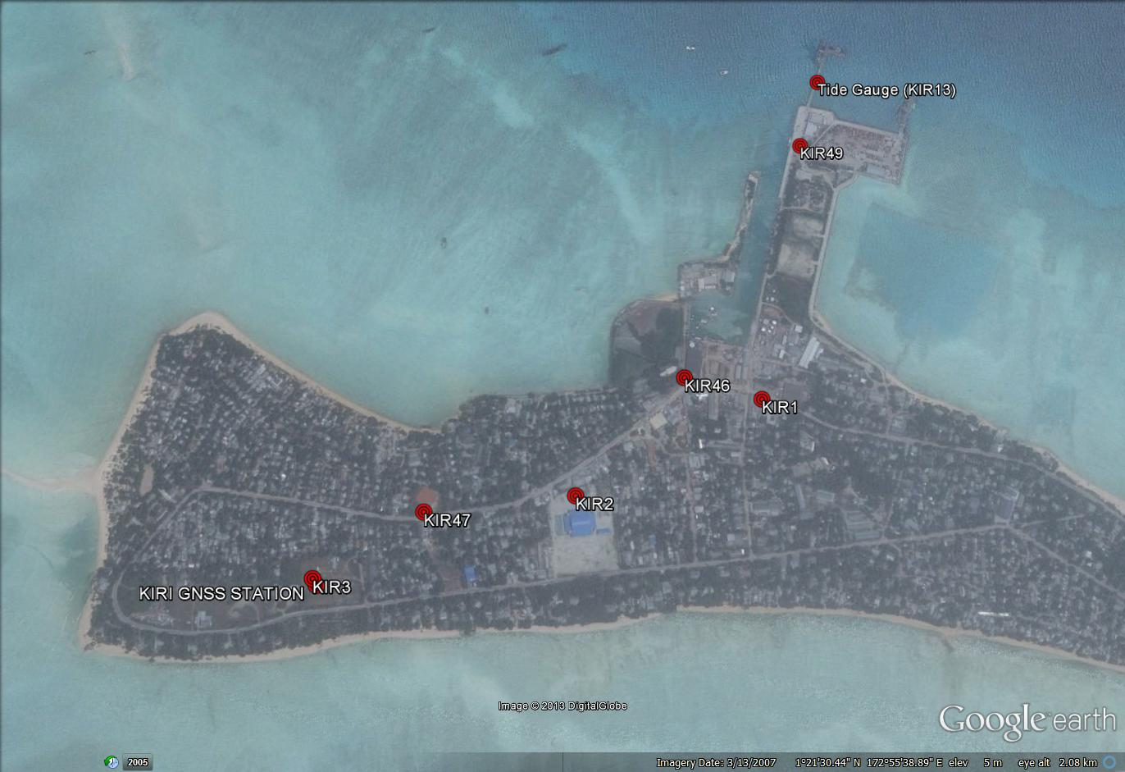

The Kiribati Datum
The adopted reference point for this survey is KIR1. Reduction of the data was calculated holding KIR 1 fixed at 3.5334 metres relative above the Tide Gauge Zero (TGZ) mark from the University of Hawaii tide gauge.
The original reference point for the 1992 survey was UT8 which had a height of 4.027 m above the Tide Gauge Zero (TGZ) mark from the University of Hawaii tide gauge, however, both the UT8 and the tide gauge no longer exist.

Equipment
- LEICA total station model TCA2003 and TM30 (Serial No: 361441)
- LEICA precision prisms GPH1P (2)
- LEICA rigid tripod
- Stainless steel target poles supported by LEICA telescopic bi-poles (2)
- Shortened stainless steel target pole for the SEAFRAME sensor BM connection
- LEICA cast iron change plates (2)
- KESTRAL 4000 pocket weather tracker

Method
The “Leap-Frog” EDM height traversing technique was employed for the Betio Island tide gauge levelling survey. This technique involves setting up a total station (TCA1800L) midway between two target/reflectors (on reflector rods with struts). The targets remain at a particular change point for the back-sight and fore-sight observations. The instrument measures slope distances (±1mm) and vertical angle (1”) to derive height differences (between the instrument’s trunnion axis and the reflectors). In support of the slope distance observations, the ambient temperature, pressure and humidity are recorded (Kestral 4000 pocket weather tracker) and input into the instrument to apply the first velocity correction to the observed distances (Rüeger & Brunner, 1982). Four rounds of observations are taken to the back-sight and fore-sight targets from each instrument setup. All levelling runs started and finished with the same reflector and reflector rod, i.e. an even number of setups when the two reflector rod configuration was used. This eliminates any reflector rod zero error. This technique can also be performed using a single set-up / single rod configuration which is particularly useful when levelling between bench marks which are close together e.g. between the CGNSS RMs.
Reduction of the digital data was computed by the Geoscience Australia levelling program “leveling1.exe”. This program computes the height difference between the two reflectors.

Kiribati 2013 Reduced Levels
Table 2.1 Tarawa, Kiribati – Reduced levels 2013 survey
Date: 15 – 22 August 2013
Datum: Tide Gauge Zero
Point ID | Reduced Level 2013 | Type
KIR1 | 3.5334 | Stainless Steel Rod in Ground
KIR102 | 4.0096 | Stainless Steel Pin in Concrete
KIR100 | 3.8317 | Stainless Steel Pin in Concrete
KIR39 | 4.0779 | Stainless Steel Pin in Concrete
KIR101 | 4.1426 | Stainless Steel Pin in Concrete
KIR49 | 4.0224 | Stainless Steel Rod in Ground
KIR12 | 4.2188 | Stainless Steel Pin in Concrete
KIR13 | 4.6316 | Stainless Steel Pin
KIR46 | 3.3801 | Stainless Steel Rod in Ground
KIR106 | 3.8032 | Stainless Steel Pin in Concrete
KIR104 | 3.6795 | Stainless Steel Pin in Concrete
KIR2 | 3.1836 | Stainless Steel Rod in Ground
KIR44 | 3.6198 | Stainless Steel Pin in Concrete
KIR47 | 3.2957 | Stainless Steel Rod in Ground
KIR105 | 3.8308 | Stainless Steel Rod in Ground
KIR3 | 3.5665 | Stainless Steel Rod in Ground
*KIRI | 5.3576 | Pillar Plate (ARP)
KIRIBM | 4.4147 | Stainless Steel Pillar Pin
KIRIRM1 | 3.5391 | Stainless Steel Rod in Ground
KIRIRM2 | 3.5017 | Stainless Steel Rod in Ground
KIRIRM3 | 3.5169 | Stainless Steel Rod in Ground
*The RL of the Reference Point KIRI (ARP) is derived from adding the static height difference of 0.9429m (KIRIBM to KIRI) to the 2013 levelled RL of KIRIBM.

Survey Support
Assistance from Boata Iabeta, Acting Chief Surveyor in Romano Reo’s absence, and his survey staff namely, Tiure Toorua and Tentao Takaaio; from the Ministry of Lands was appreciated, they provided great support throughout the survey, including assistance in obtaining customs clearances for the surveying equipment. This is a lengthy process and seems to becoming more time consuming throughout most countries in the Pacific.
The staff from the Kiribati Weather Office also provided great assistance during the 2013 visit.

Issues
No issues of any significance were encountered during the 2013 visit.

Comparisons

Comparisons between 2013 and 2012 EDM Surveys
Table 3.1 Results of Tarawa, Kiribati 2013 EDM Height Traversing Comparison 2013 – 2012. KIR1 - adopted fixed height of 3.5334m
From | To | Levelled Ht. Diff. | RL 2013 | Misclose (mm) | Dist. (km) | 1mm√k | RL 2012 | Difference (mm)  2013 - 2012
KIR1 |  |  | 3.5334 |  |  |  | 3.5334
KIR102 | KIR102 | 0.4762 | 4.0096 | -0.083 | 0.051 | 0.227 | 4.0097 | -0.12
KIR100 | KIR100 | -0.1779 | 3.8317 | 0.086 | 0.051 | 0.225 | 3.8323 | -0.65
KIR39 | KIR39 | 0.2463 | 4.0779 | 0.398 | 0.196 | 0.442 | 4.0789 | -0.99
KIR101 | KIR101 | 0.0647 | 4.1426 | -0.395 | 0.204 | 0.452 | 4.1438 | -1.21
KIR49 | KIR49 | -0.1202 | 4.0224 | -0.367 | 0.146 | 0.382 | 4.0234 | -1.04
KIR12 | KIR12 | 0.1965 | 4.2188 | -0.383 | 0.179 | 0.423 | 4.2210 | -2.16
 | KIR13 | 0.4127 | 4.6316 | -0.008 | 0.011 | 0.105 | 4.6336 | -2.05
KIR102 |  |  | 4.0096
KIR46 | KIR46 | -0.6294 | 3.3801 | 0.370 | 0.150 | 0.387 | 3.3802 | -0.07
KIR106 | KIR106 | 0.4230 | 3.8032 | -0.363 | 0.142 | 0.377 | 3.8038 | -0.64
KIR104 | KIR104 | -0.1236 | 3.6795 | 0.010 | 0.202 | 0.450 | 3.6805 | -0.97
 | KIR2 | -0.4960 | 3.1836 | -0.140 | 0.101 | 0.318 | 3.1840 | -0.43
KIR104 |  |  | 3.6795
KIR44 | KIR44 | -0.0597 | 3.6198 | -0.392 | 0.188 | 0.433 | 3.6212 | -1.39
KIR47 | KIR47 | -0.3241 | 3.2957 | 0.220 | 0.092 | 0.303 | 3.2968 | -1.06
KIR105 | KIR105 | 0.5350 | 3.8308 | 0.117 | 0.166 | 0.407 | 3.8295 | 1.27
KIR3 | KIR3 | -0.2642 | 3.5665 | 0.257 | 0.216 | 0.464 | 3.5666 | -0.07
 | KIRIBM | 0.8481 | 4.4147 | -0.108 | 0.070 | 0.265 | 4.4145 | 0.16
 |  |  | Misclose for all bays levelled = | -0.783 | 2.166 | 1.472
KIRIBM |  |  | 4.4147
 | RM1 | -0.8756 | 3.5391 | -0.092 | 0.043 | 0.208 | 3.5388 | 0.28
KIRIBM |  |  | 4.4147
 | RM2 | -0.9130 | 3.5017 | 0.067 | 0.050 | 0.223 | 3.5016 | 0.08
KIRIBM |  |  | 4.4147
 | RM3 | -0.8978 | 3.5169 | -0.058 | 0.031 | 0.177 | 3.5169 | 0.03
All levelling was performed within the project specifications of 2√k

Combined Comparisons
Examination of the level survey results do not show any significant changes in reduced levels from the 2012 survey. All indications are that no immediate or significant displacement of any of the deep driven bench marks has occurred.
Table 3.2 Tarawa, Kiribati – Deep Bench Mark final RL's for Precise Differential Levelling (1992 - 2005) and EDM Height Traversing (2005 - 2013).
Year | KIR1 | KIR2 | KIR3 | KIR12 | KIR13 | KIR46 | KIR47 | KIR49 | KIRIBM
1992.96 | 3.5334 | 3.1835 | 3.5657 | 4.2176 | 4.6302
1994.21 | 3.5334 | 3.1838 | 3.5655 | 4.2187 | 4.6319
1995.21 | 3.5334 | 3.1845 | 3.5654 | 4.2195 | 4.6331
1996.71 | 3.5334 | 3.1843 | 3.5654 | 4.2191 | 4.6321
1997.96 | 3.5334 | 3.1843 | 3.5657 | 4.2196 | 4.6325
1999.46 | 3.5334 | 3.1844 | 3.5644 | 4.2195 | 4.6324
2000.63 | 3.5334 | 3.1847 | 3.5658 | 4.2195 | 4.6321
2002.46 | 3.5334 | 3.1843 | 3.5648 | 4.2191 | 4.6321 | 3.3782 | 3.2948 | 4.0232 | 4.4124
2004.46 | 3.5334 | 3.1843 | 3.5653 | 4.2190 | 4.6324 | 3.3788 | 3.2952 | 4.0225 | 4.4130
2006.21 | 3.5334 | 3.1839 | 3.5662 | 4.2195 | 4.6328 | 3.3788 | 3.2956 | 4.0226 | 4.4139

Year | KIR1 | KIR2 | KIR3 | KIR12 | KIR13 | KIR46 | KIR47 | KIR49 | KIRIBM
2006.21 | 3.5334 | 3.1844 | 3.5646 | 4.2193 | 4.6326 | 3.3794 | 3.2953 | 4.0230 | 4.4124
2007.88 | 3.5334 | 3.1830 | 3.5641 | 4.2202 | 4.6308 | 3.3795 | 3.2941 | 4.0230 | 4.4119
2009.17 | 3.5334 | 3.1835 | 3.5646 | 4.2199 | 4.6320 | 3.3791 | 3.2951 | 4.0229 | 4.4125
2010.71 | 3.5334 | 3.1828 | 3.5655 | 4.2200 | 4.6322 | 3.3794 | 3.2954 | 4.0229 | 4.4134
2012.16 | 3.5334 | 3.1840 | 3.5666 | 4.2210 | 4.6336 | 3.3802 | 3.2968 | 4.0234 | 4.4145
2013.62 | 3.5334 | 3.1836 | 3.5665 | 4.2188 | 4.6316 | 3.3801 | 3.2957 | 4.0224 | 4.4147
The 2013 RL of KIRI is 5.3576m
*The RL of the Reference Point KIRI (ARP) is derived from adding the static height difference of 0.9429m (KIRIBM to KIRI) to the 2013 levelled RL of KIRIBM.

Time Series of Bench Mark movement relative to Fixed Deep Bench Mark KIR1
Precise Differential Levelling: 1992 - 2005
EDM Height Traversing: 2005 onwards

Deep Bench Mark Locality Diagrams
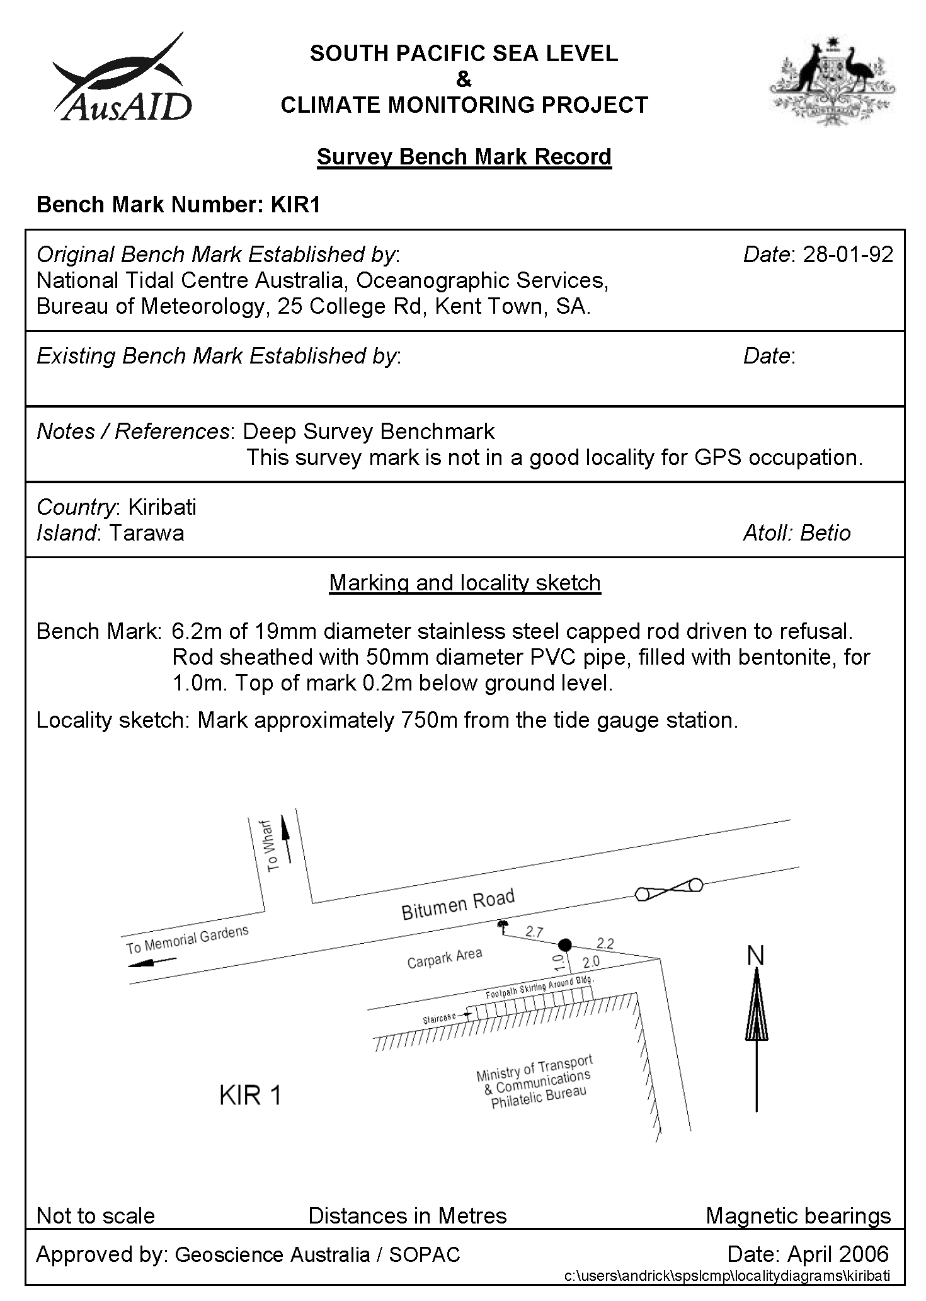
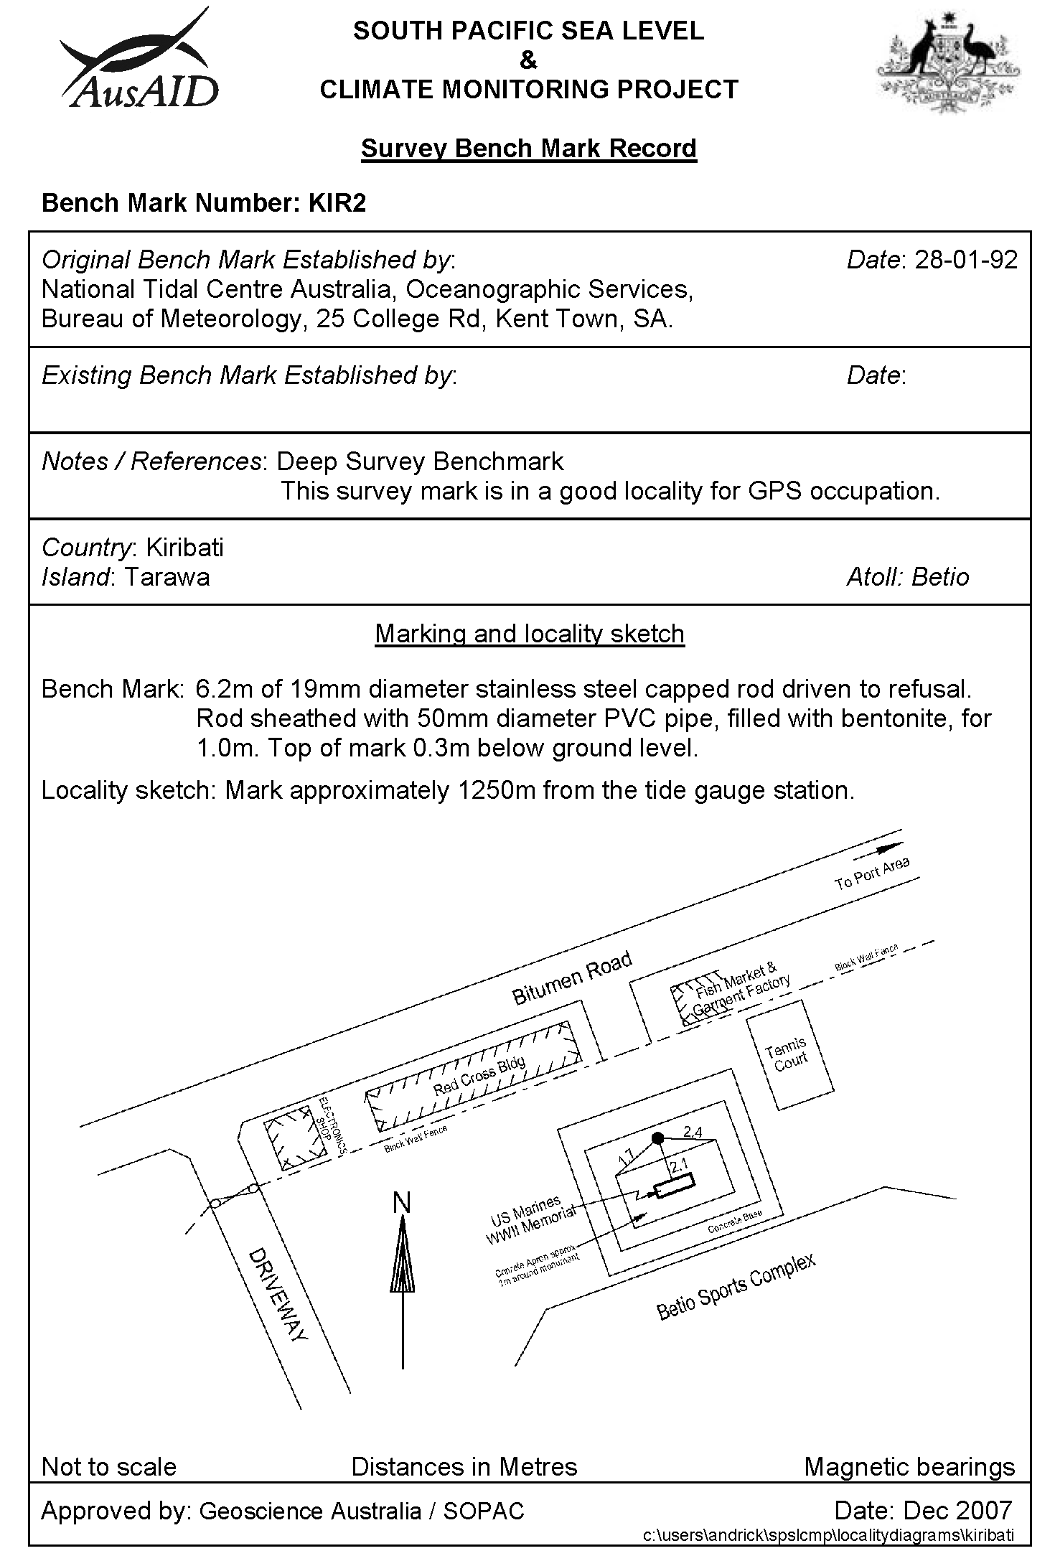
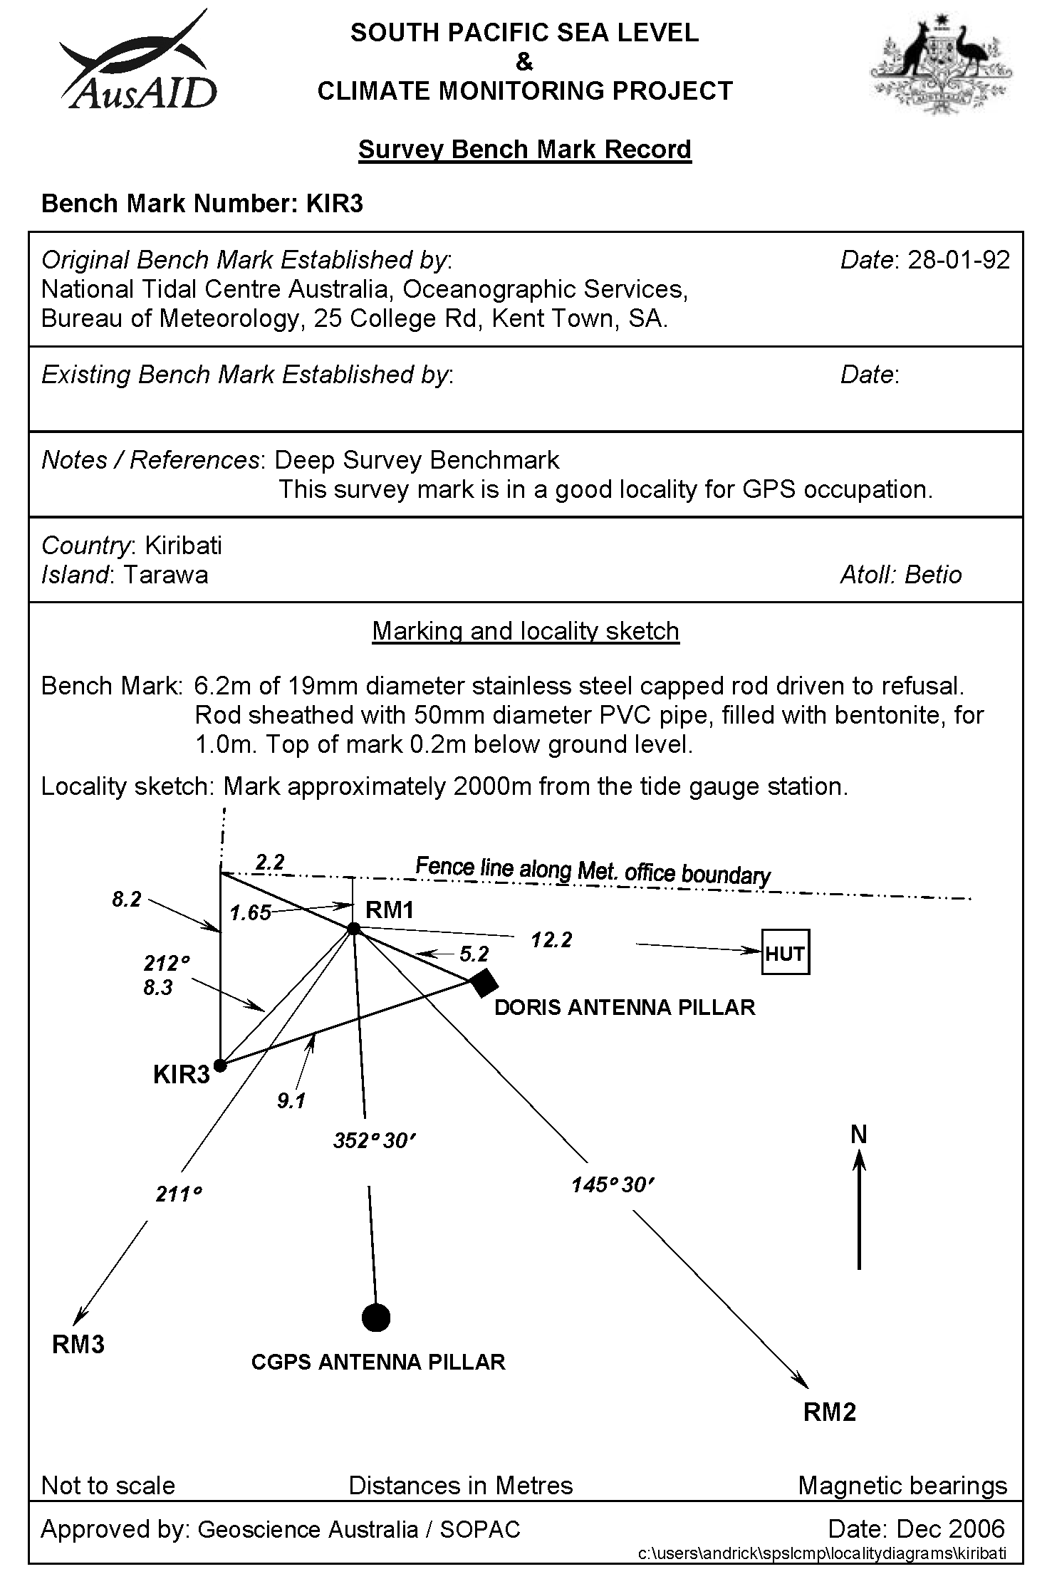
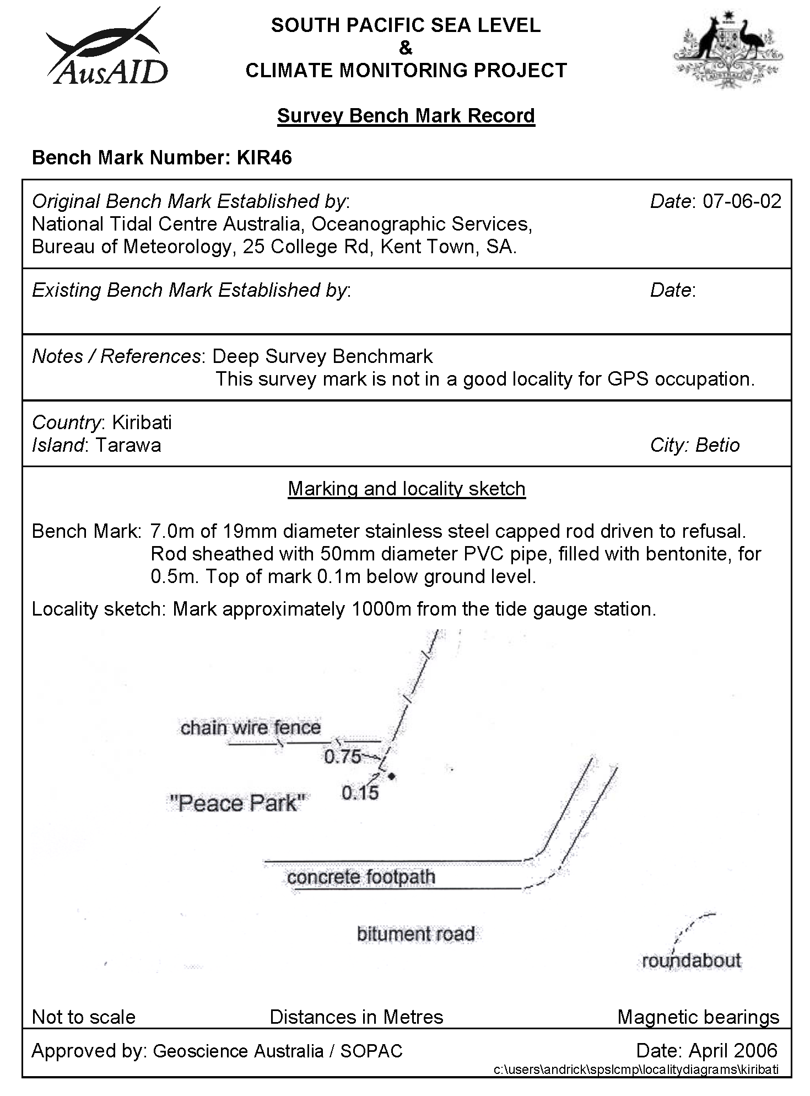
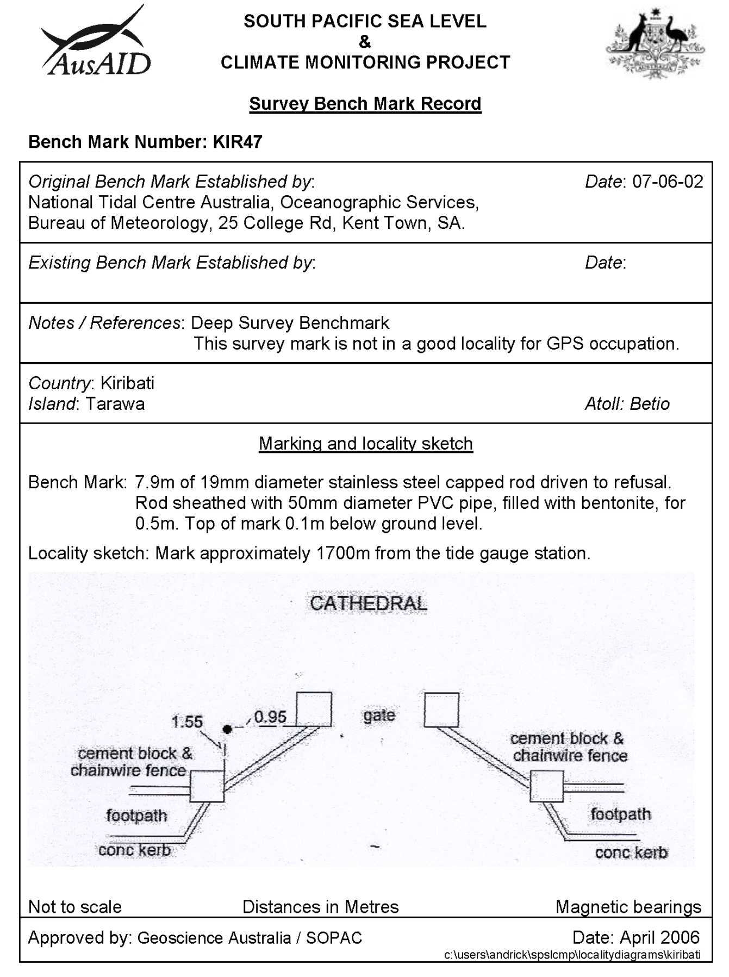
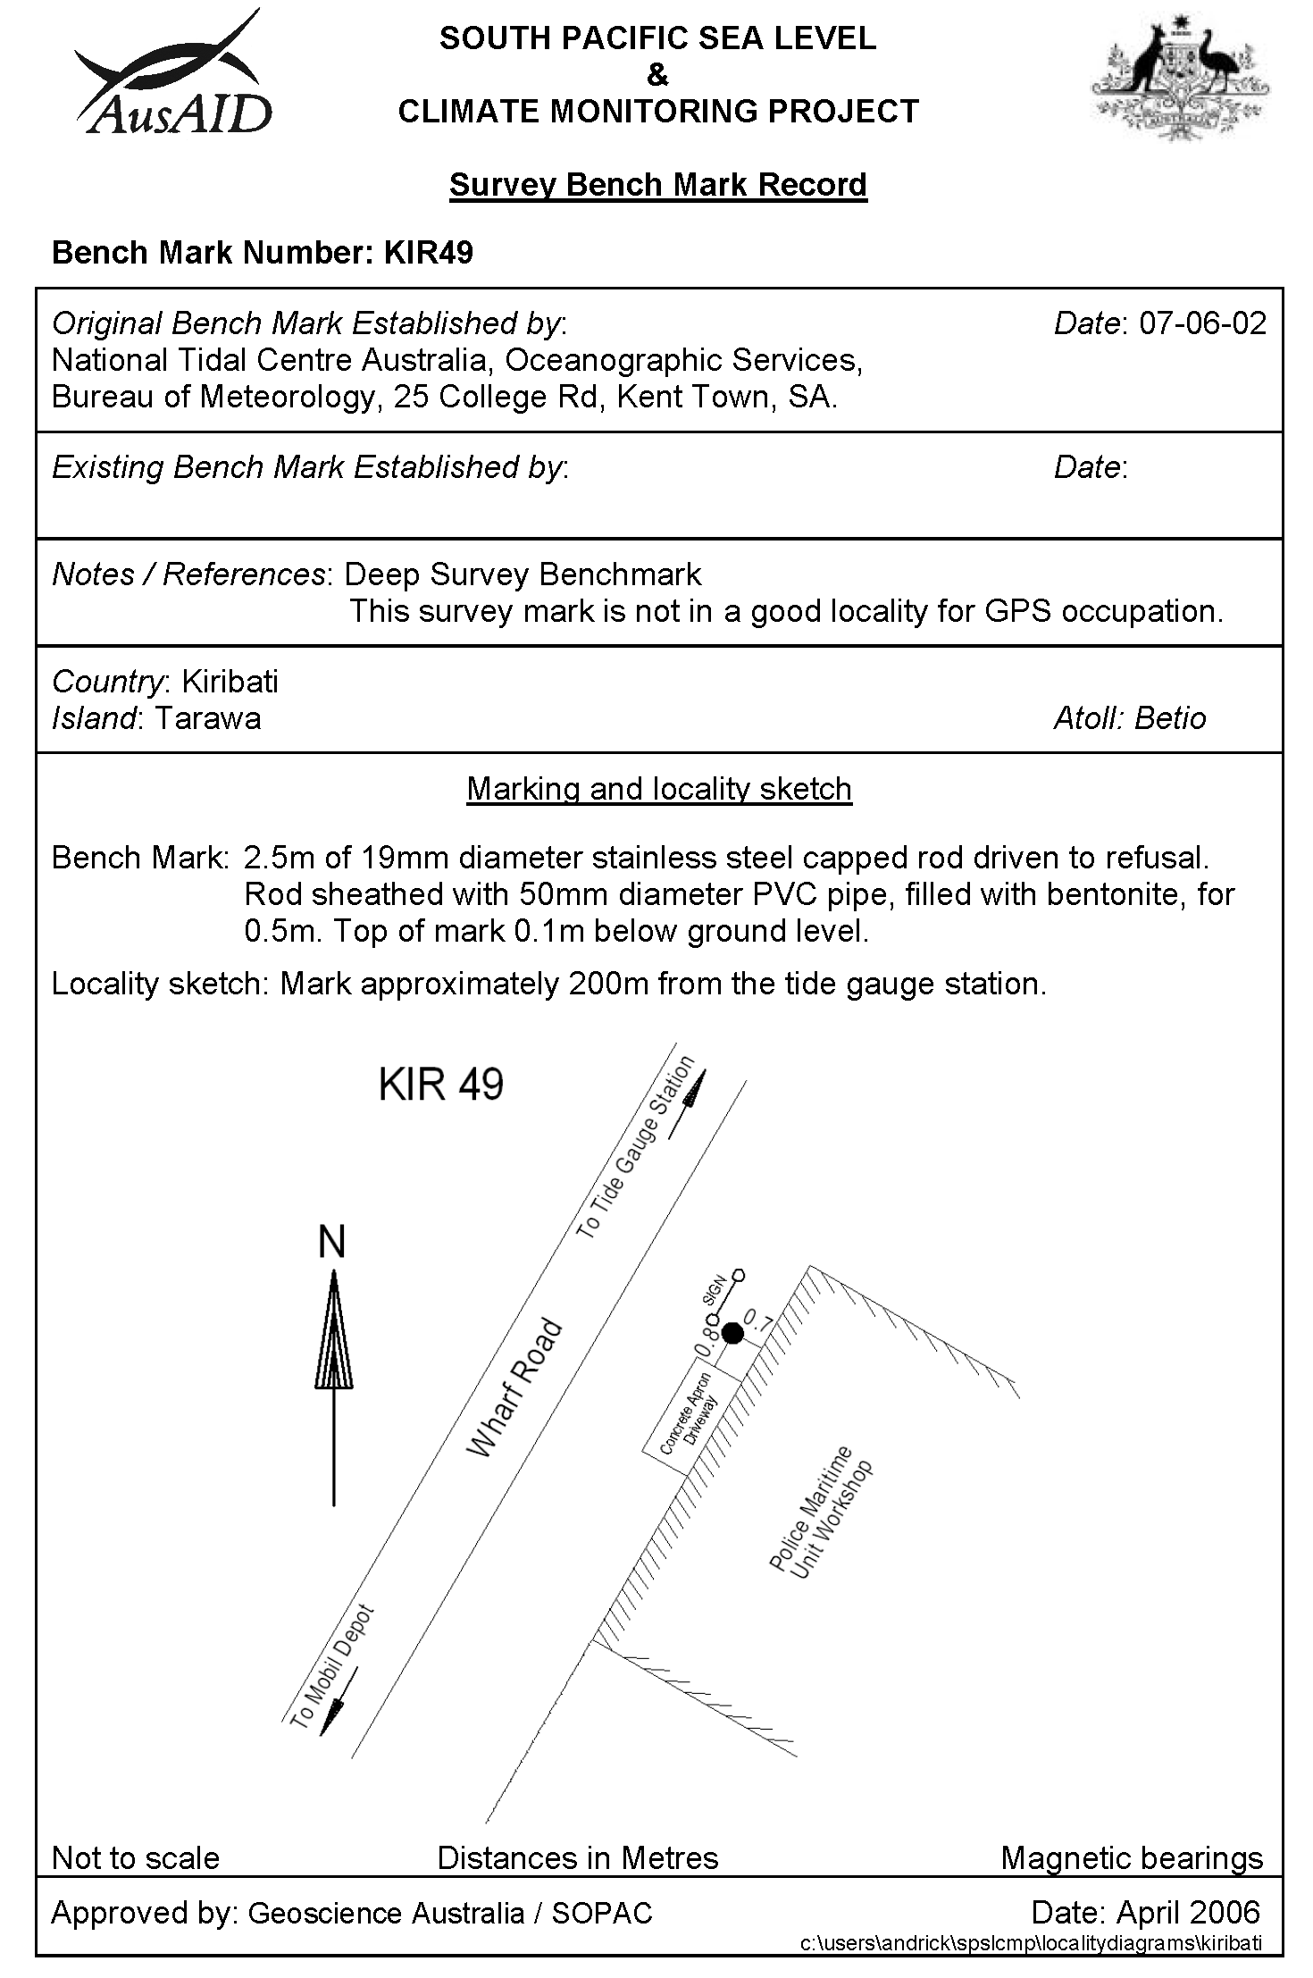

Reference Mark Locality Diagram
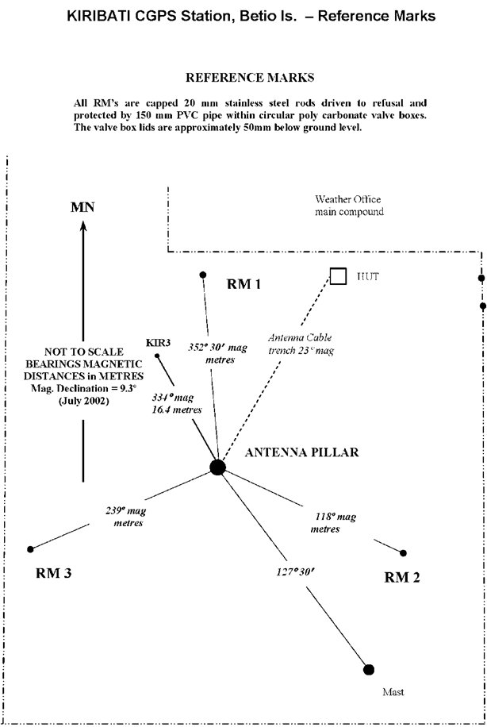
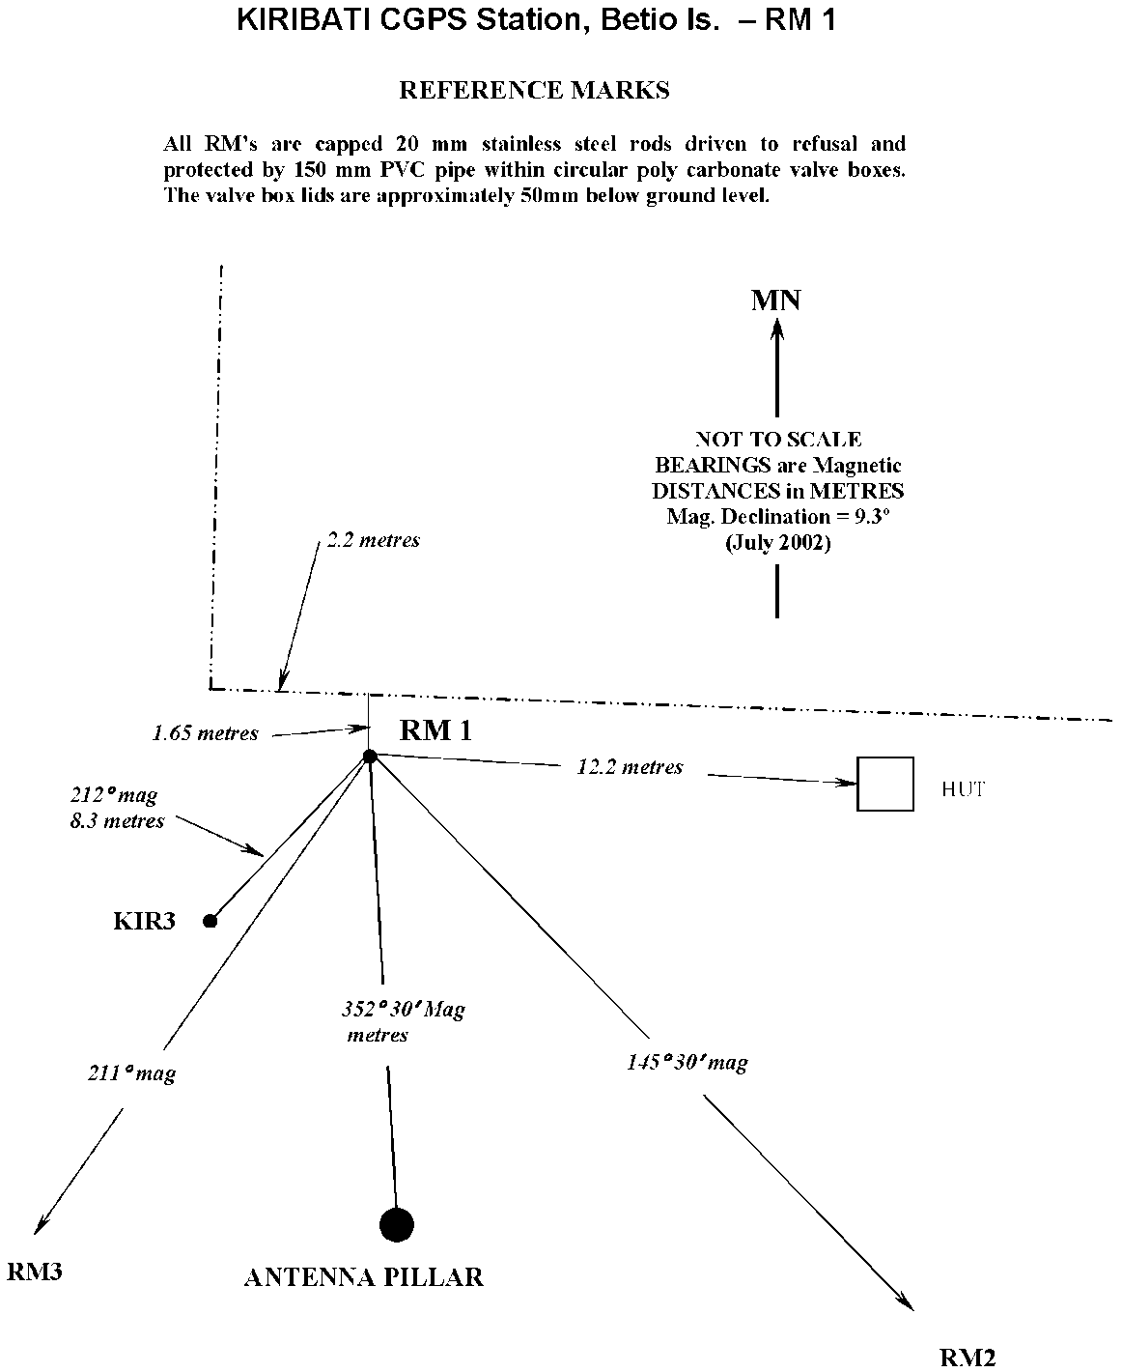
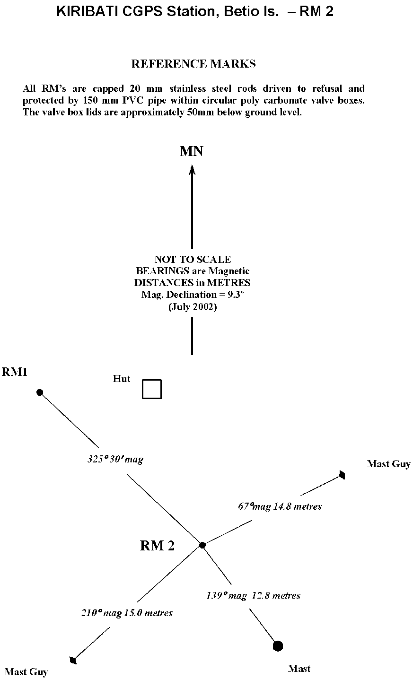
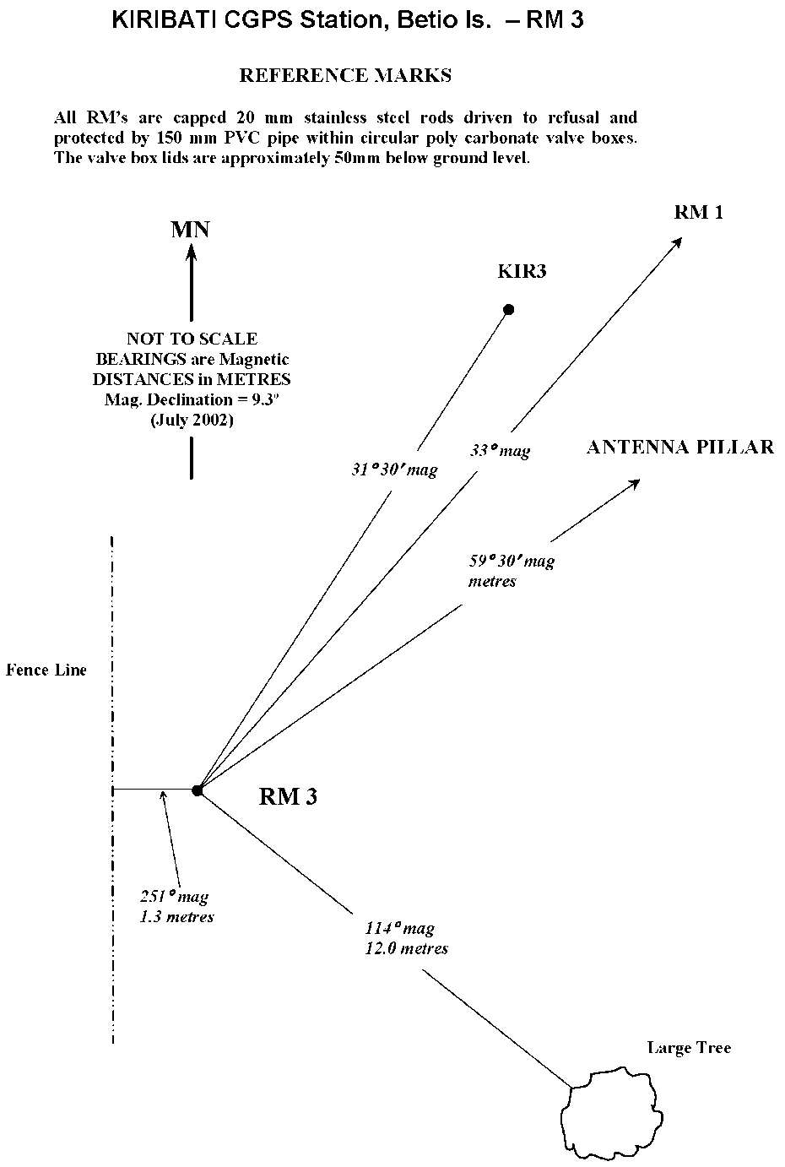

Temporary Holding Mark Locality Diagrams
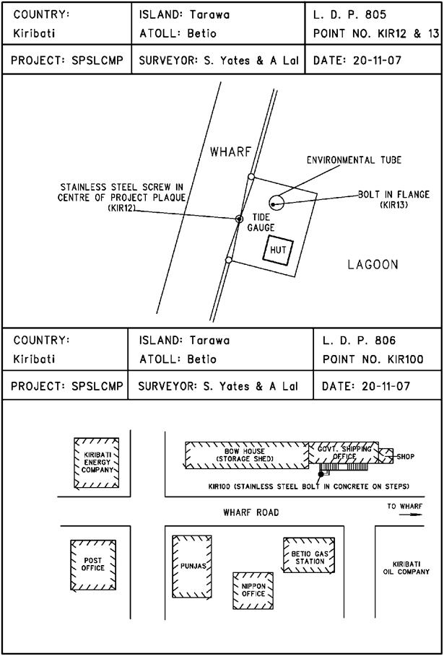
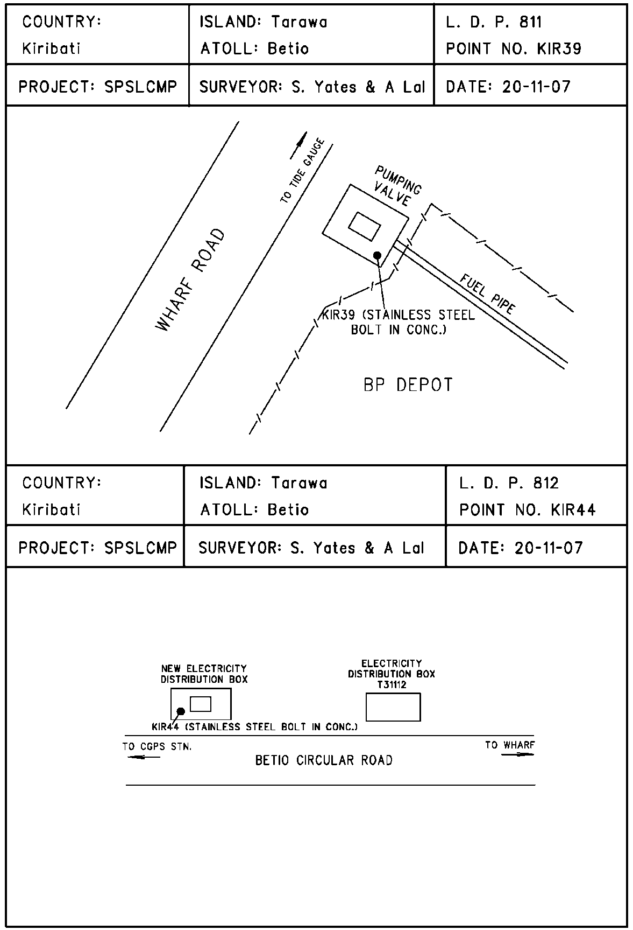
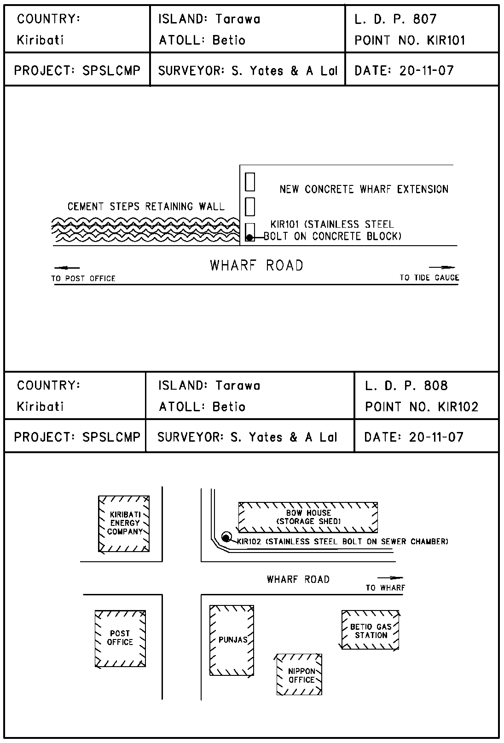
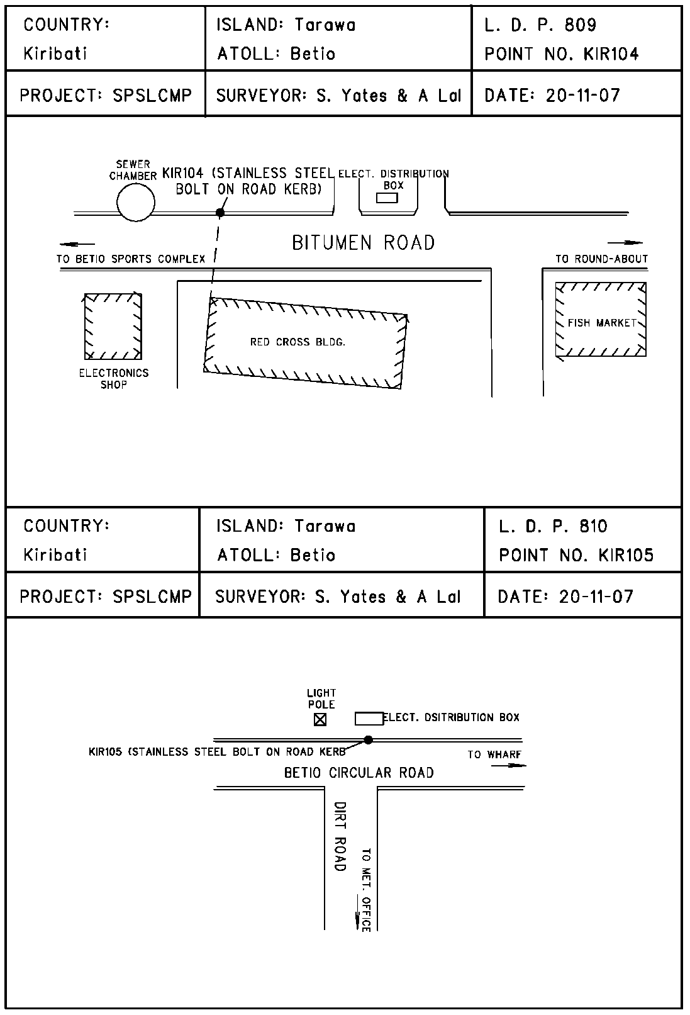

References
Rüeger, J.M. & Brunner, F.K. 1982, ‘EDM Height Traversing versus Geodetic Levelling’, The Canadian Surveyor, vol. 36, no. 1, pp. 69-87.
Inter-Government Committee on Surveying and Mapping (ICSM) 2002, Standards and Practices for Control Surveys, SP1, Ver. 1.5, May 2002.

