EDM Height Traversing Levelling Survey Report

Funafuti, Tuvalu, July 2013
Geoscience Australia
RECORD 2014/30
S. J. K. Yates1, A. Lal2
- National Geospatial Reference Systems, Minerals and Natural Hazards Division, Geoscience Australia GPO Box 378 Canberra ACT 2601
- Secretariat of the Pacific Community (SPC)
Department of Industry
Minister for Industry: The Hon Ian Macfarlane MP
Parliamentary Secretary: The Hon Bob Baldwin MP
Secretary: Ms Glenys Beauchamp PSM
Geoscience Australia
Chief Executive Officer: Dr Chris Pigram
This paper is published with the permission of the CEO, Geoscience Australia
© Commonwealth of Australia (Geoscience Australia) 2014
With the exception of the Commonwealth Coat of Arms and where otherwise noted, all material in this publication is provided under a Creative Commons Attribution 3.0 Australia Licence. (http://www.creativecommons.org/licenses/by/3.0/au/deed.en)
Geoscience Australia has tried to make the information in this product as accurate as possible. However, it does not guarantee that the information is totally accurate or complete. Therefore, you should not solely rely on this information when making a commercial decision.
Geoscience Australia is committed to providing web accessible content wherever possible. If you are having difficulties with accessing this document please email clientservices@ga.gov.au.
ISSN 2201-702X (PDF)
ISBN 978-1-925124-19-4 (PDF)
GeoCat 78481
Bibliographic reference: Yates S. J. K, Lal A., 2014. EDM Height Traversing Levelling Survey Report, Funafuti, Tuvalu, July 2013. Record 2014/30. Geoscience Australia, Canberra. http://dx.doi.org/10.11636/Record.2014.030

Contents
1 Introduction 1
2 The Survey 2
2.1 Bench Mark Locations – Funafuti 3
2.2 The Tuvalu Datum 3
2.3 Equipment 3
2.4 Method 4
2.5 Tuvalu 2013 Reduced Levels 4
2.6 Survey Support 6
2.7 Issues 6
2.8 Description of Marks – Funafuti, Tuvalu 6
3 Comparisons 7
3.1 Comparisons between 2013 and 2012 EDM Surveys 7
3.2 Combined Comparisons 9
3.3 Time Series of Bench Mark movement relative to Fixed Deep Bench Mark BM22 10
4 Deep Bench Mark Locality Diagrams 14
5 Temporary Holding Mark Locality Diagrams 20
6 TUVABM and TUVA Reference Mark Locality Diagrams 28
7 References 31

Introduction
This report outlines the high precision level survey completed between the Sea Level Fine Resolution Acoustic Measuring Equipment (SEAFRAME) tide gauge and the Continuous Global Navigation Satellite System (CGNSS) Station in Funafuti, Tuvalu from 18th – 25th July 2013.
Personnel involved in the survey were Steve Yates, Project Officer, Geoscience Australia and Andrick Lal, Surveyor, Secretariat of the Pacific Islands Community (SPC).
The Electronic Distance Measurement (EDM) Height Traversing levelling technique was employed to observe differences in height between the deep bench mark arrays in Funafuti, which runs approximately 4km from the tide gauge sensor to the CGNSS Station. Previous levelling surveys have been conducted along the route using this technique in 2005, 2007, 2009, 2010 and 2012.
In addition, precise differential levelling surveys were performed along the deep bench mark array from 1993 to 2005 by the National Tidal Centre Australia (NTCA) and the survey in 2005 included a comparison between the precise differential levelling and EDM height traversing technique. This report contains a comparison between the 2013 and 2012 EDM height traversing results as well as a combined comparison since the first levelling survey.

The Survey
The EDM height traversing levelling survey was carried out between the SEAFRAME tide gauge sensor, the CGNSS station and the deep driven bench mark array:
BM22 – reference deep driven bench mark
BM23 – deep driven bench mark
BM24 – deep driven bench mark
BM26 – deep driven bench mark
BM27 – deep driven bench mark
BM28 – deep driven bench mark
TUV19 – SEAFRAME sensor bench mark
TUV20 – SEAFRAME Project plaque bench mark
TUVABM – reference bench mark for the GNSS pillar
Also included in the survey were temporary holding marks – TUV102, TUV42, TUV103, TUV44, TUV107, TUV104, TUV101, TUV105, TUV61, TUV48, TUV49, TUV74, TUV73, TUV106, TUV71 and TUV69.
The Continuous GNSS (CGNSS) Reference Point - TUVA and the two CGNSS Reference Marks - RM2 and RM3 were also levelled. Unfortunately RM1, CGNSS Reference Mark was removed from the ground due to excavation works otherwise all the deep bench marks were located and found in good order and undisturbed.
The EDM Height Traversing levelling technique was performed to the Class L2A specifications. After reduction an internal precision of 1mm √K or better was achieved, where K is distance in kilometres. This is well within the project specification of 2mm √K. A table of results and comparisons and the 2013 reduced levels are detailed later in this report.

Bench Mark Locations – Funafuti
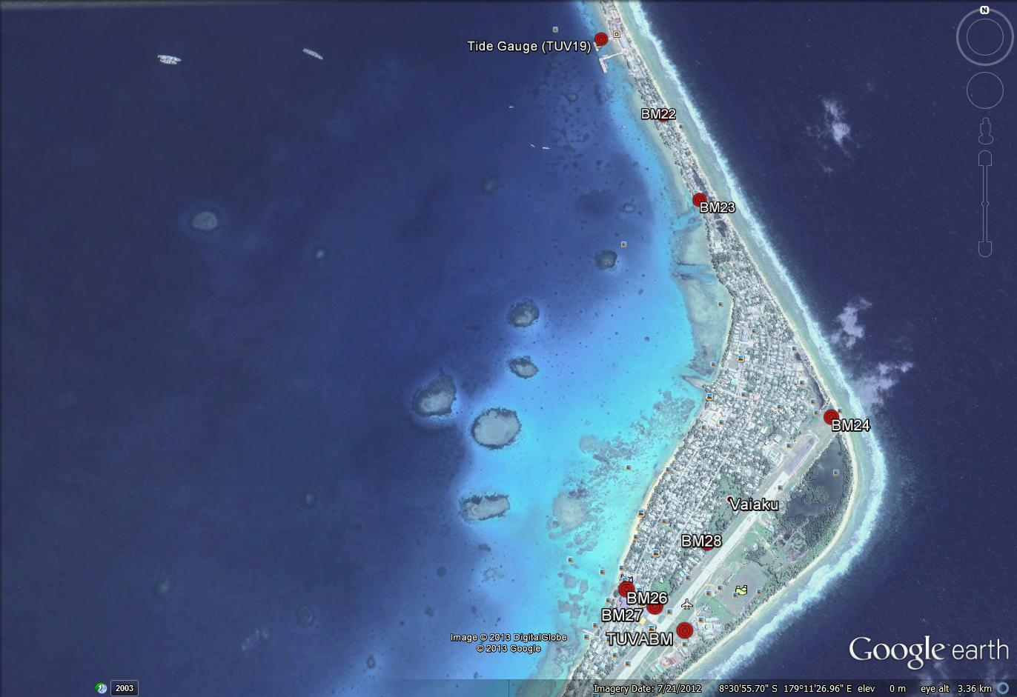

The Tuvalu Datum
The Datum for the survey is the University of Hawaii Tide Staff Zero (TSZ).
Reduction of the data has been calculated holding BM22 fixed at 3.22540 metres TSZ, this value was determined by the NTCA in 1993 by:
Adopting the height of UH 1 (RL = 3.0072 metres TSZ)
Adopting the height of BM22 as derived from the 1993 survey (RL = 3.22540 metres)

Equipment
- LEICA total station model TCA2003 and TM30 (Serial No: 361441)
- LEICA precision prisms GPH1P (2)
- LEICA rigid tripod
- Stainless steel target poles supported by LEICA telescopic bi-poles (2)
- Shortened stainless steel target pole for the SEAFRAME sensor BM connection
- LEICA cast iron change plates (2)
- KESTRAL 4000 pocket weather tracker

Method
The “Leap-Frog” EDM height traversing technique was employed for the Funafuti tide gauge levelling survey. This technique involves setting up a total station (TCA1800L) midway between two target/reflectors (on reflector rods with struts). The targets remain at a particular change point for the back-sight and fore-sight observations. The instrument measures slope distances (±1mm) and vertical angle (1”) to derive height differences (between the instrument’s trunnion axis and the reflectors). In support of the slope distance observations, the ambient temperature, pressure and humidity are recorded (Kestral 4000 pocket weather tracker) and input into the instrument to apply the first velocity correction to the observed distances (Rüeger & Brunner, 1982). Four rounds of observations are taken to the back-sight and fore-sight targets from each instrument setup. All levelling runs started and finished with the same reflector and reflector rod, i.e. an even number of setups when the two reflector rod configuration was used. This eliminates any reflector rod zero error. This technique can also be performed using a single set-up / single rod configuration which is particularly useful when levelling between bench marks which are close together e.g. between the CGNSS RMs.
Reduction of the digital data was computed by the Geoscience Australia levelling program “leveling1.exe”. This program computes the height difference between the two reflectors.

Tuvalu 2013 Reduced Levels
Table 2.1 Funafuti, Tuvalu – Reduced levels 2013 survey
Date: 18 – 25 July 2013
Datum: TSZ (1993)
Point ID | Reduced Level 2013 | Type
BM22 | 3.2254 | Stainless Steel Rod in Ground
TUV102 | 3.7604 | Stainless Steel Pin in Concrete
TUV42 | 3.7605 | Stainless Steel Pin in Concrete
TUV103 | 3.5773 | Stainless Steel Pin in Concrete
TUV19 | 3.4893 | Stainless Steel Pin in Concrete
TUV20 | 4.4585 | Stainless Steel Pin
TUV44 | 3.3249 | Stainless Steel Pin in Concrete
TUV107 | 2.7287 | Stainless Steel Pin in Concrete
BM23 | 3.1372 | Stainless Steel Rod in Ground
TUV104 | 2.9832 | Stainless Steel Pin in Concrete
TUV101 | 3.0905 | Stainless Steel Pin in Concrete
TUV105 | 2.8240 | Stainless Steel Pin in Concrete
TUV61 | 2.8766 | Stainless Steel Rod in Ground
TUV48 | 3.0606 | Stainless Steel Pin in Concrete
TUV49 | 3.2472 | Stainless Steel Pin in Concrete
TUV74 | 2.5841 | Stainless Steel Pin in Concrete
BM24 | 3.7955 | Stainless Steel Rod in Ground
TUV73 | 2.2977 | Stainless Steel Pin in Concrete
TUV106 | 2.2070 | Stainless Steel Pin in Concrete
TUV71 | 2.2400 | Stainless Steel Pin in Concrete
BM28 | 2.2160 | Stainless Steel Rod in Ground
TUV69 | 2.2144 | Stainless Steel Pin in Concrete
BM27 | 2.2154 | Stainless Steel Rod in Ground
TUVABM | 2.7413 | Stainless Steel Pillar Pin
*TUVA | 3.7045 | Pillar Plate (ARP)
P-S | 2.4176 | Top of Tuvalu Met. Office Pressure Sensor
BM26 | 3.1072 | Stainless Steel Rod in Ground
TUVARM2 | 2.1584 | Stainless Steel Rod in Ground
TUVARM3 | 1.9312 | Stainless Steel Rod in Ground
*The RL of the Reference Point TUVA (ARP) is derived from adding the static height difference of 0.9631m (TUVABM to TUVA) to the 2013 levelled RL of TUVABM.

Survey Support
Due to a recent change in field procedures, field survey technician, Samisoni Finikaso, was hired to carry the Leica total station in the carry case during the survey. This was arranged through the kind assistance of Mr Fa’atasi Malologa, Director – Lands and Survey.
The Director of Tuvalu Meteorological Service, Ms Hilia Va’ave and her staff provided valuable support during our visit.

Issues
Please note that due to fewer flights and unreliable air freight services for cargo to Funafuti, it is advisable to pre-book two (2) cargo seats for the survey equipment to and from Funafuti as DHL cannot guarantee the air freight to arrive.
RM1 was found to be destroyed therefore in the next survey visit; it has to be replaced with a new Reference Mark 4.

Description of Marks – Funafuti, Tuvalu
BM22 – reference deep driven bench mark (within Catholic Church Compound)
BM23 – deep driven bench mark (along the road on lagoon side)
BM24 – deep driven bench mark (on the north end of airport runaway)
BM26 – deep driven bench mark (on south corner of Vaiaku Lagi Hotel)
BM27 – deep driven bench mark (within airport compound)
BM28 – deep driven bench mark (in front of Mosque)
TUV19 – SEAFRAME sensor bench mark (on the old wharf)
TUV20 – SEAFRAME Project plaque bench mark (on the old wharf)
TUVABM – reference bench mark for the CGNSS pillar (within meteorology compound)
TUVA RM2 – CGNSS Pillar reference bench mark (within meteorology compound)
TUVA RM3 – CGNSS Pillar reference bench mark (within meteorology compound)
TUVA – CGNSS Pillar bench mark (within meteorology compound)
Holding pins along survey route from tide gauge to CGNSS (as listed previously) are all stainless steel bolts, drilled in concrete and glued in place.

Comparisons

Comparisons between 2013 and 2012 EDM Surveys
Table 3.1 Results of Funafuti, Tuvalu 2013 EDM Height Traversing Comparison 2013 – 2012. BM22 - adopted fixed height of 3.22540m
From | To | Levelled  Ht. Diff. | RL 2013 | Misclose  (mm) | Dist. (km) | 1mm√k | RL 2012 | Difference (mm)  2013 - 2012
BM22 |  |  | 3.2254
TUV102 | TUV102 | 0.5350 | 3.7604 | 0.389 | 0.207 | 0.455 | 3.7613 | -0.93
TUV42 | TUV42 | 0.0001 | 3.7605 | -0.301 | 0.119 | 0.344 | 3.7612 | -0.69
TUV103 | TUV103 | -0.1832 | 3.5773 | -0.231 | 0.157 | 0.397 | 3.5768 | 0.55
TUV19 | TUV19 | -0.0881 | 3.4893 | -0.176 | 0.082 | 0.286 | 3.4881 | 1.18
 | TUV20 | 0.9693 | 4.4585 | 0.051 | 0.013 | 0.114 | 4.4576 | 0.94
BM22 |  |  | 3.2254
TUV44 | TUV44 | 0.0995 | 3.3249 | -0.342 | 0.190 | 0.436 | 3.3255 | -0.62
TUV107 | TUV107 | -0.5961 | 2.7287 | -0.150 | 0.119 | 0.345 | New Mark | New Mark
BM23 | BM23 | 0.4085 | 3.1372 | 0.103 | 0.181 | 0.426 | 3.1381 | -0.89
TUV104 | TUV104 | -0.1540 | 2.9832 | 0.403 | 0.177 | 0.420 | 2.9844 | -1.20
TUV101 | TUV101 | 0.1073 | 3.0905 | -0.345 | 0.199 | 0.446 | 3.0911 | -0.62
TUV105 | TUV105 | -0.2664 | 2.8240 | -0.430 | 0.215 | 0.463 | 2.8241 | -0.07
TUV61 | TUV61 | 0.0525 | 2.8766 | -0.006 | 0.111 | 0.333 | 2.8767 | -0.13
TUV48 | TUV48 | 0.1841 | 3.0606 | -0.011 | 0.119 | 0.344 | 3.0603 | 0.35
TUV49 | TUV49 | 0.1866 | 3.2472 | 0.065 | 0.161 | 0.401 | 3.2470 | 0.23
TUV74 | TUV74 | -0.6631 | 2.5841 | 0.164 | 0.085 | 0.291 | 2.5838 | 0.35
 | BM24 | 1.2113 | 3.7955 | 0.097 | 0.108 | 0.329 | 3.7955 | -0.01
TUV74 |  |  | 2.5841
TUV73 | TUV73 | -0.2865 | 2.2977 | 0.308 | 0.201 | 0.449 | 2.2980 | -0.33
TUV106 | TUV106 | -0.0907 | 2.2070 | 0.353 | 0.199 | 0.446 | 2.2074 | -0.39
TUV71 | TUV71 | 0.0330 | 2.2400 | -0.055 | 0.099 | 0.315 | 2.2414 | -1.35
BM28 | BM28 | -0.0240 | 2.2160 | 0.074 | 0.106 | 0.326 | 2.2161 | -0.08
TUV69 | TUV69 | -0.0016 | 2.2144 | 0.046 | 0.205 | 0.453 | 2.2154 | -0.96
BM27 | BM27 | 0.0009 | 2.2154 | 0.136 | 0.152 | 0.389 | 2.2161 | -0.72
TUVABM | TUVABM | 0.5260 | 2.7413 | -0.045 | 0.144 | 0.379 | 2.7418 | -0.46
 | P-S | -0.3237 | 2.4176 | 0.177 | 0.035 | 0.186 | New Mark | New Mark
BM27 |  |  | 2.21538
 | BM26 | 0.89183 | 3.10722 | -0.124 | 0.121 | 0.347 | 3.1077 | -0.48
 |  |  | Misclose for all bays levelled = | 0.149 | 3.504 | 1.872
All levelling was performed within the project specifications of 2√k

From | To | Levelled  Ht. Diff. | RL 2013 | Misclose  (mm) | Dist. (km) | 1mm√k | RL 2012 | Difference (mm)  2013 - 2012
TUVABM |  |  | 2.74134
 | RM2 | -0.58289 | 2.15845 | -0.039 | 0.047 | 0.217 | 2.159 | -0.55
TUVABM |  |  | 2.74134
 | RM3 | -0.81016 | 1.93117 | -0.001 | 0.057 | 0.239 | 1.932 | -0.83
All levelling was performed within the project specifications of 2√k

Combined Comparisons
Examination of the level survey results do not show any significant changes in reduced levels from the 2013 survey. All indications show that no immediate or significant displacement of any of the deep driven bench marks has occurred.
Table 3.2 Funafuti, Tuvalu – Deep Bench Mark final RL's for Precise Differential Levelling (1993 - 2005) and EDM Height Traversing (2005 - 2013).
Year | BM22 | BM23 | BM24 | BM26 | BM27 | BM28 | TUVABM | TUV19 | TUV20
1993.21 | 3.2254 | 3.1385 | 3.7982 |  |  |  |  | 3.4813 | 4.4599
1994.46 | 3.2254 | 3.1394 | 3.7968 |  |  |  |  | 3.4826 | 4.4603
1995.46 | 3.2254 | 3.1392 | 3.7972 |  |  |  |  | 3.4833 | 4.4609
1997.96 | 3.2254 | 3.1387 | 3.7958 |  |  |  |  | 3.4834 | 4.4608
1998.54 | 3.2254 | 3.1383 | 3.7953 |  |  |  |  | 3.4848 | 4.4615
2000.13 | 3.2254 | 3.1386 | 3.7951 |  |  |  |  | 3.4842 | 4.4600
2001.63 | 3.2254 | 3.1390 | 3.7952 |  |  |  |  | 3.4848 | 4.4599
2003.38 | 3.2254 | 3.1391 | 3.7960 | 3.1099 | 2.2165 |  | 2.7414 | 3.4851 | 4.4593
2005.63 | 3.2254 | 3.1386 | 3.7959 | 3.1102 | 2.2176 |  | 2.7425 | 3.4864 | 4.4592

Year | BM22 | BM23 | BM24 | BM26 | BM27 | BM28 | TUVABM | TUV19 | TUV20
2005.63 | 3.2254 | 3.1393 | 3.7964 | 3.1099 | 2.2177 |  | 2.7432 | 3.4867 | 4.4593
2007.21 | 3.2254 | 3.1393 | 3.7962 | 3.1079 | 2.2157 |  | 2.7407 | 3.4879 | 4.4596
2009.06 | 3.2254 | 3.1397 | 3.7966 | 3.1082 | 2.2162 | 2.2171 | 2.7418 | 3.4877 | 4.4588
2010.08 | 3.2254 | 3.1394 | 3.7976 | 3.1108 | 2.2184 | 2.2188 | 2.7442 | 3.4889 | 4.4592
2012.41 | 3.2254 | 3.1381 | 3.7955 | 3.1077 | 2.2161 | 2.2161 | 2.7418 | 3.4881 | 4.4576
2013.55 | 3.2254 | 3.1372 | 3.7955 | 3.1072 | 2.2154 | 2.2160 | 2.7413 | 3.4893 | 4.4585
The 2013 RL of TUVA is 3.7045
*The RL of the Reference Point TUVA (ARP) is derived from adding the static height difference of 0.9631m (TUVABM to TUVA) to the 2013 levelled RL of TUVABM.

Time Series of Bench Mark movement relative to Fixed Deep Bench Mark BM22
Precise Differential Levelling: 1993 - 2005
EDM Height Traversing: 2005 onwards

Deep Bench Mark Locality Diagrams
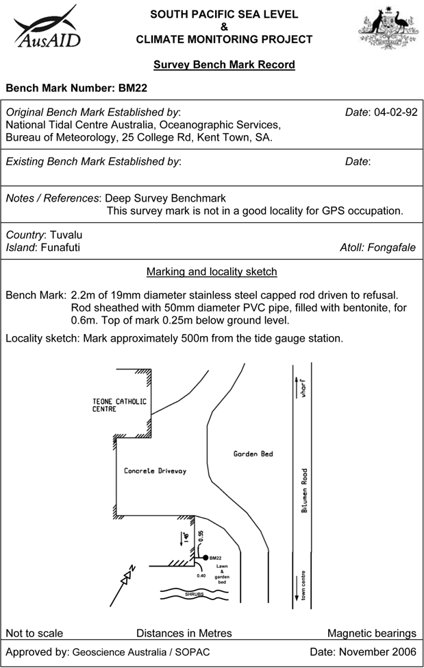
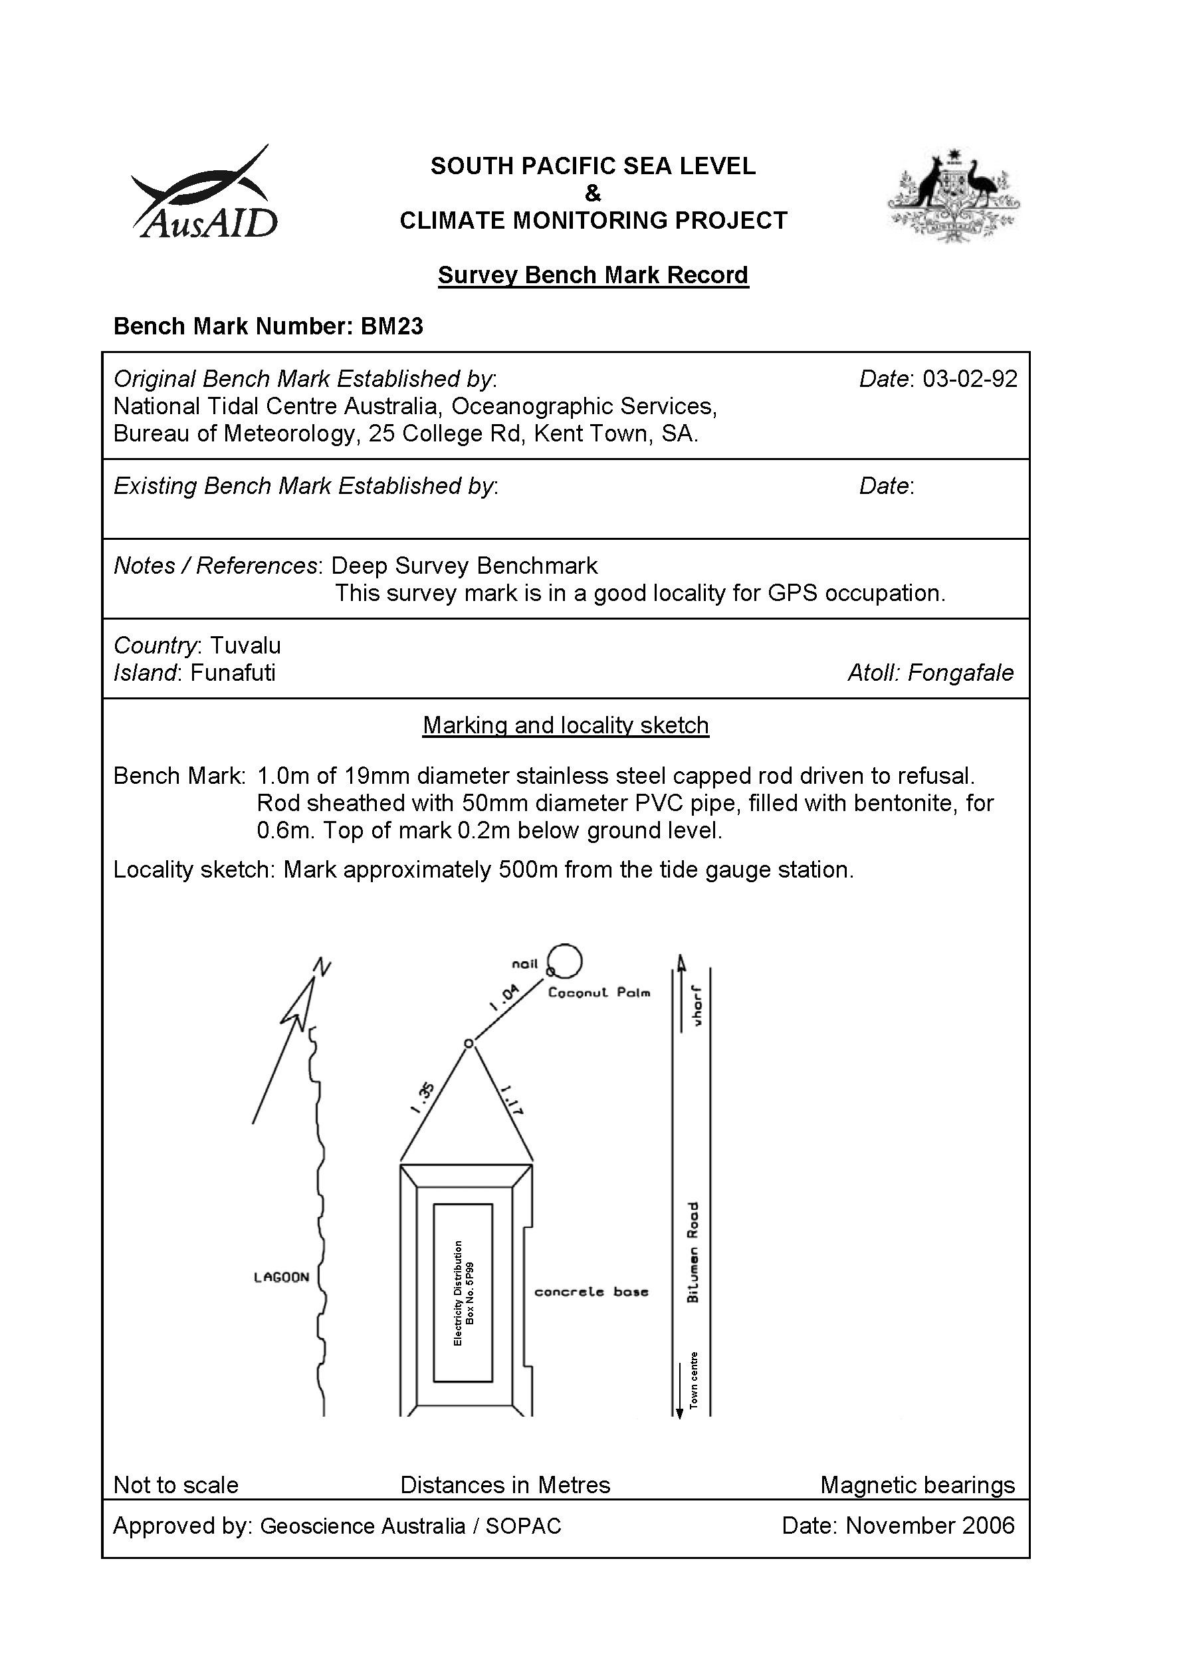
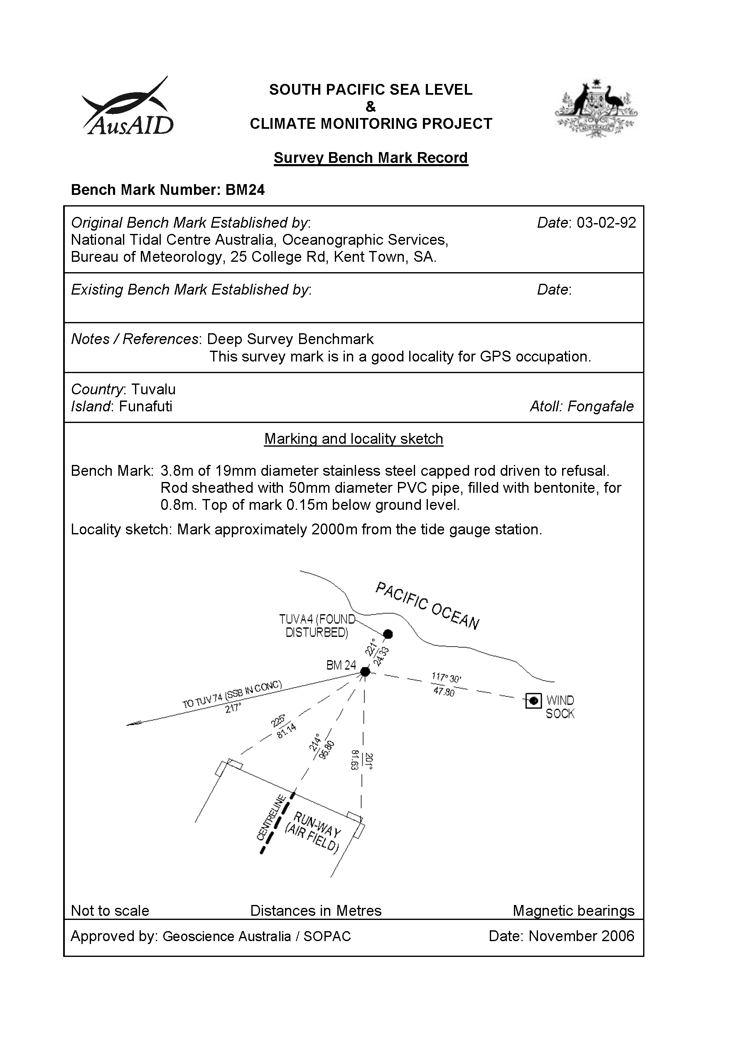
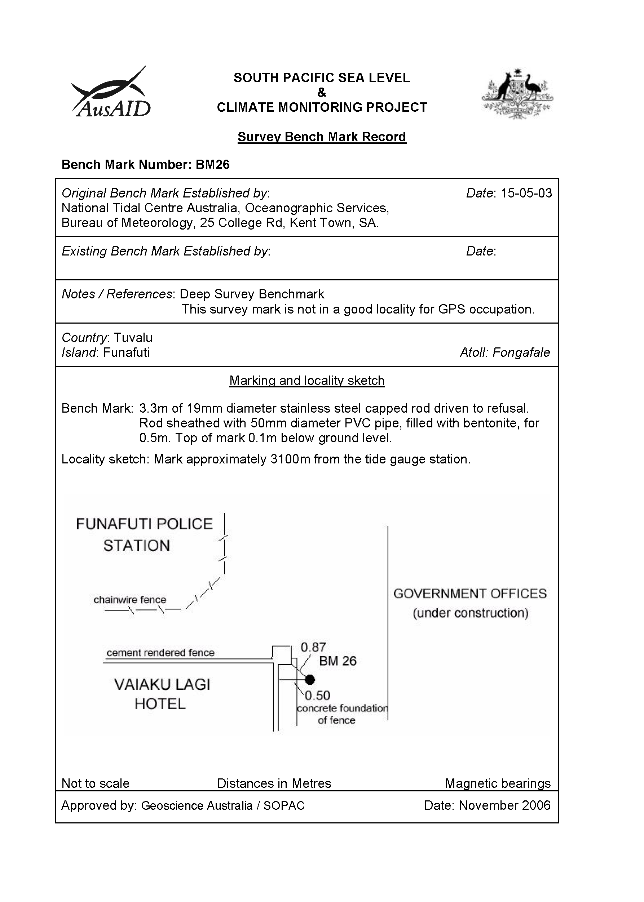
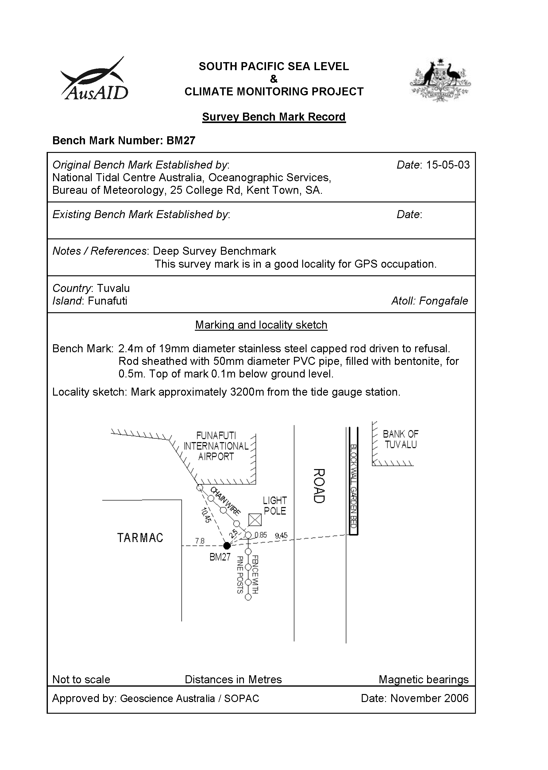
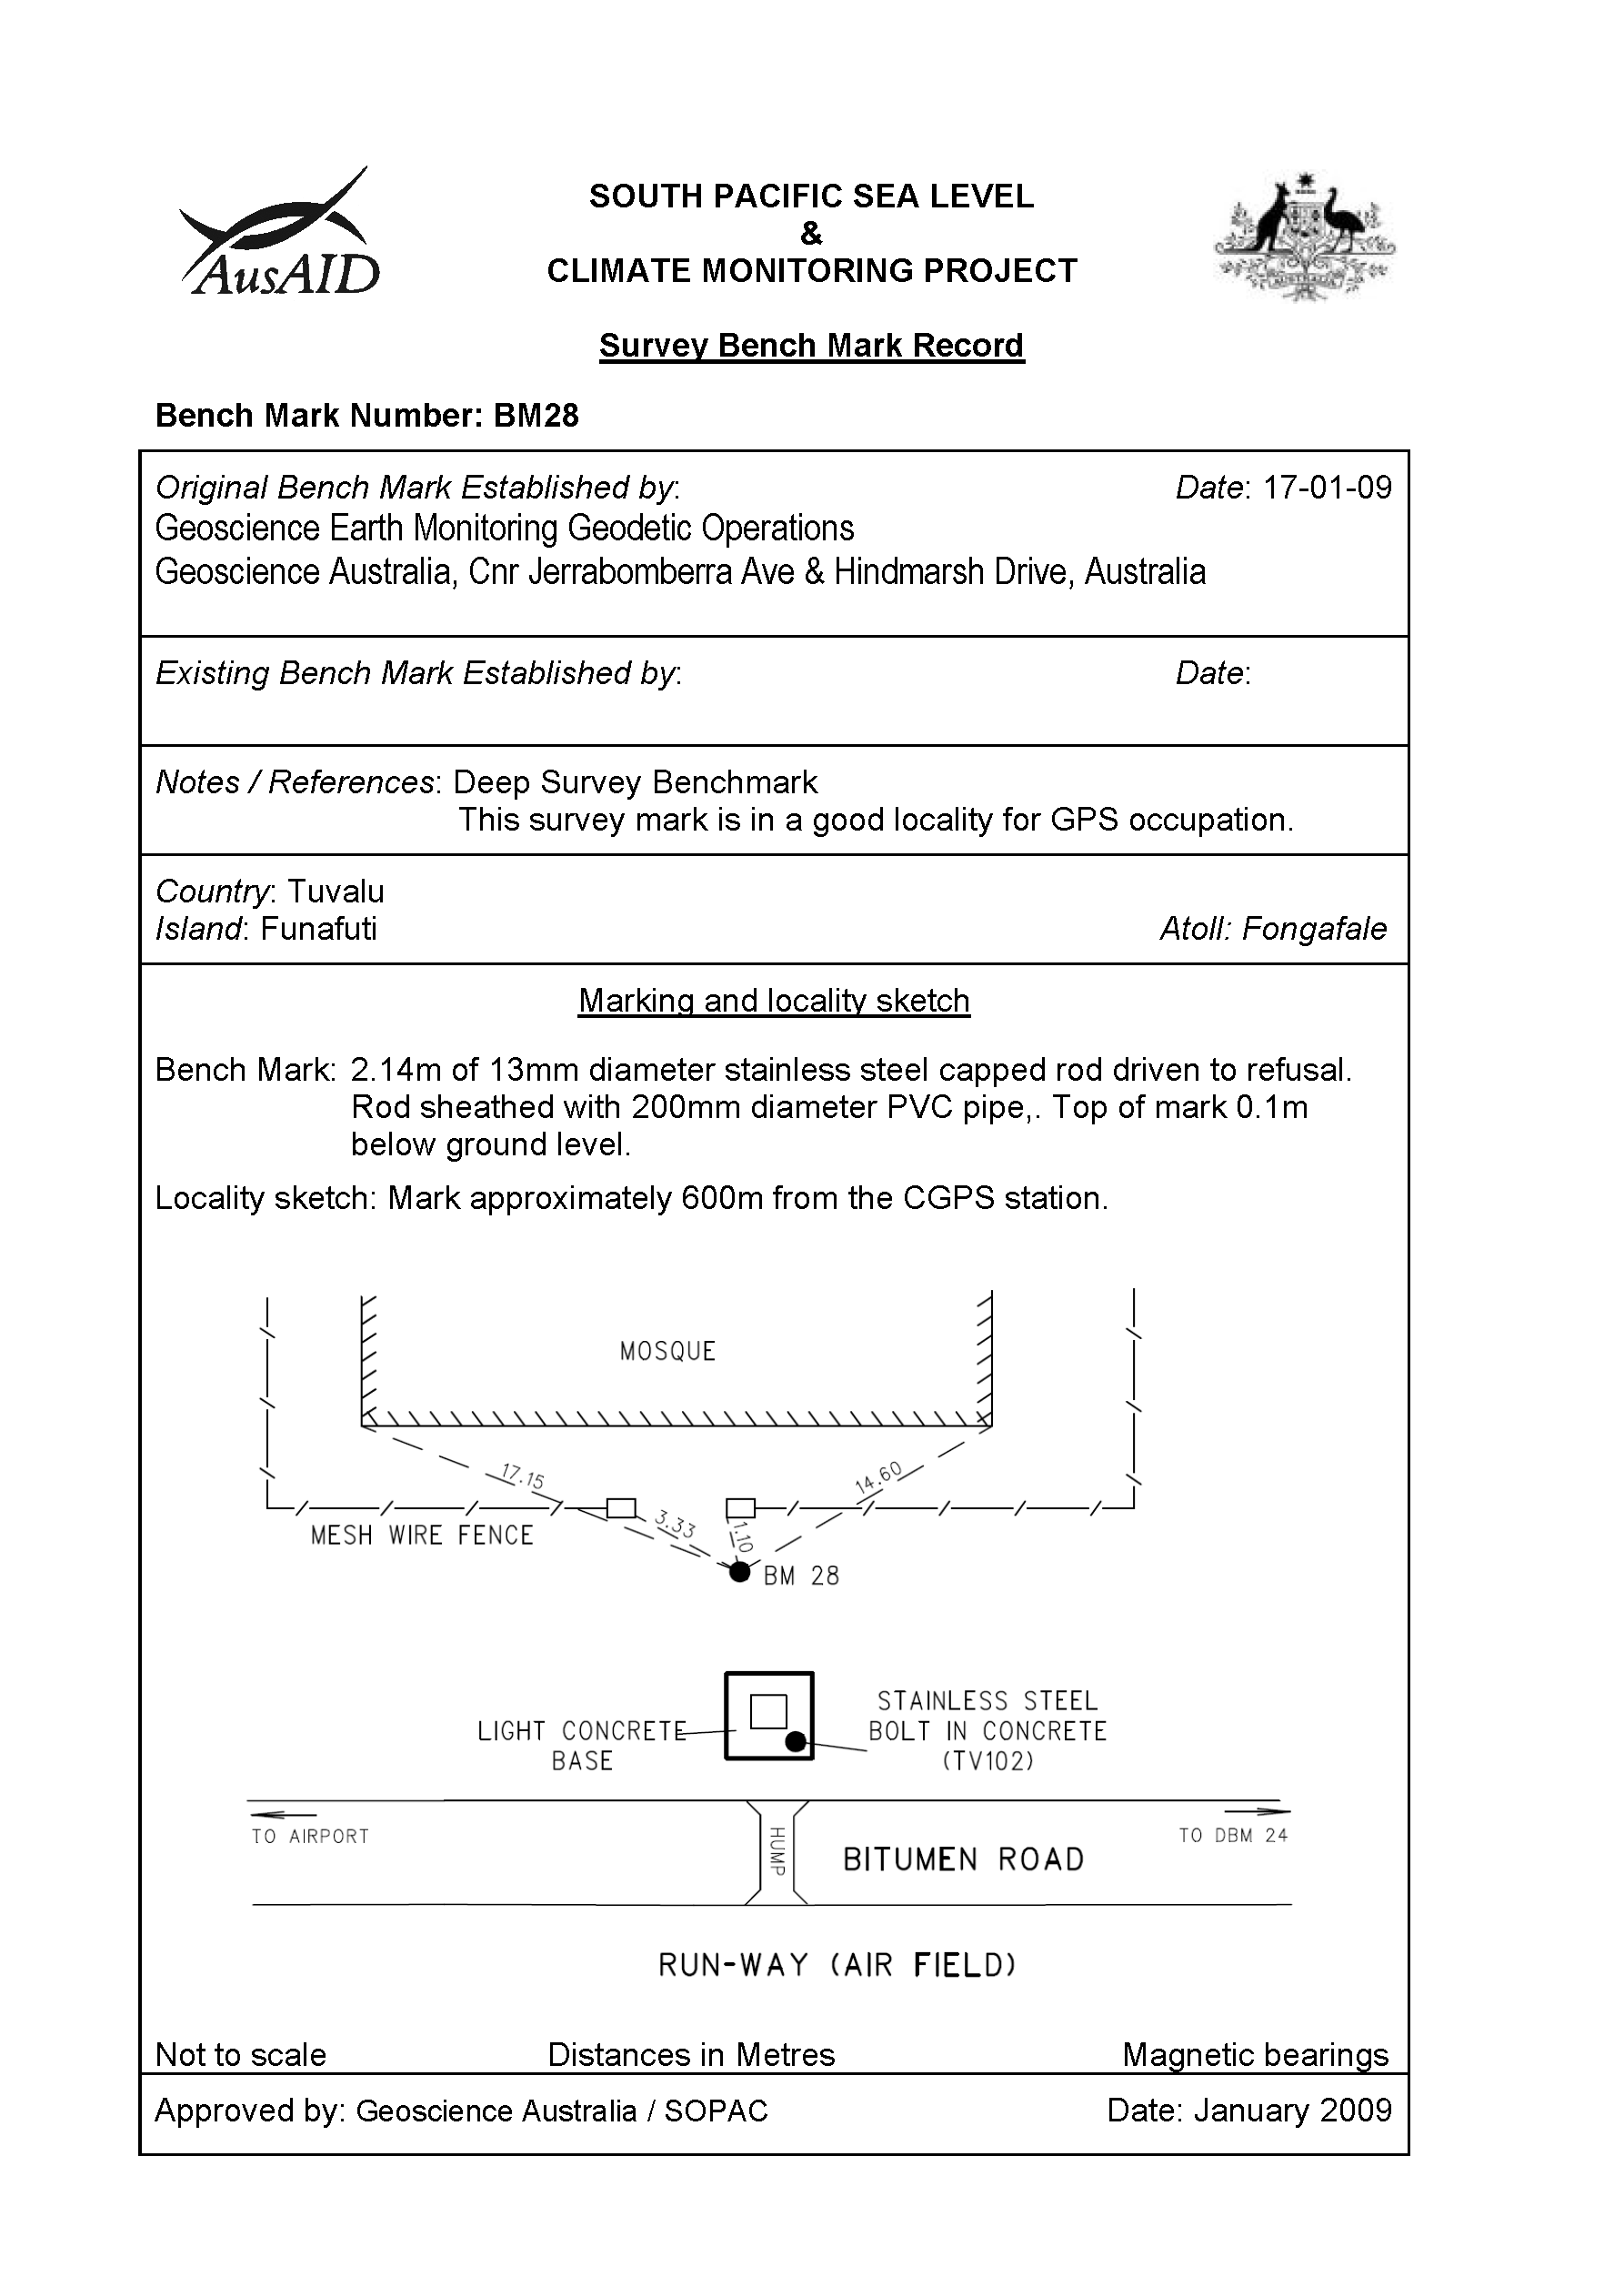

Temporary Holding Mark Locality Diagrams
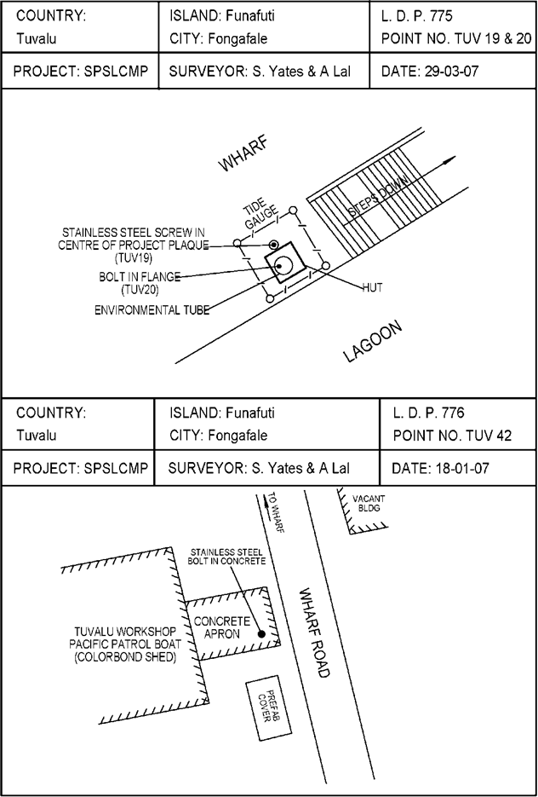
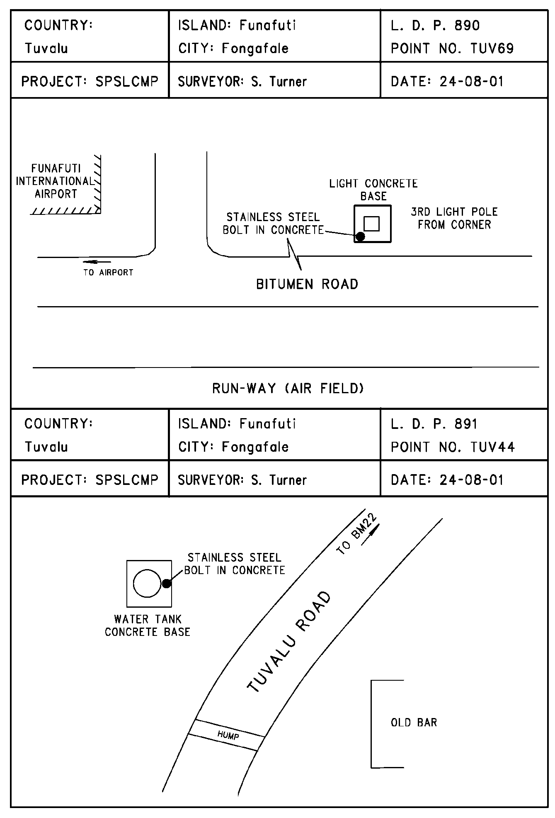
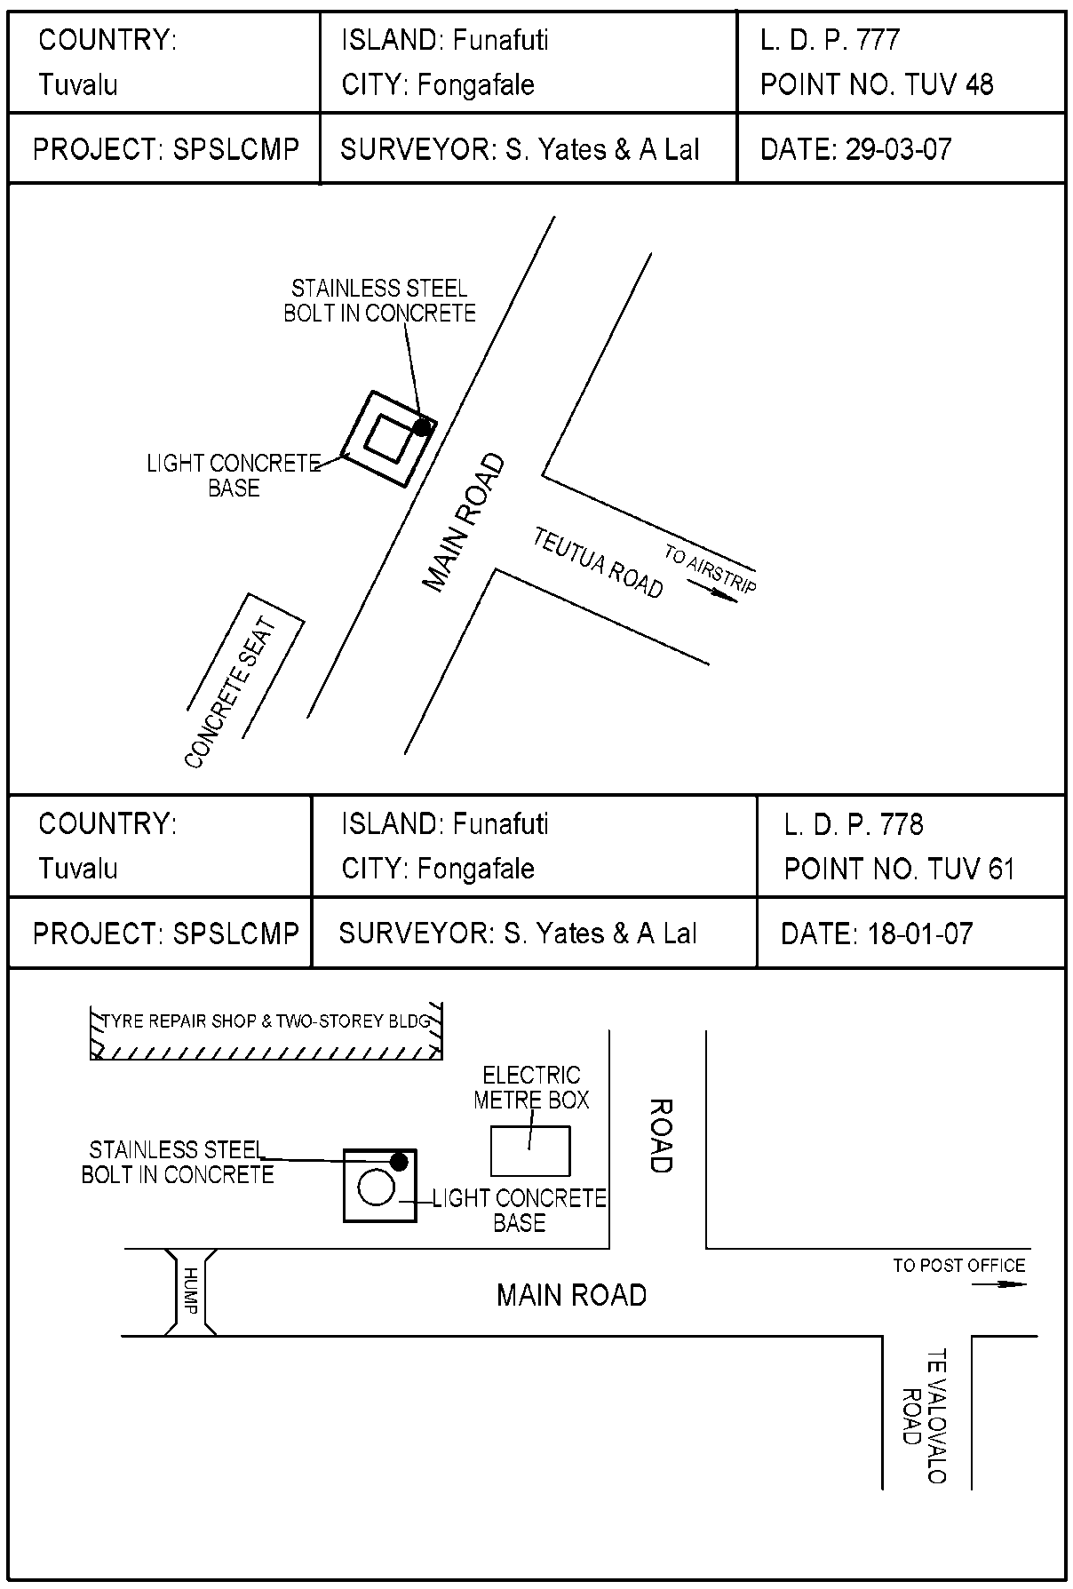
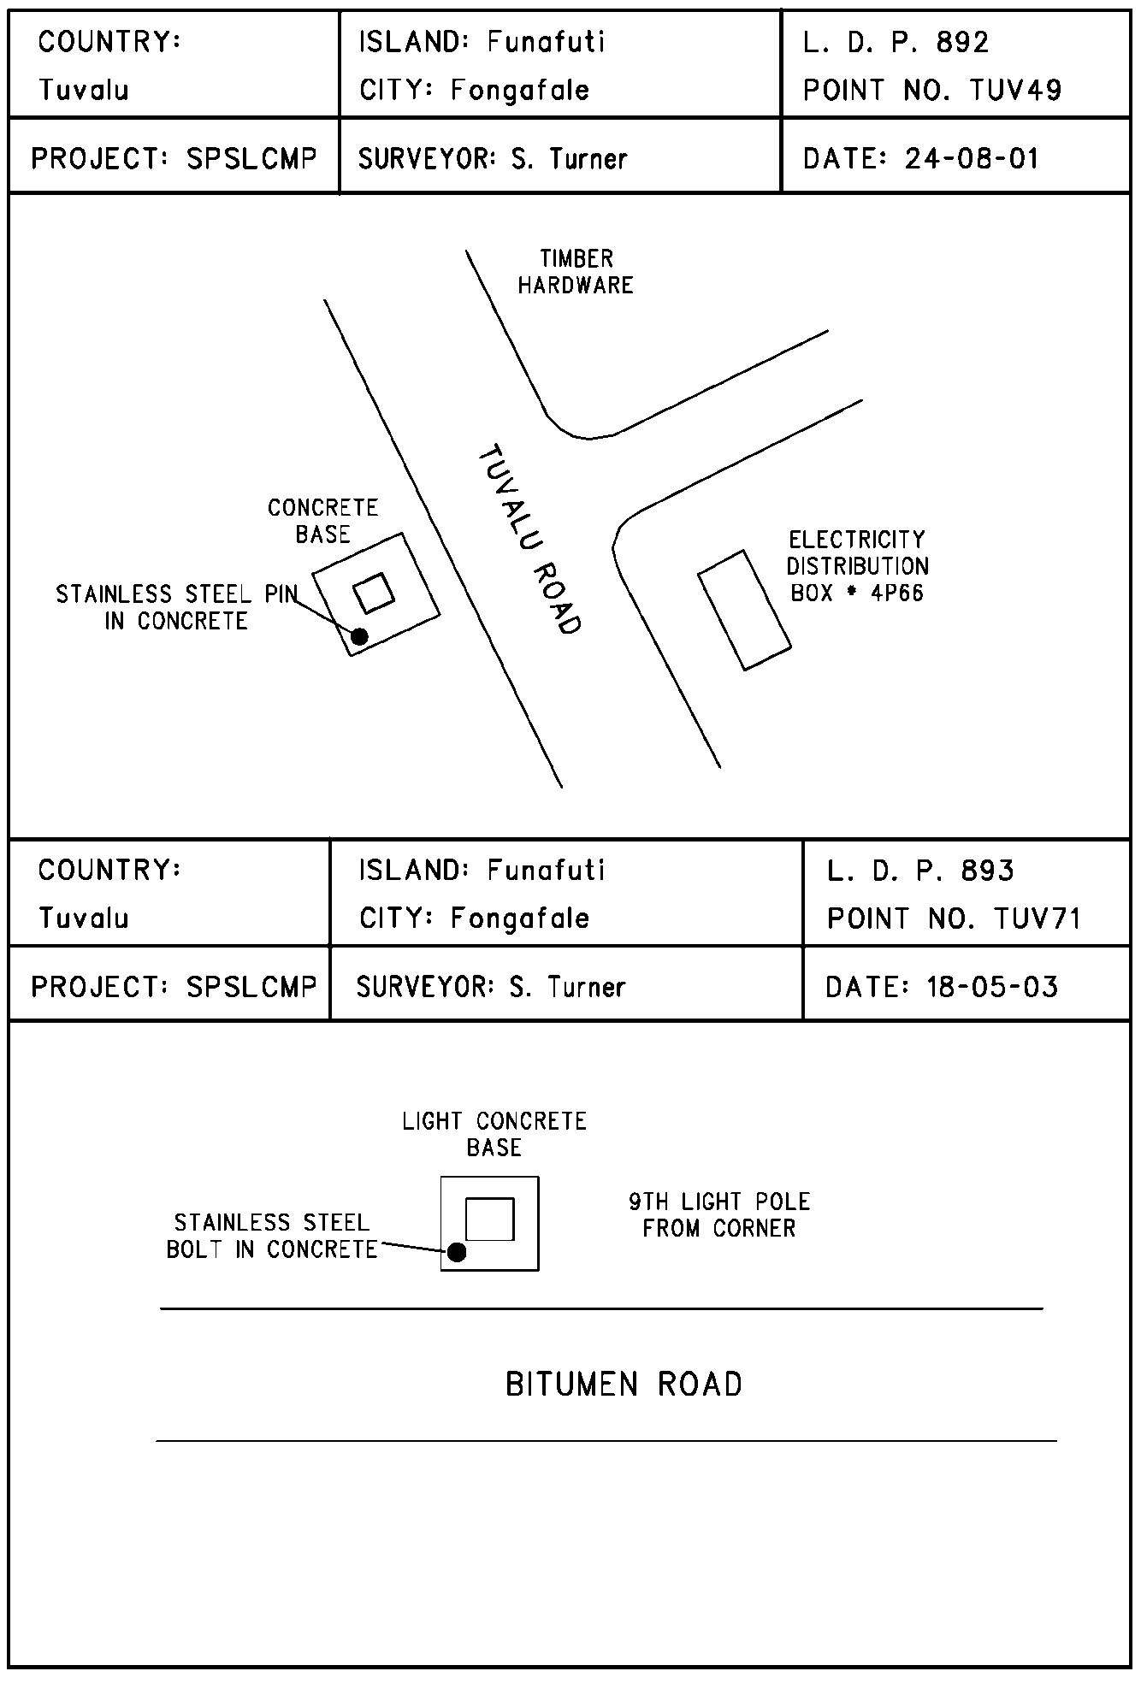
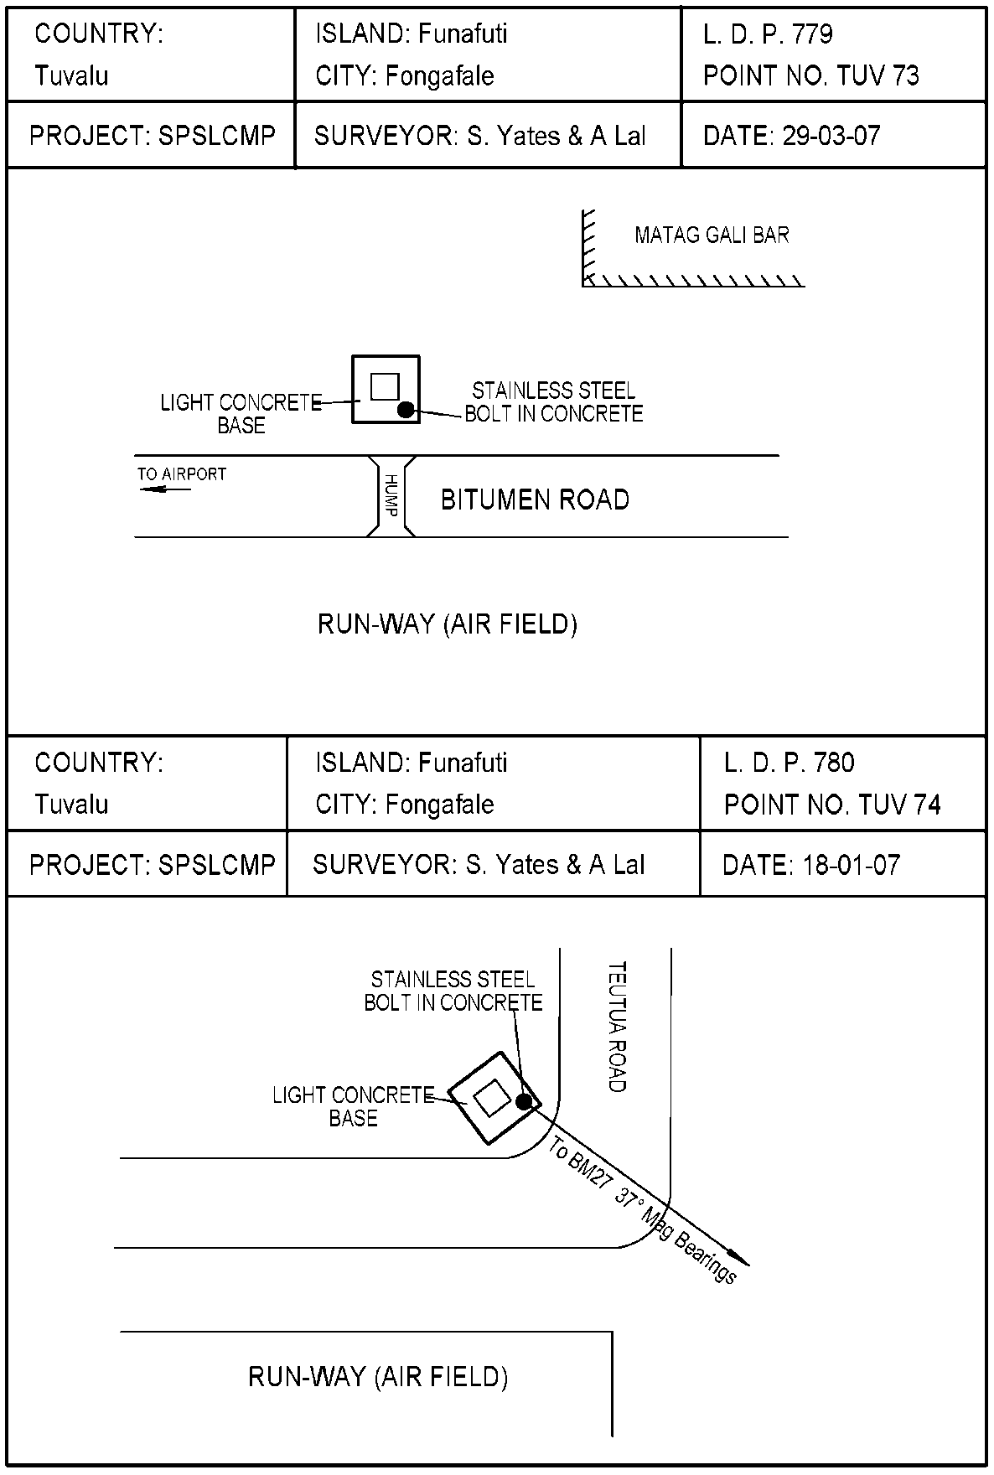
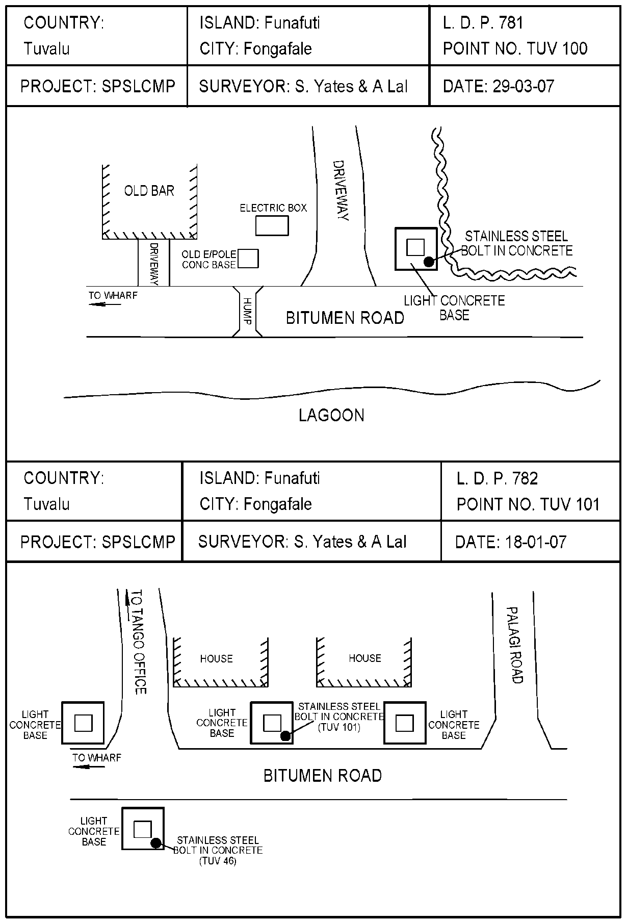
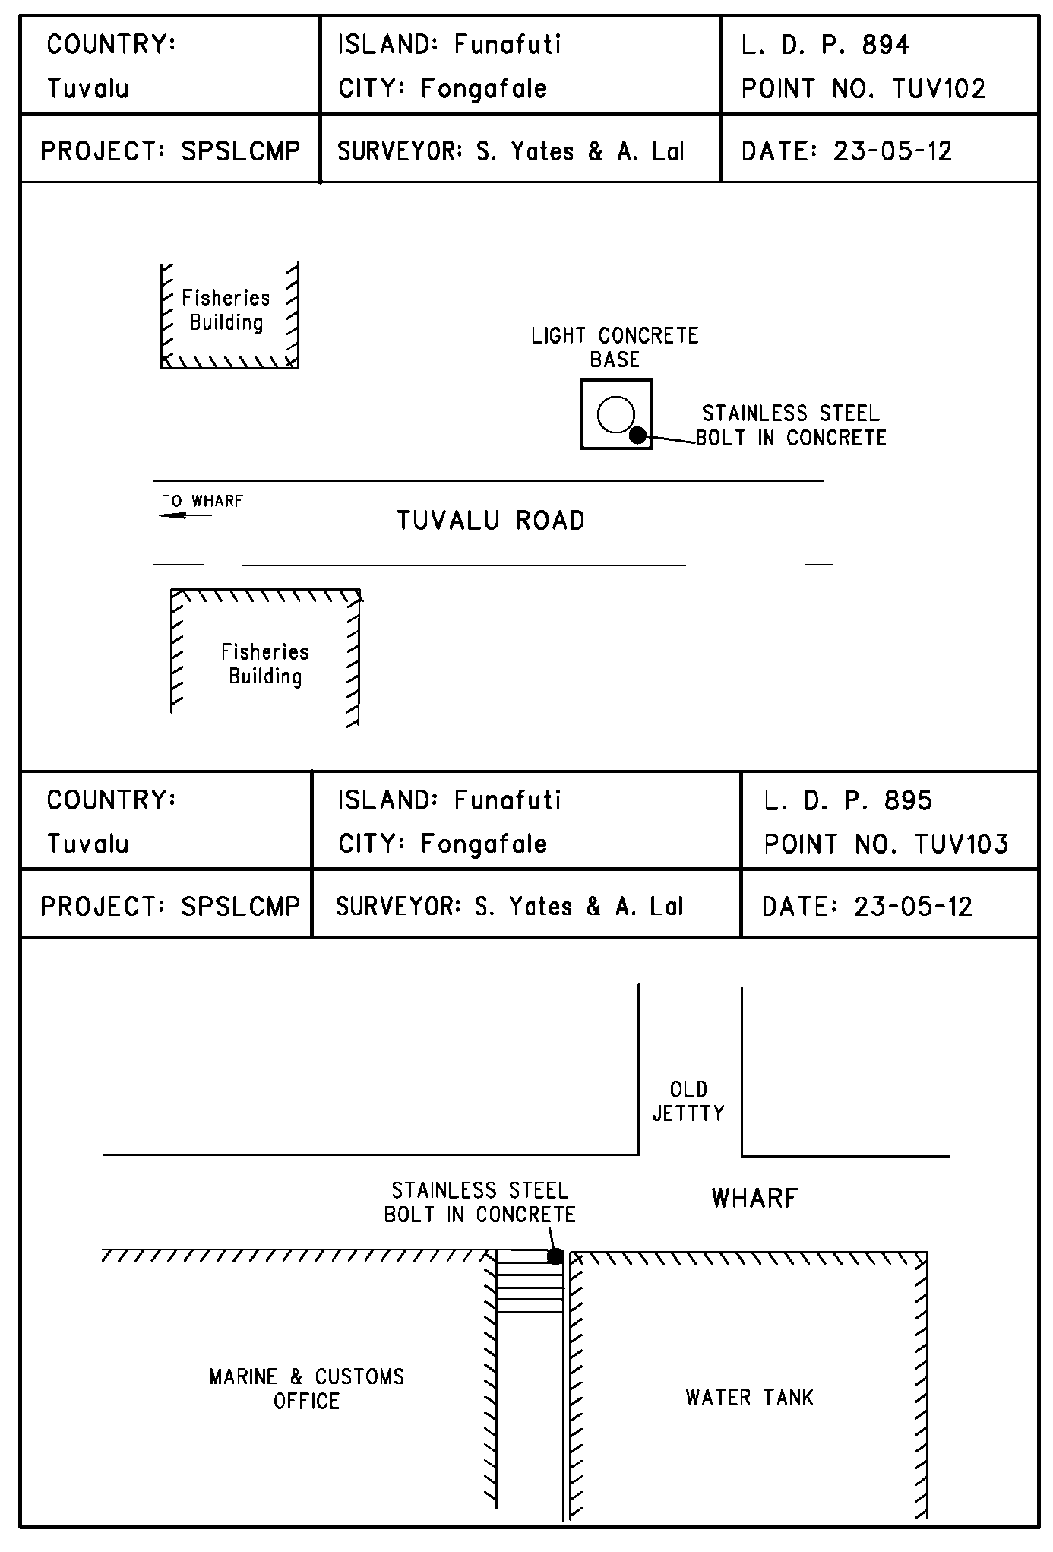
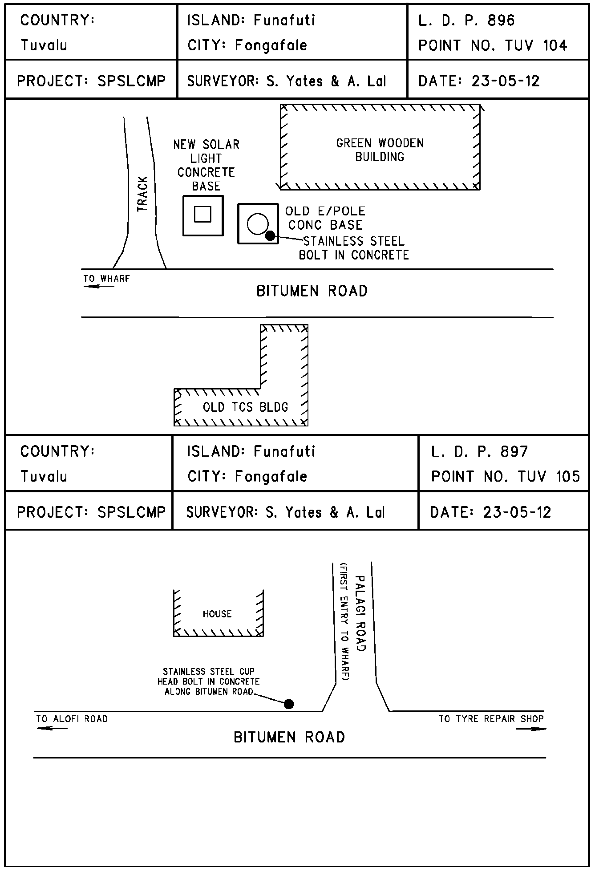

TUVABM and TUVA Reference Mark Locality Diagrams
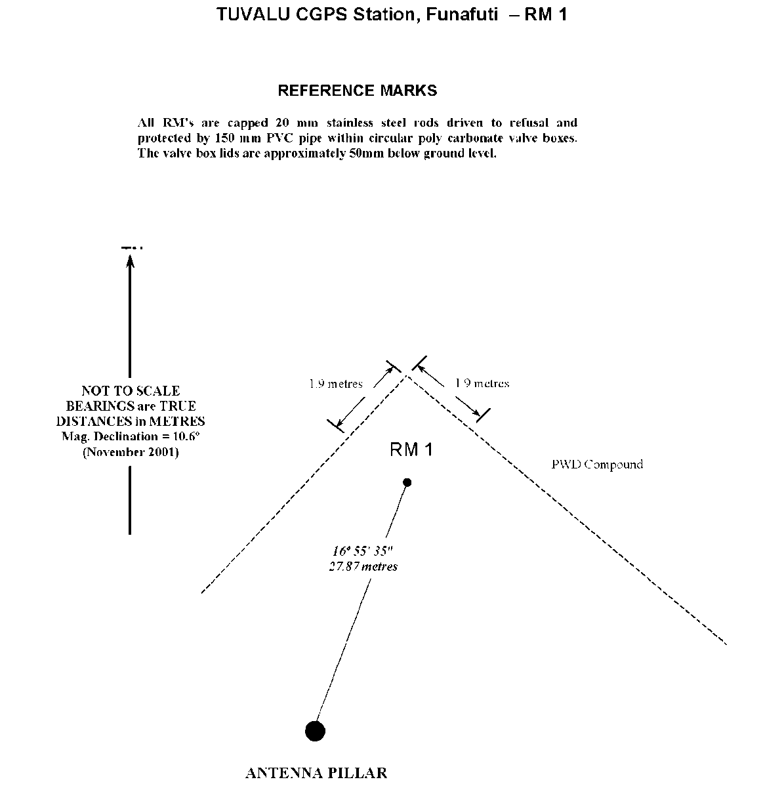
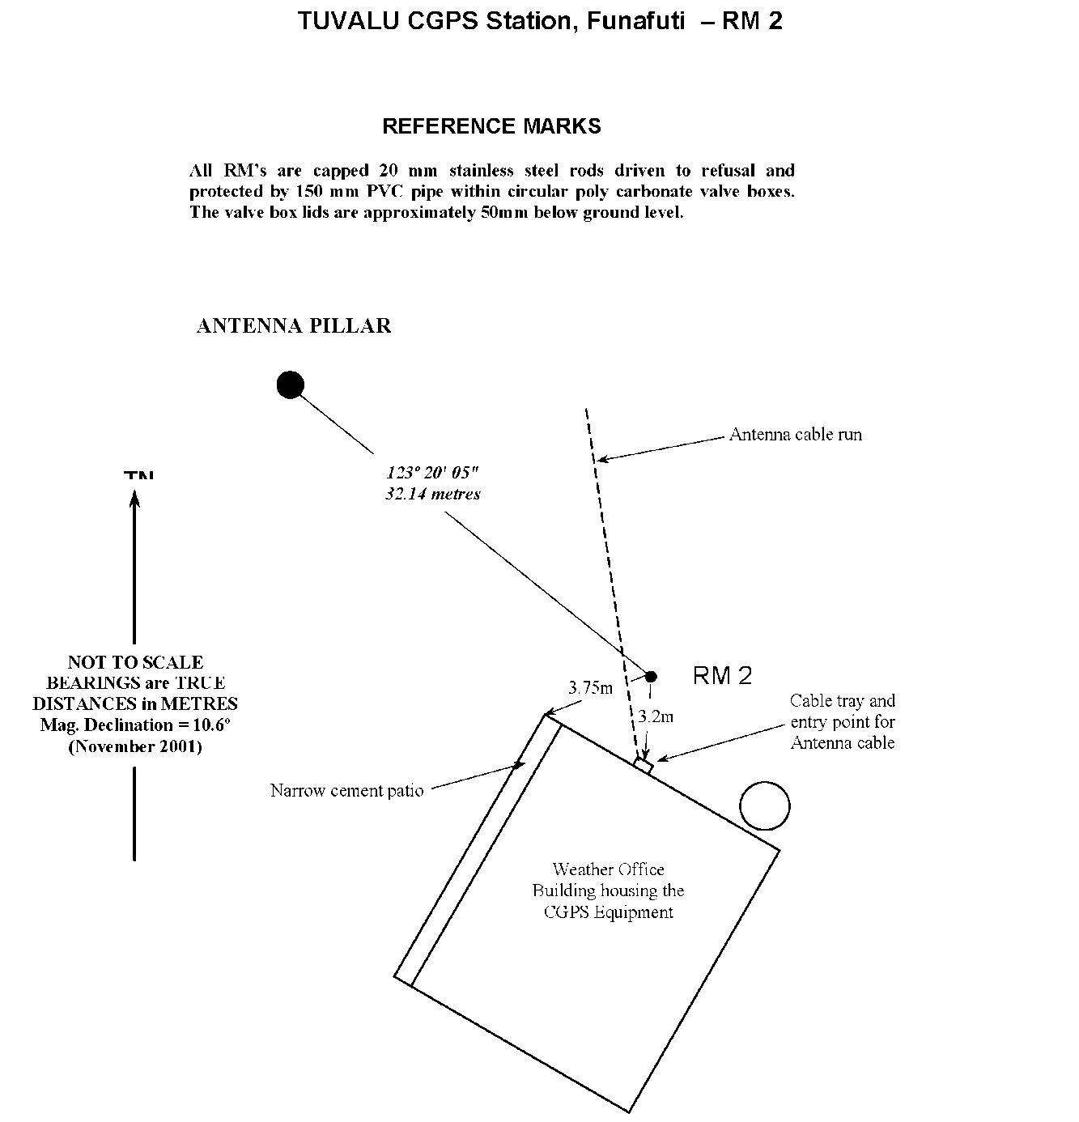
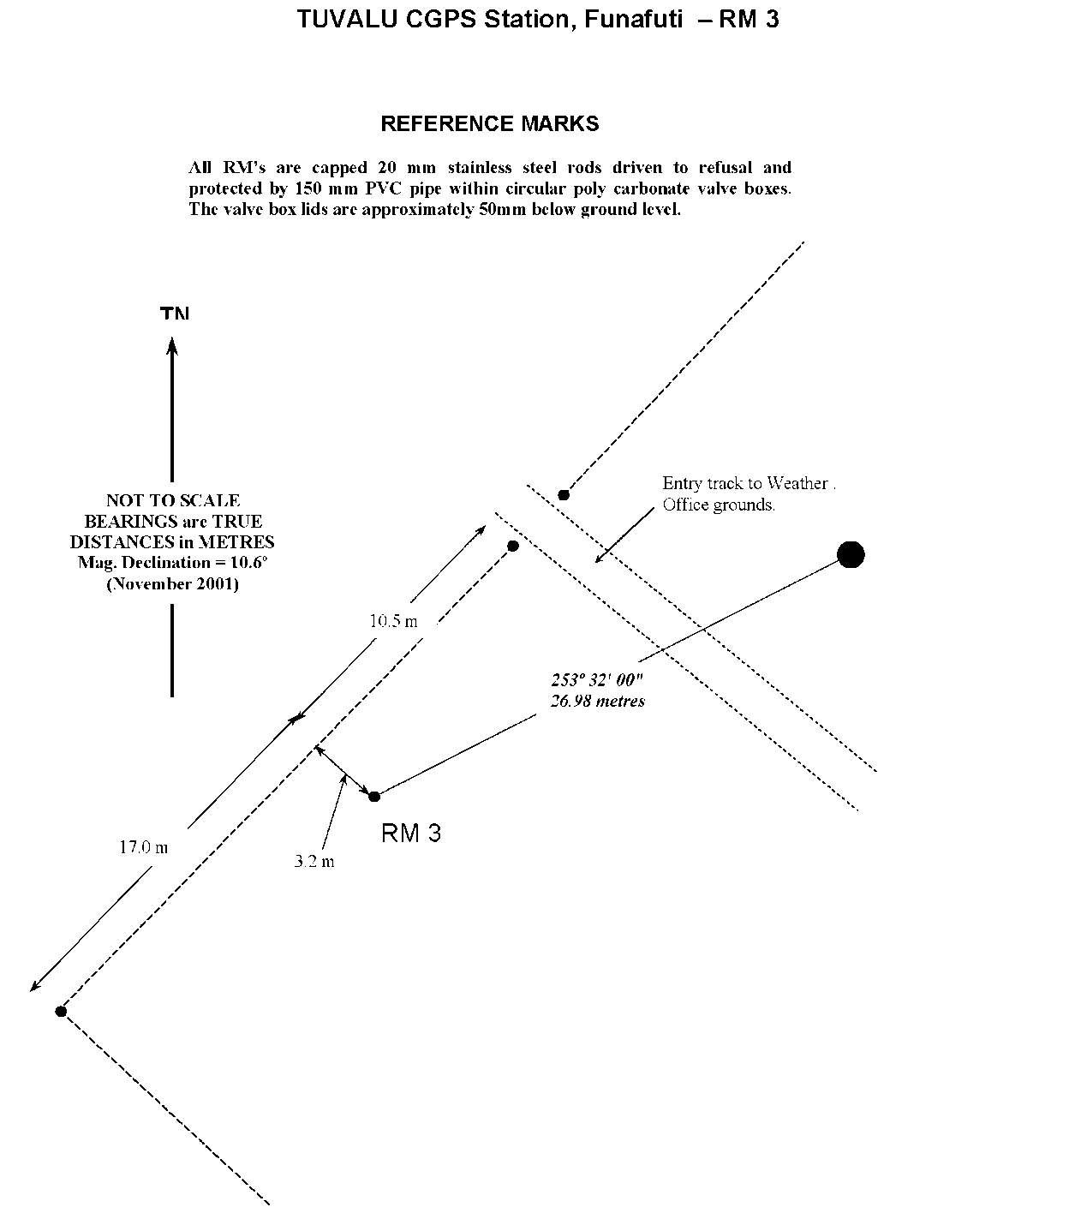

References
Rüeger, J.M. & Brunner, F.K. 1982, ‘EDM Height Traversing versus Geodetic Levelling’, The Canadian Surveyor, vol. 36, no. 1, pp. 69-87.
Inter-Government Committee on Surveying and Mapping (ICSM) 2002, Standards and Practices for Control Surveys, SP1, Ver. 1.5, May 2002.

