Guide to using the Australian Mafic-Ultramafic Magmatic Events GIS Dataset

Archean, Proterozoic and Phanerozoic Magmatic Events
Geoscience Australia
RECORD 2014/39
Jane P. Thorne, Michelle Cooper and Jonathan C. Claoué-Long
Department of Industry
Minister for Industry: The Hon Ian Macfarlane MP
Parliamentary Secretary: The Hon Bob Baldwin MP
Secretary: Ms Glenys Beauchamp PSM
Geoscience Australia
Chief Executive Officer: Dr Chris Pigram
This paper is published with the permission of the CEO, Geoscience Australia
© Commonwealth of Australia (Geoscience Australia) 2014
With the exception of the Commonwealth Coat of Arms and where otherwise noted, all material in this publication is provided under a Creative Commons Attribution 3.0 Australia Licence. (http://www.creativecommons.org/licenses/by/3.0/au/deed.en)
Geoscience Australia has tried to make the information in this product as accurate as possible. However, it does not guarantee that the information is totally accurate or complete. Therefore, you should not solely rely on this information when making a commercial decision.
Geoscience Australia is committed to providing web accessible content wherever possible. If you are having difficulties with accessing this document please email clientservices@ga.gov.au.
ISSN 2201-702X (PDF)
ISBN 978-1-925124-28-6 (PDF))
GeoCat 78742
Bibliographic reference: Thorne, J.P., Cooper, M. and Claoué-Long, J.C., 2014. Guide to using the Australian Mafic-Ultramafic Magmatic Events GIS Dataset: Archean, Proterozoic and Phanerozoic Magmatic Events. Record 2014/39. Geoscience Australia, Canberra. http://dx.doi.org/10.11636/Record.2014.039

Contents
Executive Summary 1
1. Scope of the Map 3
2. Methods 4
2.1. Sequence of Development 4
2.2. Sources of Geochronological Data and Digital Dataset 4
2.3. Crustal Elements 6
2.4. Definition of Magmatic Events 8
2.5. Definition of Igneous Provinces 10
2.6. Spatial Representation of Magmatic Events 11
2.7. GIS Dataset Specifications 12
3. Associated Maps and Reports 14
4. Mafic-Ultramafic Magmatic Events Time Series 15
4.1. Time-Space-Event Charts 27
5. Applications and Conclusions 29
Acknowledgements 34
References 35
Appendix A Digital Datasets used in this Study 37
A.1 Archean compilation 37
A.2 Proterozoic compilation 38
A.3 Phanerozoic compilation 41
Appendix B Attributes, Definitions and Values 43
Appendix C Mafic-Ultramafic Magmatic Events 48
Appendix D Time-Space-Event Charts 56
Appendix E References used in the compilation 58
Table of Figures
Figure 2.1 Major Geological Divisions of the Australian Archean cratons as used in previous work. Modified from Hoatson et al, (2009) 7
Figure 2.2 Major Australian post-Archean Crustal Elements and names used in this compilation 8
Figure 4.1 Australian Mafic-Ultramafic Magmatic Events ~2500 Ma to ~1900 Ma 16
Figure 4.2 Australian Mafic-Ultramafic Magmatic Events ~1870 Ma to ~1750 Ma 17
Figure 4.3 Australian Mafic-Ultramafic Magmatic Events ~1720 Ma to ~1530 Ma 18
Figure 4.4 Australian Mafic-Ultramafic Magmatic Events ~1470Ma to ~1130 Ma 19
Figure 4.5 Australian Mafic-Ultramafic Magmatic Event at ~1070 Ma 20
Figure 4.6 Australian Mafic-Ultramafic Magmatic Events ~975 Ma to ~825 Ma 21
Figure 4.7 Australian Mafic-Ultramafic Magmatic Events ~775 Ma to ~530 Ma 22
Figure 4.8 Australian Mafic-Ultramafic Magmatic Event at ~510 Ma 23
Figure 4.9 Australian Mafic-Ultramafic Magmatic Events ~480 Ma to ~410 Ma 24
Figure 4.10 Australian Mafic-Ultramafic Magmatic Events ~380 Ma to ~250 Ma 25
Figure 4.11 Australian Mafic-Ultramafic Magmatic Events ~225 Ma to ~80 Ma 26
Figure 4.12 Australian Mafic-Ultramafic Magmatic Events ~65 Ma to ~0 Ma 27
Figure 5.1 Mafic-Ultramafic igneous rocks of undefined age across Australia 30

Figure D1 Time-Space-Event Chart of Australian Archean Mafic-Ultramafic Magmatic Events 56
Figure D2 Time-Space-Event Chart of Australian post-Archean Mafic-Ultramafic Magmatic Events 57

Executive Summary
This document provides supporting information to assist in the use of the Australian Mafic-Ultramafic Magmatic Events GIS Dataset. The dataset is made publicly available as a GIS at nominal 1:5 000 000 scale, and shows the time-space-event distribution of mafic-ultramafic magmatism in Australia from the early Archean to the present day.
Development of this GIS has been a multi-year project and earlier released extracts (in viewable PDF form with accompanying Geoscience Australia Records) included compilations for the Archean magmatic record, the Proterozoic magmatic record, and the Australian Large Igneous Provinces (LIPs). Publication of the GIS completes the series with addition of the Phanerozoic magmatic record, and formalisation of the complete record of Archean-Phanerozoic magmatic events as a single series.
The chronology of Australian mafic-ultramafic magmatism resolves into 74 magmatic events within, predominately, resolvable bands of ±10 million years (Myr). Each event is identified by geological units grouped by similar age – this coeval magmatism may or may not be genetically related and may be in response to different geodynamic environments. These magmatic events range in age from the Eoarchean ~3730 Ma ME 1 – Manfred Event, confined within a small remnant domain within the Yilgarn Craton, to the widespread record of Cenozoic magmatism in eastern Australia (ME 72 to ME 74). The magmatic events range in magnitude from the giant volumes of magma in Large Igneous Provinces, to events whose only known occurrence is an isolated record of dated mafic igneous rock in a single drillhole. The GIS makes it possible to focus on the location of any one of these magmatic events, or groups of magmatic events that may be of interest, and overlay context from any other information that users may have available.
The delineation of magmatic events for this study is based on several hundred published ages of mafic and ultramafic igneous rocks from different isotopic systems and minerals. In addition to their ages and extents, primary recorded aspects of each magmatic event include the presence or absence of ultramafic components. Further to this, the presence or correlation of known magmatic-related mineralisation is highlighted in Time-Space-Event Charts of Australia (Appendix D, figures D1 and D2). The basis for mapping has been regional solid geology, interpreted basement geology and surface geology base maps made available by the State and Northern Territory geological surveys, providing insight into the total areal extent of the magmatic systems under cover. Also available to complement the Event GIS are the domains and element boundaries from the Australian Crustal Elements map. These boundaries which are which are based on geophysical extrapolation of crustal elements under the cover of continental basins, provide a framework of the shallow crustal structure of the continent, and are used in this guide. The Crustal Elements digital dataset is available for download from the Geoscience Australia website.
Insight into the geodynamic development of the continent is provided by the magmatic event structure through time. The compilation draws attention to concentrations of mafic-ultramafic magmatism in the Archean from ~2820–2665 Ma, in the Proterozoic from ~1870–1590 Ma, and in the late Neoproterozoic-Phanerozoic from ~530–225 Ma. These three time spans contain 39 of the 74 magmatic events, 53% of the entire mafic-ultramafic magmatic event record of the continent. The periods in between have mafic-ultramafic magmatic records that are more dispersed in time. Other features of interest include the shared geographic and crustal element locations of Large Igneous Provinces and numerous events with smaller magma volumes.
In the Archean, only three mafic-ultramafic magmatic events are known to be mineralised, but one of these (the ~2705 ME 19 Kambalda Event) is the basis of much of Australia’s world-leading production of komatiite-hosted nickel. Exploration is yet to discover world class examples of magmatic-related mineralisation in Australia’s Proterozoic and Phanerozoic magmatic events. Nine Proterozoic and nine Phanerozoic magmatic events in Australia, however, do have discovered resources, indicating that the mineral system is present in those magmatic events. The compilation identifies that every magmatic event corresponding to world-class magmatic mineral deposits in other continents is also represented in Australia, with the sole exception of the ~2585 Ma Great Dyke mineralisation in Zimbabwe. These correlations of mineralisation, both within Australia and with magmatic mineralisation in other continents, are a basis for investigating mineral potential in under-explored parts of igneous provinces, especially where they extend under cover.
The Australian Mafic-Ultramafic Magmatic Events GIS Dataset is a fundamental national framework within which to integrate other geological, geochemical and geophysical datasets, and to evaluate pointers to under-explored and potentially mineralised environments. As a compilation of all mafic-ultramafic magmatic events, large and small, this is currently the most detailed magmatic event record available for any continent. It provides the detailed basis from which to constrain the role of the mantle and mafic-ultramafic magmatism in the development of the Australian continent, and the correlation with other continents.

Scope of the Map
This document is a user guide for the GIS dataset of ‘Australian Mafic-Ultramafic Magmatic Events’ produced by Geoscience Australia (GA). The dataset adds coverage of Phanerozoic mafic-ultramafic magmatic events to previously-published Archean and Proterozoic compilations to complete the detailed magmatic event framework for the Australian continent in a single accessible dataset.
Production of the dataset was undertaken within the Mineral Systems Group of the Resources Division (RD), in collaboration with the State and Northern Territory geological surveys, all of whom made available their most recent geological and geochronological datasets (Appendix A). Two earlier releases of specific Proterozoic and Archean compilations were produced within the Mineral Exploration Promotion Project which published the resulting maps as PDFs and JPGs. This new National GIS is the final component of the series. It supersedes the earlier productions by completing the Phanerozoic magmatic event series and by publishing a digital dataset accessible to GIS systems.
This dataset focusses attention on the continent-wide extent and volume of certain magmatic systems, and can be used to make associations with mineralisation. The locations of magmatic units in space and time, their extensive correlations across the continent, and the relationship of magmatism to the present day crustal structure of the continent, are all prominent. This dataset will be of interest to those explorers searching for nickel, platinum-group elements (PGEs: platinum, palladium, rhodium, iridium, osmium, and ruthenium), chromium, titanium and vanadium, as well as being a fundamental resource for understanding the thermal and dynamic evolution of the Australian continent.
The magmatic event framework in time and space is presented as a digital GIS dataset and has been compiled from map sources ranging from 1:100 000 to 1:2 000 000 scale. This framework shows the continental distribution of 26 Archean, 29 Proterozoic and 19 Phanerozoic mafic-ultramafic magmatic events. These range from ~3730 Ma gabbros in the Narryer Terrane of the Yilgarn Crustal Element, to the record of Cenozoic magmatism in eastern Australia. Regional and local solid-geology digital maps were synthesised to produce a national presentation of mafic-ultramafic rock units, including regional rock packages that contain relatively minor coeval mafic-ultramafic igneous rock components. Colour-coding of rock unit polygons by their age of magmatism provides a visual cue to the spatial and temporal correlations of magmatic units at province and continental scales. In this guide, their relationship to the evolution of the continent is shown with an underlay of the Australian Crustal Elements map (Shaw et al, 1996a) which delineates the shallow crustal structure of the continent (see section 4.1 for a link to a digital version of this map).The Australian Mafic-Ultramafic Magmatic Events dataset includes recorded isolated occurrences of dated magmatic units, in the form of point data, and also highlights the extent of known mafic-ultramafic magmatic units which lack reliable age control.
This document provides a description of the digital dataset, and links to supporting information published in the earlier publications of Australian Archean, Proterozoic and Large Igneous Province magmatism.

Methods

Sequence of Development
This study was initiated with a State-by-State compilation of Australian Proterozoic mafic-ultramafic magmatic events which was completed with publication in PDF format of a 1:5 000 000 Map of Australian Proterozoic Mafic-Ultramafic Magmatic Events (Hoatson et al, 2008). This documented, for the first time, the time-space-event framework and wide continental extent of 30 magmatic events from ~2455 Ma to the Cambrian emplacement of the ~510 Ma Kalkarindji Large Igneous Province.
An Archean 1:5 000 000 Map compilation then followed (Hoatson et al., 2009). A 1:5 000 000 Map synthesising the extent and crustal framework of the five Proterozoic LIPs and their context was also published (Claoué-Long et al., 2009).
The Australian framework of mafic-ultramafic magmatic events has now been completed by documenting the event framework and extent of Phanerozoic mafic-ultramafic magmatism across Australia. The previously-compiled magmatic event series for the Archean (26 events), Proterozoic (29 events) and Phanerozoic (19 events including a continuum of Cenozoic magmatism that is broken into three events) have now been joined as a single series of 74 Australian mafic-ultramafic magmatic events from ~3730 Ma to the present day.
Previous maps in the series were published as PDFs at 1:5 000 000 scale. The underlying unreleased digital GIS data for those previous maps is now included with the Phanerozoic data, making the complete Archean, Proterozoic and Phanerozoic digital GIS dataset for the Australian continent publicly available. However, no updates have been made to the Proterozoic and Archean datasets since they were first complied for release as PDFs and JPEGs in 2008 and 2009 respectively. Additionally, it should be noted that due to the wide range of map sources used it has not been possible to create a seamless continent-wide integration of the combined datasets, or to release a unified national GIS. This is evident in discontinuities at the boundaries of States and of regional maps, and more subtly in widely different modes of representing mafic-ultramafic rock units in maps created across different parts of Australia at differing scales. It has also meant that it has not been possible to fully standardise many of the text fields in the associated feature class and look-up tables. Demand for access to the underlying digital dataset, even in its inherently fragmented form, has been expressed from the exploration and research communities. The complete Archean, Proterozoic and Phanerozoic digital GIS dataset is, therefore, being made publicly available—with the caveat that the combination of State / Northern Territory, regional and local data representations means that individual mafic-ultramafic units may be represented by multiple overlapping polygons (from the various data sources).

Sources of Geochronological Data and Digital Dataset
The geological and geochronological data which underpin this study were obtained from extensive searches of published and unpublished literature. Information was sourced from scientific journals; publications produced by Geoscience Australia and its precursor agencies the Bureau of Mineral Resources and the Australian Geological Survey Organisation; from the Commonwealth Scientific Industrial Research Organisation; and from the State and Northern Territory geological surveys. Publications from the geological surveys included first, second, and third Edition 1:100 000 and 1:250 000 geological maps and their respective explanatory notes, bulletins, reports, and records. Unpublished information was obtained from company exploration reports and university theses. Unpublished geochronological data were sourced from university theses, State and Northern Territory geological survey databases, and from Geoscience Australia’s OZCHRON national database of age determinations on Australian rock samples. Mineral resource data are from both the Australian Mines Atlas—database of Australian minerals and energy deposits, mines, resources, and processing centres and OZMIN—Geoscience Australia’s national database of mineral deposits and resources. The use of all sources are acknowledged and fully referenced in this guide (see Appendix E) and in the GIS dataset look-up tables.
There exists no single solid-geology map or GIS for all Australia. Consequently, the base maps used are the most current solid-geology coverages available from the State and Northern Territory geological surveys (Appendix A) at the time of compilation. Surface geological maps, which may not record the undercover extent of geological units, were used for additional data in areas where solid geology maps are not available. All of these map sources vary in their mapping approaches, coverage, scale and detail. For example, Western Australia, South Australia, New South Wales and Victoria, have solid-geology coverages but variations in the mapping approaches are wide, especially where maps join at State borders. At the time of compilation, there was no single solid geology map available for Queensland or the Northern Territory, obliging recourse to a variety of local and regional maps at a range of scales. In New South Wales, the representation of mafic and ultramafic magmatic rocks is held in different digital solid geology sources in different parts of the State. The representation of mafic and ultramafic magmatic units across the national compilation varies significantly because of the limitations and different scales of these disparate sources.
Solid-geology maps may have an advantage over outcrop-based equivalents as they can provide an insight into the interpreted total areal extent of rock units (e.g. extensions under the cover of younger rocks, or regolith), and hence the volume of the magmatic systems, which is an important criterion when assessing mineral potential. However, it should be noted that solid-geology often omit potentially important dykes and dyke swarms in larger scale formats. In addition, the actual total volumes of magmatic systems cannot be determined due to the inherent uncertainties in estimating thicknesses and amounts of erosion.
Other thematic mapping sources were integrated to achieve a more complete representation of mafic-ultramafic rocks. These include the province-wide coverage of unassigned mafic dykes and sills in Western Australia (Myers and Hocking, 1998), the inferred distribution of gabbroic intrusions under cover in the Officer Basin of Western Australia (D’Ercole and Lockwood, 2004), and local documentation of mafic dyke swarms on some, but not all, 1:250 000 and 1:100 000 geological sheets from the Northern Territory and Queensland. Where State or regional scale maps did not include important individual mafic-ultramafic units, they were incorporated from other sources (an example is the representation of the Milliwindi Dolerite Dyke, Kimberley, Western Australia from Hanley and Wingate, 2000, which is important as a well-dated component of the Kalkarindji LIP).
Where no map representation of an important mafic-ultramafic magmatic rock is available, suitably attributed point data are included in the final GIS to represent the occurrence.

Crustal Elements
Different approaches to geological province boundaries were trialled over the course of this study. An initial map of Western Australia used the 1:2 500 000 Tectonic Units of Western Australia (June 2001, Geological Survey of Western Australia). A subsequent map of the Northern Territory and South Australia used the Georegions GIS representation from Geoscience Australia.
The Map of Australian Proterozoic Mafic-Ultramafic Magmatic Events for all Australia was the first in the series to require a seamless and consistent province delineation for the entire continent. The only extant crustal framework representation at the relevant 1:500 000 scale is the Australian Crustal Elements 1:5 000 000 scale map of Shaw et al. (1996a), and this was used as a base with minor modifications (see below). The Australian Crustal Elements are based primarily on composite geophysical (magnetic and gravity) domains. The advantages of this approach to crustal elements include a consistent coverage for the entire continent, and the attempt to show the spatial distribution of provinces in the third (vertical) dimension: i.e., under younger cover. This geophysical domain map emphasises links to tectonic provinces, but is not a tectonic map as such. Shaw et al. (1996b) discuss in detail the principles and applications of the Australian Crustal Elements map (Shaw et al., 1996a). The Phanerozoic compilation is dominated by magmatic rocks in the eastern Australia States, but also includes correlatives in Western Australia, South Australia and the Northern Territory.
Subsequent publication of the Archean map required a different approach to the crustal framework because the Australian Archean cratons are each single undivided ‘elements’ in the Shaw et al. (1996a) Australian Crustal Elements map. The Australian Archean Mafic-Ultramafic Events Map (Hoatson et al., 2009) made use of subdivisions of these into specific terrane and domain schemes developed and published for each craton. While these are not consistently based, they do provide a basis for evaluating the relationship of Archean magmatism to the crustal structure within each Archean element (Figure 2.1).
In the interest of continuity and to minimise confusion the Australian Mafic-Ultramafic Magmatic Events dataset uses a modified version of the element schema from the Australian Crustal Elements map of Shaw et al (1996a) (Figure 2.2), discarding the schema of Figure 2.1.
Modifications to the Shaw et al. (1996a) element boundaries take into account new geophysical and other datasets obtained since 1995 and include:
- the locus of the Tasman Line in North Queensland is modified to reflect the recommendations of Nishiya et al. (2003) and is also modified to represent the Irindina crustal element east of the line in this guide;
- the Warumpi Province boundary in central Australia is drawn to accommodate the description of Scrimgeour et al. (2005);
- the boundary of the South Australian Element is drawn to exclude the Albany-Fraser Province and include the Peake and Denison Inliers; and
- Proterozoic subdivision of the South Australian Element into Southwest Gawler, Central Gawler, North Gawler, East Gawler and Coompana provinces follows recommendations of R. Skirrow (Geoscience Australia, pers. comm., 2008) (see Figure 2.2) based on a detailed recent study of the Gawler Craton by Geoscience Australia and the South Australian Department for Manufacturing, Innovation, Trade, Resources and Energy.
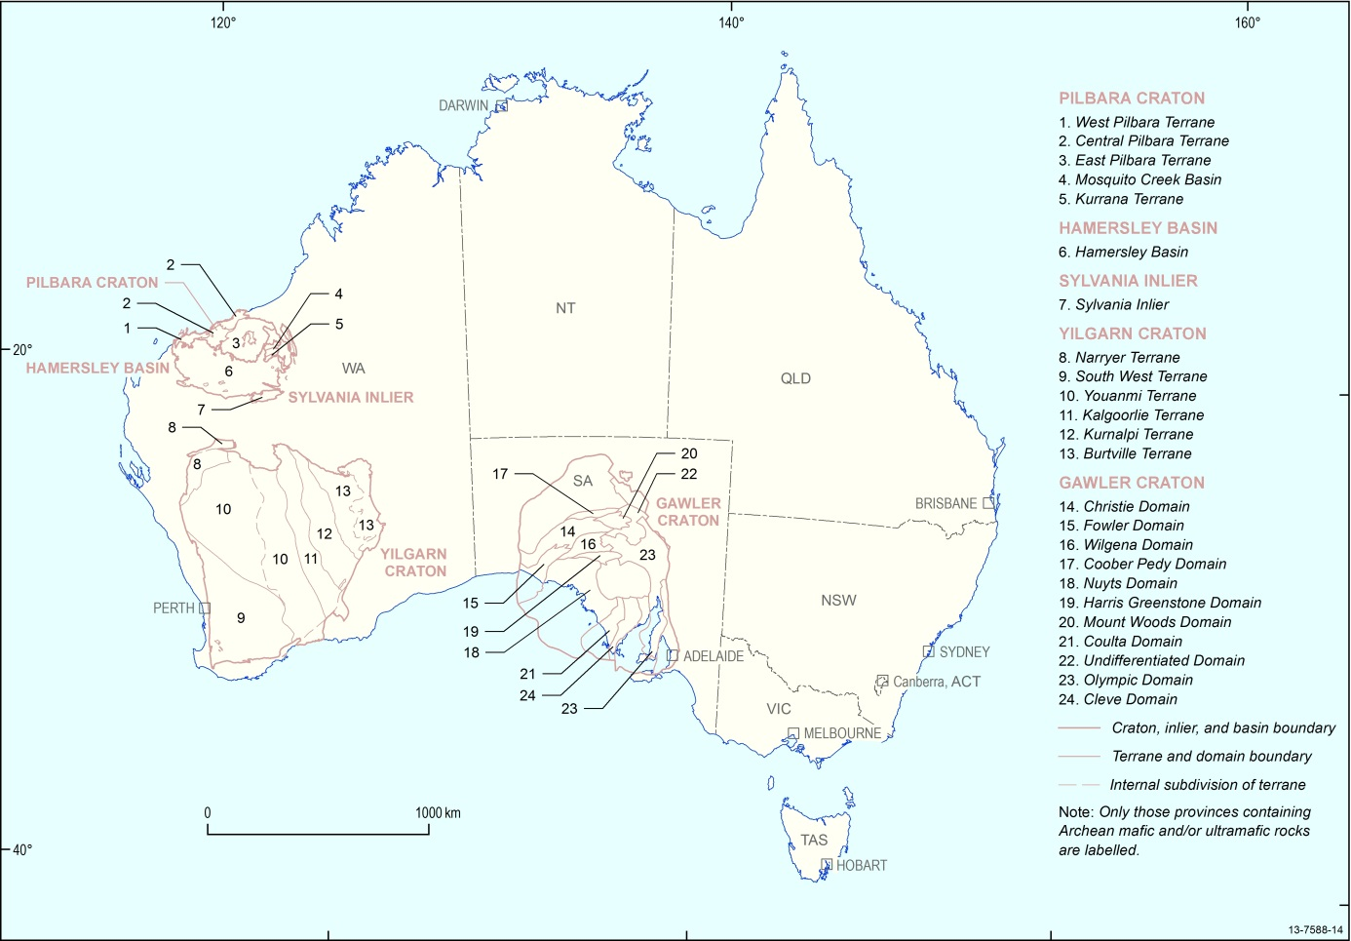
Figure 2.1 Major Geological Divisions of the Australian Archean cratons as used in previous work. Modified from Hoatson et al, (2009)
Particularly important to the Phanerozoic evolution, but also much debated, is the approximate easternmost limit of the Australian Precambrian crustal elements (Shaw et al., 1996b; Direen and Crawford, 2003; Glen, 2005). The Tasman Line, a controversial concept in the geology and tectonics of eastern Australia, is a zig-zag line that crosses the Australian continent from north to south. In regions of exposure its location is mapped in surface geology, but its extension under the cover of later basins is much debated. For consistency, the interpretation of the boundary in Shaw et al. (1996a) is used here. The Tasman Line is interpreted by some researchers to be a regional orogenic suture that demarcates the western extent of the break-up of Rodinia, followed by the growth of orogenic belts along the eastern margin of Gondwana. Other investigators have interpreted the Tasman Line to be the westernmost limit of deformation associated with the eastern Australian Palaeozoic orogen (e.g., ‘Tasman Orogenic System’). The region east of the Tasman Line, extending across to the eastern coast of the continent, has been referred to as the Tasmanides of eastern Australia. Detailed reviews of the Tasman Line and Tasmanides can be found in Direen and Crawford (2003) and Glen (2005, 2013), respectively.
The Shaw et al. (1996a) map of crustal elements does not include or represent most of the continental basins, because its purpose is delineation of the underlying basement to those basins. Mafic-ultramafic magmatic rocks hosted within those basins, therefore, appear attributed within the underlying basement element. An example is sills within the Officer Basin in central and southern Australia which form part of the ME 57 – Kalkarindji Event: in the crustal element framework these are located as part of the underlying Albany-Fraser and Capricorn basement elements.
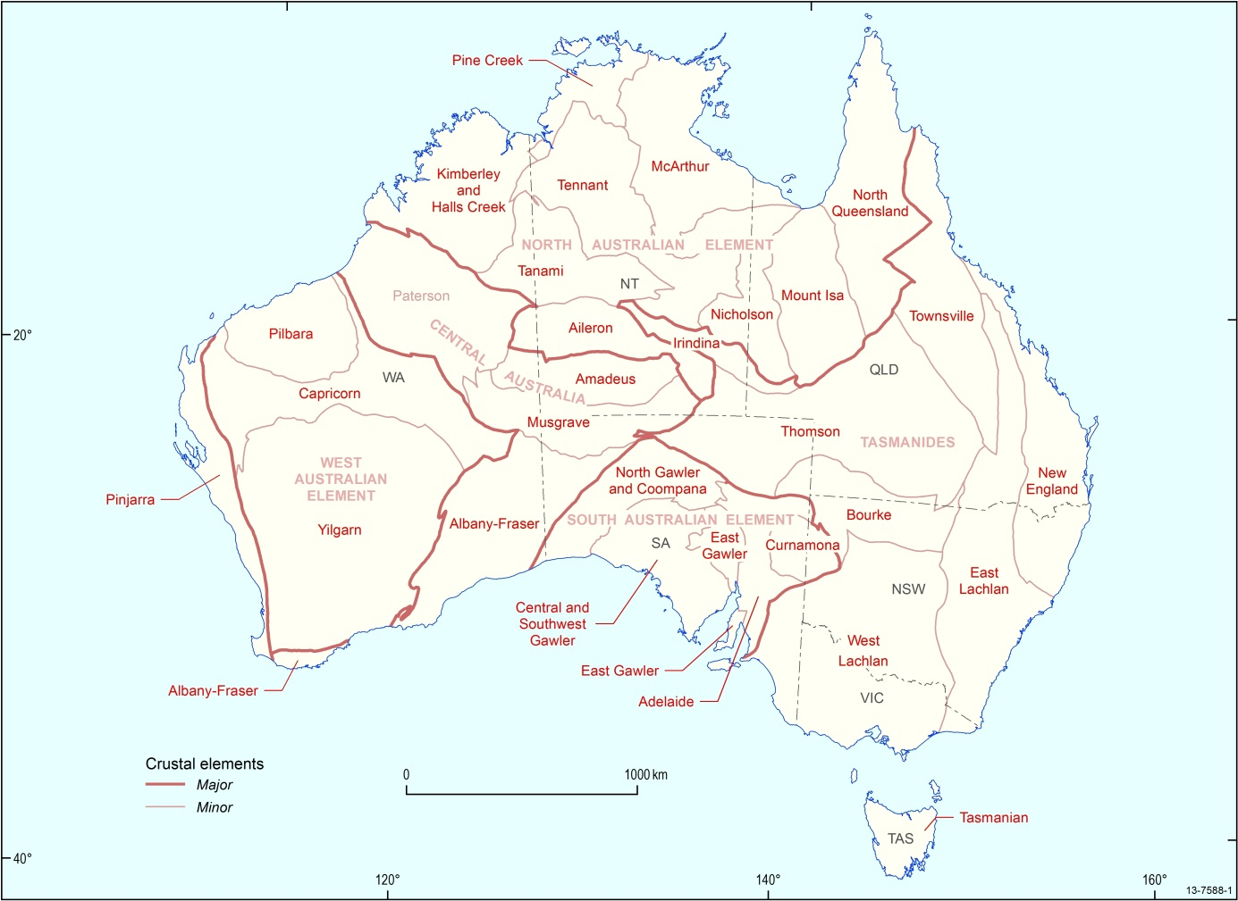
Figure 2.2 Major Australian post-Archean Crustal Elements and names used in this compilation

Definition of Magmatic Events
The compilation evaluated all available geochronological data that can constrain the timing and duration of magmatic ‘events’. ‘Events’ in this sense are defined as “probable geological incidents of significance that are suggested by geological, isotopic, or other evidence” (after Neuendorf et al., 2005). For the purpose of this dataset release, a mafic-ultramafic magmatic event is identified by geological units grouped by similar age – this coeval magmatism may or may not be genetically related and may be in response to different geodynamic environments.
The magmatic events compilation attempts to be comprehensive: it includes all recorded occurrences of Australian mafic-ultramafic magmatic rocks for which an emplacement age has been measured, or is inferred by correlation, or can be estimated from geological considerations. Thus it includes magmatic events across the spectrum from the giant systems known as Large Igneous Provinces, to ‘Isolated occurrences of dated Magmatic Events’, which are examples of dated mafic-ultramafic rocks that have no defined spatial extent (e.g., from drillhole or outcrop). Wherever possible, occurrences large and small are portrayed using published solid geology polygon or line information, supplemented with surface geology data where solid geology mapping is not available. Small occurrences are important since they may represent the named example of the dated magmatic event, or they may be the only known example of a particular magmatic event in a given province; in some cases, such as the Saxby and Elizabeth Hills events, there is only one known occurrence in the entire continent.
Units were defined as mafic and/or ultramafic using basic criteria, taking into consideration unit name and lithological description. Rocks were classified as mafic if their unitname or description included the word(s) basalt, dolerite, gabbro, amphibolite or basaltic andesite; or ultramafic if they included words like komatiite, picrite, peridotite, serpentinite, pyroxenite or dunite. Kimberlite and lamproite units were not included. Particularly in the Phanerozoic, if a unit contained ultramafic rocks it was classified as being ultramafic.
The recognition of magmatic events and their correlation has been made possible by the vastly increased coverage of geochronology in Australia over the last thirty years. Published ages were assessed for their geochronological methods and consistency with other temporal-related evidence, e.g., field relationships of associated rock units.
The series of 26 named Archean Magmatic Events is that of Hoatson et al. (2009b). The series of named 29 Proterozoic Magmatic Events is that of Hoatson et al. (2008b). The series of 19 named Phanerozoic Magmatic Events is newly compiled for this dataset and accompanying publication. The individual Archean, Proterozoic and Phanerozoic series have now been combined into a single 74-event time series for the Australian continent. The separate compilations combine seamlessly with the exception of the Phanerozoic Kalkarindji Event (Cambrian ~510 Ma), which was included as part of the Proterozoic series because of the magnitude of this magmatic episode, the overlap of its spatial distribution and crustal controls with earlier Proterozoic magmatic events, and the potential exploration importance. This is now superseded because the Phanerozoic event compilation reveals an earlier ~530 Ma magmatic event intervening between the end of the Proterozoic and the Kalkarindji event.
More than 90 per cent of the Archean and Proterozoic ages compiled are from zircon and baddeleyite U-Pb isotopic systems, and Sm-Nd isotopic studies make up most of the balance. There are fewer modern U-Pb dating studies among Phanerozoic units, creating greater reliance on the legacy of K-Ar and Ar-Ar (total cooling, fusion, plateau, feldspar) ages together with some U-Pb (monazite), Pb-Pb, and Rb-Sr isotopic dating. The criterion of choice in every case was the best available constraint on the magmatic age.
In some examples, ages of associated intermediate to felsic rocks were used, where the field relationships between the dated felsic rocks and the spatially associated mafic-ultramafic rocks were unequivocal, e.g., the felsic rocks are magmatically interlayered with the mafic-ultramafic rocks. This criterion is especially relevant to dating basalt lavas which may lack any other dating constraint.
Specific to the Phanerozoic is the relevance of biostratigraphic dating constraints. The Phanerozoic compilation documents several examples of basalt lava formations which have age attribution from biozonation of intercalated sedimentary rocks, in turn related to the Phanerozoic Time Scale of numerical ages (c.f. Gradstein et al., 2012).
In context with the available resolution of geochronology, the magmatic event series is, for the most part, defined at a maximum resolvable duration of 20 Myr (i.e., ±10 Myr). This ±10 Myr band of resolution was designed for the Archean and Proterozoic where the average precision of available isotopic dating is in the order of ±5 Myr. There are two exceptions to the resolvable 20 Ma bands, one between 2820 and 2810 (ME 9 – Lady Alma and ME 10 – Mount Sefton) and the other 2800 and 2790 (ME 11 – Narndee and ME 12 – Little Gap) where the resolvable duration is 10 Myr. This relatively low level of resolution also applies to much of the younger magmatism of the Phanerozoic – because of the pervasive reliance on legacy K-Ar dating in Phanerozoic Australia, with its inherent age uncertainty due to alteration and argon leakage. For the same reason, the 65 Myr continuum of the youngest (Cenozoic) lavas, mostly in eastern Australia, is arbitrarily divided into three wide age bands, and there is uncertainty in ascribing individual units between those bands.
Magmatic Event names are derived from the published names of reliably dated mafic ± ultramafic rock units (e.g., Gairdner, Oenpelli and Hart). In cases of unnamed units, a prominent associated name, e.g., for a deposit hosted by the mafic ± ultramafic rock unit (Bow River nickel deposit), or the formation or group that is intruded (Lane Creek) were used. The name of the most voluminous or prominent dated magmatic system was used for the naming of each magmatic event. For example, the ~1655 Ma ME – 40 Lane Creek Event was named after the dolerites which intrude the Lane Creek Formation in the Georgetown Inlier of the North Australian Crustal Element, rather than the relatively smaller coeval Tarcoola mafic magmatism in the Central Gawler province of the South Australian Crustal Element. The named examples of the each mafic-ultramafic Magmatic Event are listed in Appendix C.
The compilation of mafic-ultramafic events includes a substantial population of magmatic rock units for which there is no published age, or having doubtful age attribution, or age data inconsistent with field relationships. These are assigned as Undefined Event and divided into three categories, Archean, Proterozoic and Phanerozoic to reflect general age associations.
A relevant factor in the recognition of ‘events’, including both LIPs and smaller mafic-ultramafic magmatic events, is the range of time scales of mafic-ultramafic magmatic activity. Durations range between two end-members. One is the magmatic processes which typically occur at plate margins such as spreading ridges and subduction zones. It is inherent in the ‘conveyor-belt’ nature of plate boundary environments that magmatism, while punctuated as episodes, is in overall continuous production over the lifetime of the plate boundary movements. This is especially true at the scale of age resolution in the Precambrian where currently available geochronology has difficulty in resolving ages less than ~5–10 Myr apart. Intraplate magmatism, far-field from plate boundary processes and sometimes attributed to an exogenous event such as the arrival of a mantle plume, represents the opposite end-member in duration. The preserved records of intraplate mafic-ultramafic magmatic activity characteristically are of short duration, typically are isolated in time, and are readily identified and defined as discrete ‘events’.
There are caveats to the distinction of the two end-member cases. For example, the two may overlap where an exogenous input such as a mantle plume impinges at a plate boundary, and there are important intermediate situations between the two cases described. Nevertheless, the distinction is useful in considering the record of mafic-ultramafic magmatism. Both discrete and geologically-continuous periods of mafic-ultramafic magmatism can be identified in the Australian geological record.

Definition of Igneous Provinces
An igneous province may be defined as the extent in space and time of igneous rock units that relate to a single overall magmatic (or thermal) process. This is broader than the narrow definition above of a ‘magmatic event’ because an igneous province may encompass multiple ‘events’ and a much longer period of time than the ±10 Myr resolution of a single event within the magmatic events series. The inferred spatial extent of groups of events over longer periods of time can be explored in the GIS by grouping events considered to be related on age, geochemical or other criteria. These would then represent provinces in which the igneous rock units share a common time-space context. The boundaries of these igneous provinces today will reflect variable erosion, preservation and burial of evidence under cover.
Large Igneous Provinces (LIPs) are a subset of Igneous Provinces with a narrow definition and meaning. The published literature debating the meaning of ‘Large Igneous Province’ is enormous (cf. Ernst et al., 2005 and references therein; Bryan and Ernst, 2008). Recent definitions require not merely wide areal extent in an igneous province, but also demonstrably huge volumes of magma, and a narrow time dimension to distinguish transient magmatic ‘events’ from the long-lived magmatic systems associated with plate boundary environments.
Large Igneous Provinces are usually considered as being dominated by mafic (± ultramafic) igneous rock units, but there are important examples of LIPs associated more with silicic magmatism, referred to as silicic-dominated LIPs by some authors. The question of definition is related to divergent views of the mantle plume hypothesis of LIP formation, on which the literature is also enormous (c.f. Campbell, 2007 and references therein). This contribution does not take a position on definitions, accepting instead the five Australian LIP definitions, or proposals, already made by other authors in the context of the continuing debate.
Two aspects of the Australian context are important. First, it is clearly a precondition that the broader definition of an igneous province must first be met, before the size and time dimension of the province can be tested for adherence to definition as a LIP. Only the youngest two of the named Proterozoic LIPs (~510 Ma Kalkarindji LIP; ~825 Ma Gairdner LIP) have clearly been demonstrated to be both time equivalent and geochemically comagmatic systems throughout their extent (Glass and Philips, 2006; Zhao et al., 1994). The older proposed Proterozoic LIPs (~1070 Ma Wakurna, ~1210 Ma Marnda Moorn, and ~1780 Ma Hart LIPs) refer to igneous provinces recognised only by time equivalence of correlated igneous rock units: their geochemical coherence as igneous provinces is yet to be established.
Secondly, this compilation of mafic-ultramafic magmatic events highlights other large and transient magmatic events in Australia which have not yet attracted a proposal as candidate LIPs. Prominent examples are the ~2420 Ma ME – 28 Widgiemooltha Event, and the ~1590 Ma ME – 42 Curramulka Event, both of which have large regional extents recognised in this compilation.
It is important to note that while an event may be synonymous with a LIP, as is the case with the ME 36 – Hart Event, a LIP does not have to be synonymous with an Event. For example, ca. 510 Ma rock units in eastern Australia, related to the Tasman Orogen, have been assigned to the ME 57 – Kalkarindji Event but are not part of the Kalkarindji LIP.

Spatial Representation of Magmatic Events
Solid-geology maps available to this compilation do not always directly represent the presence of mafic-ultramafic rocks. Large igneous rock units, such as gabbro intrusions, are usually denoted with a discrete polygon. Smaller units of mafic-ultramafic rocks, such as narrow dykes, or lava flows interspersed within other stratigraphy, are often subsumed as a minor component of a regional rock package. It is necessary to include both types of unit in this compilation to properly represent the geographic extent, correlation and likely volume of each magmatic event. Accordingly a two-fold system of colour legend has been deployed:
- Bold colours are used on the map where the mafic-ultramafic rocks constitute the dominant component of a map unit.
- Pale colours of the same hue denote the presence of a subordinate component of coeval mafic-ultramafic rocks within a regional package of rocks: this is applied to map units of associated sedimentary, metamorphic, and intermediate and/or felsic igneous rocks wherever they include subordinate mafic-ultramafic units.
Examples of this dual legend occur in all areas of the map. The large area of ~1830 Ma ME 34 –Edmirringee Event in central Australia, for example, does not denote a large mafic magmatic unit: it represents a volumetrically small but regionally widespread component of metabasalt and metadolerite in dominantly sedimentary units of the Aileron and Tanami crustal elements.
A problem encountered in construction of this dataset has been the variable treatment of mafic dyke swarms in regional solid-geology maps. Individual dykes are small bodies and map compilers frequently omit them from regional scale maps. This is unfortunate, because the collective importance of a swarm of dykes can be significant. Particular effort has therefore been made to source map representation of mafic dykes wherever they are known, sometimes by recourse to detailed 1:100 000 and 1:250 000 solid geology and outcrop maps.
A particular problem exists in spatial representation of Archean mafic-ultramafic igneous rocks, owing to the lack of published, stratigraphically-attributed, solid geology polygons for major Archean greenstone belts and other provinces, especially for the Yilgarn Craton. In the absence of relevant solid geology coverage, event recognition is restricted to the few directly dated mafic-ultramafic igneous units and cannot be attributed more widely to stratigraphic correlatives. Hence entire greenstone belts lack event attribution in the current compilation, leaving only dated point data available for the map. Readers are pointed to the specific Archean compilation (Hoatson et al., 2009) for additional information on the spatial representation of Archean mafic-ultramafic magmatic events.

GIS Dataset Specifications
The National Map was produced using ArcGIS version 10. The feature classes showing the distribution of mafic and ultramafic rocks and the attributes of magmatic events are stored in an ArcGIS geodatabase. The feature classes are grouped by magmatic event to obtain event-maps showing the distribution of mafic and ultramafic rocks of that event. Since the geological datasets from the State and Northern Territory geological surveys do not follow standardised attributes for rocks, it was not possible to create a seamless nation-wide dataset of mafic and ultramafic rocks. The inclusion of Geoscience Australia’s unique unit number from the Australian Stratigraphic Units Database (Stratno), however, will allow the integration of the mafic and ultramafic rocks dataset with other national-scale datasets in GA, such as OZCHEM (GA’s inorganic geochemistry database of whole-rock and stream-sediment geochemistry).
The geochronological and geological attribution data for the mapped mafic-ultramafic units were compiled for the ArcGIS geodatabase, initially using Microsoft Excel spreadsheets, and arranged by state or territory, and geological province. The attribution data for each State and the Northern Territory were aggregated for publication in a single GIS attribute table in which the following four fields are important links to other digital data sources:
MAP_SYMB is the single map code for each unit entry in the GIS attribute table that links to the original polygon/line data within the relevant digital GIS source in a State / Northern Territory digital data source.
SOURCE is the specific citation of the source map used for geological units within the compilation.
UNITSOURCE is the key reference(s) for rock unit descriptions
STRATNO is the stratigraphic formation number linking to entries for each unit in Geoscience Australia’s Stratigraphic Units Database.
CRUSTELEMT denotes the location of each mafic-ultramafic magmatic unit within the Australian shallow crustal elements modified from Shaw et al. (1996a).
MAJELEMENT is the unit’s more local tectonic-geological unit as defined by the base maps used in each State / Northern Territory.
All the other criteria used to characterise the mafic-ultramafic units are summarised in Appendix B.

Associated Maps and Reports
The study of the time and spatial distribution of Precambrian mafic-ultramafic rocks was a staged process over four years. Earlier interim maps presented regional subsets of information. The new release GIS dataset accompanying this Record includes these earlier coverages. More recently, the study has concentrated on the time and spatial distribution of Phanerozoic mafic-ultramafic rocks.
Ideas and information evolved during the course of the study. However, all maps and reports in the series deploy consistent definitions, event criteria and names to facilitate cross-reference. The major changes introduced in the current product are the inclusion of Phanerozoic magmatism, the consistent use of major elements and crustal elements using the modified map produced by Shaw et al. (1996a), and the replacement of all earlier event numbering for parts of the geological record (Archean, Proterozoic) with a single seamless event series 1-74 for the entire mafic-ultramafic magmatic event record of the Australian continent.
The digital GIS dataset and all the earlier maps in this series (which are in PDF and JPEG format) are available for free download from Geoscience Australia’s Discovery and Delivery system (http://www.ga.gov.au/search/index.html#/) website. Users of the digital GIS dataset are referred to all the products listed below for detailed supporting data and information which is not repeated in this guide.
Outcomes from the study are available as:
- Hoatson, D.M., Claoué-Long, J.C. and Jaireth, S., 2008. Map of Australian Proterozoic mafic-ultramafic magmatic events, Sheets 1 and 2, 1:5 000 000 map, Geoscience Australia.
- Hoatson, D.M., Jaireth, S., Whitaker, A.J., Champion, D.C. and Claoué-Long, J.C., 2009. Map of Australian Archean mafic-ultramafic magmatic events, Sheets 1 and 2, 1:5 000 000 map, Geoscience Australia.
- Claoué-Long, J.C. and Hoatson, D.M., 2009. Map of Australian Proterozoic Large Igneous Provinces, Sheets 1 and 2, 1:5 000 000 map, Geoscience Australia.
- Hoatson, D.M., Claoué-Long, J.C. & Jaireth, S., 2008. Guide to Using the Australian Proterozoic Mafic-Ultramafic Magmatic Events Map. Record 2008/015. Geoscience Australia, Canberra.
- Hoatson, D.M., Jaireth, S., Whitaker, A.J., Champion, D.C. & Claoué-Long, J.C., 2009. Guide to Using the Australian Archean Mafic-Ultramafic Magmatic Events Map. Record 2009/041. Geoscience Australia, Canberra.
- Claoué-Long, J.C. & Hoatson, D.M., 2009. Guide to using the Map of Australian Proterozoic Large Igneous Provinces. Record 2009/044. Geoscience Australia, Canberra.

Mafic-Ultramafic Magmatic Events Time Series
Magmatic units have been assigned to 74 Magmatic Events (ME) ranging in age from the Early Archean ~3730 Ma (ME 1) to the Cenozoic (ME 74). The event series 1-74 supersedes the earlier partial event series devised within the Proterozoic and Archean in earlier publications.
The following figures provide a time series construction showing the secular evolution of post-Archean mafic-ultramafic magmatism in spatial relation to the Australian Crustal Elements. It is not yet possible to construct a similar map series for the Archean because stratigraphically attributed solid geology polygons were unavailable at the time of compilation for major parts of the Archean record, especially for the Yilgarn Craton.
The Proterozoic and Phanerozoic evolution of mafic-ultramafic magmatic events falls naturally into 12 time periods, each presented as a map in sequence and described in turn in the following pages. This time series should be compared with the Time–Space–Event chart in Appendix D.
Users are cautioned that the reduced scale of these maps does not permit distinction between solid geology polygons that are dominantly mafic-ultramafic rocks, and polygons representing regions that may contain very small components of mafic rocks. Detail of the distinction between the two types of polygon representation is found in the digital dataset.
In each of the eight figures there is drawn an inferred extent for all the mafic-ultramafic magmatic events within the relevant time period. These inferred igneous provinces may refer to magmatic activity over long periods of time. Events within each time period are discussed below each figure. Two codes in parenthesis (m) or (mu) attributed to each magmatic event indicate the composition of the igneous rocks constituting that event. The (m) code signifies that only mafic rocks are present, whereas (mu) indicates that both mafic and ultramafic rocks are present even if the ultramafic component may constitute only a few per cent of the total mafic-ultramafic rock assemblage.
The restricted time intervals of the five documented Australian LIPs are included within the broader periods. The time sequence maps suggest that other magmatic events may potentially meet the definition of LIPs, but their attribution will require further work. An example is the ~2420 Ma ME 2 – Widgiemooltha Event, of which the preserved area of east-west dolerite dykes may be only a remnant of the original extent of the igneous province. The ~1590 Ma ME 16 – Curramulka Event is also prominent for its wide spatial correlation across both the North and South Australian Major Crustal Elements, extending also into early protoliths of the Musgrave Element in Central Australia.
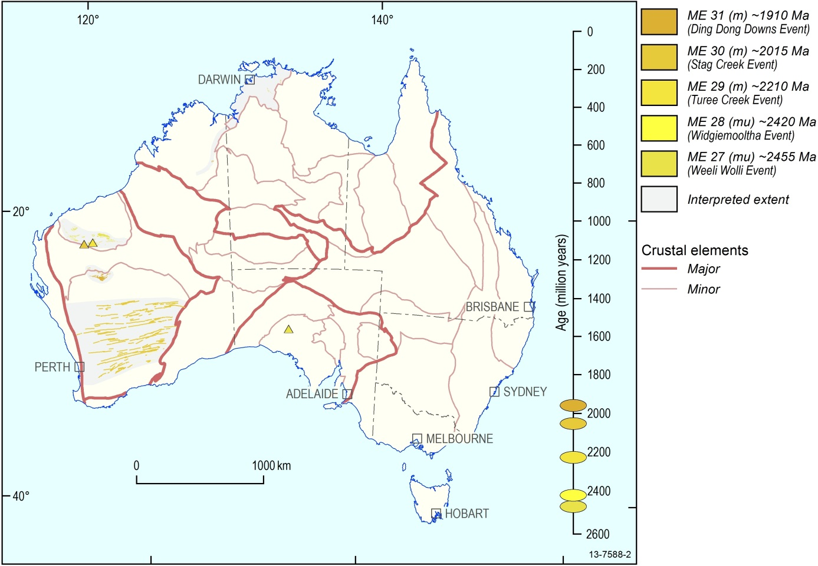
Figure 4.1 Australian Mafic-Ultramafic Magmatic Events ~2500 Ma to ~1900 Ma
In the Proterozoic prior to ~1870 Ma, the Australian mafic-ultramafic magmatic record is confined to the western half of the continent and the dominant expression is a series of east-west trending mafic-ultramafic magmatic belts (Figure 4.1). The pattern of east-west magmatic trends in this part of the continent remains a feature to the end of the Proterozoic. Magmatic Events 27, 29, 30 and 31 are preserved as east-west belts at the southern margin of the Pilbara Element and the northern margin of the Yilgarn Element. The ~2015 Ma ME 30 – Stag Creek Event, and the ~1910 Ma ME 31 – Ding Dong Downs Event, are the first to have expression within the North Australian Element, in the Pine Creek and Halls Creek provinces.
The ~2420 Ma ME 28 – Widgiemooltha Event is of wide geographic extent, comprising an east-west mafic and ultramafic dyke swarm that traverses the Yilgarn Element. The full extent of this igneous province may be wider than that shown to the south and north. An arbitrary southern extent is shown where the Widgiemooltha dykes are crossed by the later ~1210 Ma ME 47 – Marnda Moorn Event dolerite dykes at the southern margin of the Yilgarn Element. The two sets of dyke orientations are similar in this area, making it difficult to distinguish the two. It is possible that the Widgiemooltha Event extends south to the margin of the Yilgarn Element, but confirmation will require detailed field, dating and geochemical study. Similarly, the northern boundary is drawn arbitrarily where the Widgiemooltha dykes are crossed by the later ~1070 ME 50 – Warakurna Event dykes, which also have an east-west orientation. The Widgiemooltha Event has not yet been proposed for attribution as a LIP, but could qualify on its spatial extent. The preservation represents an eroded and tectonically dismembered remnant of the original area, parts of which may reside within other continental fragments.
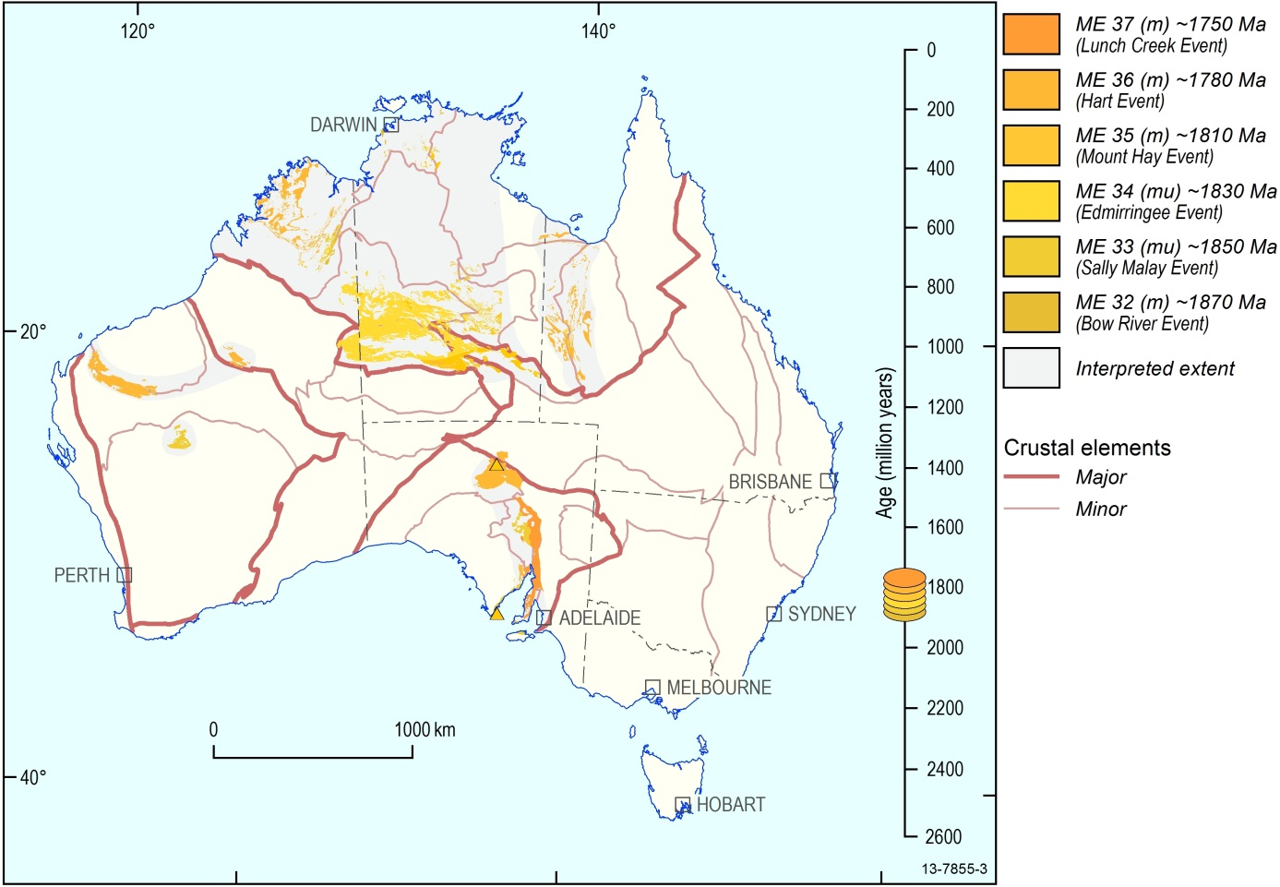
Figure 4.2 Australian Mafic-Ultramafic Magmatic Events ~1870 Ma to ~1750 Ma
Starting with the ~1870 Ma ME 32 – Bow River Event, an intense and geologically continuous period of mafic-ultramafic magmatic activity commenced in both the North and South Australian elements (Figure 4.2). Magmatism is confined to within a north-south belt in the South Australian Element, in parallel with the evolution of a north-south belt on the Queensland side of the North Australian Element. The continuity of magmatism over a long period invites consideration of plate boundary processes. Only the ~1850 Ma ME 33 – Sally Malay Event and the ~1780 Ma ME 36 – Hart Event are correlated into the West Australian Element.
The ~1780 Ma ME 36 – Hart Event is preserved in five disconnected regions across all the major crustal elements. The component within the Kimberley and Halls Creek Element has been proposed by Tyler et al. (2006) as the Hart LIP where it comprises extensive preservation of basaltic lavas (Carson Volcanics and equivalents) and the Hart Dolerite which is an equally extensive dolerite sill complex. This compilation shows the proposed LIP to be time-equivalent with a separate east-west ME 36 magmatic belt in the West Australian Element (south Pilbara and Paterson elements), another east-west ME 36 belt at the south margin of the North Australian Element (part of the Aileron Element), and within the two north-south belts noted earlier in the South Australian Element and the Queensland area of the North Australian Element. Time equivalence alone does not support comagmatic relations and detailed geochemistry and other work will be required to test the equivalence of the disconnected ME 36 magmatic belts.
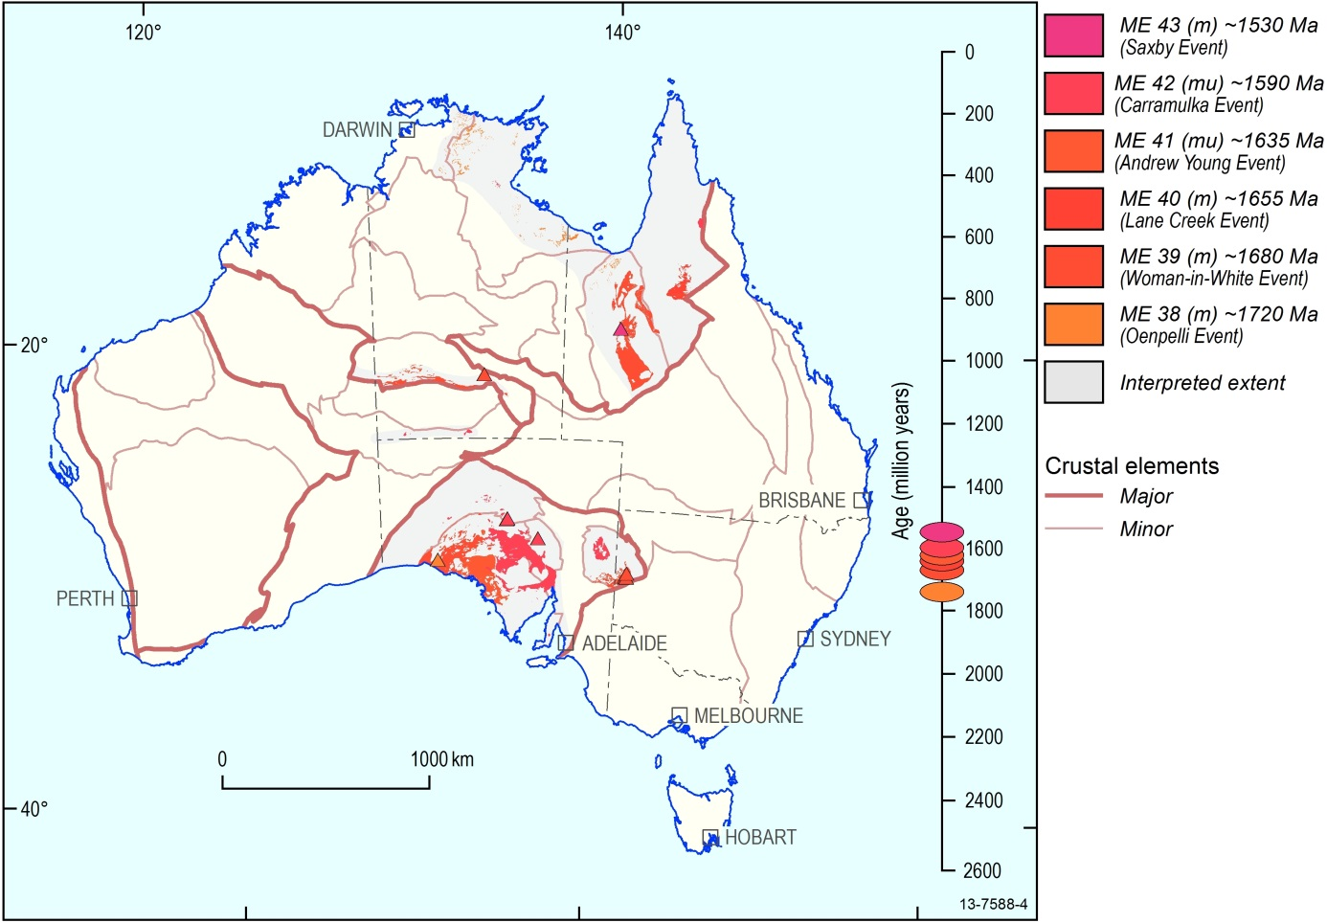
Figure 4.3 Australian Mafic-Ultramafic Magmatic Events ~1720 Ma to ~1530 Ma
Following the ~1780 Ma – Hart Event, the West Australian Element entered a ~300 Myr hiatus in mafic-ultramafic magmatic activity, with no events recorded.
Mafic-ultramafic magmatic activity in the North and South Australian Elements in this time continues the intense ~300 Myr period of magmatic events between ~1870–1590 Ma. There is no discernable hiatus between the last defined magmatic event defined on the previous map (ME 37, ~1750 Ma) and the first magmatic event on this map (ME 38, ~1720 Ma) (Figure 4.3). Within the North Australian Element there is a clear indication of diachroneity over the ~1870–1590 Ma sequence of magmatism. Regions that preserve the earlier ME 33-37 (~1850–1750 Ma) events became quiescent, and the focus of magmatism shifted to the south and east margins. The continuity, and diachroneity, of mafic-ultramafic magmatism during the 1870–1590 Ma period together invite consideration of plate boundary processes.
The same time-equivalent series of events is correlated extensively across the South Australian Element, now separated into the Curnamona and Gawler provinces by later development of the Adelaide Province. The ~1590 Ma ME 42 – Curramulka Event is notable for correlating across a very wide extent of both the North and South Australian elements; it is also the first mafic-ultramafic magmatic event recorded in protoliths of the Musgrave province in the Central Australian Element. Following the ~1590 Ma ME 42 – Curramulka Event, both the North and South Australian elements together entered a 300 Ma hiatus in magmatic activity. This pattern of quiescence after a widely correlated magmatic event is similar to the 300 Ma hiatus within the West Australian Element that followed the ~1780 Ma ME 36 – Hart Event.
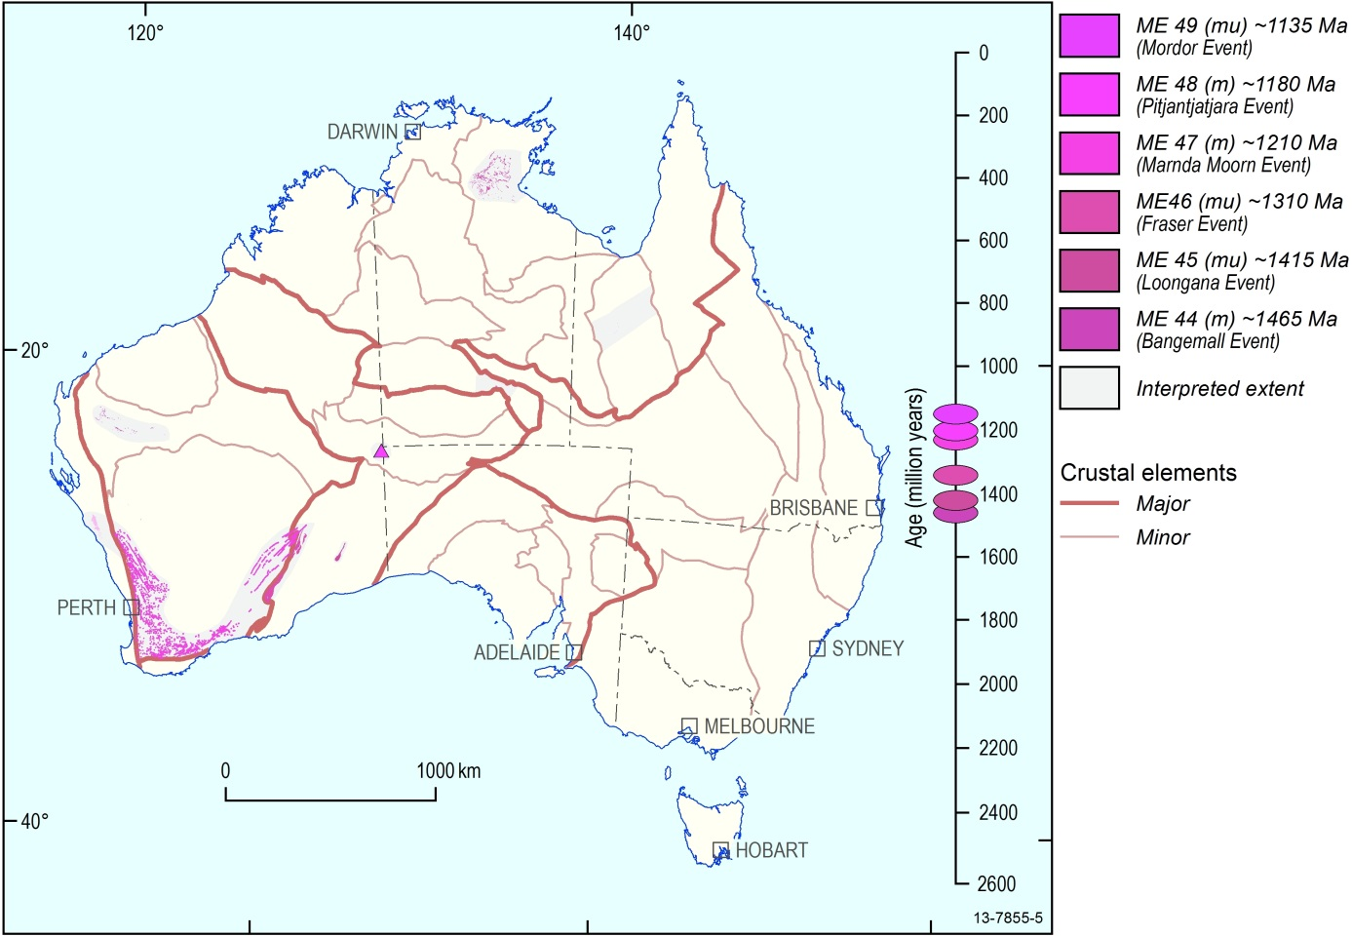
Figure 4.4 Australian Mafic-Ultramafic Magmatic Events ~1470Ma to ~1130 Ma
Following the ~1590 Ma ME 42 – Curramulka Event, the North and South Australian Elements entered a 300 Ma hiatus, with no mafic-ultramafic magmatic events recorded. The separate evolution of the West Australian Element is expressed in this period by the ~1465 Ma ME 44 – Bangemall Event, continuing the series of local east-west belts that lack correlation elsewhere in Australia (see Figure 4.4). Commencing at the ~1415 Ma ME 45 – Loongana Event, a series of poorly-known mafic-ultramafic Magmatic Events is recorded in an apparent belt northeast from the Albany–Fraser Element. Much of this area is buried beneath later cover and its Proterozoic evolution is yet to be established in detail; it is likely that further mafic-ultramafic rock units, and events, remain to be discovered.
A sill complex in the McArthur Element of far north Australia is time-equivalent with, and along strike from, the ~1310 Ma ME 46 – Fraser Event at the margin of the Yilgarn and Albany–Fraser elements. The ~1210 Ma ME 47 – Marnda Moorn Event is also located on this margin, and extends around the south and west margins of the Yilgarn Element as the Marnda Moorn LIP. Little is known about the dyke swarm forming this LIP, apart from the age and estimated extent, because most of the constituent dykes are not exposed and are inferred only from aeromagnetic mapping.
Two further mafic-ultramafic magmatic events lie within extension of the same NE-trending corridor. The ~1180 Ma ME 48 – Pitjantjatjara Event is known only within the Musgrave Element. The ~1135 Ma ME 49 – Mordor Event, named for an alkaline-ultramafic intrusion at the south margin of the North Australian Element, and is located along strike from coeval ENE-trending dolerite dykes in the Mount Isa Element.
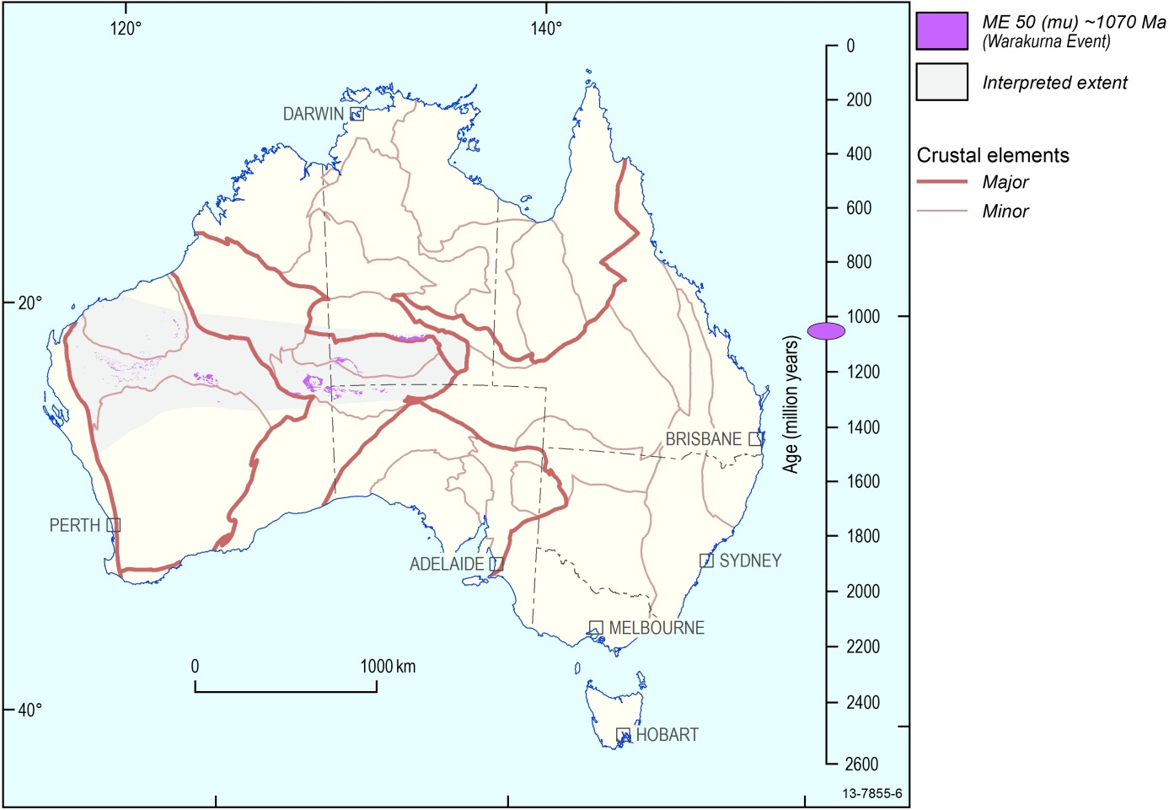
Figure 4.5 Australian Mafic-Ultramafic Magmatic Event at ~1070 Ma
The ~1070 Ma ME 50 – Warakurna Event is synonymous with the Warakurna LIP, as proposed by Wingate et al. (2004), a correlation of three geographically separate mafic-ultramafic igneous provinces across the West, Central and North Australian Crustal elements (Figure 4.5). As with the earlier proposed ~1780 Ma Hart LIP and ~1210 Ma Marnda Moorn LIP, the proposal that this is a single Large Igneous Province is so far based only on time equivalence: other attributes that would substantiate comagmatic relationships, are yet to be established.
Within the West Australian Crustal Element, the ~1070 Ma mafic-ultramafic rock units define a broad east-west belt across the south of the Pilbara Element, the northern margin of the Yilgarn Element, and the Capricorn Element between them. This is the ninth such east-west trending mafic-ultramafic magmatic belt of Proterozoic age developed within the West Australian Crustal Element. There is no evidence that it extends into the Pinjarra Element.
In central Australia, the Warakurna Event correlation includes the Giles Complex mafic and ultramafic intrusions in the Musgrave Element, an important series of large and mineralised intrusions, emplaced at a range of shallow and deep crustal levels. A coeval dolerite dyke swarm at the southern margin of the North Australian Element has a north-south orientation, orthogonal to the overall east-west trend of the Warakurna correlation.
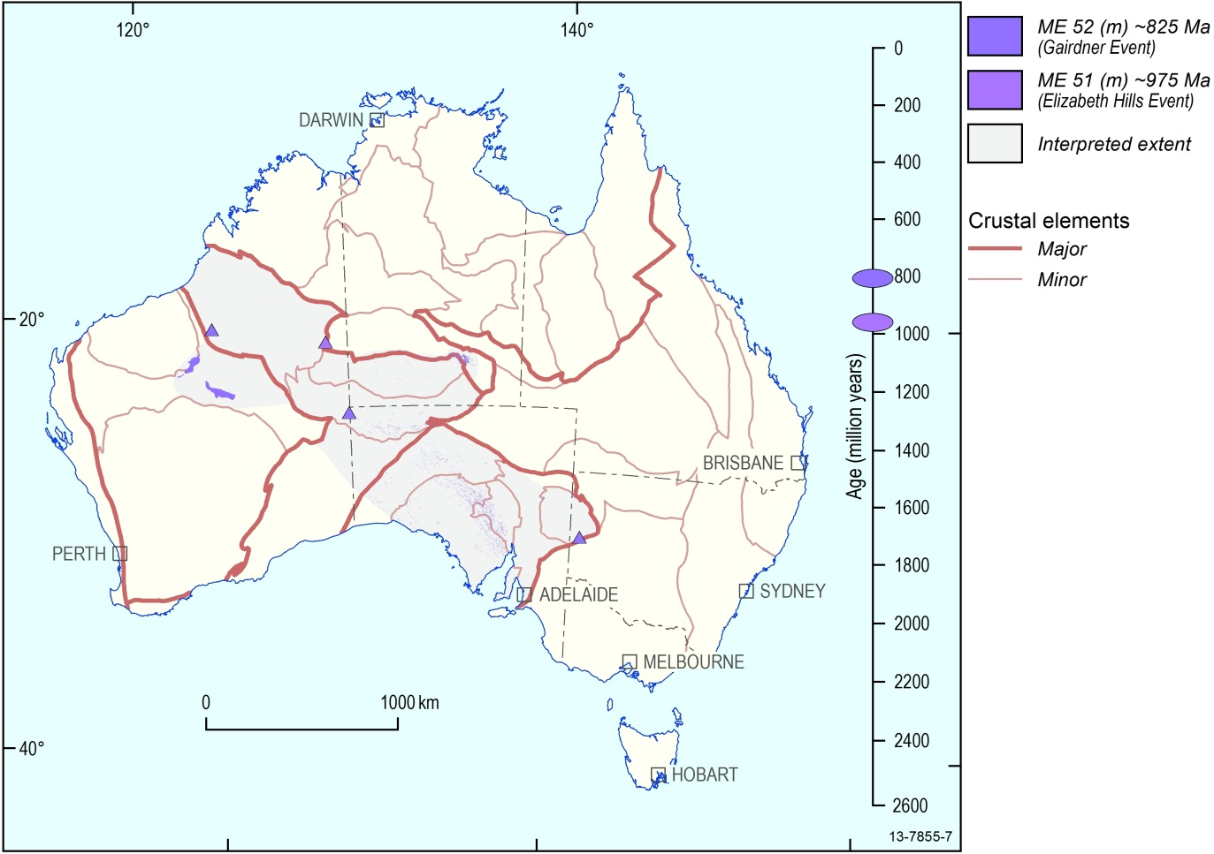
Figure 4.6 Australian Mafic-Ultramafic Magmatic Events ~975 Ma to ~825 Ma
The ~975 Ma ME 52 – Elizabeth Hills Event is known only from a single occurrence in the far west of the Warumpi Province, at the south margin of the North Australian Element (see Figure 4.6).
In contrast, the subsequent ~825 Ma ME 53 – Gairdner Event is comprised of the extensive Gairdner LIP, originally proposed from the correlation of prominent northwest-trending dyke swarms in the South Australian Crustal Element and the Musgrave Element of Central Australia with coeval lavas and sills in the basal stratigraphy of the Amadeus and Adelaide elements. The Gairdner Event is widened to include similar coeval sills in the basal stratigraphy of the West Officer Basin, another remnant of the Centralian Superbasin (which occupied a large area of central, southern and western Australia during much of the Neoproterozoic), and to the basement of the Paterson Province.
This northwest-trending belt coincides with the initiation of the Centralian Basin system and marks the initiation of a new alignment of mantle-derived magmatism through the Australian lithosphere. Other events mapped in this series display re-use of pre-existing magmatic belts oriented either east-west (in the West Australian Element) or north-south (at the east margins of the North and South Australian elements).
Only shallow erosion of the rocks that make up the Gairdener Event has been observed, exposing hypabyssal dykes and sills; some lavas are also preserved. Therefore, despite the wide extent, the event is represented only by relatively minor rock units. Large mafic-ultramafic intrusions which could be prospective for mineralisation are not exposed.
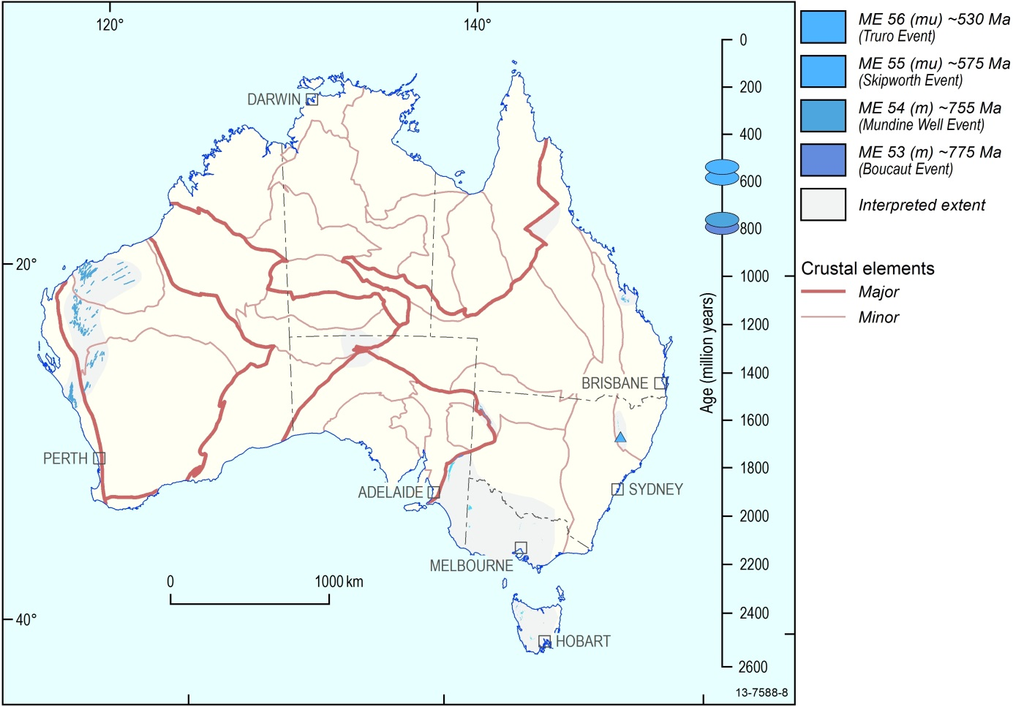
Figure 4.7 Australian Mafic-Ultramafic Magmatic Events ~775 Ma to ~530 Ma
Commencing at ~775 Ma, a series of mafic-ultramafic magmatic events are recorded at the west and east margins of the Precambrian continent. This period coincides with the continuing Paleozoic evolution of the Centralian Basin (Figure 4.7).
An early recorded event is the ~775 Ma ME – 53 Boucaut Event at the eastern margin of the South Australian Element, known only from a single recorded occurrence. It was followed 20 Myr later by the ~755 Ma ME 54 – Mundine Well Event, a regionally extensive dolerite dyke swarm at the opposite margin of the continent, crossing the northwestern West Australian Element in a direction orthogonal to the northwest belt that was developed ~70 Myr earlier by the ME 53 – Gairdner Event.
The ~575 Ma ME 55 – Skipworth Event is named for mafic-ultramafic rock units on King Island, which are coeval with mafic rocks in adjacent Tasmania, and isolated occurrences of both mafic and ultramafic (peridotite) rock units in New South Wales and Queensland. Time-equivalent mafic rock units are also recorded at the eastern margin of the South Australian Element, a location similar to that of the earlier ~775 Ma ME 53 – Boucaut Event. The subsequent ~530 Ma ME 56 – Truro Event is named for the Truro Volcanics and confined to southeast Australia.
Both the Skipworth Event and Truro Event include geological units that contain ultramafic igneous components, indicating some mafic magmatic activity during these events had high degrees of mantle partial melting in their origin. Both events also include occurrences of Ni-Cu sulphide mineralisation, noted in the Time-Space-Event Chart at Appendix D.
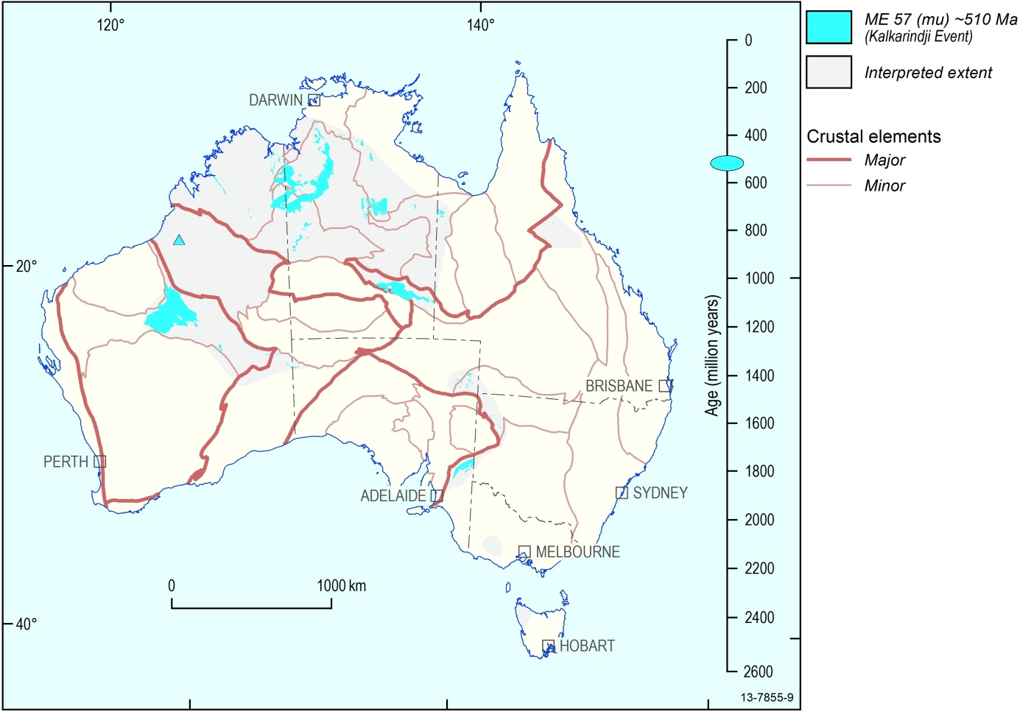
Figure 4.8 Australian Mafic-Ultramafic Magmatic Event at ~510 Ma
The early Cambrian ~510 Ma ME 30 – Kalkarindji Event (Figure 4.8) is dominated by the Kalkarindji LIP. This LIP was originally defined from voluminous early Cambrian basalt lavas which are widespread across northern Australia, from the Antrim Plateau Basalts in the west to the Colless Volcanics in Queensland (Glass, L.M. and Phillips, D., 2006). Cambrian sills in the Officer Basin are coeval and geochemically comagmatic with the north Australian occurrences. The preserved thickness of the lavas reaches its thickest development adjacent to the Kimberley and Halls Creek Element. Much of the original feeder zone is now buried beneath the lava pile and sedimentary accumulations, but uplift at the south margin of the North Australian Element has exposed two deeper crustal correlatives of the lavas. One is the Milliwindi dolerite dyke and equivalents in the Kimberley and Halls Creek Element, whose intrusion direction is parallel with the Larapinta Seaway, developed at this time (Cook, 1988; Cook and Totterdell, 1991). The other is in the Irindina Element where dated ~510 Ma mafic rocks, subsequently deformed and metamorphosed at deep-crustal levels during the Ordovician, are exposed (Maidment, 2005). The northwest-trending zone from the Irindina Element to the Milliwindi intrusion may have been the major focus of magma passage for the Kalkarindji LIP, a possibility that requires further detailed research.
Coeval with the Kalkarindji LIP magmatism, there are mafic igneous rocks preserved along the “Delamarian” eastern margin of the Precambrian continent: in a belt along the Tasman Line east of the Curnamona Province, in western Tasmania, western Victoria, with correlatives in north Queensland.
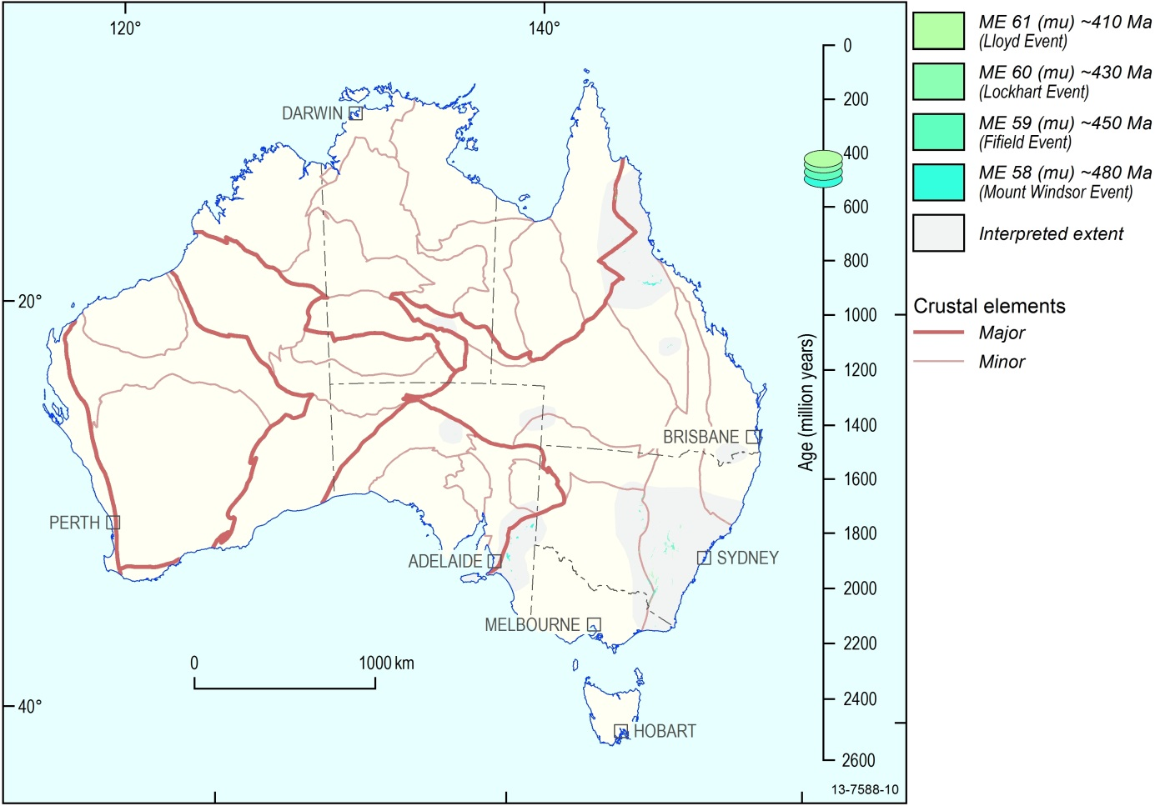
Figure 4.9 Australian Mafic-Ultramafic Magmatic Events ~480 Ma to ~410 Ma
For ~100 Ma following the Kalkarindji Event, smaller mafic-ultramafic magmatic events are recorded across all the crustal components of the Tasmanides of eastern Australia (Figure 4.9). There is evidence of dated ~480–410 Ma mafic-ultramafic igneous rocks just east of the Tasman line in the Thomson and West Lachlan elements and in north Queensland, and coeval mafic magmatic rocks also in the East Lachlan and New England elements, remote from the Precambrian margin.
Three of these events (Mount Windsor, Fifield, Lloyd) have known occurrences of magmatic Ni-Cu or PGE mineralisation. Additionally, the ME 58 – Mount Windsor and ME 61 – Lloyd Events share location attributes of the ME 57 – Kalkarindji Event, in having dated components within the western embayment of the Tasman Line into central Australia: in the western Thomson Element (Mount Windsor Event) and the Paleozoic Irindina Element (Lloyd Event). All of these magmatic events include ultramafic igneous components, indicating high degrees of mantle partial melting in their origins.
The ME 61 – Lloyd Event is named after the Lloyd Gabbronorite which is in the Irindina Element, and contains massive Ni-Cu sulphide mineralisation. This is the last Australian magmatic event to include ultramafic igneous rocks (excepting the obducted remnants of mantle lithosphere in the later Great Serpentinite Belt (New England Orogen, NSW), coeval with the ME 65 – Werrie Event).
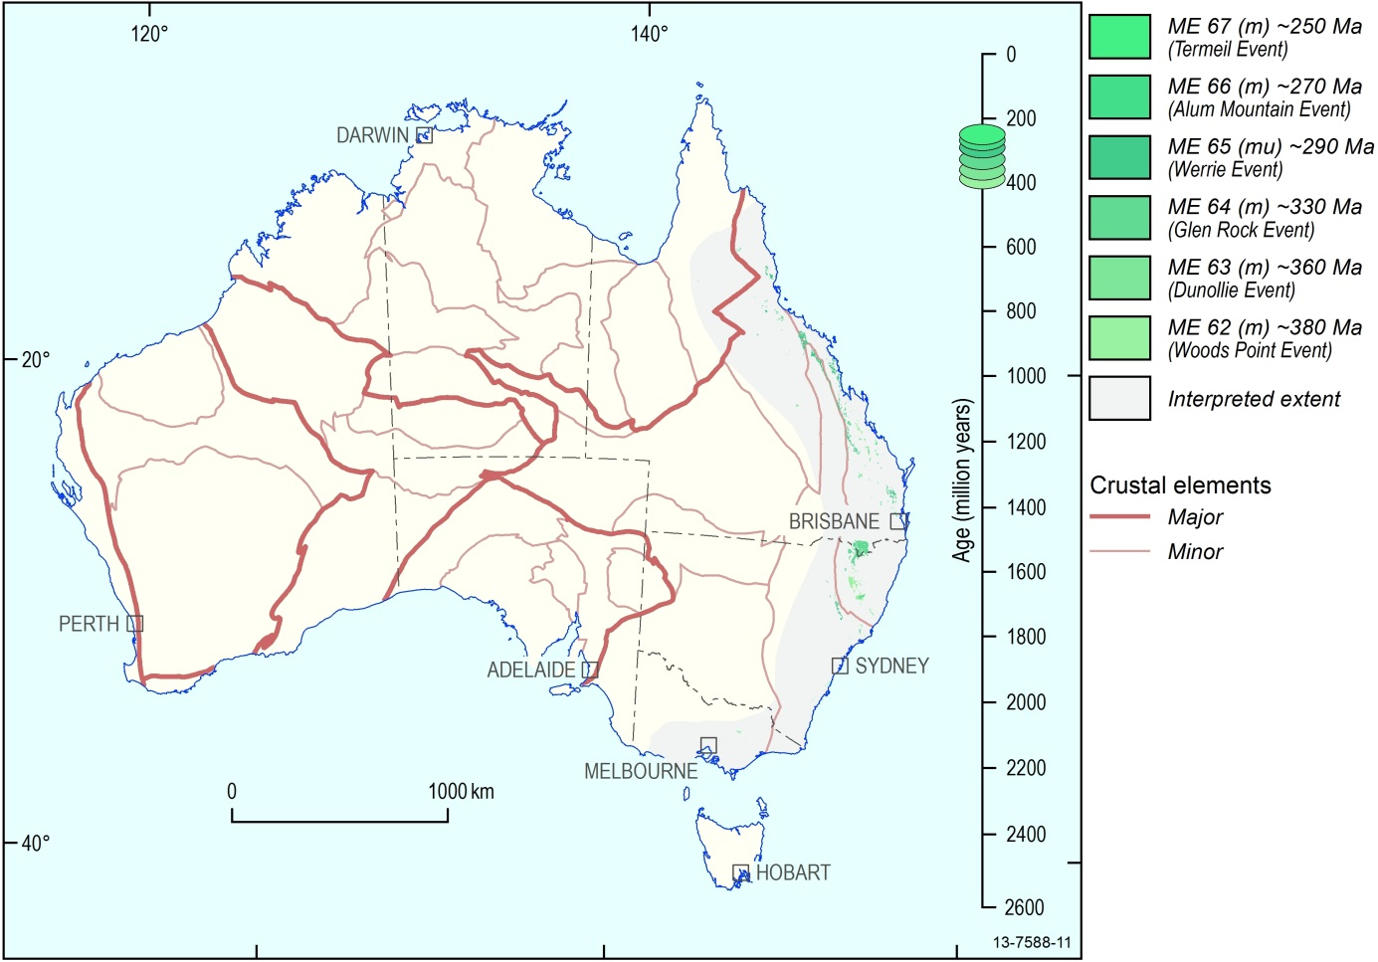
Figure 4.10 Australian Mafic-Ultramafic Magmatic Events ~380 Ma to ~250 Ma
Following the ~410 Ma ME 61 – Lloyd Event, there is a major change in both the composition and location of Australian mafic-ultramafic magmatic events (see Figure 4.10).
From the ~380 Ma ME 62 – Woods Point Event onwards, all the recorded magmatic events include only mafic igneous rocks. The ~290 Ma ME 65 – Werrie Event does include the serpentinite bodies of the Great Serpentinite Belt extending from New South Wales to Queensland, but these units are thought to represent obducted remnants of mantle lithosphere rather than the products of magmatic intrusion.
In contrast to all earlier mafic-ultramafic magmatic events, the location of the magmatic events from ~380 Ma ME 62 – Woods Point Event to ~250 Ma ME 67 – Termeil Event is confined within a narrow belt adjacent to, and parallel with, the current coastline. There are no occurrences of these events within the western embayment of the Tasman Line. The mapped distribution appears to bear little relation to the crustal element configuration, with occurrences of these events crossing crustal element boundaries for the New England, East and West Lachlan, Townsville, and North Queensland elements along the coastline from southern Victoria to north Queensland.
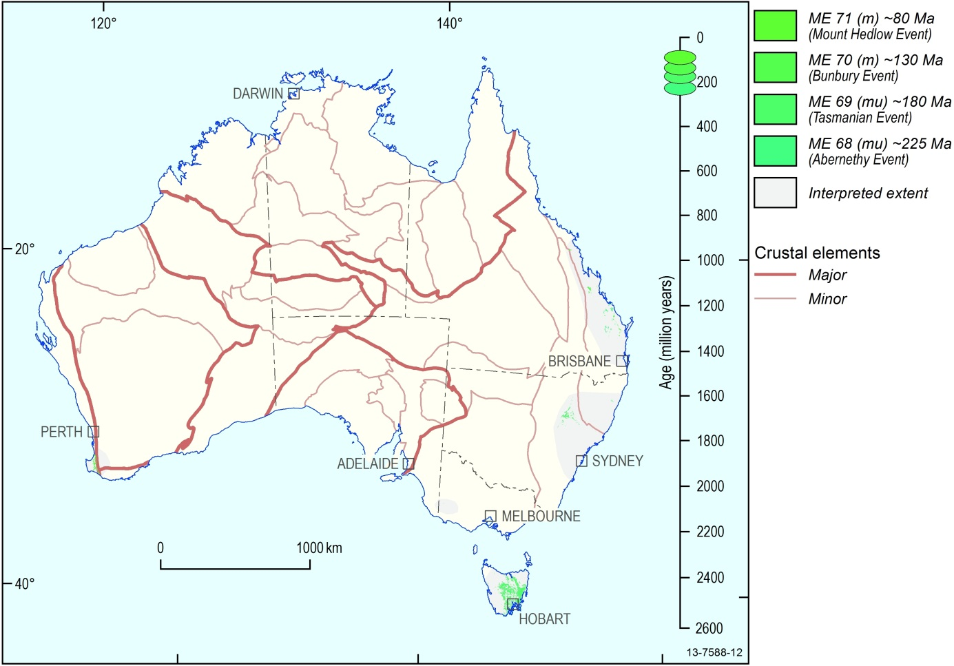
Figure 4.11 Australian Mafic-Ultramafic Magmatic Events ~225 Ma to ~80 Ma
From the ~225 Ma ME 68 – Abernethy Event onwards there is a further geographic shift in the location of mafic-ultramafic magmatism. Occurrences are confined to the New England and Eastern Lachlan elements in a very narrow zone adjacent to the east Australian coastline, a location range more restricted than the earlier magmatic events (see Figure 4.11).
This period is also marked by the onset of mafic magmatism at the south Australian margin, represented by mafic igneous rocks in Tasmania and southwest Victoria. The extent of further dated occurrences within the offshore sector of the southern margin is not known.
The ~130 Ma ME 70 – Bunbury Event marks the first occurrence of mafic magmatism on the west Australian margin. The Bunbury Basalt in the west is age-equivalent with the Mount Salmon Volcanics at the east coast of Queensland, indicating contemporaneous systems at the opposing margins of the continent. The extent of further dated occurrences within the offshore sector of the west and northwest margin is not known.
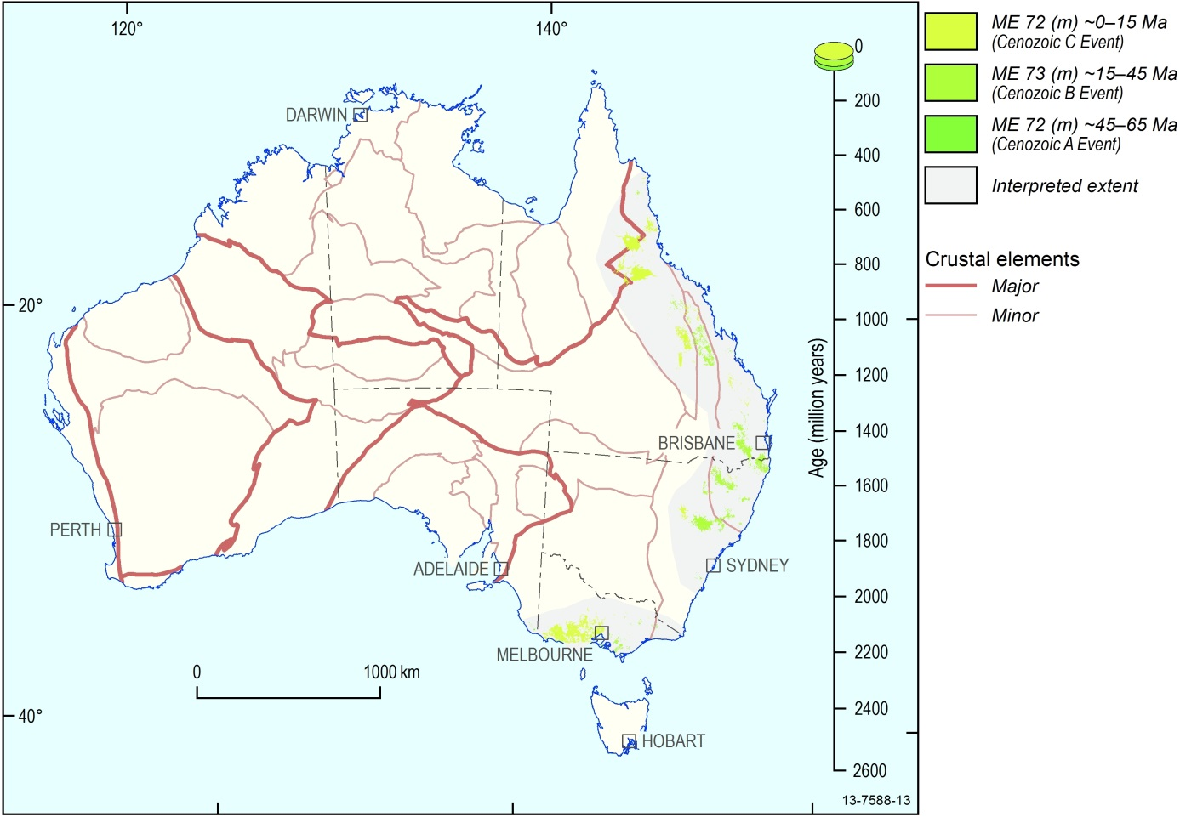
Figure 4.12 Australian Mafic-Ultramafic Magmatic Events ~65 Ma to ~0 Ma
For the purpose of this compilation the Cenozoic record is arbitrarily divided into three broad age zones consistent with the uncertainty of age estimates (Figure 4.12). However, the record of Cenozoic mafic magmatism is nearly continuous from ~65 Ma to the present day. A significant proportion of this magmatism is coincident with related hotspot activity offshore and with the opening of the Tasman Sea. The location of the continental mafic components, mapped here, is similar to the coastal belt of mafic magmatic Events 62-67 (~380–250 Myr) in occupying a location parallel to the current east Australian coastline, and crossing all the crustal element boundaries.

Time-Space-Event Charts
The presence and correlation of the 74 Australian mafic-ultramafic magmatic events are represented in two Time–Space–Event Charts in Appendix D.
A chart of the 26 Archean mafic-ultramafic magmatic events is related to the Archean craton subdivisions in Figure 2.1, as used by Hoatson et al. (2009). A chart of the 48 Proterozoic and Phanerozoic magmatic events is related to the Australian Crustal Elements framework of Australia in Figure 2.2, adapted from Shaw et al. (1996a). In both charts the event names and ages, symbol colours, and crustal elements (with informal names) are those of the digital dataset.
It is emphasised that time-equivalent magmatism in different crustal elements shown on the chart does not necessarily imply cogenetic magmatism.
The Time–Space–Event Chart is a particularly useful way of depicting the geological timing, duration, and spatial extent of geological events. It highlights the lateral extent of magmatic events, and important correlations across provinces. For example, it can be seen that some events are isolated to one element, whereas others have widespread presence across many elements. In addition, the chart shows that some elements have experienced multiple magmatic events (e.g., seven magmatic events affected the Central Gawler Element from 1850 Ma to 1590 Ma). It also highlights the frequency and groupings of magmatic events, especially three prominent groupings of mafic-ultramafic magmatic events in the Late Archean (~2800 to ~2665 Ma), Late Paleoproterozoic (~1870 Ma to ~1590 Ma) and Phanerozoic (~510 to present day), which represent important geological periods of mafic ± ultramafic magmatism in the evolution of Australia.
Within the charts, each mafic-ultramafic magmatic event name is annotated to highlight whether the event comprises only mafic magmatic rocks (m), or both mafic and ultramafic magmatic rocks are present (mu). The suffix (mu) is applied to an entire magmatic event even if only one minor ultramafic component is known, because this may potentially be important evidence about the thermal state of the mantle at the time and the possible degree of partial melting that produced the overall magmatic event.
Horizontal coloured bands in the chart indicate the presence of known Ni-PGE-Cr-V-Ti-(±Au-Cu-Ag) mineralisation within magmatic events, either in Australia or overseas. Seven of the Australian Magmatic Events (ME 27, 31, 32, 33, 45, 52, 67) are time-equivalent with important world Ni-Cu ± PGE deposits in other continents (e.g., ~2440 Ma Penikat in Finland; ~1918 Ma Raglan, ~1880 Ma Thompson, and ~1850 Ma Sudbury in Canada; ~1403 Ma Kabanga in Tanzania; ~827 Ma Jinchuan in China; ~250 Ma Noril’sk in Russia).

Applications and Conclusions
The digital release of the ‘Australian Mafic-Ultramafic Magmatic Events’ dataset completes a multi-year effort to compile all the mapped mafic-ultramafic magmatism for an entire continent. Necessarily, in different States and Territories it uses disparate datasets of different standards and scales, but wherever possible it uses solid geology to represent the known areal extent of magmatism, whether exposed or under cover. The compilation is not confined to the large and prominent igneous systems but instead is inclusive of all recorded mafic-ultramafic rock occurrences across Australia, large and small. The dataset is made possible by the significant advances in Australian solid geology mapping and in geochronology of the past 30 years. In keeping with the currently available resolution of geochronology it resolves rock units into an Archean, Proterozoic and Phanerozoic time series of 74 magmatic events based primarily on age bands of ±10 Myr.
The outcome places all occurrences of Archean, Proterozoic and Phanerozoic Australian mafic-ultramafic magmatic rocks into context with coeval magmatism elsewhere in the continent – often revealing unexpected magmatic correlations that expand the known extents of certain igneous provinces and link, for example, certain intrusions in one part of the continent have coeval erupted lavas elsewhere. The events and igneous provinces thus recognised can be placed in context with the crustal elements framework that contains them. For the first time the magmatic rock units are seen as a distinctive secular event evolution in space and time that expresses, and helps to define, the thermal and dynamic evolution of the continent towards its present day configuration.
An overview must first point out the deficiencies of the dataset, which is the first continental attempt at compilation of this kind, at this level of detail.
Most prominent of these deficiencies is the huge quantity of Australian mafic-ultramafic magmatic rock units for which no reliable age has been measured, or can be estimated. Up to half of the mapped mafic-ultramafic rock units may be estimated to be approximately Archean, Proterozoic or Phanerozoic by their location in the crustal framework (Figure 5.1), but can only be grouped as ‘Undefined Event’ because they cannot be attributed within the detailed event series. Perhaps the most important advance for the future will be the application, in quantity, of modern geochronology techniques to mafic-ultramafic rocks, a neglected target for geochronology in comparison with felsic igneous rocks, metamorphic terranes and sedimentary basins. The way forward has been shown in selected Australian provinces by Page and Hoatson (2000), Wingate et al. (2000, 2002, 2004), Hoatson and Sun (2002), Claoué-Long and Hoatson (2005), Fanning (1997), and Fanning et al. (2007). The process of successfully obtaining U-bearing zircon and baddeleyite from mafic (and even ultramafic) intrusions, using an integrated approach of field and geochemical criteria to guide sampling, opens the possibility of routinely dating mafic-ultramafic magmatic systems (Claoué-Long and Hoatson, 2005). The dating of these rocks is likely to increase the spatial extent of magmatic events defined here, and (almost certainly) reveal new magmatic events.

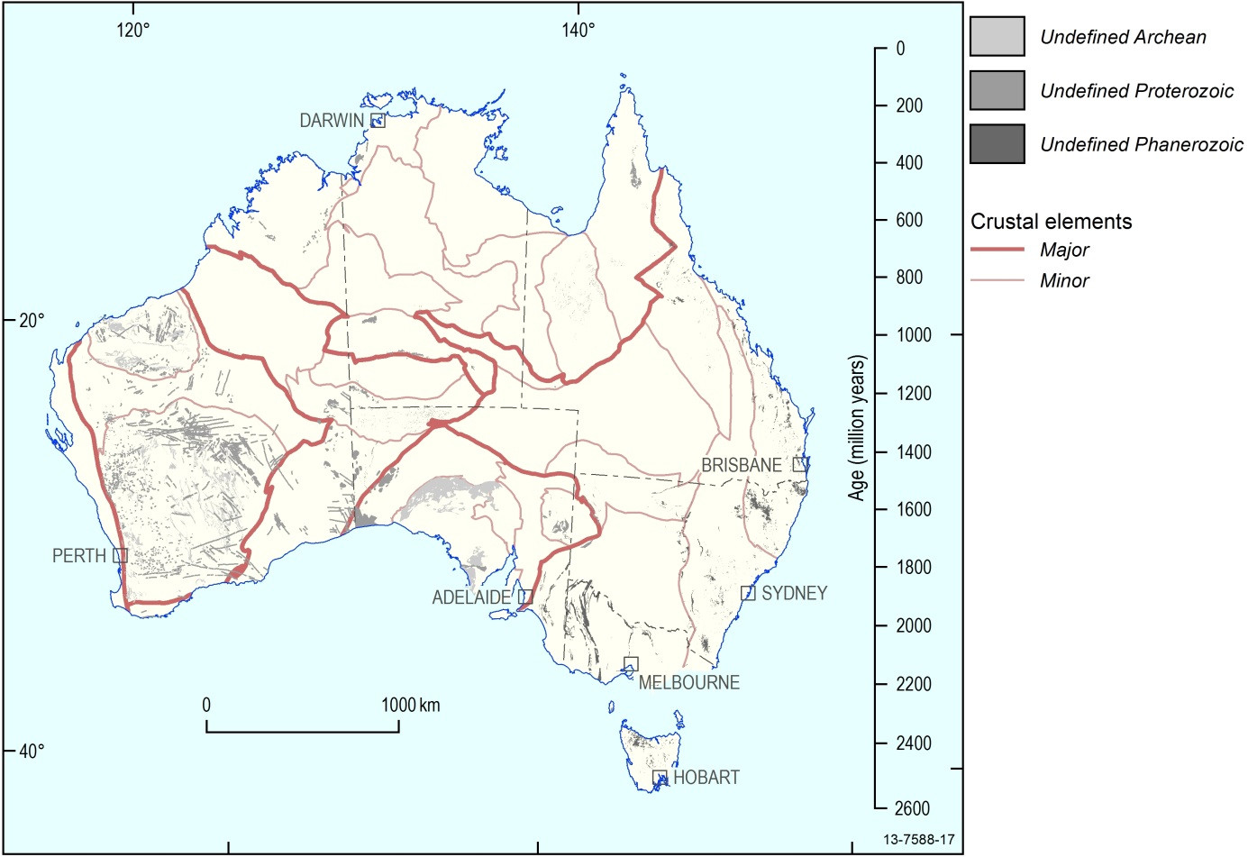
Figure 5.1 Mafic-Ultramafic igneous rocks of undefined age across Australia
The second major deficiency is the restricted availability of solid-geology mapping, which currently prevents development of a unified national GIS of mafic-ultramafic magmatic rocks. There exists no single seamless solid geology map for Australia on which to base this work. State-based solid geology mapping approaches vary from region to region and are still developing towards a seamless national coverage. There is a specific problem with accurate solid geology mapping of mafic-ultramafic igneous rock units both at the surface and under cover, in comparison with the satisfying detailed representations routinely available for felsic igneous rocks. It is particularly important for solid geology maps to progress towards depicting small, but collectively important, units such as dolerite dykes which underpin major studies such as continental reconstructions.
The third deficiency is the available crustal reference framework for Australia. Use has been made of the Australian Crustal Elements map of Shaw et al. (1996a), which remains the pioneering and, so far, only attempt to delineate the crustal framework of Australia at a detailed scale. It is specifically a shallow crust framework and does not necessarily map the deeper lithosphere which controls the passage of magma from the mantle. In the present context it has proved useful for framing Proterozoic magmatic events, but the crustal map does not subdivide the Archean cratons. The shallow crust framework is also problematic for framing Neoproterozoic and Phanerozoic magmatism younger than ~825 Ma (ME 52 – Gairdner Event), much of which is hosted within the continental basins that overlie those basement elements. An updated attempt to incorporate new geophysical and geological knowledge would improve basic continental framework understandings on which this study, and many others, depend.
With these caveats always in mind, certain general observations can be made from the Australian mafic-ultramafic magmatic events compilation.
The Australian Mafic-Ultramafic Events GIS Dataset is a fundamental framework for the exploration for magmatic-associated mineral deposits, and for assessing their generation in geodynamic processes that range in scale from the local to the continent-wide. Relative to the other continents, Australia has a deficit of discovered nickel, PGE, and other magmatic-associated mineral deposits. The primary intention of this GIS is the provision of information that may lead to redressing the discovery imbalance. The solid-geology presentation suggests significant exploration opportunities, especially in greenfields environments, by extending known outcropping magmatic systems into regions masked by shallow cover or younger basin sequences. Solid-geology datasets also provide an estimate of the total areal extent of each mafic-ultramafic magmatic system, which is an important consideration in assessing potential for magmatic-associated mineralising systems. Use of the GIS to match data with past exploration can help to determine if a particular magmatic system has been adequately tested during exploration.
The integration with geophysically-defined Major Crustal Elements permits the mafic-ultramafic rock units of each event to be evaluated in the context of the continental-scale structures and crustal processes that may be important in controlling the distribution of mineral deposits when used in conjunction with the digital dataset. These crustal elements are primarily geophysical entities (gravity and magnetic), and the reader is cautioned that their delineation and tectonic meaning are not always clear. It is probable that some units were not in their current configuration, relative to each other, at the time of emplacement. The newly-defined evolution of mafic-ultramafic magmatic events is itself a new constraint on the development of the Australian continent into its current form. The magmatic event series is comprehensive, including both subordinate and dominant mafic magmatic occurrences, so the time-event basis of the GIS serves as a reference for the correlation of other geodynamic systems and for the evolution observed in other continents.
Mafic-ultramafic magmatism in Australia has been resolved into 74 magmatic events from the Archean to the present day. Each magmatic event is defined as a short period of less than 20 million years, in keeping with the resolution of current geochronology. Colour-coding of units by their age of magmatism provides a visual cue to the spatial and temporal correlations of mafic-ultramafic magmatic units at province and continental scales. The dataset may be analysed in two ways: as a stand-alone resource, and by overlaying with other data chosen by users for a specific purpose. Here we provide some initial remarks that arise from visualisation of the mafic-ultramafic magmatic development of the continent in space and through time.
The sequential development of Australian mafic-ultramafic magmatism commenced in the northwest Yilgarn Craton, with 3730 ± 6 Ma gabbroic rocks in the Manfred Complex. This was followed by intermittent magmatism in the Pilbara Craton, and then mafic-ultramafic magmatic events became distinctly frequent and widespread in the early Neoarchean with a ~200 Myr period of frequent and coeval magmatic events across the Yilgarn and Pilbara cratons, the Hamersley Basin, and the Sylvania Inlier from ~2820 Ma to ~2665 Ma. The Archean mafic-ultramafic magmatic record concluded with two isolated magmatic occurrences (ME 25–2560 Ma and ME 26–2520 Ma) whose currently known extent is confined to the Gawler Craton.
There are periods of mineralisation associated with mafic-ultramafic magmatism during three distinct Archean events. They are: ~2925 Ma—platinum-group elements-nickel-copper (Munni Munni Intrusion: ME – 8) and nickel-copper-platinum group elements (Radio Hill Intrusion: ME – 8); ~2800 Ma—titanium-vanadium (Windimurra Intrusion: ME 11); ~2705 Ma—nickel-copper ± platinum-group elements associated with komatiitic rocks (Kambalda-Wiluna region: ME 19). Of these three, ME 19 contains significant economic resources, while ME 8 and ME 11 have experienced intermittent mining in recent decades. The ME19 economic resource is coeval with, and very similar to, nickel sulphide deposits in the Abitibi Belt of Canada. Australia appears to lack a coeval analogue to the mineralised ~2585 Ma Great Dyke of Zimbabwe, but this could be an artefact of cover and lack of discovery.
Mafic-ultramafic magmatism in Proterozoic Australia resolves into 29 magmatic events. As in the Archean, the Proterozoic record includes long periods with an intermittent record of mafic-ultramafic magmatism, and a single protracted period of mafic-dominated tholeiitic magmatism in the form of flood basalts, mafic dyke swarms and sills, and mafic ± ultramafic intrusions. Approximately one-third of all the Proterozoic magmatic events took place during the 300 Myr period from ~1870 Ma (ME 32) to ~1590 Ma (ME 42).
Many Proterozoic magmatic events which were thought to be local to certain provinces are now correlated across the continent, thereby creating the potential for locating undiscovered large-volume magmatic systems. The compilation also presents correlations across provinces of magmatic systems which are known to be mineralised in Australia, or in other continents. An example is the ~1780 Ma Hart Event (ME36) in which mineralised occurrences known in the Halls Creek and Arunta regions can now be seen to have magmatic correlatives as disparate as the Capricorn, Mt Isa and Gawler elements. An inter-continental example is the ~825 Ma Gairdner Event (ME 52), which is not yet known to be mineralised in Australia, but is coeval with the world class Jinchuan magmatic nickel deposit in China – opening the question of the geological plate configuration at that time. Five major Proterozoic LIPs, formed by the rapid and voluminous emplacement of mafic-dominated magmas in intraplate settings, have left a record of intrusions and lavas across extensive regions of the continent; and some of the LIPs may be much more extensive than previously thought (e.g., ME 36 Hart~1780 Ma).
The ~825 Ma Gairdner Event (ME 52) is coincident with the initiation of the Centralian Basin systems over much of continental Australia. Following this major change, most mafic-ultramafic magmatism extends east of the Tasman Line, with some important correlatives in central and western Australia. Consistent with its development as an evolving continental margin, the record of Phanerozoic mafic-ultramafic magmatism in eastern Australia is nearly continuous with 16 magmatic events from the Cambrian to the Cretaceous and frequent basalt lava eruptions through the Cenozoic – a similar record to the intense periods of mafic-ultramafic magmatism in the Paleoproterozoic between ~1870–1590 Ma and in the Archean between ~2820–2665 Ma. From the ~575 Ma Skipworth Event (ME 55) to the ~410 Ma Lloyd Event (ME 61), each of these Phanerozoic magmatic events includes an ultramafic component and the magmatic events correlate widely from Queensland southward to Victoria, suggesting large magmatic systems, high degrees of mantle partial melting and the potential for magmatic PGE-Cr mineralisation as well as magmatic Ni mineralisation. Some of these magmatic events (e.g. ~410 Ma ME 61 – Lloyd Event) include correlatives within the orthogonal central continental belt between the Northern Territory and northern South Australia, indicating penetration of the mantle thermal anomaly westwards into that part of the continent. An eastwards progression of the location of magmatism is observed during the course of Phanerozoic time; this switches at the time of the ~180 Ma Tasmanian Event (ME 69) to include important correlatives associated with the southern margin (e.g., Tasmania) and western margin (e.g., ~130 Ma ME 70 – Bunbury Event).
Users are encouraged to make use of this fundamental time-space-event framework to overlay and integrate their own datasets, to evaluate:
• the spatial distribution of mafic and ultramafic rocks, their geological settings, the frequency of emplacement and potential coeval relationships;
• the secular variation of mafic and ultramafic magmatism, such as mafic-dominated systems versus ultramafic-dominated systems;
• the magnitude of each magmatic system (including LIPs) which has implications for structural frameworks, tectonic settings, and metallogenesis;
• correlatives of magmatic units that are mineralised elsewhere in the Australian continent, and in other continents;
• relationships with favourable reactive (e.g., carbonaceous, sulphur-bearing) country rocks that may potentially induce contamination and sulphur saturation of mafic-ultramafic magmatic systems during emplacement; and
• the spatial distribution of extrusive versus intrusive magmatic components within each magmatic event, as an indication of erosional levels and potential vectors to favourable mineralised environments, such as feeder conduits and basal contacts of intrusive bodies.
Datasets that should be considered for integration include geochemical and isotopic data for specific magmatic events of interest: these can now be placed within a systematic context of correlation in time and space, and so used to discriminate coeval systems and their potential for mineralisation. The context of other metamorphic and igneous rocks, including alkaline igneous rocks (kimberlite, lamprophyre, etc.) can be used to evaluate mantle processes and the wider geodynamic systems of which the mafic-ultramafic magmatism is a part. Integration with the increasing coverage and sophistication of geophysical surveys, including continental seismic traverses, can improve knowledge of the fundamental crustal architecture within which the magmatic systems are emplaced, and enhance the capacity to detect and evaluate igneous rock units under cover.

Acknowledgements
The multi-year ‘Australian Mafic-Ultramafic Magmatic Events’ study was commenced in Geoscience Australia as part of the Mineral Exploration Promotion Project (leader: Mike Huleatt) within the Onshore Energy and Minerals Division of Geoscience Australia and finally completed within the Mineral Systems of Australia Section (leader: David Huston) of the Resources Division. Lynton Jaques and Richard Blewett played pivotal roles in providing continuous support for the project. An important aspect of the study was the close collaboration between diverse project groups within Geoscience Australia and the State and Northern Territory Geological Surveys. The following geoscientists from these organisations are acknowledged for providing valuable data and feedback, and/or reviews of early versions of the maps: Lance Black, Chris Carson, David Champion, Andrew Cross, Huntley Cutten, Geoffrey Fraser, George Gibson, Mike Huleatt, David Huston, Lynton Jaques, Russell Korsch, Natalie Kositcin, Patrick Lyons, David Maidment, Yanis Miezitis, Narelle Neumann, Oliver Raymond, Roger Skirrow, Alastair Stewart, Alan Whitaker, and Kurt Worden (Geoscience Australia); Leon Bagas, Charlotte Hall, Paul Morris, Franco Pirajno, Ian Tyler, Martin van Kranendonk, Michael Wingate, Stephen Wyche (Geological Survey of Western Australia); Wayne Cowley, Sue Daly, Martin Fairclough, Anthony Reid (Department of Primary Industries and Resources, South Australia); Dorothy Close, Nigel Donnellan, Christine Edgoose, Linda Glass, Julie Hollis, Ian Scrimgeour (Northern Territory Geological Survey); and Laurie Hutton, and Ian Withnall (Geological Survey of Queensland).Additional geochronological data and information for eastern Australia were provided by Tony Crawford (ARC Centre of Excellence in Ore Deposits–CODES, Tasmania), Reid Keays (Monash University, Victoria), and Mike Rubenach (James Cook University, Queensland) and Paulo Vasconcelos (University of Queensland).
John Greenfield (Geological Survey of NSW), Ross Cayley (Geological Survey of Victoria), Peter Goldsworthy, James Beeston and Ian Withnall (Geological Survey of Queensland), Linda Bibby (GeoScience Victoria), Wayne Cowley (Department of Primary Industries and Resources, South Australia), Damien Shearer (Mineral Resources Tasmania), and Ross Ocampo (Northern Territory Geological Survey) are thanked for providing GIS datasets and map coverages for the States and the Northern Territory.
Cathy Brown, Daniel Connolly and Donna Phillips (Geoscience Australia) compiled the State and Northern Territory stratigraphic index information and Peter Milligan (Geoscience Australia) produced geophysical, elevation, and bathymetry datasets. Mark Hollow (Geoscience Australia) provided copious state geological reports and map commentaries from the N.H. (Doc) Fisher Geoscience Library. Helen Dulfer (Geoscience Australia) provided valued support with this guide.
The final design and merging of the Archean, Proterozoic and Phanerozoic digital datasets was achieved by Lindsay Highet (Geoscience Australia). Ollie Raymond and Robyn Gallagher are thanked for advice on preparation of the digital GIS.
Review comments on aspects of the compilation as it proceeded were provided by David Champion, Alan Whitaker, George Gibson, Linda Glass, Paul Henson, David Huston, Songfa Liu, David Maidment, Alastair Stewart, Robyn Gallagher, Ollie Raymond and Jo Whelan.

References
Bryan, S.E. and Ernst, R.E., 2008. Revised definition of Large Igneous Provinces (LIPs). Earth Science Reviews 86, 175–202.
Campbell, I.H., 2007. Testing the plume theory. Chemical Geology, 241, 153–176.
Claoué-Long, J.C. and Hoatson, D.M., 2005. Proterozoic mafic-ultramafic intrusions in the Arunta Region, central Australia. Part 2: Event chronology and regional correlations. Precambrian Research, 142, 134–158.
Claoué-Long, J.C. and Hoatson, D.M., 2009. Map of Australian Proterozoic Large Igneous Provinces, Sheets 1 and 2, 1:5 000 000 map, Geoscience Australia.
Cook, P.J., 1988. Paleogeographic atlas of Australia. Volume 1 – Cambrian. Bureau of Mineral Resources, Canberra.
Cook, P.J. and Totterdell, J 1991. Paleogeographic atlas of Australia. Volume 2 – Ordovician. Bureau of Mineral Resources, Canberra.
D’Ercole, C. and Lockwood, A.M., 2004. The tectonic history of the Waigen area, western Officer Basin, interpreted from geophysical data. Western Australia Geological Survey, Annual Review 2003–04, Technical Paper, 71–80.
Direen, N.G. and Crawford, A.J., 2003. The Tasman Line: where is it, what is it, and is it Australia’s Rodinian breakup boundary? Australian Journal of Earth Sciences, 50, 491–502
Ernst, R.E., Buchan, K.L. and Campbell, I.H., 2005. Frontiers in Large Igneous Province research. Lithos,79, 271–297.
Fanning, C.M., 1997. Geochronological synthesis of southern Australia: Part II: The Gawler Craton: PRISE–Precise Radiogenic Isotope Services Report (unpublished), Australian National University, Canberra. Open File Envelope, 8918, 19 September 1997, 45 pp.
Fanning, C.M., Reid, A.J. and Teale, G.S., 2007. A geochronological framework for the Gawler Craton, South Australia. South Australia Geological Survey, Bulletin, 55, 258 pp.
Glass, L.M. and Phillips, D., 2006. The Kalkarindji continental flood basalt province: A new Cambrian large igneous province in Australia with possible links to faunal extinctions. Geology, 34, 461–464.
Glen, R.A., 2005. The Tasmanides of eastern Australia. In: Vaughan, A.P.M., Leat, P.T. and Pankhurst, R.J. (editors), Terrane Processes at the Margins of Gondwana. The Geological Society of London Special Publication, 246, 23–96.
Glen, R.A., 2013. Refining accretionary orogen models for the Tasmanides of eastern Australia. Australian Journal of Earth Sciences, 60, 315–370.
Gradstein, F.M., Ogg, J.G, Smitz, M. and Ogg, G, 2012. The Geologic Time Scale 2012. Elsevier, 1176p.
Hanley, L.M. and Wingate, M.T.D., 2000. SHRIMP zircon age for an Early Cambrian dolerite dyke: an intrusive phase of the Antrim Plateau Volcanics of northern Australia. Australian Journal of Earth Sciences, 47, 1029–1040.
Hoatson, D.M. and Sun, S-s., 2002. Archean layered mafic-ultramafic intrusions in the west Pilbara Craton, Western Australia: a synthesis of some of the oldest orthomagmatic mineralizing systems in the world. Economic Geology, 97, 847–872.
Hoatson, D.M., Claoué-Long, J.C. and Jaireth, S., 2008. Map of Australian Proterozoic mafic-ultramafic magmatic events, Sheets 1 and 2, 1:5 000 000 map, Geoscience Australia.
Hoatson, D.M., Jaireth, S., Whitaker, A.J., Champion, D.C. and Claoué-Long, J.C., 2009. Map of Australian Archean mafic-ultramafic magmatic events, Sheets 1 and 2, 1:5 000 000 map, Geoscience Australia.
Myers, J.S. and Hocking, R.M., 1998. Geological map of Western Australia, 1:2 500 000 (13th Edition). Geological Survey of Western Australia, Perth.
Neuendorf, K.K.E., Mehl, J.P.Jr. and Jackson, J.A. (editors), 2005. Glossary of Geology, Fifth Edition. American Geological Institute, Alexandria, Virginia, 779 pp.
Nishiya, T., Watanabe, T., Yokiyama, K. and Kuramoto, Y., 2003. New isotopic constraints on the age of the Halls Reward Metamorphics, north Queensland, Australia: Delamerian metamorphic ages and Grenville detrital zircons. Gondwana Research, 6, 241–249.
Page, R.W. and Hoatson, D.M., 2000. Chapter 6. Geochronology of the mafic-ultramafic intrusions. In: Hoatson, D.M. and Blake, D.H. (editors), Geology and Economic Potential of the Palaeoproterozoic Layered Mafic-Ultramafic intrusions in the East Kimberley, Western Australia. Australian Geological Survey Organisation, Bulletin, 246, 163–172.
Scrimgeour, I.R., Kinny, P.D., Close, D.F. and Edgoose, C.J., 2005. High-T granulites and polymetamorphism in the southern Arunta Region, central Australia: evidence for a 1.64 Ga accretional event. Precambrian Research, 142, 1–27.
Seth, H.C., 2007. ‘Large Igneous Provinces (LIPs)’: definition, recommended terminology, and a hierarchical classification. Earth Science Reviews, 85, 117–124.
Shaw, R.D., Wellman, P., Gunn, P., Whitaker, A.J., Tarlowski, C. and Morse, M., 1996a. Australian Crustal Elements (1:5,000,000 scale map) based on the distribution of geophysical domains. Australian Geological Survey Organisation, Canberra.
Shaw, R.D., Wellman, P., Gunn, P., Whitaker, A.J., Tarlowski, C. and Morse, M., 1996b. Guide to using the Australian Crustal Elements map. Record 1996/30. Australian Geological Survey Organisation, Canberra. 93 pp.
Tyler, I.M., Sheppard, S., Pirajno, F. and Griffin, T.J., 2006. Hart-Carson LIP, Kimberley region, northern Western Australia. August 2006 LIP of the month. Large Igneous Province Commission, International Association of Volcanology and Chemistry of the Earth’s Interior www site, 1–8, (http://www.largeigneousprovinces.org/06aug.html).
Tyler, I.M., Sheppard, S., Pirajno, F. and Griffin, T.J., 2006. Hart-Carson LIP, Kimberley region, northern Western Australia. August 2006 LIP of the month. Large Igneous Province Commission, International Association of Volcanology and Chemistry of the Earth’s Interior, 1–8, viewed August 2006, http://www.largeigneousprovinces.org/06aug.html
Wingate, M.T.D., Campbell, I.H. and Harris, L.B., 2000. SHRIMP baddeleyite age for the Fraser Dyke Swarm, southeast Yilgarn Craton, Western Australia. Australian Journal of Earth Sciences, 47, 309–313.
Wingate, M.T.D., Pisarevsky, S.A. and Evans, D.A.D., 2002. Rodinia connections between Australia and Laurentia: no SWEAT, no AUSWUS? Terra Nova, 14, 121–128.
Wingate, M.T.D., Pirajno F. and Morris, P.A., 2004. Warakurna large igneous province: A new Mesoproterozoic large igneous province in west-central Australia. Geology, 32, 105–108.
Wingate, M.T.D. and Pidgeon, R.T., 2005. The Marnda Moorn LIP, a late Mesoproterozoic large igneous province in the Yilgarn craton, Western Australia. July 2005 LIP of the month. Large Igneous Province Commission, International Association of Volcanology and Chemistry of the Earth’s Interior, 1–5, viewed July 2005, http://www.largeigneousprovinces.org/05july.html
Wingate, M.T.D., Pirajno F. and Morris, P.A., 2004. Warakurna large igneous province: A new Mesoproterozoic large igneous province in west-central Australia. Geology, 32, 105–108.
Zhao, J.-Y., McCulloch, M.T. and Korsch, R.J., 1994. Characterization of a plume-related ~800 Ma magmatic event and its implications for basin formation in central-southern Australia. Earth and Planetary Science Letters, 121, 349–367.

Digital Datasets used in this Study
  - Archean compilation
Geological base maps and solid-geology rock GIS
Western Australia
Geological Survey of Western Australia, 2008, Distribution of Precambrian mafic and ultramafic rocks in Western Australia:1:500 000 Interpreted Bedrock Geology Map of Western Australia, Geological Survey of Western Australia.
South Australia
Cowley, W.M. (Compiler), 2006. Solid geology of South Australia. Department of Primary Industries and Resources, South Australia. Mineral Exploration Data Package 15 (version 1.1.).
Geological and tectonic province boundaries (Sheets 1 and 2):
Yilgarn Craton
Cassidy, K.F., Champion, D.C., Krapez, B., Barley, M.E., Brown, S.J.A., Blewett, R.S., Groenewald, P.B. and Tyler, I.M., 2006. A revised geological framework for the Yilgarn Craton, Western Australia. Geological Survey of Western Australia, Record 2006/8, 8 pp.
Pilbara Craton, Hamersley Basin, Sylvania Inlier
Geological Survey of Western Australia, 2001, 1:2 500 000 Tectonic Units of Western Australia, June 2001, Geological Survey of Western Australia.
Gawler Craton
Fairclough, M.C., Schwarz, M.P. and Ferris, G.M., 2003. Interpreted crystalline basement geology of the Gawler Craton, South Australia, Geological Survey, Special map, 1:1 000 000 scale.
Distribution of Archean dolerite dykes and sills in Western Australia
Thorne, A.M. and Trendall, A.F., 2001. Geology of the Fortescue Group, Pilbara Craton, Western Australia. Geological Survey of Western Australia, Bulletin 144, 249 pp.
Geological and geophysical datasets
Interpreted distribution of Archean mafic and ultramafic rocks
Whitaker, A.J. and Bastrakova, I.V., 2002. Yilgarn Craton aeromagnetic interpretation (1:1 500 000 scale map), Geoscience Australia.
Geochronology of Archean mafic and ultramafic rocks
Hoatson, D.M., Jaireth, S. and Jaques, A.L., 2006. Nickel sulphide deposits in Australia: Characteristics, resources, and potential. Ore Geology Reviews, 29, 177–241.
Van Kranendonk, M.J. and Ivanic, T.J., 2009. A new lithostratigraphic scheme for the northeastern Murchison Domain, Yilgarn Craton. Geological Survey of Western Australia Annual Review
2007–08, 35–53.
Van Kranendonk, M.J., Hickman, A.H., Smithies, R.H., Williams, I.R., Bagas, L. and Farrell, T.R., 2006. Revised lithostratigraphy of Archean supracrustal and intrusive rocks in the northern Pilbara Craton, Western Australia. Geological Survey of Western Australia, Record 2006/15, 57 pp.
Wilde, S.A., 2001. Jimperding and Chittering Metamorphic Belts, southwestern Yilgarn Craton, Western Australia–a field guide. Geological Survey of Western Australia, Record 2001/12, 24 pp.
Compositional data of komatiitic rocks
Barley, M.E., Blewett, R.S., Cassidy, K.F., Champion, D.C., Czarnota, K., Doyle, M.G., Krapez, B., Kositcin, N., Pickard, A.L. and Weinberg, R.F., 2006. Tectonostratigraphic and structural architecture of the eastern Yilgarn Craton. Final AMIRA Report P763/pmd*CRC Project Y1, December 2006.
Barnes, S.J., Hill, R.E.T., Perring, C.S. and Dowling, S.E., 2004. Lithogeochemical exploration for komatiite-associated Ni-sulfide deposits: strategies and limitations. Mineralogy and Petrology, 82, 259–293.
Lesher, C.M. and Keays, R.R., 2002. Komatiite-associated Ni-Cu-PGE deposits: geology, mineralogy, geochemistry, and genesis. In: Cabri, L.J. (editor), The Geology, Geochemistry, Mineralogy and Mineral Beneficiation of Platinum-Group Elements. Canadian Institute of Mining, Metallurgy and Petroleum, Special Volume 54, 579–617.
Nickel sulphide resources for deposits and regional nickel endowment
Geoscience Australia, 2008, OZMIN–Geoscience Australia’s national database of mineral deposits and resources, http://ga.gov.au
Neodymium model ages
Champion, D.C. and Cassidy, K.F., 2008. Geodynamics: Using geochemistry and isotopic signatures of granites to aid mineral systems studies: an example from the Yilgarn Craton. In: Korsch, R.J. and Barnicoat, A.C. (editors), New Perspectives: The Foundations and Future of Australian Exploration. Abstracts for the 11–12th June 2008 pmd*CRC Conference. Geoscience Australia, Record 2008/09, 7–16).
  - Proterozoic compilation
Solid-geology coverage of Western Australia, South Australia, Victoria, New South Wales, and Tasmania is available as State Maps from the relevant State geological surveys. Coverage of Queensland and the Northern Territory was assembled from a variety of regional solid- and surface-geology sources at scales ranging from 1:100 000 to 1:1 000 000.
Geological base maps and relevant publications
Western Australia
Distribution of Precambrian mafic and ultramafic rocks in Western Australia:
Geological Survey of Western Australia, 2001. 1:500 000 Interpreted Bedrock Geology Map of Western Australia, Geological Survey of Western Australia (June 2001).
Distribution of dolerite dykes and sills:
Myers, J.S. and Hocking, R.M., 1998. Geological Map of Western Australia, 1:2 500 000 (13th Edition). Geological Survey of Western Australia, Perth.
Distribution of gabbroic intrusions under cover in the Officer Bain:
D’Ercole, C. and Lockwood, A.M., 2004. The tectonic history of the Waigen area, western Officer Basin, interpreted from geophysical data. Western Australia Geological Survey, Annual Review 2003–04, Technical Paper, 71–80.
Northern Territory
Ahmad, M. and Scrimgeour, I.R., 2006. Geological map of the Northern Territory (1:2 500 000 scale map, 2006 Edition), Northern Territory Geological Survey, Darwin.
Donnellan, N. and Johnstone, A., 2004. Mapped and interpreted geology of the Tennant Region (1:500 000 scale map, First Edition), Northern Territory Geological Survey, Darwin and Alice Springs.
Edgoose, C.J., Close, D.F. and Scrimgeour, I.M., 2004. Musgrave Block Special, Northern Territory (First Edition) 1:500 000 scale geological map. Northern Territory Geological Survey, Alice Springs.
Lally, J. and Doyle, N., 2005. Pine Creek Orogen 1:500 000 Solid Geology Interpretation, preliminary release, Northern Territory Geological Survey, Darwin.
Liu, S.F., Raymond, O.L., Stewart, A.J., Sweet, I.P., Duggan, M.B., Charlick, C., Phillips, D. and Retter, A.J., 2007. Surface Geology of Australia, Northern Territory, 1:1 000 000 GIS dataset. Geoscience Australia, Canberra.
Meixner, A. and Hoatson, D.M., 2004. Geophysical interpretation of Proterozoic mafic-ultramafic intrusions in the Arunta Region, central Australia, Geoscience Australia, Record, 2003/29, 125 pp.
Meixner, T., Scrimgeour, I.M., Close, D.G. and Edgoose, C.J., 2004. Mount Liebig, Northern Territory (Second Edition) 1:250 000 interpreted geological map series (Sheet SF 52–16). Northern Territory Geological Survey, Alice Springs.
Rawlings, D.J., 2001. Tectonostratigraphy of the McArthur Basin (1:1 000 000 scale map, First Edition), Northern Territory Geological Survey, Darwin.
Shaw, R.D. and Warren, R.G., 1995. Hermannsburg, Northern Territory (Second Edition), 1:250 000 Geological Series map (Sheet SF 53–13). Australian Geological Survey Organisation, Canberra.
Shaw, A.D., Langworthy, A.P., Stewart, A.J., Offe, L.A. and Jones, B.G., 1983. Alice Springs, Northern Territory (Second Edition), 1:250 000 geological map (Sheet SF 53–14). Bureau of Mineral Resources, Australia.
Slater, K.R., 2000a. Tanami 1:250 000 integrated interpretation of geophysics and geology (First Edition), Northern Territory Geological Survey, Darwin.
Slater, K.R., 2000b. The Granites (SF 52–3) 1:250 000 integrated interpretation of geophysics and geology (First Edition), Northern Territory Geological Survey, Darwin.
Slater, K.R., 2004. Musgrave Block Special, Northern Territory, integrated interpretation of geophysics and geology (1:500 000 scale map, First Edition), Northern Territory Geological Survey, Darwin and Alice Springs.
Vandenberg, L.C., Johnstone, A., Donnellan, N., Green, M.G. and Crispe, A., 2004. Northern Arunta Region integrated interpretation of geophysics and geology, Northern Territory (1:500 000 scale map, First Edition), Northern Territory Geological Survey, Alice Springs.
South Australia
Cowley, W.M. (Compiler), 2006. Solid geology of South Australia. Department of Primary Industries and Resources, South Australia. Mineral Exploration Data Package, 15 (version 1.1.).
Queensland
Bain, J.H.C. and Draper, J.J. (Compilers), 1997. North Queensland Geology. Australian Geological Survey Organisation, Bulletin, 240, and Queensland Department of Mines and Energy, Queensland Geology, 9, 600 pp.
Geological Survey of Queensland, 2002. North Queensland gold and base metal study, Stage 1 (Georgetown) geoscience (GIS) dataset. Department of Mines and Energy, Queensland, Brisbane.
Geological Survey of Queensland, 2002. South-east Queensland region geoscience (GIS) dataset. Department of Mines and Energy, Queensland, Brisbane.
Geological Survey of Queensland, 2003. North Queensland gold and base metal study, Stage 2 (Charters Towers) geoscience (GIS) dataset. Department of Mines and Energy, Queensland, Brisbane.
Geological Survey of Queensland, 2005. Central Queensland region (Yarrol–Connors–Auburn) geoscience (GIS) dataset (version 2). Department of Mines and Energy, Queensland, Brisbane.
Geological Survey of Queensland, SRK Consulting, ESRI Australia, and Taylor, Wall and Associates, 2006. North-west Queensland mineral province geoscience (GIS) dataset (version 2006). Department of Mines and Energy, Queensland, Brisbane.
New South Wales
Scheibner, E. and Hayward, D., 1999. New South Wales State Geoscience Package. Geological Survey of New South Wales, Sydney.
Victoria
Simons, B.A. and Moore, D.H., 1999. Victoria 1:1 000 000 Pre-Permian Geology. Geological Survey of Victoria, Melbourne.
Tasmania
Brown, A.V., Calver, C.R., Clarke, M.J., Corbett, K.D., Everard, J.L., Forsyth, S.M., Goscombe, B.A., Green, D.C., Green, G.R., McClenaghan, M.P., Pemberton, J. and Vicary, M.J., 2007. 1:250 000 Digital Geology of Tasmania. Mineral Resources Tasmania, Hobart.
Geophysical datasets
Total Magnetic Intensity, Fourth Edition, 2004: Milligan, P.R. and Franklin, R., 2004. Magnetic Anomaly Map of Australia (1:5 000 000 scale map, Fourth Edition), Geoscience Australia, Canberra.
Bouguer Gravity, Second Edition, 1997: Murray, A.S., Morse, M.P., Milligan, P.R. and Mackey, T.E., 1997. Gravity Anomaly Map of the Australian Region (1:5 000 000 scale map, Second Edition), Australian Geological Survey Organisation, Canberra.
Digital Elevation and Bathymetry, 2006: Image compiled from Land Digital Elevation Model (SRTM), National Geospatial–Intelligence Agency and the National Aeronautics and Space Administration; Australian bathymetry and topography grid (June 2005), Geoscience Australia; and ETOPO2 Global 2_Minute Gridded Elevation data_ocean bathymetry, U.S. Department of Commerce, National Oceanic and Atmospheric Administration.
Crustal Elements and Provinces used for National Map
Shaw, R.D., Wellman, P., Gunn, P., Whitaker, A.J., Tarlowski, C. and Morse, M., 1996a. Australian Crustal Elements 1:5 000 000 map based on the distribution of geophysical domains, GIS dataset. Australian Geological Survey Organisation, Canberra.
  - Phanerozoic compilation
Solid-geology coverage of Western Australia and surface-geology coverage of Tasmania are available as State Maps from the relevant State geological survey. Coverage of Queensland, New South Wales, South Australia, the Northern Territory and Victoria was assembled from a variety of regional solid- and surface-geology sources at scales ranging from 1:100 000 to 1:2 000 000, also available as State Maps from the relevant State geological survey.
Geological base maps
Western Australia
Geological Survey of Western Australia, 2008. 1:500 000 Interpreted Bedrock Geology Map of Western Australia, Geological Survey of Western Australia, Perth.
Northern Territory
Larson, R. 2006. Digital geology and lithology of the Quartz, Northern Territory 1:100 000 map sheet 5951. Geoscience Australia, Canberra.
South Australia
Cowley, W.M. (Compiler), 2006. Solid geology of South Australia. Department of Primary Industries and Resources, South Australia. Mineral Exploration Data Package, 15 (version 1.1.)
Geological Survey of South Australia. 2012. Surface Geology 2M. Department of Primary Industries and Resources, South Australia
Queensland
Geological Survey of Queensland, November 2011. Geoldata Queensland Geological Digital Data - state, regional and detailed mapping (DVD). Geological Survey of Queensland
New South Wales
Gilmore, P.J., Greenfield, J.E., Mills, K., Musgrave, R.E., and Reid, W.J. 2011 Koonenberry Belt 1:250 000 Solid Geology, Geological Survey of NSW, Maitland
Geological Survey of New South Wales, New England Orogen Z56 seamless geology pre-release, 2012, Geological Survey of NSW, Maitland
New South Wales Geological Survey, 2012. Western Division geological-geophysical basement interpretation map, 2012. Geological Survey of NSW, Maitland
Dawson M.W. and Glen R.A. 2006. Eastern Subprovince of the Lachlan Orogen Version 2– Solid Geology and Mineral Deposits, 1:500 000 map. Geological Survey of NSW, Sydney
Victoria
Simons, B.A. and Moore, D.H., 1999. Victoria 1:1 000 000 Pre-Permian Geology. Geological Survey of Victoria, Melbourne.
Welch, S.I., Higgins, D.V., Callaway, G.A. (eds), 2011. Surface Geology of Victoria 1:250 000. Geological Survey of Victoria, Department of Primary Industries, Melbourne.
Tasmania
Brown, A.V., Calver, C.R., Clarke, M.J., Corbett, K.D., Everard, J.L., Forsyth, S.M., Goscombe, B.A., Green, D.C., Green, G.R., McClenaghan, M.P., Pemberton, J., Seymour, D.B., and Vicary, M.J., 2011. 1:250 000 Digital Geology of Tasmania, Digital Geological Atlas 1:250,000 Scale Series Mineral Resources Tasmania, Hobart.
National
Geoscience Australia, 2010. Surface Geology of Australia 2010: GIS data package. Geoscience Australia, Canberra.
Crustal Elements and Provinces used for National Map
Shaw, R.D., Wellman, P., Gunn, P., Whitaker, A.J., Tarlowski, C. and Morse, M., 1996a. Australian Crustal Elements 1:5 000 000 map based on the distribution of geophysical domains, GIS dataset. Australian Geological Survey Organisation, Canberra.

Attributes, Definitions and Values
Australian Mafic-Ultramafic Magmatic Events Polygons, Lines, Points Table
EVENTID
Unique identifier for the geologic event from Geoscience Australia’s geological events database
EVENT_NAME
Name of the geological Magmatic Event and informal name defined in the National study
PROPORTION
Relative abundance of mafic-ultramafic rock composition within the geological unit. Values are:
- Dominant: mafic ± ultramafic rocks comprise a major component of total rock package
- Subordinate: mafic ± ultramafic rocks comprise a minor component of total rock package
SOURCE
Specific citation of the source map used for geologic units within the compilation
CAPT_SCALE
The denominator of the scale from which the mapped feature has been compiled
CAPT_DATE
The date of original data capture for this mapped feature
RES_SCALE
Is the resolution scale at which the mapped data is designed to be represented.
MAP_SYMB
Letter symbol or code representing the geologic unit from the State or Northern Territory digital datasets used in the dataset (see Appendix A for relevant State and Northern Territory datasets or see source attribution within dataset tables)
STRATNO
Unique rock unit formation number from Geoscience Australia’s Stratigraphic Units Database
UNITNAME
The name of the mafic or ultramafic unit or the unit in which a mafic or ultramafic is assigned from Geoscience Australia’s Stratigraphic Units Database
SOURCENAME
Name of the geological unit as described by the original map source or previous mafic- ultramafic map releases.
UID
Unique identification key for polygon, line and point unit attribution: the key used to join to the MUMGeologicalUnit and MUMGeologicalUnitAge tables

Australian Mafic-Ultramafic Magmatic Events Geological Unit Table
MAJORELEMENT
Modified from Australian Crustal Elements, 1:5 000 000 scale map by Shaw et al. (1996a)
CRUSTALELEMENT
Modified from Australian Crustal Elements, 1:5 000 000 scale map by Shaw et al. (1996a)
BULK_COMP
Bulk composition of mafic ± ultramafic body, i.e. Mafic, Ultramafic
LITHOLOGY
A summary description of the mafic/ultramafic lithological composition of the geologic unit.
MORPHOLOGY
Description of the style/form of mafic ± ultramafic body. Values include:
- Dyke, layered dyke, massive dyke
- Sill, composite sill
- Plug
- Pluton
- Lava
- Xenolith
- Raft
- Feeder conduit
- Flood
- Flood basalt
- Lava flow, lava channel, basaltic flow
- Komatiitic flow, komatiitic intrusion
- Intrusion, layered intrusion, massive intrusion
- Fault-bounded intrusion
- Tectonised intrusion
Volcaniclastic sheet deposit
ENVIRO
Broad emplacement setting of mafic ± ultramafic body. Values include:
- Intrusive
- Extrusive
- Hypabyssal
- Emplacement
COUNTRYROC
Major country rocks for intrusive body or associated rock types if extrusive listed by either unitname or lithology
UNITSOURCE
Key reference for rock unit descriptions
GEOLHIST
Text summary description of the geological history of the geological unit
SUPERGROUP
Name of the supergroup rank unit in the stratigraphic hierarchy for the geological unit, if applicable
GROUPNAME
Name of the group rank unit in the stratigraphic hierarchy for the geological unit, if applicable
SUBGROUP
Name of the subgroup rank unit in the stratigraphic hierarchy for the geological unit, if applicable
FORMATION
Name of the formation rank unit in the stratigraphic hierarchy for the geological unit, if applicable
MEMBER
Name of the member rank unit in the stratigraphic hierarchy for the geological unit, if applicable
BED
Name of the bed rank unit in the stratigraphic hierarchy for the geological unit, if applicable

Australian Mafic-Ultramafic Magmatic Events Geological Unit Age Table
NUMAGE
Absolute measured age (in million years: Ma) from published and unpublished sources.
NUMAGEER
Calculated error in +/- million years
NUMAGECOM
Additional information regarding measured age
NUMAGEMETH
The analytical method used to determine the measured absolute age. Values include:
- U-Pb (zircon)
- Pb-Pb (zircon evaporation)
- TIMS
- Sm-Nd
- Rb-Sr
- K-Ar
- mineral isochron
- whole-rock
- Ar-Ar (total cooling, fusion, plateau)
NUMAGEREF
Reference for absolute age
YGNUMAGE
Relative minimum age (in million years: Ma) from published reports, maps, etc
YGNUMAGEER
Calculated error in +/- million years
YGNUMMETH
Geochronological method used. Values include:
- U-Pb (zircon)
- Pb-Pb (zircon evaporation)
- TIMS
- Sm-Nd
- Rb-Sr
- K-Ar
- mineral isochron
- whole-rock
- Ar-Ar (total cooling, fusion, plateau)
YGSOURCE
Reference for minimum age data
OLDNUMAGE
Relative maximum age (in million years: Ma) from published reports, maps, etc
OLDNUMAGER
Calculated error in +/- million years
OLDNUMMETH
Geochronological method used. Values include:
- U-Pb (zircon)
- Pb-Pb (zircon evaporation)
- TIMS
- Sm-Nd
- Rb-Sr
- K-Ar
- mineral isochron
- whole-rock
- Ar-Ar (total cooling, fusion, plateau:
OLDSOURCE
Reference for maximum age data

Australian Mafic Ultramafic Events Table
EVENTID
Unique identifier for the geological event
EVENTNAME
Name of the geological event
EVENTPROC
The type of geological process of the event
YNGNUMAGE
The younger numerical age of the geological event, if known, in Ma
YNGAGEERR
The uncertainty associated with the younger numerical age of the geological event, if known, in Ma
YNGAGEMETH
The method used to derive the younger age of the geological event
OLDNUMAGE
The older numerical age of the geological event, if known, in Ma
OLDAGEERR
The uncertainty associated with the older numerical age of the geological event, if known, in Ma
OLDAGEMETH
The method used to derive the older age of the geological event
DOMCOMP
A description of whether the event has mafic or ultramafic components.
DESCR
A summary of the event
SOURCE
Text describing feature-specific details and citations to source materials, and if available providing URLs to reference material and publications describing the geological feature.

Mafic-Ultramafic Magmatic Events
ME 74 – Cenozoic C (0-15 Ma) (mafic)
ME 73 – Cenozoic B (15-45 Ma) (mafic)
ME 72 – Cenozoic A (45-65Ma) (mafic)
For the purpose of the GIS, the available solid and surface geology polygons for Cenozoic magmatism across much of eastern Australia are arbitrarily grouped as three broad age spans denoted A, B and C. This is because much of the available isotopic dating (especially whole-rock K-Ar ages) is of uncertain accuracy.
ME 71 – Mount Hedlow (80 Ma) (mafic)
Named after the Mount Hedlow Trachyte which, although predominately comprised of rhyolite and trachyte plugs, includes two basalt plugs and associated basalt flows.
ME 70 – Bunbury (130 Ma) (mafic)
Named after the Bunbury Basalt located in the far south–west of Pinjarra province in Western Australia, consisting of porphyritic tholeiitic basalt. There is coeval mafic magmatism at the eastern Australian margin in Queensland.
ME 69 – Tasmanian (180 Ma) (mafic)
Named after the large volumes of unnamed dolerites that were intruded across much of Tasmania during the Middle Jurassic. These formed mainly as sills and concentrated in the Tasmania Basin.
ME 68 – Abernethy (225 Ma) (mafic)
The Abernethy Basalt is a Late Triassic olivine basalt of the Aranbanga Volcanic Group with a whole-rock K-Ar whole age.
ME 67 – Termeil (250 Ma) (mafic)
Named after the Termeil Essexite located at Bawley Point in New South Wales, comprising small intrusions of monzogabbro with basalt dykes and sills.
ME 66 – Alum Mountain (270 Ma) (mafic)
The early Permian Alum Mountain Volcanics disconformably overlie Carboniferous rocks within the Hunter-Myall Region. Mafic igneous rocks are present in the Burdekins Gap Basalt and the Lakes Road Rhyolite Member.
ME 65 – Werrie (290 Ma) (mafic)
Named after the Werrie Basalt in the Gunnadah Basin, which is the mafic component of bimodal volcanism that dominated the region during that time period.
ME 64 – Glenrock (330 Ma) (mafic)
The Glenrock Group in the uppermost part of the Burdekin Basin contains multiple basaltic lavas throughout the Group’s six units. An upper age limit of 330±7Ma is provided by granitoid intrusions into the Ewan Formation. Lower age limit is early Visean.
ME 63 – Dunollie (360 Ma) (mafic)
Named after the Dunollie Beds which include flows and pyroclastics of basalt, andesite, dacite and volcaniclastic rocks.
ME 62 – Woods Point (380 Ma) (mafic)
Named for dated Woods Point Dyke Swarm in Victoria in which compositions range from felsic to mafic. The date is based on an Ar-Ar (Hornblende) date for the mafic Mountain Home dyke.
ME 61 – Lloyd (410 Ma) (mafic and ultramafic)
The Lloyd event is named for the Lloyd Gabbronorite located within the Irindina province in the south-east of the Northern Territory; there is coeval mafic magmatism in eastern Victoria, New South Wales and Queensland.
ME 60 – Lockhart (430 Ma) (mafic and ultramafic)
Named after the Lockhart Basic Intrusive Complex, in which the plutonic rocks range from olivine-bearing gabbro to leucogranite. The date represents the magmatic crystallisation age of a tonalite phase.
ME 59 – Fifield (450 Ma) (mafic and ultramafic)
Named after the Fifield mafic-ultramafic intrusions in the Lachlan Orogen. The age is based on a single U-Pb isotopic date for the Bulbodney Creek Complex of the Fifield Suite.
ME 58 – Mount Windsor (480 Ma) (mafic and ultramafic)
Named for basalt associated with the Mount Windsor Volcanics of the Seventy Mile Range Group in the Charters Towers region.
ME 57 – Kalkarindji (510 Ma) (mafic and ultramafic)
(Formerly Proterozoic ME 30). Kalkarindji LIP: modified after Glass and Phillips, 2006. Extensive preservation of basaltic lavas and associated sills across the North Australian and Central Australia Crustal Elements; intrusions in the Kimberley and Irindina provinces. Coeval mafic lavas and sills also occur in the Tasmanides Element.
ME 56 – Truro (530 Ma) (mafic and ultramafic)
Named after the Truro Volcanics of the lower Cambrian Normanville Group in south–east South Australia and western Victoria. The volcanics are interbedded with the dated Heatherdale Shale in South Australia.
ME 55 – Skipworth (575 Ma) (mafic and ultramafic)
(Formerly Proterozoic ME 29). Named after mafic-ultramafic volcanics (Skipworth Subgroup) on King Island. Other isolated dated occurrences of basalt and dolerite include those along the Tasman Line in Tasmania and New South Wales such as the Mt Arrowsmith Volcanics north of Broken Hill, NSW, as well as ultramafics, dolerite and gabbro pods within the Princhester Serpentinite in Queensland. Other fault-bounded occurrences of mafic-ultramafic rocks in the Tasmanides are undated and could belong to this, or later Phanerozoic, events
ME 54 – Mundine Well (755 Ma) (mafic)
(Formerly Proterozoic ME 28). The only dated occurrence is the Mundine Well Dolerite dyke in the Pilbara province; other dykes in the Pilbara and Capricorn provinces could belong to this event.
ME 53 – Boucaut (775 Ma) (mafic)
(Formerly Proterozoic ME 27). Only known occurrence is the Boucaut Volcanics near the southeastern margin of the Adelaide province.
ME 52 – Gairdner (825 Ma) (mafic)
(Formerly Proterozoic ME 26) Gairdner LIP: modified after Zhao et al., 1994) Northwest-trending Gairdner Dyke Swarm traversing the South Australian Crustal Element and the Musgrave province; basalt lavas in the basal stratigraphy of the Adelaide and Amadeus provinces; and possible correlatives in the Paterson province.
ME 51 – Elizabeth Hills (975 Ma) (mafic)
(Formerly Proterozoic ME 25). Only known occurrence is un-named dolerite dykes near Elizabeth Hills in the western Aileron province.
ME 50 – Warakurna (1070 Ma) (mafic and ultramafic)
(Formerly Proterozoic ME 24) Warakurna LIP: modified after Wingate et al., 2004). Time-equivalent magmatism in an east-trending belt that includes the Musgrave province and crosses the West Australian Crustal Element; dolerite dykes in the southern margin of the North Australian Crustal Element.
ME 49 – Mordor (1135 Ma) (mafic and ultramafic)
(Formerly Proterozoic ME 23). Named after the sub-circular Mordor ultramafic-mafic intrusion in the Aileron province; only other known occurrence is the northeast-trending Lakeview dolerite dykes in the Mount Isa province.
ME 48 – Pitjantjatjara (1180 Ma) (mafic)
(Formerly Proterozoic ME 22). Only known occurrence is a dated gabbro intrusion and associated mafic granulite associated with granitic rocks of the Pitjantjatjara Supersuite, Musgrave province.
ME 47 – Marnda Moorn (1210 Ma) (mafic)
(Formerly Proterozoic ME 21). Marnda Moorn LIP: modified after Wingate and Pidgeon, 2005. Extensive coeval dolerite dyke swarms and sills, with variable emplacement orientations in the Yilgarn and Pinjarra provinces.
ME 46 – Fraser (1310 Ma) (mafic and ultramafic)
(Formerly Proterozoic ME 20). Named for dated mafic intrusions in the Albany-Fraser province; correlative is the Derim Derim dolerite sills in the McArthur province.
ME 45 – Loongana (1415 Ma) (mafic and ultramafic)
(Formerly Proterozoic ME 19). Only known occurrence is the Loongana mafic-ultramafic intrusion in the basement to the Officer Basin.
ME 44 – Bangemall (1465 Ma) (mafic)
(Formerly Proterozoic ME 18). Only known occurrence is dated dolerite sills in the Bangemall Supergroup of the Capricorn province.
ME 43 – Saxby (1530 Ma) (mafic)
(Formerly Proterozoic ME 17). Only known occurrence is small gabbro and dolerite bodies associated with the ~1530 Ma Saxby Granite, Mount Isa province.
ME 42 – Curramulka (1590 Ma) (mafic and ultramafic)
(Formerly Proterozoic ME 16). Named after the Curramulka gabbronorite in East Gawler province; correlated mafic magmatism throughout the South Australian Crustal Element; minor correlatives in North Queensland, Mount Isa and McArthur provinces.
ME 41 – Andrew Young (1635 Ma) (mafic and ultramafic)
(Formerly Proterozoic ME 15). Named for the Andrew Young Hills gabbro intrusion and numerous associated mafic and ultramafic intrusions in the Warumpi and southern Aileron provinces; correlatives in the South and Central Gawler provinces.
ME 40 – Lane Creek (1655 Ma) (mafic)
(Formerly Proterozoic ME 14). Named for un-named sills and basalt associated with the Lane Creek Formation in the Georgetown province; minor basalt correlatives known in the Central Gawler province.
ME 39 – Woman-in-White (1680 Ma) (mafic)
(Formerly Proterozoic ME 13). Named after Woman-in-White Amphibolite in Curnamona province; widespread correlatives occur in the Curnamona and Central Gawler provinces, and the Warumpi, Aileron, Mount Isa, and Georgetown provinces in northern Australia.
ME 38 – Oenpelli (1720 Ma) (mafic)
(Formerly Proterozoic ME 12). Named after the Oenpelli Dolerite in the Pine Creek province; correlated basalt and mafic sills in parts of the stratigraphy of McArthur and Mount Isa provinces.
ME 37 – Lunch Creek (1750 Ma) (mafic)
(Formerly Proterozoic ME 11). Named for the Lunch Creek Gabbro in the Mount Isa province and associated mafic intrusions; correlatives in the Eastern Gawler province.
ME 36 – Hart (1780 Ma) (mafic)
(Formerly Proterozoic ME 10). Dolerite and basalt within the Kimberley province (the Hart LIP); possible extension of this LIP to the south and southeast encompasses time-equivalent magmatism in eight other provinces across the West, North, and South Australian Crustal Elements, and in Central Australia.
ME 35 – Mount Hay (1810 Ma) (mafic)
(Formerly Proterozoic ME 9). Named for the Mount Hay Granulite and associated gabbro intrusions in the Aileron province; geographically extensive basalt elsewhere in the stratigraphy of the Aileron, Tennant, and Tanami provinces; minor correlatives in the Eastern Gawler province.
ME 34 – Edmirringee (1830 Ma) (mafic and ultramafic)
(Formerly Proterozoic ME 8). Named for the Edmirringee Basalt in the Tennant province; geographically extensive but volumetrically minor metabasalt and metadolerite in the regional sedimentary rock packages of the Aileron, Tennant, and Tanami provinces, minor correlatives in the Kimberley and Pine Creek provinces.
ME 33 – Sally Malay (1850 Ma) (mafic and ultramafic)
(Formerly Proterozoic ME 7). Named for the Sally Malay mafic-ultramafic intrusion and correlatives in the Kimberley province; minor gabbros in the Tennant province, correlatives in the East and Central Gawler provinces; basalt and dolerite sills in the Yerrida Basin overlying the Yilgarn province.
ME 32 – Bow River (1870 Ma) (mafic)
(Formerly Proterozoic ME 6). Named for the Bow River nickel deposit hosted by un-named gabbro in the Tickalara Metamorphics in the Kimberley province, and associated basalt and mafic intrusions; correlated Wangi Basics in the Pine Creek province.
ME 31 – Ding Dong Downs (1910 Ma) (mafic)
(Formerly Proterozoic ME 5). Named for the Ding Dong Downs Volcanics in the Kimberley province; correlated basalt in the Bryah Basin overlying the Yilgarn Craton.
ME 30 – Stag Creek (2015 Ma) (mafic)
(Formerly Proterozoic ME 4). Named for the basaltic component of the Stag Creek Volcanics in the Pine Creek province; isolated correlative in the Pilbara Craton.
ME 29 – Turee Creek (2210 Ma) (mafic)
(Formerly Proterozoic ME 3). Only known occurrence is un-named dolerite dykes and sills near Turee Creek in the Pilbara Craton.
ME 28 – Widgiemooltha (2420 Ma) (mafic and ultramafic)
(Formerly Proterozoic ME 2). The Widgiemooltha mafic-ultramafic dyke swarm crossing the Yilgarn Craton; many un-named and undated mafic dykes within the Yilgarn Craton assigned as Undefined Event may belong to this event.
ME 27 – Weeli Wolli (2455 Ma) (mafic and ultramafic)
(Formerly Proterozoic ME 1). Named for dolerite dykes and sills and basalt in the Weeli Wolli Formation, Pilbara province; correlative is Blackfellow Hill Pyroxenite in the Central Gawler province.
ME 26 – Lake Harris (2520 Ma) (mafic and ultramafic)
(Formerly Archean AME 26). Named after dated volcaniclastic rock interbedded with komatiite from Lake Harris Komatiite, Gawler Craton.
ME 25 – Devils Playground (2560 Ma) (mafic and ultramafic)
(Formerly Archean AME 25). Named after dated rhyodacite interbedded with basalt of Devils Playground volcanics, Gawler Craton, South Australia. The Australian Archean mafic-ultramafic magmatic record concludes in the late Neoarchean with two isolated magmatic events (AME 25 and ME 26) recorded in the Gawler Craton.
ME 24 – Kaluweerie (2625 Ma) (mafic)
(Formerly Archean AME 24). Named after dated granophyric dolerite from Kaluweerie, Yilgarn Craton.
ME 23 – Coates Siding (2665 Ma) (mafic)
(Formerly Archean AME 23). Named after dated gabbro from Coates Siding, Yilgarn Craton. Correlatives in the South West Terrane and Kalgoorlie Terrane.
ME 22 – Golden Mile (2675 Ma) (mafic)
(Formerly Archean AME 22). Named after dated granophyre from Golden Mile Dolerite, Yilgarn Craton. Correlatives in the Kalgoorlie Terrane and South West Terrane.
ME 21 – Mount Pleasant (2685 Ma) (mafic and ultramafic)
(Formerly Archean AME 21). Named after dated Mount Pleasant sill, Yilgarn Craton. Correlatives in the Kalgoorlie Terrane and Kurnalpi Terrane.
ME 20 – Williamstown (2695 Ma) (mafic and ultramafic)
(Formerly Archean AME 20). (Formerly Archean AME 26). Named after dated granophyric quartz gabbro from Williamstown Peridotite, Yilgarn Craton. Correlatives in the Kalgoorlie Terrane and South West Terrane.
ME 19 – Kambalda (2705 Ma) (mafic and ultramafic)
(Formerly Archean AME 19). Named after dated felsic tuff interbedded with komatiite of the Kambalda Komatiite, Yilgarn Craton. Correlatives in the Kurnalpi Terrane, Kalgoorlie Terrane, and South West Terrane.
ME 18 – Maddina (2715 Ma) (mafic)
(Formerly Archean AME 18). Named after dated felsic tuff interbedded with basalt of Maddina Basalt, Pilbara Craton. Correlatives in the Hamersley Basin, West Pilbara Terrane, East Pilbara Terrane, and South West Terrane, Youanmi Terrane, and Kalgoorlie Terrane. This is the final major mafic-ultramafic magmatic event documented in the Pilbara Craton and Hamersley Basin.
ME 17 – Gidley (2725 Ma) (mafic)
(Formerly Archean AME 17). Named after dated gabbro from Gidley Granophyre, Pilbara Craton. This event is confined to the Dampier Archipelago in the West Pilbara Terrane.
ME 16 – Kathleen Valley (2735 Ma) (mafic and ultramafic)
(Formerly Archean AME 16). Named after dated quartz gabbro from Kathleen Valley Gabbro, Yilgarn Craton. Correlatives in the Kalgoorlie Terrane, Hamersley Basin, West Pilbara Terrane, East Pilbara Terrane, and Kurrana Terrane.
ME 15 – Sylvania (2745 Ma) (mafic)
(Formerly Archean AME 15). Named after dated dolerite from Sylvania dyke swarm, Sylvania Inlier. Correlatives in the Sylvania Inlier and Youanmi Terrane.
ME 14 – Mount Warren (2755 Ma) (mafic and ultramafic)
(Formerly Archean AME 14). Named after dated leucogabbro from Mount Warren, Yilgarn Craton. Correlatives in the Burtville Terrane and Youanmi Terrane.
ME 13 – Black Range (2770 Ma) (mafic)
(Formerly Archean AME 13). Named after dated dolerite from Black Range Dolerite Suite, Pilbara Craton. Correlatives in the East Pilbara Terrane, West Pilbara Terrane, Central Pilbara Terrane, Mosquito Creek Terrane, and Hamersley Basin.
ME 12 – Little Gap (2790 Ma) (mafic)
(Formerly Archean AME 12). Named after dated unnamed dolerite from Little Gap Yilgarn Craton.
ME 11 – Narndee (2800 Ma) (mafic and ultramafic)
(Formerly Archean AME 11). Named after dated gabbronorite from Narndee Intrusion, Yilgarn Craton. Correlatives in the Youanmi Terrane and South West Terrane.
ME 10 – Mount Sefton (2810 Ma) (mafic)
(Formerly Archean AME 10). Named after dated pegmatoidal leucogabbro from Mount Sefton leucogabbro, Yilgarn Craton.
ME 9 – Lady Alma (2820 Ma) (mafic and ultramafic)
(Formerly Archean AME 9). Named after dated gabbro from Lady Alma Intrusion, Yilgarn Craton. The Mesoarchean period from ~2820 million years (ME 9) to ~2665 million years (ME 23) represents an extremely busy evolutionary phase with multiple overlapping coeval events recorded for the Pilbara and Yilgarn cratons, Hamersley Basin, and Sylvania Inlier.
ME 8 – Munni Munni (2925 Ma) (mafic and ultramafic)
(Formerly Archean AME 8). Named after dated ferrogabbro pegmatite from the Munni Munni Intrusion, Pilbara Craton. This ME is confined to the Pilbara Craton with correlatives documented in the West Pilbara Terrane and Central Pilbara Terrane.
ME 7 – Lake Wells (2960 Ma) (mafic)
(Formerly Archean AME 7). Named after dated felsic volcaniclastic rock interbedded with basalt from Lake Wells Station, Yilgarn Craton. Outside the Manfred Complex in the Narryer Terrane (ME 1), the Lake Wells Event in the Burtville Terrane is the oldest mafic-ultramafic magmatic event documented in the Yilgarn Craton.
ME 6 – Bradley (3115 Ma) (mafic and ultramafic)
(Formerly Archean AME 6). Named after dated felsic tuff interbedded with basalt of Bradley Basalt, Pilbara Craton. Correlatives in the West Pilbara Terrane and Central Pilbara Terrane.
ME 5 – Honeyeater (3175 Ma) (mafic and ultramafic)
(Formerly Archean AME 5). Named after dated tuff interbedded with basalt of Honeyeater Basalt, Pilbara Craton.
ME 4 – Euro (3350 Ma) (mafic and ultramafic)
(Formerly Archean AME 4). Named after dated volcaniclastic sandstone interbedded with chert
and basalt of Euro Basalt, Pilbara Craton.
ME 3 – Mount Ada (3470 Ma) (mafic and ultramafic)
(Formerly Archean AME 3). Named after dated tuff interbedded with basalt of Mount Ada Basalt, Pilbara Craton (note location of dated sample is very close to the dated ME 2 sample).
ME 2 – North Star (3490 Ma) (mafic and ultramafic)
(Formerly Archean AME 2). Named after dated pyroxenite lens interbedded with basalt of North Star Basalt, Pilbara Craton. The next evolutionary phase for the Archean in Australia involves the Pilbara Craton, with dated mafic-ultramafic rocks in ME 2 to ME 6 reported from the East, Central, and West Pilbara terranes.
ME 1 – Manfred (3730 Ma (mafic and ultramafic))
(Formerly Archean AME 1). The Archean mafic-ultramafic magmatic record for Australia commences with dated leucogabbroic and meta-anorthositic rocks from the Manfred Complex in the Narryer Terrane, northwest Yilgarn Craton. Gabbroic rocks in this layered igneous complex are the oldest known rocks in Australia that have been dated. The Narryer Terrane appears to be anomalous (exotic accreted origin?) in its age context relative to the other juxtaposed terranes of the Yilgarn Craton.
Undefined Archean , Undefined Proterozoic, Undefined Phanerozoic
Units assigned as Undefined Archean, Undefined Proterozoic or Undefined Phanerozoic Event include all available mapped occurrences of mafic-ultramafic rocks that are known to be Archean, Proterozoic or Phanerozoic in age, but are without reliable isotopic age control. Prominent examples are mafic dyke swarms of many orientations and probable ages throughout most provinces.
For example, most Archean mafic and ultramafic rocks in the Yilgarn Craton are designated Undefined Archean Event because the solid-geology datasets available from the Geological Survey of Western Australia do not contain stratigraphic Formation or Member attributes for these rocks. Consequently, their stratigraphic details are unknown (and, therefore, their age is not known with sufficient confidence to assign an Event).

Time-Space-Event Charts
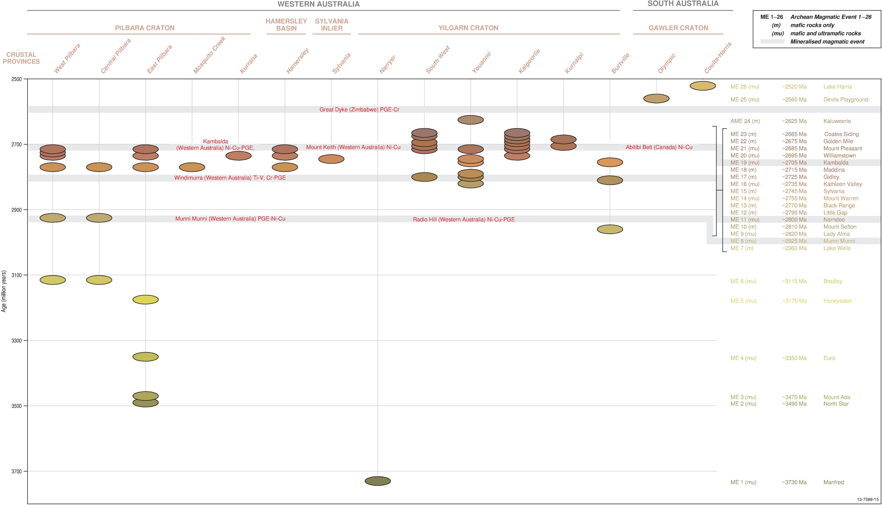
Figure D1 Time-Space-Event Chart of Australian Archean Mafic-Ultramafic Magmatic Events
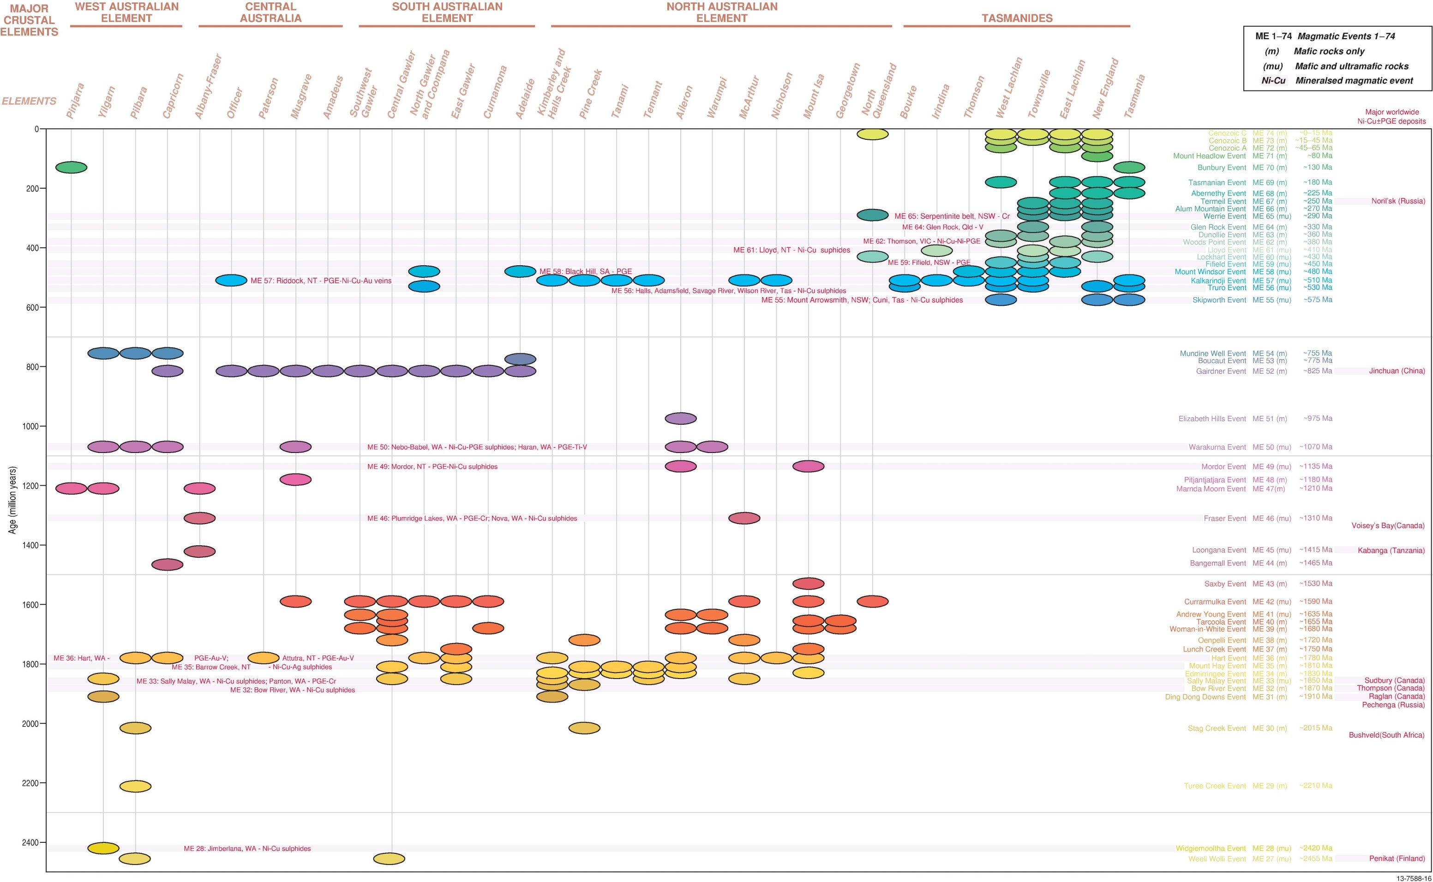
Figure D2 Time-Space-Event Chart of Australian post-Archean Mafic-Ultramafic Magmatic Events

References used in the compilation
Abbott, S.T., Sweet, I.P., Plumb, K.A., Young, D.N. and Cutovinos, A., 2001. Roper Region: Urapunga and Roper River Special, Northern Territory (Second Edition), 1:250 000 Geological Series map (Sheets SD 53–10 and SD 53–11). Explanatory Notes, Northern Territory Geological Survey: Darwin, pp.100.
Abele, C., Page, R.W., 1974. Stratigraphic and isotopic ages of Tertiary basalts at Maude and Aireys Inlet, Victoria. Australia Bureau of Mineral Resources Record 1973/2, Geoscience Australia: Canberra, pp.23.
Abell, R.S., 1991. Geology of the Canberra 1:100 000 Sheet area, New South Wales and Australian Capital Territory. Bureau of Mineral Resources Bulletin, Geoscience Australia: Canberra, pp.233-116.
Adams, C.J., Black, L.P., Corbett, K.D. and Corbett, K.D., 1985. Reconnaissance isotopic studies bearing on the tectonothermal history of Early Palaeozoic and Late Proterozoic sequences in western Tasmania. Australian Journal of Earth Sciences, 32: 7–36.
Ahmat, A.L., 1995. Kanowna, Western Australia (First Edition), 1:100 000 geological map (Sheet 3236). Geological Survey of Western Australia: Perth.
Ahmad, M. and Wygralak, A, S., 1989. Calvert Hills, Northern Territory (First Edition), 1:250 000 metallogenic map (Sheet SE 53–08). Explanatory Notes and mineral deposit data sheets, Northern Territory Geological Survey: Darwin, pp.55.
Ahmad, M., Wygralak, A.S., Ferenczi, P.A. and Bajwah, Z.U., 1993. Pine Creek, Northern Territory, 1:250 000 metallogenic map series (Sheet SD 52–8). Northern Territory Geological Survey: Darwin.
Aitchison, J.C., Blake Jnr., M.C., Flood, P.G., Murchey, B.L., 1988. New and revised lithostratigraphic units from the southwestern New England Fold Belt. Geological Survey of New South Wales. Quarterly Notes, 72: 10-16.
Aitchison, J.C. and Ireland, T.R., 1995. Age profile of ophiolitic rocks across the Late Palaeozoic New England Orogen, New South Wales: implications for tectonic models. Australian Journal of Earth Sciences, 42: 11–23.
Aitchison, J.C., Ireland, T.R., Blake, M.C. Jr. and Flood P.G., 1992. 530 Ma zircon age for ophiolites from New England Orogen: Oldest rocks from eastern Australia. Geology, 20: 125–128.
Allen, R.J., Staines, H.R.E., and Wilson, E.G. 1960 Triassic. The Ipswich Basin. Geological Society of Australia Journal, 7: 252-262.
Allen, C.M., Williams, I.S., Stephens, C.J., Fielding, C.R., 1998. Granite genesis and basin formation in an extensional setting: the magmatic history of the northernmost New England Orogen. Australian Journal of Earth Sciences, 45(6): 875-888.
Allen, R. J., Cribb, H. G. S., Isbell, R. F., Jenkins, T. B. H., McTaggart, N. R., Mott, W. D., Staines, H. R. E., Stephenson, P. J., Stevens, N. C., Traves, D. M., and Tweedale, G. W., 1960. XI Lower Cainozoic. Journal of the Geological Society of Australia, 7(1-2): 341-371.
Ambrose, G.J. and Flint, R.B., 1980. Billa Kalina, South Australia, 1:250 000 geological map (Sheet SH 53–7). Geological Survey of South Australia, Department of Mines: Adelaide.
Amdel, 1982. Geochronology report and data for Bureau of Mineral Resources. Unpublished Report 6039/82.
Amdel, 1985. K-Ar results for the Geological Survey of Queensland. Unpublished Report.
Anderson, J.C., Palmieri, V., 1977. The Fork Lagoons Beds, an Ordovician unit of the Anakie Inlier, central Queensland. Queensland Government Mining Journal, 78(908): 260-263.
Arndt, N.T., Bruzak, G. and Reischmann, T., 2001. The oldest continental and oceanic plateaus: geochemistry of basalts and komatiites of the Pilbara Craton in Ernst, R.E., and Buchan, K.L. (eds.) Mantle Plumes: Their Identification Through Time. Geological Society of America, Special Publication, 352: 359–387.
Arndt, N.T., Nelson, D.R., Compston, W., Trendall, A.F. and Thorne, A.M., 1991. The age of the Fortescue Group, Hamersley Basin, Western Australia, from ion microprobe zircon U-Pb results. Australian Journal of Earth Sciences, 38: 261–281.
Arnold, G.O., Rubenach, M.J., 1976. Mafic-ultramafic complexes of the Greenvale area, north Queensland: Devonian intrusions or Precambrian metamorphics? Royal Society of New South Wales Journal and Proceedings, 23(2): 119-139.
Ashley, P.M., Dawson, M. W., Sivell, W.J., Wilson, J.S., Dunlap, W.J., 2003. New data on the geology and geochronology of the area south of Tooraweenah, New South Wales. Geological Survey of New South Wales Quarterly Notes, 115: 13-32.
Ashley, P. M., Duncan R. A. and Feebrey, C. A., 1995. Ebor Volcano and Crescent Complex, northeastern New South Wales: age and geological development. Australia Journal of Earth Sciences, 4: 471-480.
Australasian Oil and Gas Journal. 1959 New names in Queensland Stratigraphy. (Part 4) Australasian Oil and Gas Journal, 5(11): 26-36.
Bagas, L., 1999. Rudall, Western Australia (Second Edition), 1:250 000 geological map (Sheet SF 51–10). Geological Survey of Western Australia: Perth.
Bagas, L., 2000. Paterson, Western Australia, 1:100 000 geological map (Sheet 3354). Geological Survey of Western Australia: Perth.
Bagas, L., 2005. Nullagine, Western Australia (First Edition), 1:100 000 geological map (Sheet 2954). Explanatory Notes, Geological Survey of Western Australia: Perth. pp.33.
Bagas, L., Beukenhorst, O. and Hos, K., 2004. Nullagine, Western Australia (First Edition), 1:100 000 geological map (Sheet 2954). Geological Survey of Western Australia: Perth.
Bagas, L. and Haines, P.W., 1991. Barrow Creek, Northern Territory (Second Edition), 1:250 000 geological map (Sheet SF 53–6). Northern Territory Geological Survey: Darwin.
Bagas, L. and Smithies, R.H., 1996. Connaughton, Western Australia, 1:100 000 geological map (Sheet 3452). Geological Survey of Western Australia: Perth.
Bagas, L., Van Kranendonk, M.J. and Pawley, M., 2002. Split Rock, Western Australia (First Edition), 1:100 000 geological map (Sheet 2854). Geological Survey of Western Australia: Perth.
Bagas, L., Williams, I.R. and Hickman, A.H., 2000. Rudall, Western Australia (Second Edition), 1:250 000 Geological Series map (Sheet SF 51–10). Explanatory Notes, Western Australia Geological Survey. pp.50.
Baillie, P.W., 1980. A basaltic intrusion near St Marys. Tasmanian Geological Survey Report 1980/14, pp.6.
Balfe, P.E., Draper, J.J., Scott, S.G., Belcher, R.L., 1988. Bowen Basin solid geology, Queensland, 1:500 000 geology map. Department of Mines: Queensland, 1v.
Barley, M.E., Blewett, R.S., Cassidy, K.F., Champion, D.C., Czarnota, K., Doyle, M.G., Krapez, B., Kositcin, N., Pickard, A.L. and Weinberg, R.F., 2006. Tectonostratigraphic and structural architecture of the eastern Yilgarn Craton. Final AMIRA Report P763/pmd*CRC Project Y1, December 2006.
Barley, M.E., Pickard, A.L. and Sylvester, P.J., 1997. Emplacement of a large igneous province as a possible cause of a banded iron formation 2.45 billion years ago. Nature, 385: 55–58.
Barnes, S.J. (ed.), 2006. Nickel Deposits of the Yilgarn Craton: Geology, Geochemistry, and Geophysics Applied to Exploration. Economic Geology, Special Publication 13: 210.
Barnes, S.J., Hill, R.E.T., Perring, C.S. and Dowling, S.E., 2004. Lithogeochemical exploration for komatiite-associated Ni-sulfide deposits: strategies and limitations. Mineralogy and Petrology,
82: 259–293.
Barnes, T.A., 1959. Alberga, South Australia 4–mile geological map (Sheet G 53–9 Zone 4). Bureau of Mineral Resources, Canberra.
Basden, H., 1990. Geology of the Tumut 1:100 000 sheet 8527. Geological Survey of New South Wales. 1:100,000. Geological sheet series Tumut, pp.275.
Bateman, R., Costa, S., Swe, T. and Lambert, D., 2001. Archaean mafic magmatism in the Kalgoorlie area of the Yilgarn Craton, Western Australia: a geochronological and Nd isotopic study of the petrogenetic and tectonic evolution of a greenstone belt. Precambrian Research, 108: 75–112.
Baxter, J.L., 1974. Murgoo, Western Australia (First Edition), 1:250 000 Geological Series map (Sheet SG 50–14). Explanatory Notes, Western Australia Geological Survey, pp.23.
Baxter, J.L., 1978. Molybdenum, tungsten, vanadium and chromium in Western Australia. Geological Survey of Western Australia, Mineral Resources, Bulletin 11, pp.140.
Baxter, J.L. and Lipple, S.L., 1983. Perenjori, Western Australia (First Edition), 1:250 000 geological map (Sheet SH 50–06). Geological Survey of Western Australia: Perth.
Baxter, J.L. and Lipple, S.L., 1985. Perenjori, Western Australia (First Edition), 1:250 000 Geological Series map (Sheet SH 50–06). Explanatory Notes, Western Australia Geological Survey, pp.32.
Baxter, J.L., Lipple, S.L. and Marston, R.J., 1982. Kirkalocka, Western Australia (First Edition),
1:250 000 geological map (Sheet SH 50–3). Geological Survey of Western Australia: Perth.
Baxter, J.L., de la Hunty, L.E. and Muhling, P.C., 1972. Murgoo, Western Australia, 1:250 000 geological map (Sheet SG 50–14). Geological Survey of Western Australia: Perth.
Benbow, M.C., 1981. Coober Pedy, South Australia, 1:250 000 geological map (Sheet SH 53–6). Geological Survey of South Australia Department of Mines: Adelaide.
Benbow, M.C., Crooks, A.F., Rankin, L.R., Martin, A.R. and Fairclough, M.C., 1995. Barton, South Australia, 1:250 000 geological map (Sheet SH 53–9). Geological Survey of South Australia Department of Mines: Adelaide.
Bennett R., Page R.W., and Bladon G.M., 1975. Catalogue of isotopic age determinations of Australian rocks, 1966-70. Australia Bureau of Mineral Resources Report, 162, pp.135.
Berry, R.F., and Crawford, A.J., 1988. The tectonic significance of Cambrian allochthonous mafic-ultramafic complexes in Tasmania. Australian Journal of Earth Sciences, 35: 523-433.
Bierlein, F.P., Dennis, A.C., Foster, D.A and Reynolds, P. 2001 A geochronological framework for orogenic gold mineralisation in central Victoria, Australia Mineralium Deposita, 36: 741-767
Birch, W.D. (ed.), 2003. Geology of Victoria. Geological Society of Australia Special Publication 23. Geological Society of Australia: Victoria, pp.842.
Black, L.P., 1994. U-Pb zircon ion-microprobe ages from the northern Drummond Basin, northeastern Queensland. Record 1994/34. Australian Geological Survey Organisation: Canberra.
Black L.P., 1998. SHRIMP zircon U/Pb isotopic age dating of samples from the Dubbo 1:250 000 Sheet area. Geological Survey of New South wales Report GS1998/126.
Black L.P., 2005. SHRIMP U-Pb zircon ages obtained during 2004/05 for NSW Geological Survey. Unpublished report, GS2005/745.
Black, L.P., 2007. SHRIMP U-Pb zircon ages obtained during 2006/07 for NSW Geological Survey projects. Unpublished report for NSW Department of Primary Industries, GS2007/298.
Black, L. P., Bell, T. H., Rubenach, M. J. and Withnall, I. W., 1979. Geochronology of discrete structural-metamorphic events in a multiply deformed Precambrian terrain. Tectonophysics, 54.
Black, L.P., and McCulloch, M.T., 1990. Isotopic evidence for the dependence of recurrent felsic magmatism on new crust formation: an example from the Georgetown region of northeast Australia. Geochimica et Cosmochimica Acta, 54: 183-196.
Black, L.P., Seymour, D.B., Corbett, K.D., Cox, S.F., Streit, J.E., Bottril, R.S., Calver, C.R., Everard, J.L., Green, G.R., McClenaghan, M.P., Pemberton, J., Taheri, J., and Turner, N.J., 1997. Dating Tasmania’s oldest geologic events. Record 1997/15. Australian Geological Survey Organisation: Canberra, pp.57.
Black, L.P., Gregory, P., Withnall, I.W. and Bain, J.H.C., 1998. U-Pb zircon age for the Etheridge Group, Georgetown region, north Queensland: implications for relationship with the Broken Hill and Mt Isa sequences. Australian Journal of Earth Sciences, 45, pp.925–935.
Black, L. P., Kamo, S. L., Allen, C. M., Aleinikoff, J. N., Davis, D. W., Korsch, R. J. and Foudoulis, C., 2003. TEMORA 1: a new zircon standard for Phanerozoic U-Pb geochronology. Chemical Geology, 200(1-2): 155-170.
Black, L.P., Kamo, S.L., Williams, I.S., Mundil, R., Davis, D.W., Korsch, R.J. and Foudoulis, C., 2003. The application of SHRIMP to Phanerozoic geochronology; a critical appraisal of four zircon standards. Chemical Geology, 200: 171–188.
Black, L.P., Calver, C.R., Seymour, D.B. and Reed, A., 2004. SHRIMP U-Pb detrital zircon ages from Proterozoic and Early Palaeozoic sandstones and their bearing on the early geological evolution of Tasmania. Australian Journal of Earth Sciences, 51: 885–900.
Black, P.P., McClenaghan, M.P., Korsch, R.J., Everard, J.L. and Foudoulis, C., 2005. Significance of Devonian–Carboniferous igneous activity in Tasmania as derived from U–Pb SHRIMP dating of zircon. Australian Journal of Earth Sciences, 52: 807–829.
Blake, D.H., 1976. Webb, Western Australia (First Edition), 1:250 000 geological map (Sheet SF 52–10). Bureau of Mineral Resources, Australia, and Geological Survey of Western Australia.
Blake, D.H., 1987. Geology of the Mount Isa Inlier and environs, Queensland and Northern Territory. Bureau of Mineral Resources, Australia, Bulletin, 225, pp.83.
Blake, T.S., 2001. Cyclic continental mafic tuff and flood basalt volcanism in the Late Archaean Nullagine and Mount Jope Supersequences in the eastern Pilbara, Western Australia. Precambrian Research, 107: 139–177.
Blake, P.R., 2010. Devonian Corals of the Yarrol Province, eastern central Queensland. AAP Memoir 38.
Blake, T.S., Buick, R., Brown, S.J.A. and Barley, M.E., 2004. Geochronology of a Late Archaean flood basalt province in the Pilbara Craton, Australia: constraints on basin evolution, volcanic and sedimentary accumulation, and continental drift rates. Precambrian Research, 133: 143–173.
Blake, D.H., Yeates, A.N., Passmore, V.L., Hodgson, I.M., Walton, D.G., Muhling, P.C. and Crowe, R.W.A., 1977. Billiluna, Western Australia (Second Edition), 1:250 000 geological map (Sheet SE 52–14). Bureau of Mineral Resources, Australia, and Geological Survey of Western Australia, Perth.
Blake, D.H., Bultitude, R.J. and Donchack, P.J.T., 1982. Dajarra, Queensland (Sheet 6854). Bureau of Mineral Resources, Australia, 1:100 000 Geological Map Commentary, pp.28.
Blake, D.H., Jaques, A.L. and Donchak, P.J.T., 1983. Selwyn Region, Queensland (Sheets 7054 and part of 6954). Bureau of Mineral Resources, Australia, 1:100 000 Geological Map Commentary, pp.29.
Blake, D.H., Stewart, A.J., Sweet, I.P. and Hone, I.G., 1987. Geology of the Proterozoic Davenport Province, central Australia. Bureau of Mineral Resources, Australia, Bulletin, 226, pp.70.
Blake, D.H., Griffin, T.J., Tyler, I.M., Thorne, A.M. and Warren, R.G., 1999a. Halls Creek, Western Australia, 1:100 000 geological map (Sheet 4461). Australian Geological Survey Organisation: Canberra.
Blake, D.H., Tyler, I.M., Griffin, T.J., Sheppard, S., Thorne, A.M. and Warren, R.G., 1999b. Geology of the Halls Creek, Western Australia 1:100 000 Sheet area (Sheet 4461) geological map. Australian Geological Survey Organisation: Canberra. Explanatory Notes, pp.36.
Blake, D.W., Tyler, I.M. and Page, R.W., 2000. Regional geology of the Halls Creek Orogen. Appendix, in Hoatson, D.M. and Blake, D.H. (eds.), Geology and Economic Potential of the Palaeoproterozoic Layered Mafic-Ultramafic intrusions in the East Kimberley, Western Australia. Australian Geological Survey Organisation, Bulletin, 246: 35–62.
Blake, D.H., Tyler, I.M. and Warren, R.G., 2000. Gordon Downs, Western Australia (Second Edition), 1:250 000 geological map (Sheet SE 52–10). Australian Geological Survey Organisation: Canberra.
Blewett, R.S., 2008a. pmd*CRC Project, Y4 Final Report–Parts I & II, January 2005–July 2008. Concepts to targets: a scale-integrated mineral systems study of the Eastern Yilgarn Craton,
162 pp.
Blewett, R.S., 2008b. pmd*CRC Project, Y4 Final Report–Parts III & IV, January 2005–July 2008. Concepts to targets: a scale-integrated mineral systems study of the Eastern Yilgarn Craton,
391 pp.
Blewett, R.S., Trail, D.S., Mackenzie, D.E.M., Wellman, P., Knutson, J., von Gnielinski, F.E., Bain, J.H.C., Wilford, J.R. and Dohrenwend, J.C., 1995. Ebagoola, Queensland (Second Edition), 1:250 000 geological map (Sheet SD 54–12). Australian Geological Survey Organisation: Canberra.
Blewett, R.S., and Wilford, J.R., 1996. Hann River, Queensland; 1:250 000 geological series - commentary. Australian Geological Survey Organisation and Geological Survey of Queensland, 1-pp. 66.
Blewett, R.S., Denaro, T.J., Knutson, J., Wellman, P., Mackenzie, D.E., Cruikshank, B.I., Wilford, J.R., von Gnielinski, F.E., Pain, C.F., Sun, S.-s. and Bultitude, R.J., 1997. Coen Region in Bain, J.H.C. and Draper, J.JH. (eds.), North Queensland Geology. Australian Geological Survey Organisation, Bulletin, 240: 117–158.
Blewett, R.S., Black, L.P., Sun, S.-s., Knutson, J., Hutton, L.J. and Bain, J.H.C., 1998. U-Pb zircon and Sm-Nd geochronology of the Mesoproterozoic of North Queensland: implications for a Rodinian connection with the Belt supergroup of North America. Precambrian Research, 89: 101–127.
Blight, D.F., Seymour, D.B. and Thorne, A.M., 1986. Wyloo, Western Australia (Second Edition), 1:250 000 geological map (Sheet SF 50–10). Geological Survey of Western Australia: Perth.
Blissett, A.H., 1977. Gairdner, South Australia, 1:250 000 geological map (Sheet SH 53–15). Geological Survey of South Australia Department of Mines: Adelaide.
Bodorkos, S., Simpson, C.J., Thomas, O.D., Trigg, S.J., Blevin, P.L., Campbell, L.M., Deyssing, L.J. and Fitzherbert, J.A., 2010. New SHRIMP U-Pb zircon ages from the eastern Lachlan Orogen, New South Wales. July 2008-June 2009. Record 2010/31. Geoscience Australia: Canberra, pp.100.
Bottrill, R.S. and Neef, G., 1998. Mid-Devonian Ultrabasic sill near White Cliffs, New South Wales. Australian Journal of Earth Sciences, 45: 93-96.
Bowen, K.G., 1975. Potassium-Argon dates - determinations carried out by the Geological Survey of Victoria. Geological Survey of Victoria Unpublished report 1975/3. Department of Mines: Victoria. Pp.34.
Bowman, H.N., 1974. Geology of the Wollongong, Kiama, and Robertson 1:50 000 sheets. 9029-II, 9028-I & IV. Geological Survey of New South Wales 1v.
Brakel, A.T., Moncrieff, J.S., Muhling, P.C. and Chin, R.J., 1985. Dumbleyung, Western Australia (First Edition), 1:250 000 geological map (Sheet SI 50–7). Geological Survey of Western Australia: Perth.
Brauns, C.M., Hergt, J.M., Woodhead, J.D., and Maas, R., 2000. Os isotopes and the origin of the Tasmanian dolerites. Journal of Petrology, 41: 9-5-918.
Brown, A.V., 1986. Geology of the Dundas–Mt Lindsay–Mt Youngbuck region. Geological Survey of Tasmania, Bulletin, 62: 221.
Brown, R.E., 1987. Newly defined stratigraphic units from the western New England Fold Belt, Manilla 1:250 000 sheet area. Geological Survey of New South Wales. Quarterly Notes, 69: 1-9.
Brown, A.V., 1989. Orthopyroxene-rich ultramafic frocks from western Tasmania and their PGE contents. Tasmania Department of Mines Report 1989/40, pp.11.
Brown, R.E., Krynen, J.P. and Brownlow, J.W., 1973. Manilla, New South Wales (Second Edition), 1:250 000 geological map (Sheet SH 56–09). Geological Survey of New South Wales: Sydney.
Bruce, M.C., Nui, Y., Jarbort, T.A. and Holcombe, R.J., 2000. Petrological, geochemical and geochronological evidence for a Neoproterozoic ocean basin recorded in the Marlborough terrane of the northern New England Fold Belt. Australian Journal of Earth Sciences, 47: 1053–1064.
Bruguier, O., Bosch, D., Pidgeon, R.T., Byrne, D.I. and Harris, L.B., 1999. U-Pb chronology of the Northampton Complex, Western Australia–evidence for Grenvillian sedimentation, metamorphism and deformation and geodynamic implications. Contributions to Mineralogy and Petrology, 136: 258–272.
Brunker, R.L. and O’Connell, P., 1967. Cobham Lake, New South Wales (First Edition), 1:250 000 geological map (Sheet SH 54–11). Geological Survey of New South Wales: Sydney.
Brunker, R., 1968. Bourke, New South Wales 1:250 000 geological series sheet SH55-10 1st edition explanatory notes, Geological Survey of New South Wales, 1v pp.9.
Bryan, W.H., Denmead, A.K., Jones, O.A. , Mathews, R.T., 1960. The Brisbane Metamorphics in Hill, D. and Denmead A.K. (eds.) The Geology of Queensland, Vol 7. Melbourne University Press on behalf of the Geological Society of Australia, Parkville Victoria, pp.80-87.
Bryan, S.E., Fielding, C.R., Holcombe, R.J., Cook, A., Moffitt, C.A., 2003. Stratigraphy, facies architecture and tectonic implications of the Upper Devonian to Lower Carboniferous Campwyn Volcanics of the northern New England Fold Belt. Australian Journal of Earth Sciences, 50(3): 377-401.
Buckley, P.M., 2003. Nuchea, New South Wales, 1:100 000 geological map series (Sheet 7335). Geological Survey of New South Wales, Explanatory Notes, pp.92.
Buick, R., Thornett, J.R., McNaughton, N.J., Smith, J.B., Barley, M.E. and Savage, M., 1995. Record of emergent continental crust approx. 3.5 billion years ago in the Pilbara craton of Australia. Nature, 375: 574–577.
Buick, R., Brauhart, C.W., Morant, P., Thornett, J.R., Maniw, J.G., Archibald, N.J., Doepel, M.G., Fletcher, I.R., Pickard, A.L., Smith, J.B., Barley, M.E., McNaughton, N.J. and Groves, D.I., 2002. Geochronology and stratigraphic relationships of the Sulphur Springs Group and Strelley Granite: a temporally distinct igneous province in the Archaean Pilbara Craton, Australia. Precambrian Research, 114: 87–120.
Bultitude, R., 1982a. Ardmore, Queensland (Sheet 6754). 1:100 000 Geological Map Commentary, Bureau of Mineral Resources: Australia. pp.27.
Bultitude, R.J., Blake, D.H., Donchack, P.J.T. and Mock, C.M., 1982b. Duchess Region, Queensland (Sheet 6855). 1:100 000 Geological Map Commentary, Bureau of Mineral Resources: Australia. pp.35.
Bultitude, R.J., Donchak, P.J.T., 1992. Pre-Mesozoic stratigraphy and structure of the Maytown Region. Queensland. Record 1992/5. Department of Resource Industries: Queensland, pp.221.
Bultitude, R.J., Champion, D.C., Mackenzie, D.E., 1993. New and revised intrusive units in the Chillagoe region, north Queensland. Queensland Geological Record 1993/28, pp.106.
Bultitude, R.J., Garrad, P.D., Donchak, P.J.T , Domagala, J., Champion, D.C., Rees, I.D., Mackenzie, D.E., Wellman, P., Knutson, J., Fanning, C.M., Fordham, B.G., Grimes, K.G., Oversby, B.S., Rienks, I.P., Stephenson, P.J., Chappell, B.W., Pain, C.F., Wilford, J.R., Rigby, J.F., Woodbury, M.J., 1997. Cairns Region in Bain J.H.C and Draper J.J. (eds.) North Queensland Geology. Australian Geological Survey Organisation Bulletin/Queensland Department of Mines and Energy Qld Geo 240/9, pp.225-325.
Bultitude, R.J., Garrad, P.D., Wegner, S , Donchak, P.J.T., Fanning, C.M., 1999. Innisfail, second edition. Queensland 1:250 000 Geological Series. Explanatory Notes Geological Survey of Queensland, Queensland Department of Mines and Energy, 1: 77.
Bultitude, R.J., Withnall, I.W., Nieuwenburg, A., 2003. Cracow, Queensland, 1:100 000 Sheet 8947, First Edition Queensland. Department of Natural Resources and Mines. 1v Map.
Bultitude, R.J. and Young, G.A. 1983 Ardmore, Queensland (First Edition), 1:100 000 geological series map (Sheet 6754). Bureau of Mineral Resources, Australia & Geological Survey of Queensland v1 Map
Bunting, J.A., 1980. Kingston, Western Australia (First Edition), 1:250 000 geological map (Sheet SG 51–10). Geological Survey of Western Australia: Perth.
Bunting, J.A., 2007. Albany–Fraser and sub–Eucla: a new but not-so-remote frontier. PowerPoint presentation (unpublished) at Proterozoic Mineralisation in Western Australia Conference, 11 June 2007. Australian Institute of Geoscientists, Western Australian Branch, 1–8.
Bunting, J.A., Commander, D.P., Elias, M. and Wharton, P.H., 1981. Glengarry, Western Australia (First Edition), 1:250 000 geological map (Sheet SG 50–12). Geological Survey of Western Australia: Perth.
Burch, G.J., 1999. Zircon U-Pb dating of Late Carboniferous and Early Permian igneous rocks from the Mt Mackenzie prospect. Excerpt from B.SC. (Honours) Thesis, Department of Geology, Australian National University.
Burrett, C.F. and Martin, E.L. (eds.), 1989. Geology and Mineral Resources of Tasmania. Geological Society of Australia Special Publication, 15, pp.574.
Burtt, A.C. and Purvis, A.C., 2002. The Black Hill Gabbroic Complex–a Bushveld or Fifield analog? Geological Survey of South Australia, Department of Mines and Energy, MESA Journal, 24: 32–40.
Cayley, R.A., and Taylor, D.H., 2001. Ararat 1:100 000 Map Area Geological Report. Geological Survey of Victoria 115, pp.329.
Callen, R.A., 1986. Curnamona, South Australia (First Edition), 1:250 000 geological map (Sheet SH 54–14). Department of Mines and Energy: Adelaide.
Callan, R.A. and Coats, R.P., 1975. Frome, South Australia, 1:250 000 geological map (Sheet SH 54–10). Geological Survey of South Australia, Department of Mines and Energy: Adelaide.
Callan, R.A. and Gravestock, D.I., 1994. Strzelecki, South Australia (First Edition), 1:250 000 geological map (Sheet SH 54–2). Geological Survey of South Australia, Department of Mines and Energy: Adelaide.
Calver, C.R., 1998. Isotope stratigraphy of the Neoproterozoic Togari Group, Tasmania. Australian Journal of Earth Sciences, 45: 865–874.
Calver, C.R., 2007. Some notes on the geology of King Island. Record, 2007/02. Tasmanian Geological Survey, pp.20.
Calver, C.R., 2012. Explanatory report for the Grassy and Naracoopa geological map sheets. Explanatory Report 1:25 000 scale digital geological map series. Mineral Resources Tasmania, 5.
Calver, C.R., Black, L.P., Everard, J.L., and Seymour, D.B., 2004. U-Pb zircon age constraints on late Neoproterozoic glaciation in Tasmania. Geology, 32: 893-896.
Calver, C.R., and Castleden, R.H., 1981. Triassic basalt from Tasmania. Search, 12: 92-103.
Campbell, K.S.W. 1960 The Brisbane Valley in Hill, D. and Denmead A.K. (eds.) The Geology of Queensland, vol. 7, Melbourne University Press on behalf of the Geological Society of Australia: Parkville Victoria, pp.223-223.
Campbell, L.M., Holcombe, R.J. and Fielding, C.R., 1999. The Esk Basin - a Triassic foreland basin within the northern New England Orogen in Flood, P. G. (ed.) Regional geology, tectonics and metallogenesis, New England Orogen. Papers presented at a conference held at The University of New England, Armidale, 1-3 February 1999. University of New England, Earth Sciences: Armidale, NSW. 1v pp.275-284
Carey, M.L., 1994. Petrography and geochemistry of selected sills from the Kambalda-Kalgoorlie region, WA. Australian National University, Canberra, B.Sc. (Hon.) thesis, (unpublished).
Carr, H.W., 1989. The geochemistry and platinum group element distribution of the Rudall River ultramafic bodies, Paterson Province, Western Australia. BSc(Hons) thesis (unpublished), University of Western Australia, Perth, pp.80.
Carson, C.J., Claoué-Long, J.C., Stern, R.A., Close, D.F. and Glass, L.M., 2009. Summary of results. Joint NTGS–GA geochronology project: Arunta and Pine Creek regions July 2006–May 2007. Northern Territory Geological Survey, Record, 2009-001.
Carson, C.J., Hutton, L.J., Withnall, I.W. and Perkins, W.G., 2009. Joint GSQ-GA NGA geochronology project Mount Isa region, 2007-2008. Queensland Geological Record 2008/05
Carson, L.J., Haines, P.W., Brakel, A., Pietsch, B.A. and Ferneczi, P.A., 1999. Milingimbi, Northern Territory (Second Edition), 1:250 000 geological map (Sheet SD 53–2). Australian Geological Survey Organisation: Canberra.
Carson, C.J., von Gnielinski, F.E., Bultitude, R.J., 2007. Results of the joint GSQ-GA geochronology project, New England Orogen, Rosedale, Mount Perry and Gladstone 1:100 000 Sheet Areas, March 2006 - December 2006 Queensland Geological Record 2006/01, pp.58.
Carter, E.K., Brooks, J.H. and Walker, K.R., 1961. The Precambrian mineral belt of north-western Queensland. Bureau of Mineral Resources, Australia, Bulletin, 51: 344.
Carter, E.K., Bennett, E.M., Smart, J., McLaren, M. and Mikolajczak, A.S., 1972. Dobbyn, Queensland (Second Edition), 1:250 000 geological map (Sheet SE 54–14). Bureau of Mineral Resources: Australia.
Cassidy, K.F., Champion, D.C., Krapez, B., Barley, M.E., Brown, S.J.A., Blewett, R.S., Groenewald, P.B. and Tyler, I.M., 2006. A revised geological framework for the Yilgarn Craton, Western Australia. Record 2006/8. Geological Survey of Western Australia: Perth, pp.8.
Cayley, R.A., Taylor, D.H., 2001. Ararat - 1:100 000 Map Area Geological Report. Geological Survey of Victoria. Report 115: 324.
Cayley, R.A., Skladzien, P.B., Williams, B., Willman, C.E., 2008. Redesdale and part of Pyalong 1:50 000 map area geological report. Geological Survey of Victoria. Report 128: 98.
Champion, D.C. and Cassidy, K.F., 2008. Geodynamics: Using geochemistry and isotopic signatures of granites to aid mineral systems studies: an example from the Yilgarn Craton in Korsch, R.J. and Barnicoat, A.C. (eds.) New Perspectives: The foundations and future of Australian exploration. Abstracts for the 11-12th June 2008 pmd*CRC Conference. Record 2008/09. Geoscience Australia: Canberra, pp.7–16.
Claoué-Long, J.C. and Hoatson, D.M., 2005. Proterozoic mafic-ultramafic intrusions in the Arunta Region, central Australia Part 2: event chronology and regional correlations. Precambrian Research, 142: 134–158.
Claoué-Long, J.C. and Hoatson, D.M., 2009. Guide to using the Map of Australian Proterozoic Large Igneous Provinces. Record 2009/44. Geoscience Australia: Canberra, pp.37.
Claoué-Long, J.C., Compston, W. and Cowden, A., 1988. The age of the Kambalda greenstones resolved by ion-microprobe: implications for Archaean dating methods. Earth and Planetary Science Letters, 89: 239–259.
Claoué-Long, J.C., Maidment, D. and Donnellan, N., 2008a. Stratigraphic correlation of the Davenport Province in central Australia: a template for the Arunta and Tanami Regions. Precambrian Research, 166: 204-218.
Claoué-Long, J.C., Maidment, D., Hussey, K. and Huston, D., 2008b. The timing and duration of the Strangways Event in central Australia. Precambrian Research, 166: 246-262.
Clark, D.J., Kinny, P.D., Post, N.J. and Hensen, B.J., 1999. Relationships between magmatism, metamorphism and deformation in the Fraser Complex, Western Australia: constraints from new SHRIMP U-Pb zircon geochronology. Australian Journal of Earth Sciences, 46: 923–932.
Clarke, M.J., Farmer, N. and Gulline, A.B., 1973. Parmeener Supergroup (lower part), Poatina in Banks M.R.(ed.) the Lake Country of Tasmania A symposium held in Poatina, Tasmania. Royal Society of Tasmania, pp.35-41.
Clark, D. A., and Lackie, M. A., 2003. Palaeomagnetism of the Early Permian Mount Leyshon Intrusive Complex and Tuckers Igneous Complex, North Queensland, Australia. Geophysical Journal International, 153(3): 523-547.
Clutha Minerals Ltd., 1990. First and final report, EL3416, Ulladulla, Bawley Point area. Mineral Exploration Reports GS1990/327 (R00002000). New South Wales Geological Survey, pp.10.
Coenraads R.R., 1990. Key areas for alluvial diamond and sapphire exploration in the New England gem fields, New South Wales, Australia. Economic Geology, 85: 1186–1207.
Compston, D., 1994. The geochronology of the Tennant Creek Inlier, Northern Territory. Thesis (unpublished), Australian National University: Canberra.
Compston, W. and Arriens, P.A., 1968. The Precambrian geochronology of Australia. Canadian Journal of Earth Sciences, 5: 561–583.
Compston, W., Williams, I.S., Campbell, I.H. and Gresham, J.J., 1986. Zircon xenocrysts from the Kambalda volcanics: age constraints and direct evidence for older continental crust below the Kambalda Norseman greenstones. Earth and Planetary Science Letters, 76: 299–311.
Condie, K.C. and Myers, J.S., 1999. Mesoproterozoic Fraser Complex: geochemical evidence for multiple subduction-related sources of lower crustal rocks in the Albany-Fraser Orogen, Western Australia. Australian Journal of Earth Sciences, 46: 875–882.
Conor, C.H.H., 2004. Geology of the Olary Domain, Curnamona Province, South Australia. Report Book, 2004/8. South Australian Department of Primary Industries and Resources, pp.86.
Conor, C.H.H. and Fanning, C.M., 2001. Geochronology of the Woman-in-White amphibolite, Olary Domain. Geological Survey of South Australia, Department of Mines and Energy, MESA Journal, 20: 41–43.
Cooper, J.A., Jenkins, R.J.F., Compston, W. and Williams, I.S., 1992. Ion-probe zircon dating of a mid-Early Cambrian tuff in South Australia. Journal of the Geological Society, London, 149: 185–192.
Cooper, P.F., 1975. Torrowangee-Fowlers Gap, New South Wales (First Edition), 1:100 000 geological map (Sheets 7135 and 7235). Geological Survey of New South Wales: Sydney.
Cooper, J.A. and Dong, Y.B., 1983. Zircon age data from a greenstone of the Archaean Yilgarn Block, Australia: Mid Proterozoic heating or uplift? Contributions to Mineralogy and Petrology, 82: 397–402.
Cooper, P.F., Tuckwell, K.D., Gilligan, L.B. and Meares, R.M.D., 1978. Torrowangee and Fowlers Gap, New South Wales (First Edition), 1:100 000 geological map series (Sheets 7135 and 7235). Geological Survey of New South Wales, Explanatory Notes, pp.149.
Corbett, K.D. and Brown, A.V., 1974. Queenstown, Tasmania (First Edition), 1:250 000 geological map (Sheet SK 55–05). Geological Survey, Tasmania Department of Mines: Tasmania.
Corbett, K.D., Qualty, P.G., and Calver, C.R., (eds.). In prep. The Geological Evolution of Tasmania. Geological Society of Australia Special Publication.
Coventry, R. J., Stephenson, P. J. and Webb, A. W., 1985. Chronology of landscape evolution and soil development in the upper Flinders River area, Queensland, based on isotopic dating of Cainozoic basalts. Australian Journal of Earth Sciences, 32(4): 433-447.
Cowley, W.M., 2006. Solid geology of South Australia. South Australia. Department of Primary Industries and Resources. Mineral Exploration Data Package, 15, version 1.1.
Cowley, W.M. and Fanning, C.M., 1991. Low-grade Archaean metavolcanics in the northern Gawler Craton. The Geological Survey of South Australia, Quarterly Geological Notes, July 1991, 119: 2–17.
Cowley, W.M. and Martin, A.R., 1991. Kingoonya, South Australia, 1:250 000 geological map (Sheet SH 53–11). Geological Survey of South Australia Department of Mines and Energy: Adelaide.
Cowley, W., Conor, C. and Zang, W., 2003. New and revised Proterozoic stratigraphic units on northern Yorke Peninsula. Geological Survey of South Australia, Department of Mines and Energy, MESA Journal, 29, April 2003: 46–58.
Cox, D.P. and Singer, D.A. (eds), 1986. Mineral deposit models. United States Geological Survey Bulletin, 1693: 379.
Cranfield, L.C., 1989a. New and revised Mesozoic stratigraphic units in the Maryborough 1:250 000 sheet area, southeast Queensland. Queensland Government Mining Journal 90(1049): 163-174.
Cranfield, L.C., 1989b. New Palaeozoic stratigraphic units in the Maryborough 1:250 000 sheet area, southeast Queensland. Queensland Government Mining Journal 90(1048): 115-120.
Cranfield, L.C., Donchak, P.J.T., Randall, R.E., Crosby, G.C., 2001. Geology and mineralisation of the Yarraman Subprovince, south-east Queensland. Queensland Geology 10.
Cranfield, L.C., Hutton, L.J., Green, P.M., 1989. Ipswich, Queensland. Sheet 9442. Queensland. Department of Mines 1:100 000 Geological Map Commentary 1v.
Cranfield, L.C., Schwarzbock, H., 1974. New and revised stratigraphic names in the Ipswich 1:250 000 sheet area. Queensland Government Mining Journal LXXV(875): 322-323.
Cranfield, L.C., Schwarzbock, H., and Day, R.W., 1976. Geology of the Ipswich and Brisbane 1250k sheet areas. Geological Survey of Queensland.
Crawford, A.J. and Berry, R.F., 1992. Tectonic implications of Late Proterozoic–Early Palaeozoic igneous rock associations in western Tasmania in Ferguson, C.L. and Glen, R.A. (eds.) the Palaeozoic Eastern Margin of Gondwanaland: Tectonics of the Lachlan Fold Belt, Southeastern Australia and Related Orogens. Tectonophysics, 214: 37–56.
Crawford, A.J., Cayley, R.A., Taylor, D.H., Morand, V.J., Gray, C.M., Kemp A.I.S., Wohlt, K.E., Vandenberg, A.H.M., Moore, D.H., Maher, S., Direen, N.G., Edwards, J., Donachy, A.G., Anderson, J.A., and Black, P., 2003. Neoproterozoic and Cambrian in Birch, W.D., (eds) Geology of Victoria, Geological Society of Australia Special Publication 23: 73 – 92.
Crawford, A.J., Meffre, S., Squire, R.J., Barron, L.M., Falloon, T.J., 2007. Middle to Late Ordovician magmatic evolution of the Macquarie Arc, Lachlan Orogen, New South Wales. Australian Journal of Earth Sciences, 54(3/4): 181-214.
Crawford, A.J., Stevens, B.P.J. and Fanning, M., 1997. Geochemistry and tectonic setting of some Neoproterozoic and Early Cambrian volcanics in western New South Wales. Australian Journal of Earth Sciences, 44: 831–852.
Creaser, R.A. and Fanning, C.M., 1993. A U-Pb zircon study of the Mesoproterozoic Charleston Granite, Gawler Craton, South Australia. Australian Journal of Earth Sciences, 40: 519–526.
Crispe, A.J., Vandenberg, L.C., Dean, A.A. and Hendrickx, M.A., 2000. Granites, Northern Territory (First Edition), 1:100 000 Surface geology map (Sheet 4956). Northern Territory Geological Survey: Darwin.
Crispe, A.J., Vandenberg, L.C. and Scrimgeour, I.R., 2007. Geological framework of the Archean and Paleoproterozoic Tanami Region, Northern Territory. Mineralium Deposita, 42: 3–26.
Crook, K.A.W., 1979. Tectonic implications of some field relations of the Adelaidean Cooee Dolerite, Tasmania. Journal of the Geological Society of Australia, 26: 353–361.
Crooks, A.F., 2003. Mafic rocks of the Mingary 1:100 000 map area–a review. Report Book, 2002/027. Department of Primary Industries and Resources: South Australia, pp. 47.
Cross, A.J., Fletcher, I.R., Crispe, A.J., Huston, D.L. and Williams, N., 2005. New constraints on the timing of deposition and mineralisation in the Tanami Group. Annual Geoscience Exploration Seminar (AGES) 2005. Abstracts. Record, 2005/001. Northern Territory Geological Survey: Darwin, pp.2.
Crouch, S.B.S., Donchak, P.J.T., Tenison Woods, K., Scott, M., Kwiecien, W., Grayson, R., 1995. Plutonic Rocks of the North D'Aguilar Block. Queensland Geological Record 1995/8, pp.1-77.
Crouch, S.B.S., Withnall, I.W., Tenison Woods, K., Hayward, M.A., Carr, P., 1994. New Plutonic Rock Units in the Southern Anakie Inlier, Central Queensland. Queensland Government Mining Journal 95(1112): 12-24.
Cutovinos, A. and Abbott, S.T., 2001. Urapunga–Roper River Special, Northern Territory (Second Edition), 1:250 000 geological map (Sheet SD 53–10). Northern Territory Geological Survey: Darwin.
Dalgarno, C.R., Johnson, J.E., Forbes, B.G. and Thomson, B.P., 1968. Port Augusta, South Australia, 1:250 000 geological map (Sheet SI 53–4). Bureau of Mineral Resources, Australia.
Daly, S.J., Crooks, A.F., Benbow, M., Flint, R.B. and Forbes, B.G., 1985. Tarcoola, South Australia, 1:250 000 geological map (Sheet SH 53–10). Geological Survey of South Australia Department of Mines and Energy: Adelaide.
Daly, S.J. and Fanning, C.M., 1993, Archaean in Drexel, J.F., Preiss, W.V. and Parker A.J. (eds.), The Geology of South Australia. Volume 1. The Precambrian. South Australia Geological Survey Bulletin 54: 33–50.
Daly, S.J., Tonkin, D.G., Purvis, A.C. and Shi, Z., 1994. Colona drilling program. South Australia Department of Mines and Energy. Open File Envelope 8768 (unpublished).
Daniels, J.L., 1968. Edmund, Western Australia (First Edition), 1:250 000 geological map (Sheet SF 50–14). Geological Survey of Western Australia: Perth.
Daniels, J.L., 1970a. Scott, Western Australia (First Edition), 1:250 000 geological map (Sheet SG 52–6). Geological Survey of Western Australia: Perth.
Daniels, J.L., 1970b. Talbot, Western Australia (First Edition), 1:250 000 geological map (Sheet SG 52–9). Geological Survey of Western Australia: Perth.
Daniels, J.L., 1971. Talbot, Western Australia, 1:250 000 Geological Series map (Sheet SG 52–09). Geological Survey of Western Australia, Explanatory Notes, pp.28.
Daniels, J.L., Horwitz, R.C., Kriewaldt, M.J.B., Doepel, J.J.G. and Fairbridge, R.A., 1970. Cooper, Western Australia (First Edition), 1:250 000 geological map (Sheet SG 52–10). Geological Survey of Western Australia: Perth.
Dawes, P.R. and Le Blanc Smith, G., 1996. Mount Bartle, Western Australia, 1:100 000 geological map (Sheet 2845). Geological Survey of Western Australia: Perth.
Dawson, M. W., Dunlap, W.J., 2003. New geochronology from the Coolah-Mendooran area: evidence for Middle Jurassic erosion in the southern Surat Basin Geological Survey of New South Wales. Quarterly Notes 115: 1-12.
Day, R.W., Whitaker, W.G., Murray, C.G., Wilson, I.H., Grimes, K.G., 1983. Queensland Geology. A companion volume to the 1:2 500 000 scale geological map (1975). Geological Survey of Queensland. Publication 383.
de Laeter, J.R. and Trendall, A.F., 1971. The age of the Gidley Granophyre. Geological Survey of Western Australia, Annual Report 1970, pp.62–67.
de Keyser, F., Lucas, K.G., 1968. Geology of the Hodgkinson and Laura Basins, north Queensland. Bureau of Mineral Resources: Australia. Bulletin 84: 254.
Dean, A.A., 2001. Igneous Rocks of the Tanami Region. Record, 2001/003. Northern Territory Geological Survey, pp.78.
Dear, J.F., 1968. The geology of the Cania District. Geological Survey of Queensland. Publication 330, 27 pp, map 1:31,680.
Dear, J.F., McKellar, R.G., Tucker, R.M., 1971. Geology of the Monto 1:250 000 sheet area. Geological Survey of Queensland, Report 46.
Denaro, T.J., Cranfield, L.C., Fitzell, M.J., Burrows, P.E., Morwood, D.A., 2007. Mines, mineralisation and mineral exploration in the Maryborough 1:250 000 map sheet area, South-east Queensland. Queensland Geological Record 2007/01. Queensland Department of Minerals & energy: Queensland, pp.302.
Denman P.D., Hocking R.M., Lavering I.H., Moore, P.S., van De Graaff, W.J.E. and Williams S.J., 1985. Kennedy Range, Western Australia (Second Edition), 1:250 000 geological map (Sheet SG 50–1). Geological Survey of Western Australia: Perth.
Derrick, G.M., 1980. Marraba, Queensland (Sheet 6956), 1:100 000. Bureau of Mineral Resource: Australia. Geological Map Commentary, pp.33.
Derrick, G.M. and Wilson, I.H., 1982. Geology of the Alsace, Queensland, 1:100 000 sheet area (Sheet 6568). Record, 1982/6. Bureau of Mineral Resources: Australia, pp.88.
Derrick, G.M., Pillinger, D.M., D’Addario, G., Bultitude, J. and Wilson, I.H., 1976. Mary Kathleen, Queensland (First Edition), 1:100 000 geological map (Sheet 6856). Bureau of Mineral Resources: Australia, and Geological Survey of Queensland: Brisbane.
Derrick, G.M., Wilson, I.H., Hill, R.M., Glikson, A.Y. and Mitchell, J.E., 1977. Geology of the Mary Kathleen 1:100 000 sheet area, northwestern Queensland. Bureau of Mineral Resources: Australia, Bulletin, 193: 114.
Derrick, G.M., Millist, G. and Little, M., 1977. Marraba, Queensland (First Edition), 1:100 000 geological map (Sheet 6956). Bureau of Mineral Resources: Australia, and Geological Survey of Queensland: Brisbane.
Derrick, G.M., Hill, R.M., Wilson, I.H. and Stirzaker, J.F., 1982. Alsace, Queensland (First Edition), 1:100 000 geological map (Sheet 6858). Bureau of Mineral Resources: Australia, and Geological Survey of Queensland: Brisbane.
Derrick, G.M., Sweet, I.P., Butterworth, G.J., Stirzaker, J.F. and Green, D.E., 1984. Mount Oxide Region, Queensland (First Edition), 1:100 000 geological special map. Bureau of Mineral Resources: Australia, and Geological Survey of Queensland: Brisbane.
Dickins, J.M., Malone, E.J., 1973. Geology of the Bowen Basin, Queensland. Bureau of Mineral Resources: Australia. Bulletin 130.
Doepel, J.J.G., 1972. Norseman, Western Australia, 1:250 000 geological map (Sheet SI 51–02). Geological Survey of Western Australia: Perth.
Doepel, J.J.G. and Lowry, D.C., 1971. Zanthus, Western Australian (First Edition), 1:250 000 geological map (Sheet SH 51–15). Geological Survey of Western Australia: Perth.
Doepel, J.J.G., Newton-Smith, J. and Koehn, P.R., 1972. Norseman, Western Australia, (First Edition), 1:250 000 geological map (Sheet SI 51–02). Geological Survey of Western Australia: Perth.
Donchak, P.J.T., Blake, D.H., Noon, T.A. and Jaques, A.L., 1983. Kuridala Region, Queensland (Sheets 7055 and part of 6955) 1:100 000 Geological Map Commentary. Bureau of Mineral Resources: Australia, pp.32.
Donchak, P.J.T., Bultitude, R.J., Purdy, D.J., Denaro, T.J., 2007. Geology and mineralisation of the Texas region, south-eastern Queensland. Queensland Geology, 11: 95.
Donchak, P.J.T., Little, T.A., Sliwa, R., Holcombe, R.J., 1995. Geology of metamorphic units of the North D’Aguilar Block-Goomeri, Nanango and Nambour 1:100 000 sheet areas. Queensland Geological Record 1995/7, pp.1-88.
Donchak, P.J.T., Purdy, D.J., Withnall, I.W., Blake, P.R., and Jell, P.A., 2013. New England Orogen in Jell, P.A (ed.) Geology of Queensland. Geological Survey of Queensland: Brisbane.
Donnellan, N., 2006. Mount Peake, Northern Territory (Second Edition), 1:250 000 Geological Series map (Sheet SF 53–05). Northern Territory Geological Survey, Explanatory Notes.
Donnellan, N. and Morrison, R.S., 1995. Tennant Creek, Northern Territory (First Edition), 1:100 000 geological map (Sheet 5758). Northern Territory Geological Survey: Darwin.
Donnellan, N., Hussey, K.J. and Morrison, R.S., 1995a. Flynn, Northern Territory (First Edition), 1:100 000 geological map (Sheet 5759). Northern Territory Geological Survey: Darwin.
Donnellan, N., Hussey, K.J. and Morrison, R.S., 1995b. Flynn (Sheet 5759) and Tennant Creek (Sheet 5758), Northern Territory, 1:100 000 geological map series. Northern Territory Geological Survey: Darwin, Explanatory Notes, pp.79.
Donnellan, N., Kruse, P.D., Morrison, R.S., Hussey, K.J. and Scott, D.I., 1998. Tennant Creek, Northern Territory (Second Edition), 1:250 000 geological map (Sheet SE 53–14). Northern Territory, Department of Mines and Energy: Darwin.
Donnellan, N., Morrison, R.S., Hussey, K.J., Ferenczi, P.A. and Kruse, P.D., 1999. Tennant Creek, Northern Territory, 1:250 000 Geological Series map (Sheet SE 53–14). Northern Territory Geological Survey: Darwin, Explanatory Notes, pp.54.
Donnellan, N., Hussey, K.J. and Morrison, R.S., 2001. Short Range, Northern Territory, 1:100 000 geological map series (Sheet 5659). Northern Territory Geological Survey: Darwin, Explanatory Notes, pp.45.
Dougherty-Page, J. S., and Bartlett, J. M., 1999. New analytical procedures to increase the resolution of zircon geochronology by the evaporation technique Chemical Geology, 153 (1–4):227–240.
Draper, J.J., Lang, S.C., 1994. Geology of the Devonian to Carboniferous Burdekin Basin. Queensland Geological Record 1994/9, pp.156.
Draper, J.J., Withnall, I.W., Hill, R.B., 1997. Townsville Sheet SE55-14 Second Edition 1:250 000 Geological Series, Queensland. Department of Mines and Energy, Map, Map Legend.
Drexel, J.F. and Preiss, J.F., 1995. The geology of South Australia. Volume 2–The Phanerozoic. Geological Survey of South Australia: Adelaide, Bulletin, 54, pp.347.
Drexel, J.F., Preiss, J.F. and Parker, A.J., 1993. The geology of South Australia. Volume 1–The Precambrian. Geological Survey of South Australia: Adelaide, Bulletin, 54, pp.242.
Duggan, M.B. and Jaques, L., 1996. Mineralogy and geochemistry of Proterozoic shoshonitic lamprophyres from the Tennant Inlier, Northern Territory. Australian Journal of Earth Sciences, 43: 269–278.
Duggan, M.B., Knutson, J., Ewart, A., 1993. IAVCEI Canberra 1993 -Excursion Guide -Warrumbungle, Nandewar and Tweed Volcanic Complexes. Record 1993/70. Australian Geological Survey Organisation, pp.44.
Duggan, M.B., Mason, D.R., 1978. Stratigraphy of the Lamington Volcanics in far northeastern New South Wales. Geological Society of Australia Journal, 25(2): 65-73.
Dulhunty, J.A., and McDougall, I., 1966. Potassium-argon dating of basalts in the Coonabarabran-Gunnedah district, New South Wales. Australian Journal of Science, 28: 393-394.
Duncan, A.C., Withnall, I.W., 1983. Definition of the Proterozoic Juntala Metamorphics, Georgetown Inlier, North Queensland. Queensland Government Mining Journal, 84(979): 191-192.
Dundas, D.L., Edgoose, C.J., Fahey, G.M. and Fahey, J.E., 1987. Daly River, Northern Territory (First Edition), 1:100 000 geological map (Sheet 5070). Northern Territory Geological Survey: Darwin.
Edgoose, C.J. and Fahey, J.E., 1985. Anson, Northern Territory (First Edition), 1:100 000 geological map (Sheet 4971). Northern Territory Geological Survey: Darwin.
Edgoose, C.J., Scrimgeour, I.R. and Close, D.F., 2004. Geology of the Musgrave Block, Northern Territory. Northern Territory Geological Survey, Report, 15, pp.44.
Edwards, J., Slater, K.R., McHaffie, I.W., 2001. Bendigo 1:250 000 map area geological report, Victorian Initiative for Minerals and Petroleum Report, 72.
Elias, M., Bunting, J.A. and Wharton, P.H., 1982. Glengarry, Western Australia, 1:250 000 geological map (Sheet SG 50–12). Geological Survey of Western Australia, Explanatory Notes, pp.27.
Elias, M. and Williams, S.J., 1980. Robinson Range, Western Australia, 1:250 000 Geological Series map (Sheet SG 50–7). Western Australia Geological Survey, Explanatory Notes, pp.32.
Elias, M., Barnett, J.C. and Williams, S.J., 1980. Robinson Range, Western Australia (First Edition), 1:250 000 geological map (Sheet SG 50–7). Geological Survey of Western Australia: Perth
Elliot S.J. and Martin, A.R. 1991. Geology and mineralisation of the Fifield Platinum Province, New South Wales 6th International Platinum Symposium, Guidebook Pre-Symposium Field Excursion. Vanguard, Perth Wembley, WA, CSIRO, Division of Exploration Geoscience 42 pp.
Ellis, P.L., 1968. Geology of the Maryborough 1:250 000 sheet area. Geological Survey of Queensland, Report 26.
Ellis, P. L., McConnochie, M. J., Henstridge, D. A., Von Gnielinski, F. E., Purdy, D. J., Bultitude, R. J., Murray, C. G., Denaro, T., Morwood, D. A., Nieuwenburg, A., & Lane, P. R. 2008. Miriam Vale, Queensland Special (First Edition) 1:100 000 geological map series (Sheet 9249), Department of Mines and Energy, Queensland. Map Legend
Ellis, P. L., Robertson, A. D., McConnochie, M. J., Henstridge, D. A., Von Gnielinski, F. E., Bultitude R. J., Purdy, D. J., Murray, C. G., Carson, C. J., Young, D., Denaro, T. J., Morwood, D. A., And Fitzell, M., 2008. Rosedale, Queensland Special (First Edition) 1:100 000 geological map series (Sheet 9248), Department of Mines and Energy, Queensland
Ellis, P.L., Whitaker, W.G., 1976. Geology of the Bundaberg 1:250 000 sheet area. Geological Survey of Queensland, Report 90.
Ernst, R.E. and Buchan, K.L. (eds.), 2001. Mantle plumes: their identification through time. The Geological Society of America Incorporated, Geological Society of America Special Paper,
352: 593.
Eromanga Uranium, 2007, ASX announcement, 24 August 2007. Billa Kalina Drilling–Progress Report. Announcement to the Australian Securities Exchange, 1 pp
Evans, W.J., Arculus, R.J., and Ashley, P.M., 1993. Petrological variation within the Wateranga layered intrusion southeast Queensland in Flood, P.G. and Atchison, J.C. (eds.) New England Orogen eastern Australia, NEO 93 Conference. Department of Geology and Geophysics, University of New England, Armidale, New South Wales, pp.629–636.
Evans, D.A.D., Sircombe, K.N., Wingate, M.T.D., Doyle, M., McCarthy, M., Pidgeon, R.T. and Van Niekerk, H.S., 2003. Revised geochronology of magmatism in the western Capricorn Orogen at 1805–1785 Ma: diachroneity of the Pilbara–Yilgarn collision. Australian Journal of Earth Sciences, 50: 853–864.
Ewart, A., Stevens, N.C, Ross, J.A., 1987. The Tweed and Focal Peak shield volcanoes, southeast Queensland and northeast New South Wales. University of Queensland Department of Geology. Papers, 11(4), pp.82.
Exon, N.F., Reiser, R.F., Casey, D.J., Brunker, R.L., 1974. The post-Palaeozoic rocks of the Warwick 1:250 000 Sheet area, Queensland and New South Wales. Bureau of Mineral Resources: Australia, Report 140.
Facer, R.A., Carr, P.F., 1979. K-Ar dating of Permian and Tertiary igneous activity in the southeastern Sydney Basin, New South Wales. Geological Society of Australia Journal, 26(2): 73-79.
Fahey, J.E. and Edgoose, C.J. (1986). Anson, Northern Territory, 1:100 000 geological map series (Sheet 4971). Northern Territory Geological Survey, Explanatory Notes, pp.26.
Fairclough, M.C., Schwarz, M.P. and Ferris, G.M., 2003. Interpreted crystalline basement geology of the Gawler Craton, South Australia, Geological Survey, Special map, 1:1 000 000 scale.
Fanning, C.M., 1997. Geochronological synthesis of southern Australia: Part II: The Gawler Craton: PRISE – Precise Radiogenic Isotope Services Report (unpublished), Australian National University, Canberra. Open File Envelope 8918, 19 September 1997, pp.45.
Fanning, C.M., Ludwig, K.R., Forbes, B.G. and Preiss, W.V., 1986. Single and multiple grain U-Pb zircon analyses for the early Adelaidian Rook Tuff, Willouran Ranges, South Australia. Geological Society of Australia, Eighth Australian Geological Convention, Abstracts, 15: 71–72.
Fanning, C.M., Flint, R.B., Parker, A.J., Ludwig, K.R. and Blissett, A.H., 1988. Refined Proterozoic evolution of the Gawler Craton, South Australia, through U-Pb zircon geochronology. Precambrian Research, 40–41: 363–386.
Fanning, C.M., Reid, A.J. and Teale, G.S., 2007. A geochronological framework for the Gawler Craton, South Australia. South Australia Geological Survey, Bulletin, 55, pp.258.
Farrell, T.R., 2006. Revised lithostratigraphy of Archean supracrustal and intrusive rocks in the northern Pilbara Craton, Western Australia. Record 2006/15. Geological Survey of Western Australia: Perth, pp.57.
Farrell, T.R. and Smithies, R.H., 2005. Noreena Downs, Western Australia (First Edition), 1:100 000 geological map (Sheet 2953). Geological Survey of Western Australia: Perth.
Ferenczi, P.A. and Sweet, I.P., 2004. Mount Evelyn, Northern Territory (Second Edition). 1:250 000 geological map (SD 53–05). Northern Territory Geological Survey: Darwin.
Ferenczi, P.A. and Sweet, I.P., 2005. Mount Evelyn, Northern Territory. 1:250 000 Geological Series map (SD 53–05). Northern Territory Geological Survey: Darwin, Explanatory Notes, pp.86.
Fergusson, C.L., 1984. Tectono-stratigraphy of a Palaeozoic subduction complex in the central Coffs Harbour Block of north-eastern New South Wales. Australian Journal of Earth Sciences, 31(2): 217-234.
Fergusson, C.L., Carr, P.F., Fanning, C.M., Green, T.J., 2001. Proterozoic - Cambrian detrital zircon and monazite ages from the Anakie Inlier, central Queensland: Grenville and Pacific-Gondwana signatures. Australian Journal of Earth Sciences, 48(6): 857-866.
Fergusson, C.L., Henderson, R.A., Withnall, I.W., Fanning, C.M., 2007. Structural history of the Greenvale Province, north Queensland: Early Palaeozoic extension and convergence on the Pacific margin of Gondwana. Australian Journal of Earth Sciences, 54(4): 573-595.
Ferris, G.M., Schwarz, M.P. and Heithersay, P., 2002. The geological framework, distribution and controls of Fe-oxide Cu-Au mineralisation in the Gawler Craton, South Australia. Part 1; Geological and tectonic framework in Porter, T.M. (ed.) Hydrothermal Iron Oxide Copper-Gold and Related Deposits; A Global Perspective, Volume 2. Porter GeoConsultancy Publishing Pty Ltd, Adelaide, pp.9–31.
Finlayson, D.M., 1990. The Eromanga-Brisbane Geoscience Transect: Map 1. Geology Bureau of Mineral Resources: Australia, Bulletin 232 map.
Firman, J.B., 1975. Fowler, South Australia (First Edition), 1:250 000 geological map (Sheet SH 53–13). Geological Survey of South Australia Department of Mines and Energy: Adelaide.
Firman, J.B., Thomson, B.P. and Walker, N.C., 1972a. Coompana, South Australia (Preliminary Edition), 1:250 000 geological map (Sheet SH 52–15). Geological Survey of South Australia, Department of Mines and Energy: Adelaide.
Firman, J.B., Thomson, B.P. and Walker, N.C., 1972b. Nullarbor, South Australia (Preliminary Edition), 1:250 000 geological map (Sheet SH 52–16). Geological Survey of South Australia, Department of Mines and Energy: Adelaide.
Fitzsimons, I.C.W. and Buchan, C., 2005. Geology of the western Albany-Fraser Orogen, Western Australia–a field guide. Record, 2005/11. Geological Survey of Western Australia, pp.32.
Fletcher, I.R., Dunphy, J.M., Cassidy, K.F. and Champion, D.C., 2001. Compilation of SHRIMP U-Pb geochronological data, Yilgarn Craton, Western Australia, 2000–2001. Record 2001/47. Geoscience Australia: Canberra, pp.111.
Fletcher, I.R., Libby, W.G. and Rosman, K.J.R., 1987. Geological Note: Sm-Nd dating of the 2411 Ma Jimberlana dyke, Yilgarn Block, Western Australia. Australian Journal of Earth Sciences, 34: 523–525.
Fletcher, I.R., Myer, J.S. and Ahmat, A.L., 1991. Isotopic evidence on the age and origin of the Fraser Complex, Western Australia: a sample of Mid-Proterozoic lower crust. Chemical Geology, 87: 197–216.
Flint, R.B. and Rankin, L.R., 1989. Kimba, South Australia, 1:250 000 geological map (Sheet SI 53–7). Geological Survey of South Australia Department of Mines and Energy: Adelaide.
Flint, R.B. and Rankin, L.R., 1991. Kimba, South Australia (First Edition), 1:250 000 Geological Series map (Sheet SI 53–7). Geological Survey of South Australia Department of Mines and Energy: Adelaide, Explanatory Notes, pp.46.
Forbes, B.G., 1989. Olary, South Australia, 1:250 000 Geological Series map (Sheet SI 54–2). Geological Survey of South Australia Department of Mines and Energy: Adelaide, Explanatory Notes, pp.46.
Forbes, B.G., 1991. Olary, South Australia (First Edition), 1:250 000 Geological Series map (Sheet SI 54–2). South Australian Department of Mines and Energy: Adelaide, Explanatory Notes, pp.47.
Forster, S. C., and Warrington, G., 1985, Geochronology of the Carboniferous, Permian and Triassic. Geological Society, London, Memoirs, 10(1): 99-113.
Foster, D.R.W. and Austin, J.R., 2008. The 1800–1610 Ma stratigraphic and magmatic history of the Eastern Succession, Mount Isa Inlier, and correlations with adjacent Paleoproterozoic terranes. Precambrian Research, 163: 7–30.
Foster, D.A. and Ehlers, K., 1998. 40Ar-39Ar thermochronology of the southern Gawler Craton, Australia: Implications for Mesoproterozoic and Neoproterozoic tectonics of East Gondwana and Rodinia. Journal of Geophysical Research, 103: 177–10, 193.
Fraser, G.L. and Lyons, P., 2006. Timing of Mesoproterozoic tectonic activity in the northwestern Gawler Craton constrained by 40Ar/39Ar geochronology. Precambrian Research, 151: 160–184.
Frey, F. A., McNaughton, N. J., Nelson, D. R., deLaeter, J. R., and Duncan, R. A., 1996. Petrogenesis of the Bunbury Basalt, Western Australia: interaction between the Kerguelen plume and Gondwana lithosphere? Earth and Planetary Science Letters, 144(1-2): 163-183.
Freytag, I.B., Heath, G.R. and Wopfner, H., 1967. Oodnadatta, South Australia, 1:250 000 geological map (Sheet SG 53–15). Bureau of Mineral Resources: Australia.
Frick, L.R., Lambert, D.D. and Hoatson, D.M., 2001. Re-Os dating of the Radio Hill Ni-Cu deposit, west Pilbara Craton, Western Australia. Australian Journal of Earth Sciences, 48: 4347.
Galloway R.W., and Webb A.W., 1979. Ages of some volcanic rocks in the Hunter Valley, N.S.W. Search, 10(3): 87-88.
Garrad, P., & Bultitude, R. J. 1999. Geology, mining history and mineralisation of the Hodgkinson and Kennedy Provinces, Cairns Region, North Queensland. Queensland Department of Mines and Energy: Brisbane.
Garrad, P.D., and Withnall, I.W., 2004. Mineral occurrences - St Lawrence and Port Clinton 1:250 000 Sheet areas, Central Queensland. Geological Record 2004/7. Queensland, pp.90
Gee, R.D., 1981. Southern Cross, Western Australia (First Edition), 1:250 000 geological map (Sheet SH 50–16). Geological Survey of Western Australia: Perth.
Gee, R.D., 1982. Southern Cross, Western Australia, 1:250 000 geological map (Sheet SH 50–16). Geological Survey of Western Australia: Perth, Explanatory Notes, pp.25
Gee, R.D., 1985. Peak Hill, Western Australia (Second Edition), 1:250 000 geological map (Sheet SG 50–8). Geological Survey of Western Australia: Perth.
Gee, R.D., 1987. Peak Hill, Western Australia (Second Edition), 1:250 000 Geological Series map (Sheet SG 50–8). Western Australia Geological Survey: Perth, Explanatory Notes, pp.24.
Gee, R.D., 1990. Nabberu Basin in Geology and Mineral Resources of Western Australia, Geological Survey of Western Australia, Memoir, 3: 202–210.
Geological Survey of New South Wales. 1973, New England, New South Wales, 1:500 000 geological series map. 1st edition. Geological Survey of New South Wales, 1v
Geological Survey of South Australia, 1975. Innamincka, South Australia, 1:250 000 geological map (Sheet SH 54–14). Geological Survey of South Australia, Department of Mines and Energy: Adelaide.
Geological Survey of South Australia, 1976. Lindsay, South Australia (First Edition), 1:250 000 geological atlas series map (Sheet SH 54–16). Geological Survey of South Australia, Department of Mines and Energy: Adelaide.
Gibson, G.M. and Nutman, A.P., 2004. Detachment faulting and bimodal magmatism in the Palaeoproterozoic Willyama Supergroup, south-central Australia: keys to recognition of a multiply deformed Precambrian metamorphic core complex. Journal of the Geological Society, London, 161: 55–66.
Gibson, G.M., Donaghy, A.G., Peljo, M., Hall, M. and Maidment, D.W., 1998. Broken Hill Exploration Initiative: Field Excursion Guide: Allendale, Stephens Creek and Thackaringa Areas. Record 1998/26. Geoscience Australia: Canberra, pp.25.
Gill, E.D., 1972. Eruption date of Tower Hill volcano, western Victoria, Australia. Victorian Naturalist 89: 188–192.
Gilligan, L.B., Brownlow, J.W., Cameron, R.G., 1987. Tamworth-Hastings, New South Wales, 1:250 000 metallogenic series map. Sheets SH 56-13, SH/56-14, 1st edition, Geological Survey of New South Wales. Metallogenic Map Series, 1v, Map.
Gilligan, L.B., Brownlow, J.W., Cameron, R.G., Henley, H.F., 1992. Dorrigo - Coffs Harbour 1:250 000 Metallogenic Map SH/56-10. Geological Survey of New South Wales. Metallogenic Map Series Map, Map Legend.
Glass, L.M., Bennett, V.C. and Phillips, D., 2004. A new flood basalt province from northern Australia: geochronology and petrogenesis of the Cambrian Kalkarindji low-Ti basalts. 2004 Goldschmidt Conference, Abstracts. Geochimica et Cosmochimica Acta, 68(11), Supplement 1, A585.
Glass, L.M., Phillips, D., 2006. The Kalkarindji continental flood basalt province: a new Cambrian large igneous province in Australia with possible links to faunal extinctions. Geology, 34(6): 461-464.
Gleadow A.J.W., and Ollier C.D., 1987. The age of gabbro and The Crescent, New South Wales. Australian Journal of Earth Sciences, 34: 209-212.
Glen R.A., Saeed A., Quinn C.D., Griffin W.L. 2011. U-Pb and Hf isotope data from zircons in the Macquarie Arc, Lachlan Orogen: Implications for arc evolution and Ordovician palaeogeography along part of the east Gondwana margin. Gondwana Research, 19(3): 670-685.
Glikson, A.Y., Stewart, A.J., Ballhaus, C.G., Clarke, G.L., Feeken, E.H.J., Leven, J.H., Sheraton, J.W. and Sun, S.-s., 1996. Geology of the western Musgrave Block, central Australia, with particular reference to the mafic–ultramafic Giles Complex. Bulletin 239/ Australian Geological Survey Organisation: Canberra, pp.206.
Gower, C.F., Boegli, J.C., van de Graaff, W.J.E., Jackson, M.J., Lowry, D.C. and Kennewell, P.J., 1976. Rason, Western Australia (First Edition), 1:250 000 geological map (Sheet SH 51–3). Geological Survey of Western Australia: Perth.
Graham, I. T., Franklin, B. J., Marshall, B., Leitch, E. C. and Fanning, C. M., 1996. Tectonic significance of 400 Ma zircon ages for ophiolitic rocks from the Lachlan fold belt, eastern Australia. Geology (Boulder), 24(12): 1111-1114.
Gravestock, D. I., 1995. Early and Middle Paleozoic. in Drexel, J. F., and Preiss W. V., (eds.) The Geology of South Australia Volume 2 The Phanerozoic. South Australia Geological Survey. Bulletin, 54, pp.3-61.
Gravestock, D.I., Callen, R.A., Alexander, E.M. and Hill, A.J., 1995. Strzelecki, South Australia (First Edition), 1:250 000 Geological Series map (Sheet SH 54–2). South Australian Department of Mines and Energy: Adelaide, Explanatory Notes, pp.49.
Green, D.C., 1975. Isotope geology laboratory report No.2, 1971-1974. University of Queensland, Department of geology and mineralogy (unpublished).
Green, D.C., Stevens, N.C., 1975. Age and stratigraphy of Tertiary volcanic and sedimentary rocks of the Ipswich district southeast Queensland. Queensland Government Mining Journal, LXXVI(883): 148-150.
Greenfield, J.E., Gilmore, P.J., Mills, K.J., 2010. Explanatory notes for the Koonenberry Belt geological maps. Geological Survey of New South Wales, Bulletin 35: 498.
Gregory, C.M., Malone, E.J., Jensen, A.R., Paine, A.G.L., Olgers, F., Clarke, D.E., Forbes, V.R., Webb, E.A., and Crapp, C.E., 1972. Bowen Sheet SF55-03 AND 1:250,000 Geological Series - Explanatory Notes, Geological Survey of Queensland: Brisbane, pp.40.
Grey, K., Hocking, R.M., Stevens, M.K., Bagas, L., Carlsen, G.M., Irimies, F., Pirajno, F., Haines, P.W., Apak, S.N., 2005. Lithostratigraphic nomenclature of the Officer Basin and correlative parts of the Paterson Orogen Western Australia. Report 93. Geological Survey of Western Australia: Perth, pp.95.
Griffin, T.J., 1988. Cowan, Western Australia, Western Australia 1:100 000 geological map (Sheet 3234). Geological Survey of Western Australia: Perth.
Griffin, T.J., 1989. Widgiemooltha, Western Australia (Second Edition), 1:250 000 Geological Series map (Sheet SH 51–14). Western Australia Geological Survey: Perth, Explanatory Notes, 43 pp.
Griffin, T.J. and Grey, K., 1990. Kimberley Basin in Geology and Mineral Resources of Western Australia. Geological Survey of Western Australia: Perth, Memoir 3: 293–304.
Griffin, T.J. and Hickman, A.H., 1988a. Widgiemooltha, Western Australia (Second Edition), 1:250 000 geological map (Sheet SH 51–14). Geological Survey of Western Australia: Perth.
Griffin, T.J. and Hickman, A.H., 1988b. Lake Lefroy, Western Australia (First Edition), 1:100 000 geological map (Sheet 3235). Geological Survey of Western Australia: Perth.
Griffin, T. J., and McDougall, I., 1975. Geochronology of the Cainozoic McBride Volcanic Province, Northern Queensland. Journal of the Geological Society of Australia, 22(4): 387-396.
Griffin, T.J., Tyler, I.M. and Playford, P.E., 1993. Lennard River, Western Australia (Third Edition), 1:250 000 geological map (Sheet SE 51–8). Geological Survey of Western Australia: Perth.
Griffin, T.J. Page, R.W., Sheppard, S. and Tyler, I.M., 2000. Tectonic implications of Palaeoproterozoic post-collisional, high-K felsic igneous rocks from the Kimberley region of northwestern Australia. Precambrian Research, 101: 1–23.
Grimes, K., Slater, P. and Sweet, I., 1979. Westmoreland, Queensland (Second Edition), 1:250 000 geological map (Sheet SE 54–05). Bureau of Mineral Resources: Australia, and Geological Survey of Queensland: Brisbane.
Grimes, K.G., Hutton, L.J. and Wilson, I.H., 1987. Mount Isa, Queensland (Second Edition), 1:250 000 geological map (Sheet SF 54–1). Bureau of Mineral Resources: Australia, and Geological Survey of Queensland: Brisbane.
Groenewald, P.B. and Goscombe, B., 2008. Minerie, Western Australia (Second Edition), 1:100 000 geological map (Sheet 3240). Geological Survey of Western Australia: Perth.
Groenewald, P.B., Doyle, M.G., Brown, S.J.A. and Barnes, S.J., 2006. Stratigraphy and physical volcanology of the Archean Kurnalpi Terrane, Yilgarn Craton - A field guide. Record 2006/11. Geological Survey of Western Australia: Perth, 25 pp.
GSWA, 2008. Compilation of geochronology data, 2008 update CD. Geological Survey of Western Australia: Perth.
Gunther, M.C., and Withnall, I.W., 1995. New and Revised Igneous rock units of the Rollingstone and Ewan 1:100 000 Sheet areas. Queensland Government Mining, Journal 96(1129):16-26.
Haines, P.W., Bagas, L., Wyche, S., Simons, B. and Morris, D.G., 1991. Barrow Creek 1:250 000 Geological Series map (Sheet SF53–6). Northern Territory Geological Survey: Darwin, Explanatory Notes, 53 pp.
Haines, P.W., Turner, S.P., Foden, J.D., Jago, J.B., 2009. Isotopic and geochemical characterisation of the Cambrian Kanmantoo Group, South Australia: implications for stratigraphy and provenance. Australian Journal of Earth Sciences, 56(8): 1095-1110.
Hanley, L.M., and Wingate, M.T.D., 2000. SHRIMP zircon age for an Early Cambrian dolerite dyke: an intrusive phase of the Antrim Plateau Volcanics of northern Australia. Australian Journal of Earth Sciences, 47(6): 1029-1040.
Hall, C.E., Pawley, M.J. Doublier, M.J., Romano, S.S., Wyche, S. and Wingate, M.T.D., 2009. The Burtville Terrane, northeast Yilgarn Craton: does it really belong in the eastern Goldfields Superterrane? Extended Abstract in Promoting the Prospectivity of Western Australia. Record 2009/2. Geological Survey of Western Australia: Perth, 1–3 pp.
Hallett, M., Vassallo, J., Glen, R. and Webster, S., 2005. Murray–Riverina region: an interpretation of bedrock Palaeozoic geology based on geophysical data. Geological Survey of New South Wales Quarterly Notes, 118: 15.
Halligan, R., Gellatly, D.C., Derrick, G.M., McGovern, J.L., Tatarow, A. and McLaren, M., 1971. Charnley, Western Australia, 1:250 000 geological map (Sheet SE 51–4). Bureau of Mineral Resources: Australia.
Hamilton, P.J., Evensen, N.M., O’Nions, R.K., Glikson, A.Y. and Hickman, A.H., 1981. Sm-Nd dating of the North Star Basalt, Warrawoona Group, Pilbara Block, Western Australia. Geological Society of Australia, Special Publication 7: 187–192.
Hand, M., Mawby, J., Miller, J.A., Ballevre, M., Hensen, B.J., Moller, A. and Buick, I.S., 1999. Tectonothermal evolution of the Harts and Strangways Range region, eastern Arunta Inlier, central Australia. Specialist Group in geochemistry, mineralogy and petrology Field Guide No. 4, Geological Society of Australia: Australia.
Hand, M., Reid, A. and Jagodzinski, L., 2007. Tectonic framework and evolution of the Gawler Craton, Southern Australia. Economic Geology, 102: 1377–1395.
Hanley, L.M. and Wingate, M.T.D., 2000. SHRIMP zircon age for an Early Cambrian dolerite dyke: an intrusive phase of the Antrim Plateau Volcanics of northern Australia. Australian Journal of Earth Sciences, 47: 1029–1040.
Hayward, M.A., Blake, P.R., Messenger, P.R., Taube, A., 1999. Significance of Middle Devonian granitoid-bearing conglomerates in the Mt Morgan region, central Queensland. Australian Journal of Earth Sciences, 46(4): 487-492.
Henderson, R.A., 1986. Geology of the Mt Windsor Subprovince - a lower Palaeozoic volcano-sedimentary terrane in the northern Tasman Orogenic Zone. Australian Journal of Earth Sciences, 33(3): 343-364.
Henderson, R.A., Davis, B.K., Fanning, C.M., 1998. Stratigraphy, age relationships and tectonic setting of rift-phase infill in the Drummond Basin, central Queensland. Australian Journal of Earth Sciences, 45(4): 579-595.
Hendrickx, M.A., 2000. Wilson Creek, Northern Territory (First Edition), 1:100 000 Surface geology map (Sheet 4959). Northern Territory Geological Survey: Darwin.
Hendrickx, M.A., Vandenberg, L.C., Crispe, A.J. and Dean, A.A., 2000a. McFarlane, Northern Territory (First Edition), 1:100 000 Surface geology map (Sheet 4757). Northern Territory Geological Survey: Darwin.
Hendrickx, M.A., Willman, C.E., Magart, A.P.M., Rooney, S., VandenBerg, A.H.M., Oranskaia, A. & White A.J.R., 1996. The geology and prospectivity of the Murrungowar 1:100,000 map geological report. Victorian Initiative for Minerals and Petroleum Report 26. Department of Natural Resources & Environment; Melbourne.
Hendrickx, M.A., Slater, K.R., Crispe, A.J., Dean, A.A., Vandenberg, L.C. and Smith, J.B., 2000b. Palaeoproterozoic stratigraphy of the Tanami Region: regional correlations and relation to mineralisation–preliminary results. Record, GS 2000/0013. Northern Territory Geological Survey: Darwin.
Henley, H.F., Brown, R.E., Brownlow, J.W., Barnes, R.G., Stroud, W.J., 2001. Grafton-Maclean 1:250 000 Metallogenic Map SH/56-6 and SH/56-7: Metallogenic Study and Mineral Deposit Data Sheets Geological Survey of New South Wales: Sydney, 1: 292.
Henry, D.A. and Birch, W.D., 1992. Cambrian greenstone on Phillip Island, Victoria. Australian Journal of Earth Sciences, 39: 567–575.
Hensel, H.D., Chappell, B.W., Compston, W., McCulloch, M.T., 1982. A neodymium and strontium isotopic investigation of granitoids and possible source rocks from New England, eastern Australia in Flood P.G., Runnegar B. (eds.) New England geology. Proceedings of symposium, Armidale University of New England. Department of Geology & AHV Club 1: 193-199.
Hickey, S.H. (1985). Fog Bay, Northern Territory, 1:100 000 geological map series (Sheet 4972). Northern Territory Geological Survey: Darwin, Explanatory Notes, 22 pp.
Hickman, A.H., 1997. Dampier, Western Australia (First Edition), 1:100 000 geological map (Sheet 2256). Geological Survey of Western Australia: Perth.
Hickman, A.H., 2000. Roebourne, Western Australia (First Edition), 1:100 000 geological map (Sheet 2356). Geological Survey of Western Australia: Perth.
Hickman, A.H., 2002. Cooya Pooya, Western Australia (First Edition), 1:100 000 geological map (Sheet 2355). Geological Survey of Western Australia: Perth.
Hickman, A.H. and Gibson, D.L, 1982. Port Hedland–Bedout Island, Western Australia (Second Edition), 1:250 000 geological map (Sheet SF 50–04 and part of Sheet SE 50–16). Geological Survey of Western Australia: Perth, and Bureau of Mineral Resources, Geology and Geophysics: Canberra, Explanatory Notes, 28 pp.
Hickman, A.H. and Lipple, S.L., 1978a. Marble Bar, Western Australia (Second Edition), 1:250 000 geological map (Sheet SF 50–08). Geological Survey of Western Australia: Perth.
Hickman, A.H. and Lipple, S.L., 1978b. Marble Bar, Western Australia, 1:250 000 geological map (Sheet SF 50–08). Geological Survey of Western Australia: Perth, Explanatory Notes, 24 pp.
Hickman, A.H. and Smithies, R.H., 2000. Roebourne, Western Australia (Second Edition), 1:250 000 geological map (Sheet SF 50–3). Geological Survey of Western Australia: Perth.
Hickman, A.H. and Smithies, R.H., 2001. Roebourne, Western Australia (Second Edition), 1:250 000 Geological series map (Sheet SF 50–3). Geological Survey of Western Australia: Perth, Explanatory Notes, 52 pp.
Hickman, A.H. and Strong, C.A., 2001. Dampier - Barrow Island, Western Australia (Second Edition), 1:250 000 geological map (Sheet SF 50–2 and part of Sheet SF 50–1). Geological Survey of Western Australia: Perth
Hickman, A.H. and Strong, C.A., 2003. Dampier–Barrow Island, Western Australia (Second Edition), 1:250 000 Geological series map (Sheet SF 50–2 and part of Sheet SF 50–1). Geological Survey of Western Australia: Perth, Explanatory Notes, 75 pp.
Hickman, A.H. and Van Kranendonk, M.J., 2008a. Marble Bar, Western Australia (First Edition), 1:100 000 geological map (Sheet 2855). Geological Survey of Western Australia: Perth.
Hickman, A.H. and Van Kranendonk, M.J., 2008b. Archean crustal evolution and mineralization of the northern Pilbara Craton - a field guide. Record 2008/13. Geological Survey of Western Australia: Perth, 79 pp.
Hickman, A.H., Chin, R.J., Towner, R.R. and Crowe, R.W.A., 1980. Paterson Range, Western Australia (Second Edition), 1:250 000 geological map (Sheet SF 51–06). Bureau of Mineral Resources: Australia, and Geological Survey of Western Australia: Perth.
Hill, R.I., Chappell, B.W. and Campbell, I.H., 1992. Late Archaean granites of the southeastern Yilgarn Block, Western Australia: age, geochemistry and origin. Transactions of the Royal Society of Edinburgh Earth Sciences, 83: 211–226.
Hill, R.M., Wilson, I.H. and Derrick, G.M., 1975. Geology of the Mount Isa 1:100 000 sheet area, northwestern Queensland. Record 1975/175. Bureau of Mineral Resources: Australia, 112 pp.
Hoatson, D.M. and Blake, D.H. (eds.), 2000. Geology and economic potential of the Palaeoproterozoic layered mafic-ultramafic intrusions in the East Kimberley, Western Australia. Australian Geological Survey Organisation: Canberra, Bulletin 246: 476.
Hoatson, D.M. and Sun, S-s., 2002. Archean layered mafic-ultramafic intrusions in the west Pilbara Craton, Western Australia: a synthesis of some of the oldest orthomagmatic mineralizing systems in the world. Economic Geology, 97: 847–872.
Hoatson, D.M., Direen, N.G., Whitaker, A.J., Lane, R.J.L., Daly, S.J., Schwarz, M.P. and Davies, M.B., 2002. Geophysical interpretation of the Harris Greenstone Belt, Gawler Craton, South Australia, Preliminary Edition, 1:250 000 geological map. Geoscience Australia: Canberra, Australia.
Hoatson, D.M., Jaireth, S. and Jaques, A.L., 2006. Nickel sulfide deposits in Australia: Characteristics, resources, and potential. Ore Geology Reviews, 29: 177–241
Hoatson, D.M., Sun, S-s., Duggan, M.B., Davies, M.B., Daly, S.J. and Purvis, A.C., 2005. Late Archean Lake Harris Komatiite, central Gawler Craton, South Australia: geologic setting and geochemistry. Economic Geology, 100: 349–374.
Hoatson, D.M., Wallace, D.A., Sun, S-s., Macias, L.F., Simpson, C.J. and Keays, R.R., 1992. Petrology and platinum-group-element geochemistry of Archaean layered mafic-ultramafic intrusions, west Pilbara Block, Western Australia. Australian Geological Survey Organisation, Bulletin 242: 319.
Hoatson, D,M., Sun, S,-s. and Claoué-Long, J.C., 2005. Proterozoic mafic-ultramafic intrusions in the Arunta Region, central Australia Part 1: geological setting and mineral potential. Precambrian Research, 142: 93–133.
Hocking R.M., Williams S.J., Denman P.D. and van De Graaff, W.J.E., 1985. Kennedy Range, Western Australia (Second Edition), 1:250 000 Geological Series map (Sheet SG 50–1). Western Australia Geological Survey: Perth, Explanatory Notes, 31 pp.
Holcombe, R.J. 1998. New England Fold belt age database (unpublished). University of Queensland, Department of Earth Science
Holcombe, R.J., Stephens, C.J., Fielding, C.R., Gust, D., Little, T.A., Sliwa, R., McPhile, J. & Ewart, A., 1997. Tectonic evolution of the northern New England Fold Belt: Carboniferous to Early Permian transition from active accretion to extension in Ashley, P.M. & Flood, P.G. (eds.) Tectonics and metallogenesis of the New England Orogen. Alan H. Voisey Memorial Volume. Geological Society of Australia Special Publication, 19: 66–79.
Holm, O.H., Crawford, A.J. and Berry, R.F., 2003. Geochemistry and tectonic settings of meta-igneous rocks in the Arthur Lineament and surrounding area, northwest Tasmania. Australian Journal of Earth Sciences, 50: 903–918.
Hopper, D.J., 2001. Crustal evolution of Palaeo- to Mesoproterozoic rocks in the Peake and Denison Ranges, South Australia. PhD thesis (unpublished), University of Queensland: Brisbane, 216 pp.
Houston, B.R., 1965. New and re-defined names in Queensland stratigraphy; the city of Brisbane. Queensland Government Mining Journal, 66(763): 221-227.
Howard, H.M., Smithies, R.H., Pirajno, F. and Skwarnecki, M.S., 2006. Bell Rock, Western Australia (First Edition), 1:100 000 geological map (Sheet 4645). Geological Survey of Western Australia: Perth.
Hussey, K.J., Beier, P.R., Crispe, A.J., Donnellan, N. and Kruse, P.D., 2001. Helen Springs, Northern Territory, 1:250 000 Geological Series map (Sheet SE 53–10). Northern Territory Geological Survey: Darwin, Explanatory Notes, 63 pp.
Hunter, W.M., 1988. Kalgoorlie, Western Australia (First Edition), 1:100 000 geological map (Sheet 3136). Geological Survey of Western Australia: Perth.
Hutton, L.J., 2001. Geology of the Bullock Creek 1:100 000 Sheet area. Record 2001/4. Geological Survey of Queensland: Brisbane, 40 pp.
Hutton, L.J. and Grimes, K.G., 1983. Lawn Hill, Queensland (Second Edition), 1:250 000 geological map (Sheet SE 54–09). Geological Survey of Queensland: Brisbane.
Hutton, L.J., Beams, S.D., Rapkins, R.J., 1996. Charters Towers 1:100 000 geological sheet 8157, Queensland. Department of Minerals & Energy: Brisbane, Map Legend.
Hutton, L.J., Crouch, S.B.S., 1993. New and revised Igneous Units in the Charters Towers and Dotswood 1:100 000 sheet areas. Queensland Government Mining Journal, 94(1098): 32-46.
Hutton, L.J., Draper, J.J., Rienks, I.P., Withnall, I.W., Knutson, J., 1997. Charters Towers Region in Bain, J.H.C. and Draper J.J. (eds.), North Queensland Geology. Queensland Geological Record 240/9. Australian Geological Survey Organisation Bulletin: Canberra and Queensland Department of Mines and Energy: Brisbane, 165-224 pp.
Hutton, L.J., Garrad, P.D., Withnall, I.W., 1995. New intrusive units in the Lolworth Batholith and its surrounds. Queensland Government Mining Journal, 96(1127): 17-31.
Hutton, L.J., Garrad, P.D., Withnall, I.W., 1996. Geology of the Lolworth Batholith and adjacent Igneous Units, North Queensland. Queensland Geological Record 1996/7. Geological Survey of Queensland: Brisbane.
Hutton, L.J., and Rienks, I.P., 1997. Geology of the Ravenswood Batholith. Queensland Geology 8.
Hutton, L.J., Rienks, I.P., Tenison Woods, K.L., Hartley, J.S., Crouch, S.B.S., 1994. Geology of the Ravenswood Batholith, north Queensland. Queensland Geological Record 1994/4. Geological Survey of Queensland: Brisbane, 124 pp.
Hutton, L.J. and Wilson, I.H., 1984. Mount Oxide Region, Queensland (Sheets 6759 and part of 6760). Bureau of Mineral Resources: Australia, 1:100 000 Geological Map Commentary, 27 pp.
Hutton, L.J. and Wilson, I.H., 1985. Mammoth Mines Region, Queensland (Sheets 6758 and part of 6658). Bureau of Mineral Resources: Australia, 1:100 000 Geological Map Commentary, 26 pp.
Hutton, L.J., Withnall, I.W., Bultitude, R.J., von Gnielinski, F.E., Lam, J.S., 1999. South Connors-Auburn-Gogango Project: Progress report on investigations during 1998. Queensland Geological Record 1999/7. Geological Survey of Queensland, 1-131 pp.
Hutton, L.J., Withnall, I.W., Rienks, I.P., Bultitude, R.J., Hayward, M.A., von Gnielinski, F.E., Fordham, B.G., Simpson, G.A., 1999. A preliminary Carboniferous to Permian magmatic framework for the Auburn and Connors Arches, central Queensland in Flood, P. G. (ed.) Regional Geology Tectonics and Metallogenesis: New England Orogen. NEO 99 Conference University of New England. Earth Sciences 1: 223-232.
Ickert R.B., and Williams I.S., 2011. U-Pb zircon geochronology of Silurian-Devonian granites in southeastern Australia: implications for the timing of the Benambran Orogeny and the I-S dichotomy. Australian Journal of Earth sciences, 58: 501-516.
Idnurm, M., 2004. Precambrian palaeolatitudes for Australia–an update. Unpublished report to Geoscience Australia: Canberra.
Ivanic, T.J., Wingate, M.T.D., Kirkland, C.L., Van Kranendonk, C.L., and Wyche, S., 2010. Age and significance of voluminous mafic-ultramafic magmatic events in the Murchison Domain, Yilgarn Craton. Australian Journal of Earth Sciences, 57(5): 597-614.
Jackson, M.J., 1978. Robert, Western Australia (First Edition), 1:250 000 Geological Series map (Sheet SG 51–11). Bureau of Mineral Resources: Australia, and Geological Survey of Western Australia: Perth, Explanatory Notes, 20 pp.
Jackson, M.J. and Lamberts, I.T., 1978. Robert, Western Australia (First Edition), 1:250 000 geological map (Sheet SG 51–11). Bureau of Mineral Resources: Australia.
Jackson, M.J., Bunting, J.A., Chin, R. and Kopras, J., 1977. Throssell, Western Australia (First Edition), 1:250 000 geological map (Sheet SG 51–15). Bureau of Mineral Resources, Geology and Geophysics: Australia, Canberra, and Geological Survey of Western Australia: Perth.
Jackson, M.J., Scott, D.L. and Rawlings, D.J., 2000. Stratigraphic framework for Leichhardt and Calvert Superbasins: review and correlations of pre-1700 Ma successions between Mt Isa and McArthur River. Australian Journal of Earth Sciences, 47: 381–403.
Jagodzinski, E.A., 1992. A study of the felsic volcanic succession south-east of Coronation Hill: Palaeovolcanology, Geochemistry, Geochronology. Record 1192–09. Bureau of Mineral Resources: Australia, 147 pp.
Jagodzinski, E.A., 1998. SHRIMP U-Pb dating of ignimbrites in the Pul Pul Rhyolite, Northern Territory: a cautionary tale. Australian Geological Survey Organisation, Research Newsletter, 28: 23–25.
Jagodzinski, E.A., 2005. Compilation of SHRIMP U-Pb geochronological data, Olympic Domain, Gawler Craton, South Australia, 2001–2003. Record, 2005/20. Geoscience Australia, 211 pp.
Jennings, D.J. and Cox, S.F., 1978. King Island–Flinders Island, Tasmania (First Edition), 1:250 000 geological atlas series map (Sheets SK 55–01 and 02). Technical Report, Tasmania Department of Mines: Hobart.
Johns, R.K., 1988. Yardea, South Australia (First Edition), 1:250 000 geological atlas series (Sheet SI 53–3). Geological Survey of South Australia: Adelaide.
Johns, R.K., Hiern, M.N. and Nixon, L.G., 1966. Andamooka, South Australia, 1:250 000 geological map (Sheet SH 53–12). Bureau of Mineral Resources: Australia.
Johnson, J.P., 1993. The geochronology and radiogenic isotope systematics of the Olympic Dam copper-uranium-gold-silver deposit, South Australia. PhD thesis (unpublished), Australian National University: Canberra, 251 pp.
Johnston, A.J., Scott, M.M., Thomas, O.D., Pogson, D.J., Warren, A.Y.E., Sherwin, L., Colquhoun, G.P., Watkins, J.J., Cameron, R.G., MacRae, G.P., and Glen, R.A., 2010. Goulburn 1:250 000 Geological Sheet SI/55-12, Provisional 2nd edition. Geological Survey of New South Wales: Maitland.
Jones J. A., Carr P. F., Fergusson C. L. and McDougall I. 1995. Silurian volcanism in the Wollondilly Basin, eastern Lachlan Fold Belt, New South Wales. Australian Journal of Earth Sciences, 42: 25–34.
Jones J. A., Stephens C. J. and Ewart A. 1996. Constraints on the Early Permian and Late Carboniferous of the northern New England Fold Belt from the Camboon Volcanics and the Torsdale beds. Geological Society of Australia Abstracts 41, 222.
Keays, R.R. and Campbell, I.H., 1981. Precious metals in the Jimberlana Intrusion, Western Australia: Implications for the genesis of platiniferous ores in layered intrusions. Economic Geology, 76: 1118–1141.
Kennewell, P.J. and Offe, L.A., 1979. Lander River, Northern Territory (First Edition), 1:250 000 geological map (Sheet SF 53–01). Bureau of Mineral Resources: Australia.
Kent, A.J.R. and McDougall, I., 1995. 40Ar-39Ar and U-Pb age constraints on the timing of gold mineralization in the Kalgoorlie Gold Field, Western Australia. Economic Geology, 90: 845–859.
Kinny, P.D., Wijbrans, J.R., Froude, D.O., Williams, I.S. and Compston, W., 1990. Age constraints on the geological evolution of the Narryer Gneiss Complex, Western Australia. Australian Journal of Earth Sciences, 37: 51–69.
Kinny, P.D., Williams, I.S., Froude, D.O., Ireland, T.R. and Compston, W., 1988. Early Archaean zircon ages from orthogneisses and anorthosites at Mount Narryer, Western Australia. Precambrian Research, 38: 325–341.
Kirkegaard, A.G., Shaw, R.D., Murray, C.G., 1970. Geology of the Rockhampton and Port Clinton 1:250 000 sheet areas. Geological Survey of Queensland, Report 38, 155 pp and Plates 1-6.
Kojan, C.J. and Hickman, A.H., 2000. Pinderi Hills, Western Australia (First Edition), 1:100 000 geological map (Sheet 2255). Geological Survey of Western Australia: Perth.
Korsch, M.J. and Gulson, B.L., 1986. Nd and Pb isotopic studies of an Archaean layered mafic-ultramafic complex, Western Australia, and implications for mantle heterogeneity. Geochimica et Cosmochimica Acta, 50: 1–10.
Korsch, R.J., Totterdell, J.M., Cathro, D.L., Nicoll, M.G., 2009. Early Permian East Australian Rift System. Australian Journal of Earth Sciences, 56(3): 381-400.
Kositcin, N., Brown, S.J.A., Barley, M.E., Krapez, B., Cassidy, K.F. and Champion, D.C., 2008. SHRIMP U-Pb zircon age constraints on the Late Archaean tectonostratigraphic architecture of the Eastern Goldfields Superterrane, Yilgarn Craton, Western Australia. Precambrian Research, 161: 5–33.
Krieg, G.W., 1970. Maurice, South Australia (Preliminary Edition), 1:250 000 geological map (Sheet SH 52–8). Geological Survey of South Australia, Department of Mines and Energy: Adelaide.
Krieg, G.W., 1972. Everard, South Australia, 1:250 000 geological map (Sheet SG 53–13). Geological Survey of South Australia, Department of Mines and Energy: Adelaide.
Kriewaldt, M., Ryan, G.R., 1966. Pyramid, Western Australia (First Edition), 1:250 000 geological map (Sheet SF 50–7). Geological Survey of Western Australia: Perth.
Kruse, P.D., Pillinger, D.M., Sweet, I.P., Pieters, P.E. and Crick, I.H., 1994a. Katherine, Northern Territory (Second Edition) 1:250 000 geological map (Sheet SD 53–9). Australian Geological Survey Organisation: Canberra.
Kruse, P.D., Sweet, I.P., Stuart-Smith, P.G., Wygralak, A.S. and Pieters, P.E., 1994b. Katherine, Northern Territory (Second Edition), 1:250 000 Geological Series map (Sheet SD 53–9). Northern Territory Geological Survey: Darwin, Explanatory Notes, 69 pp.
Lafferty, S., and Golding, S.D., 1985. Isotope geology laboratory report number 3 1975-1984. Department of Geology and Mineralogy, University of Queensland; Brisbane.
Lam, J.S., 2004. A review of company exploration for metalliferous mineralisation in the Mackay 1:250 000 sheet area, central Queensland. Queensland Geological Record 2004/4, Geological Survey of Queensland: Brisbane, 102 pp.
Lam, J.S., von Gnielinski, F.E., 2004. A review of mines and metalliferous mineralisation in the Mackay Special 1:250 000 sheet area. Queensland Geological Record 2004/5. Geological Survey of Queensland: Brisbane, 108 pp.
Langford, R.P., Wilford, G.E., Truswell, E.M., Isern, A.R., 1995. Palaeogeographic Atlas of Australia: Cainozoic. Australian Geological Survey Organisation: Canberra, 10, 37 pp.
Leitch, E.C., 1980. Rock units, structure and metamorphism of the Port Macquarie Block, eastern New England Fold Belt. Proceedings of the Linnean Society of New South Wales, 104(4): 273-292.
Lesher, C.M. and Keays, R.R., 2002. Komatiite-associated Ni-Cu-PGE deposits: geology, mineralogy, geochemistry, and genesis in Cabri, L.J. (ed.) The Geology, Geochemistry, Mineralogy and Mineral Beneficiation of Platinum-Group Elements. Canadian Institute of Mining, Metallurgy and Petroleum, Special Volume 54: 579–617.
Lewis, P.C., Glen, R.A., Pratt, G.W., Clarke, I., 1994. Bega-Mallacoota 1:250000 Geological Sheet SJ/55-4, SJ/55-8: Explanatory Notes. Geological Survey of New South Wales, 1v, 144 pp.
Li, X.-h., Li, Z.-x., Wingate, M.T.D., Chung, S.-l., Liu, Y., Lin, G.-c., and Li, W.-x., 2006. Geochemistry of the 755 Ma Mundine Well dyke swarm, northwestern Australia: Part of a Neoproterozoic mantle superplume beneath Rodinia? Precambrian Research, 146: 1–15.
Little, T.A., Holcombe, R.J., and McWilliams, 1993. 40Ar/39Ar thermochronology of epidote-blueschists and granitoids from the north D’Aguilar Block, Queensland: Implications for the timing of metamorphism and unroofing in the New England Orogen in Flood, P.G., and Aitchinson, J.C., (eds.), New England Orogen, Eastern Australia. Neo 93 Conference. Department of Geology and Geophysics, University of New England: Armidale, NSW, 536-549 pp.
Liu, S.F., 2000. Sir Samuel, Western Australia (Second Edition), 1:250 000 geological map (Sheet SG 51–13). Bureau of Mineral Resources, Geology and Geophysics: Australia, Canberra,
Liu, S.F., Champion, D.C., Cassidy, K.F., 2002. Geology of the Sir Samuel 1:250 000 sheet area, Western Australia. Record 2002/14. Geoscience Australia: Canberra, 57 pp.
Liu, S.F., Griffin, T.J., Wyche, S. and Westaway, J.M., 1996. Sir Samuel, Western Australia (First Edition), 1:100 000 geological map (Sheet 3042). Geological Survey of Western Australia: Perth.
Lowry, D.C., 1969. Loongana, Western Australia (First Edition), 1:250 000 geological map (Sheet SH 52–9). Geological Survey of Western Australia: Perth.
Lyons, P. (Eds.) , Raymond, O.L. (Eds.) , Duggan, M.B. (Eds.), Barron, L.M., Burton, G., Chan, R.A., Downes, P.M., Gibson, D.L., Leys, M.T.C., Percival, I.G., Robson, D.F., Scott, M.M., Sherwin, L., Young, G.C., Wallace, D.A., Wyborn, D., 2000. Forbes 1:250 000 Geological Sheet SI55-7, second edition, Explanatory Notes. Record 2000/20. Australian Geological Survey Organisation: Canberra, 230 pp.
Maidment, D., Huston, D., Maas, R., Czarnota, K., Neumann, N., McIntyre, A. and Bagas, L., 2008. The Nifty–Kintyre–Duke Cu-U-Pb-Zn mineralising events: links to the evolution of the Yeneena Basin, NW Paterson Orogen in GSWA 2008 Extended Abstracts: Promoting the prospectivity of Western Australia. Record 2008/2. Geological Survey of Western Australia: Perth, 27–29 pp.
Major, R.B., 1971. Birksgate, South Australia, 1:250 000 geological map (Sheet SG 52–15). Geological Survey of South Australia, Department of Mines and Energy: Adelaide.
Major, R.B., Johnson, J.E., Leeson, B., Mirams, R.C. and Thompson, B.P., 1967. Woodroffe, South Australia, 1:250 000 geological map (Sheet SG 52–12). Geological Survey of South Australia, Department of Mines and Energy: Adelaide.
Malone, E.J., Corbett, D.W.P., Jensen, A.R., 1964. Geology of the Mount Coolon 1:250 000 Sheet area. Bureau of Mineral Resources: Australia, Report 64: 1-53.
Malone, E.J., Mollan, R.G., Olgers, F., Jensen, A.R. and Gregory, C.M., 1963. The Geology of the Duaringa and St Lawrence 1:250000 Sheet Areas, Queensland. Record 1963/60. Bureau of Mineral Resources, Geology and Geophysics: Canberra.
Mark, G., Pollard, P., Foster, D., McNaughton, N., Mustard, R., 2005. Episodic syn-tectonic magmatism in the Eastern Succession, Mount Isa Block, Australia: implications for the origin, derivation and tectonic setting of A-type magmas. In Blenkinsop, T., (eds.), Predictive Mineral Discovery Cooperative Research Centre Project I2 and I3 Total Systems Analysis of the Mt Isa Eastern Succession. Final Report. Available at http://www.pmdcrc.com.au/final_reports_projectI2.html
Marston, R.J., 1979. Copper mineralization in Western Australia. Geological Survey of Western Australia: Perth, Mineral Resources Bulletin 14, 271 pp.
Marston, R.J., 1984. Nickel mineralization in Western Australia. Geological Survey of Western Australia: Perth, Mineral Resources Bulletin 13, 208 pp.
Martin, D.McB., Li, Z.X., Nemchin, A.A. and McA Powell, C., 1998. A pre-2.2 Ga age for giant hematite ores of the Hamersley Province, Australia. Economic Geology, 93: 1084–1090.
Martin, D.McB., Thorne, A.M. and Occhipinti, S.A., 2002. Edmund, Western Australia (First Edition). 1:100 000 geological map (Sheet 2150). Geological Survey of Western Australia: Perth.
Martin, D.McB., Sheppard, S. and Thorne, A.M., 2005. Geology of the Maroonah, Ullawarra, Capricorn, Mangaroon, Edmund, and Elliot Creek 1:100 000 Sheets. Geological Survey of Western Australia: Perth, Explanatory Notes, 65 pp.
Mathison, C.I., Perring, R.J., Vogt, J.H., Parks, J., Hill, R.E.T. and Ahmat, A.L., 1991. The Windimurra Complex in Barnes, S.J., Hill, R.E.T. (eds.) Mafic-ultramafic complexes of Western Australia. Excursion Guidebook 3. Sixth International Platinum Symposium, July 1991, Perth, Western Australia. IAGOD and the Geological Society of Australia, 45–76 pp.
Maung, T.U., Alder, D., Shaw, R., Hawley, S., 1997. Offshore Sydney Basin. Box 1, Bureau of Resource Sciences, Petroleum Prospectively Bulletin.
Mayne, S.J., Nicholas, E., Bigg-Wither, A.L, Rasidi, J.S and Raine, M.J. 1974. Geology of the Sydney Basin - A Review. Bureau of Mineral Resources: Canberra, bulletin 149.
McCall, G.J.H., 1973. Geochemical characteristics of some Archaean greenstone suites of the Yilgarn Structural Province. Chemical Geology, 11: 243–269.
McClenaghan, M.P. and Baillie, P.W., 1974. Launceston, Tasmania (First Edition), 1:250 000 geological atlas series map (Sheet SK 55–04). Geological Survey, Tasmania Department of Mines: Hobart.
McClenaghan M. P., Phillips D. & Everard J. L. In Prep. Dolerite dykes of eastern Tasmania. Tasmanian Geological Survey Report.
McDougall, I. and Slessar G.C., 1972. Tertiary volcanism in the Cape Hillsborough area, North Queensland. Journal of the Geological Society of Australia, 18(4): 401-408.
McDougall, I. and Wilkinson, J. F. G., 1967. Potassium-argon dates on some Cainozoic volcanic rocks from Northeastern New South Wales. Journal of the Geological Society of Australia, 14(2): 225-233.
McGoldrick, P., 1993. Norseman, Western Australia (First Edition), 1:100 000 geological map (Sheet 3233). Geological Survey of Western Australia: Perth.
McElhinny, M.W., Powell, C.McA., Pisarevsky, S.A., 2003. Paleozoic terranes of eastern Australia and the drift history of Gondwana. Tectonophysics, 362(1-4): 41-65.
McElroy, C.T., 1962. The geology of the Clarence-Moreton Basin. Geological Survey of New South Wales. Memoir, 9: 1-172 and Maps.
McHaffie, I.W., and Radojkovic, A., 2001. Synthesis and evaluation of east Victorian soil and drainage geochemistry. Victorian Initiative for Minerals and Petroleum Report, 73, 154 pp.
McIlveen, G.R., 1975. The Eden-Comerong-Yalwal Rift Zone and the contained gold mineralization. Geological Survey of New South Wales, Records 16(3): 245-277.
McKenzie, D.A., Nott, R.J. and Bolger, P.F.,1984. Radiometric Age Determinations. Geological Survey of Victoria, Report 74. Department of Mines: Victoria.
McNaughton, N.J., Compston, W. and Barley, M.E., 1993. Constraints on the age of the Warrawoona Group, eastern Pilbara Block, Western Australia. Precambrian Research, 60: 69–98.
McTaggart, N.R., 1962. The sequence of Tertiary volcanics and sedimentary rocks of the Mount Warning Volcanic Shield. Royal Society of New South Wales. Journal and Proceedings, 95(3&4): 137-139.
Meakin, N.S., and Morgan, E.J., 1999. Dubbo 1:250 000 geological Sheet SI/55-4, 2nd Edition. Explanatory Notes. Australian Geological Survey Organisation: Canberra and Geological Survey of New South Wales 1v, 504 pp.
Meffre, S., Direen, N.G., Crawford, A.J. and Kamenetsky, V., 2004. Mafic volcanic rocks on King Island, Tasmania: evidence for 579 Ma break-up in east Gondwana. Precambrian Research, 135: 177–191.
Meffre, S., Scott, R.J., Glen, R.A., Squire, R., 2007. Re-evaluation of contact relationships between Ordovician volcanic belts and the quartz-rich turbidites of the Lachlan Orogen. Australian Journal of Earth Sciences, 54: 363–383.
Meisel, T., Moser, J. and Wegscheider, W., 2001. Recognizing heterogeneous distribution of platinum group elements (PGE) in geological materials by means of the Re-Os isotope system. Fresenius Journal of Analytical Chemistry, 370: 566–572.
Meixner, T.J., Gunn, P.J., Boucher, R.K., Yeates, T.N., Richardson, L.M., and Frears, R.A., 2000. The nature of the basement to the Cooper Basin region, South Australia. Exploration Geophysics, 31: 24-32.
Meixner, A.J. and Hoatson, D.M., 2003. Geophysical interpretation of Proterozoic mafic-ultramafic intrusions in the Arunta Region, Central Australia. Record, 2003/29. Geoscience Australia: Canberra, 25 pp.
Mensel, H.D., McCulloch, M.T., Chappell, B.W., 1985. The New England Batholith: constraints on its derivation from Nd and Sr isotopic studies of granitoids and country rocks. Geochimica et Cosmochimica Acta, 49: 369-384.
Miller, J.M., Wilson, C.J.L., 2002. The Magdala Lode System, Stawell, Southeastern Australia: Structural Style and relationship to Gold Mineralization across the Western Lachlan Fold Belt. Economic Geology, 97(2): 325-349.
Mills, K.J., 1992. Geological evolution of the Wonominta Block in Fergusson, C.L. and Glen, R.A. (eds.), The Palaeozoic Eastern Margin of Gondwanaland: Tectonics of the Lachlan Fold Belt, Southeastern Australia and Related Orogens. Tectonophysics, 214: 57–68.
Mills, K.J., Hicks, M.G. and Cooper, I.B., 2001. Wonnaminta, New South Wales (First Edition), 1:100 000 geological map (Sheet 7336). Geological Survey of New South Wales: Sydney.
Mitchell, J.E., Slater, P.J., Sweet, I.P., Ingram, J.A. and Plumb, K.A., 1980. Hedleys Creek, Queensland (First Edition), 1:100 000 geological map (Sheet 6562). Bureau of Mineral Resources, Australia: Canberra, and Geological Survey of Queensland: Brisbane.
Mitchell, J.E., Gardner, C.M., Sweet, I.P., Mifsud, J.M. and Slater, P.J., 1981. Seigal, Northern Territory (First Edition), 1:100 000 geological map (Sheet 6462). Bureau of Mineral Resources: Australia.
Morand, V.J., 1995. The Barrabool Hills Metagabbro: A curious piece of the Cambrian jig-saw puzzle in Victoria. Geological Society of Australia, Abstracts, 40. Specialist Group in Tectonics and Structural Geology, Clare Valley Conference, 25–29 September 1995, 111–112.
Morand, V.J., 2010. Stratigraphic name changes in the Melbourne Zone, Seamless Geology Project. Technical Record 2010/1. Geological Survey of Victoria; Melbourne, 12 pp.
Morand, V.J., 2011. Stratigraphic name changes in Eastern Victoria, Seamless Geology Project. Technical Record 2011/1. GeoScience Victoria; Melbourne, 14 pp.
Morand, V.J., Wohlt, K.E., Cayley, R.A., Taylor, D.H., Kemp, A.I.S., Simons, B.A. and Magart, A.P.M., 2003. Glenelg Special Map Area. Geological Report, 123. Geological Survey of Victoria: Melbourne, 256 pp.
Morgan, C.M., Sweet, I.M. and Mendum, J.R., 1971. Cape Scott, Northern Territory (First Edition), 1:250 000 geological map (Sheet SD 52–07). Bureau of Mineral Resources: Australia.
Morris, P.A., 1994. Mulgabbie, Western Australia (First Edition), 1:100 000 geological map (Sheet 3337). Geological Survey of Western Australia: Perth.
Morris, P.A. and Pirajno, F., 2005. Mesoproterozoic sill complexes in the Bangemall Supergroup, Western Australia: geology, geochemistry, and mineralization potential. Western Australia Geological Survey: Perth, Report 99, 75 pp.
Mortensen, J.K., Gemmell, J.B., McNeill, A.W., and Friedman, R.M., in press. High-precision U-Pb zircon chronostratigraphy of the Mount Read Volcanic Belt in western Tasmania, Australia: implications for VHMS deposit formation. Economic Geology.
Mortimer, G.E., Cooper, G.A. and Oliver, R.L., 1988. The geochemical evolution of Proterozoic granitoids near Port Lincoln in the Gawler Orogenic Domain of South Australia. Precambrian Research, 40(41): 387–406.
Muhling, P.C. and Brakel, A.T., 1985. Mount Barker–Albany, Western Australia (First Edition), 1:250 000 Geological Series map (Sheets SI 50–11 and part of SI 50–15). Geological Survey of Western Australia, Explanatory Notes, 21 pp.
Muhling, P.C. and Low, G.H., 1977. Yalgoo, Western Australia, 1:250 000 Geological Series map (Sheet SH 50–2). Geological Survey of Western Australia, Explanatory Notes, 36 pp.
Muhling, P.C., Baxter, J.L. and Playford, P.E., 1975. Yalgoo, Western Australia (First Edition), 1:250 000 geological map (Sheet SH 50–2). Geological Survey of Western Australia: Perth.
Muhling, P.C., Brakel, A.T. and Moncrief, J.S., 1984. Mount Barker–Albany, Western Australia (First Edition), 1:250 000 geological map (Sheet SI 50–15). Geological Survey of Western Australia: Perth.
Müller, S.G., Krapez., B., Barley, M.E. and Fletcher, I.R., 2005. Giant iron-ore deposits of the Hamersley province related to the breakup of Palaeoproterozoic Australia: New insights from in situ SHRIMP dating of baddeleyite from mafic intrusions. Geology, 33: 577–580.
Murphy, P.R. 1976. Yarrol Basin. In Leslie, R.B., Evans, H.J. & Knight, C.L. (eds.), Economic Geology of Australia and Papua New Guinea 3. Petroleum. AusIMM. Monograph Series, 7: 395-398.
Murphy, P.R., Schwarzbock, M., Cranfield, L.C., Withnall, I.W., Murray, C.G., 1976. Geology of the Gympie 1:250 000 sheet area. Geological Survey of Queensland, Report 96.
Murray, C.G., 2007. Devonian supra-subduction zone setting for the Princhester and Northumberland Serpentinites: implications for the tectonic evolution of the northern New England Orogen. Australian Journal of Earth Sciences, 54(7): 899-925.
Murray, C.G., Blake, P.R., Crouch, S.B.S., Hayward, M.A., Robertson, A.D.C., and Simpson, G.A., 2012. Geology of the Yarrol Province, central coastal Queensland. Queensland Geology 13.
Murray, C.G., Cranfield, L.C., 1989. Geology of the Rockhampton region. Geological Society of Australia. Queensland Division. Field Conference 1989, 1-19 pp.
Murray, C.G., Kirkgaard, A.G., Shaw, R.D. and Hunt, N.J. 1974. Rockhampton Sheet SF56-13 and 1:250 000 Geological Series, Explanatory Notes. Geological Survey of Queensland: Brisbane.
Murray, C. G., Hayward, M. A., Robertson, A. D., Simpson, G. A., Blake, P. R., Morwood, D. A., And Denaro, T. J. 2001. Biloela Sheet 9049, first edition 1:100 000 geological series, Queensland. Department of Natural Resources and Mines. 1v Map.
Murray, C.G., McClung, G.R., and Whitaker, W.G., 1979. Early Permian fossils from the Amamoor Beds and the age of the Booloumba Beds - A new stratigraphic unit of the North D’Aguilar Block. Queensland Government Mining Journal, 80(928): 71-78.
Myers, J.S., 1988. Oldest know terrestrial anorthosite at Mount Narryer, Western Australia. Precambrian Research, 38: 309–323.
Myers, J.S., 1997. Byro, Western Australia (Second Edition), 1:250 000 geological map (Sheet SG 50–10). Geological Survey of Western Australia: Perth.
Myers, J.S., 1990. Mafic dyke swarms in Geology and Mineral Resources of Western Australia, Geological Survey of Western Australia, Memoir, 3: 126–127.
Myers, J.S., 1995. Geology of Esperance, Western Australia, 1:100 000 geological map series (Sheet 3230). Geological Survey of Western Australia, Explanatory Notes, 18 pp.
Myers, J.S. and Williams, I.R., 1985. Early Precambrian crustal evolution at Mount Narryer, Western Australia. Precambrian Research, 27: 153–163.
Needham, R.S. and O’Donnell, I.C., 1983. Alligator River, Northern Territory (Second Edition), 1:250 000 geological map (Sheet SD 53–01). Bureau of Mineral Resources: Australia.
Needham, R.S., Stuart-Smith, P.G. and Page, R.W., 1988. Tectonic evolution of the Pine Creek Inlier, Northern Territory. Precambrian Research, 40(41): 543–564.
Needham, R.S., Stuart-Smith, P.G. and Bagas, L., 1989. Geology of the Edith River Region, Northern Territory (First Edition), 1:100 000 geological map (Sheets 5269 and 5369). Bureau of Mineral Resources: Australia, and Northern Territory Geological Survey: Darwin.
Nelson, D.R., 1995. Compilation of SHRIMP U-Pb zircon dates, 1994. Record 1995/3. Geological Survey of Western Australia: Perth, 244 pp.
Nelson, D.R., 1996. Compilation of SHRIMP U-Pb zircon geochronological data, 1995. Record 1996/5. Geological Survey of Western Australia: Perth, 168 pp.
Nelson, D.R., 1997. Compilation of SHRIMP U-Pb zircon geochronology data, 1996. Record, 1997/2. Geological Survey of Western Australia: Perth, 189 pp.
Nelson, D.R., 1998. Compilation of SHRIMP U-Pb zircon geochronological data, 1997. Record 1998/2. Geological Survey of Western Australia: Perth, 242 pp.
Nelson, D.R., 1999. Compilation of geochronological data, 1998. Record 1999/2. Geological Survey of Western Australia: Perth, 222 pp.
Nelson, D.R., 2000. Compilation of geochronological data, 1999. Record 2000/2. Geological Survey of Western Australia: Perth, 251 pp.
Nelson, D.R., 2001. Compilation of geochronological data, 2000. Record 2001/2. Geological Survey of Western Australia: Perth, 205 pp.
Nelson, D.R., 2002. Compilation of geochronological data, 2001. Record 2002/2. Geological Survey of Western Australia: Perth, 282 pp.
Nelson, D.R., 2005. Compilation of geochronological data, June 2005 update CD. Geological Survey of Western Australia: Perth.
Nelson, D.R., 2008. Geochronology of the Archean of Australia. Australian Journal of Earth Sciences, 55: 779–793.
Nelson, D.R., Trendall, A.F. and Altermann, W., 1999. Chronological correlations between the Pilbara and Kaapvaal cratons. Precambrian Research, 97: 165–189.
Nemchin, A.A. and Pidgeon, R.T., 1998. Precise conventional and SHRIMP baddeleyite U-Pb age for the Binneringie Dyke, near Narrogin, Western Australia. Australian Journal of Earth Sciences, 45: 673–675.
Neumann, N.L. and Fraser, G.L. (eds.), 2007. Geochronological synthesis and Time–Space plots for Proterozoic Australia. Record, 2007/06. Geoscience Australia: Canberra, 216 pp.
Neumann, N.L., Southgate, P.N., Gibson, G.M. and McIntyre, A., 2006. New SHRIMP geochronology for the Western Fold Belt of the Mt Isa Inlier: developing a 1800–1650 Ma event framework. Australian Journal of Earth Sciences, 53: 10213–1039.
Nisbet, E.G. and Chinner, G.A., 1981. Controls on the eruption of mafic and ultramafic lavas, Ruth Well Ni-Cu prospect, West Pilbara. Economic Geology, 76: 1729–1735.
Nishiya, T., Watanabe, T., Yokoyama, K. and Kuramoto, Y., 2003. New Isotopic Constraints on the Age of the Halls Reward Metamorphics, North Queensland, Australia: Delamerian Metamorphic Ages and Grenville Detrital Zircons. Gondwana Research, 6(2): 241-249 pp.
Nutman, A.P. and Ehlers, K., 1998. Evidence for multiple Palaeoproterozoic thermal events and magmatism adjacent to the Broken Hill Pb-Zn-Ag orebody, Australia. Precambrian Research, 90, 203–238.
Occhipinti, S.A. and Sheppard, S., 2000. Glenburgh, Western Australia, 1:100 000 geological map (Sheet 2147). Geological Survey of Western Australia: Perth.
Occhipinti, S.A. and Sheppard, S., 2001. Glenburgh, Western Australia, 1:100 000 geological map series (Sheet 2147). Geological Survey of Western Australia: Perth, Explanatory Notes, 37 pp.
Occhipinti, S.A., Swager, C.P. and Myers, J.S., 1997. Padbury, Western Australia, 1:100 000 geological map (Sheet 2646). Geological Survey of Western Australia: Perth.
Och, D.J., Leitch, E.C., Caprarelli, G., 2007. Geological units of the Port Macquarie-Tacking Point tract, north-eastern Port Macquarie Block, Mid North Coast region of New South Wales. Geological Survey of New South Wales. Quarterly Notes 126.
Offe, L.A. and Stewart, A.J., 1977. Mount Peake, Northern Territory (First Edition), 1:250 000 geological map (Sheet SF 53–05). Bureau of Mineral Resources: Canberra.
Offler, R., and Gamble, J., 2002. Evolution of an intra-oceanic island arc during the Late Silurian to Late Devonian, New England Fold Belt. Australian Journal of Earth Sciences, 49(2): 349-368.
Offler, R. and Shaw, S., 2006. Hornblende gabbro block in serpentinite mélange, Peel-Manning Fault System, New South Wales, Australia: Lu-Hf and U-Pb isotopic evidence for mantle-derived, Late Ordovician igneous activity. The Journal of Geology, 114: 211–230.
Oranskaia, A.N., 1998. Craigie 1:100 000 Geological interpretation of geophysical features. Geological Survey of Victoria: Melbourne, 1v Map.
Orth, K., VandenBerg, A.H.M., Nott, R.J., Simons, B.A., 1995. Murrindal 1:100 000 map geological report. Geological Survey of Victoria: Melbourne, Report 100, 237 pp.
O'Shea, P.J., 1979. Hume, New South Wales and Victoria, 1:50 000 geological map. Sheet 8325-IV, zone 55, 1st edition. Geological Survey of Victoria: Melbourne, 1v.
Oversby, B.S., Bain, J.H.C., Withnall, I.W. and Blythe, P.L., 1976. Georgetown, Queensland (Preliminary Edition), 1:100 000 geological map (Sheet 7661). Bureau of Mineral Resources: Canberra.
Oversby, B.S., Mackenzie, D.E., McPhie, J., Law, S.R., Wyborn, D., 1994. The Geology of Palaeozoic Volcanic and Associated Rocks in the Burdekin Falls Dam - "Conway" Area, Northeastern Queensland. Record 1994/21. Australian Geological Survey Organisation: Canberra.
Owen, M., and Wyborn, D., 1979. Geology and geochemistry of the Tantangara and Brindabella 1:100 000 Sheet areas, New South Wales and Australian Capital Territory. Bureau of Mineral Resources: Canberra, Bulletin 204.
Page, R.W., 1983a. Chronology of magmatism, skarn formation and uranium mineralisation, Mary Kathleen, Queensland, Australia. Economic Geology, 78: 838–853.
Page, R.W., 1983b. Timing of superposed volcanism in the Proterozoic Mount Isa Inlier, Australia. Precambrian Research, 21: 223–245
Page, R.W., 1996a. Sample 881263035 Oenpelli Dolerite. Unpublished data in Geoscience Australia OZCHRON database. Available at http://www.ga.gov.au.
Page, R.W., 1996b. Sample 79125009 Plum Tree Volcanics. Unpublished data in Geoscience Australia OZCHRON database. Available at http://www.ga.gov.au.
Page, R.W. and Hoatson, D.M., 2000. Chapter 6. Geochronology of the mafic-ultramafic intrusions in Hoatson, D.M. and Blake, D.H. (eds.), Geology and Economic Potential of the Palaeoproterozoic Layered Mafic-Ultramafic intrusions in the East Kimberley, Western Australia. Australian Geological Survey Organisation: Canberra, Bulletin 246, 163–172.
Page, R.W. and Laing, W.P., 1992. Felsic metavolcanic rocks related to the Broken Hill Pb-Zn-Ag orebody, Australia: Geology, depositional age, and timing of high-grade metamorphism. Economic Geology, 87: 2138–2168.
Page, R.W. and Sweet, I.P., 1998. Geochronology of basin phases in the western Mt Isa Inlier and correlation with the McArthur Basin. Australian Journal of Earth Sciences, 45: 219–232.
Page, R.W., Jackson, M.J. and Krassay, A.A., 2000. Constraining sequence stratigraphy in north Australian basins: SHRIMP U-Pb zircon geochronology between Mt Isa and McArthur River. Australian Journal of Earth Sciences, 47: 431–461.
Paine, A.G.L., Clarke, D.E., and Gregory, C.M., 1974. Geology of northern half of the Bowen 1:250 000 Sheet area, Queensland (with additions to the geology of the southern half). Bureau of Mineral Resources: Canberra, Report 145.
Paine, A.G.L., Gregory, C.M., and Clarke, D.E., 1970. Geology of the Ayr 1:250 000 sheet area, Queensland. Bureau of Mineral Resources: Canberra, Geology and Geophysics, Report 128.
Parker, A.J., 1983. Whyalla, South Australia, 1:250 000 geological map (Sheet SI 53–8). Geological Survey of South Australia, Department of Mines and Energy: Adelaide.
Pearson, J.M., 1996. Alkaline rocks of the Gifford Creek Complex, Gascoyne Province, Western Australia–their petrogenetic and tectonic significance. PhD thesis (unpublished), University of Western Australia: Perth, 286 pp.
Pemberton, J., Vicary, M.J., and Corbett, K.D., 1991. Geology of the Cradle Mountain Link road – Mt Tor area. Mt Read Volcanics Project Geological Report 4.
Pickett, J., 1982. The Silurian System in New South Wales. Geological Survey of New South Wales. Bulletin 29.
Pidgeon, R.T., 1984. Geochronological constraints on early volcanic evolution of the Pilbara Block, Western Australia. Australian Journal of Earth Sciences, 31: 237–242.
Pidgeon, R.T. and Hallberg. J.A., 2000. Age relationships in supracrustal sequences of the northern part of the Murchison Terrane, Archaean Yilgarn Craton, Western Australia: a combined field and zircon U-Pb study. Australian Journal of Earth Sciences, 47: 153–165.
Pidgeon, R.T. and Wilde, S.A., 1990. The distribution of 3.0 Ga and 2.7 Ga volcanic episodes in the Yilgarn Craton, Western Australia. Precambrian Research, 48: 309–325.
Pietsch, B.A. and Haines, P.W., 1993. Mount Young, Northern Territory (Second Edition), 1:250 000 geological map (Sheet SD53–15). Northern Territory Geological Survey: Darwin.
Pietsch, B.A., Rawlings, B.A. and Haines, P.W., 1995. Groote Eylandt Region, Northern Territory (First Edition), 1:250 000 special geological map (Sheets SD53–7, 8, 11, 12). Northern Territory Geological Survey: Darwin.
Pietsch, B.A., Rawlings, D.J., Haines, P.W. and Page, M., 1997. Groote Eylandt Region 1:250 000 Geological Series map (SD 53–7, 8, 11, 12). Northern Territory Geological Survey: Darwin, Explanatory Notes, 32 pp.
Pirajno, F. and Adamides, N.G., 1997. Thaduna, Western Australia, 1:100 000 geological map (Sheet 2846). Geological Survey of Western Australia: Perth.
Pirajno, F. and Adamides, N.G., 2000. Geology and mineralization of the Palaeoproterozoic Yerrida Basin, Western Australia. Geological Survey of Western Australia: Perth, Report 60, 43 pp.
Pirajno, F. and Occhipinti, S.A., 1996. Bryah, Western Australia, 1:100 000 geological map (Sheet 2646). Geological Survey of Western Australia: Perth.
Playford, P.E., Horwitz, R.C., Peers, R. and Baxter, J.L., 1971. Geraldton–Houtman Abrolhos, Western Australia (First Edition), 1:250 000 geological map (Sheet SH 50–01 and part of Sheet SH 49–4). Geological Survey of Western Australia: Perth.
Pogson, D.J., and Hilyard, D., 1981. Results of isotopic age dating related to Geological Survey of New South Wales investigations, 1974-1978. Geological Survey of New South Wales, Records 20(2), 251-273 pp.
Pogson, D.J., and Watkins, J.J., 1998. Bathurst 1:250 000 geological Sheet. SI/55-8: Explanatory Notes. Australian Geological Survey Organisation: Canberra and Geological Survey of New South Wales SI/55-8.
Pratt, W., 1996. Coal resources of the Werrie Basin. NSW Department of Mineral and Petroleum Resources, GS1996/528, 19 pp.
Preiss, W.V., 2000. The Adelaide Geosyncline of South Australia and its significance in Neoproterozoic continental reconstruction. Precambrian Research, 100: 21–63.
Price, R.C., Nicholls, I.A. and Gray, C.M. 2003 Cainozoic igneous activity in Birch, W.D. (ed.) Geology of Victoria. Geological Society of Australia, Special Publication 23, 842 pp.
Purdy, D.J., 2010. Geology and Geochemistry of the Late Triassic Bobby Volcanics, Many Peaks area, Central Queensland. Geological Record 2010/02. Geological Survey of Queensland: Brisbane.
Purvis, A.C. and Moeskops, P.G., 1981. Nickel-copper sulphide-rich Proterozoic dikes at Cowarna Rocks, Western Australia. Economic Geology, 76: 1597–1605.
Queensland Department Natural Resources and Mines. 2002 Yarrol Project GIS, Central Queensland Region Geoscience data set Queensland. Department of Natural Resources and Mines: Brisbane. CD-ROM
Raetz, M., Krabbendam, M. and Donaghy, A.G., 2002. Compilation of U-Pb zircon data from the Willyama Supergroup, Broken Hill region. Australia: evidence for three tectonostratigraphic successions and four magmatic events? Australian Journal of Earth Sciences, 49: 965–983.
Råheim, A. and Compston, W., 1977. Correlations between metamorphic events and Rb/Sr ages in metasediments and eclogite from western Tasmania. Lithos, 10: 271–289.
Rankin, L.R. and Flint, R.B., 1991a. Streaky Bay, South Australia, 1:250 000 geological map (Sheet SI 53–2). Geological Survey of South Australia, Department of Mines and Energy: Adelaide.
Rankin, L.R. and Flint, R.B., 1991b. Streaky Bay, South Australia (First Edition), 1:250 000 Geological Series map (Sheet SI 53–2). Geological Survey of South Australia, Explanatory Notes, 40 pp.
Rankin, L.R., Clough, B.J. and Gatehouse, C.G., 1991. Mafic units in basement beneath the Murray Basin: New data for the early Palaeozoic history of the Tasman orogenic province. in Abstracts on a Conference on Tectonics and Metallogenesis of the Lachlan Fold Belt, Abstracts and Field Trip Guide Number 29, Canberra 4–6 1991, Geological Society of Australia, 45.
Rankin, L.R., Benbow, M.C., Fairclough, M.C. and Daly, S.J., 1996. Barton, South Australia (First Edition), 1:250 000 Geological Series map (Sheet SH 53–9). Geological Survey of South Australia, Explanatory Notes, 44 pp.
Rasmussen, B. and Fletcher, I.R., 2002. Indirect dating of mafic intrusions by SHRIMP U-Pb analysis of monazite in contact metamorphosed shale: an example from the Palaeoproterozoic Capricorn Orogen, Western Australia. Earth and Planetary Science Letters, 197: 287–299.
Rasmussen, B., Mueller, A. and Fletcher, I., 2009. Zirconolite and xenotime U-Pb age constraints on the emplacement of the Golden Mile Dolerite sill and gold mineralisation at the Mt Charlotte mine, Eastern Goldfields Province, Yilgarn Craton, Western Australia. Contributions to Mineralogy and Petrology, 157: 559–572.
Rattigan, J.H., 1969. The Sydney Basin - Permian of the Hunter Valley. Dalwood Group in Packham G.H.(ed.), The geology of New South Wales. Geological Society of Australia Journal, 16(1): 319-322.
Rawlings, D.JH., Madigan, T.L., Pietsch, B.A. and Haines, P.W., 1993. Tawallah Range, Northern Territory, 1:100 000 geological map series (Sheet 6066). Northern Territory Geological Survey: Darwin, Explanatory Notes, 74 pp.
Rawlings, D.J., Haines, P.W., Madigan, T.L.A., Pietsch, B.A. and Sweet, I.P., 1997. Arnhem Bay-Gove, Northern Territory, 1:250 000 Geological Series map (Sheets SD53–3 and 4). Northern Territory Geological Survey: Darwin, Explanatory Notes, 113 pp.
Reed, A.R., Calver, C. and Bottrill, R.S., 2002. Palaeozoic suturing of eastern and western Tasmania in the west Tamar region: implications for the tectonic evolution of southeast Australia. Australian Journal of Earth Sciences, 49: 809-830.
Reid, A.J., 2007. Geochronology of the Gawler Craton, South Australia. South Australia. Department of Primary Industries and Resources Report Book 2007/15, 220 pp.
Reid, A.J. and Daly, S.J., 2009. The Mulgathing and Sleaford complexes of the Gawler Craton: a historical perspective of the geology and mineral potential. Geological Survey of South Australia, Department of Mines and Energy, MESA Journal, 52, March 2009, 4–12.
Retallack, G., Gould, R.E., and Runnegar, B., 1977. Isotopic dating of a Middle Triassic megafossil flora from Nymboida, north eastern New South Wales. Linnean Society New South Wales Proceedings, 101(2): 77-113.
Rezaee, M.R., and Sun, X., 2007. Fracture-filling cements in the Palaeozoic Warburton Basin, South Australia. Journal of Petroleum Geology, 30(1): 79-90.
Richards, D.N.G., 1980. Palaeozoic granitoids of northeastern Australia in Henderson R.A., and Stephenson P. J. (eds.), The Geology and Geophysics of Northeastern Australia. Geological Society of Australia, Queensland Division: Brisbane, 299-246 pp.
Richards, J.R., and Singleton, O.P., 1981. Palaeozoic Victoria, Australia: Igneous rocks, ages and their interpretation. Journal of the Geological Society of Australia, 28(3-4): 395-421.
Richards, J.R., Whilet, D.A., Webb, A.W., and Branch, C.D., 1966. Isotopic ages of acid igneous rocks in the Cairns hinterland, north Queensland. Bureau of Mineral Resources, Geology and Geophysics: Australia, Bulletin 88.
Rienks, I.P., 1991. New plutonic rock units in the northeastern portion of the Ravenswood Batholith. Queensland Government Mining Journal, 92(1070): 30-42.
Rienks, I.P., Gunther, M.C., Bultitude, R.J., Morwood, D.A., Dash, P.H., Withnall, I.W., Fanning, C.M., 2000. Ingham, second edition. Queensland 1:250 000 Geological Series Explanatory Notes. Geological Survey of Queensland, Queensland Department of Mines and Energy: Brisbane, 1v, 82 pp.
Rienks, I.P., von Gnielinski, F.E., Withnall, I.W., Nieuwenburg, A., 2003. Auburn Special, Queensland, 1:100 00 Sheet 9046 and Part 9146, First edition Queensland. Department of Natural Resources and Mines: Brisbane. 1v Map.
Rienks, I.P., and Withnall, I.W., 1996. Pre-Mesozoic geology of the Reedy Springs Batholith and environs, North Queensland. Queensland Geological Record 1996/8, Geological Survey of Queensland: Brisbane, 1-86 pp.
Rix, P., 1964. Junction Bay, Northern Territory, 1:250 000 Geological Series map (Sheet SC 53–14). Bureau of Mineral Resources: Australia, Explanatory Notes, 10 pp.
Roberts, P.S, 1981. Explanatory notes on the Carrajung and Darriman 1:50 000 geological maps. Geological Survey of Victoria: Melbourne, Report 67.
Roberts, P.S. 1984. Explanatory notes on Bacchus Marsh and Ballan 1:50 000 geological maps. Geological Survey of Victoria: Melbourne. Report 76;
Roberts, J., Claoué-Long, J.C., and Foster, C.B., 1996. SHRIMP zircon dating of the Permian System of eastern Australia. Australian Journal of Earth Sciences, 43(4): 401-422 pp.
Roberts, J., Engel, B., and Chapman, J., 1991. Geology of the Camberwell, Dungog, and Bulahdelah 1:100 000 sheets 9133, 9233, 9333. Geological Survey of New South Wales 1v, 382 pp.
Roberts, J., Leitch, E.C., Lennox, P.G., and Offler, R., 1995. Devonian-Carboniferous stratigraphy of the southern Hastings Block, New England Orogen, eastern Australia. Australian Journal of Earth Sciences, 42(6): 609-634 pp.
Robertson, A. D., 1985. Cainozoic volcanic rocks in the Bundaberg–Gin Gin–ialba area, Queensland. Department of Geology, University of Queensland: Brisbane, 11, 72, 92 pp.
Robertson, A.D., 1992. The Bundaberg volcanic province: field relations, petrochemistry and tectonic setting. PhD thesis, University of Queensland: Brisbane.
Robertson, A.D., 1993. Bundaberg Volcanic Province Queensland. Geology, 5: 44-87.
Rogers, P.A., 1977. Chowilla, South Australia, 1:250 000 geological map (Sheet SI 54–6). Geological Survey of South Australia, Department of Mines and Energy: Adelaide.
Rogers, P.A., 1979. Pinnaroo, South Australia, 1:250 000 geological map (Sheet SI 54–14). Geological Survey of South Australia, Department of Mines and Energy: Adelaide.
Rogers, P.A. and Freeman, P.J., 1996a. Warrina, South Australia (First Edition), 1:250 000 Geological Series map (Sheet SH 53–3). Geological Survey of South Australia, Department of Mines and Energy: Adelaide, Explanatory Notes, 44 pp.
Rogers, P.A. and Freeman, P.J., 1996b. Warrina, South Australia, 1:250 000 geological map (Sheet SH 53–3). Geological Survey of South Australia, Department of Mines and Energy: Adelaide.
Rose, G., 1969. Menindee, New South Wales (First Edition), 1:250 000 geological map (Sheet SI 54–3). New South Wales Department of Mines: Sydney.
Rose, G., 1970. Broken Hill, New South Wales (First Edition), 1:250 000 geological map (Sheet SH 54–15). New South Wales Department of Mines: Sydney.
Rosenbaum G., Li P. and Rubatto D., 2012. The contorted New England Orogen (eastern Australia): New evidence from U-Pb geochronology of early Permian granitoids. Tectonics, 31, TC1006, doi:10.1029/2011TC002960.
Rubenach, M.J., Foster, D.R.W., Evins, P.M., Blake, K.L. and Fanning, C.M., 2008. Age constraints on the tectonothermal evolution of the Selwyn Zone, Eastern Fold Belt, Mt Isa Inlier. Precambrian Research, 163, 81–107.
Ryburn, R.J., Wilson, I.H., Grimes, K.G. and Hill, R.M., 1988. Cloncurry, Queensland (Sheet 7056). Bureau of Mineral Resources: Australia, 1:100 000 Geological Map Commentary, 30 pp.
Sano, S., Offler, R., Hyodo, H. and Watanabe, T., 2004. Geochemistry and chronology of tectonic blocks in serpentinite mélange of the southern New England Fold Belt, NSW, Australia. Gondwana Research, 7: 817–831.
Schaefer, B.F., 1998. Insights into Proterozoic tectonics from the southern Eyre Peninsula, South Australia. PhD thesis (unpublished), University of Adelaide: Adelaide, 131 pp.
Scheibner, E. and Basden, H. (editors), 1998. Geology of New South Wales–Synthesis. Volume 2 Geological Evolution. Geological Survey of New South Wales, Memoir Geology, 13(2): 666.
Schwarz, M.P., 1998a. Helicopter survey of islands off the Port Lincoln coast. Geological Survey of South Australia, Department of Mines and Energy, MESA Journal, 9, April 1998, 12–14 pp.
Schwarz, M.P., 1998b. The Coonta Gabbro, Southern Gawler Craton. Geological Survey of South Australia, Department of Mines and Energy, MESA Journal, 9, April 1998, 34–35 pp.
Schwarz, M.P., 2003. Lincoln, South Australia (Second Edition), 1:250 000 geological map (Sheet SI 53–11). Geological Survey of South Australia, Department of Mines and Energy: Adelaide.
Scott, M., and Cranfield, L.C., 1993. Geological Mapping in the Gympie 1:100 000 sheet area - an update for 1991-1992. Queensland Government Mining Journal, 94(1095): 22-30.
Scrimgeour, I.R., Kinny, P.D., Close, D.F. and Edgoose, C.J., 2005. High-T granulites and polymetamorphism in the southern Arunta Region, central Australia: Evidence for a 1.64Ga accretional event. Precambrian Research, 142: 1–27.
Seymour, D.B., 1997. A re-evaluation of the structural significance of the Boat harbour Fault, northwestern Tasmania. Tasmanian Geological Survey Bulletin, 1997/09, 23 pp.
Seymour, D.B. and Calver, C.R., 1995. Explanatory notes for the time-sequence diagram and Stratotectonic Elements Map of Tasmania. Record, 1995/01. Tasmanian Geological Survey: Hobart, 62 pp.
Seymour, D.B., Green, G.R. and Calver, C.R., 2006. The geology and mineral deposits of Tasmania: a summary. Mineral Resources Tasmania, Tasmanian Geological Survey: Hobart, Bulletin, 72, 29 pp.
Seymour, D.B., Green, G.R., and Calver, C.R., 2007. The geology and mineral deposits of Tasmania: a summary (Second Edition). Tasmanian Geological Survey Bulletin, 72, 32 pp
Seymour, D.B., Green, G.R., and Calver, C.R., 2013. The geology and mineral resources of Tasmania: a summary (Third Edition). Mineral resources Tasmania: Hobart.
Sharp, T., 2006. The Koonenberry Belt–Greenfield Ni Exploration in Korsch, R.J. and Barnes, R.G., (eds.), Broken Hill Exploration Initiative: Abstracts for the September 2006 Conference. Record 2006/21. Geoscience Australia: Canberra,160 pp.
Sharp, T.R., Buckley, P.M. and Mills, K.J., 2005. Nuchea, New South Wales (Second Edition), 1:100 000 Geological map (Sheet 7335). Geological Survey of New South Wales: Sydney.
Shaw, S.E. and Flood, R.H., 1974. Eclogite from serpentinite near Attunga, New South Wales. Journal of the Geological Society of Australia, 21: 377–385.
Shaw, R.D. and Warren, R.G., 1995. Hermannsburg, Northern Territory (Second Edition), 1:250 000 geological map (Sheet SF 53–13). Australian Geological Survey Organisation: Canberra.
Shaw, R.D., Wellman, P., Gunn, P., Whitaker, A.J., Tarlowski, C. and Morse, M., 1996a. Australian Crustal Elements (1:5,000,000 scale map) based on the distribution of geophysical domains. Australian Geological Survey Organisation, Canberra.
Shaw, R.D. and Wells, A.T., 1983. Alice Springs, Northern Territory (Second Edition), 1:250 000 Geological Series map (Sheet SF 53–14). Bureau of Mineral Resources, Australia, Explanatory Notes, 44 pp.
Shaw, R.D., Warren, R.G., Kopras, J. and Green, D.E., 1975. Alcoota, Northern Territory (First Edition), 1:250 000 geological map (Sheet SF 53–10). Bureau of Mineral Resources: Australia.
Shaw, A.D., Langworthy, A.P., Stewart, A.J., Offe, L.A. and Jones, B.G., 1983. Alice Springs, Northern Territory (Second Edition), 1:250 000 geological map (Sheet SF 53–14). Bureau of Mineral Resources: Australia.
Shaw, R.D., Senior, B.R., Offe, L.A., Sitrzaker, J.F. and Walton, D.G., 1985. Illogwa Creek, Northern Territory (Second Edition), 1:250 000 geological map (Sheet SF 53–15). Bureau of Mineral Resources: Australia, and Northern Territory Geological Survey: Darwin.
Sheppard, S. and Occhipinti, S.A., 2000. Landor, Western Australia, 1:100 000 geological map (Sheet 2247). Geological Survey of Western Australia: Perth.
Sheppard, S., Tyler, I.M. and Hoatson, D.M., 1996. Mount Remarkable, Western Australia, 1:100 000 geological map (Sheet 4463). Geological Survey of Western Australia: Perth.
Sheppard, S., Thorne, A.M. and Tyler, I.M., 1997. Bow, Western Australia, 1:100 000 geological map (Sheet 4564). Geological Survey of Western Australia: Perth.
Sheppard, S., Tyler, I.M., Griffin, T.J. and Taylor, W.R., 1999. Palaeoproterozoic subduction-related and passive margin basalts in the Halls Creek Orogen, northwest Australia. Australian Journal of Earth Sciences, 46: 679–690.
Sheppard, S., Occhipinti, S.A. and Tyler, I.M., 2004. 2005–1970 Ma Andean-type batholith in the southern Gascoyne Complex, Western Australia. Precambrian Research, 128: 257–277.
Sherwin, L., 1996. Narromine 1:250 000 geological sheet SI/55-3. Explanatory Notes, Geological Survey of New South Wales, 104 pp.
Sherwin, L., and Holmes, G.G., 1986. Geology of the Wollongong and Port Hacking 1:100 000 sheets 9029, 9129. Geological Survey of New South Wales 1v 179 pp.
Sherwood, J., Oyston, B., and Kershaw, A.P., 2004. The age and contemporary environments of Tower Hill volcano, southwest Victoria, Australia. Proceedings of the Royal Society of Victoria 116: 71–78.
Simons, B.A. and Moore, D.H., 1999. Victoria 1:1 000 000 Pre-Permian Geology. Geological Survey of Victoria: Melbourne.
Sivell, W.J., and McCulloch, M.T., 2001. Geochemical and Nd-isotopic systematics of the Permo-Triassic Gympie Group, southeast Queensland. Australian Journal of Earth Sciences, 48(3): 377-393.
Slater, K.R., 2000. The Granites (First Edition), 1:250 000 Integrated interpretation of geophysics and geology (Sheet SF52–3). Northern Territory Geological Survey: Darwin.
Sliwa, R., 1994. Regional structural geology of the central North Daguilar Block, southeastern Queensland. PhD thesis, Department of Earth Sciences, University of Queensland. (unpublished)
Smith, K.G., 1963. Hay River, Northern Territory, 1:250 000 Geological Series map (Sheet SF 53–16). Bureau of Mineral Resources: Australia, Explanatory Notes, 19 pp.
Smithies, R.H., 1997. Sherlock, Western Australia (First Edition), 1:100 000 geological map (Sheet 2456). Geological Survey of Western Australia: Perth.
Smithies, R.H., 1998a. Mount Wohler, Western Australia (First Edition), 1:100 000 geological map (Sheet 2455). Geological Survey of Western Australia: Perth.
Smithies, R.H., 1998b. Mount Wohler, Western Australia (First Edition), 1:100 000 Geological series map (Sheet 2455). Geological Survey of Western Australia: Perth, Explanatory Notes, 19 pp.
Smithies, R.H., 2002a. Hooley, Western Australia (First Edition), 1:100 000 geological map (Sheet 2554). Geological Survey of Western Australia: Perth.
Smithies, R.H., 2002b. White Springs, Western Australia (First Edition), 1:100 000 geological map (Sheet 2654). Geological Survey of Western Australia: Perth.
Smithies, R.H., 2003. White Springs, Western Australia (First Edition), 1:100 000 Geological series map (Sheet 2654). Geological Survey of Western Australia: Perth, Explanatory Notes, 16 pp.
Smithies, R.H. and Farrell, T.R., 2000. Satirist, Western Australia (First Edition), 1:100 000 geological map (Sheet 2555). Geological Survey of Western Australia: Perth.
Smithies, R.H. and Hickman, A.H., 2004. Pyramid, Western Australia (Second Edition), 1:250 000 geological map (Sheet SF 50–7). Geological Survey of Western Australia: Perth.
Smithies, R.H., Champion, D.C. and Blewett, R.S., 2001. Wallaringa, Western Australia (First Edition), 1:100 000 geological map (Sheet 2656). Geological Survey of Western Australia: Perth.
Smithies, R.H., Van Kranendonk, M.J. and Champion, D.C., 2005. It started with a plume—early Archaean basaltic proto-continental crust. Earth and Planetary Science Letters, 238: 284–297.
Spaggiari, C. V., Gray, D. R., and Foster, D. A., 2003. Formation and emplacement of the Dolodrook serpentinite body, Lachlan Orogen, Victoria. Australian Journal of Earth Sciences, 50(5): 709-723.
Squire, R. J. and McPhie, J., 2007. Complex volcanic facies architecture of the Forest Reefs Volcanics near Cadia, New South Wales, associated with prolonged arc-related volcanism. Australian Journal of Earth Sciences, 54(2-3): 273-292.
Squire, R.J., Wilson, C.J.L., Dugdale, L.J., Jupp, B.J., and Kaufman, A.L., 2006. Cambrian backarc-basin basalt in western Victoria related to evolution of a continent-dipping subduction zone. Australian Journal of Earth Sciences, 53(5): 707-719.
Stephenson, P.J., 1960. Triassic. Mount Barney in The Geology of Queensland. Geological Society of Australia. Journal, 7: 262-263.
Stephenson, P.J., 1985. Tertiary volcanic-plutonic rocks of the Cape Hillsborough - Mount Jukes Area in Johnson D.P., and Stevens A.W. (eds.), Guide to the Permian to Quaternary geology of the Mackay-Collinsville-Townsville region. Geological Society of Australia. Queensland Division. Field Conference 1985, 46-61 pp.
Stephenson A.E., and Burch G.J., 2004. Preliminary Evaluation of the Petroleum Potential of Australia’s Central Eastern Margin. Record 2004/006. Geoscience Australia: Canberra.
Stephenson, P.J. & Griffin, T.J., 1976 Some long basaltic lava flows in north Queensland. In Johnson, R.W. (Eds) Volcanism in Australia. Elsevier, Amsterdam, 41-51.
Stephenson, P.J., Stevens, N.C., and Tweedale, G.W., 1960. Lower Cainozoic. Igneous rocks. In The Geology of Queensland. Geological Society of Australia Journal, 7: 355-369.
Stern, R.A., Fletcher, I.R., Rasmussen, B., McNaughton, N.J. and Griffin, B.J., 2005. Ion microprobe (NanoSIMS 50) Pb-isotope geochronology at <5 micron scale. International Journal of Mass Spectrometry, 244: 125–134.
Stewart, A.J., 2001a. Laverton, Western Australia (Second Edition), 1:250 000 Geological map (Sheet SH 51–2). Geological Survey of Western Australia: Perth.
Stewart, A.J., 2001b. Leonora, Western Australia (Second Edition), 1:250 000 geological map (Sheet SH 51–1). Geological Survey of Western Australia: Perth.
Stewart, A.J., 2004. Leonora, Western Australia (Second Edition), 1:250 000 Geological Series map (Sheet SH 51–1). Geological Survey of Western Australia: Perth, Explanatory Notes, 46 pp.
Stewart, K.P., 1992. High temperature felsic volcanism and the role of mantle magmas in Proterozoic crustal growth: The Gawler Range Volcanic Province. PhD thesis (unpublished), University of Adelaide: Adelaide, 232 pp.
Stidolph, P.A., 1988. Elkedra, Northern Territory (Second Edition), 1:250 000 geological map (Sheet SF 53–7). Bureau of Mineral Resources: Australia, and Northern Territory Geological Survey: Darwin.
Stuart-Smith, P.G., and Black, L.P., 1999. Willaura Sheet 7422, Victoria 1:100 000 map geological report. Record 1999/38. Australian Geological Survey Organisation: Canberra.
Stuart-Smith, P.G. and Ferguson, J., 1978. The Oenpelli Dolerite–a Precambrian continental tholeiitic suite from the Northern Territory, Australia. Bureau of Mineral Resources Journal of Australian Geology & Geophysics, 3: 125–133.
Sun, S-s. and Hickman, A.H., 1998. New Nd-isotopic and geochemical data from the west Pilbara—implications for Archaean crustal accretion and shear zone development. Australian Geological Survey Organisation: Canberra, Research Newsletter, 28, May 1998, 25–29 pp.
Sun, S.-s., Sheraton, J.W., Glickson, A.Y. and Stewart, A.J., 1996. A major magmatic event during 1050–1080 Ma in central Australia, and an emplacement age for the Giles Complex. AGSO Research Newsletter, 24, 13–15 pp.
Sutherland, F. L., and Fanning, C. M., 2001. Gem-bearing basaltic volcanism, Barrington, New South Wales: Cenozoic evolution, based on basalt K-Ar ages and zircon fission track and U-Pb isotope dating. Australian Journal of Earth Sciences, 48(2): 221-237.
Sutherland, F.L., Robertson, A.D., Barron, B.J., and Pogson, P.E., 1996. The Rockhampton plume and its late Mesozoic trace in Mesozoic geology of the Eastern Australia Plate Conference 23-26 September, 1996, Brisbane. Geological Society of Australia, extended abstracts, 43: 519-527.
Sutherland, F.L., Stubbs, D., and Green, D, C., 1977. K-Ar ages of Cainozoic volcanic suites, Bowen-St Lawrence Hinterland, North Queensland with some implications for petrologic models. Journal of Geological Society of Australia, 24: 447-460.
Sutherland, F.L., and Wellman, P., 1986. Potassium-argon ages of Tertiary volcanic rocks, Tasmania. Papers and Proceedings of the Royal Society of Tasmania, 120: 77-86..
Swager, C., 1993. Kurnalpi, Western Australia, 1:100 000 geological map (Sheet 3336). Geological Survey of Western Australia: Perth.
Swager, C.P., 1996. Kurnalpi, Western Australia (Second Edition), 1:250 000 geological map (Sheet SH 51–10). Geological Survey of Western Australia: Perth.
Swager, C., Griffin, T.J., Witt, W.K., Wyche, S., Ahmat, A.L., Hunter, W.M. and McGoldrick, P. J., 1990. Geology of the Archaean Kalgoorlie Terrane—An explanatory note. Record 1990/12. Geological Survey of Western Australia: Perth, 54 pp.
Swain, G., Woodhouse, A., Hand, M., Barovich, K., Schwarz, M. and Fanning, C.M., 2005. Provenance and tectonic development of the late Archaean Gawler Craton, Australia: U-Pb zircon, geochemical and Sm-Nd isotopic implications. Precambrian Research, 141: 106–136.
Sweet, I.P. and Hutton, L.J., 1980. Geology of the Lawn Hill/Riversleigh region, Queensland. Record, 1980/43. Bureau of Mineral Resources: Australia.
Sweet, I.P. Mock, C.M. and Mitchell, J.E., 1981. Seigal (Sheet 6462), Northern Territory, and Hedleys Creek (Sheet 6562), Queensland. Bureau of Mineral Resources: Australia, 1:100 000 Geological Map Commentary, 32 pp.
Sweet, I.P., Brakel, A.T., Rawlings, D.J., Haines, P.W. and Pietsch, B.A., 1999a. Mount Marumba, Northern Territory (Second Edition), 1:250 000 geological map (Sheet SD 53–6). Australian Geological Survey Organisation: Canberra.
Sweet, I.P., Brakel, A.T., Rawlings, D.J., Haines, P.W., Plumb, K.A. and Wygralak, A.S., 1999b. Mount Marumba, Northern Territory (Second Edition), 1:250 000 Geological Series map (Sheet SD 53–6). Australian Geological Survey Organisation: Canberra, Explanatory Notes, 84 pp.
Taylor, D., Dalstrar, H.J., Harding, A.E., Broadbent, G.C. and Barley, M.E., 2001. Genesis of high-grade hematite orebodies of the Hamersley Province, Western Australia. Economic Geology, 96: 837–873.
Teale, G.S., Fanning, C.M., Flood, R.H., and Purvis, A.C., 1999. The Geology, Geochemistry and Mineralisation of the Mt Terrible Volcanic Complex in Flood, P. G. (ed.) Regional Geology Tectonics and Metallogenesis. New England Orogen University of New England, Armidale 1999 - NEO 99 Conference University of New England. Earth Sciences 1v 403-407 pp.
Teale, G.S., Schwarz, M.P. and Fanning, C.M., 2000. Potential for Archaean VHMS-style mineralisation and other targets in Southern Eyre Peninsula. Geological Survey of South Australia, Department of Mines and Energy, MESA Journal, 18, July 2000, 17–21 pp.
Thomas, O.D., Johnston, A.J., Scott, M.M., Pogson, D.J., Sherwin, L., and MacRae, G.P., 2002. Goulburn, New South Wales, 1:100 000 Geological Sheet 8828, First Edition. Geological Survey of New South Wales: Orange and Sydney 1v Map.
Thom, R., Chin, R.J. and Hickman, A.H., 1984a. Newdegate, Western Australia (First Edition),
1:250 000 Geological Series Explanatory Notes. Geological Survey of Western Australia: Perth, 24 pp.
Thom, R., Hickman, A.H. and Chin, R.J., 1984. Newdegate, Western Australia (First Edition), 1:250 000 geological map (Sheet SI 50–8). Geological Survey of Western Australia: Perth.
Thomson, B.P., 1969. Adelaide, South Australia, 1:250 000 geological map (Sheet SI 54–9). Geological Survey of South Australia, Department of Mines and Energy: Adelaide.
Thomson, B.P., Mirams, R.C., Johnson, J., Webb, B.P. and O'Driscoll, E.S., 1962. Mann, South Australia, 1:250 000 geological map (Sheet SG 52–11). Geological Survey of South Australia, Department of Mines and Energy: Adelaide.
Thorne, A.M. and Seymour, D.B., 1991. Geology of the Ashburton Basin, Western Australia. Geological Survey of Western Australia: Perth, Bulletin, 139, 141 pp.
Thorne, A.M. and Trendall, A.F., 2001. Geology of the Fortescue Group, Pilbara Craton, Western Australia. Geological Survey of Western Australia: Perth, Bulletin 144, 249 pp.
Thorne, A.M. and Tyler, I.M., 1993. Paraburdoo, Western Australia (First Edition), 1:100 000 geological map (Sheet 2451). Geological Survey of Western Australia: Perth.
Thorne, A.M. and Tyler, I.M., 1995. Rocklea, Western Australia, 1:100 000 geological map (Sheet 2352). Geological Survey of Western Australia: Perth.
Thorne, A.M. and Tyler, I.M., 1996. Roy Hill Western Australia (Second Edition), 1:250 000 geological map (Sheet SF 50–12). Geological Survey of Western Australia: Perth.
Thorne, A.M. and Tyler, I.M., 1997. Mount Bruce, Western Australia (Second Edition), 1:250 000 Geological Series map (Sheet SF 50–11). Geological Survey of Western Australia: Perth, Explanatory Notes, 28 pp.
Thorne, A.M., Seymour, D.B., Tyler, I.M. and Hunter, W.M., 1991. Turee Creek, Western Australia (Second Edition), 1:250 000 geological map (Sheet SF 50–15). Geological Survey of Western Australia: Perth.
Thorne, A.M., Sheppard, S. and Tyler, I.M., 1998. Lissadell, Western Australia, 1:250 000 geological map (Sheet SE 52–2). Geological Survey of Western Australia: Perth.
Thorne, A.M., Sheppard, S. and Tyler, I.M., 1999. Lissadell, Western Australia (Second Edition), 1:250 000 Geological Series map (Sheet SE 52–2). Geological Survey of Western Australia: Perth, Explanatory Notes, 68 pp.
Thorne, A.M., Tyler, I.M., Blockley, J.G. and Blight, D.F., 1996. Mount Bruce, Western Australia (Second Edition), 1:250 000 geological map (Sheet SF 50–11). Geological Survey of Western Australia: Perth.
Thorpe, R.I., Hickman, A.H., Davis, D.W., Mortensen, J.K. and Trendall, A.F., 1992. U-Pb zircon geochronology of Archaean felsic units in the Marble Bar region, Pilbara Craton, Western Australia. Precambrian Research, 56: 169–189.
Towner, R.R. and Walton, D.G., 1981. Munro, Western Australia (First Edition), 1:250 000 geological map (Sheet SE 51–14). Bureau of Mineral Resources: Australia.
Trail, D.S., Grimes, K.G. and Kopras, J., 1978. Hann River, Queensland (First Edition), 1:250 000 geological map (Sheet SD 54–16). Bureau of Mineral Resources: Australia, and Geological Survey of Queensland: Brisbane.
Travis, G.A., Woodall, R. and Bartram, G.D., 1971. The geology of the Kalgoorlie goldfield. Geological Society of Australia, Special Publication, 3: 175–190.
Trendall, A.F. and Blockley, J.G., 1970. The iron formations of the Precambrian Hamersley Group, Western Australia. Western Australia Geological Survey: Perth, Bulletin, 119, 366 pp.
Turner, N.J., Black, L.P. and Kamperman, M., 1998. Dating of Neoproterozoic and Cambrian orogenies in Tasmania. Australian Journal of Earth Sciences, 45: 789–806.
Turner, S.P., 1996. Petrogenesis of the late-Delamerian gabbroic complex at Black Hill, South Australia: implications for convective thinning of the lithospheric mantle. Mineralogy and Petrology, 56: 51–89.
Turner, S.P., Adams, C.J., Flöttmann, T. and Foden, J.D., 1993. Geochemical and geochronological constraints on the Glenelg River Complex, western Victoria. Australian Journal of Earth Sciences, 40: 275–292.
Tyler, I.M., 1989. Newman, Western Australia (First Edition), 1:100 000 geological map (Sheet 2851). Geological Survey of Western Australia: Perth.
Tyler, I.M., 1991. The geology of the Sylvania Inlier and the southeast Hamersley Basin. Geological Survey of Western Australia: Adelaide, Bulletin 138, 108 pp.
Tyler, I.M. and Williams, I.R., 1989. Robertson, Western Australia (Second Edition), 1:250 000 geological map (Sheet SF 51–13). Geological Survey of Western Australia: Perth.
Tyler, I.M., Hunter, W.M. and Williams, I.R., 1991. Newman, Western Australia (Second Edition), 1:250 000 Geological Series map (Sheet SF 50–16). Geological Survey of Western Australia: Perth, Explanatory Notes, 36 pp.
Tyler, I.M., Hoatson, D.M., Griffin, T.J., Sheppard, S., Blake, D.H. and Warren, R.G., 1997a. McIntosh, Western Australia, 1:100 000 geological map (Sheet 4462). Geological Survey of Western Australia: Perth.
Tyler, I.M., Thorne, A.M., Hoatson, D.M. and Blake, D.H., 1997b. Turkey Creek, Western Australia, 1:100 000 geological map (Sheet 4563). Geological Survey of Western Australia: Perth.
Tyler, I.M., Thorne, A.M., Sheppard, S., Hoatson, D.M., Griffin, T.J., Blake, D.H. and Warren, R.G., 1998. Dixon Range, Western Australia, 1:250 000 geological map (Sheet SE 52–6). Geological Survey of Western Australia: Perth.
van Koolwijk, M.E., Beintema, K.A., White, S.H. and Wijbrans, J.R., 2001. Petrogenesis and structures of the basal Warrawoona Group, Marble Bar Belt, Pilbara, Western Australia. in Cassidy, K.F., Dunphy, J.M. and Van Kranendonk, M.J. (eds.), 4th International Archaean Symposium, Extended Abstracts. Record 2001/37. Australian Geological Survey Organisation–Geoscience Australia, 102–103 pp.
van De Graaff, W.J.E. and Bunting, J.A., 1978. Plumridge, Western Australia (First Edition), 1:250 000 geological map (Sheet SH 51–08). Geological Survey of Western Australia: Perth.
van De Graaff, W.J.E., Denman, P.D., Hocking, R.M. and Baxter, J.L., 1980a. Yanrey–Ningaloo, Western Australia (First Edition), 1:250 000 Geological Series map (Sheet SF 49–12). Geological Survey of Western Australia: Perth, Explanatory Notes, 24 pp.
van De Graaff, W.J.E., Denman, P.D., Hocking, R.M. and Baxter, J.L., 1980b. Yanrey–Ningaloo, Western Australia (First Edition), 1:250 000 geological map (Sheet SF 49–12). Geological Survey of Western Australia: Perth.
van De Graaff, W.J.E., Hocking, R.M., Denman, P.D., Williams, S.G., Williams, I.R. and Chin, R.J., 1983. Glenburgh, Western Australia (Second Edition), 1:250 000 geological map (Sheet SG 50–6). Geological Survey of Western Australia: Perth.
van Noord, K.A.A., 1999. Basin development, geological evolution and tectonic setting of the Silverwood Group in Flood, P. G. (ed.), Regional Geology Tectonics and Metallogenesis: New England Orogen. NEO 99 Conference University of New England. Earth Sciences 1v,163-180 pp.
VandenBerg, A.H.M., 1992. Kilmore 1:50 000 map - geological report. Geological Survey of Victoria: Melbourne. Report 91, 86 pp.
VandenBerg, A.H.M., 1997a. Hamilton, Victoria (Second Edition), 1:250 000 geological map (Sheet SJ 54–7). Geological Survey of Victoria: Melbourne.
VandenBerg, A.H.M., 1997b. Queenscliff, Victoria (Second Edition), 1:250 000 geological map (Sheet SJ 55–9). Geological Survey of Victoria: Melbourne.
VandenBerg, A.H.M., 1997c. Warburton 1:250 000 geological map series sheet SJ55-6. Edition 2. Geological Survey of Victoria: Melbourne, 1v Map Legend.
VandenBerg, A.H.M., 2005. Lancefield 1:50 000 provisional geological map. Sheet 7823-3. Geological Survey of Victoria: Melbourne, 1v map.
VandenBerg, A.H.M., 2007. Special Report - Saying goodbye to old friends -- vale the Newer and Older Volcanics of Victoria. The Australian Geologist, 143: 25-26 pp.
VandenBerg, A.H.M., 2009. Rock unit names in the Bendigo Zone portion of central Victoria, Seamless Geology project. Geological Survey of Victoria: Melbourne, Report 129, 11-15 pp.
Vandenberg, L.C., Crispe, A.J., Hendrickx, M.A. and Dean, A.A., 2002. Frankenia, Northern Territory (First Edition), 1:100 000 Surface geology map (Sheet 4857). Northern Territory Geological Survey: Darwin.
VandenBerg, A.H.M., Hendrickx, M.A., Willman, C.E., Magart, A.P.M., Oranskaia, A., Rooney, S., White, A.J.R., 1996. The geology and prospectively of the Orbost 1:100 000 map area, Eastern Victoria. Victorian Initiative for Minerals and Petroleum Report, 25,158 pp.
VandenBerg, A.H.M., Willman, C.E., Maher, S., Simons, B.A., Cayley, R.A., Taylor, D.H., Morand, V.J., Moore, D.H. and Radojkovic, A., 2000. The Tasman Fold Belt System in Victoria. Geological Survey of Victoria Special Publication, 462 pp.
Vanderhor, F., Flint, R.B., Tyler, I.M., and Hocking, R.M., 2006. 1:500 000 interpreted bedrock geology of Western Australia map. Geological Survey of Western Australia: Perth.
Van Kranendonk, M.J., 1999. North Shaw, Western Australia (First Edition), 1:100 000 geological map (Sheet 2755). Geological Survey of Western Australia: Perth.
Van Kranendonk, M.J., 2004a. Carlindie, Western Australia (First Edition), 1:100 000 geological map (Sheet 2756). Geological Survey of Western Australia: Perth.
Van Kranendonk, M.J., 2004b. Coongan, Western Australia (First Edition), 1:100 000 geological map (Sheet 2856). Geological Survey of Western Australia: Perth.
Van Kranendonk, M.J., 2005a. Warrie, Western Australia (First Edition), 1:100 000 geological map (Sheet 2853). Geological Survey of Western Australia: Perth.
Van Kranendonk, M.J., 2005b. Mount Marsh, Western Australia (First Edition), 1:100 000 geological map (Sheet 2753). Geological Survey of Western Australia: Perth.
Van Kranendonk, M.J. and Ivanic, T.J., 2009. A new lithostratigraphic scheme for the northeastern Murchison Domain, Yilgarn Craton. Geological Survey of Western Australia: Perth, Annual Review 2007–08, 34–53 pp.
Van Kranendonk, M.J. and Pawley, M., 2002. Tambourah, Western Australia (First Edition), 1:100 000 geological map (Sheet 2754). Geological Survey of Western Australia: Perth.
Van Kranendonk, M.J. and Smithies, R.H., 2006. Port Hedland–Bedout Island, Western Australia (Third Edition), 1:250 000 geological map (Sheet SF 50–4 and part of Sheet SE 50–16). Geological Survey of Western Australia: Perth.
Van Kranendonk, M.J., Hickman, A.H., Smithies, R.H. and Nelson, D.R., 2002. Geology and tectonic evolution of the Archean North Pilbara Terrain, Pilbara Craton, Western Australia. Economic Geology, 97: 695–732.
Van Kranendonk, M.J., Hickman, A.H., Smithies, R.H., Williams, I.R., Bagas, L. and Farrell, T.R., 2006. Revised lithostratigraphy of Archaean supracrustal and intrusive rocks in the northern Pilbara Craton, Western Australia. Record 2006/15. Geological Survey of Western Australia: Perth, 57 pp.
Van Kranendonk, M.J., Philippot, P., Lepot, K., Bordorkos, S. and Pirajno, F., 2008. Geological setting of Earths oldest fossils in the ca. 3.5 Ga Dresser Formation, Pilbara Craton, Western Australia. Precambrian Research, 167: 93–124.
Van Kranendonk, M.J., Smithies, R.H., Hickman, A.H., Wingate, M.T.D. and Bodorkos, S., 2010. Evidence for Mesoarchean (~3.2 Ga) rifting of the Pilbara Craton: The missing link in an early Precambrian Wilson cycle. Precambrian Research, 177(1-2): 145-161.
Van Kranendonk, M.J., Smithies, R.H. and Bennett, V.C. (eds.), 2010. Earths Oldest Rocks. Developments in Precambrian Geology 15, Elsevier, The Netherlands, 1307 pp.
Vasconcelos, P. M., Knesel, K. M., Cohen, B. E., and Heim, J. A., 2008. Geochronology of the Australian Cenozoic: a history of tectonic and igneous activity, weathering, erosion, and sedimentation* Supplementary Papers. Australian Journal of Earth Sciences, 55(6-7): 865-914.
Veevers, J.J., Mollan, R.G., Olgers, F., and Kirkegaard, A.G., 1964. The geology of the Emerald 1:250 000 Sheet area, Queensland. Bureau of Mineral Resources: Australia, Report 68, 1-71 pp.
Vickery, N.M., Dawson, M. W., Sivell, W.J., Malloch, K.R., and Dunlap, W.J., 2007. Cainozoic igneous rocks in the Bingara to Inverell area, northeastern New South Wales. Geological Survey of New South Wales. Quarterly Notes, 123, 1-31 pp.
von Gnielinski, F.E., and Nieuwenburg, T., 2004. MIRANI, Queensland, 1:100 000 geological Series, Sheet 8655 - First edition Queensland. Department of Natural Resources and Mines: Brisbane, 1v Map.
von Gnielinski, F.E., Purdy, D.J., Nieuwenburg, A., 2008. Miriam Vale Special 1:100 000 geological sheet 9249 and parts of 9250, 9349 Geological Survey of Queensland map. Geological Survey of Queensland: Brisbane.
von Gnielinski, F.E., and Roberts, C.W. 2008. Bundaberg 1:100 000 Geological Series Sheet 9348 1st edition. Geological Survey of Queensland: Brisbane.
von Gnielinski, F.E., Withnall, I.W., and Nieuwenburg, A., 2003. Rawbelle Special, Queensland, 1:100 000 Geological Special, First Edition, Sheet 9047 & part 9147 Queensland. Department of Mines 1:100 000 Geological Map Commentary First Edition Map Legend.
Wade, B.P., Barovich, K.M., Hand, M., Scrimgeour, I.R. and Close, D.F., 2006. Evidence for Early Mesoproterozoic arc magmatism in the Musgrave Block, Central Australia: Implications for Proterozoic crustal growth and tectonic reconstructions of Australia. Journal of Geology, 114: 43–63.
Wang, Q., 1998. Geochronology of the granite–greenstone terranes in the Murchison and Southern Cross Provinces of the Yilgarn Craton, Western Australia. Australian National University: Canberra, PhD thesis, 186 pp (unpublished).
Warren, A.Y.E., Gilligan, L.B., and Raphael, N.M., 1995. Explanatory Notes, Cootamundra 1:250 000 geological sheet SI/55-11. Geological Survey of New South Wales 1v, 160 pp.
Warren, R.G. and Shaw, R.D., 1995. Hermannsburg, Northern Territory, 1:250 000 Geological Series map (Sheet SF 53–13). Australian Geological Survey Organisation: Canberra, Explanatory Notes, 81 pp.
Watanabe. T., Fanning, C.M. and Leitch, E., 1998. Neoproterozoic Attunga Eclogite in the New England Fold Belt. Geoscience For The Millennium, Geological Society of Australia, Abstracts 49, 14th Australian Geological Convention, Townsville, July 1998, 458.
Watkins, K.P., Tyler, I.M. and Hickman, A.H., 1986. Cue, Western Australia (Second Edition),
1:250 000 geological map (Sheet SG 50–15). Geological Survey of Western Australia: Perth.
Webb, A.W., 1985. Geochronology of the Musgrave Block. Mineral Resources Review, South Australia, 155: 23–37.
Webb, A.W., 1969. Metallogenic epochs in eastern Queensland. Proceedings of the Australasian Institute of Mining and Metallurgy, 230: 27-39.
Webb, A.W., 1977. K-Ar analyses of igneous and metamorphic rocks from the Burcher. Port Macquarie. Lachlan Downs and Nymagee areas, New South Wales. (AMDEL reports AN 3109177). New South Wales geological Survey, File GS 19771346 (unpublished).
Webb, A.W., Cooper, J.A. and Richards, J.R., 1963. K-Ar ages on some Central Queensland granites. Journal of Geological Society of Australia, 10: 317-324.
Webb, A.W., and McDougall, I., 1967. Isotopic dating evidence on the age of the Upper Permian and Middle Triassic. Earth and Planetary Sciences Letters, 2: 483-488.
Webb, A.W., and McDougall, I., 1968. The geochronology of the igneous rocks of Eastern Queensland. Journal of the Geological Society of Australia, 15: 313-346.
Webb, A.W., Stevens, N.C., and McDougall, I., 1967. Isotopic age determinations on Tertiary volcanic rocks and intrusives of south-eastern Queensland. Royal Society of Queensland Proceedings, 79(7): 79-92.
Webb, A.W., Thomson, B.P., Blissett, A.H., Daly, S.J., Flint, R.B. and Parker, A.J., 1986. Geochronology of the Gawler Craton, South Australia. Australian Journal of Earth Sciences, 33: 119–143.
Webb, G. and Crooks, A., 2005. Metamorphic investigation of the Palaeoproterozoic metasediments of the Willyama Inliers, southern Curnamona Province–a new isograd map. Geological Survey of South Australia, Department of Mines and Energy, MESA Journal, 37, 2005, 53–57.
Wellman, P., 1978. Potassium-Argon ages of Cainozoic volcanic rocks from the Bundaberg, Rockhampton and Clermont areas of Eastern Queensland. Proceedings of the Royal Society of Queensland, 89: 59-64.
Wellman, P., 1974. Potassium-argon ages on the Cainozoic volcanic rocks of eastern Victoria, Australia. Geological Society of Australia Journal, 21(4): 359-376.
Wellman, P., and McDougall, I., 1974. Potassium-argon ages on the Cainozoic volcanic rocks of New South Wales. Geological Society of Australia Journal, 21: 247-272.
Wellman, P., and McDougall, I., 1974. Cainozoic igneous activity in Eastern Australia. Tectonophysics, 23: 49-65.
Wells, A.T., Stewart, A.J., Shaw, R.D. and Kerec, L., 1968. Hale River, Northern Territory, 1:250 000 geological map (Sheet SG 53–3). Bureau of Mineral Resources: Australia.
Wells, A.T., Evans, T.G., Nicholas, T., Glickson, A.Y. and Pillinger, D.M., 1971. Napperby, Northern Territory (First Edition), 1:250 000 geological map (Sheet SF 53–09). Bureau of Mineral Resources: Australia.
Whelan, J.A., Hallett, L., Close., D.F., and Yaxley, G.M., 2010. Annual Geoscience Exploration Seminar, Record of Abstracts. Northern Territory Geological Survey: Darwin, 29-32 pp.
Whitehead, B.R. and Mulder C.A., 1990. Tipperary, Northern Territory, 1:100 000 geological map (Sheet 5170). Northern Territory Geological Survey: Perth.
Whitaker, W.G., 1981. New stratigraphic names in Queensland – 1980. Queensland Government Mining Journal, 82(955): 229-230.
Whitaker, A.J. and Bastrakova, I.V., 2002. Yilgarn Craton aeromagnetic interpretation (1:1 500 000 scale map). Geoscience Australia: Canberra.
Whitaker, W.G., Murphy, P.R., and Rollason, R.G., 1974. Geology of the Mundubbera 1:250 000 sheet area. Geological Survey of Queensland: Brisbane, Report 84,113 pp + map.
Wilde, S.A. 2001. Jimperding and Chittering metamorphic belts, southwestern Yilgarn Craton, Western Australia—a field guide. Record 2001/12. Geological Survey of Western Australia: Perth, 24 pp
Wilde, S.A. and Pidgeon, R.T., 1986. Geology and geochronology of the Saddleback Greenstone Belt in the Archaean Yilgarn Block, southwest Australia. Australian Journal of Earth Sciences 33: 491–501.
Wilde, S.A. and Pidgeon, R.T., 2006. Nature and timing of Late Archaean arc magmatism along the western margin of the Yilgarn Craton. 16th Annual V.M. Goldschmidt Conference 2006 Abstracts, 27 August to 1 September 2006, Melbourne, Australia. Geochimica et Cosmochimica Acta, 70: A701.
Wilde, S.A. and Spaggiari, C., 2007. The Narryer Terrane, Western Australia: a review in Van Kranendonk, M.J., Smithies, R.H. and Bennett, V.C. (eds), Earths Oldest Rocks. Developments in Precambrian Geology 15, Elsevier, The Netherlands, 275–304.
Wilde, S.A., Low, G.H. and Lake, R.W., 1978. Perth, Western Australia (First Edition), 1:250 000 geological map (Sheet SH 50–14 and part of Sheet SH 50–13. Geological Survey of Western Australia: Perth.
Williams, E. and Turner, N.J., 1973. Burnie, Tasmania (First Edition), 1:250 000 geological atlas series map (Sheet SK 55–3). Geological Survey, Tasmania Department of Mines: Hobart.
Williams, I.R., 1998. Muccan, Western Australia (First Edition), 1:100 000 geological map (Sheet 2956). Geological Survey of Western Australia: Perth.
Williams, I.R., 2003. Yarrie, Western Australia (Third Edition), 1:250 000 geological map (Sheet SF 51–1). Geological Survey of Western Australia: Perth, Explanatory Notes, 84 pp.
Williams, I.R., 2004. Yarrie, Western Australia (Third Edition), 1:250 000 geological map (Sheet SF 51–1). Geological Survey of Western Australia: Perth.
Williams, I.R. and Doepel, J.J.G., 1971. Kurnalpi, Western Australia, 1:250 000 geological map (Sheet SH 51–10). Geological Survey of Western Australia: Perth.
Williams, I.R. and Chin, R.J., 1987. Balfour Downs, Western Australia (Second Edition), 1:250 000 geological map (Sheet SF 51–9). Geological Survey of Western Australia: Perth.
Williams, I.R., Leach, R.E.J., Bunting, J.A., Commander, D.P., Muhling, P.C. and Brakel, A.T., 1981. Stanley, Western Australia (First Edition), 1:250 000 geological map (Sheet SG 51–06). Geological Survey of Western Australia: Perth.
Williams, I.R. and Hickman, A.H., 2007. Nullagine, Western Australia (Third Edition), 1:250 000 geological map (Sheet SF 51–5). Geological Survey of Western Australia: Perth.
Williams, I.R., Ryan, G.R. and Halligan, R., 1968. Yarraloola, Western Australia (First Edition),
1:250 000 geological map (Sheet SF 50–6). Geological Survey of Western Australia: Perth.
Williams, I.R. and Trendall, A.F., 1996. Braeside, Western Australia (First Edition), 1:100 000 geological map (Sheet 3155). Geological Survey of Western Australia: Perth.
Williams, I.R. and Trendall, A.F., 1998. Braeside, Western Australia (First Edition), 1:100 000 geological map (Sheet 3155). Geological Survey of Western Australia: Perth, Explanatory Notes 39 pp.
Willmott, W.F., and Suwitadiredja, D.A., 2003. Slope stability and its constraints on closer settlement - Mount Mee Plateau, south-east Queensland. Queensland Geological Record 2003/3. Geological Survey of Queensland: Brisbane 28 pp.
Wilson, I.H. and Grimes, K.G., 1984. Myally, Queensland (Sheet 6859). Bureau of Mineral Resources: Australia, 1:100 000 Geological Map Commentary, 26 pp.
Wilson, I.H. and Grimes, K.G., 1986. Coolullah, Queensland (Sheet 6958). Bureau of Mineral Resources: Australia, 1:100 000 Geological Map Commentary, 20 pp.
Wilson, I.H. and Little, M.R., 1980. Kennedy Gap, Queensland (First Edition), 1:100 000 geological map (Sheet 6757). Bureau of Mineral Resources: Australia, and Geological Survey of Queensland: Brisbane.
Wilson, I.H., Derrick, G.M., Hill, R.M., Duff, B.A., Noon, T.A. and Ellis, D.J., 1977. Geology of the Prospector 1:100 000 sheet area (6857), Queensland. Record 1977/4. Bureau of Mineral Resources: Australia, 197 pp.
Wilson, I.H., Hill, R.M., Noon, T.A., Duff, B.A. and Derrick, G.M., 1979. Geology of the Kennedy Gap 1:100 000 sheet area (6757), Queensland. Record 1979/24. Bureau of Mineral Resources: Australia, 104 pp.
Wilson, I.H., Grimes, K.G., Derrick, G.M., 1983. Cloncurry, Queensland (Second Edition), 1:250 000 geological map (Sheet SF 54–02). Geological Survey of Queensland: Brisbane.
Wilson, I.H., Noon, T.A., Hill, R.M. and Duff, B.A., 1979. Geology of the Quamby 1:100 000 sheet area (6957), Queensland. Record, 1979/56. Bureau of Mineral Resources: Australia, 123 pp.
Wilson, M.M., and Mathison, C.I., 1968. The Eulogie Park Gabbro, a layered basic intrusion from eastern Queensland. Geological Society of Australia Journal, 15(1): 139-158.
Windh, J., 1992. Tectonic evolution and metallogenesis of the early Proterozoic Glengarry Basin, Western Australia. PhD thesis (unpublished), University of Western Australia: Perth.
Wingate, M.T.D., 1997. Ion microprobe geochronology of baddeleyite and the use of mafic dyke swarms in testing Precambrian continental reconstructions. Australian National University: Canberra, PhD thesis (unpublished).
Wingate, M.T.D., 1999. Ion microprobe baddeleyite and zircon ages for Late Archaean mafic dykes of the Pilbara Craton, Western Australia. Australian Journal of Earth Sciences, 46: 493–500.
Wingate, M.T.D. and Giddings , J.W., 2000. Age and palaeomagnetism of the Mundine Well dyke swarm, Western Australia: implications for an Australia–Laurentia connection at 755 Ma. Precambrian Research, 100: 335–357.
Wingate, M.T.D. and Hickman, A.H., in prep. 185976; gabbro, Zebra Hill. Geological Survey of Western Australia, Geochronology Record.
Wingate, M.T.D. and Pidgeon, R.T., 2005. The Marnda Moorn LIP, a late Mesoproterozoic large igneous province in the Yilgarn craton, Western Australia. July 2005 LIP of the Month (unpub.). Large Igneous Provinces Commission, International Association of Volcanology and Chemistry of the Earth’s Interior, 6 pp. Available at http://www.largeigneousprovinces.org/05july.html
Wingate, M.T.D., Bodorkos, S. and Kirkland, C.L., 2008. 185138: felsic volcaniclastic rock, Lordy Bore. Geological Survey of Western Australia: Perth, Geochronology Record 733, 4 pp.
Wingate, M.T.D., Bodorkos, S. and Van Kranendonk, M.J., 2009. 178185: gabbro sill, Sulphur Springs. Geological Survey of Western Australia: Perth, Geochronology Record 804, 4 pp.
Wingate, M.T.D., Campbell, I.H., Compston, W. and Gibson, G. M., 1998. Ion microprobe U-Pb ages for Neoproterozoic basaltic magmatism in south-central Australia and implications for the breakup of Rodinia. Precambrian Research, 87: 135–159.
Wingate, M.T.D., Campbell, I.H, Harris, L.B., 2000. SHRIMP baddeleyite age for the Fraser Dyke Swarm, southeast Yilgarn Craton, Western Australia. Australian Journal of Earth Sciences, 47: 309–313.
Wingate, M.T.D., Kirkland, C.L. and Hall, C.E., in prep a. 193363; metadacite, Lake Wells. Geological Survey of Western Australia, Geochronology Record.
Wingate, M.T.D., Kirkland, C.L. and Ivanic, T.J., in prep b. 191056; gabbronorite, Kockalocka Bore. Geological Survey of Western Australia, Geochronology Record.
Wingate, M.T.D., Kirkland, C.L. and Pawley, M.J., in prep c. 185968; pegmatoidal leucogabbro, Mount Sefton. Geological Survey of Western Australia, Geochronology Record.
Wingate, M.T.D., Kirkland, C.L. and Pawley, M.J., in prep d. 185976; pegmatoidal leucogabbro, Mount Warren. Geological Survey of Western Australia, Geochronology Record.
Wingate, M.T.D., Pisarevsky, S.A. and Evans, D.A.D., 2002. Rodinia connections between Australia and Laurentia: no SWEAT, no AUSWUS? Terra Nova, 14: 121–128.
Wingate, M.T.D., Pirajno, F. and Morris, P.A., 2004. Warakurna large igneous province: A new Mesoproterozoic large igneous province in west-central Australia. Geology, 32: 105–108.
Wingate, M.T.D., Morris, P.A., Pirajno, F. and Pidgeon, R.T., 2005. Two large igneous provinces in Late Mesoproterozoic Australia in Wingate, M.T.D. and Pisarevsky, S.A (eds), Supercontinents and Earth Evolution Symposium 2005. Geological Society of Australia Abstracts, 18, 151.
Withnall, I.W., 1972. New rock unit names in the Toondahra Creek area, near Gayndah, Queensland. Queensland Government Mining Journal, LXXIII(849): 265-267.
Withnall, I.W., 1989. Revision of the stratigraphy of the Broken River area, north Queensland - Ordovician and Silurian rock units. Queensland Government Mining Journal, 90(1050): 213-218.
Withnall, I., 1990. Geology of the Ewan area, north Queensland. Queensland Government Mining Journal, 91(1058): 25-34.
Withnall, I.W., 1994. Definitions of new metamorphic rock units in the southern Anakie inlier, central Queensland. Queensland Government Mining Journal, 95(1115): 24-31.
Withnall, I. W., Black, L. P., and Harvey, K. J., 1991. Geology and geochronology of the Balcooma area: Part of an early Palaeozoic magmatic belt in North Queensland. Australian Journal of Earth Sciences, 38(1): 15-29.
Withnall, I.W., Blake, P.R., Crouch,S.B.S., Tenison Woods, K., Grimes, K.G, Hayward, M.A., Lam, J.S., Garrad, P. and Rees, I.D. 1995. Geology of the southern part of the Anakie Inlier, central Queensland. Queensland Geology, 7.
Withnall, I.W., Blight, R.K.J. and Pascoe, G.S., 2003. Gilberton, Queensland (First Edition), 1:100 000 geological map (Sheet 7659). Queensland Department of Natural Resources and Mines: Brisbane.
Withnall, I.W., Draper, J.J., Lang, S.C., Lam, J.S., Oversby, B.S., Grimes, K.G., and Rienks, I.P., 1996. Clarke River, Queensland 1:250000 Geological Series- Explanatory Notes: second edition. Queensland. Department of Mines and Energy: Brisbane, 1v, 92 pp.
Withnall, I.W., Draper, J.J., Mackenzie, D.E., Knutson, J., Blewett, R.S., Hutton, L.J., Bultitude, R.J., Wellman, P., McConachie, B.A., Bain, J.H.C., Donchak, P.J.T., Lang, S.C., Domagala, J., Symonds, P.A., and Rienks, I.P., 1997. Review of Geological Provinces and Basins of North Queensland in Bain J.H.C. & Draper J.J. (eds.), North Queensland Geology. Australian Geological Survey Organisation Bulletin: Canberra and Queensland Department of Mines and Energy: Brisbane, Queensland Geology 240/9, 449-528 pp.
Withnall, I.W., and Grimes, K.G.,1995. Einasleigh second edition. Queensland 1:250 000 Geological Series Explanatory Notes. Geological Survey of Queensland, Queensland Department of Mines and Energy: Brisbane, 1v 50 pp.
Withnall, I.W., Hutton, L.J., Bultitude, R.J., von Gnielinski, F.E., and Rienks, I.P., 2009. Geology of the Auburn Arch, Southern Connors Arch and adjacent parts of the Bowen Basin and Yarrol Province, Central Queensland. Queensland Geology, 12.
Withnall, I.W., Hutton, L.J., Rienks, I.P., Bultitude, R.J., von Gnielinski, F.E., Lam, J.S., Garrad, P.D., John, B.H., 1998. South Connors-Auburn-Gogango project: Progress report on investigations during 1997. Queensland Geological Record 1998/1, Geological Survey of Queensland: Brisbane, 1-154 pp.
Withnall, I.W., and Lang, S.C., 1993. Geology of the Broken River Province, North Queensland. Queensland Geology 4, 289 pp.
Withnall, I.W., Lang, S.C., Lam, J.S., Draper, J.J., Knutson, J., and Grimes, K.G., 1997. Clarke River Region in Bain J.H.C. and Draper J.J. (eds.), North Queensland Geology Australian Geological Survey Organisation Bulletin. Queensland Department of Mines and Energy Qld Geo 240/9 327-363 pp.
Withnall, I.W., Mackenzie, D.E., Denaro, T.J., Bain, J.H.C., Oversby, B.S., Knutson, J., Donchak, P.T.J., Champion, D.C., Wellman, P., Cruikshank, B.I., Sun, S.-s. and Pain, C.F., 1997. Georgetown Region in Bain, J.H.C. and Draper, J.JH. (eds.), North Queensland Geology. Australian Geological Survey Organisation: Canberra, Bulletin 240, 19–116 pp.
Withnall, I.W., and McLennan, T.P.T., 1991. Geology of the northern part of the Lolworth-Ravenswood Province. Record 1991/12. Queensland Department of Resource Industries: Brisbane, 56 pp.
Withnall, I.W. and Nieuwenburg, A., 2004. Marlborough, Queensland (First Edition), 1:100 000 geological map (Sheet 8852). Queensland Department of Natural Resources, Mines and Energy: Brisbane.
Witt, W.K., 1996. Cocanarup, Western Australia (First Edition), 1:100 000 geological map (Sheet 2830). Geological Survey of Western Australia: Perth.
Witt, W.K., 1997. Geology of the Ravensthorpe (Sheet 2930) and Cocanarup (Sheet 2830) 1:100 000 sheets, Western Australia. 1:100 000 geological series. Geological Survey of Western Australia: Perth, Explanatory Notes, 26 pp.
Witt, W.K. and Swager, C.P., 1989. Bardoc, Western Australia (First Edition), 1:100 000 geological map (Sheet 3137). Geological Survey of Western Australia: Perth.
Witt, W.K., Davy, R. and Chapman, D., 1991. The Mount Pleasant Sill, Eastern Goldfields, Western Australia: iron-rich granophyre in a layered high-Mg intrusion. Geological Survey of Western Australia: Perth, Report 30, 73–92.
Woodhead, J.D. and Hergt, J.M., 1997. Application of double spike technique to Pb-isotope geochronology. Chemical Geology, 138: 311–321.
Woods, B.K., 1997. Petrogenesis and geochronology of felsic porphyry dykes in the Kalgoorlie Terrane, Kalgoorlie, Western Australia. Curtin University of Technology: Perth, B.Sc. (Hon.) thesis (unpublished), 154 pp.
Worden, K., Carson, C., Scrimgeour, I., Lally, J. and Doyle, N., 2008. A revised Palaeoproterozoic chronostratigraphy for the Pine Creek Orogen, northern Australia: evidence from SHRIMP U-Pb zircon geochronology. Precambrian Research, 166(1-4): 122-144.
Worden, K.E., Carson, C.J. Close, D.F., Donnellan, N., and Scrimgeour, I.R., 2008. Summary of results. Joint NTGSGA geochronology: Tanami Region, Arunta Region, Pine Creek Orogen and Halls Creek Orogen correlatives, January 2005–March 2007. Record 2008-003. Northern Territory Geological Survey.
Wyatt, D. H. and Webb, A. W., 1970. Potassium-argon ages of some northern Queensland basalts and an interpretation of late Cainozoic history. Journal of the Geological Society of Australia, 17(1): 39-51.
Wyborn, D., and Henderson, G.A.M., 1996. Blayney 1:100 000 Sheet Area. Notes to Accompany Geological Map. Record 1996/56. Australian Geological Survey Organisation: Canberra.
Wyborn, D., Owen, M., and Wyborn, L., 1990. Geology of the Kosciusko National Park (1:250 000 scale map). Bureau of Mineral Resources: Australia, 1v map.
Wyborn, L, Hazell, M., Page, R., Idnurm, M. and Sun S.-S., 1998. A newly discovered major Proterozoic granite-alteration system in the Mount Webb region, central Australia, and implications for Cu-Au mineralisation. Australian Geological Survey Organisation Research Newsletter, 28, 1–6.
Wyche, S., 1986. Bonney Well, Northern Territory (Second Edition), 1:250 000 geological map (Sheet SF53–2). Bureau of Mineral Resources, Australia, and Department of Mines and Energy, Northern Territory: Darwin.
Wyche, S., 1993. Kalgoorlie, Western Australia (Second Edition), 1:250 000 geological map (Sheet SH 51–9). Geological Survey of Western Australia: Perth.
Wyche, S., 1998a. Depot Springs, Western Australia (First Edition), 1:100 000 geological map (Sheet 2942). Geological Survey of Western Australia: Perth.
Wyche, S., 1998b. Kalgoorlie, Western Australia (Second Edition), 1:250 000 geological map (Sheet SH 51–9). Geological Survey of Western Australia: Perth, Explanatory Notes, 31 pp.
Wyche, S. and Simons, B., 1987. Bonney Well, Northern Territory, 1:250 000 Geological Series map (SF 53–2). Northern Territory Geological Survey: Darwin, Explanatory Notes, 26 pp.
Yarrol Project Team 1997 New insights into the geology of the northern New England Orogen in the Rockhampton-Monto region, central coastal Queensland. Progress report on the Yarrol Project. Queensland Government Mining Journal, 98(1146): 11-26 pp.
Young, D.N., Blake, D.H., Edgoose, C.J., Camacho, A. and Pillinger, D.M., 1996. Mount Doreen, Northern Territory (Second Edition), 1:250 000 geological map. Australian Geological Survey Organisation: Canberra.
Zang, W.L., 2002. Late Palaeoproterozoic Wallaroo Group and early Mesoproterozoic mineralisation in the Moonta Subdomain, eastern Gawler Craton, South Australia. South Australian Department of Primary Industry and Resources: Adelaide, Report Book 2002/001, 161 pp.
Zang, W.L., 2003. Maitland Special map, South Australia (Second Edition), Geological Atlas 1:250 000 Series (Sheet SI 53–12 and portion of SI 53–16). South Australian Department of Primary Industry and Resources: Adelaide.
Zang, W.L., Fanning, C.M., Purvis, A.C., Raymond, O.L. and Both, R.A., 2007. Early Mesoproterozoic bimodal plutonism in the southeastern Gawler Craton, South Australia. Australian Journal of Earth Sciences, 54: 661–674.
Zegers, T.E., Wijbrans, J.R. and White, S.H., 1999. 40Ar/39Ar age constraints on tectonothermal events in the Shaw area of the eastern Pilbara granite-greenstone terrain (W Australia): 700 Ma of Archean tectonic evolution. Tectonophysics, 311: 45–81.
Zhao J.-x., and McCulloch, M.T., 1993. Sm-Nd mineral isochron ages of Late Proterozoic dyke swarms in Australia: evidence for two distinctive events of mafic magmatism and crustal extension. Chemical Geology, 109: 341–354.
Zhao, J.-x., McCulloch, M.T. and Korsch, R.J., 1994. Characterisation of a plume-related ~800 Ma magmatic event and its implications for basin formation in central-southern Australia. Earth and Planetary Science Letters, 121: 349–367.

