Australian Earthquakes 2013
This document provides an overview of earthquakes experienced in Australia during 2013. Geoscience Australia’s annual Australian Seismological Report will be released mid-year.
  - Across Australia
There were a total of 579 earthquakes recorded in Australia during 2013.
Table 1 Total Earthquakes in Australia in 2013 by state/territory
Jurisdiction | Number of recorded earthquakes
Western Australia | 332
Northern Territory | 13
South Australia | 88
Queensland | 7
New South Wales | 94
Victoria | 30
Tasmania | 15
Australian Capital Territory | 0
Total Australian Earthquakes 2013 | 579
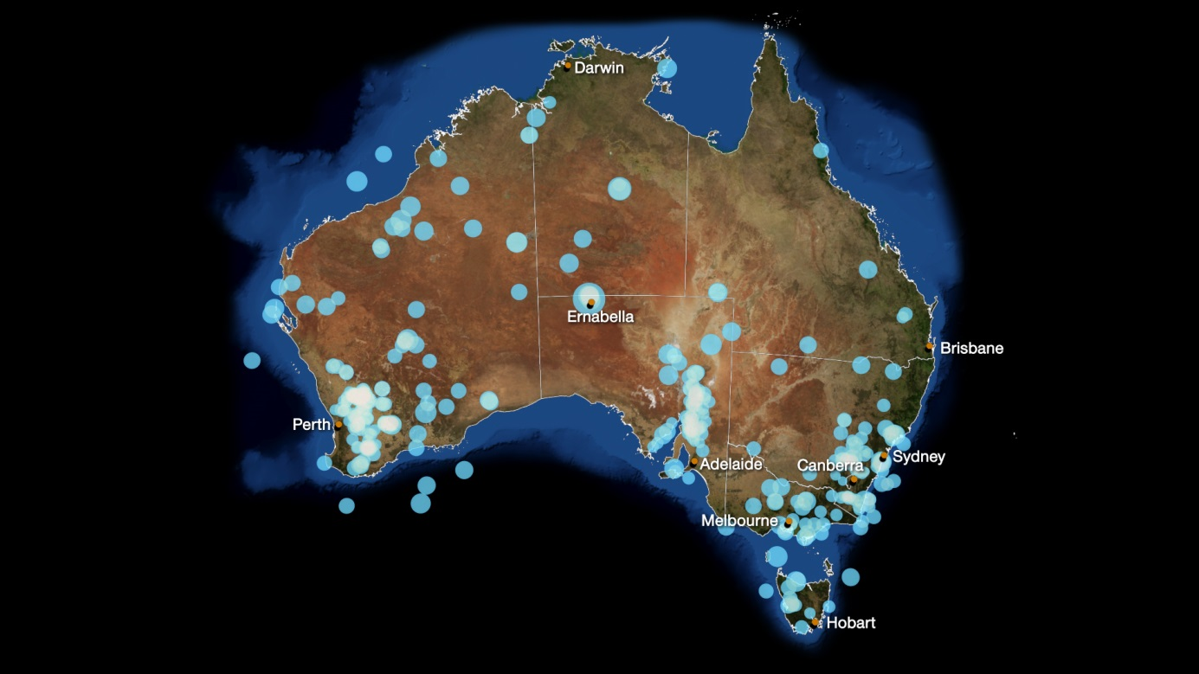
Figure 1 Map of 2013 Australian Earthquakes recorded by Geoscience Australia (circle size scales with magnitude).
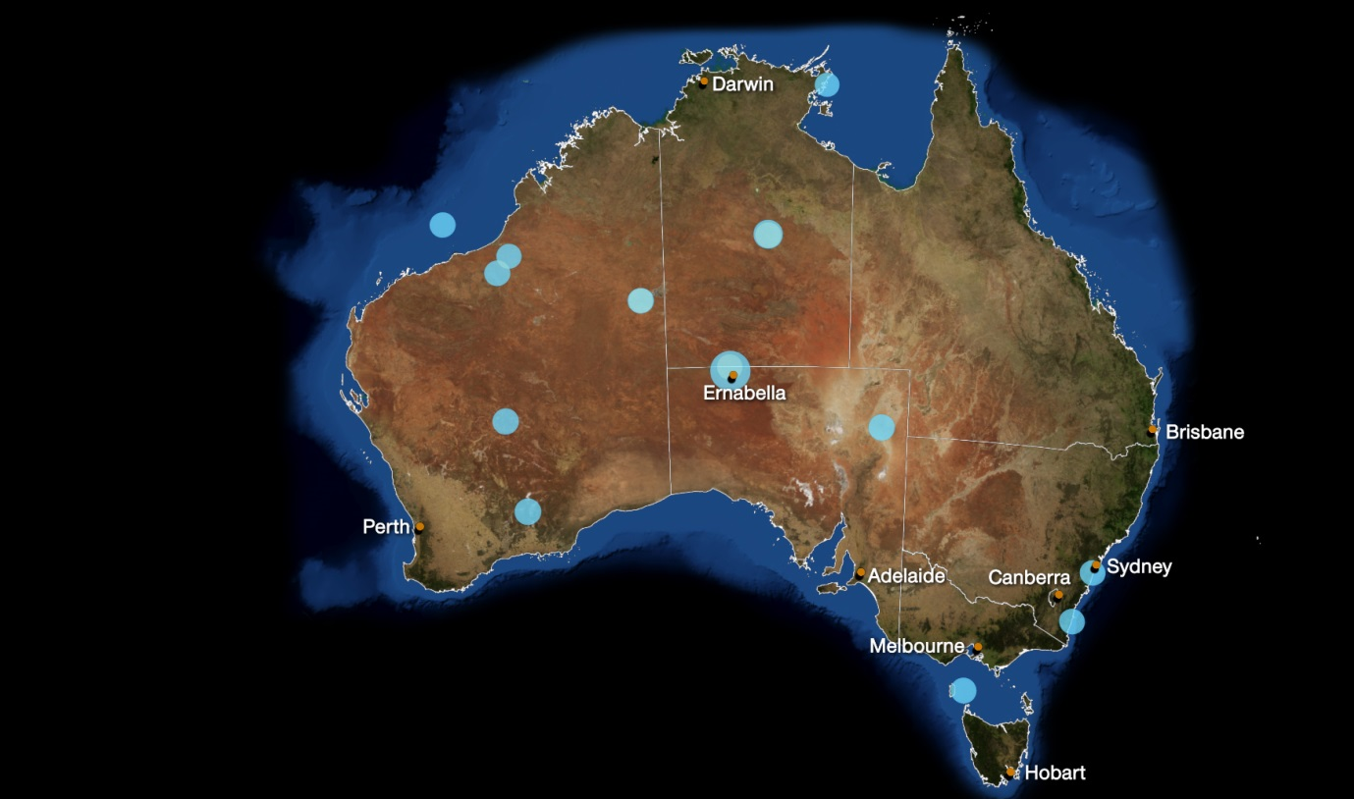
Figure 2 Map of top 16 Australian Earthquakes recorded by Geoscience Australia (circle size scales with magnitude).
Table 2 Top 16 Australian Earthquakes 2013 (recorded by Geoscience Australia)
Magnitude | Date | Time (UTC) | Latitude | Longitude | Depth (Km) | Location
5.7 | 9/06/2013 | 14:22:15 | -26.11 | 131.99 | 0 | Near Ernabella, SA
4.2 | 18/07/2013 | 11:39:11 | -19.82 | 133.89 | 10 | Tennant Creek, NT
3.7 | 30/11/2013 | 5:49:23 | -28.57 | 139.54 | 11 | SE of Mungeranie Homestead, SA
3.7 | 30/10/2013 | 22:25:38 | -27.79 | 120.75 | 0 | Near Leinster, WA
3.7 | 30/09/2013 | 21:14:03 | -31.90 | 121.50 | 12 | Near Norseman, WA
3.7 | 13/09/2013 | 11:58:52 | -20.99 | 120.93 | 2 | Pilbara, WA
3.7 | 11/03/2013 | 10:32:34 | -19.86 | 133.89 | 13 | SW of Tennant Creek, NT
3.7 | 18/01/2013 | 15:35:44 | -18.49 | 118.56 | 5 | SW of Broome, WA
3.6 | 12/06/2013 | 13:30:39 | -22.75 | 127.74 | 0 | Lake Mackay, WA
3.6 | 9/06/2013 | 5:38:43 | -25.92 | 131.97 | 0 | Near Mulga Park, NT
3.6 | 5/06/2013 | 13:17:52 | -20.26 | 121.55 | 0 | Great Sandy Desert, WA
3.6 | 15/03/2013 | 4:40:02 | -22.76 | 127.69 | 10 | W of Lake Mackay, WA
3.6 | 13/02/2013 | 16:49:40 | -12.80 | 136.59 | 10 | Near Gove, NT
3.5 | 3/11/2013 | 2:51:57 | -36.37 | 149.94 | 2 | Cobargo, NSW
3.5 | 7/10/2013 | 20:15:41 | -34.17 | 150.76 | 0 | Appin, NSW
3.5 | 15/07/2013 | 4:19:14 | -39.75 | 144.43 | 10 | Offshore King Island, Bass Strait, Tas.
  - Top Australian Earthquakes by State/Territory
    - Western Australia
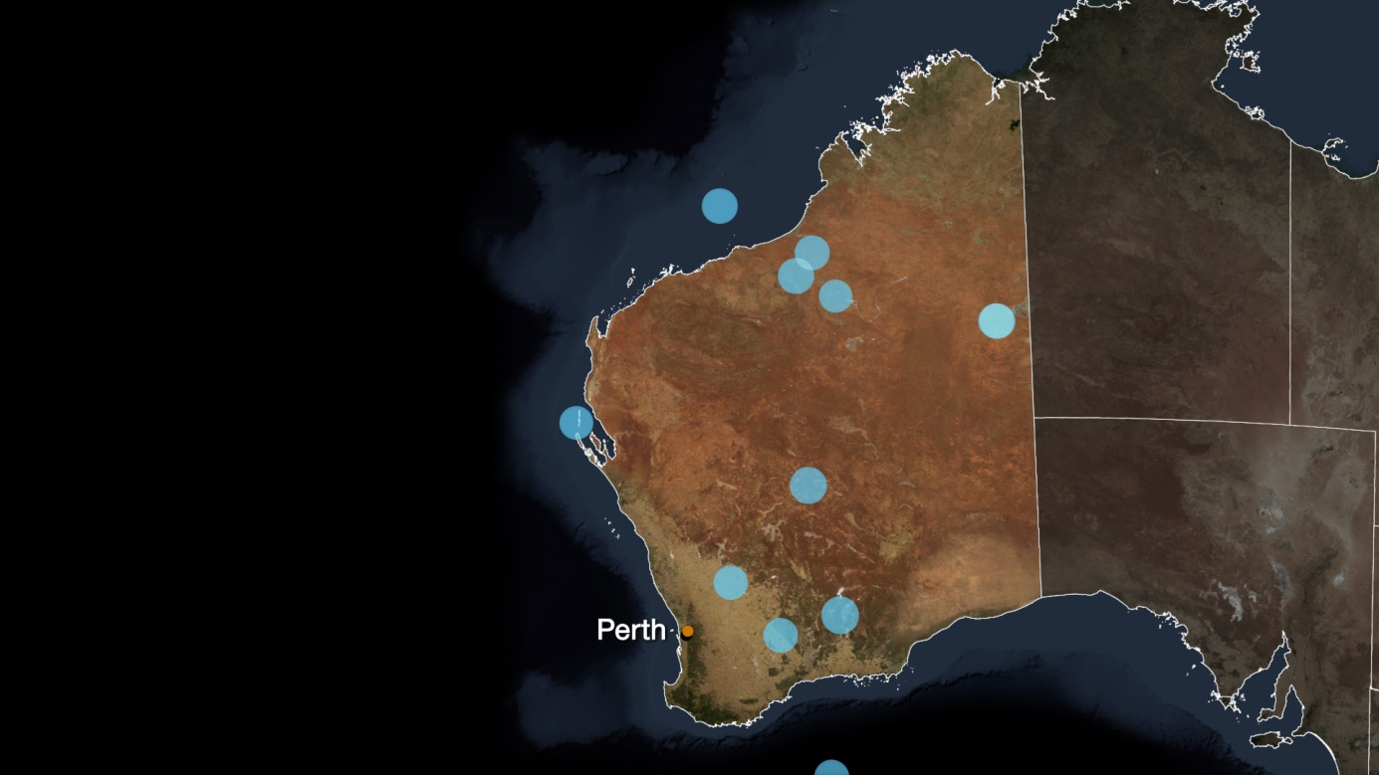
Figure 3 Map of top 12 Western Australia earthquakes recorded by Geoscience Australia (circle size scales with magnitude).
Table 3 Top 12 Western Australia Earthquakes 2013 (recorded by Geoscience Australia)
Magnitude | Date | Time (UTC) | Latitude | Longitude | Depth (Km) | Location
3.7 | 18/01/2013 | 15:35:44 | -18.49 | 118.56 | 5 | SW of Broome, WA
3.7 | 30/10/2013 | 22:25:38 | -27.79 | 120.75 | 0 | Near Leinster, WA
3.7 | 13/09/2013 | 11:58:52 | -20.99 | 120.93 | 2 | Pilbara, WA
3.7 | 30/09/2013 | 21:14:03 | -31.90 | 121.50 | 12 | Near Norseman, WA
3.6 | 5/06/2013 | 13:17:52 | -20.26 | 121.55 | 0 | Great Sandy Desert, WA
3.6 | 15/03/2013 | 4:40:02 | -22.76 | 127.69 | 10 | W of Lake Mackay, WA
3.6 | 12/06/2013 | 13:30:39 | -22.75 | 127.74 | 0 | Lake Mackay, WA
3.4 | 15/01/2013 | 7:11:07 | -25.04 | 112.86 | 0 | Offshore, W of Carnarvon, WA
3.4 | 4/10/2013 | 20:03:00 | -30.62 | 117.66 | 0 | NE of Koorda, WA
3.4 | 3/03/2013 | 21:36:12 | -32.38 | 119.28 | 1 | NE of Hyden, WA
3.4 | 2/05/2013 | 17:27:35 | -36.75 | 120.70 | 10 | Offshore SE of Albany, WA
3.4 | 8/03/2013 | 21:59:20 | -21.74 | 122.23 | 10 | SE of Marble Bar, WA
    - Northern Territory
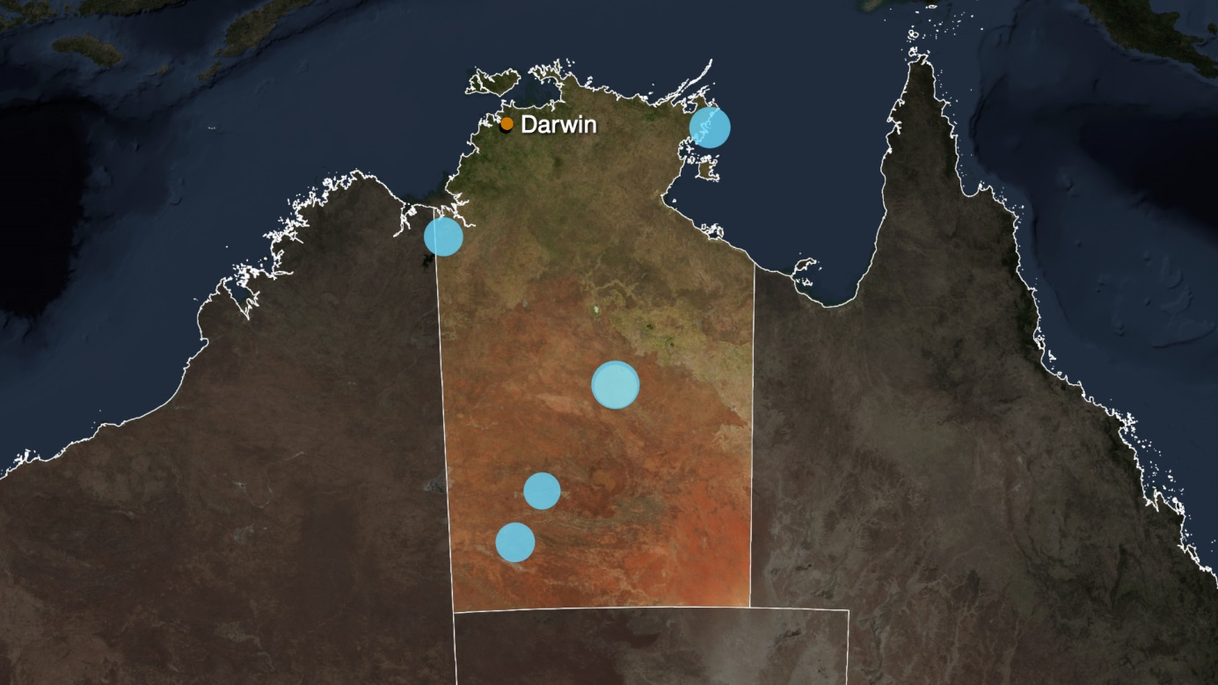
Figure 4 Map of top 10 Northern Territory earthquakes recorded by Geoscience Australia (circle size scales with magnitude).
Table 4 Top 10 Northern Territory Earthquakes 2013 (recorded by Geoscience Australia)
Magnitude | Date | Time (UTC) | Latitude | Longitude | Depth (Km) | Location
4.2 | 18/07/2013 | 11:39:11 | -19.82 | 133.89 | 10 | Tennant Creek, NT
3.7 | 11/03/2013 | 10:32:34 | -19.86 | 133.89 | 13 | SW of Tennant Creek, NT
3.6 | 13/02/2013 | 16:49:40 | -12.80 | 136.59 | 10 | Near Gove, NT
3.6 | 9/06/2013 | 5:38:43 | -25.92 | 131.97 | 0 | Near Mulga Park, NT
3.4 | 28/09/2013 | 4:00:32 | -15.61 | 129.12 | 0 | NE of Kununurra, NT
3.4 | 14/10/2013 | 15:54:33 | -24.05 | 130.83 | 0 | SE of Lake Mackay, NT
3.3 | 9/06/2013 | 14:34:41 | -25.91 | 132.05 | 0 | Near Mulga Park, NT
3.3 | 9/06/2013 | 15:54:33 | -25.97 | 132.04 | 0 | Near Mulga Park, NT
3.2 | 13/07/2013 | 10:19:02 | -25.89 | 132 | 0 | Near Mulga Park, NT
3.2 | 29/07/2013 | 5:21:51 | -22.68 | 131.67 | 0 | SW of Yuendumu, NT
    - South Australia
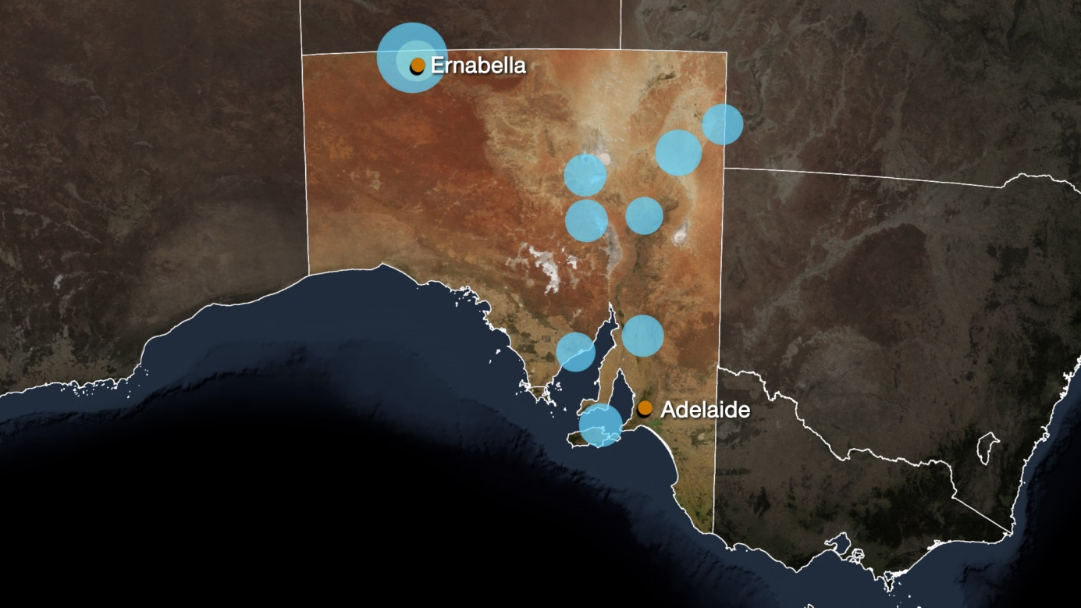
Figure 5 Map of top 10 South Australian earthquakes recorded by Geoscience Australia (circle size scales with magnitude).
Table 5 Top 10 South Australian Earthquakes 2013 (recorded by Geoscience Australia)
Magnitude | Date | Time (UTC) | Latitude | Longitude | Depth (Km) | Location
5.7 | 9/06/2013 | 14:22:15 | -26.11 | 131.99 | 0 | Near Ernabella, SA
3.7 | 30/11/2013 | 5:49:23 | -28.57 | 139.54 | 11 | SE of Mungeranie Homestead, SA
3.4 | 20/06/2013 | 3:54:33 | -29.19 | 136.88 | 10 | Near Lake Eyre, SA
3.4 | 1/05/2013 | 19:41:58 | -30.36 | 136.93 | 0 | Near Olympic Dam, SA
3.4 | 20/02/2013 | 9:57:19 | -35.43 | 137.38 | 5 | Near Kangaroo Island, SA
3.3 | 7/05/2013 | 21:48:15 | -26.19 | 132.11 | 4 | Near Ernabella, SA
3.3 | 26/02/2013 | 12:53:16 | -27.80 | 140.79 | 10 | Near Innamincka, SA
3.3 | 5/01/2013 | 0:22:30 | -33.22 | 138.60 | 15 | Jamestown, SA
3.1 | 14/08/2013 | 11:39:22 | -33.65 | 136.63 | 12 | NE of Cleve, SA
3.0 | 26/10/2013 | 10:32:13 | -30.21 | 138.59 | 6 | NE of Leigh Creek, SA
    - Queensland
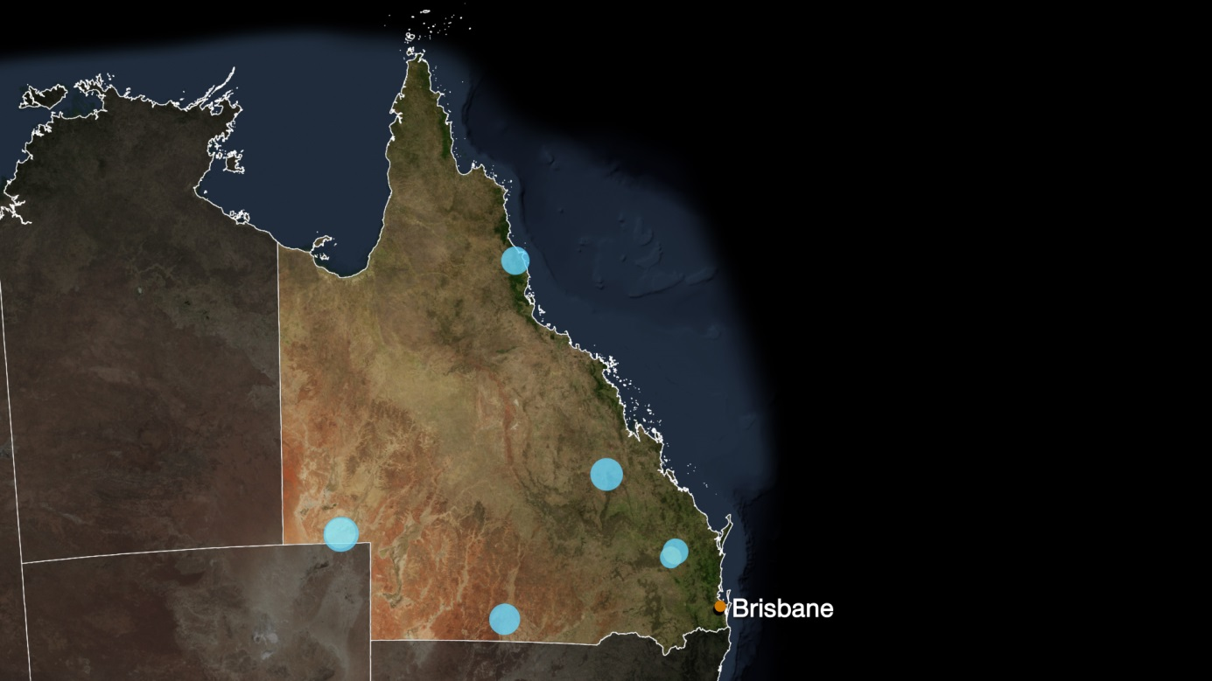
Figure 6 Map of top 7 Queensland earthquakes recorded by Geoscience Australia (circle size scales with magnitude).
Table 6 Top 7 Queensland Earthquakes 2013 (recorded by Geoscience Australia)
Magnitude | Date | Time (UTC) | Latitude | Longitude | Depth (Km) | Location
3.4 | 27/12/2013 | 13:33:50 | -25.63 | 139.86 | 10 | NE of Birdsville, Qld
3.2 | 1/06/2013 | 5:58:56 | -23.65 | 148.85 | 3 | Near Blackwater, Qld
3.0 | 27/11/2013 | 9:24:51 | -28.23 | 145.55 | 15 | Near Cunnamulla, Qld
2.9 | 12/12/2013 | 17:24:54 | -25.60 | 139.84 | 6 | NE od Birdsville, Qld
2.8 | 1/12/2013 | 9:51:23 | -17.09 | 145.55 | 0 | SW of Cairns, Qld
2.5 | 22/05/2013 | 15:48:58 | -25.89 | 151.35 | 6 | S of Mundubbera, Qld
2.1 | 1/11/2013 | 8:18:28 | -26.09 | 151.19 | 0 | NW of Coverty, Qld
    - New South Wales
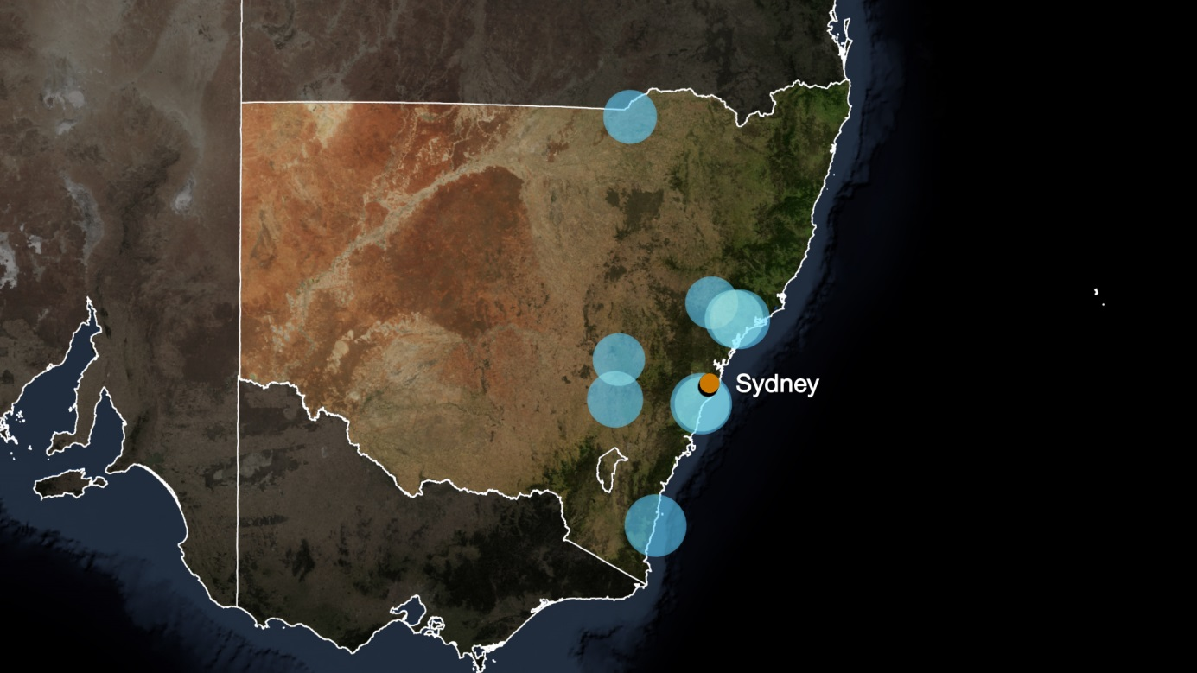
Figure 7 Map of top 9 New South Wales earthquakes recorded by Geoscience Australia (circle size scales with magnitude).
Table 7 Top 9 New South Wales Earthquakes 2013 (recorded by Geoscience Australia)
Magnitude | Date | Time (UTC) | Latitude | Longitude | Depth (Km) | Location
3.5 | 7/10/2013 | 20:15:41 | -34.17 | 150.76 | 0 | Appin, NSW
3.5 | 3/11/2013 | 2:51:57 | -36.37 | 149.94 | 2 | Cobargo, NSW
3.4 | 8/08/2013 | 23:23:33 | -32.62 | 151.48 | 2 | NW of Maitland, NSW
3.3 | 29/11/2013 | 2:11:17 | -32.62 | 151.35 | 5 | Near Singleton, NSW
3.2 | 12/01/2013 | 16:10:53 | -34.19 | 148.92 | 9 | Near Frogmore, NSW
3.1 | 3/06/2013 | 19:44:09 | -29.05 | 148.94 | 5 | Mungindi, NSW
3.1 | 24/10/2013 | 12:49:39 | -34.18 | 150.79 | 8 | Appin, NSW
3.0 | 18/02/2013 | 9:23:58 | -33.47 | 148.95 | 0 | SW of Orange, NSW
3.0 | 21/07/2013 | 8:48:53 | -32.35 | 150.86 | 0 | Near Muswellbrook, NSW
    - Victoria
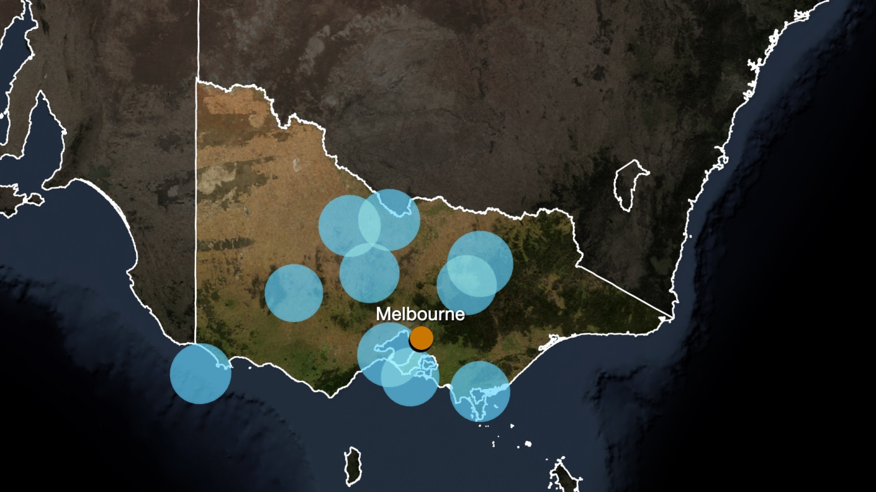
Figure 8 Map of top 10 Victorian earthquakes recorded by Geoscience Australia (circle size scales with magnitude).
Table 8 Top 10 Victorian Earthquakes 2013 (recorded by Geoscience Australia)
Magnitude | Date | Time (UTC) | Latitude | Longitude | Depth (Km) | Location
3.2 | 22/06/2013 | 11:57:48 | -36.73 | 146.15 | 11 | N of Mansfield, Vic.
3.1 | 1/05/2013 | 16:41:49 | -38.11 | 144.48 | 10 | Near Geelong, Vic.
3.0 | 22/12/2013 | 16:19:35 | -36.19 | 143.69 | 0 | Boort, Vic.
3.0 | 21/02/2013 | 13:36:47 | -36.09 | 144.43 | 11 | W of Echuca, Vic.
2.9 | 8/12/2013 | 6:47:30 | -38.63 | 146.21 | 5 | Foster, Vic.
2.9 | 25/03/2013 | 7:53:41 | -38.40 | 140.92 | 10 | Off Portland, Vic.
2.9 | 15/02/2013 | 12:32:28 | -37.05 | 145.90 | 12 | W of Mansfield, Vic.
2.9 | 9/06/2013 | 2:35:54 | -36.90 | 144.08 | 3 | Bradford Hills, Vic.
2.8 | 14/04/2013 | 22:20:30 | -38.44 | 144.88 | 9 | Near Rye, Vic.
2.8 | 30/03/2013 | 13:22:36 | -37.21 | 142.67 | 11 | NW of Ararat, Vic.
    - Tasmania
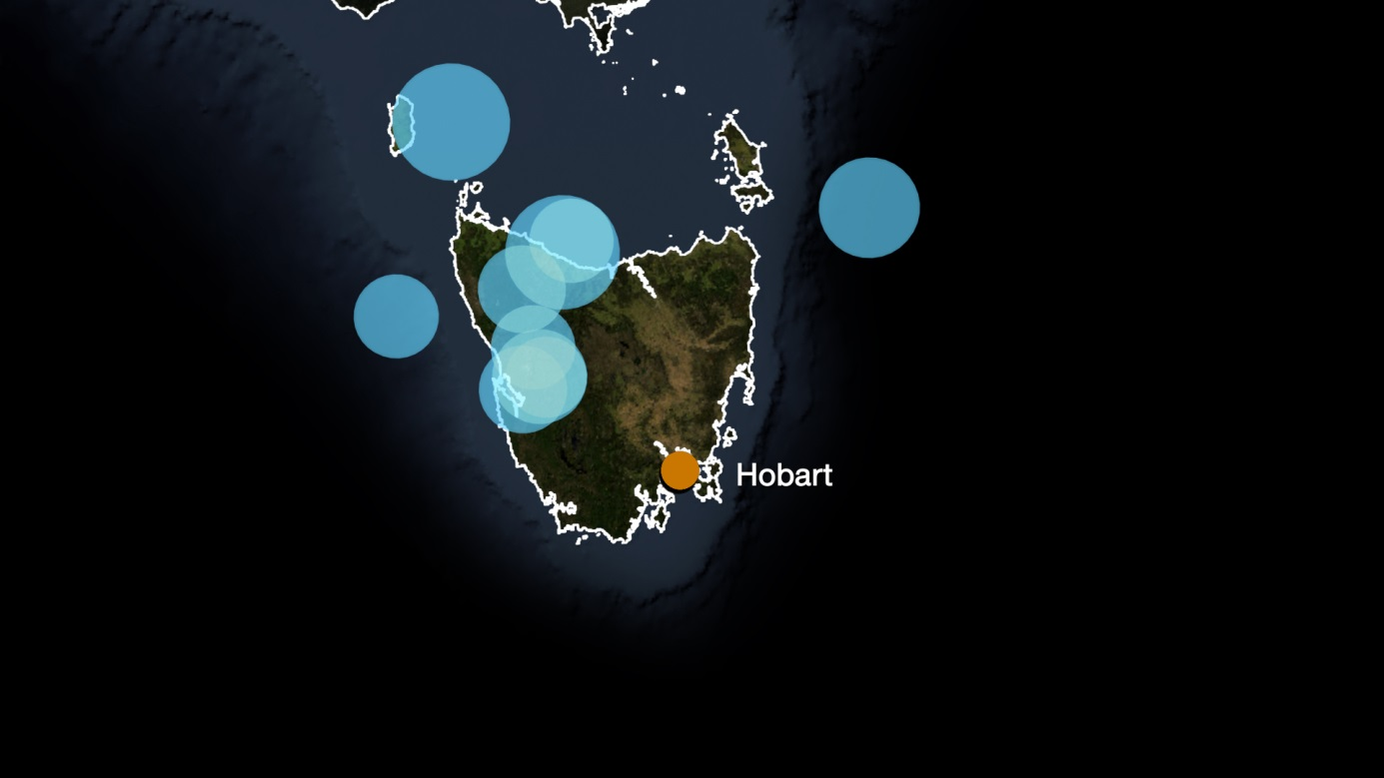
Figure 9 Map of top 10 Tasmanian earthquakes recorded by Geoscience Australia (circle size scales with magnitude).
Table 9 Top 10 Tasmanian Earthquakes 2013 (recorded by Geoscience Australia)
Magnitude | Date | Time (UTC) | Latitude | Longitude | Depth (Km) | Location
3.5 | 15/07/2013 | 4:19:14 | -39.75 | 144.43 | 10 | Offshore King Island, Bass Strait, Tas.
3.4 | 12/01/2013 | 20:21:16 | -40.94 | 145.81 | 10 | Offshore, NE of Wynyard, Tas.
3.0 | 6/09/2013 | 19:08:26 | -40.41 | 149.48 | 0 | Tasman Sea
2.8 | 5/04/2013 | 12:20:22 | -42.08 | 145.58 | 0 | Near Queenstown, Tas.
2.6 | 23/12/2013 | 13:40:57 | -42.20 | 145.38 | 0 | Near Strahan, Tas.
2.6 | 10/07/2013 | 2:57:26 | -41.28 | 145.33 | 11 | Near Lyons River, Tas.
2.5 | 14/12/2013 | 9:39:22 | -41.81 | 145.49 | 0 | Near Rosebery, Tas.
2.5 | 16/07/2013 | 4:55:38 | -41.55 | 143.82 | 10 | W of Kenneth Bay, Tas.
2.5 | 12/01/2013 | 23:27:44 | -40.82 | 145.92 | 10 | Offshore, NE of Wynyard, Tas.
2.4 | 25/06/2013 | 11:43:06 | -42.08 | 145.66 | 0 | Near Queenstown, Tas.
    - Australian Capital Territory
There were no earthquakes recorded by Geoscience Australia within the ACT during 2013.

