Identification of a new gold event at Tennant Creek expands ‘search space’ for more discoveries
New age measurements suggest the timing of some gold-bearing mineralisation at Tennant Creek is nearly 200 million years younger than previously thought. This new result widens the exploration ‘search space’ for gold into rock formations previously regarded as too young to host this style of mineralisation.

A key objective of the Exploring for the Future (EFTF) program is to identify new areas of high potential for mineral resources across northern Australia. A major focus of the program is the Tennant Creek goldfield region, a historic mining district in the central Northern Territory known for its high grade gold, copper and bismuth (Au, Cu, Bi) deposits that are typically hosted by ironstones. There are more than 600 ironstone bodies mapped in the district yet only a few dozen contain economic concentrations of Au, Cu or Bi. Traditionally these ironstone-hosted deposits have been discovered from outcrops and through the application of aeromagnetic techniques combined with gravity surveys, which very effectively map the ironstones to depths of several hundreds of metres. More recently, airborne electromagnetic techniques have been applied successfully in discovering new resources (Osborne et al., 2012).
The exploration ‘search space’ for the ironstone-hosted Au-Cu-Bi deposits has for many decades been limited mostly to areas where the stratigraphy hosting the ironstones, the ~1860 Ma Warramunga Formation, is present (Figure 1). Research on the timing of Au-Cu-Bi mineralisation also showed that ore formation occurred during the regional tectonic and magmatic Tennant Event at ~1840-1850 Ma (Compston et al., 1994; Fraser et al., 2008). However, it has been known since the 1990s that some Au-Cu-Bi mineralisation occurs outside the ironstones and within shear and fault zones in different structural settings to those of the ironstone-hosted mineralisation (Main et al., 1990; Skirrow, 1993, 2000; Osborne et al., 2012). The broader significance of such ‘non-ironstone’ mineralisation had not been fully appreciated until new investigations recently commenced during the EFTF program.
The Australian designed and built SHRIMP (Sensitive High Resolution Ion Microprobe) mass spectrometer is capable of determining the ages of mineral grains by analysing their uranium, thorium and lead isotopes. One such mineral is monazite, which can grow from hydrothermal fluids together with ore minerals such as gold and sulfides. Careful petrographic searching of many dozens of samples from Tennant Creek deposits has revealed for the first time the widespread presence of minor quantities of monazite in close association with Au-Cu-Bi mineralisation (Figures 2a, 2b). Interestingly, the monazite has been observed almost exclusively to be present in association with non-ironstone Au-Cu-Bi mineralisation. It is this monazite that has been the focus of recent geochronological studies, although only a small sub-set of crystals have proved to be suitably large and enriched in thorium to provide high-quality isotope results.

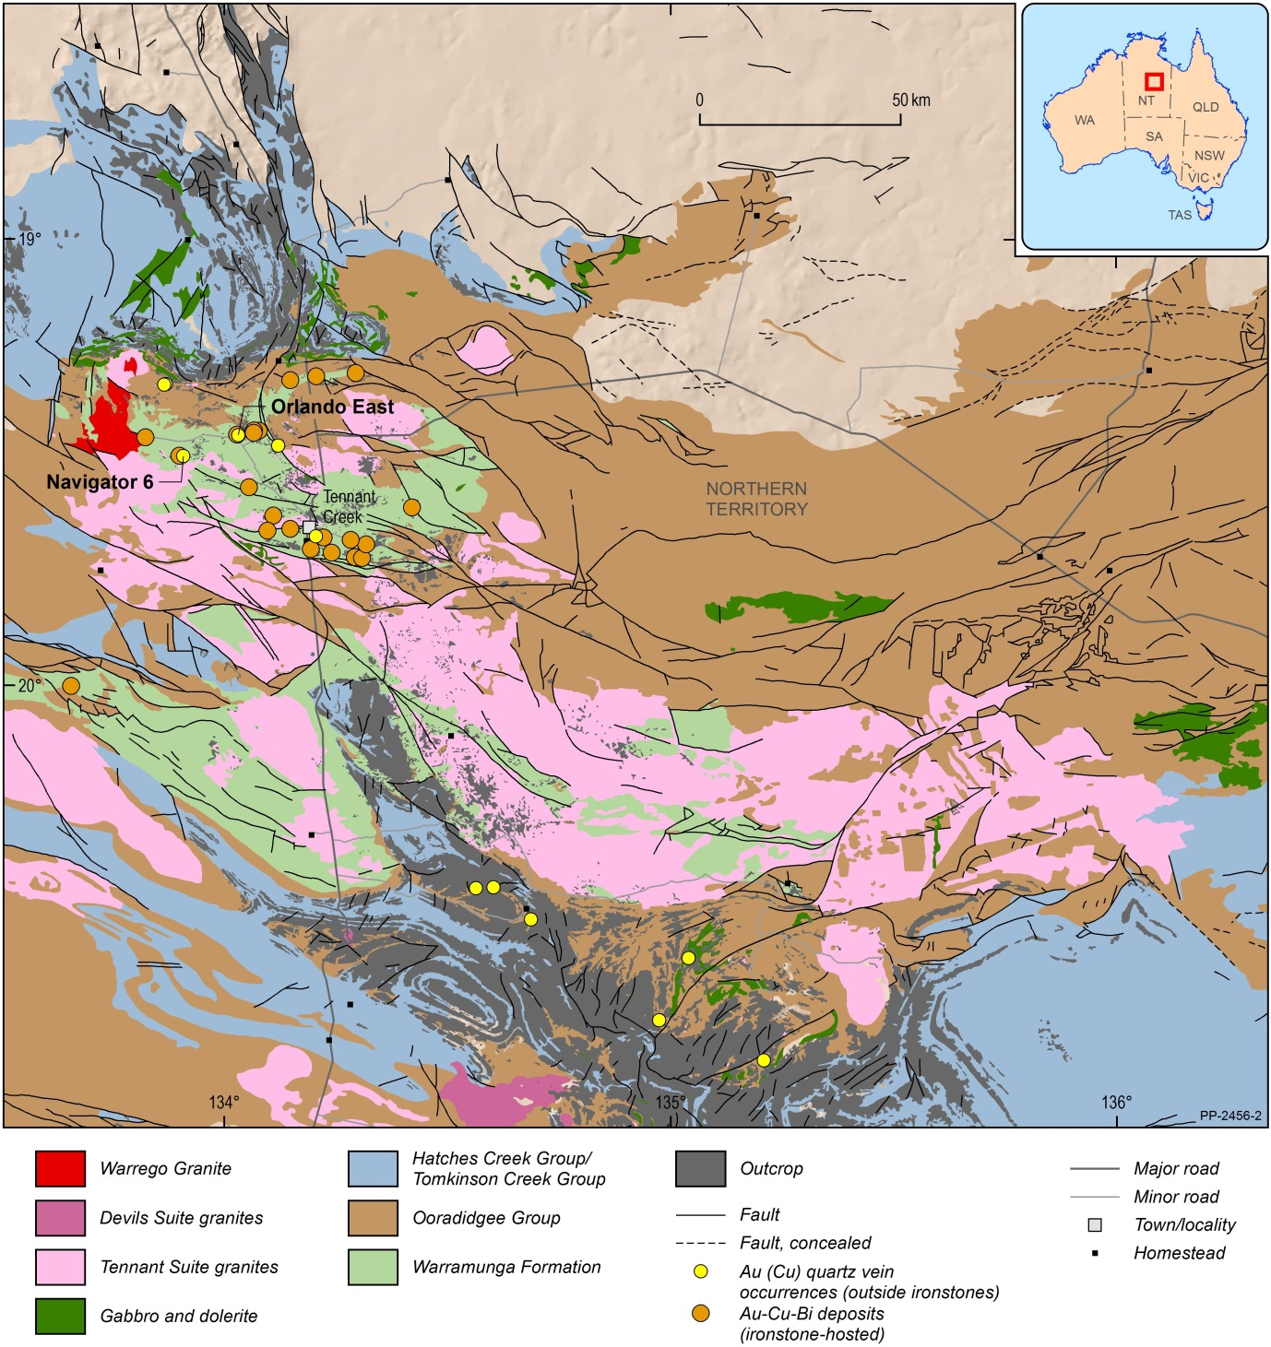
Figure 1 Map of interpreted pre ~1660 Ma solid geology of the Tennant Creek region, showing the locations of ironstone-hosted Au-Cu-Bi deposits (orange circles) and Au (-Cu) quartz vein, non-ironstone hosted deposits (yellow circles). Geological units correspond to those shown in Figure 3. Map adapted from Stewart (2018). Mineral deposit information was derived from the MINLOC database (Geoscience Australia, 2018).

Carefully selected areas of monazite from Au-Cu-Bi-bearing thin sections were analysed by Geoscience Australia’s SHRIMP which is capable of measuring areas as small as 5 micrometres (millionths of a metre) in diameter. The results from multiple spots in each sample are used to calculate the age of the mineral, based on the natural decay rate of uranium and/or thorium to lead. After numerous attempts on several deposits, monazite from a hematite-bearing quartz vein within a gold-bearing sample from the Navigator 6 Au prospect, ~500 metres east of the White Devil deposit, yielded a surprisingly ‘young’ age of ~1660 Ma (Figures 1, 26, 2c). Importantly, this age has been confirmed by a second sample from a different location, the Orlando East non-ironstone hosted Au-Cu-Bi deposit (Figures 1, 2a). Mineralised quartz veins at this deposit occur within a late-stage shear zone that is interpreted to have reactivated an earlier shear zone that, along strike to the west, contains the ironstone-hosted Orlando Cu-Au deposit. At both Orlando East and Navigator 6 it is evident that the monazite grew in hydrothermal veins with Au, Cu and Bi sulfide minerals, and these veins cut earlier hydrothermal magnetite-bearing veins.
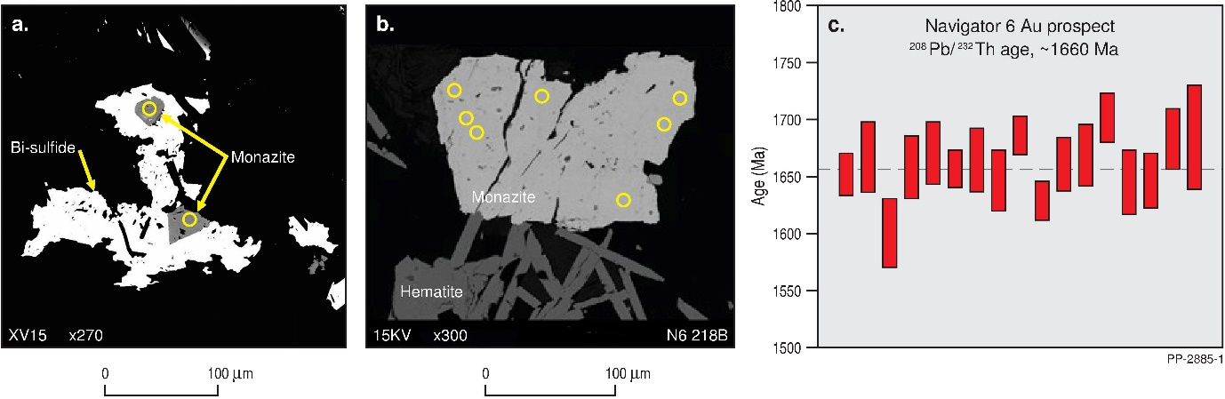
Figure 2 Backscattered scanning electron microscope images of monazite crystals analysed in situ from the Orlando East Au-Cu-Bi deposit (a) and Navigator 6 Au prospect (b). The yellow ellipses on the monazite grains represent the locations of the SHRIMP U-Pb-Th analytical spots. Monazites analysed from both deposits gave 208Pb/232Th ages of approximately 1660 Ma. A plot of the individual SHRIMP 208Pb/232Th ages of monazite crystals from the Navigator 6 prospect is shown in (c).

It is not yet clear whether the ~1660 Ma gold-bearing veins represent substantial new addition of gold to the region or instead represent remobilisation of gold from the earlier ~1840-1850 Ma mineralising event. This question and the broader geological context of the new result are the subjects of ongoing research. We note that several geological events are known to have occurred in the Tennant Creek region around the time of the newly identified Au-Cu-Bi event at ~1660 Ma (Figure 3). These include the intrusion of the Warrego Granite (preferred age ~1645 Ma, Compston, 1994) and mantle-derived lamprophyre dykes (between ~1665 and ~1690 Ma, Black, 1977; Compston and McDougall, 1994). At present, it is unclear whether either of these igneous events is related directly or indirectly to the ~1660 Ma Au-Cu-Bi event.
If substantiated by further work, the exploration implications of the new results are two-fold. First, the findings strongly support the hypothesis of a second Au-Cu-Bi mineralising event in the Tennant Creek district, represented by shear- and fault-hosted mineralisation outside ironstones (e.g. Orlando East deposit, parts of the Gecko deposits, Bishop Creek deposit, parts of West Peko deposit). This shear- and fault-hosted style of Au-Cu-Bi mineralisation offers a new type of exploration target in the region, which will require different exploration techniques to those employed in targeting ironstone-hosted mineralisation. Second, the age of the newly identified Au-Cu-Bi event is almost 200 million years younger than the accepted age of the main ironstone-hosted Au-Cu-Bi deposits in the Tennant Creek goldfield, meaning that rock packages up to ~200 million years younger than those of the previous ‘search space’ (Warramunga Formation) could now be considered as potential hosts to Au-Cu-Bi mineralisation at ~1660 Ma. This finding greatly expands the exploration ‘search space’ into the regionally extensive Ooradidgee Group (~1840-1810 Ma), Hatches Creek Group (~1810-1790 Ma) and Tomkinson Creek Group (~1805-1710 Ma) (Figures 1 and 3). However, only very specific structural and lithogeochemical settings will be favourable sites for Au-Cu-Bi mineralisation, requiring new exploration targeting strategies in order to make discoveries, particularly in areas where these rock sequences are concealed beneath younger rocks and sediments.

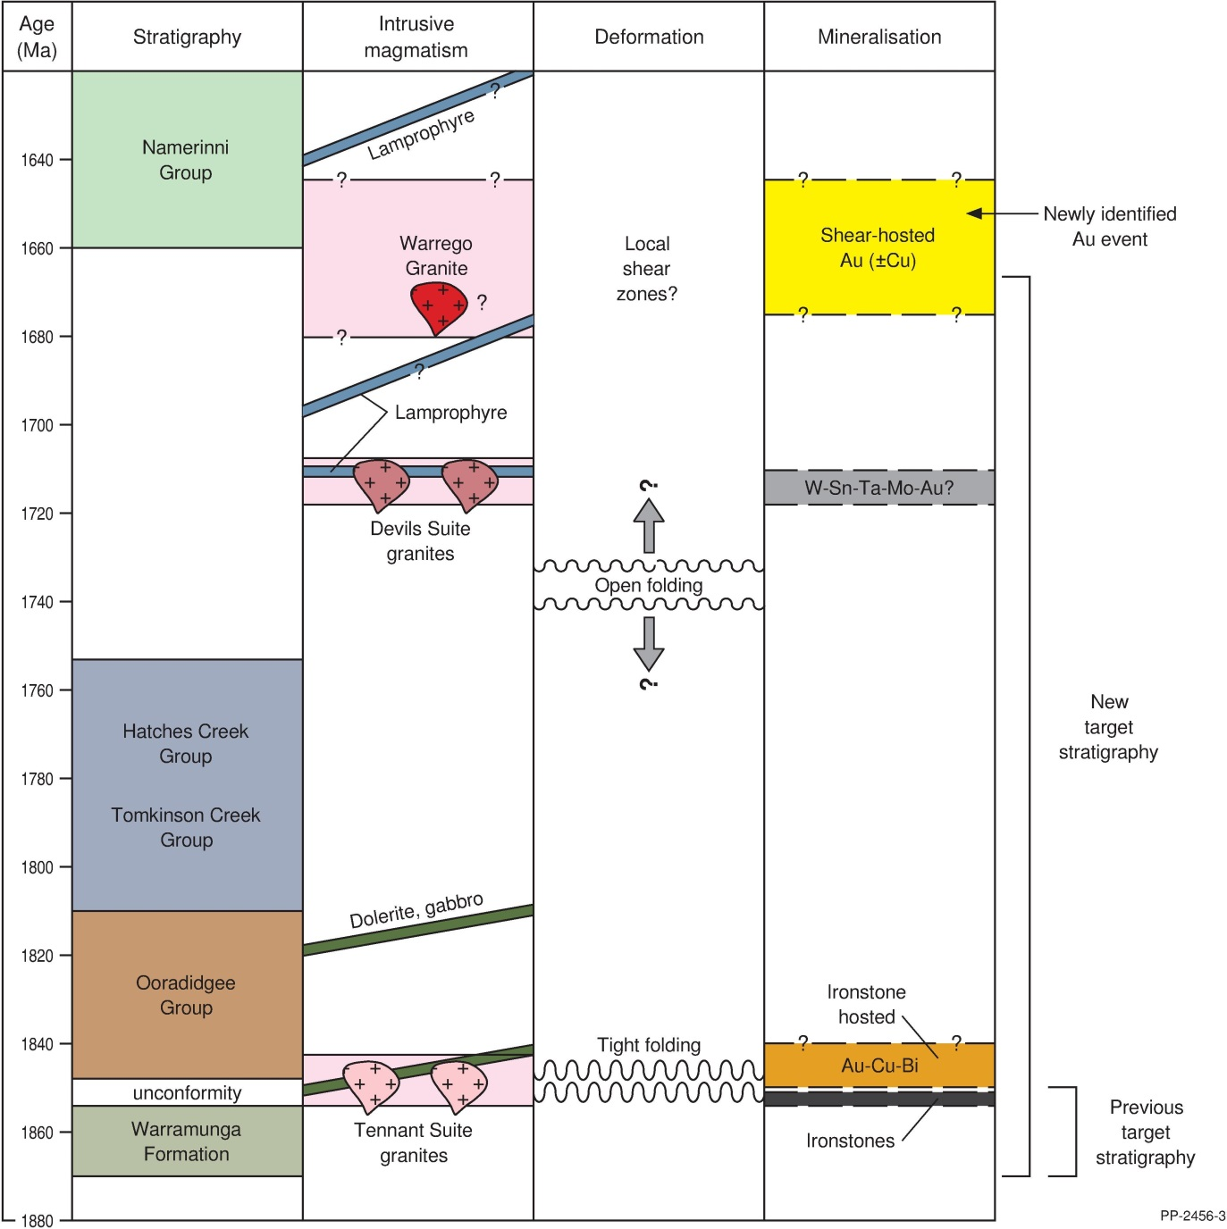Figure 3 Diagrammatic representation of the geological history of the Tennant Creek region showing currently known age constraints for stratigraphy, intrusive magmatism, deformation and mineralisation. Ages (Ma) shown in millions of years. Adapted from Fraser et al. (2008).

References
Black, L.P., 1977. A Rb-Sr geochronological study in the Proterozoic Tennant Creek block, central Australia. BMR Journal of Australian Geology and Geophysics, 2, 111-122.
Compston, D. M., 1994. The Geochronology of the Tennant Creek Inlier and its ore deposits, Northern Territory. Unpublished PhD thesis, Australian National University.
Compston, D. M. and McDougall, I., 1994. ⁴⁰Ar/³⁹Ar and K-Ar age constraints on the Early Proterozoic Tennant Creek Block, northern Australia, and the age of its gold deposits. Australian Journal of Earth Sciences, 41, 609-616.
Fraser, G. L., Hussey, K. and Compston, D. M., 2008. Timing of Paleoproterozoic Au-Cu-Bi and W mineralisation in the Tennant Creek region, northern Australia: improved constraints via intercalibration of ⁴⁰Ar/³⁹Ar and U-Pb ages. Precambrian Research, 164, 50 -65.
Geoscience Australia 2018. MINLOC, Mineral Occurrence database. http://pid.geoscience.gov.au/dataset/ga/73131
Main, J.V., Nicholson, P.M. and O’Neill, W.J., 1990. K44 ironstone copper-gold deposit, Gecko Mine. In Hughes, F.E. (Ed.), Geology of the mineral deposits of Australia and Papua New Guinea. The Australasian Institute of Mining and Metallurgy, 845-848.
Osborne, G.A., Bills, R.T. and Russell, S.C., 2012. Cracking the code of the Tennant Creek Mineral Field – luck is not a good strategy! Annual Geoscience Exploration Seminar (AGES), Record of Abstracts. Northern Territory Geological Survey, Record 2012-002, 23-25.
Skirrow, R. G., 1993. The genesis of gold-copper-bismuth deposits, Tennant Creek, Northern Territory. Unpublished PhD thesis, Australian National University.
Skirrow, R. G., 2000. Gold-Copper-Bismuth Deposits of the Tennant Creek District, Australia: A Reappraisal of Diverse High Grade Systems. In Porter, T. M. (Ed), Hydrothermal Iron Oxide Copper-Gold & Related Deposits: A Global Perspective, Australian Mineral Foundation, Adelaide, pp 149-160.
Stewart, A.J., 2018. Solid Geology of the Tennant Creek – Mt Isa area, 1:2 500 000 scale, 1st edition [Digital Dataset]. Geoscience Australia, Commonwealth of Australia, Canberra. https://ecat.ga.gov.au/geonetwork/srv/eng/catalog.search?node=srv#/metadata/28bfac95-27cb-4365-a45e-c3863ed315ef

For further information, contact:
Roger Skirrow (roger.skirrow@ga.gov.au) or Andrew Cross (Andrew.cross@ga.gov.au)
Website: www.ga.gov.au/eftf

Monazite is a rare-earth-element-rich and thorium-bearing phosphate mineral. Samples have been dated by uranium-thorium-lead isotope methods using the SHRIMP at Geoscience Australia. The monazite occurs in the same veins and alteration assemblages as gold, hematite, and in places chalcopyrite (CuFeS₂) and bismuth sulfide minerals.

